62 x 62 adjacency matrix (dolphin dataset):

Iteration: 1000

**Batch number: 1 (each batch with size 62); Batch number: 1.5 (each batch with size 42);**

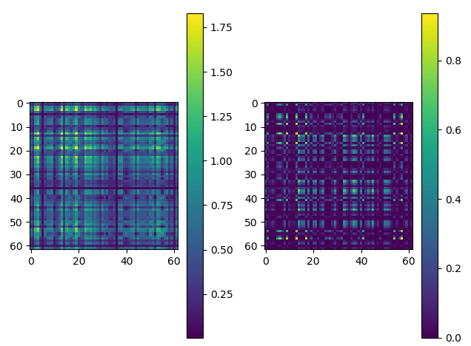 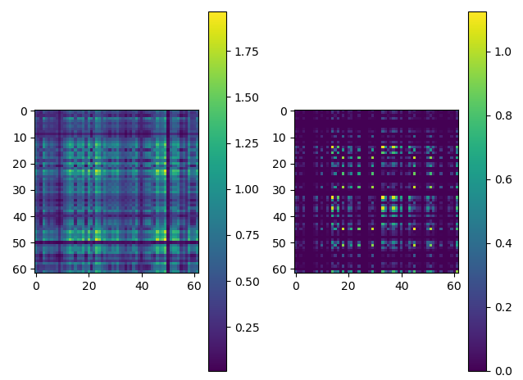

[Staring error: 36.237183576308595] [Staring error: 40.43510603567927]

[Final error is: 15.207835500940607] [Final error is: 15.732554573941226]

[Time taken: 0.12092447280883789] [Time taken: 0.19687914848327637]

**Batch number: 2 (each batch with size 31); Batch number: 4 (each batch with size 16);**

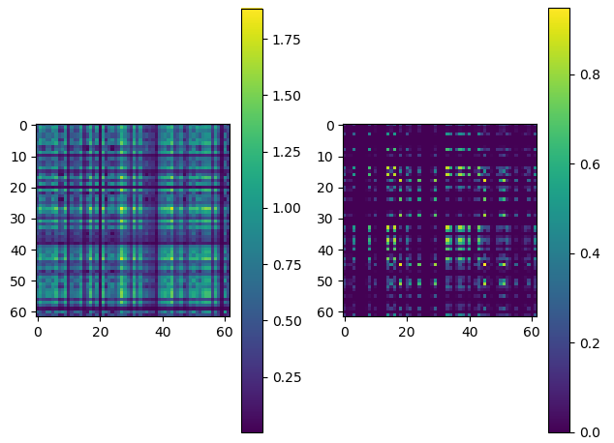 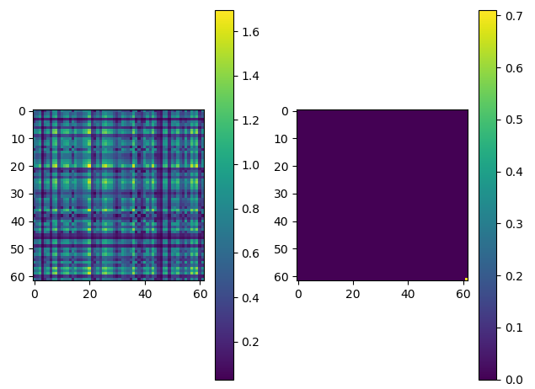

[Staring error is: 39.25734919059044] [Staring error is: 38.95539814163412]

[Final error is: 16.089694115092055] [Final error is: 17.846667588242187]

[Time taken: 0.14191126823425293] [Time taken: 0.1329188346862793]

With iteration 100:

**Batch number: 4 (each batch with size 16) has some values;**

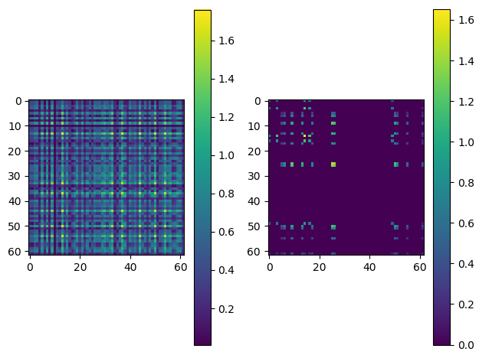

With iteration 50:

**Batch number: 4 (each batch with size 16):**

