CSIS 4495-050
Francis Awoyale - 300356743
10-23-2025

GreenPath.
Sustainable Products Website with AI ChatBot Integration.

Table of Contents
1 Introduction 3
2 Proposed Research Project 3
3 Project Planning and Timeline 5
4 Implemented Features 6
4.1 Implemented Feature A - HOME PAGE 6
4.1.1 Introduction/Overview - home page 6
4.1.2 Details of Implementation - home page 6
4.2 Implemented Feature B - CATEGORIES PAGE 9
4.2.1 Introduction/Overview - categories page 9
4.2.2 Details of Implementation - categories page 9
4.3 Implemented Feature C - ANALYTICS PAGE 11
4.3.1 Introduction/Overview – analytics page 11
4.3.2 Details of Implementation - analytics page 11
4.4 Implemented Feature D - ANALYTICS ML PAGE 16
4.4.1 Introduction/Overview – analytics ml page 16
4.4.2 Details of Implementation - analytics ml page 16
4.5 Implemented Feature E – CHAT PAGE (AI CHATBOT) 18
4.5.1 Introduction/Overview – chat page 18
4.5.2 Details of Implementation - chat page 19
4.6 Implemented Feature F – ROOT LAYOUT AND NAVIGATION 24
4.6.1 Introduction/Overview – chat page 24
4.6.2 Details of Implementation - chat page 24
5 Lessons Learned and Future Work 25
6 Concluding Remarks 26
7 Appendix 26
7.1 Appendix A: Installation Guide 26
7.2 Appendix B: User Guide 27
7.3 Appendix C: Dataset and API Used 29
7.4 Appendix D: Hardware, Software, Cloud, Architecture, etc. 29
7.5 Appendix E: Code Explanation 30
8 closing. 31
9 References. 31

1 Introduction
GreenPath is an applied research project that adapts the concept of Happy Nutrition Riipen project brief to the broader sustainability domain. The aim is to develop a modern, cloud‑hosted website that educates users about sustainable product choices. The system combines a React frontend, a Node.js backend, and a PostgreSQL database deployed on Amazon Web Services. An AI‑powered chatbot provides conversational guidance, and a sustainability analytics dashboard that presents real world emissions data in an accessible, interactive format. The project emphasizes accessibility, performance, and transparency of data use so that results are meaningful to a general audience.

2 Proposed Research Project
Design: GreenPath delivers three user‑facing capabilities: a category explorer that presents examples of eco‑friendly products with details, a chatbot that provides sustainability guidance, and an analytics dashboard that exposes sector‑level emissions trends. The system is implemented with React and TypeScript on the client, a Node.js and Express backend running on AWS Lambda behind API Gateway, and a PostgreSQL database hosted on Amazon RDS with RDS Proxy to manage connections. The front end is hosted through AWS Amplify and served via CloudFront. Secrets such as the OpenAI API key are stored in AWS Secrets Manager.
Objectives: The objective of GreenPath is to deliver a deployed and accessible web application that helps users understand sustainability topics through an integrated experience of product exploration, conversational assistance, and data‑driven insight. Concretely, the project aims to build a responsive React interface hosted on AWS Amplify, implement a serverless Node.js backend that secures keys and serves compact APIs, integrate an AI‑powered chatbot for sustainability question‑and‑answer interactions, and provide an analytics dashboard with at least three interactive charts that present sector‑level CO₂ emissions over time in gigatonnes. A focused machine learning component will be trained and embedded into the dashboard to generate short‑term forecasts for a selected country and sector, with results presented transparently and accompanied by interpretation notes. The application will adhere to WCAG 2.1 Level AA practices and target a strong baseline performance so that the experience is fast, readable, and keyboard‑friendly for all users.
Method: The project begins by preparing the data and establishing a stable deployment pipeline. The React application is scaffolded, and the core pages are created for the home view, the categories, the analytics dashboard, and the chatbot. The backend exposes a small set of REST endpoints for categories and analytics, and a single endpoint that relays chatbot prompts to the OpenAI API. Once the pipeline is in place the focus shifts to data ingestion, analysis, and presentation. Accessibility and performance are evaluated throughout using a combination of automated tools and manual checks.
Data collection and preparation: The analytics module uses the CO₂ Emissions Dataset by Saloni1712 on Kaggle. The dataset includes the country or region, the year, a sector designation, a numerical value, and a timestamp. The working copy is normalized by renaming columns to country, year, sector, and value; removing the timestamp; filtering to a practical subset of countries; and indexing the database for efficient queries. A magnitude check indicates that values should be interpreted as gigatonnes of CO₂, and charts and labels are annotated accordingly so users understand what the numbers represent.
Sample size and data scope: For a realistic and manageable analysis during the project, the minimum viable sample will focus on a representative subset of countries such as Canada, the United States, the United Kingdom, Germany, Brazil, Nigeria, India, and China, spanning approximately 2019 to 2023 across all six sectors. This scope yields several hundred to more than a thousand records, which is ample for descriptive analytics and for training a simple, interpretable model while retaining headroom for validation. The full dataset remains available in PostgreSQL for extended exploration, but the forecasting model will be trained on the defined subset using a chronological split that reserves the most recent years as a holdout period to approximate real‑world prediction.
Analysis techniques: The dashboard exposes interpretable views that support exploration. A line chart shows how a sector’s emissions evolve over time for a given country. A stacked bar or grouped bar enables a yearly comparison of sector contributions. A small machine learning component is integrated into the dashboard to demonstrate applied analytics. For the minimum viable product, the preferred option is a simple regression that predicts the next year’s sector value for a selected country using recent history; alternatively, a compact classifier can assign countries to high, medium, or low emission categories based on historical distributions. Results are presented alongside the charts with clear statements of limitations.
Technology justification: React with TypeScript provides a fast, accessible interface and strong developer ergonomics. Node.js on Lambda minimizes operational overhead while API Gateway and RDS Proxy provide reliable connectivity. PostgreSQL offers mature querying, indexing, and aggregation suitable for the analytics workload. Recharts integrate cleanly with React for accessible visualizations.
Expected results: The outcome will be a working system that combines a friendly interface, meaningful analytics, and a modest predictive capability. Users will browse sustainable product categories, ask questions through the chatbot, and explore emissions data with interactive charts that clarify sector contributions and year‑over‑year changes. The model will produce short‑term forecasts for a chosen country and sector, visualized alongside historical trends and accompanied by plain‑language explanations of uncertainty, assumptions, and limitations. From an engineering perspective, the system is expected to achieve a Lighthouse performance score in the mid‑eighties or higher, pass core accessibility checks aligned to WCAG 2.1 practices, and maintain low API latency under typical classroom loads. From an analytics perspective, the regression baseline should reach a reasonable fit on the validation period for at least one country‑sector pair, emphasizing interpretability and defensibility over complexity.

3 Project Planning and Timeline
WEEKS | ACTIVITIES | DELIVERABLES
1–2 | Requirements gathering, finalize dataset (Kaggle CO₂ emission by Sector), repo setup. | Requirement document, dataset README.
3 -4 | React Frontend scaffold, category UI prototype, Amplify hosting, initial accessibility checks. | Deployed React skeleton (Amplify), initial Web Content Accessibility Guidelines (WCAG) check.
5-6 | Backend setup (API Gateway, Lambda), PostgreSQL schema (categories and emissions), load Kaggle dataset into RDS, Secrets Manager integration. | Functional API, dataset stored in PostgreSQL, secure secret management.
7-8 | Chatbot endpoint development, React integration, log queries to DB. | Working chatbot in React UI with logs.
9-10 | Analytics Dashboard development: build Recharts charts (trend, sector comparison, distribution), integrate API endpoints from RDS. | Interactive analytics page with 2 visual charts.  A tabular ranking for the dataset emissions.
11 | ML Component: implement regression (future emission prediction) or classification  (high/medium/low emitters) using dataset; integrate results into Analytics Dashboard. | ML model integrated and demo ready insights.
12 | Testing (performance, accessibility, API reliability), final refinements, report preparation, demo script. | Final deployed system, applied research report and demo.

4 Implemented Features
This section outlines the core features developed in the GreenPath project, describing their purpose, design approach, and technical implementation. Each feature contributes to the system’s overall functionality and demonstrates the integration of modern web technologies, cloud services, and AI to achieve the project’s sustainability objectives.

4.1 Implemented Feature A - HOME PAGE
The Home Page serves as the welcoming interface of the GreenPath application, offering users an immediate overview of the project’s sustainability mission. It introduces the application’s purpose, visual identity, and navigational flow while guiding users toward other core modules such as Categories, Analytics and the Chatbot.

4.1.1 Introduction/Overview - home page
Developed during the first milestone, the Home Page fulfills the objective of creating a visually engaging and accessible interface that introduces users to sustainable living concepts. It anchors GreenPath’s brand identity through its green color scheme, minimal layout, and eco-centric imagery. The design reflects the project’s goal of merging education with modern digital presentation, encouraging users to explore analytics, product categories, and AI interaction through clear navigation cues.

4.1.2 Details of Implementation - home page
The Home Page was implemented in Home.tsx using React functional components and Tailwind CSS for responsive styling. The hero section displays the GreenPath title and a rotating carousel of sustainability themed visuals controlled by a useEffect hook. An introductory paragraph summarizing the app’s mission sits below the banner, and a persistent button launches the Chatbot. The layout hierarchy is illustrated in Figure 4.1(a), showing component relationships under the RootLayout wrapper. Code excerpts in Figure 4.1(b) highlight the carousel logic and Tailwind class structure, while Figure 4.1(c) presents the rendered Home Page interface.

Figure 4.1(a): Layout hierarchy connecting RootLayout to the Home Page hero and carousel.
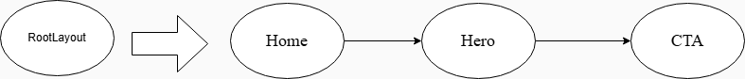

Figure 4.1(b): Home.tsx component structure and carousel timer hook
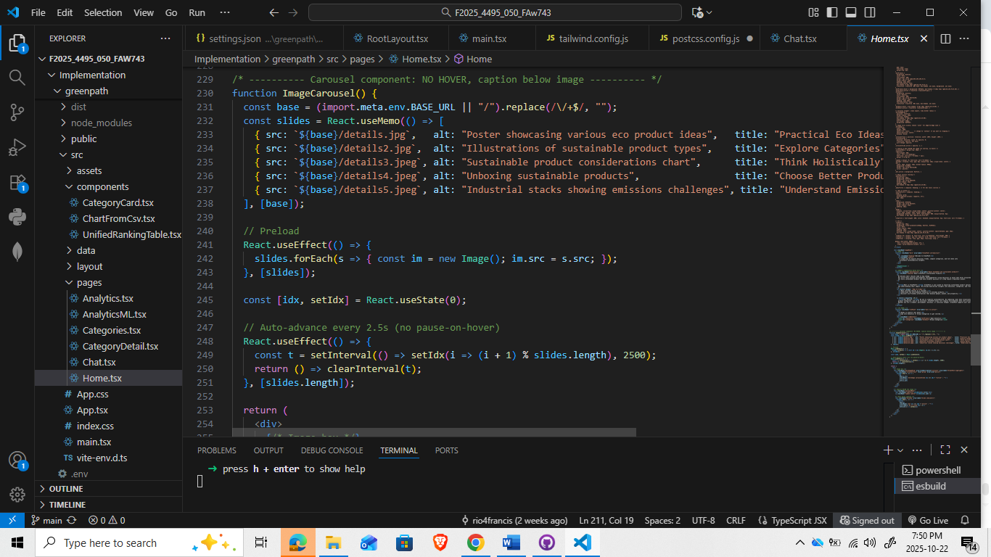

Figure 4.1(c): Rendered Home Page hero with rotating carousel and chatbot entry.
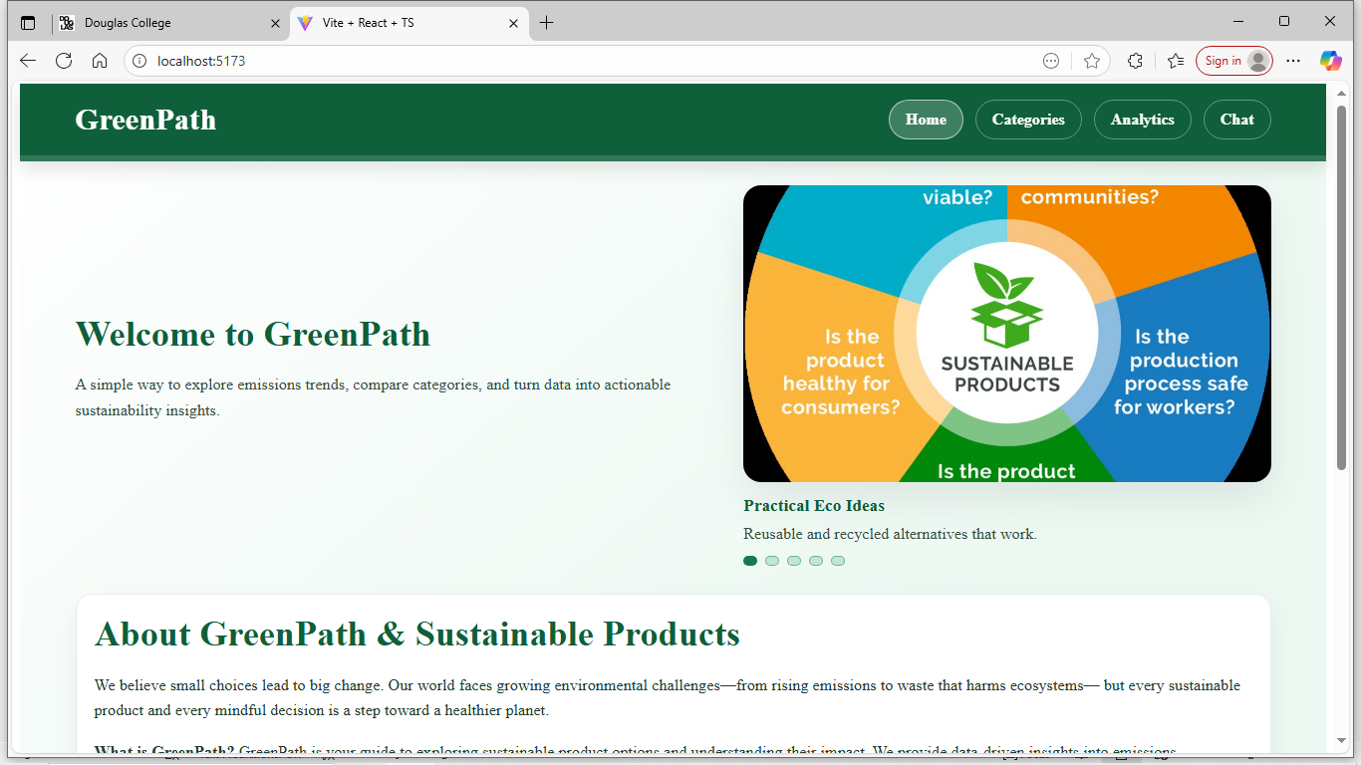
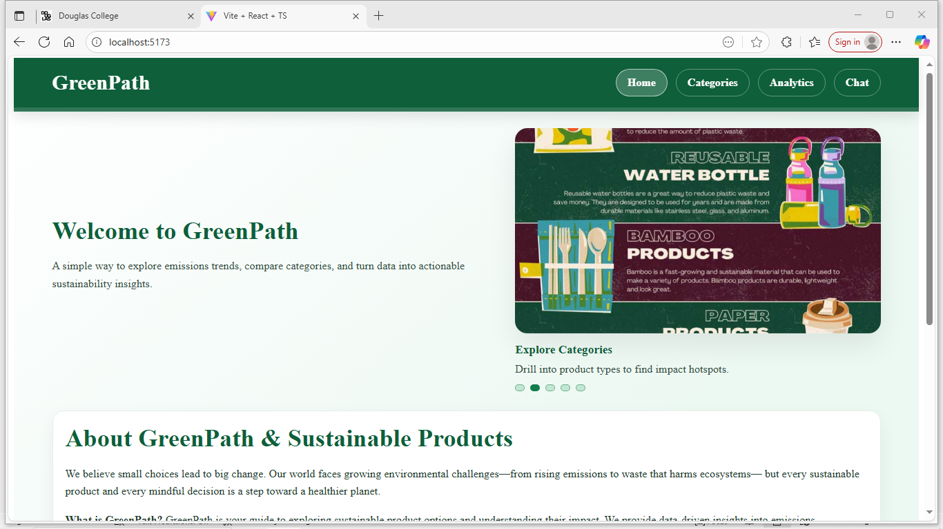

4.2 Implemented Feature B - CATEGORIES PAGE
The Categories Page enables users to browse sustainable products and resources organized by topic, bridging awareness and actionable learning.

4.2.1 Introduction/Overview - categories page
This feature supports the project’s objective of structuring sustainability information into intuitive segments. Introduced in the second development phase, it enhances user interaction by transforming static content into navigable cards that encourage exploration. It also maintains consistency in layout and accessibility established by the Home Page.

4.2.2 Details of Implementation - categories page
Developed in Categories.tsx, the module employs “React’s map()” function to render category cards dynamically from an internal JSON dataset. Each card includes an icon, name, and brief description with Tailwind grid utilities ensuring full responsiveness. Hover states and border transitions provide visual feedback. Figure 4.2(a) shows the React snippet generating cards, Figure 4.2(b) illustrates the layout architecture, and Figure 4.2(c) displays the responsive grid as rendered on desktop.
Figure 4.2(a): Categories.tsx mapping logic for dynamic category card rendering
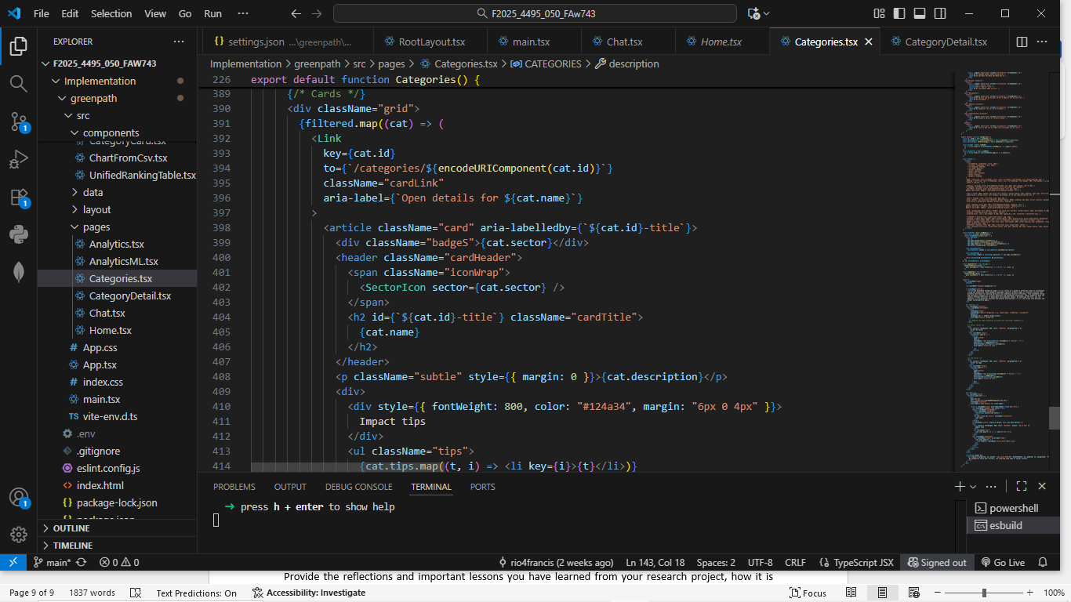
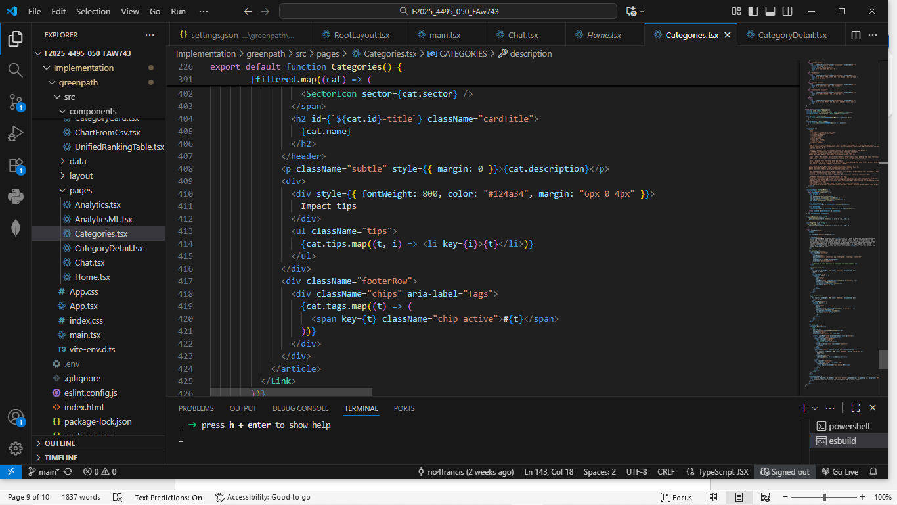
Figure 4.2(b): Component layout for the Categories grid and card composition
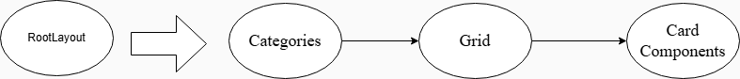
Figure 4.2(c): Responsive category grid with interactive card states.
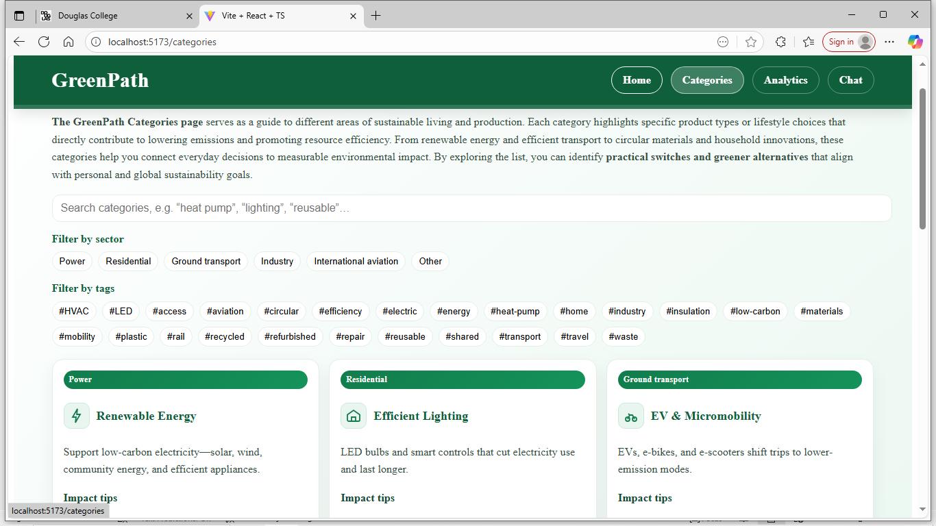
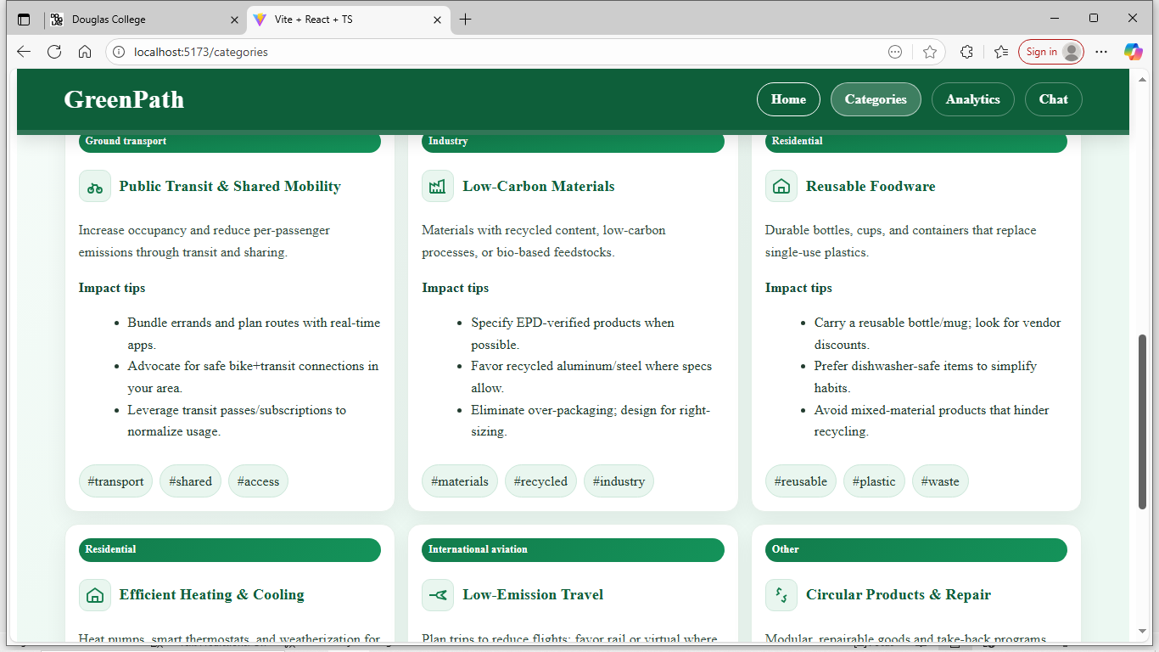

4.3 Implemented Feature C - ANALYTICS PAGE
The Analytics Page forms the analytical core of GreenPath, allowing users to interpret emission metrics and sustainability performance by country and sector.

4.3.1 Introduction/Overview – analytics page
Aligned with GreenPath’s research objective of visualizing environmental data, this module transforms numeric emission data into clear, comparative visuals. It was implemented as the third milestone to showcase practical sustainability analytics within a web-based framework.

4.3.2 Details of Implementation - analytics page
Implemented in Analytics.tsx, the page renders a dynamic, sortable table powered by React state hooks. Data rows are conditionally styled using Tailwind color utilities to reflect emission magnitude for quick pattern recognition. The structure supports horizontal scrolling for larger datasets and automatic scaling for smaller screens. Figure 4.3(a) presents the table mapping logic, Figure 4.3(b) illustrates the module’s integration within RootLayout, and Figure 4.3(c) shows the finalized Analytics Page with color-coded emission rankings.

Figure 4.3(a): Analytics.tsx table mapping and conditional styling for emission values.
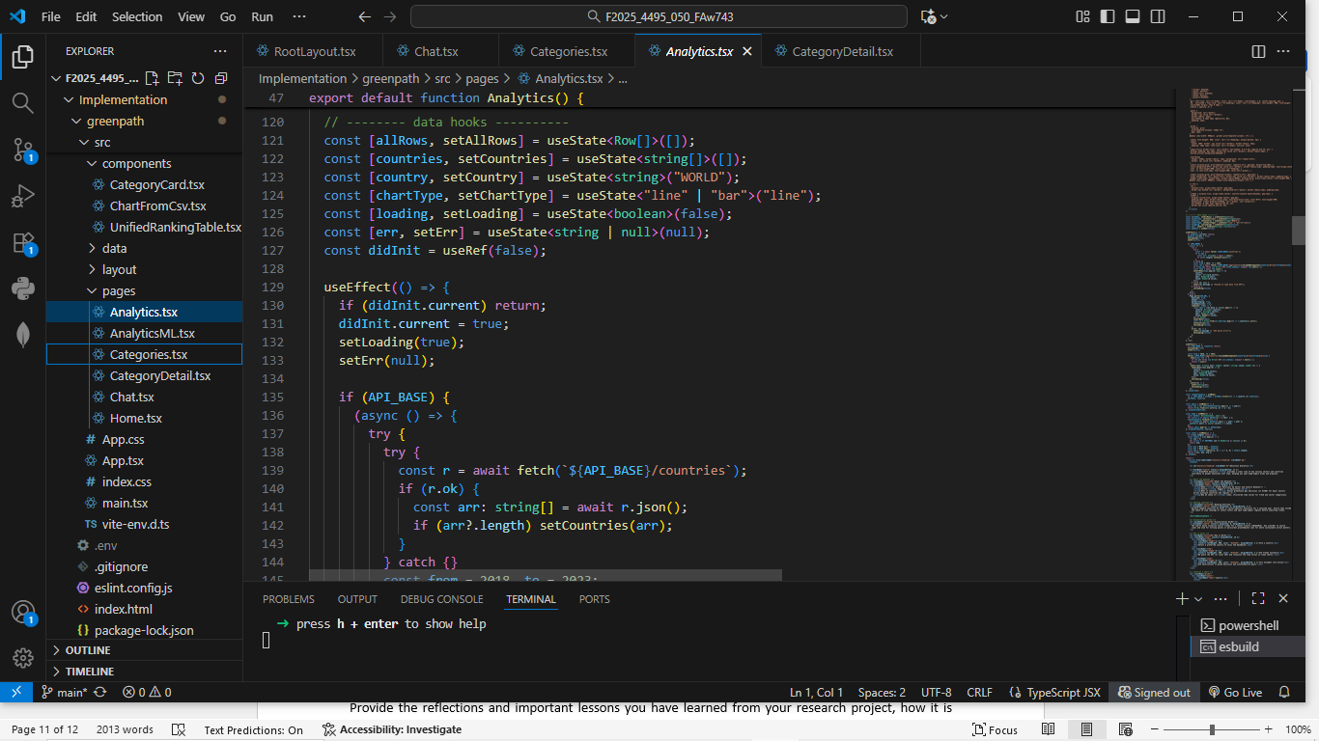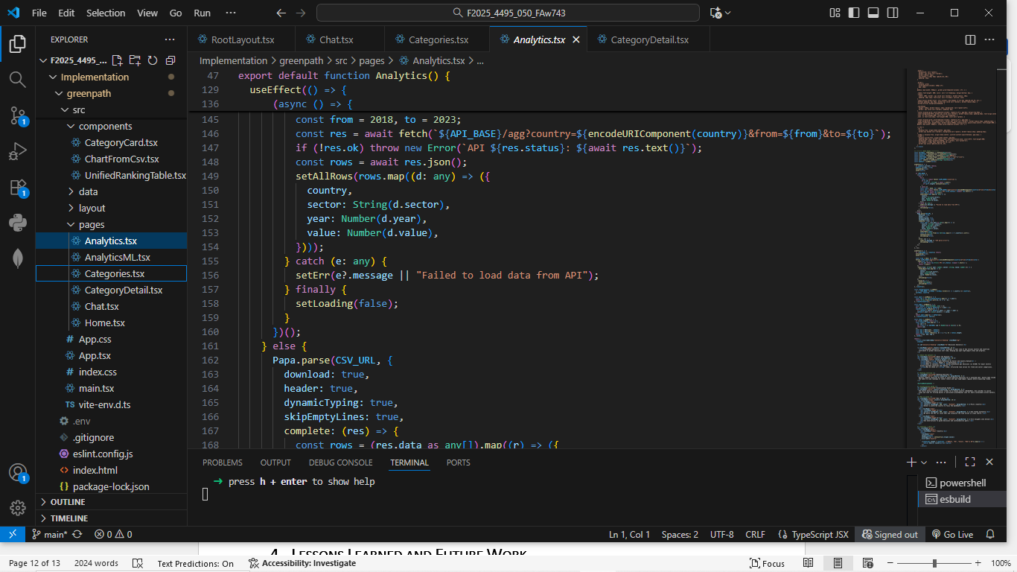

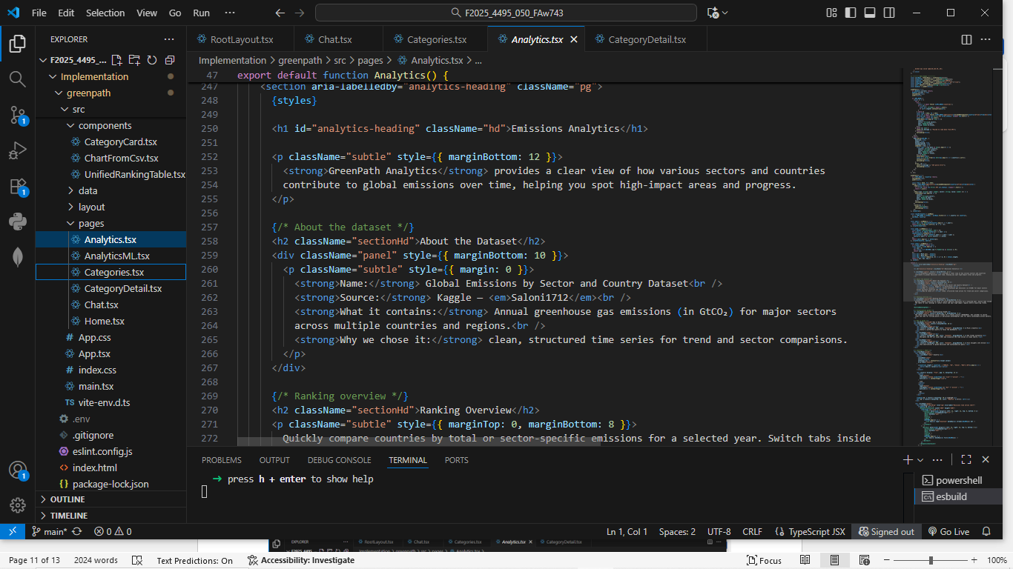

Figure 4.3(b): Route and module linkage between Analytics and AnalyticsML.
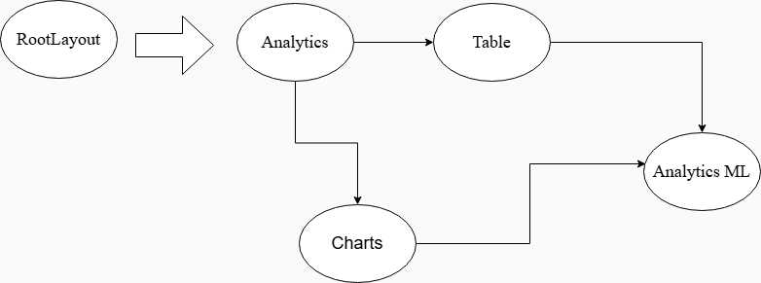

Figure 4.3(c): Country ranking table by sector and year with responsive layout.
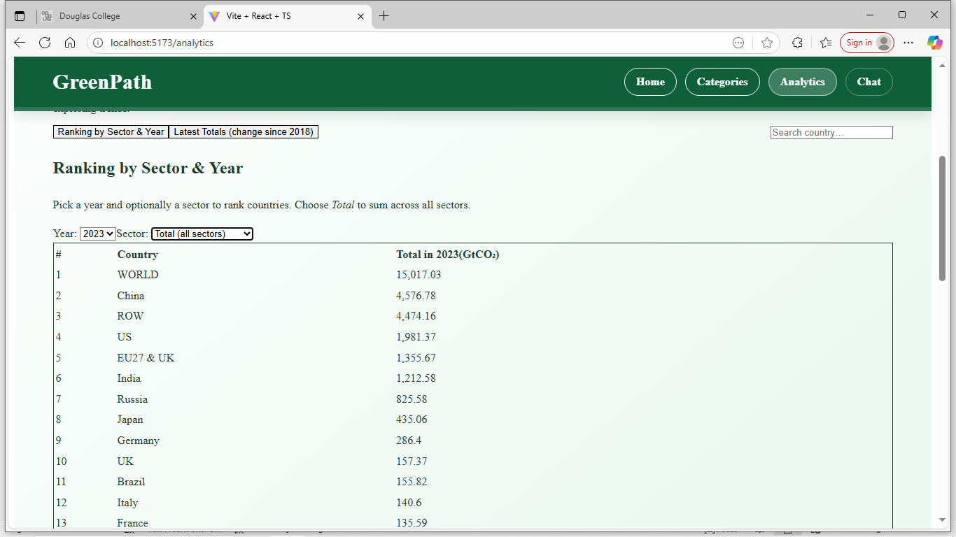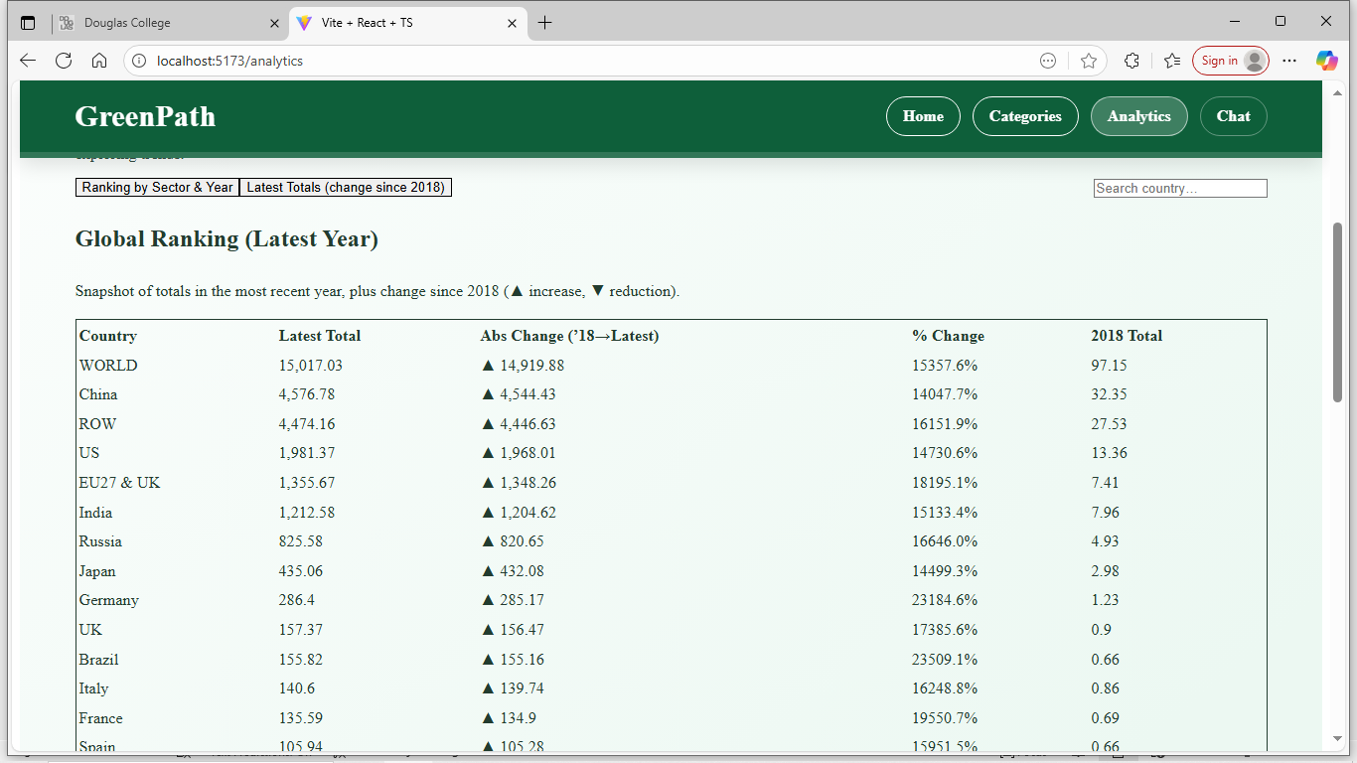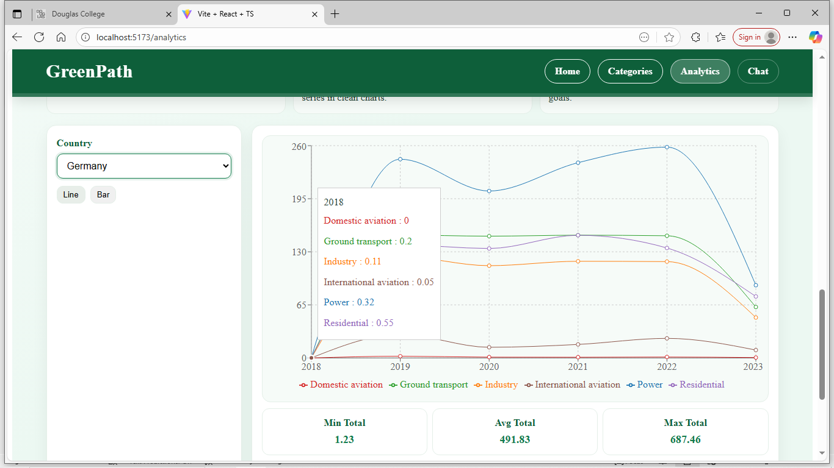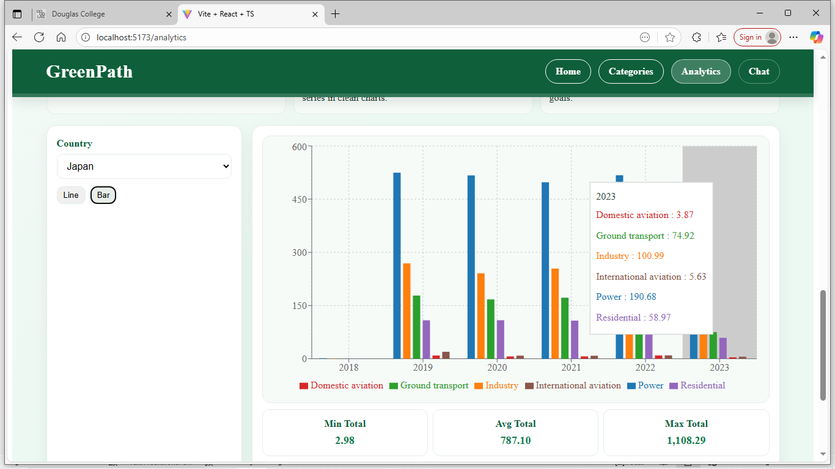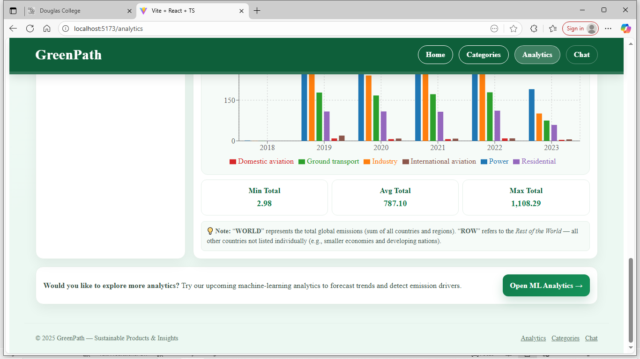

4.4 Implemented Feature D - ANALYTICS ML PAGE
The AnalyticsML Page extends the analytical capabilities of GreenPath by establishing the groundwork for future predictive analytics.

4.4.1 Introduction/Overview – analytics ml page
This sub-page corresponds to the long-term objective of embedding machine-learning predictions into the platform. It demonstrates foresight in system design, ensuring the infrastructure is ready for integrating models that forecast sustainability metrics.

4.4.2 Details of Implementation - analytics ml page
Implemented in AnalyticsML.tsx, this component introduces a dedicated route /AnalyticsML defined in React Router. The interface inherits the Analytics layout and includes placeholder components for model visualization. Hooks and API endpoints have been predefined for upcoming integration with AWS Lambda based ML services. Figure 4.4(a) shows the React skeleton code, Figure 4.4(b) the architectural diagram, and Figure 4.4(c) the UI layout prepared for predictive analytics.

Figure 4.4(a): AnalyticsML.tsx scaffold with placeholder chart containers and route setup.
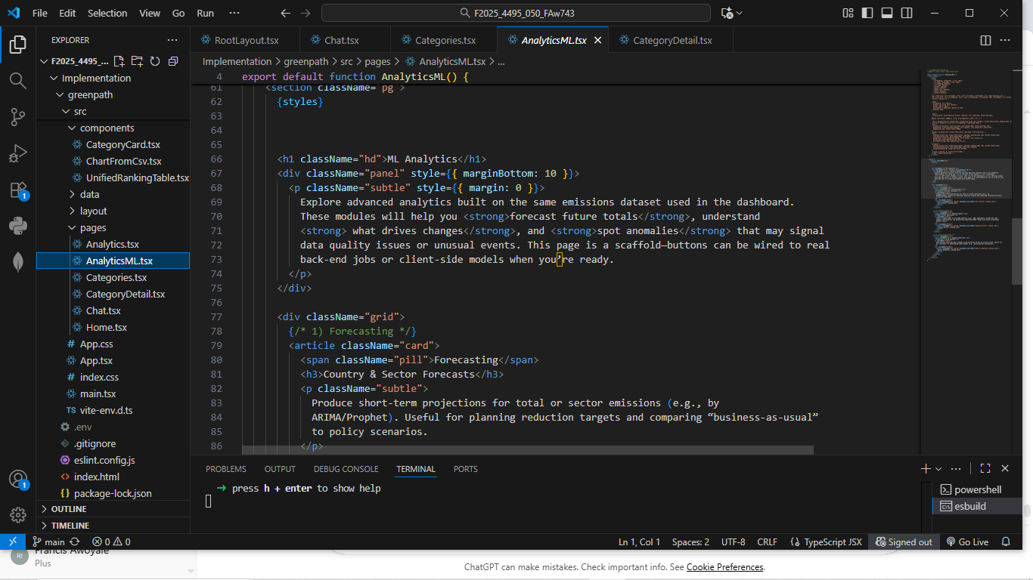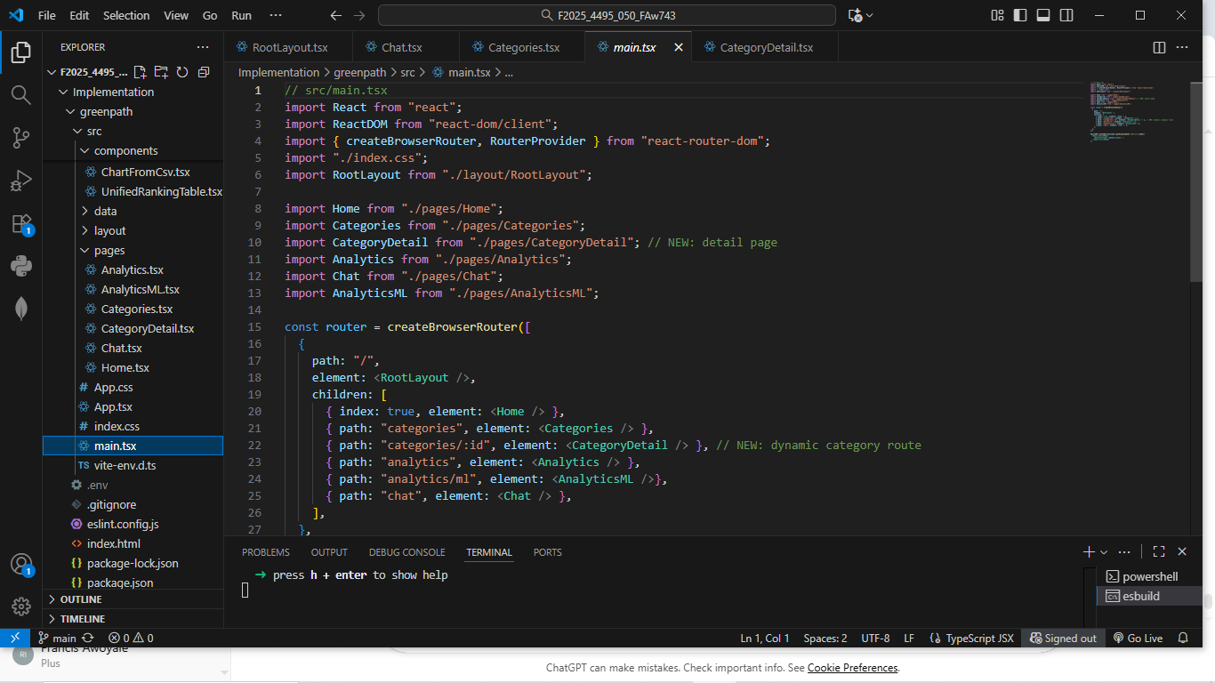
Figure 4.4(b): Planned integration path for future ML inference endpoints.

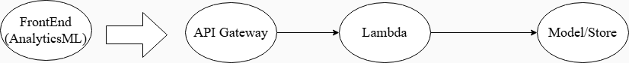

Figure 4.4(c): Prepared AnalyticsML layout for forthcoming predictive analytics.
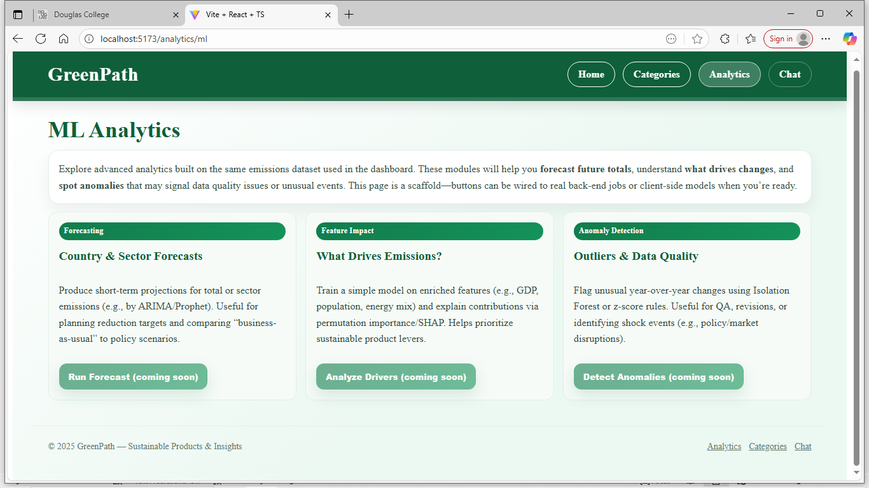

4.5 Implemented Feature E – CHAT PAGE (AI CHATBOT)
The Chat Page introduces an AI-driven conversational interface that allows users to ask sustainability questions and receive real-time responses. It transforms GreenPath from a static information site into an interactive assistant that supports learning through natural language.

4.5.1 Introduction/Overview – chat page
This module fulfills GreenPath’s objective of enabling AI-assisted exploration of sustainability content. Implemented as a dedicated page in the routing structure, it provides an accessible entry point to the assistant and maintains the project’s visual consistency through the global RootLayout and Tailwind styling.

4.5.2 Details of Implementation - chat page
The Chat Page was implemented in src/pages/Chat.tsx using React functional components with state hooks to manage conversation flow and asynchronous communication. When a user submits a message, the input is added to a message array, and an API request is sent through AWS API Gateway to invoke a Lambda function, which forwards the prompt to the OpenAI API and returns the generated response. The reply is appended dynamically, and a typing animation indicates ongoing processing to enhance interactivity. The interface features scrollable, color-coded chat bubbles for user and AI messages, a fixed input field, and responsive design achieved with Tailwind CSS. The implementation maintains real-time interaction and stable performance under AWS Amplify hosting. Figure 4.5(a) shows the message handling code logic, Figure 4.5(b) depicts the architecture linking React, API Gateway, Lambda, and OpenAI, Figure 4.5(c) presents the Lambda configuration, and Figure 4.5(d) displays the live Chat UI during an AI conversation.
Figure 4.5(a): Chat.tsx submission, state updates, typing flag, and API call.
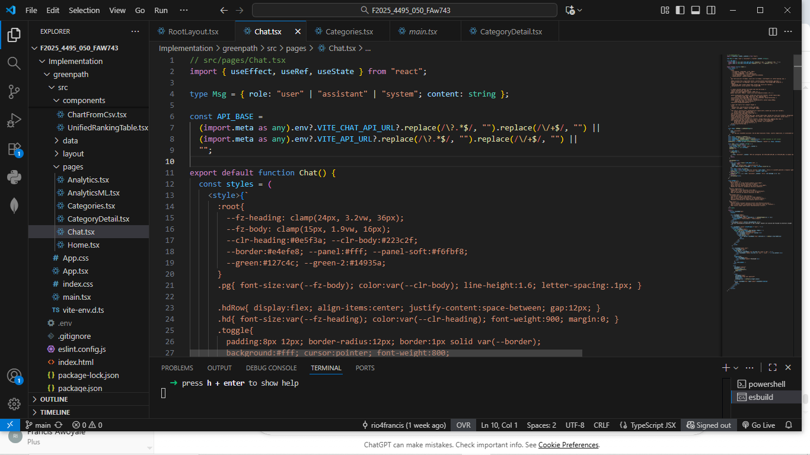
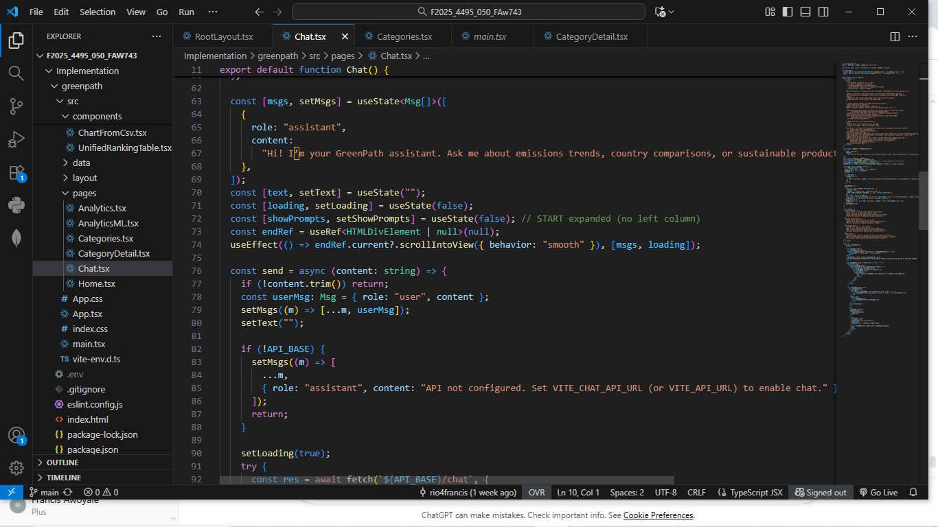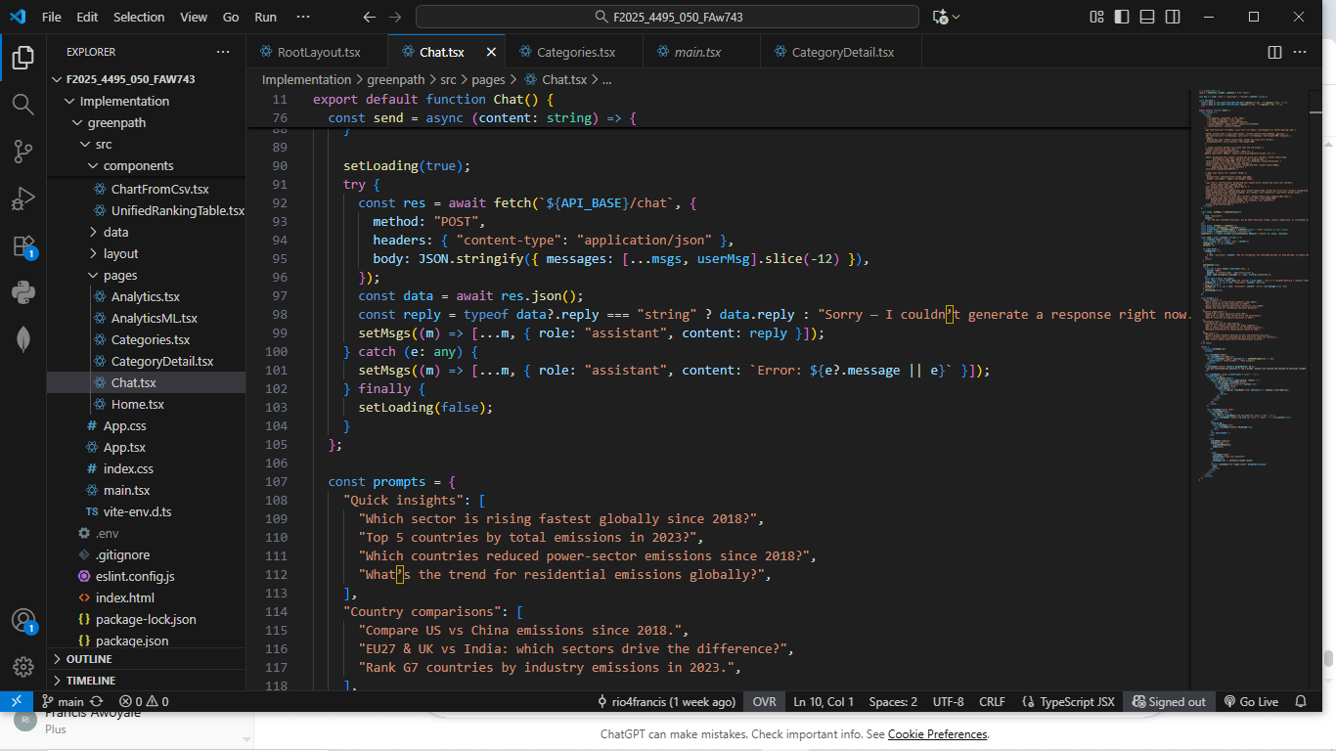
Figure 4.5(b): End-to-end chatbot request–response flow via API Gateway and Lambda.
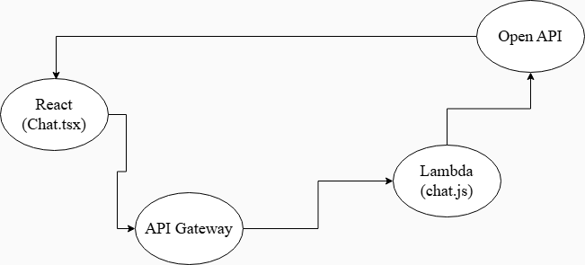

Figure 4.5(c): Configured AWS Lambda function with API Gateway trigger for chat.

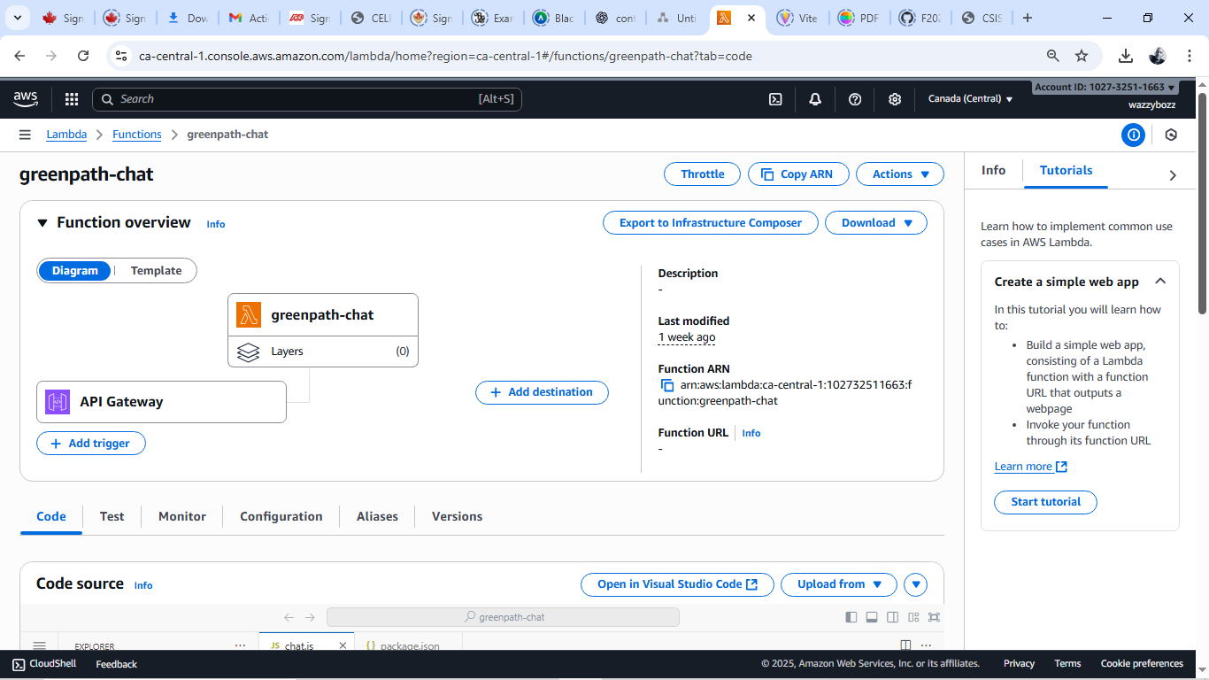
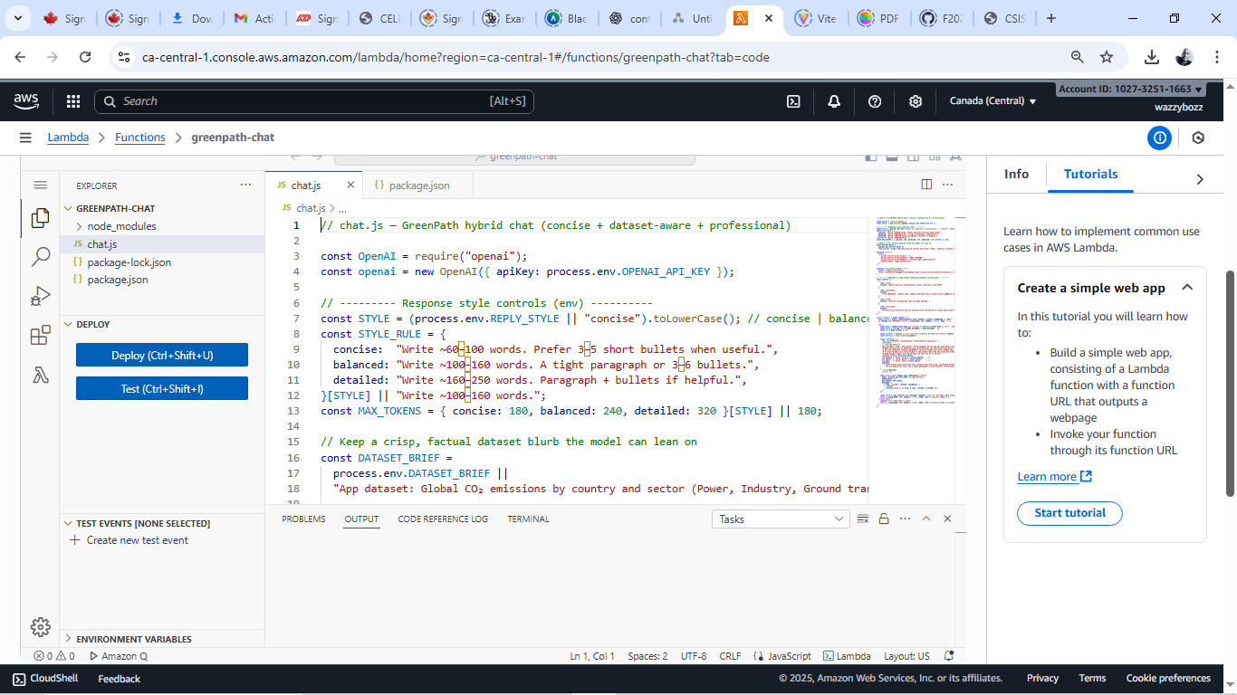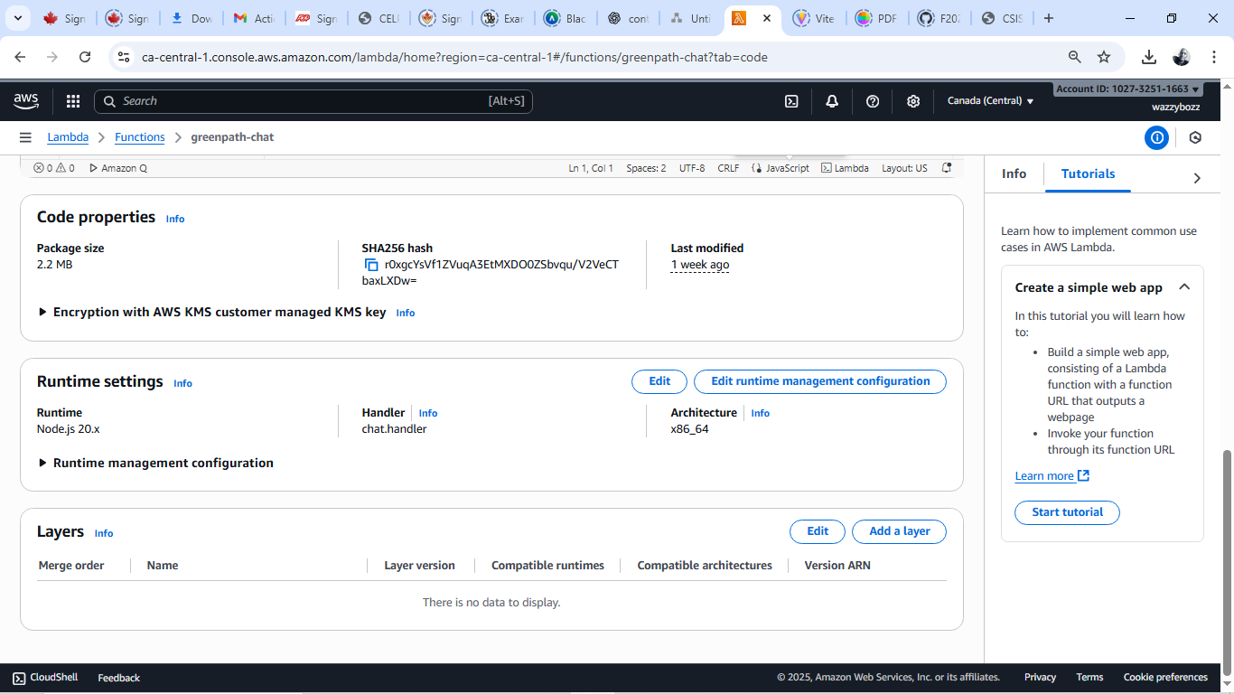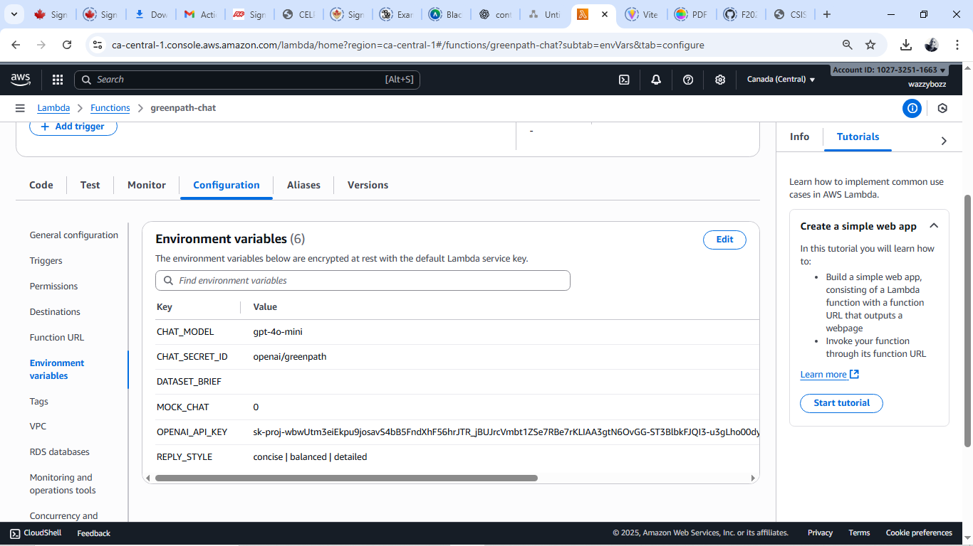

Figure 4.5(d): Operational chatbot interface displaying real-time user–AI exchange.
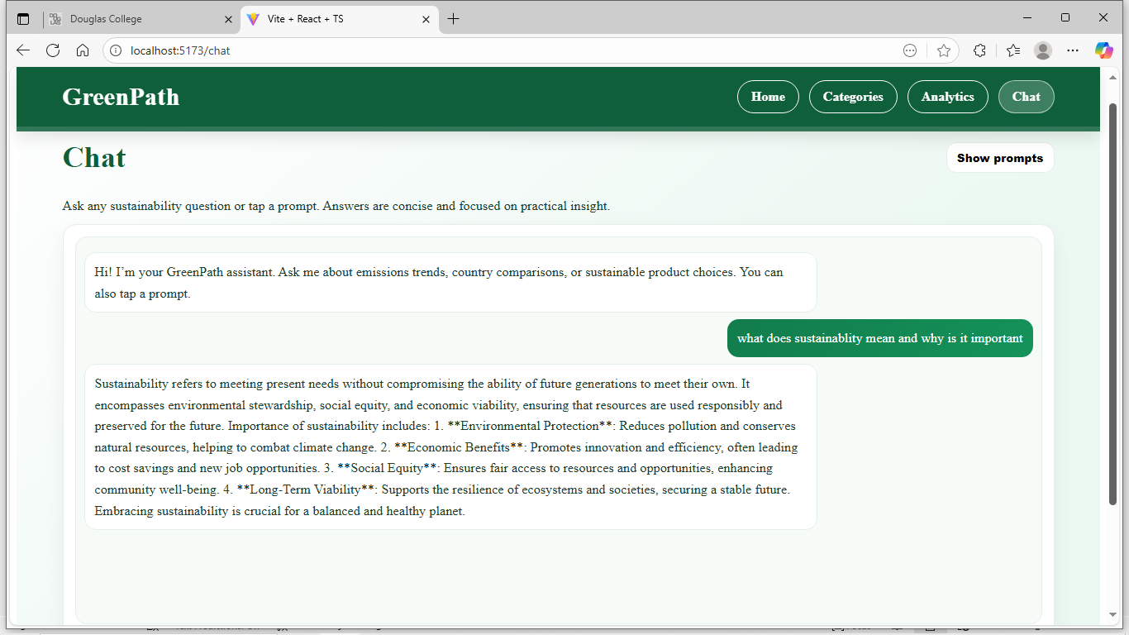
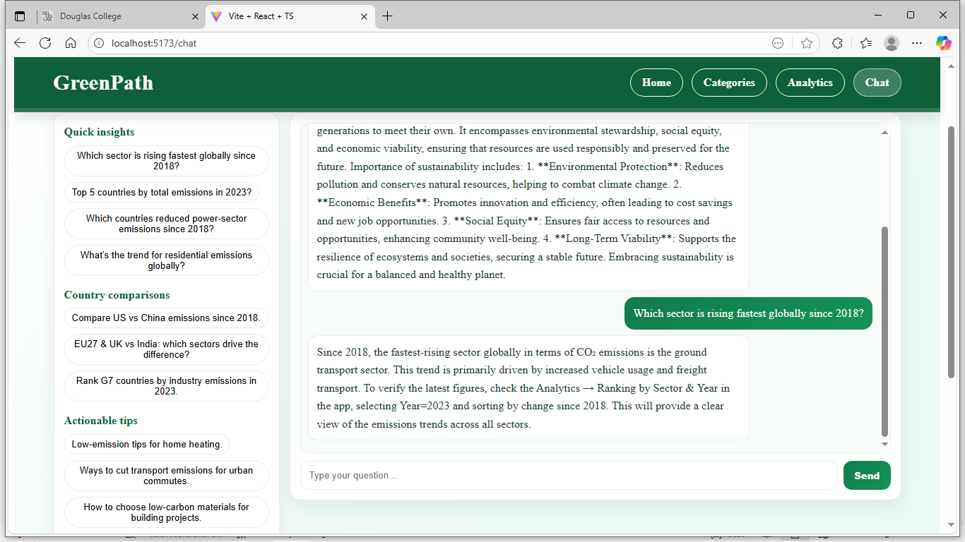

4.6 Implemented Feature F – ROOT LAYOUT AND NAVIGATION
The RootLayout governs GreenPath’s structural consistency and global navigation across all modules.

4.6.1 Introduction/Overview – chat page
Serving as the backbone of the user interface, RootLayout ensures every page shares a unified navigation experience and cohesive design, reinforcing accessibility and brand continuity.

4.6.2 Details of Implementation - chat page
Implemented in RootLayout.tsx, this component defines the sticky header, content outlet, and footer. Navigation links use React Router’s “NavLink” to display active states. Tailwind classes manage spacing and color consistency, while AWS Amplify automates redeployment from GitHub. Figure 4.6 provides a screenshot of the header logic.
Figure 4.6: RootLayout.tsx showing the header logic.
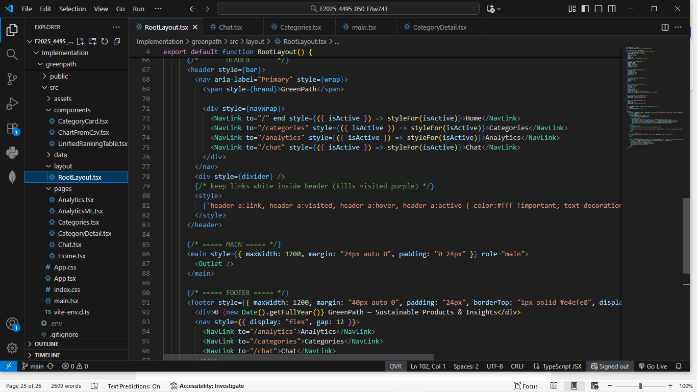

Lessons Learned and Future Work
Developing the GreenPath application has been an enriching learning experience that strengthened both my technical and analytical skills. The project taught me how to design and deploy a complete web application using React, Vite, and Tailwind CSS while leveraging AWS Amplify, Lambda, and API Gateway to manage scalable serverless functions. Integrating the OpenAI API enhanced my understanding of asynchronous data handling and real-time interaction design. This work directly relates to coursework in Applied Research, Web Application Development, and Machine Learning, where theoretical knowledge was applied to real world problem solving. The experience improved my debugging, time management, and teamwork abilities while deepening my appreciation for sustainable technology innovation. Looking ahead, I plan to extend this research by enhancing the chatbot’s natural-language capabilities, integrating real time sustainability datasets, and completing the AnalyticsML predictive analysis module. Professionally, this project has reinforced my aspiration to pursue a career in software engineering and AI-driven environmental technology, applying intelligent systems to solve sustainability challenges in the future.

Concluding Remarks
The GreenPath project has successfully evolved from a research concept into a functional web-based sustainability platform that combines analytics, artificial intelligence, and cloud computing. This achievement reflects the integration of technical knowledge gained through coursework at Douglas College with practical problem solving and innovation. The project not only enhanced my technical skills in full-stack development and cloud deployment but also deepened my commitment to applying technology toward environmental awareness and sustainable living. I am sincerely grateful to Douglas College, my instructor, Dr. Bambang Sarif, and my peers for their continuous guidance, feedback, and encouragement throughout this project. Their support has been instrumental in refining my professional development and preparing me for future work in software engineering and AI-driven environmental solutions.

Appendix
The Appendix provides supporting information and technical documentation for the GreenPath project, including installation steps, user instructions, datasets, system architecture, and key code explanations to aid understanding

Appendix A: Installation Guide
To install and run the GreenPath application locally, ensure Node.js (v18 or later) and “npm” are installed. Clone the GitHub repository to your computer and open it in Visual Studio Code. Run “npm install” to install all dependencies and “npm run dev” to start the local development server. The project uses Vite as its build tool, with a React (TypeScript) front end styled using Tailwind CSS. The application is fully deployed and publicly accessible through AWS Amplify at https://main.dr4j5cc9fnii3.amplifyapp.com/. The Amplify environment automatically builds and deploys each new commit pushed to the repository. API keys for OpenAI are stored securely within the Amplify console under environment variables to protect sensitive credentials.

Figure 7.1 shows a screenshot of the AWS amplify deployment status.
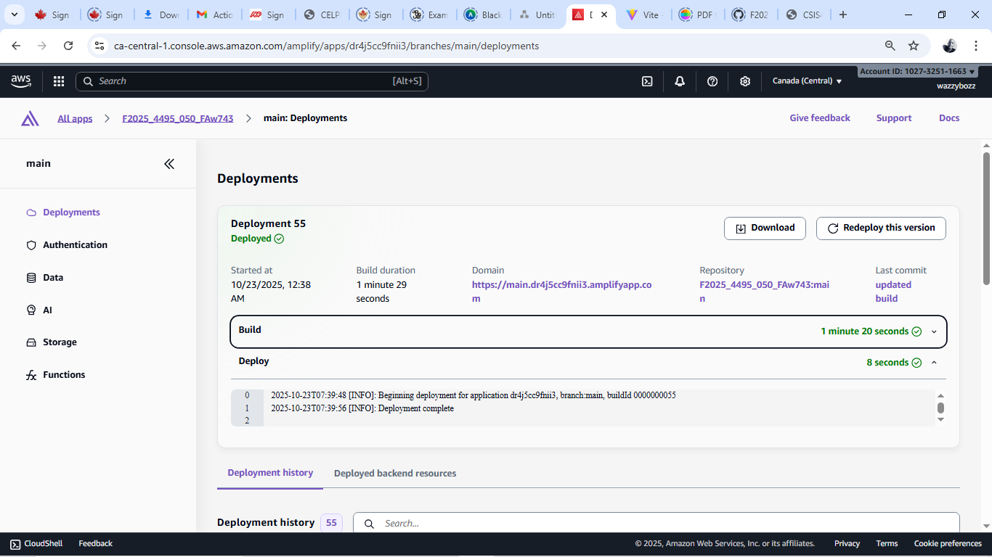

Appendix B: User Guide
Upon launching, users land on the Home Page, which introduces GreenPath’s sustainability mission and provides navigation links across the system. The Categories Page displays responsive interactive cards that redirect to individual sub-pages containing detailed information, visual explanations, and image galleries for each sustainability sub-category. The Analytics Page offers a dynamic country ranking table and chart visuals that displays emission totals by sector and year and also features a Search box for filtering purposes. The Analytics ML Page which is a foundation for the next milestone will provide predictive machine learning analysis. The Chat Page enables real time, AI-powered conversations that assist users with sustainability insights. A consistent sticky header and global navigation ensure seamless movement across pages. Figure 7.2 (a), (b), (c) shows samples of the sub-categories UI.

Figure 7.2(a): screenshot of reusable food ware sub-category.
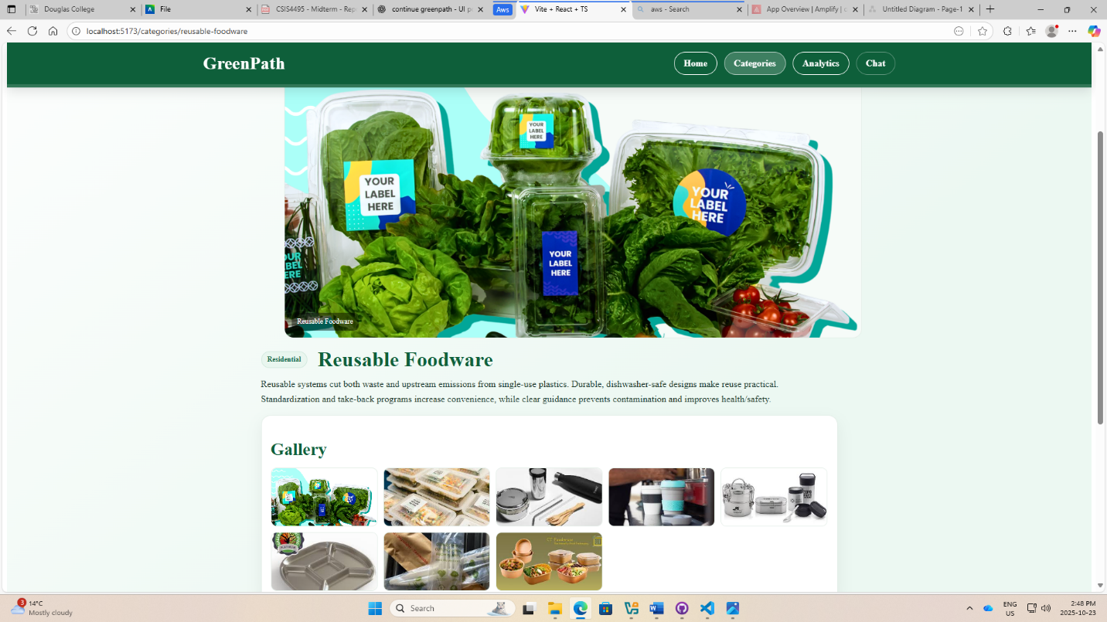

Figure 7.2(b): screenshot of renewable energy sub-category.
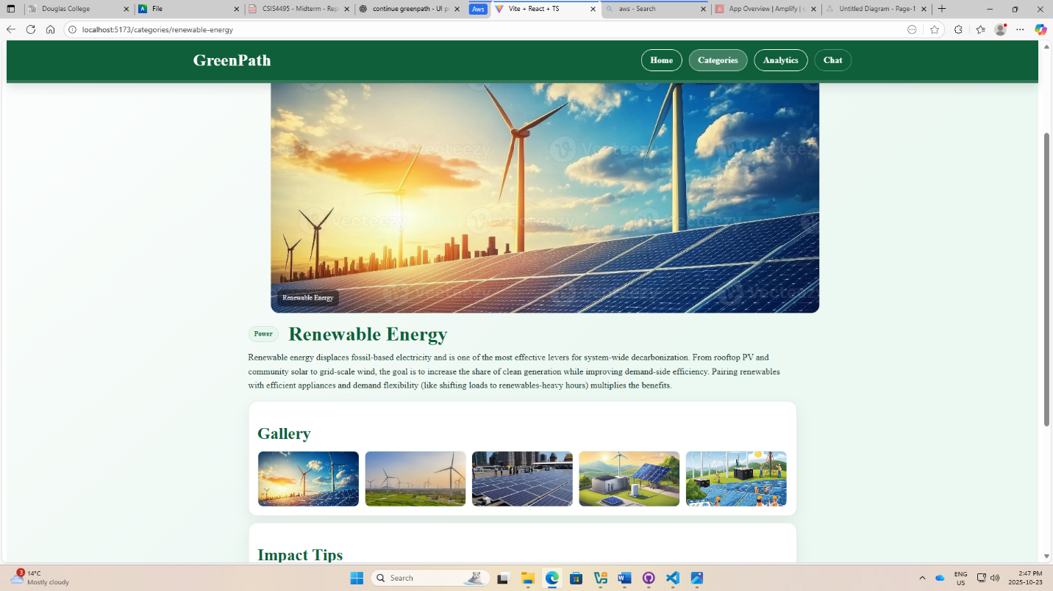

Figure 7.2(c): screenshot of EV AND mobility sub-category.
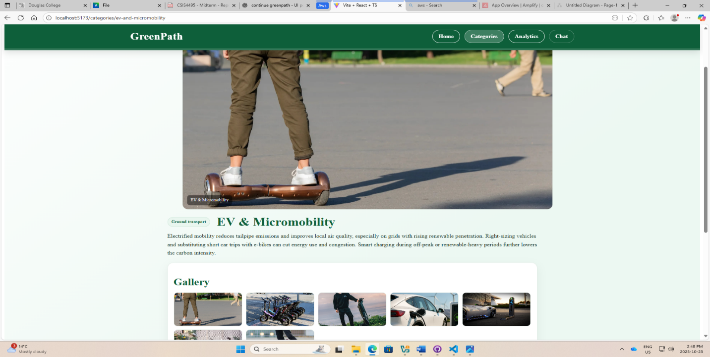

Appendix C: Dataset and API Used
The analytics module relies on a cleaned aggregate dataset stored in public/data/agg.csv, derived from the Global Emissions by Sector and Country dataset originally published on Kaggle by Saloni 1712. The file contains processed emission metrics categorized by country and sector for visualization within the Analytics Page. Data are parsed through “PapaParse” and displayed via React tables and Recharts components. The OpenAI API is integrated to power the chatbot’s natural language responses, facilitated through AWS Lambda and API Gateway. All API calls are handled asynchronously, and authentication keys are managed within Amplify’s secured environment configuration.

Appendix D: Hardware, Software, Cloud, Architecture, etc.
Development and testing were conducted on a Windows 10 laptop with an Intel Core i7 processor and 16 GB RAM. The software stack includes React 19, Vite 7, Tailwind CSS 4, TypeScript 5, and the AWS Amplify cloud framework. The project architecture follows a serverless model:
The frontend is hosted on AWS Amplify.
API Gateway routes requests.
AWS Lambda functions handle OpenAI API interactions.
The OpenAI endpoint generates chatbot responses.
This design ensures scalability, low latency, and minimal server maintenance. Figure 7.4 depict the flow from client-side interaction to backend processing and AI response delivery.

Figure 7.4: Interaction flow process.
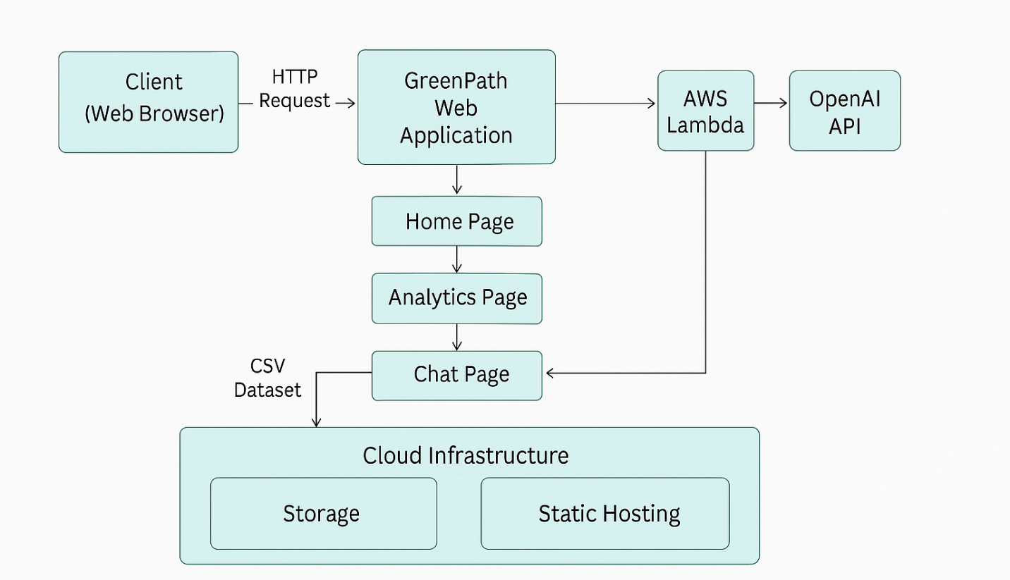

Appendix E: Code Explanation
The project follows a modular folder structure housed within the src/ directory:
components/ – Contains reusable UI elements such as CategoryCard.tsx, ChartFromCsv.tsx, and UnifiedRankingTable.tsx, which render category cards and analytics charts.
data/ – Holds the emissions dataset (agg.csv) and related parsing logic.
layout/ – Includes RootLayout.tsx, which defines the global header, navigation, and footer shared across all pages.
pages/ – Contains the main feature modules:
Home.tsx (landing page content and overview)
Categories.tsx (card grid with sub-page routing to CategoryDetail.tsx)
Analytics.tsx (interactive ranking table)
AnalyticsML.tsx (future machine-learning dashboard)
Chat.tsx (AI-powered conversation interface with OpenAI API integration)
index.css – Imports Tailwind directives and defines custom global styling rules.
vite.config.ts and tailwind.config.js – Contain environment configuration and plugin integration.
Backend support is managed through AWS Lambda (chat.js) for API calls and Amplify hosting for continuous integration/continuous deployment. Inline documentation within each component explains key state variables, hooks, and request handlers.

8 closing.
GreenPath offers a realistic and educational path to demonstrating applied research outcomes. The project integrates accessible web design with cloud architecture, curated sustainability data, and a focused machine learning task.

9 References.
W3C. Web Content Accessibility Guidelines (WCAG) 2.1. World Wide Web Consortium.
Google. Web Vitals and Lighthouse documentation. Google Developers.
Amazon Web Services. Amplify, API Gateway, Lambda, Amazon RDS for PostgreSQL, Secrets Manager, and CloudWatch service documentation.
OpenAI. API Documentation for text generation and chat completions.
Kaggle – CO₂ Emissions Dataset by Saloni1712. Retrieved from: https://www.kaggle.com/datasets/saloni1712/co2-emissions
Géron, A. (2022). Hands‑On Machine Learning with Scikit‑Learn, Keras, and TensorFlow (3rd ed.). O’Reilly Media.
Bishop, C. M. (2006). Pattern Recognition and Machine Learning Springer.
Sheehan, B., et al. (2020). The role of AI‑powered chatbots in health promotion: a scoping review. Journal of Medical Internet Research.

