CSIS 4495-050
Francis Awoyale - 300356743
11-27-2025

GreenPath.
Sustainable Products Website with AI ChatBot Integration.

Table of Contents
1 Introduction 3
2 Proposed Research Project 3
3 Project Planning and Timeline 5
4 Implemented Features 6
4.1 Home Page Information Layer (home.tsx) 6
4.1.1 Introduction/Overview - home page 6
4.1.2 Details of Implementation - home page 6
4.2 Sustainability Categories System (categories.tsx) 9
4.2.1 Introduction/Overview - categories page 9
4.2.2 Details of Implementation - categories page 9
4.3 Analytics Engine (analytics.tsx) 11
4.3.1 Introduction/Overview – analytics page 12
4.3.2 Details of Implementation - analytics page 12
4.4 Machine Learning Analytics Module (analyticsML.tsx) 15
4.4.1 Introduction/Overview – analytics ml page 15
4.4.2 Details of Implementation - analytics ml page 16
4.5 Intelligent Chat Assistant (chat.tsx) 20
4.5.1 Introduction/Overview – chat page 20
4.5.2 Details of Implementation - chat page 20
4.6 Routing and Layout Architecture (RootLayout.tsx) 23
4.6.1 Introduction/overview – rootlayout page 23
4.6.2 Details of Implementation -rootlayout page 23
5 Lessons Learned and Future Work 24
6 Concluding Remarks 24
7 Appendix 24
7.1 Appendix A: Installation Guide 24
7.2 Appendix B: User Guide 26
7.3 Appendix C: Dataset and API Used 28
7.4 Appendix D: Hardware, Software, Cloud, Architecture, etc. 28
7.5 Appendix E: Code Explanation 29
7.6 Appendix F: Machine Learning, Analytics And Chat Diagrams. 30
8 closing. 40
9 References. 40

1 Introduction
GreenPath is an applied research project that adapts the concept of Happy Nutrition Riipen project brief to the broader sustainability domain. The aim is to develop a modern, cloud‑hosted website that educates users about sustainable product choices. The system combines a React frontend, a Node.js backend, and a PostgreSQL database deployed on Amazon Web Services. An AI‑powered chatbot provides conversational guidance, and a sustainability analytics dashboard that presents real world emissions data in an accessible, interactive format. The project emphasizes accessibility, performance, and transparency of data use so that results are meaningful to a general audience.

2 Proposed Research Project
Design: GreenPath delivers three user‑facing capabilities: a category explorer that presents examples of eco‑friendly products with details, a chatbot that provides sustainability guidance, and an analytics dashboard that exposes sector‑level emissions trends. The system is implemented with React and TypeScript on the client, a Node.js and Express backend running on AWS Lambda behind API Gateway, and a PostgreSQL database hosted on Amazon RDS with RDS Proxy to manage connections. The front end is hosted through AWS Amplify and served via CloudFront. Secrets such as the OpenAI API key are stored in AWS Secrets Manager.
Objectives: The objective of GreenPath is to deliver a deployed and accessible web application that helps users understand sustainability topics through an integrated experience of product exploration, conversational assistance, and data‑driven insight. Concretely, the project aims to build a responsive React interface hosted on AWS Amplify, implement a serverless Node.js backend that secures keys and serves compact APIs, integrate an AI‑powered chatbot for sustainability question‑and‑answer interactions, and provide an analytics dashboard with at least three interactive charts that present sector‑level CO₂ emissions over time in gigatonnes. A focused machine learning component will be trained and embedded into the dashboard to generate short‑term forecasts for a selected country and sector, with results presented transparently and accompanied by interpretation notes. The application will adhere to WCAG 2.1 Level AA practices and target a strong baseline performance so that the experience is fast, readable, and keyboard‑friendly for all users.
Method: The project begins by preparing the data and establishing a stable deployment pipeline. The React application is scaffolded, and the core pages are created for the home view, the categories, the analytics dashboard, and the chatbot. The backend exposes a small set of REST endpoints for categories and analytics, and a single endpoint that relays chatbot prompts to the OpenAI API. Once the pipeline is in place the focus shifts to data ingestion, analysis, and presentation. Accessibility and performance are evaluated throughout using a combination of automated tools and manual checks.
Data collection and preparation: The analytics module uses the CO₂ Emissions Dataset by Saloni1712 on Kaggle. The dataset includes the country or region, the year, a sector designation, a numerical value, and a timestamp. The working copy is normalized by renaming columns to country, year, sector, and value; removing the timestamp; filtering to a practical subset of countries; and indexing the database for efficient queries. A magnitude check indicates that values should be interpreted as gigatonnes of CO₂, and charts and labels are annotated accordingly so users understand what the numbers represent.
Sample size and data scope: For a realistic and manageable analysis during the project, the minimum viable sample will focus on a representative subset of countries such as Canada, the United States, the United Kingdom, Germany, Brazil, Nigeria, India, and China, spanning approximately 2019 to 2023 across all six sectors. This scope yields several hundred to more than a thousand records, which is ample for descriptive analytics and for training a simple, interpretable model while retaining headroom for validation. The full dataset remains available in PostgreSQL for extended exploration, but the forecasting model will be trained on the defined subset using a chronological split that reserves the most recent years as a holdout period to approximate real‑world prediction.
Analysis techniques: The dashboard exposes interpretable views that support exploration. A line chart shows how a sector’s emissions evolve over time for a given country. A stacked bar or grouped bar enables a yearly comparison of sector contributions. A small machine learning component is integrated into the dashboard to demonstrate applied analytics. For the minimum viable product, the preferred option is a simple regression that predicts the next year’s sector value for a selected country using recent history; alternatively, a compact classifier can assign countries to high, medium, or low emission categories based on historical distributions. Results are presented alongside the charts with clear statements of limitations.
Technology justification: React with TypeScript provides a fast, accessible interface and strong developer ergonomics. Node.js on Lambda minimizes operational overhead while API Gateway and RDS Proxy provide reliable connectivity. PostgreSQL offers mature querying, indexing, and aggregation suitable for the analytics workload. Recharts integrate cleanly with React for accessible visualizations.
Expected results: The outcome will be a working system that combines a friendly interface, meaningful analytics, and a modest predictive capability. Users will browse sustainable product categories, ask questions through the chatbot, and explore emissions data with interactive charts that clarify sector contributions and year‑over‑year changes. The model will produce short‑term forecasts for a chosen country and sector, visualized alongside historical trends and accompanied by plain‑language explanations of uncertainty, assumptions, and limitations. From an engineering perspective, the system is expected to achieve a Lighthouse performance score in the mid‑eighties or higher, pass core accessibility checks aligned to WCAG 2.1 practices, and maintain low API latency under typical classroom loads. From an analytics perspective, the regression baseline should reach a reasonable fit on the validation period for at least one country‑sector pair, emphasizing interpretability and defensibility over complexity.

3 Project Planning and Timeline
WEEKS | ACTIVITIES | DELIVERABLES
1–2 | Requirements gathering, finalize dataset (Kaggle CO₂ emission by Sector), repo setup. | Requirement document, dataset README.
3 -4 | React Frontend scaffold, category UI prototype, Amplify hosting, initial accessibility checks. | Deployed React skeleton (Amplify), initial Web Content Accessibility Guidelines (WCAG) check.
5-6 | Backend setup (API Gateway, Lambda), PostgreSQL schema (categories and emissions), load Kaggle dataset into RDS, Secrets Manager integration. | Functional API, dataset stored in PostgreSQL, secure secret management.
7-8 | Chatbot endpoint development, React integration, log queries to DB. | Working chatbot in React UI with logs.
9-10 | Analytics Dashboard development: build Recharts charts (trend, sector comparison, distribution), integrate API endpoints from RDS. | Interactive analytics page with 2 visual charts.  A tabular ranking for the dataset emissions.
11 | ML Component: implement regression (future emission prediction) or classification  (high/medium/low emitters) using dataset; integrate results into Analytics Dashboard. | ML model integrated and demo ready insights.
12 | Testing (performance, accessibility, API reliability), final refinements, report preparation, demo script. | Final deployed system, applied research report and demo.

4 Implemented Features
This section outlines the core features developed in the GreenPath project, describing their purpose, design approach, and technical implementation. Each feature contributes to the system’s overall functionality and demonstrates the integration of modern web technologies, cloud services, and AI to achieve the project’s sustainability objectives.

4.1 Home Page Information Layer (home.tsx)
The Home Page serves as the welcoming interface of the GreenPath application, offering users an immediate overview of the project’s sustainability mission. It introduces the application’s purpose, visual identity, and navigational flow while guiding users toward other core modules such as Categories, Analytics and the Chatbot.

4.1.1 Introduction/Overview - home page
Developed during the first milestone, the Home Page fulfills the objective of creating a visually engaging and accessible interface that introduces users to sustainable living concepts. It anchors GreenPath’s brand identity through its green color scheme, minimal layout, and eco-centric imagery. The design reflects the project’s goal of merging education with modern digital presentation, encouraging users to explore analytics, product categories, and AI interaction through clear navigation cues.

4.1.2 Details of Implementation - home page
The Home Page was implemented in Home.tsx using React functional components and Tailwind CSS for responsive styling. The hero section displays the GreenPath title and a rotating carousel of sustainability themed visuals controlled by a useEffect hook. An introductory paragraph summarizing the app’s mission sits below the banner, and a persistent button launches the Chatbot. The layout hierarchy is illustrated in Figure 4.1(a), showing component relationships under the RootLayout wrapper. Code excerpts in Figure 4.1(b) highlight the carousel logic and Tailwind class structure, while Figure 4.1(c) presents the rendered Home Page interface.

Figure 4.1(a): Layout hierarchy connecting RootLayout to the Home Page hero and carousel.
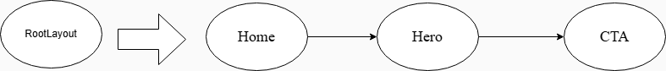
This diagram illustrates the navigation and rendering flow of the Home Page components, beginning from the global RootLayout and progressing through the main Home container into the Hero section and final Call-to-Action (CTA) segment. It highlights how content is sequentially delivered to users through a clean, component-driven pipeline.

Figure 4.1(b): Home.tsx component structure and carousel timer hook
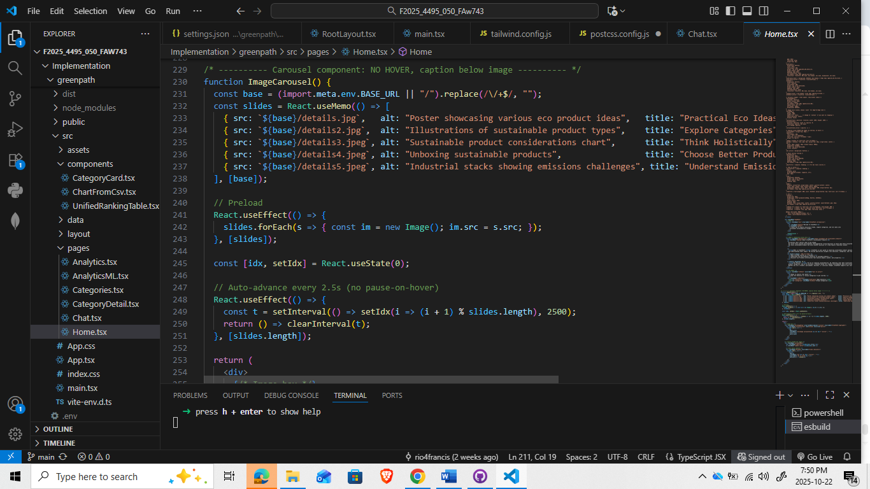
This screenshot shows the implementation of the Home Page image carousel, including image preloading, automatic slide rotation, and caption metadata for each slide. The code demonstrates how React state, effects, and dynamic asset loading combine to deliver a smooth, continuously cycling visual banner.

Figure 4.1(c): Rendered Home Page hero with rotating carousel and chatbot entry.
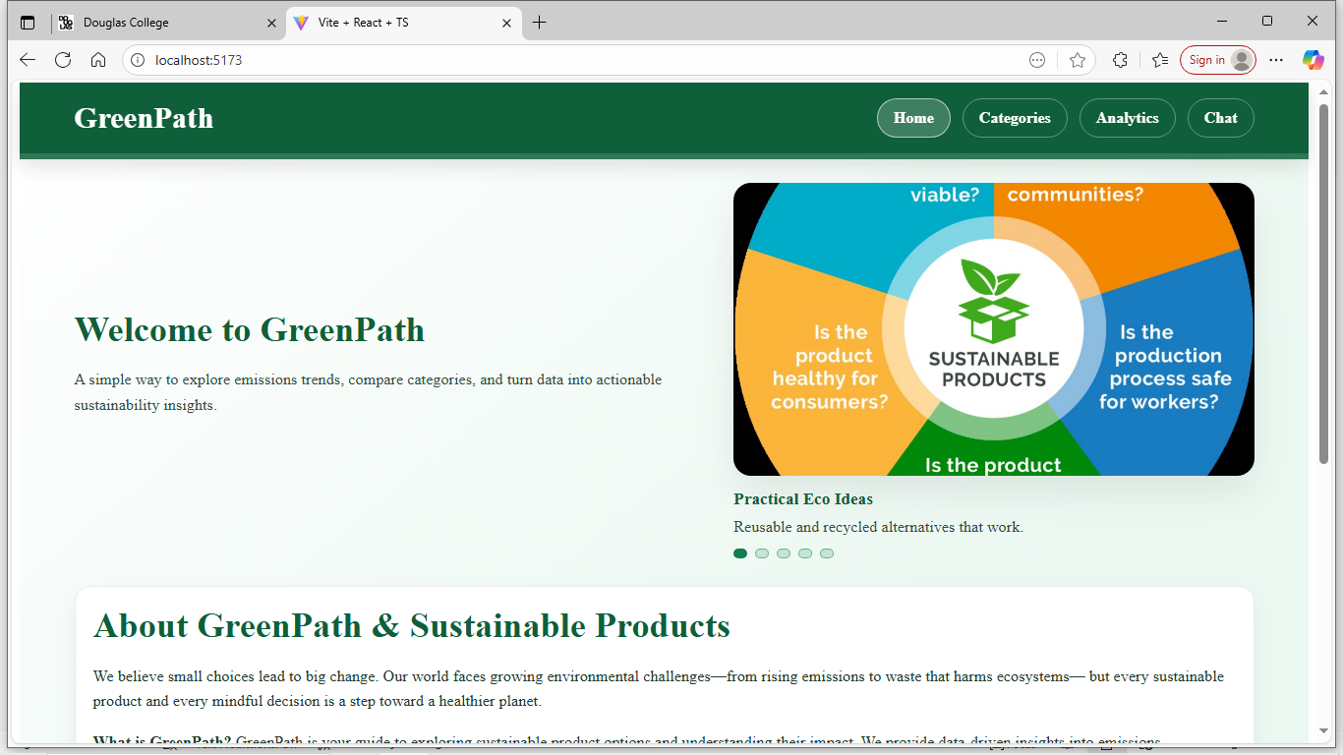
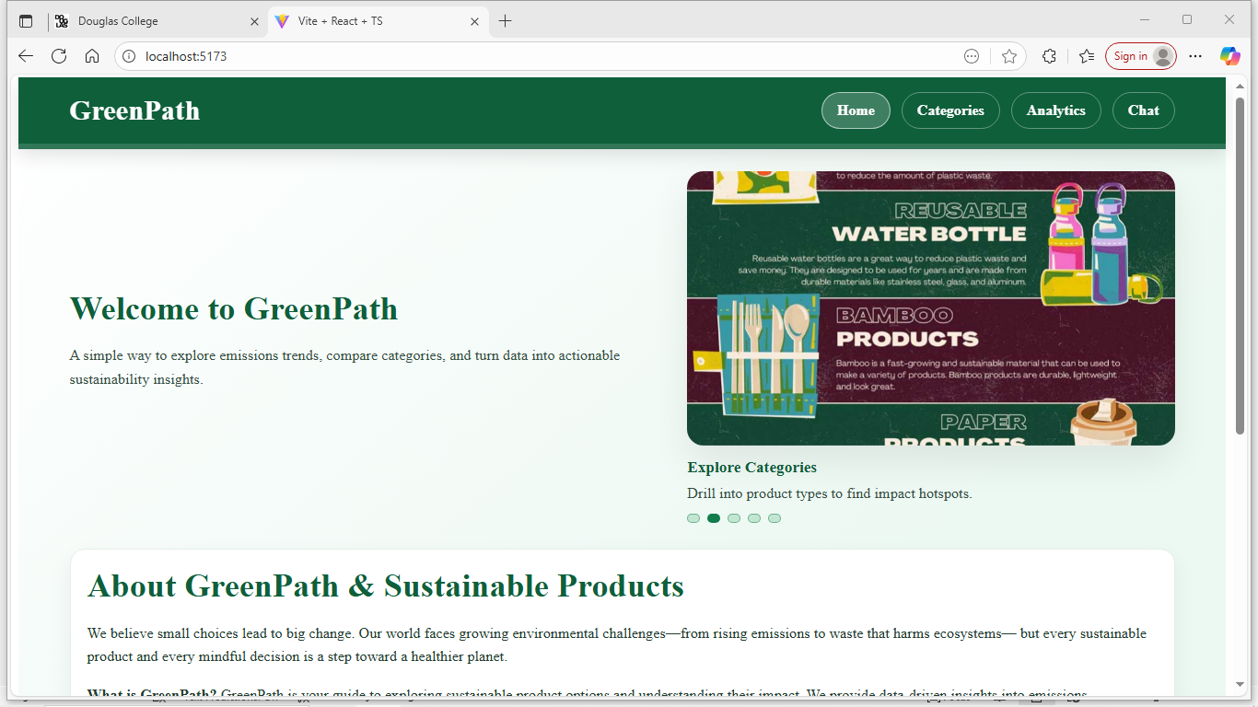

4.2 Sustainability Categories System (categories.tsx)
The Categories Page enables users to browse sustainable products and resources organized by topic, bridging awareness and actionable learning.

4.2.1 Introduction/Overview - categories page
This feature supports the project’s objective of structuring sustainability information into intuitive segments. Introduced in the second development phase, it enhances user interaction by transforming static content into navigable cards that encourage exploration. It also maintains consistency in layout and accessibility established by the Home Page.

4.2.2 Details of Implementation - categories page
Developed in Categories.tsx, the module employs “React’s map()” function to render category cards dynamically from an internal JSON dataset. Each card includes an icon, name, and brief description with Tailwind grid utilities ensuring full responsiveness. Hover states and border transitions provide visual feedback. Figure 4.2(a) shows the React snippet generating cards, Figure 4.2(b) illustrates the layout architecture, and Figure 4.2(c) displays the responsive grid as rendered on desktop.
Figure 4.2(a): Categories.tsx mapping logic for dynamic category card rendering
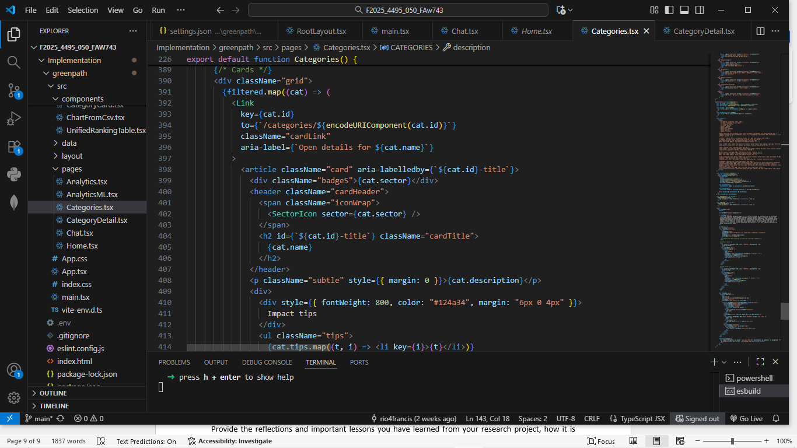
This figure shows the core structure of the Categories.tsx component, where each sustainability category is dynamically rendered using a reusable card template. The logic includes mapping through filtered category data, passing unique identifiers, and constructing accessible, interactive cards containing names, descriptions, sector icons, and impact tips
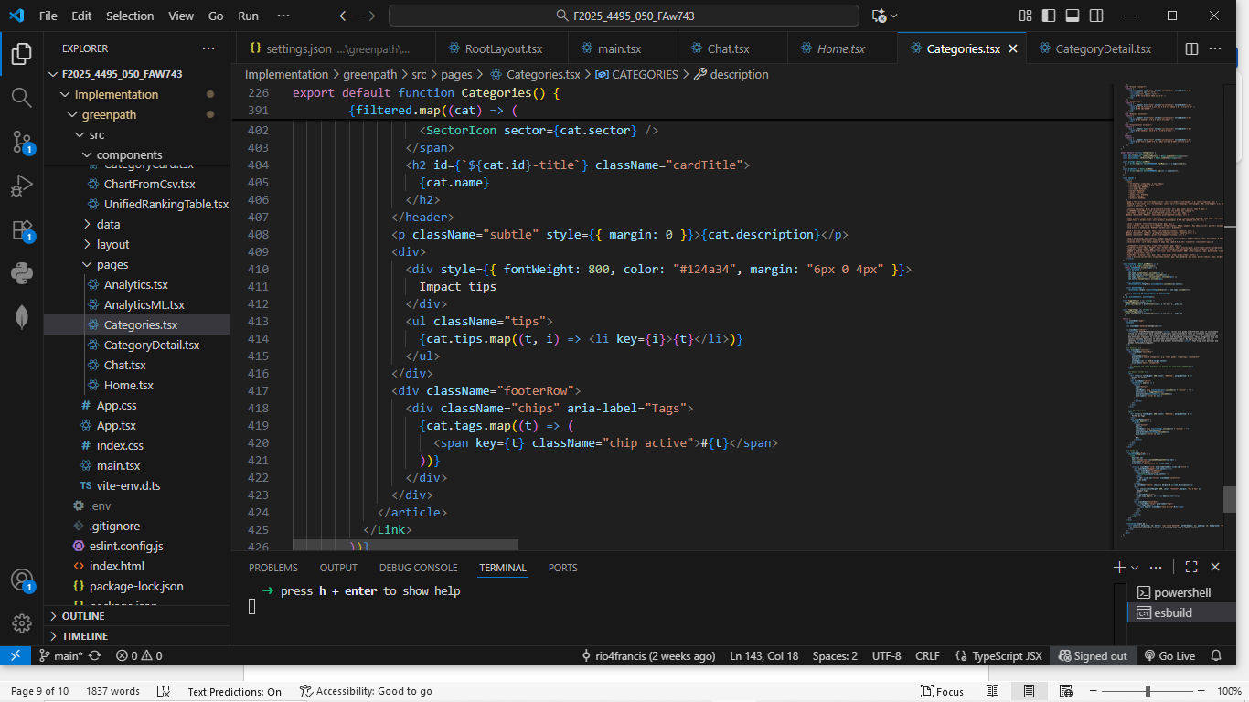
This code section highlights how tag chips, impact tips, and footer metadata are displayed within each category card. The layout ensures a clean presentation by applying structured typography, spacing, and semantic grouping, making the grid of categories both responsive and easy to navigate.

Figure 4.2(b): Component layout for the Categories grid and card composition
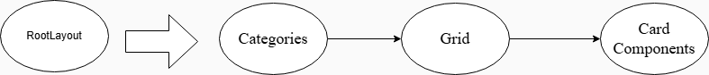
This diagram illustrates the high-level rendering flow for the Categories Page. User navigation begins at the RootLayout, which routes to the Categories Page, where category data is organized into a structured Grid. Each grid cell is then populated with a reusable Card Component, delivering a consistent, modular display across all categories.
Figure 4.2(c): Responsive category grid with interactive card states.
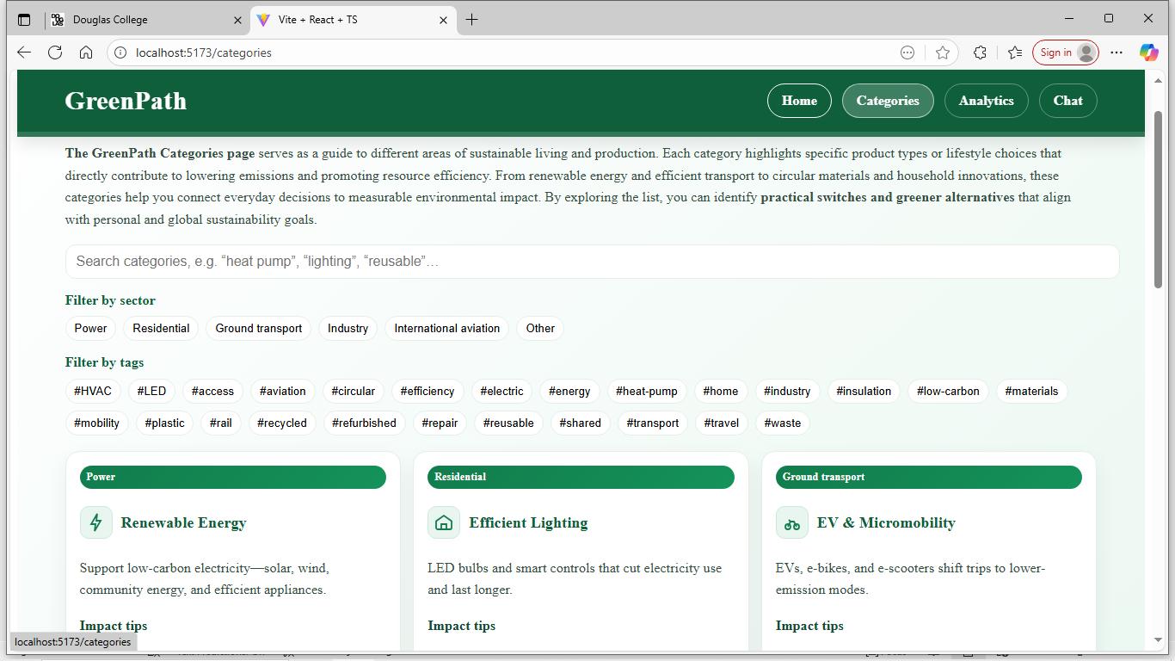
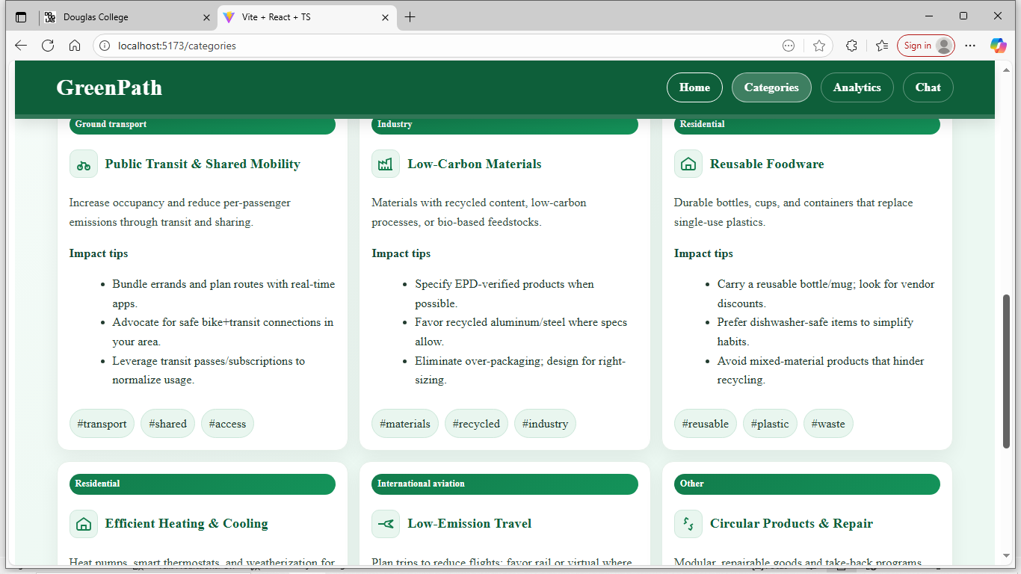

4.3 Analytics Engine (analytics.tsx)
The Analytics Page forms the analytical core of GreenPath, allowing users to interpret emission metrics and sustainability performance by country and sector.

4.3.1 Introduction/Overview – analytics page
Aligned with GreenPath’s research objective of visualizing environmental data, this module transforms numeric emission data into clear, comparative visuals. It was implemented as the third milestone to showcase practical sustainability analytics within a web-based framework.

4.3.2 Details of Implementation - analytics page
The Analytics Page, implemented in src/pages/Analytics.tsx, serves as the primary interface for visualizing the historical emissions dataset and preparing the inputs used across the system’s analytical modules. The page loads, filters, and aggregates the multi-year emissions data for all countries and sectors, forming the foundation for both descriptive analysis and all downstream machine-learning operations. A structured preprocessing pipeline was created to extract annual totals, generate per-sector time series, and prepare country-level comparisons. These transformations ensure consistency across all visualizations and enable the calculations used in trend charts, cumulative rankings, and sector distributions.
The data-loading logic retrieves the emissions dataset either from the local CSV file (agg.csv) or from the AWS-hosted API endpoint depending on the environment configuration. Once loaded, the dataset is normalized by converting numeric fields, grouping entries by country and sector, and computing summary metrics such as total national emissions per year. Additional processing includes sorting the dataset chronologically, computing sector-level aggregates, and generating cumulative emissions rankings for the latest available year. This layered preprocessing allows the Analytics Page to act as a fully self-contained analytical dashboard independent of the ML modules.
A significant improvement since the midterm was the reorganization of the page layout to prioritize analytical insights. The visualization elements, including the line charts and bar charts, were moved above the ranking table so that users first interact with the key emissions trends before exploring comparative summaries. This restructuring enhances interpretability by presenting temporal behavior, sectoral variation, and historical patterns before showing static rankings. The ranking logic itself was refined to compute totals dynamically from the same cleaned dataset, ensuring accuracy regardless of the selected filters or country subsets.
The page also incorporates refined country-selection logic and a memorized transformation process to prevent unnecessary recalculations. By caching the list of unique countries and grouping emissions by year using shared helper functions, the system reduces rendering overhead and improves responsiveness, especially when switching between countries. Each visualization component draws from the same standardized data structures, increasing maintainability and reducing the risk of inconsistencies. The updated Analytics Page therefore provides a reliable analytical foundation for users exploring emissions trends while preparing the structured outputs used by the more advanced ML components in the AnalyticsML page. Figure 4.3(a) shows the country ranking. Figure 4.3(b)shows the finalized Analytics Page with color-coded emission rankings.
Figure 4.3(a): Country ranking table by sector and year with responsive layout.
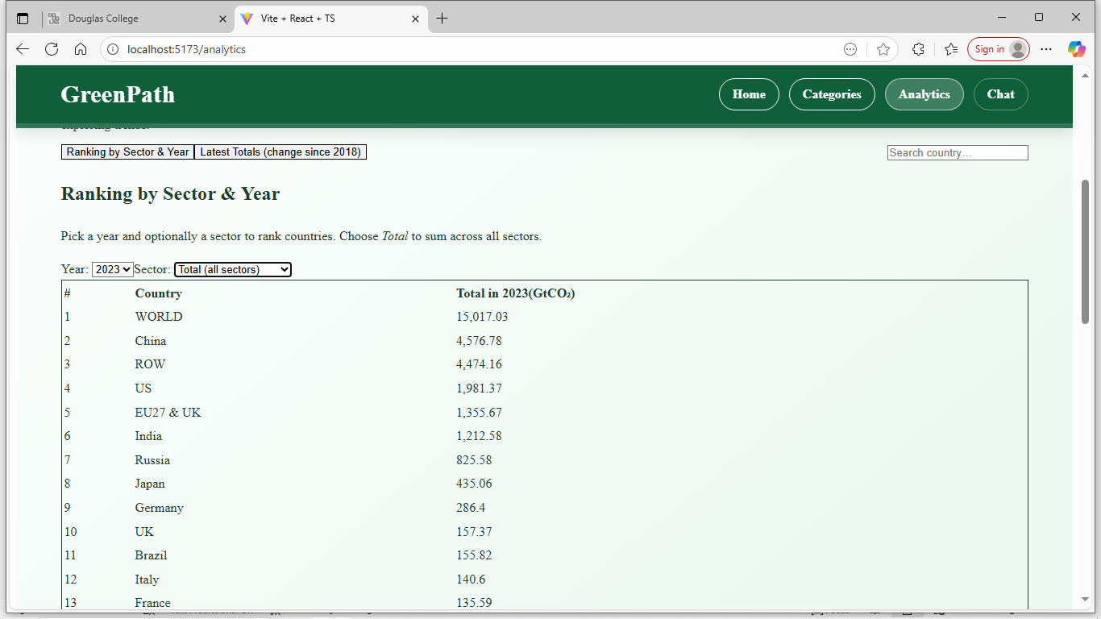
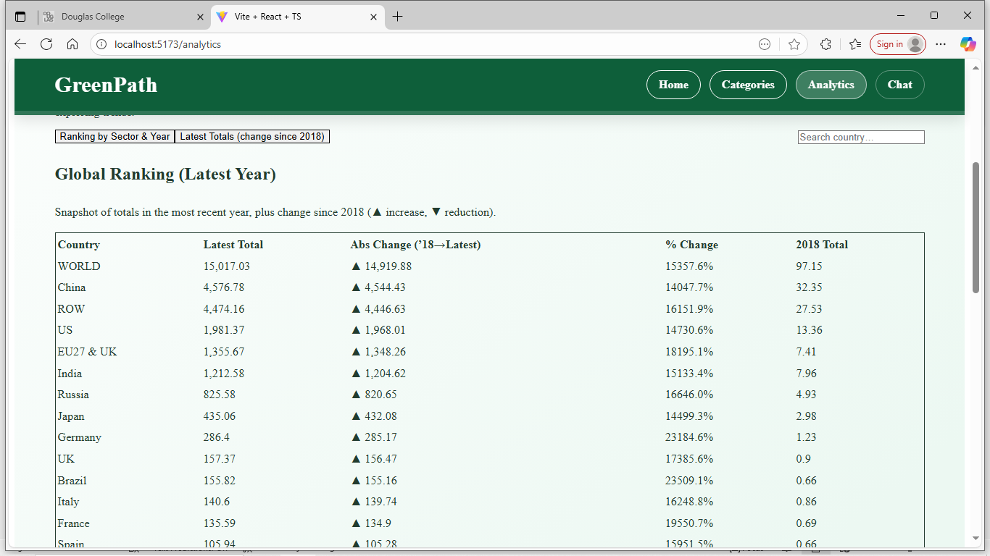
Figure 4.3(b) Interactive analytics visualizations showing sector-level emissions for selected countries, displayed using Line and Bar Charts with tooltip-based annual breakdown.
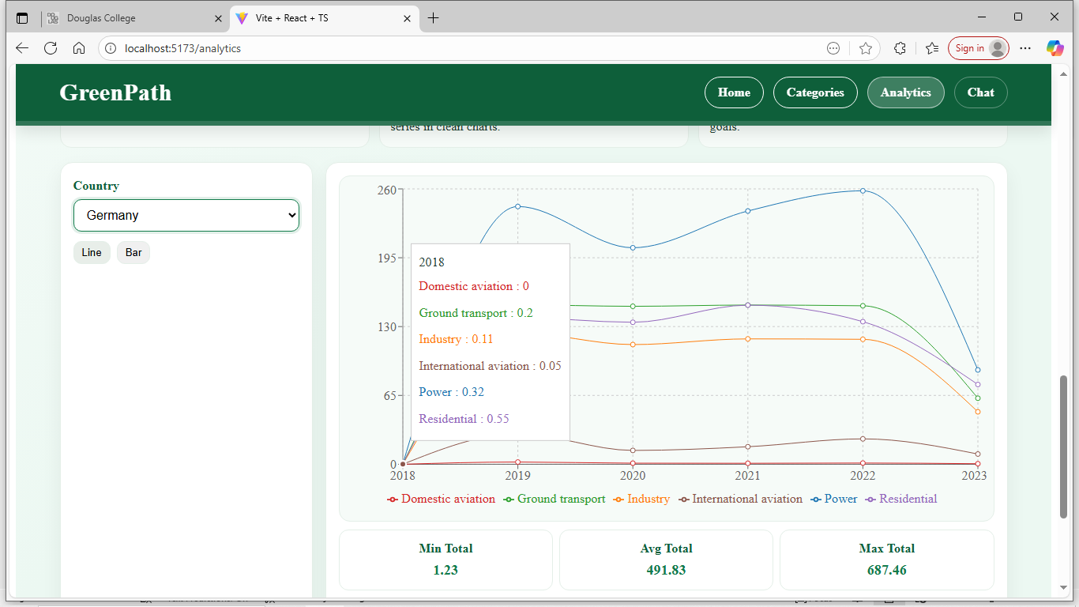
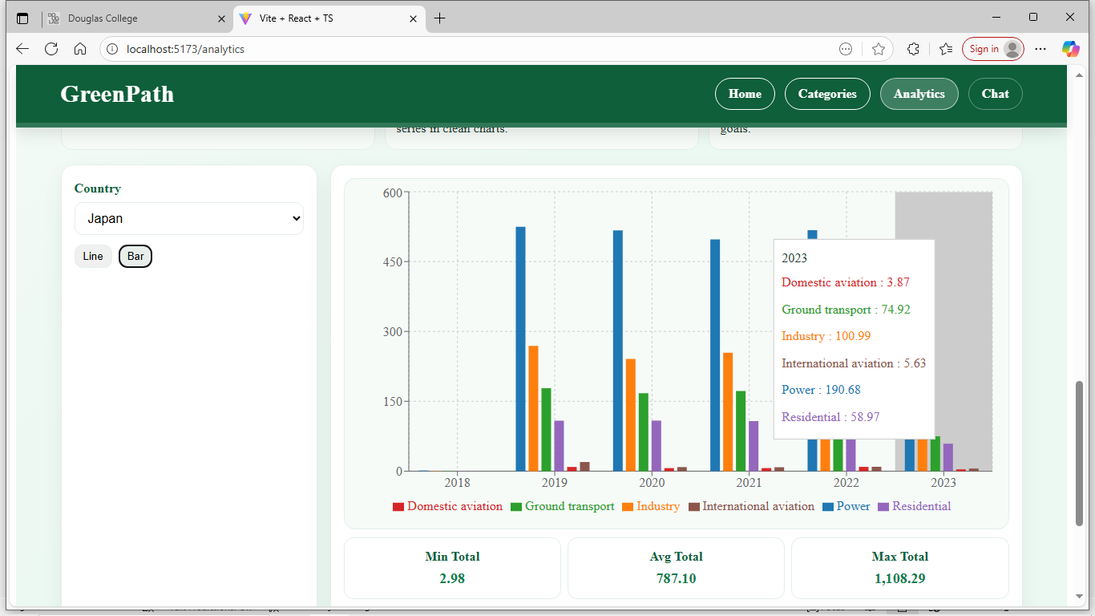
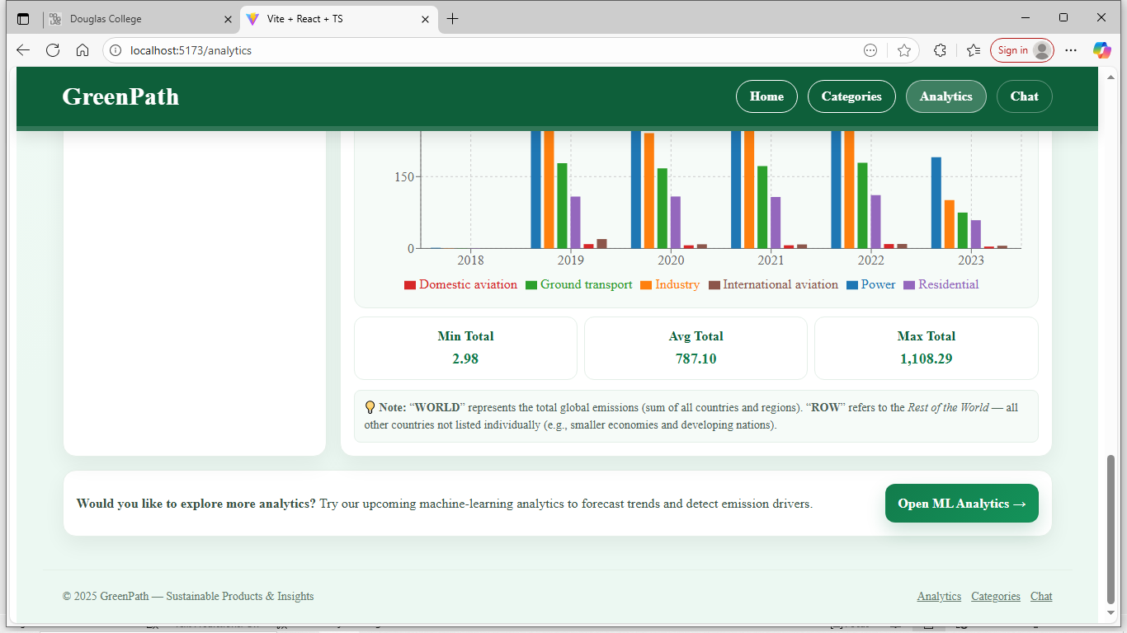

4.4 Machine Learning Analytics Module (analyticsML.tsx)
The AnalyticsML Page significantly enhances GreenPath’s analytical capabilities by integrating machine-learning driven insights derived from the aggregated emissions dataset. This page moves beyond simple visualizations and introduces intelligent models that forecast future trends, generate predictive estimates, detect anomalies, and cluster countries by emissions similarity. The component establishes the foundation for server-side model hosting on AWS Lambda while providing a fully functional client-side ML experience

4.4.1 Introduction/Overview – analytics ml page
This sub-page corresponds to the long-term objective of embedding full machine-learning analytics directly into the GreenPath platform. The AnalyticsML Page now supports four ML modules which are: Forecasting, Prediction, Anomaly Detection, and Clustering. Each built using structured logic applied to multi-year emissions data across all sectors.
The introduction of these modules ensures that the GreenPath system evolves into a robust analytical engine capable of trend evaluation, risk interpretation, and pattern discovery. The implementation demonstrates thoughtful architectural foresight by separating ML computations, visual components, and routing. This foundation ensures seamless future integration with AWS cloud-hosted inference services without redesigning the user interface or data pipeline.

4.4.2 Details of Implementation - analytics ml page
The AnalyticsML Page, implemented in src/pages/AnalyticsML.tsx, constitutes the core analytical engine of the GreenPath platform. While the standard Analytics Page visualizes historical emissions, the AnalyticsML module extends this functionality by applying four machine-learning techniques: forecasting, prediction, anomaly detection, and clustering directly to emissions data spanning 2018 to 2023. To support these models, a dedicated dataset processing pipeline was developed to ingest raw CSV entries, parse them via PapaParse, and convert them into a structured, ML-ready format. During preprocessing, sectoral emissions are filtered, grouped by country, aligned by year, and normalized where appropriate to produce consistent time-series arrays, annual change sequences, and multi-dimensional feature vectors. These transformations ensure that each model receives clean, standardized input and that computations performed in the browser remain reliable and reproducible.
The forecasting module applies Holt’s Linear Trend method to generate short-term emissions projections. For each sector within a selected country, the model computes smoothed level and trend components from historical data, then extrapolates these values to produce a three-year forward estimate. Holt’s method was chosen specifically because emissions datasets exhibit directional trends without meaningful seasonality, making it suitable for computationally lightweight, browser-side inference. The resulting projections are merged with historical data and plotted as dashed extensions to the time-series charts, enabling side by side comparison between observed trajectories and projected future behavior.
The prediction module quantifies how total national emissions may shift in the next year by combining structural share analysis with trend-based forecasting. Sector totals from the two most recent years are converted into proportional shares and compared to determine the underlying drift in each sector’s contribution. These drifted shares are normalized and scaled by a one-year Holt forecast of total national emissions, yielding a predicted emissions value for each sector. This hybrid approach involving both compositional change and top-level trend estimation produces more realistic sector-level forecasts than simple extrapolation and highlights how emissions structures may evolve in the near term.
The anomaly detection module identifies statistically unexpected variations in sector emissions. For each sector, year over year changes are computed and transformed into standardized Z-scores. Any change whose Z-score exceeds a fixed threshold is flagged as an anomaly, indicating an unusually large rise or drop compared to historical patterns. These anomalies may reflect policy interventions, economic shocks, dataset irregularities, or other external drivers. The flagged anomalies are visually rendered as distinct markers on the time-series charts, enabling users to immediately identify abnormal emission behavior within a country’s emission trajectory.
The clustering module categorizes countries based on the structure of their emissions profiles rather than the magnitude of their total emissions. Sectoral values across all years are aggregated and normalized such that each country’s feature vector sums to one, ensuring meaningful comparison across countries of different sizes. A full implementation of the K-Means algorithm was developed in JavaScript, including centroid initialization, Euclidean distance computation, iterative reassignment of countries to clusters, and centroid recomputation until convergence. The final clusters are visualized in a scatter plot where power sector share and ground-transport share form the axes, and bubble size reflects overall emission totals. This representation uncovers groups of countries with similar emission compositions and enables cross-national comparison.
Overall, the AnalyticsML Page integrates data preparation, machine-learning logic, and algorithmic computation into a unified analytical framework that transforms raw emissions data into actionable insights. The implementation emphasizes model construction, statistical reasoning, and dataset transformation. Through forecasting, predictive modeling, anomaly detection, and clustering, this module demonstrates the project’s central technical achievement and significantly enhances the analytical capabilities of the GreenPath platform. Figure 4.4 Screenshot of the AnalyticsML UI page.
Figure 4.4: User interface layout of the AnalyticsML Page displaying the machine learning controls and results panel for country selection and model execution.
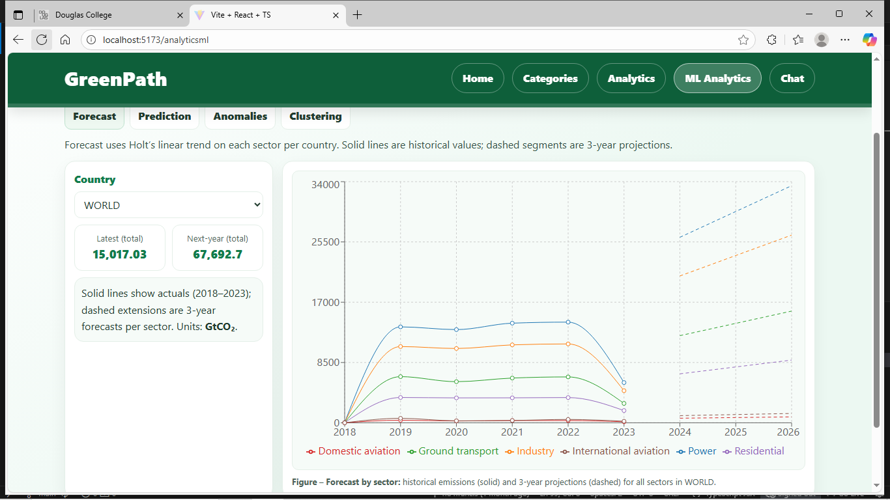
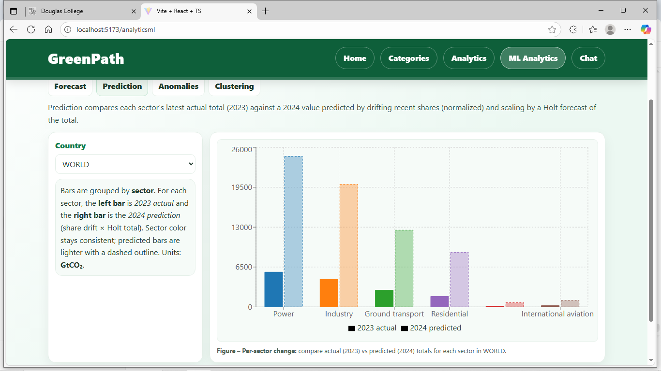 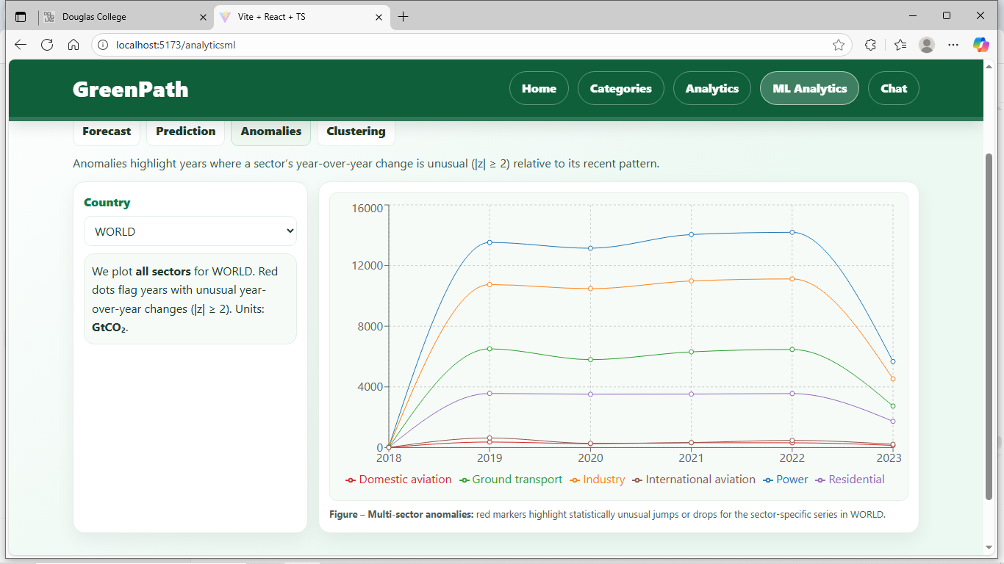 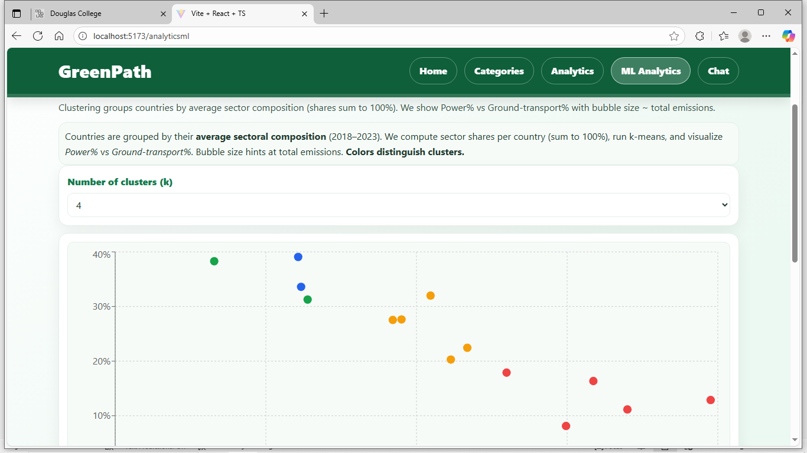 +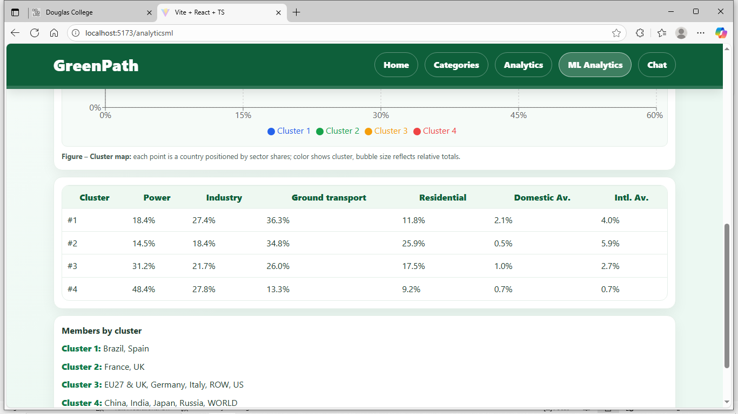

4.5 Intelligent Chat Assistant (chat.tsx)
The Chat Page introduces an AI-driven conversational interface that allows users to ask sustainability questions and receive real-time responses. It transforms GreenPath from a static information site into an interactive assistant that supports learning through natural language.

4.5.1 Introduction/Overview – chat page
This module fulfills GreenPath’s objective of enabling AI-assisted exploration of sustainability content. Implemented as a dedicated page in the routing structure, it provides an accessible entry point to the assistant and maintains the project’s visual consistency through the global RootLayout and Tailwind styling.

4.5.2 Details of Implementation - chat page
The Chat Page was implemented in src/pages/Chat.tsx using a React functional component that manages conversations through state hooks and asynchronous API calls. User messages are appended to a local message array and sent to the backend endpoint, which forwards the prompt to the Lambda-powered chat model. The returned assistant response is added dynamically, and Markdown rendering was integrated using ReactMarkdown and remark-gfm to support structured outputs such as lists, links, and formatted text.
The interface was significantly enhanced. A chatbot SVG icon now visually identifies assistant messages, and redesigned left/right-aligned message bubbles improve readability. A scroll reference was added to ensure smooth automatic scrolling without page jumps, and custom inline styling replaced Tailwind to maintain consistent formatting with the overall GreenPath theme. These updates result in a cleaner, more stable, and more intuitive chat experience. Figure 4.5 displays the live Chat UI during an AI conversation.

Figure 4.5: Operational chatbot interface displaying real-time user–AI exchange.
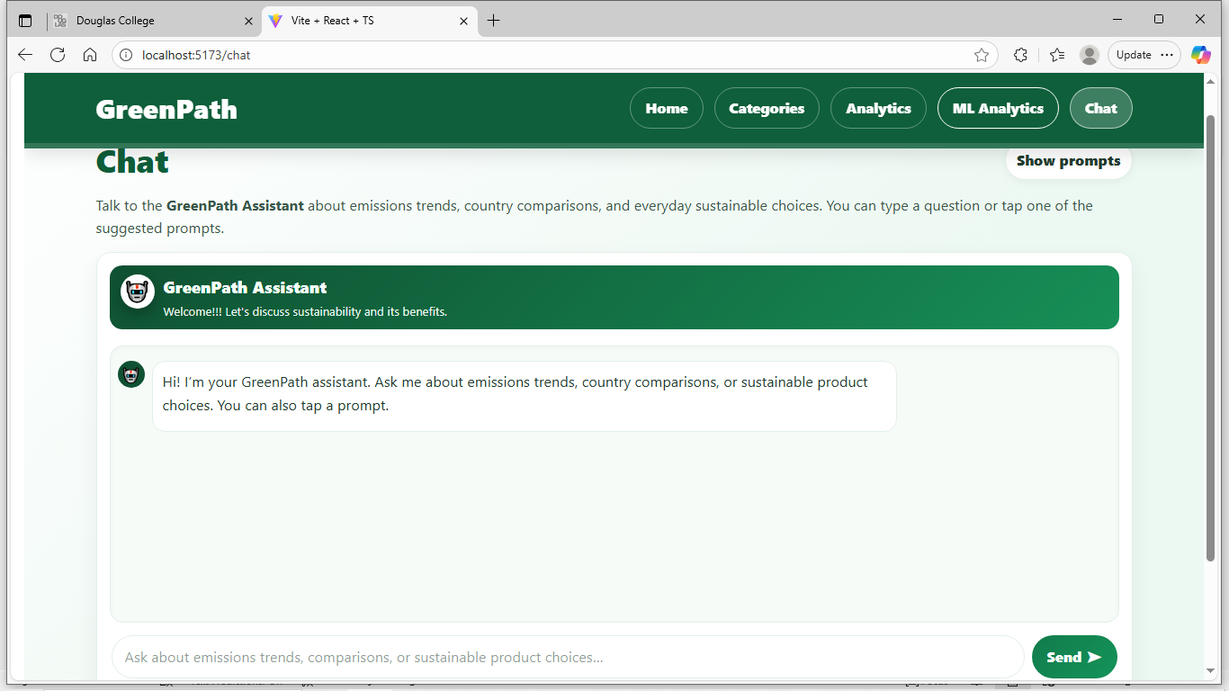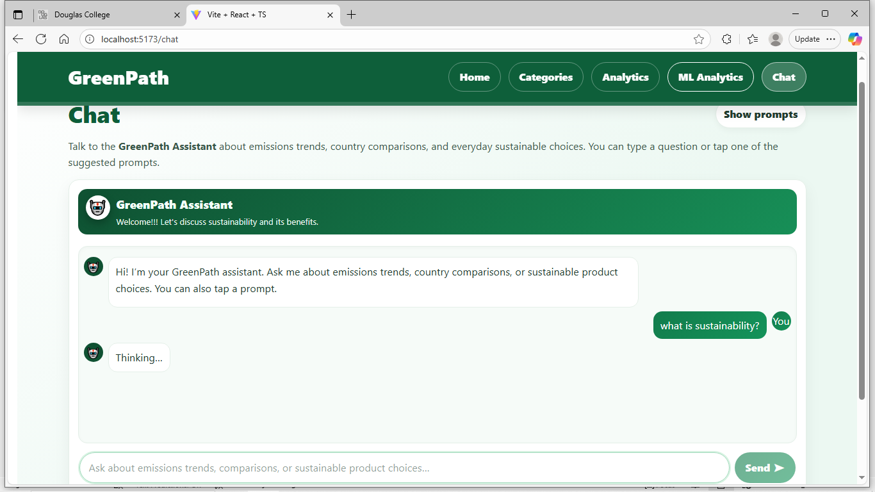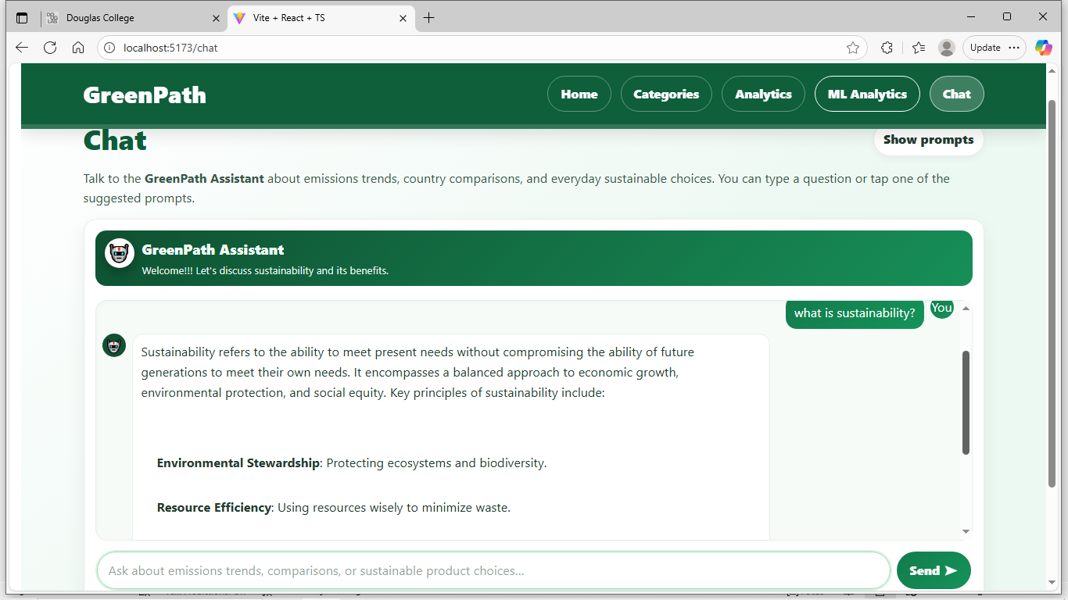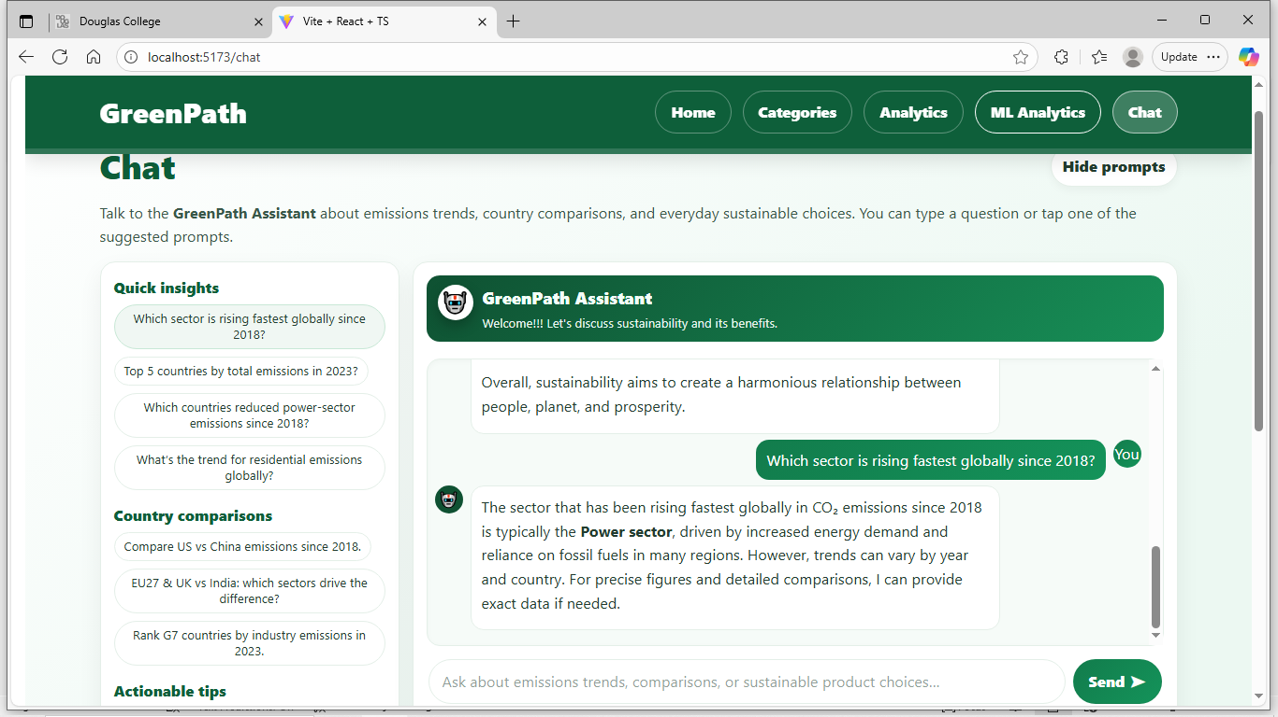

4.6 Routing and Layout Architecture (RootLayout.tsx)
The RootLayout governs GreenPath’s structural consistency and global navigation across all modules.

4.6.1 Introduction/overview – rootlayout page
Serving as the backbone of the user interface, RootLayout ensures every page shares a unified navigation experience and cohesive design, reinforcing accessibility and brand continuity.

4.6.2 Details of Implementation -rootlayout page
Implemented in RootLayout.tsx, this component defines the sticky header, content outlet, and footer. Navigation links use React Router’s “NavLink” to display active states. Tailwind classes manage spacing and color consistency, while AWS Amplify automates redeployment from GitHub. Figure 4.6 provides a screenshot of the header logic.
Figure 4.6: RootLayout.tsx showing the header logic.
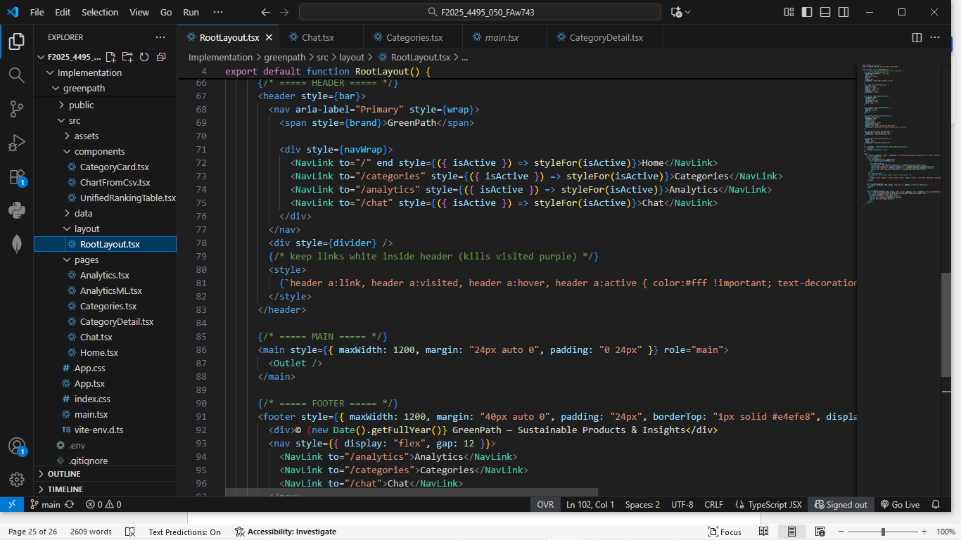

Lessons Learned and Future Work
Developing the GreenPath application has been an enriching learning experience that strengthened both my technical and analytical skills. The project taught me how to design and deploy a complete web application using React, Vite, and Tailwind CSS while leveraging AWS Amplify, Lambda, and API Gateway to manage scalable serverless functions. Integrating the OpenAI API enhanced my understanding of asynchronous data handling and real-time interaction design. This work directly relates to coursework in Applied Research, Web Application Development, and Machine Learning, where theoretical knowledge was applied to real world problem solving. The experience improved my debugging, time management, and teamwork abilities while deepening my appreciation for sustainable technology innovation. Looking ahead, I plan to extend this research by enhancing the chatbot’s natural-language capabilities, integrating real time sustainability datasets, and completing the AnalyticsML predictive analysis module. Professionally, this project has reinforced my aspiration to pursue a career in software engineering and AI-driven environmental technology, applying intelligent systems to solve sustainability challenges in the future.

Concluding Remarks
The GreenPath project has successfully evolved from a research concept into a functional web-based sustainability platform that combines analytics, artificial intelligence, and cloud computing. This achievement reflects the integration of technical knowledge gained through coursework at Douglas College with practical problem solving and innovation. The project not only enhanced my technical skills in full-stack development and cloud deployment but also deepened my commitment to applying technology toward environmental awareness and sustainable living. I am sincerely grateful to Douglas College, my instructor, Dr. Bambang Sarif, and my peers for their continuous guidance, feedback, and encouragement throughout this project. Their support has been instrumental in refining my professional development and preparing me for future work in software engineering and AI-driven environmental solutions.

Appendix
The Appendix provides supporting information and technical documentation for the GreenPath project, including installation steps, user instructions, datasets, system architecture, and key code explanations to aid understanding

Appendix A: Installation Guide
To install and run the GreenPath application locally, ensure Node.js (v18 or later) and “npm” are installed. Clone the GitHub repository to your computer and open it in Visual Studio Code. Run “npm install” to install all dependencies and “npm run dev” to start the local development server. The project uses Vite as its build tool, with a React (TypeScript) front end styled using Tailwind CSS. The application is fully deployed and publicly accessible through AWS Amplify at https://main.dr4j5cc9fnii3.amplifyapp.com/. The Amplify environment automatically builds and deploys each new commit pushed to the repository. API keys for OpenAI are stored securely within the Amplify console under environment variables to protect sensitive credentials.

Figure 7.1 shows a screenshot of the AWS amplify deployment status.
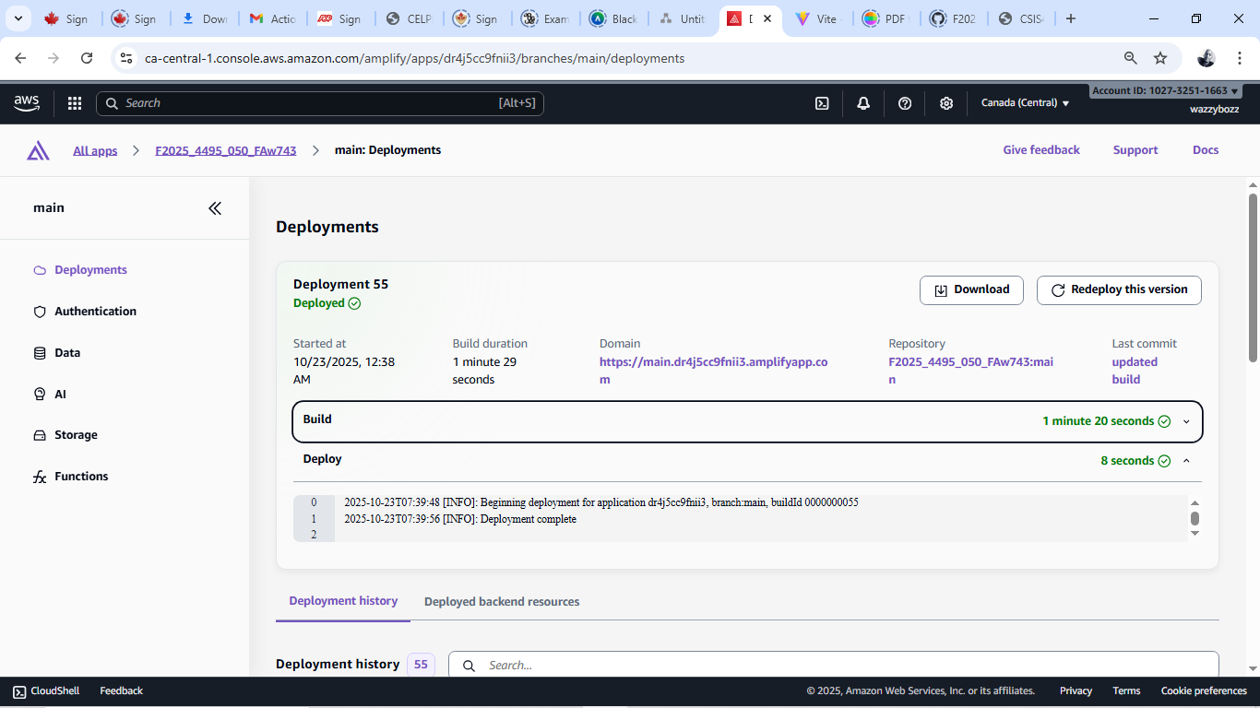

Appendix B: User Guide
Upon launching the GreenPath application, users are welcomed on the Home Page, which introduces the project’s sustainability mission and provides clear navigation links to all major features. The Categories Page presents a set of interactive, responsive cards that guide users into detailed sub-pages containing explanations, visual illustrations, and curated image galleries for various sustainability themes.
The Analytics Page provides a dynamic, interactive dashboard where users can explore national CO₂ emissions by sector and year. This page includes a searchable ranking table, sector-filtered charts, and multi-year visual summaries generated from the processed emissions dataset.
The newly completed Analytics ML Page extends these capabilities with predictive machine-learning analytics. Users can now explore four ML modules: forecasting, anomaly detection, prediction (next-year KPI estimation), and clustering. Each module operates on real dataset values and provides charts, insights, and explanatory outputs derived from custom-built algorithms implemented directly in React. Users may select a country to explore forecasting, prediction, anomaly detection, and clustering results generated from processed emissions data. These outputs are computed through custom TypeScript implementations of Holt’s Linear Trend, structural-share drift prediction, Z-score anomaly filtering, and K-Means clustering. The page is designed for exploration, enabling users to compare future projections, identify unusual emission patterns, and interact with sustainability metrics in an analytical, data-driven manner.
The Chat Page offers real-time, AI-powered discussion using a dataset-aware chatbot. Users can ask questions about emissions, sustainability practices, or any topic supported by the underlying OpenAI model. The interface includes scrollable chat bubbles, Markdown rendering for rich answers, and quick-prompt suggestions to help users explore insights more efficiently.
A consistent global navigation bar, visible across all pages, ensures smooth movement throughout the platform and provides users with an intuitive and unified experience. Figure 7.2 (a), (b), (c) shows samples of the sub-categories UI.

Figure 7.2(a): screenshot of reusable food ware sub-category.
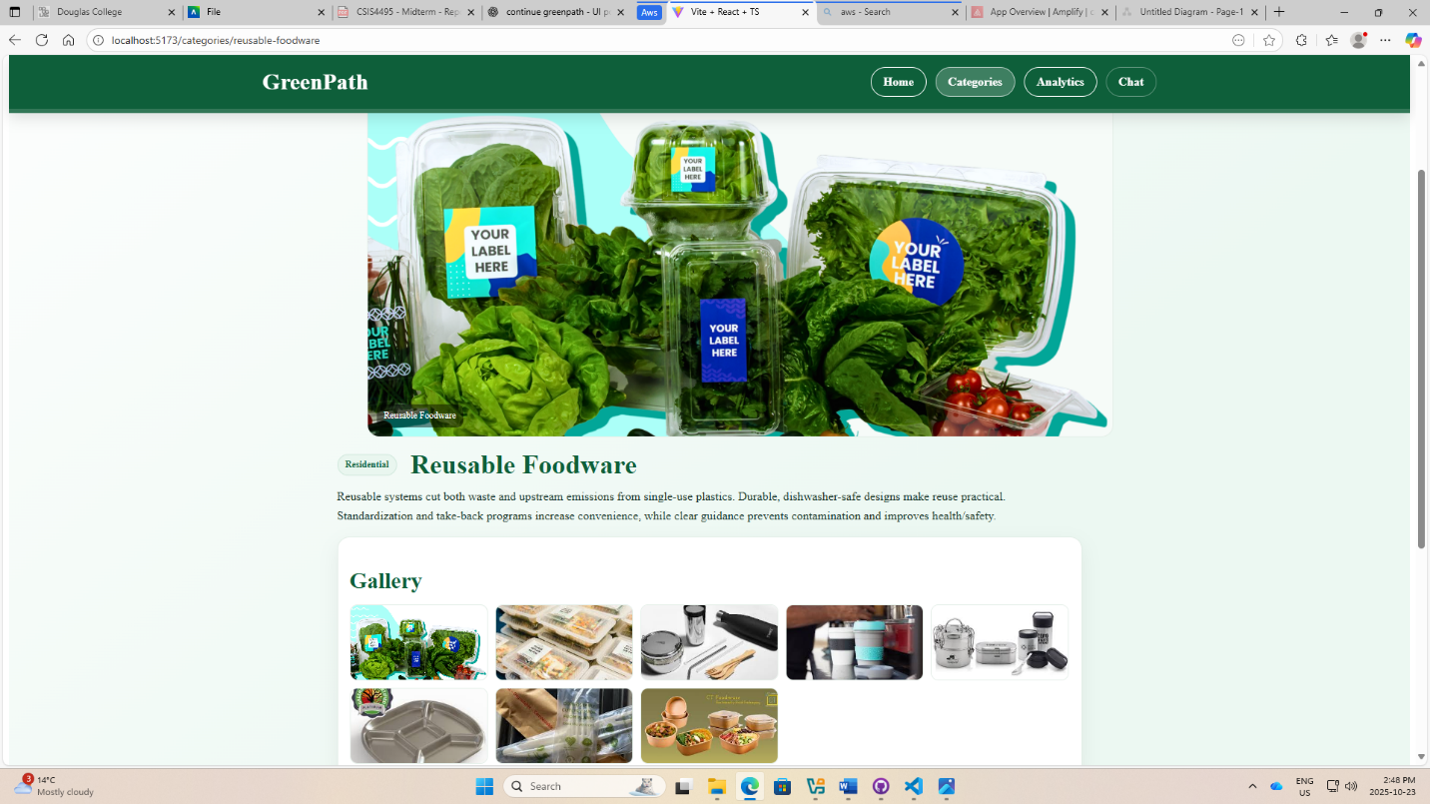

Figure 7.2(b): screenshot of renewable energy sub-category.
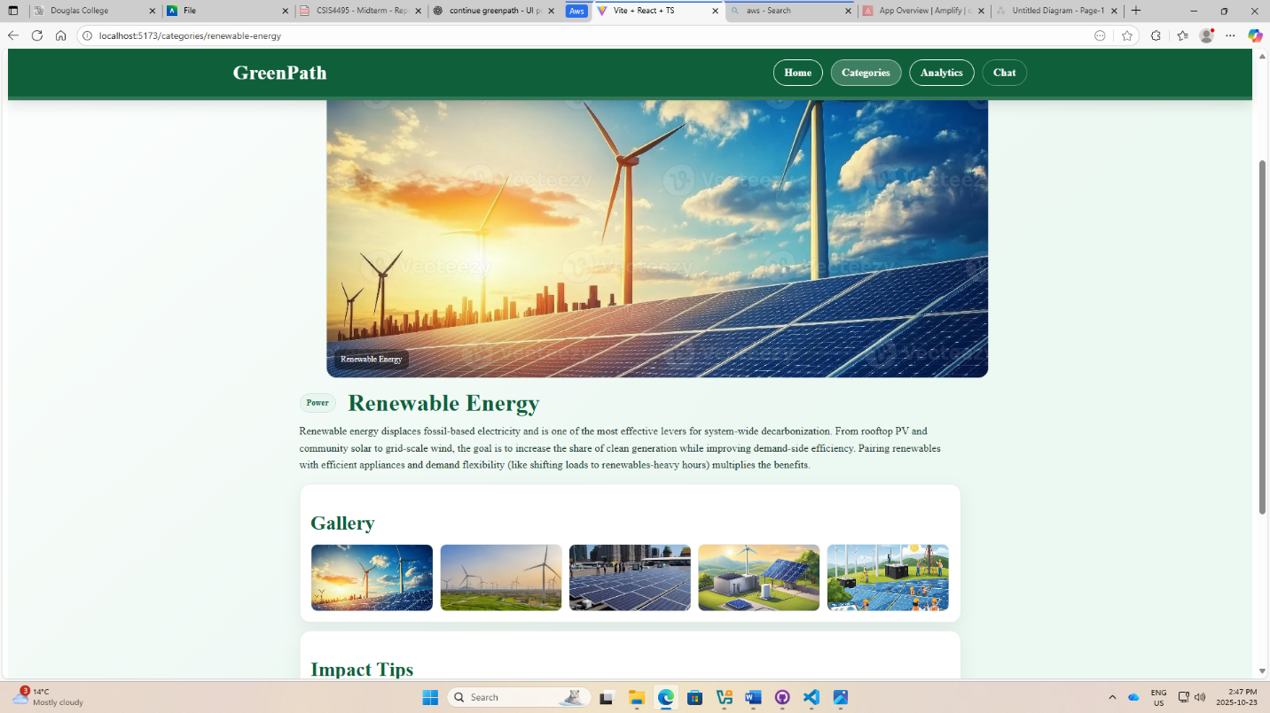

Figure 7.2(c): screenshot of EV AND mobility sub-category.


Appendix C: Dataset and API Used
The analytics module relies on a cleaned aggregate dataset stored in public/data/agg.csv, derived from the Global Emissions by Sector and Country dataset originally published on Kaggle by Saloni 1712. The file contains processed emission metrics categorized by country and sector for visualization within the Analytics Page. Data are parsed through “PapaParse” and displayed via React tables and Recharts components. The OpenAI API is integrated to power the chatbot’s natural language responses, facilitated through AWS Lambda and API Gateway. All API calls are handled asynchronously, and authentication keys are managed within Amplify’s secured environment configuration.

Appendix D: Hardware, Software, Cloud, Architecture, etc.
Development and testing were conducted on a Windows 10 laptop with an Intel Core i7 processor and 16 GB RAM. The software stack includes React 19, Vite 7, Tailwind CSS 4, TypeScript 5, and the AWS Amplify cloud framework. The project architecture follows a serverless model:
The frontend is hosted on AWS Amplify.
API Gateway routes requests.
AWS Lambda functions handle OpenAI API interactions.
The OpenAI endpoint generates chatbot responses.
This design ensures scalability, low latency, and minimal server maintenance. Figure 7.4 depict the flow from client-side interaction to backend processing and AI response delivery.

Figure 7.4: Interaction flow process.
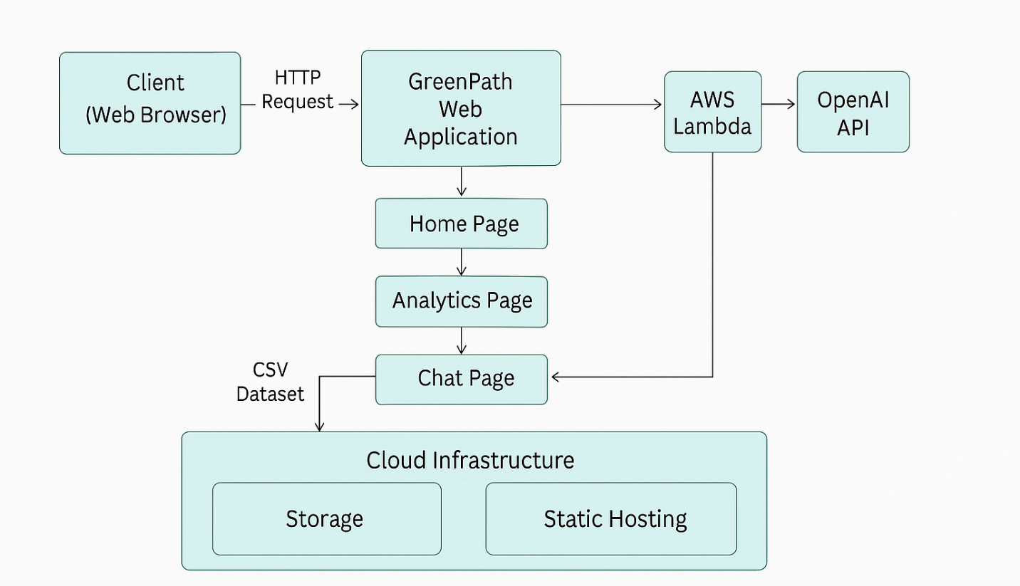

Appendix E: Code Explanation
The project follows a modular folder structure housed within the src/ directory:
components/ – Contains reusable UI elements such as CategoryCard.tsx, ChartFromCsv.tsx, and UnifiedRankingTable.tsx, which render category cards and analytics charts.
data/ – Holds the emissions dataset (agg.csv) and related parsing logic.
layout/ – Includes RootLayout.tsx, which defines the global header, navigation, and footer shared across all pages.
pages/ – Contains the main feature modules:
Home.tsx (landing page content and overview)
Categories.tsx (card grid with sub-page routing to CategoryDetail.tsx)
Analytics.tsx (interactive ranking table)
AnalyticsML.tsx (future machine-learning dashboard)
Chat.tsx (AI-powered conversation interface with OpenAI API integration)
index.css – Imports Tailwind directives and defines custom global styling rules.
vite.config.ts and tailwind.config.js – Contain environment configuration and plugin integration.
Backend support is managed through AWS Lambda (chat.js) for API calls and Amplify hosting for continuous integration/continuous deployment. Inline documentation within each component explains key state variables, hooks, and request handlers.

Appendix F: Machine Learning, Analytics And Chat Diagrams.

Figure 7.6(a): Route and module linkage between Analytics and AnalyticsML.
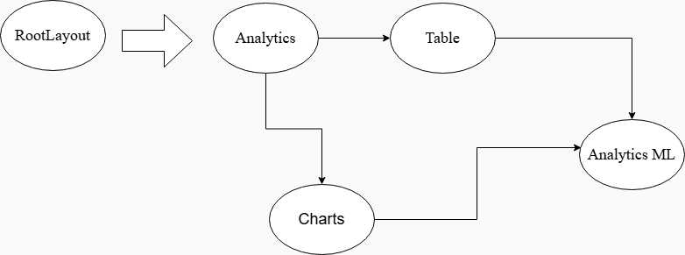
The workflow illustrates how navigation begins at the RootLayout, directing the user to the Analytics page, where the system retrieves and organizes emissions data. From there, data flows into the Table component for ranking and comparison, and into Charts for visualization, with both components providing structured inputs that support deeper analysis within the Analytics ML module.

Figure7.6(b): Analytics.tsx table mapping and conditional styling for emission values.

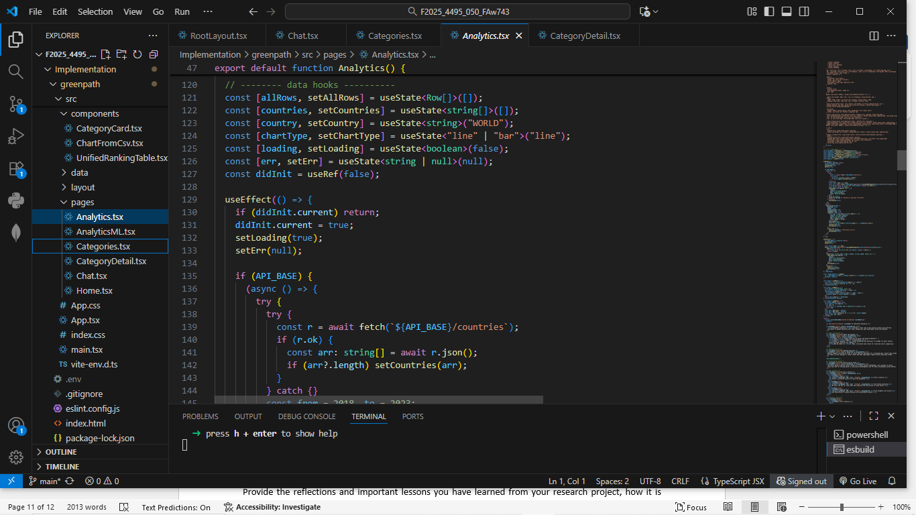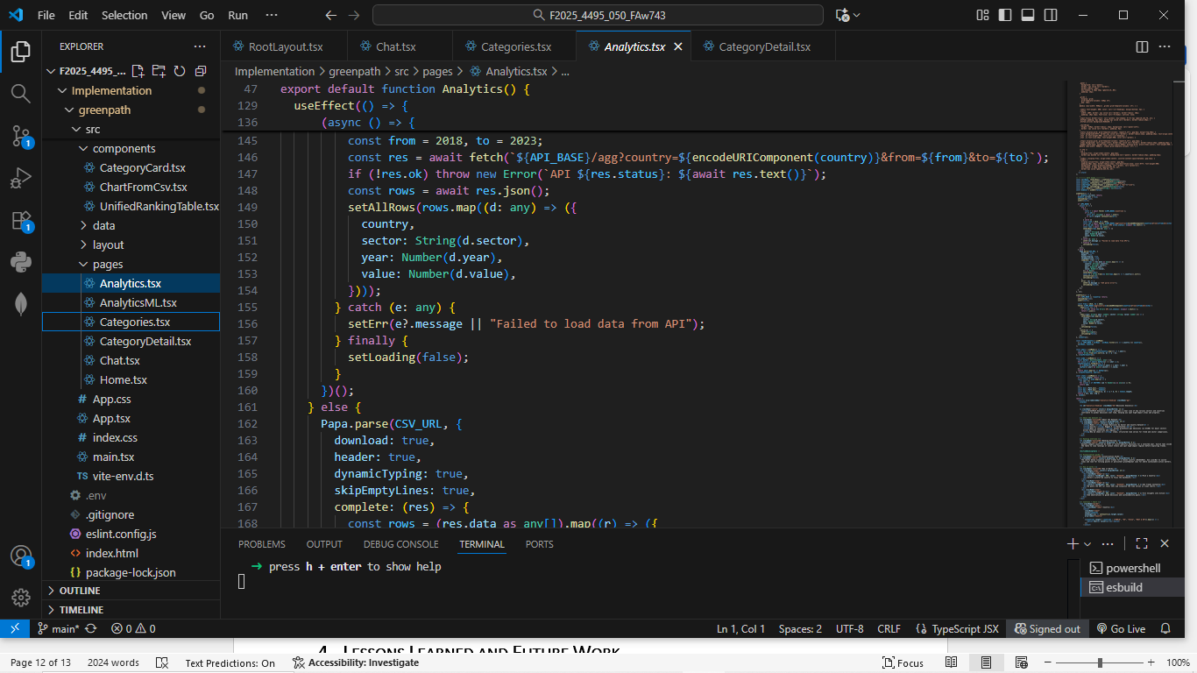

Figure 7.6(c): Data reshaping and yearly aggregation logic used for chart rendering.
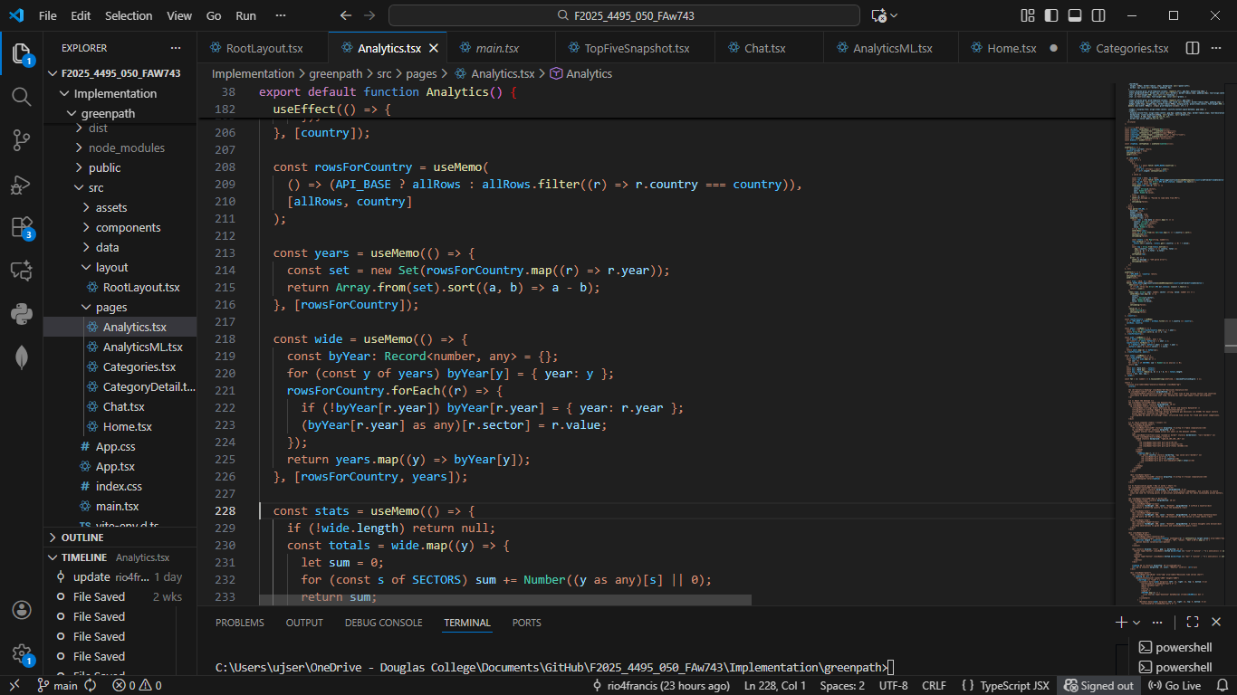
Figure 7.6(c) shows the TypeScript logic in Analytics.tsx that reshapes the raw emissions data into a wide, year-by-sector format and then computes yearly summary statistics. The rowsForCountry, years, wide, and stats hooks collaboratively filter records by country, derive the ordered list of years, pivot sector values into a chart-friendly structure, and aggregate totals to support both the ranking table and time-series visualizations.

Figure 7.6(d): Latest emissions and percentage-change calculation in UnifiedRankingTable.tsx.
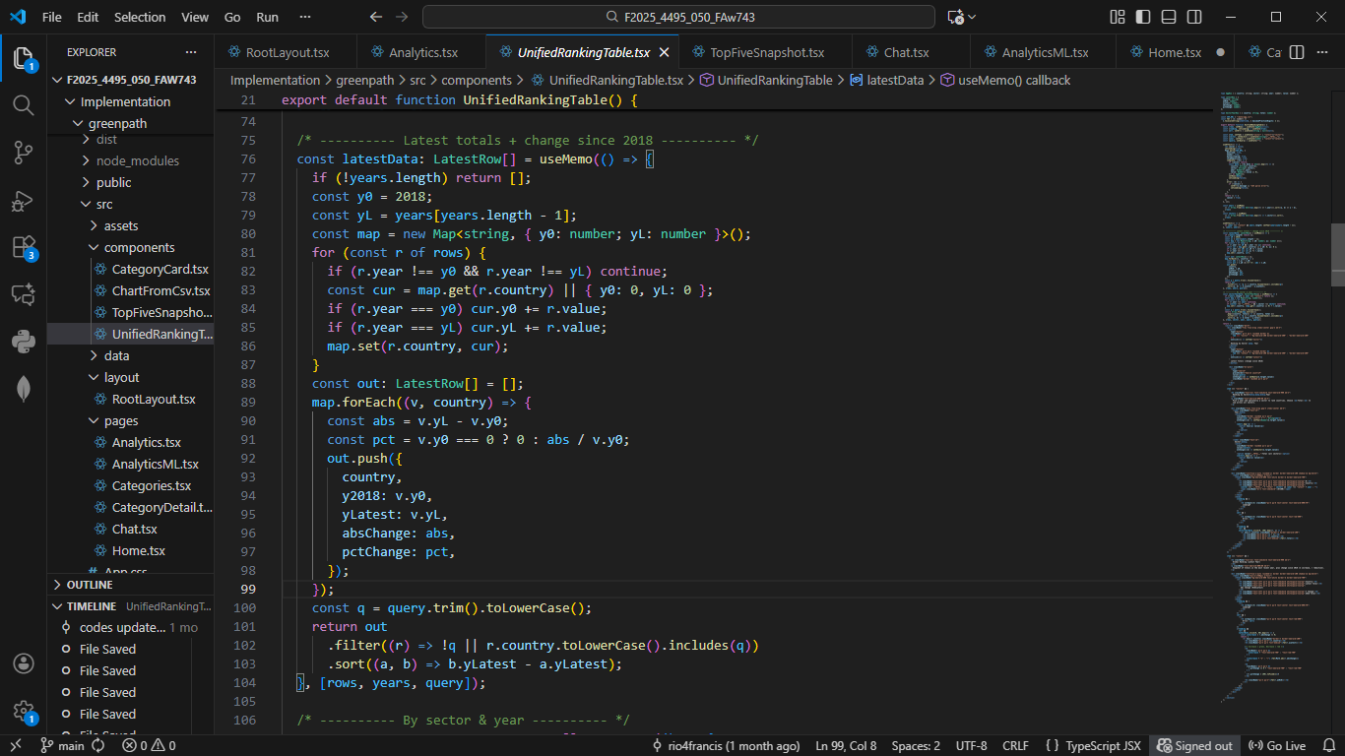
This displays the computation block inside UnifiedRankingTable.tsx that calculates each country’s most recent emissions total and the percentage change relative to the 2018 baseline. The code aggregates values year-over-year, constructs a structured ranking row for each country, and sorts the results to drive the table displayed in the Analytics Page. This transformation is central to producing meaningful comparative insights and supports both the ranking UI and subsequent ML-ready feature generation.

Figure 7.6(e): Architecture diagram illustrating the AnalyticsML flow from the FrontEnd through the API Gateway to Lambda and the Model/Store.

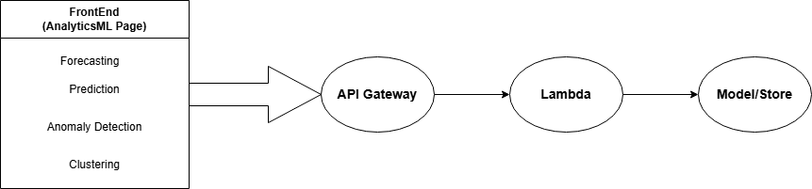
The workflow illustrates how the AnalyticsML page sends user-initiated ML requests from the frontend to the backend through API Gateway, which triggers an AWS Lambda function responsible for executing the appropriate analytics or machine-learning routine. The Lambda function then retrieves or processes the required model outputs within the Model/Store layer and returns the computed results back to the frontend for visualization.

Figure 7.6(f): Implementation of forecasting and anomaly-detection logic in AnalyticsML.tsx, showing type definitions, Holt’s linear trend forecasting routine, and Z-score–based anomaly identification.
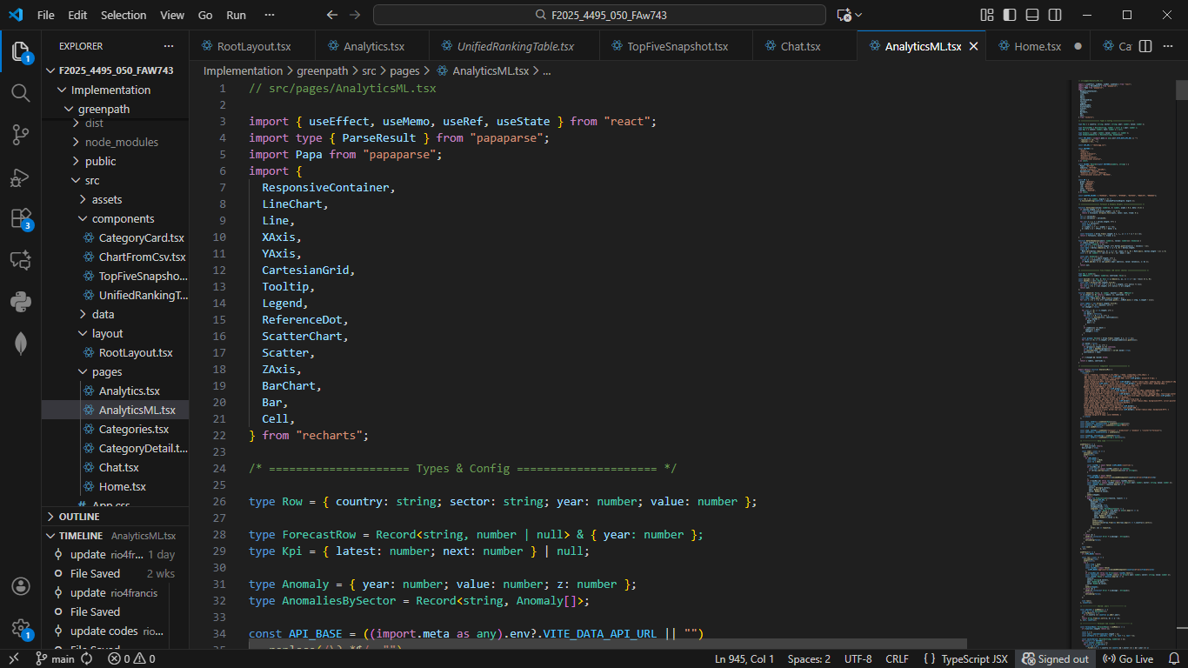
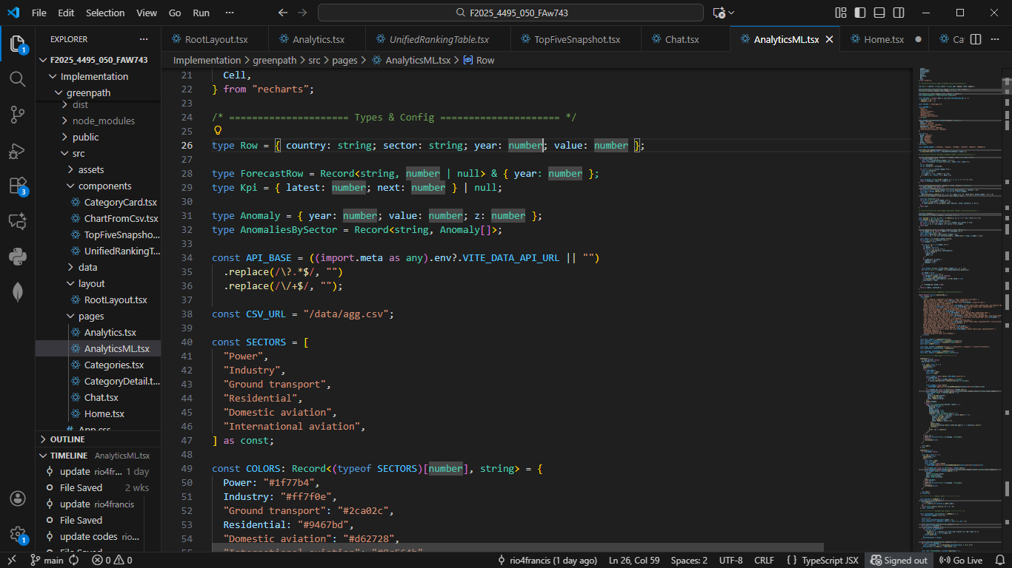
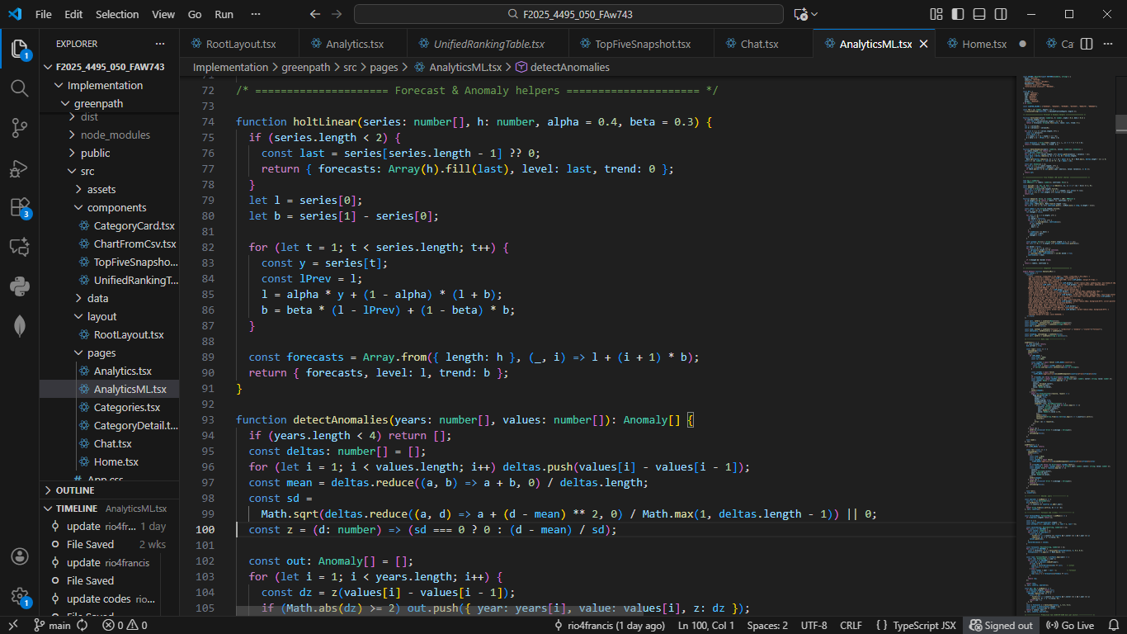
The screenshots in Figure 7.6(f) illustrate the core machine-learning logic implemented inside AnalyticsML.tsx. The first part shows the type definitions and configuration objects used to structure ML-ready data, including type interfaces for forecasting rows, KPI summaries, and anomaly structures indexed by sector. These definitions ensure the AnalyticsML module handles emissions data in a strongly-typed, predictable format throughout the forecasting and detection pipeline.
The second part of the figure shows the implementation of the project’s forecasting algorithm, which uses a lightweight version of Holt’s Linear Trend Method. The function computes a smoothed level and trend component for each sector’s time-series emissions data and then extrapolates future values for a user-specified number of years. This supports predictive insights directly inside the browser without relying on external ML services.
The final section of the screenshot highlights the anomaly-detection routine, which identifies sudden changes or irregular spikes in emissions data. The algorithm computes first-order deltas, derives a mean and standard deviation, and then uses a Z-score threshold to determine whether a year-to-year change is statistically unusual. Each anomaly is saved with its year, value, and severity (“z”) to support visual highlighting in the charts.
Together, these code sections demonstrate the technical foundation of the ML Analytics module: structured data handling, forecasting of future emission trends, and detection of meaningful deviations within historical records.

Figure 7.6(g): End-to-end chatbot request–response flow via API Gateway and Lambda.
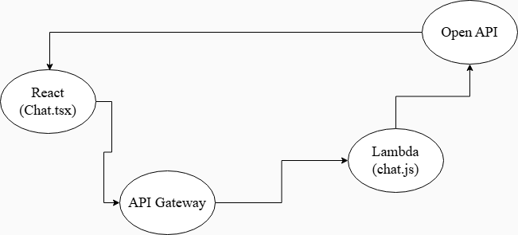
The workflow illustrates how a user message originating from the React Chat.tsx interface travels through the backend pipeline to generate an AI-powered response. When a message is submitted in Chat.tsx, it is sent to the AWS API Gateway, which securely forwards the request to the Lambda function (chat.js). The Lambda function formats the prompt and interacts directly with the OpenAI API to obtain a generated response. The response then flows back through the same chain: OpenAI → Lambda → API Gateway → Chat.tsx, where it is rendered inside the chat interface. This architecture ensures a fully serverless, scalable, and secure communication loop between the frontend and the AI model.

Figure 7.6(h): Key Logic Implementations for the Chat.tsx Component
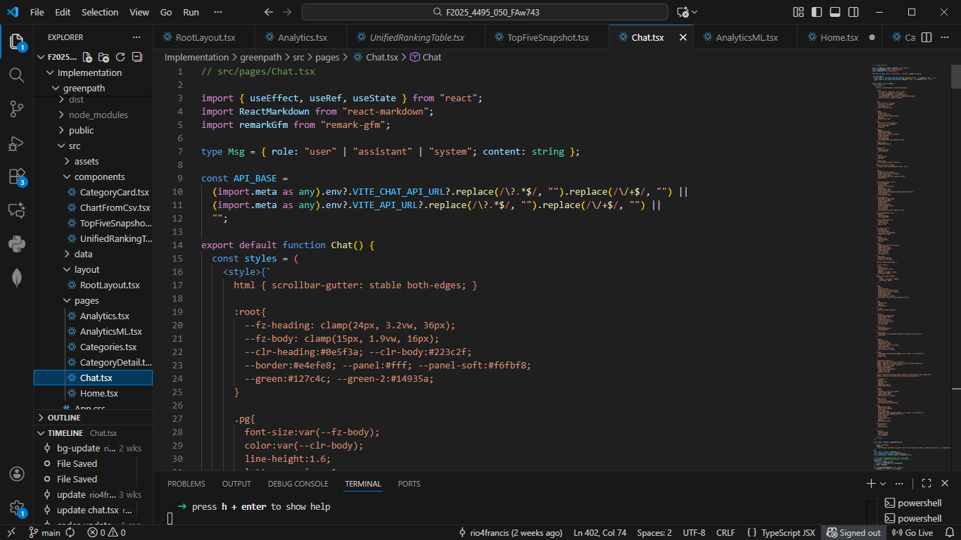
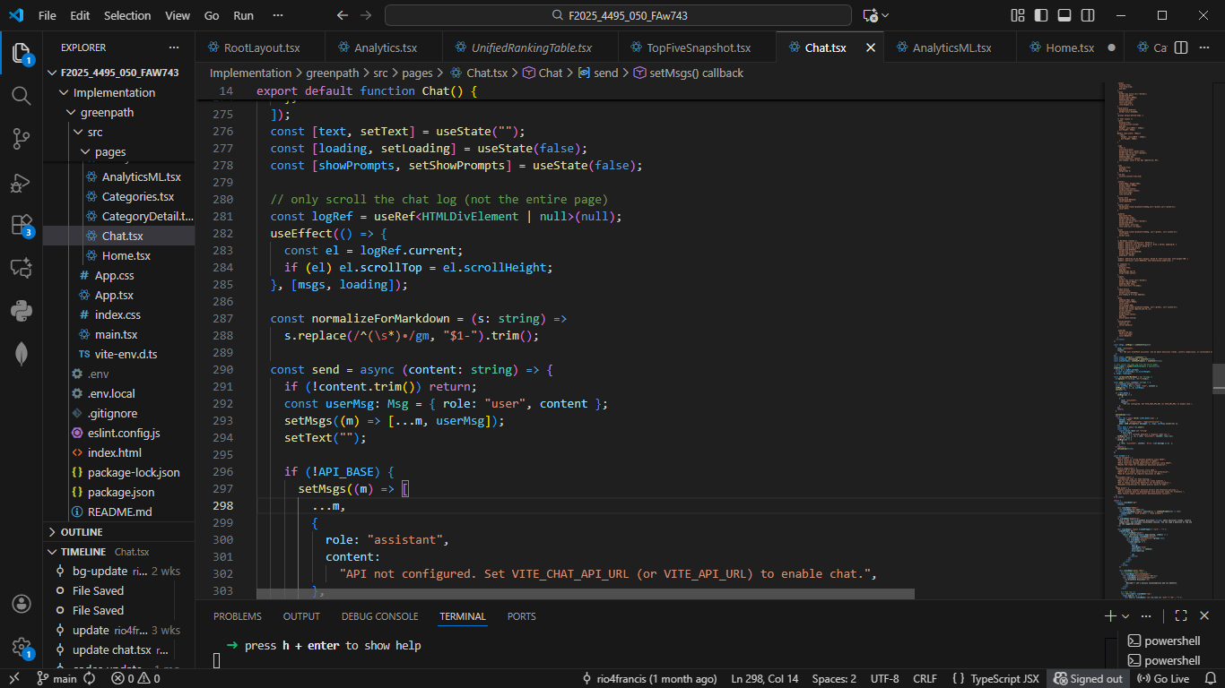
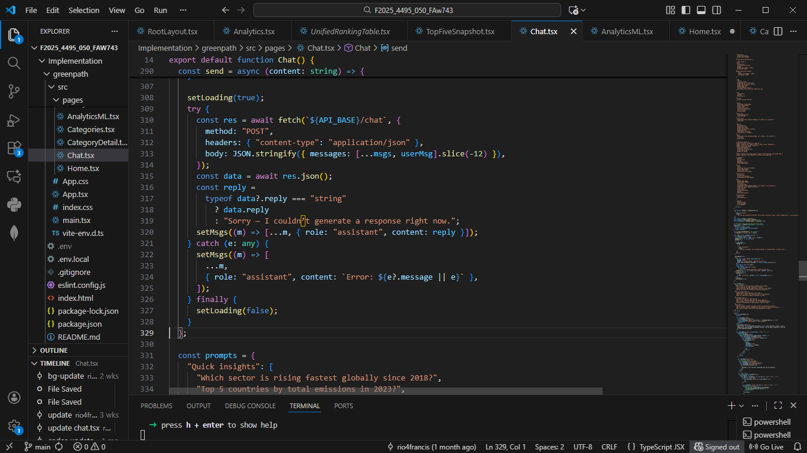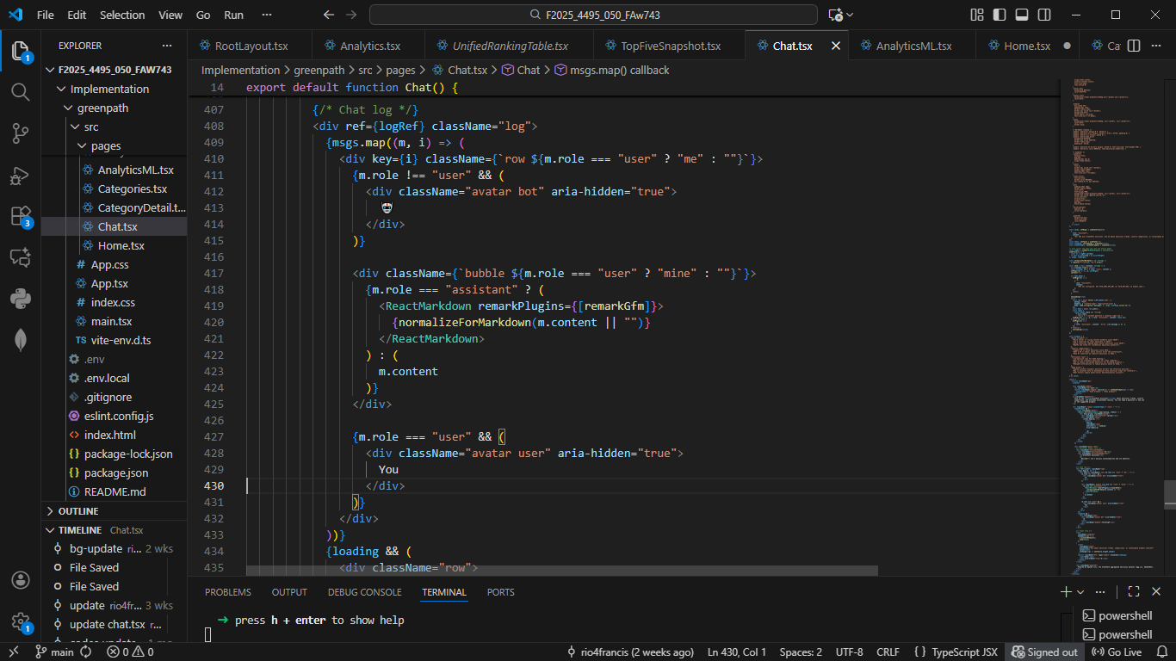
The Chat.tsx component implements GreenPath’s intelligent assistant by combining structured state management, AWS-powered backend communication, and a fully responsive chat interface. The component begins by defining the message schema and configuring API endpoints through environment variables, ensuring secure routing of user prompts to AWS API Gateway. Internal logic manages user input, loading states, scroll behavior, and message normalization to maintain a smooth interaction flow. The send() function orchestrates the entire request cycle, packaging conversation history, forwarding it to the Lambda function, and processing the OpenAI-generated response returned through the serverless pipeline. Finally, Chat.tsx renders a dynamic and accessible user interface using conditional React components, Markdown rendering for assistant messages, and styled chat bubbles that distinguish between user and AI roles. Together, these elements illustrate a complete front-end implementation that integrates seamlessly with the project’s cloud-based AI service.

Figure 7.6(i): AWS Lambda console showing chat.js handler, including style controls and dataset-aware system prompt.
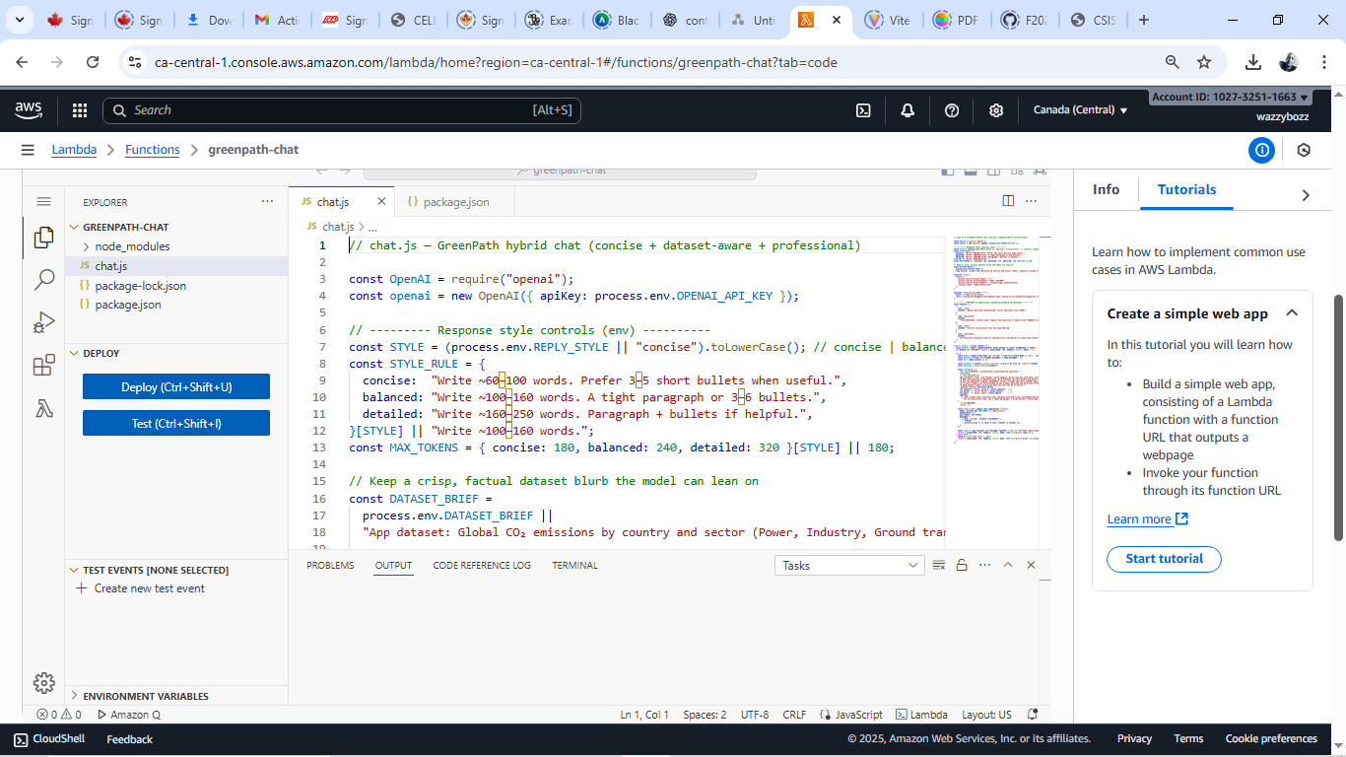

Figure 7.6(j): Lambda runtime configuration for the GreenPath chat function, highlighting Node.js runtime and chat.handler entry point.
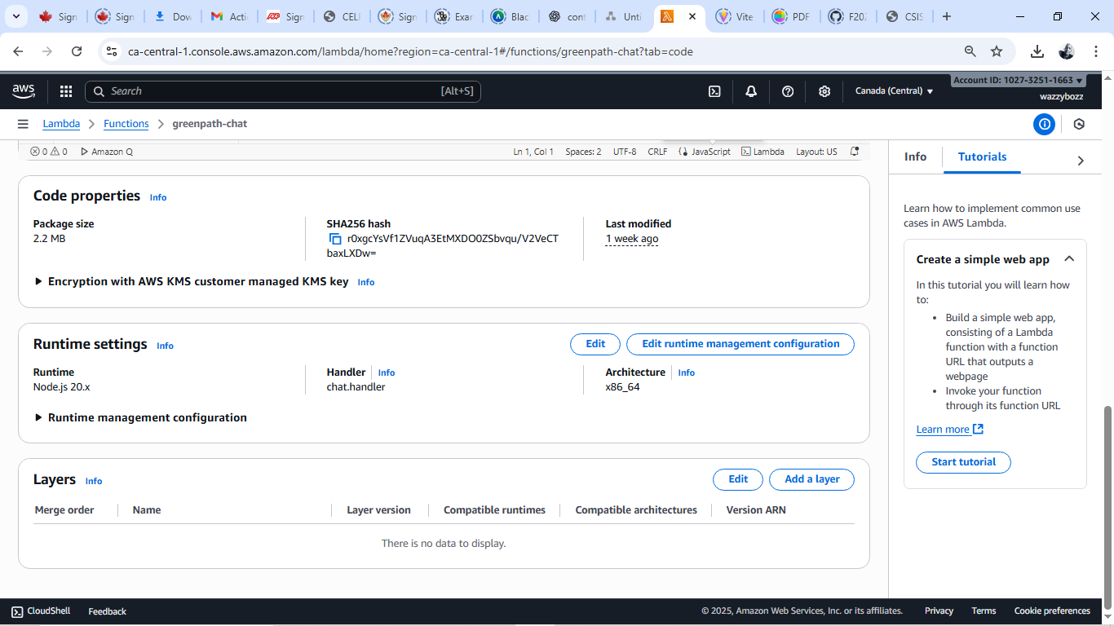

Figure 7.6(k): Lambda runtime configuration for the GreenPath chat function, highlighting Node.js runtime and chat.handler entry point.
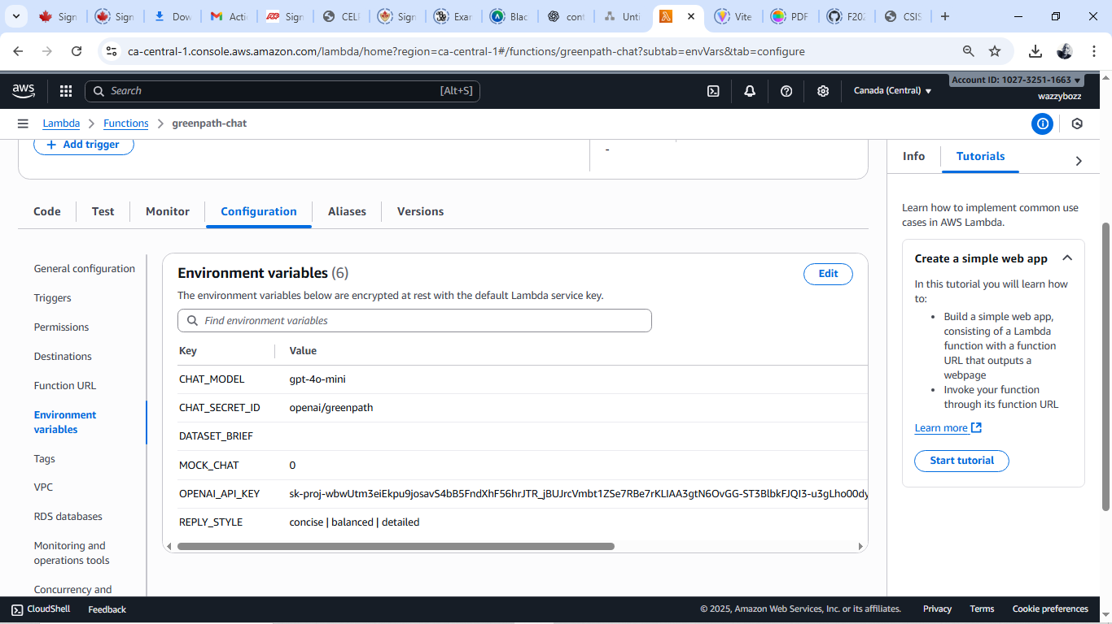
The AWS Lambda screenshots illustrate the backend logic that powers the GreenPath Chat Assistant. The first screenshot shows the chat.js Lambda handler, where the serverless function formats system prompts, manages response styles (concise, balanced, detailed), and embeds the sustainability dataset brief sent to the OpenAI model. The second screenshot displays the runtime configuration, confirming that the function runs on Node.js 20.x with the entry point set to chat.handler. The final screenshot shows the secure environment variables, including the OpenAI API key, model selection (gpt-4o-mini), dataset summary, and response-style settings. Together, these figures demonstrate how the serverless backend complements the chat.tsx front-end by handling message processing, securely storing credentials, and generating intelligent, dataset-aware responses.

8 Closing.
The GreenPath system demonstrates a complete, cloud-backed sustainability analytics platform that integrates data-driven insights with user-friendly design. Over the course of development, the project evolved from static informational pages into a dynamic analytical environment capable of processing real-world emission datasets, generating interpretable visualizations, and supporting meaningful user interaction through an AI-powered chat assistant. The introduction of machine-learning capabilities marks a significant step forward, enabling forecasting, anomaly detection, prediction, and clustering directly within the application workflow.
Beyond its technical achievements, GreenPath highlights the practical synergy between modern front-end engineering, scalable cloud infrastructure, and applied machine-learning concepts. These components collectively showcase how sustainability data can be transformed into accessible insights for education, awareness, and informed decision-making. Future enhancements, such as deeper model training, expanded datasets, and automated cloud-side inference, will further strengthen the platform’s analytical depth and reinforce its potential as a foundation for environmental decision-support systems

9 References.
W3C. Web Content Accessibility Guidelines (WCAG) 2.1. World Wide Web Consortium.
Google. Web Vitals and Lighthouse documentation. Google Developers.
Amazon Web Services. Amplify, API Gateway, Lambda, Amazon RDS for PostgreSQL, Secrets Manager, and CloudWatch service documentation.
OpenAI. API Documentation for text generation and chat completions.
Kaggle – CO₂ Emissions Dataset by Saloni1712. Retrieved from: https://www.kaggle.com/datasets/saloni1712/co2-emissions
Géron, A. (2022). Hands‑On Machine Learning with Scikit‑Learn, Keras, and TensorFlow (3rd ed.). O’Reilly Media.
Bishop, C. M. (2006). Pattern Recognition and Machine Learning Springer.
Sheehan, B., et al. (2020). The role of AI‑powered chatbots in health promotion: a scoping review. Journal of Medical Internet Research.

