Rio Weber - 10/6/2015

Project 4

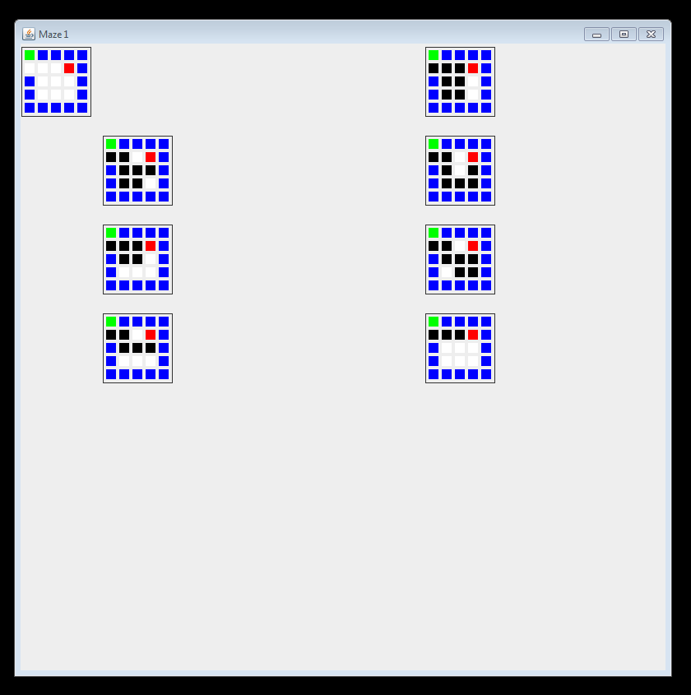Advanced Java – BU

Dr. Youmin Lu

**INPUT 1:**

b1111

000e1

10001

10001

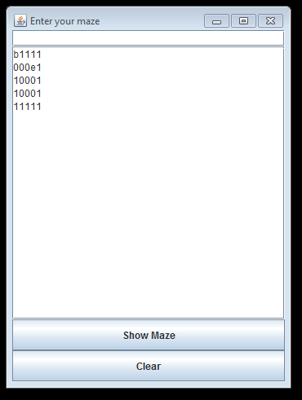11111

**OUTPUT:**

|  |  |  |
| --- | --- | --- |
| run:  0 : 0  ****  solution number: 1  S 1 1 1 1  p p p e 1  1 p p 0 1  1 p p 0 1  1 1 1 1 1  ****  solution number: 2  S 1 1 1 1  p p 0 e 1  1 p p p 1  1 p p 0 1  1 1 1 1 1 | ****  solution number: 3  S 1 1 1 1  p p 0 e 1  1 p 0 p 1  1 p p p 1  1 1 1 1 1  ****  solution number: 4  S 1 1 1 1  p p p e 1  1 p p 0 1  1 0 0 0 1  1 1 1 1 1  ****  solution number: 5  S 1 1 1 1  p p 0 e 1  1 p p p 1  1 0 p p 1  1 1 1 1 1 | ****  solution number: 6  S 1 1 1 1  p p 0 e 1  1 p p p 1  1 0 0 0 1  1 1 1 1 1  ****  solution number: 7  S 1 1 1 1  p p p e 1  1 0 0 0 1  1 0 0 0 1  1 1 1 1 1  8  BUILD SUCCESSFUL (total time: 3 seconds) |

**INPUT 2:**

b1111

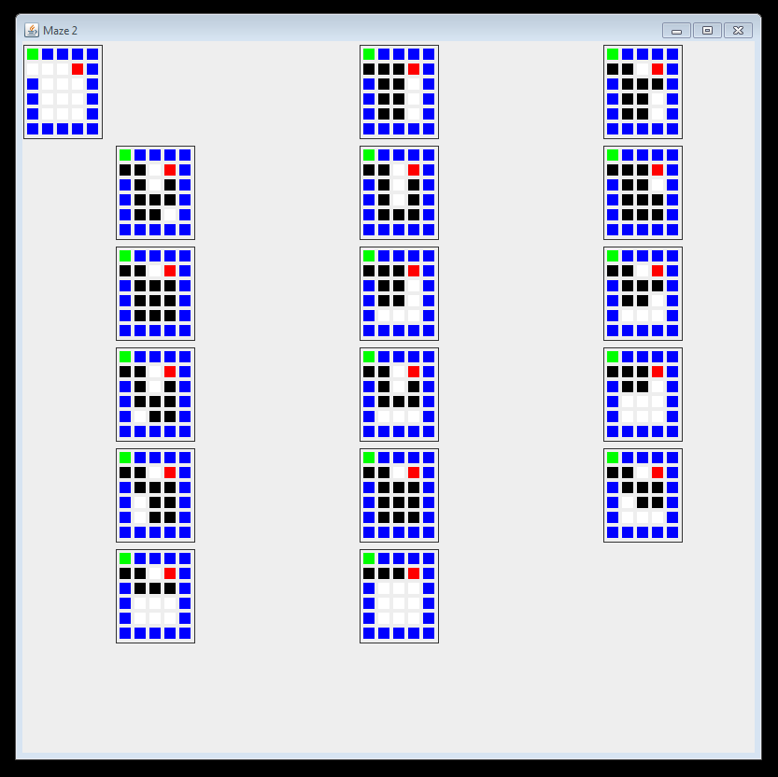000e1

10001

10001

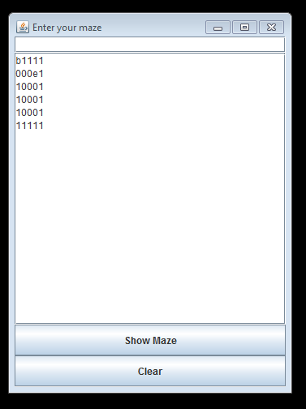11111

**OUTPUT:**

|  |  |  |  |  |
| --- | --- | --- | --- | --- |
| run:  0 : 0  ****  solution number: 1  S 1 1 1 1  p p p e 1  1 p p 0 1  1 p p 0 1  1 p p 0 1  1 1 1 1 1  ****  solution number: 2  S 1 1 1 1  p p 0 e 1  1 p p p 1  1 p p 0 1  1 p p 0 1  1 1 1 1 1  ****  solution number: 3  S 1 1 1 1  p p 0 e 1  1 p 0 p 1  1 p p p 1  1 p p 0 1  1 1 1 1 1 | ****  solution number: 4  S 1 1 1 1  p p 0 e 1  1 p 0 p 1  1 p 0 p 1  1 p p p 1  1 1 1 1 1  ****  solution number: 5  S 1 1 1 1  p p p e 1  1 p p 0 1  1 p p p 1  1 p p p 1  1 1 1 1 1  ****  solution number: 6  S 1 1 1 1  p p 0 e 1  1 p p p 1  1 p p p 1  1 p p p 1  1 1 1 1 1  ****  solution number: 7  S 1 1 1 1  p p p e 1  1 p p 0 1 | 1 p p 0 1  1 0 0 0 1  1 1 1 1 1  ****  solution number: 8  S 1 1 1 1  p p 0 e 1  1 p p p 1  1 p p 0 1  1 0 0 0 1  1 1 1 1 1  ****  solution number: 9  S 1 1 1 1  p p 0 e 1  1 p 0 p 1  1 p p p 1  1 0 p p 1  1 1 1 1 1  ****  solution number: 10  S 1 1 1 1  p p 0 e 1  1 p 0 p 1  1 p p p 1  1 0 0 0 1  1 1 1 1 1 | ****  solution number: 11  S 1 1 1 1  p p p e 1  1 p p 0 1  1 0 0 0 1  1 0 0 0 1  1 1 1 1 1  ****  solution number: 12  S 1 1 1 1  p p 0 e 1  1 p p p 1  1 0 p p 1  1 0 p p 1  1 1 1 1 1  ****  solution number: 13  S 1 1 1 1  p p 0 e 1  1 p p p 1  1 p p p 1  1 p p p 1  1 1 1 1 1  ****  solution number: 14  S 1 1 1 1  p p 0 e 1  1 p p p 1  1 0 p p 1  1 0 0 0 1  1 1 1 1 1 | ****  solution number: 15  S 1 1 1 1  p p 0 e 1  1 p p p 1  1 0 0 0 1  1 0 0 0 1  1 1 1 1 1  ****  solution number: 16  S 1 1 1 1  p p p e 1  1 0 0 0 1  1 0 0 0 1  1 0 0 0 1  1 1 1 1 1  17  BUILD SUCCESSFUL (total time: 16 seconds) |

**INPUT 3:**

11111111111

10000010001

10100010101 This one does not show them all because there are too many.

e0100000101

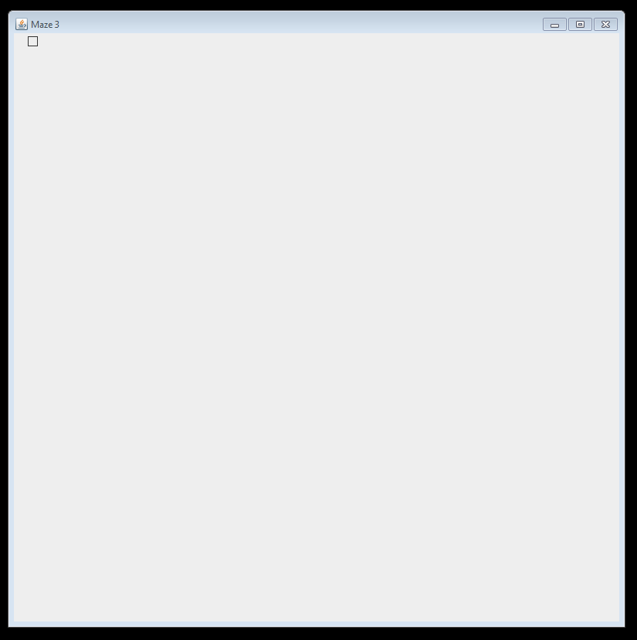10111110101

10101000101

10001010001

11111010001

101b1010001

10000010001

11111111111

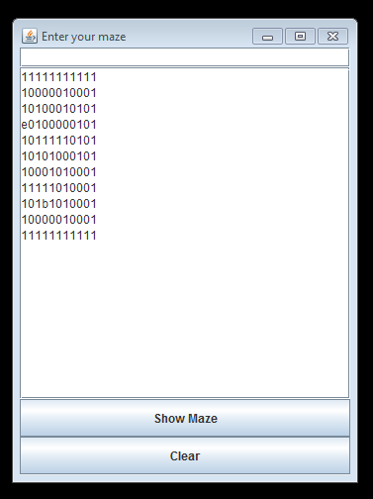

|  |  |  |
| --- | --- | --- |
| run:  8 : 3  ****  solution number: 1  1 1 1 1 1 1 1 1 1 1 1  1 p p p p p 1 0 0 0 1  1 p 1 p p p 1 0 1 0 1  e p 1 p p p p p 1 0 1  1 0 1 1 1 1 1 p 1 0 1  1 0 1 0 1 p p p 1 0 1  1 0 0 0 1 p 1 0 0 0 1  1 1 1 1 1 p 1 0 0 0 1  1 0 1 S 1 p 1 0 0 0 1  1 0 0 p p p 1 0 0 0 1  1 1 1 1 1 1 1 1 1 1 1  ****  solution number: 2  1 1 1 1 1 1 1 1 1 1 1  1 p p p p p 1 0 0 0 1  1 p 1 p p p 1 0 1 0 1  e p 1 0 0 p p p 1 0 1  1 0 1 1 1 1 1 p 1 0 1  1 0 1 0 1 p p p 1 0 1  1 0 0 0 1 p 1 0 0 0 1  1 1 1 1 1 p 1 0 0 0 1  1 0 1 S 1 p 1 0 0 0 1  1 0 0 p p p 1 0 0 0 1  1 1 1 1 1 1 1 1 1 1 1  ****  solution number: 3  1 1 1 1 1 1 1 1 1 1 1  1 p p p p p 1 0 0 0 1  1 p 1 0 0 p 1 0 1 0 1  e p 1 0 0 p p p 1 0 1  1 0 1 1 1 1 1 p 1 0 1  1 0 1 0 1 p p p 1 0 1  1 0 0 0 1 p 1 0 0 0 1  1 1 1 1 1 p 1 0 0 0 1  1 0 1 S 1 p 1 0 0 0 1  1 0 0 p p p 1 0 0 0 1  1 1 1 1 1 1 1 1 1 1 1  ****  solution number: 4  1 1 1 1 1 1 1 1 1 1 1  1 p p p p 0 1 0 0 0 1  1 p 1 0 p p 1 0 1 0 1  e p 1 0 0 p p p 1 0 1  1 0 1 1 1 1 1 p 1 0 1  1 0 1 0 1 p p p 1 0 1  1 0 0 0 1 p 1 0 0 0 1  1 1 1 1 1 p 1 0 0 0 1  1 0 1 S 1 p 1 0 0 0 1  1 0 0 p p p 1 0 0 0 1  1 1 1 1 1 1 1 1 1 1 1  ****  solution number: 5  1 1 1 1 1 1 1 1 1 1 1  1 p p p 0 0 1 0 0 0 1  1 p 1 p p p 1 0 1 0 1  e p 1 p p p p p 1 0 1  1 0 1 1 1 1 1 p 1 0 1  1 0 1 0 1 p p p 1 0 1  1 0 0 0 1 p 1 0 0 0 1  1 1 1 1 1 p 1 0 0 0 1  1 0 1 S 1 p 1 0 0 0 1  1 0 0 p p p 1 0 0 0 1  1 1 1 1 1 1 1 1 1 1 1 | ****  solution number: 148  1 1 1 1 1 1 1 1 1 1 1  1 p p p p 0 1 p p p 1  1 p 1 0 p p 1 p 1 p 1  e p 1 0 0 p p p 1 p 1  1 0 1 1 1 1 1 0 1 p 1  1 0 1 0 1 p p p 1 p 1  1 0 0 0 1 p 1 p p p 1  1 1 1 1 1 p 1 p p p 1  1 0 1 S 1 p 1 p p p 1  1 0 0 p p p 1 0 p p 1  1 1 1 1 1 1 1 1 1 1 1  ****  solution number: 149  1 1 1 1 1 1 1 1 1 1 1  1 p p p 0 0 1 p p p 1  1 p 1 p p p 1 p 1 p 1  e p 1 p p p p p 1 p 1  1 0 1 1 1 1 1 0 1 p 1  1 0 1 0 1 p p p 1 p 1  1 0 0 0 1 p 1 p p p 1  1 1 1 1 1 p 1 p p p 1  1 0 1 S 1 p 1 p p p 1  1 0 0 p p p 1 0 p p 1  1 1 1 1 1 1 1 1 1 1 1  ****  solution number: 150  1 1 1 1 1 1 1 1 1 1 1  1 p p p 0 0 1 p p p 1  1 p 1 p p p 1 p 1 p 1  e p 1 0 0 p p p 1 p 1  1 0 1 1 1 1 1 0 1 p 1  1 0 1 0 1 p p p 1 p 1  1 0 0 0 1 p 1 p p p 1  1 1 1 1 1 p 1 p p p 1  1 0 1 S 1 p 1 p p p 1  1 0 0 p p p 1 0 p p 1  1 1 1 1 1 1 1 1 1 1 1  ****  solution number: 151  1 1 1 1 1 1 1 1 1 1 1  1 p p p p 0 1 p p p 1  1 p 1 0 p 0 1 p 1 p 1  e p 1 0 p p p p 1 p 1  1 0 1 1 1 1 1 0 1 p 1  1 0 1 0 1 p p p 1 p 1  1 0 0 0 1 p 1 p p p 1  1 1 1 1 1 p 1 p p p 1  1 0 1 S 1 p 1 p p p 1  1 0 0 p p p 1 0 p p 1  1 1 1 1 1 1 1 1 1 1 1  ****  solution number: 152  1 1 1 1 1 1 1 1 1 1 1  1 p p p 0 0 1 p p p 1  1 p 1 p p 0 1 p 1 p 1  e p 1 0 p p p p 1 p 1  1 0 1 1 1 1 1 0 1 p 1  1 0 1 0 1 p p p 1 p 1  1 0 0 0 1 p 1 p p p 1  1 1 1 1 1 p 1 p p p 1  1 0 1 S 1 p 1 p p p 1  1 0 0 p p p 1 0 p p 1  1 1 1 1 1 1 1 1 1 1 1 | ****  solution number: 344  1 1 1 1 1 1 1 1 1 1 1  1 p p p 0 0 1 p p p 1  1 p 1 p p 0 1 p 1 p 1  e p 1 0 p p p p 1 p 1  1 0 1 1 1 1 1 0 1 p 1  1 0 1 0 1 p p p 1 p 1  1 0 0 0 1 p 1 p p p 1  1 1 1 1 1 p 1 0 0 0 1  1 0 1 S 1 p 1 0 0 0 1  1 0 0 p p p 1 0 0 0 1  1 1 1 1 1 1 1 1 1 1 1  ****  solution number: 345  1 1 1 1 1 1 1 1 1 1 1  1 p p p p p 1 p p p 1  1 p 1 0 p p 1 p 1 p 1  e p 1 0 p p p p 1 p 1  1 0 1 1 1 1 1 0 1 p 1  1 0 1 0 1 p p p 1 p 1  1 0 0 0 1 p 1 p p p 1  1 1 1 1 1 p 1 0 0 0 1  1 0 1 S 1 p 1 0 0 0 1  1 0 0 p p p 1 0 0 0 1  1 1 1 1 1 1 1 1 1 1 1  ****  solution number: 346  1 1 1 1 1 1 1 1 1 1 1  1 p p p 0 0 1 p p p 1  1 p 1 p 0 0 1 p 1 p 1  e p 1 p p p p p 1 p 1  1 0 1 1 1 1 1 0 1 p 1  1 0 1 0 1 p p p 1 p 1  1 0 0 0 1 p 1 p p p 1  1 1 1 1 1 p 1 0 0 0 1  1 0 1 S 1 p 1 0 0 0 1  1 0 0 p p p 1 0 0 0 1  1 1 1 1 1 1 1 1 1 1 1  ****  solution number: 347  1 1 1 1 1 1 1 1 1 1 1  1 p p p p 0 1 p p p 1  1 p 1 p p 0 1 p 1 p 1  e p 1 p p p p p 1 p 1  1 0 1 1 1 1 1 0 1 p 1  1 0 1 0 1 p p p 1 p 1  1 0 0 0 1 p 1 p p p 1  1 1 1 1 1 p 1 0 0 0 1  1 0 1 S 1 p 1 0 0 0 1  1 0 0 p p p 1 0 0 0 1  1 1 1 1 1 1 1 1 1 1 1  ****  solution number: 348  1 1 1 1 1 1 1 1 1 1 1  1 p p p p p 1 p p p 1  1 p 1 p p p 1 p 1 p 1  e p 1 p p p p p 1 p 1  1 0 1 1 1 1 1 0 1 p 1  1 0 1 0 1 p p p 1 p 1  1 0 0 0 1 p 1 p p p 1  1 1 1 1 1 p 1 0 0 0 1  1 0 1 S 1 p 1 0 0 0 1  1 0 0 p p p 1 0 0 0 1  1 1 1 1 1 1 1 1 1 1 1  349  BUILD SUCCESSFUL (total time: 18 seconds) |