
PRODUCT GUIDE / NOVEMBER 2026

AlignSynch Logged In Webapp User Guide
  - Screens, member journeys, and what happens behind the page
A practical guide to the member workspace and restricted staff areas. It explains what people see, what to do next, and how AlignSynch handles each step behind the scenes.
Prepared from the signed-in dashboard view, supplied screen captures, local desktop/mobile QA captures, the route inventory, and a read-only review of application services. The records shown in these captures are demo data.
1 Choose | 2 Invite | 3 Compare | 4 Discuss
Pick a Relationship Template and create a private copy. | Publish when ready and invite the other person to their seat. | Both people answer the same Aspects privately and accept. | Review the shared Gap and work through suggested Steps.

Intended reader. A member using AlignSynch for a personal or business relationship, plus staff who need to understand the restricted support and administration pages.
Scope. This guide covers the logged-in AlignSynch workspace and the invitation and assessment screens that complete its main journey. It excludes QuizHub, public marketing pages, and API endpoints.
Evidence labels. “On screen” describes visible controls from the screen captures. “Behind the page” describes behavior found in the current application routes and services. Where the UI and service code do not agree, the guide calls that out for confirmation.
GUIDE MAP

Start here
Use the headings in Word’s navigation pane to jump between topics. Member pages come first, followed by staff-only operations and a route index.
Part | What it covers
1. Member workspace | Overview, My Relationships, Templates, setup, invitation, answers, acceptance, shared report, help, account settings.
2. Staff workspace | Console, registries, relationship operations, gaps, inbox, health, billing, broadcast, review, audit.
3. Reference | Login and recovery screens, route index, status meanings, privacy notes, and terms.

The relationship journey
A Relationship is a shared workspace for two people. It starts from a template, then moves through setup, invitation, two private answer sheets, an explicit acceptance from each person, and a shared report. The report may include suggested Steps for the pair to work on.
Choose | Configure | Publish | Answer | Accept | Review
Template and roles | Name, mode, setting, Aspects | Invite the counterparty | Each person privately answers | Both confirm readiness | Shared comparison and Steps

Privacy at the center. A participant sees their own answers while answering. The other person’s answer sheet is withheld until both answer and explicitly accept the shared result.
Two surfaces. Member-facing pages help people create, answer, and discuss. Staff pages are role-gated and support operational work such as inbox handling, health checks, billing records, and audit review.
MEMBER WORKSPACE

Overview and shared navigation
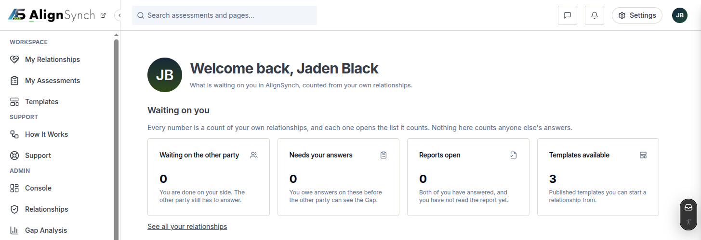
Figure 1. Signed-in overview with demo account data.
ON SCREEN
The top bar keeps global search, messages, notifications, settings, and the account menu available. The side navigation groups the member’s workspace, support links, and any staff tools enabled for that account. Overview is a post-login landing page, even though it is not a row in the side rail.
WHAT THE SUMMARY MEANS
- Waiting on the other party: relationships where you have finished your side and the other person still has work to do.
- Needs your answers: relationships where you still owe answers before a shared report can open.
- Reports open: completed relationships whose shared report is available for you to read.
- Templates available: published starting templates you can use to begin a relationship.
BEHIND THE PAGE
Counts are calculated from relationships connected to the signed-in member. Each count links into the relevant list; it is not a count of other people’s private answers. A first-run tour can show the answer-sheet flow using a demo path, and the member can replay it from How It Works.
Good next step. If you are new, open Templates to choose a starting point. If you have been invited, open My Assessments or follow the invitation link.
MEMBER WORKSPACE

My Relationships
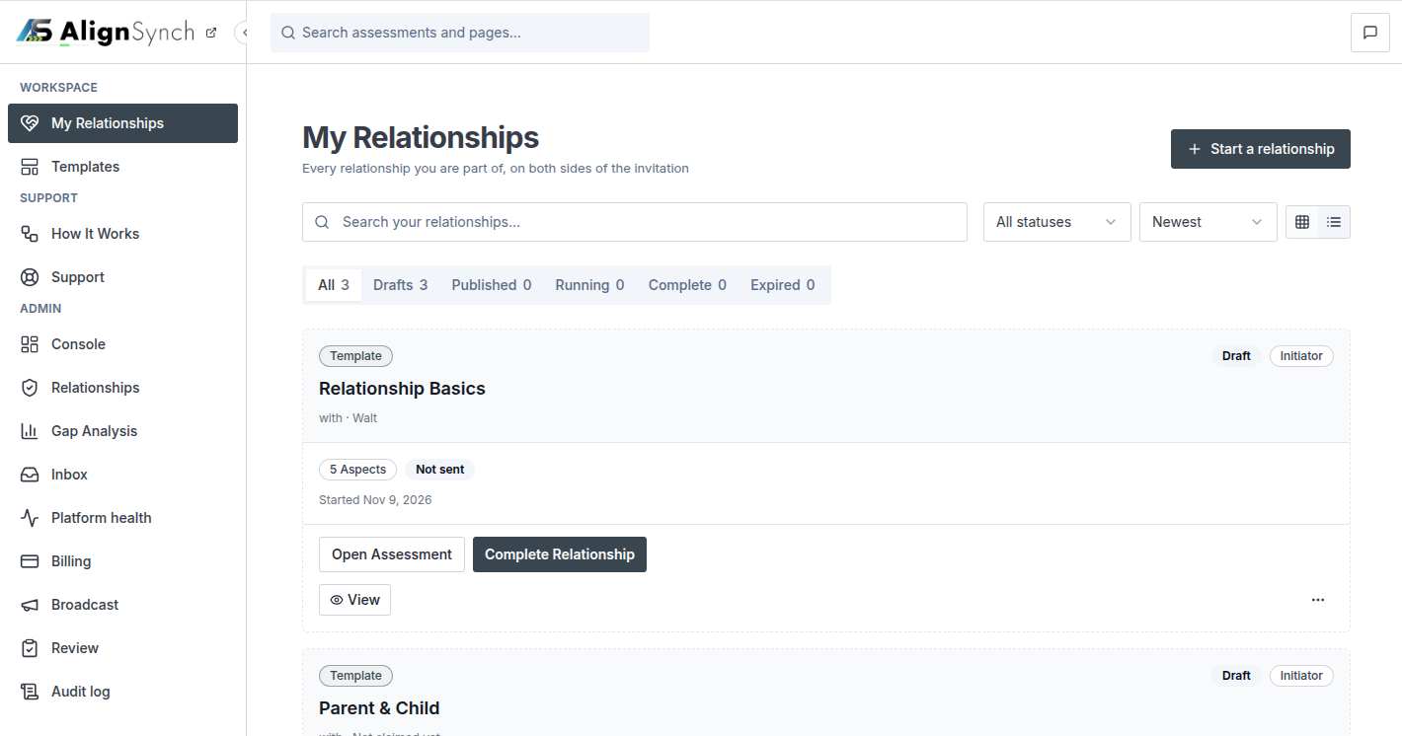
Figure 2. Relationship list with search, lifecycle filters, and card actions.
ON SCREEN
Use search, status tabs, sorting, and grid/list controls to find a relationship. Each card identifies its template, status, role, counterparty state, Aspect count, and available actions. Start a relationship opens the template picker.
Status | What it tells you | Typical next action
Draft | You are still preparing it; no active answer session is underway. | Open the relationship, adjust the setup, then publish when ready.
Published | The other person has been invited or the invitation is awaiting a claim. | Wait for the other person or reissue an expired invitation.
Running | The shared assessment is in progress. | Open your answer sheet or check whether the other person has acted.
Complete | Both people answered and accepted; the shared report is available. | Open the report and work through the Steps.
Expired | The workflow has passed its available period or is no longer active. | Open the relationship to see any permitted recovery action.

MEMBER WORKSPACE

Relationship list ownership and privacy

Behind the page
The list includes relationships you initiated or where you occupy a participant seat. Search, filters, sort order, and grid/list choice affect only the view; opening a card loads relationship detail after the server checks that your account belongs to that relationship.

Choose the right place
My Relationships | My Assessments
Use this list to manage the relationship record, template copy, invitation, and overall lifecycle. | Use this list to find your answer sheet, see whether the other person has acted, and open a report when it is ready.

Privacy. A relationship card can show the counterparty name and invitation state, but not their answers. A report stays unavailable until both participants finish and accept.

Card actions depend on the stage
A draft card points back to setup. A published relationship can show invitation and assessment actions. A completed relationship can open its shared report. When an invitation has expired, the detail page may offer a reissue action if the seat is still unclaimed.
MEMBER WORKSPACE

Templates catalogue and My Templates
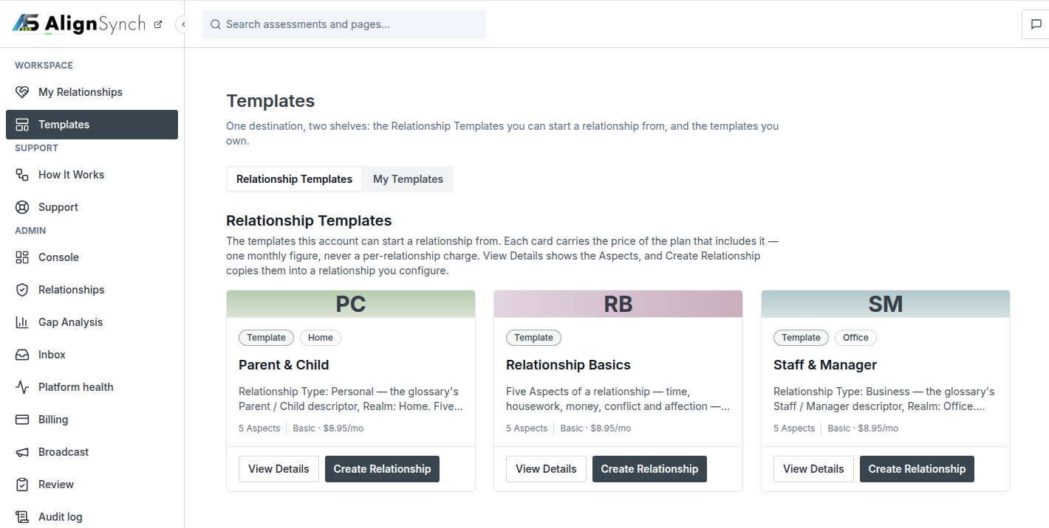
Figure 3. Catalogue cards show the relationship type, realm, Aspect count, plan cue, and actions.
ON SCREEN
The Templates page has two URL-backed shelves: Relationship Templates (published catalogue) and My Templates (templates you own or have copied). Cards help compare the relationship type, role labels, number of Aspects, and any plan information. Search or browse the available relationship areas when the catalogue controls are present.
Shelf | What it contains | Available actions
Relationship Templates | Published starting templates such as Parent & Child, Relationship Basics, and Staff & Manager. | View Details; start a relationship from the template.
My Templates | Private templates you own or have adopted for later use. | Open, edit, duplicate, archive or delete where allowed; create a private template.

BEHIND THE PAGE
Choosing a catalogue template does not purchase the template. Creating a relationship copies the selected template and its Aspects into a new relationship so later template edits do not silently change an active assessment. The plan figure shown on a card is a plan cue; it is not necessarily a per-relationship charge.
Good next step. Open Details before starting if you need to confirm the roles, intended audience, Aspect wording, and scale endpoints.
MEMBER WORKSPACE

Template detail
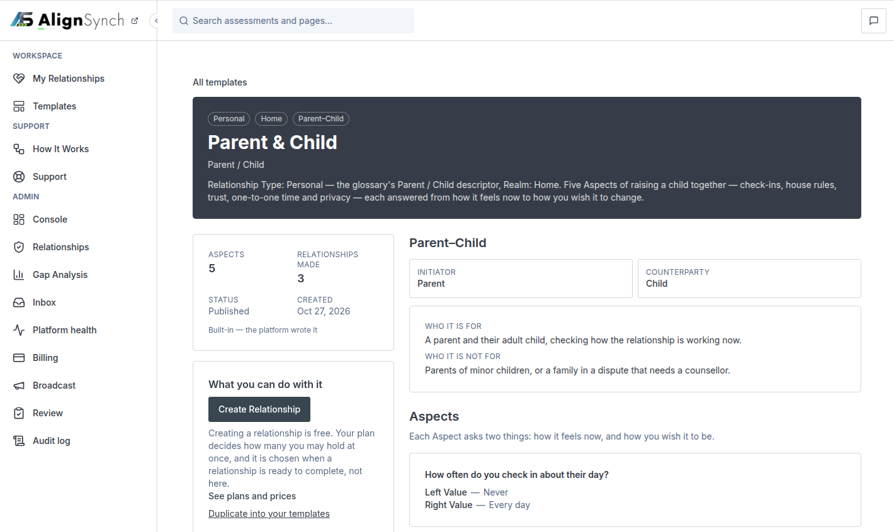
Figure 4. Template detail explains intended use, participant roles, and Aspect examples.
ON SCREEN
The detail page provides the template’s identity and realm, participant roles, who it is for and not for, the Aspect count, and the ordered questions with their low and high endpoints. The action area explains what creating a relationship or duplicating the template will do.
BEHIND THE PAGE
Template details are read-only for a built-in catalogue item. A member can create a relationship from it or duplicate it into a private template before changing its wording. The detail page is the best place to check whether the template fits the relationship before inviting anyone.
Interpret the scale. Each Aspect asks how something feels now and how the participant wishes it to be. The scale endpoints describe the direction of the answer; they are not a diagnosis or a verdict.
MEMBER WORKSPACE

Starting a relationship

The current member path
From My Relationships, choose Start a relationship and select a published template. The application creates a private relationship copy and a draft. The initiator can then review the title, the two roles, the mode and setting, and the copied Aspects before publishing.
Step | Member action | Behind the page
1. Choose | Pick the relationship type that best fits the two people. | The service verifies that the template is available to the member.
2. Name and assign | Give the relationship a recognizable label and confirm which role is yours. | The relationship’s initiator seat is created for the signed-in member.
3. Set context | Choose the mode and setting when requested. | These values are stored with the relationship context.
4. Review Aspects | Keep, edit, or remove questions where editing is offered. | A version snapshot binds the relationship to its selected wording.
5. Save draft | Save the setup before asking anyone to join. | The template and Aspects are copied into the relationship; no invitation session is opened yet.

Two creation surfaces exist
The current logged-in My Relationships page uses a template picker and the newer private-copy flow. The route tree also retains a five-stage legacy wizard under /templates/relationship/[slug]/create. Its screens include naming/roles, mode/setting, Aspect review, sign-in/review, and plan/send choices. Treat that wizard as an alternate or legacy entry until product owners confirm that it is the active default.
Before moving on. Check that the relationship title makes sense to both people and that the participant roles are assigned correctly. The initiator is also the payer in the current billing model.
MEMBER WORKSPACE

Relationship detail and invitation setup

What the detail page organizes
Relationship detail is the home for one relationship. It brings together the template copy, current status, two participant seats, Aspect setup, invitation state, answer progress, and the actions available to the current role.
Area | What the member can do | Behind the page
Setup | Edit relationship details and Aspects while still in an editable state. | Saving records the current content and the template version used.
Participants | Confirm your role and the counterparty seat/contact information. | The server resolves the viewer as a participant before returning private data.
Invitation | Enter the other person’s details and publish when the relationship is ready. | Publishing opens the assessment session and issues a signed, expiring invitation token.
Progress | See sent/claimed state and answer progress. | Progress is derived from the two party seats and their answer/acceptance state.
After completion | Open the report and, where allowed, save/fork a template. | The completed relationship is kept as the record; template actions create a separate reusable copy.

Publish and reissue
Publishing changes a draft into an active invitation. The invitation link is shown once; the system keeps a hash of the token rather than a recoverable raw link. Links expire after seven days. If an unclaimed invitation expires or is revoked, the initiator may be able to reissue it from detail.
Mail outcome. Publication is committed before email delivery is attempted. If the email attempt fails, the relationship remains published and the app provides a recovery/reissue path; the initiator should check the invitation status rather than assume the relationship was rolled back.
MEMBER JOURNEY

Invitation and counterparty claim

What the invited person sees
Opening /invite/[token] previews the relationship and the role they are being invited to claim. Opening the link alone does not claim the seat. The invitee reviews the request, confirms the action, and may be asked to sign in or create an account before joining.

Behind the page
- The invitation must still be within its expiry window and must not already have been claimed.
- The claim action checks that the counterparty seat is free; only the first valid claim can occupy it.
- A signed-in user is bound to the participant seat. A party session can also be established for a person who is not yet signed in, depending on the route state.
- The invitation token is single use. After claim, the app establishes the party context and sends a join notice.

If the link does not work
Check that the invitation has not expired, that it has not already been used, and that the invited person has completed the confirmation step. Ask the initiator to reissue the invitation if recovery is available. Never forward a private invitation link to anyone other than the intended counterparty.
MEMBER WORKSPACE

My Assessments and the private answer sheet

My Assessments /assessments
This page collects assessment sessions tied to the signed-in member. Search, lifecycle filters, sort, and grid/list controls help separate work that is yours to answer, work waiting on the other person, and completed sessions. Cards link to the session, originating template, relationship detail, or the report when it is open.

Answer sheet /assessment/instances/[id]/answer
The answer sheet presents the relationship context and one question per Aspect. Choose where the relationship feels now and where you wish it to be, then save or submit when the sheet is complete. Each participant answers the same set privately.
What you can see | What remains private
Your own choices, your progress, and whether you have finished your sheet. | The other person’s per-Aspect answers remain hidden until both people have answered and accepted.
The relationship name, template context, and your participant role. | The other party cannot edit your answer sheet or impersonate your role.

Behind the page
Answers are stored per Aspect and participant seat. The server resolves the participant role for each request, so the browser cannot switch into the other person’s seat simply by changing a page parameter. Each Aspect must be answered before the member can accept their sheet.
Editing. A participant can revise their own sheet until accepting it. After acceptance, the acceptance marker records that the person is ready for the shared comparison.
MEMBER JOURNEY

Acceptance, shared report, and Steps

Acceptance screen /assessment/instances/[id]/accept
After completing all Aspects, review your own progress and choose Accept when you are ready for the shared result. Acceptance is explicit: finishing the answers alone does not open the report.

The two-person gate
First person accepts | Second person accepts
The app records your accepted state. Your private sheet remains separate while the other person completes and accepts theirs. | The server finalizes the relationship, derives the shared comparison, sends the report-unlocked notice, and opens the report for both participants.

Shared report /assessment/instances/[id]/report
The report compares both participants’ opinions by Aspect and presents the differences that can guide a conversation. A person who is not one of the participants cannot open it. Before both accept, the report remains locked.

Steps
After the second acceptance, the app derives relationship Steps from the results. Members can mark a Step open or done or reword it to fit their situation. The current member flow does not let someone directly create or close a Step outside those supported actions.
Keep the conversation constructive. Use the report to compare understanding and wishes, not to label either person as right or wrong. The shared result is a starting point for discussion.
MEMBER WORKSPACE

How It Works and Support
Page | Purpose | Available actions
How It Works /dashboard/help | Explain the relationship flow and introduce the assessment model. | Review the guide content; replay the onboarding tour, which returns to Overview.
Support /dashboard/support | Search help topics or contact the AlignSynch team from inside the workspace. | Browse help entries, submit a contact request, and review support content.
Support article /dashboard/support/articles/[slug] | Read one help article without leaving the signed-in shell. | Use breadcrumbs and related links to browse more help.

Behind the page
Support contact details are associated with the signed-in account. The app validates and throttles submissions, stores the request, and then attempts to notify the support team. A failed email delivery does not erase the stored request. Signed-in users are routed to account support; signed-out visitors use the public help route.
When contacting support. Include the page name, what you expected to happen, and the time it occurred. Do not include passwords, invitation tokens, or another person’s private answers.
MEMBER WORKSPACE

Account settings and sign-in

Settings /settings
Profile settings let you update display name, public handle, biography, and country. The page also shows the signed-in email address, password controls, sign-out, and a delete-account confirmation. Email is read-only in the profile form.

Account access screens
Route | Purpose | What happens behind the page
/login | Sign in with the account’s available methods. | A safe same-site return destination can send the member back to the intended workflow.
/register | Create a new account and continue to the original task. | The registration flow returns to the requested destination where possible.
/forgot-password | Request a password reset. | Requests are rate limited; the page communicates a general result.
/reset/[token] | Choose a new password from a reset link. | The token may be valid, expired, used, or unavailable; completion revokes other sessions.
/reset/complete | Confirm the password change. | The user receives a completion state after password and session handling.

Privacy and deletion
Account deletion requires a typed confirmation phrase. The delete action removes the managed-auth account and scrubs associated records as implemented by the service. Consider saving any information you need before confirming deletion.
RESTRICTED STAFF PAGES

Staff workspace and role access
The side rail adds staff links only when the signed-in role permits them. These screens are not part of the standard member journey. Support staff receive inbox access; administrators and owners can see broader operations pages.
Role group | Typical visible areas | What access means
Member | My Relationships, My Assessments, Templates, How It Works, Support. | Can manage only relationships and participant seats linked to their account.
Support | Member support plus Inbox and report-support tools where enabled. | Can investigate support requests and specific report operations under restricted rules.
Admin / owner | Console, relationship operations, Gap Analysis, Health, Billing, Broadcast, Review, Audit. | Can inspect operational records; write actions require additional role checks and are logged.

Behind the page
Admin routes check role access before loading protected records. Mutating actions use the application’s audited action path and append an admin-action record. Seeing a page does not imply every action on that page is permitted; specific buttons may require a stronger role.
Support professionals. The current route set does not provide a standard counselor/therapist/coach assignment workflow. Staff access is operational support, not a practitioner management platform.
RESTRICTED STAFF PAGES

Console and staff registries
Screen and route | What the user does | Behind the page
Console /admin/console | Staff landing page and links to operational registries. | Role gate runs before registry reads.
Users /admin/console/users | Inspect account records and open user context. | Registry view; current UI is not a member profile editor.
Templates /admin/console/templates and /[id] | Inspect built-in template records and their use. | Separate console surface; template enable/disable actions have admin restrictions.
Relationships /admin/console/relationships and /[id] | Inspect operational relationship records, participant seats, and subscription/session state. | Archive/restore actions are audited and remain distinct from member editing.

How to use staff lists
Search and filtering reduce the list before opening a detail record. Confirm the entity type and current lifecycle stage before taking action: a Relationship is the shared workspace, while an assessment instance is the answer session attached to it.
Operational caution. Console records and current database-backed operations pages are two different staff surfaces. Use the route appropriate to the task, and confirm the record’s identity before making a change.
RESTRICTED STAFF PAGES

Instances and report operations
Screen and route | What the user does | Behind the page
Instances /admin/instances | Find relationship assessment sessions by mode, setting, lifecycle stage, or stalled state. | The list supports operational diagnosis rather than member self-service.
Instance detail /admin/instances/[id] | Inspect the session, participant seats, and state; review a safe edit preview. | Repairs are gated and audited; available actions can include seat, email, or session-state corrections.
Report operations /admin/instances/[id]/report | Support staff review report availability and resolve specific report issues. | Answer reads require the applicable PII permission; repair or reissue actions are audited.

Safe support sequence
- Confirm the member and relationship context before opening a record.
- Inspect the current lifecycle stage and participant-seat state.
- Use preview or read-only diagnosis before choosing a repair.
- Explain the impact to the member and record the support outcome.
RESTRICTED STAFF PAGES

Gap Analysis
/admin/gaps presents aggregate relationship-pattern information: population counts, distributions, and guidance for reading the results. It is an analytics surface for authorized staff, not a member-facing diagnosis page.

What it is for
- Understand broad patterns across completed relationship data.
- Review counts and distributions before discussing trends with the product or support team.
- Spot whether data coverage or small sample sizes could affect how a pattern should be interpreted.

Behind the page
The route reads aggregate information and is designed as a read-only analytics view. Use the displayed population and context before drawing conclusions; a summary pattern does not describe any one person’s answers or explain why a relationship differs.
For members. The shared report is the right place to review one relationship’s Gap. The admin Gap Analysis page is not part of the member’s private workspace.
RESTRICTED SUPPORT PAGE

Support inbox
/admin/inbox gives support staff a queue of member contact requests and a detail view for handling them. The interface supports the team’s inbox workflow, such as reviewing a message and updating its handling state or response where available.

Behind the page
Contact requests are stored before notification email is attempted. Inbox reads and updates are restricted to support roles and operational changes are audited. The member-facing support page re-reads the thread using the signed-in email scope.

Member outcome
After submitting, keep the confirmation on screen and note any reference details presented. If a reply is needed, use the same account email so support can associate the conversation with the right workspace.
Handle private data carefully. Do not copy answer-sheet details into general support notes unless the support task requires it and your role permits access.
RESTRICTED STAFF PAGES

Platform health and Billing

Platform health /admin/health
The health page brings together source freshness, database checks, release/gate state, and diagnostic links. It helps staff distinguish a stale data feed from a blocked release or an application issue. Use linked details to identify the source of a problem before escalating.

Billing /admin/billing
Billing shows plan, source, status, and compensation/entitlement records. Authorized staff can apply an adjustment such as a grant, compensation, or extension. Billing changes affect the member’s entitlement and must follow the role checks and audit trail.

What the member charging flow does
The current service creates a relationship payment obligation with the initiator as payer. Fee capture is connected to relationship completion after both people accept. Provider capture is idempotent and records an attempt and audit history. A hosted or embedded payment step can resolve a provider session when a method is needed.

Product behavior to confirm
The relationship detail UI hides publish controls unless a payment method exists and directs members to Pricing. The publish service itself states that publishing does not bill and does not enforce that same payment-method gate. The service code places the charge at completion, and old comments referring to a publish-time trial are stale. Confirm the intended member experience before treating a publish/payment sequence as guaranteed.
RESTRICTED STAFF PAGES

Broadcast, Review, and Audit
Screen and route | What the user does | Behind the page
Broadcast /admin/broadcast | Compose a one-off notice, preview its audience and recipient count, inspect history, then send. | Sending is elevated and creates an audit entry; confirm audience and copy before sending.
Review /admin/review | Review shipped artifacts, preview content, check off tasks, and track feedback issues. | Issue-state changes are saved as review records.
Audit /admin/audit | Filter admin actions by actor, action, or target and inspect change metadata. | Read-only history of logged staff operations; useful for tracing what changed and by whom.

Before a staff action
For broadcasts, verify recipients and timing. For operational changes, capture the reason and expected member effect. For audit review, search by the affected record or staff actor and compare the action history with the current record state.
REFERENCE

Route index for member work
These screens support the primary logged-in relationship journey. Some assessment and invitation pages are opened from a card or a private link rather than the navigation rail.
Route | Page or purpose | Access / note
/dashboard | Post-login Overview. | Member home; not a side-rail row.
/dashboard/relationships | My Relationships list and relationship start picker. | Member-scoped.
/dashboard/relationships/[id] | One relationship’s setup, invitation, progress, and report actions. | Participant ownership is checked.
/assessments | My Assessments list. | Signed-in member.
/assessment/instances/[id] | Assessment status and next action. | Participant or valid party context.
/assessment/instances/[id]/answer | Private answer sheet. | Own participant seat only.
/assessment/instances/[id]/accept | Acceptance/progress confirmation. | Own participant seat only.
/assessment/instances/[id]/report | Shared comparison. | Locked until both accept.
/assessment/instances/[id]/sent | Invitation send/result state. | Recovery and result view.
/invite/[token] | Invitation preview and counterparty claim. | Unclaimed, valid token required.

REFERENCE

Route index for templates and account
These routes help members select, inspect, and reuse templates, find support, or recover account access.
Route | Page or purpose | Access / note
/dashboard/templates?tab=catalogue | Published Relationship Templates. | Default Templates shelf.
/dashboard/templates?tab=mine | My Templates. | Member-owned/adopted templates.
/dashboard/templates/[id] | Private template view or editor. | Owner editing; copy rules apply.
/templates/relationship | Alternate template library. | Legacy/alternate catalogue.
/templates/relationship/[slug] | Template details. | Read-only catalogue data.
/templates/relationship/new | Create a blank private template. | Member authoring route.
/templates/relationship/[slug]/create | Five-stage relationship creation wizard. | Alternate/legacy entry; dashboard picker is current default.
/dashboard/help | How It Works. | Replay tour returns to Overview.
/dashboard/support | Account support. | Signed-in contact flow.
/dashboard/support/articles/[slug] | One support article. | Within signed-in shell.
/settings | Account profile, password, deletion. | Email is read-only here.
/login, /register | Sign-in and account creation. | Safe return destination where available.
/forgot-password, /reset/[token], /reset/complete | Password recovery and completion. | Tokens expire and can be used once.

Redirects and exclusions
/assessment/instances redirects to My Assessments, /dashboard/library redirects to Templates, and /support routes signed-in users to account support. QuizHub pages such as /dashboard/user belong to a separate product area and are excluded from this guide.
REFERENCE

Route index for staff operations
Staff routes are role-gated. They do not appear in every member’s navigation.
Route | Page or purpose
/admin/console | Staff operations landing page.
/admin/console/users | Account registry.
/admin/console/templates and /[id] | Built-in template registry and detail.
/admin/console/relationships and /[id] | Relationship registry and detail.
/admin/instances | Assessment-session operations list.
/admin/instances/[id] | Session detail, safe edit preview, and audited repairs.
/admin/instances/[id]/report | Restricted report support and repair actions.
/admin/gaps | Aggregate relationship-pattern analysis.
/admin/inbox | Support request queue and detail.
/admin/health | Release, source, database, and diagnostic status.
/admin/billing | Plan and entitlement records.
/admin/broadcast | One-off member notice workflow.
/admin/review | Artifact review and feedback tracking.
/admin/audit | Searchable admin action history.

REFERENCE

Status guide, privacy, and terms

How to read the shared result
An Aspect is a topic the two participants answer. Each participant records their own view and wish. The shared report compares those two opinions only after both participants accept. A Gap describes a difference between answers; it is a prompt for discussion, not proof of fault.

Terms used in the app
Term | Plain-language meaning
Relationship | The shared workspace for two people and the relationship they are reviewing.
Relationship Template | A reusable starting pattern containing role labels and Aspects.
Aspect | One topic or question to consider, with scale endpoints that describe a range.
Party / participant seat | One of the two roles in a relationship, such as initiator or counterparty.
Assessment session | The active answer process attached to a relationship.
Opinion | One participant’s answer to one Aspect.
Accept | A participant’s explicit confirmation that their sheet is ready for comparison.
Gap | A difference between two people’s answers in the shared report.
Step | A suggested follow-up action derived when both participants complete acceptance.
Mode and setting | Context selections captured during relationship setup when offered.

Privacy reminders
- Do not share an invitation link; it is intended for one counterparty and expires.
- Your answer sheet is private until both people have answered and accepted.
- The report is available to the two participants after the two-person acceptance gate.
- Staff access is role-gated and recorded; members should not expect admin pages in their workspace.
- Use support for access or workflow problems, not to request another person’s private answers.
REFERENCE

Known behavior and practical help

Current system details to keep in mind
- A relationship starts from a copied template so its wording is preserved for that relationship.
- The invitation URL is shown once, is single-use, and expires after seven days. A new invitation may be issued if it remains unclaimed and recovery is available.
- The shared report stays locked until both people complete and accept their own answer sheets.
- Steps are derived on completion. Members can update supported Step wording or completion status but cannot freely add or close Steps in the current member flow.
- The current source has a mismatch between the payment-method check shown by the detail UI and the publish service. Confirm this with the product owner before relying on a payment instruction as a universal rule.
- Older template and creation routes remain in the application. Their presence does not mean they are the standard current path.

If you need help
Start with the relationship’s own detail page, where the current state and next action are shown. If you cannot find the page, open My Relationships or My Assessments. For account or invitation problems, use Support and include the page name and what happened. Staff should use the inbox and audited operations pages appropriate to their role.
Guide prepared November 12, 2026. Route and backend details reflect the application source reviewed on that date; interface labels and plan terms can change as the product evolves.
SCREEN ATLAS

Capture coverage and evidence limits
This atlas places available screen captures in the guide at readable size. Long captures are split into consecutive vertical bands; the source image and pixel offsets are printed below each band so reviewers can reconstruct the full captured page. Desktop and mobile are shown as separate modes. The captures are local prototype/QA screenshots plus the specific browser images supplied by the user; this document does not claim a fresh production-browser session.
Coverage class | Included in this guide
Current route, desktop + mobile | Overview, My Relationships, answer sheet, invite response, send confirmation, How It Works, settings, profile, staff instances, and Gap Analysis. Long pages are sliced top-to-bottom.
Current route, desktop only | Relationship detail and counterparty read-only; support inbox; template authoring; broadcast/review. Mobile is listed as unavailable where no current capture exists.
User-supplied browser view | Templates catalogue and template detail images supplied in this conversation.
Prototype / legacy or component state | Old wizard steps, older support shell, localStorage staff console, old template route, and health diagnostic preview. Each is labeled where shown.
Not captured at current route | My Assessments list, dedicated acceptance page, dedicated /report page, several staff detail pages, and current login/reset sequence. Their route and service behavior is documented without presenting a different screen as current.

Interpreting the capture sources
- A QA folder name identifies a local capture set, not an application URL. The source path printed with each image should be used to find the full original.
- Several mobile sources were captured at 2× resolution. They are downsampled to CSS width 390 for placement; the entire screenshot height is retained and split into bands.
- Where a capture is explicitly described as a viewport, the guide represents that viewport only. It does not imply a full-page scroll capture.
- The current backend references point to the application code reviewed on November 12, 2026. They explain route, permission, storage, or workflow behavior alongside what is visible.
SCREEN ATLAS / /DASHBOARD

Overview and navigation
Page and user purpose | What the member or staff user does
/dashboard | Review relationship progress, choose the next action, and reach shared navigation.

Front-end evidence | Behind the page
Desktop/mobile full-page captures from qa-858-columns/capture-report-after.json; the newest shell labels vary by account role. | app/(mainlayout)/dashboard/page.tsx:76; components/console/overview.tsx:59; components/layout/main-layout.tsx:65; components/layout/sidebar.tsx:92; data/nav-menu.json:5-70; lib/nav-menu.ts:149,168.

DESKTOP · SECTION 1 OF 2
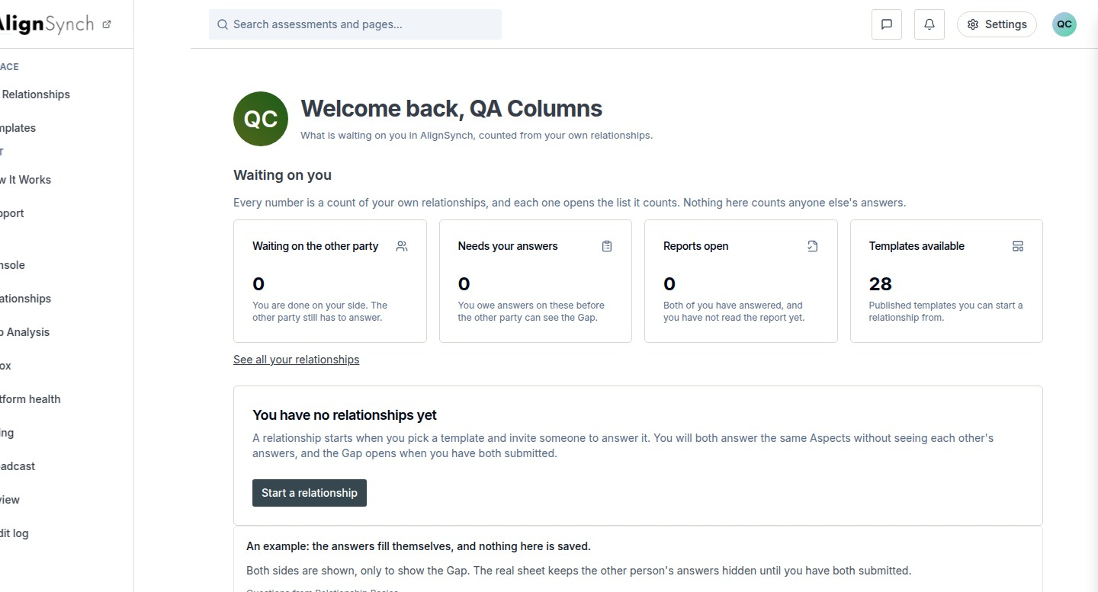
docs/qa-858-columns/after-dashboard-1440.png · source 1440×1554 px · displayed band y=0–777 of 1554 px. Full-page capture, seeded first-run account state.
SCREEN ATLAS / CONTINUED

Overview and navigation · Desktop · section 2
DESKTOP · SECTION 2 OF 2
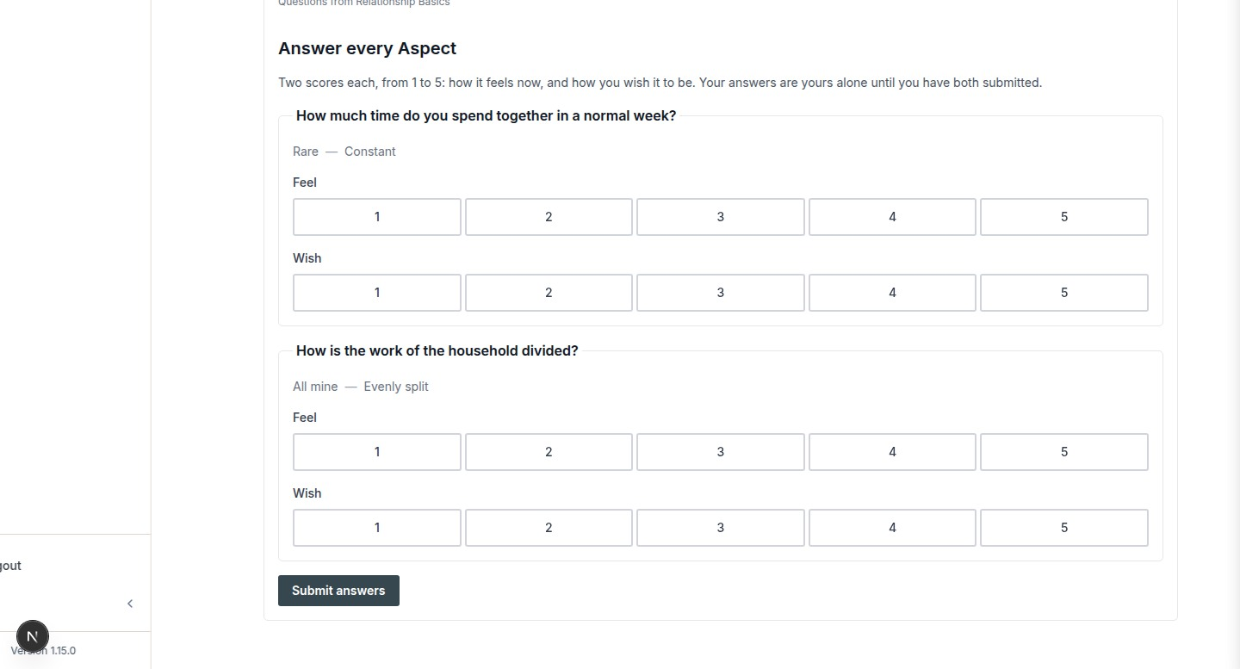
docs/qa-858-columns/after-dashboard-1440.png · source 1440×1554 px · displayed band y=777–1554 of 1554 px. Full-page capture, seeded first-run account state.
SCREEN ATLAS / CONTINUED

Overview and navigation · Mobile · section 1
MOBILE · SECTION 1 OF 4
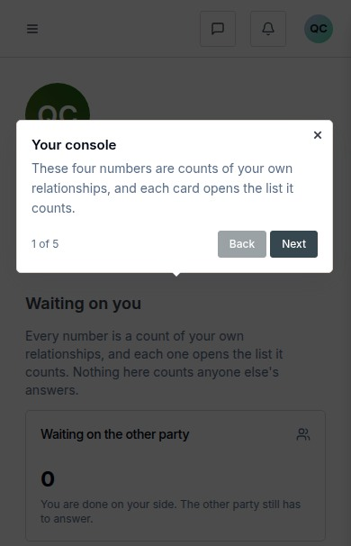
docs/qa-858-columns/after-dashboard-390.png · source 390×2423 px · displayed band y=0–606 of 2423 px. Full-page capture, CSS 390px viewport.
SCREEN ATLAS / CONTINUED

Overview and navigation · Mobile · section 2
MOBILE · SECTION 2 OF 4
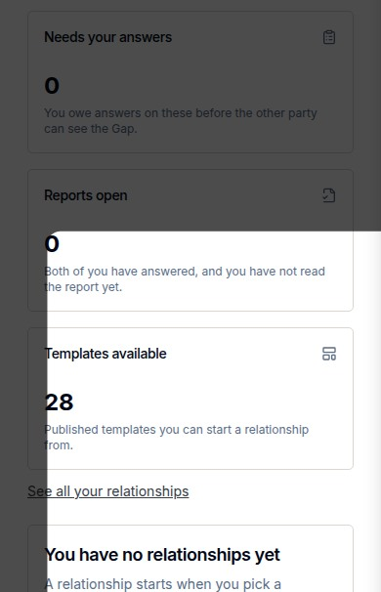
docs/qa-858-columns/after-dashboard-390.png · source 390×2423 px · displayed band y=606–1212 of 2423 px. Full-page capture, CSS 390px viewport.
SCREEN ATLAS / CONTINUED

Overview and navigation · Mobile · section 3
MOBILE · SECTION 3 OF 4
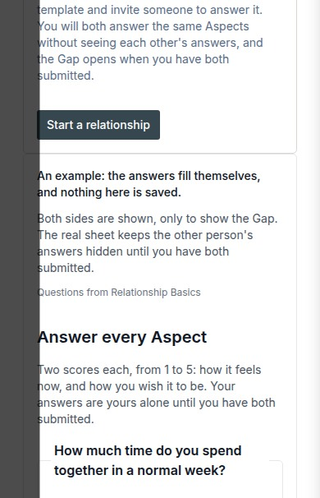
docs/qa-858-columns/after-dashboard-390.png · source 390×2423 px · displayed band y=1212–1818 of 2423 px. Full-page capture, CSS 390px viewport.
SCREEN ATLAS / CONTINUED

Overview and navigation · Mobile · section 4
MOBILE · SECTION 4 OF 4
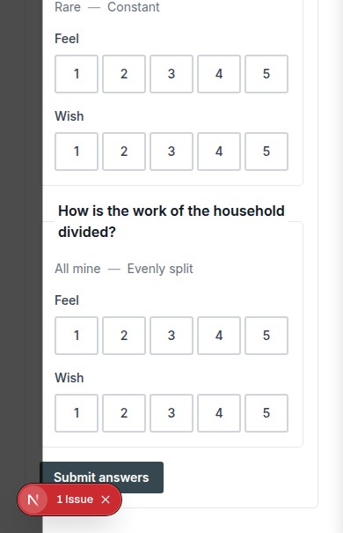
docs/qa-858-columns/after-dashboard-390.png · source 390×2423 px · displayed band y=1818–2423 of 2423 px. Full-page capture, CSS 390px viewport.
SCREEN ATLAS / /DASHBOARD/RELATIONSHIPS

My Relationships list
Page and user purpose | What the member or staff user does
/dashboard/relationships | Find a relationship, read its lifecycle state, and start another from a template.

Front-end evidence | Behind the page
Current after-fix desktop/mobile pair; route and heading verified in the QA capture report. | app/(mainlayout)/dashboard/relationships/page.tsx:43; components/dashboard/relationships-list.tsx:101; lib/member/relationships.ts:388,721.

DESKTOP · CAPTURED VIEW
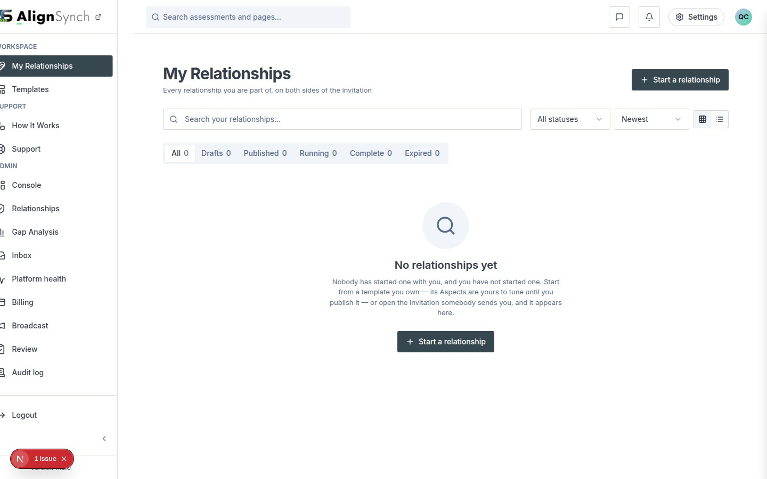
docs/qa-858-columns/after-dashboard-relationships-1440.png · source 1440×900 px · displayed band y=0–900 of 900 px. Current route capture, populated demo cards.
SCREEN ATLAS / CONTINUED

My Relationships list · Mobile · section 1
MOBILE · CAPTURED VIEW
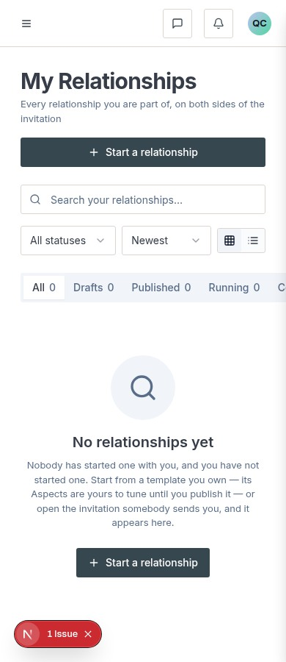
docs/qa-858-columns/after-dashboard-relationships-390.png · source 390×900 px · displayed band y=0–900 of 900 px. Current route capture at CSS 390px.
SCREEN ATLAS / /DASHBOARD/RELATIONSHIPS/[ID]

Relationship detail: initiator draft
Page and user purpose | What the member or staff user does
/dashboard/relationships/[id] | Review setup, edit Aspects, and prepare to publish an invitation.

Front-end evidence | Behind the page
Desktop full-page states show the initiator draft and the publish/plan section. No paired mobile capture was found. | app/(mainlayout)/dashboard/relationships/[id]/page.tsx:57; components/dashboard/relationship-detail.tsx:109; actions.ts:112,157,217; lib/member/relationships.ts:904,1116,1427.

Capture context. These are local QA captures of demo relationships, not newly opened production records.
DESKTOP · DRAFT AND ASPECTS · SECTION 1 OF 3
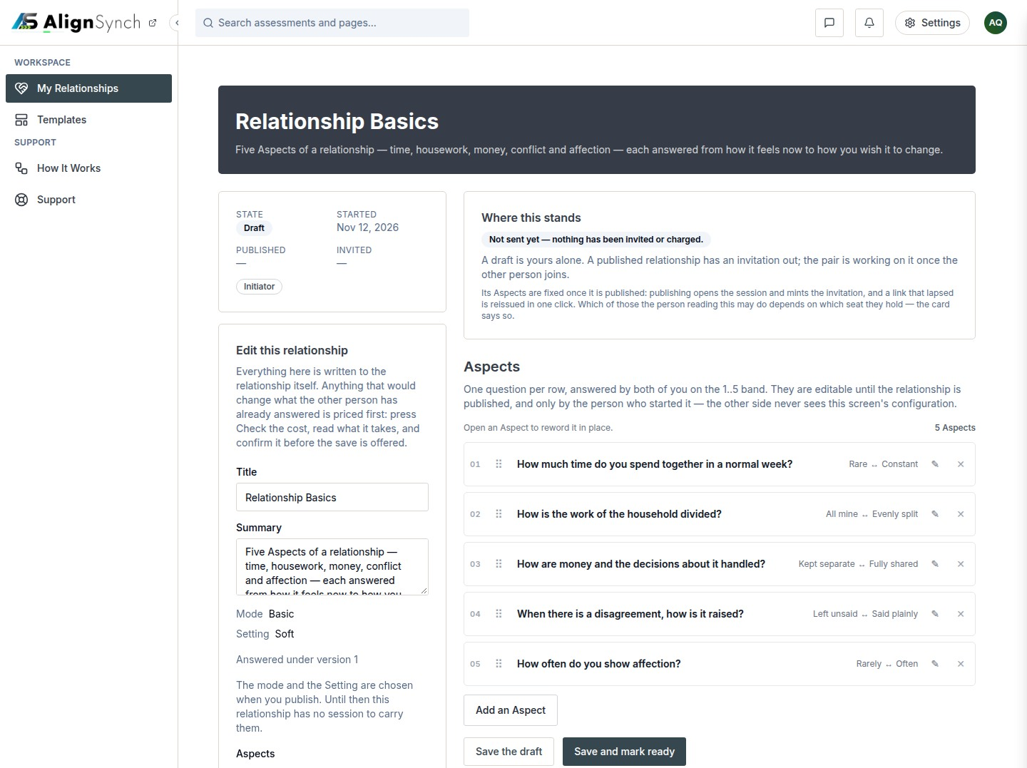
docs/qa-873/873-initiator-draft-steps-1-3-1440.png · source 1440×3229 px · displayed band y=0–1077 of 3229 px. Full-page capture; split into consecutive bands.
SCREEN ATLAS / CONTINUED

Relationship detail: initiator draft · Desktop · draft and Aspects · section 2
DESKTOP · DRAFT AND ASPECTS · SECTION 2 OF 3
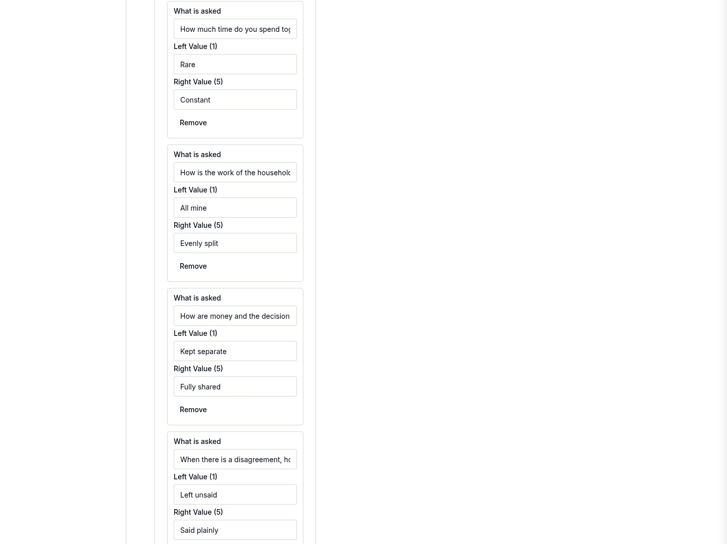
docs/qa-873/873-initiator-draft-steps-1-3-1440.png · source 1440×3229 px · displayed band y=1077–2154 of 3229 px. Full-page capture; split into consecutive bands.
SCREEN ATLAS / CONTINUED

Relationship detail: initiator draft · Desktop · draft and Aspects · section 3
DESKTOP · DRAFT AND ASPECTS · SECTION 3 OF 3
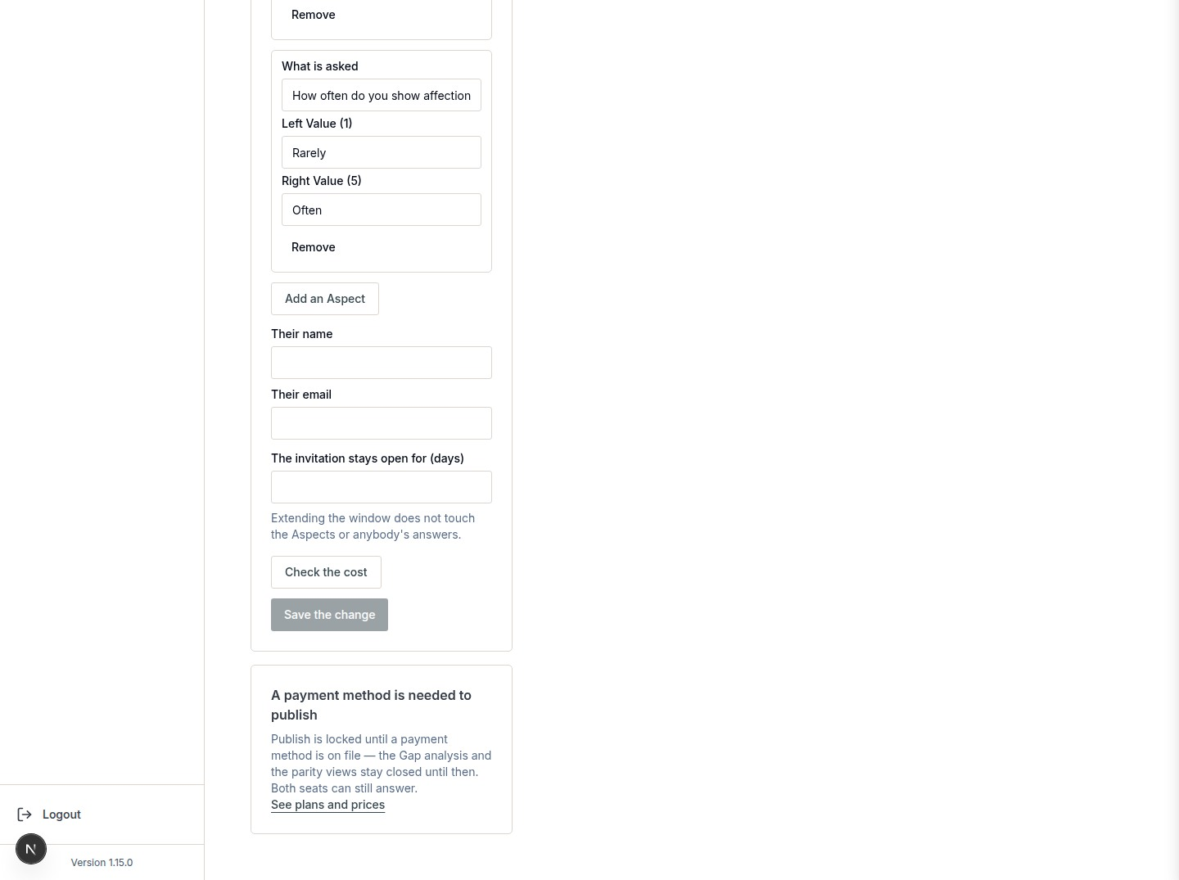
docs/qa-873/873-initiator-draft-steps-1-3-1440.png · source 1440×3229 px · displayed band y=2154–3229 of 3229 px. Full-page capture; split into consecutive bands.
SCREEN ATLAS / CONTINUED

Relationship detail: initiator draft · Desktop · publish section · section 1
DESKTOP · PUBLISH SECTION · SECTION 1 OF 4
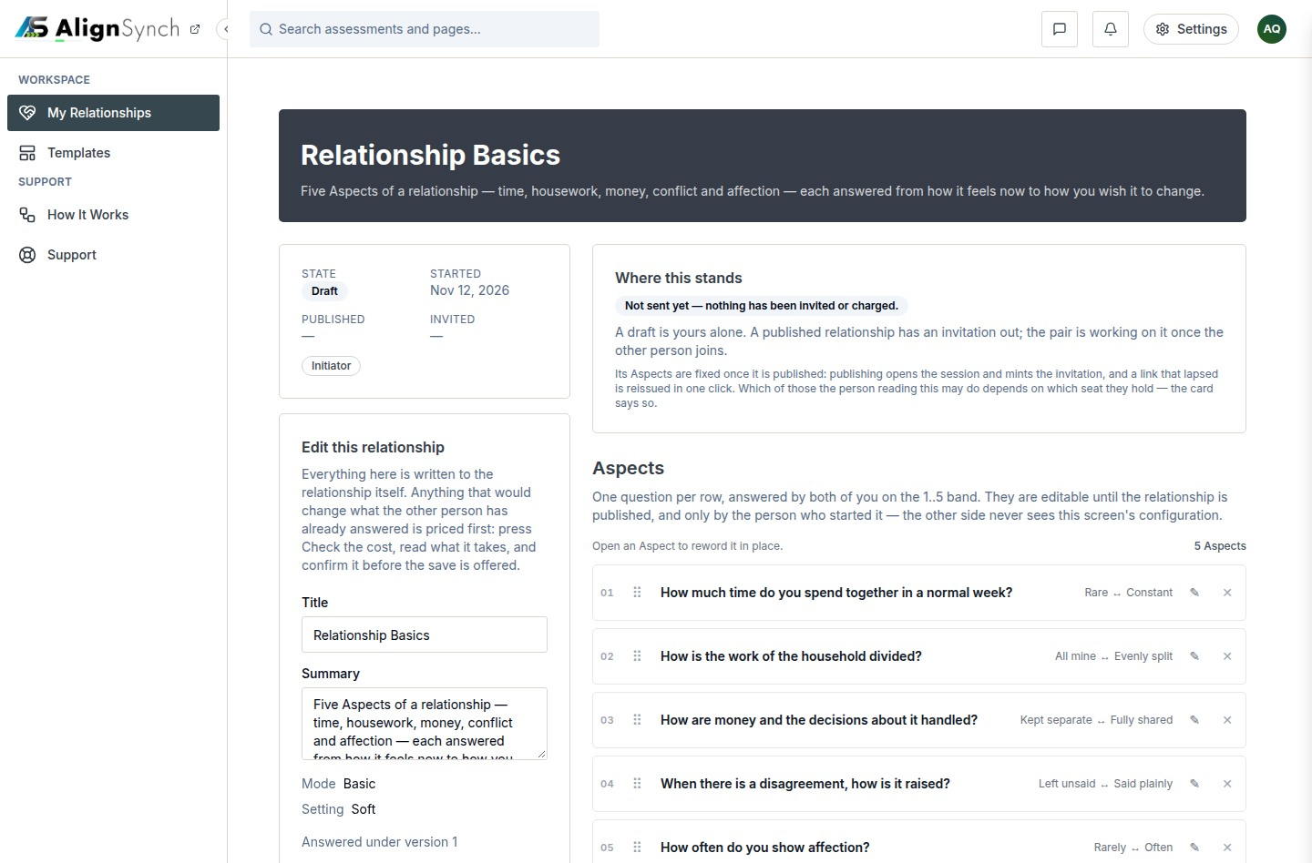
docs/qa-873/873-initiator-draft-publish-1440.png · source 1440×3792 px · displayed band y=0–948 of 3792 px. Full-page capture with publish and plan-door content.
SCREEN ATLAS / CONTINUED

Relationship detail: initiator draft · Desktop · publish section · section 2
DESKTOP · PUBLISH SECTION · SECTION 2 OF 4
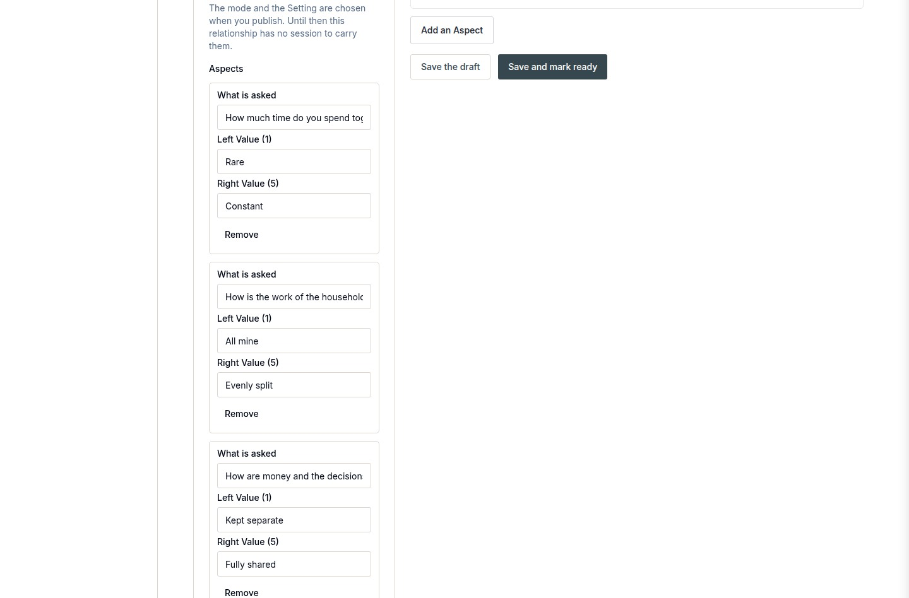
docs/qa-873/873-initiator-draft-publish-1440.png · source 1440×3792 px · displayed band y=948–1896 of 3792 px. Full-page capture with publish and plan-door content.
SCREEN ATLAS / CONTINUED

Relationship detail: initiator draft · Desktop · publish section · section 3
DESKTOP · PUBLISH SECTION · SECTION 3 OF 4
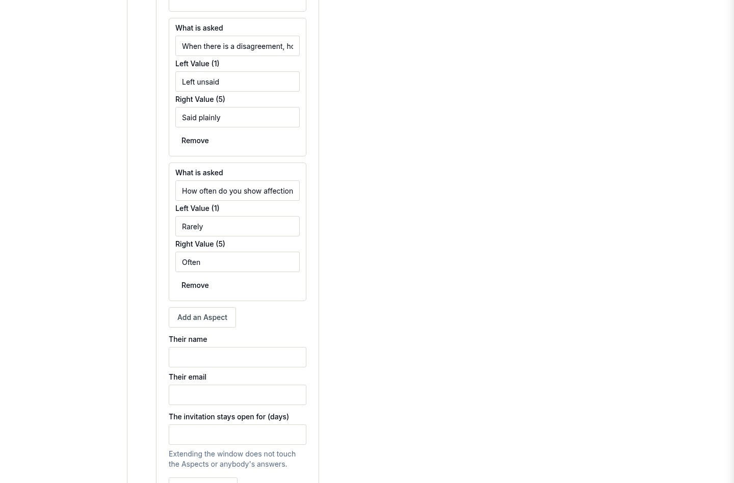
docs/qa-873/873-initiator-draft-publish-1440.png · source 1440×3792 px · displayed band y=1896–2844 of 3792 px. Full-page capture with publish and plan-door content.
SCREEN ATLAS / CONTINUED

Relationship detail: initiator draft · Desktop · publish section · section 4
DESKTOP · PUBLISH SECTION · SECTION 4 OF 4
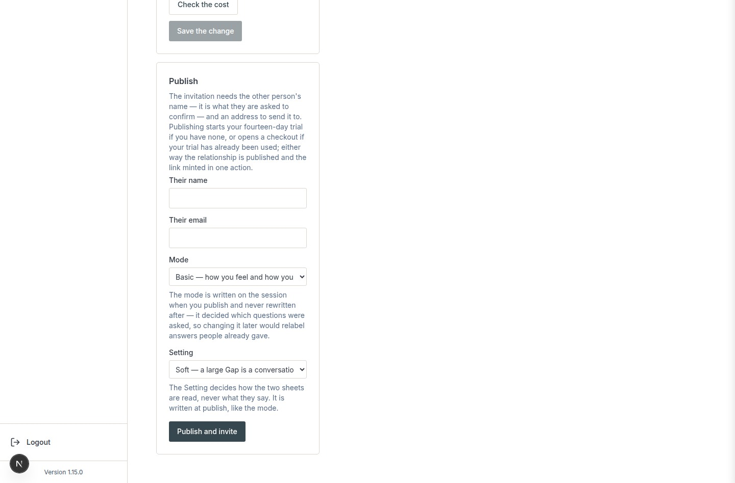
docs/qa-873/873-initiator-draft-publish-1440.png · source 1440×3792 px · displayed band y=2844–3792 of 3792 px. Full-page capture with publish and plan-door content.
SCREEN ATLAS / CONTINUED

Relationship detail: initiator draft · Desktop · counterparty read-only · section 1
DESKTOP · COUNTERPARTY READ-ONLY · SECTION 1 OF 2
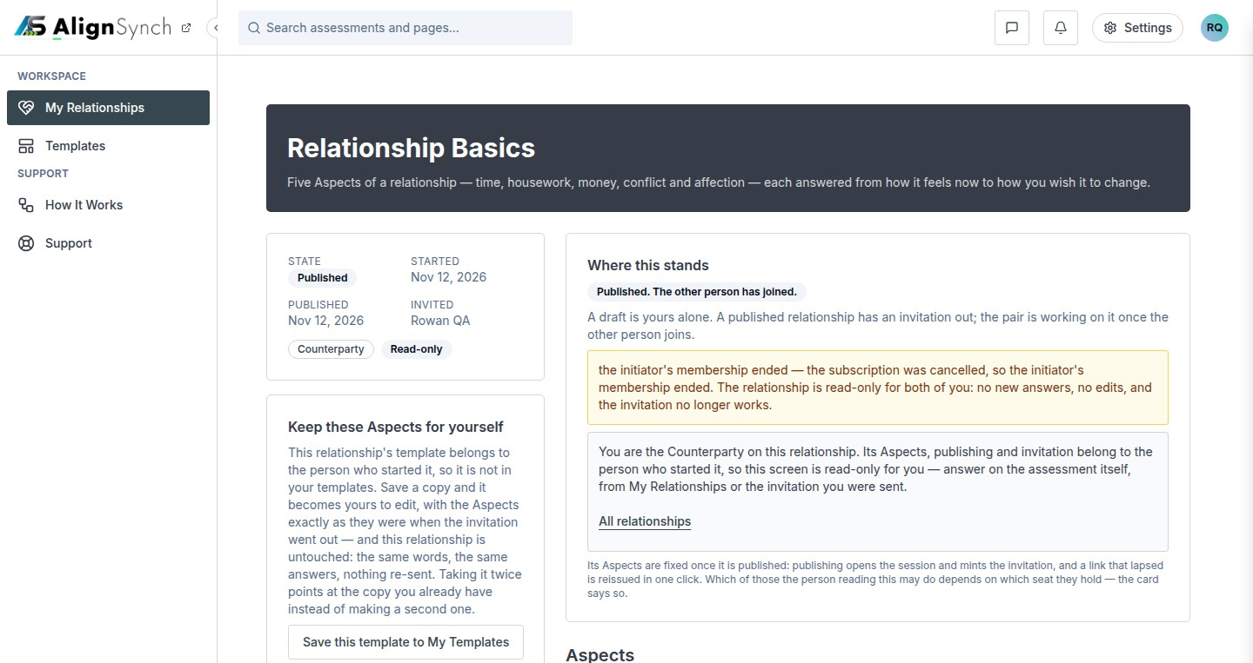
docs/qa-873/873-counterparty-read-only-door-1440.png · source 1440×1526 px · displayed band y=0–763 of 1526 px. Counterparty seat after publication; read-only return path.
SCREEN ATLAS / CONTINUED

Relationship detail: initiator draft · Desktop · counterparty read-only · section 2
DESKTOP · COUNTERPARTY READ-ONLY · SECTION 2 OF 2
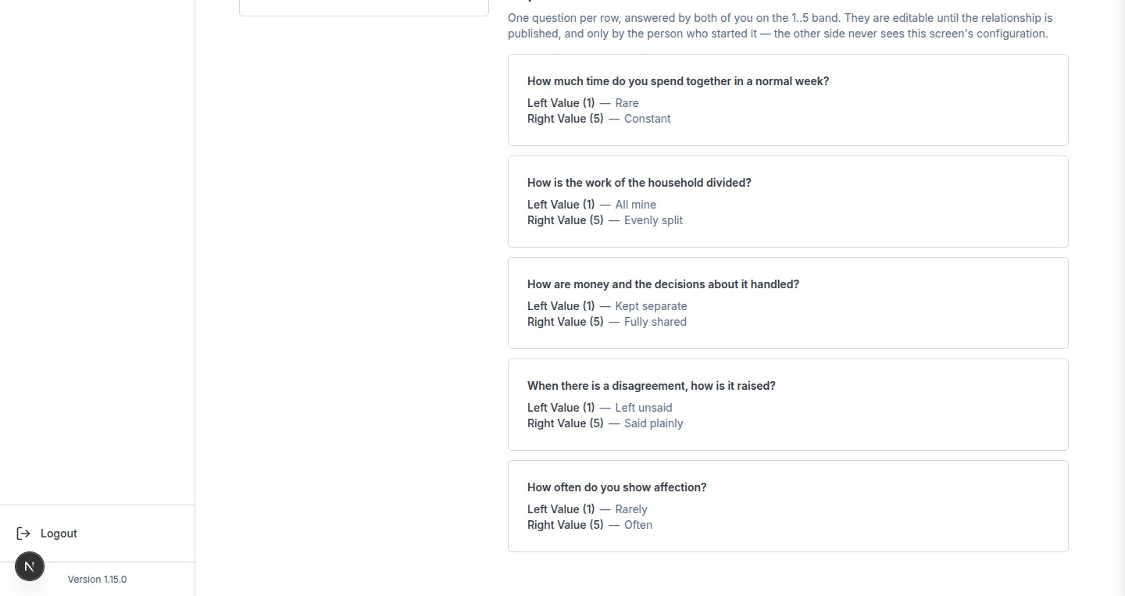
docs/qa-873/873-counterparty-read-only-door-1440.png · source 1440×1526 px · displayed band y=763–1526 of 1526 px. Counterparty seat after publication; read-only return path.
SCREEN ATLAS / /DASHBOARD/TEMPLATES

Templates catalogue
Page and user purpose | What the member or staff user does
/dashboard/templates | Browse relationship templates, compare intended roles and Aspects, and open a detail view.

Front-end evidence | Behind the page
Current browser screenshot supplied by the user, plus older responsive QA captures from the alternate /assessment/templates route. The latter are marked historical. | app/(mainlayout)/dashboard/templates/page.tsx:67; components/dashboard/template-gallery.tsx:66; lib/member/templates.ts:92,133; app/(mainlayout)/dashboard/templates/actions.ts:88,121,146.

Capture context. Catalogue and detail screenshots from the current user-supplied app view are included alongside older responsive captures. Do not use the older /assessment/templates URL as the current route.
DESKTOP · USER-SUPPLIED CURRENT BROWSER VIEW · CAPTURED VIEW
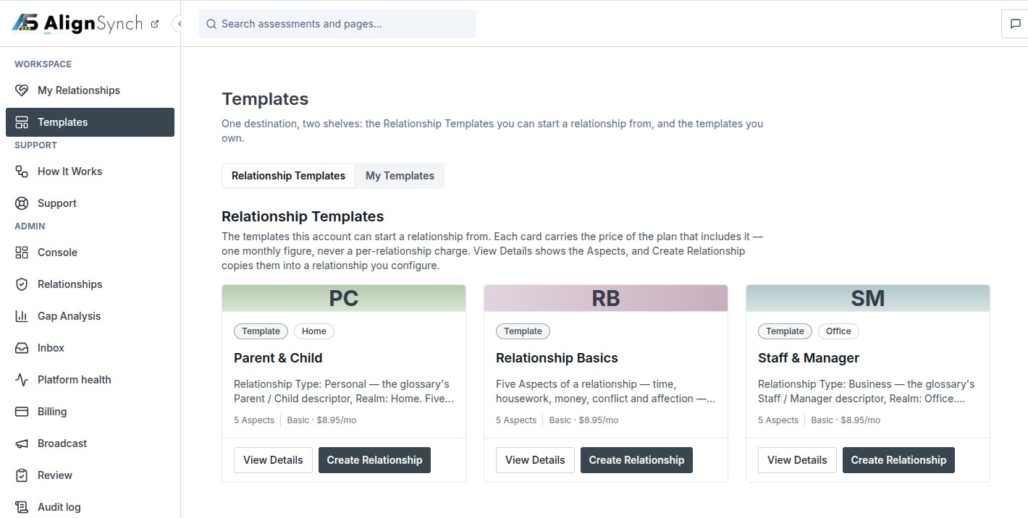
user supplied: codex-clipboard-410aa6ed-191c-4a34-b1b0-a860ad1ae2c2.png · source 1420×716 px · displayed band y=0–716 of 716 px. Current signed-in template listing; browser chrome removed.
SCREEN ATLAS / CONTINUED

Templates catalogue · Desktop · alternate-route QA capture · section 1
DESKTOP · ALTERNATE-ROUTE QA CAPTURE · CAPTURED VIEW
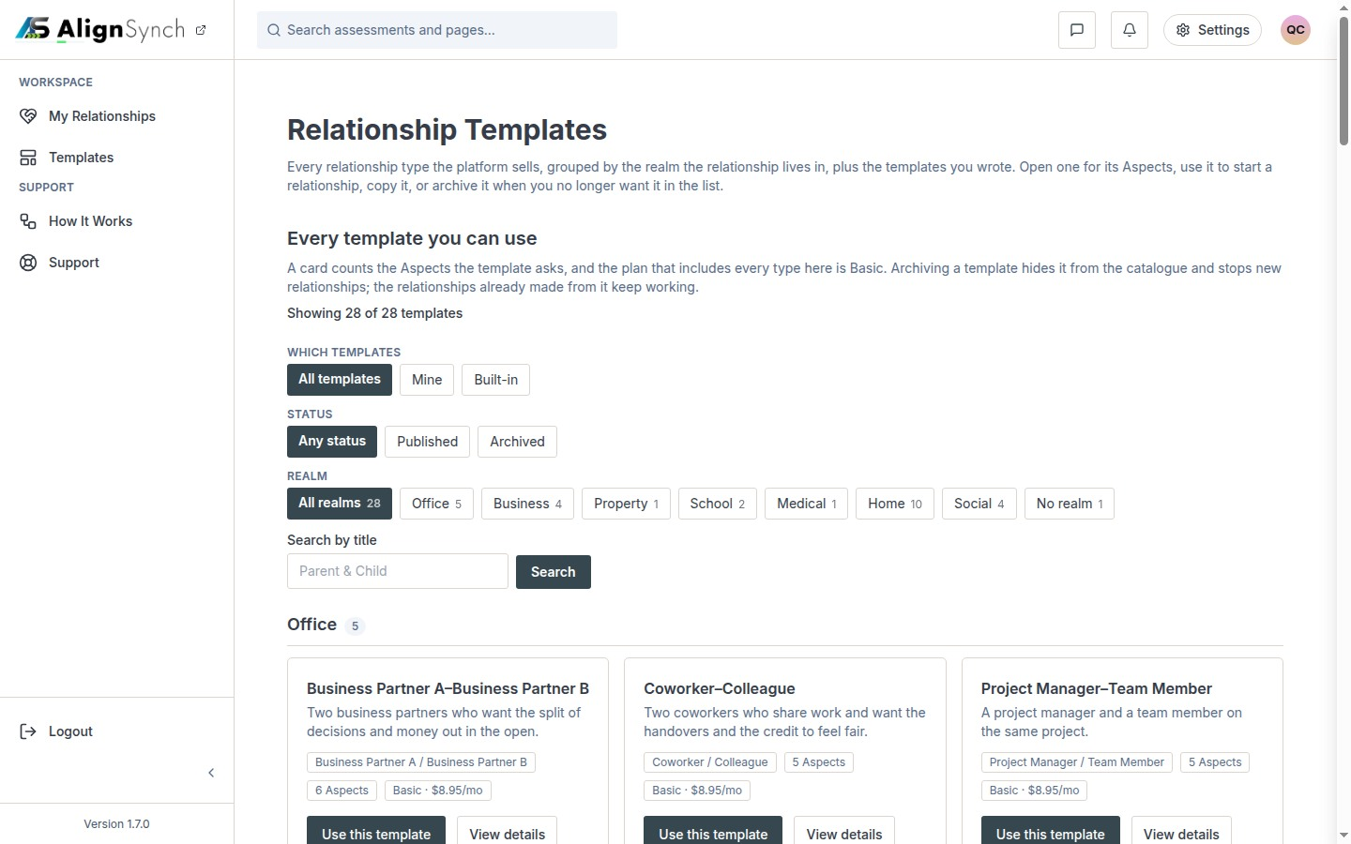
docs/qa-conformance/templates-1440.png · source 1440×900 px · displayed band y=0–900 of 900 px. Historical /assessment/templates route; not the current Templates shelf.
SCREEN ATLAS / CONTINUED

Templates catalogue · Mobile · alternate-route QA capture · section 1
MOBILE · ALTERNATE-ROUTE QA CAPTURE · CAPTURED VIEW
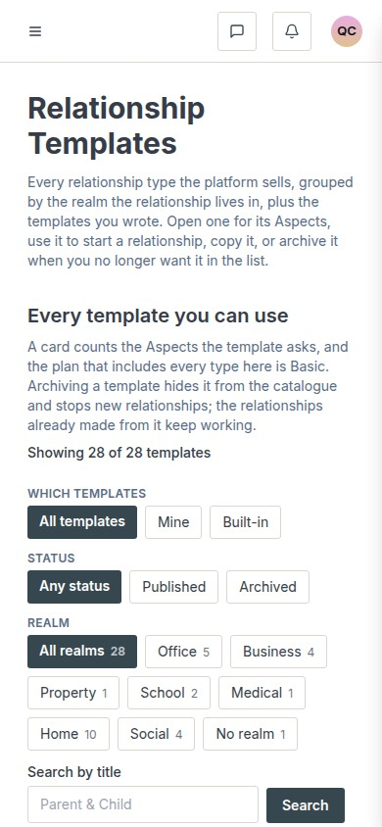
docs/qa-conformance/templates-390.png · source 390×844 px · displayed band y=0–844 of 844 px. Historical /assessment/templates route; use as responsive component reference only.
SCREEN ATLAS / /DASHBOARD/TEMPLATES/[ID] AND /TEMPLATES/RELATIONSHIP/[SLUG]

Template detail
Page and user purpose | What the member or staff user does
/dashboard/templates/[id] and /templates/relationship/[slug] | Check roles, intended audience, and every Aspect before creating a relationship.

Front-end evidence | Behind the page
Current user-supplied detail image is paired with older responsive QA images from the /assessment/templates/... route. | app/(mainlayout)/dashboard/templates/[id]/page.tsx:45; lib/member/templates.ts:180; shared TemplateEditor; lib/member/relationships.ts:721.

Capture context. The two current-detail screenshots supplied in the conversation show demo content. The older QA pair is included to show the mobile layout but is not asserted to be the current route.
DESKTOP · USER-SUPPLIED DETAIL VIEW · CAPTURED VIEW
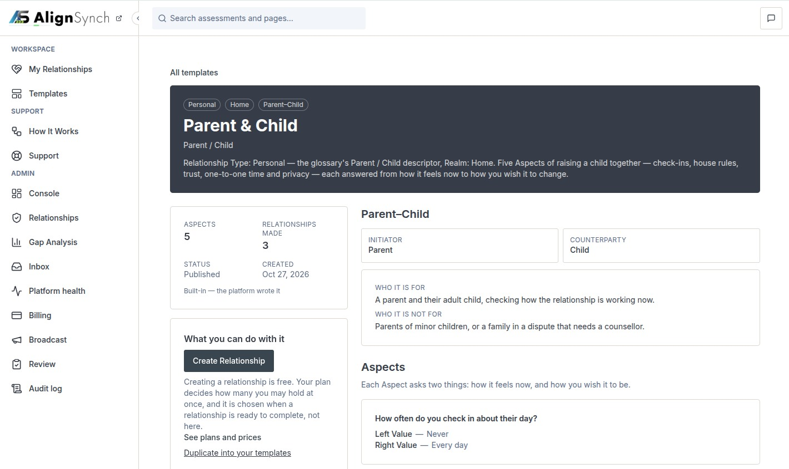
user supplied: codex-clipboard-b3c3d683-d8ff-44f3-bebf-dd478f2ab82a.png · source 1420×846 px · displayed band y=0–846 of 846 px. Current browser detail capture; browser chrome removed.
SCREEN ATLAS / CONTINUED

Template detail · Desktop · alternate-route QA capture · section 1
DESKTOP · ALTERNATE-ROUTE QA CAPTURE · CAPTURED VIEW
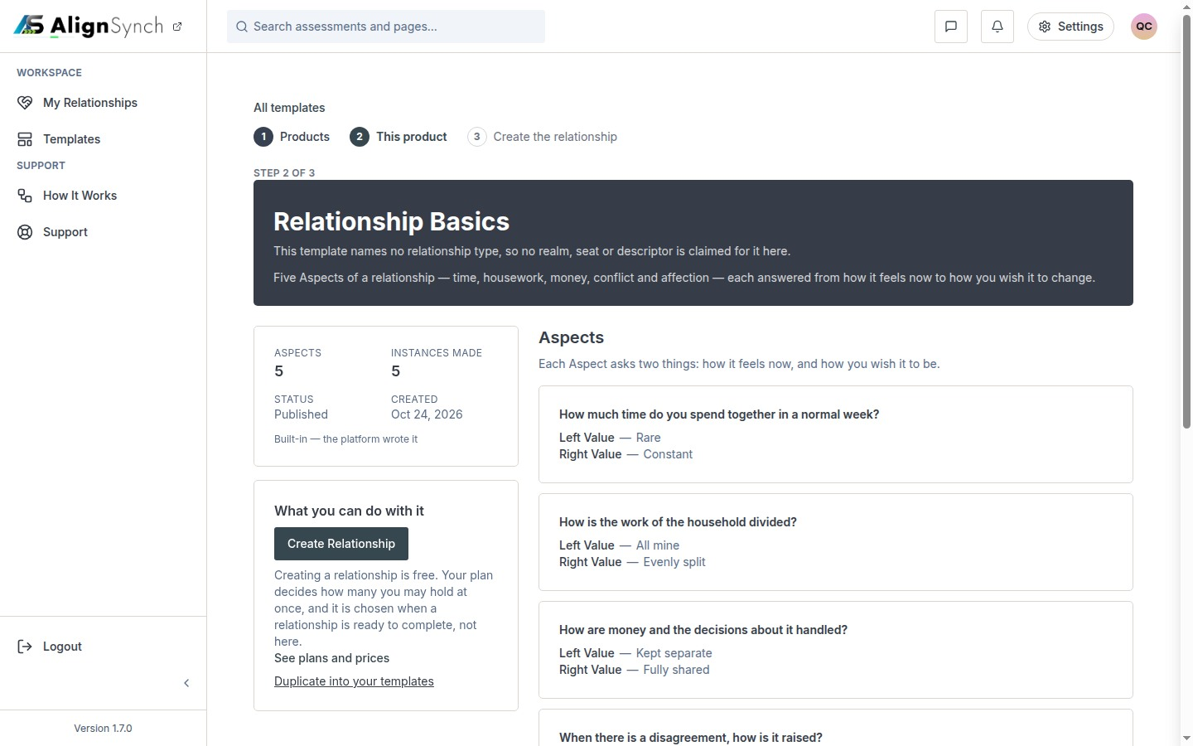
docs/qa-conformance/template-detail-1440.png · source 1440×900 px · displayed band y=0–900 of 900 px. Historical /assessment/templates/assessment-relationship-basics route.
SCREEN ATLAS / CONTINUED

Template detail · Mobile · alternate-route QA capture · section 1
MOBILE · ALTERNATE-ROUTE QA CAPTURE · CAPTURED VIEW
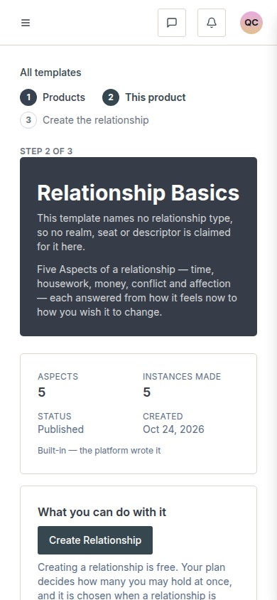
docs/qa-conformance/template-detail-390.png · source 390×844 px · displayed band y=0–844 of 844 px. Historical route, responsive component reference only.
SCREEN ATLAS / /DASHBOARD/RELATIONSHIPS → START A RELATIONSHIP

Create relationship: context and role
Page and user purpose | What the member or staff user does
/dashboard/relationships → Start a relationship | Choose a relationship template, name the shared workspace, and assign the two roles.

Front-end evidence | Behind the page
Older wizard component captures show setup stages; route grammar predates the current dashboard picker. | components/dashboard/relationships-list.tsx:101; app/(mainlayout)/dashboard/relationships/actions.ts:79; lib/member/relationships.ts:721; app/(mainlayout)/dashboard/templates/actions.ts:88,121.

Capture context. These capture images illustrate the available setup stages but come from the earlier wizard path; use the current dashboard route and service references as authoritative.
DESKTOP · SETUP STEP · CAPTURED VIEW
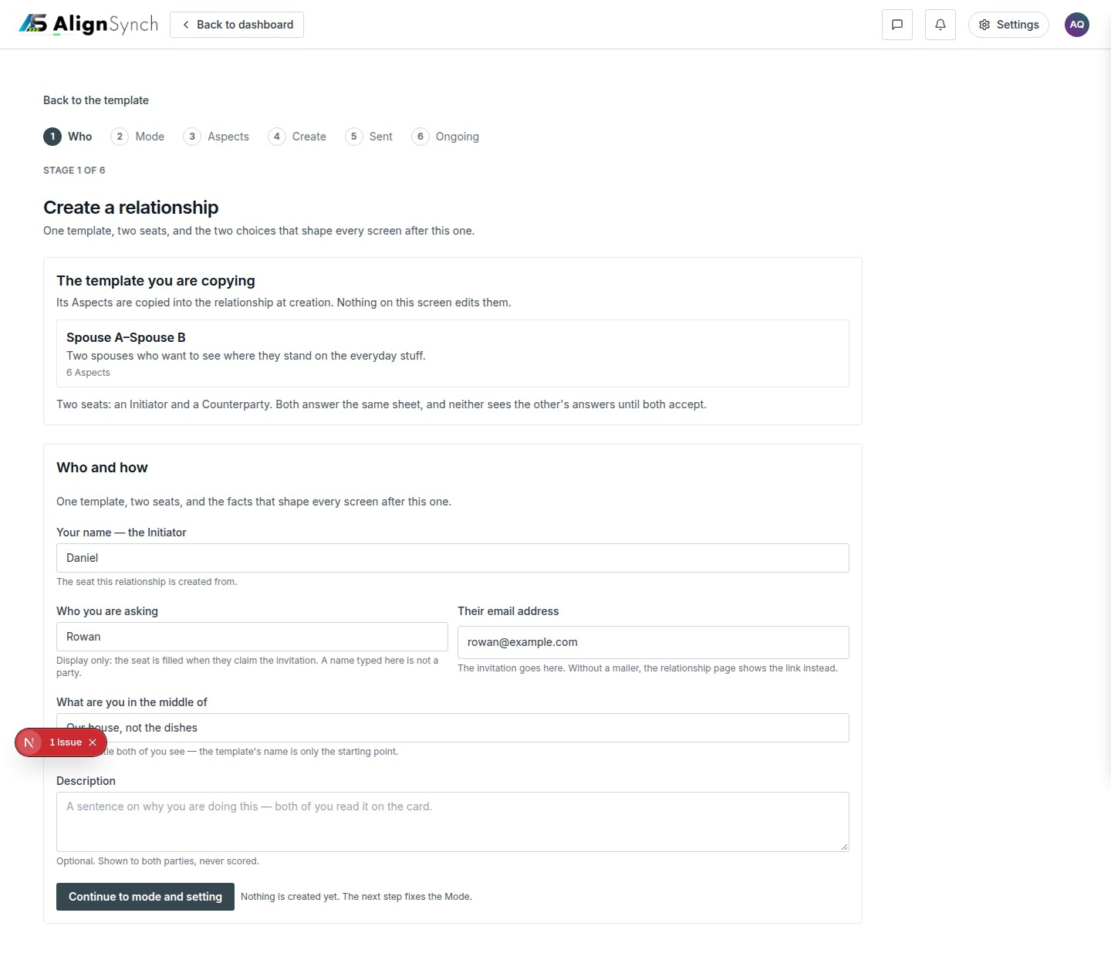
docs/qa-create-stages/create-who-1440.png · source 1440×1253 px · displayed band y=0–1253 of 1253 px. Wizard capture from the earlier /assessment/templates/.../create entry.
SCREEN ATLAS / CONTINUED

Create relationship: context and role · Mobile · setup step · section 1
MOBILE · SETUP STEP · SECTION 1 OF 2
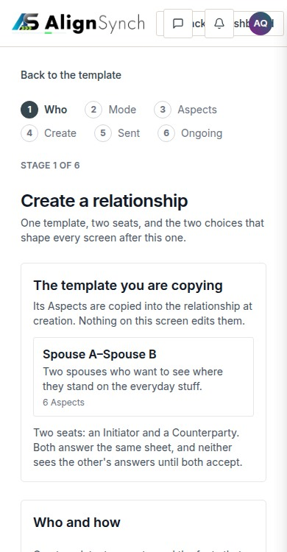
docs/qa-create-stages/create-who-390.png · source 390×1499 px · displayed band y=0–750 of 1499 px. Earlier wizard path; CSS-width mobile full-page capture.
SCREEN ATLAS / CONTINUED

Create relationship: context and role · Mobile · setup step · section 2
MOBILE · SETUP STEP · SECTION 2 OF 2
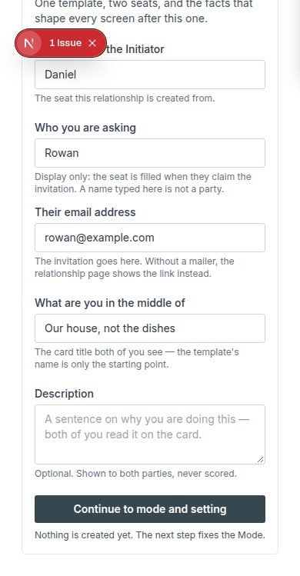
docs/qa-create-stages/create-who-390.png · source 390×1499 px · displayed band y=750–1499 of 1499 px. Earlier wizard path; CSS-width mobile full-page capture.
SCREEN ATLAS / CONTINUED

Create relationship: context and role · Desktop · mode and setting · section 1
DESKTOP · MODE AND SETTING · CAPTURED VIEW
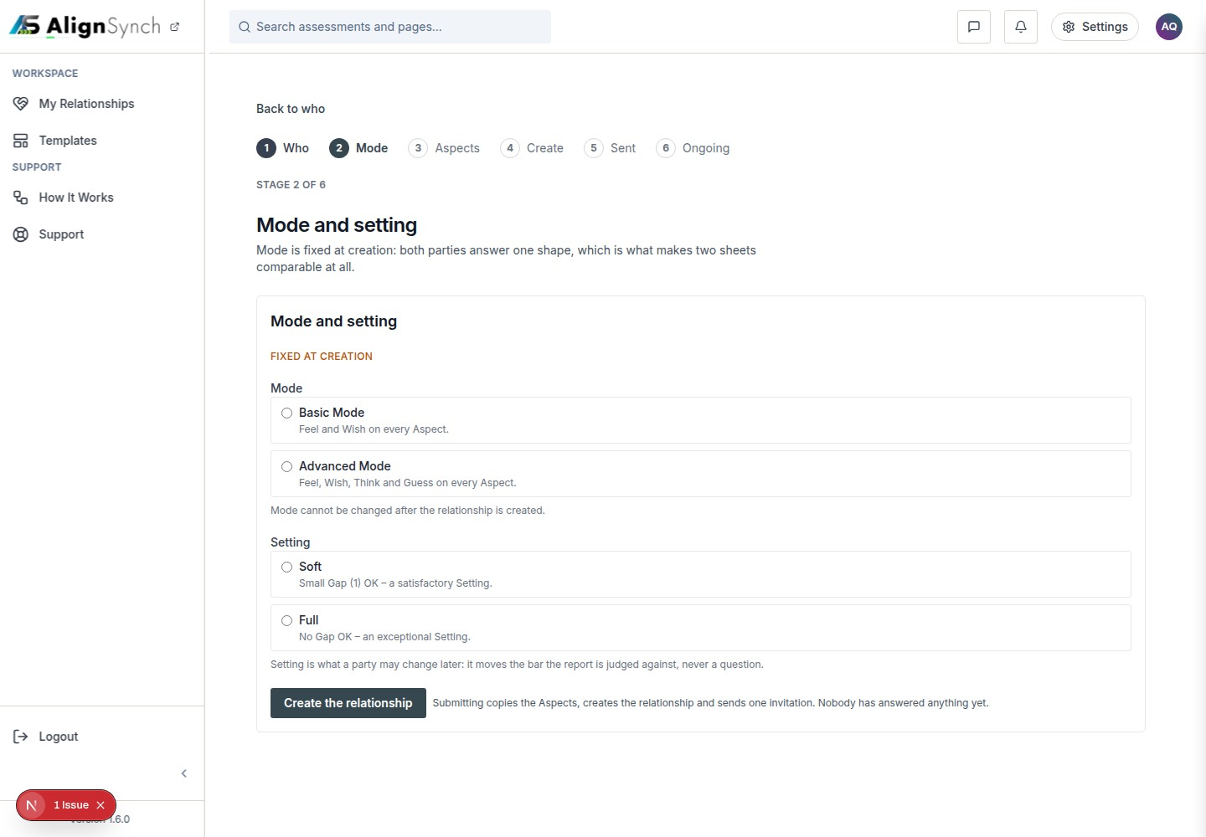
docs/qa-create-stages/create-mode-1440.png · source 1440×1000 px · displayed band y=0–1000 of 1000 px. Earlier wizard component capture.
SCREEN ATLAS / CONTINUED

Create relationship: context and role · Mobile · mode and setting · section 1
MOBILE · MODE AND SETTING · SECTION 1 OF 2
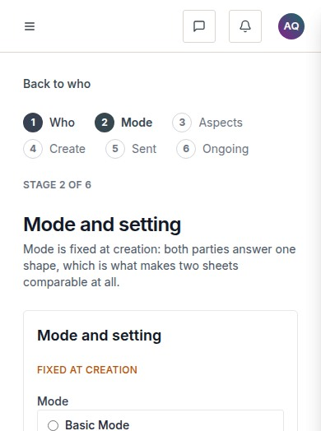
docs/qa-create-stages/create-mode-390.png · source 390×1047 px · displayed band y=0–524 of 1047 px. Earlier wizard component capture.
SCREEN ATLAS / CONTINUED

Create relationship: context and role · Mobile · mode and setting · section 2
MOBILE · MODE AND SETTING · SECTION 2 OF 2
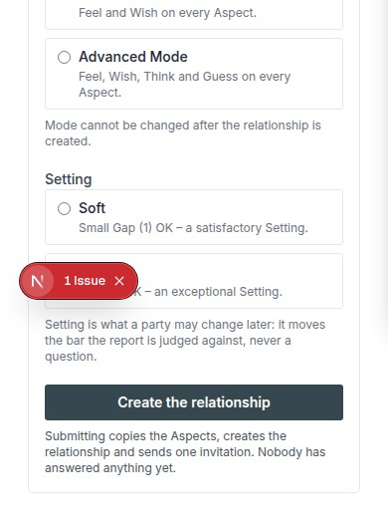
docs/qa-create-stages/create-mode-390.png · source 390×1047 px · displayed band y=524–1047 of 1047 px. Earlier wizard component capture.
SCREEN ATLAS / /DASHBOARD/RELATIONSHIPS/[ID]

Create relationship: review Aspects
Page and user purpose | What the member or staff user does
/dashboard/relationships/[id] | Inspect, reorder, or revise the copied Aspects while the relationship remains a draft.

Front-end evidence | Behind the page
The current draft route owns the relationship copy. Aspect interaction captures are QA component states from the earlier wizard. | components/dashboard/relationship-detail.tsx:109; app/(mainlayout)/dashboard/relationships/[id]/actions.ts:255,298; lib/member/relationships.ts:904.

Capture context. These are fixture-backed QA states rather than a newly captured production wizard. They document the interaction model for a draft.
DESKTOP · COLLAPSED ASPECTS · CAPTURED VIEW
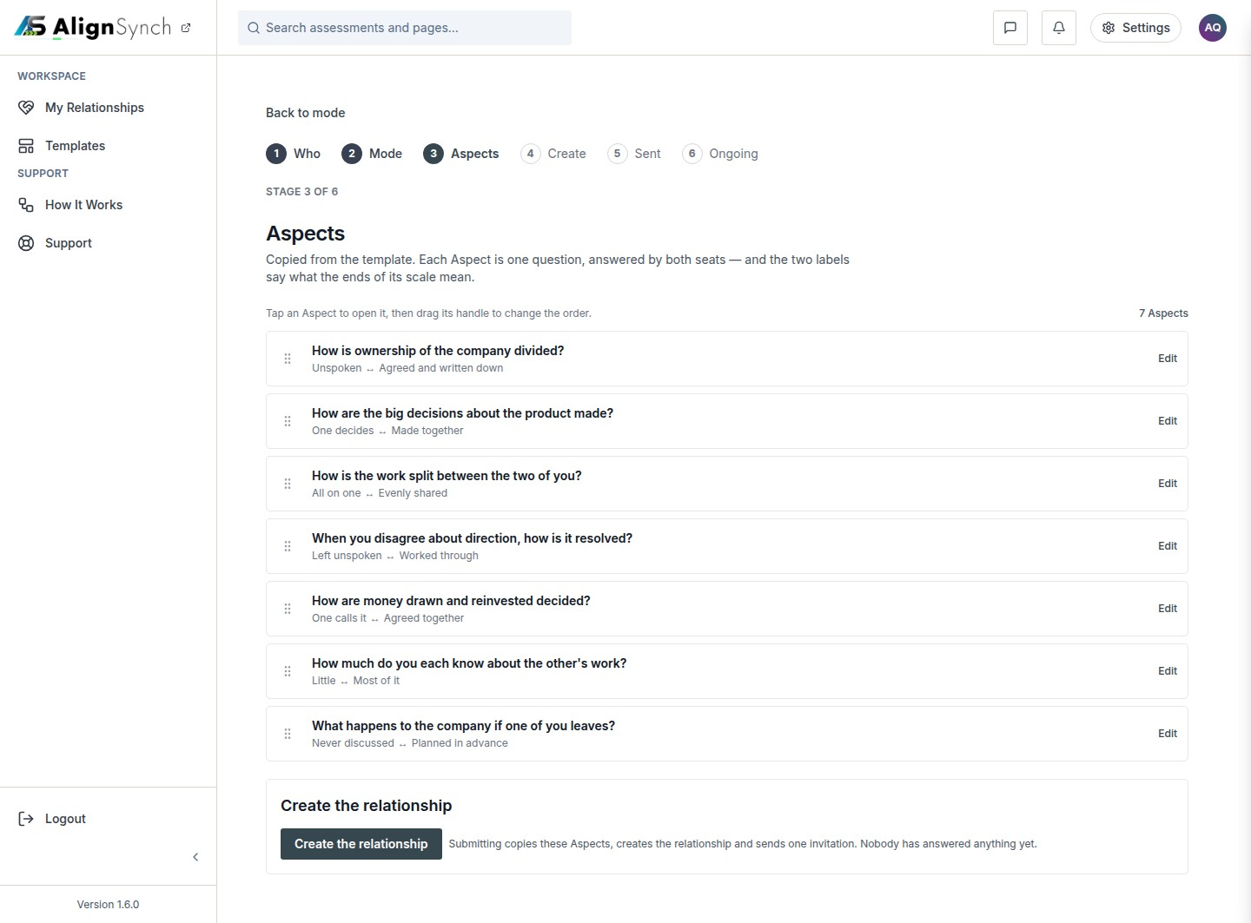
docs/qa-aspects/aspects-1440-collapsed.png · source 1440×1063 px · displayed band y=0–1063 of 1063 px. QA component capture; collapsed list.
SCREEN ATLAS / CONTINUED

Create relationship: review Aspects · Desktop · open Aspect editor · section 1
DESKTOP · OPEN ASPECT EDITOR · CAPTURED VIEW
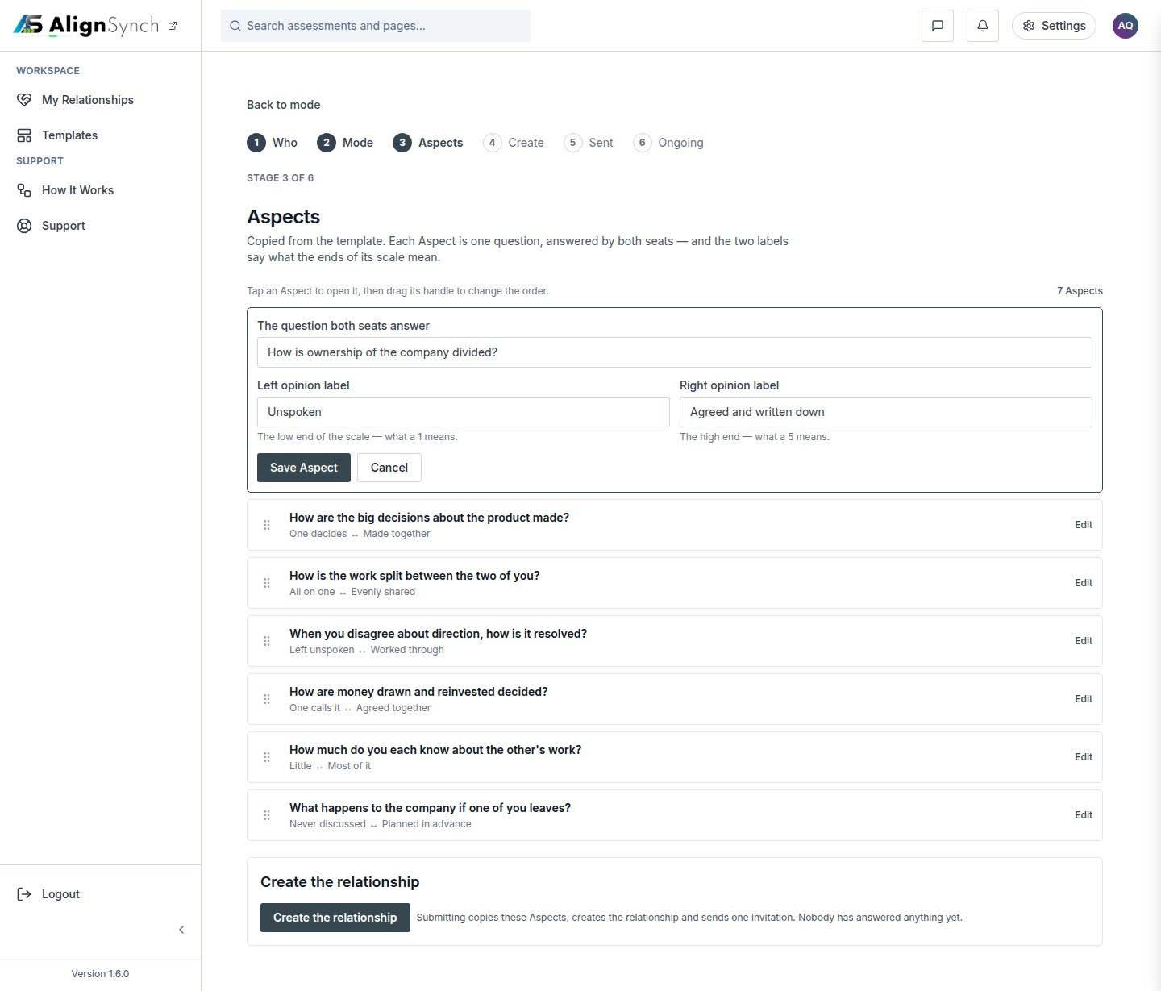
docs/qa-aspects/aspects-1440-open.png · source 1440×1229 px · displayed band y=0–1229 of 1229 px. QA component capture; edit fields expanded.
SCREEN ATLAS / CONTINUED

Create relationship: review Aspects · Mobile · collapsed Aspects · section 1
MOBILE · COLLAPSED ASPECTS · SECTION 1 OF 2
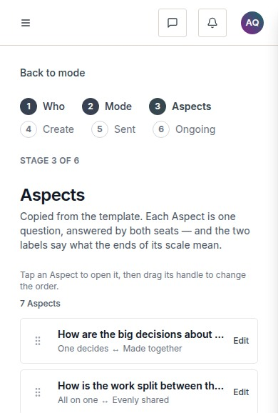
docs/qa-aspects/aspects-390-collapsed.png · source 390×1155 px · displayed band y=0–578 of 1155 px. Earlier component state; CSS 390px.
SCREEN ATLAS / CONTINUED

Create relationship: review Aspects · Mobile · collapsed Aspects · section 2
MOBILE · COLLAPSED ASPECTS · SECTION 2 OF 2
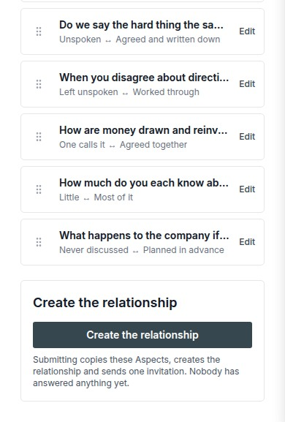
docs/qa-aspects/aspects-390-collapsed.png · source 390×1155 px · displayed band y=578–1155 of 1155 px. Earlier component state; CSS 390px.
SCREEN ATLAS / CONTINUED

Create relationship: review Aspects · Mobile · reordered list · section 1
MOBILE · REORDERED LIST · SECTION 1 OF 2
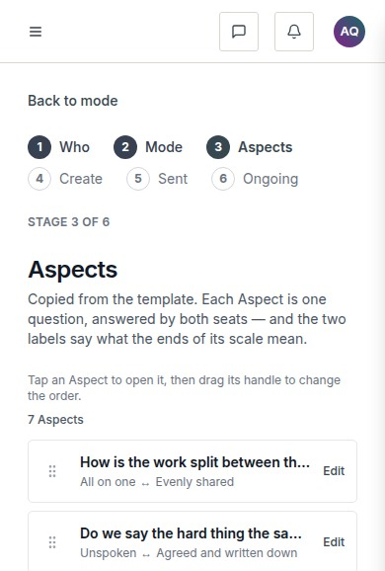
docs/qa-aspects/aspects-390-reordered.png · source 390×1155 px · displayed band y=0–578 of 1155 px. Shows mobile ordering interaction.
SCREEN ATLAS / CONTINUED

Create relationship: review Aspects · Mobile · reordered list · section 2
MOBILE · REORDERED LIST · SECTION 2 OF 2
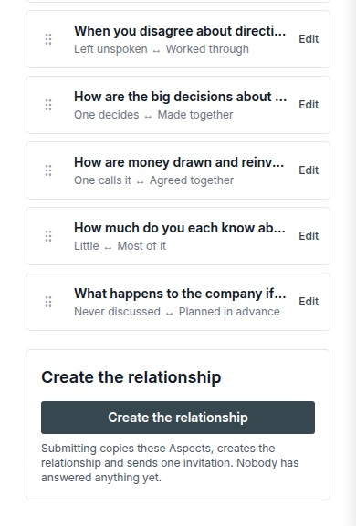
docs/qa-aspects/aspects-390-reordered.png · source 390×1155 px · displayed band y=578–1155 of 1155 px. Shows mobile ordering interaction.
SCREEN ATLAS / /DASHBOARD/RELATIONSHIPS/[ID] → PUBLISH

Publish and send invitation
Page and user purpose | What the member or staff user does
/dashboard/relationships/[id] → Publish | Check the plan choice, address the counterparty, and send or keep the relationship as a draft.

Front-end evidence | Behind the page
Current QA capture pair covers entitled and not-entitled states at the invitation stage. | components/dashboard/relationship-detail.tsx:225-233,551-570; relationship actions :157,217; lib/member/relationships.ts:1116,1427; lib/member/payment.ts:268,358,457.

Capture context. The UI’s payment-method door and the publish service do not enforce the same check. This is called out in the payment section for product confirmation.
DESKTOP · PLAN NEEDED · CAPTURED VIEW
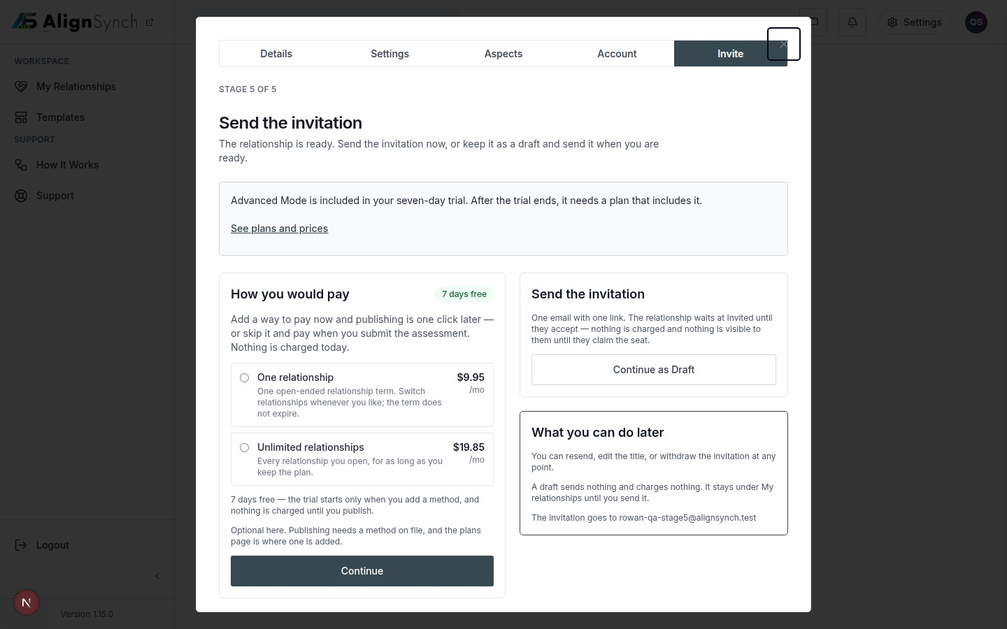
docs/qa-stage5/stage5-not-entitled-1440.png · source 1440×900 px · displayed band y=0–900 of 900 px. Demo state with plan choices and free-trial notice.
SCREEN ATLAS / CONTINUED

Publish and send invitation · Mobile · plan needed · section 1
MOBILE · PLAN NEEDED · CAPTURED VIEW
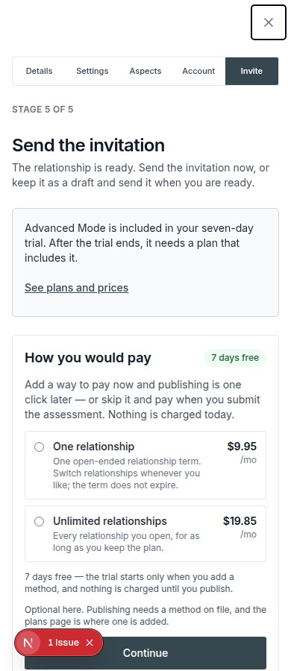
docs/qa-stage5/stage5-not-entitled-390.png · source 390×900 px · displayed band y=0–900 of 900 px. Same state at CSS 390px.
SCREEN ATLAS / CONTINUED

Publish and send invitation · Desktop · plan already available · section 1
DESKTOP · PLAN ALREADY AVAILABLE · CAPTURED VIEW
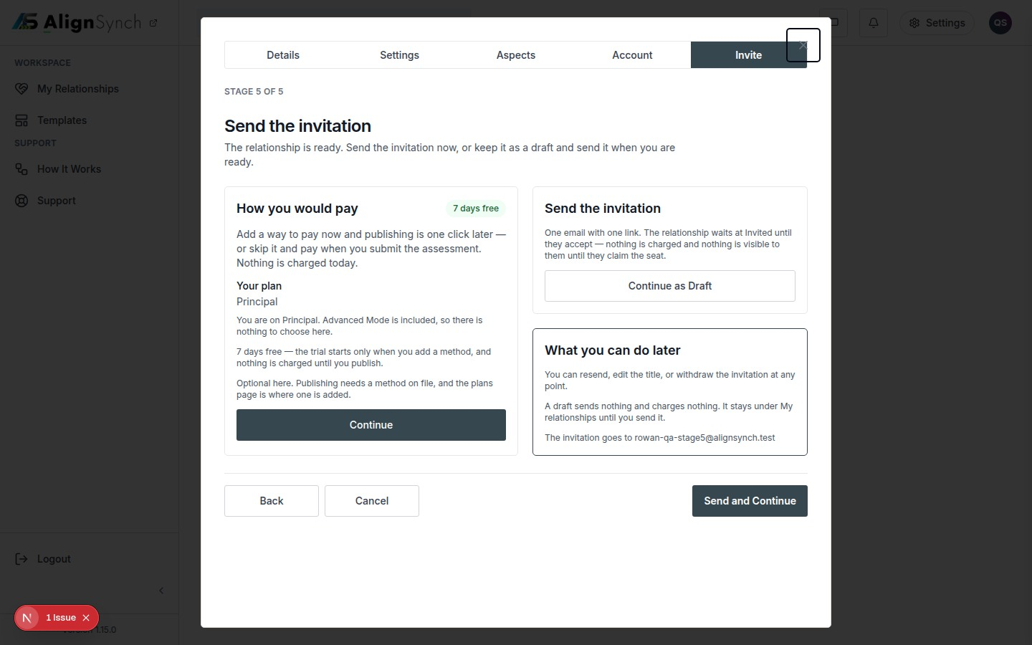
docs/qa-stage5/stage5-entitled-1440.png · source 1440×900 px · displayed band y=0–900 of 900 px. Demo state with existing entitlement summary.
SCREEN ATLAS / CONTINUED

Publish and send invitation · Mobile · plan already available · section 1
MOBILE · PLAN ALREADY AVAILABLE · CAPTURED VIEW
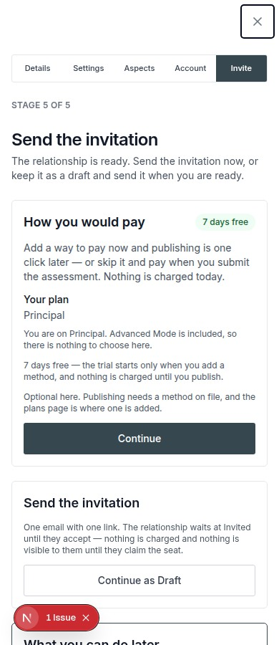
docs/qa-stage5/stage5-entitled-390.png · source 390×900 px · displayed band y=0–900 of 900 px. Same state at CSS 390px.
SCREEN ATLAS / /INVITE/[TOKEN]

Invitation and claim
Page and user purpose | What the member or staff user does
/invite/[token] | Review who invited you, which role is offered, and confirm before claiming the participant seat.

Front-end evidence | Behind the page
Local browser captures exercise invite preview, account gate, and confirmation states. | app/(mainlayout)/invite/[token]/page.tsx:61; components/assessment-flow/counterparty-wizard.tsx:73; lib/flow/store.ts:2878,921; claim API app/(mainlayout)/invite/[token]/claim/route.ts:55.

Capture context. These are seeded demo invitations. A raw token is not included in the guide.
DESKTOP · INVITE PREVIEW · CAPTURED VIEW
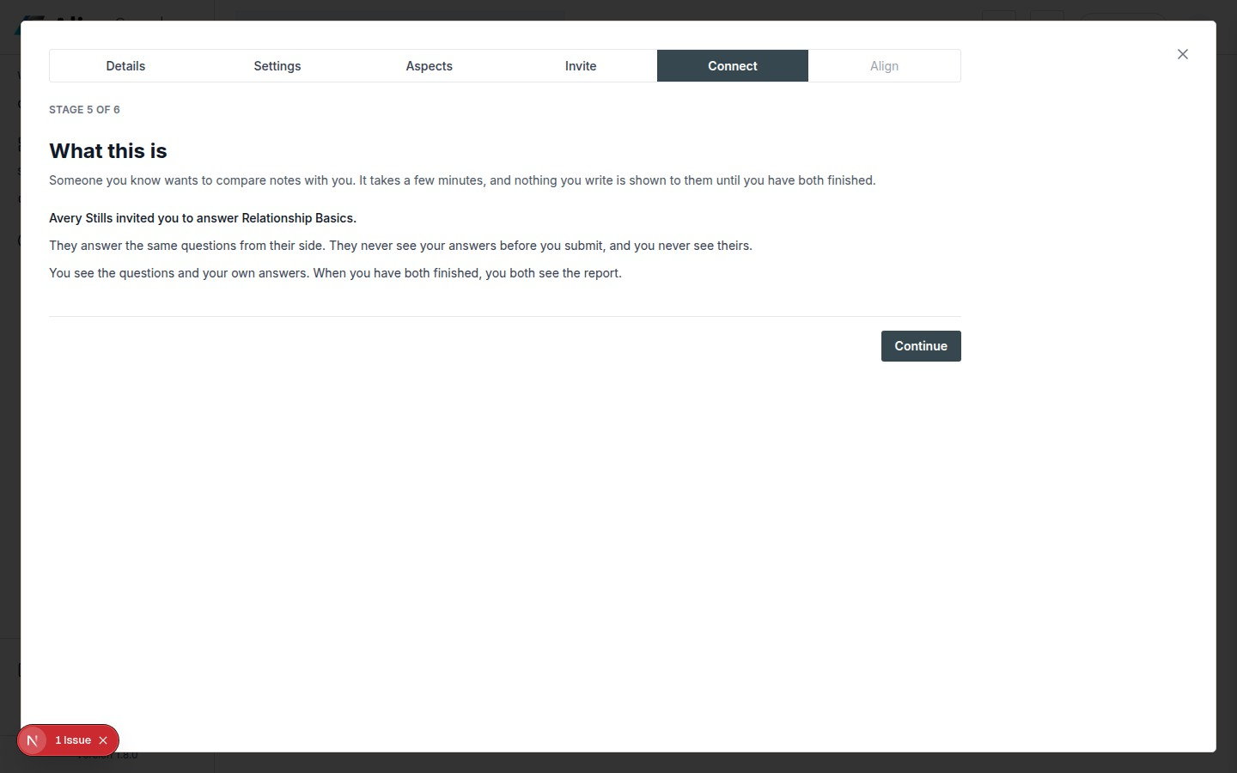
docs/qa-invite-response/response-step-1-1440.png · source 1440×900 px · displayed band y=0–900 of 900 px. Valid demo invite; claim has not yet been made.
SCREEN ATLAS / CONTINUED

Invitation and claim · Mobile · invite preview · section 1
MOBILE · INVITE PREVIEW · CAPTURED VIEW
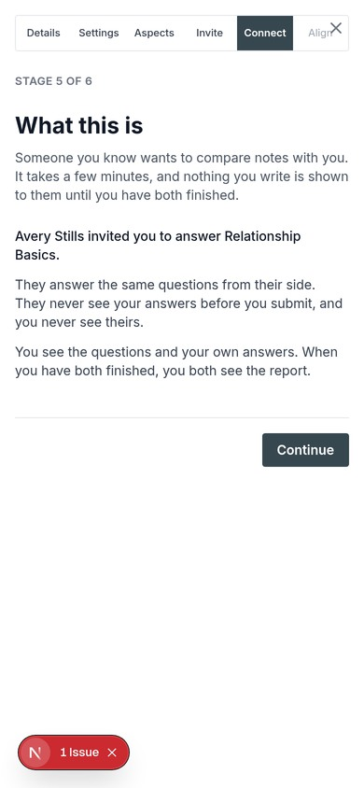
docs/qa-invite-response/response-step-1-390.png · source 780×1688 px · displayed band y=0–844 of 844 px. Captured at 2×; shown at CSS 390px.
SCREEN ATLAS / CONTINUED

Invitation and claim · Desktop · account gate · section 1
DESKTOP · ACCOUNT GATE · CAPTURED VIEW
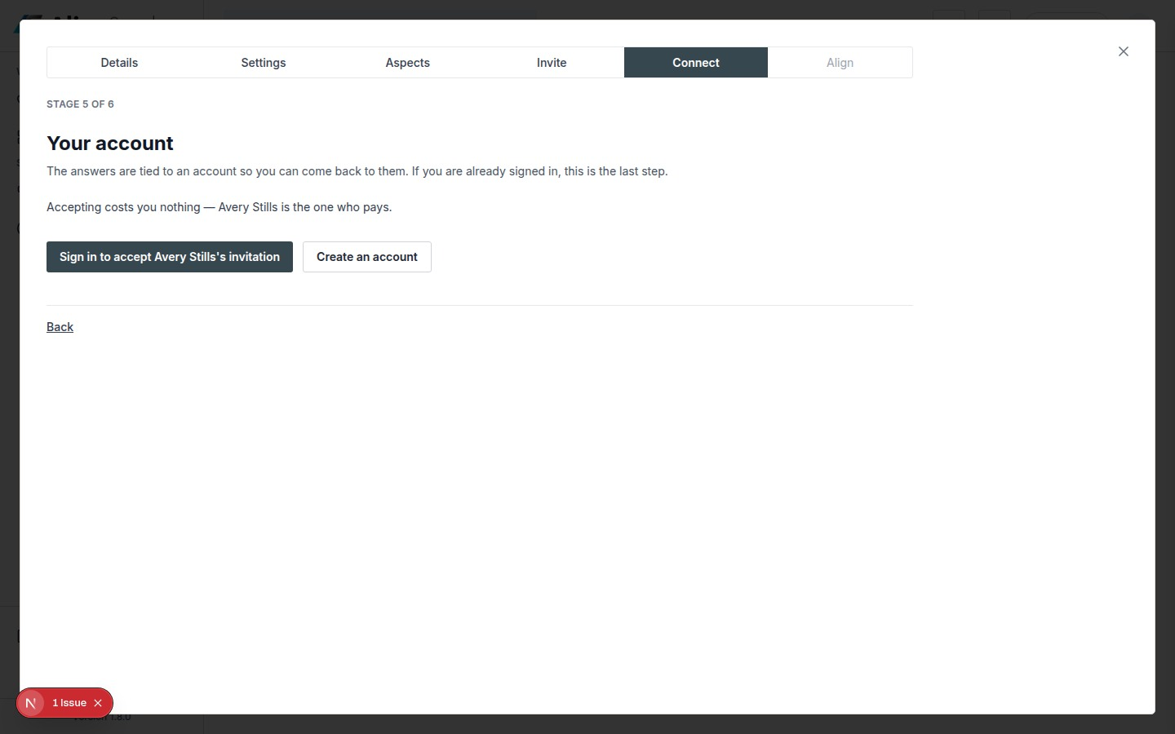
docs/qa-invite-response/response-step-3-1440.png · source 1440×900 px · displayed band y=0–900 of 900 px. Account confirmation state before claim.
SCREEN ATLAS / CONTINUED

Invitation and claim · Mobile · account gate · section 1
MOBILE · ACCOUNT GATE · CAPTURED VIEW
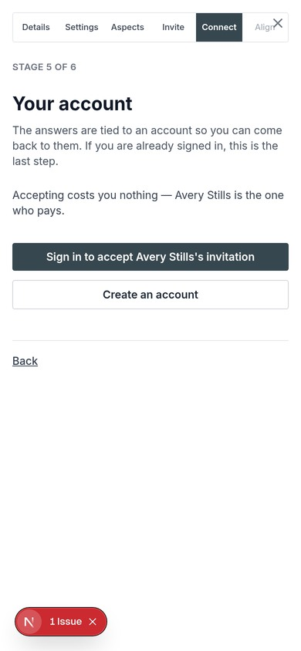
docs/qa-invite-response/response-step-3-390.png · source 780×1688 px · displayed band y=0–844 of 844 px. Captured at 2×; shown at CSS 390px.
SCREEN ATLAS / CONTINUED

Invitation and claim · Desktop · claim confirmation · section 1
DESKTOP · CLAIM CONFIRMATION · SECTION 1 OF 3
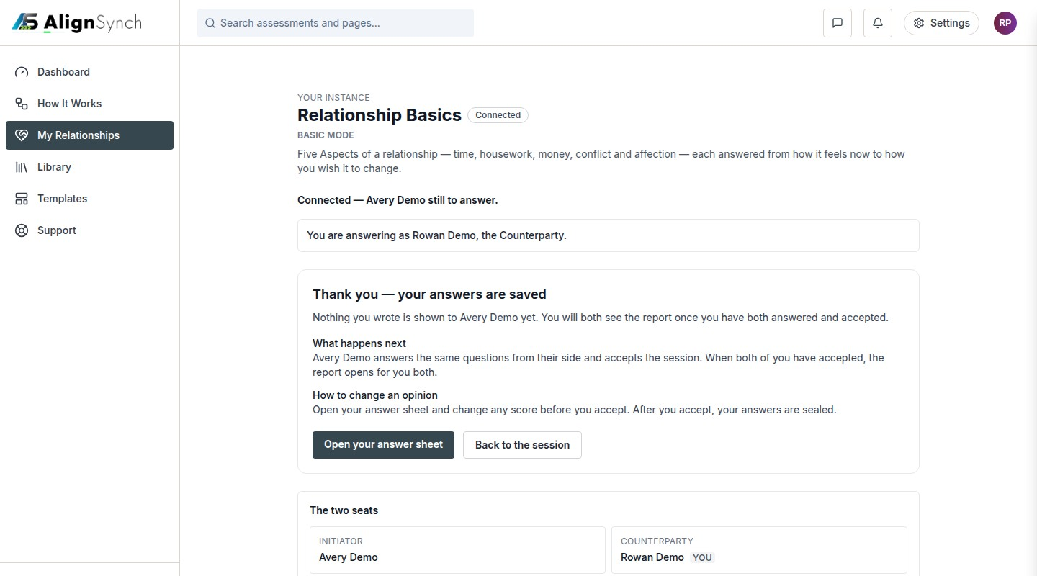
docs/qa-counterparty-onboarding/confirmation-1440.png · source 1440×2400 px · displayed band y=0–800 of 2400 px. Confirmation page after the counterparty journey.
SCREEN ATLAS / CONTINUED

Invitation and claim · Desktop · claim confirmation · section 2
DESKTOP · CLAIM CONFIRMATION · SECTION 2 OF 3
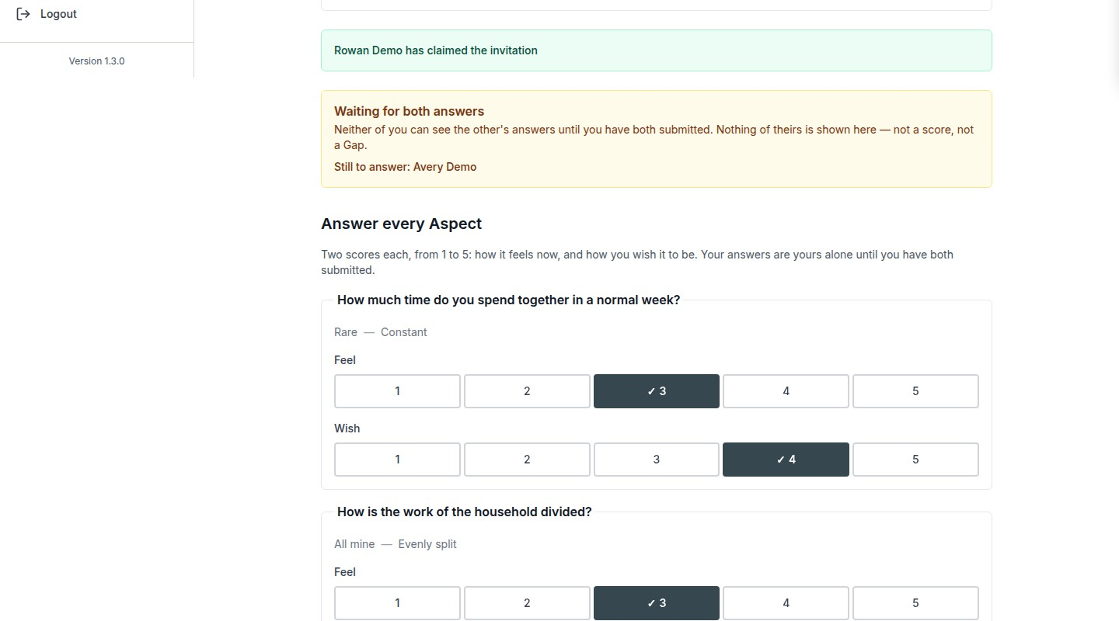
docs/qa-counterparty-onboarding/confirmation-1440.png · source 1440×2400 px · displayed band y=800–1600 of 2400 px. Confirmation page after the counterparty journey.
SCREEN ATLAS / CONTINUED

Invitation and claim · Desktop · claim confirmation · section 3
DESKTOP · CLAIM CONFIRMATION · SECTION 3 OF 3
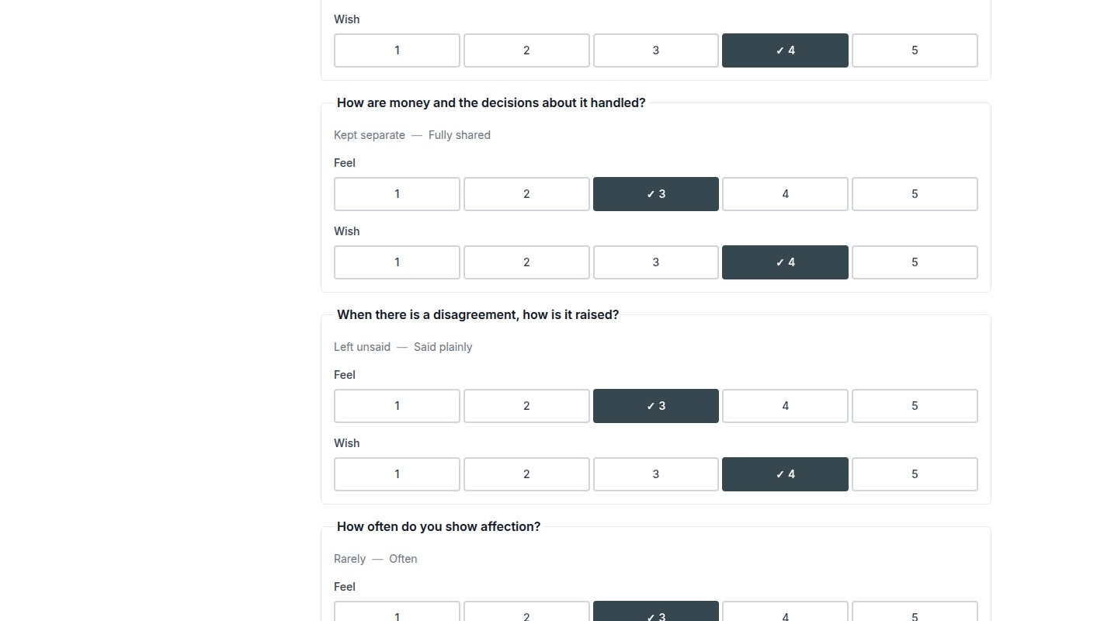
docs/qa-counterparty-onboarding/confirmation-1440.png · source 1440×2400 px · displayed band y=1600–2400 of 2400 px. Confirmation page after the counterparty journey.
SCREEN ATLAS / CONTINUED

Invitation and claim · Mobile · claim confirmation · section 1
MOBILE · CLAIM CONFIRMATION · SECTION 1 OF 4
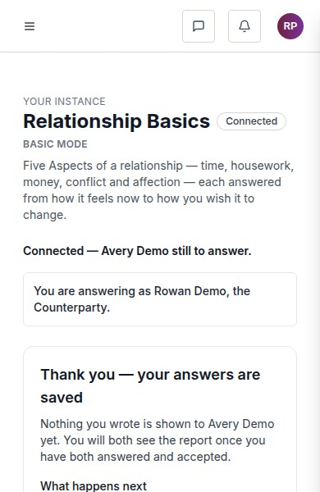
docs/qa-counterparty-onboarding/confirmation-390.png · source 390×2400 px · displayed band y=0–600 of 2400 px. Full page at CSS 390px.
SCREEN ATLAS / CONTINUED

Invitation and claim · Mobile · claim confirmation · section 2
MOBILE · CLAIM CONFIRMATION · SECTION 2 OF 4
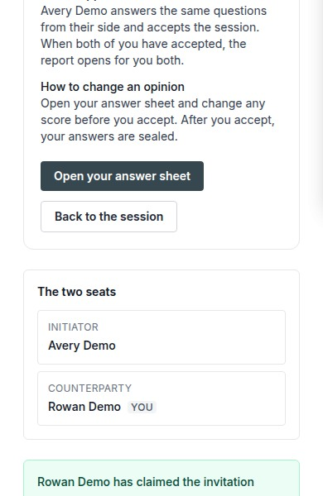
docs/qa-counterparty-onboarding/confirmation-390.png · source 390×2400 px · displayed band y=600–1200 of 2400 px. Full page at CSS 390px.
SCREEN ATLAS / CONTINUED

Invitation and claim · Mobile · claim confirmation · section 3
MOBILE · CLAIM CONFIRMATION · SECTION 3 OF 4
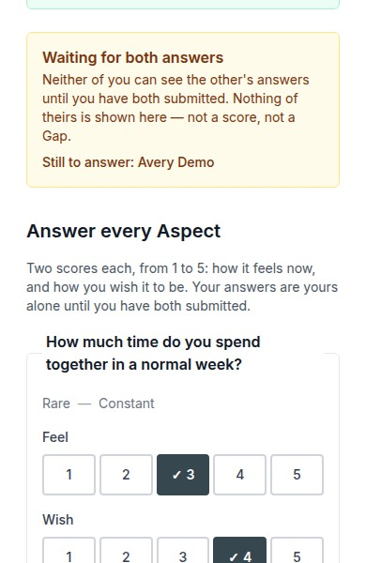
docs/qa-counterparty-onboarding/confirmation-390.png · source 390×2400 px · displayed band y=1200–1800 of 2400 px. Full page at CSS 390px.
SCREEN ATLAS / CONTINUED

Invitation and claim · Mobile · claim confirmation · section 4
MOBILE · CLAIM CONFIRMATION · SECTION 4 OF 4
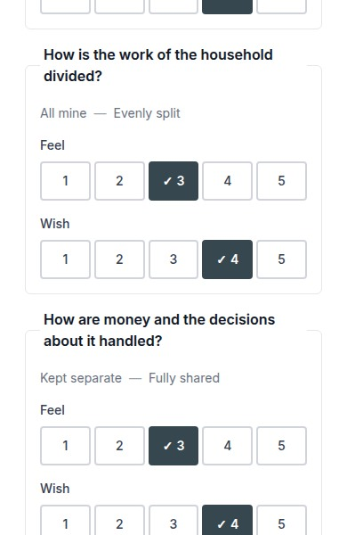
docs/qa-counterparty-onboarding/confirmation-390.png · source 390×2400 px · displayed band y=1800–2400 of 2400 px. Full page at CSS 390px.
SCREEN ATLAS / /ASSESSMENTS

My Assessments list
Page and user purpose | What the member or staff user does
/assessments | Find sessions that need your answers, are waiting for the other person, or have an open report.

Front-end evidence | Behind the page
No screenshot of the exact current route was found. The route and current implementation are referenced here; older /assessment/instances screens are documented as historical in the capture notes. | app/(mainlayout)/assessments/page.tsx:73; components/dashboard/assessments-list.tsx:143; lib/db/assessments.ts:787.

Capture context. No exact current-route screenshot exists in the available QA bundle. The legacy list capture is not substituted because its route and content differ.
SCREEN ATLAS / /ASSESSMENT/INSTANCES/[ID]/ANSWER

Private answer sheet
Page and user purpose | What the member or staff user does
/assessment/instances/[id]/answer | Record how each Aspect feels now and how you wish it to be, privately from the other participant.

Front-end evidence | Behind the page
Exact answer route desktop/mobile pair, verified in qa-conformance/answer-report.json. | app/(mainlayout)/assessment/instances/[instanceId]/answer/page.tsx:99; components/assessment-flow/answer-sheet.tsx:105; answer API .../answers/route.ts:94; lib/flow/store.ts:1535.

DESKTOP · CAPTURED VIEW
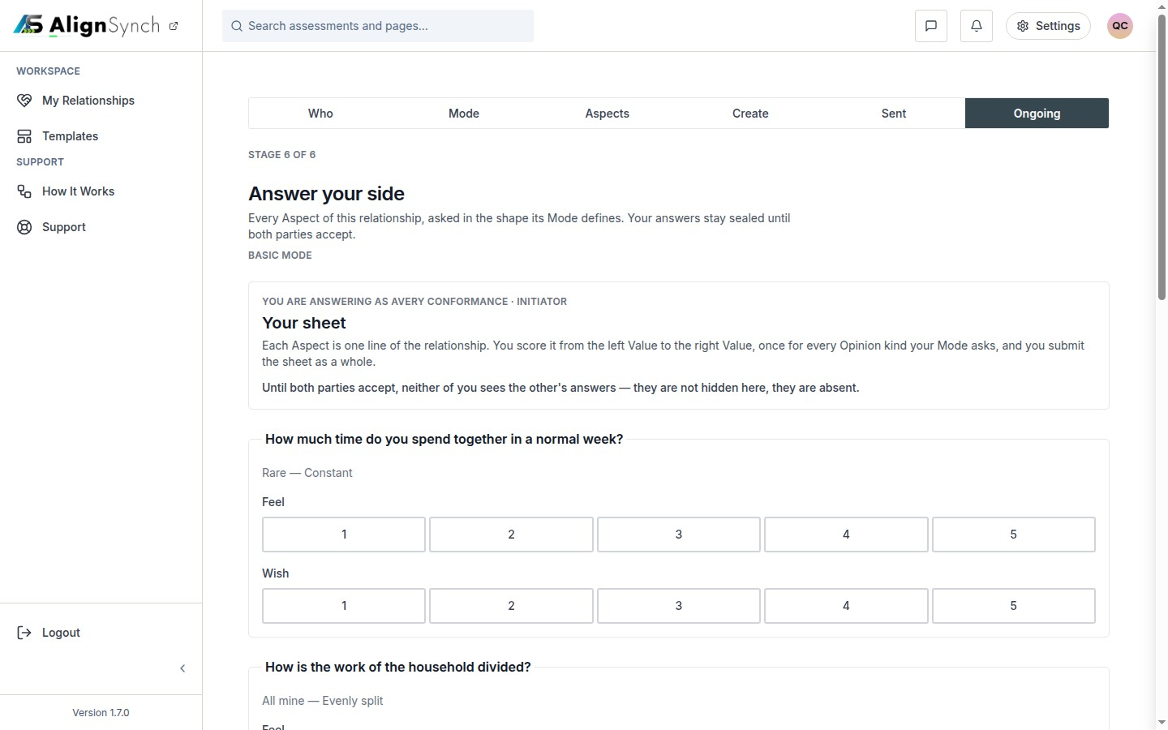
docs/qa-conformance/answer-1440.png · source 1440×900 px · displayed band y=0–900 of 900 px. Viewport capture; 5 Aspects in the demo relationship.
SCREEN ATLAS / CONTINUED

Private answer sheet · Mobile · section 1
MOBILE · CAPTURED VIEW
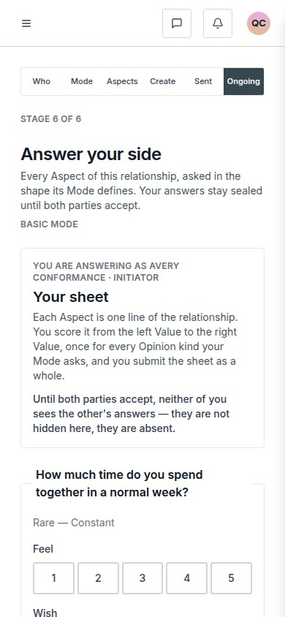
docs/qa-conformance/answer-390.png · source 390×844 px · displayed band y=0–844 of 844 px. Viewport capture at CSS 390px.
SCREEN ATLAS / /ASSESSMENT/INSTANCES/[ID] → ALIGNMENT

Acceptance and shared Alignment
Page and user purpose | What the member or staff user does
/assessment/instances/[id] → Alignment | Accept your completed sheet and, after both people accept, review the shared differences and suggested Steps.

Front-end evidence | Behind the page
Available screenshots show the stage page and opened Alignment state. A dedicated /report route capture was not found. | app/(mainlayout)/assessment/instances/[instanceId]/page.tsx:179; components/assessment-flow/report-view.tsx:426; lib/assessment-report.ts:178; lib/flow/store.ts:1912,2661; content/gaps.ts:192,255.

Capture context. The long Alignment captures show the open report state on the session route, not proof that the dedicated /report URL was visited.
DESKTOP · ALIGNMENT OPENS · CAPTURED VIEW
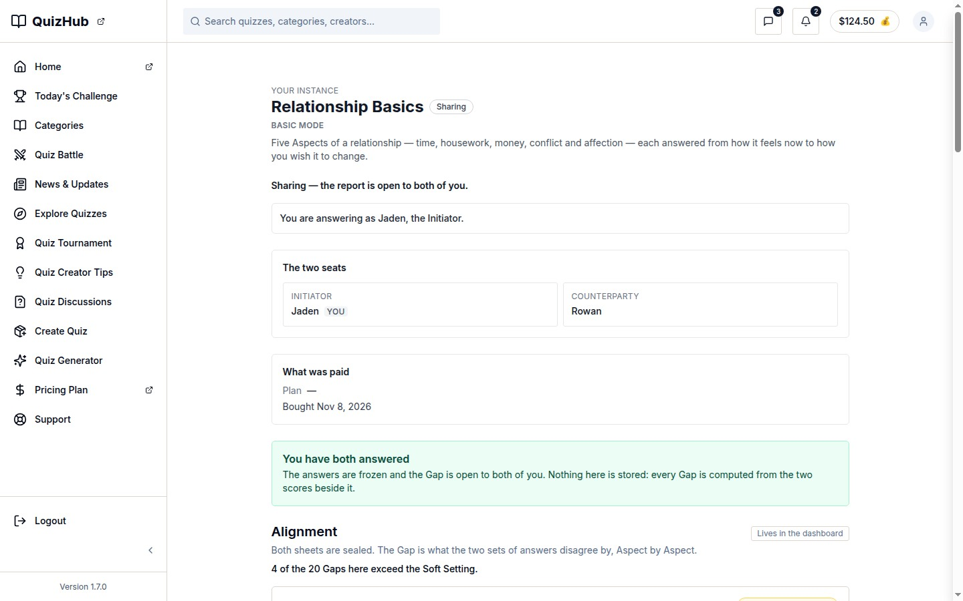
docs/qa-flow-stages/align-opens-alignment-1440.png · source 1440×900 px · displayed band y=0–900 of 900 px. Viewport capture with shared report open.
SCREEN ATLAS / CONTINUED

Acceptance and shared Alignment · Mobile · Alignment opens · section 1
MOBILE · ALIGNMENT OPENS · CAPTURED VIEW
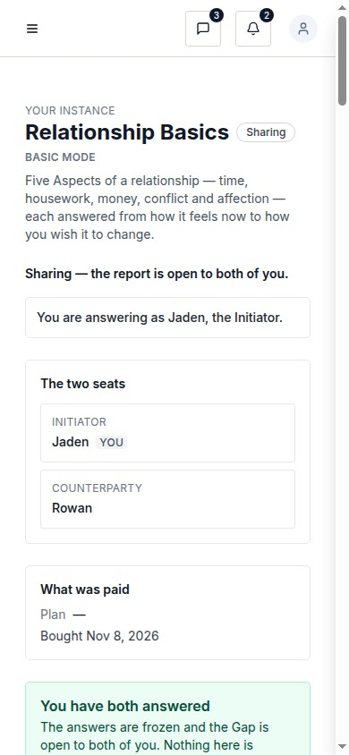
docs/qa-flow-stages/align-opens-alignment-390.png · source 390×844 px · displayed band y=0–844 of 844 px. Viewport capture at CSS 390px.
SCREEN ATLAS / CONTINUED

Acceptance and shared Alignment · Desktop · full Alignment · section 1
DESKTOP · FULL ALIGNMENT · SECTION 1 OF 3
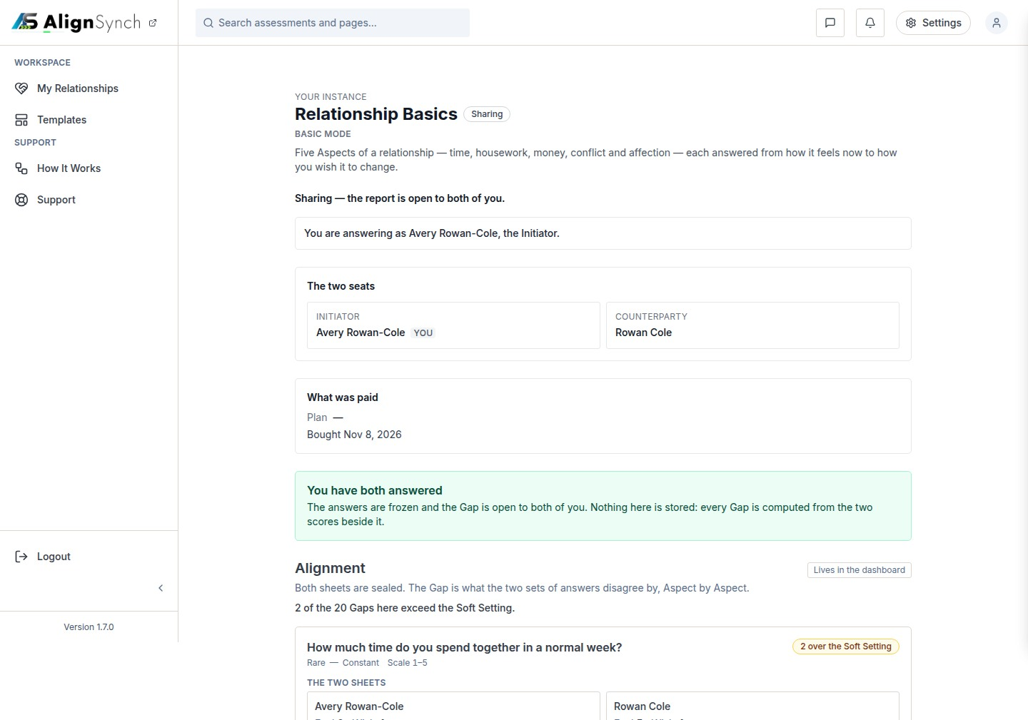
docs/qa-ongoing/alignment-1440.png · source 1440×3025 px · displayed band y=0–1009 of 3025 px. Long full-page report view split into consecutive bands.
SCREEN ATLAS / CONTINUED

Acceptance and shared Alignment · Desktop · full Alignment · section 2
DESKTOP · FULL ALIGNMENT · SECTION 2 OF 3
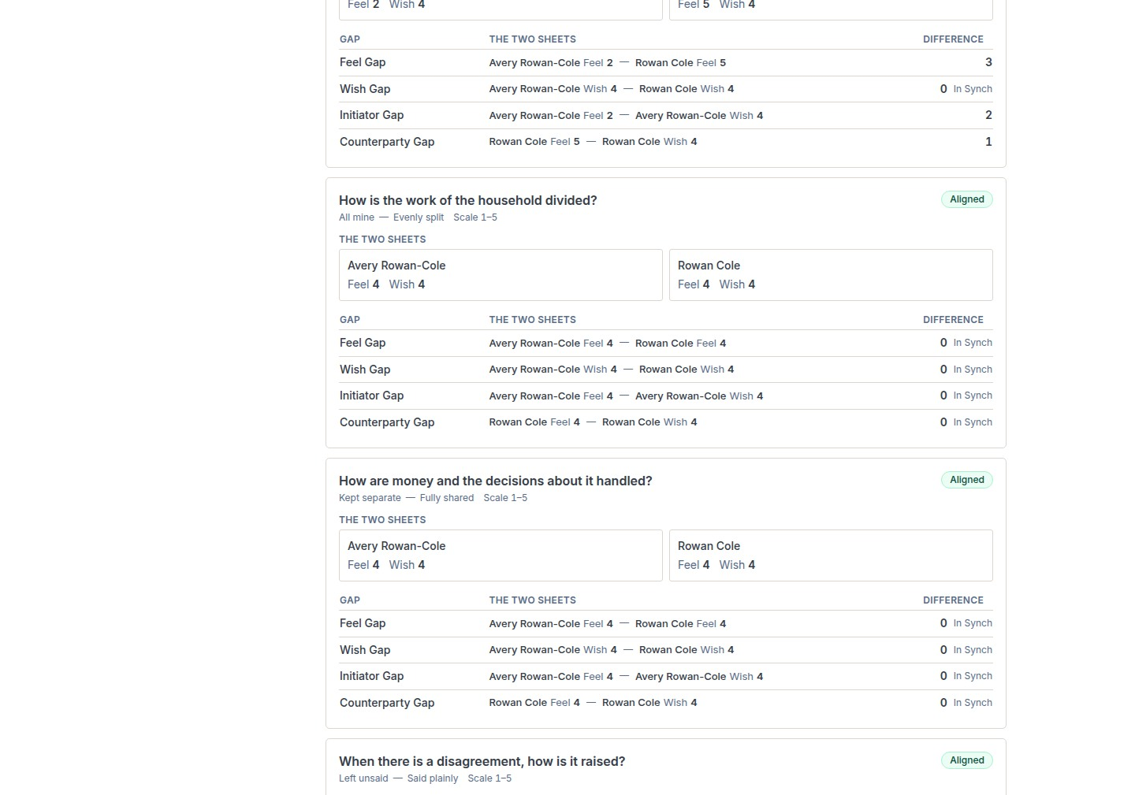
docs/qa-ongoing/alignment-1440.png · source 1440×3025 px · displayed band y=1009–2018 of 3025 px. Long full-page report view split into consecutive bands.
SCREEN ATLAS / CONTINUED

Acceptance and shared Alignment · Desktop · full Alignment · section 3
DESKTOP · FULL ALIGNMENT · SECTION 3 OF 3
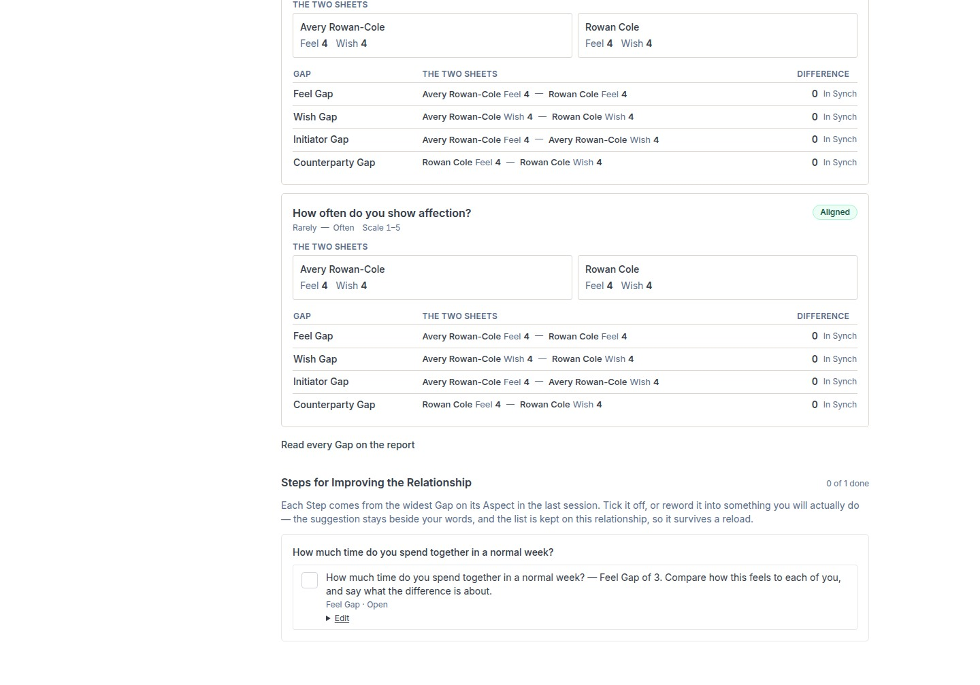
docs/qa-ongoing/alignment-1440.png · source 1440×3025 px · displayed band y=2018–3025 of 3025 px. Long full-page report view split into consecutive bands.
SCREEN ATLAS / CONTINUED

Acceptance and shared Alignment · Mobile · full Alignment · section 1
MOBILE · FULL ALIGNMENT · SECTION 1 OF 9
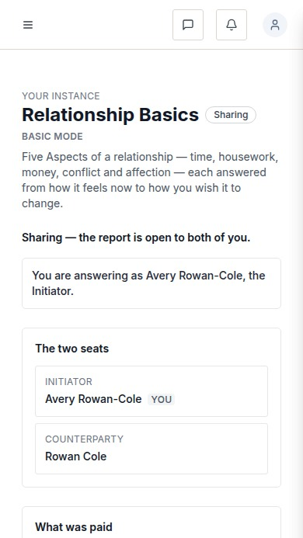
docs/qa-ongoing/alignment-390.png · source 390×6235 px · displayed band y=0–693 of 6235 px. Long full-page report view split into consecutive bands.
SCREEN ATLAS / CONTINUED

Acceptance and shared Alignment · Mobile · full Alignment · section 2
MOBILE · FULL ALIGNMENT · SECTION 2 OF 9
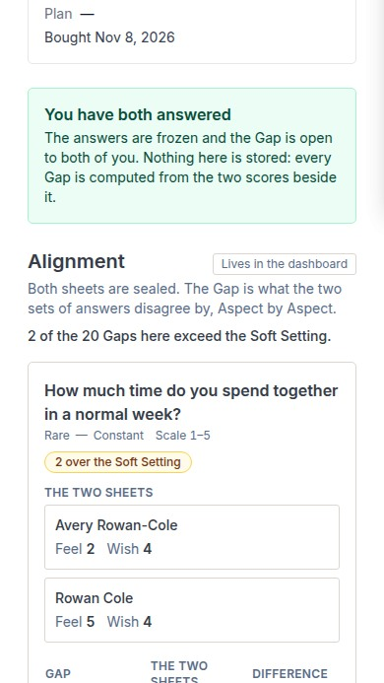
docs/qa-ongoing/alignment-390.png · source 390×6235 px · displayed band y=693–1386 of 6235 px. Long full-page report view split into consecutive bands.
SCREEN ATLAS / CONTINUED

Acceptance and shared Alignment · Mobile · full Alignment · section 3
MOBILE · FULL ALIGNMENT · SECTION 3 OF 9
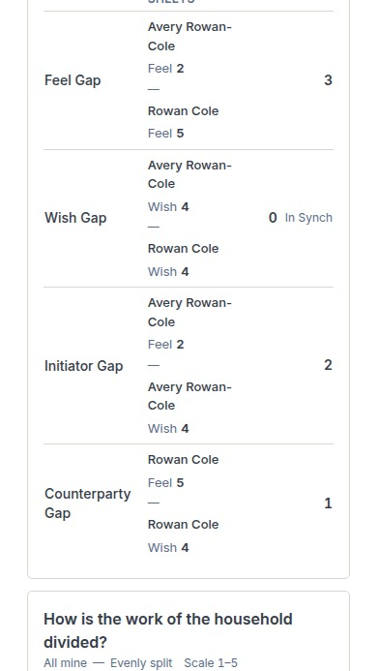
docs/qa-ongoing/alignment-390.png · source 390×6235 px · displayed band y=1386–2079 of 6235 px. Long full-page report view split into consecutive bands.
SCREEN ATLAS / CONTINUED

Acceptance and shared Alignment · Mobile · full Alignment · section 4
MOBILE · FULL ALIGNMENT · SECTION 4 OF 9
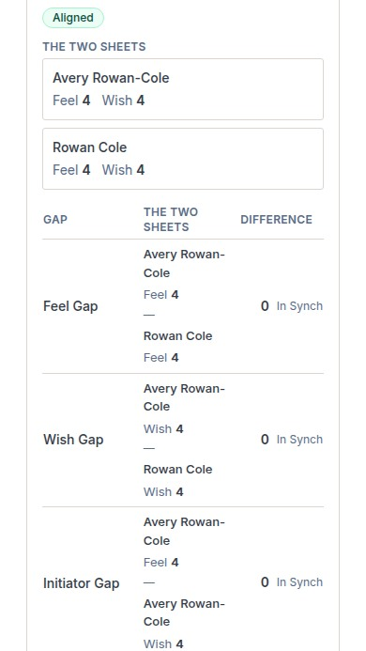
docs/qa-ongoing/alignment-390.png · source 390×6235 px · displayed band y=2079–2772 of 6235 px. Long full-page report view split into consecutive bands.
SCREEN ATLAS / CONTINUED

Acceptance and shared Alignment · Mobile · full Alignment · section 5
MOBILE · FULL ALIGNMENT · SECTION 5 OF 9
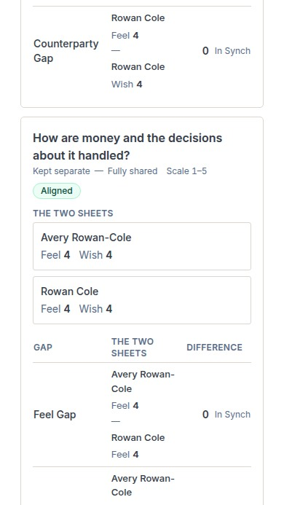
docs/qa-ongoing/alignment-390.png · source 390×6235 px · displayed band y=2772–3465 of 6235 px. Long full-page report view split into consecutive bands.
SCREEN ATLAS / CONTINUED

Acceptance and shared Alignment · Mobile · full Alignment · section 6
MOBILE · FULL ALIGNMENT · SECTION 6 OF 9
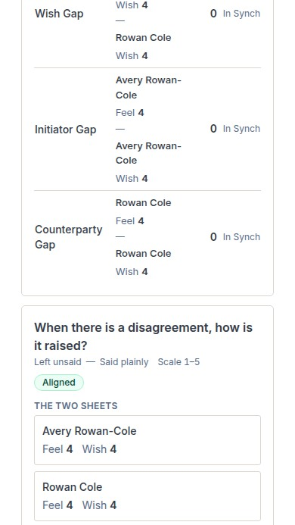
docs/qa-ongoing/alignment-390.png · source 390×6235 px · displayed band y=3465–4158 of 6235 px. Long full-page report view split into consecutive bands.
SCREEN ATLAS / CONTINUED

Acceptance and shared Alignment · Mobile · full Alignment · section 7
MOBILE · FULL ALIGNMENT · SECTION 7 OF 9
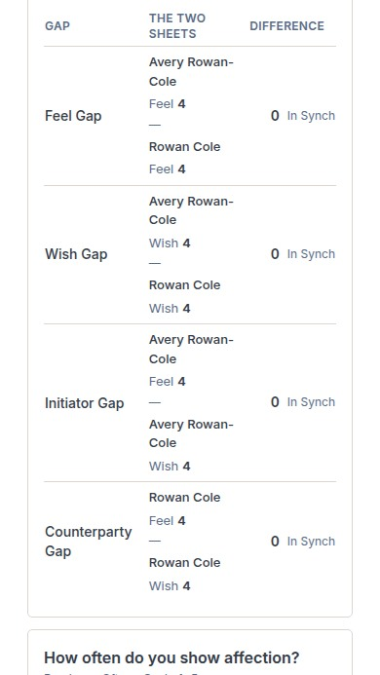
docs/qa-ongoing/alignment-390.png · source 390×6235 px · displayed band y=4158–4851 of 6235 px. Long full-page report view split into consecutive bands.
SCREEN ATLAS / CONTINUED

Acceptance and shared Alignment · Mobile · full Alignment · section 8
MOBILE · FULL ALIGNMENT · SECTION 8 OF 9
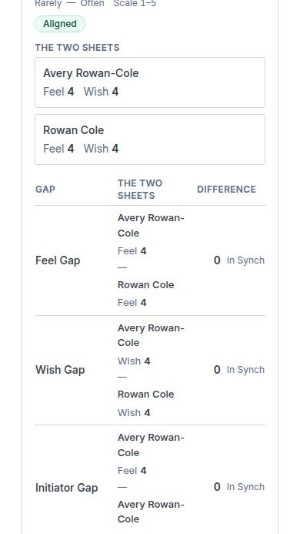
docs/qa-ongoing/alignment-390.png · source 390×6235 px · displayed band y=4851–5544 of 6235 px. Long full-page report view split into consecutive bands.
SCREEN ATLAS / CONTINUED

Acceptance and shared Alignment · Mobile · full Alignment · section 9
MOBILE · FULL ALIGNMENT · SECTION 9 OF 9
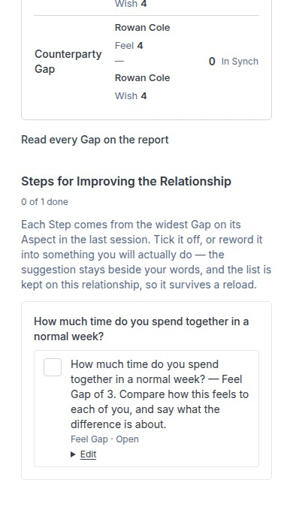
docs/qa-ongoing/alignment-390.png · source 390×6235 px · displayed band y=5544–6235 of 6235 px. Long full-page report view split into consecutive bands.
SCREEN ATLAS / /ASSESSMENT/INSTANCES/[ID]/SENT

Invitation sent confirmation
Page and user purpose | What the member or staff user does
/assessment/instances/[id]/sent | Confirm that an invitation was sent and choose a useful next action.

Front-end evidence | Behind the page
Local QA full-page desktop/mobile pair. | app/(mainlayout)/assessment/instances/[instanceId]/sent/page.tsx:52; invitation creation lib/member/relationships.ts:1116; resend :1427.

DESKTOP · CAPTURED VIEW
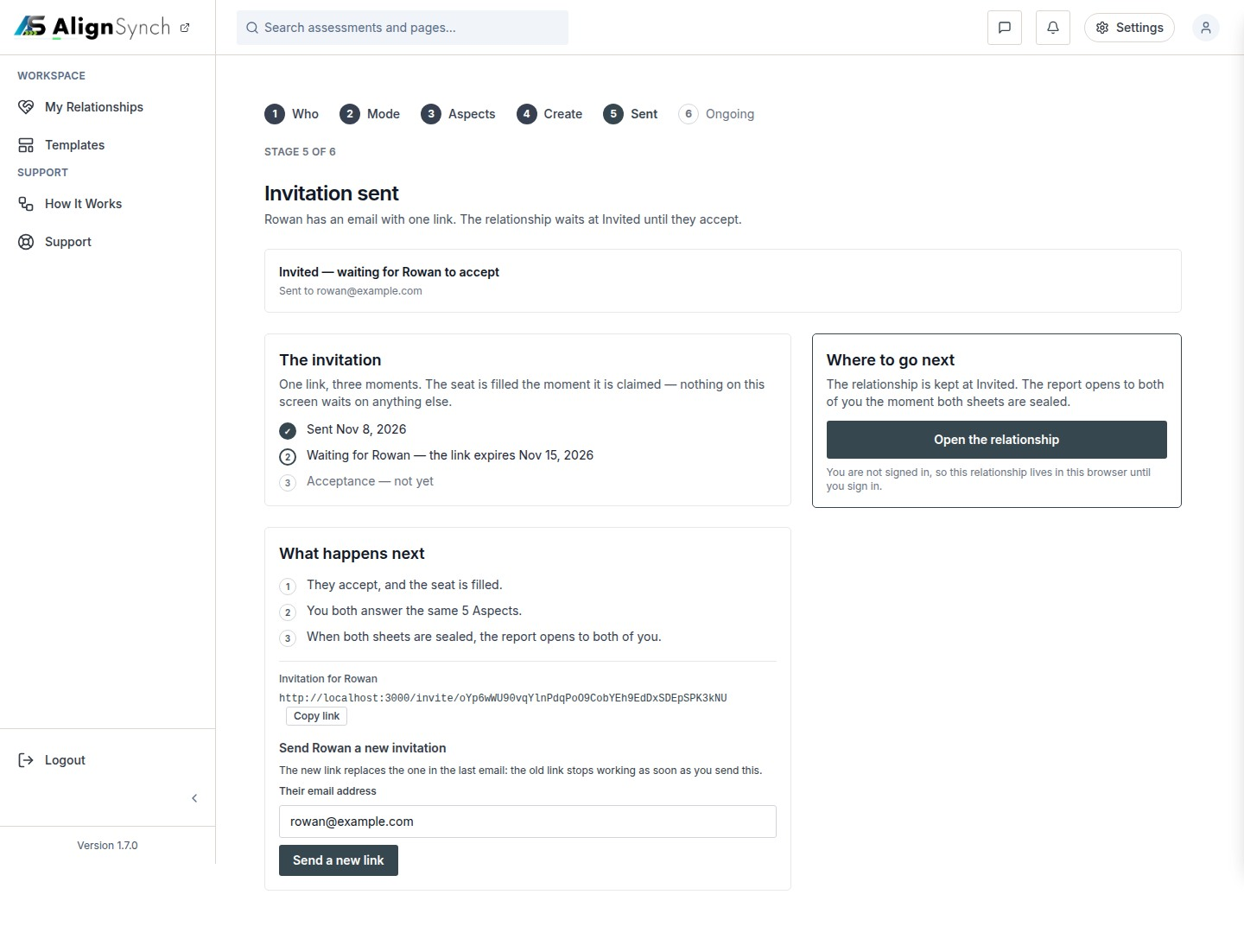
docs/qa-sent/sent-1440.png · source 1440×1087 px · displayed band y=0–1087 of 1087 px. Full-page confirmation state.
SCREEN ATLAS / CONTINUED

Invitation sent confirmation · Mobile · section 1
MOBILE · SECTION 1 OF 2
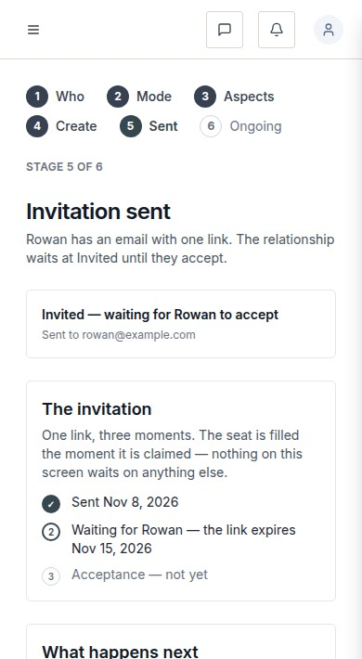
docs/qa-sent/sent-390.png · source 390×1420 px · displayed band y=0–710 of 1420 px. Full-page confirmation state at CSS 390px.
SCREEN ATLAS / CONTINUED

Invitation sent confirmation · Mobile · section 2
MOBILE · SECTION 2 OF 2
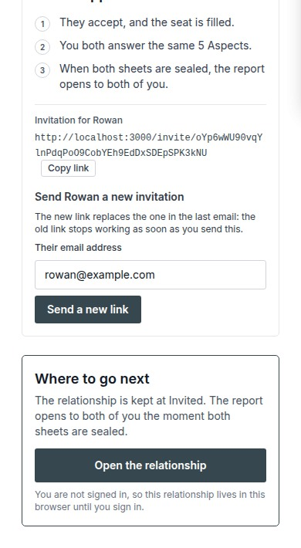
docs/qa-sent/sent-390.png · source 390×1420 px · displayed band y=710–1420 of 1420 px. Full-page confirmation state at CSS 390px.
SCREEN ATLAS / /DASHBOARD/HELP

How It Works
Page and user purpose | What the member or staff user does
/dashboard/help | Learn the six-step relationship process and replay the guided tour.

Front-end evidence | Behind the page
Current route pair from QA Columns, verified by the capture report. | app/(mainlayout)/dashboard/help/page.tsx:44; tour action /api/tour; shell components/layout/main-layout.tsx:65.

DESKTOP · SECTION 1 OF 2
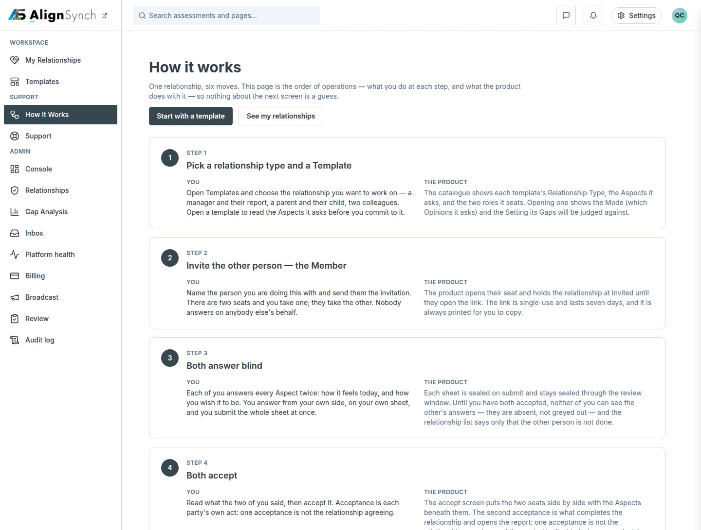
docs/qa-858-columns/after-dashboard-help-1440.png · source 1440×2182 px · displayed band y=0–1091 of 2182 px. Full-page content; split into readable bands.
SCREEN ATLAS / CONTINUED

How It Works · Desktop · section 2
DESKTOP · SECTION 2 OF 2
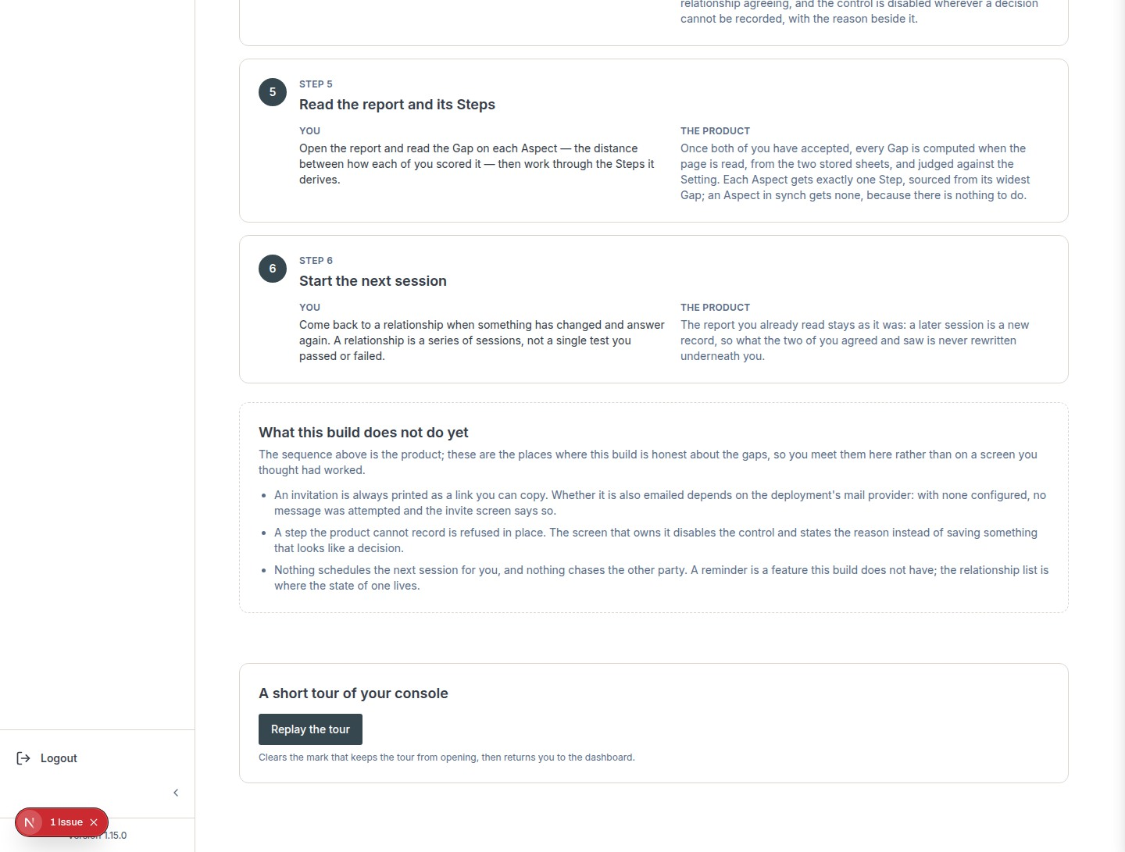
docs/qa-858-columns/after-dashboard-help-1440.png · source 1440×2182 px · displayed band y=1091–2182 of 2182 px. Full-page content; split into readable bands.
SCREEN ATLAS / CONTINUED

How It Works · Mobile · section 1
MOBILE · SECTION 1 OF 6
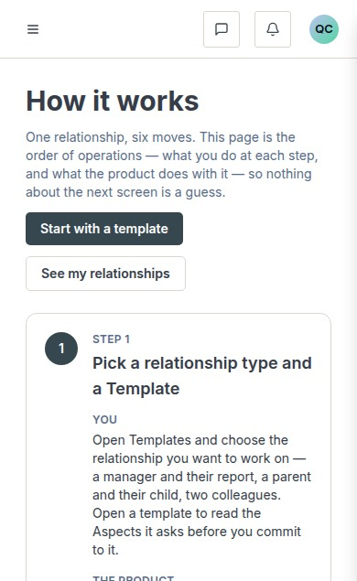
docs/qa-858-columns/after-dashboard-help-390.png · source 390×3806 px · displayed band y=0–635 of 3806 px. Full-page content at CSS 390px; split into readable bands.
SCREEN ATLAS / CONTINUED

How It Works · Mobile · section 2
MOBILE · SECTION 2 OF 6
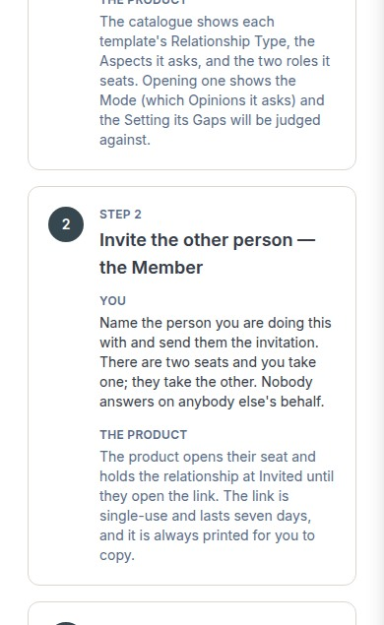
docs/qa-858-columns/after-dashboard-help-390.png · source 390×3806 px · displayed band y=635–1270 of 3806 px. Full-page content at CSS 390px; split into readable bands.
SCREEN ATLAS / CONTINUED

How It Works · Mobile · section 3
MOBILE · SECTION 3 OF 6
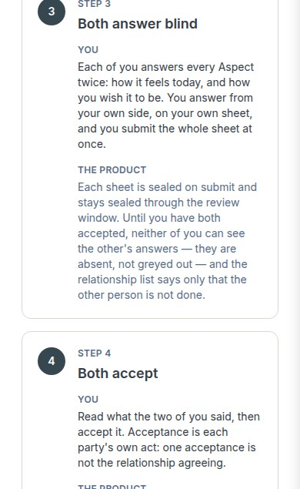
docs/qa-858-columns/after-dashboard-help-390.png · source 390×3806 px · displayed band y=1270–1905 of 3806 px. Full-page content at CSS 390px; split into readable bands.
SCREEN ATLAS / CONTINUED

How It Works · Mobile · section 4
MOBILE · SECTION 4 OF 6
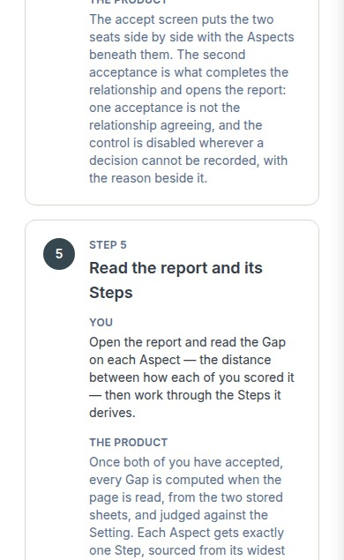
docs/qa-858-columns/after-dashboard-help-390.png · source 390×3806 px · displayed band y=1905–2540 of 3806 px. Full-page content at CSS 390px; split into readable bands.
SCREEN ATLAS / CONTINUED

How It Works · Mobile · section 5
MOBILE · SECTION 5 OF 6
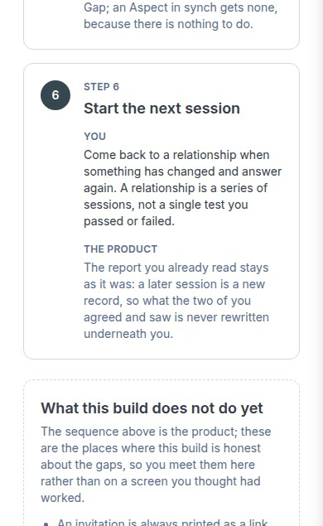
docs/qa-858-columns/after-dashboard-help-390.png · source 390×3806 px · displayed band y=2540–3175 of 3806 px. Full-page content at CSS 390px; split into readable bands.
SCREEN ATLAS / CONTINUED

How It Works · Mobile · section 6
MOBILE · SECTION 6 OF 6
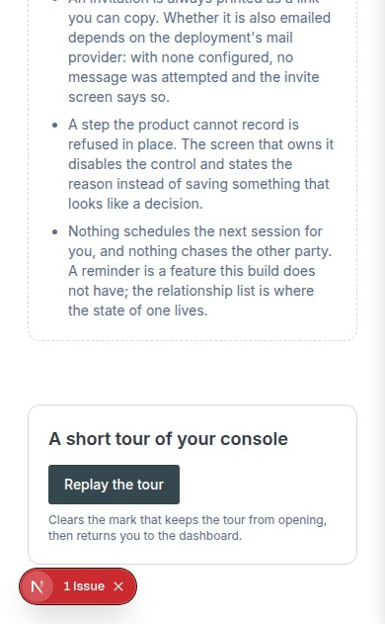
docs/qa-858-columns/after-dashboard-help-390.png · source 390×3806 px · displayed band y=3175–3806 of 3806 px. Full-page content at CSS 390px; split into readable bands.
SCREEN ATLAS / /DASHBOARD/SUPPORT

Support
Page and user purpose | What the member or staff user does
/dashboard/support | Search help topics or send an account-scoped request to the support team.

Front-end evidence | Behind the page
Only older support captures with an earlier navigation rail are available. They show the content area and submission states, not the current full shell. | app/(mainlayout)/dashboard/support/page.tsx:62; components/support/dashboard-support-view.tsx:60; actions :48; lib/contact/submit.ts:82; lib/contact/store.ts:39,118.

Capture context. Capture labels retain the older navigation context; current route source and support behavior are described in the preceding guide section.
DESKTOP · EARLIER SIGNED-IN CAPTURE · CAPTURED VIEW
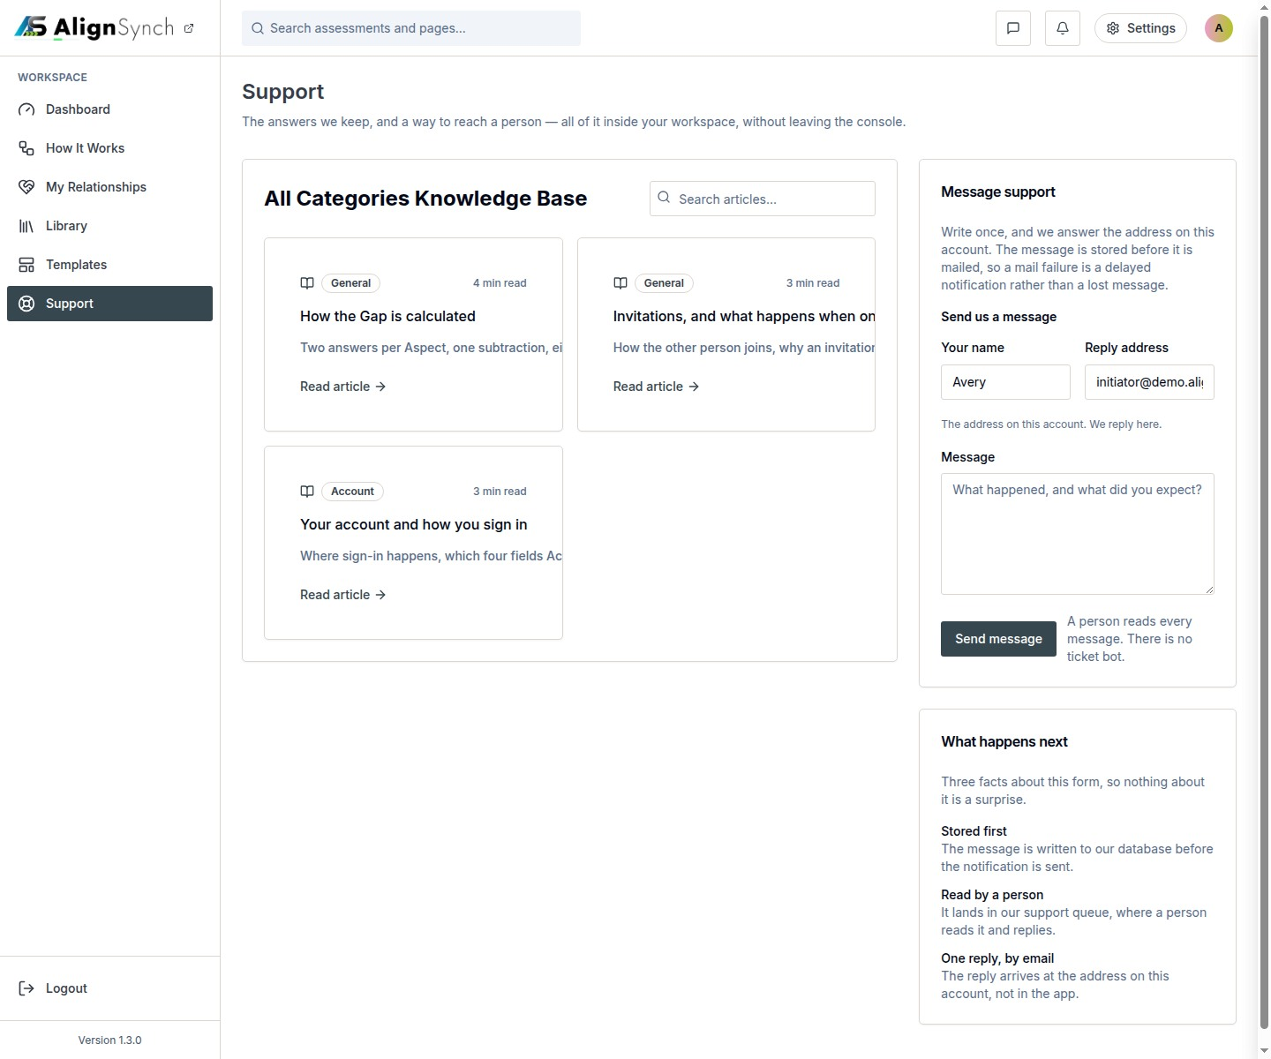
docs/qa-542/support-1440.png · source 1440×1200 px · displayed band y=0–1200 of 1200 px. Older shell and navigation; page-body reference only.
SCREEN ATLAS / CONTINUED

Support · Mobile · earlier signed-in capture · section 1
MOBILE · EARLIER SIGNED-IN CAPTURE · CAPTURED VIEW
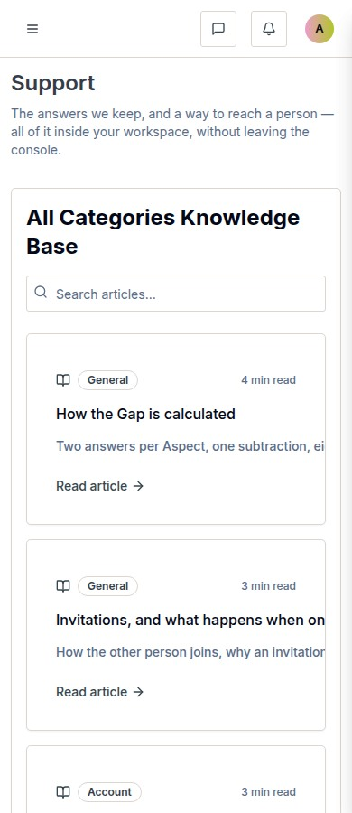
docs/qa-542/support-390.png · source 390×900 px · displayed band y=0–900 of 900 px. Older shell; content-area reference only.
SCREEN ATLAS / CONTINUED

Support · Desktop · submission result · section 1
DESKTOP · SUBMISSION RESULT · CAPTURED VIEW
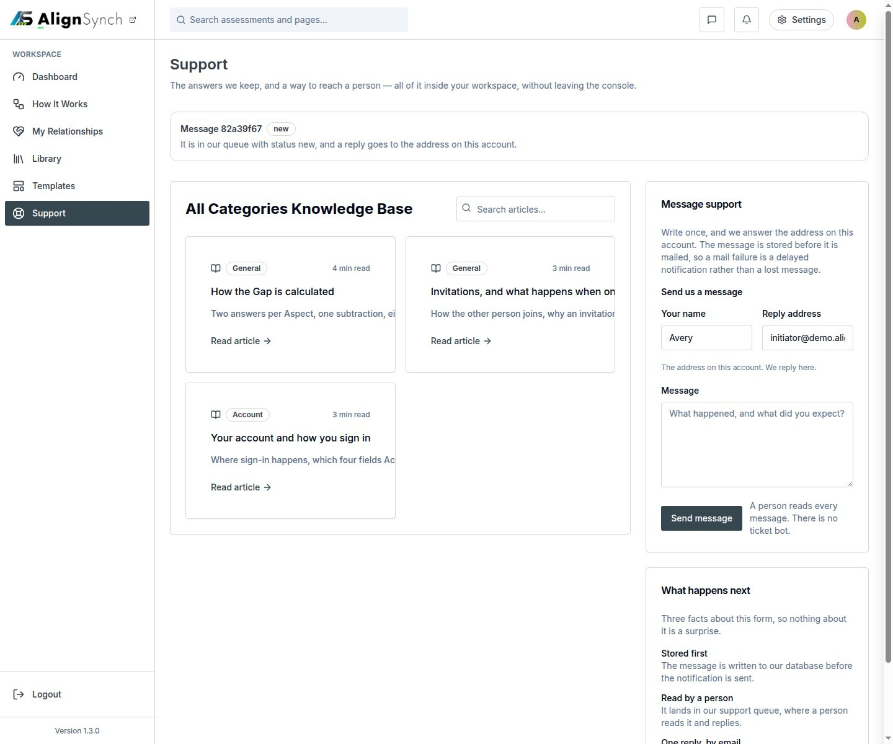
docs/qa-542/support-received-1440.png · source 1440×1200 px · displayed band y=0–1200 of 1200 px. Older confirmation state.
SCREEN ATLAS / CONTINUED

Support · Mobile · submission result · section 1
MOBILE · SUBMISSION RESULT · CAPTURED VIEW
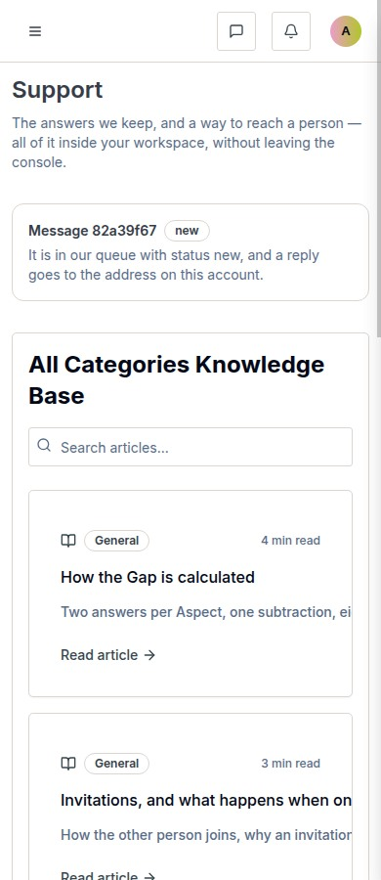
docs/qa-542/support-received-390.png · source 390×900 px · displayed band y=0–900 of 900 px. Older confirmation state.
SCREEN ATLAS / /SETTINGS AND /PROFILE/[HANDLE]

Account settings and profile
Page and user purpose | What the member or staff user does
/settings and /profile/[handle] | Update profile fields, manage password and account access, and review the profile view.

Front-end evidence | Behind the page
Current settings desktop/mobile pair plus profile route pair. | app/(mainlayout)/settings/page.tsx:48; components/identity/settings-view.tsx:80; app/api/profile/route.ts:48; lib/db/user-profiles.ts:78; lib/account/purge.ts:752.

Capture context. All names and records shown are prototype/demo data.
DESKTOP · SETTINGS · SECTION 1 OF 2
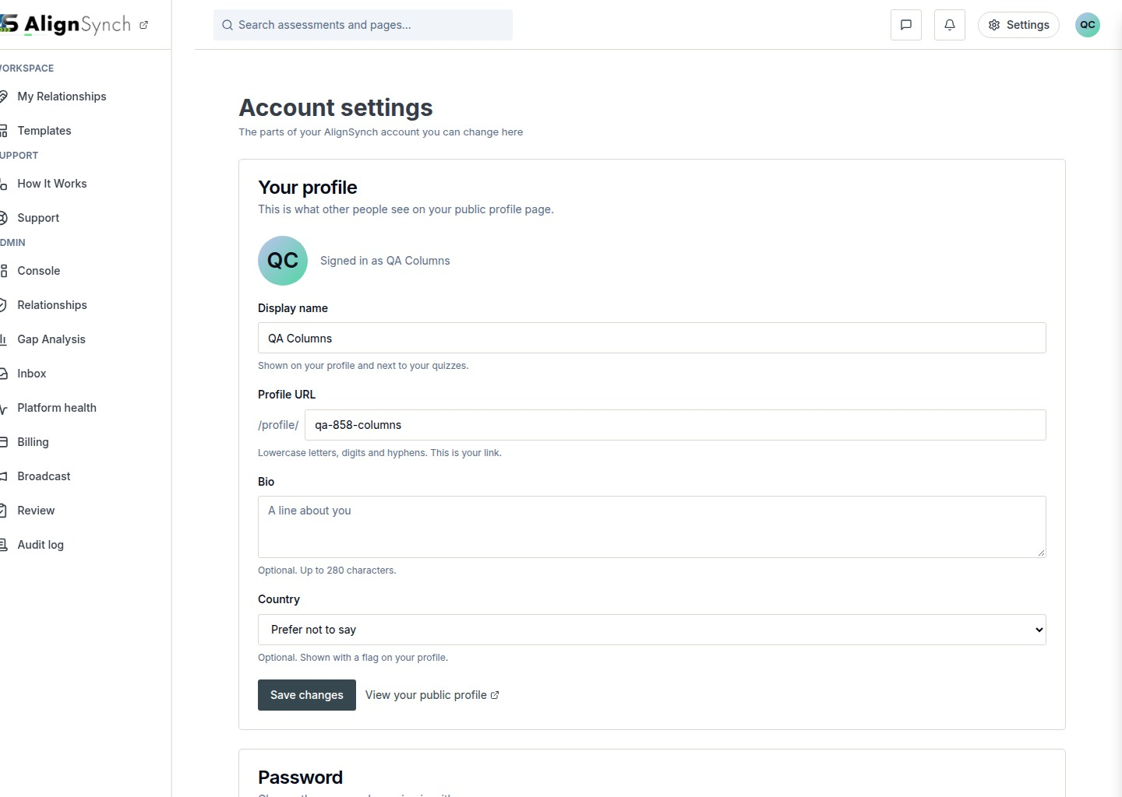
docs/qa-858-columns/after-settings-1440.png · source 1440×2047 px · displayed band y=0–1024 of 2047 px. Full-page settings view split into bands.
SCREEN ATLAS / CONTINUED

Account settings and profile · Desktop · settings · section 2
DESKTOP · SETTINGS · SECTION 2 OF 2
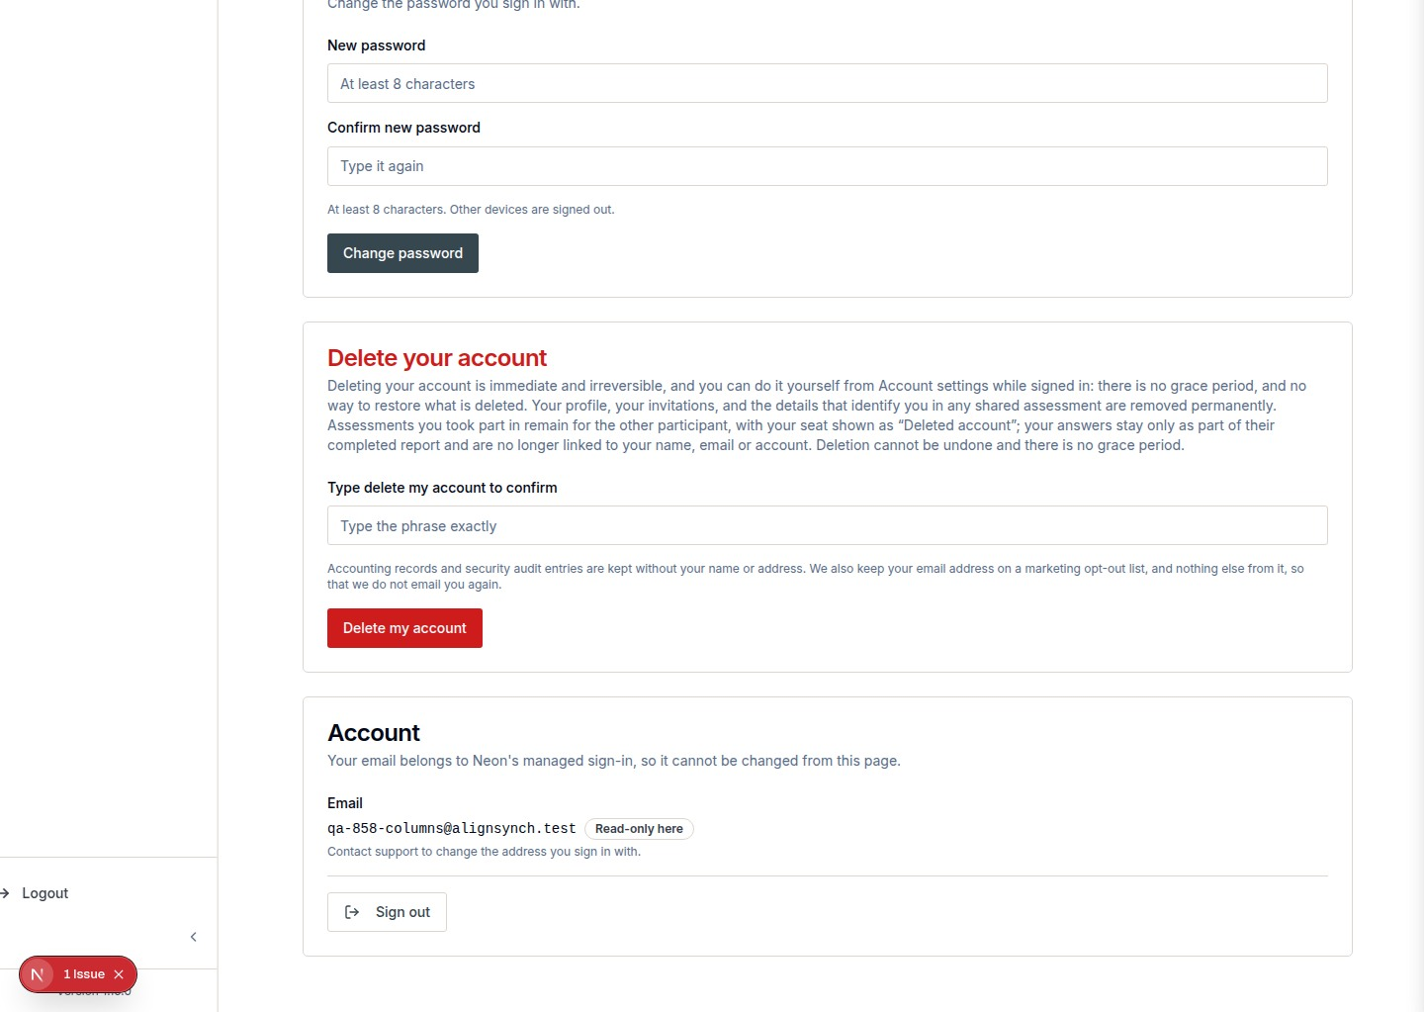
docs/qa-858-columns/after-settings-1440.png · source 1440×2047 px · displayed band y=1024–2047 of 2047 px. Full-page settings view split into bands.
SCREEN ATLAS / CONTINUED

Account settings and profile · Mobile · settings · section 1
MOBILE · SETTINGS · SECTION 1 OF 4
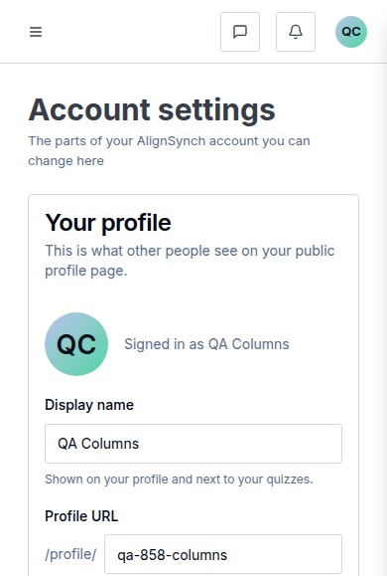
docs/qa-858-columns/after-settings-390.png · source 390×2316 px · displayed band y=0–579 of 2316 px. Full-page settings view at CSS 390px.
SCREEN ATLAS / CONTINUED

Account settings and profile · Mobile · settings · section 2
MOBILE · SETTINGS · SECTION 2 OF 4
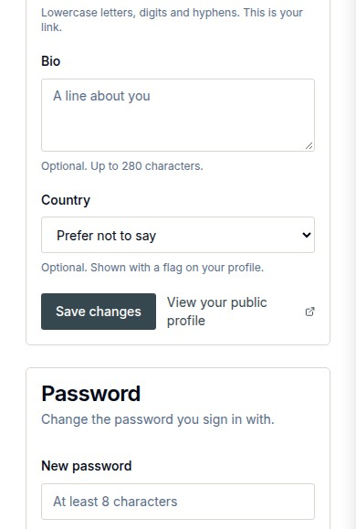
docs/qa-858-columns/after-settings-390.png · source 390×2316 px · displayed band y=579–1158 of 2316 px. Full-page settings view at CSS 390px.
SCREEN ATLAS / CONTINUED

Account settings and profile · Mobile · settings · section 3
MOBILE · SETTINGS · SECTION 3 OF 4
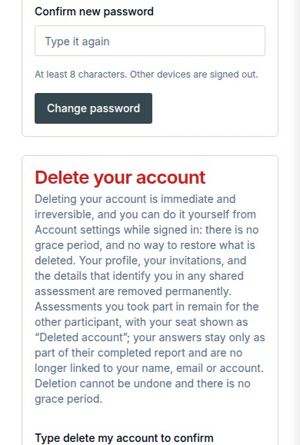
docs/qa-858-columns/after-settings-390.png · source 390×2316 px · displayed band y=1158–1737 of 2316 px. Full-page settings view at CSS 390px.
SCREEN ATLAS / CONTINUED

Account settings and profile · Mobile · settings · section 4
MOBILE · SETTINGS · SECTION 4 OF 4
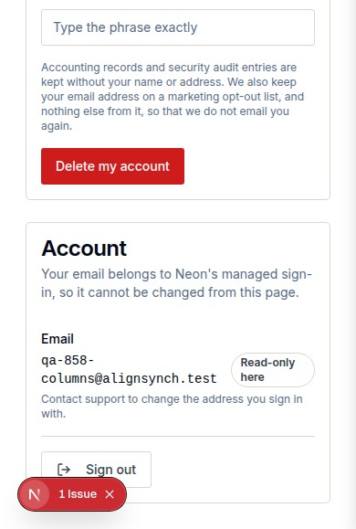
docs/qa-858-columns/after-settings-390.png · source 390×2316 px · displayed band y=1737–2316 of 2316 px. Full-page settings view at CSS 390px.
SCREEN ATLAS / CONTINUED

Account settings and profile · Desktop · member profile · section 1
DESKTOP · MEMBER PROFILE · CAPTURED VIEW
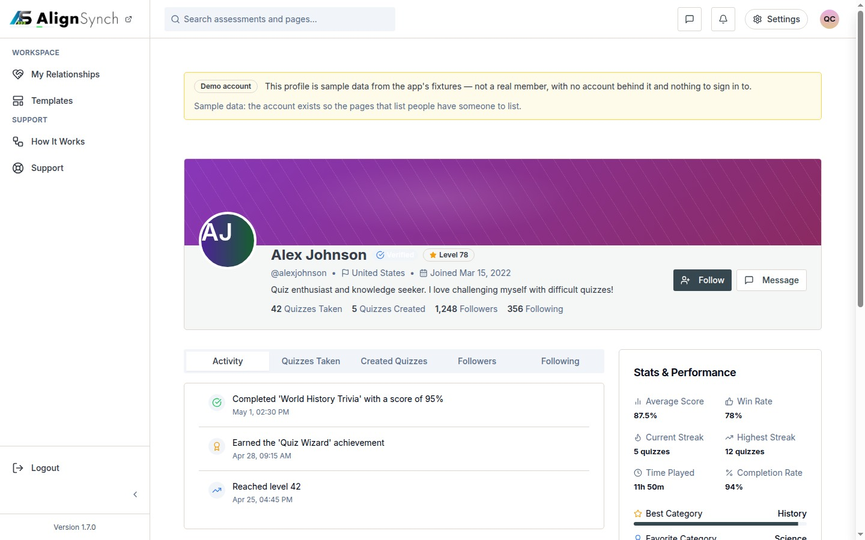
docs/qa-conformance/profile-1440.png · source 1440×900 px · displayed band y=0–900 of 900 px. Viewport profile capture with demo identity.
SCREEN ATLAS / CONTINUED

Account settings and profile · Mobile · member profile · section 1
MOBILE · MEMBER PROFILE · CAPTURED VIEW
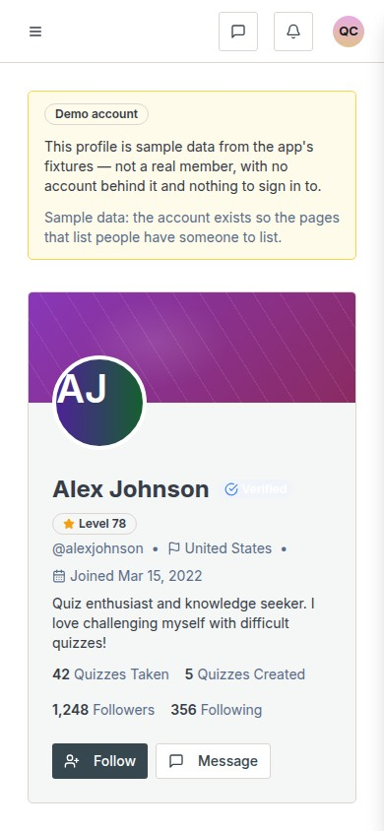
docs/qa-conformance/profile-390.png · source 390×844 px · displayed band y=0–844 of 844 px. Viewport capture at CSS 390px.
SCREEN ATLAS / /ADMIN/CONSOLE AND NESTED REGISTRIES

Staff console prototype
Page and user purpose | What the member or staff user does
/admin/console and nested registries | Review prototype user, template, and relationship records in the browser-backed staff console.

Front-end evidence | Behind the page
LocalStorage-backed prototype capture; it is separate from the database-backed admin operations pages. | app/(mainlayout)/admin/console/layout.tsx:39; console routes .../console/page.tsx:25, users/page.tsx:12, templates/page.tsx:11, relationships/page.tsx:14; lib/v1/store.tsx:4-18; data/v1/fixtures.ts.

Capture context. This screen family is explicitly prototype-only and uses browser localStorage fixtures. It is not the production database-backed operations console.
DESKTOP · CONSOLE OVERVIEW · CAPTURED VIEW
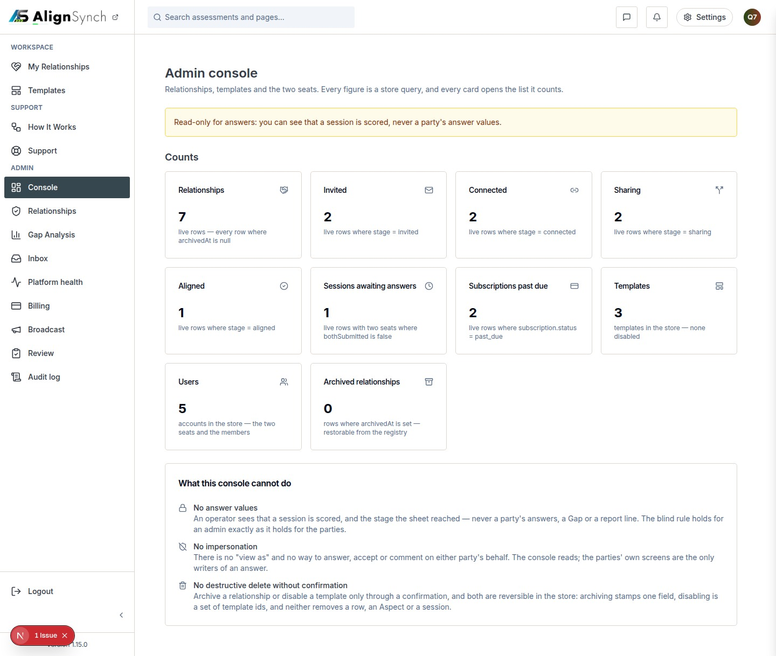
docs/qa-717-column/console-1440.png · source 1440×1218 px · displayed band y=0–1218 of 1218 px. Prototype console full-page view.
SCREEN ATLAS / CONTINUED

Staff console prototype · Mobile · console overview · section 1
MOBILE · CONSOLE OVERVIEW · SECTION 1 OF 4
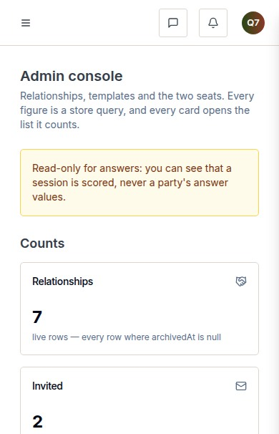
docs/qa-717-column/console-390.png · source 390×2424 px · displayed band y=0–606 of 2424 px. Prototype console full-page view.
SCREEN ATLAS / CONTINUED

Staff console prototype · Mobile · console overview · section 2
MOBILE · CONSOLE OVERVIEW · SECTION 2 OF 4
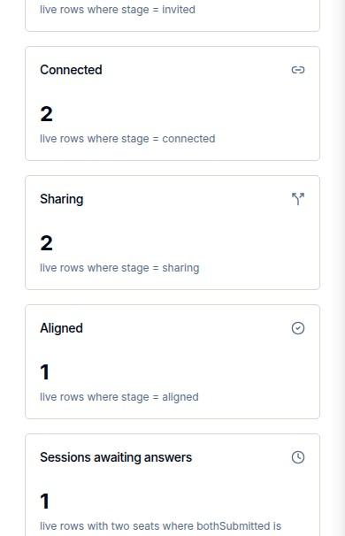
docs/qa-717-column/console-390.png · source 390×2424 px · displayed band y=606–1212 of 2424 px. Prototype console full-page view.
SCREEN ATLAS / CONTINUED

Staff console prototype · Mobile · console overview · section 3
MOBILE · CONSOLE OVERVIEW · SECTION 3 OF 4
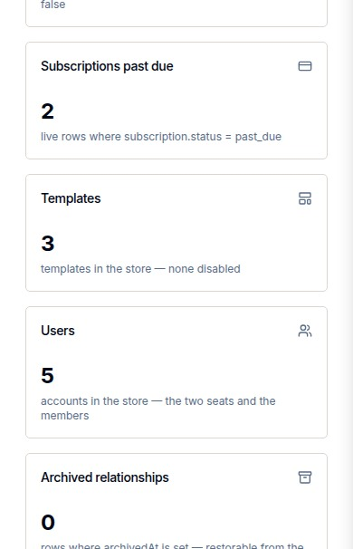
docs/qa-717-column/console-390.png · source 390×2424 px · displayed band y=1212–1818 of 2424 px. Prototype console full-page view.
SCREEN ATLAS / CONTINUED

Staff console prototype · Mobile · console overview · section 4
MOBILE · CONSOLE OVERVIEW · SECTION 4 OF 4
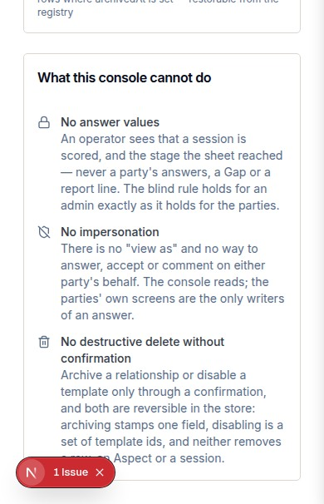
docs/qa-717-column/console-390.png · source 390×2424 px · displayed band y=1818–2424 of 2424 px. Prototype console full-page view.
SCREEN ATLAS / CONTINUED

Staff console prototype · Desktop · users registry · section 1
DESKTOP · USERS REGISTRY · CAPTURED VIEW
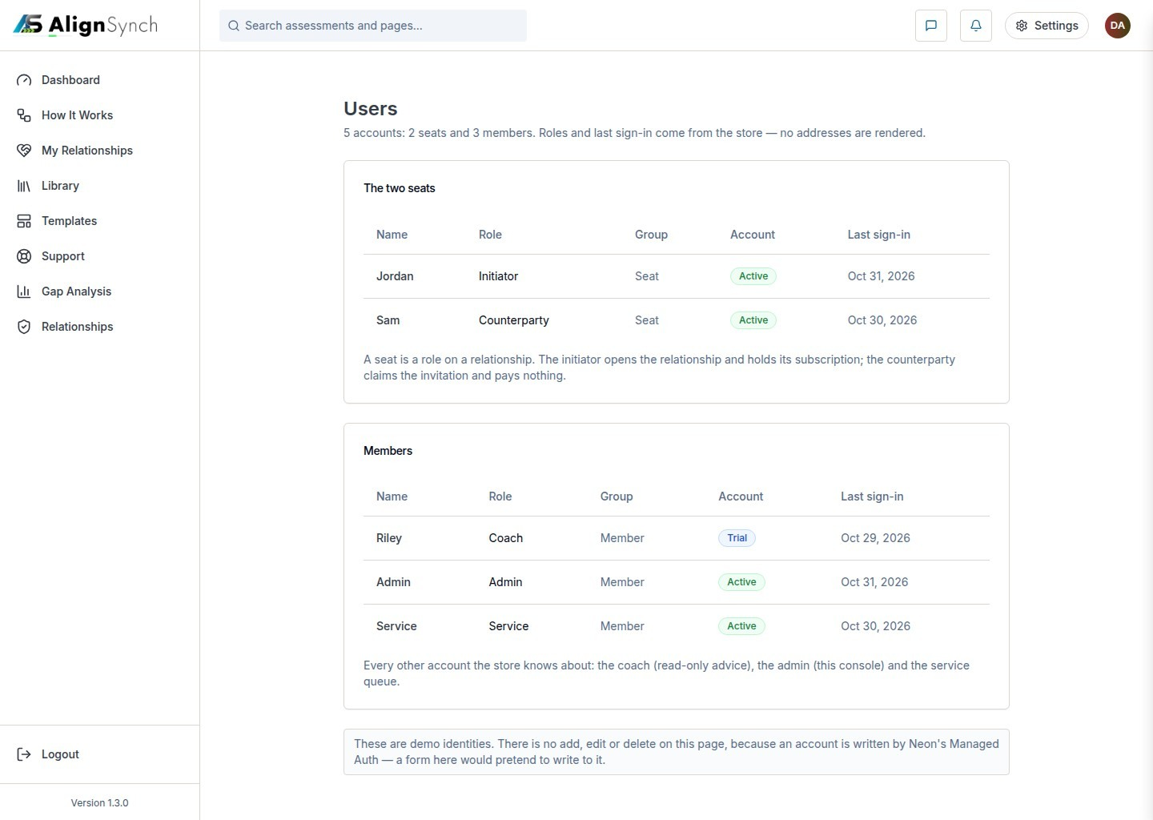
docs/qa-admin-console/users.png · source 1440×1024 px · displayed band y=0–1024 of 1024 px. LocalStorage fixture records; browser prototype, not live member data.
SCREEN ATLAS / CONTINUED

Staff console prototype · Desktop · templates registry · section 1
DESKTOP · TEMPLATES REGISTRY · CAPTURED VIEW
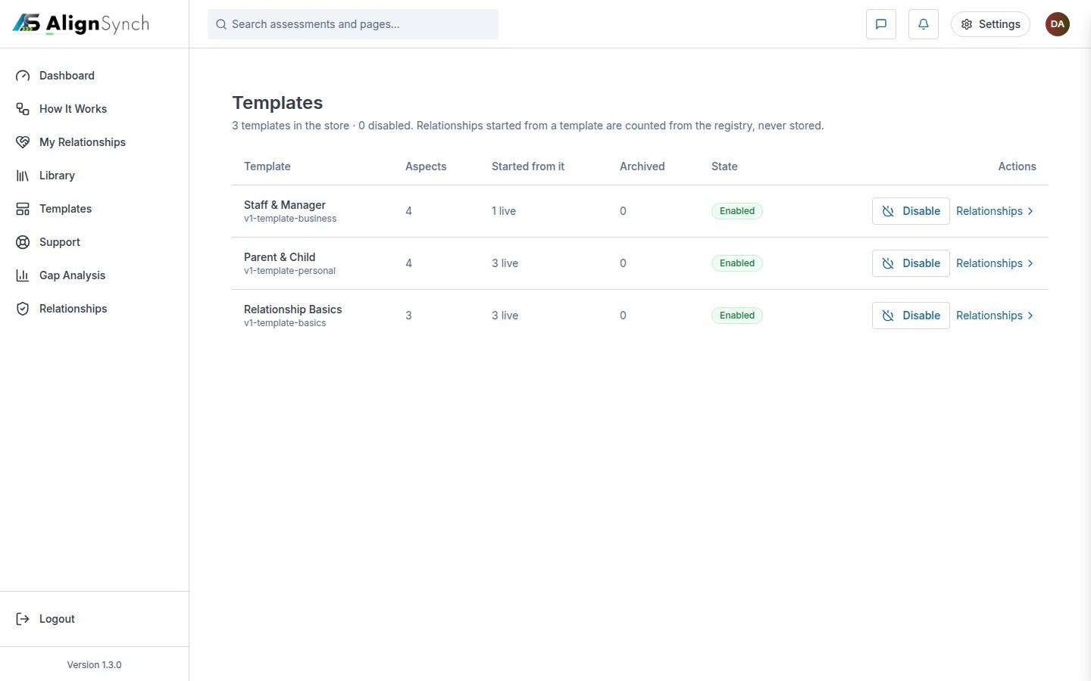
docs/qa-admin-console/templates.png · source 1440×900 px · displayed band y=0–900 of 900 px. LocalStorage fixture records.
SCREEN ATLAS / CONTINUED

Staff console prototype · Desktop · relationships registry · section 1
DESKTOP · RELATIONSHIPS REGISTRY · CAPTURED VIEW
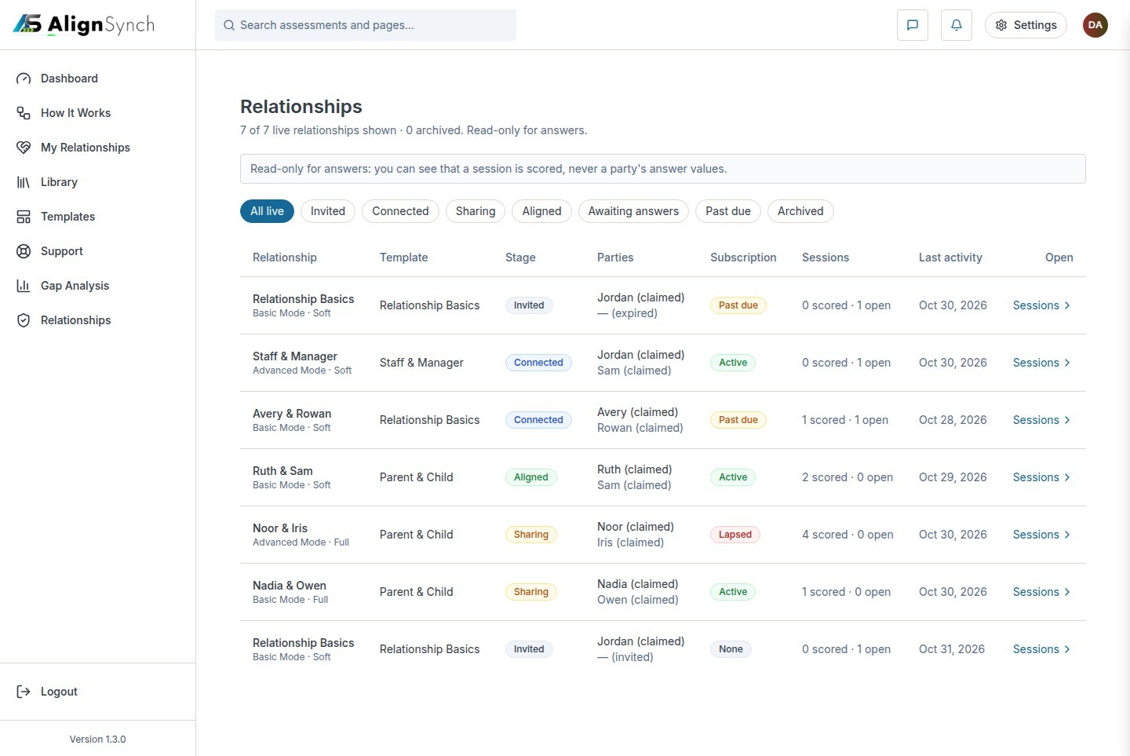
docs/qa-admin-console/relationships.png · source 1440×963 px · displayed band y=0–963 of 963 px. LocalStorage fixture records.
SCREEN ATLAS / /ADMIN/INSTANCES AND /ADMIN/GAPS

Assessment operations and Gap Analysis
Page and user purpose | What the member or staff user does
/admin/instances and /admin/gaps | Find sessions that need diagnosis, then review aggregate relationship patterns.

Front-end evidence | Behind the page
Current local QA desktop/mobile pairs; long Gap Analysis pages are split into consecutive crops. | app/(mainlayout)/admin/instances/page.tsx:65; detail .../[id]/page.tsx:50; app/(mainlayout)/admin/gaps/page.tsx:48; lib/auth/require-role.ts:181.

Capture context. Staff captures contain synthetic demo records and reflect the local QA app, not a live production tenant.
DESKTOP · ASSESSMENT INSTANCES · CAPTURED VIEW
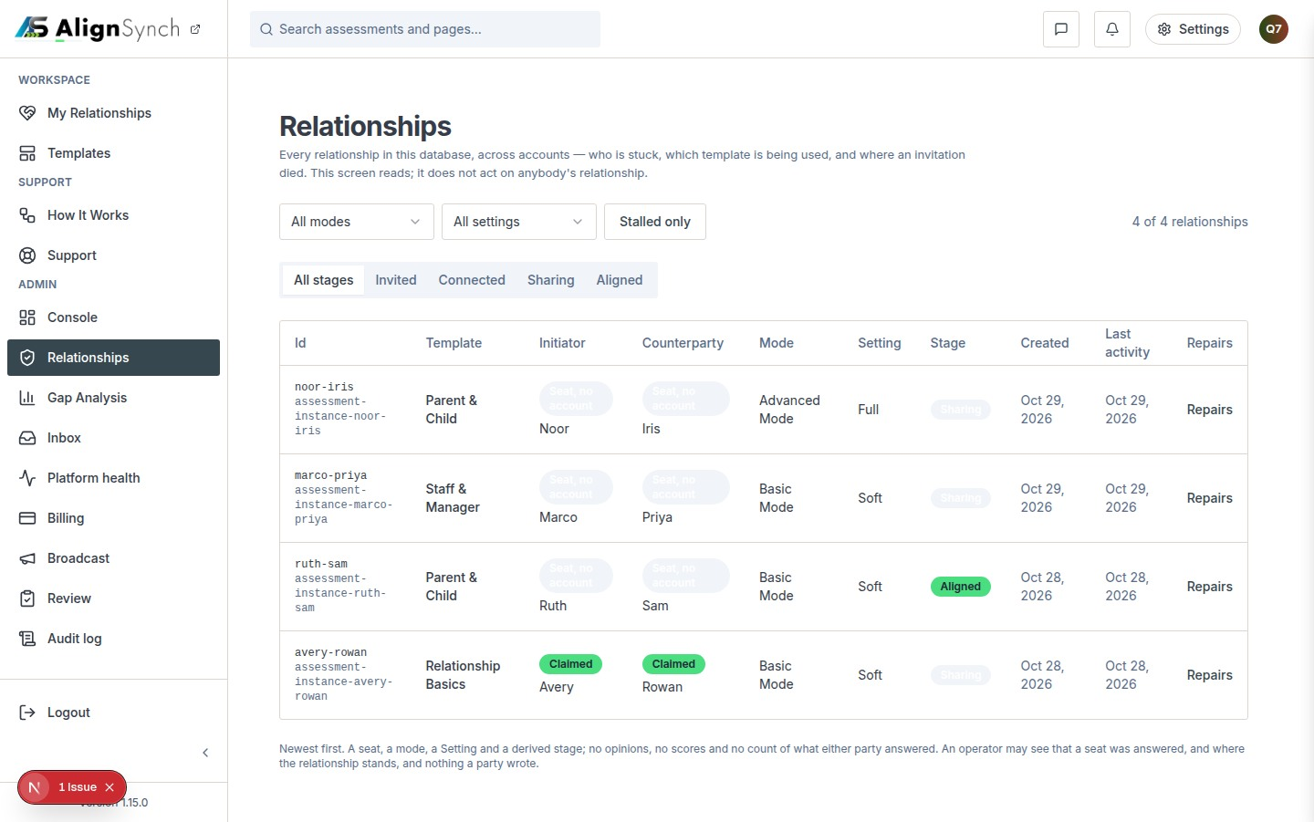
docs/qa-717-column/instances-1440.png · source 1440×901 px · displayed band y=0–901 of 901 px. Current staff route capture.
SCREEN ATLAS / CONTINUED

Assessment operations and Gap Analysis · Mobile · assessment instances · section 1
MOBILE · ASSESSMENT INSTANCES · SECTION 1 OF 2
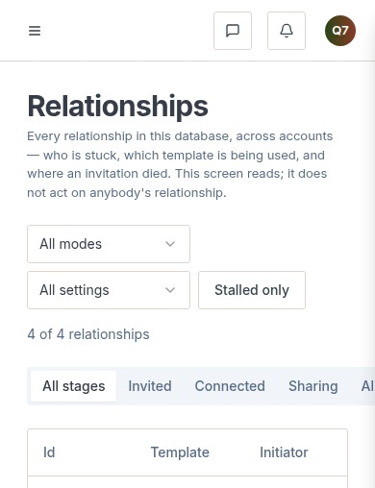
docs/qa-717-column/instances-390.png · source 390×1016 px · displayed band y=0–508 of 1016 px. Current staff route capture at CSS 390px.
SCREEN ATLAS / CONTINUED

Assessment operations and Gap Analysis · Mobile · assessment instances · section 2
MOBILE · ASSESSMENT INSTANCES · SECTION 2 OF 2
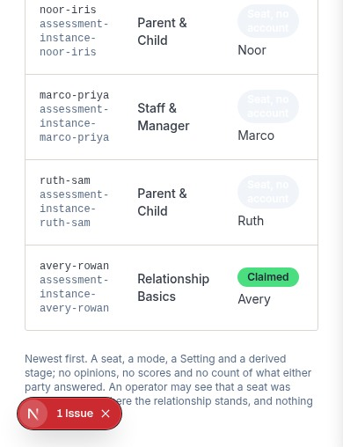
docs/qa-717-column/instances-390.png · source 390×1016 px · displayed band y=508–1016 of 1016 px. Current staff route capture at CSS 390px.
SCREEN ATLAS / CONTINUED

Assessment operations and Gap Analysis · Desktop · Gap Analysis · section 1
DESKTOP · GAP ANALYSIS · SECTION 1 OF 3
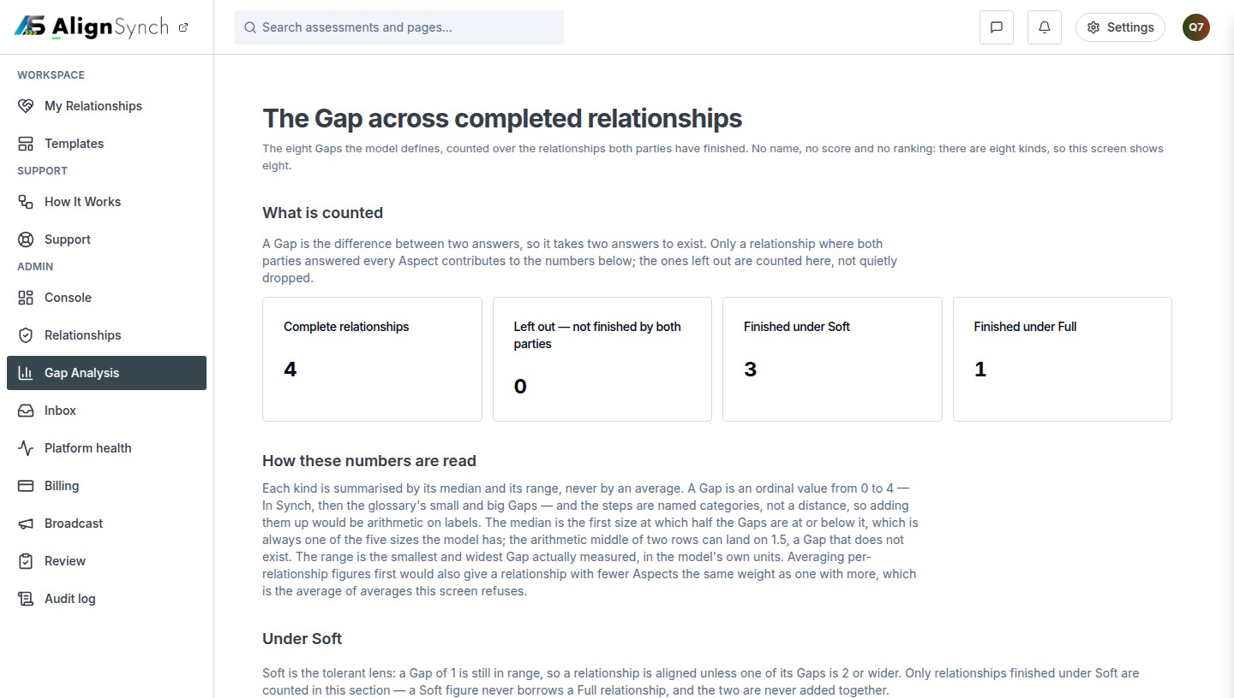
docs/qa-717-column/gaps-1440.png · source 1440×2448 px · displayed band y=0–816 of 2448 px. Long capture split from top to bottom.
SCREEN ATLAS / CONTINUED

Assessment operations and Gap Analysis · Desktop · Gap Analysis · section 2
DESKTOP · GAP ANALYSIS · SECTION 2 OF 3
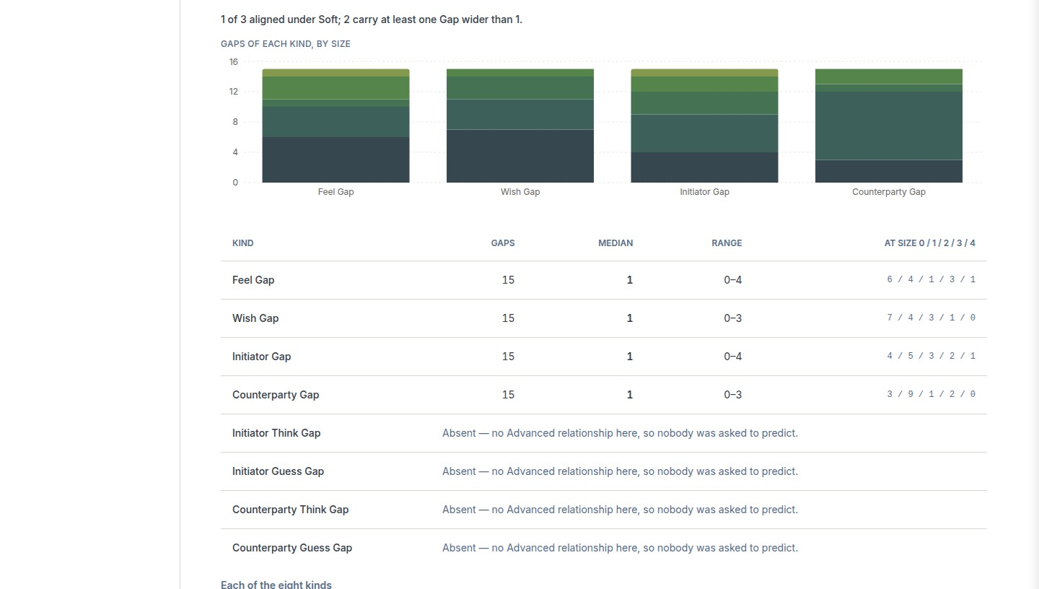
docs/qa-717-column/gaps-1440.png · source 1440×2448 px · displayed band y=816–1632 of 2448 px. Long capture split from top to bottom.
SCREEN ATLAS / CONTINUED

Assessment operations and Gap Analysis · Desktop · Gap Analysis · section 3
DESKTOP · GAP ANALYSIS · SECTION 3 OF 3
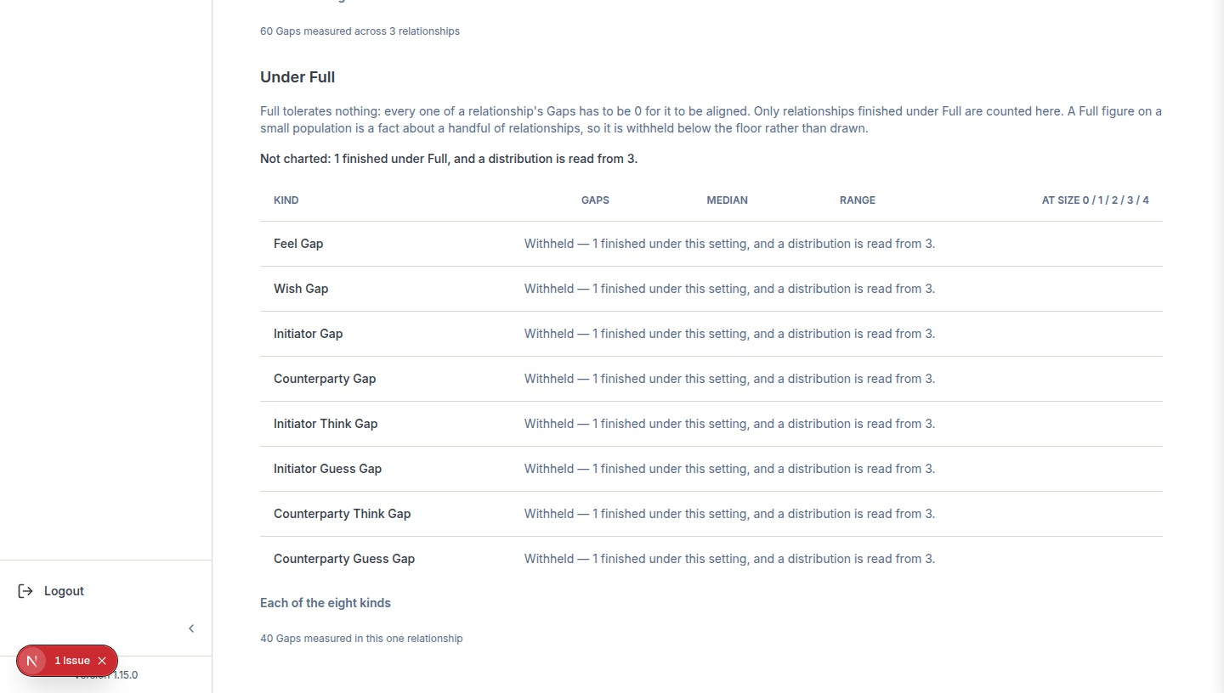
docs/qa-717-column/gaps-1440.png · source 1440×2448 px · displayed band y=1632–2448 of 2448 px. Long capture split from top to bottom.
SCREEN ATLAS / CONTINUED

Assessment operations and Gap Analysis · Mobile · Gap Analysis · section 1
MOBILE · GAP ANALYSIS · SECTION 1 OF 6
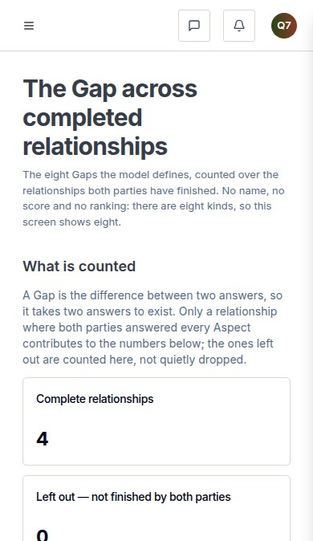
docs/qa-717-column/gaps-390.png · source 390×4042 px · displayed band y=0–674 of 4042 px. Long capture at CSS 390px, split from top to bottom.
SCREEN ATLAS / CONTINUED

Assessment operations and Gap Analysis · Mobile · Gap Analysis · section 2
MOBILE · GAP ANALYSIS · SECTION 2 OF 6
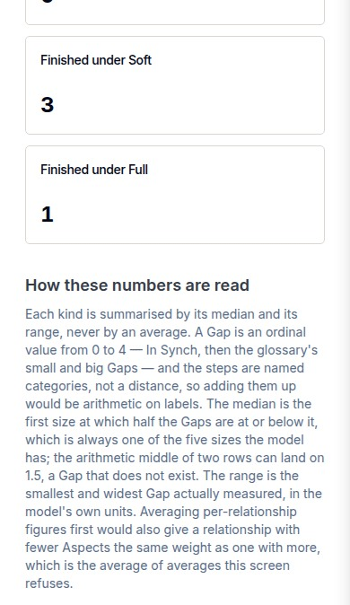
docs/qa-717-column/gaps-390.png · source 390×4042 px · displayed band y=674–1348 of 4042 px. Long capture at CSS 390px, split from top to bottom.
SCREEN ATLAS / CONTINUED

Assessment operations and Gap Analysis · Mobile · Gap Analysis · section 3
MOBILE · GAP ANALYSIS · SECTION 3 OF 6
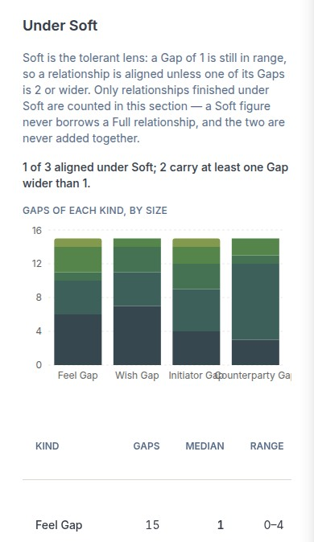
docs/qa-717-column/gaps-390.png · source 390×4042 px · displayed band y=1348–2022 of 4042 px. Long capture at CSS 390px, split from top to bottom.
SCREEN ATLAS / CONTINUED

Assessment operations and Gap Analysis · Mobile · Gap Analysis · section 4
MOBILE · GAP ANALYSIS · SECTION 4 OF 6
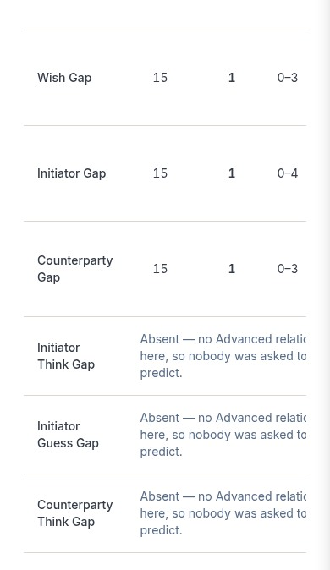
docs/qa-717-column/gaps-390.png · source 390×4042 px · displayed band y=2022–2696 of 4042 px. Long capture at CSS 390px, split from top to bottom.
SCREEN ATLAS / CONTINUED

Assessment operations and Gap Analysis · Mobile · Gap Analysis · section 5
MOBILE · GAP ANALYSIS · SECTION 5 OF 6
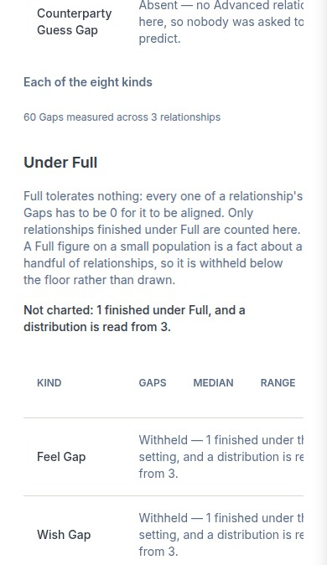
docs/qa-717-column/gaps-390.png · source 390×4042 px · displayed band y=2696–3370 of 4042 px. Long capture at CSS 390px, split from top to bottom.
SCREEN ATLAS / CONTINUED

Assessment operations and Gap Analysis · Mobile · Gap Analysis · section 6
MOBILE · GAP ANALYSIS · SECTION 6 OF 6
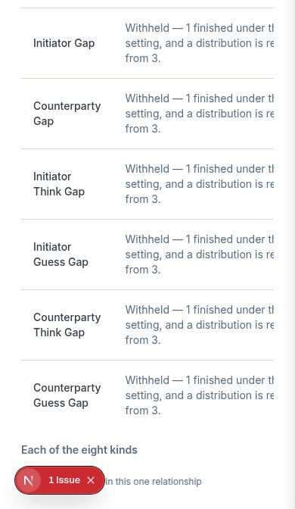
docs/qa-717-column/gaps-390.png · source 390×4042 px · displayed band y=3370–4042 of 4042 px. Long capture at CSS 390px, split from top to bottom.
SCREEN ATLAS / /ADMIN/INBOX

Support inbox
Page and user purpose | What the member or staff user does
/admin/inbox | Review stored member requests, inspect delivery state, and handle replies under a support role.

Front-end evidence | Behind the page
One page-scale queue capture plus focused refusal/detail states. | app/(mainlayout)/admin/inbox/page.tsx:55; actions actions.ts:42; lib/contact/store.ts:39,118; lib/auth/require-role.ts:157.

Capture context. No current mobile inbox screenshot was found; small state cutouts are described as cutouts, not full pages.
DESKTOP · INBOX QUEUE · CAPTURED VIEW
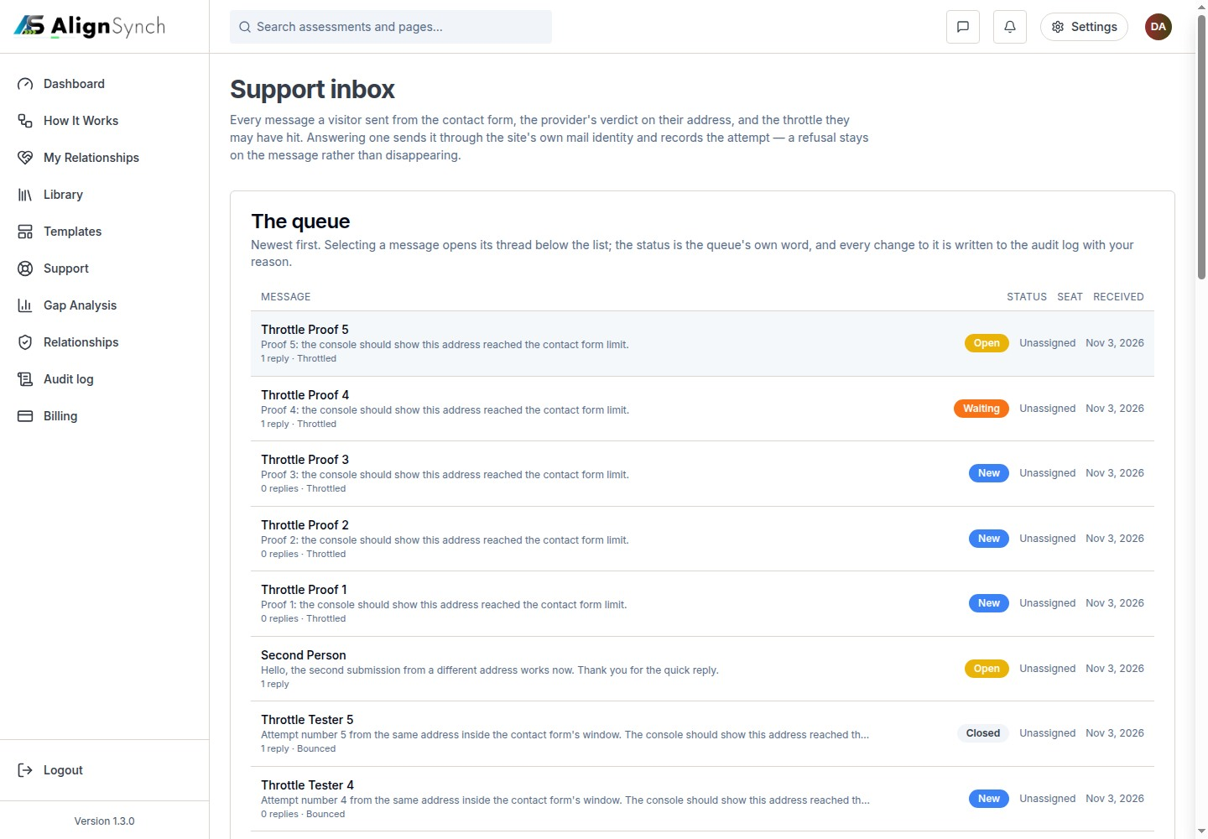
docs/qa-support-inbox/inbox-throttle-queue.png · source 1440×1000 px · displayed band y=0–1000 of 1000 px. Page-scale support inbox capture.
SCREEN ATLAS / CONTINUED

Support inbox · Desktop · request detail · section 1
DESKTOP · REQUEST DETAIL · CAPTURED VIEW
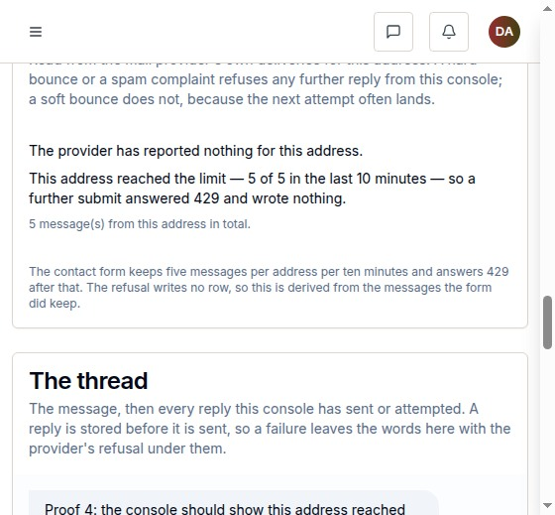
docs/qa-support-inbox/inbox-throttle-detail.png · source 560×519 px · displayed band y=0–519 of 519 px. Focused state crop from the support-inbox QA run.
SCREEN ATLAS / CONTINUED

Support inbox · Desktop · reply refused state · section 1
DESKTOP · REPLY REFUSED STATE · CAPTURED VIEW
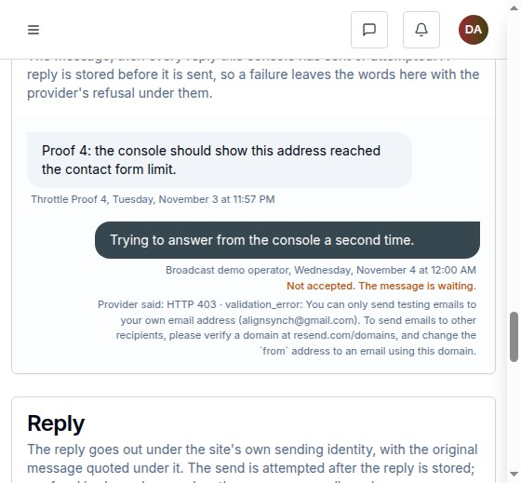
docs/qa-support-inbox/inbox-reply-refused.png · source 560×519 px · displayed band y=0–519 of 519 px. Role/validation refusal cutout.
SCREEN ATLAS / CONTINUED

Support inbox · Desktop · bounced state · section 1
DESKTOP · BOUNCED STATE · CAPTURED VIEW
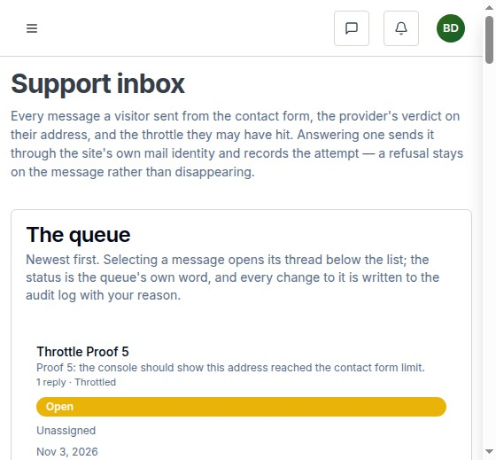
docs/qa-support-inbox/inbox-bounced-refused.png · source 560×519 px · displayed band y=0–519 of 519 px. Delivery/refusal cutout.
SCREEN ATLAS / /ADMIN/HEALTH, /ADMIN/BILLING, /ADMIN/AUDIT

Health, Billing, Audit
Page and user purpose | What the member or staff user does
/admin/health, /admin/billing, /admin/audit | Review system checks, entitlement records, and the history of staff operations.

Front-end evidence | Behind the page
Billing and Audit QA states are included. Health is an older diagnostic render explicitly marked as not a live session. | app/(mainlayout)/admin/health/page.tsx:63; app/(mainlayout)/admin/billing/page.tsx:75, actions :38; app/(mainlayout)/admin/audit/page.tsx:58; lib/db/admin-audit.ts:133.

Capture context. Health is represented by an older diagnostic preview only; its banner says the record came from a fixture file and it is not a live session.
DESKTOP · BILLING RECORDS · CAPTURED VIEW
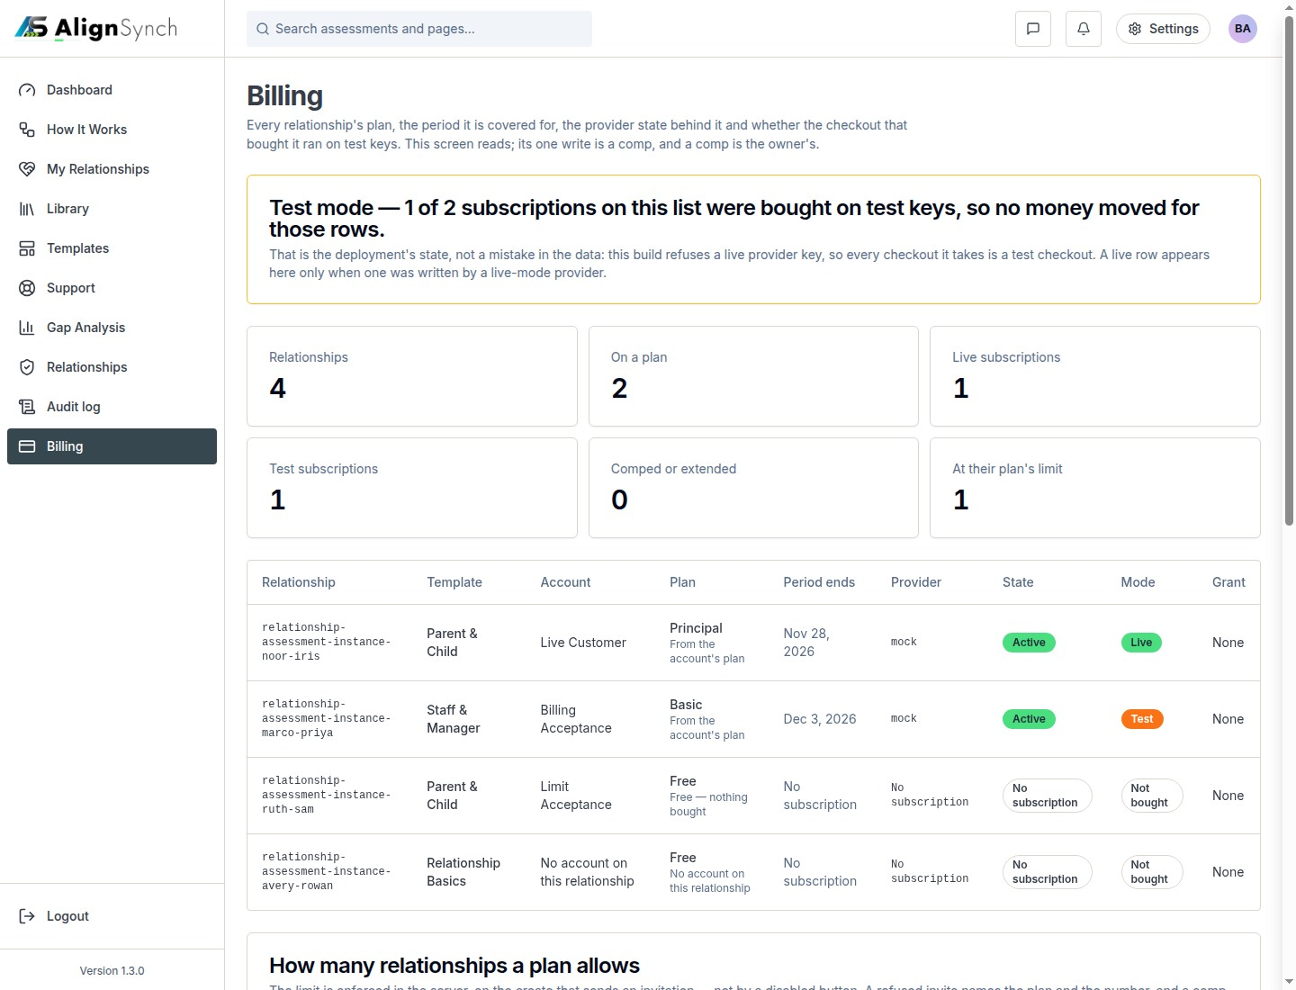
docs/qa-admin-billing/billing-live-and-test-1440.png · source 1440×1100 px · displayed band y=0–1100 of 1100 px. Demo state showing live and test records.
SCREEN ATLAS / CONTINUED

Health, Billing, Audit · Desktop · entitlement granted · section 1
DESKTOP · ENTITLEMENT GRANTED · CAPTURED VIEW
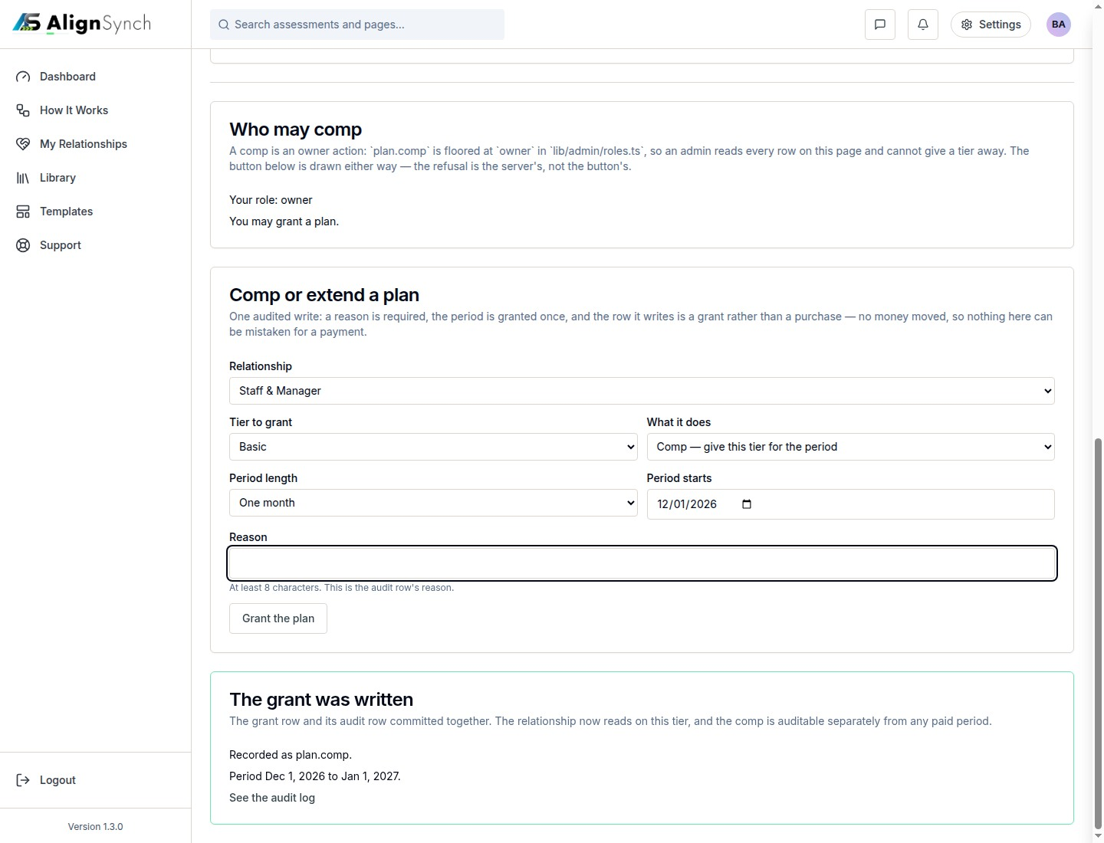
docs/qa-admin-billing/billing-comp-granted-1440.png · source 1440×1100 px · displayed band y=0–1100 of 1100 px. Example audited adjustment state.
SCREEN ATLAS / CONTINUED

Health, Billing, Audit · Desktop · duplicate refused · section 1
DESKTOP · DUPLICATE REFUSED · CAPTURED VIEW
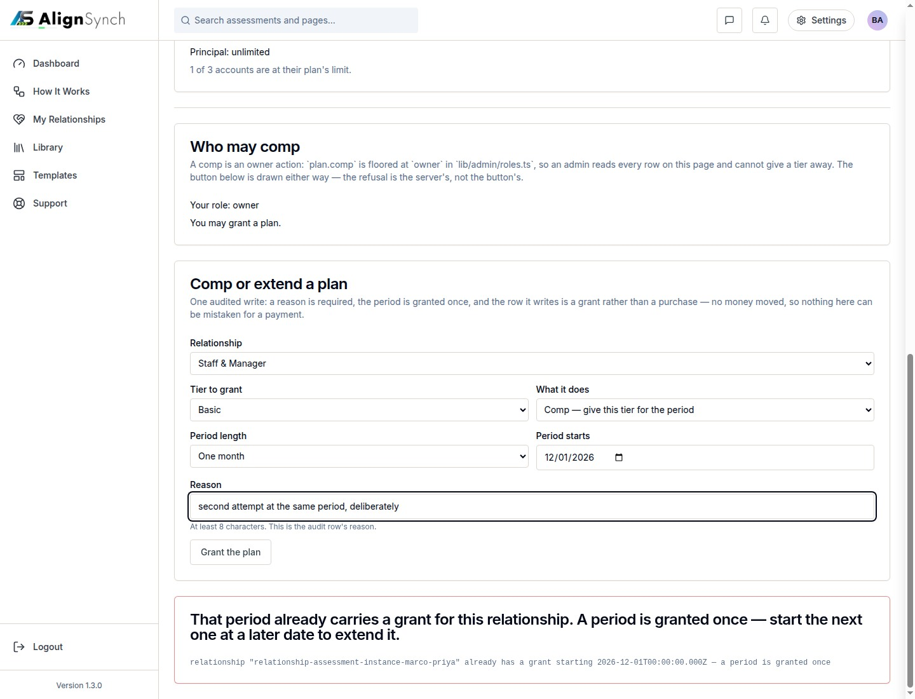
docs/qa-admin-billing/billing-comp-duplicate-refused-1440.png · source 1440×1100 px · displayed band y=0–1100 of 1100 px. Example refusal state.
SCREEN ATLAS / CONTINUED

Health, Billing, Audit · Desktop · audit rows · section 1
DESKTOP · AUDIT ROWS · CAPTURED VIEW
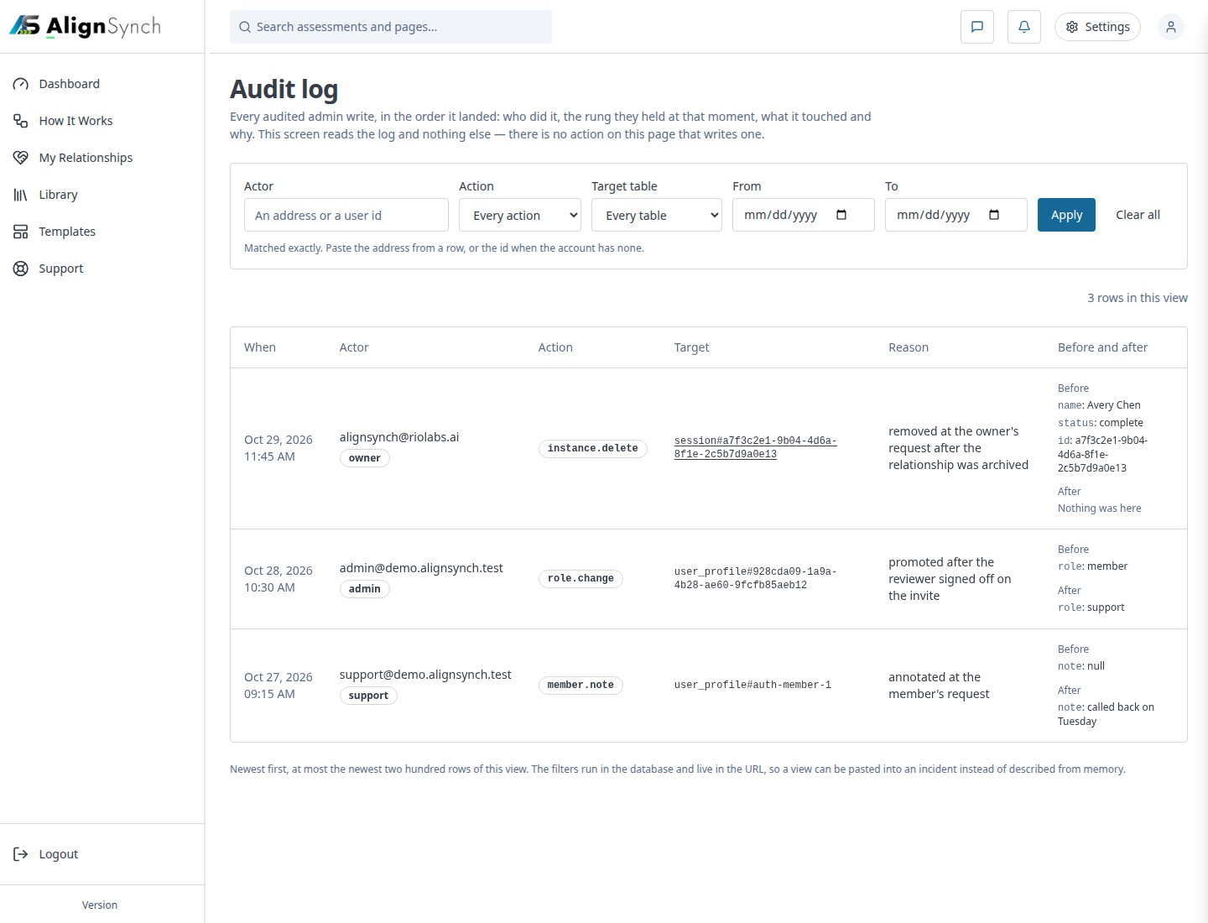
docs/qa-admin-audit/audit-rows-1440.png · source 1440×1100 px · displayed band y=0–1100 of 1100 px. Filtered audit list state.
SCREEN ATLAS / CONTINUED

Health, Billing, Audit · Mobile · audit rows · section 1
MOBILE · AUDIT ROWS · SECTION 1 OF 2
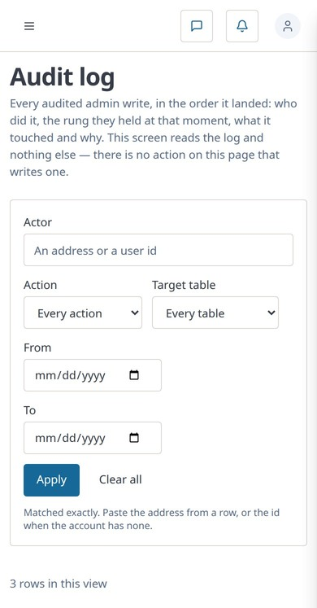
docs/qa-admin-audit/audit-rows-390.png · source 780×2988 px · displayed band y=0–747 of 1494 px. Captured at 2× and displayed at CSS 390px.
SCREEN ATLAS / CONTINUED

Health, Billing, Audit · Mobile · audit rows · section 2
MOBILE · AUDIT ROWS · SECTION 2 OF 2
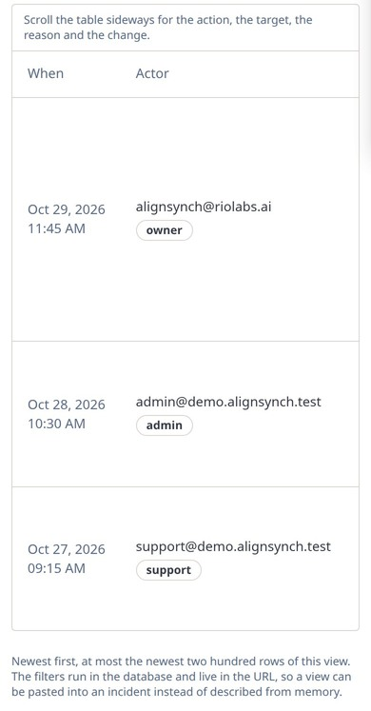
docs/qa-admin-audit/audit-rows-390.png · source 780×2988 px · displayed band y=747–1494 of 1494 px. Captured at 2× and displayed at CSS 390px.
SCREEN ATLAS / CONTINUED

Health, Billing, Audit · Desktop · older health diagnostic render · section 1
DESKTOP · OLDER HEALTH DIAGNOSTIC RENDER · SECTION 1 OF 3
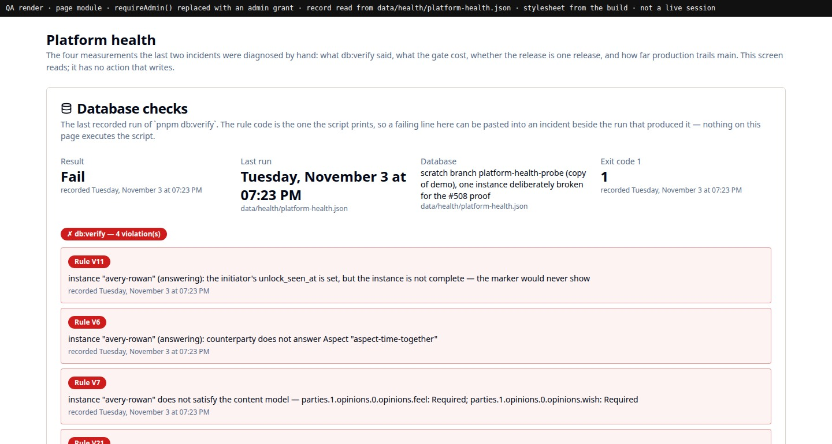
docs/qa-admin-health/health-1440.png · source 1440×2308 px · displayed band y=0–770 of 2308 px. Older QA render; image itself states it is not a live session.
SCREEN ATLAS / CONTINUED

Health, Billing, Audit · Desktop · older health diagnostic render · section 2
DESKTOP · OLDER HEALTH DIAGNOSTIC RENDER · SECTION 2 OF 3
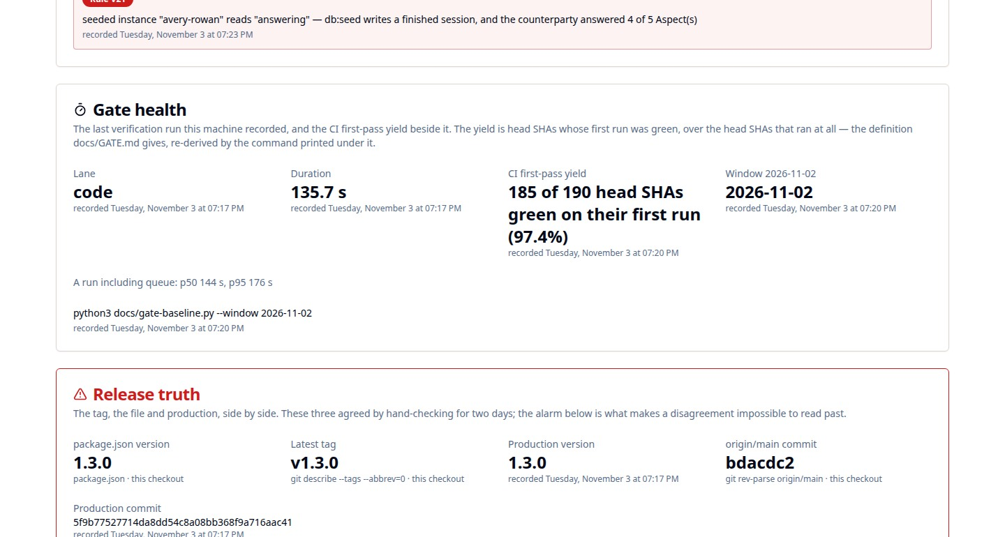
docs/qa-admin-health/health-1440.png · source 1440×2308 px · displayed band y=770–1540 of 2308 px. Older QA render; image itself states it is not a live session.
SCREEN ATLAS / CONTINUED

Health, Billing, Audit · Desktop · older health diagnostic render · section 3
DESKTOP · OLDER HEALTH DIAGNOSTIC RENDER · SECTION 3 OF 3
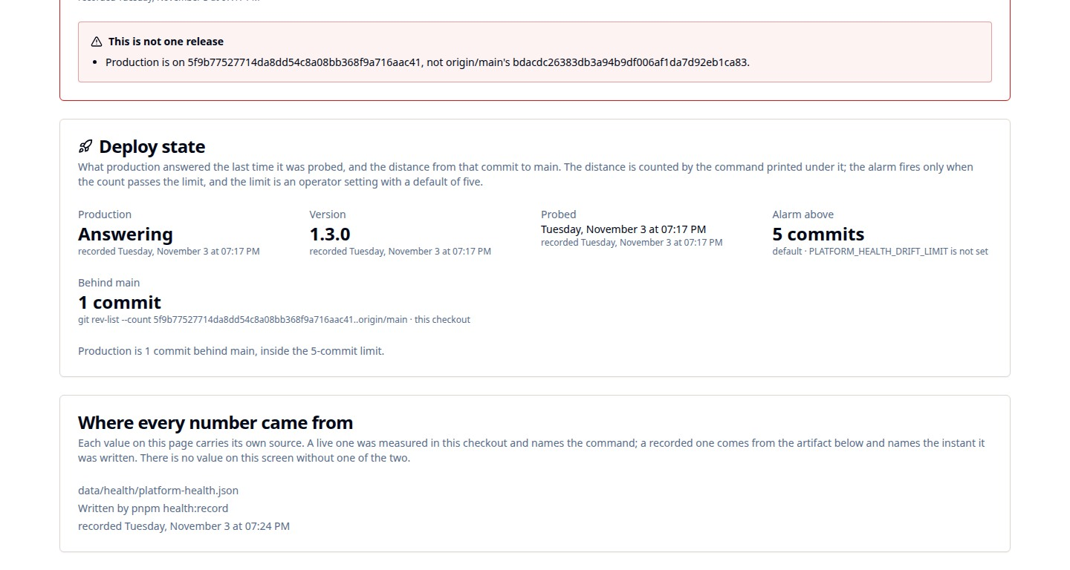
docs/qa-admin-health/health-1440.png · source 1440×2308 px · displayed band y=1540–2308 of 2308 px. Older QA render; image itself states it is not a live session.
SCREEN ATLAS / /ADMIN/BROADCAST AND /ADMIN/REVIEW

Broadcast and review
Page and user purpose | What the member or staff user does
/admin/broadcast and /admin/review | Preview a notice before sending; track shipped artifacts and feedback.

Front-end evidence | Behind the page
Broadcast captures show compose, dry run, sent, cooldown, and refusal states. Review has a desktop/mobile list and thread. | app/(mainlayout)/admin/broadcast/page.tsx:73, actions :61,97; app/(mainlayout)/admin/review/page.tsx:81, actions :89,122,151,175; lib/admin/act.ts:271.

Capture context. Staff mutations are role-gated and audited. Broadcast images are workflow fixtures, not proof of an actual notice sent to customers.
DESKTOP · BROADCAST COMPOSER · CAPTURED VIEW
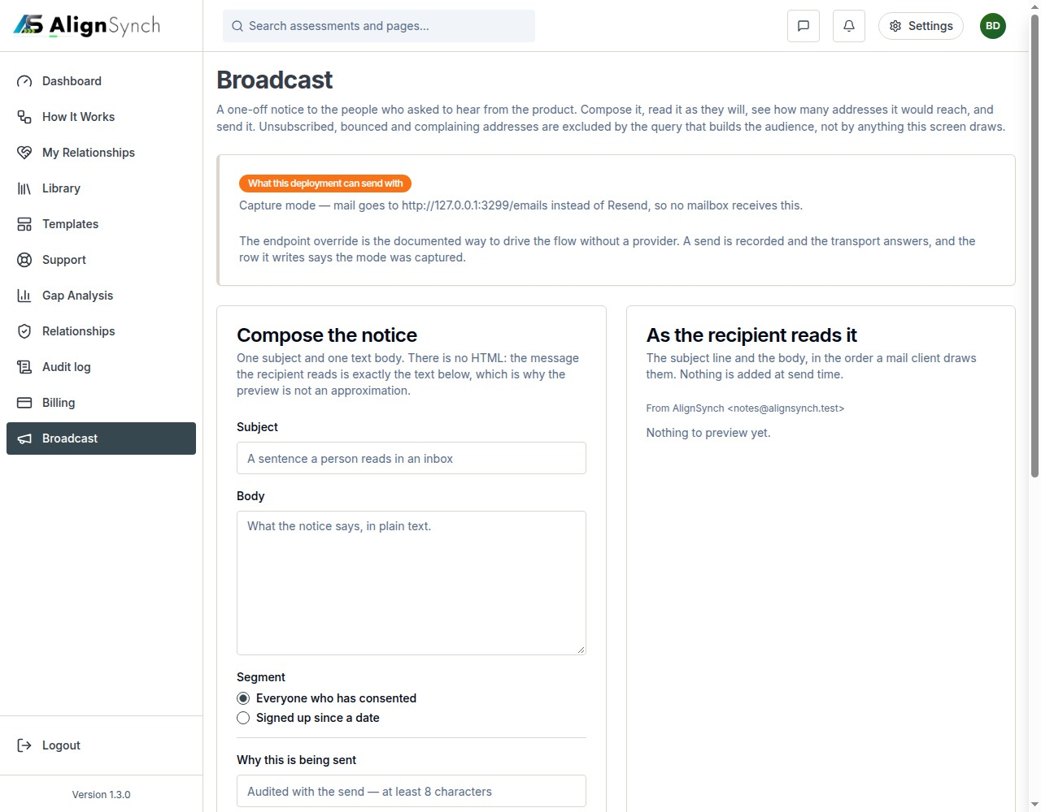
docs/qa-broadcast/01-compose-capture-mode.png · source 1280×1000 px · displayed band y=0–1000 of 1000 px. Composer state before preview.
SCREEN ATLAS / CONTINUED

Broadcast and review · Desktop · dry run · section 1
DESKTOP · DRY RUN · SECTION 1 OF 2
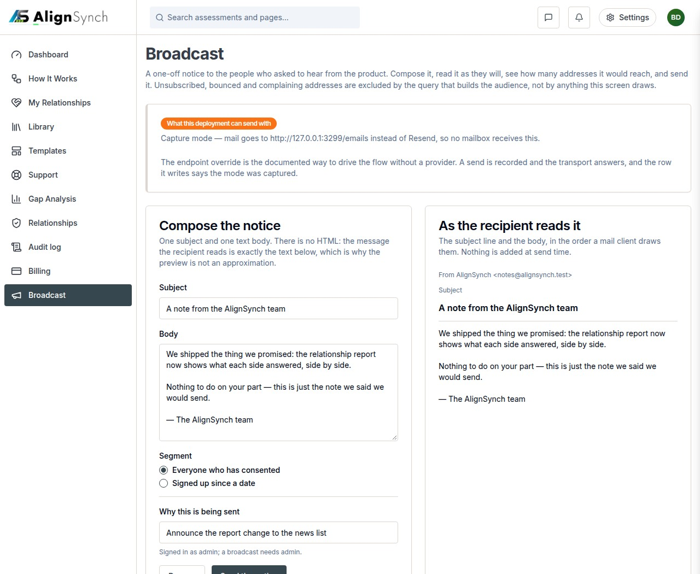
docs/qa-broadcast/02-dry-run-5-of-5.png · source 1280×2100 px · displayed band y=0–1050 of 2100 px. Long preview and recipient count, split into bands.
SCREEN ATLAS / CONTINUED

Broadcast and review · Desktop · dry run · section 2
DESKTOP · DRY RUN · SECTION 2 OF 2
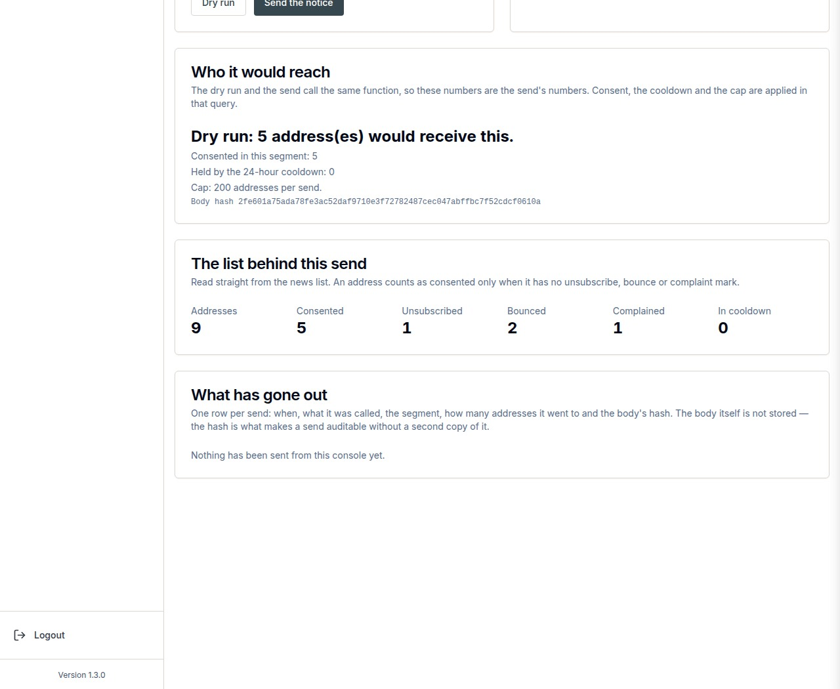
docs/qa-broadcast/02-dry-run-5-of-5.png · source 1280×2100 px · displayed band y=1050–2100 of 2100 px. Long preview and recipient count, split into bands.
SCREEN ATLAS / CONTINUED

Broadcast and review · Desktop · sent result · section 1
DESKTOP · SENT RESULT · SECTION 1 OF 2
docs/qa-broadcast/03-sent-5-of-5.png · source 1280×2100 px · displayed band y=0–1050 of 2100 px. Long result state.
SCREEN ATLAS / CONTINUED

Broadcast and review · Desktop · sent result · section 2
DESKTOP · SENT RESULT · SECTION 2 OF 2
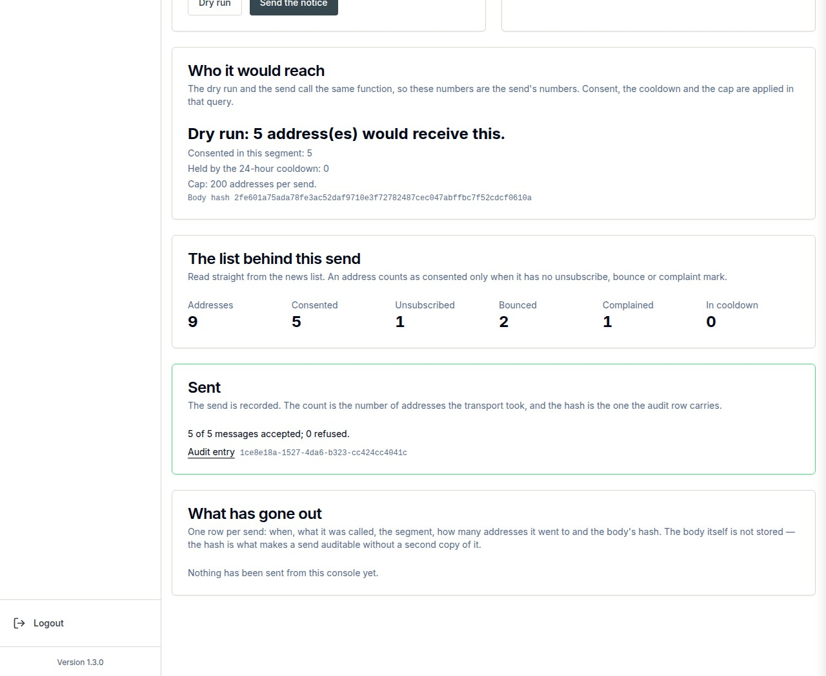
docs/qa-broadcast/03-sent-5-of-5.png · source 1280×2100 px · displayed band y=1050–2100 of 2100 px. Long result state.
SCREEN ATLAS / CONTINUED

Broadcast and review · Desktop · cooldown guard · section 1
DESKTOP · COOLDOWN GUARD · SECTION 1 OF 2
docs/qa-broadcast/04-cooldown-refusal.png · source 1280×2100 px · displayed band y=0–1050 of 2100 px. Guard/refusal state.
SCREEN ATLAS / CONTINUED

Broadcast and review · Desktop · cooldown guard · section 2
DESKTOP · COOLDOWN GUARD · SECTION 2 OF 2
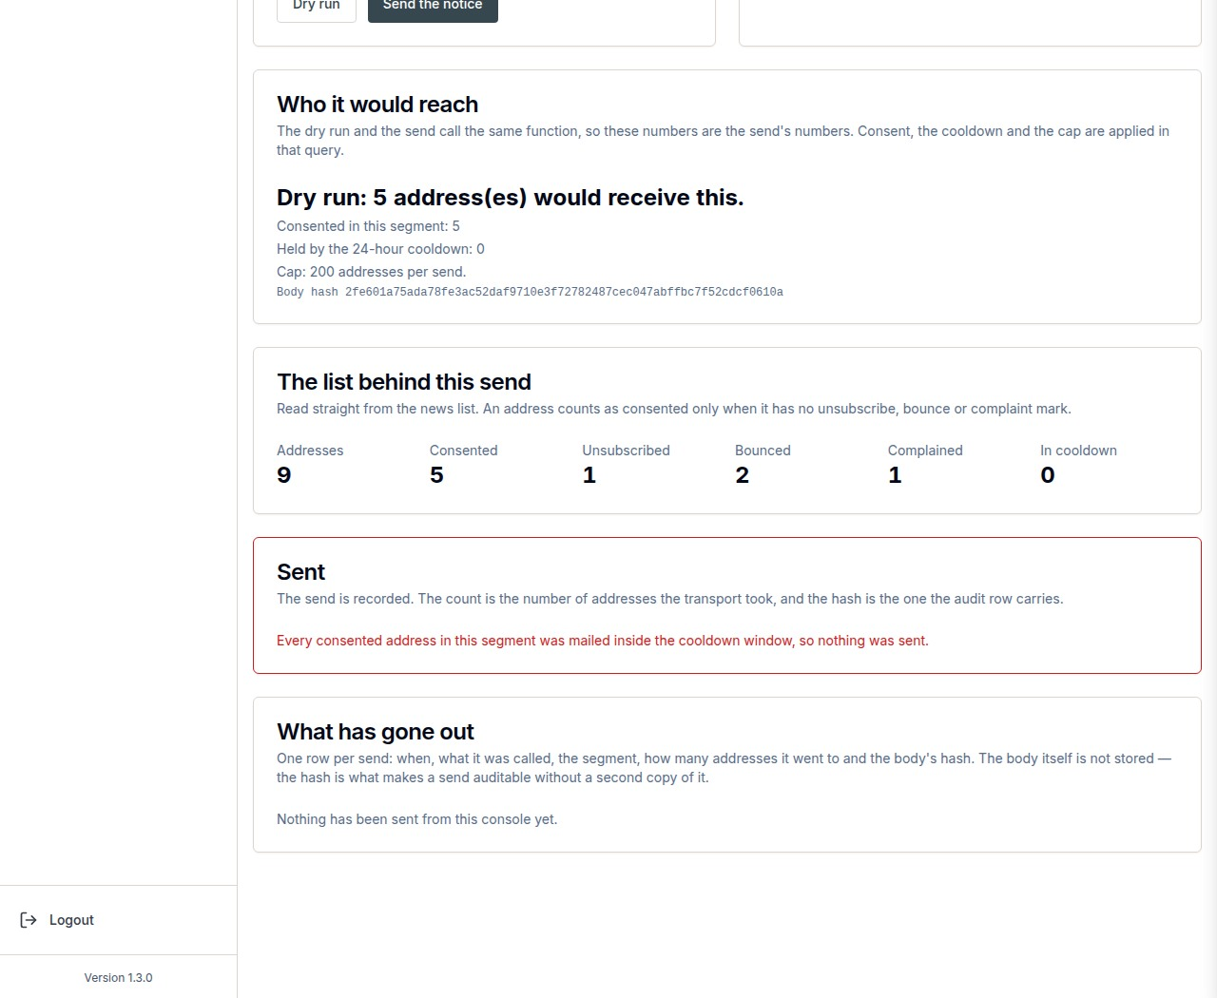
docs/qa-broadcast/04-cooldown-refusal.png · source 1280×2100 px · displayed band y=1050–2100 of 2100 px. Guard/refusal state.
SCREEN ATLAS / CONTINUED

Broadcast and review · Desktop · review queue · section 1
DESKTOP · REVIEW QUEUE · SECTION 1 OF 3
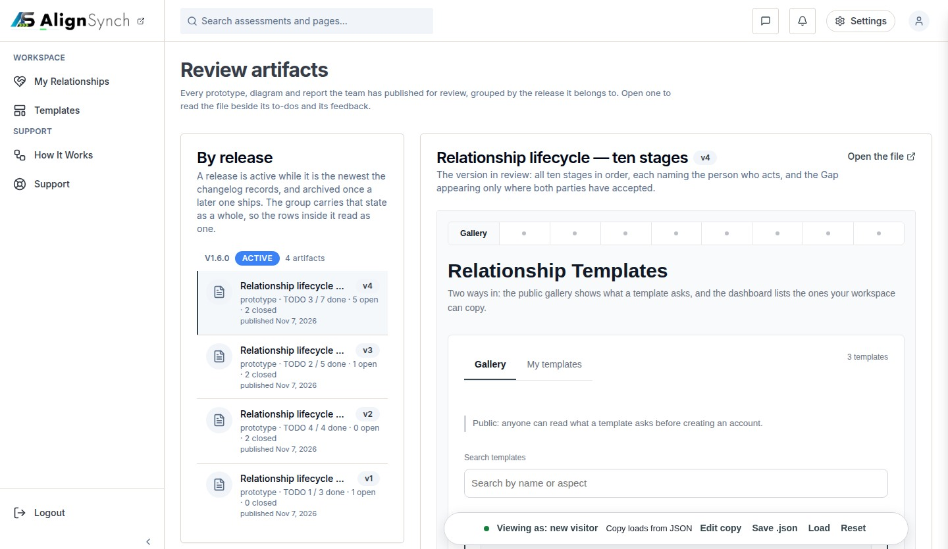
docs/qa-review-admin/review-1440.png · source 1440×2503 px · displayed band y=0–835 of 2503 px. Full-page review queue split into bands.
SCREEN ATLAS / CONTINUED

Broadcast and review · Desktop · review queue · section 2
DESKTOP · REVIEW QUEUE · SECTION 2 OF 3
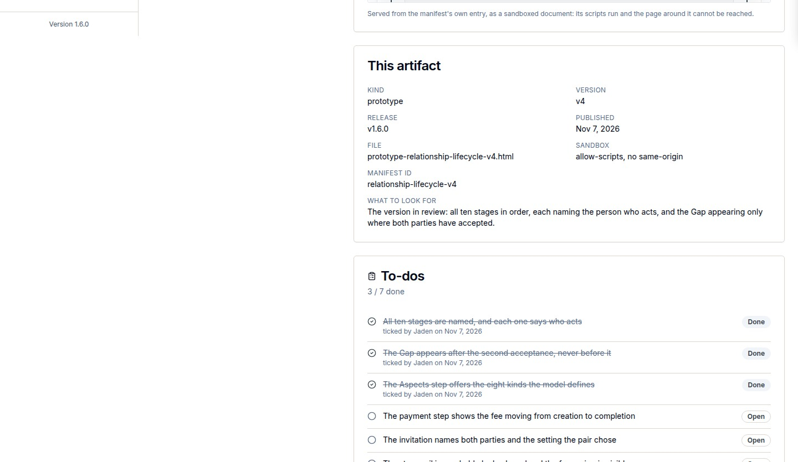
docs/qa-review-admin/review-1440.png · source 1440×2503 px · displayed band y=835–1670 of 2503 px. Full-page review queue split into bands.
SCREEN ATLAS / CONTINUED

Broadcast and review · Desktop · review queue · section 3
DESKTOP · REVIEW QUEUE · SECTION 3 OF 3
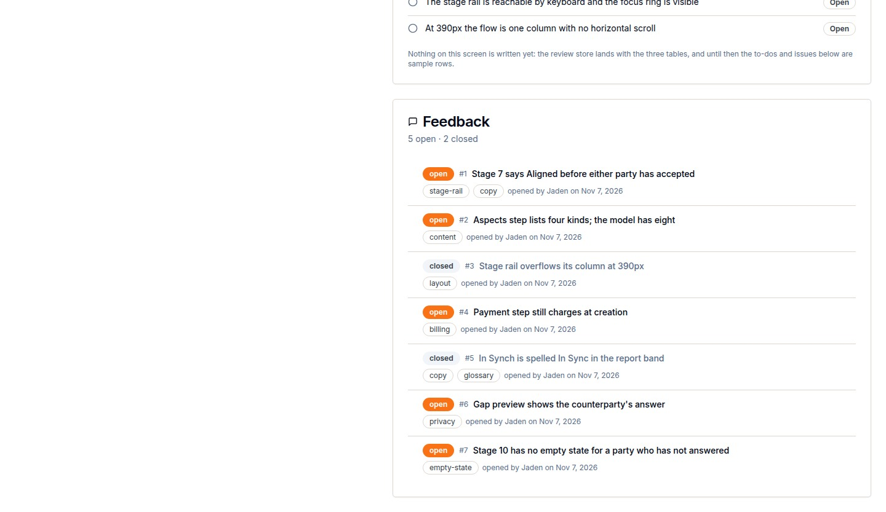
docs/qa-review-admin/review-1440.png · source 1440×2503 px · displayed band y=1670–2503 of 2503 px. Full-page review queue split into bands.
SCREEN ATLAS / CONTINUED

Broadcast and review · Mobile · review queue · section 1
MOBILE · REVIEW QUEUE · SECTION 1 OF 5
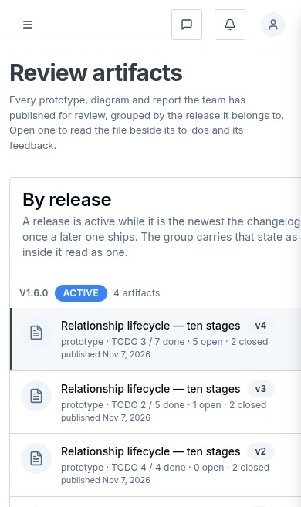
docs/qa-review-admin/review-390.png · source 390×3285 px · displayed band y=0–657 of 3285 px. Full-page mobile review queue split into bands.
SCREEN ATLAS / CONTINUED

Broadcast and review · Mobile · review queue · section 2
MOBILE · REVIEW QUEUE · SECTION 2 OF 5
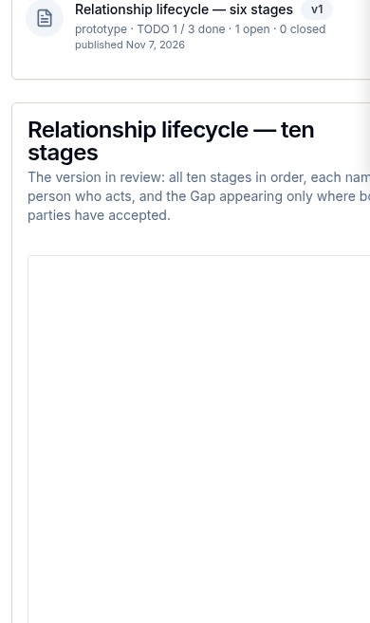
docs/qa-review-admin/review-390.png · source 390×3285 px · displayed band y=657–1314 of 3285 px. Full-page mobile review queue split into bands.
SCREEN ATLAS / CONTINUED

Broadcast and review · Mobile · review queue · section 3
MOBILE · REVIEW QUEUE · SECTION 3 OF 5
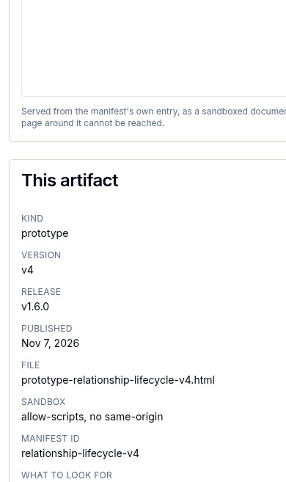
docs/qa-review-admin/review-390.png · source 390×3285 px · displayed band y=1314–1971 of 3285 px. Full-page mobile review queue split into bands.
SCREEN ATLAS / CONTINUED

Broadcast and review · Mobile · review queue · section 4
MOBILE · REVIEW QUEUE · SECTION 4 OF 5
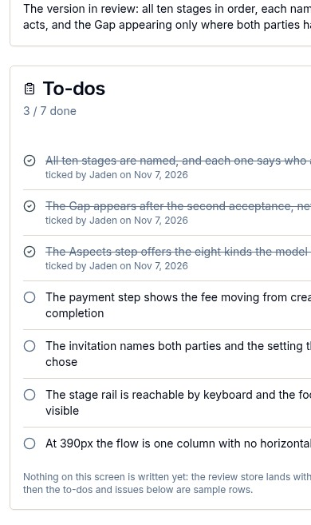
docs/qa-review-admin/review-390.png · source 390×3285 px · displayed band y=1971–2628 of 3285 px. Full-page mobile review queue split into bands.
SCREEN ATLAS / CONTINUED

Broadcast and review · Mobile · review queue · section 5
MOBILE · REVIEW QUEUE · SECTION 5 OF 5
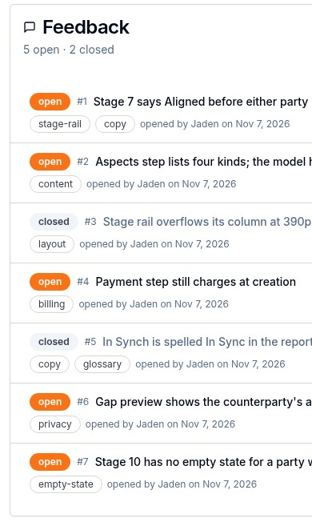
docs/qa-review-admin/review-390.png · source 390×3285 px · displayed band y=2628–3285 of 3285 px. Full-page mobile review queue split into bands.
SCREEN ATLAS / CONTINUED

Broadcast and review · Desktop · feedback thread · section 1
DESKTOP · FEEDBACK THREAD · SECTION 1 OF 2
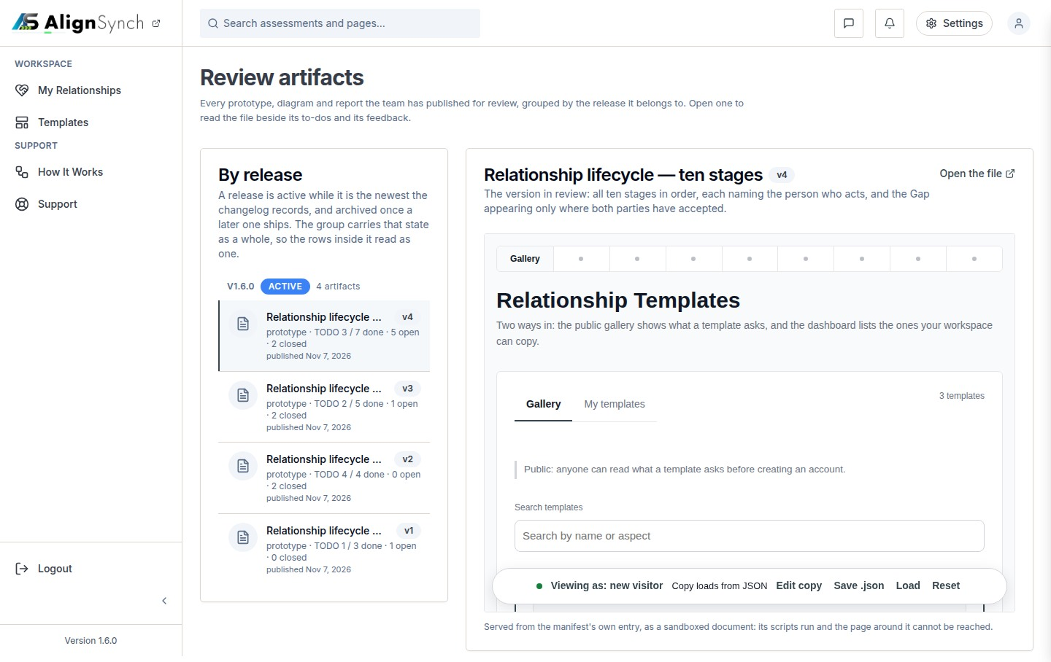
docs/qa-review-admin/review-thread.png · source 1440×1815 px · displayed band y=0–908 of 1815 px. Selected artifact and thread.
SCREEN ATLAS / CONTINUED

Broadcast and review · Desktop · feedback thread · section 2
DESKTOP · FEEDBACK THREAD · SECTION 2 OF 2
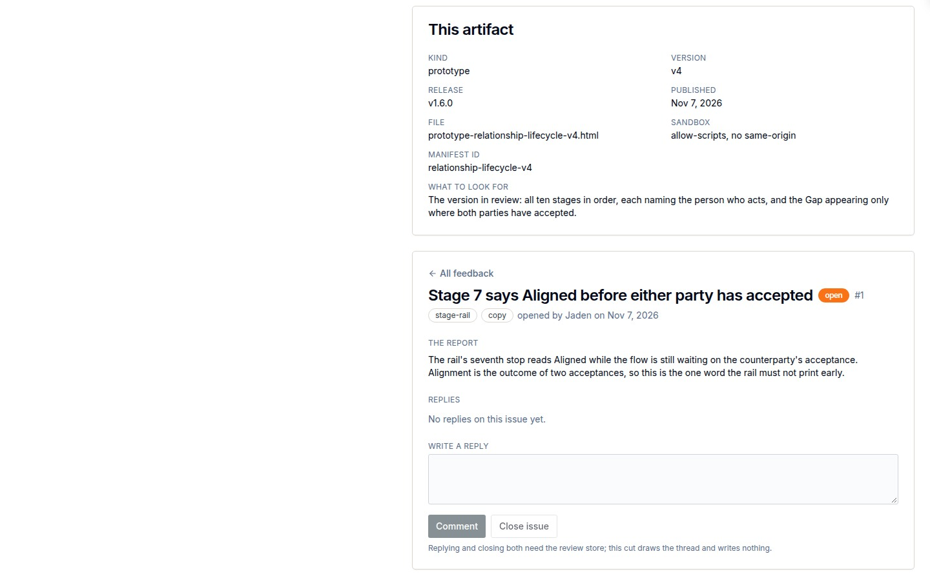
docs/qa-review-admin/review-thread.png · source 1440×1815 px · displayed band y=908–1815 of 1815 px. Selected artifact and thread.
SCREEN ATLAS / /ADMIN/TEMPLATES AND /ADMIN/TEMPLATES/[ID]

Template authoring
Page and user purpose | What the member or staff user does
/admin/templates and /admin/templates/[id] | Create or update a curated template, inspect its preview, and confirm save state.

Front-end evidence | Behind the page
Desktop captures show the list, editor fields, preview, and saved result. | app/(mainlayout)/admin/templates/page.tsx:52; lib/auth/require-role.ts:157,181; write actions use lib/admin/act.ts:271.

Capture context. Only desktop authoring captures were available; no mobile screenshot is asserted.
DESKTOP · CURATED TEMPLATES · CAPTURED VIEW
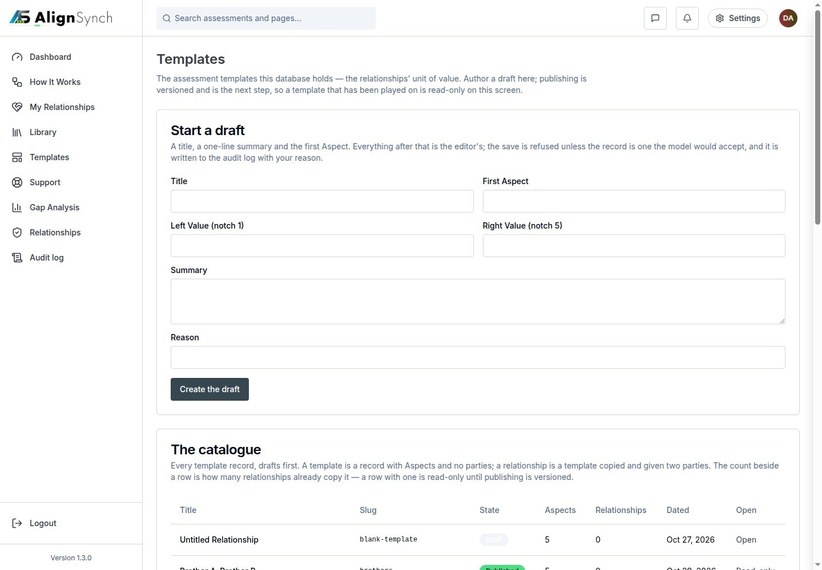
docs/qa-admin-template-authoring/templates-list.png · source 1440×1000 px · displayed band y=0–1000 of 1000 px. Admin catalogue view.
SCREEN ATLAS / CONTINUED

Template authoring · Desktop · editor details · section 1
DESKTOP · EDITOR DETAILS · CAPTURED VIEW
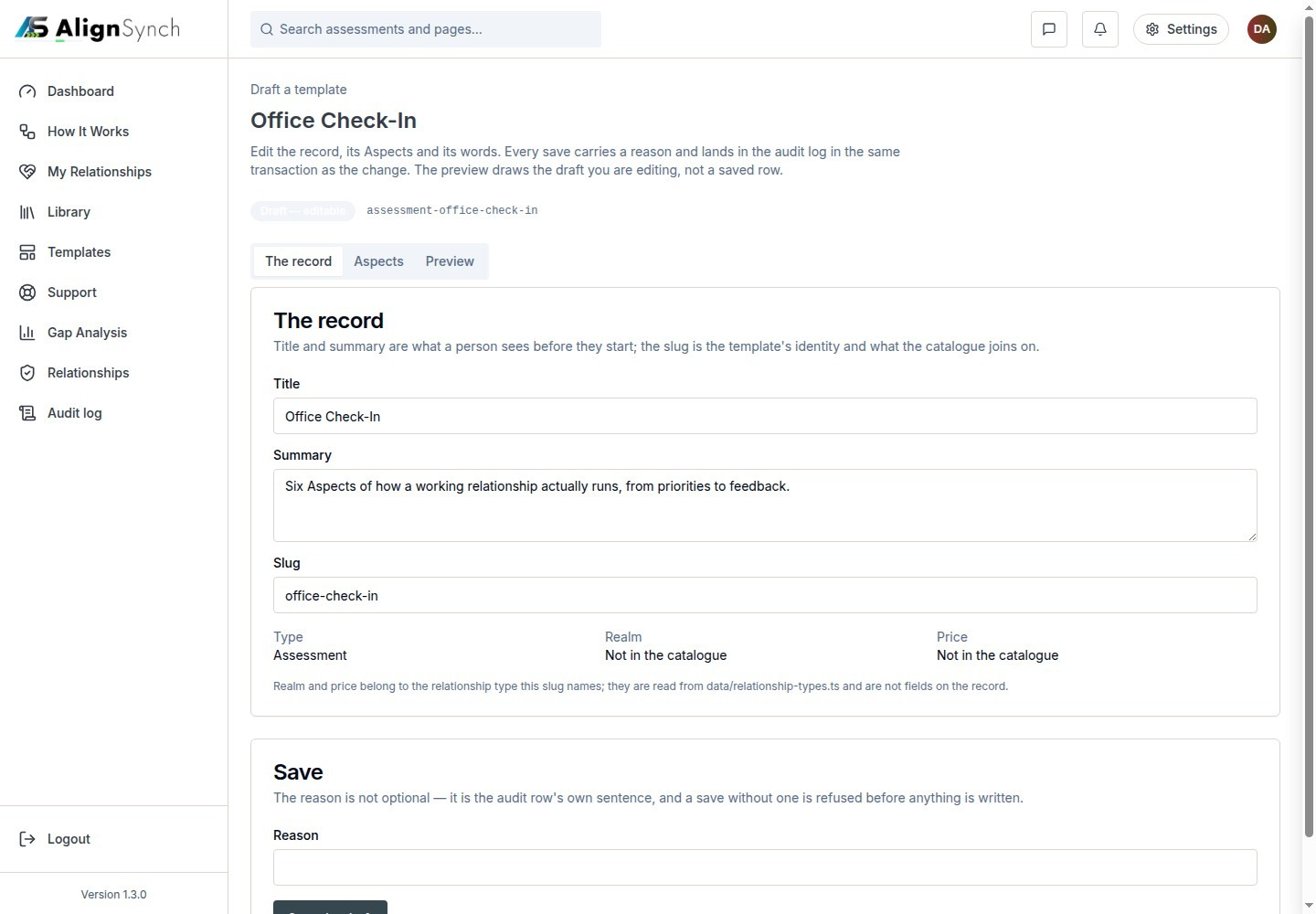
docs/qa-admin-template-authoring/editor-details.png · source 1440×1000 px · displayed band y=0–1000 of 1000 px. Template editing fields.
SCREEN ATLAS / CONTINUED

Template authoring · Desktop · template preview · section 1
DESKTOP · TEMPLATE PREVIEW · CAPTURED VIEW
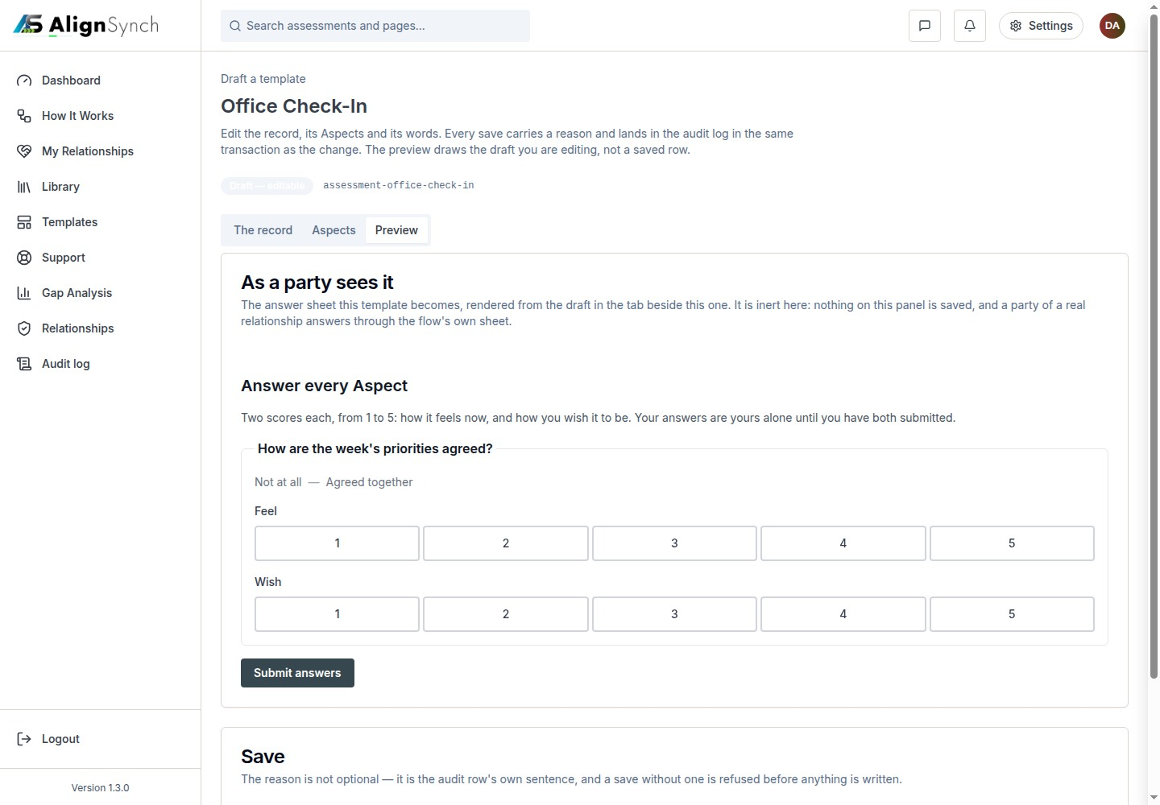
docs/qa-admin-template-authoring/editor-preview.png · source 1440×1000 px · displayed band y=0–1000 of 1000 px. Preview state before saving.
SCREEN ATLAS / CONTINUED

Template authoring · Desktop · saved state · section 1
DESKTOP · SAVED STATE · CAPTURED VIEW
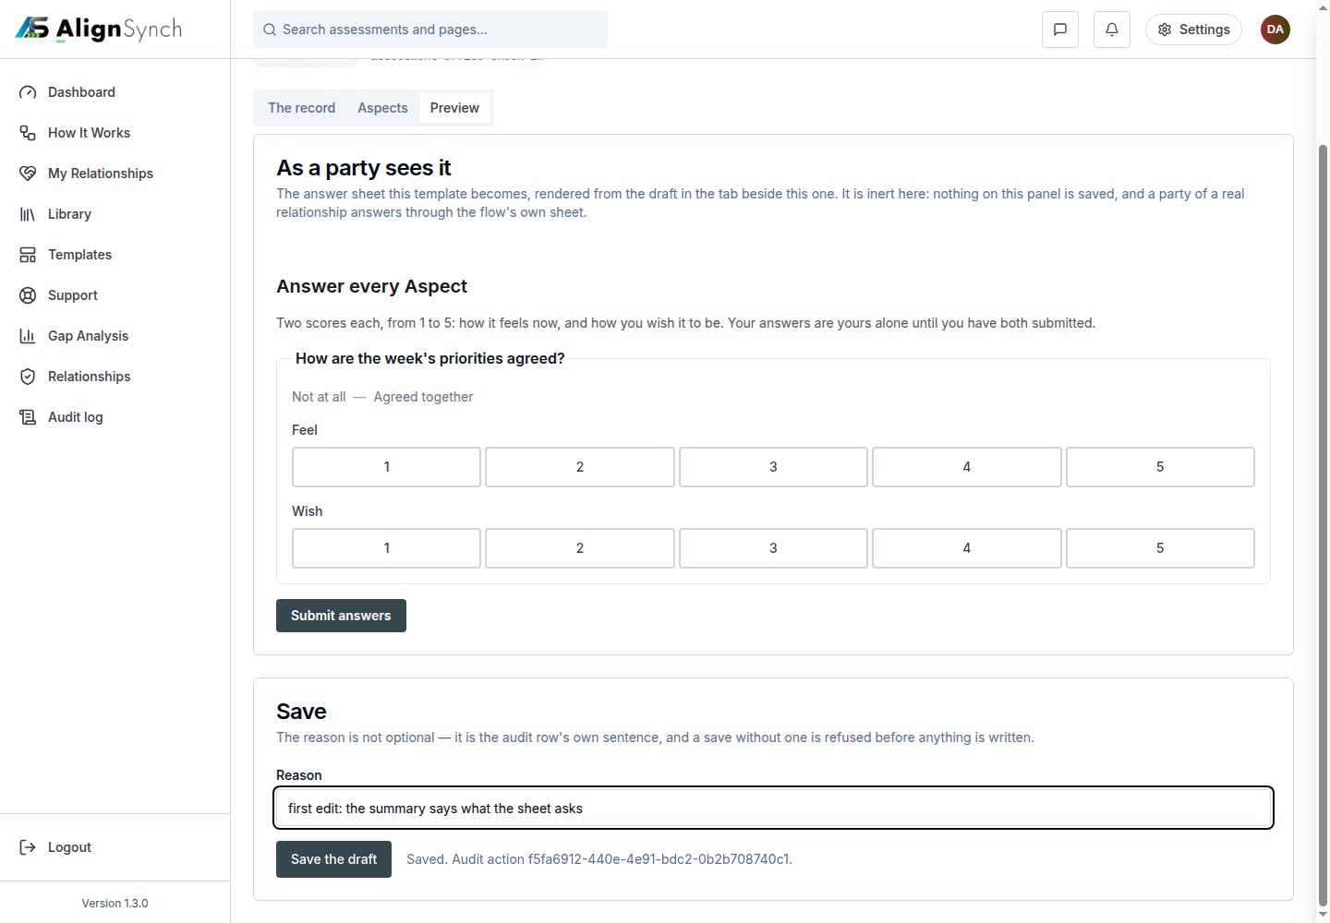
docs/qa-admin-template-authoring/editor-saved.png · source 1440×1000 px · displayed band y=0–1000 of 1000 px. Save confirmation state.

