
MEMBER EXPERIENCE / VOLUME 1

Member Experience Manual
  - Member screens, workflows, and technical references
Volume 1 documents the member-facing product. Volume 2 will cover the staff Console, billing, and daily operations.
Member flow | Template selection → Relationship setup → Invitation → Private assessment → Shared result
Audience | Members initiating or joining a personal or business relationship.
Screen evidence | Prototype and local QA captures. All visible records are demo data.

MEMBER INTERFACE PRESENTATION

Workspace Overview
/dashboard
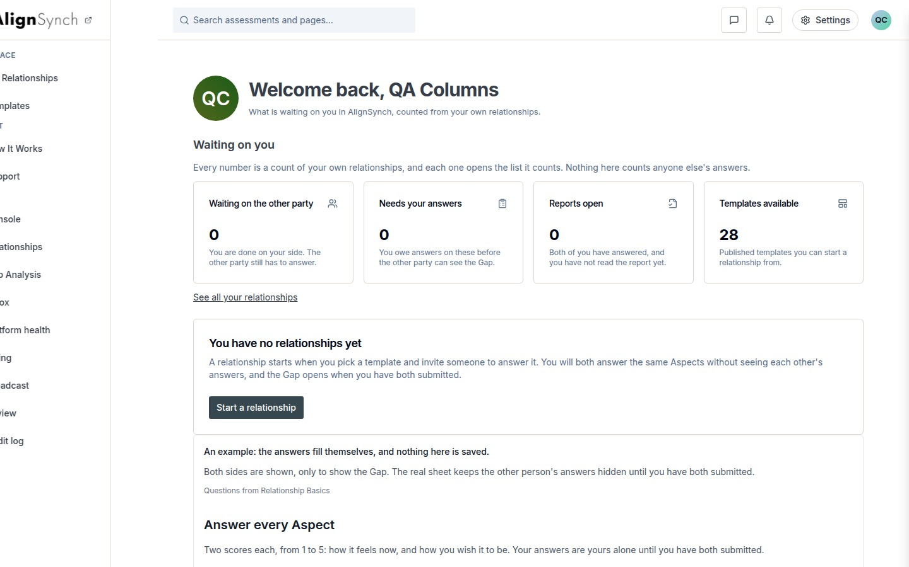
docs/qa-858-columns/after-dashboard-1440.png · Relationship status summary and next actions.
MEMBER INTERFACE PRESENTATION

My Relationships
/dashboard/relationships
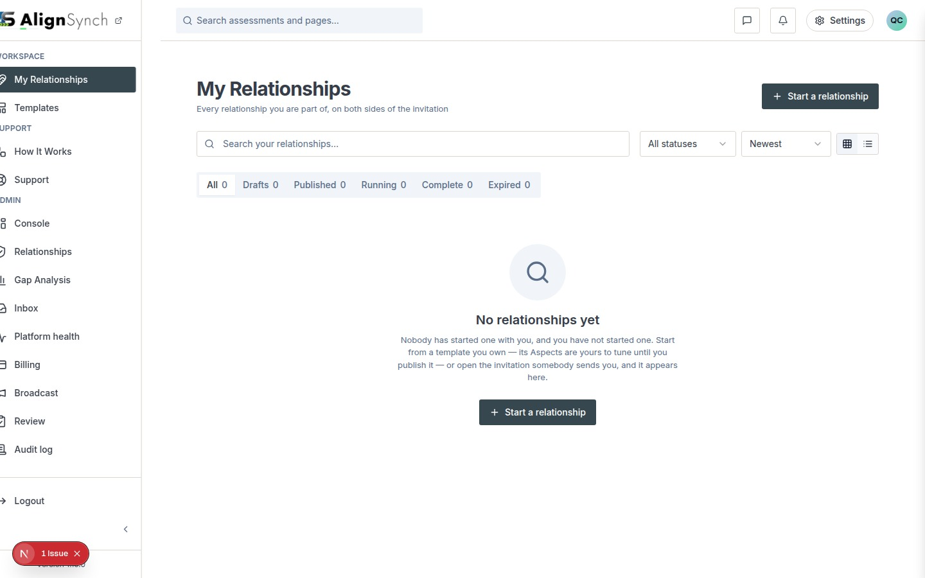
docs/qa-858-columns/after-dashboard-relationships-1440.png · List, lifecycle filters, search, and relationship start action.
MEMBER INTERFACE PRESENTATION

Template Catalogue
/dashboard/templates
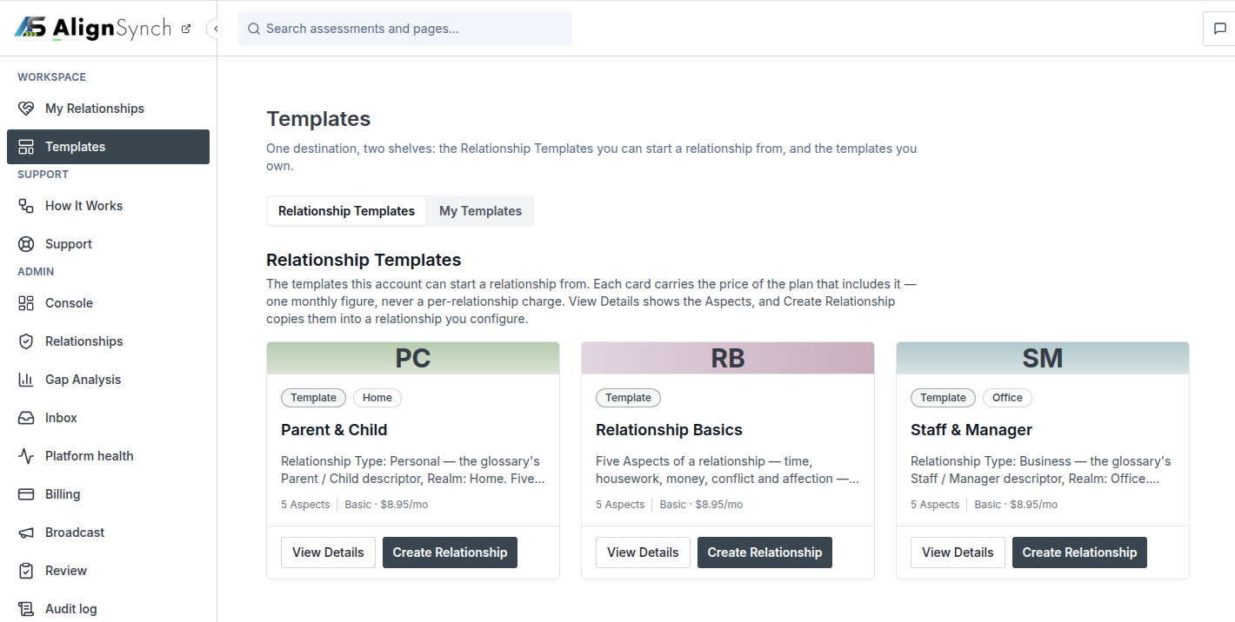
User-supplied browser image · Published relationship templates and My Templates shelves.
MEMBER INTERFACE PRESENTATION

Template Detail
/templates/relationship/[slug]
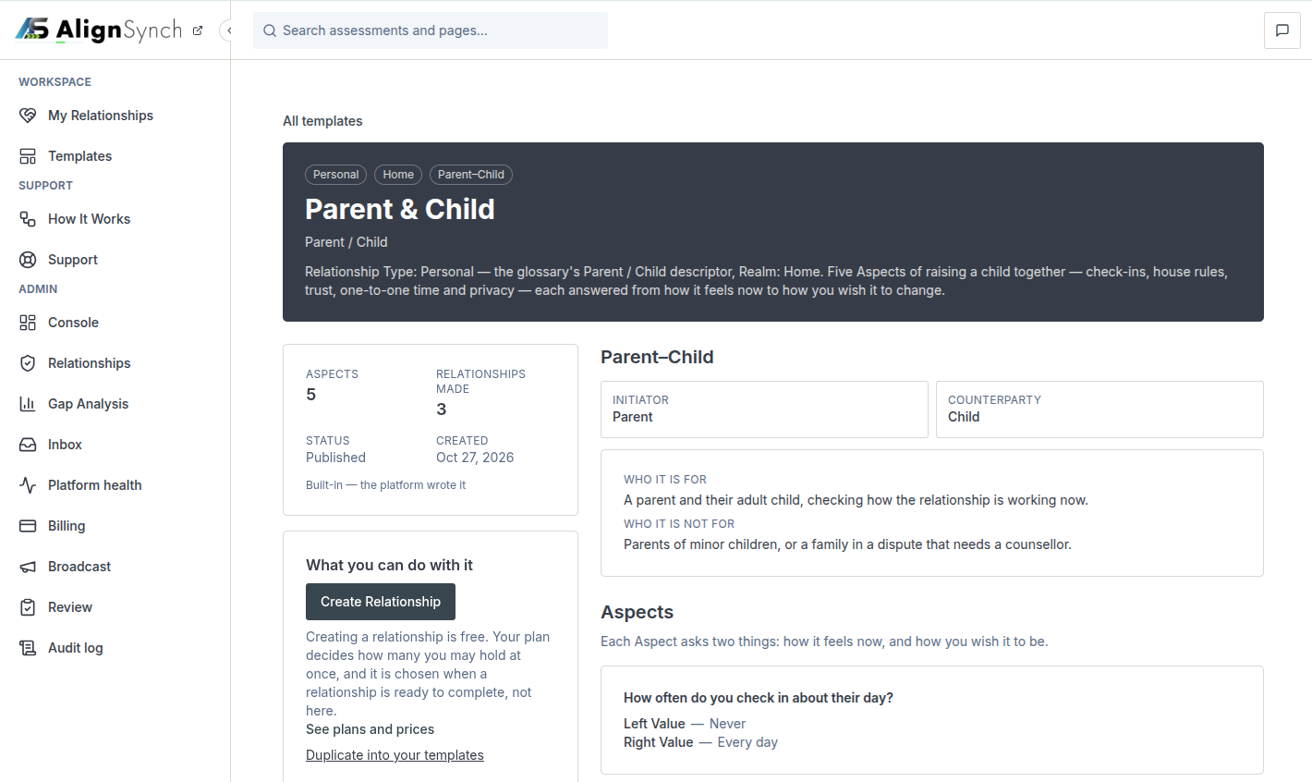
User-supplied browser image · Roles, intended audience, Aspects, and creation action.
MEMBER INTERFACE PRESENTATION

Private Answer Sheet
/assessment/instances/[id]/answer
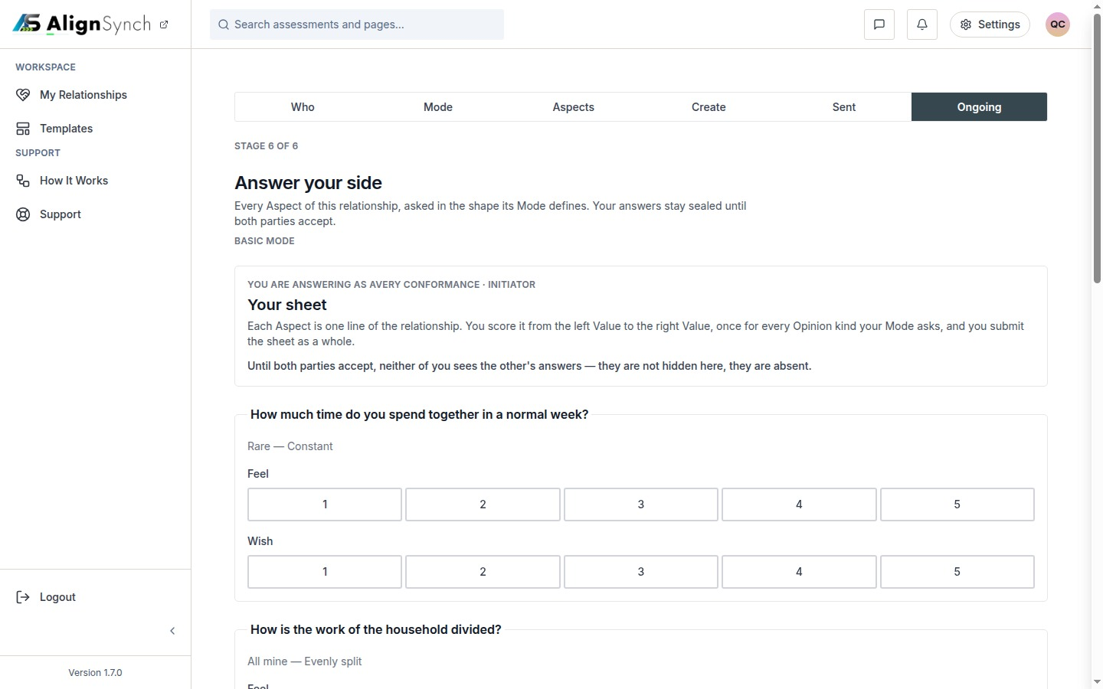
docs/qa-conformance/answer-1440.png · The participant’s own opinions for each Aspect.
MEMBER INTERFACE PRESENTATION

Shared Alignment
/assessment/instances/[id]
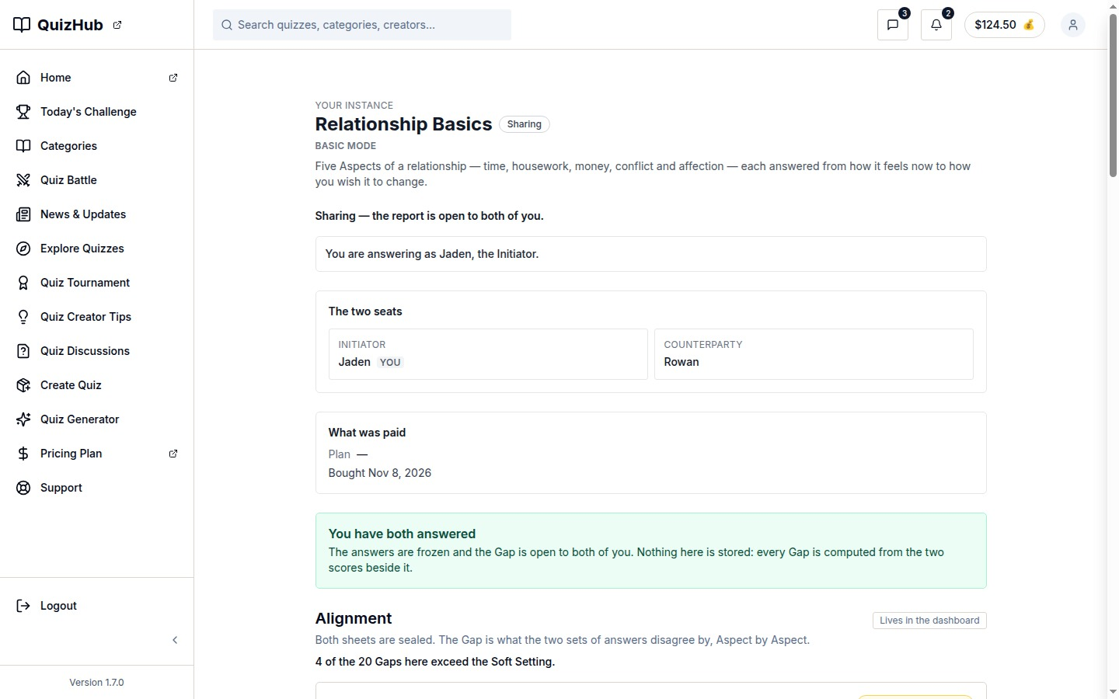
docs/qa-flow-stages/align-opens-alignment-1440.png · Shared comparison after both participants accept.
MEMBER INTERFACE PRESENTATION

Account Settings
/settings
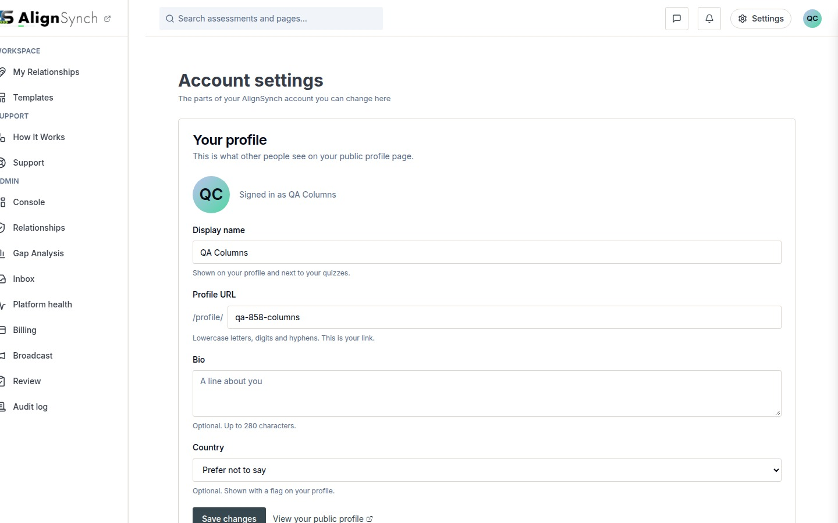
docs/qa-858-columns/after-settings-1440.png · Profile, password, and account controls.
MEMBER INTERFACE PRESENTATION

How It Works
/dashboard/help
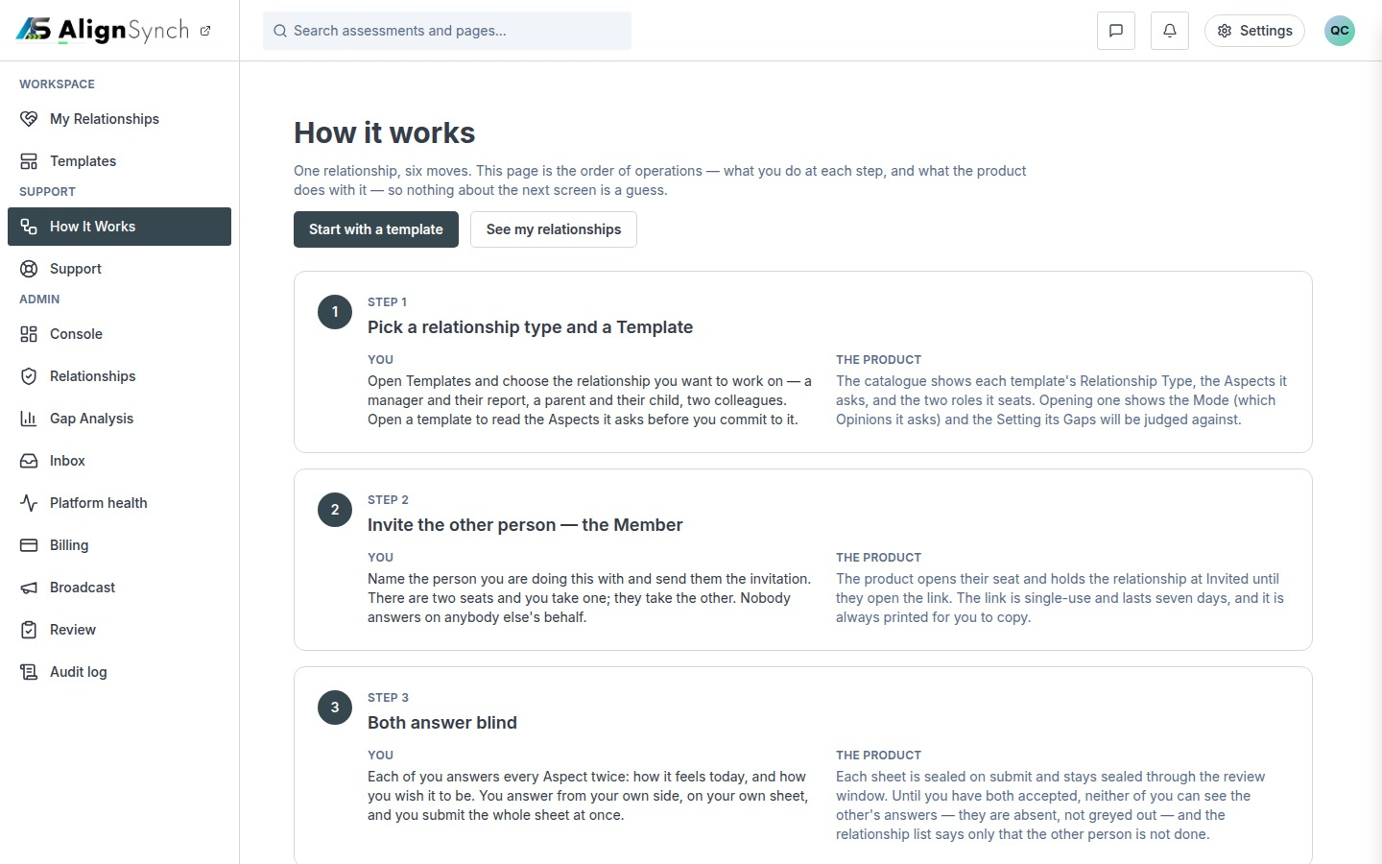
docs/qa-858-columns/after-dashboard-help-1440.png · Member process guide and tour replay.
01 ACCESS

Authentication Flows
Route | React view or action | Contract
/login | components/auth/login-view.tsx | Authenticate, then return to the validated same-site destination when available.
/register | components/auth/register-view.tsx | Create an account and continue to the requested destination.
/forgot-password | app/(auth)/forgot-password/actions.ts:31 | Request a reset link; responses avoid exposing account existence.
/reset/[token] | app/(auth)/reset/[token]/actions.ts:25 | Validate single-use reset token and set a replacement password.
/reset/complete | Completion page | Confirm password update after session handling.

Invitee authentication
A valid invitation opens its preview before account claim. If the invitee is signed out, the account gate routes through sign-in or registration and resumes the invitation. Claiming binds the invitee to the counterparty seat.
Transition | Handler or guard
Return destination | lib/auth/paths.ts; same-site destination validation.
Invitation claim | app/(mainlayout)/invite/[token]/claim/route.ts:55 → lib/flow/store.ts:921.
Seat binding | Valid unexpired token; counterparty seat must be empty; token is single use.
Password reset | Token expires and is consumed once; successful update revokes existing sessions.

AUTHENTICATION CAPTURES

Registration Screen
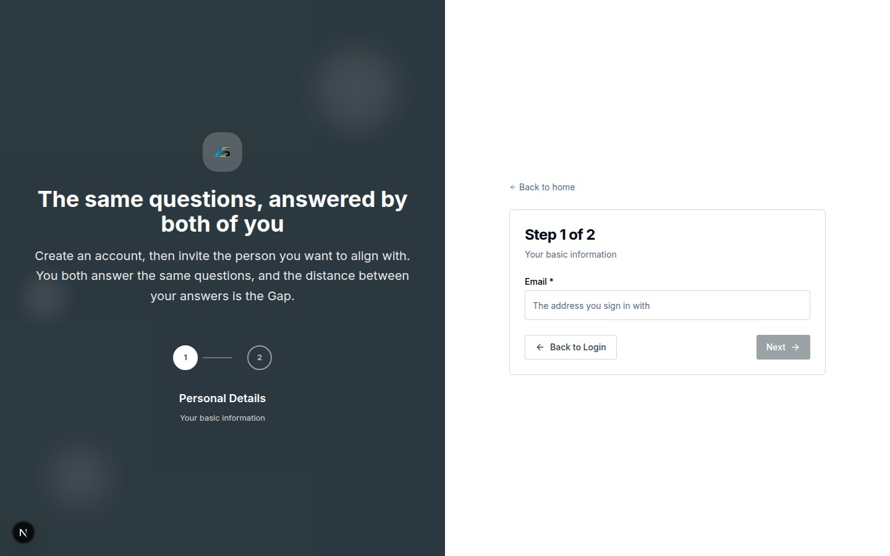
docs/qa-brand-lockup/register-1440-after.png · desktop capture.
AUTHENTICATION CAPTURES

Registration Screen Mobile
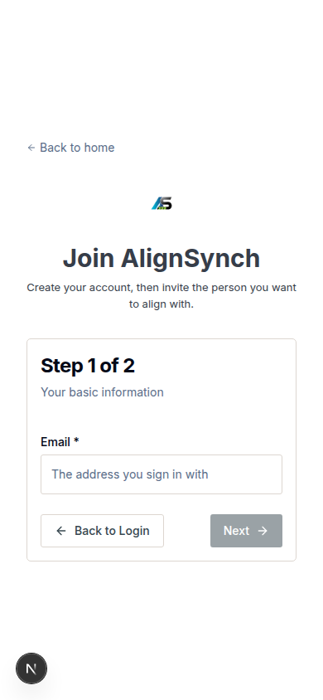
docs/qa-brand-lockup/register-390-after.png · mobile capture at CSS width 390.
AUTHENTICATION CAPTURES

Login Form
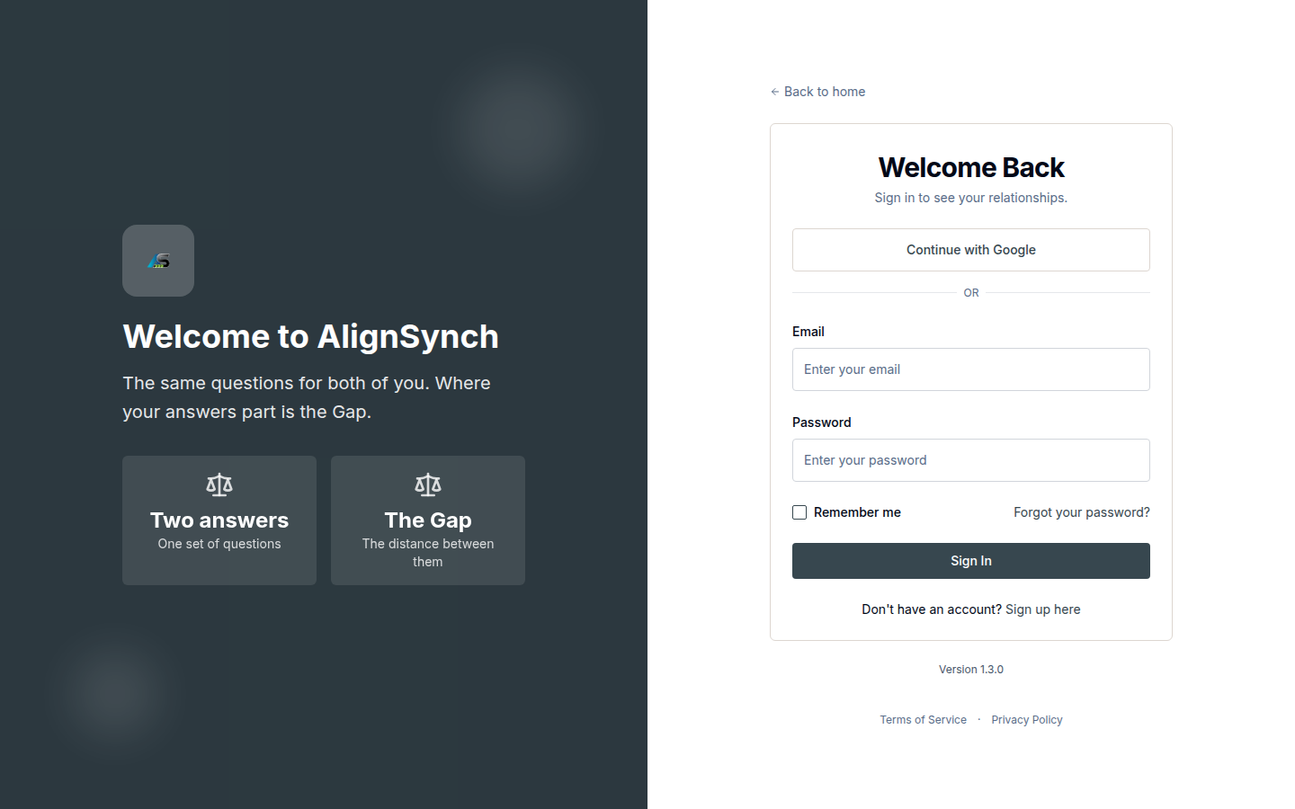
docs/qa-leaving-links/login-form-surface-1440.png · login form surface capture.
02 TEMPLATES

Relationship Template Flows
Route | React view | Read and write contract
/dashboard/templates | components/dashboard/template-gallery.tsx | Published Relationship Templates and member-owned templates; reads lib/member/templates.ts:92,133 and lib/member/library.ts.
/dashboard/templates/[id] | Shared TemplateEditor | Private template read through lib/member/templates.ts:180; edits remain owner-scoped.
/templates/relationship/[slug] | Template detail route | Published template detail and relationship-specific roles/Aspects.
/dashboard/templates/actions | Server actions | Create private template, clone public template, and save private template.

Selection path
Step | Result
Browse | Search the published catalogue by relationship type and realm.
Inspect | Read roles, intended audience, Aspect wording, and scale endpoints.
Start a Relationship | Copy the chosen template into a new versioned Relationship.
Create a private template | Enter a title, summary, and first Aspect; member writes are private.
Clone a published template | Copy template content and Aspects into the member’s private shelf.

Implementation references
Page: app/(mainlayout)/dashboard/templates/page.tsx:67. View: components/dashboard/template-gallery.tsx:66. Actions: app/(mainlayout)/dashboard/templates/actions.ts:88,121,146. Data: lib/member/templates.ts:280,342,440.
03 CREATION

Create Relationship Flow
Stage | Member action | System write
Choose | Select a published or private template. | Validate template access.
Configure | Set title, participant roles, mode/setting, and Aspects. | Create draft and relationship content version.
Save | Keep a draft or save the configured relationship. | Create participant membership and payment obligation.
Publish | Enter counterparty details and send invitation. | Open assessment session; mint invitation; persist token hash.
Recover | Reissue an unclaimed expired or revoked invitation where allowed. | Rotate invitation token and update delivery state.

Current entry point
Start a relationship opens the create band from My Relationships. The current route creates a private copy through the member action; the older multi-stage wizard screenshots in the atlas are labeled as earlier flow states.

Mutation references
Create: app/(mainlayout)/dashboard/relationships/actions.ts:79 → lib/member/relationships.ts:721. Save: actions.ts:112 → relationships.ts:904. Publish: actions.ts:157 → relationships.ts:1116. Reissue: actions.ts:217 → relationships.ts:1427.
Billing condition. The detail UI gates publication on a payment method, but the publish service does not bill or enforce that same gate. Capture is connected to relationship completion. Confirm intended billing order before relying on the UI sequence.
04 RELATIONSHIPS

Member Management of Relationships
Operation | Supported member action | Route or service
Create | Start from a template and create a draft copy. | /dashboard/relationships; createRelationshipAction; lib/member/relationships.ts:721.
Read | Search, filter, sort, and open a relationship. | RelationshipsList; list read at lib/member/relationships.ts:388.
Update | Edit draft details or Aspects; save a draft or pending state. | relationship-detail.tsx; edit actions at actions.ts:255,298.
Publish | Invite the counterparty and start the assessment. | publish action → lib/member/relationships.ts:1116.
Reissue | Replace an unclaimed invitation when recovery is permitted. | republish action → relationships.ts:1427.
Complete | Finish the payer action and relationship completion path. | complete action → lib/member/payment.ts:457.
Delete | No member delete action appears on the reviewed relationship route. | Account deletion is a separate settings operation.

List state
Status tabs represent the stored relationship lifecycle. Search covers the relationship title and counterparty name. Sort defaults to newest. Grid/list selection changes presentation only.

Access rule
The server checks the viewer’s participant membership before returning relationship detail or write outcomes. Initiator and counterparty actions are resolved from the seat, not a browser-supplied role.
05 ASSESSMENT

Assessments and Sessions
Route | React view | Member operation
/assessments | components/dashboard/assessments-list.tsx | Find sessions requiring the member’s answers, waiting for the other participant, or ready to report.
/assessment/instances/[id] | Session page; readFlowScreen | Read session state and next allowed action.
/assessment/instances/[id]/answer | components/assessment-flow/answer-sheet.tsx | Create or revise own opinions before acceptance.
/assessment/instances/[id]/accept | components/assessment-flow/accept-session.tsx | Explicitly accept own completed answer sheet.
/assessment/instances/[id]/report | components/assessment-flow/report-view.tsx | Read shared comparison after both participants accept.
/assessment/instances/[id]/sent | Sent confirmation page | Review invitation send result and next actions.

Session state contract
State | Data and allowed action
Answering | Each participant reads and writes only their own Aspect opinions.
Submitted | The participant’s answer sheet is complete; it remains private from the other seat.
Accepted by one | Acceptance is recorded for that participant. The report remains locked.
Accepted by both | Session completes; shared Alignment and Steps become available.
After acceptance | The participant cannot revise the sealed answer sheet.

Service references
Session read: lib/flow/store.ts:2661 and lib/db/assessments.ts:923. Answers: POST answers route → lib/flow/store.ts:1535. Acceptance: POST accepts route → store.ts:1912. Report math: lib/assessment-report.ts:178 and content/gaps.ts:192,255.
06 MEMBER SERVICES

Account and Support
Route | React view or action | Contract
/settings | components/identity/settings-view.tsx | Edit profile fields; email is read-only. Password and account deletion are separate actions.
/profile/[handle] | Profile route | Read profile projection for the selected handle.
/dashboard/help | How It Works page | Read the relationship flow; replay the tour.
/dashboard/support | components/support/dashboard-support-view.tsx | Submit account-scoped support request.
/dashboard/support/articles/[slug] | Support article route | Read help content in the signed-in shell.

Profile write: app/api/profile/route.ts:48 → lib/db/user-profiles.ts:78. Password: settings/password-actions.ts:25 → lib/auth/reset-set.ts:136. Account purge: settings/delete-account-actions.ts:57 → lib/account/purge.ts:752. Support: actions.ts:48 → lib/contact/submit.ts:82 → lib/contact/store.ts:39,118.
07 COMPONENT SYSTEM

UI React Template Components
The shared React UI layer lives in components/ui and is configured by components.json for TSX, React Server Components, Tailwind CSS variables, and Lucide icons. Feature views compose local primitives; route data and mutations remain in domain code.
Primitive | Use
Button, Badge, Card | Actions, lifecycle state, and content grouping.
Input, Label, Textarea, Select | Forms and accessible field controls.
Tabs, Table, DropdownMenu | Shelves, registries, filters, and row actions.
Alert, Dialog, AlertDialog, Popover | Inline status, destructive confirmation, modal steps, and anchored prompts.
FormSurface, PageHeader, Skeleton, Sonner | Form grouping, page heading/action layout, loading, and transient feedback.

Feature components
Feature | React components
Workspace | components/layout/main-layout.tsx; components/layout/sidebar.tsx.
Relationships | relationships-list.tsx; relationship-cards.tsx; relationship-detail.tsx; relationship-create.tsx.
Templates | template-gallery.tsx; shared TemplateEditor.
Assessment | answer-sheet.tsx; counterparty-wizard.tsx; accept-session.tsx; report-view.tsx.
Support | dashboard-support-view.tsx.

Brand tokens
Token | Value
Action | #37474F
Ink and body | #363D49 and #59636E
Cyan and soft cyan | #08ADD5 and #E5F5FA
Green | #8DC63F
Mist and border | #F5F7F8 and #D9E0E3

08 DATA

Member Data and Access Rules
Entity | Member boundary
Template | Published source is read-only; member-created and cloned versions remain private.
Relationship | Two seats, role-bound membership, and a versioned content snapshot.
Assessment session | One session belongs to a Relationship and has two participant contexts.
Opinion | Read/write scoped to the current participant seat.
Acceptance | Per-seat event; both are required to open the shared report.
Report | Shared projection available only after both participants accept.
Payment | Initiator is payer; completion capture is handled by the payment service.

Role enforcement
Member routes require signed-in identity and relationship membership. Invitation claim validates token status and seat availability. Administrative workflows are documented separately in Volume 2.

Schema references
Database milestones: 0001_content_model.sql, 0002_two_party_flow.sql, 0014_relationship_membership.sql, 0016_party_acceptance.sql, and 0036_relationship_payment.sql.
09 REFERENCE

Member Route and Capture Index
Area | Routes
Workspace | /dashboard; /dashboard/relationships; /dashboard/relationships/[id]; /assessments.
Templates | /dashboard/templates; /dashboard/templates/[id]; /templates/relationship/[slug].
Relationship flow | /invite/[token]; /assessment/instances/[id]; /assessment/instances/[id]/sent.
Assessment | /assessment/instances/[id]/answer; /assessment/instances/[id]/accept; /assessment/instances/[id]/report.
Account and support | /login; /register; /forgot-password; /reset/[token]; /reset/complete; /settings; /profile/[handle]; /dashboard/help; /dashboard/support; /dashboard/support/articles/[slug].

Capture coverage
Capture status | Member routes
Desktop and mobile | Overview, My Relationships, answer sheet, invitation response, sent confirmation, How It Works, settings, and profile.
Desktop only | Relationship detail, template detail, support page, and selected invitation and report states.
Route image gaps | My Assessments list, dedicated acceptance/report pages, password recovery sequence, and some session details.
Earlier flow captures | Older create-wizard steps and support shell are labeled as historical/component references.

Volume 2 is reserved for the staff Console, billing, and daily operations.
SCREEN ATLAS

Capture coverage and evidence limits
This atlas places available screen captures in the guide at readable size. Long captures are split into consecutive vertical bands; the source image and pixel offsets are printed below each band so reviewers can reconstruct the full captured page. Desktop and mobile are shown as separate modes. The captures are local prototype/QA screenshots plus the specific browser images supplied by the user; this document does not claim a fresh production-browser session.
Coverage class | Included in this guide
Current route, desktop + mobile | Overview, My Relationships, answer sheet, invite response, send confirmation, How It Works, settings, and profile. Long pages are sliced top-to-bottom.
Current route, desktop only | Relationship detail, template detail, support page, and selected invitation and Alignment states. Mobile is marked unavailable where no current capture exists.
User-supplied browser view | Templates catalogue and template detail images supplied in this conversation.
Prototype / legacy or component state | Old wizard steps, older support shell, and old template route. Each is labeled where shown.
Not captured at current route | My Assessments list, dedicated acceptance page, dedicated /report page, and current login/reset sequence. Their route and service behavior is documented without presenting a different screen as current.

Interpreting the capture sources
- A QA folder name identifies a local capture set, not an application URL. The source path printed with each image should be used to find the full original.
- Several mobile sources were captured at 2× resolution. They are downsampled to CSS width 390 for placement; the entire screenshot height is retained and split into bands.
- Where a capture is explicitly described as a viewport, the guide represents that viewport only. It does not imply a full-page scroll capture.
- The current backend references point to the application code reviewed on November 12, 2026. They explain route, permission, storage, or workflow behavior alongside what is visible.
SCREEN ATLAS / /DASHBOARD

Overview and navigation
Route | Member task
/dashboard | Review relationship progress, choose the next action, and reach shared navigation.

Screen evidence | Implementation references
Desktop/mobile full-page captures from qa-858-columns/capture-report-after.json; the newest shell labels vary by account role. | app/(mainlayout)/dashboard/page.tsx:76; components/console/overview.tsx:59; components/layout/main-layout.tsx:65; components/layout/sidebar.tsx:92; data/nav-menu.json:5-70; lib/nav-menu.ts:149,168.

DESKTOP · SECTION 1 OF 2
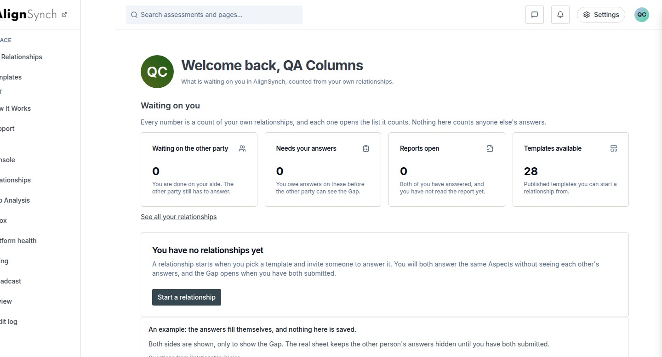
docs/qa-858-columns/after-dashboard-1440.png · source 1440×1554 px · displayed band y=0–777 of 1554 px. Full-page capture, seeded first-run account state.
SCREEN ATLAS / CONTINUED

Overview and navigation Desktop section 2
DESKTOP · SECTION 2 OF 2
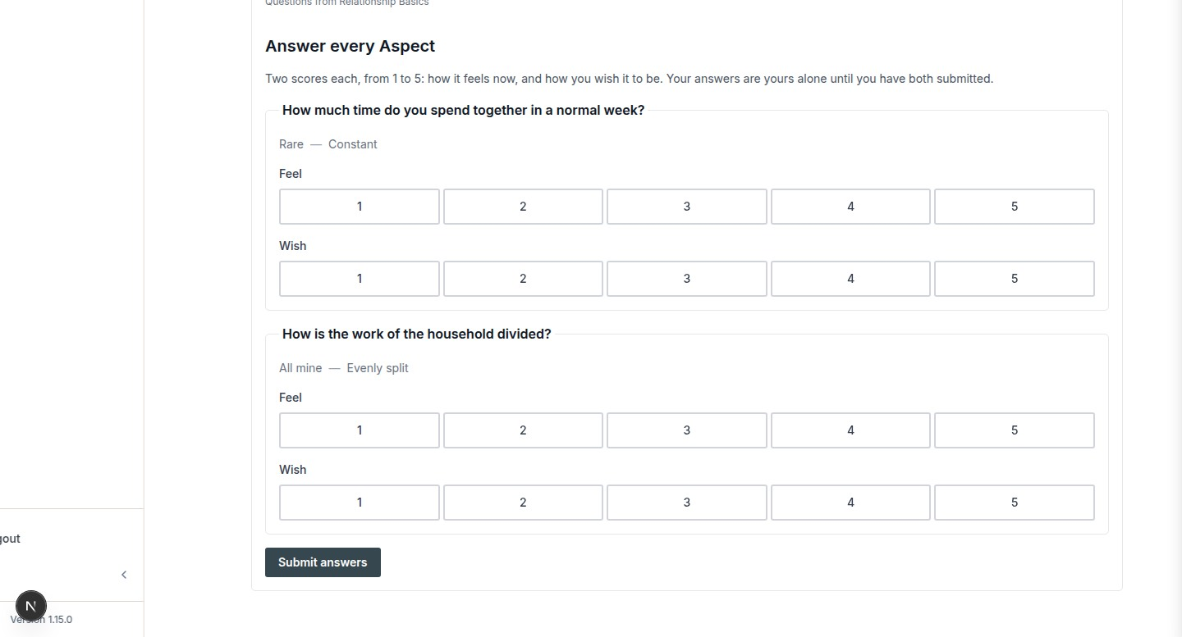
docs/qa-858-columns/after-dashboard-1440.png · source 1440×1554 px · displayed band y=777–1554 of 1554 px. Full-page capture, seeded first-run account state.
SCREEN ATLAS / CONTINUED

Overview and navigation Mobile section 1
MOBILE · SECTION 1 OF 4
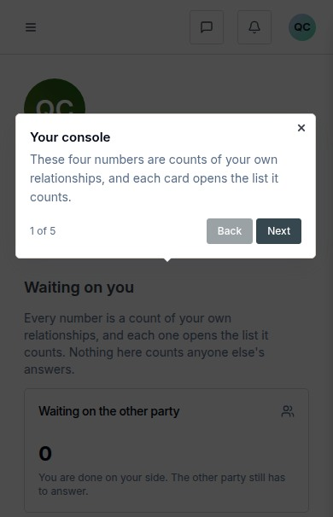
docs/qa-858-columns/after-dashboard-390.png · source 390×2423 px · displayed band y=0–606 of 2423 px. Full-page capture, CSS 390px viewport.
SCREEN ATLAS / CONTINUED

Overview and navigation Mobile section 2
MOBILE · SECTION 2 OF 4
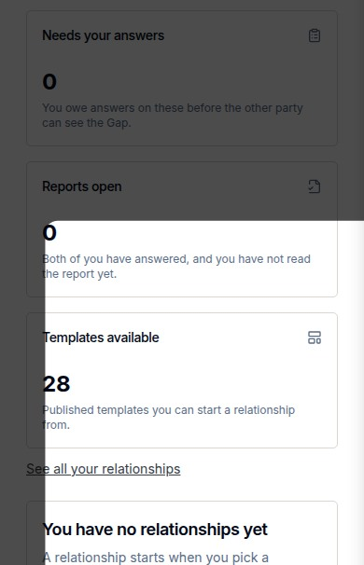
docs/qa-858-columns/after-dashboard-390.png · source 390×2423 px · displayed band y=606–1212 of 2423 px. Full-page capture, CSS 390px viewport.
SCREEN ATLAS / CONTINUED

Overview and navigation Mobile section 3
MOBILE · SECTION 3 OF 4
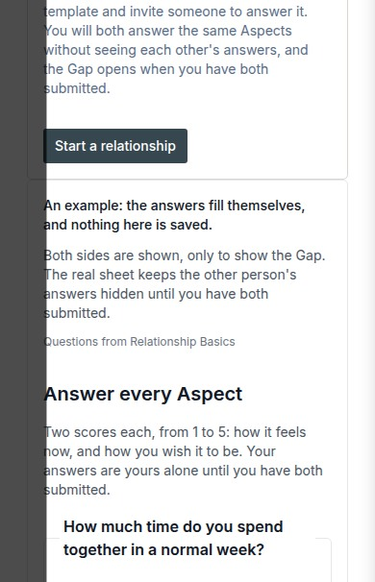
docs/qa-858-columns/after-dashboard-390.png · source 390×2423 px · displayed band y=1212–1818 of 2423 px. Full-page capture, CSS 390px viewport.
SCREEN ATLAS / CONTINUED

Overview and navigation Mobile section 4
MOBILE · SECTION 4 OF 4
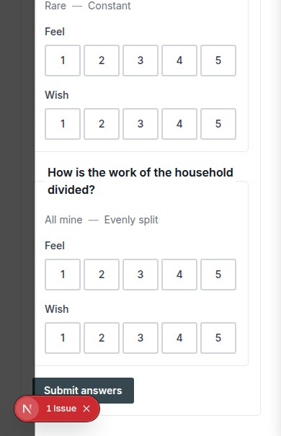
docs/qa-858-columns/after-dashboard-390.png · source 390×2423 px · displayed band y=1818–2423 of 2423 px. Full-page capture, CSS 390px viewport.
SCREEN ATLAS / /DASHBOARD/RELATIONSHIPS

My Relationships list
Route | Member task
/dashboard/relationships | Find a relationship, read its lifecycle state, and start another from a template.

Screen evidence | Implementation references
Current after-fix desktop/mobile pair; route and heading verified in the QA capture report. | app/(mainlayout)/dashboard/relationships/page.tsx:43; components/dashboard/relationships-list.tsx:101; lib/member/relationships.ts:388,721.

DESKTOP · CAPTURED VIEW
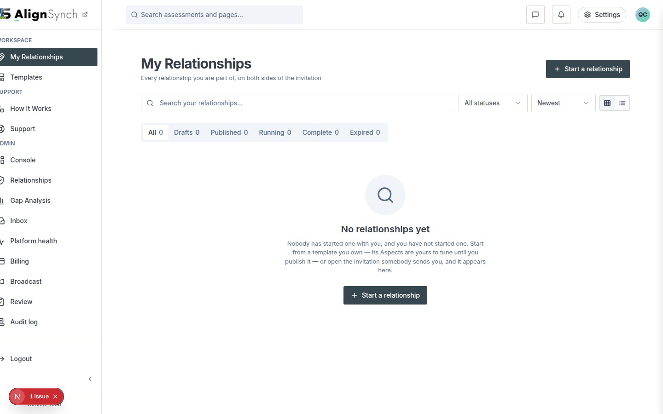
docs/qa-858-columns/after-dashboard-relationships-1440.png · source 1440×900 px · displayed band y=0–900 of 900 px. Current route capture, populated demo cards.
SCREEN ATLAS / CONTINUED

My Relationships list Mobile section 1
MOBILE · CAPTURED VIEW
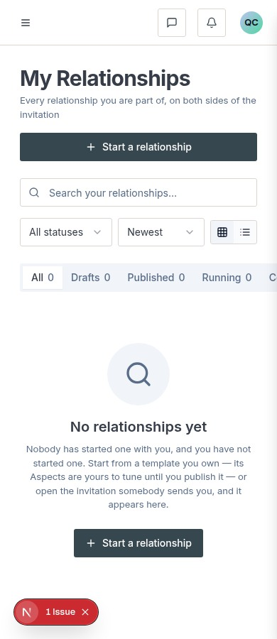
docs/qa-858-columns/after-dashboard-relationships-390.png · source 390×900 px · displayed band y=0–900 of 900 px. Current route capture at CSS 390px.
SCREEN ATLAS / /DASHBOARD/RELATIONSHIPS/[ID]

Relationship detail initiator draft
Route | Member task
/dashboard/relationships/[id] | Review setup, edit Aspects, and prepare to publish an invitation.

Screen evidence | Implementation references
Desktop full-page states show the initiator draft and the publish/plan section. No paired mobile capture was found. | app/(mainlayout)/dashboard/relationships/[id]/page.tsx:57; components/dashboard/relationship-detail.tsx:109; actions.ts:112,157,217; lib/member/relationships.ts:904,1116,1427.

Capture context. These are local QA captures of demo relationships, not newly opened production records.
DESKTOP · DRAFT AND ASPECTS · SECTION 1 OF 3
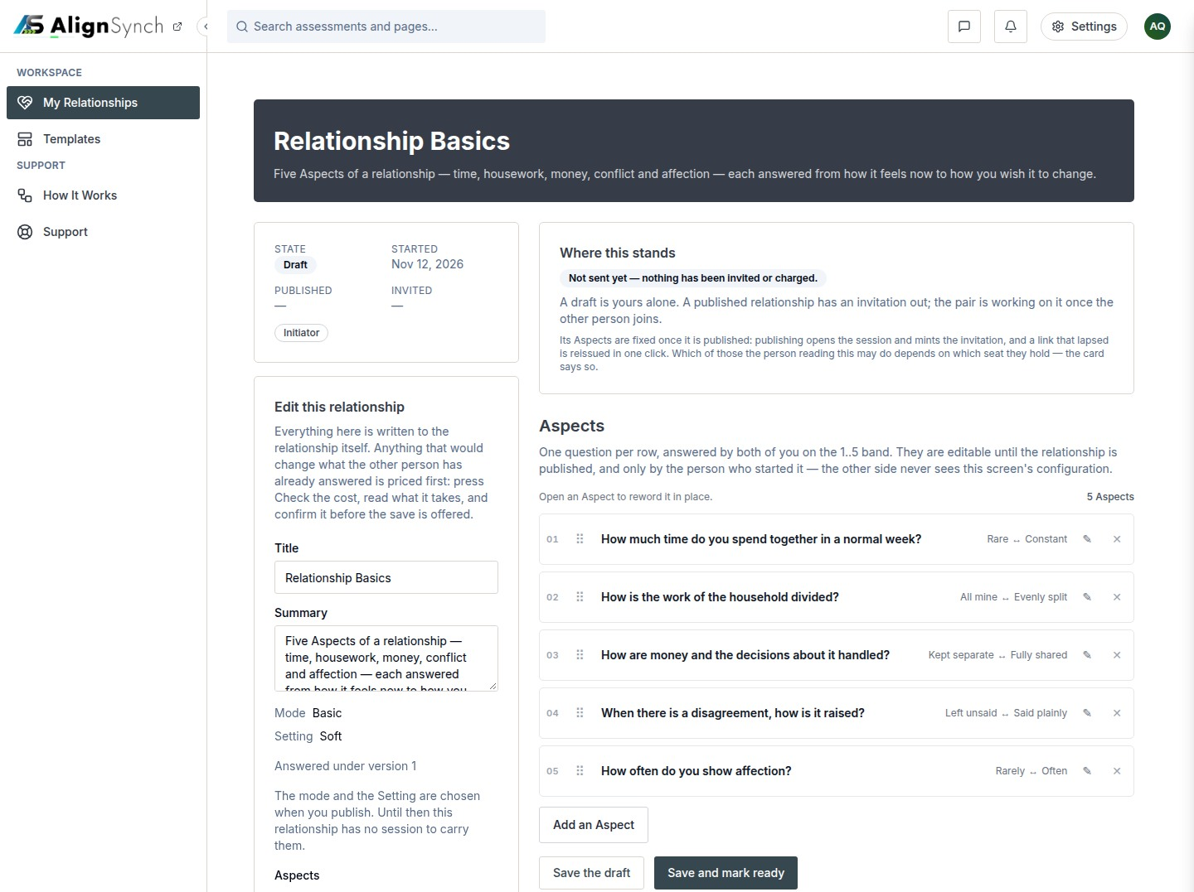
docs/qa-873/873-initiator-draft-steps-1-3-1440.png · source 1440×3229 px · displayed band y=0–1077 of 3229 px. Full-page capture; split into consecutive bands.
SCREEN ATLAS / CONTINUED

Relationship detail initiator draft Desktop draft and Aspects section 2
DESKTOP · DRAFT AND ASPECTS · SECTION 2 OF 3
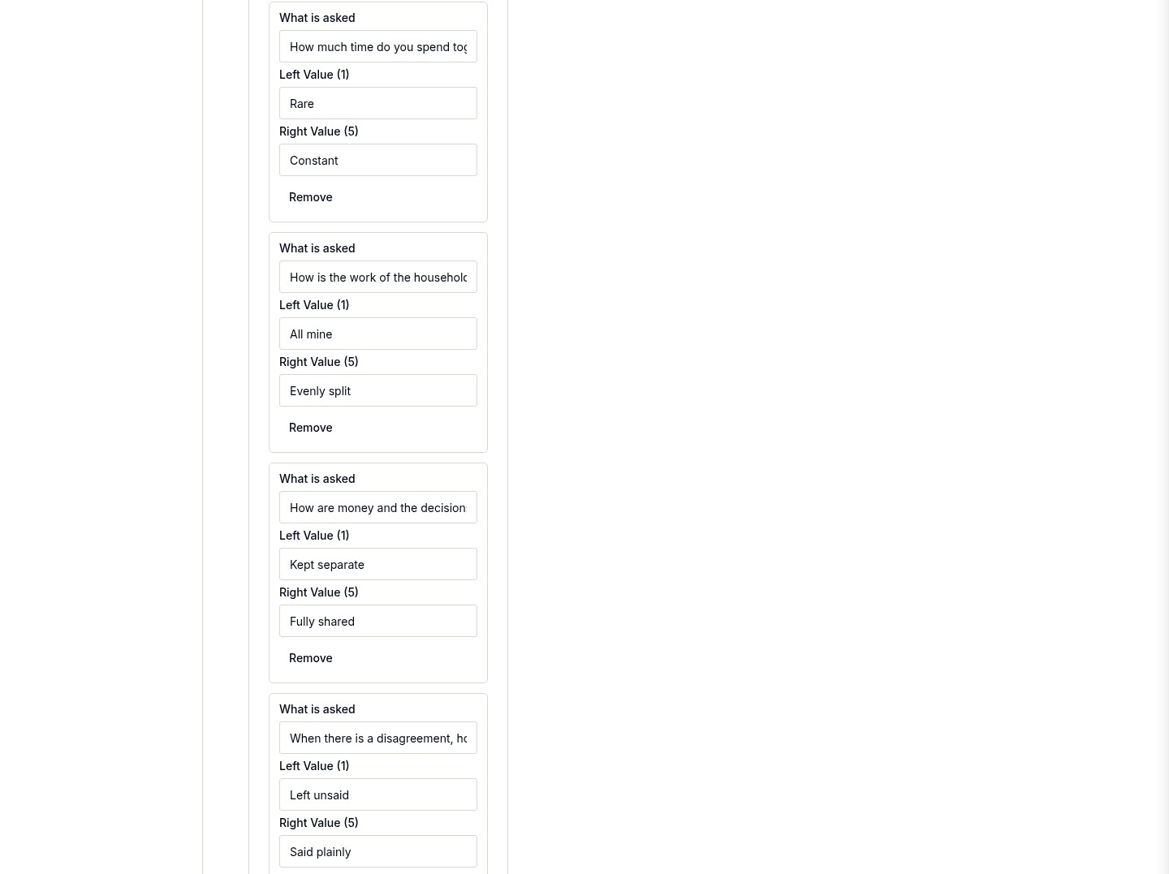
docs/qa-873/873-initiator-draft-steps-1-3-1440.png · source 1440×3229 px · displayed band y=1077–2154 of 3229 px. Full-page capture; split into consecutive bands.
SCREEN ATLAS / CONTINUED

Relationship detail initiator draft Desktop draft and Aspects section 3
DESKTOP · DRAFT AND ASPECTS · SECTION 3 OF 3
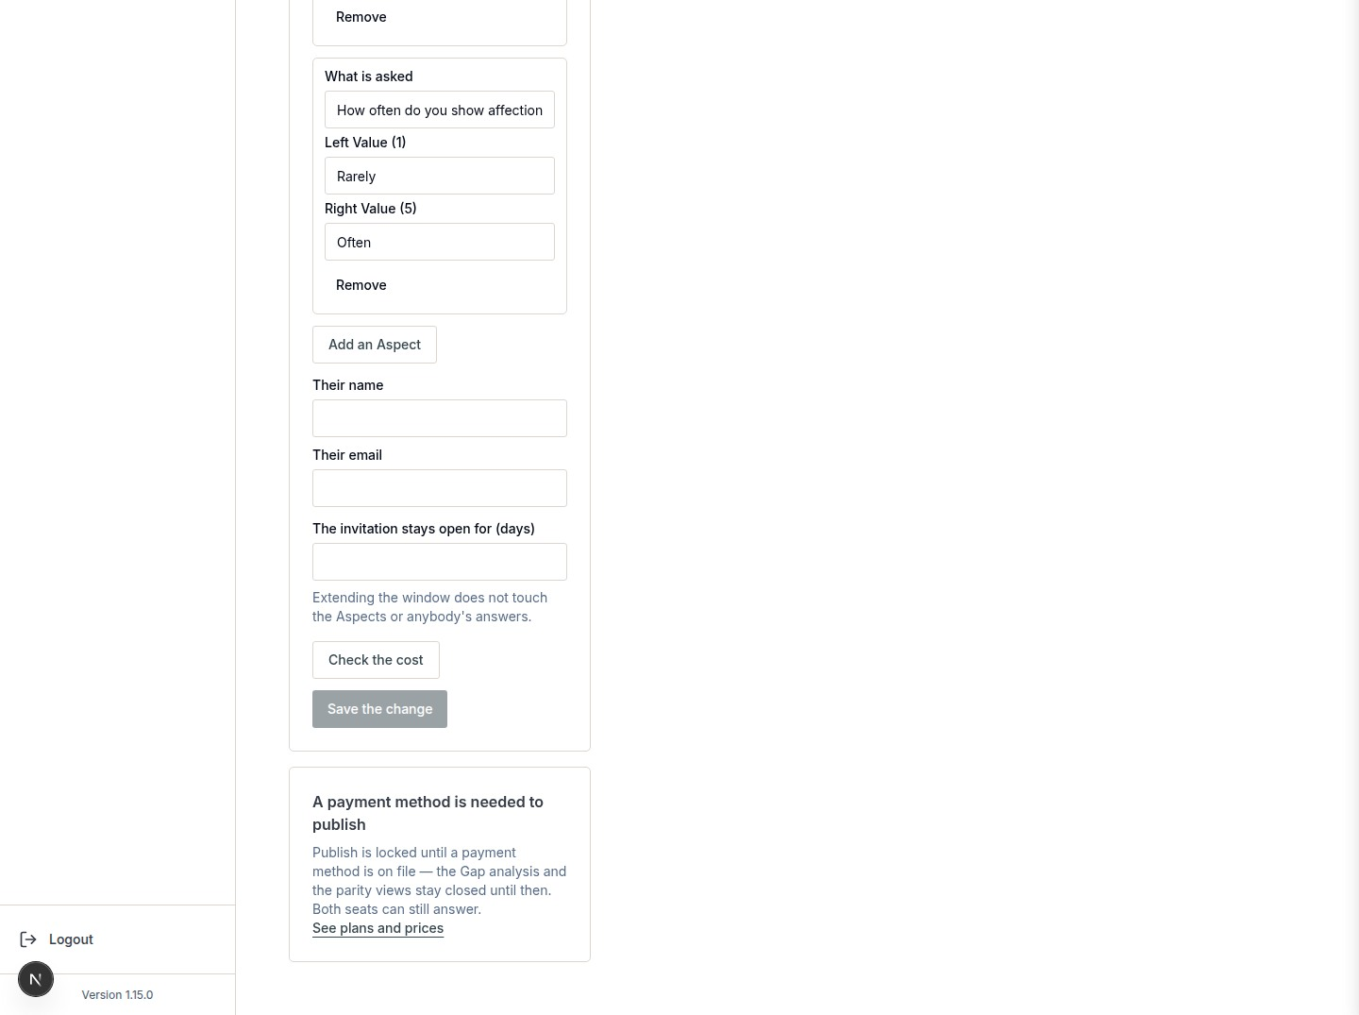
docs/qa-873/873-initiator-draft-steps-1-3-1440.png · source 1440×3229 px · displayed band y=2154–3229 of 3229 px. Full-page capture; split into consecutive bands.
SCREEN ATLAS / CONTINUED

Relationship detail initiator draft Desktop publish section section 1
DESKTOP · PUBLISH SECTION · SECTION 1 OF 4
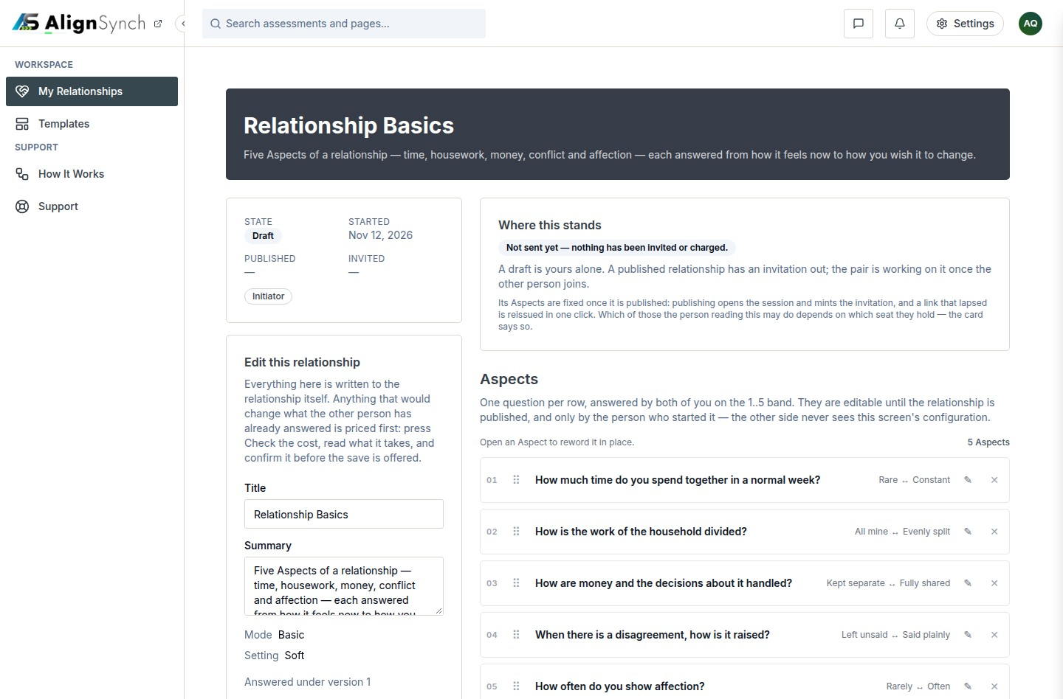
docs/qa-873/873-initiator-draft-publish-1440.png · source 1440×3792 px · displayed band y=0–948 of 3792 px. Full-page capture with publish and plan-door content.
SCREEN ATLAS / CONTINUED

Relationship detail initiator draft Desktop publish section section 2
DESKTOP · PUBLISH SECTION · SECTION 2 OF 4
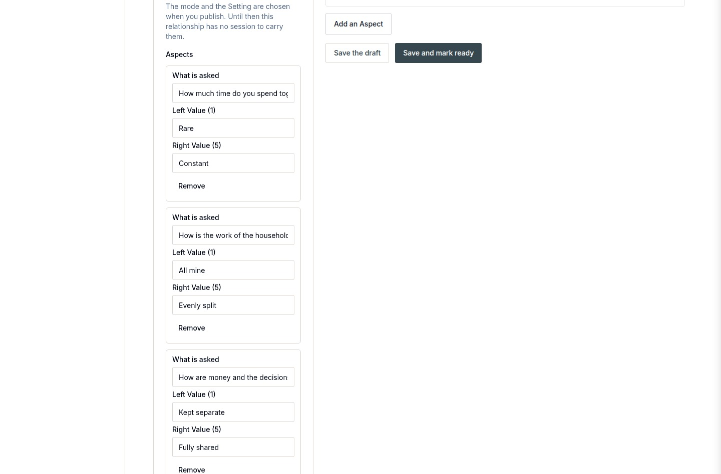
docs/qa-873/873-initiator-draft-publish-1440.png · source 1440×3792 px · displayed band y=948–1896 of 3792 px. Full-page capture with publish and plan-door content.
SCREEN ATLAS / CONTINUED

Relationship detail initiator draft Desktop publish section section 3
DESKTOP · PUBLISH SECTION · SECTION 3 OF 4
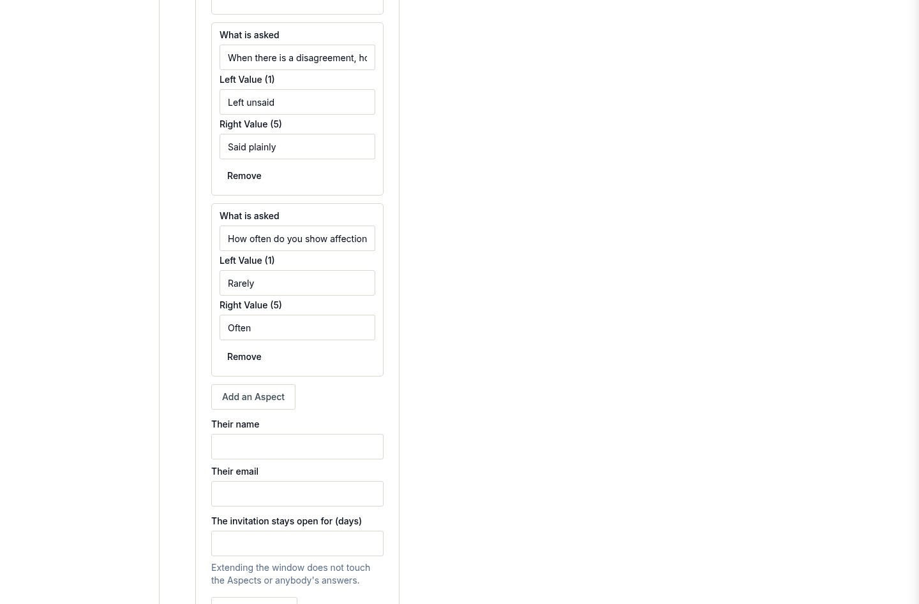
docs/qa-873/873-initiator-draft-publish-1440.png · source 1440×3792 px · displayed band y=1896–2844 of 3792 px. Full-page capture with publish and plan-door content.
SCREEN ATLAS / CONTINUED

Relationship detail initiator draft Desktop publish section section 4
DESKTOP · PUBLISH SECTION · SECTION 4 OF 4
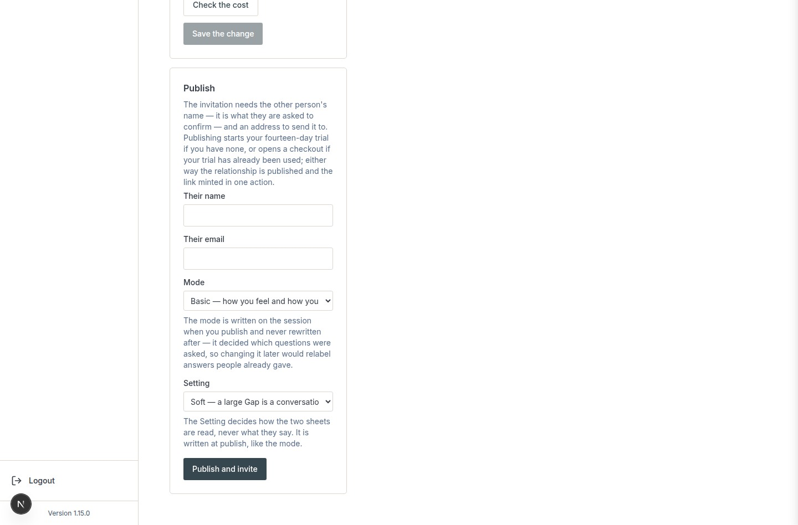
docs/qa-873/873-initiator-draft-publish-1440.png · source 1440×3792 px · displayed band y=2844–3792 of 3792 px. Full-page capture with publish and plan-door content.
SCREEN ATLAS / CONTINUED

Relationship detail initiator draft Desktop counterparty read only section 1
DESKTOP · COUNTERPARTY READ-ONLY · SECTION 1 OF 2
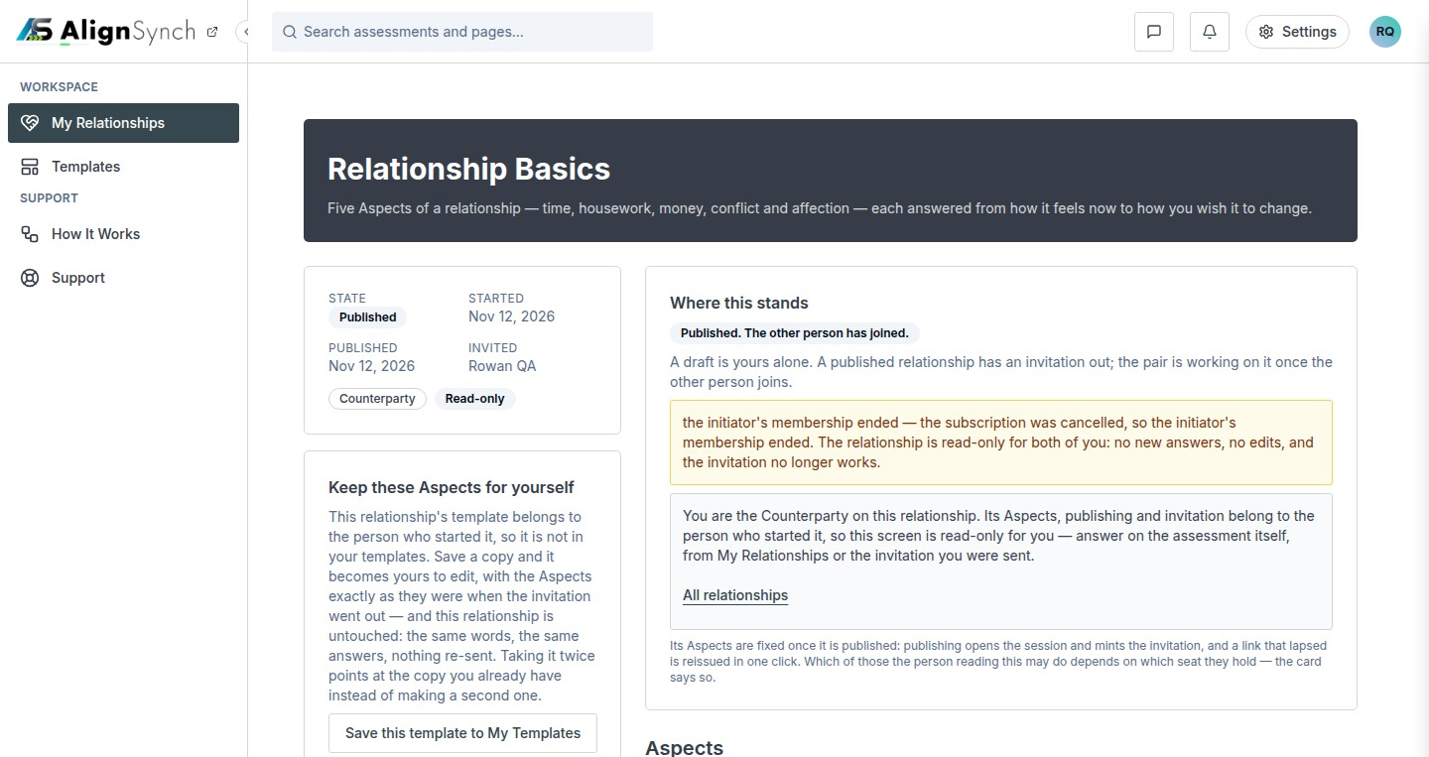
docs/qa-873/873-counterparty-read-only-door-1440.png · source 1440×1526 px · displayed band y=0–763 of 1526 px. Counterparty seat after publication; read-only return path.
SCREEN ATLAS / CONTINUED

Relationship detail initiator draft Desktop counterparty read only section 2
DESKTOP · COUNTERPARTY READ-ONLY · SECTION 2 OF 2
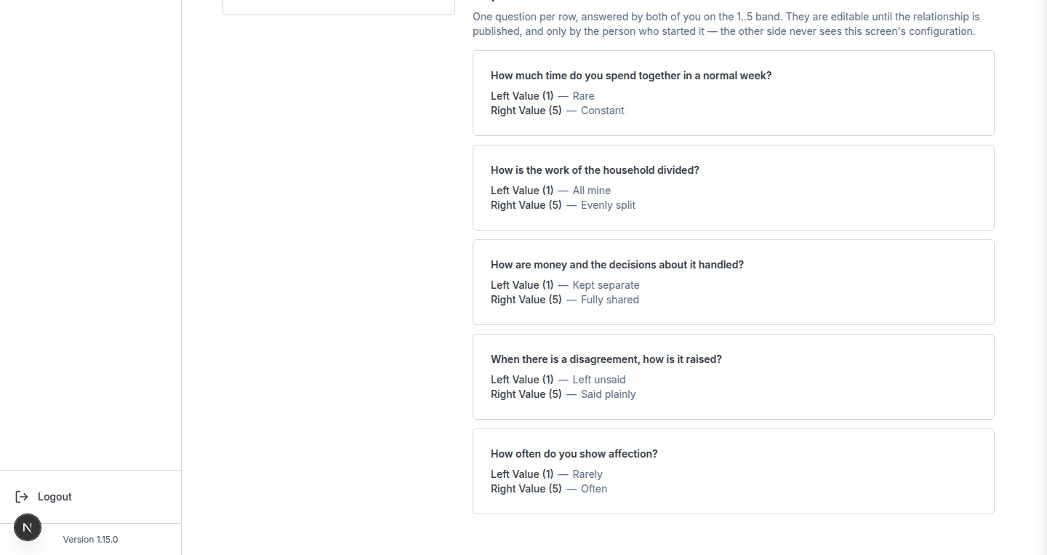
docs/qa-873/873-counterparty-read-only-door-1440.png · source 1440×1526 px · displayed band y=763–1526 of 1526 px. Counterparty seat after publication; read-only return path.
SCREEN ATLAS / /DASHBOARD/TEMPLATES

Templates catalogue
Route | Member task
/dashboard/templates | Browse relationship templates, compare intended roles and Aspects, and open a detail view.

Screen evidence | Implementation references
Current browser screenshot supplied by the user, plus older responsive QA captures from the alternate /assessment/templates route. The latter are marked historical. | app/(mainlayout)/dashboard/templates/page.tsx:67; components/dashboard/template-gallery.tsx:66; lib/member/templates.ts:92,133; app/(mainlayout)/dashboard/templates/actions.ts:88,121,146.

Capture context. Catalogue and detail screenshots from the current user-supplied app view are included alongside older responsive captures. Do not use the older /assessment/templates URL as the current route.
DESKTOP · USER-SUPPLIED CURRENT BROWSER VIEW · CAPTURED VIEW
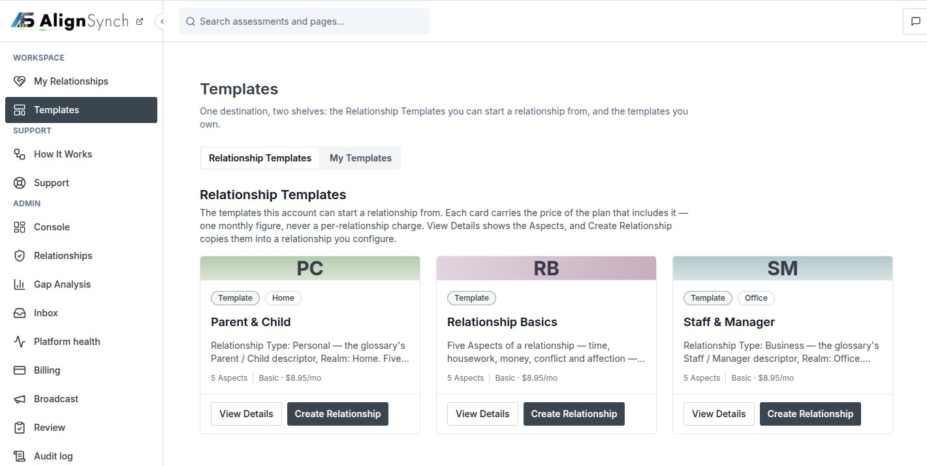
user supplied: codex-clipboard-410aa6ed-191c-4a34-b1b0-a860ad1ae2c2.png · source 1420×716 px · displayed band y=0–716 of 716 px. Current signed-in template listing; browser chrome removed.
SCREEN ATLAS / CONTINUED

Templates catalogue Desktop alternate route QA capture section 1
DESKTOP · ALTERNATE-ROUTE QA CAPTURE · CAPTURED VIEW
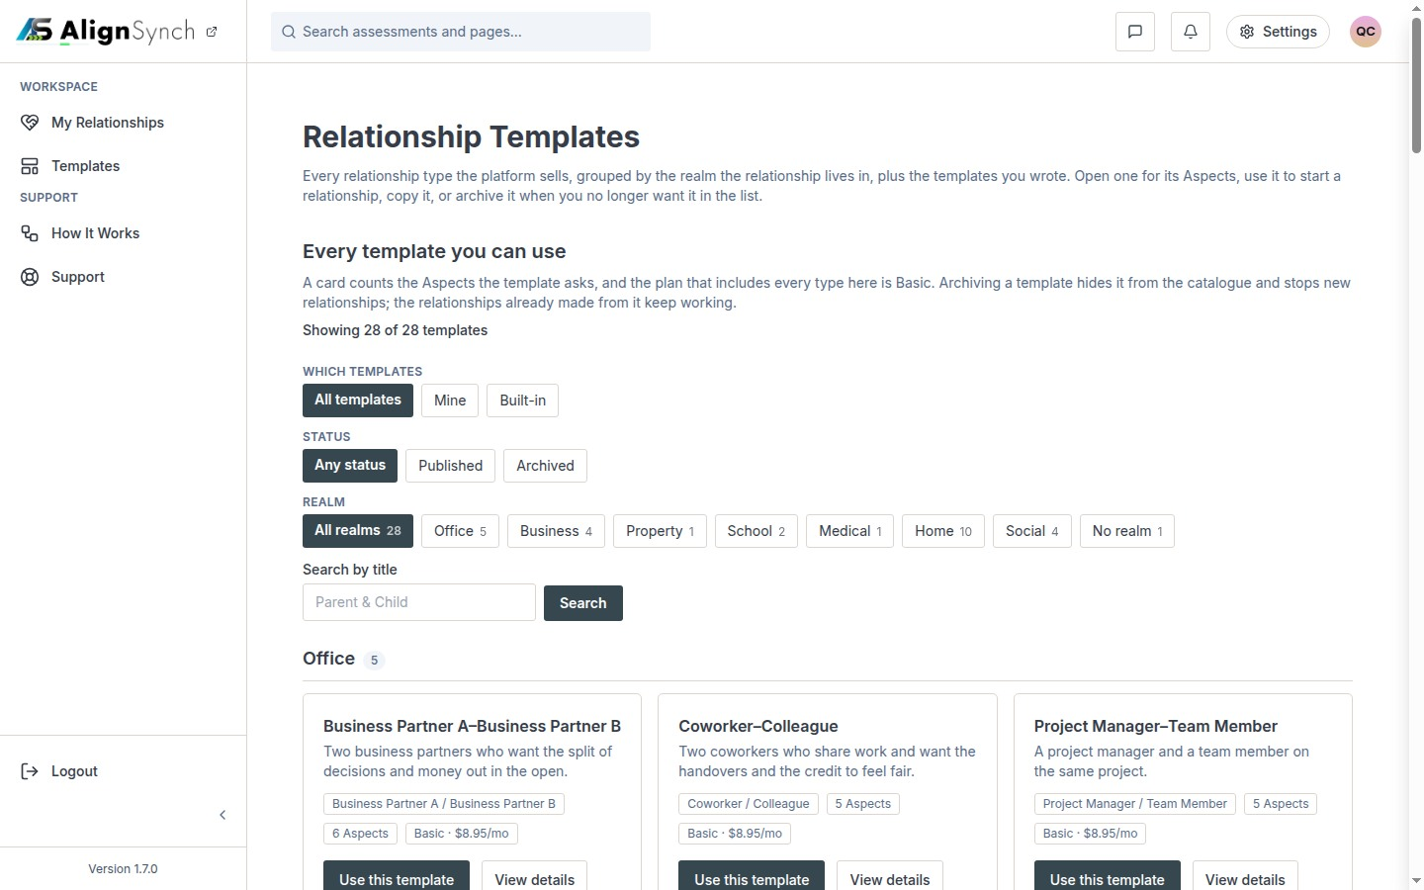
docs/qa-conformance/templates-1440.png · source 1440×900 px · displayed band y=0–900 of 900 px. Historical /assessment/templates route; not the current Templates shelf.
SCREEN ATLAS / CONTINUED

Templates catalogue Mobile alternate route QA capture section 1
MOBILE · ALTERNATE-ROUTE QA CAPTURE · CAPTURED VIEW
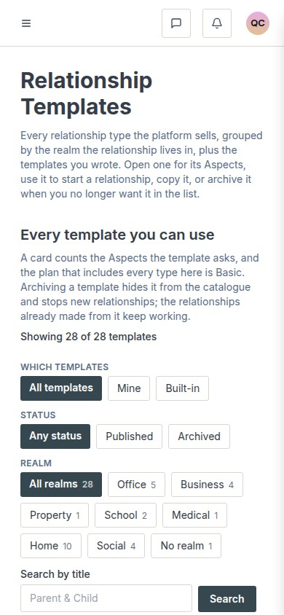
docs/qa-conformance/templates-390.png · source 390×844 px · displayed band y=0–844 of 844 px. Historical /assessment/templates route; use as responsive component reference only.
SCREEN ATLAS / /DASHBOARD/TEMPLATES/[ID] AND /TEMPLATES/RELATIONSHIP/[SLUG]

Template detail
Route | Member task
/dashboard/templates/[id] and /templates/relationship/[slug] | Check roles, intended audience, and every Aspect before creating a relationship.

Screen evidence | Implementation references
Current user-supplied detail image is paired with older responsive QA images from the /assessment/templates/... route. | app/(mainlayout)/dashboard/templates/[id]/page.tsx:45; lib/member/templates.ts:180; shared TemplateEditor; lib/member/relationships.ts:721.

Capture context. The two current-detail screenshots supplied in the conversation show demo content. The older QA pair is included to show the mobile layout but is not asserted to be the current route.
DESKTOP · USER-SUPPLIED DETAIL VIEW · CAPTURED VIEW
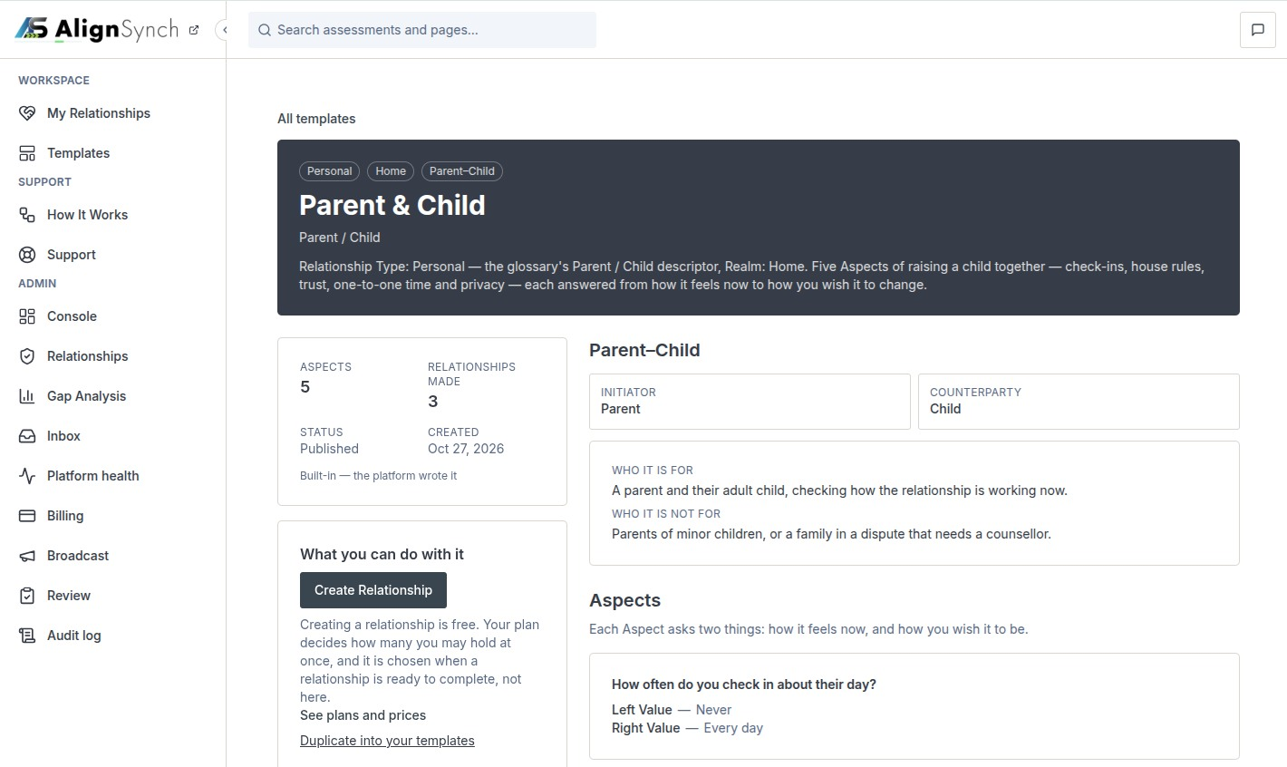
user supplied: codex-clipboard-b3c3d683-d8ff-44f3-bebf-dd478f2ab82a.png · source 1420×846 px · displayed band y=0–846 of 846 px. Current browser detail capture; browser chrome removed.
SCREEN ATLAS / CONTINUED

Template detail Desktop alternate route QA capture section 1
DESKTOP · ALTERNATE-ROUTE QA CAPTURE · CAPTURED VIEW
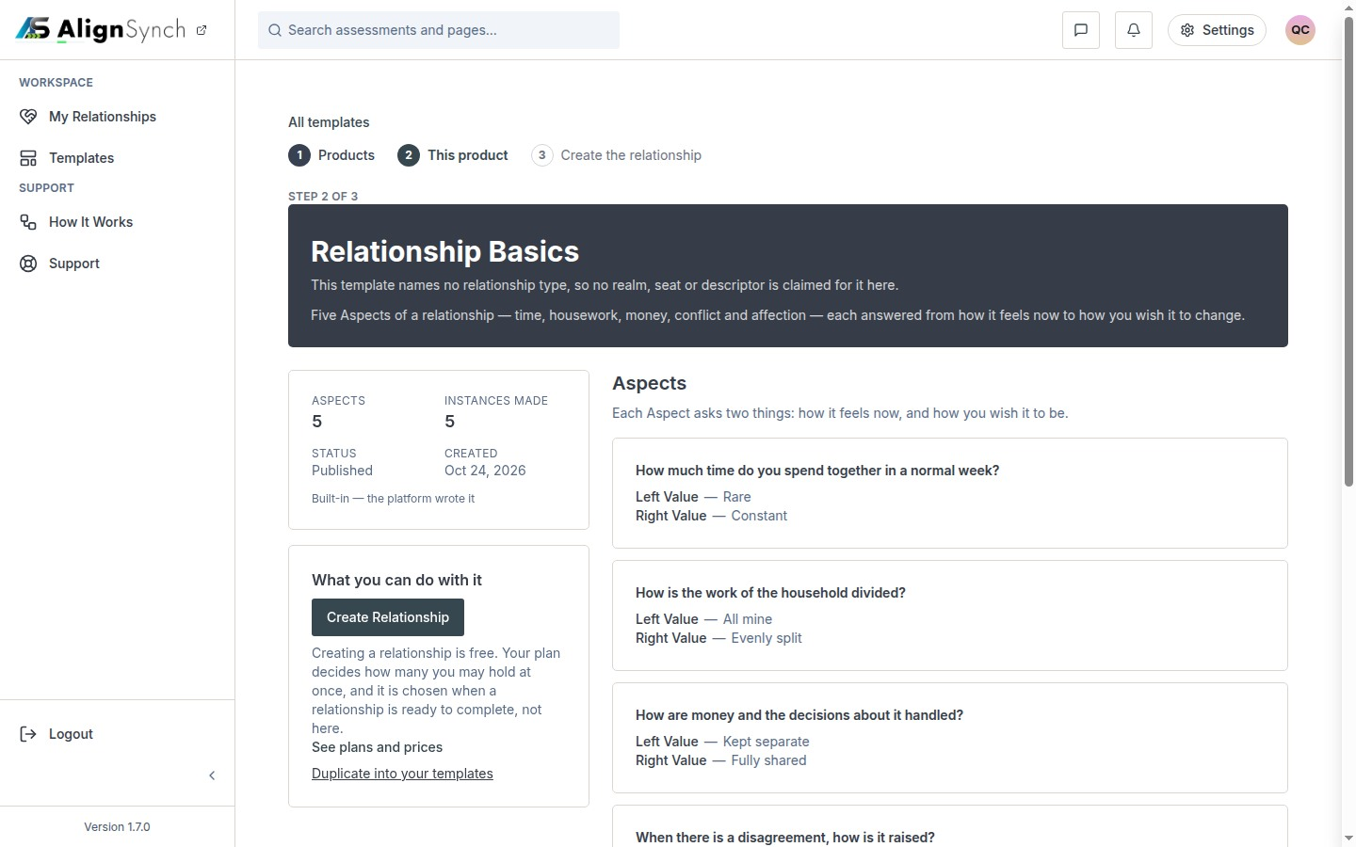
docs/qa-conformance/template-detail-1440.png · source 1440×900 px · displayed band y=0–900 of 900 px. Historical /assessment/templates/assessment-relationship-basics route.
SCREEN ATLAS / CONTINUED

Template detail Mobile alternate route QA capture section 1
MOBILE · ALTERNATE-ROUTE QA CAPTURE · CAPTURED VIEW
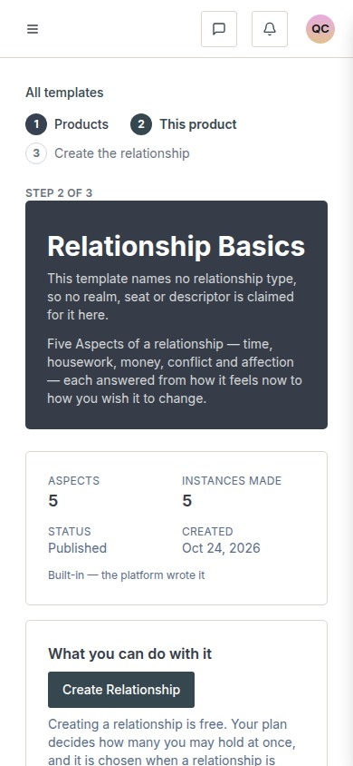
docs/qa-conformance/template-detail-390.png · source 390×844 px · displayed band y=0–844 of 844 px. Historical route, responsive component reference only.
SCREEN ATLAS / /DASHBOARD/RELATIONSHIPS → START A RELATIONSHIP

Create relationship context and role
Route | Member task
/dashboard/relationships → Start a relationship | Choose a relationship template, name the shared workspace, and assign the two roles.

Screen evidence | Implementation references
Older wizard component captures show setup stages; route grammar predates the current dashboard picker. | components/dashboard/relationships-list.tsx:101; app/(mainlayout)/dashboard/relationships/actions.ts:79; lib/member/relationships.ts:721; app/(mainlayout)/dashboard/templates/actions.ts:88,121.

Capture context. These capture images illustrate the available setup stages but come from the earlier wizard path; use the current dashboard route and service references as authoritative.
DESKTOP · SETUP STEP · CAPTURED VIEW
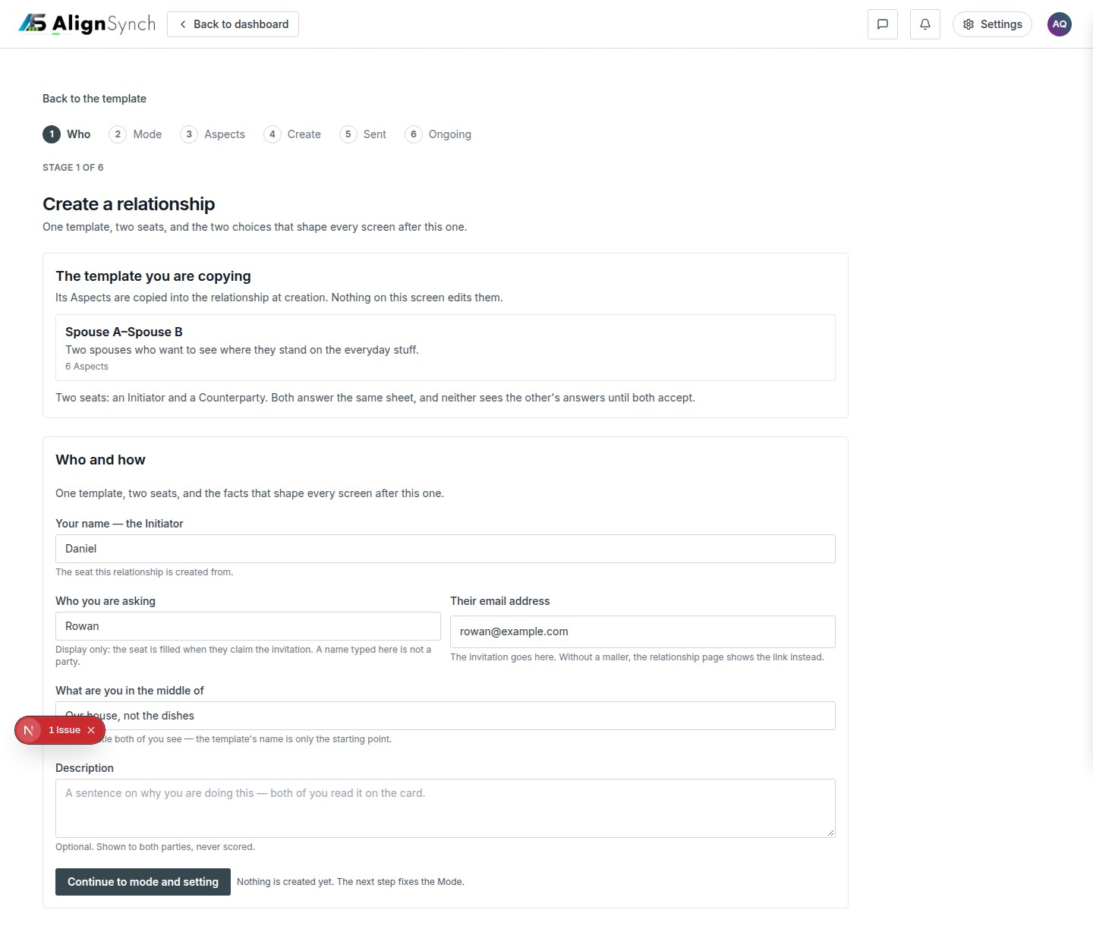
docs/qa-create-stages/create-who-1440.png · source 1440×1253 px · displayed band y=0–1253 of 1253 px. Wizard capture from the earlier /assessment/templates/.../create entry.
SCREEN ATLAS / CONTINUED

Create relationship context and role Mobile setup step section 1
MOBILE · SETUP STEP · SECTION 1 OF 2
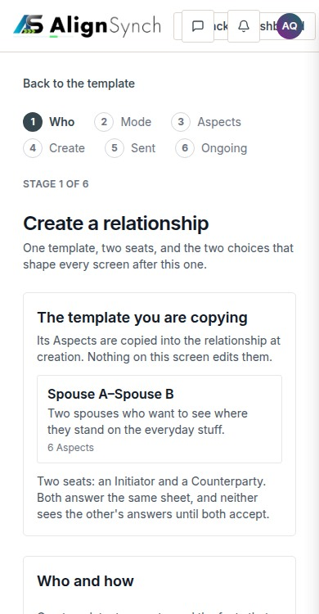
docs/qa-create-stages/create-who-390.png · source 390×1499 px · displayed band y=0–750 of 1499 px. Earlier wizard path; CSS-width mobile full-page capture.
SCREEN ATLAS / CONTINUED

Create relationship context and role Mobile setup step section 2
MOBILE · SETUP STEP · SECTION 2 OF 2
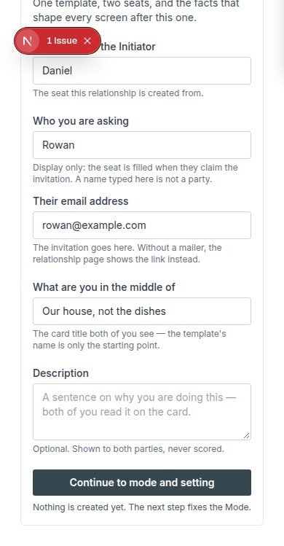
docs/qa-create-stages/create-who-390.png · source 390×1499 px · displayed band y=750–1499 of 1499 px. Earlier wizard path; CSS-width mobile full-page capture.
SCREEN ATLAS / CONTINUED

Create relationship context and role Desktop mode and setting section 1
DESKTOP · MODE AND SETTING · CAPTURED VIEW
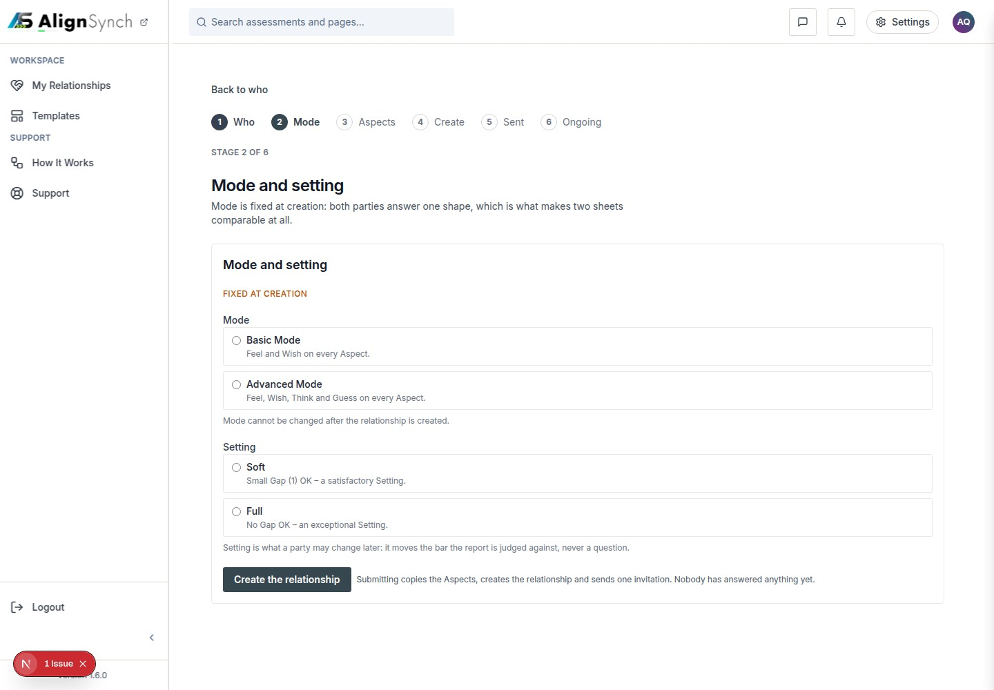
docs/qa-create-stages/create-mode-1440.png · source 1440×1000 px · displayed band y=0–1000 of 1000 px. Earlier wizard component capture.
SCREEN ATLAS / CONTINUED

Create relationship context and role Mobile mode and setting section 1
MOBILE · MODE AND SETTING · SECTION 1 OF 2
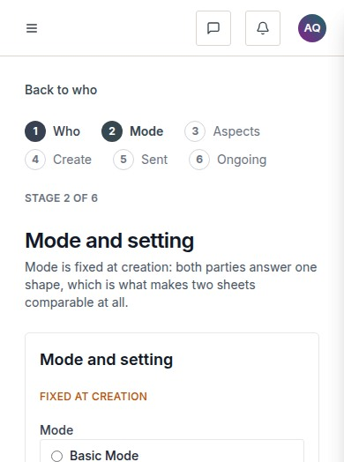
docs/qa-create-stages/create-mode-390.png · source 390×1047 px · displayed band y=0–524 of 1047 px. Earlier wizard component capture.
SCREEN ATLAS / CONTINUED

Create relationship context and role Mobile mode and setting section 2
MOBILE · MODE AND SETTING · SECTION 2 OF 2
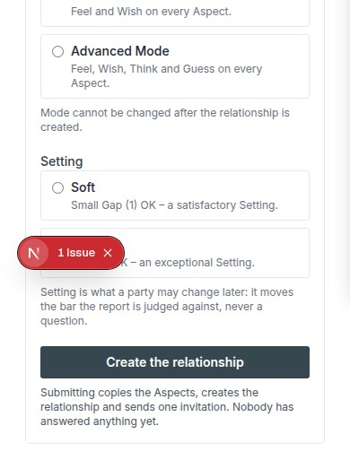
docs/qa-create-stages/create-mode-390.png · source 390×1047 px · displayed band y=524–1047 of 1047 px. Earlier wizard component capture.
SCREEN ATLAS / /DASHBOARD/RELATIONSHIPS/[ID]

Create relationship review Aspects
Route | Member task
/dashboard/relationships/[id] | Inspect, reorder, or revise the copied Aspects while the relationship remains a draft.

Screen evidence | Implementation references
The current draft route owns the relationship copy. Aspect interaction captures are QA component states from the earlier wizard. | components/dashboard/relationship-detail.tsx:109; app/(mainlayout)/dashboard/relationships/[id]/actions.ts:255,298; lib/member/relationships.ts:904.

Capture context. These are fixture-backed QA states rather than a newly captured production wizard. They document the interaction model for a draft.
DESKTOP · COLLAPSED ASPECTS · CAPTURED VIEW
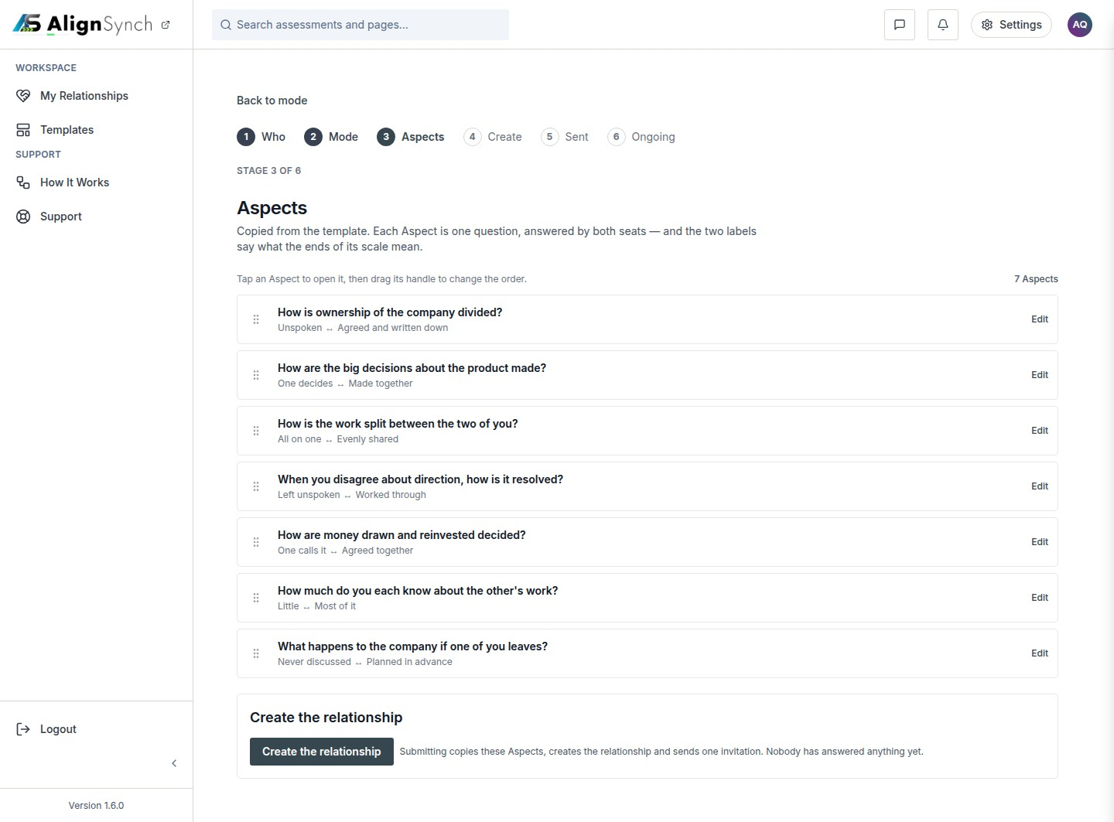
docs/qa-aspects/aspects-1440-collapsed.png · source 1440×1063 px · displayed band y=0–1063 of 1063 px. QA component capture; collapsed list.
SCREEN ATLAS / CONTINUED

Create relationship review Aspects Desktop open Aspect editor section 1
DESKTOP · OPEN ASPECT EDITOR · CAPTURED VIEW
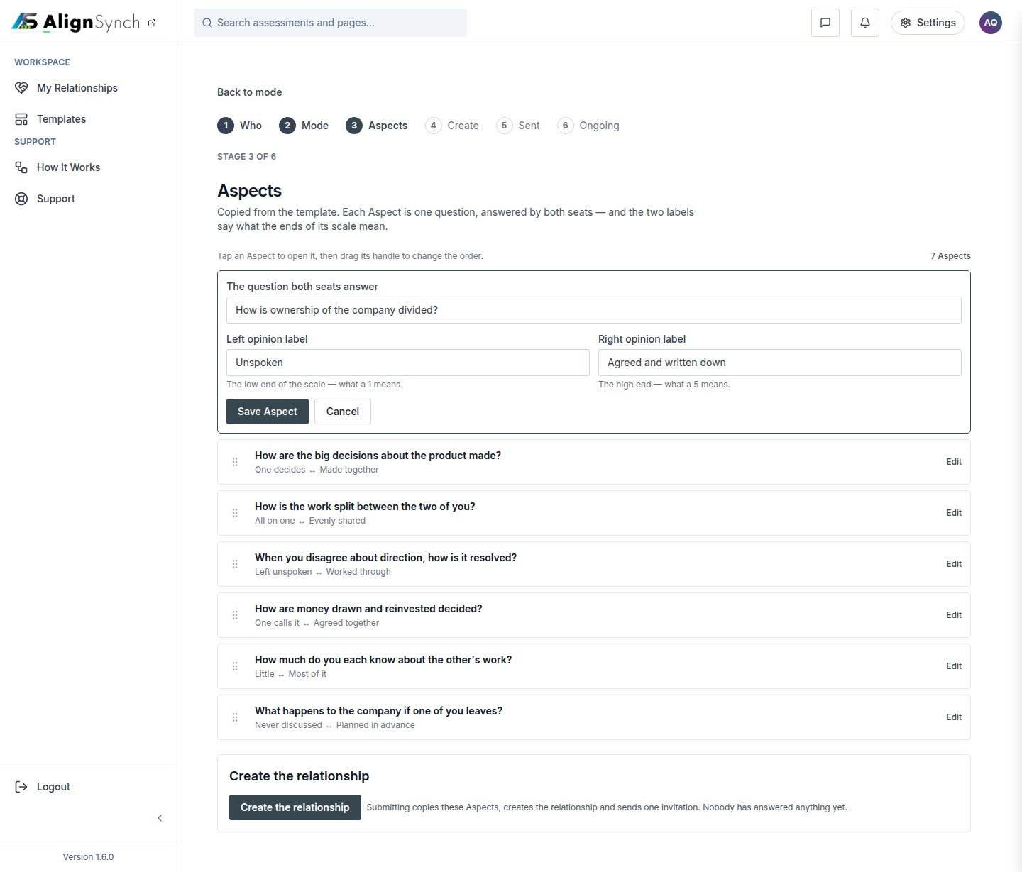
docs/qa-aspects/aspects-1440-open.png · source 1440×1229 px · displayed band y=0–1229 of 1229 px. QA component capture; edit fields expanded.
SCREEN ATLAS / CONTINUED

Create relationship review Aspects Mobile collapsed Aspects section 1
MOBILE · COLLAPSED ASPECTS · SECTION 1 OF 2
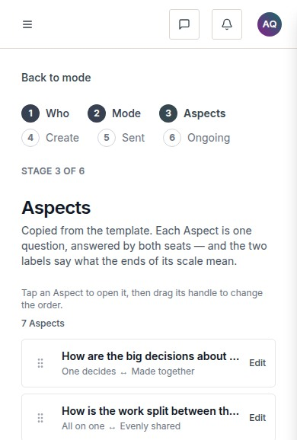
docs/qa-aspects/aspects-390-collapsed.png · source 390×1155 px · displayed band y=0–578 of 1155 px. Earlier component state; CSS 390px.
SCREEN ATLAS / CONTINUED

Create relationship review Aspects Mobile collapsed Aspects section 2
MOBILE · COLLAPSED ASPECTS · SECTION 2 OF 2
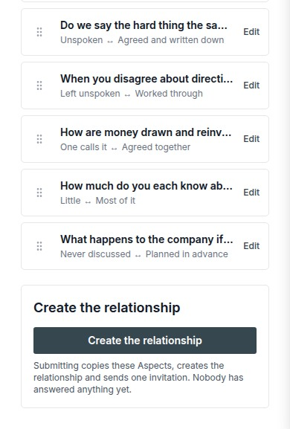
docs/qa-aspects/aspects-390-collapsed.png · source 390×1155 px · displayed band y=578–1155 of 1155 px. Earlier component state; CSS 390px.
SCREEN ATLAS / CONTINUED

Create relationship review Aspects Mobile reordered list section 1
MOBILE · REORDERED LIST · SECTION 1 OF 2
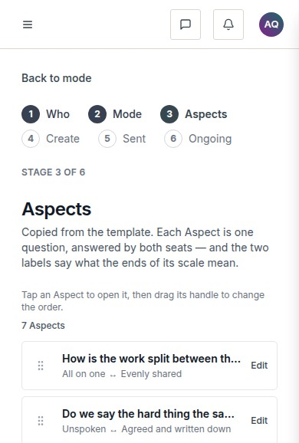
docs/qa-aspects/aspects-390-reordered.png · source 390×1155 px · displayed band y=0–578 of 1155 px. Shows mobile ordering interaction.
SCREEN ATLAS / CONTINUED

Create relationship review Aspects Mobile reordered list section 2
MOBILE · REORDERED LIST · SECTION 2 OF 2
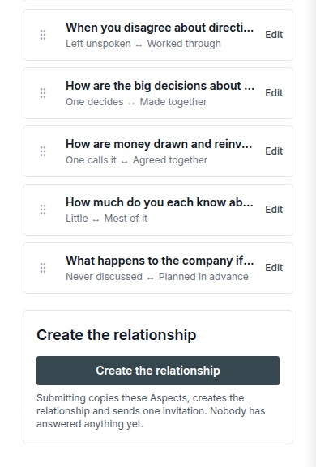
docs/qa-aspects/aspects-390-reordered.png · source 390×1155 px · displayed band y=578–1155 of 1155 px. Shows mobile ordering interaction.
SCREEN ATLAS / /DASHBOARD/RELATIONSHIPS/[ID] → PUBLISH

Publish and send invitation
Route | Member task
/dashboard/relationships/[id] → Publish | Check the plan choice, address the counterparty, and send or keep the relationship as a draft.

Screen evidence | Implementation references
Current QA capture pair covers entitled and not-entitled states at the invitation stage. | components/dashboard/relationship-detail.tsx:225-233,551-570; relationship actions :157,217; lib/member/relationships.ts:1116,1427; lib/member/payment.ts:268,358,457.

Capture context. The UI’s payment-method door and the publish service do not enforce the same check. This is called out in the payment section for product confirmation.
DESKTOP · PLAN NEEDED · CAPTURED VIEW
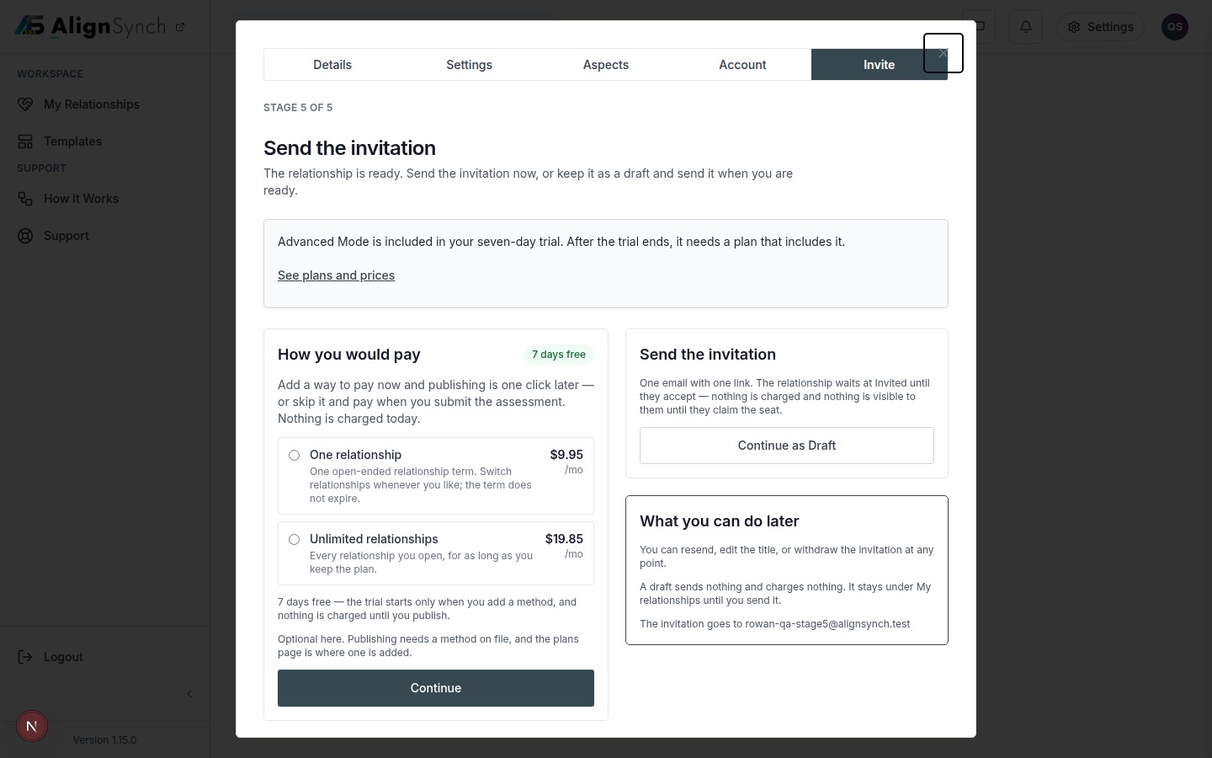
docs/qa-stage5/stage5-not-entitled-1440.png · source 1440×900 px · displayed band y=0–900 of 900 px. Demo state with plan choices and free-trial notice.
SCREEN ATLAS / CONTINUED

Publish and send invitation Mobile plan needed section 1
MOBILE · PLAN NEEDED · CAPTURED VIEW
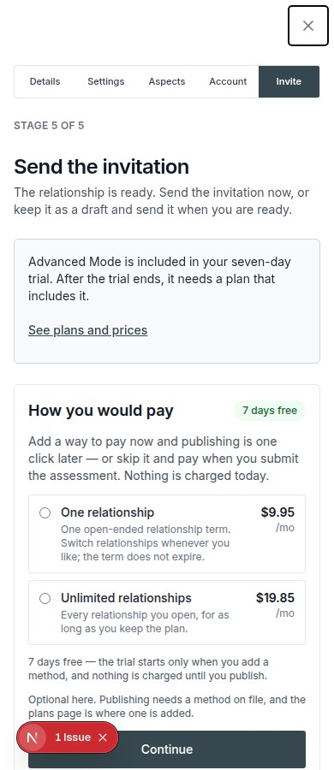
docs/qa-stage5/stage5-not-entitled-390.png · source 390×900 px · displayed band y=0–900 of 900 px. Same state at CSS 390px.
SCREEN ATLAS / CONTINUED

Publish and send invitation Desktop plan already available section 1
DESKTOP · PLAN ALREADY AVAILABLE · CAPTURED VIEW
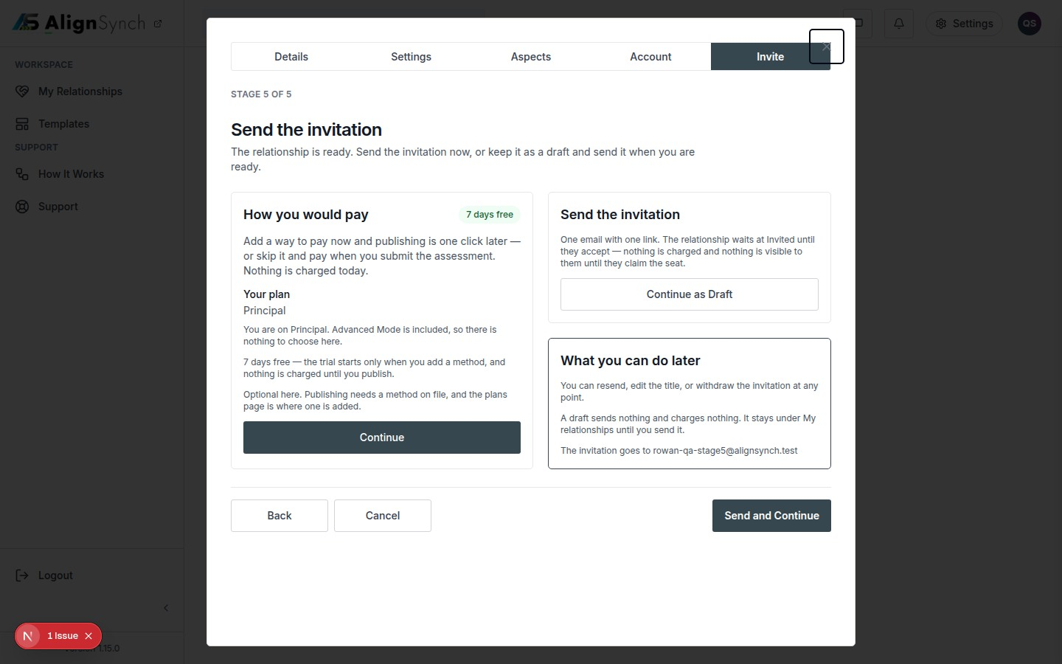
docs/qa-stage5/stage5-entitled-1440.png · source 1440×900 px · displayed band y=0–900 of 900 px. Demo state with existing entitlement summary.
SCREEN ATLAS / CONTINUED

Publish and send invitation Mobile plan already available section 1
MOBILE · PLAN ALREADY AVAILABLE · CAPTURED VIEW
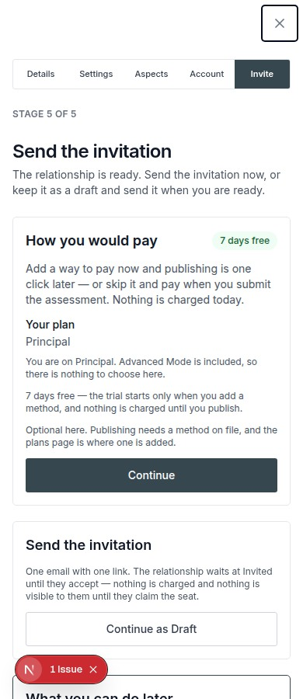
docs/qa-stage5/stage5-entitled-390.png · source 390×900 px · displayed band y=0–900 of 900 px. Same state at CSS 390px.
SCREEN ATLAS / /INVITE/[TOKEN]

Invitation and claim
Route | Member task
/invite/[token] | Review who invited you, which role is offered, and confirm before claiming the participant seat.

Screen evidence | Implementation references
Local browser captures exercise invite preview, account gate, and confirmation states. | app/(mainlayout)/invite/[token]/page.tsx:61; components/assessment-flow/counterparty-wizard.tsx:73; lib/flow/store.ts:2878,921; claim API app/(mainlayout)/invite/[token]/claim/route.ts:55.

Capture context. These are seeded demo invitations. A raw token is not included in the guide.
DESKTOP · INVITE PREVIEW · CAPTURED VIEW
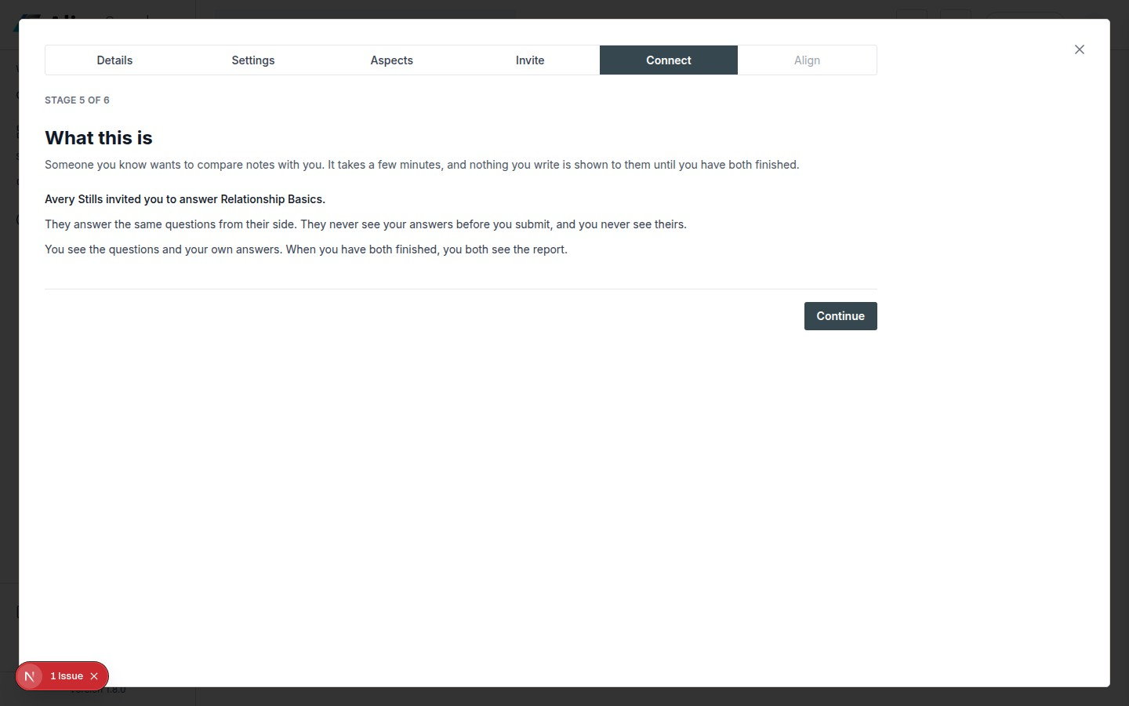
docs/qa-invite-response/response-step-1-1440.png · source 1440×900 px · displayed band y=0–900 of 900 px. Valid demo invite; claim has not yet been made.
SCREEN ATLAS / CONTINUED

Invitation and claim Mobile invite preview section 1
MOBILE · INVITE PREVIEW · CAPTURED VIEW
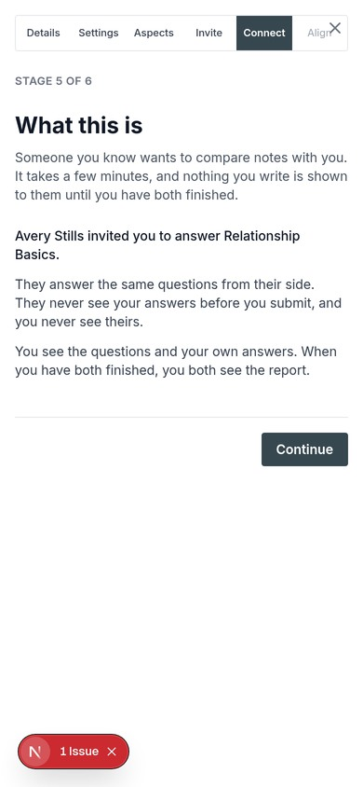
docs/qa-invite-response/response-step-1-390.png · source 780×1688 px · displayed band y=0–844 of 844 px. Captured at 2×; shown at CSS 390px.
SCREEN ATLAS / CONTINUED

Invitation and claim Desktop account gate section 1
DESKTOP · ACCOUNT GATE · CAPTURED VIEW
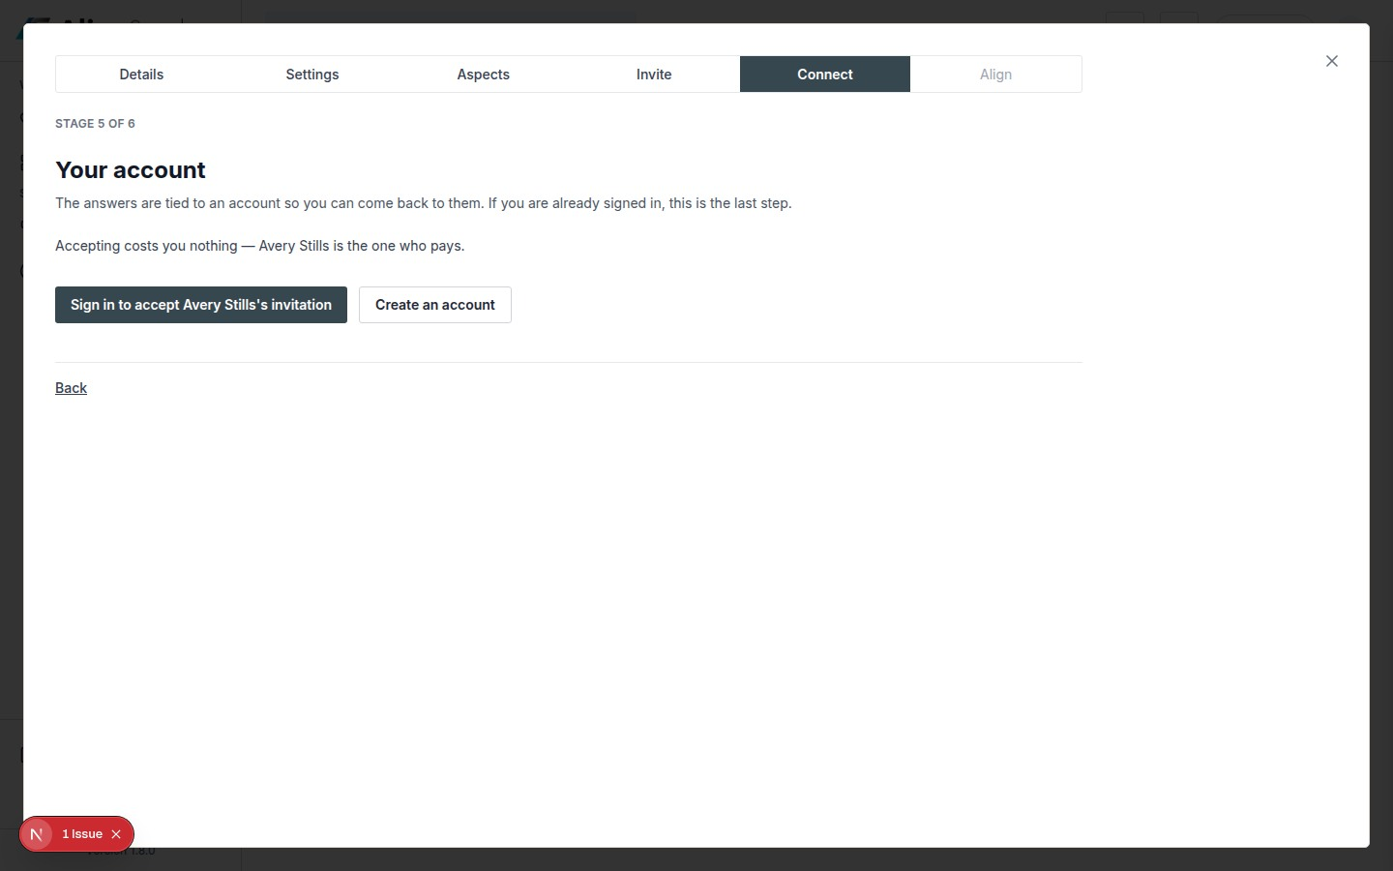
docs/qa-invite-response/response-step-3-1440.png · source 1440×900 px · displayed band y=0–900 of 900 px. Account confirmation state before claim.
SCREEN ATLAS / CONTINUED

Invitation and claim Mobile account gate section 1
MOBILE · ACCOUNT GATE · CAPTURED VIEW
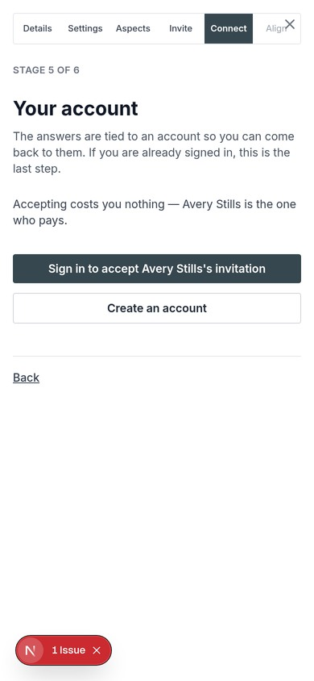
docs/qa-invite-response/response-step-3-390.png · source 780×1688 px · displayed band y=0–844 of 844 px. Captured at 2×; shown at CSS 390px.
SCREEN ATLAS / CONTINUED

Invitation and claim Desktop claim confirmation section 1
DESKTOP · CLAIM CONFIRMATION · SECTION 1 OF 3
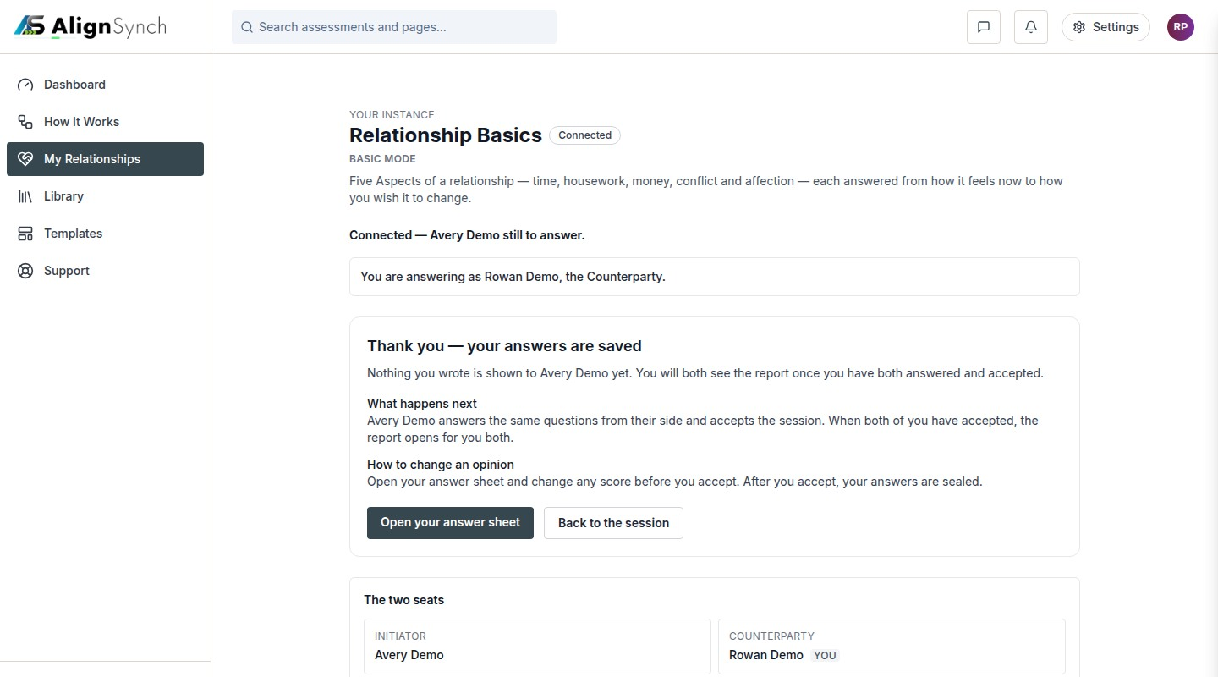
docs/qa-counterparty-onboarding/confirmation-1440.png · source 1440×2400 px · displayed band y=0–800 of 2400 px. Confirmation page after the counterparty journey.
SCREEN ATLAS / CONTINUED

Invitation and claim Desktop claim confirmation section 2
DESKTOP · CLAIM CONFIRMATION · SECTION 2 OF 3
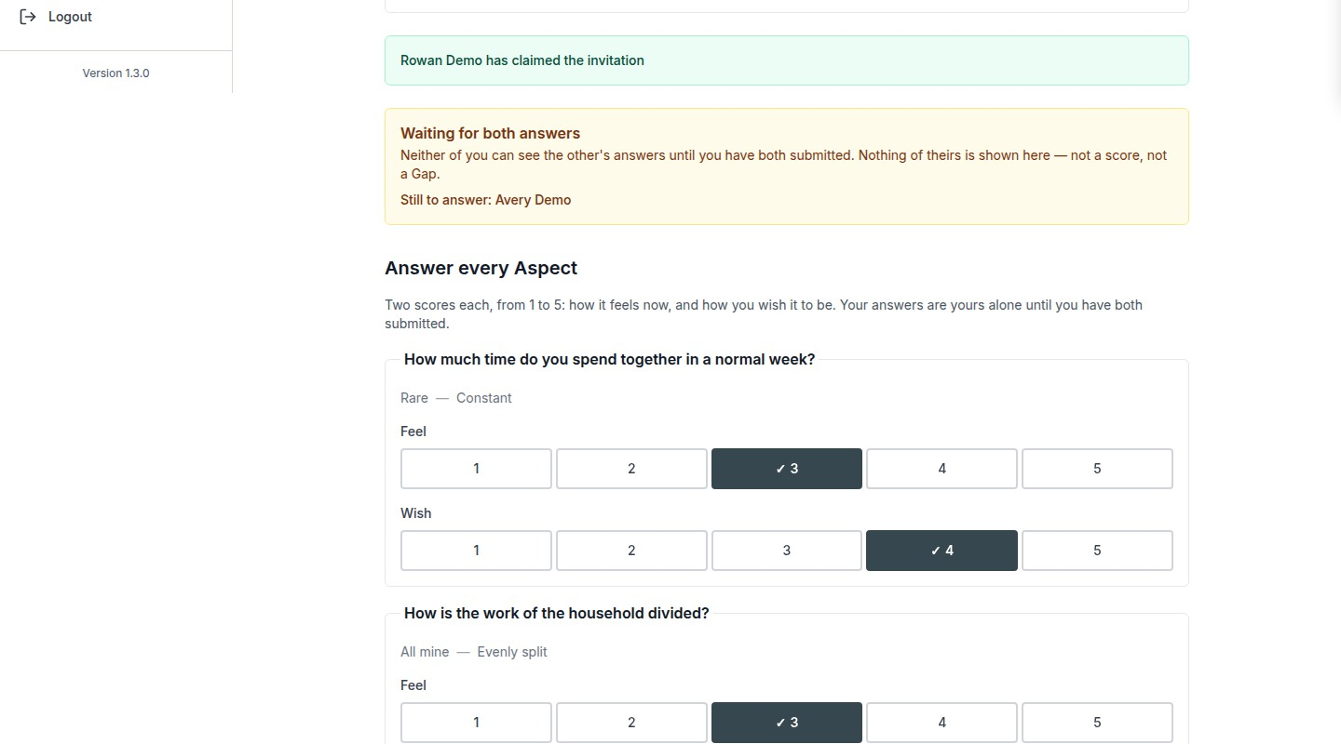
docs/qa-counterparty-onboarding/confirmation-1440.png · source 1440×2400 px · displayed band y=800–1600 of 2400 px. Confirmation page after the counterparty journey.
SCREEN ATLAS / CONTINUED

Invitation and claim Desktop claim confirmation section 3
DESKTOP · CLAIM CONFIRMATION · SECTION 3 OF 3
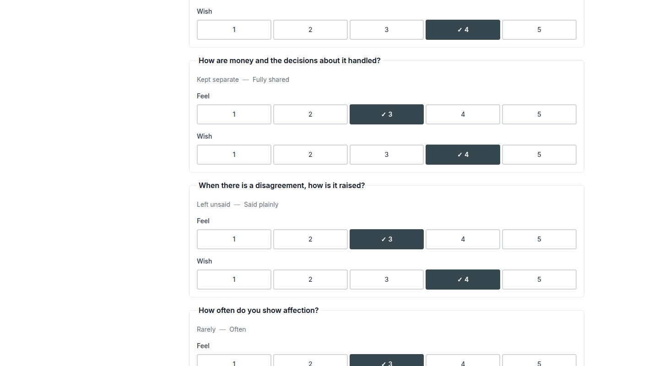
docs/qa-counterparty-onboarding/confirmation-1440.png · source 1440×2400 px · displayed band y=1600–2400 of 2400 px. Confirmation page after the counterparty journey.
SCREEN ATLAS / CONTINUED

Invitation and claim Mobile claim confirmation section 1
MOBILE · CLAIM CONFIRMATION · SECTION 1 OF 4
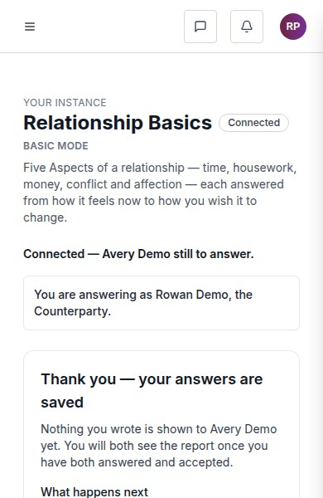
docs/qa-counterparty-onboarding/confirmation-390.png · source 390×2400 px · displayed band y=0–600 of 2400 px. Full page at CSS 390px.
SCREEN ATLAS / CONTINUED

Invitation and claim Mobile claim confirmation section 2
MOBILE · CLAIM CONFIRMATION · SECTION 2 OF 4
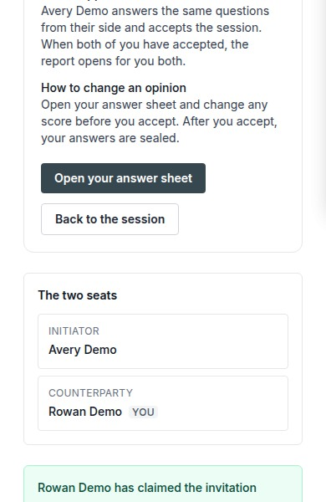
docs/qa-counterparty-onboarding/confirmation-390.png · source 390×2400 px · displayed band y=600–1200 of 2400 px. Full page at CSS 390px.
SCREEN ATLAS / CONTINUED

Invitation and claim Mobile claim confirmation section 3
MOBILE · CLAIM CONFIRMATION · SECTION 3 OF 4
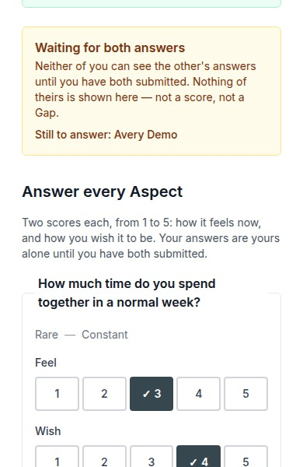
docs/qa-counterparty-onboarding/confirmation-390.png · source 390×2400 px · displayed band y=1200–1800 of 2400 px. Full page at CSS 390px.
SCREEN ATLAS / CONTINUED

Invitation and claim Mobile claim confirmation section 4
MOBILE · CLAIM CONFIRMATION · SECTION 4 OF 4
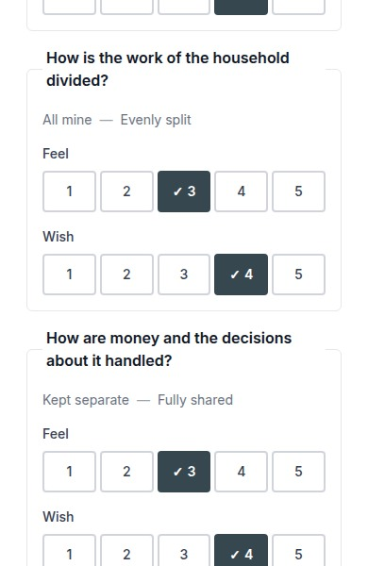
docs/qa-counterparty-onboarding/confirmation-390.png · source 390×2400 px · displayed band y=1800–2400 of 2400 px. Full page at CSS 390px.
SCREEN ATLAS / /ASSESSMENTS

My Assessments list
Route | Member task
/assessments | Find sessions that need your answers, are waiting for the other person, or have an open report.

Screen evidence | Implementation references
No screenshot of the exact current route was found. The route and current implementation are referenced here; older /assessment/instances screens are documented as historical in the capture notes. | app/(mainlayout)/assessments/page.tsx:73; components/dashboard/assessments-list.tsx:143; lib/db/assessments.ts:787.

Capture context. No exact current-route screenshot exists in the available QA bundle. The legacy list capture is not substituted because its route and content differ.
SCREEN ATLAS / /ASSESSMENT/INSTANCES/[ID]/ANSWER

Private answer sheet
Route | Member task
/assessment/instances/[id]/answer | Record how each Aspect feels now and how you wish it to be, privately from the other participant.

Screen evidence | Implementation references
Exact answer route desktop/mobile pair, verified in qa-conformance/answer-report.json. | app/(mainlayout)/assessment/instances/[instanceId]/answer/page.tsx:99; components/assessment-flow/answer-sheet.tsx:105; answer API .../answers/route.ts:94; lib/flow/store.ts:1535.

DESKTOP · CAPTURED VIEW
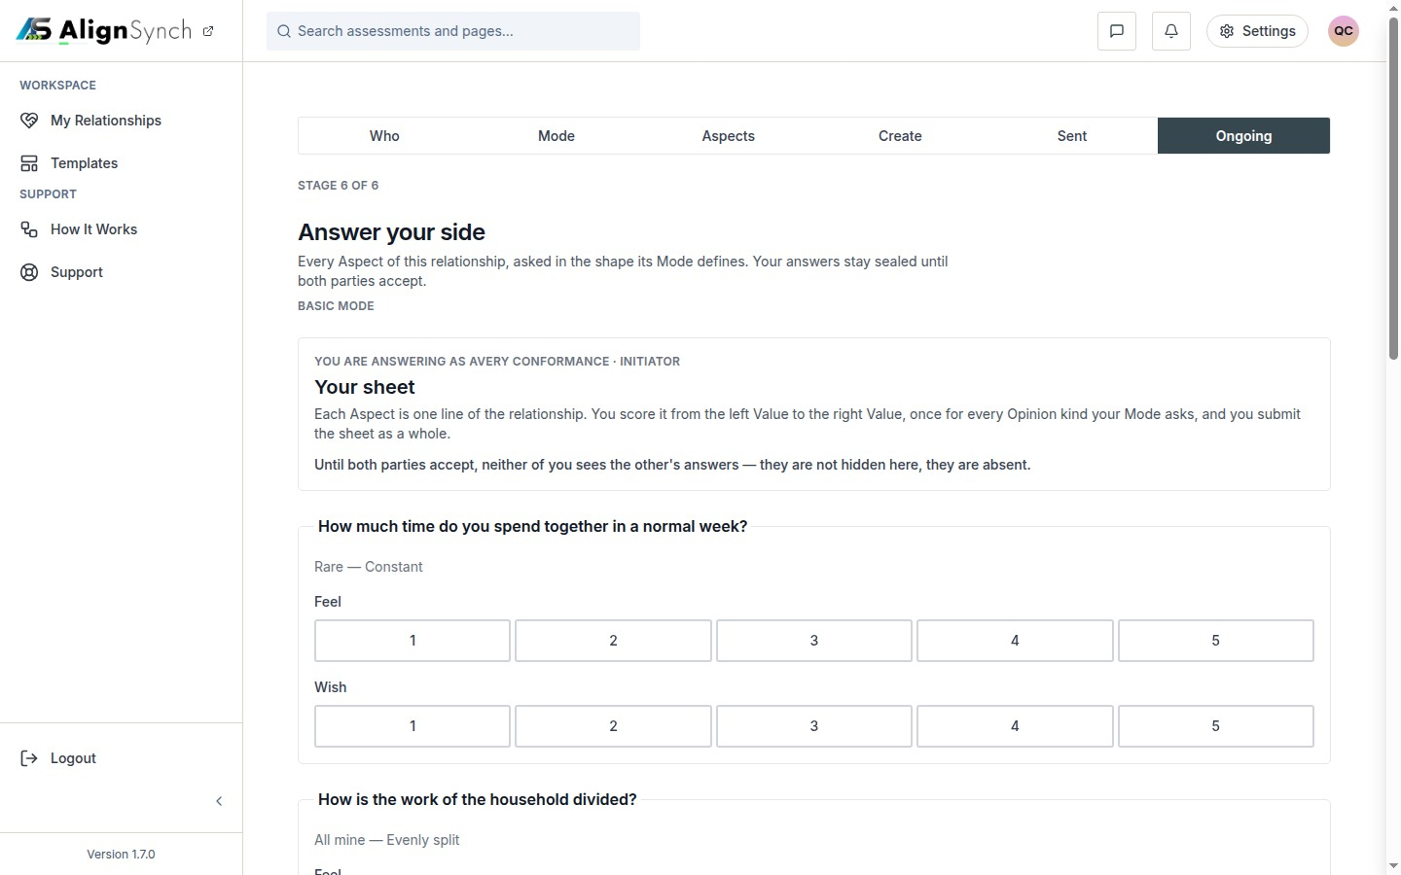
docs/qa-conformance/answer-1440.png · source 1440×900 px · displayed band y=0–900 of 900 px. Viewport capture; 5 Aspects in the demo relationship.
SCREEN ATLAS / CONTINUED

Private answer sheet Mobile section 1
MOBILE · CAPTURED VIEW
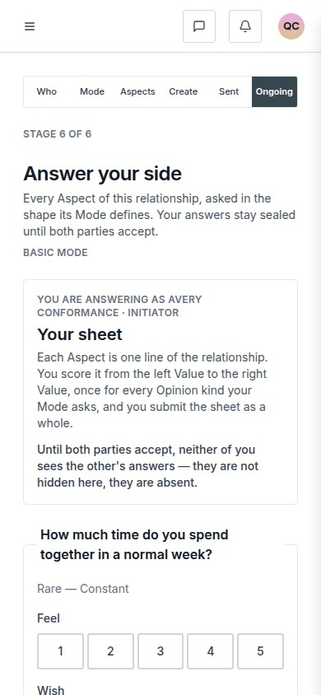
docs/qa-conformance/answer-390.png · source 390×844 px · displayed band y=0–844 of 844 px. Viewport capture at CSS 390px.
SCREEN ATLAS / /ASSESSMENT/INSTANCES/[ID] → ALIGNMENT

Acceptance and shared Alignment
Route | Member task
/assessment/instances/[id] → Alignment | Accept your completed sheet and, after both people accept, review the shared differences and suggested Steps.

Screen evidence | Implementation references
Available screenshots show the stage page and opened Alignment state. A dedicated /report route capture was not found. | app/(mainlayout)/assessment/instances/[instanceId]/page.tsx:179; components/assessment-flow/report-view.tsx:426; lib/assessment-report.ts:178; lib/flow/store.ts:1912,2661; content/gaps.ts:192,255.

Capture context. The long Alignment captures show the open report state on the session route, not proof that the dedicated /report URL was visited.
DESKTOP · ALIGNMENT OPENS · CAPTURED VIEW
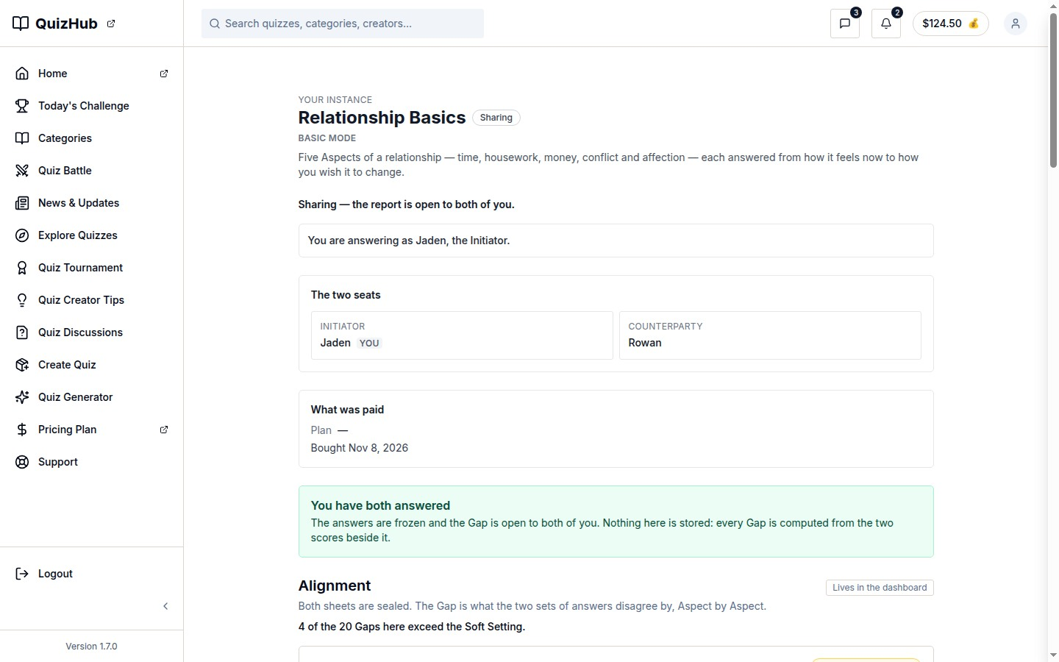
docs/qa-flow-stages/align-opens-alignment-1440.png · source 1440×900 px · displayed band y=0–900 of 900 px. Viewport capture with shared report open.
SCREEN ATLAS / CONTINUED

Acceptance and shared Alignment Mobile Alignment opens section 1
MOBILE · ALIGNMENT OPENS · CAPTURED VIEW
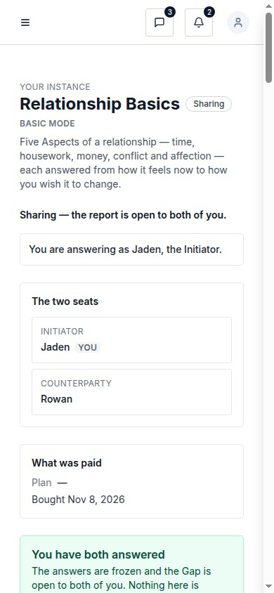
docs/qa-flow-stages/align-opens-alignment-390.png · source 390×844 px · displayed band y=0–844 of 844 px. Viewport capture at CSS 390px.
SCREEN ATLAS / CONTINUED

Acceptance and shared Alignment Desktop full Alignment section 1
DESKTOP · FULL ALIGNMENT · SECTION 1 OF 3
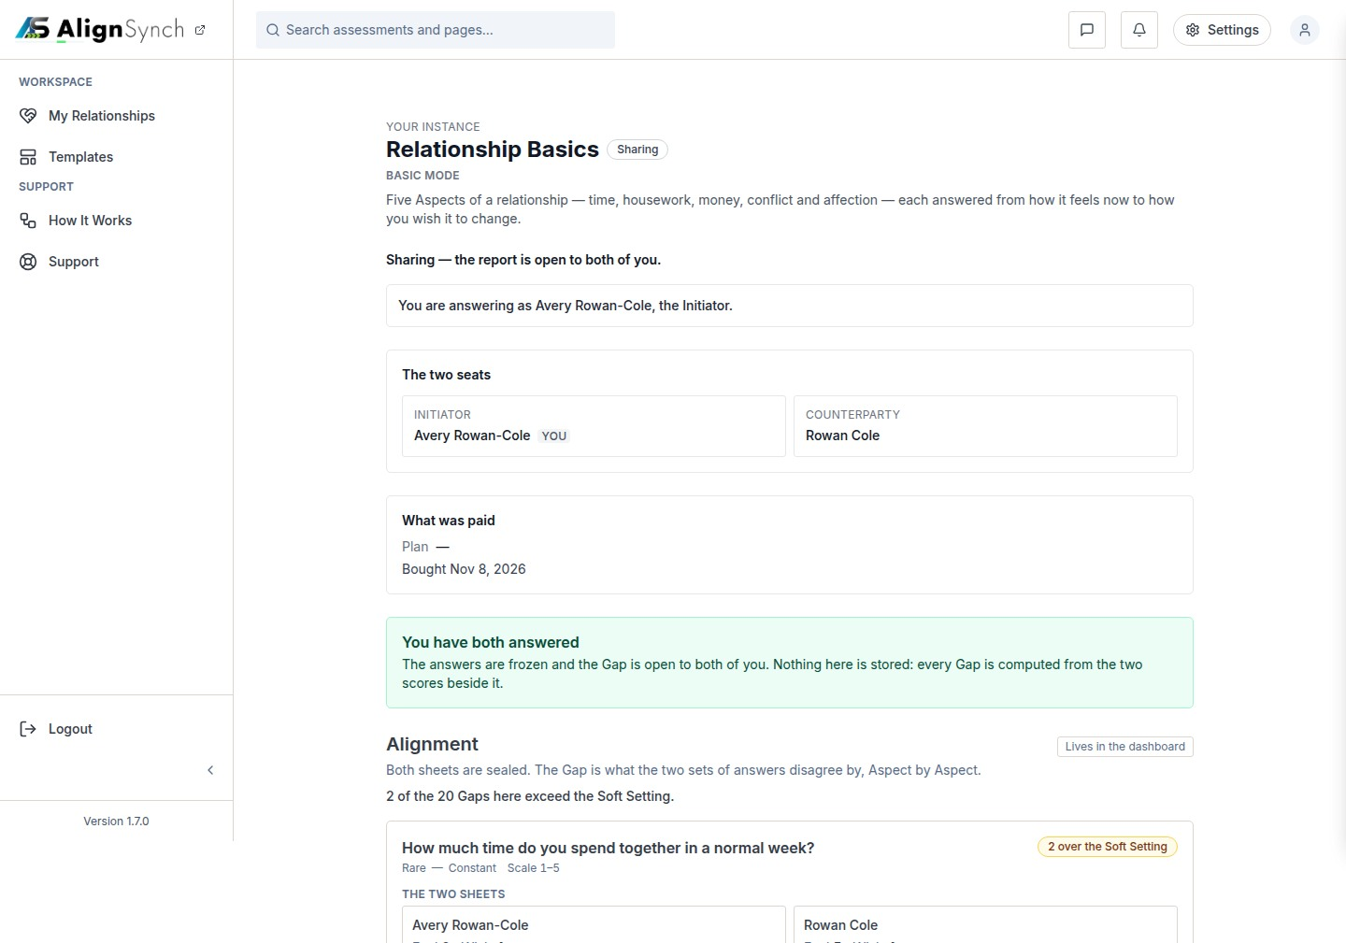
docs/qa-ongoing/alignment-1440.png · source 1440×3025 px · displayed band y=0–1009 of 3025 px. Long full-page report view split into consecutive bands.
SCREEN ATLAS / CONTINUED

Acceptance and shared Alignment Desktop full Alignment section 2
DESKTOP · FULL ALIGNMENT · SECTION 2 OF 3
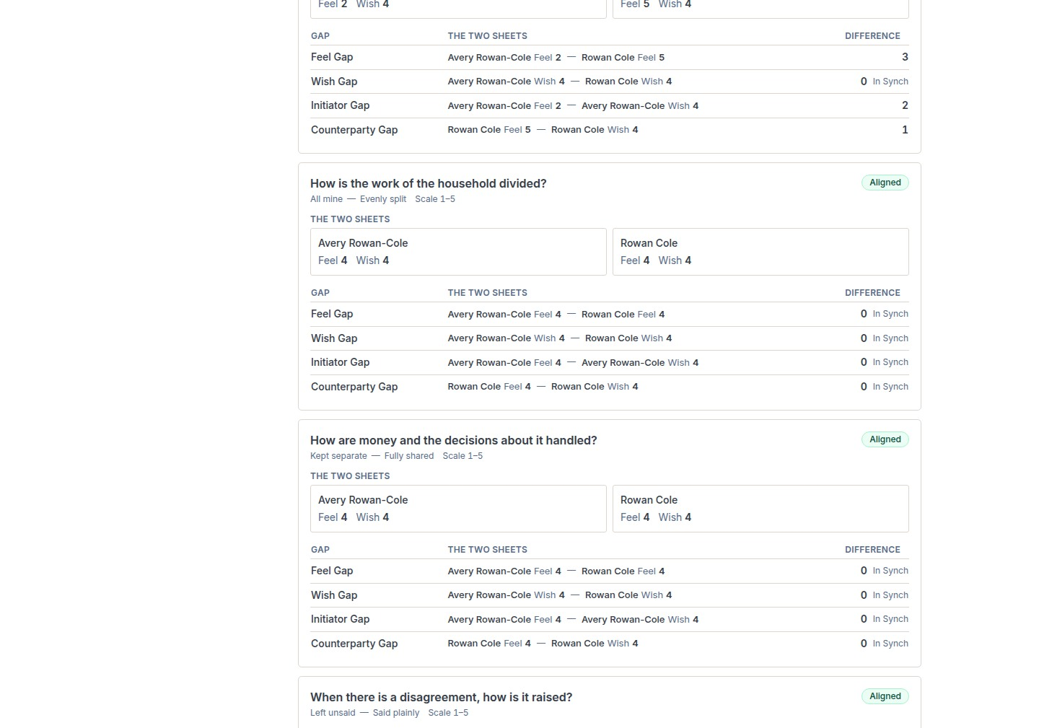
docs/qa-ongoing/alignment-1440.png · source 1440×3025 px · displayed band y=1009–2018 of 3025 px. Long full-page report view split into consecutive bands.
SCREEN ATLAS / CONTINUED

Acceptance and shared Alignment Desktop full Alignment section 3
DESKTOP · FULL ALIGNMENT · SECTION 3 OF 3
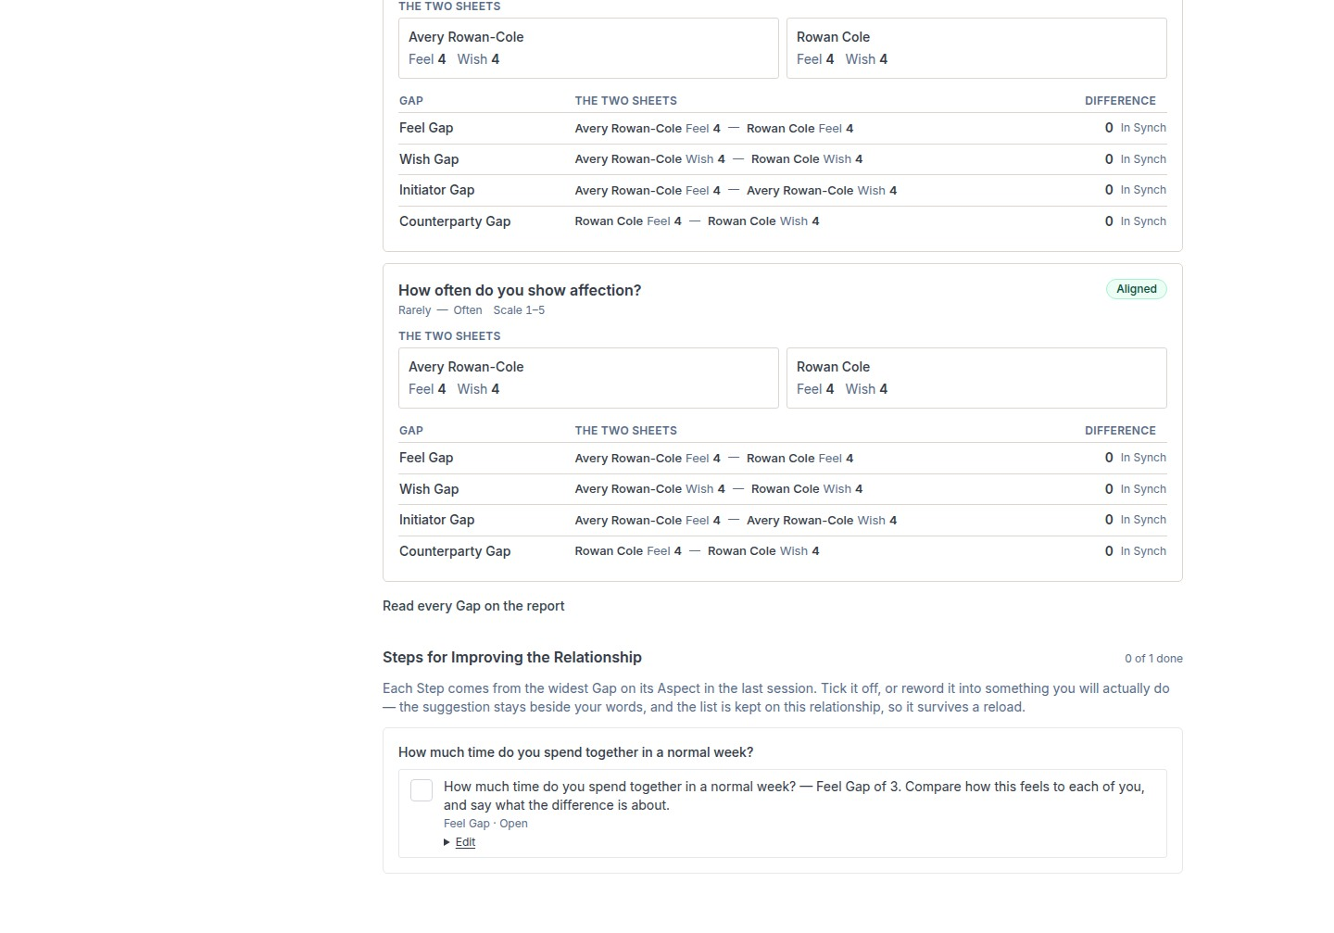
docs/qa-ongoing/alignment-1440.png · source 1440×3025 px · displayed band y=2018–3025 of 3025 px. Long full-page report view split into consecutive bands.
SCREEN ATLAS / CONTINUED

Acceptance and shared Alignment Mobile full Alignment section 1
MOBILE · FULL ALIGNMENT · SECTION 1 OF 9
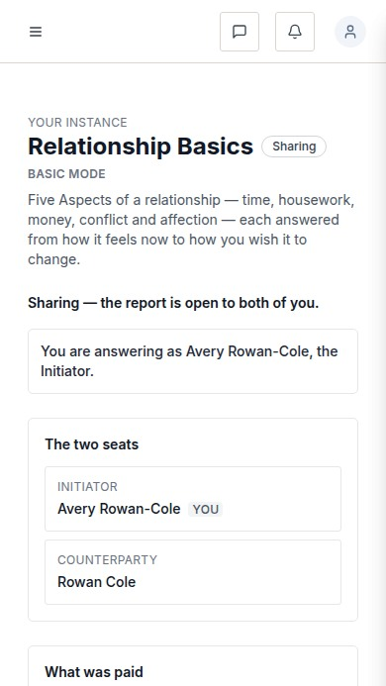
docs/qa-ongoing/alignment-390.png · source 390×6235 px · displayed band y=0–693 of 6235 px. Long full-page report view split into consecutive bands.
SCREEN ATLAS / CONTINUED

Acceptance and shared Alignment Mobile full Alignment section 2
MOBILE · FULL ALIGNMENT · SECTION 2 OF 9
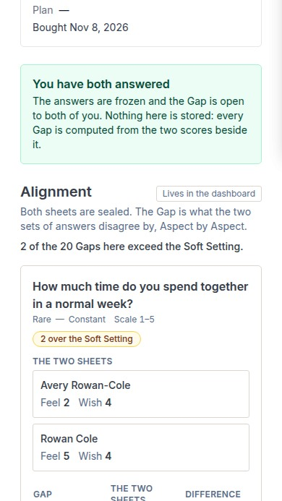
docs/qa-ongoing/alignment-390.png · source 390×6235 px · displayed band y=693–1386 of 6235 px. Long full-page report view split into consecutive bands.
SCREEN ATLAS / CONTINUED

Acceptance and shared Alignment Mobile full Alignment section 3
MOBILE · FULL ALIGNMENT · SECTION 3 OF 9
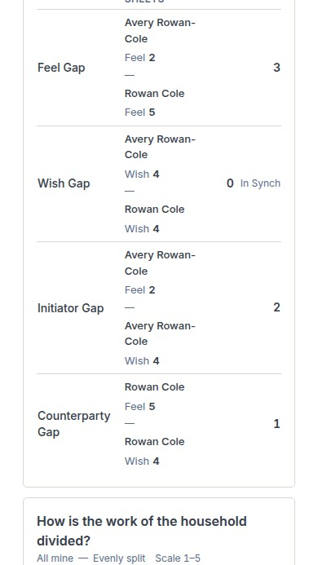
docs/qa-ongoing/alignment-390.png · source 390×6235 px · displayed band y=1386–2079 of 6235 px. Long full-page report view split into consecutive bands.
SCREEN ATLAS / CONTINUED

Acceptance and shared Alignment Mobile full Alignment section 4
MOBILE · FULL ALIGNMENT · SECTION 4 OF 9
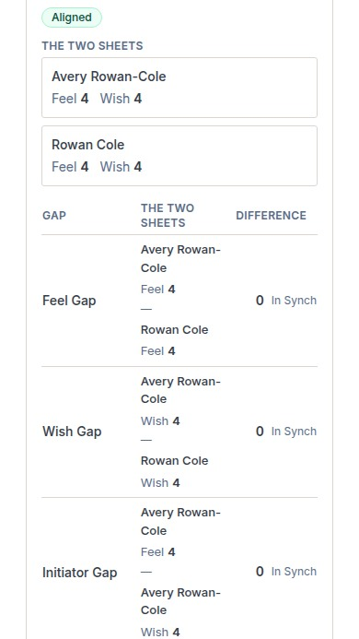
docs/qa-ongoing/alignment-390.png · source 390×6235 px · displayed band y=2079–2772 of 6235 px. Long full-page report view split into consecutive bands.
SCREEN ATLAS / CONTINUED

Acceptance and shared Alignment Mobile full Alignment section 5
MOBILE · FULL ALIGNMENT · SECTION 5 OF 9
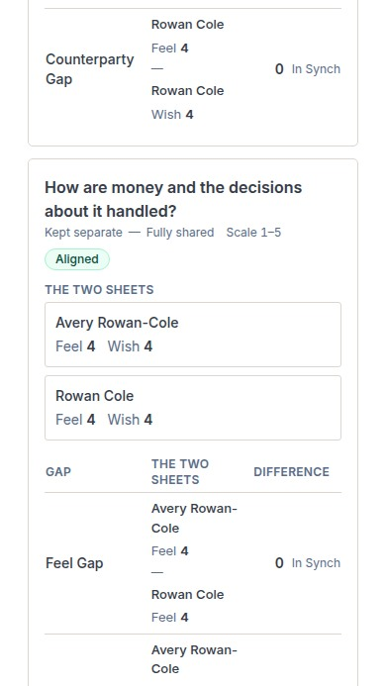
docs/qa-ongoing/alignment-390.png · source 390×6235 px · displayed band y=2772–3465 of 6235 px. Long full-page report view split into consecutive bands.
SCREEN ATLAS / CONTINUED

Acceptance and shared Alignment Mobile full Alignment section 6
MOBILE · FULL ALIGNMENT · SECTION 6 OF 9
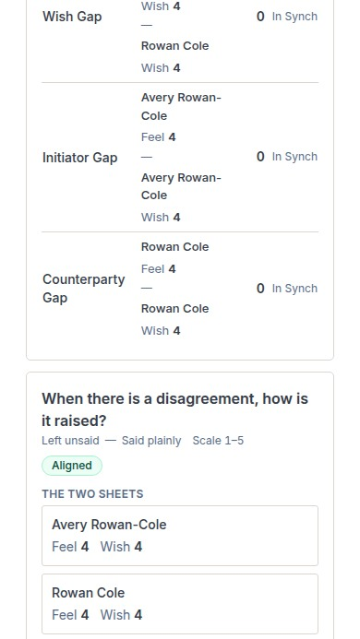
docs/qa-ongoing/alignment-390.png · source 390×6235 px · displayed band y=3465–4158 of 6235 px. Long full-page report view split into consecutive bands.
SCREEN ATLAS / CONTINUED

Acceptance and shared Alignment Mobile full Alignment section 7
MOBILE · FULL ALIGNMENT · SECTION 7 OF 9
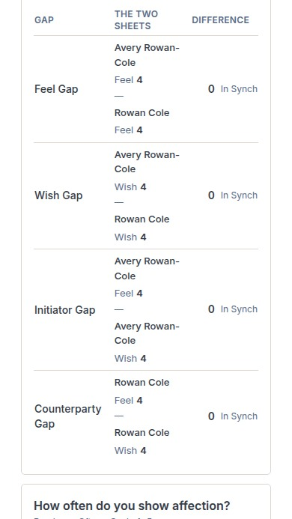
docs/qa-ongoing/alignment-390.png · source 390×6235 px · displayed band y=4158–4851 of 6235 px. Long full-page report view split into consecutive bands.
SCREEN ATLAS / CONTINUED

Acceptance and shared Alignment Mobile full Alignment section 8
MOBILE · FULL ALIGNMENT · SECTION 8 OF 9
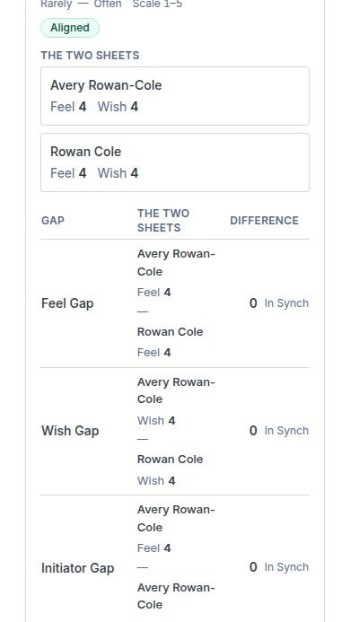
docs/qa-ongoing/alignment-390.png · source 390×6235 px · displayed band y=4851–5544 of 6235 px. Long full-page report view split into consecutive bands.
SCREEN ATLAS / CONTINUED

Acceptance and shared Alignment Mobile full Alignment section 9
MOBILE · FULL ALIGNMENT · SECTION 9 OF 9
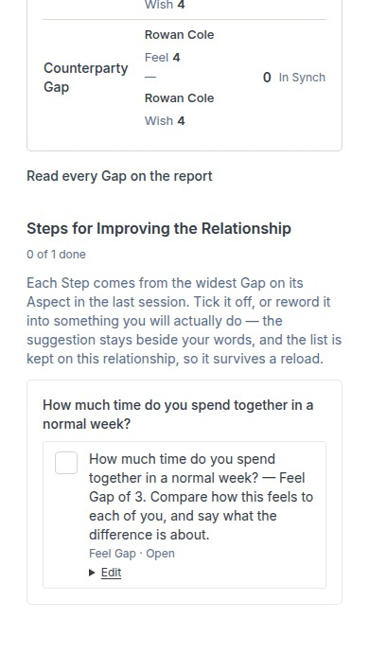
docs/qa-ongoing/alignment-390.png · source 390×6235 px · displayed band y=5544–6235 of 6235 px. Long full-page report view split into consecutive bands.
SCREEN ATLAS / /ASSESSMENT/INSTANCES/[ID]/SENT

Invitation sent confirmation
Route | Member task
/assessment/instances/[id]/sent | Confirm that an invitation was sent and choose a useful next action.

Screen evidence | Implementation references
Local QA full-page desktop/mobile pair. | app/(mainlayout)/assessment/instances/[instanceId]/sent/page.tsx:52; invitation creation lib/member/relationships.ts:1116; resend :1427.

DESKTOP · CAPTURED VIEW
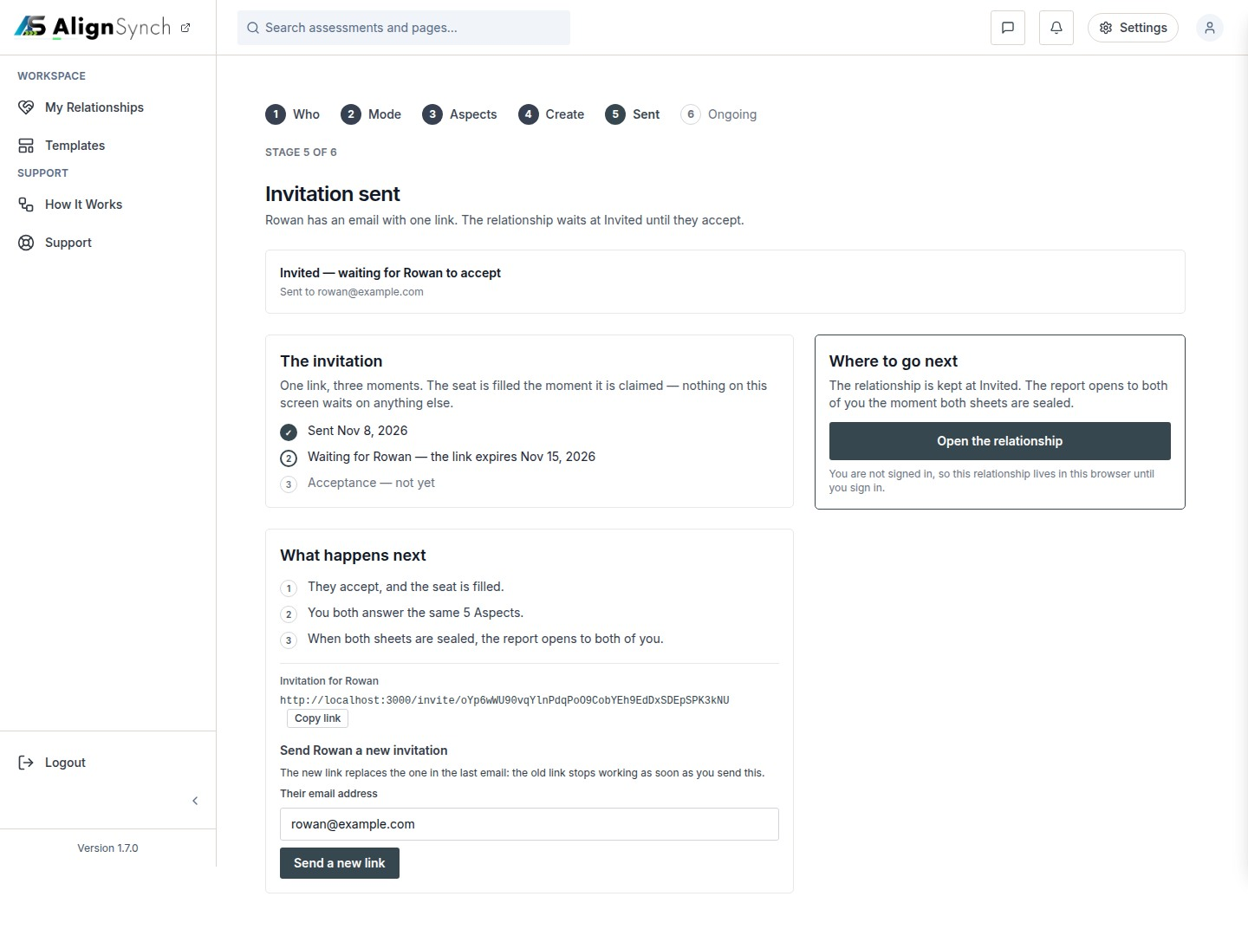
docs/qa-sent/sent-1440.png · source 1440×1087 px · displayed band y=0–1087 of 1087 px. Full-page confirmation state.
SCREEN ATLAS / CONTINUED

Invitation sent confirmation Mobile section 1
MOBILE · SECTION 1 OF 2
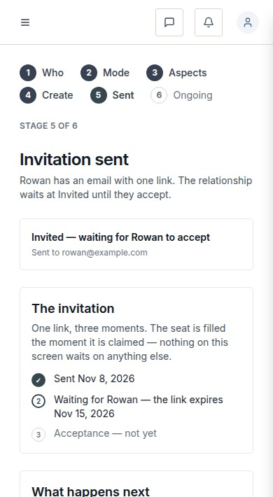
docs/qa-sent/sent-390.png · source 390×1420 px · displayed band y=0–710 of 1420 px. Full-page confirmation state at CSS 390px.
SCREEN ATLAS / CONTINUED

Invitation sent confirmation Mobile section 2
MOBILE · SECTION 2 OF 2
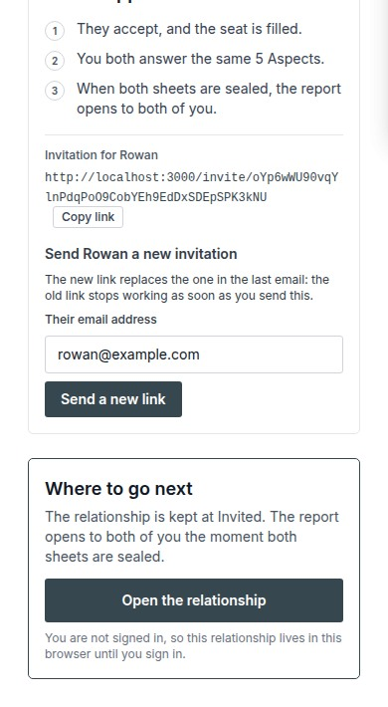
docs/qa-sent/sent-390.png · source 390×1420 px · displayed band y=710–1420 of 1420 px. Full-page confirmation state at CSS 390px.
SCREEN ATLAS / /DASHBOARD/HELP

How It Works
Route | Member task
/dashboard/help | Learn the six-step relationship process and replay the guided tour.

Screen evidence | Implementation references
Current route pair from QA Columns, verified by the capture report. | app/(mainlayout)/dashboard/help/page.tsx:44; tour action /api/tour; shell components/layout/main-layout.tsx:65.

DESKTOP · SECTION 1 OF 2
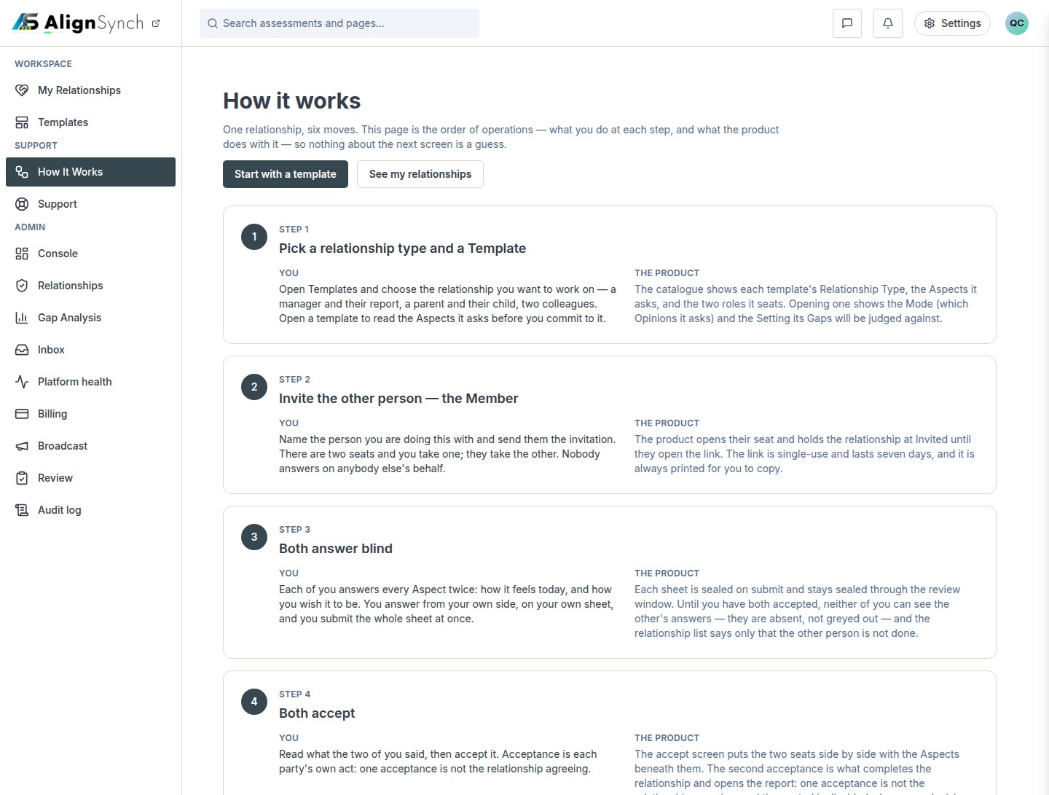
docs/qa-858-columns/after-dashboard-help-1440.png · source 1440×2182 px · displayed band y=0–1091 of 2182 px. Full-page content; split into readable bands.
SCREEN ATLAS / CONTINUED

How It Works Desktop section 2
DESKTOP · SECTION 2 OF 2
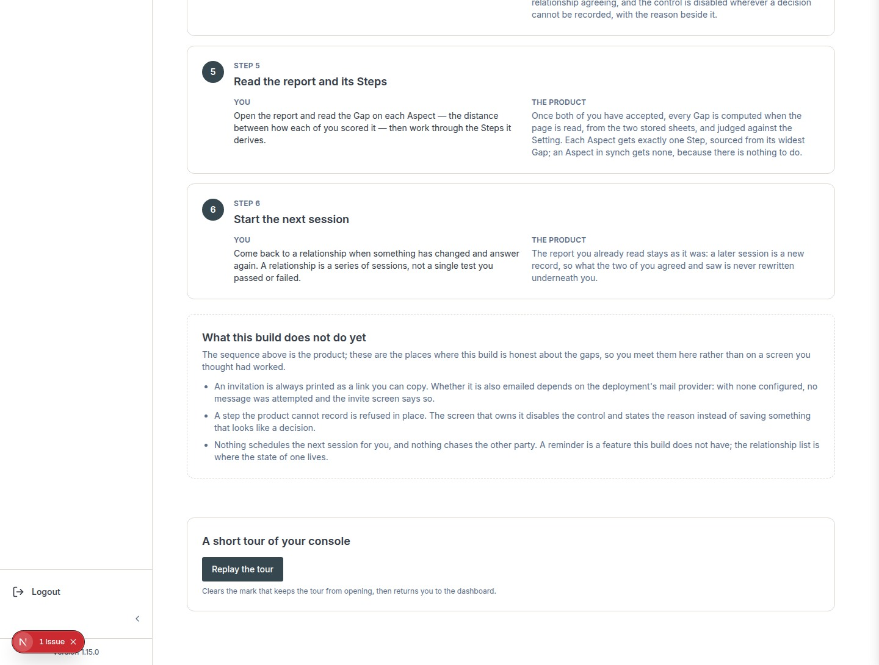
docs/qa-858-columns/after-dashboard-help-1440.png · source 1440×2182 px · displayed band y=1091–2182 of 2182 px. Full-page content; split into readable bands.
SCREEN ATLAS / CONTINUED

How It Works Mobile section 1
MOBILE · SECTION 1 OF 6
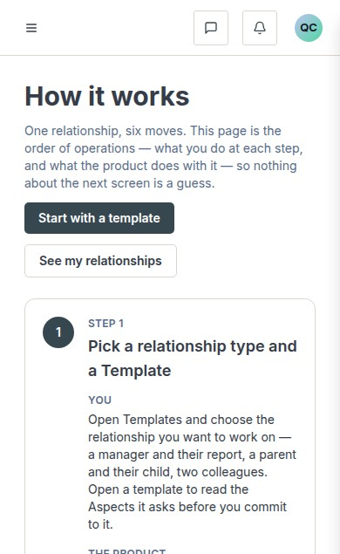
docs/qa-858-columns/after-dashboard-help-390.png · source 390×3806 px · displayed band y=0–635 of 3806 px. Full-page content at CSS 390px; split into readable bands.
SCREEN ATLAS / CONTINUED

How It Works Mobile section 2
MOBILE · SECTION 2 OF 6
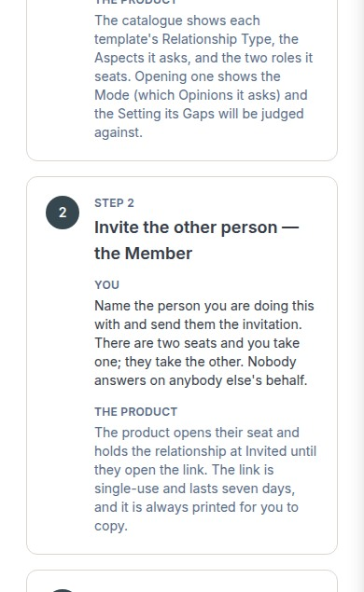
docs/qa-858-columns/after-dashboard-help-390.png · source 390×3806 px · displayed band y=635–1270 of 3806 px. Full-page content at CSS 390px; split into readable bands.
SCREEN ATLAS / CONTINUED

How It Works Mobile section 3
MOBILE · SECTION 3 OF 6
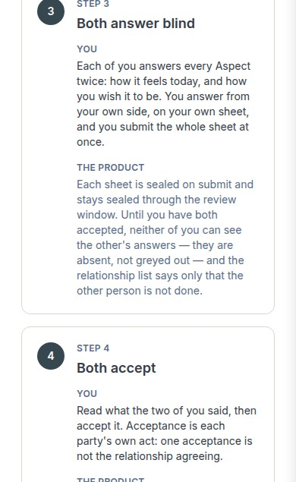
docs/qa-858-columns/after-dashboard-help-390.png · source 390×3806 px · displayed band y=1270–1905 of 3806 px. Full-page content at CSS 390px; split into readable bands.
SCREEN ATLAS / CONTINUED

How It Works Mobile section 4
MOBILE · SECTION 4 OF 6
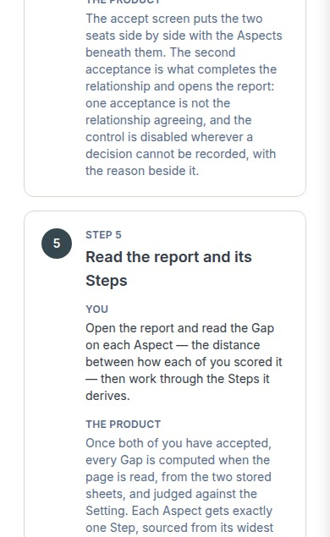
docs/qa-858-columns/after-dashboard-help-390.png · source 390×3806 px · displayed band y=1905–2540 of 3806 px. Full-page content at CSS 390px; split into readable bands.
SCREEN ATLAS / CONTINUED

How It Works Mobile section 5
MOBILE · SECTION 5 OF 6
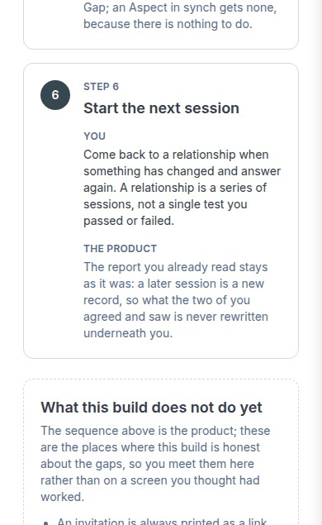
docs/qa-858-columns/after-dashboard-help-390.png · source 390×3806 px · displayed band y=2540–3175 of 3806 px. Full-page content at CSS 390px; split into readable bands.
SCREEN ATLAS / CONTINUED

How It Works Mobile section 6
MOBILE · SECTION 6 OF 6
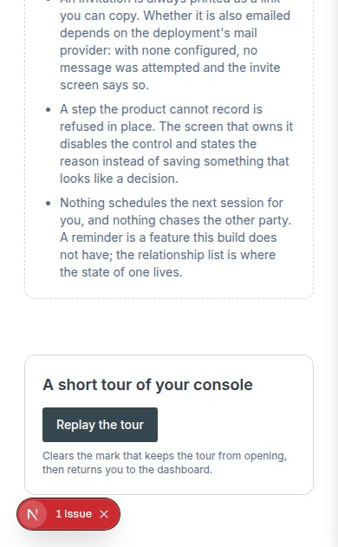
docs/qa-858-columns/after-dashboard-help-390.png · source 390×3806 px · displayed band y=3175–3806 of 3806 px. Full-page content at CSS 390px; split into readable bands.
SCREEN ATLAS / /DASHBOARD/SUPPORT

Support
Route | Member task
/dashboard/support | Search help topics or send an account-scoped request to the support team.

Screen evidence | Implementation references
Only older support captures with an earlier navigation rail are available. They show the content area and submission states, not the current full shell. | app/(mainlayout)/dashboard/support/page.tsx:62; components/support/dashboard-support-view.tsx:60; actions :48; lib/contact/submit.ts:82; lib/contact/store.ts:39,118.

Capture context. Capture labels retain the older navigation context; current route source and support behavior are described in the preceding guide section.
DESKTOP · EARLIER SIGNED-IN CAPTURE · CAPTURED VIEW
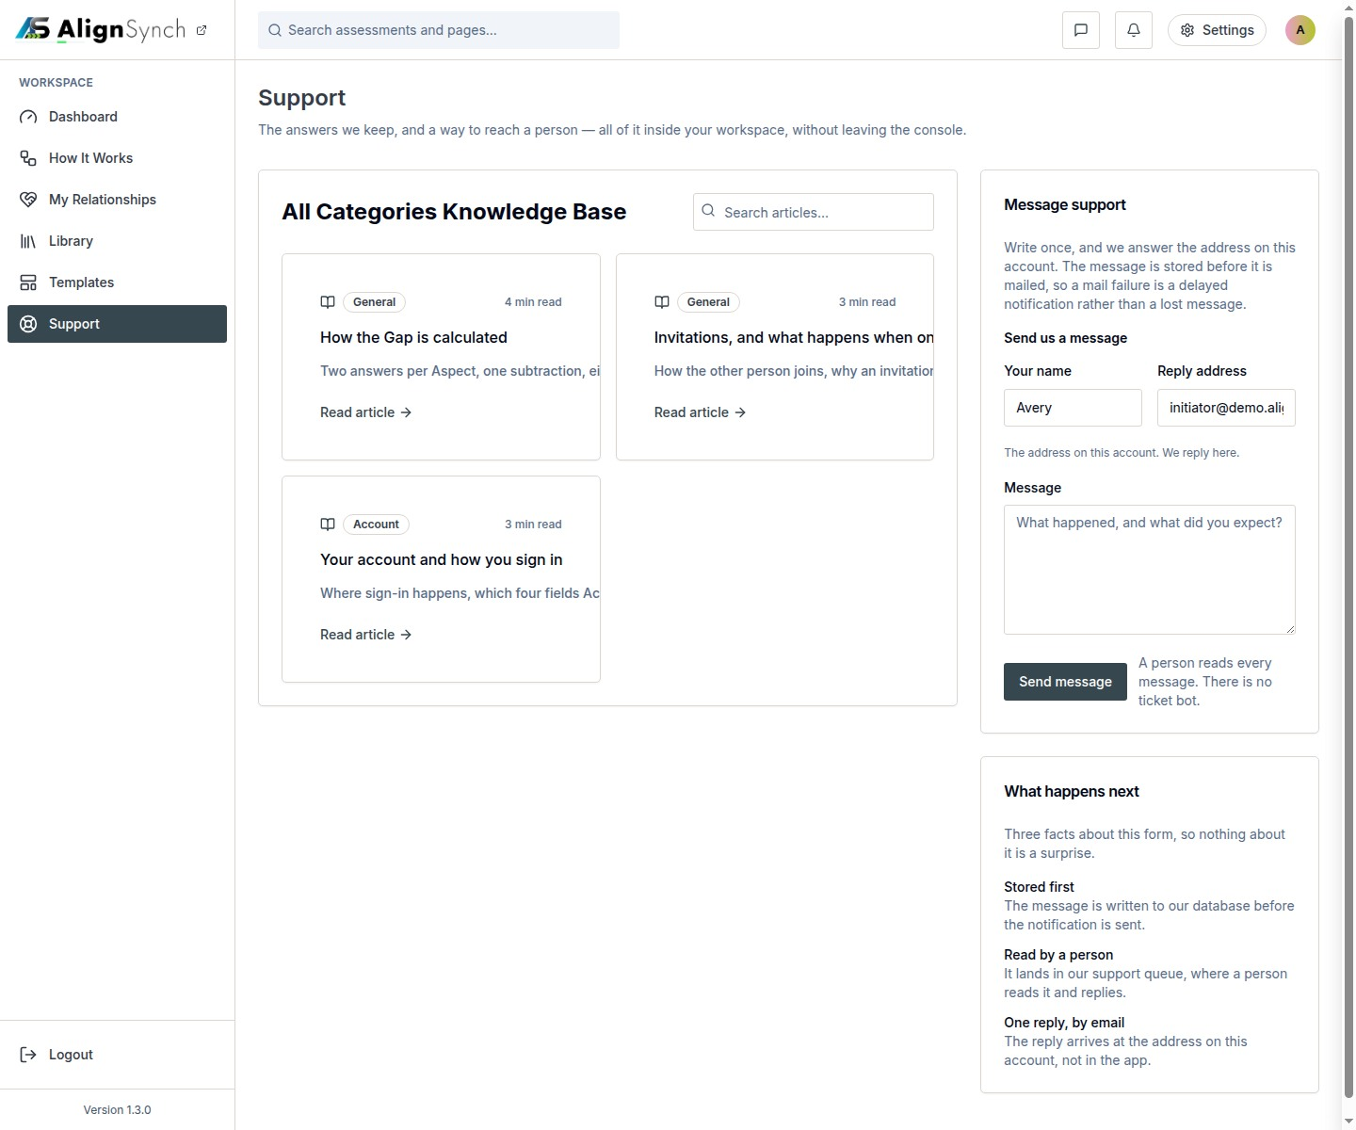
docs/qa-542/support-1440.png · source 1440×1200 px · displayed band y=0–1200 of 1200 px. Older shell and navigation; page-body reference only.
SCREEN ATLAS / CONTINUED

Support Mobile earlier signed in capture section 1
MOBILE · EARLIER SIGNED-IN CAPTURE · CAPTURED VIEW
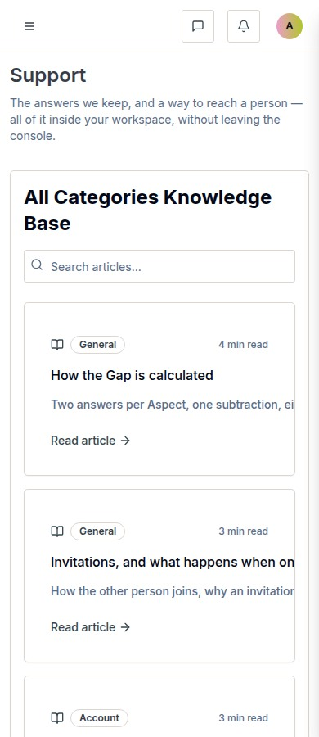
docs/qa-542/support-390.png · source 390×900 px · displayed band y=0–900 of 900 px. Older shell; content-area reference only.
SCREEN ATLAS / CONTINUED

Support Desktop submission result section 1
DESKTOP · SUBMISSION RESULT · CAPTURED VIEW
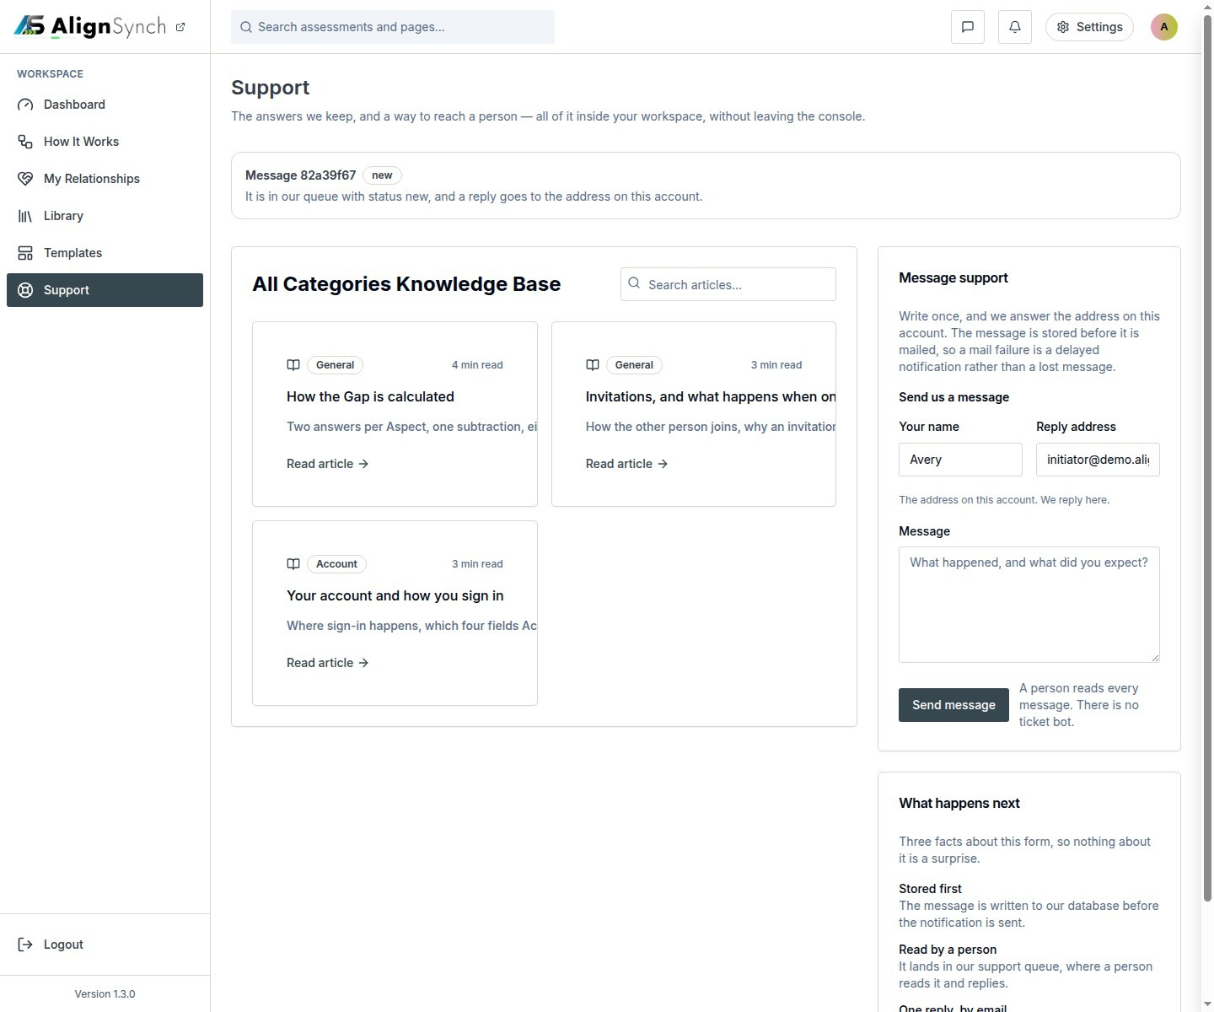
docs/qa-542/support-received-1440.png · source 1440×1200 px · displayed band y=0–1200 of 1200 px. Older confirmation state.
SCREEN ATLAS / CONTINUED

Support Mobile submission result section 1
MOBILE · SUBMISSION RESULT · CAPTURED VIEW
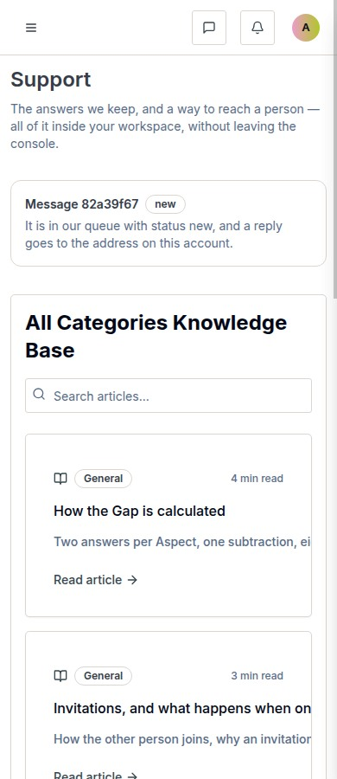
docs/qa-542/support-received-390.png · source 390×900 px · displayed band y=0–900 of 900 px. Older confirmation state.
SCREEN ATLAS / /SETTINGS AND /PROFILE/[HANDLE]

Account settings and profile
Route | Member task
/settings and /profile/[handle] | Update profile fields, manage password and account access, and review the profile view.

Screen evidence | Implementation references
Current settings desktop/mobile pair plus profile route pair. | app/(mainlayout)/settings/page.tsx:48; components/identity/settings-view.tsx:80; app/api/profile/route.ts:48; lib/db/user-profiles.ts:78; lib/account/purge.ts:752.

Capture context. All names and records shown are prototype/demo data.
DESKTOP · SETTINGS · SECTION 1 OF 2
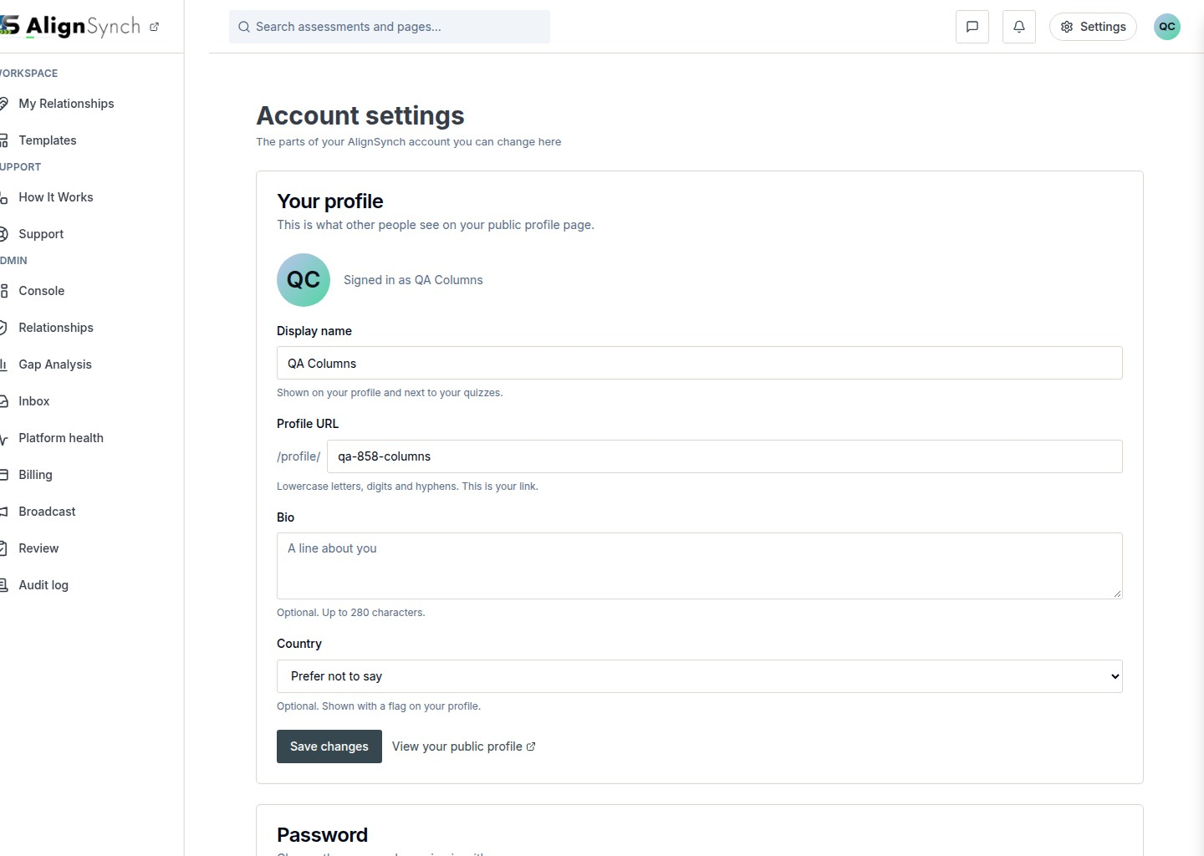
docs/qa-858-columns/after-settings-1440.png · source 1440×2047 px · displayed band y=0–1024 of 2047 px. Full-page settings view split into bands.
SCREEN ATLAS / CONTINUED

Account settings and profile Desktop settings section 2
DESKTOP · SETTINGS · SECTION 2 OF 2
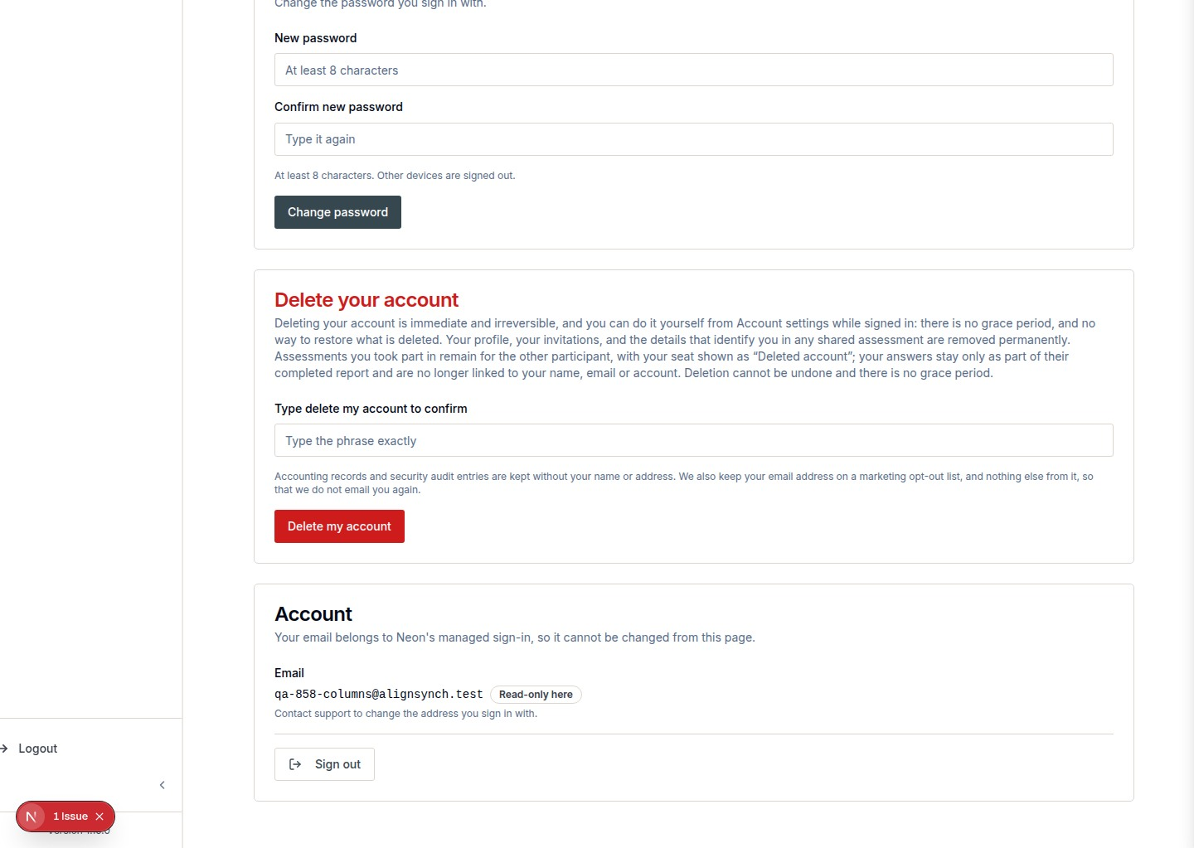
docs/qa-858-columns/after-settings-1440.png · source 1440×2047 px · displayed band y=1024–2047 of 2047 px. Full-page settings view split into bands.
SCREEN ATLAS / CONTINUED

Account settings and profile Mobile settings section 1
MOBILE · SETTINGS · SECTION 1 OF 4
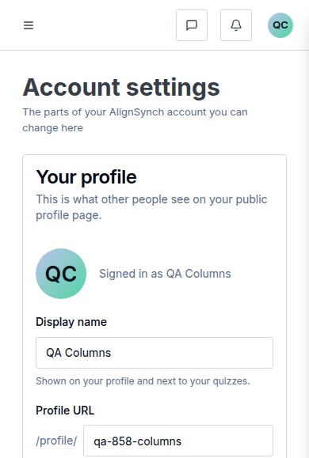
docs/qa-858-columns/after-settings-390.png · source 390×2316 px · displayed band y=0–579 of 2316 px. Full-page settings view at CSS 390px.
SCREEN ATLAS / CONTINUED

Account settings and profile Mobile settings section 2
MOBILE · SETTINGS · SECTION 2 OF 4
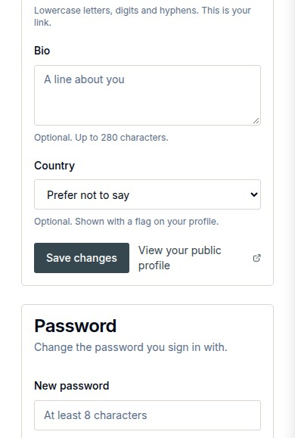
docs/qa-858-columns/after-settings-390.png · source 390×2316 px · displayed band y=579–1158 of 2316 px. Full-page settings view at CSS 390px.
SCREEN ATLAS / CONTINUED

Account settings and profile Mobile settings section 3
MOBILE · SETTINGS · SECTION 3 OF 4
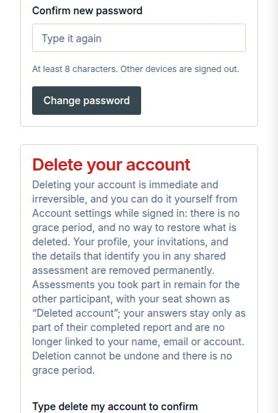
docs/qa-858-columns/after-settings-390.png · source 390×2316 px · displayed band y=1158–1737 of 2316 px. Full-page settings view at CSS 390px.
SCREEN ATLAS / CONTINUED

Account settings and profile Mobile settings section 4
MOBILE · SETTINGS · SECTION 4 OF 4
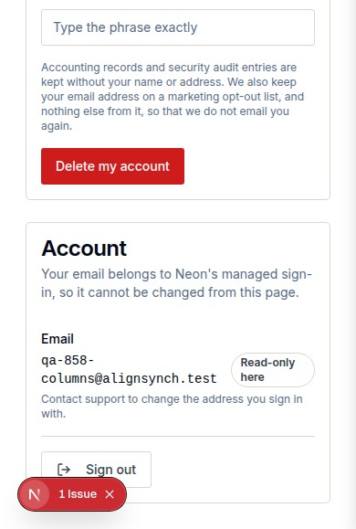
docs/qa-858-columns/after-settings-390.png · source 390×2316 px · displayed band y=1737–2316 of 2316 px. Full-page settings view at CSS 390px.
SCREEN ATLAS / CONTINUED

Account settings and profile Desktop member profile section 1
DESKTOP · MEMBER PROFILE · CAPTURED VIEW
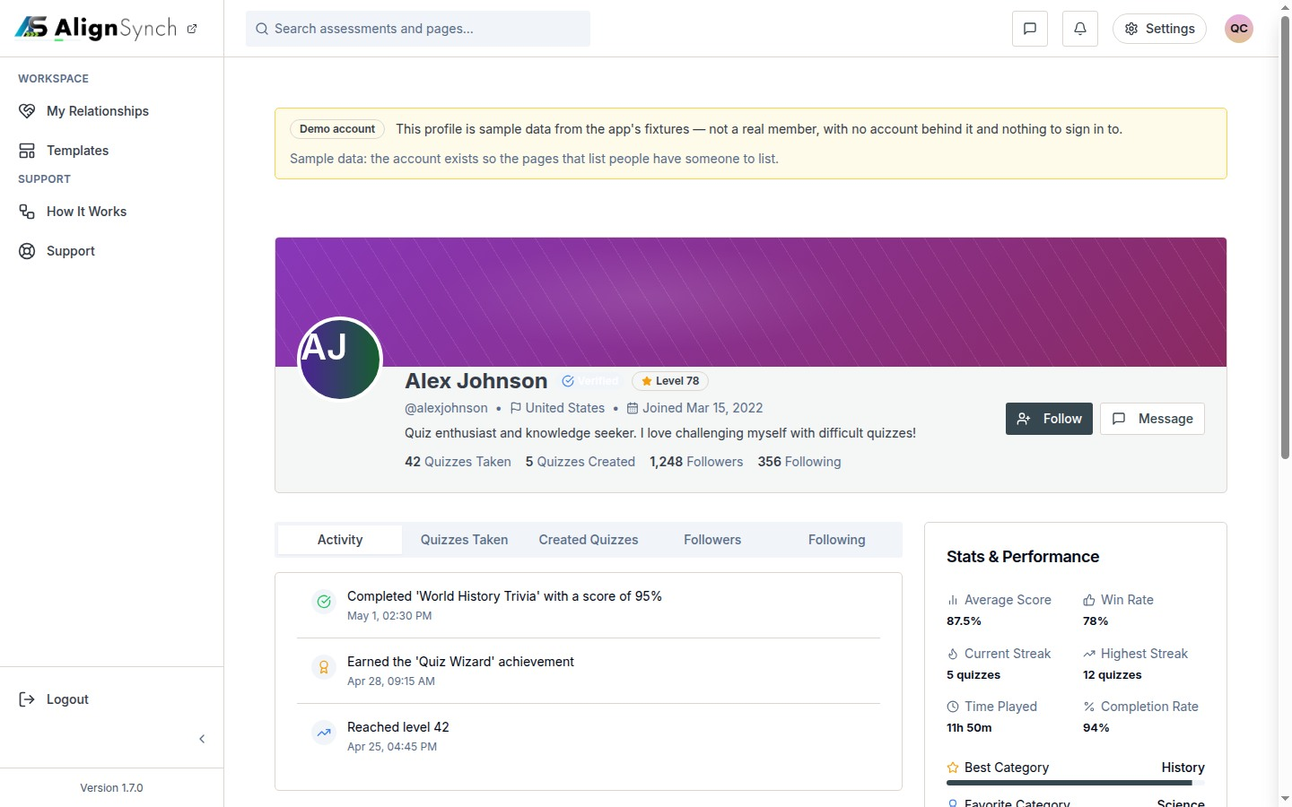
docs/qa-conformance/profile-1440.png · source 1440×900 px · displayed band y=0–900 of 900 px. Viewport profile capture with demo identity.
SCREEN ATLAS / CONTINUED

Account settings and profile Mobile member profile section 1
MOBILE · MEMBER PROFILE · CAPTURED VIEW
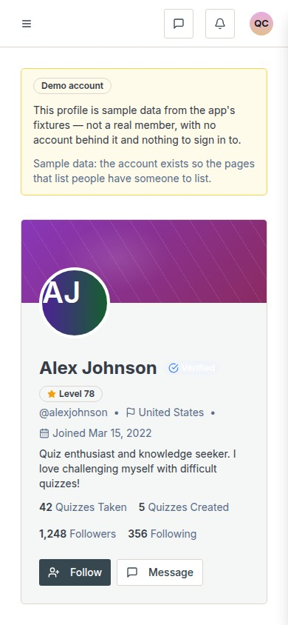
docs/qa-conformance/profile-390.png · source 390×844 px · displayed band y=0–844 of 844 px. Viewport capture at CSS 390px.

