PESCADOR, Rio Ysabel D. 2ECE-E

**PROBLEM 1**

1. Load the corresponding *.csv* file into a data frame named *cars* using *pandas*
2. Display the first five and last five rows of the resulting *cars*

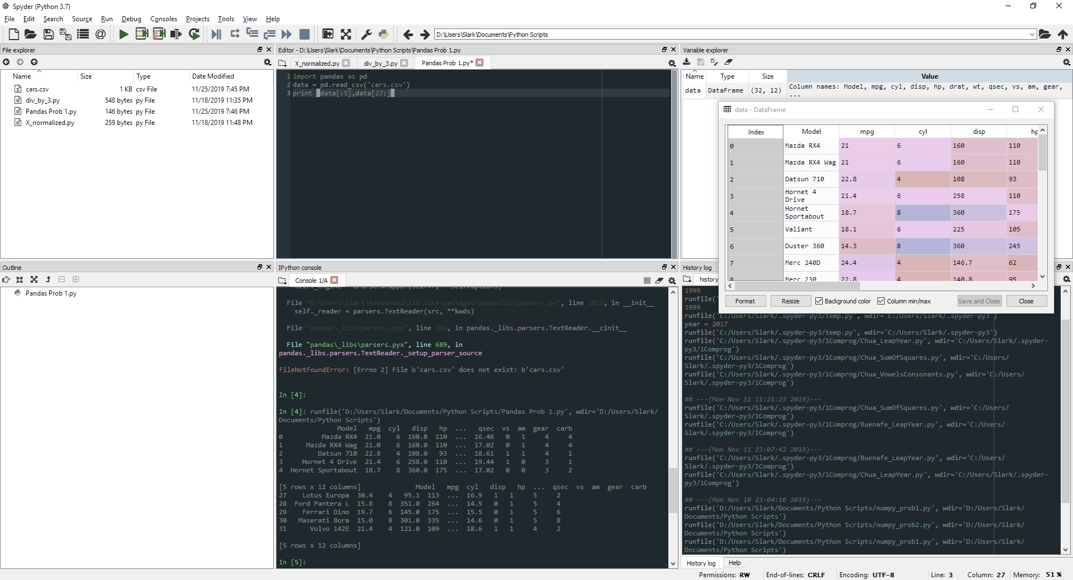

**PROBLEM 2**

1. Display the first five rows with odd-numbered columns of *cars*

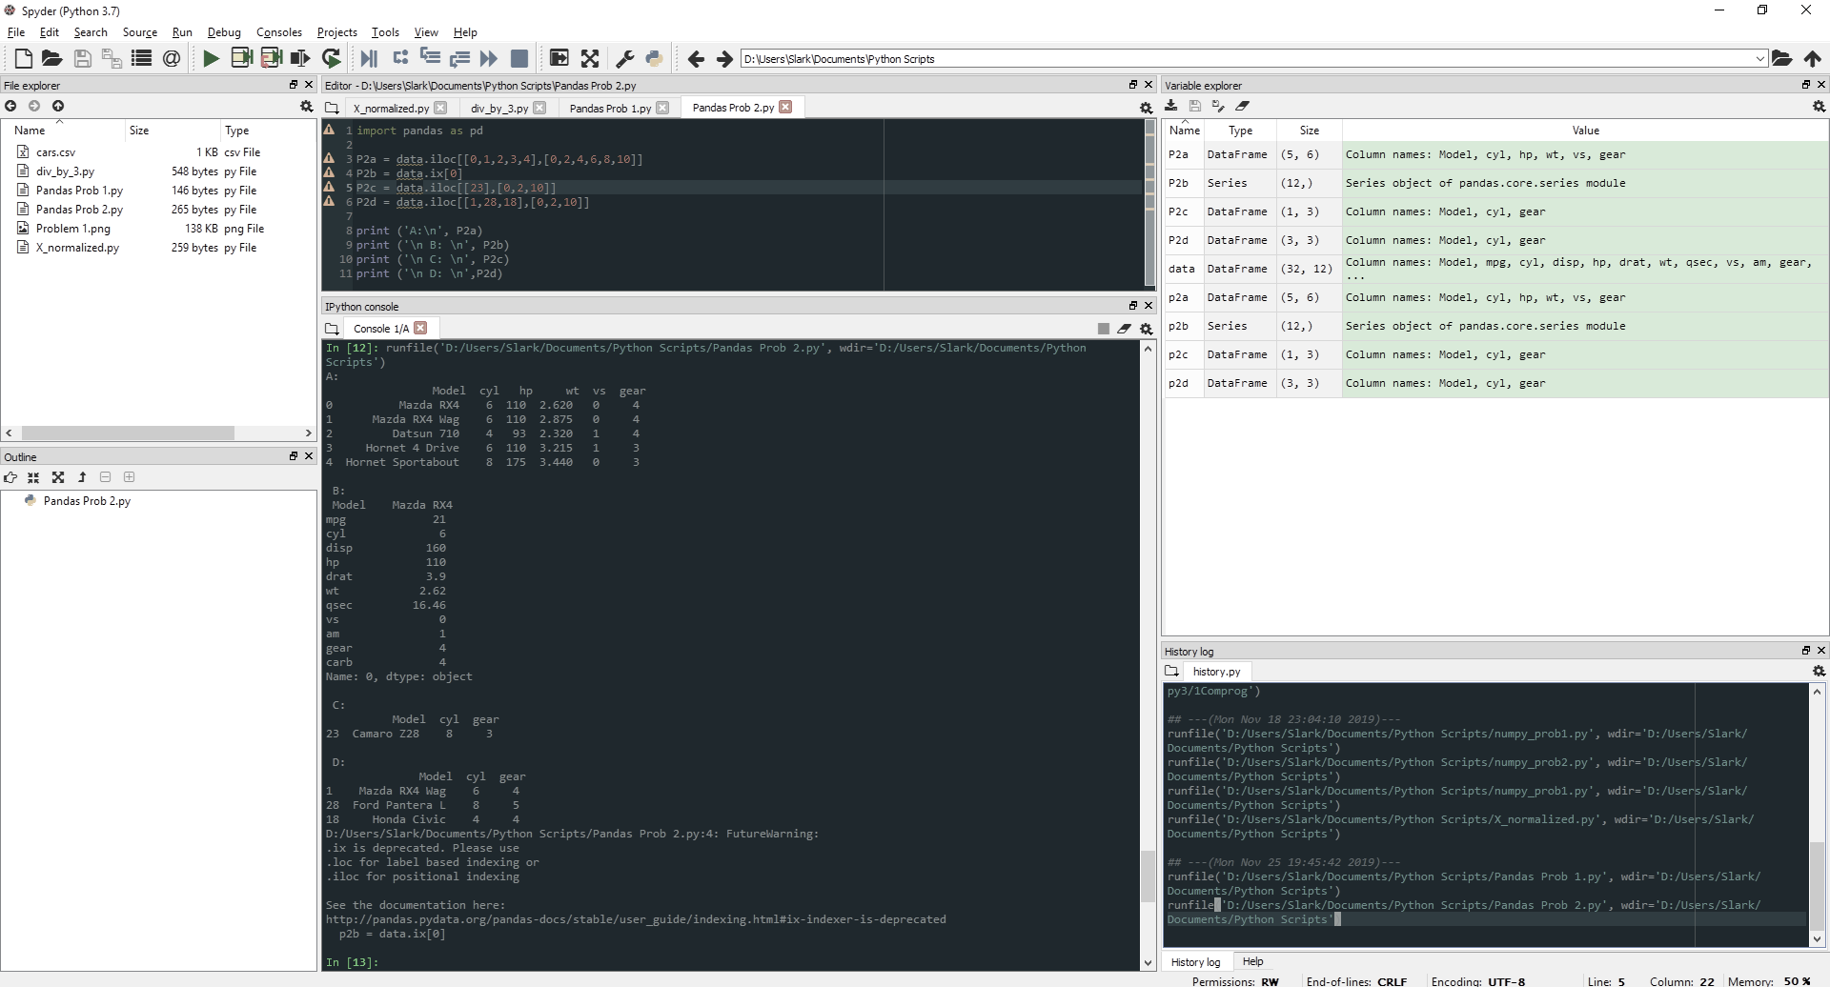

1. Display the row that contains the ‘Model’ of ‘Mazda RX4’.



1. How many cylinders (‘cyl’) does the car model ‘Camaro Z28’ have?



1. Determine how many cylinders (‘cyl’) and what gear type (‘gear’) do the car models ‘Mazda RX4 Wag’, ‘Ford Pantera L’, and ‘Honda Civic’ have.

