RIO PRINT MEDIA ERP
User Guide — Screens, Buttons & Options
Version 3.0 (Web & Mobile)
Generated: 2026-07-05 · Updated: 2026-10-21 (covers changes up to v280)

About This Guide
This guide walks through every module of the RIO Print Media ERP application. For each screen you will find a screenshot of the interface followed by a plain-English list of every button, dropdown, and input field found on that screen, along with what it does.

What's New (v218 – v280)
This guide was first written on 2026-07-05. The features below were added afterwards. Each item points to the chapter that explains it; look for the heading "Updates since the original guide" at the end of that chapter. Screenshots of new screens use sample data, so your own names and figures will differ.
Sales & Payments
- Payment rows — Payment Details now show Advance and Balance 1. A new + Add Payment button adds Balance 2, 3 and 4 only when needed. Older orders open with exactly the payment rows they used. (Chapter 2)
- Wider Product dropdown — Long product names now show in full on the order entry rows. (Chapter 2)
Expenses
- Duplicate, quick-add chips and category filter — Copy a past expense into a new entry, start a fresh entry from your most-used categories, and filter the list by Category / Sub Category. (Chapter 4)
- Excel template — The Date column is a DD-MM-YYYY dropdown and Sub Category follows the chosen Category. (Chapter 4)
Customers
- Check Duplicates — Finds customers entered twice under the same name and merges them without losing their sales, invoices or quotations. (Chapter 12)
Ledger & Bank Loans
- Bank loan tracking — Admins can record a bank loan with its interest %, see the outstanding balance, and record each EMI split into principal and interest. (Chapter 16)
Reports
- Bill Money Not in Indian Bank — A new report listing With-Bill payments received outside Indian Bank, and the amount to transfer from savings to Indian Bank. (Chapter 18)
- Report accuracy and access — The Sales Report reads its own date fields; Invoice and Quotation reports include every record in the range; restricted users see only their own records in the Sales, Invoice, Quotation and Customer-wise reports. (Chapter 18)
Attendance & Salary
- Shifts and grace period — Full-time employees can have a shift (start, end, grace minutes) that applies from a chosen week; late and extra time are measured against it. (Chapter 19)
- Total Extra Hrs column and Salary tab — A net figure (extra minus late/short) on the attendance screens, and a Salary tab to calculate pay for a date range. (Chapter 19)
Security & Administration
- Admin protection on the server — Backup, Restore, Bank Loans and user/role management now require an admin login on the server itself, not just a hidden button. (Chapters 20 and 24)
- Database Backup and Restore — One-click full backup of both companies and a guarded restore. (Chapter 21)
- Server update banner — Admins see an orange bar when the server is older than the page. (Chapter 24)
Invoicing
- Cancel instead of delete — Admins cancel an invoice (reason required): its number is kept, it is marked CANCELLED and left out of totals and reports. Delete is only for the newest invoice of its series that was never printed or shared. A Check numbering button finds missing numbers, and a clash on save is refused with the next free number. (Chapter 14)
- Duplicate invoice numbers — The Invoice Manager now shows every invoice (it used to hide a second invoice with the same number) and marks a number used twice DUPLICATE. Check numbering lists them, and an admin gives one invoice a new number or cancels it. A quick second click on Save can no longer create a second invoice, and Edit opens the exact invoice you clicked. (Chapter 14)
- Update Invoice fixed — Edit an invoice, change it and click Update Invoice now saves it. Save & Print had the same fault. If a save cannot be sent, a message now says why instead of the button doing nothing. (Chapter 14)
- Version 251 — From this version on every release has its own number in all its file names. The program itself is the same as v250.1; only the version labels and file names changed.
- Version 280 — Expense page: the + button beside Sub Category is removed (use Manage Categories). Account and Amount boxes are 3px wider; the Description box takes the rest. Date, Category and Sub Category keep their exact size.
- Version 279 — Dashboard: the Overdue Payments card now shows the 5 latest unpaid sales entries (newest first) instead of the 5 oldest. The Pending page is unchanged.
- Version 278 — PC scripts: only the newest 5 online backups of each PC are kept in Google Drive (older settings move to 5 by themselves; the other PC's files are never touched).
- Version 277 — PC scripts: the online backup looks every 15 minutes and only acts when something changed (live data uploaded, nothing written to Google Drive when nothing changed). The server is started automatically after a restart: the update sets up the 'RIO server' task, it also starts at logon and after a crash, and the 15-minute check starts it when it is down.
- Version 276 — Invoice from a sales entry: it is now dated inside the selected financial year, so it shows in the Invoice Manager (the popup names the year). One sales entry has ONE invoice: pressing Generate again says 'Invoice already generated'; only after the invoice is deleted a new one can be made. The delete/cancel release is exact (by invoice Id), not by number across years.
- Version 275 — Attendance: RECALCULATE no longer shows 'HTTP 404'. TEMPLATE is now an Excel file with dropdowns (Name, Date, Type, Job Type; In Time and Out Time are typed by hand) and IMPORT CSV / EXCEL reads the filled Excel file. The user guide describes SHIFTS, TEMPLATE, IMPORT and DEL EMPLOYEE.
- Version 274 — Fixes: after a restore the next new entry could get a number that was already taken (the number counters are now rebuilt after a restore and at every start). The 30-minute online backup task now also restores the newest backup of the other PC when it is safe, so a restore no longer depends on how the PC was woken up. New: 'What is different between the PCs?' lists the entries that exist only on one PC or were changed on both.
- Version 273 — The automatic restore from Google Drive no longer misses the other PC's file when Google Drive is slow (it keeps checking for 10 minutes), shows a short self-closing box with what it found, repairs old login tasks by itself so they also run on unlock, and stops with a clear message when two PCs have the same name. The RIO Tool button 'Why was it (not) restored?' shows everything that decides it. The program itself is unchanged.
- Version 272 — Automatic restore from Google Drive: a brand-new PC restores by itself at its first login, the check also runs when you unlock the PC, and there is an optional 'use the newest' mode for the case that both PCs changed data (your own entries are kept in two places). The program itself is unchanged.
- Version 271 — RIO Tool: the Overview status cards are equal-size rectangles on an aligned grid with the same outline and coloured left edge as the buttons. The program itself is unchanged.
- Version 270 — New look for the RIO Tool: a left navigation like the Rio ERP (Overview, Daily and Setup tabs, coloured buttons with icons), one panel per button, and F5 reload now works. The program itself is unchanged.
- Version 269 — RIO Tool fix: the buttons that open their own window (set up the online backup, fetch, friendly address, update, remove) no longer show 'Windows cannot find RIO'. The program itself is unchanged.
- Version 268 — The automatic backup now writes a file only when something changed (any entry added, removed or edited), so the 72 kept files are 72 different versions. Back up now and the backup before an update always take a backup. The program itself is unchanged.
- Version 267 — Copying the factory address QR code no longer saves a file: the picture is copied directly on a secure address, and shown with 'Right-click > Copy image' otherwise. The friendly address is now http://rio.localhost/ (run setup_name.bat again).
- Version 266 — The RIO Tool uses the Exo 2 font, like the app (loaded from Google Fonts when online, Segoe UI otherwise). The program itself is unchanged.
- Version 265 — New RIO Tool: one window with buttons for starting and stopping the server, backups, the online backup to Google Drive, setup and updates (Render\RIO_Tool.bat). The program itself is unchanged.
- Version 264 — Online backup fix: the first upload to Google Drive no longer fails on the size check of the copy (Google Drive can report the size of a new file late). The program itself is unchanged.
- Version 263 — Automatic restore at login: when you log in, the PC restores the newest online backup of the other PC, but only when nothing of this PC would be lost (safety copy first). The current data is also uploaded when the PC is locked or shut down. The program itself is unchanged.
- Version 262 — Online backup fix: it now uploads again when the file is not really in the Google Drive folder (for example after the folder was changed), and the setup refuses a folder on the PC itself. The program itself is unchanged.
- Version 261 — Online backup to Google Drive every 30 minutes (setup_online.bat), and a safe two-PC handover: online_get.bat fetches the other PC's newest backup only when no entries would be lost. The program itself is unchanged.
- Version 260 — After an update the old server could keep running (when the server was started by the scheduled task). The update tool now asks for administrator rights and restarts the server through the task. The program itself is unchanged.
- Version 259 — The PC version gets a friendly address: run setup_name.bat once and the app opens at http://rio/ (with a Rio desktop shortcut). The program itself is unchanged.
- Version 258 — The PC update tool no longer stops on a brand-new PC at the backup step (the packages do not exist yet there). The program itself is unchanged.
- Version 257 — Sales entry: the HSN, GST %, Quantity and Rate boxes are wider (a full 8-digit HSN now shows). The rest of the program is unchanged.
- Version 256 — Sales entry: choosing a product fills its HSN again (it had stopped working in v249). The rest of the program is unchanged.
- Version 255 — Duplicates for the same customer get a Remove button, and the Delete button on the last invoice works again (a printed bill needs an admin and a confirmation). Removed bills are kept in the removed_invoices table. The web version gets the same changes.
- Version 254 — The PC start and stop scripts close their own window, and the update tool puts older update files away in a Files folder. The program itself is unchanged.
- Version 253 — The PC start script's check that the server is answering was fixed: it could report a failure although the server was running. The program itself is unchanged.
- Version 252 — The PC scripts and the read-me files in the update zip now carry the version number, and the scripts keep small log files. The program itself is unchanged.

1. Dashboard
The Dashboard is the landing screen after login. It gives a quick, at-a-glance summary of the business — pending payments, active jobs, and key numbers pulled from every other module — plus quick links to jump straight into related screens.
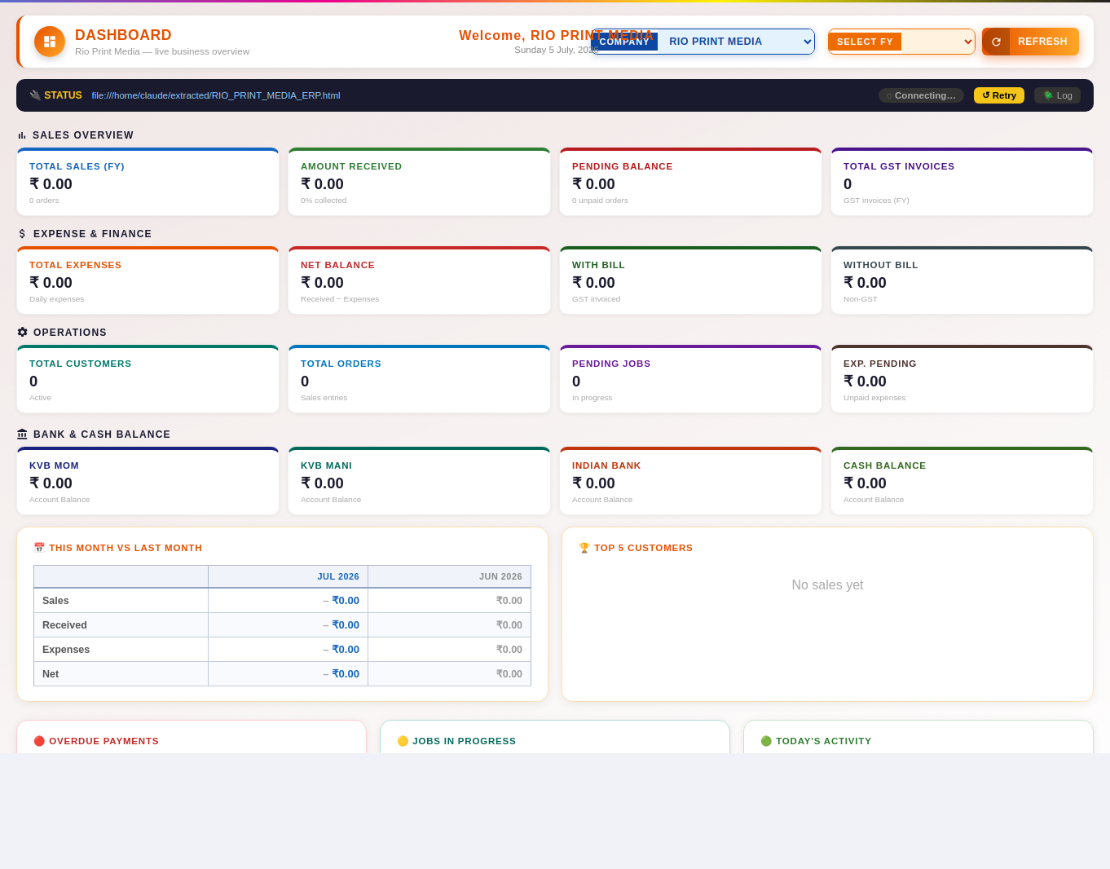
Buttons & Actions
- REFRESH — Reloads the latest data from the server.
- ↺ Retry — Retries the last failed server connection or sync attempt.
- 🪲 Log — Opens a technical connection log, useful for troubleshooting sync issues.
- View All Pending → — Opens the full Payment / Expense Pending list.
- View All Jobs → — Opens the full Job Tracker list.
Dropdown Fields
- Company Select — Switch between businesses (e.g. RIO PRINT MEDIA / RAINBOW UMBRELLAS). Most screens only show data for the company selected here. (Options: RIO PRINT MEDIA, RAINBOW UMBRELLAS)

2. Sales Tracker
Sales Tracker is where day-to-day sales entries are recorded — product, size, quantity, rate, GST, billing type, and payment/advance details. Entries here flow into the Ledger, Invoice, and Customer records.
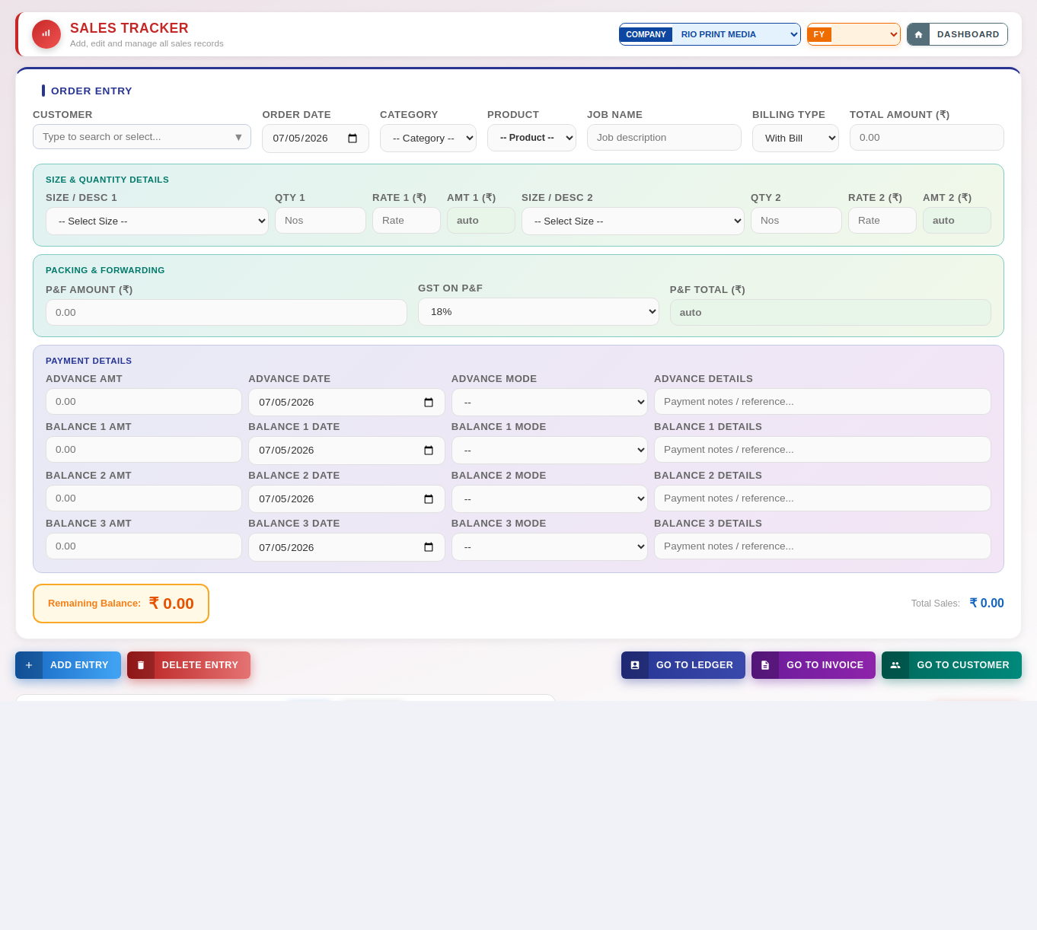
Buttons & Actions
- ✕ Cancel Edit — Exits edit mode without saving changes and returns the form to blank.
- ADD ENTRY — Saves the entry currently filled in on the form into the list/table below.
- DELETE ENTRY — Deletes the selected sales entry.
- GO TO LEDGER — Jumps to the Ledger screen, filtered to the relevant account.
- GO TO INVOICE — Jumps to the Invoice screen to raise an invoice for this sale.
- INVOICE button on a sales row — Makes the invoice for that sales entry in one step. The invoice is dated inside the financial year chosen at the top of the screen (today, when today is in that year). One sales entry has ONE invoice: if you press the button again the screen says "Invoice already generated" and shows the invoice number, with a button to open it in the Invoice Manager. A new invoice can be generated only after that invoice has been deleted (or cancelled).
- GO TO CUSTOMER — Jumps to the Customers screen for this customer's record.
- GO — Runs the search/report for the date range, customer, or filters selected above.
- RESET — Clears the filter fields back to their defaults.
- REFRESH — Reloads the latest data from the server.
Dropdown Fields
- Selection field — Choose from: RIO PRINT MEDIA, RAINBOW UMBRELLAS.
- S Category Sel — Choose the product category for this sale. (Options: -- Category --, Sunpac, Promotional)
- S Product — Choose the specific product within the selected category. (Options: -- Product --)
- S Billingtype — Choose whether this sale is billed With Bill (GST) or Without Bill. (Options: With Bill, Without Bill)
- S Size1 — Choose the size/dimension variant of the product (row 1). (Options: -- Select Size --, 16x6 Inches, 18x6 Inches, 12x18 Inches, 12x12 Inches, 16x16 Inches, …)
- S Size2 — Choose the size/dimension variant of the product (row 2). (Options: -- Select Size --, 16x6 Inches, 18x6 Inches, 12x18 Inches, 12x12 Inches, 16x16 Inches, …)
- S Rb Product1 — Choose the product for the second product row of this order. (Options: -- Product --)
- S Rb Size1 — Choose the size for the second product row of this order. (Options: -- Size --)
- S Rb Product2 — Choose the product for a further product row of this order. (Options: -- Product --)
- S Rb Size2 — Choose the size for a further product row of this order. (Options: -- Size --)
- S Pf Gst — GST rate applied to packing & forwarding charges. (Options: 0%, 5%, 18%)
- Product (per row) — Rio sales entry now uses unlimited product rows instead of a fixed Size 1/2/3 layout — each row picks its own product, with its own GST rate, CGST/SGST/IGST split (shown live based on the customer’s state), Qty, Rate, Amount, and row Total. Starts with 2 rows.
- + Add Product — Adds another product row. There is no limit on how many products one sale can have.
This replaced the previous fixed Size 1/2/3 layout for Rio only — Rainbow is unchanged and still uses its own fixed 2-product form. Existing sales records saved before this change keep working exactly as before; nothing in the database was altered. Packing & Forwarding remains a separate section below the product rows.
- S Adv Mode — Bank/cash account through which the advance payment was received. (Options: --, KVB MOM, KVB Mani, Indian Bank, KVB CA, Cash)
- S Bal1 Mode — Bank/cash account through which balance payment 1 was received. (Options: --, KVB MOM, KVB Mani, Indian Bank, KVB CA, Cash)
- S Bal2 Mode — Bank/cash account through which balance payment 2 was received. (Options: --, KVB MOM, KVB Mani, Indian Bank, KVB CA, Cash) This row appears only after you click + Add Payment (or when an existing order has this payment).
- S Bal3 Mode — Bank/cash account through which balance payment 3 was received. (Options: --, KVB MOM, KVB Mani, Indian Bank, KVB CA, Cash) This row appears only after you click + Add Payment (or when an existing order has this payment).
Input Fields
- Type to search or select... — Free-text field.
- S Orderdate — Date the sale/order took place.
- Job description — Free-text field.
- Amount — Enter an amount in rupees.
- Quantity (Nos) — Enter the quantity for this line item.
- Rate — Enter the rate per unit for this line item.
- Amount (auto) — Auto-calculated amount — filled in automatically from quantity × rate.
- S Rb Gstshow1 — Auto-calculated GST amount for product row 1 (read-only display).
- S Rb Gstshow2 — Auto-calculated GST amount for product row 2 (read-only display).
- S Adv Date — Date the advance payment was received.
- Payment notes / reference... — Free-text field.
- S Bal1 Date — Date balance payment 1 was received.
- S Bal2 Date — Date balance payment 2 was received. This row appears only after you click + Add Payment (or when an existing order has this payment).
- S Bal3 Date — Date balance payment 3 was received. This row appears only after you click + Add Payment (or when an existing order has this payment).
- S Summary From — Start date for the mini summary shown on this screen.
- S Summary To — End date for the mini summary shown on this screen.
- S Rem Only — Tick to show only entries with an outstanding reminder/balance.
- Search invoice / customer… — Free-text field.

Updates since the original guide (v241 – v243)
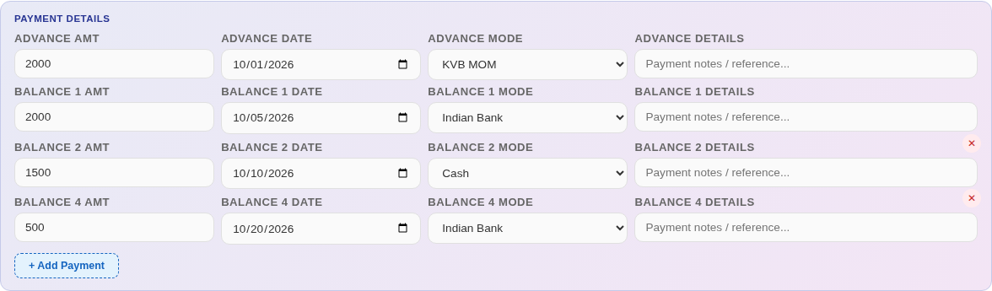
Payment Details with two extra payments added (sample data). Balance 3 was removed, so the rows read 2 then 4.
- + Add Payment — Under Payment Details. Advance and Balance 1 are always shown; each click adds the next row (Balance 2, then 3, then 4). The button disappears once Balance 4 is open.
- ✕ (remove payment) — At the right of each added row. Clears that payment's amount, date, mode and notes, hides the row, and updates the Remaining Balance.
- Balance 2 / Balance 3 / Balance 4 fields — Each payment has Amount, Date, Mode (KVB MOM, KVB Mani, Indian Bank or Cash) and Details. Balance 4 is new and posts to the Ledger like the other payments.
- Opening an existing order — Only the payment rows that have data are shown. An order with Balance 1 and Balance 3 but no Balance 2 shows Balance 3 only. Nothing is carried over from the order you opened before.
- Remaining Balance — Total amount minus every payment, including Balance 4.
- Product dropdown (per row) — Wider so long product names show in full (up to 340 px; Size / Desc up to 300 px). When CGST / SGST or IGST columns appear for a With Bill sale, the row re-arranges itself automatically.
- Sales table — A Balance 4 column follows Balance 3 (15 columns in all). Hover over a payment amount to see the date it was paid.
- Product list refresh — The product list is reloaded every time you open the Sales screen, and the rows already on screen are updated, so a product you have just added in the Products tab appears straight away. If the list could not be loaded the dropdown says so and clicking it tries again; if no products exist yet it says to add them in the Products tab.

3. Customer Billing
Customer Billing lists all billing records for customers, with filters to narrow down by date range or view the complete record set.
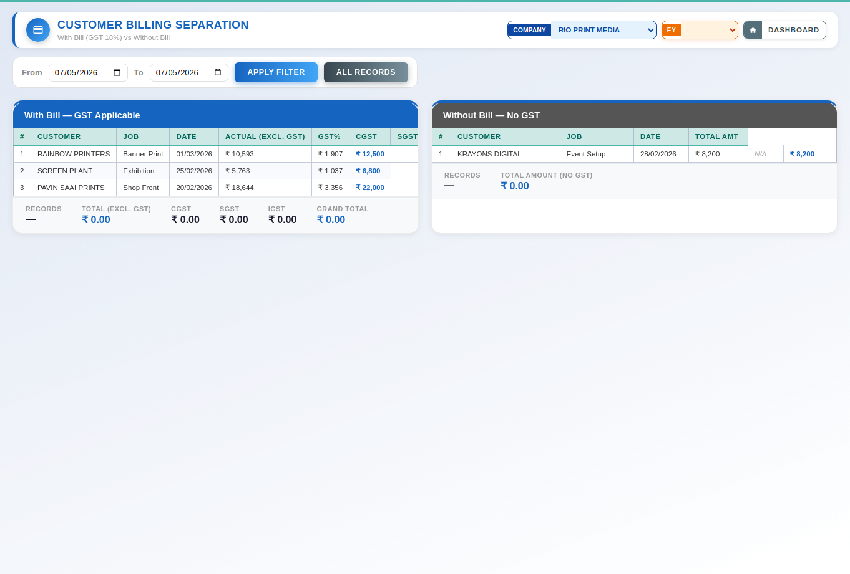
Buttons & Actions
- APPLY FILTER — Applies the date range (or other filters) selected above to the list below.
- ALL RECORDS — Clears any date filter and shows the complete, unfiltered list of records.
Dropdown Fields
- Selection field — Choose from: RIO PRINT MEDIA, RAINBOW UMBRELLAS.
Input Fields
- Date — Pick a date.

4. Daily Expense
Daily Expense is used to log business expenses against categories and sub-categories, record the payment mode used, and manage the expense category list.
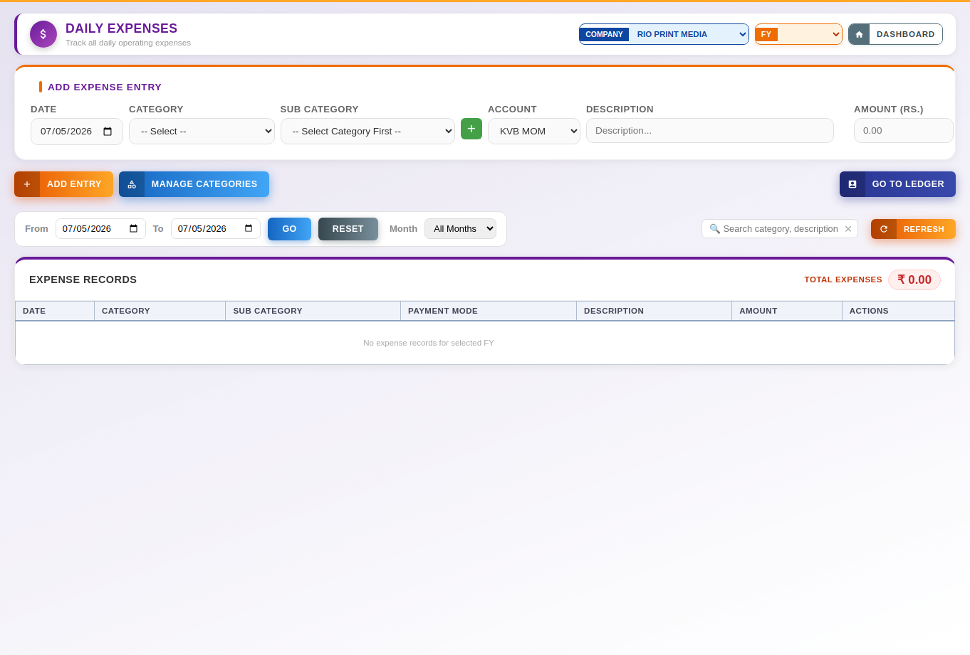
Buttons & Actions
- ADD ENTRY — Saves the entry currently filled in on the form into the list/table below.
- MANAGE CATEGORIES — Opens a dialog to add, rename, or delete expense categories and sub-categories. This is where a new sub-category is added (the small + button beside the Sub Category box was removed).
- Update Expense — Saves changes made to the expense entry currently being edited.
- ✕ Cancel — Cancels the current entry without saving and clears the form.
- GO TO LEDGER — Jumps to the Ledger screen, filtered to the relevant account.
- GO — Runs the search/report for the date range, customer, or filters selected above.
- RESET — Clears the filter fields back to their defaults.
- REFRESH — Reloads the latest data from the server.
Dropdown Fields
- Selection field — Choose from: RIO PRINT MEDIA, RAINBOW UMBRELLAS.
- E Category — Expense category this entry belongs to. (Options: -- Select --)
- E Subcategory — Expense sub-category, narrowed down based on the category chosen. (Options: -- Select Category First --)
- E Paymode — Payment mode used for this expense (bank account or cash). (Options: KVB MOM, KVB Mani, Indian Bank, KVB CA, Cash, Pending)
- Exp Month Filter — Filter the expense list to a specific month. (Options: All Months, January, February, March, April, May, …)
Input Fields
- E Date — Date the expense was incurred.
- Description... — Free-text field.
- Amount — Enter an amount in rupees.
- Exp From — Start date of the expense filter range.
- Exp To — End date of the expense filter range.
- Search category, description… — Free-text field.

Updates since the original guide (v222 – v242)
- ⧉ Duplicate (on every expense row) — A green button beside Edit and Del. Copies the row's Category, Sub Category, Account, Amount and Description into the Add Expense Entry form with today's date and puts the cursor in Amount. Check the date and amount, then Add Entry; the original is never changed.
- Quick-add chips — A row of up to eight pill buttons under the form showing your most-used Category / Sub Category pairs. Clicking one fills only Category and Sub Category; Amount and Description stay blank.
- Category / Sub filter — A dropdown after the Account filter that lists every Category and Sub Category in use. It is cleared by Reset.
- Excel template — Date is a dropdown of the current month's dates in DD-MM-YYYY. Category, Sub Category (which depends on the Category) and Account are dropdowns; Amount and Description are typed. On import the date is converted to the stored format and any new categories are registered straight away.
- Manage Categories — Deleting a category or sub-category now works. A category that expenses still use cannot be deleted; the message tells you how many records use it.
- Bank Interest — Interest recorded from a bank-loan EMI in the Ledger (chapter 16) appears here as Admin & Finance › Bank Interest. Do not also enter the same EMI as an expense or it is counted twice.

5. Summary & Balance
Summary & Balance gives a consolidated month/year view of sales, expenses, and account balances across all payment modes (bank accounts, cash, etc.).
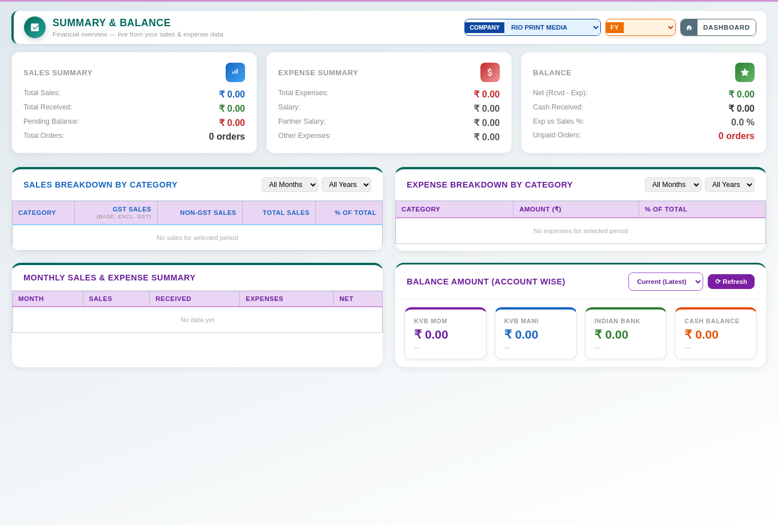
Buttons & Actions
- ⟳ Refresh — Reloads the latest data from the server.
Dropdown Fields
- Selection field — Choose from: RIO PRINT MEDIA, RAINBOW UMBRELLAS.
- Sales Cat Month — Filter the sales-by-category summary to a specific month. (Options: All Months, April, May, June, July, August, …)
- Sales Cat Year — Filter the sales-by-category summary to a specific year. (Options: All Years)
- Exp Cat Month — Filter the expense-by-category summary to a specific month. (Options: All Months, April, May, June, July, August, …)
- Exp Cat Year — Filter the expense-by-category summary to a specific year. (Options: All Years)
- Sum Acct Month Filter — Choose which month's account balances to display. (Options: Current (Latest), April 2026, May 2026, June 2026, July 2026, August 2026, …)

6. Payment / Expense Pending
Payment / Expense Pending lists outstanding customer payments and pending expense settlements so nothing is missed.
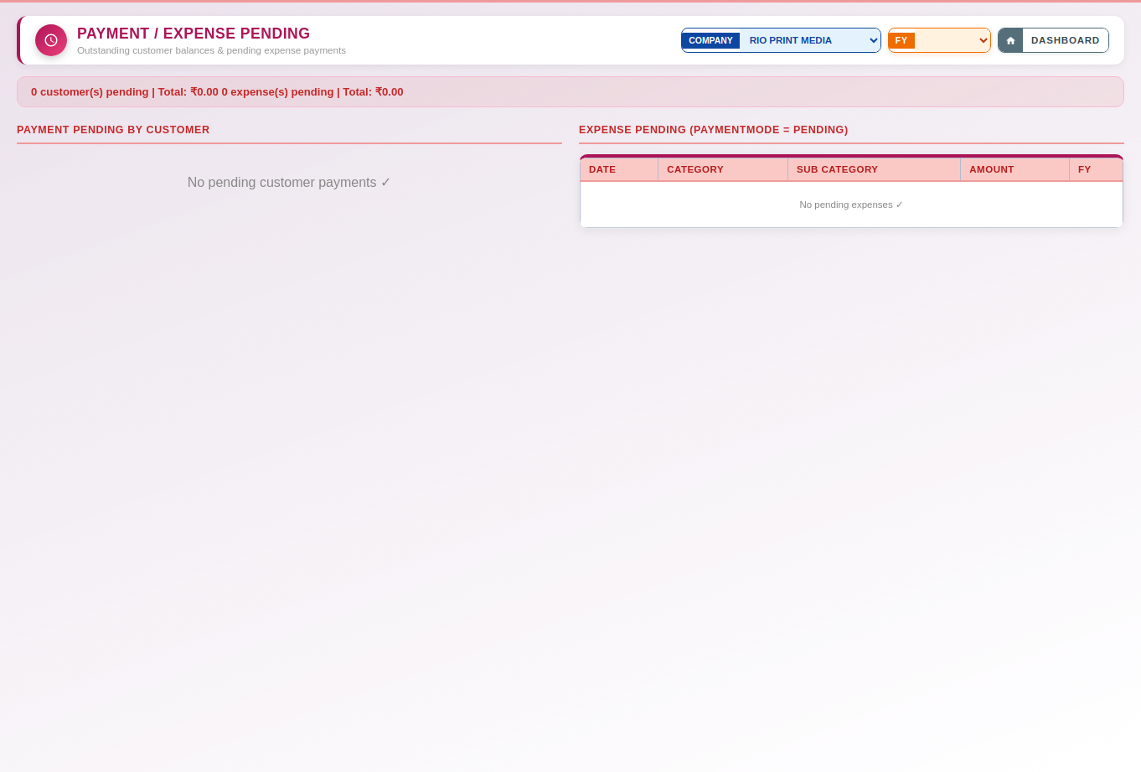
Dropdown Fields
- Selection field — Choose from: RIO PRINT MEDIA, RAINBOW UMBRELLAS.

7. Customer-Wise Sales
Customer-Wise Sales lets you pull a sales report filtered to a single customer over a chosen date range.
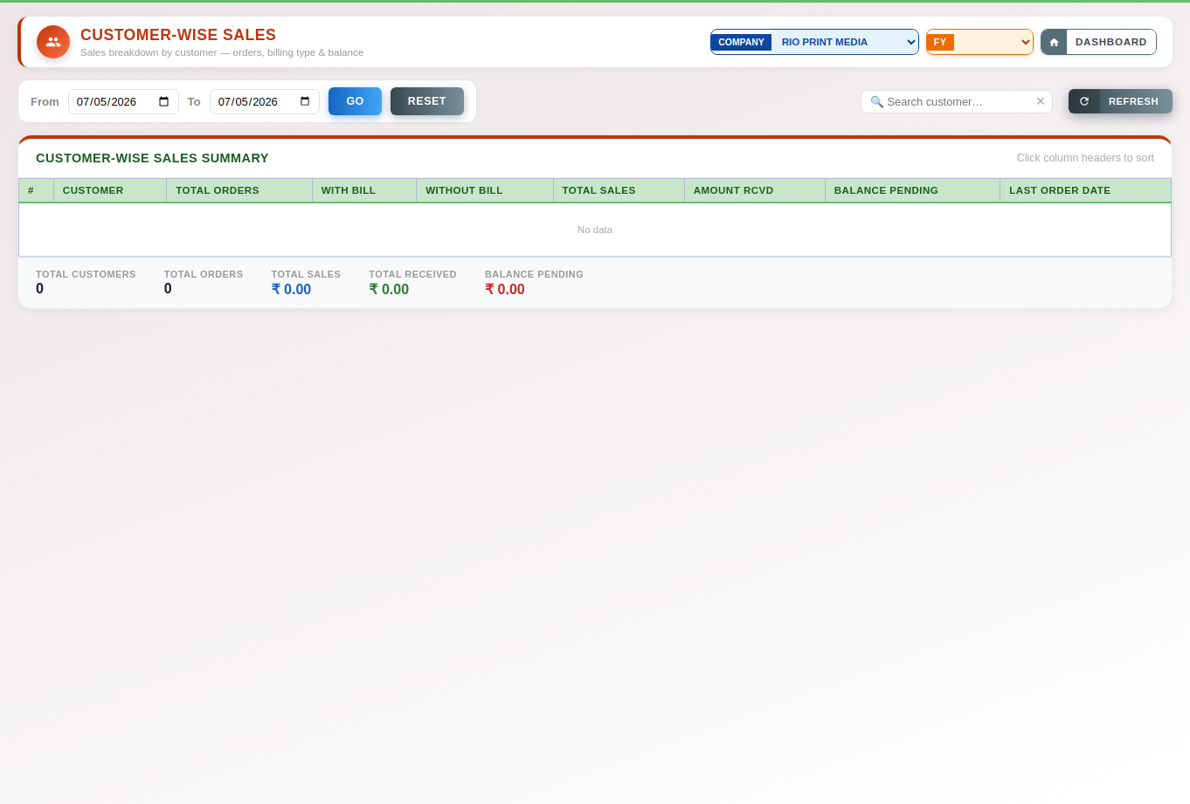
Buttons & Actions
- GO — Runs the search/report for the date range, customer, or filters selected above.
- RESET — Clears the filter fields back to their defaults.
- REFRESH — Reloads the latest data from the server.
Dropdown Fields
- Selection field — Choose from: RIO PRINT MEDIA, RAINBOW UMBRELLAS.
Input Fields
- Date — Pick a date.
- Search customer… — Free-text field.

8. Profit / Loss
The Profit / Loss screen calculates income vs. expenses for a selected financial year and can generate a printable P&L statement as PDF.
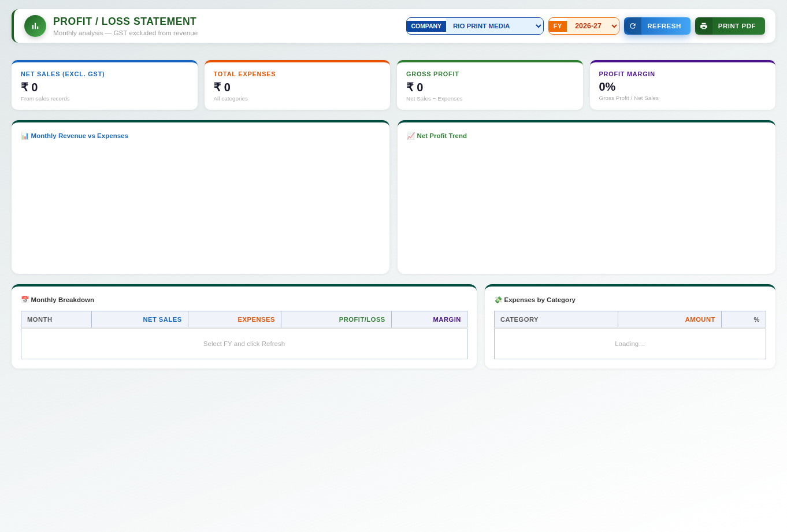
Buttons & Actions
- REFRESH — Reloads the latest data from the server.
- PRINT PDF — Generates a downloadable, printable PDF of the profit & loss statement.
Dropdown Fields
- Selection field — Choose from: RIO PRINT MEDIA, RAINBOW UMBRELLAS.
- Pnl Fy Select — Financial year used for the profit & loss calculation. (Options: 2027-28, 2026-27, 2025-26, 2024-25, 2023-24, 2022-23)

9. Follow-ups
Follow-ups is a lightweight task/reminder list for customer or job follow-up actions, each with a priority level and due date.
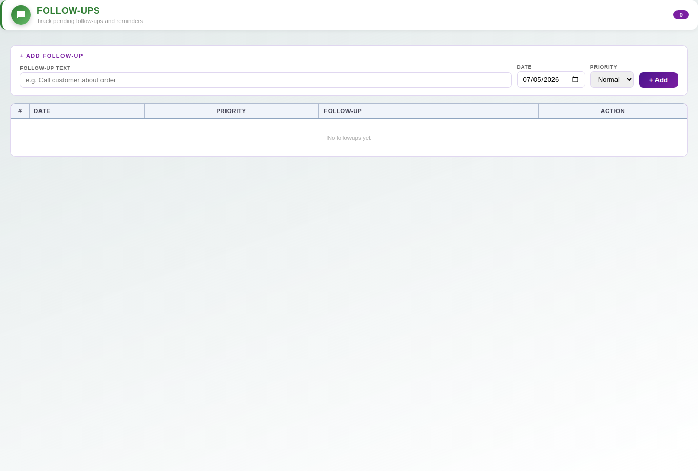
Buttons & Actions
- + Add — Adds a new record (the exact item depends on the section it appears in — e.g. a bank account, contact, or category).
Dropdown Fields
- New Followup Priority — Priority level of the new follow-up (High / Normal / Low). (Options: Normal, High, Low)
Input Fields
- e.g. Call customer about order — Free-text field.
- New Followup Date — Date the follow-up is due.

10. Notes
Notes lets staff record free-form notes tied to a date, with the ability to convert a note into a follow-up or mark it addressed.
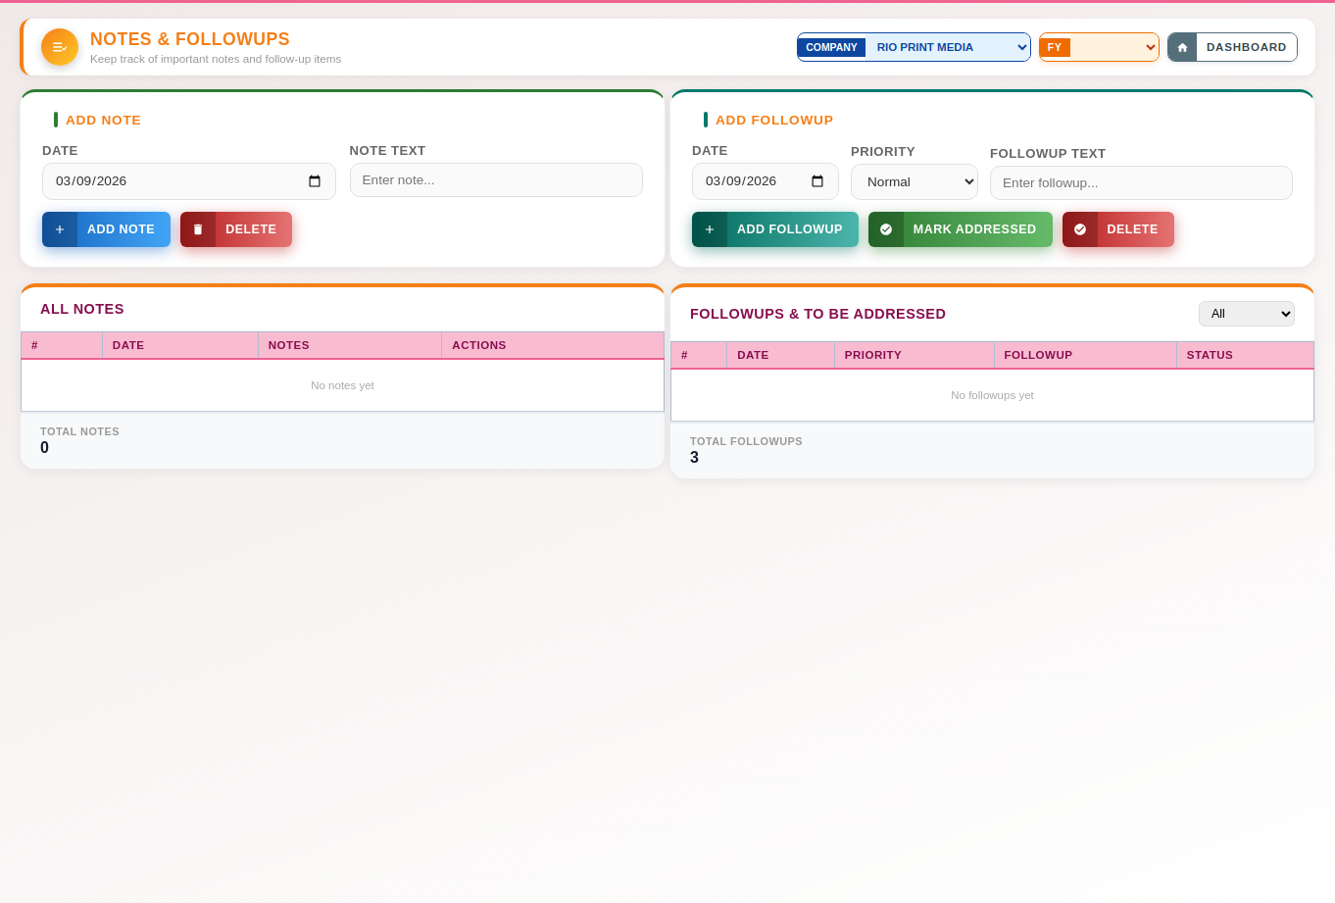
Buttons & Actions
- ADD NOTE — Saves the note currently being typed.
- DELETE — Deletes the selected record. This cannot be undone.
- ADD FOLLOWUP — Converts the selected note into a follow-up task.
- MARK ADDRESSED — Marks the selected follow-up as complete/actioned.
Dropdown Fields
- Selection field — Choose from: RIO PRINT MEDIA, RAINBOW UMBRELLAS.
- F Priority — Priority level shown for this follow-up (High / Normal / Low). (Options: High, Normal, Low)
- Selection field — Choose from: All, Pending, Addressed.
Input Fields
- N Date — Date associated with the note.
- Enter note... — Free-text field.
- F Date — Date the follow-up is due.
- Enter followup... — Free-text field.

11. Job Tracker
Job Tracker manages production jobs from creation through completion — status, size, job card printing, CSV export, and filtering by status.
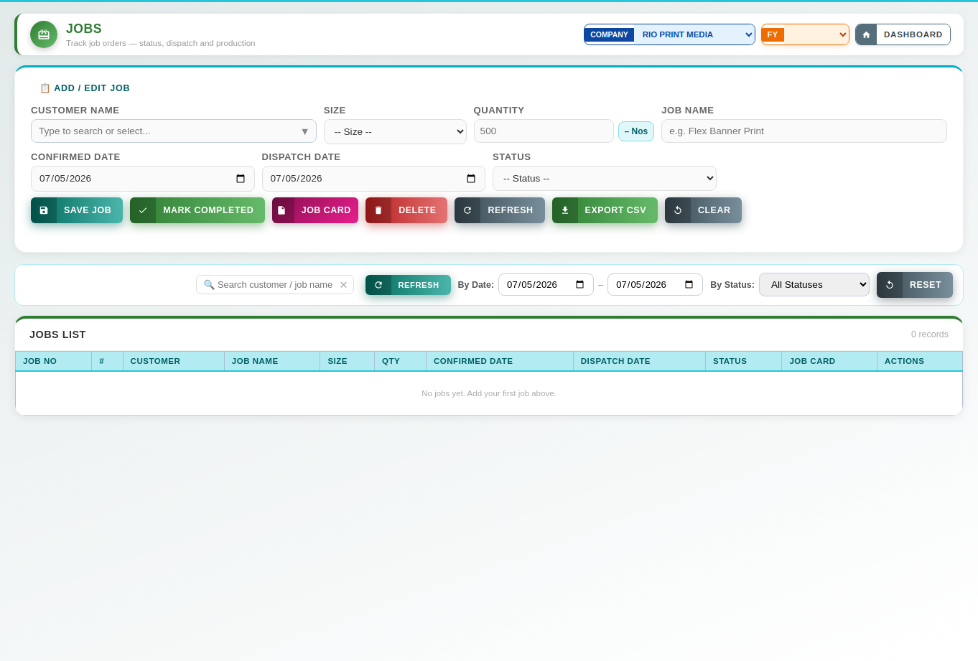
Buttons & Actions
- ✕ Cancel — Cancels the current entry without saving and clears the form.
- SAVE JOB — Saves the new or edited job record.
- MARK COMPLETED — Marks the selected job as completed.
- JOB CARD — Opens a printable job card for the selected production job.
- DELETE — Deletes the selected record. This cannot be undone.
- REFRESH — Reloads the latest data from the server.
- EXPORT CSV — Downloads the current list as a CSV file for use in Excel or other software.
- CLEAR — Clears every field in the form back to blank/default values.
- RESET — Clears the filter fields back to their defaults.
Dropdown Fields
- Selection field — Choose from: RIO PRINT MEDIA, RAINBOW UMBRELLAS.
- J Size — Size/dimension of the job. (Options: -- Size --, 16x6 Inches, 18x6 Inches, 12x18 Inches, 12x12 Inches, 16x16 Inches, …)
- J Status — Current production status of the job. (Options: -- Status --, Color Correction, In Production, Pending Payment, Completed)
- J Status Filter — Filter the job list by production status. (Options: All Statuses, Color Correction, In Production, Pending Payment, Completed)
Input Fields
- Type to search or select... — Free-text field.
- 500 — Enter a numeric value.
- e.g. Flex Banner Print — Free-text field.
- J Confirmed Date — Date the job order was confirmed.
- J Dispatch Date — Date the job was (or should be) dispatched.
- Search customer / job name… — Free-text field.
- J Date From — Start date of the job list filter range.
- J Date To — End date of the job list filter range.

12. Customers
The Customers module is the master customer database — add, edit, and manage customer records, including bulk import/export via CSV and a one-click sync to the sales tracker.
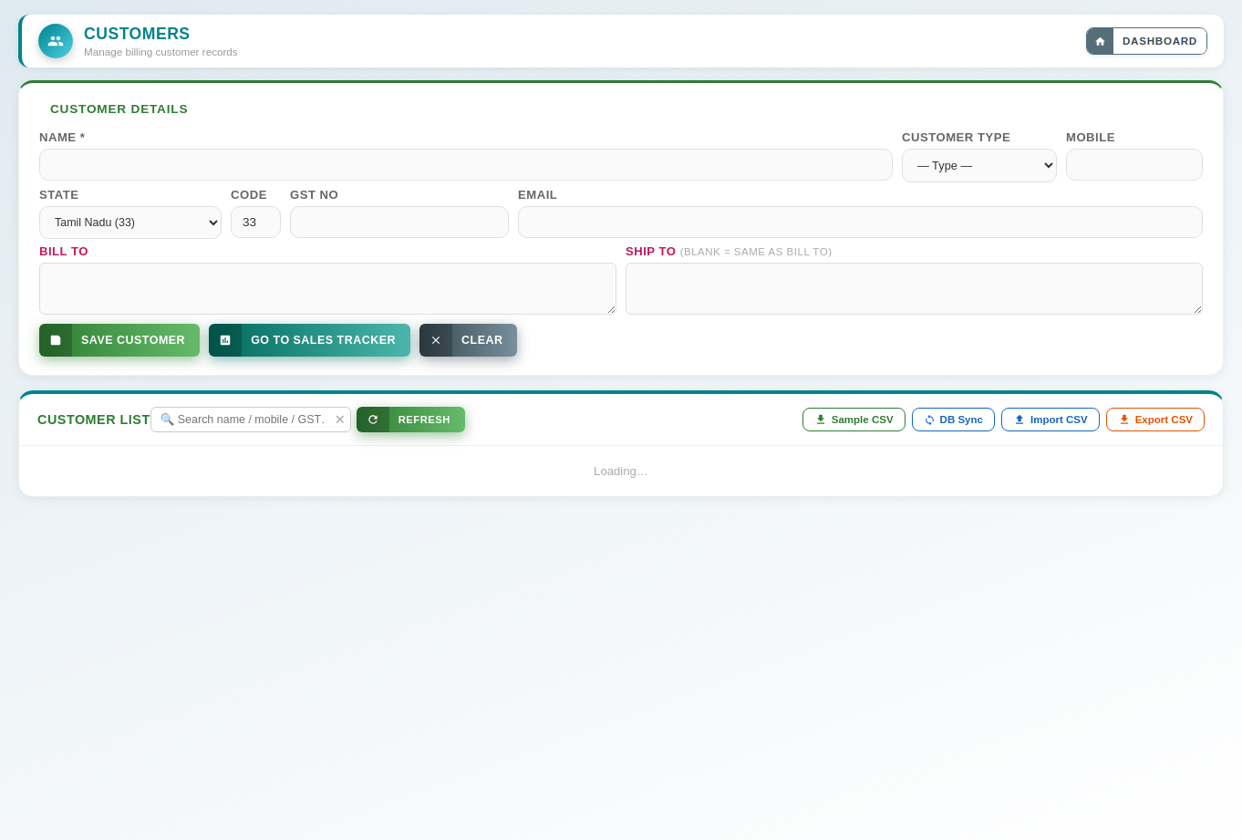
Buttons & Actions
- SAVE CUSTOMER — Saves the new or edited customer record.
- GO TO SALES TRACKER — Jumps back to the Sales Tracker screen.
- Cancel Edit — Exits edit mode without saving changes and returns the form to blank.
- CLEAR — Clears every field in the form back to blank/default values.
- REFRESH — Reloads the latest data from the server.
- Sample CSV — Downloads a blank template CSV showing the column headings expected for import.
- DB Sync — Synchronises the on-screen data with the server database.
- Import CSV — Uploads a CSV file to bulk add or update records in one go.
- Export CSV — Downloads the current list as a CSV file for use in Excel or other software.
Dropdown Fields
- Cust Type — Customer category/type (Retailer, Trust, Corporate, Dealer, etc.). (Options: — Type —, Retailer, Trust, Corporate, Dealer, End Customer)
- Cust State Sel — Customer's state, used for GST place-of-supply. (Options: — State —, Andhra Pradesh (37), Arunachal Pradesh (12), Assam (18), Bihar (10), Chhattisgarh (22), …)
Input Fields
- Cust Name — Customer's full name.
- Cust Mobile — Customer's mobile number.
- Cust State Code — GST state code, auto-filled from the selected state.
- Cust Gst — Customer's GSTIN (GST registration number), if registered.
- Cust Email — Enter an email address.
- Search name / mobile / GST… — Free-text field.
- Cust Import File — Choose a CSV file to bulk-import customers.

Updates since the original guide (v224 – v242)
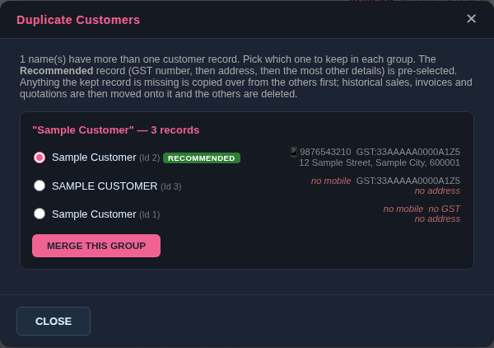
Check Duplicates (sample data). The recommended record is pre-selected; each row shows what it has and what it is missing.
- Check Duplicates — Next to DB Sync. Lists customers that share a name once capital letters and spaces are ignored. In each group choose the record to keep then click Merge This Group. Each record shows its mobile, GST number and billing address. The record with a GST number, then a billing address, then the most other details filled in is pre-selected and marked Recommended; choose a different one if you prefer.
- What merging does — Any detail the kept record is missing (GST number, billing and shipping address, mobile, email, state, customer type) is first copied over from the records being removed, so nothing is lost; where both have a value, the kept record's is used. Sales, invoices and quotations then move to the kept customer; old invoices and quotations are never blanked (a detail is written to them only when it has a value). The other records are deleted. This cannot be undone, so take a database backup first.
- Saving a customer — Names are compared ignoring capital letters, so 'john' and 'John' cannot be added twice. Renaming a customer to a name that already exists is refused.

13. Invoice
The Invoice screen is used to raise GST or Non-GST invoices, add multiple line items, and save/print or email the finished invoice directly to the customer.
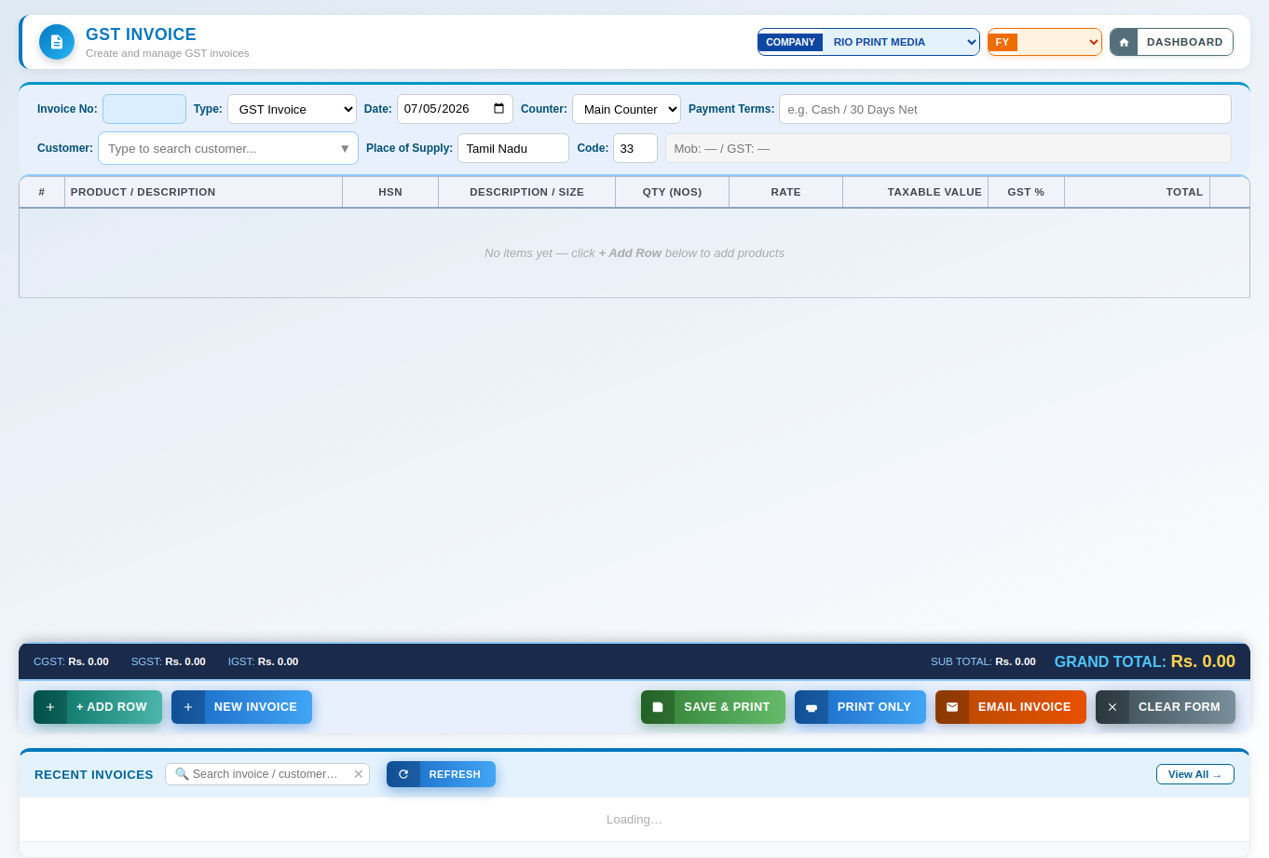
Buttons & Actions
- + ADD ROW — Adds another blank line-item row to the table above.
- NEW INVOICE — Clears the form so a fresh invoice can be started.
- SAVE & PRINT — Saves the invoice and immediately opens the print view.
- PRINT ONLY — Opens a printable view of the invoice without marking it as emailed/sent.
- EMAIL INVOICE — Emails the saved invoice as a PDF directly to the customer.
- CLEAR FORM — Empties the form so a brand-new record can be started.
- Cancel Edit — Exits edit mode without saving changes and returns the form to blank.
- REFRESH — Reloads the latest data from the server.
- View All → — Opens the full list on its own dedicated screen.
Dropdown Fields
- Selection field — Choose from: RIO PRINT MEDIA, RAINBOW UMBRELLAS.
- Inv Type — Whether this is a GST Invoice or a Non-GST Invoice. (Options: GST Invoice, Non-GST Invoice)
- Inv Counter — Billing counter the invoice is being raised from. (Options: Main Counter, Counter 2, Counter 3)
Input Fields
- Inv No — Invoice number (auto-generated; editable if needed).
- Inv Date — Date printed on the invoice.
- e.g. Cash / 30 Days Net — Free-text field.
- Type to search customer... — Free-text field.
- Inv Cust Search — Search box used to find and select the customer for this invoice.
- Inv Supply — Place of Supply — the customer's state, auto-filled once a customer is chosen.
- Inv Supply Code — Place of Supply state code, auto-filled from the customer's state.
- Mob: — / GST: — — Free-text field.
- Search invoice / customer… — Free-text field.

14. Invoice Manager
Invoice Manager is the searchable list of all invoices raised, filterable by invoice type (GST/Non-GST), with quick search.
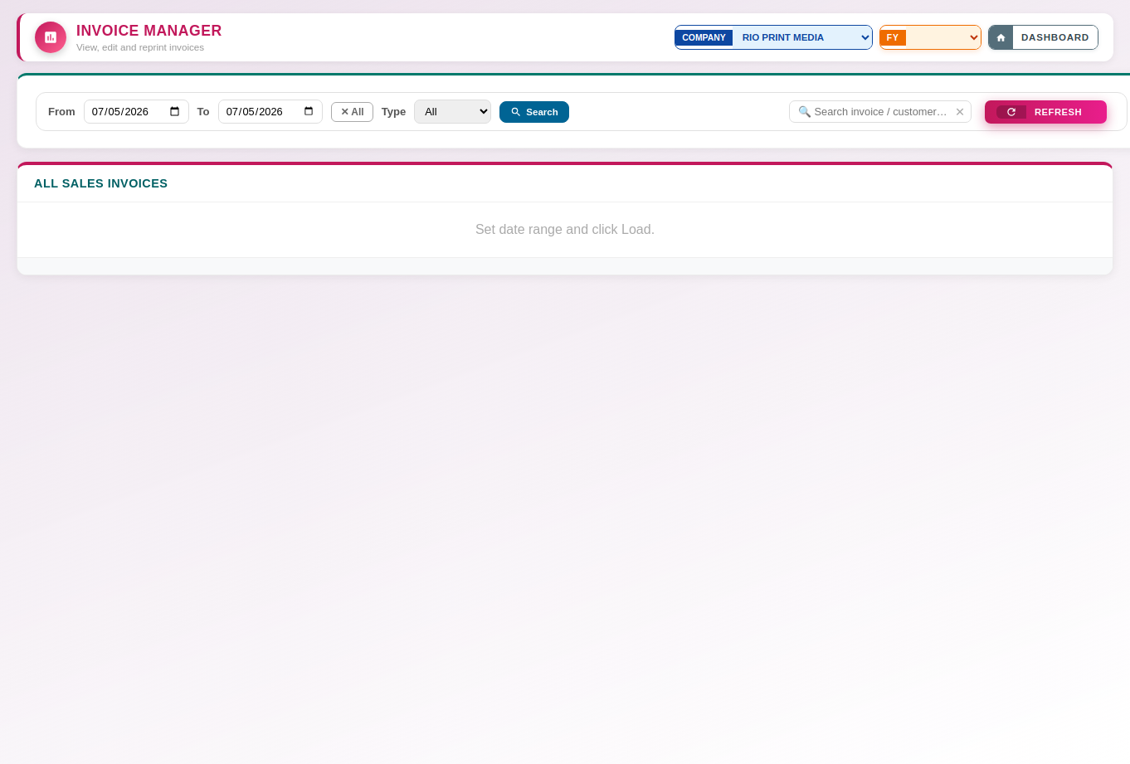
Buttons & Actions
- ✕ All — Clears the type filter and shows every record regardless of type.
- Search — Searches the list by the text entered (e.g. invoice number or customer name).
- REFRESH — Reloads the latest data from the server.
- Financial year — The list shows the invoices whose DATE is in the financial year chosen at the top of the screen (All Years shows every year). If an invoice seems to be missing, check the year selected at the top. The "Invoice already generated" message names the year of the invoice and can switch to it.
Dropdown Fields
- Selection field — Choose from: RIO PRINT MEDIA, RAINBOW UMBRELLAS.
- Mgr Type — Filter the invoice list by GST / Non-GST type. (Options: All, GST, Non-GST)
Input Fields
- Mgr From — Start date of the invoice manager filter range.
- Mgr To — End date of the invoice manager filter range.
- Search invoice / customer… — Free-text field.

Updates since the original guide (v248): cancelling invoices
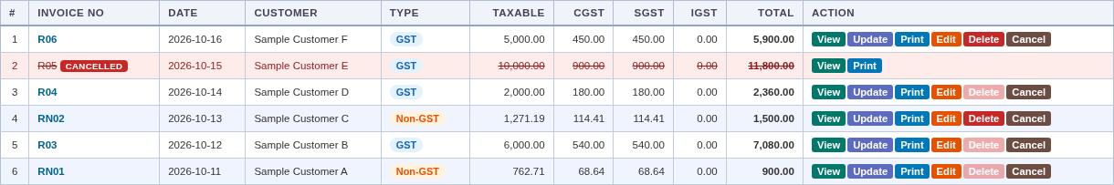
Invoice Manager with a cancelled invoice (sample data).
- Cancel (new button on every invoice) — Admins only. Asks for a reason, then marks the invoice CANCELLED. It keeps its number and stays in the list, struck through with a red CANCELLED badge (hover it to see the reason, who and when). It is left out of totals and reports, can no longer be edited or updated, and the sale it was made for can be invoiced again with a new number. This cannot be undone.
- Delete (stricter) — Only the most recent invoice of its series (GST or Non-GST), and only if it was never printed or shared. Once an invoice has been printed or made into a PDF it can only be cancelled. A cancelled invoice cannot be deleted.
- Numbers are not reused after a cancellation — Cancelling R05 means the next invoice is R06. (A never-issued invoice that is deleted does give its number back, because it never left the building.)
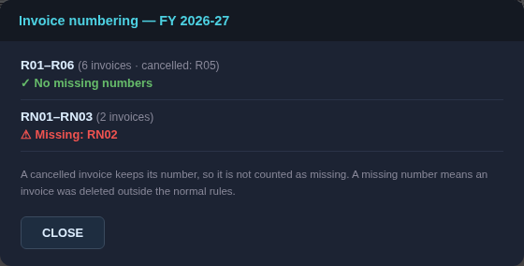
Check numbering (sample data).
- Check numbering — Beside Search. For each series in the selected financial year it shows how many invoices there are, which were cancelled, and any number that is missing (a cancelled number is not missing). A missing number means an invoice was deleted outside the normal rules.
- Duplicate numbers — If one number is used by more than one invoice, Check numbering lists each invoice (id, date, customer, amount, and whether it was printed or cancelled). An admin can give one invoice the next free number (New number) or cancel it. Once only one live invoice is left on the number, the DUPLICATE mark disappears (a cancelled copy does not count). Keep one invoice on the number; a customer who already holds a printed or sent invoice still knows it by the old number, and sales linked to the shared number are left alone and reported. In the Invoice Manager and the register, such invoices carry an orange DUPLICATE mark and the header counts them.
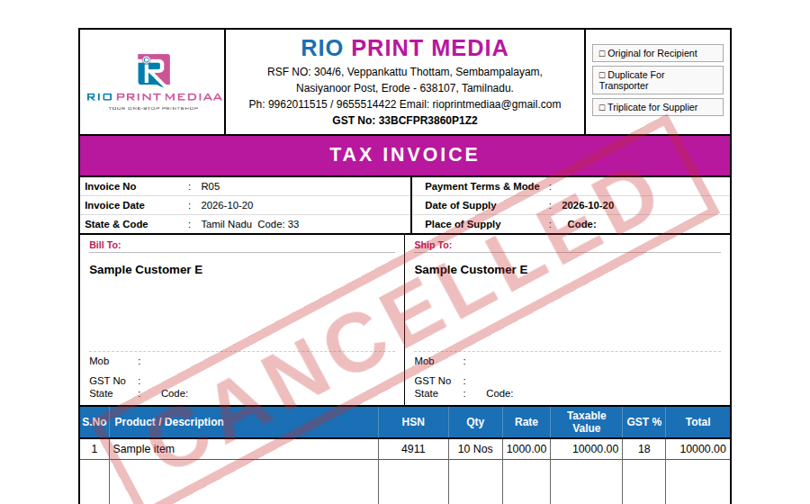
A cancelled invoice still opens and prints, with CANCELLED across it (sample data).
- CANCELLED watermark — A cancelled invoice can still be viewed, printed and downloaded; it carries a large red CANCELLED so it cannot be mistaken for a live one.
- Saving — If another user has just used the same invoice number, the save is refused with a message giving the next free number. Refresh the number and save again.
- Lists and reports — The Invoice Manager and the invoice register show cancelled invoices; the Dashboard totals, the Invoice Report and the sales report leave them out.
- GST returns — Ask your accountant how cancelled invoices should be shown in your GST return.

15. Quotation
Quotation works like the Invoice screen but for pre-sale quotations — add line items, save, print, or email a quotation to a prospective customer.
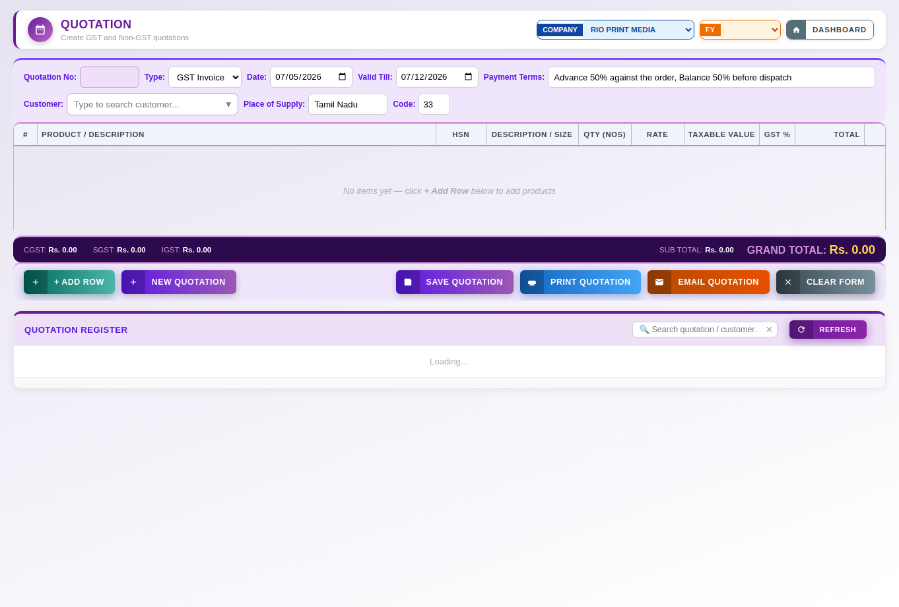
Buttons & Actions
- + ADD ROW — Adds another blank line-item row to the table above.
- NEW QUOTATION — Clears the form so a fresh quotation can be started.
- SAVE QUOTATION — Saves the quotation.
- PRINT QUOTATION — Opens a printable view of the quotation.
- EMAIL QUOTATION — Emails the saved quotation as a PDF directly to the customer.
- CLEAR FORM — Empties the form so a brand-new record can be started.
- Cancel Edit — Exits edit mode without saving changes and returns the form to blank.
- REFRESH — Reloads the latest data from the server.
Dropdown Fields
- Selection field — Choose from: RIO PRINT MEDIA, RAINBOW UMBRELLAS.
- Quot Type — Whether this is a GST or Non-GST quotation. (Options: GST Invoice, Non-GST)
Input Fields
- Quot No — Quotation number (auto-generated; editable if needed).
- Quot Date — Date printed on the quotation.
- Quot Valid — Date the quotation remains valid until.
- Quot Terms — Payment or delivery terms printed on the quotation.
- Type to search customer... — Free-text field.
- Quot Cust Search — Search box used to find and select the customer for this quotation.
- Quot Supply — Place of Supply — the customer's state, auto-filled once a customer is chosen.
- Quot Supply Code — Place of Supply state code, auto-filled from the customer's state.
- Search quotation / customer… — Free-text field.

16. Ledger
Ledger is the core accounting register — opening balances, credits/debits by account and month, with filters by financial year, month, account, and entry type.
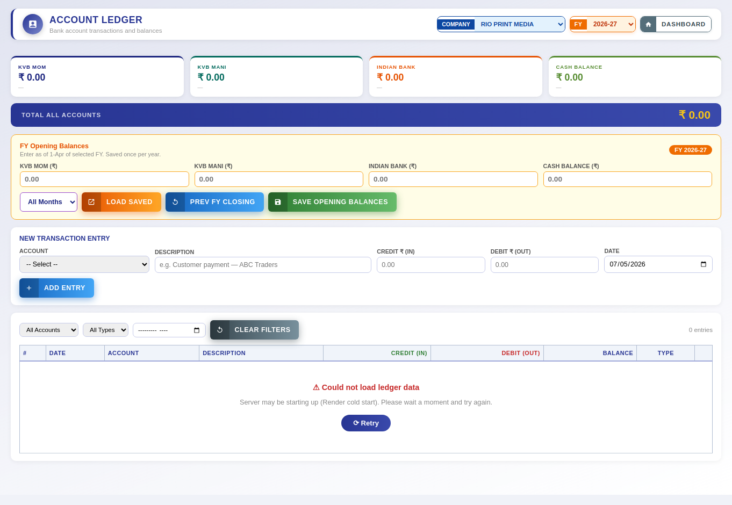
Buttons & Actions
- LOAD SAVED — Loads the previously saved opening balances for the selected financial year.
- PREV FY CLOSING — Copies the closing balances from the previous financial year in as this year's opening balances.
- SAVE OPENING BALANCES — Saves the opening balances entered for each account for the selected financial year.
- ADD ENTRY — Saves the entry currently filled in on the form into the list/table below.
- CLEAR FILTERS — Resets all filters back to their default, unfiltered state.
- ⟳ Retry — Retries the last failed server connection or sync attempt.
Dropdown Fields
- Selection field — Choose from: RIO PRINT MEDIA, RAINBOW UMBRELLAS.
- Ledger Fy Select — Financial year shown in the ledger. (Options: 2027-28, 2026-27, 2025-26, 2024-25, 2023-24)
- Acct Month Filter — Filter ledger entries to a specific month. (Options: All Months, January, February, March, April, May, …)
- Ledger Acct — Bank/cash account the opening balance or entry applies to. (Options: -- Select --, KVB MOM, KVB Mani, Indian Bank, Cash Balance)
- Ledger Filter Acct — Filter the ledger to a specific account. (Options: All Accounts, KVB MOM, KVB Mani, Indian Bank, Cash Balance)
- Ledger Filter Type — Filter the ledger by entry type (Opening, Credit, Debit, Manual). (Options: All Types, Opening, Credit, Debit, Manual)
Input Fields
- Amount — Enter an amount in rupees.
- e.g. Customer payment — ABC Traders — Free-text field.
- Ledger Date — Date of the ledger entry.
- Ledger Filter Month — Filter the ledger to a specific month.

Updates since the original guide (v236)
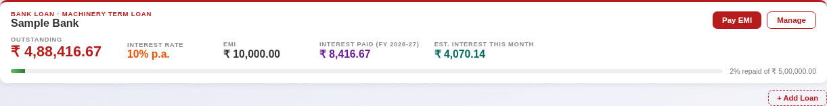
The Bank loan strip under Total All Accounts (sample data). Visible to admins only.
- Bank loan strip — Shown to admins under TOTAL ALL ACCOUNTS. For each active loan: lender, OUTSTANDING balance, interest % per year, EMI, interest paid in the selected financial year, estimated interest for this month (outstanding × rate ÷ 12, an estimate only) and a % repaid bar. The loan is a liability, so it is not added into the account totals.
- Pay EMI — Opens the Record EMI window (below). Manage opens the loan's details and payment history. + Add Loan adds another loan.
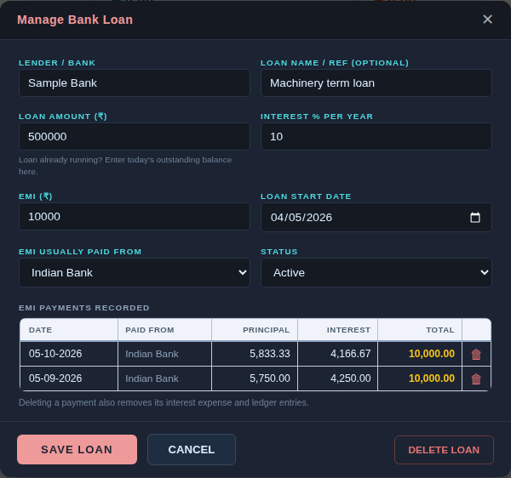
Manage Bank Loan (sample data).
- Add / Manage Loan fields — Lender / Bank; Loan name / ref (optional); Loan amount (for a loan that is already running, enter today's outstanding balance); Interest % per year; EMI; Loan start date; EMI usually paid from; Status (Active or Closed). If you change the interest %, a Rate effective from date appears and the earlier rate is kept in the loan's history.
- EMI payments recorded — A table of every EMI with a 🗑 button. Deleting a payment also removes its interest expense and ledger entries and puts the outstanding balance back. A loan that has payments cannot be deleted; mark it Closed instead.
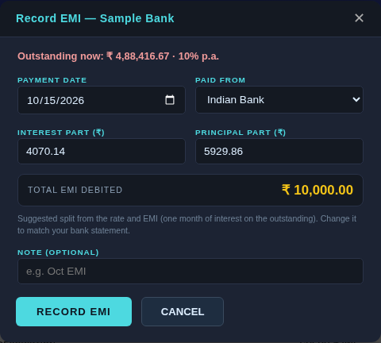
Record EMI (sample data). The split is suggested from the rate and EMI; change it to match your bank statement.
- Record EMI — Payment date, Paid from (KVB MOM, KVB Mani, Indian Bank or Cash), Interest part, Principal part, a live Total EMI debited, and an optional Note. The principal part reduces the outstanding balance. The interest part is recorded as an expense (Admin & Finance › Bank Interest). Both debit the paying account in the Ledger; the principal shows with type Loan Repayment.
- Balance 4 payments — Sales payments recorded as Balance 4 in the Sales Tracker appear in the Ledger as credits like any other payment.

17. Products
Products is the master product/catalog list — category, unit of measure, GST rate, and size variants, with CSV import/export and a shortcut back to Sales Tracker.
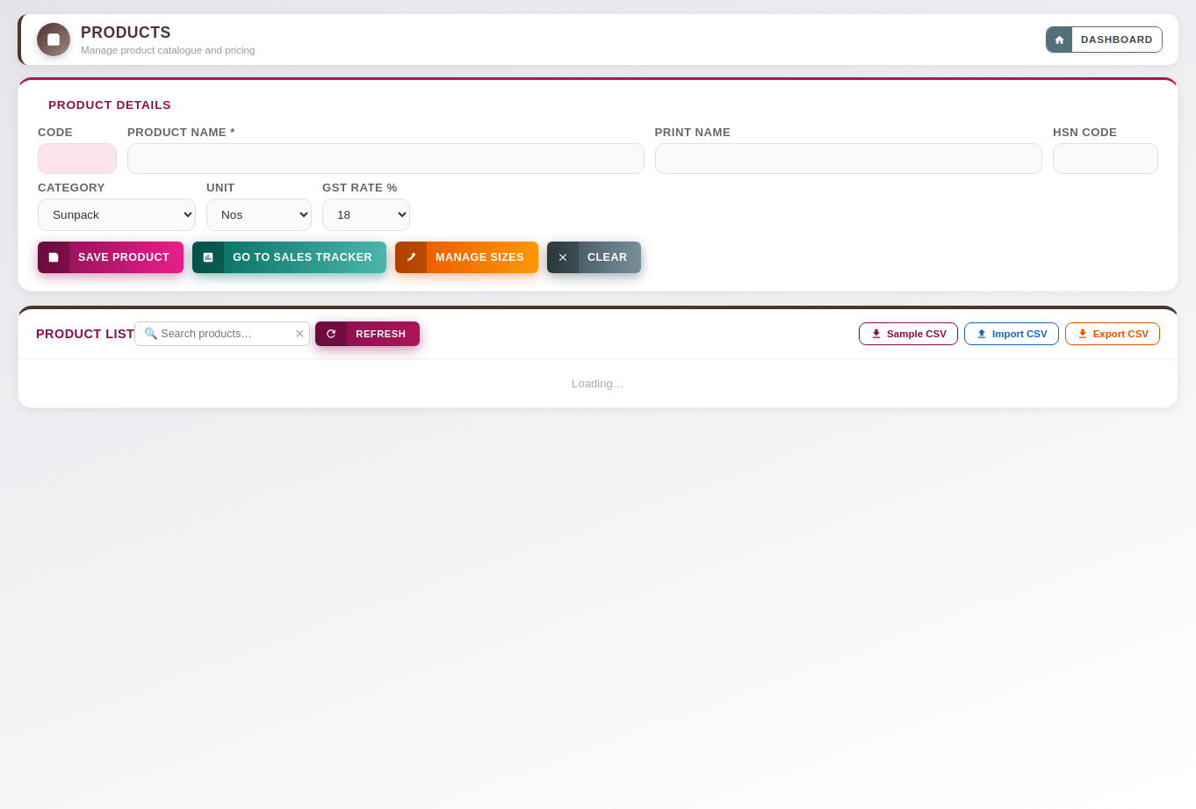
Buttons & Actions
- SAVE PRODUCT — Saves the new or edited product record.
- GO TO SALES TRACKER — Jumps back to the Sales Tracker screen.
- MANAGE SIZES — Opens a dialog to add or edit the list of available product sizes.
- Delete — Deletes the selected record. This cannot be undone.
- Cancel Edit — Exits edit mode without saving changes and returns the form to blank.
- CLEAR — Clears every field in the form back to blank/default values.
- REFRESH — Reloads the latest data from the server.
- Sample CSV — Downloads a blank template CSV showing the column headings expected for import.
- Import CSV — Uploads a CSV file to bulk add or update records in one go.
- Export CSV — Downloads the current list as a CSV file for use in Excel or other software.
Dropdown Fields
- Prod Cat — Product category. (Options: Sunpack, Flex, Vinyl, Banner, Label, Sticker, …)
- Prod Unit — Unit of measure used for this product (Nos, Sq.Ft, Mtr, etc.). (Options: Nos, Sq.Ft, Sq.Mtr, Mtr, Kg, Set, …)
- Prod Gst — GST rate applied to this product. (Options: 0, 5, 12, 18, 28)
Input Fields
- Prod Code — Internal product code/SKU.
- Prod Name — Full product name.
- Prod Print — Short name printed on invoices and job cards.
- Prod Hsn — HSN code used for GST classification.
- Search products… — Free-text field.
- Prod Import File — Choose a CSV file to bulk-import products.

18. Reports
Reports is a central hub of pre-built report types (sales, expenses, invoices, quotations, customers, jobs, bank transactions, etc.) each with its own filters and Export to Excel/PDF, Print, and Email actions.
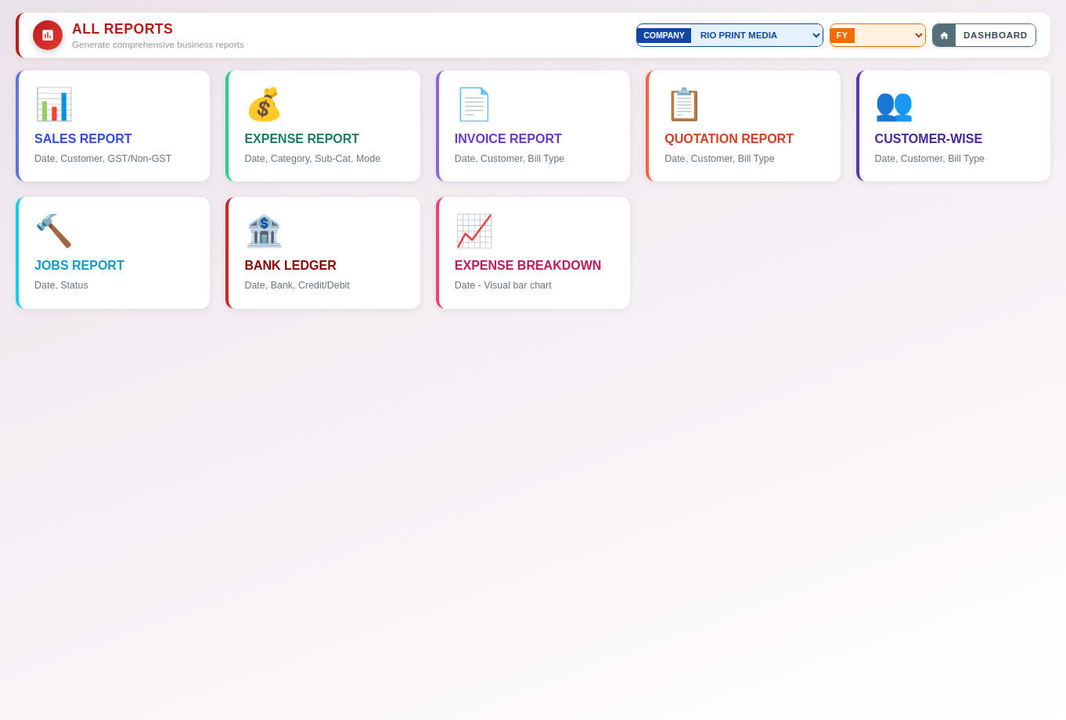
Buttons & Actions
- ← Back to All Reports — Returns to the main Reports hub grid.
- Load Report — Generates the report below using the filters chosen above.
- Export Excel — Downloads the report as an Excel spreadsheet.
- Export PDF — Downloads the report as a PDF file.
- Print — Prints the current report or document.
- Email — Emails the generated report.
Dropdown Fields
- Selection field — Choose from: RIO PRINT MEDIA, RAINBOW UMBRELLAS.
- Sales Type — Filter the sales report by GST / Non-GST type. (Options: All Types, GST, Non-GST)
- Expense Category — Filter the expense report by category. (Options: All Categories)
- Expense Subcategory — Filter the expense report by sub-category. (Options: All Sub-Categories)
- Expense Paymode — Filter the expense report by payment mode. (Options: All Modes, Cash, Card, UPI, Bank Transfer, Pending)
- Invoice Type — Filter the invoice report by GST / Non-GST type. (Options: All Types, GST, Non-GST)
- Quotation Type — Filter the quotation report by GST / Non-GST type. (Options: All Types, GST, Non-GST)
- Customer Type — Filter the customer report by type. (Options: All Types, GST, Non-GST)
- Jobs Status — Filter the jobs report by production status. (Options: All Status, Pending, In Progress, Completed)
- Bank Account — Filter the bank ledger report by account. (Options: All Banks, KVB MOM, KVB Mani, Indian Bank, Cash)
- Bank Txntype — Filter the bank ledger report by transaction type (Credit/Debit). (Options: All Transactions, Credit, Debit)
Input Fields
- Sales From — Pick a date.
- Sales To — Pick a date.
- Type to search or select... — Free-text field.
- Expense From — Pick a date.
- Expense To — Pick a date.
- Invoice From — Pick a date.
- Invoice To — Pick a date.
- Quotation From — Pick a date.
- Quotation To — Pick a date.
- Customer From — Pick a date.
- Customer To — Pick a date.
- Jobs From — Pick a date.
- Jobs To — Pick a date.
- Bank From — Pick a date.
- Bank To — Pick a date.
- Breakdown From — Pick a date.
- Breakdown To — Pick a date.

Updates since the original guide (v237 – v240)
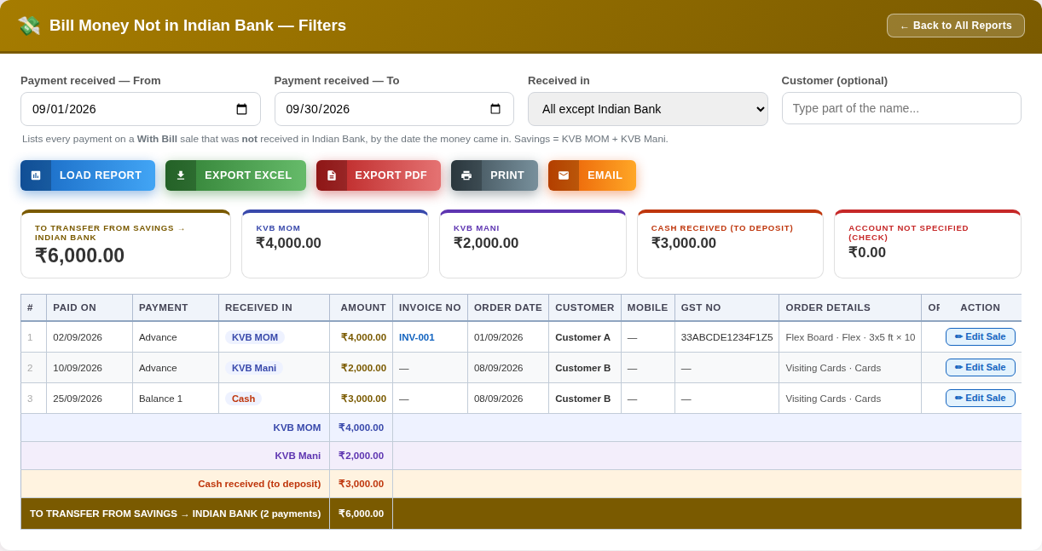
Bill Money Not in Indian Bank (sample data).
- Bill Money Not in Indian Bank (new report) — Lists every payment on a With Bill sale that was not received in Indian Bank, by the date the money came in, so you can see how much to move from savings to Indian Bank.
- Filters — Payment received — From and To (default: the current month); Received in (All except Indian Bank, KVB MOM, KVB Mani, Cash or Not specified); Customer (optional, part of the name).
- Summary cards and totals — To transfer from savings → Indian Bank (KVB MOM plus KVB Mani); each savings account; Cash received (to deposit), shown separately; and Account not specified (check). A payment with no account chosen is not posted to any ledger account, so check those.
- Table columns — Paid on, Payment (Advance or Balance 1–4), Received in, Amount, Invoice No, Order date, Customer, Mobile, GST No, Order details, Order total, Balance due, and Action.
- ✏ Edit Sale (Action column) — Opens that order in the Sales Tracker's edit form. The Action column is not included in Excel, PDF or Print.
- Sales Report dates — The Sales Report now reads its own From / To fields (they default to the current month). Previously it could read the Sales Tracker's date filter instead and say "Please select a date range" even when dates were filled in.
- Invoice and Quotation reports — Now include every record in the date range. Previously a very large range could be cut off after 500 records, understating the totals.
- Restricted users — Users set to see only their own records now also see only their own records in the Sales, Invoice, Quotation and Customer-wise reports, the same as in their registers.

19. Attendance
Attendance tracks employee attendance day by day — working day / holiday / off, permission hours, plus employee management, monthly reports, and CSV export.
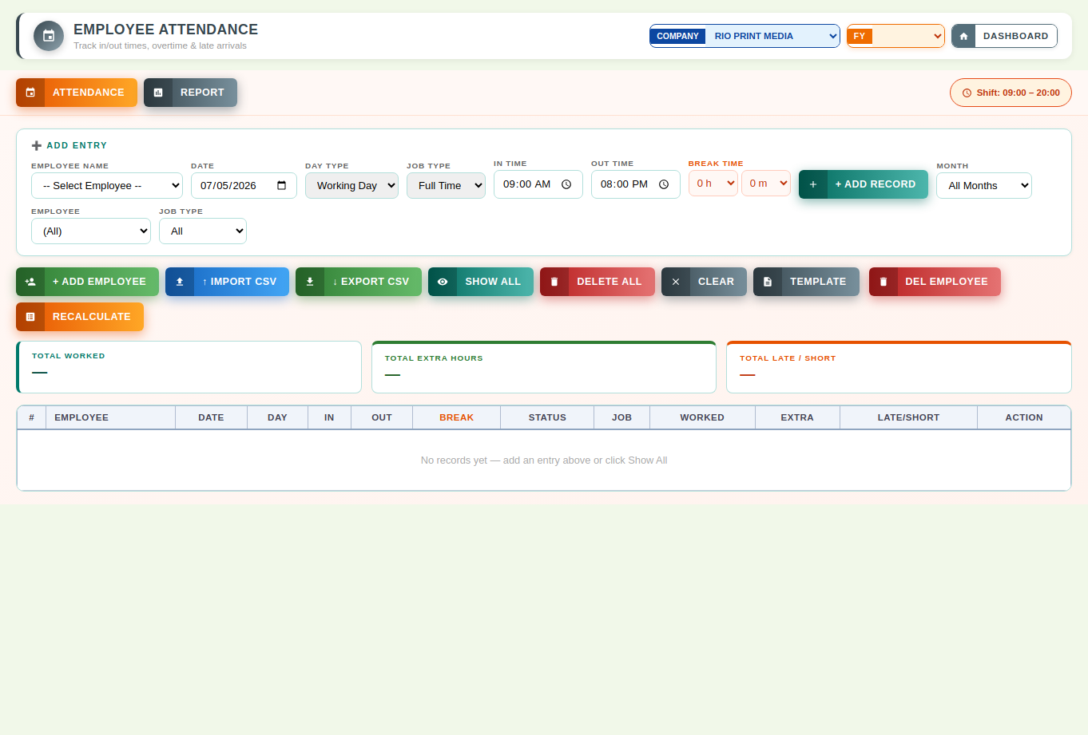
Buttons & Actions
- ATTENDANCE — Switches to the daily Attendance entry tab.
- REPORT — Switches to the Attendance monthly report tab.
- + ADD RECORD — Adds a new attendance record for the selected employee and date.
- + ADD EMPLOYEE — Opens a form to add a new employee to the attendance register.
- ↓ EXPORT CSV — Downloads the current list as a CSV file for use in Excel or other software.
- SHOW ALL — Removes all filters and shows every attendance record.
- DELETE ALL — Deletes every attendance record currently shown in the list (use with caution — this cannot be undone).
- CLEAR — Clears every field in the form back to blank/default values.
- TEMPLATE — Downloads an Excel template (attendance_template.xlsx). Name, Date, Type and Job Type are dropdowns; In Time and Out Time are typed by hand (24-hour, for example 09:00). Fill it in Excel, then use IMPORT CSV / EXCEL.
- IMPORT CSV / EXCEL — Uploads a filled attendance Excel file (.xlsx or .xls) or a CSV file and adds all its rows as attendance records. For an employee and date that already has a record you choose: skip it, or overwrite it.
- SHIFTS — Opens the shift dialog: for every employee choose Full Time or Part Time and the shift Start, End and Grace minutes. The change applies from the week of the date you choose; earlier days keep their old shift. Use RECALCULATE afterwards if old records should follow a new shift.
- DEL EMPLOYEE — Deletes the selected employees AND all their attendance records (this cannot be undone). To change an employee’s shift or type use SHIFTS instead.
- RECALCULATE — Recalculates attendance totals such as days worked and permission hours.
- Search DB — Looks up an employee's attendance history directly from the database.
- Delete from DB — Permanently removes the matched record from the database.
- ↓ Export CSV — Downloads the current list as a CSV file for use in Excel or other software.
Dropdown Fields
- Selection field — Choose from: RIO PRINT MEDIA, RAINBOW UMBRELLAS.
- Att Inp Name — Employee this attendance record belongs to. (Options: -- Select Employee --)
- Att Inp Type — Day type: Working Day, Sunday Off, or Holiday. (Options: Working Day, Sunday Off, Holiday)
- Att Inp Job — Employment type: Full Time or Part Time. (Options: Full Time, Part Time)
- Att Inp Perm H — Permission (short-leave) hours taken on this day. (Options: 0 h, 1 h, 2 h, 3 h, 4 h, 5 h, …)
- Att Inp Perm M — Permission (short-leave) minutes taken on this day. (Options: 0 m, 5 m, 10 m, 15 m, 20 m, 25 m, …)
- Att Filter Month — Filter the attendance list to a specific month. (Options: All Months, January, February, March, April, May, …)
- Att Filter Emp — Filter the attendance list to a specific employee. (Options: (All))
- Att Filter Job — Filter the attendance list by employment type. (Options: All, Full Time, Part Time)
- Att Rpt Emp — Employee to include in the attendance report. (Options: (All))
- Att Rpt Job — Employment type to include in the attendance report. (Options: All, Full Time, Part Time)
Input Fields
- Att Inp Date — Date of the attendance record.
- Att Inp In — Check-in time.
- Att Inp Out — Check-out time.
- File — Choose a CSV file to upload.
- Att Rpt From — Start date of the attendance report range.
- Att Rpt To — End date of the attendance report range.
- Att Hide Nonworking — Tick to hide holidays/off-days from the attendance report.

Updates since the original guide (v218 – v235)
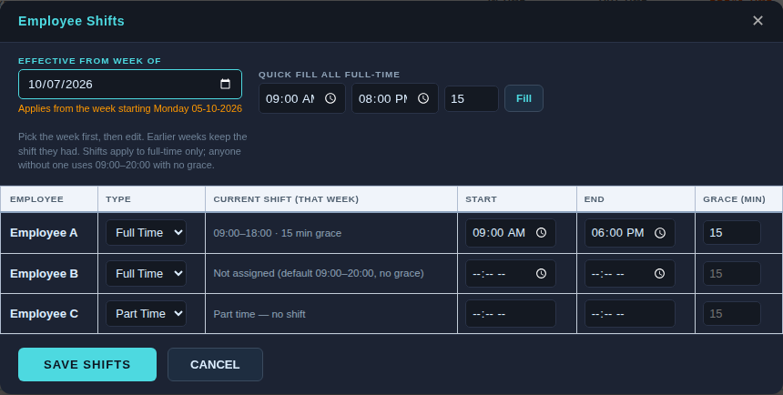
Employee Shifts (sample data).
- + ADD EMPLOYEE (updated) — Now a form: Employee name, Job Type (Full Time or Part Time) and, for full-time staff, the shift Start, End and Grace minutes (default 09:00, 20:00 and 15).
- SHIFTS — Opens Employee Shifts for existing employees. Pick Effective from week of (the date snaps to that week's Monday; weeks run Monday to Sunday), edit each full-time employee's Start, End and Grace, or use Quick fill all full-time, then Save Shifts.
- How shifts apply — A change applies from the chosen week onward; earlier weeks keep the shift they had. Re-saving the same week replaces that week's entry. Saving recalculates only that employee's records from that week. Part-time employees have no shift. An employee with no shift assigned uses 09:00–20:00 with no grace, as before.
- Grace period and late time — Arriving within the grace minutes is not late. After that, only the minutes past the grace count (shift 09:00, grace 15: 09:10 is not late, 09:20 is 5 minutes late). Leaving before the shift end counts as late; time before the start or after the end is extra; Sunday work is all extra. Part-time employees have no late or extra time.
- Shift label (top right) — Shows the selected employee's shift for the selected date, or "Part time — no shift".
- Total Extra Hrs column — On the Attendance grid and the Report tab, after Late/Short: Extra minus Late/Short. Positive is green with +, negative is red with −, and nothing shows as --.
- SALARY tab — A third tab beside Attendance and Report. Choose From and To dates (default: the current month), Rate Type (Per Hour or Per Day), the rate, and Employee Type (All, Part Time or Full Time), tick the employees, and click Calculate to see days present, total hours, extra hours and pay at the single rate. Export CSV downloads the result; Save Salary Record stores it.
- DEL EMPLOYEE (updated) — Opens a list of all employees with their record counts, with Select all, Clear and Delete Selected.

20. User Management
User Management is the admin screen for creating staff logins, assigning roles, choosing which company/companies a user can access, defining data-visibility scope, and building fully custom roles with granular permission checkboxes.
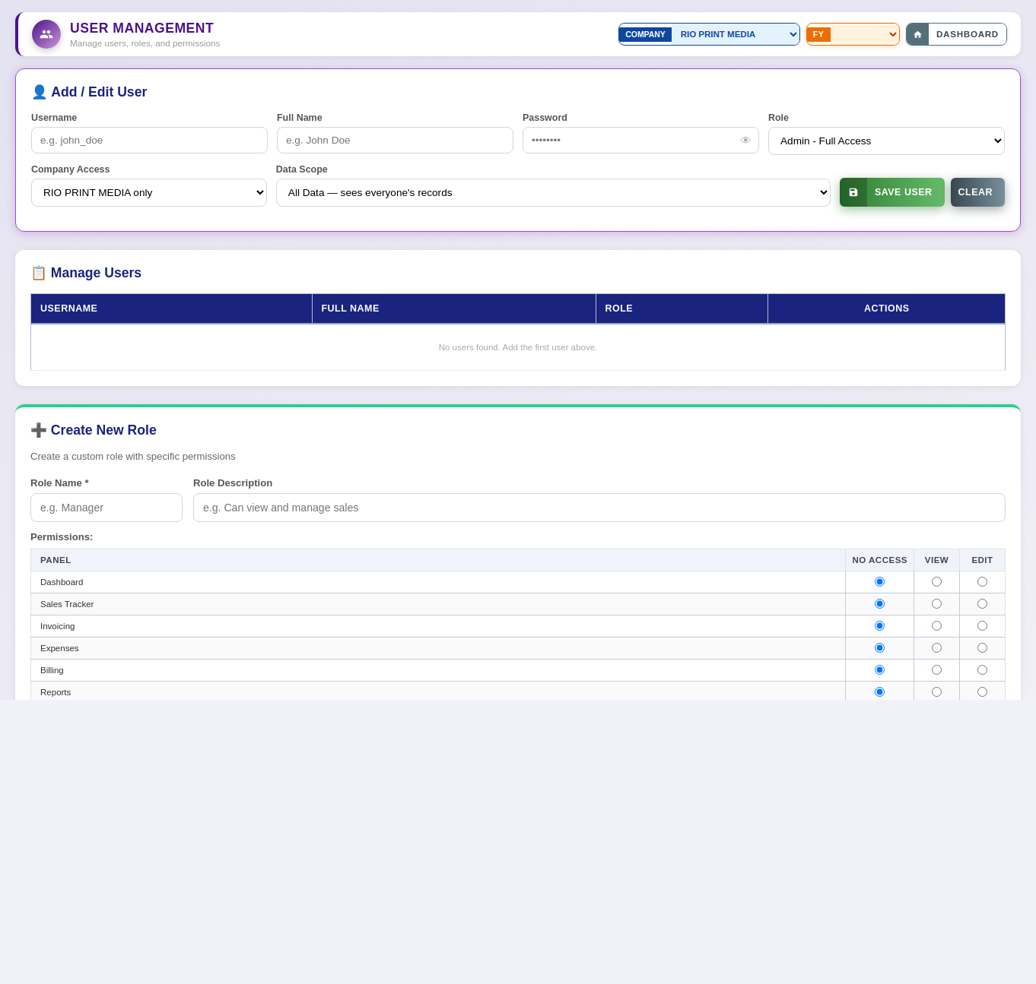
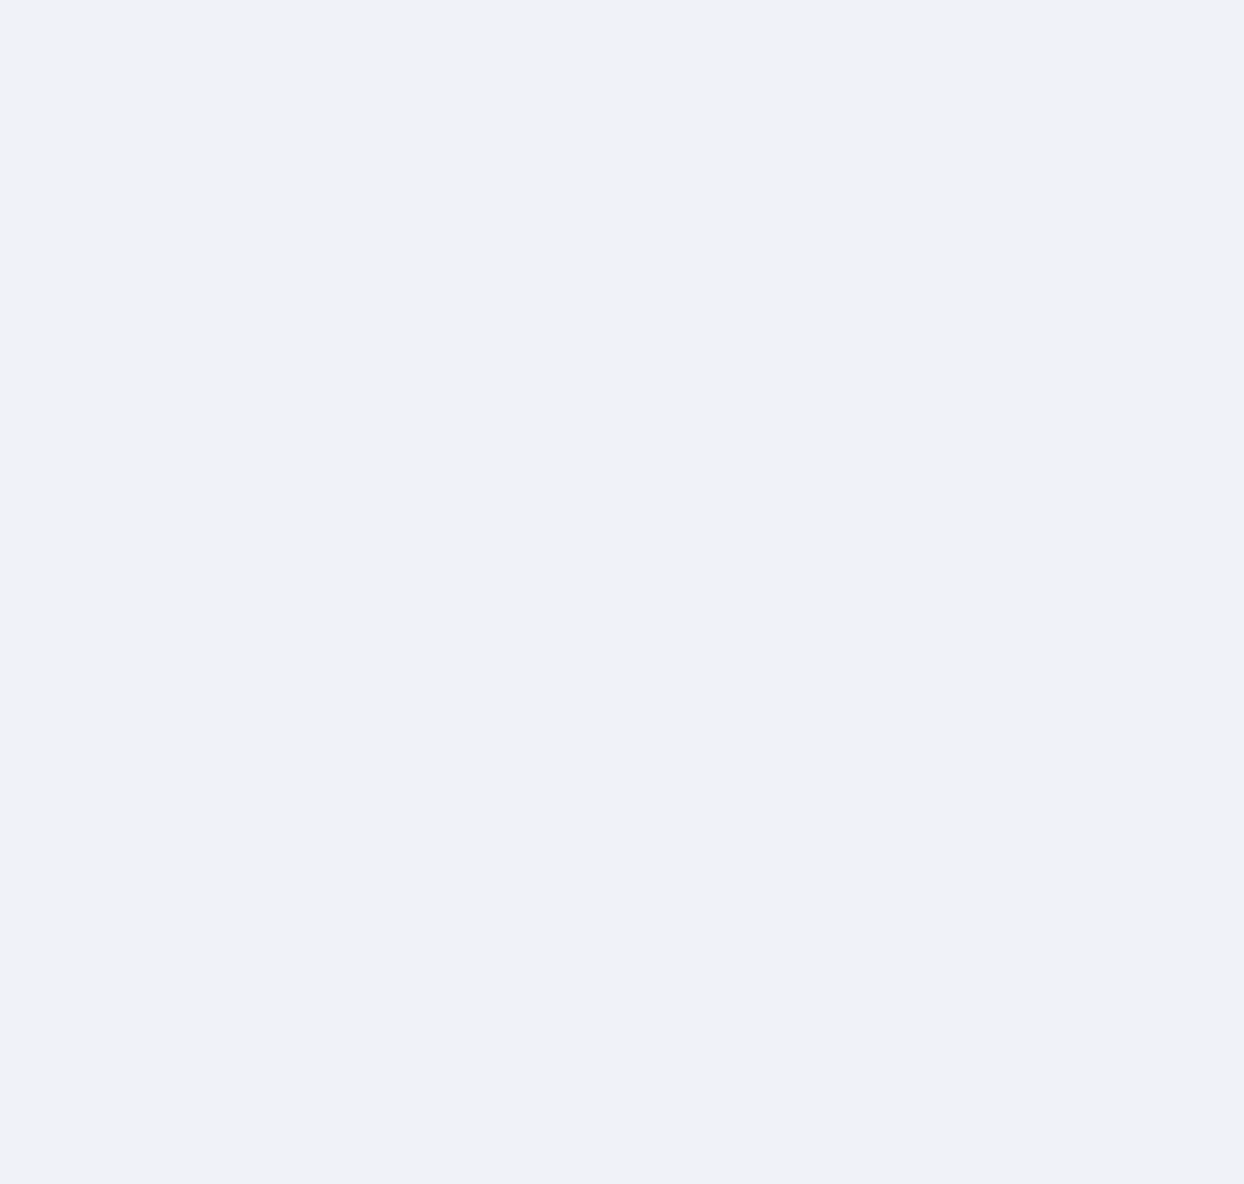
Buttons & Actions
- SAVE USER — Creates the new staff user account with the selected role, company access, and data scope.
- CLEAR — Clears every field in the form back to blank/default values.
- ✓ CREATE ROLE — Creates a new custom role using the name entered above.
- 🗑 Delete All — Permanently deletes all saved custom roles.
- SAVE ROLE CONFIGURATION — Saves the permission checkboxes configured for the role shown below.
Dropdown Fields
- Selection field — Choose from: RIO PRINT MEDIA, RAINBOW UMBRELLAS.
- Um Role — Role to assign to the new user — this controls what they can see and do. (Options: Admin - Full Access)
- Um Company Select — Which company (or both) this user is allowed to access. (Options: RIO PRINT MEDIA only, RAINBOW UMBRELLAS only, Both Companies)
- Um Scope — Whether the user can see everyone's records or only records they personally created. (Options: All Data — sees everyone's records, My Data Only — sees only their own records)
- Role Config Select — Choose which role's permission checkboxes you are editing below. (Options: Admin - Full Access)
The permission checkbox list below also includes Customer Billing, Customer-Wise Sales, and Profit / Loss Statement, which were previously missing from Configure Roles and Create Role — access to these three pages can now be granted or restricted per role like every other module.
Input Fields
- e.g. john_doe — Free-text field.
- e.g. John Doe — Free-text field.
- •••••••• — Enter the password (characters are hidden while typing).
- e.g. Manager — Free-text field.
- e.g. Can view and manage sales — Free-text field.
- Radio — Choose one option (e.g. Full Access / View Only / No Access).
- Cfgsub V Admin Sales — Tick to enable, untick to disable.
- Cfgsub E Admin Sales — Tick to enable, untick to disable.
- Cfgsub V Admin Expense — Tick to enable, untick to disable.
- Cfgsub E Admin Expense — Tick to enable, untick to disable.
- Cfgsub V Admin Invoice — Tick to enable, untick to disable.
- Cfgsub E Admin Invoice — Tick to enable, untick to disable.
- Cfgsub V Admin Quotation — Tick to enable, untick to disable.
- Cfgsub E Admin Quotation — Tick to enable, untick to disable.
- Cfgsub V Admin Customer — Tick to enable, untick to disable.
- Cfgsub E Admin Customer — Tick to enable, untick to disable.
- Cfgsub V Admin Jobs — Tick to enable, untick to disable.
- Cfgsub E Admin Jobs — Tick to enable, untick to disable.
- Cfgsub V Admin Bank — Tick to enable, untick to disable.
- Cfgsub E Admin Bank — Tick to enable, untick to disable.
- Cfgsub V Admin Breakdown — Tick to enable, untick to disable.
- Cfgsub E Admin Breakdown — Tick to enable, untick to disable.
- Purchase & Stock (role permission) — Grants access to the Purchase & Stock nav page (view or edit), same as any other module permission.
- Cfgsubps V Admin Suppliers / Purchases / Stock — Tick to enable view access to that Purchase & Stock sub-tab for this role, mirroring the Reports sub-permission checkboxes above.
- Cfgsubps E Admin Suppliers / Purchases / Stock — Tick to enable edit access to that Purchase & Stock sub-tab for this role.

Updates since the original guide (v244)
- Server-side protection — Creating or deleting users and creating or deleting roles now require an admin login on the server itself. Hiding a button was not enough: before this change anyone who could reach the server could call these actions directly.
- Changing your own password — Any logged-in user can still change their own password (for example the first-login change). Any other change to their own account, such as role or scope, is ignored.
- If an action is refused — A message explains why: "session expired, please log out and log in again" or "admin access is required". See chapter 24.

21. Company Settings
Company Settings stores company-level master data such as bank accounts, UPI/QR details, and business contacts, organised into categories.
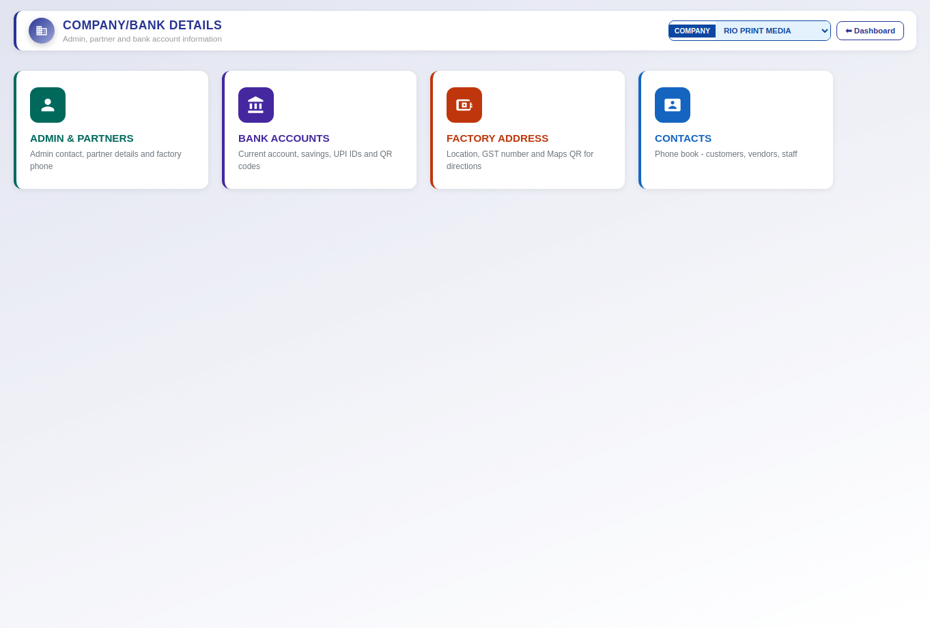
Buttons & Actions
- ⬅ Dashboard — Returns to the Dashboard.
- ← Back — Returns to the previous screen.
- + Add — Adds a new record (the exact item depends on the section it appears in — e.g. a bank account, contact, or category).
- ✏ Edit — Edits the selected record.
- 📋 Copy — Copies the selected details (e.g. bank account or contact info) to the clipboard.
- 📲 Copy QR — Copies the UPI QR code image so it can be shared or printed.
- Refresh — Reloads the latest data from the server.
- + Category — Adds a new contact category.
- ✏ Categories — Opens the category editor.
- + Add Contact — Opens a form to add a new company contact.
- SAVE — Saves the current record.
- CANCEL — Cancels the current entry without saving and clears the form.
- Open WhatsApp Web — Opens WhatsApp Web so the document can be sent to the customer from a browser.
- Open in App — Opens the document directly in the WhatsApp mobile app.
Dropdown Fields
- Selection field — Choose from: RIO PRINT MEDIA, RAINBOW UMBRELLAS.
- Contacts Cat Filter — Filter the contacts list by category. (Options: All)
- Contact Category — Category the new contact belongs to. (Options: Select category…)
Input Fields
- Search... — Free-text field.
- Full name — Free-text field.
- +91 XXXXX XXXXX — Enter a phone number.
- City or town — Free-text field.
- Company, role, notes… — Free-text field.

Updates since the original guide (v227 – v244)
- DATABASE BACKUP card (admin only) — A card in the Company / Bank Details grid. Backup Database downloads one timestamped JSON file (rio_db_backup_<date-time>.json) containing every collection from both companies; the status line shows how many databases and collections were saved and warns if anything was skipped.
- Choose Backup File and Restore Database — Pick a backup file; a confirmation shows the date it was taken and what it contains, then Restore Database deletes everything currently in those databases and replaces it with the file. It cannot be undone and the page reloads afterwards, so take a fresh backup first.
- Access — Backup and Restore require an admin login on the server, and the card is hidden for other users.

22. Purchase & Stock
Purchase & Stock manages raw material suppliers, purchase orders, and a running stock ledger with automatic IN entries from purchases and manual OUT entries when material is used. It has three tabs: Suppliers, Purchases, and Stock Ledger, reached from three cards on the Purchase & Stock landing screen.
This module was added after the original screenshots for this guide were captured, so it is documented here in text form without screenshots.
Suppliers Tab
Add and manage material suppliers with GST and bank details.
Buttons & Actions
- + Add Supplier — Opens a blank form to add a new supplier.
- ✏ Edit — Opens the selected supplier’s details for editing (per row).
- 🗑 Del — Deletes the selected supplier (per row).
- SAVE — Saves the supplier form (Add or Edit).
- CANCEL — Closes the form without saving.
Input Fields
- Name — Supplier / company name.
- Contact Person — Name of the contact at the supplier.
- Phone — Contact phone number.
- Email — Contact email address.
- GST No — Supplier’s GSTIN.
- Bill To Address — Supplier’s billing address.
- Bank Details — Supplier’s bank account details for payments.
- Search suppliers… — Free-text search across the supplier list.
Purchases Tab
Record purchases from suppliers — each purchase automatically writes matching Stock IN entries per line item.
Buttons & Actions
- + New Purchase — Opens a blank form to record a new purchase.
- Manage Products — Opens the Purchase Products catalog (name, size, and HSN code) used by the product dropdown on purchase line items and the Stock OUT form.
- ✏ Edit — Opens the selected purchase for editing — updates the purchase and automatically regenerates its Stock IN entries to match (per row).
- 👁 View — Opens a read-only, receipt-style view of the purchase (per row).
- 🗑 Del — Deletes the purchase and removes the Stock IN entries it created (per row).
- SAVE PURCHASE — Saves the purchase (Add or Edit) and writes/updates Stock IN entries automatically.
- + Add Item — Adds another product line to the purchase.
Dropdown Fields
- Supplier — Choose the supplier this purchase is from.
- Product (per line item) — Choose the product from the Purchase Products catalog — selecting a product auto-fills its HSN code.
- Unit (per line item) — Unit of measure for this line item. (Options: Nos, Kg, Rolls, Sheets, Boxes, Bags, Pcs)
Input Fields
- Date — Date of the purchase.
- Supplier Inv. Ref — Supplier’s own invoice/reference number (optional).
- HSN (per line item) — HSN code — auto-filled when a product is selected, can be overridden.
- Qty (per line item) — Quantity purchased for this line item.
- Rate (per line item) — Rate per unit for this line item.
- Notes — Free-text notes for this purchase.
- Search purchases… — Free-text search across the purchase list.
Stock Ledger Tab
View all stock IN/OUT movements with a running balance, and add manual OUT entries when material is used.
Buttons & Actions
- + Add OUT Entry — Opens a form to record material going out of stock.
- ✏ Edit — Opens the selected manual OUT entry for editing (per row — not available for automatic IN entries, which are tied to a Purchase).
- 🗑 Del — Deletes the selected manual OUT entry (per row — not available for automatic IN entries).
- SAVE OUT ENTRY — Saves the OUT entry (Add or Edit).
- 🔄 Refresh — Reloads the ledger and the current stock balance summary.
Dropdown Fields
- Product — Choose the product from the Purchase Products catalog.
- Customer name — Choose the customer this material is going out for — pulled from the same customer list used in Sales Tracker.
- Job name — Choose the job — this list fills in automatically from that customer’s Sales Tracker records once a customer is selected.
- Job Size — Choose the size for this job, from the master Sizes list.
- Updated By — Choose which staff member made this entry, from the Employees list. A + Add button opens a small form to add a new employee, which then appears in this dropdown immediately.
- Unit — Unit of measure. (Options: Nos, Kg, Rolls, Sheets, Boxes, Bags, Pcs)
Input Fields
- Date — Date of the stock movement.
- Job Qty — Reference quantity for the job itself (separate from Qty Used below). Desktop: fully editable; locked once an entry is saved on mobile.
- Qty Used — Quantity of the product actually taken out of stock for this entry (this field was previously labelled just “Qty”).
- Remarks — Free-text notes for this entry.
- Product / Type / Date filters — Filter the ledger table by product, movement type (IN/OUT), or date range.
Stock App Access Log (on this page)
A small collapsible panel below the three tabs on the desktop Purchase & Stock page. Shows every PIN unlock attempt from the mobile Stock Update tool (see Section 23), successful or failed, and lets you change the shared PIN and how many days a device stays remembered before it must be re-entered.
Buttons & Actions
- 🔒 Stock App (Mobile) Access Log — Click to expand or collapse the log panel.
- 🔄 Refresh — Reloads the access log list.
- 🔑 Change PIN / Session Length — Opens a small form to set a new 4-digit PIN and how many days a device stays remembered before needing to re-enter it.
Input Fields
- New 4-digit PIN — The new access code for the mobile Stock Update tool.
- Remember device for (days) — How many days a device stays unlocked before the PIN must be entered again.

23. Stock Update (Mobile)
Stock Update is a separate, single-purpose mobile page (reached at the /stock web address, independent from the main RIO Mobile app) built for production staff to record material used day-to-day, without needing access to the rest of the system. It uses the same database as the desktop app and RIO Mobile — an entry saved here appears immediately in the desktop Stock Ledger tab, and stock changes made on desktop are reflected here too. The page is protected by a shared 4-digit PIN screen — entered once per device, remembered for a configurable number of days (set from the Access Log panel in the desktop Purchase & Stock page), after which that device must re-enter the PIN. Every unlock attempt, successful or failed, is logged with timestamp, IP address, and device info, visible in that same Access Log panel.
This is a new page added after the original screenshots for this guide were captured, so it is documented here in text form without screenshots.
Buttons & Actions
- Add OUT Entry (tab) — Switches to the form for recording material going out of stock.
- Entries (tab) — Switches to a list of recent OUT entries. Each entry shows an Edit button — opening it for edit locks Customer, Job name, Job Size, and Job Qty (shown but not changeable) so production staff can correct the Product, Qty Used, Unit, Updated By, or Remarks without accidentally reassigning the entry to the wrong job.
- Stock Balance (tab) — Switches to a live, searchable list of current stock balance per product.
- RIO / RAINBOW toggle — Switches which company’s stock data is shown, since stock is tracked separately per company.
- UNLOCK — Shown on the PIN screen before the app loads. Submits the 4-digit code (auto-submits after the 4th digit is typed) and, if correct, remembers this device for the configured number of days.
- SUBMIT OUT ENTRY — Saves the OUT entry.
- CANCEL — Discards changes and clears the form. If you were editing an existing entry, returns to the Entries list; otherwise stays on a blank Add OUT Entry form.
- 🔄 Refresh — Reloads the current stock balance list.
Dropdown Fields
- Product — Choose the product from the Purchase Products catalog.
- Customer name — Choose the customer — same shared list used in Sales Tracker.
- Job name — Choose the job — fills in automatically once a customer is selected, from that customer’s Sales Tracker records.
- Job Size — Choose the size for this job, from the master Sizes list. Locked (shown but not editable) once the entry has been saved and you are editing it.
- Updated By — Choose which staff member made this entry, from the Employees list. A + Add button opens a small form to add a new employee, which then appears in this dropdown immediately.
- Unit — Unit of measure. (Options: Nos, Kg, Rolls, Sheets, Boxes, Bags, Pcs)
Input Fields
- Date — Date of the stock movement — defaults to today.
- Job Qty — Reference quantity for the job itself (separate from Qty Used below). Desktop: fully editable; locked once an entry is saved on mobile.
- Qty Used — Quantity of the product actually taken out of stock for this entry (this field was previously labelled just “Qty”).
- Remarks — Free-text notes for this entry (optional).
- 🔍 Search product… — Free-text search on the Stock Balance screen.

24. Administration, Security & Deployment
This chapter was added in v244 and explains who can do what, how login sessions work, and how to deploy an update safely.
Who can do what (enforced by the server)
- Admin only — Database Backup and Restore; Bank Loans; creating or deleting users; creating or deleting roles.
- Any logged-in user — Change their own password. Nothing else about user accounts.
- Everything else — Sales, expenses, customers, invoices and reports follow each user's role and scope inside the app. The server does not yet require a login for these routes; that is a possible future step.
Login sessions
- Session token — When you log in, the server gives your browser a token and the page sends it with every request. Each user has one token, so logging in on another device (for example the mobile app) replaces it.
- "Session expired" message — Appears on an admin action when your token is no longer valid. Log out and log in again.
Emergency switch
- RIO_ENFORCE_ADMIN — An environment variable on Render. Set it to 0 and restart to switch the server-side admin check off if it ever locks the owner out. Set it back to 1 (or remove it) to protect the admin actions again.
Server update banner
- Orange bar at the bottom (admins only) — Means the server is older than this page. Upload the latest rio_erp_api file to Render. The ✕ hides it for the session.
Deploying an update
- Deploy both files together — Each release contains the server file (rio_erp_api_vNN.py) and the page (RIO_PRINT_MEDIA_ERP_vNN.html). Upload both. A new server with an old page blocks Bank Loans and Backup / Restore; an old server with a new page shows the update banner.
- Checks after deploying — (1) Backup Database works when logged in as admin. (2) A staff user can change their own password but cannot create users. (3) A test sale with a Balance 4 payment saves and shows in the Ledger.
- Keep a backup — Take a database backup (Company Settings › Database Backup) before any large update.
- Release notes — Every version is recorded in Rio_ERP_Changelog.xlsx, which ships with each release.

