FINS5545 Part B: Systematic Multi-Asset Funds with Sentiment Fusion
z5334681, Folio DiversInator, Part B (Stations 3-4)

1. Introduction and Fund Construction
This project develops and evaluates a systematic multi-asset investment framework through Folio DiversInator. The analysis combines traditional portfolio optimisation with a sector-level financial news sentiment model to investigate whether textual information can provide incremental value beyond historical price-based portfolio construction.
The investment framework consists of nine portfolios formed from three portfolio construction methods and three investment universes. The three construction methods are minimum variance, maximum Sharpe ratio, and equal weight. These methods were applied separately to an equity universe, a cryptocurrency universe, and a combined equity and cryptocurrency universe. The equal-weight portfolios provide a simple benchmark against which the optimisation-based strategies can be evaluated, while the minimum-variance and maximum-Sharpe portfolios represent conventional mean-variance optimisation approaches.
The portfolio construction process uses historical information available before each portfolio rebalance. Equity and combined portfolios use a trailing 252 trading-day estimation window, while cryptocurrency portfolios use a 365-day window to account for the continuous trading calendar of cryptocurrency markets. The resulting portfolio weights are then held until the next monthly rebalance.
The backtest begins in January 2021 and continues through December 2023. Portfolios are rebalanced on the first trading day of each calendar month. This produces a systematic investment process in which portfolio decisions are made at predetermined intervals rather than being influenced by subsequent market outcomes.
A zero risk-free rate is assumed throughout the analysis. Transaction costs are initially set to zero in order to isolate the portfolio construction and sentiment effects. This assumption is appropriate for assessing the theoretical behaviour of the strategies, but it is also an important limitation because the strategies do not all have the same level of turnover.
All portfolios are long-only and fully invested, with portfolio weights required to sum to one. Individual asset weights are capped at 30%. The concentration constraint is designed to prevent the optimisation procedure from producing highly concentrated portfolios as a result of estimation error. Covariance matrices are estimated using historical sample covariance.
For the combined universe, equity and cryptocurrency returns are calculated using their respective trading calendars before being aligned. Cryptocurrency markets trade continuously, whereas the equity market operates on trading days. Calculating returns before merging the datasets reduces the risk of introducing artificial price movements through inappropriate calendar alignment.
The optimisation process was also independently checked during the development and audit stages. Across the re-run sample, the optimisation completed successfully for all 216 portfolio rebalances, with iteration counts between 4 and 18. No near-equal-weight cases or single-iteration false convergence cases were identified in the corrected implementation. This provides evidence that the optimisation component of the pipeline is functioning as intended.
An important feature of the methodology is the strict separation between historical information used for portfolio construction and subsequent portfolio returns. The out-of-sample estimation window excludes the rebalance date itself. The sentiment data are also lagged before being incorporated into portfolio construction. A detailed audit of the pipeline found no evidence of look-ahead bias. In particular, a headline published before a weekend or public holiday is mapped to the appropriate subsequent trading date, while the sentiment value used at a rebalance is based only on information available before that rebalance.
The resulting framework therefore provides a consistent basis for comparing conventional portfolio optimisation with sentiment-integrated portfolio construction.

2. Portfolio Performance Evaluation
Portfolio performance is evaluated using annualised return, annualised volatility, Sharpe ratio, and maximum drawdown. These measures provide complementary perspectives on the risk and return characteristics of each strategy.
The nine-fund fact sheet is presented in Table 1.
Fund | Ann. return | Ann. vol | Sharpe | Max drawdown | First live date
equity_min_variance | 5.5% | 12.8% | 0.43 | -15.4% | 2021-01-04
equity_max_sharpe | 7.4% | 17.7% | 0.42 | -24.7% | 2021-01-04
equity_equal_weight | 12.6% | 16.2% | 0.78 | -20.3% | 2021-01-04
crypto_min_variance | 65.9% | 73.0% | 0.90 | -71.8% | 2021-01-01
crypto_max_sharpe | 7.6% | 75.7% | 0.10 | -84.8% | 2021-01-01
crypto_equal_weight | 34.2% | 80.4% | 0.43 | -81.6% | 2021-01-01
combined_min_variance | 5.6% | 12.8% | 0.44 | -15.6% | 2021-01-04
combined_max_sharpe | 20.6% | 22.9% | 0.90 | -24.9% | 2021-01-04
combined_equal_weight | 15.0% | 21.3% | 0.70 | -28.7% | 2021-01-04
Table 1. Portfolio fact sheet across the nine investment strategies.
Within each investment universe, the minimum-variance strategy generally produces the lowest volatility. This is consistent with its construction objective, which explicitly seeks to minimise portfolio variance subject to the investment constraints. The resulting portfolios therefore provide a useful illustration of the relationship between portfolio risk and expected return.
The maximum-Sharpe portfolios take a different approach. Rather than directly minimising volatility, the optimisation seeks the portfolio with the highest estimated risk-adjusted return based on historical expected returns and covariance relationships. This produces more concentrated allocations in some periods, particularly when a small number of securities have relatively strong estimated historical returns.
The equal-weight portfolios provide an important benchmark because they do not depend on estimated expected returns or covariance matrices to determine their allocations. They therefore provide a simple alternative against which the benefits and risks of optimisation can be considered.
Cryptocurrency portfolios exhibit substantially greater volatility and drawdowns than equity portfolios. This reflects the higher historical variability of cryptocurrency prices during the sample period. The result is important for interpreting the combined portfolios because cryptocurrency exposure can materially change overall portfolio risk even when its average weight across the entire sample is relatively modest.
Across the nine funds, the highest full-period Sharpe ratios are approximately 0.90. The cryptocurrency minimum-variance portfolio records a Sharpe ratio of 0.9022, while the combined maximum-Sharpe portfolio records 0.8990. The difference is very small, so it would be inappropriate to describe the combined maximum-Sharpe strategy as unambiguously superior based only on the full-period Sharpe ratio.
The full-period figures also require careful interpretation because portfolio performance varies considerably across calendar years.
Fund | 2021 Sharpe | 2022 Sharpe | 2023 Sharpe
equity_min_variance | +1.28 | +0.20 | +0.02
equity_max_sharpe | +1.10 | -0.08 | +0.44
equity_equal_weight | +2.16 | -0.21 | +1.32
combined_min_variance | +1.24 | +0.18 | +0.08
combined_max_sharpe | +2.30 | -0.08 | +0.36
combined_equal_weight | +2.01 | -0.62 | +1.65
crypto_min_variance | +3.46 | -0.89 | +3.32
crypto_max_sharpe | +2.76 | -0.97 | +0.58
crypto_equal_weight | +2.19 | -0.84 | +1.84
Table 1b. Annual Sharpe ratios by strategy and calendar year.
The strongest performance occurs during 2021. For example, the combined maximum-Sharpe portfolio records a Sharpe ratio of approximately 2.30 during 2021. Performance then deteriorates substantially in 2022, when its annual Sharpe ratio falls to approximately -0.08, before recovering partially to approximately 0.36 in 2023.
A similar regime dependence is visible in the cryptocurrency portfolios. The cryptocurrency minimum-variance strategy records a Sharpe ratio of approximately 3.46 during 2021, followed by approximately -0.89 in 2022 and approximately 3.32 in 2023. These results demonstrate that a strong full-period Sharpe ratio can conceal considerable instability across market regimes.
This is particularly relevant when evaluating the combined portfolio. The combined maximum-Sharpe strategy held approximately 48.7% in cryptocurrency at its first rebalance on 4 January 2021. Cryptocurrency subsequently accounted for a much smaller proportion of the portfolio over the full sample, with an average weight of approximately 8.6%. From around the middle of 2022 onwards, the cryptocurrency allocation fell to zero.
The initial cryptocurrency allocation also contributed substantially to portfolio risk. During the first rebalance period, cryptocurrency accounted for approximately 72% of total portfolio variance. This indicates that the strong full-period performance of the combined maximum-Sharpe strategy cannot be interpreted simply as evidence of a stable diversification benefit from combining asset classes.
Instead, a significant component of the result reflects the timing of the backtest. The portfolio entered the sample with a large cryptocurrency allocation immediately before a particularly strong cryptocurrency market period. When the cryptocurrency environment deteriorated, the optimisation subsequently reduced exposure.
This illustrates an important distinction between historical backtest performance and persistent investment skill. A strategy can produce a strong full-period risk-adjusted return while still being highly dependent on a particular market regime. The annual decomposition therefore provides a more cautious interpretation of the headline results.
The growth of $1 charts provide a complementary visual assessment of the cumulative performance of the strategies.
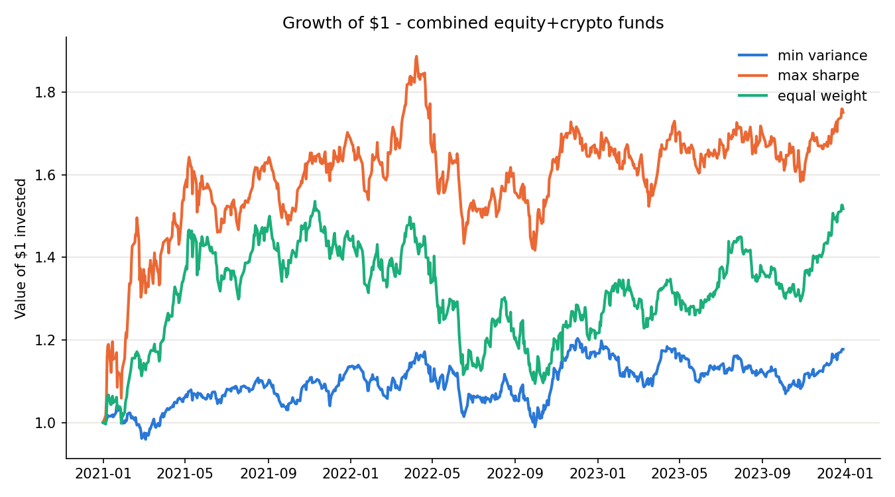
Figure 1. Growth of $1 invested in the portfolio strategies.
The growth charts show that portfolio outcomes diverge substantially over the sample period. The drawdown analysis provides additional information about the path taken to achieve these returns.
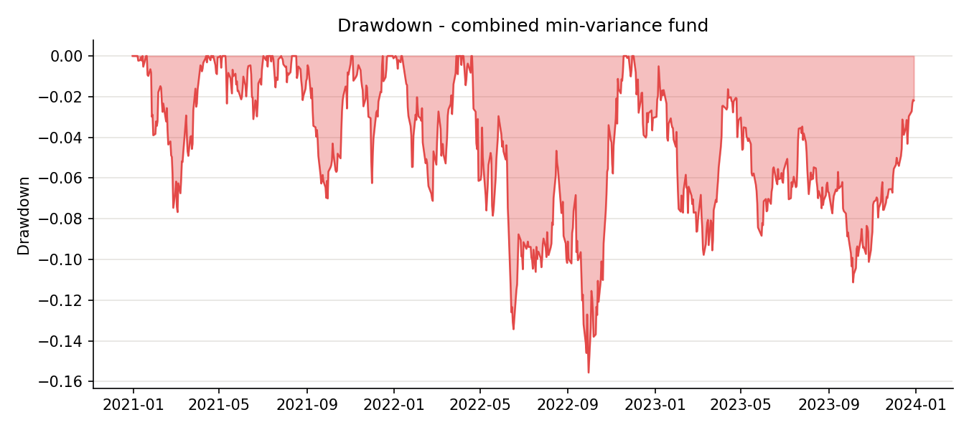
Figure 2. Portfolio drawdowns through the backtest period.
The cryptocurrency strategies experience the largest drawdowns, consistent with their higher volatility. The equity portfolios exhibit more moderate drawdowns, while combined portfolios sit between the two depending on their changing cryptocurrency exposure.
Portfolio allocation charts also illustrate the dynamic nature of the optimisation process.
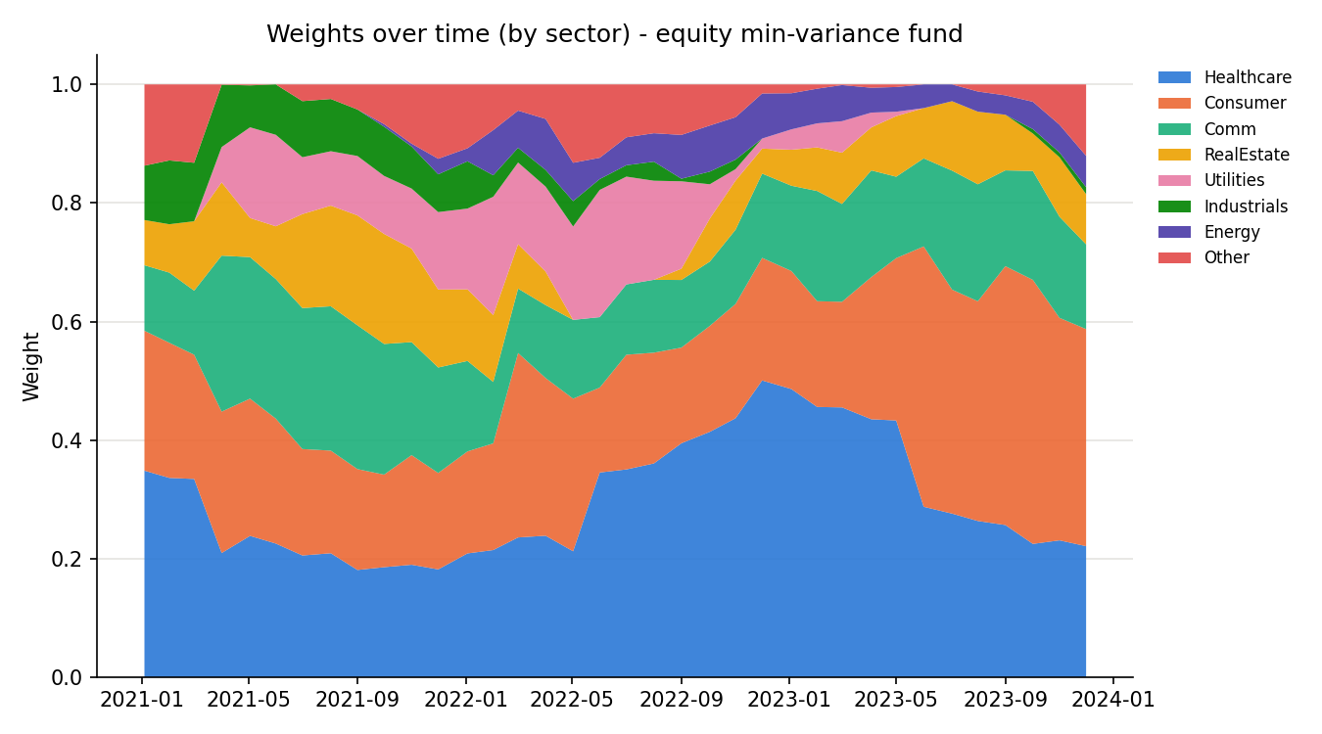
Figure 3. Portfolio weights through time.
The maximum-Sharpe portfolios tend to exhibit greater concentration than equal-weight portfolios. This is an expected consequence of using historical return estimates within the optimisation process. The 30% concentration constraint limits the most extreme allocations but does not eliminate concentration entirely.
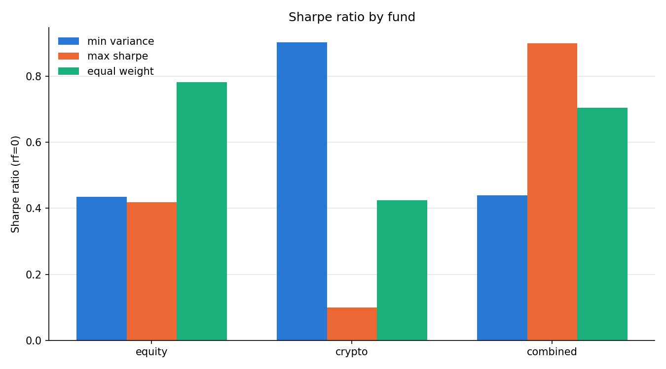
Figure 4. Sharpe ratio comparison across the nine portfolios.
Overall, the performance results demonstrate that portfolio optimisation can produce materially different outcomes depending on the objective and investment universe. However, the results also show why full-period performance should not be considered sufficient evidence of a robust investment strategy. The strong contribution from 2021, particularly within cryptocurrency and combined portfolios, means that regime-specific results are essential to the interpretation.

3. Sector Sentiment Modelling
The second component of the project introduces a financial news sentiment model designed to capture information that may not be directly represented in historical price and covariance estimates.
The sentiment framework uses the VADER sentiment model to score financial news headlines. VADER is designed to incorporate textual features such as punctuation, capitalisation, and negation when determining sentiment. These features were retained rather than normalised away because they form part of the model's scoring mechanism.
Headlines are initially scored at the ticker level. The resulting observations are then aggregated into sector-level sentiment measures. This creates a daily sentiment index representing the overall tone of available news associated with companies within each sector.
An important challenge in constructing a daily financial sentiment index is that news coverage is uneven. Some securities receive headlines every day, while others may have several days without any new information. Treating the absence of a headline as automatically neutral could therefore introduce unnecessary discontinuities.
The implementation addresses this issue by carrying the most recent sentiment value forward for up to five trading days. If no new headline is observed within that period, the sentiment value reverts to neutral. This approach attempts to balance continuity against the risk of allowing stale information to remain influential for too long.
Approximately 24.5% of ticker-days contain no headline at all. The treatment of these observations is therefore not a minor implementation detail. It affects a meaningful proportion of the dataset.
A sensitivity comparison between the current five-day carry-forward approach and an immediate-neutral approach produced an overall correlation of approximately 0.83. However, the correlation is lower for several sectors with relatively sparse coverage, including Materials, Utilities, and Real Estate, where correlations are approximately 0.69 to 0.73.
This indicates that the no-headline treatment can have a material effect on individual sector sentiment measures. It is therefore an important consideration for future development of the sentiment model.
The sentiment series is lagged before being incorporated into portfolio construction. This is a critical methodological requirement because using sentiment measured on the same day as the portfolio return could allow information that was only available after the investment decision to influence the strategy.
The implementation uses the trading-day mapping associated with the underlying market data. For example, a weekend headline is not treated as though it were available during a preceding Friday rebalance. The audit of the pipeline found that the sentiment input used at each rebalance was based on information available before that rebalance. No look-ahead error was identified.

Finance-Specific Lexicon Extension
The standard VADER lexicon was extended with 32 finance-specific terms and phrases. The motivation for the extension was that general-purpose sentiment models may not adequately capture the meaning of financial language.
Financial headlines frequently contain terms whose meaning depends strongly on market context. Words such as “surge”, “plunge”, “upgrade”, “downgrade”, “rally”, and “slump” can convey meaningful market information but may not always be interpreted appropriately by a general sentiment dictionary.
The additional terms were assigned sentiment scores by one human rater and one AI rater using a scale from -4 to +4. The final scores were based on the average of these ratings.
The mean absolute difference between the two rating sources was approximately 0.65 points. This indicates that some degree of disagreement exists regarding the appropriate sentiment intensity of financial terminology. This is particularly relevant for ambiguous terms such as debt and liability, where the interpretation can vary depending on context.
The extension reduced the proportion of headlines receiving an exactly neutral classification from approximately 48.8% to 47.6%.
However, the size of this change should not be interpreted as evidence that the extension comprehensively resolves the limitations of VADER for financial language. Only approximately 3.26% of all headlines experienced any score change under the extension.
One reason for this limited coverage is the use of literal token matching. The model does not automatically identify all morphological variations of a word. For example, an extension containing “downgrade” may not necessarily capture “downgraded” or “downgrades”. Similar issues occur for terms such as “upgrade” and “soar”.
The phrase matching also has limitations. A phrase such as “miss estimates” is not necessarily equivalent to “misses estimates”, meaning that semantically related headlines can receive different treatment.
The extension should therefore be viewed as a targeted improvement rather than a complete financial-language model. Its main contribution is to demonstrate how domain-specific terminology can be incorporated into an existing sentiment framework, while also highlighting the limitations of simple dictionary-based approaches.
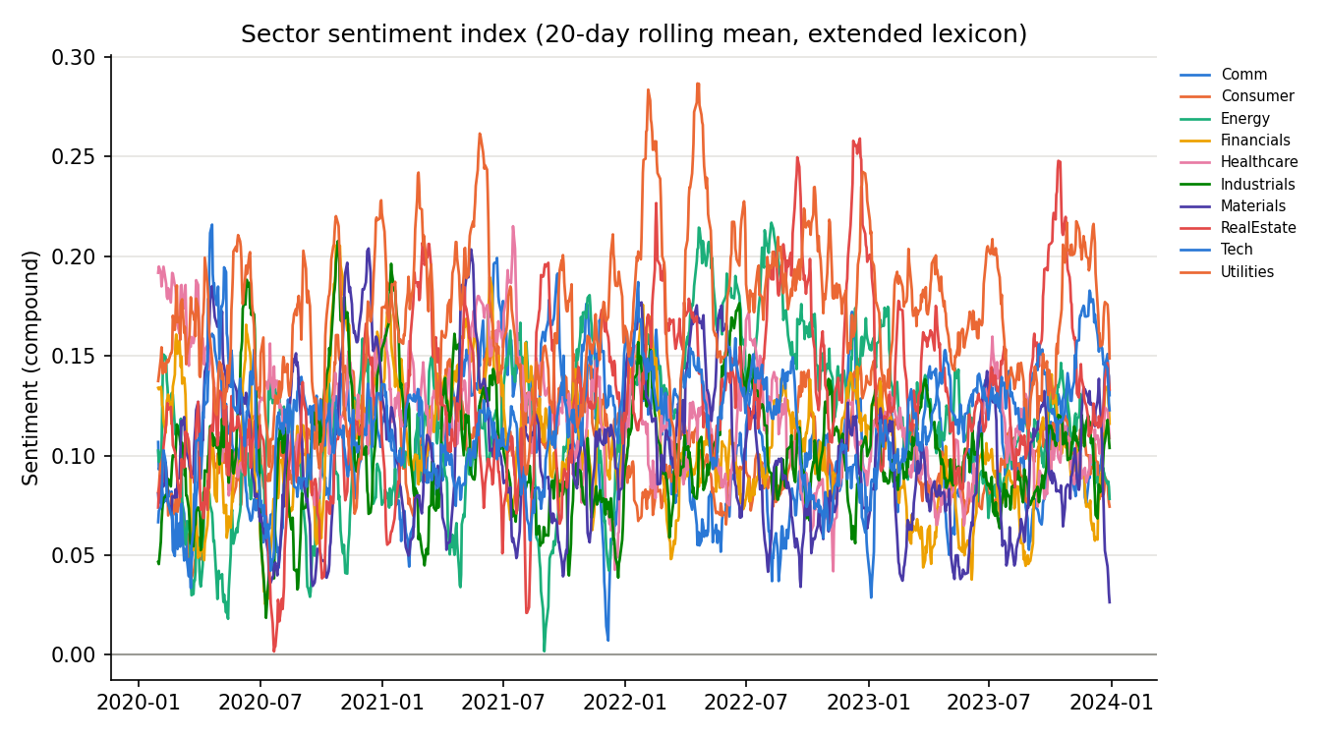
Figure 5. Sector sentiment index using the extended finance lexicon.
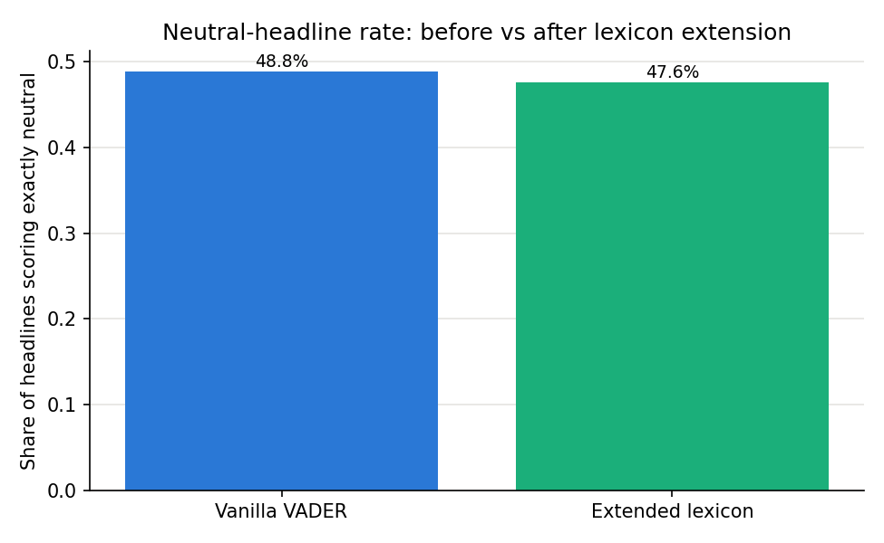
Figure 6. Neutral headline proportion before and after the lexicon extension.

4. Sentiment-Integrated Portfolio Construction
The central extension of the project investigates whether the sentiment information developed above can improve portfolio construction.
At each monthly rebalance, ticker-level sentiment scores are standardised cross-sectionally. These standardised scores are then used to adjust the baseline portfolio weights. Positive sentiment increases the allocation relative to the baseline, while negative sentiment reduces it.
The sentiment adjustment is controlled by a parameter (k), which determines the strength of the tilt. The main analysis uses (k=0.5), with additional sensitivity testing at (k=0.25) and (k=1.0).
The original implementation contained an important constraint issue. The optimisation process correctly imposed a 30% maximum individual weight, but the subsequent sentiment adjustment could push an asset above this limit. An audit identified cases where the post-sentiment weight exceeded 30%, with one observed example increasing an allocation from approximately 29.4% to 47.1%.
This was corrected by enforcing the concentration constraint after the sentiment adjustment as well as during the original optimisation. The pipeline was then re-run using the corrected implementation.
The corrected results are shown in Table 2.
Fund | Variant | Ann. return | Sharpe | Max drawdown
equity_min_variance | base | 5.5% | 0.43 | -15.4%
equity_min_variance | vanilla_tilt | 5.5% | 0.42 | -16.0%
equity_min_variance | extended_tilt | 5.5% | 0.43 | -15.1%
equity_max_sharpe | base | 7.4% | 0.42 | -24.7%
equity_max_sharpe | vanilla_tilt | 4.4% | 0.24 | -28.8%
equity_max_sharpe | extended_tilt | 4.3% | 0.23 | -29.1%
equity_equal_weight | base | 12.6% | 0.78 | -20.3%
equity_equal_weight | vanilla_tilt | 12.1% | 0.75 | -20.6%
equity_equal_weight | extended_tilt | 12.7% | 0.79 | -20.3%
Table 2. Portfolio performance before and after sentiment integration.
The correction did not recover the performance lost through sentiment integration. Instead, the corrected results showed that the negative effect remained.
For the minimum-variance portfolio, the baseline Sharpe ratio was 0.4348. The extended sentiment tilt at (k=0.5) produced a Sharpe ratio of 0.4261. For the maximum-Sharpe portfolio, the baseline Sharpe ratio was 0.4179, while the extended sentiment strategy produced only 0.2345.
The equal-weight portfolio behaved differently. Its baseline Sharpe ratio was 0.7821 and its extended sentiment result was approximately 0.7930. The fact that the equal-weight result is unchanged by the concentration-cap correction provides a useful internal consistency check because its weights never breached the 30% constraint.
Sensitivity analysis provides further evidence that the result is not driven solely by the choice of (k=0.5).
For the maximum-Sharpe strategy, the Sharpe ratio falls from 0.4179 without sentiment to 0.3210 at (k=0.25), 0.2345 at (k=0.5), and 0.0767 at (k=1.0). The relationship is therefore strongly negative for this strategy.
The minimum-variance strategy behaves differently. Its Sharpe ratio is 0.4348 without sentiment, approximately 0.4340 at (k=0.25), 0.4261 at (k=0.5), and 0.4661 at (k=1.0). This relationship is not monotonic. Consequently, it would be inappropriate to claim that sentiment consistently harms every portfolio.
The equal-weight strategy is also relatively insensitive to the sentiment adjustment compared with the maximum-Sharpe strategy. This difference is informative because the baseline portfolios have different levels of concentration. The maximum-Sharpe portfolio is already relatively concentrated before sentiment is introduced, whereas the equal-weight portfolio is substantially more diversified.

Predictive Power of Sentiment
The lack of improvement from the sentiment tilt raises the question of whether sentiment contains useful information about future returns.
To investigate this, lagged sentiment was compared with subsequent equity returns over one-day, five-day, and 21-day horizons.
The correlations were approximately -0.0008 at the one-day horizon, -0.0106 at five days, and -0.0166 at 21 days. The one-day relationship was statistically insignificant, with a p-value of approximately 0.87. The five-day and 21-day relationships were statistically significant because of the large number of observations, but the correlation magnitudes remained extremely small.
The corresponding explanatory power is therefore negligible. The findings do not provide evidence that the lagged sentiment series has economically meaningful predictive power for future returns.
Interestingly, same-day sentiment has a positive relationship with same-day returns, with a correlation of approximately 0.051 and a highly significant p-value. This suggests that the sentiment measure is more closely associated with contemporaneous market movements than with subsequent returns.
This distinction is important. A sentiment measure can accurately describe the tone of news associated with a market move without providing information that predicts the next market move.
The results therefore provide a plausible explanation for why the sentiment tilt fails to improve the portfolios. The portfolio is being adjusted using information that appears to describe what has already happened rather than what is likely to happen next.

Randomised Placebo Test
A further placebo experiment was conducted to determine whether the real sentiment allocation performs differently from a purely random sentiment allocation.
For each trading day, sentiment scores were shuffled across securities while preserving the cross-sectional distribution of sentiment. This preserves the overall level and dispersion of sentiment on each day while destroying the relationship between a particular security and its sentiment score.
The identical sentiment-tilt and backtest process was then repeated 300 times.
For the minimum-variance portfolio, the real sentiment strategy produced a Sharpe ratio of approximately 0.426, compared with a random-shuffle mean of approximately 0.413 with a standard deviation of 0.118. The real result sits around the 55th percentile of the random distribution.
For equal-weight, the real sentiment result was approximately 0.793, compared with a random-shuffle mean of approximately 0.770 and standard deviation of 0.076. The real result was around the 64th percentile.
These results indicate that the real sentiment signal does not perform substantially differently from randomised sentiment for either strategy.
The maximum-Sharpe result is more unusual. The real sentiment strategy produced a Sharpe ratio of approximately 0.235, compared with a random-shuffle mean of approximately 0.372 and standard deviation of 0.117. The real result was around the 14th percentile, meaning that approximately 86% of the randomised sentiment allocations produced a higher Sharpe ratio.
This does not prove that sentiment is negatively predictive. Rather, it demonstrates that the particular security-level mapping of the real sentiment scores produced a particularly poor result for this portfolio during the sample period.
A follow-up test examined whether this could be explained by the maximum-Sharpe portfolio systematically reducing exposure to its highest-conviction holdings. The cross-sectional correlation between the baseline portfolio weight and the sentiment tilt was close to zero.
The mean Pearson correlation across 36 rebalance dates was 0.0102, with a p-value of 0.62. The mean Spearman correlation was 0.0603. Although the Spearman result was statistically significant at the 5% level, the coefficient is economically very small.
The evidence therefore does not support the proposed explanation that sentiment systematically reduced exposure to the securities most favoured by the maximum-Sharpe optimiser.
The exact reason why real sentiment performed substantially worse than most randomised signals for maximum-Sharpe therefore remains unresolved. This is preferable to presenting an unsupported causal explanation. The result is reported as an empirical finding rather than attributing it to a mechanism that has not been demonstrated.
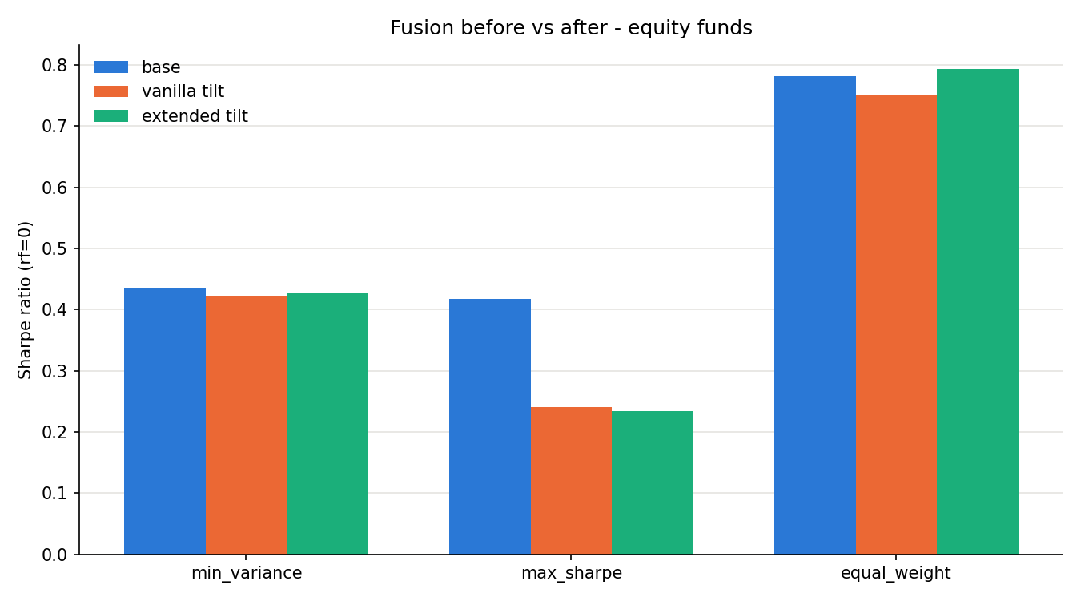
Figure 7. Sharpe ratio sensitivity to sentiment-tilt strength.
Overall, the fusion experiment provides a negative but informative result. The sentiment model does not demonstrate consistent incremental predictive value, and stronger sentiment tilts can substantially reduce performance in an already concentrated optimisation-based portfolio.
The appropriate conclusion is therefore not that sentiment integration is universally ineffective. Rather, the evidence from this backtest does not demonstrate that this particular sentiment construction improves the portfolio strategies tested.

5. Application Implementation
The Streamlit application provides an interactive interface for exploring the portfolio and sentiment analysis developed throughout the project.
The application is organised into three main areas: Funds, Sentiment, and Data.
The Funds section allows users to compare the nine portfolio strategies and inspect individual fund characteristics. Performance measures include annualised return, annualised volatility, Sharpe ratio, maximum drawdown, and portfolio allocation. Growth-of-$1 and portfolio-weight visualisations provide additional context around the numerical results.
The Sentiment section presents the sector-level sentiment indices and allows users to examine the effect of the finance-specific lexicon extension. The sentiment-fusion results are also presented to allow users to compare baseline portfolio performance with sentiment-adjusted performance.
The Data section provides a preview of the underlying datasets used by the analysis. This improves transparency by allowing users to inspect the data underlying the reported results.
The application does not rerun the computationally intensive optimisation and sentiment pipeline during normal use. Instead, it reads the pre-generated outputs produced by the research pipeline. This approach improves deployment efficiency and ensures that the values displayed by the application correspond to the analysed results.
The separation between the research pipeline and application layer also reduces the risk that an application-side calculation produces values inconsistent with the underlying analysis.
The deployed application is available at:
[INSERT STREAMLIT COMMUNITY CLOUD URL]
The application therefore acts as the presentation layer for the research rather than as an independent implementation of the portfolio construction methodology.

6. Limitations and Future Development
Several limitations affect the interpretation and potential practical application of the results.

6.1 Transaction Costs
The primary portfolio backtest assumes zero transaction costs. This allows the analysis to focus on the portfolio construction methodology, but it does not represent the full economic cost of implementing the strategies.
This issue is particularly important because turnover differs substantially between the portfolio methods. The equity maximum-Sharpe portfolio has approximate turnover of 0.65 per rebalance, equivalent to approximately 7.8 one-way turnover events per year. Equal-weight has almost no comparable rebalancing requirement.
Consequently, a zero-cost assumption is not neutral across the strategies. It is more favourable to the higher-turnover strategies because the costs associated with their frequent trading are ignored.
A preliminary transaction-cost assessment suggests that applying realistic costs reduces the Sharpe ratio of the equity maximum-Sharpe strategy from approximately 0.418 to 0.371 under the tested assumptions. This demonstrates that implementation costs can materially affect the attractiveness of optimisation-based strategies.
Future work should therefore include a formal sensitivity analysis using multiple transaction-cost assumptions, such as 10, 25, and 50 basis points per trade. This would help determine whether the relative ranking of the strategies remains stable after implementation costs.

6.2 Sentiment Lexicon Limitations
The finance-specific lexicon is another important limitation.
Although the extension reduced the neutral headline rate from 48.8% to 47.6%, only approximately 3.26% of all headlines experienced any score change. This indicates that the extension affects a relatively small portion of the overall dataset.
The use of literal token matching also means that different forms of the same financial word may not be recognised consistently. For example, “downgrade”, “downgraded”, and “downgrades” can be treated differently if only one form is explicitly included.
The phrase matching approach has similar limitations. Financial language can express the same concept using several grammatical constructions, and a dictionary containing one exact phrase cannot necessarily capture all of them.
The ratings themselves were produced by one human and one AI rater. Although the average disagreement was relatively moderate, this does not constitute a broad independent validation exercise. A larger group of independent human raters would provide stronger evidence regarding the appropriate sentiment intensity of finance-specific terminology.
Future development could therefore incorporate stemming or lemmatisation, contextual language models, larger independently rated dictionaries, or a financial language model specifically trained on market-related text.

6.3 Regime Dependence
The backtest results are strongly dependent on market conditions.
The combined maximum-Sharpe portfolio's 2.30 Sharpe ratio during 2021 contrasts sharply with its approximately -0.08 Sharpe ratio during 2022. The cryptocurrency minimum-variance strategy shows an even more pronounced variation, moving from approximately 3.46 in 2021 to -0.89 in 2022 before recovering to approximately 3.32 in 2023.
This variation demonstrates that full-period performance can be misleading when the sample includes a strong market regime.
The combined strategy also illustrates the importance of entry timing. The approximately 48.7% cryptocurrency allocation at the first rebalance provided substantial exposure to the subsequent 2021 cryptocurrency rally. The allocation then declined as the market environment changed.
Future analysis should therefore include rolling Sharpe ratios, rolling volatility, and performance across additional market regimes. Extending the sample beyond 2023 would also provide a stronger test of whether the observed results persist.

6.4 Sentiment Predictive Power
The central limitation of the sentiment experiment is that it did not demonstrate meaningful predictive power.
Lagged sentiment had almost no correlation with subsequent returns across one-day, five-day, and 21-day horizons. At the same time, same-day sentiment had a positive relationship with same-day returns.
This suggests that the sentiment measure may primarily capture information associated with current market movements rather than provide a forward-looking signal.
The placebo experiment reinforces this conclusion. For minimum-variance and equal-weight portfolios, the real sentiment strategy performed similarly to randomised sentiment allocations. For maximum-Sharpe, the real sentiment allocation performed worse than most randomised alternatives.
The concentration-cap correction is also important here. The original fusion implementation could breach the 30% portfolio constraint after the sentiment adjustment. This implementation error was corrected and the full fusion analysis was rerun. The negative result remained after the correction.
This means that the observed deterioration cannot simply be attributed to the original concentration bug.
At the same time, the evidence does not justify claiming that sentiment necessarily harms optimised portfolios in all circumstances. The minimum-variance results are non-monotonic across tilt strengths, while equal-weight remains relatively stable.
The strongest defensible conclusion is therefore that the tested sentiment signal did not demonstrate reliable incremental value within this backtest.

6.5 No-Headline Treatment
The treatment of days without new headlines is another area for improvement.
Approximately 24.5% of ticker-days contain no headline. Carrying sentiment forward for five trading days provides continuity, but it also means that a sentiment observation can influence the index after the original news has become less relevant.
The effect is particularly important for sectors with lower news coverage. The correlation between the current treatment and an immediate-neutral alternative falls to approximately 0.69 to 0.73 for Materials, Utilities, and Real Estate.
Future analysis should compare three alternatives more formally: five-day carry-forward, immediate neutral treatment, and exclusion of observations without current headlines. This would establish whether the sentiment-fusion result is sensitive to the missing-news methodology.

6.6 Frequency of Sentiment Aggregation
The current implementation uses the available lagged sentiment at the rebalance and applies the resulting portfolio tilt for the subsequent holding period.
This creates a potential mismatch between the frequency of the sentiment signal and the frequency at which portfolio decisions are made. A single day's cross-sectional sentiment score may influence portfolio weights for an extended period until the next rebalance.
Future work could therefore test multi-day sentiment aggregation, such as a trailing five-day sentiment average, rather than relying on a single daily observation. This may reduce the influence of unusually noisy headlines and create a more stable portfolio signal.
Alternative approaches could also include sentiment momentum, changes in sentiment rather than sentiment levels, or disagreement between positive and negative news.

6.7 Overall Assessment and Future Development
The analysis demonstrates that adding a more complex information source does not automatically improve an already optimised portfolio.
The baseline portfolio construction methods use historical returns and covariance estimates to determine portfolio weights. Introducing a sentiment tilt changes those weights based on an additional signal. If that signal contains little information about future returns, the adjustment can move the portfolio away from its original allocation without providing sufficient additional expected return to compensate.
The empirical results are consistent with this interpretation. The sentiment signal has negligible predictive correlations with future returns, performs similarly to randomised sentiment for two of the three portfolio methods, and performs particularly poorly for the maximum-Sharpe strategy.
The most important future development is therefore not simply increasing the sentiment tilt. Instead, the underlying signal should be improved and tested independently before being integrated into portfolio construction.
Potential improvements include using a financial-domain language model, incorporating headline changes and sentiment momentum, aggregating sentiment across multiple days, improving financial phrase recognition, and validating the signal on a separate out-of-sample period.
The portfolio framework could also be extended through realistic transaction costs, additional asset classes, alternative covariance estimators, shrinkage methods, and more robust optimisation techniques.
Most importantly, future testing should distinguish between a signal that explains contemporaneous market behaviour and one that genuinely predicts future returns. The current results provide evidence for the former but not the latter.

Conclusion
This project developed a systematic multi-asset portfolio framework combining conventional portfolio optimisation with financial news sentiment analysis.
The nine baseline portfolios demonstrate substantial differences between minimum-variance, maximum-Sharpe, and equal-weight construction methods. Cryptocurrency exposure increases both return potential and risk, while the combined portfolios demonstrate the importance of asset allocation timing. The full-period results are strong in some cases, but annual decomposition shows that a substantial portion of performance is concentrated in favourable 2021 market conditions.
The sentiment component successfully demonstrates a practical method for incorporating finance-specific terminology into VADER. However, the extension is relatively narrow, affecting only a small proportion of headlines, and several linguistic limitations remain.
The sentiment-fusion experiment produces the most important negative finding of the analysis. The corrected implementation does not show that sentiment improves portfolio performance. The maximum-Sharpe strategy is particularly sensitive to the sentiment adjustment, with its Sharpe ratio falling from 0.4179 to 0.2345 under the corrected extended-lexicon tilt at (k=0.5).
The predictive-power analysis provides a consistent explanation for the lack of improvement. Lagged sentiment has almost no relationship with subsequent returns, while its relationship with same-day returns is positive. This indicates that the sentiment model appears more descriptive of current market conditions than predictive of future returns.
The placebo experiment strengthens this conclusion. Real sentiment performs similarly to randomised sentiment for minimum-variance and equal-weight portfolios, while the maximum-Sharpe sentiment strategy performs worse than approximately 86% of randomised alternatives. A subsequent test found no meaningful relationship between maximum-Sharpe baseline weights and sentiment tilt scores, so the precise reason for this unusually poor result remains unresolved.
This uncertainty is itself an important limitation. Rather than imposing an unsupported explanation on the result, the analysis treats the mechanism as an open question for future research.
Overall, the project demonstrates both the potential and limitations of combining alternative data with systematic portfolio construction. The results suggest that additional information should not be assumed to improve an already optimised portfolio. Before a sentiment signal is used to modify investment weights, it must demonstrate genuine out-of-sample predictive information, robustness across market regimes, and sufficient economic value to justify the additional complexity and trading activity.

References
Hutto, C.J. and Gilbert, E. (2014) VADER: A Parsimonious Rule-Based Model for Sentiment Analysis of Social Media Text. Proceedings of the Eighth International AAAI Conference on Weblogs and Social Media, pp. 216-225.
Loughran, T. and McDonald, B. (2011) When Is a Liability Not a Liability? Textual Analysis, Dictionaries, and 10-Ks. The Journal of Finance, 66(1), pp. 35-65.
FINS5545 (2026) FinTech Project 2026 course data bundle: equity_prices, crypto_prices, news_headlines [Dataset]. UNSW Business School.

