The Criminalization of Poverty

**1 Interim Data Report**

**1.1 Literature Review**

There is an established relationship between economic insecurity and crime. This section serves to briefly outline the preexisting literature on this topic, including quantitative research about the correlation between poverty indicators and crime, and qualitative studies about systemic racism and oppression of poor people in the criminal legal system.

In the late 1970s and early 1980s, several key literature reviews were unable to reach a clear consensus regarding the relationship between economic conditions and violent crime. Quantitative research conducted (Hsieh and Pugh 1993) used meta-analysis techniques to examine 34 aggregate data studies that explore the connections between violent crime, poverty, and income inequality. These studies provided 76 zero-order correlation coefficients for various measures of violent crime in relation to poverty or income inequality. Of these, 97 percent (all but two) were positive, suggesting that both poverty and income inequality are linked to violent crime. The research also indicated that homicide and assault may have a stronger association with poverty or income inequality than rape or robbery.

The relationship between unemployment and imprisonment has often been described as “elusive” and “conflicting,” with such conclusions largely drawn from aggregate-level data. Individual-level data has provided only indirect evidence of this connection. A study (Chiricos and Bales 1991) examined prosecution, incarceration, and the length of incarceration for 1,970 criminal defendants arrested in 1982. Using multivariate logit and OLS estimates, the findings revealed a significant, strong, and independent effect of unemployment on both pretrial and post-sentencing incarceration. The interaction between race and unemployment highlighted that unemployed Black defendants — particularly young males or those charged with violent and public order crimes — face the highest

1

likelihood of incarceration. A regression analysis conducted by myself in undergrad built upon this kind of quantitative research to demonstrate the relationship between unemployment and incarceration, providing an current analysis of the correlation between unemployment at the macro level and national incarceration rates.

Another study (Freeman 1987) seeked to estimate the impact of present and past criminal activity on the employment rates of inner-city Black male youths from high-poverty neighborhoods. The study illuminated a significant inverse relationship between crime and employment, with criminal activity linked to a decrease in employment for the sample population. Recidivism is an important aspect of the criminalization of poverty, as economic insecurity of individuals involved with the criminal justice system can explain the tendency of people with records to reoffend. The United States has long been known for having the highest incarceration rates. At the time she was writing (Esparza Flores 2018), recidivism rates were unprecedentedly high, with over 76.6% of offenders reoffending and returning to prison, often due to unemployment and lack of education. Her paper explored how race and socioeconomic disparities fuel mass incarceration and recidivism.

The criminalization of poverty is also elucidated through the punitive nature of the criminal legal system. The system is structured to submit to the financial means that economically privileged people have access to, while restricting the liberties and rights of people who lack access to financial means of defending themselves. This direct issue of poverty criminalization has been written about in “Punishment without Crime: How Our Massive Misdemeanor System Traps the Innocent and Makes America More Unequal” (Natapoff 2018). The book exposed the harsh realities of the justice system, revealing punitive bureaucracies that devastate those ensnared in the excessive policing and enforcement of minor offenses. Natapoff argued that state and local governments have built systems of injustice that erode the core purpose of criminal law by undermining the principles of equal justice. These systems impose a de facto punitive tax on those least able to bear it.

Several other scholars have delved into the issue of inequality, poverty, and incarceration. It was argued by (Gustafson n.d.) that in 2009 the welfare and criminal justice systems in the U.S. were increasingly intertwined, though scholars were yet to fully explore the implications of this convergence. Her article mapped the criminalization of welfare, detailing the rise of welfare fraud as a government focus and the integration of criminal justice strategies into the welfare system. It also examined how welfare recipients are treated in courts, where they are granted limited rights similar to parolees. Several publications in 2019 put out work about the criminalization of poverty

2

(Edelman 2019) (Yungman 2019). The purpose of this project is to provide an updated exploratory data analysis of the criminalization of poverty.

**1.2 Background and Research Question**

This study explores the criminalization of poverty. The design of the criminal legal system is set up to penalize the behavior of segments of the population who have limited options for providing for themselves and their families. There are structures within education, legal, and economic systems that trap people in a cycle of poverty. The most vulnerable people in society, who experience housing and food insecurity, miseducation, debt, unemployment, and other factors of economic inequality, are likely to engage in criminal activity as a means of survival. The financial and psychological toll of experiences in the criminal legal system serve to perpetuate the oppression of poor, predominantly Black and brown people. The criminal legal system contributes to the cycle of poverty that harms swaths of American people.

Formerly incarcerated people face great barriers in the labor market. The unemployment rate of formerly incarcerated people is more than twice the level that the national rate was during the great depression. A regression analysis conducted exploring the relationship between national annual unemployment rates and incarceration rates showed a statistically significant relationship between an increase in the national unemployment rate and an increase in the national incarceration rate. This project was a first step in researching the relationship between poverty and incarceration, and further development of this research can serve as an evidence-based framework for designing economic policy for individuals impacted by the criminal legal system. I propose an exploratory data analysis project exploring the criminalization of poverty.

The question that this study will be addressing is whether poverty rates are correlated with crime rates. To explore this question, New York county-level data for several years (2017-2022) of poverty rates and of crime rates will be used for a regression analysis. It is hypothesized that poverty will be positively correlated with crime.

**1.3 Data Sources**

The data collected about poverty rates at the county-level comes from the United States Census. (census.gov/saipe/datatool)

The crime data was sourced from the Division of Criminal Justice Services. (criminaljustice.ny.gov) 3

**1.4 Data Cleaning**

The poverty data had several unnecessary variables and had untidy variable names. The irrelevant variables for this study were dropped from the dataset and the variable names were cleaned. The observations had names in the county variable that did not match the county names in the crime dataset. The county names were changed to be consistent with the crime data.

The crime data was already tidy, and only needed the column names to be changed to lowercase.

**1.5 Challenges**

The merge command is not working, so scatter plots could not be generated at this point. The tables are not copying from Stata properly, so screenshots were inserted into the report.

**1.6 Descriptive Statistics**

Table 1: The summary statistics of the number in poverty variable.

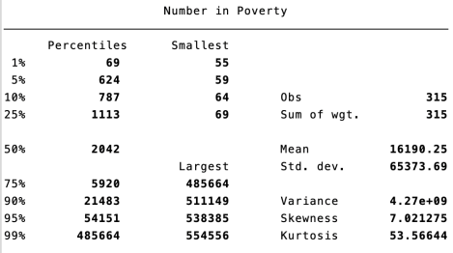4

Table 2: The summary statistics of the percent in poverty variable.

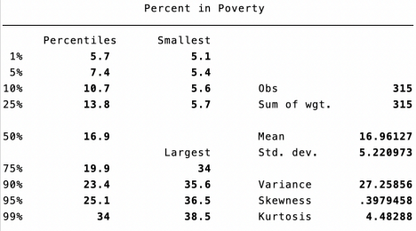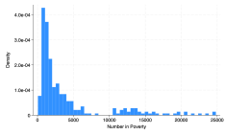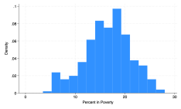Figure 1: Poverty variables distributions.

The percent in poverty variable has a normal distribution, while the number in poverty variable has a significant right skew.

5

Table 3: The summary statistics of the index crime variable.

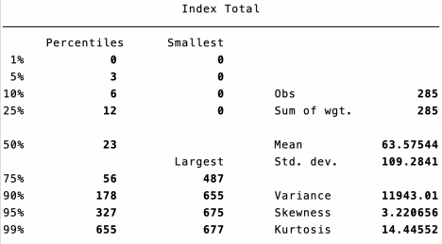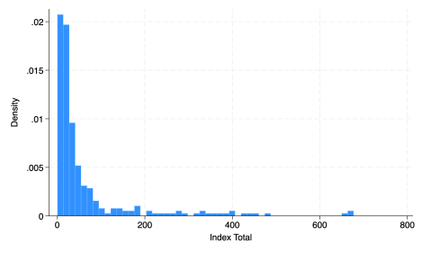Figure 2: Distribution of index crime variable.

The index crime variable has a significant right skew.

6

Table 4: The summary statistics of the non-index crime variable.

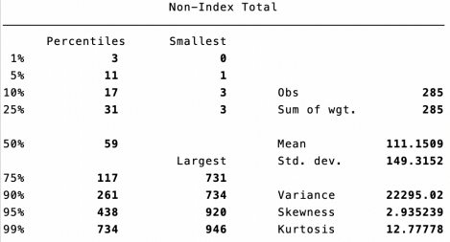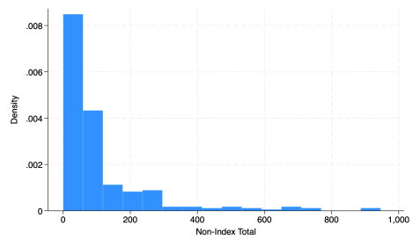Figure 3: Distribution of non-index crime variable.

7

**1.7 Bivariate Analysis**

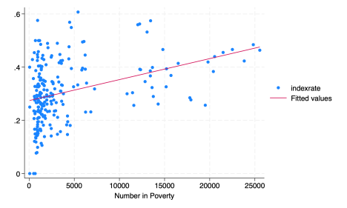Figure 4: Scatterplot: Index Crime Rate Predicted by Poverty Rate.

This shows a strongly positive correlation between the percent of index crime (as a share of total crime) and the percent of the county population in poverty.

**References**

Chiricos, Theodore G., and William D. Bales. 1991. “Unemployment and Punishment: An Em pirical Assessment*.” *Criminology* 29 (4): 701–24. https://doi.org/10.1111/j.1745-9125.1991. tb01085.x.

Edelman, Peter. 2019. “The Criminalization of Poverty and the People Who Fight Back.” *George town Journal on Poverty Law and Policy*.

Esparza Flores, Nayely. 2018. “Contributing Factors to Mass Incarceration and Recidivism.” *Themis: Research Journal of Justice Studies and Forensic Science* 6 (1). https://doi.org/10. 31979/THEMIS.2018.0604.

Freeman, Richard B. 1987. “The Relation of Criminal Activity to Black Youth Employment.” *The Review of Black Political Economy* 16 (1): 99–107. https://doi.org/10.1007/BF02900926.

8

Gustafson, Kaaryn. n.d. “The Criminalization of Poverty.” *The Journal of Criminal Law and Criminology* 99 (3). Accessed 2009.

Hsieh, Ching-Chi, and M. D. Pugh. 1993. “Poverty, Income Inequality, and Violent Crime: A Meta-Analysis of Recent Aggregate Data Studies.” *Criminal Justice Review* 18 (2): 182–202. https://doi.org/10.1177/073401689301800203.

Natapoff, Alexandra. 2018. *Punishment Without Crime*. Hachette Book Group. https: //www.hachettebookgroup.com/titles/alexandra-natapoff/punishment-without-crime/ 9781549142154/?lens=basic-books.

Yungman, Jeff. 2019. “The Criminalization of Poverty.” *GPSolo* 36 (1): 34–39. https://www.jstor. org/stable/27044562.

9