Documentation for the HSP project “LogAnalyzer”

By Philipp Rieger, Andreas Kalo Fogados, Michael Dorr

Date: WS 15/16

Examiner: Prof. Dr. Skornia

# 1 Environment Setup

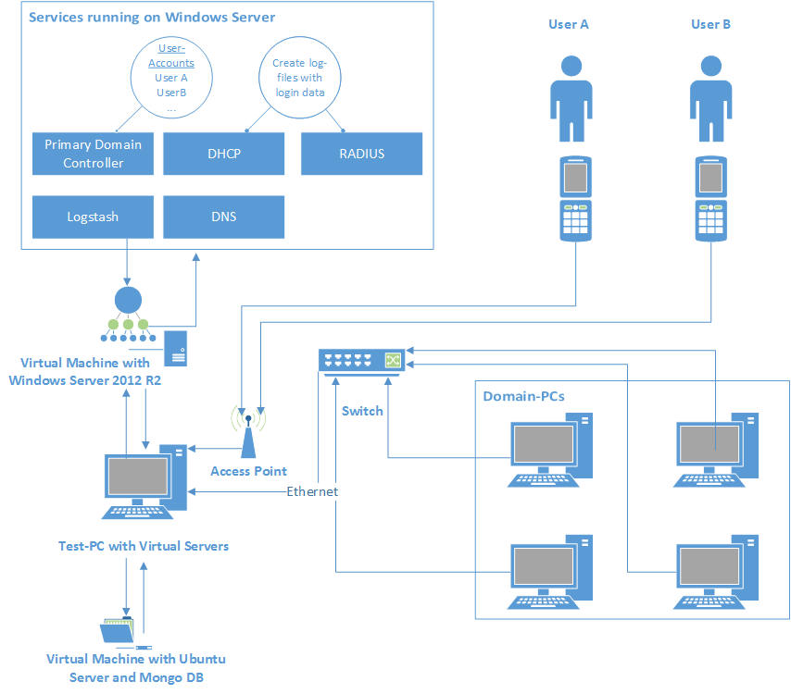

Figure : Test-Environment Setup

Figure 1 shows the environment setup for the generation of log-files with the user-login-data. Therefore a Test-PC with two virtual machines is used. One virtual machine runs Windows Server 2012 R2 with a static IP-Address and several services:

* *Primary Domain Controller* to create and manage user-accounts within the created Domain “OTHR”
* *DHCP* to distribute IP-Addresses to connecting devices
* *RADIUS* as network access control to provide centralized authentication, authorization and accounting management for the users who connect to the domain
* *Logstash* to write log-lines to the Mongo database

The second virtual machine runs a Ubuntu 14.04 Server with a Mongo database to store log-lines from the RADIUS log-file and extracted login record objects.

The Access Point is directly connected to the Test-PC. It is used to connect to the domain with a mobile phone via WIFI. The domain-network is simulated with PCs connected with a switch and Ethernet. The switch is directly connected to the Test-PC.

Consequently PCs are connected to the domain directly via Ethernet and mobile-phones are connected via WIFI.

## Log Production with RADIUS-Service

The RADIUS (Remote Authentication Dial-In User Service) is used to provide 802.1X authentication. It ensures that users who try to connect to the domain have to enter their username and password managed by the PDC. Hence users use their own password to connect to the domain.

The RADIUS automatically logs all connections to the domain in a log file. It creates a new file for each month. The entries within this log files are used for the calculations of the tool.

For instance, with the setup described by figure 1 it is possible to use the log file information of the RADIUS to determine if the mobile phone of a user connected to the domain before the user logged in on a domain-pc. Thus collected information can be used to raise statistics on account behavior and upon this statistics deviations can be calculated to detect anomalies.

## 1.2 Database Setup

The setup of the Mongo database is divided into two major steps:

* Setting up the database itself
* Setting up the Mongo C++ driver for Linux so that the “.cpp”-files created later in the programming part of the project can be compiled properly.

### 1.2.1 Set up the Mongo database

Following the steps below in the given order will set up the required Mongo database. It will start running after the setup is completed and start up with the operating system going forward. The provided steps are meant to work on Ubuntu 14.04, it’s not guaranteed to work on other versions or other operating systems.

1. Open the Terminal
2. Execute the following statements from the Terminal one after another:
   * sudo apt-key adv --keyserver hkp://keyserver.ubuntu.com:80 --recv EA312927
   * echo "deb http://repo.mongodb.org/apt/ubuntu trusty/mongodb-org/3.2 multiverse" | sudo tee /etc/apt/sources.list.d/mongodb-org-3.2.list
   * sudo apt-get update
   * sudo apt-get install -y mongodb-org
3. MongoDB is now installed and running in the background. By default, the database is running on port 27017. The connection string to a MongoDB running on the local machine is mongodb://localhost:27017.

### 1.2.2 Set up the Mongo C++ Driver

To be able to compile code using the Mongo features, the Boost library and the Mongo C++ driver version 1.1.0 are needed. The following steps will go through the setup of both of these. After finishing this part, it is possible to compile and execute code taking use of the Mongo features.

1. Open the Terminal
2. Install the prerequired libraries:
   * sudo apt-get install build-essential
   * sudo apt-get install libreadline-gplv2-dev libncursesw5-dev libssl-dev libsqlite3-dev tk-dev libgdbm-dev libc6-dev libbz2-dev scons git
3. Set up G++4.9:
   * sudo add-apt-repository ppa:ubuntu-toolchain-r/test
   * sudo apt-get update
   * sudo apt-get install g++-4.9
4. Set up Python:
   * cd Downloads/
   * wget <http://python.org/ftp/python/2.7.2/Python-2.7.2.tgz>
   * tar -xvf Python-2.7.2.tgz && cd Python-2.7.2/
   * ./configure
   * make
   * sudo make altinstall
5. Set up the Boost library:
   * sudo apt-get install libboost-all-dev
6. Set up the Mongo C++ driver:

* cd $HOME/Downloads
* Download the source code from <https://github.com/mongodb/mongo-cxx-driver/archive/legacy-1.1.0.tar.gz>
* tar –xvf mongo-cxx-driver-legacy-1.1.0.tar.gz && cd mongo-cxx-driver-legacy-1.1.0/
* sudo scons install --prefix=/usr/local/ --c++11=on

1. After finishing the driver setup the following command compiles an „example.cpp“ making use of the Mongo features:

g++-4.9 example.cpp -std=c++11 -o example -pthread -lmongoclient -lboost_thread -lboost_filesystem -lboost_program_options -lboost_system -lboost_regex

Following these two guides will set up everthing required to compile and execute the code provided in this project. Additionally, they provide the possibility to develop other application making use of Mongo features in C++ on Ubuntu 14.04.

## 1.3 Project Structure

The hierarchy of the project is as following:

* src: this folder contains all source and header files
* files: the directory lists different files such as log files or test files that were made use of during the development
* bin: folder with the final binary file
* Makefile: file that builds the source files and stores the binary in the bin folder when the “make” command is issued

The development process of the project was performed on a Linux virtual machine, more specifically Ubuntu 14.04, that was running the mongo db service. Furthermore, Git was used as a version control system to simplify the distributed work.

# 2 Implementation Details

The application reads content from log files and stores them into the database. The analyzer starts by reading those log contents from the mongo database and applying a regular expression in order to build login record objects.

As a further step, the application filters information from these records to build user objects that are, in turn, stored in the repository. Thereafter, the analyzer goes ahead with determining the handy mac address for each user based on the frequency of its appearance in the user’s login records.

Eventually, the standard deviation of all considered entries is calculated and further used to check if any anomalies occurred.