**Calculus Optimization**

**Linear Programming**

A system of linear equations and inequalities often have many possible solutions. Linear programming is a set of mathematical and computational tools that allows you to find a particular solution to this system that corresponds to the maximum or minimum of some other linear function.

Linear programming is a fundamental optimization technique that’s been used for decades in science- and math-intensive fields. It’s precise, relatively fast, and suitable for a range of practical applications.

**Mixed-Integer Linear Programming**

It is an extension of linear programming. It handles problems in which at least one variable takes a discrete integer rather than a continuous value. Although mixed-integer problems look similar to continuous variable problems at first sight, they offer significant advantages in terms of flexibility and precision.

Example: (python notebook program has been mentioned in the link)

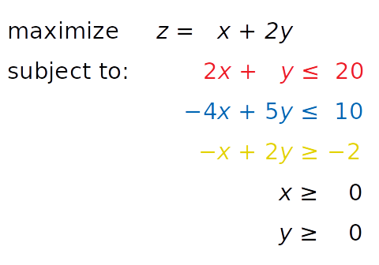

SciPy (stand for Scientific Python)

SciPy is an optimization and root-finding library for linear programming. It provides more utility functions for optimization, stats and signal processing.

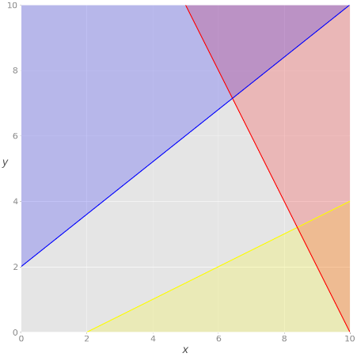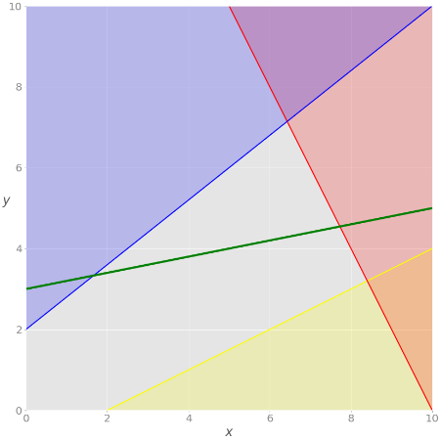 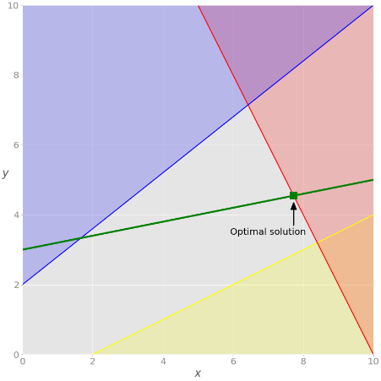

1. Problem Visualization (b) Problem Visualization with constraint (c) Optimal solution using SciPy