**Support Vector Machines (SVM)**

Support Vector Machine” (SVM) is a supervised machine learning algorithm that can be used for both classification or regression challenges. However, it is mostly used in classification problems. In the SVM algorithm, we plot each data item as a point in n-dimensional space (where n is a number of features you have) with the value of each feature being the value of a particular coordinate.

Compared to newer algorithms like neural networks, they have two main advantages: higher speed and better performance with a limited number of samples (in the thousands). This makes the algorithm very suitable for text classification problems, where it’s common to have access to a dataset of at most a couple of thousands of tagged samples.

**The Kernel Trick**

SVM is also used to classify nonlinear data by cleverly mapping feature space to a higher dimension. Kernel Function is a method used to take data as input and transform into the required form of processing data. “Kernel” is used due to set of mathematical functions used in Support Vector Machine provides the window to manipulate the data. So, Kernel Function generally transforms the training set of data so that a non-linear decision surface is able to transformed to a linear equation in a higher number of dimension spaces.

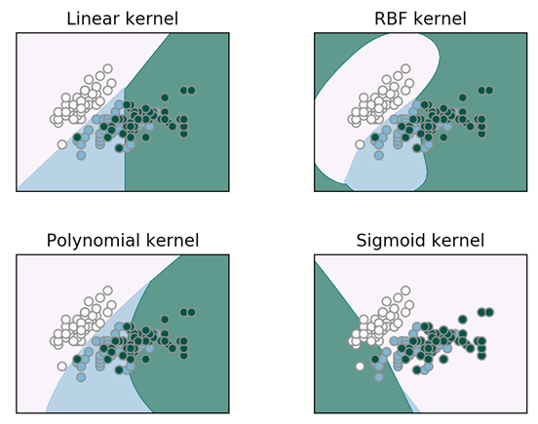

The python notebook is given for Classification task and resultant ROC curve have been shown as below for two class and multiple class, respectively.

