**Face Recognition Installation**

The Face Recognition library is widely known around the web for being the world's most straightforward facial recognition API for Python and the command line. The best of all is that you won't need to pay a dime for it, the project is open-source, so if you have some development knowledge and you can build a library from scratch, you will surely know how to work with this library.

To build our face recognition system, we will perform face detection, extract face embeddings from each face using deep learning, train a face recognition model on the embeddings, and finally recognize faces in both images and video streams with OpenCV.

**Pre-Requisites**

* A system running on Windows/Ubuntu APP/Ubuntu OS
* A user account with sudo/administration privileges
* Access to a terminal window/command-line

Before continuing with this tutorial, make sure you are logged in as root or a user with sudo/administration privileges.

In this tutorial, we will show you how to install Face Recognition on Windows and Ubuntu.

1. Install Face Recognition on Windows
2. Install Face Recognition on Ubuntu APP (Windows 10) or Ubuntu OS
3. Install Face Recognition on PyCharm

If you are working on the Windows system, please follow step 1, step 2, and step 3, but if you are working on Ubuntu OS, you follow only step 2 and step 3.

1. **Install Face Recognition** **on Windows**

Windows systems typically do not have Face Recognition build-in. Before installing Face Recognition, make sure you have installed Python 3+ version and upgraded Pip. Let us look at how to install Face Recognition on Windows:

* Open a Command Terminal from Windows system and verify Python & Pip3 as follow:

$ python –-version

$ python -m pip --version

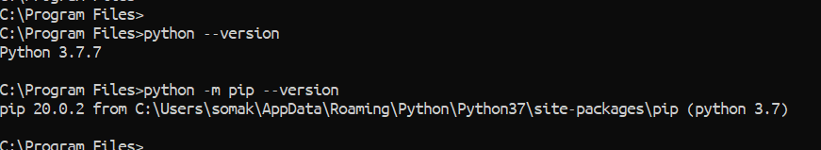

* First, we need to install CMake as below:

$ python -m pip install cmake

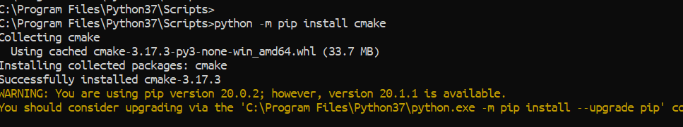

* Then go to the [dlib.net](http://dlib.net/compile.html) website and download the dlib file as below and later unzip it.

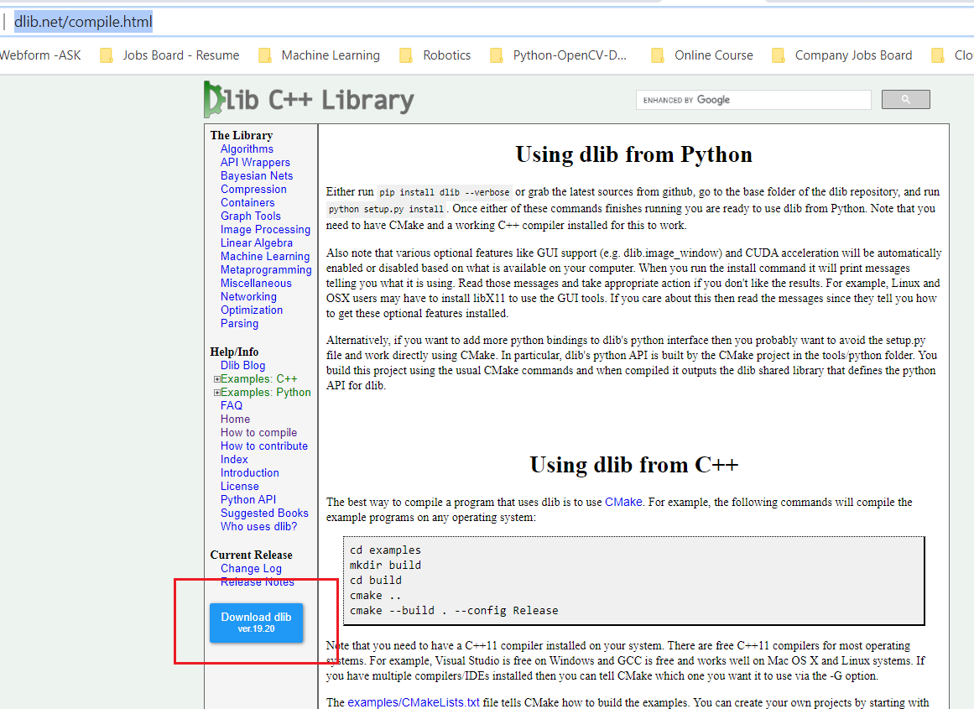

* Copy that unzip dlib file and paste it to "C:\Program Files\Python37\Lib\site-packages". It would help if you found your Python installed location. If you installed in a separate place, then go to your Python installed area and inside of the Python folder, go to Lib\site-packages and paste it over there.
* Go to Command Terminal again and navigate to the "C:\Program Files\Python37\Lib\site-packages\dlib-19.20" and install dlib as below:

$ python setup.py install

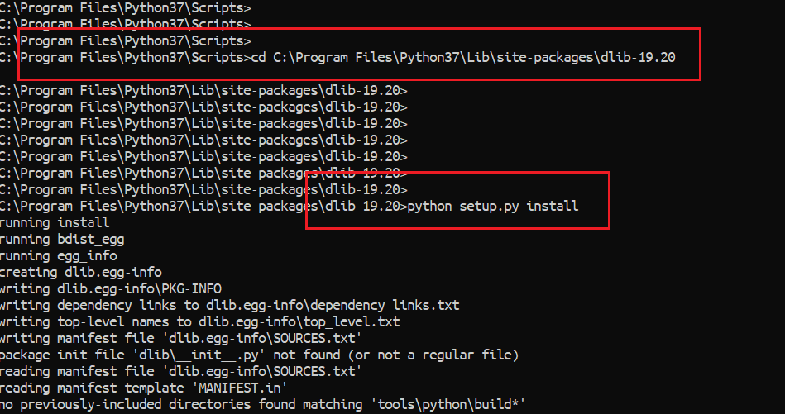

* The above process will take some time, and when it will finish, you need to install Face Recognition and need to upgrade imutils as below:

$ python -m pip install face_recognition

$ python -m pip install --upgrade imutils

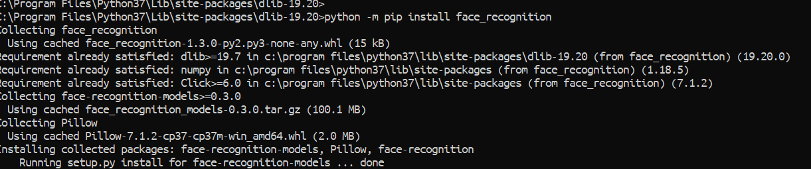

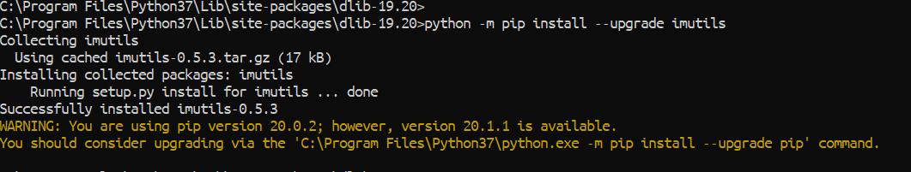

* Verify Face Recognition

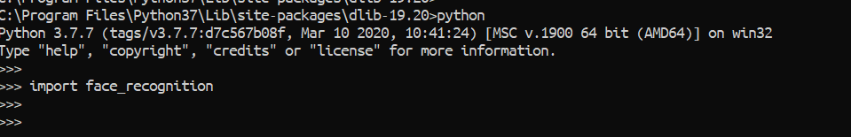

1. **Install Face Recognition on Ubuntu APP (Windows 10) or Ubuntu OS**

There are several ways you can install Face Recognition on the Ubuntu system, and you can use any of the below process on Ubuntu APP or Ubuntu OS because all are the same.

1. Install Face Recognition using Command Terminal
2. Install Face Recognition using Shell Scripts
3. **Install Face Recognition using Command Terminal**

To install Face Recognition package with Command Terminal, open Command Terminal from the Ubuntu OS, or Ubuntu APP from Windows.

* First, go to python console and verify it as below:

>> import face_recognition

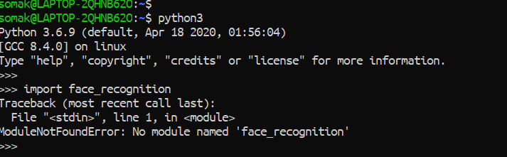

* Later, come out from the Python Console and run the below command to install Face Recognition:

$ pip3 install dlib

$ pip3 install face_recognition

$ pip3 install --upgrade imutils

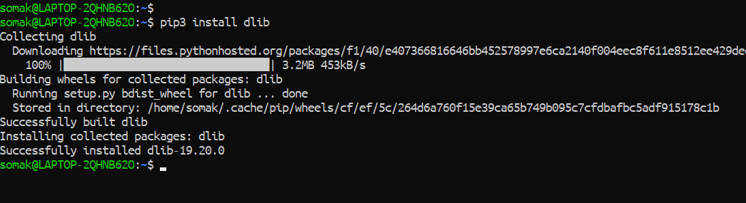

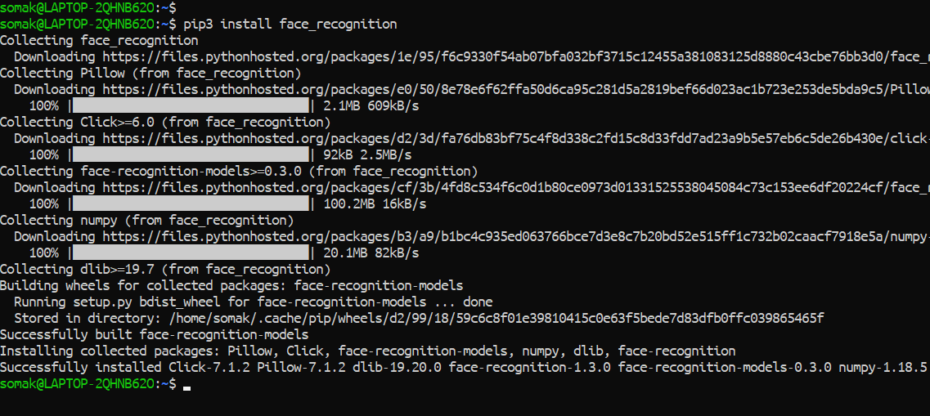

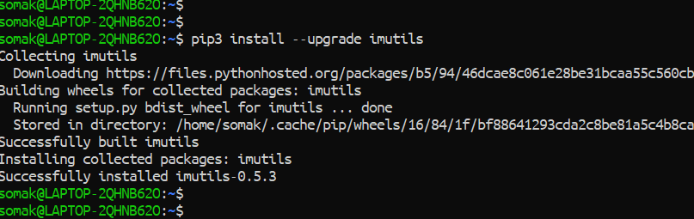

* Verify it again

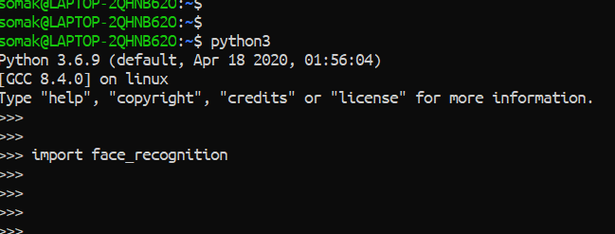

1. **Install Face Recognition using Shell Script**

First, we need to download the Robotic-Greeter folder from the [Robotic-Greeter-GitHub](https://github.com/ripanmukherjee/Robotic-Greeter) link.

You can download it in two ways:

1. Clone it with Command Terminal
2. Download it as a Zip file

Inside of the Robotic-Greeter folder, we have the shell (Unix) script, which you need to run, and this script will automatically install Face Recognition on your computer.

1. **Using Clone method**

Go to Ubuntu APP from Windows 10 or Command Terminal from Ubuntu OS and run the following command:

$ git clone https://github.com/ripanmukherjee/Robotic-Greeter.git

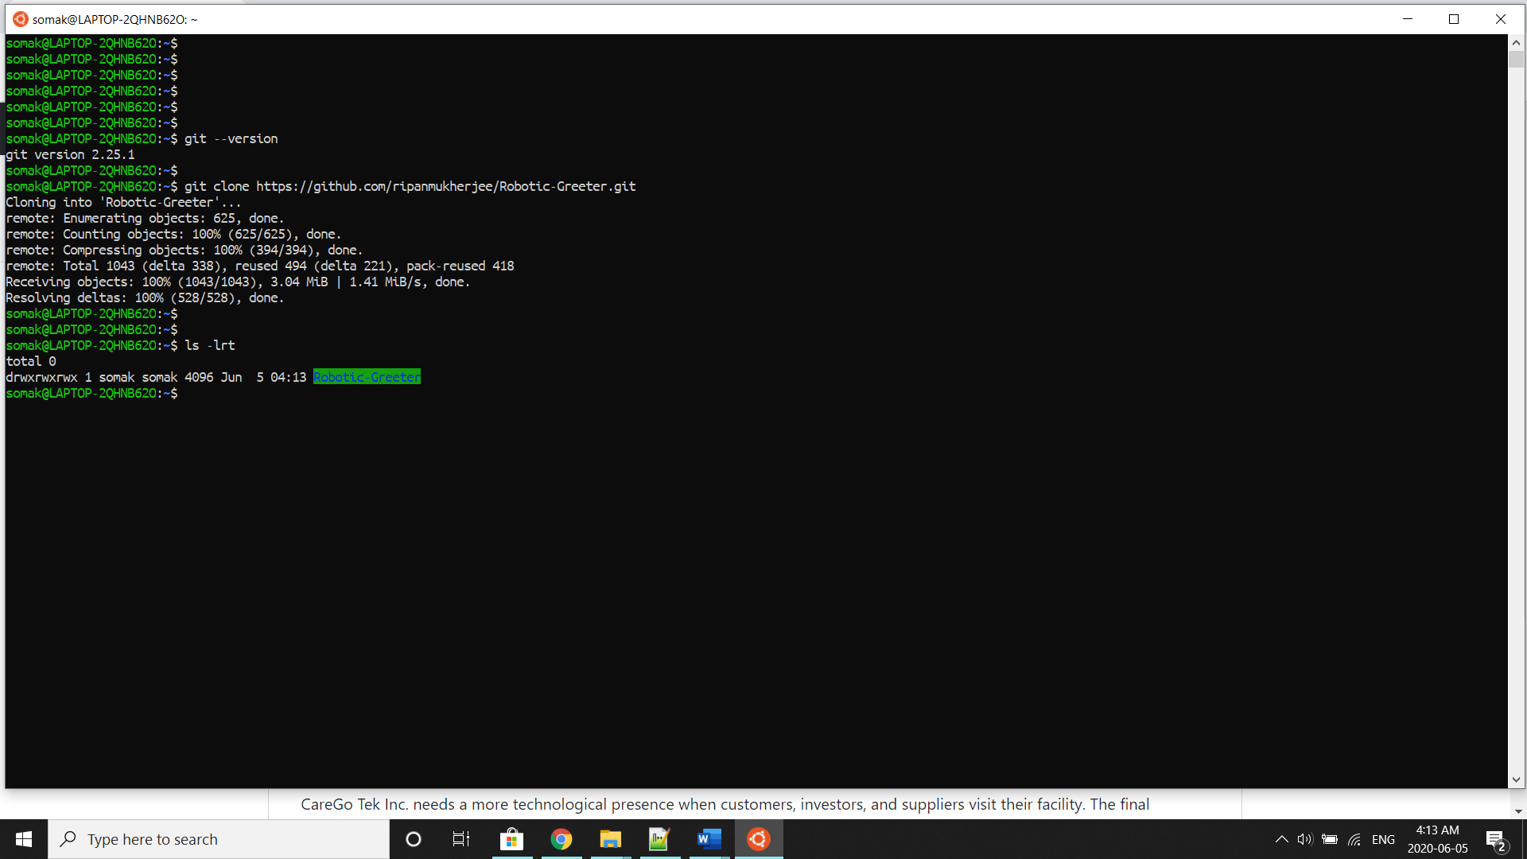

This command will automatically download the Robotic-Greeter folder on your computer.

1. **Download as Zip**

Also, you can directly download the Zip file and Unzip it. Then it would be best if you put it in the proper directory or your project directory.

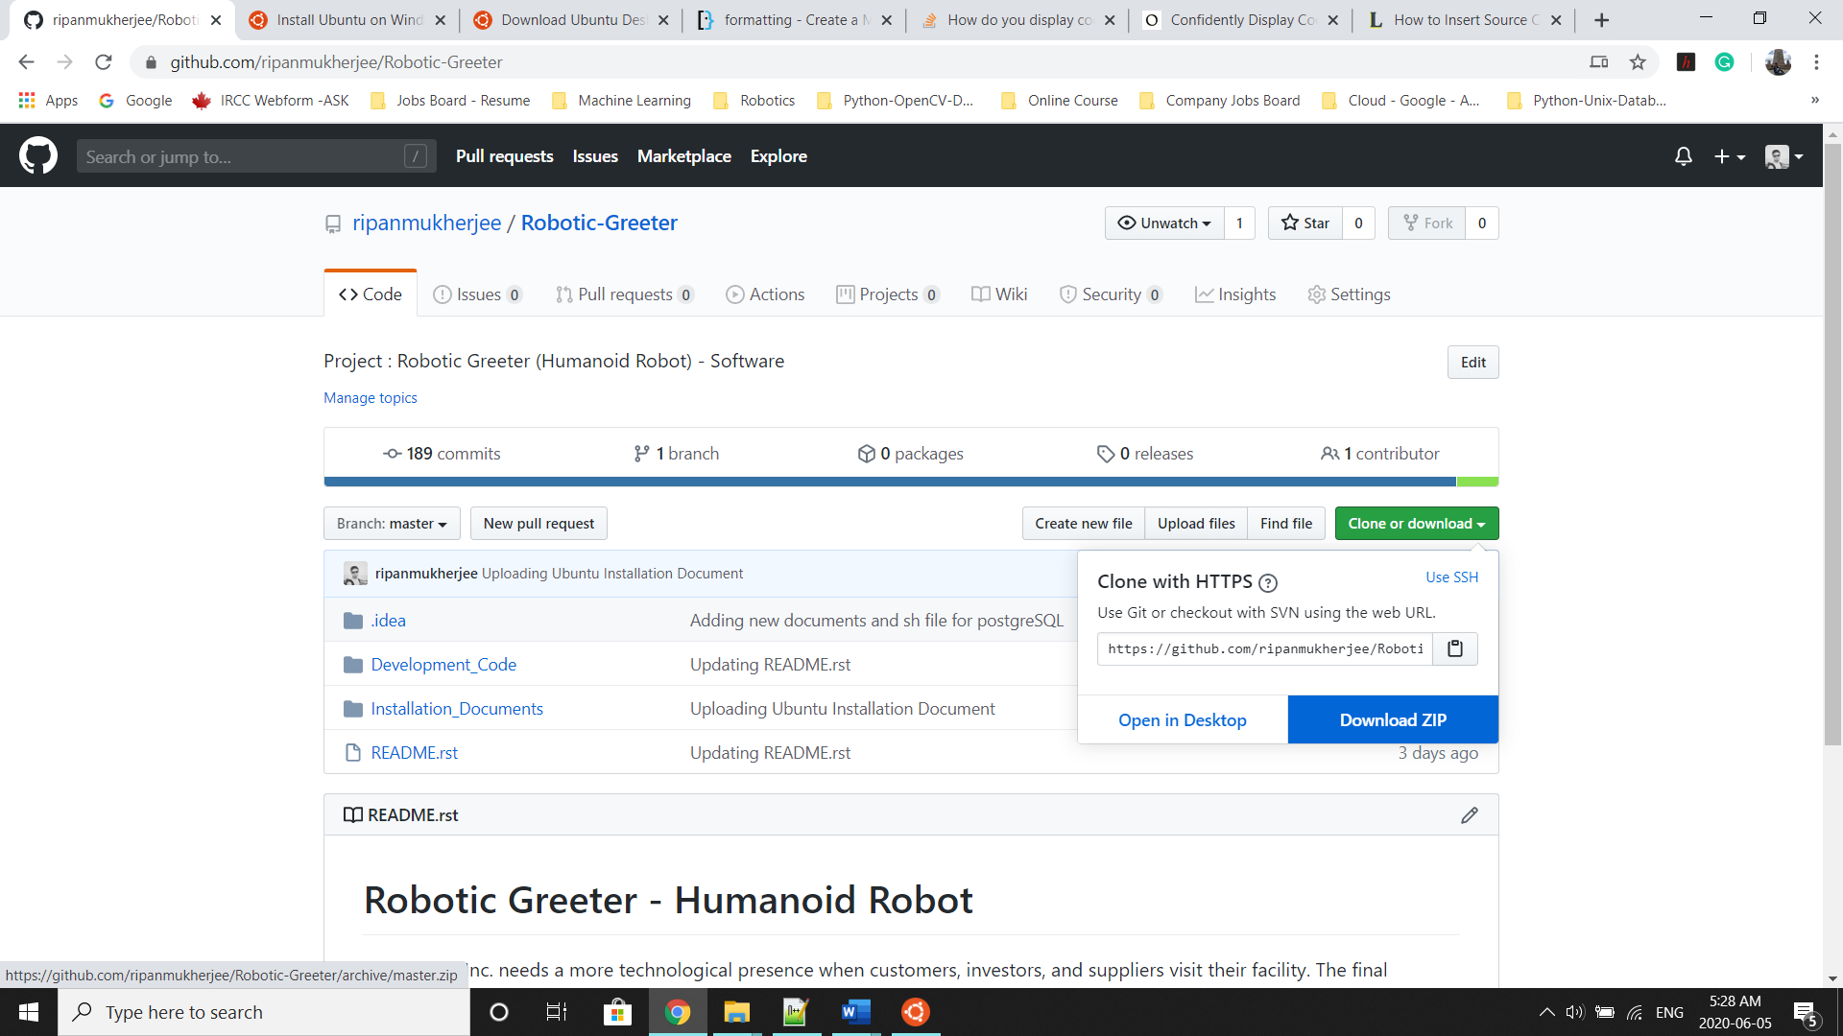

Once the download is complete, please go to the following directory:

$ cd Robotic-Greeter/Installation_Documents/Face_Recognition_Installation

In this folder, you will get ***Face_Recognition*_Installation.sh**script. To list the directories and files in this folder, run "ls -lrt" and later change the executable permission for the file with "chmod."

$ ls -lrt

$ chmod +x *.sh

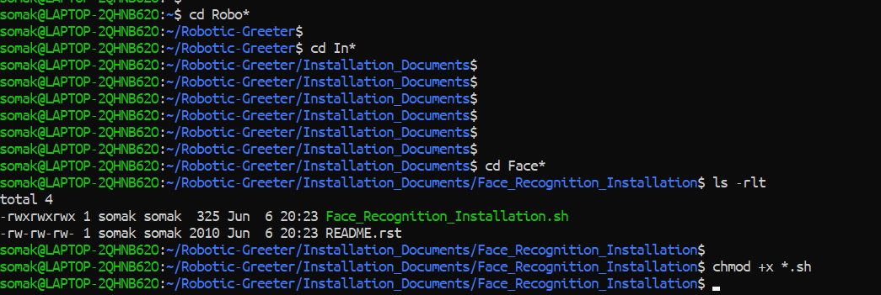

After that, run the scripts as follow:

$ sh Face_Recognition_Installation.sh

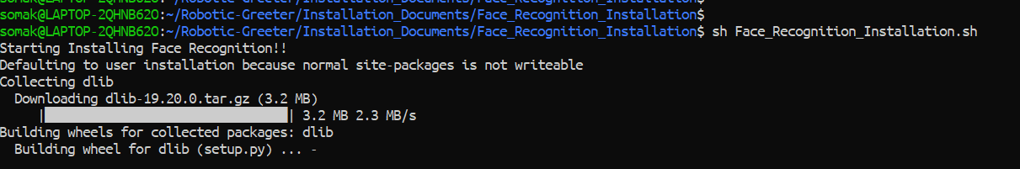

Later, you can verify it again as below:



Installation done!!

1. **Install Face Recognition on PyCharm**

If you are wished to run or execute the code from PyCharm CE, and PyCharm CE gives error regarding Face Recognition module, then you can also install it from PyCharm Packages as below:

Before installing Face Recognition through PyCharm CE, it is recommended to complete all steps from "Install Face Recognition on Windows." If you did not complete it or the above process gave an error, then it will not work with PyCharm CE also. In that case, it is better to use Ubuntu OS than Windows.

* Go to the PyCharm Terminal and install CMake as below:

$ python -m pip install cmake

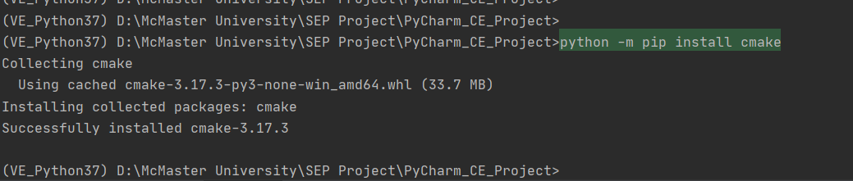

* Copy that unzip dlib file and paste it to Project's Virtual Environment(venv) directory. Inside of your Virtual Environment directory, you will get "Lib\site-packages." You need to paste this file here and then from PyCharm Terminal go to the same location and install dlib as below:

$ python setup.py install

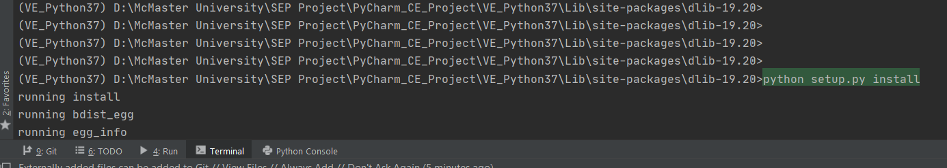

* The above process will take some time, and when it will finish, you need to install Face Recognition and need to upgrade imutils as below:

$ python -m pip install face_recognition

$ python -m pip install --upgrade imutils

* Later verify it as below:

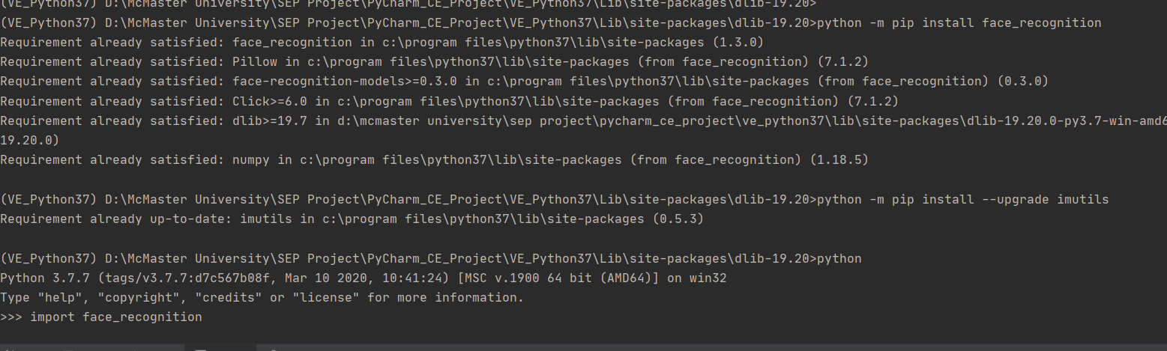

For more details related to Face Recognition, please visit the [Face Recognition](https://pypi.org/project/face-recognition/) Website.