**NLTK Installation**

NLTK is a leading platform for building Python programs to work with human language data. It provides easy-to-use interfaces to over 50 corpora and lexical resources such as WordNet, along with a suite of text processing libraries for classification, tokenization, stemming, tagging, parsing, and semantic reasoning, wrappers for industrial-strength NLP libraries, and an active discussion forum.

Thanks to a hands-on guide introducing programming fundamentals alongside topics in computational linguistics, plus comprehensive API documentation, NLTK is suitable for linguists, engineers, students, educators, researchers, and industry users alike. NLTK is available for Windows, Mac OS X, and Linux. Best of all, NLTK is a free, open-source, community-driven project.

The Natural Language Toolkit, or more commonly NLTK, is a suite of libraries and programs for symbolic and statistical Natural Language Processing (NLP) for English written in the Python programming language.

**Pre-Requisites**

* A system running on Windows/Ubuntu APP/Ubuntu OS
* A user account with sudo/administration privileges
* Access to a terminal window/command-line

Before continuing with this tutorial, make sure you are logged in as root or a user with sudo/administration privileges.

In this tutorial, we will show you how to install NLTK module on Windows and Ubuntu.

1. Install NLTK module on Windows
2. Install NLTK module on Ubuntu APP (Windows 10) or Ubuntu OS
3. Install NLTK module on PyCharm

If you are working on the Windows system, please follow step 1, step 2, and step 3, but if you are working on Ubuntu OS, you follow only step 2 and step 3.

1. **Install NLTK module** **on Windows**

Windows systems typically do not have NLTK module build-in. Before installing the NLTK module, make sure you have installed Python 3+ version and upgraded Pip. Let us look at how to install NLTK module on Windows:

* Open a Command Terminal from Windows system and verify Python & Pip as follow:

$ python –-version

$ python -m pip --version

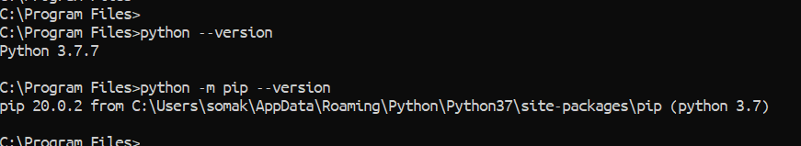

* To verify the NLTK module, go to Python Console and type as below:

>> import nltk

>> import numpy

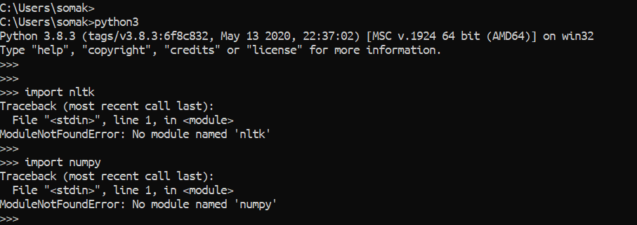

* If you do not have the NLTK module, then running the above command will give no module error as above. Now, to install the NLTK module from Command Terminal type the below command and also, we need to download NLTK data.

$ python -m pip install --user -U nltk

$ python -m pip install --user -U numpy

$ python -c "import nltk; nltk.download('all')"

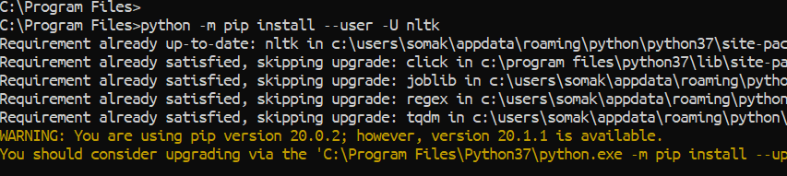

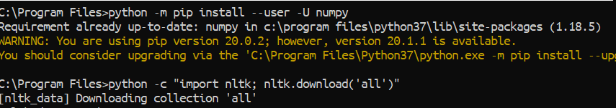

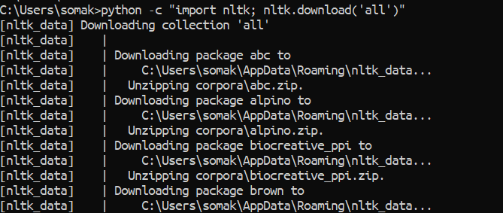

* Verify NLTK module as below:

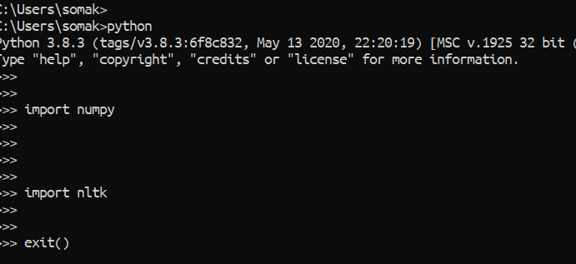

1. **Install NLTK module on Ubuntu APP (Windows 10) or Ubuntu OS**

There are several ways you can install NLTK module on the Ubuntu system, and you can use any of the below process on Ubuntu APP or Ubuntu OS because all are the same.

1. Install NLTK module using Command Terminal
2. Install NLTK module using Shell Scripts
3. **Install NLTK module using Command Terminal**

To install the NLTK package with Command Terminal, open Command Terminal from the Ubuntu OS, or Ubuntu APP from Windows.

* First, go to Python console and verify it as below:

>> import nltk

>> import numpy

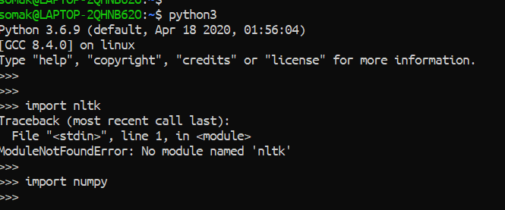

* Later, come out from the Python Console and run the below command to install NLTK module:

$ pip3 install --user -U nltk

$ pip3 install --user -U numpy

$ python3 -c "import nltk; nltk.download('all')"

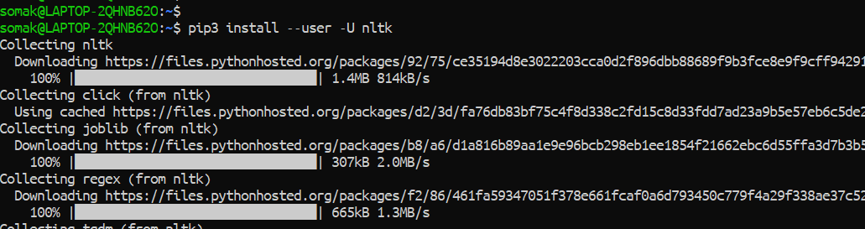

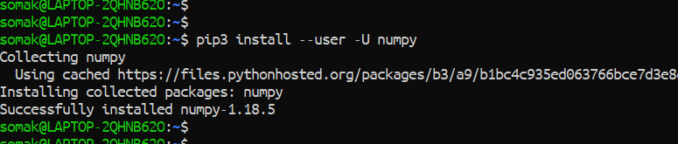

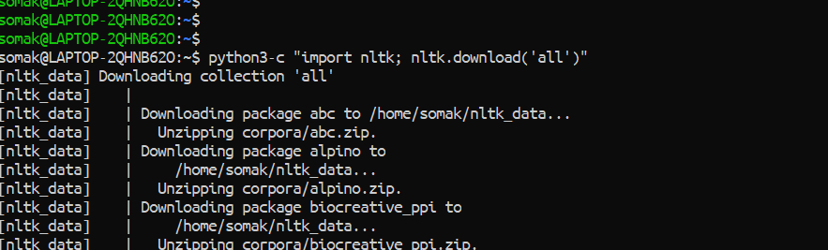

* Verify NLTK again as below:

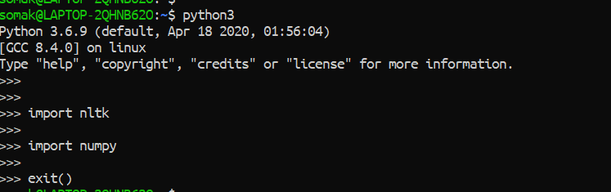

1. **Install NLTK module using Shell Script**

First, we need to download the Robotic-Greeter folder from the [Robotic-Greeter-GitHub](https://github.com/ripanmukherjee/Robotic-Greeter) link.

You can download it in two ways:

1. Clone it with Command Terminal
2. Download it as a Zip file

Inside of the Robotic-Greeter folder, we have the shell (Unix) script, which you need to run, and this script will automatically install NLTK on your computer.

1. **Using Clone method**

Go to Ubuntu APP from Windows 10 or Command Terminal from Ubuntu OS and run the following command:

$ git clone https://github.com/ripanmukherjee/Robotic-Greeter.git

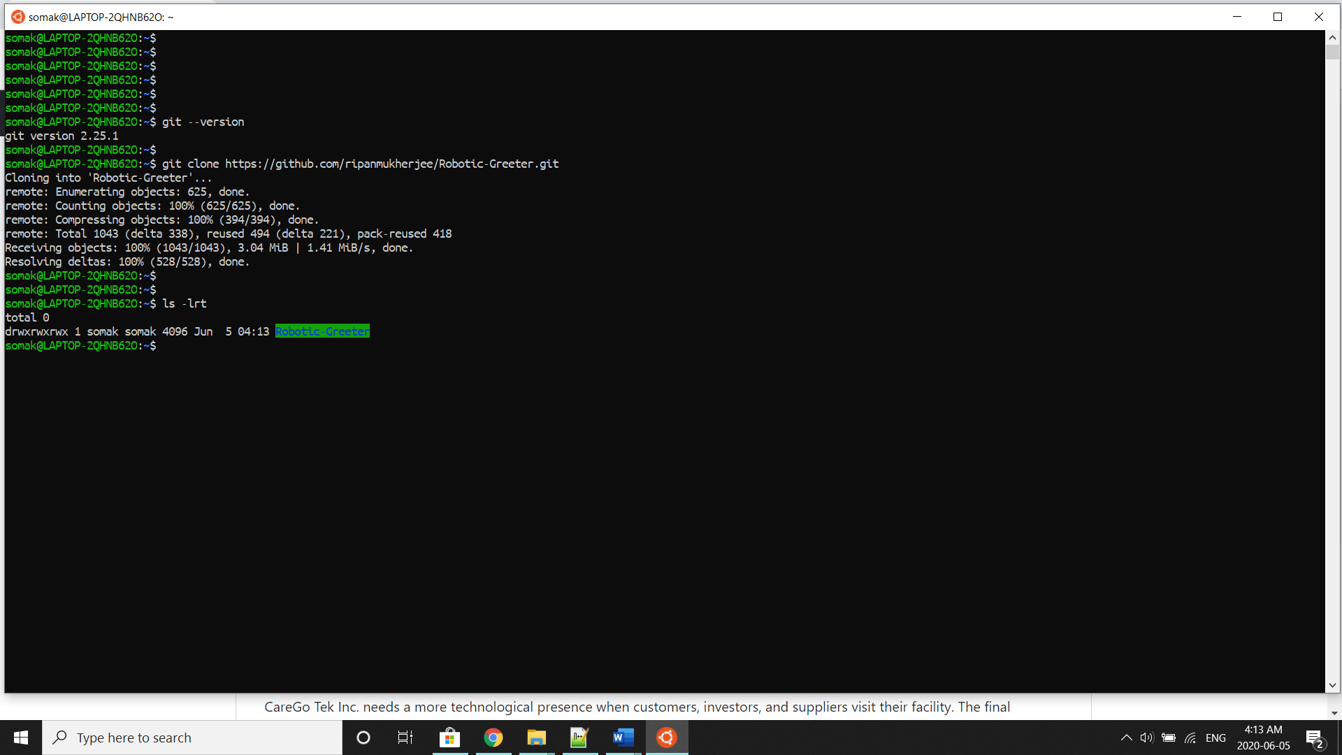

This command will automatically download the Robotic-Greeter folder on your computer.

1. **Download as Zip**

Also, you can directly download the Zip file and Unzip it. Then it would be best if you put it in the proper directory or your project directory.

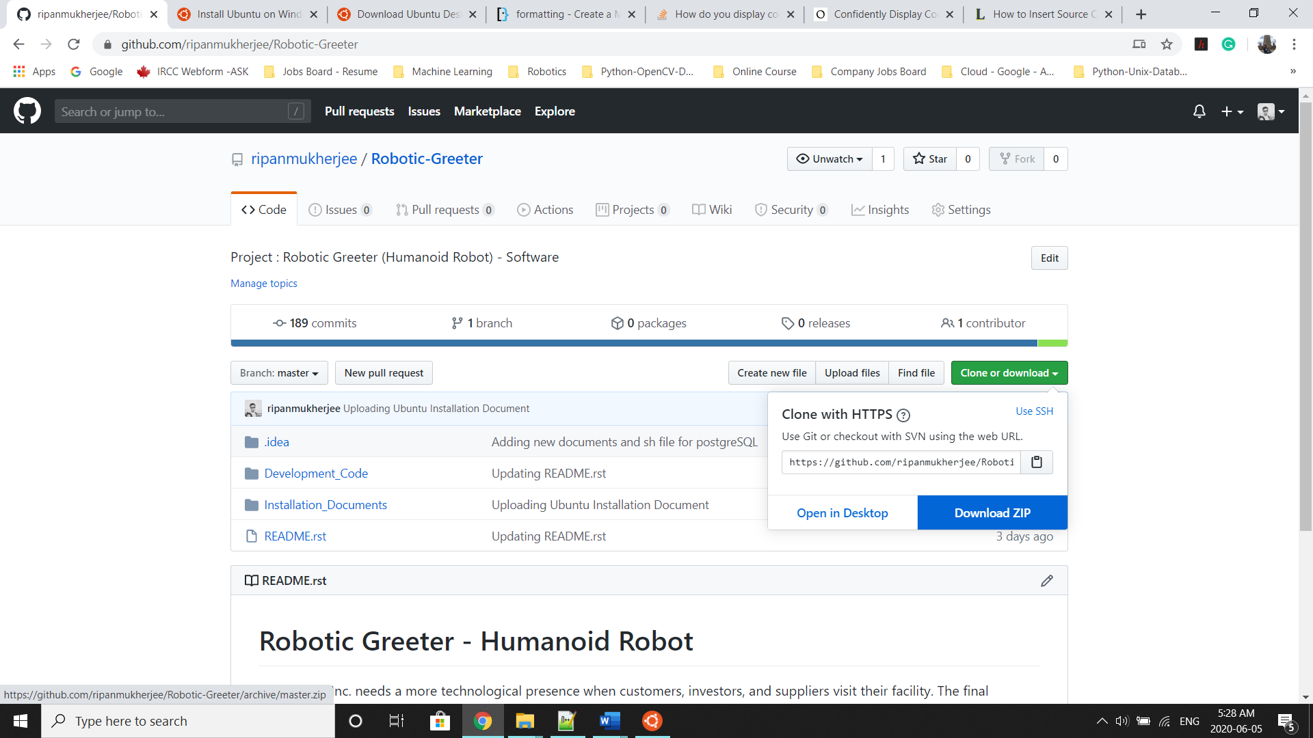

Once the download is complete, please go to the following directory:

$ cd Robotic-Greeter/Installation_Documents/NLTK_Installation

In this folder, you will get ***NLTK*_Installation.sh**script. To list the directories and files in this folder, run “ls -lrt” and later change the executable permission for the file with “chmod.”

$ ls -lrt

$ chmod +x *.sh

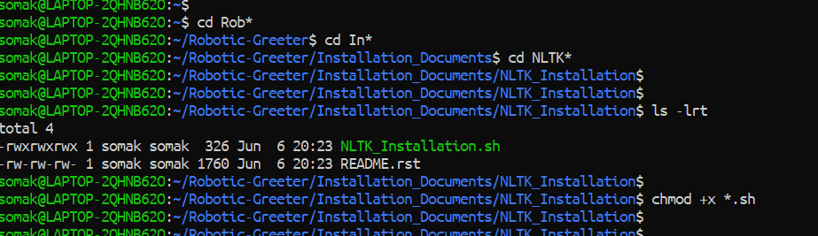

After that, run the scripts as follow:

$ sh NLTK_Installation.sh

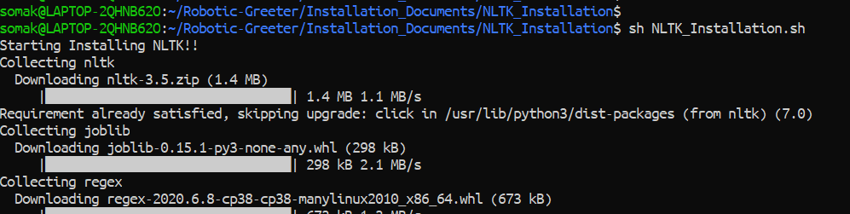

Later, you can verify NLTK again as below:



1. **Install NLTK on PyCharm**

If you wish to run or execute the code from PyCharm CE, and PyCharm CE gives error regarding NLTK module, you can also install it from PyCharm Packages as below:

* Go to Settings and click on Project Interpreter.
* In the Project Interpreter, click on “+” to add packages.

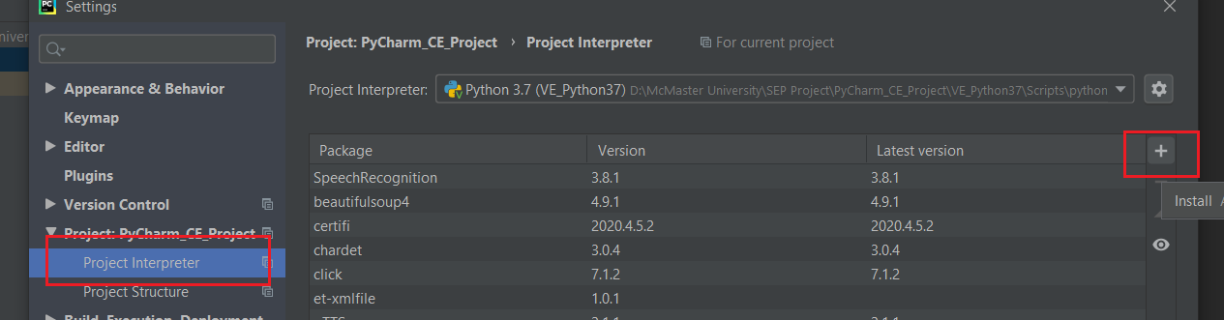

* In the Available Packages tab, you can search for “nltk” and install it.

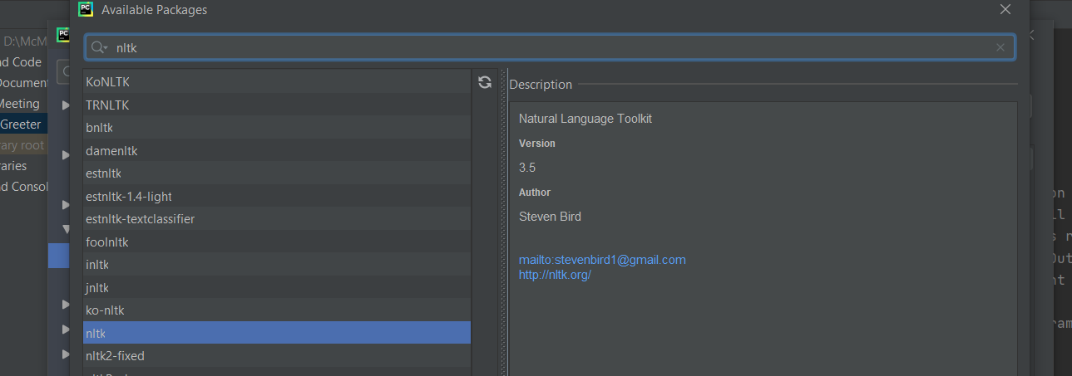

* In the Available Packages tab, you can search for “numpy” and install it.

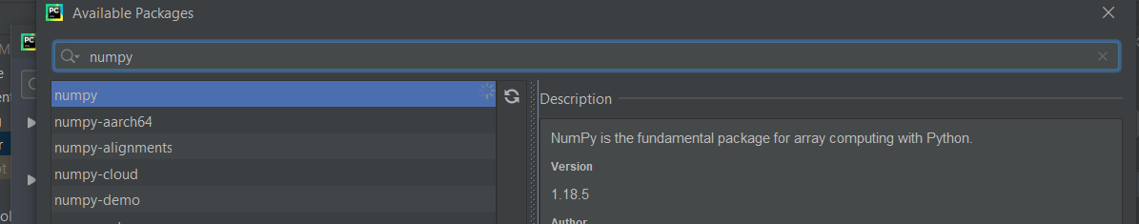

For more details related to NLKT, please visit the [NLTK](https://www.nltk.org/data.html) Website.