**OpenCV Installation**

OpenCV (Open Source Computer Vision Library) is an open-source computer vision library with bindings for C++, Python, and Java. It is used for a wide range of applications, including medical image analysis, stitching street view images, surveillance video, detecting and recognizing faces, tracking moving objects, extracting 3D models, and much more. OpenCV can take advantage of multi-core processing and features GPU acceleration for real-time operation.

OpenCV-Python is a library of Python bindings designed to solve computer vision problems. OpenCV-Python uses of NumPy, a highly optimized library for numerical operations with a MATLAB-style syntax. All the OpenCV array structures are converted to and from NumPy arrays.

**Pre-Requisites**

* A system running on Windows/Ubuntu APP/Ubuntu OS
* A user account with sudo/administration privileges
* Access to a terminal window/command-line

Before continuing with this tutorial, make sure you are logged in as root or a user with sudo/administration privileges.

In this tutorial, we will show you how to install OpenCV on Windows and Ubuntu.

1. Install OpenCV on Windows
2. Install OpenCV on Ubuntu APP (Windows 10) or Ubuntu OS
3. Install OpenCV on PyCharm

If you are working on the Windows system, please follow step 1, step 2, and step 3, but if you are working on Ubuntu OS, you follow only step 2, and step 3.

1. **Install OpenCV** **on Windows**

Windows systems typically do not have OpenCV build-in. Before installing OpenCV, make sure you have installed Python 3+ version. Let us look at how to install OpenCV on Windows:

* Open a Command Terminal from Windows system and verify Python & Pip as follow:

$ python –-version

$ python -m pip --version

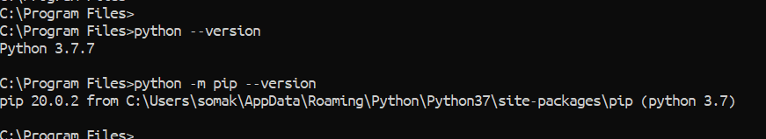

* To verify OpenCV, go to Python Console and type as below:

>> import cv2

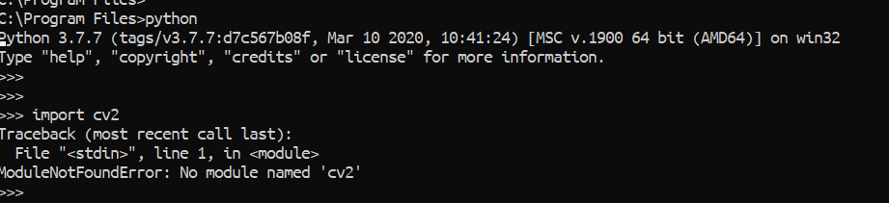

* If you do not have OpenCV, then running the above command will give no module error as above. Now, to install OpenCV from Command Terminal type the command as below:

$ python -m pip install opencv-python

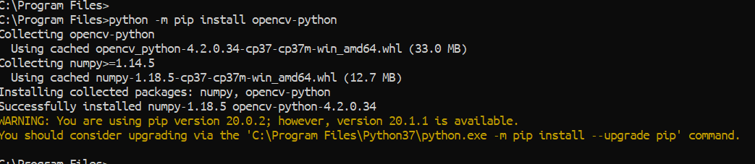

* Verify OpenCV

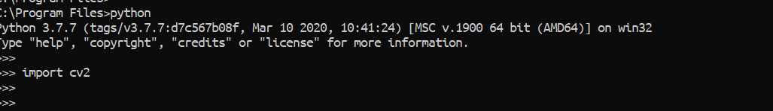

* As above you can see we installed OpenCV for Python version not for Python3 version. So, if you call or run any Python program with “python code.py” then the above process will work for you. But if you want to run with “python3 code.py” then it will not work.

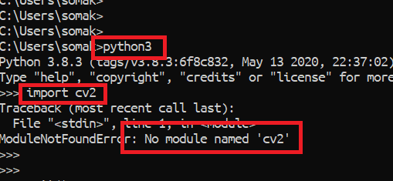

* To install OpenCV with Python3, please follow the below steps:
* First go to [here](https://www.lfd.uci.edu/~gohlke/pythonlibs/#opencv) and search for OpenCV as below:

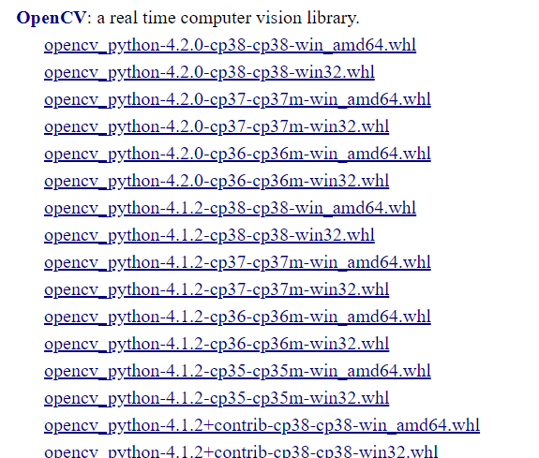

* Here you will get many Windows Wheel file. You need to download them on your computer and install it. On my computer, I have Python 3.7, Windows10 and 64 bits. So, for me “[opencv_python‑4.2.0‑cp38‑cp38‑win_amd64.whl](javascript:;)” worked. Maybe it will be different for you. So, it will be better if you can download them one and install it. If that file does not work, then try with another.
* To install Wheel file, copy them from Downloads folder to your “C:” drive. Inside of the “C:” drive you can create a new folder and you can paste it there.
* Now go to your Command Terminal on Windows system and run the below command to install them. Remember for your computer you may need to install another file, but the command will be the same. Also, you need to install Numpy with this process.

$ python3 -m pip install opencv_python-4.2.0-cp38-cp38-win_amd64.whl

$ python3 -m pip install numpy

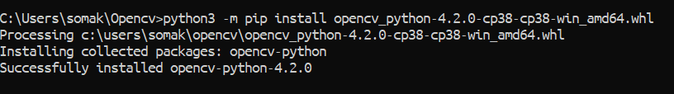

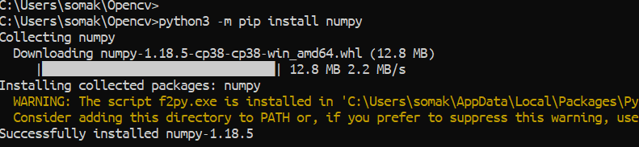

* Then verify OpenCV as below:

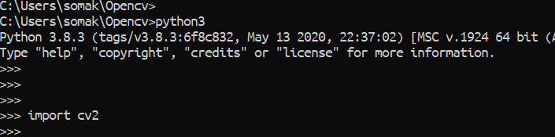

1. **Install OpenCV on Ubuntu APP (Windows 10) or Ubuntu OS**

There are several ways you can install OpenCV on the Ubuntu system, and you can use any of the below process on Ubuntu APP or Ubuntu OS because all are the same.

1. Install OpenCV from the Ubuntu Repository.
2. Install OpenCV from the Source.
3. Install OpenCV from the Shell Scripts.
4. **Install OpenCV from the Ubuntu Repository**

To find out what version(s) you have, open a Terminal window from Ubuntu OS or open Ubuntu APP from Windows 10, and try the following commands:

$ python3 -c "import cv2; print(cv2.__version__)"

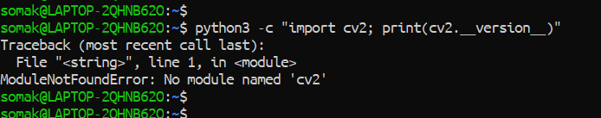

The OpenCV package is available from the Ubuntu 18.04 distribution repository. At the time of writing, the version in the repositories is 3.2, not the latest version. To install OpenCV from the Ubuntu 18.04 repositories, follow these steps:

* Refresh the packages index and install the OpenCV package by typing:

$ sudo apt update

$ sudo apt install python3-opencv

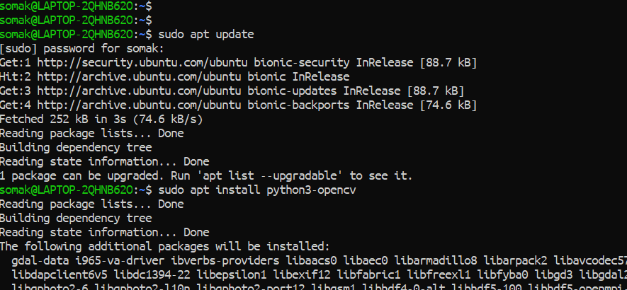



* To verify the installation, import the cv2 module and print the OpenCV version:

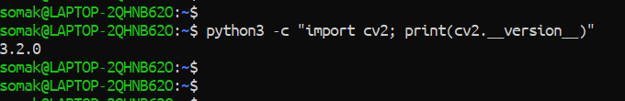

1. **Install OpenCV from the Source**

Building the OpenCV library from source is the recommended way of installing OpenCV. It will be optimized for your system, and you will have complete control over the build options. To install the latest OpenCV version from the source, perform the following steps:

* Install the required dependencies and press “Y” to continue:

$ sudo apt install build-essential cmake git pkg-config libgtk-3-dev \

libavcodec-dev libavformat-dev libswscale-dev libv4l-dev \

libxvidcore-dev libx264-dev libjpeg-dev libpng-dev libtiff-dev \

gfortran openexr libatlas-base-dev python3-dev python3-numpy \

libtbb2 libtbb-dev libdc1394-22-dev

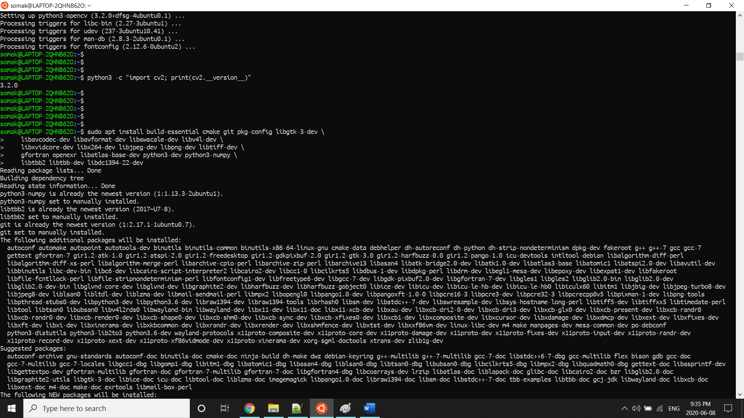

* Clone the OpenCV’s and OpenCV Contrib repositories:

$ mkdir ~/opencv_build && cd ~/opencv_build

$ git clone https://github.com/opencv/opencv.git

$ git clone https://github.com/opencv/opencv_contrib.git

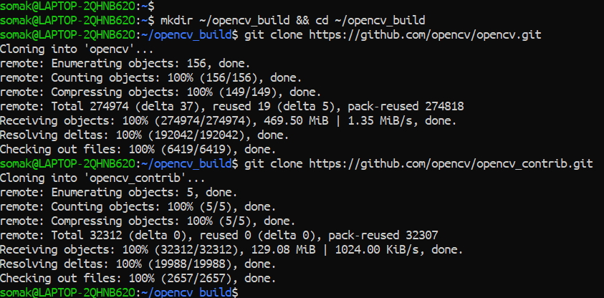

* At the time of writing, the default version in the GitHub repositories is version 4.2.0. If you want to install an older version of OpenCV, cd to both OpenCV and OpenCV_Contrib directories and run git checkout.
* Now changed the directory after the download is done:

$ cd ~/opencv_build/opencv

$ mkdir build && cd build

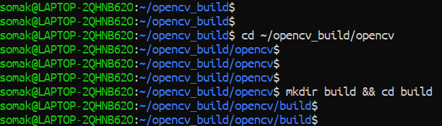

* Set up the OpenCV build with CMake:

$ cmake -D CMAKE_BUILD_TYPE=RELEASE \

-D CMAKE_INSTALL_PREFIX=/usr/local \

-D INSTALL_C_EXAMPLES=ON \

-D INSTALL_PYTHON_EXAMPLES=ON \

-D OPENCV_GENERATE_PKGCONFIG=ON \

-D OPENCV_EXTRA_MODULES_PATH=~/opencv_build/opencv_contrib/modules \

-D BUILD_EXAMPLES=ON ..

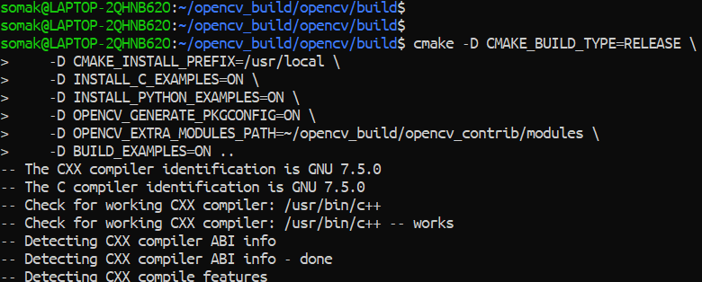

* Start the compilation process with make -j8. This process is going to take 10-20 minutes.

$ make -j8

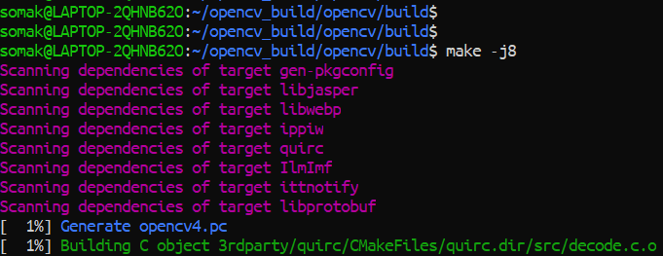

* Install OpenCV with:

$ sudo make install

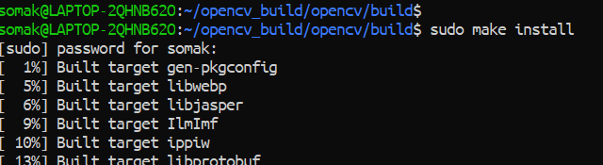

* Now verify the OpenCV version:

$ pkg-config --modversion opencv4

$ python3 -c "import cv2; print(cv2.__version__)"

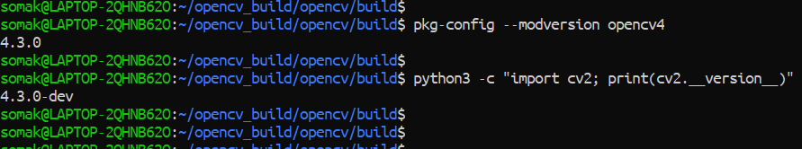

1. **Install OpenCV from the Shell Script**

First, we need to download the Robotic-Greeter folder from the [Robotic-Greeter-GitHub](https://github.com/ripanmukherjee/Robotic-Greeter) link.

You can download it in two ways:

1. Clone it with Command Terminal
2. Download it as a Zip file

Inside of the Robotic-Greeter folder, we have the shell (Unix) script, which you need to run, and this script will automatically install OpenCV on your computer.

1. **Using Clone method**

Go to Ubuntu APP from Windows 10 or Command Terminal from Ubuntu OS and run the following command:

$ git clone https://github.com/ripanmukherjee/Robotic-Greeter.git

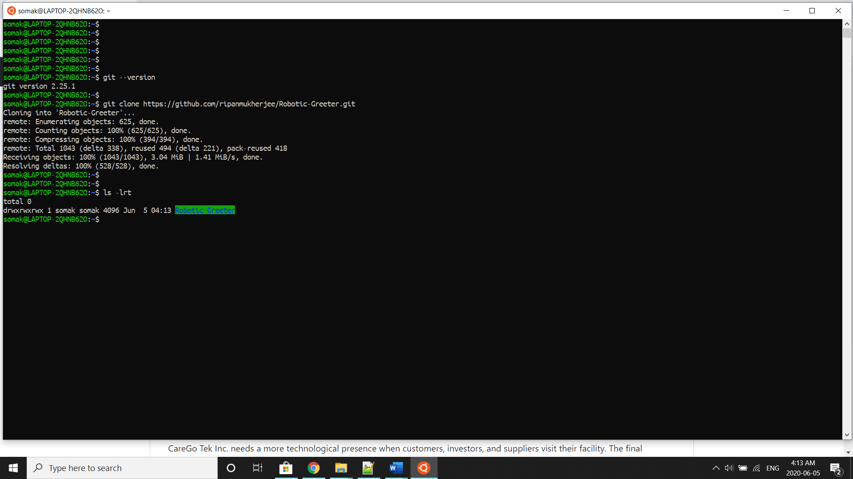

This command will automatically download the Robotic-Greeter folder on your computer.

1. **Download as Zip**

Also, you can directly download the Zip file and Unzip it. Then it would be best if you put it in the proper directory or your project directory.

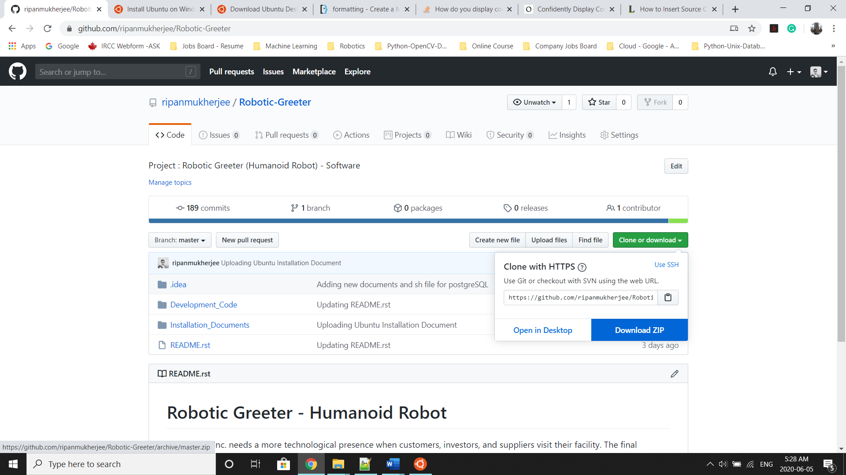

Once the download is complete, please go to the following directory from Ubuntu APP Terminal or Command Terminal on Ubuntu OS:

$ cd Robotic-Greeter/Installation_Documents/OpenCV_Installation

In the OpenCV_Installation folder, you will get **OpenCV_Installation.sh**script. To list the directories and files in this folder run “ls -lrt” and later change the executable permission for the file with “chmod”.

$ ls -lrt

$ chmod +x *.sh

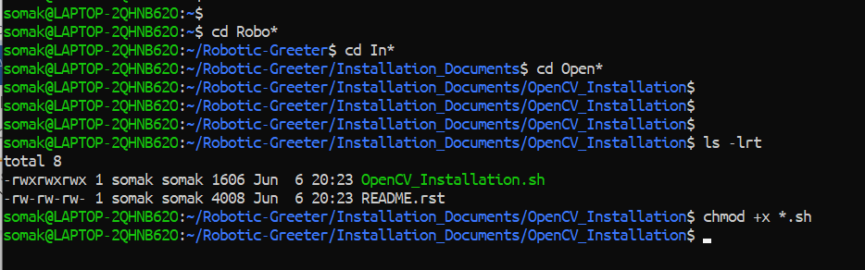

After that, run the scripts as follow:

$ sh OpenCV_Installation.sh

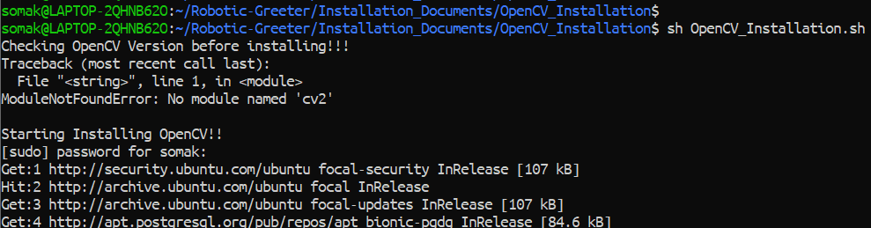

Later, you can again verify it as below:



Installation done!!

1. **Install OpenCV on PyCharm**

If you are wished to run or execute the code from PyCharm CE, and PyCharm CE gives error regarding OpenCV module, then you can also install it from PyCharm Packages as below:

* Go to Settings and click on Project Interpreter
* In the Project Interpreter, click on “+” to add packages.

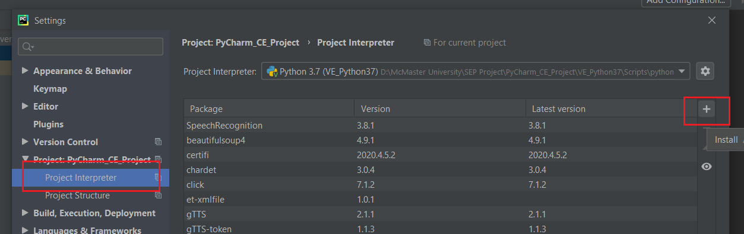

* In the Available Packages tab, you can search for “opencv-python” and install it. You can install any packages related to OpenCV.

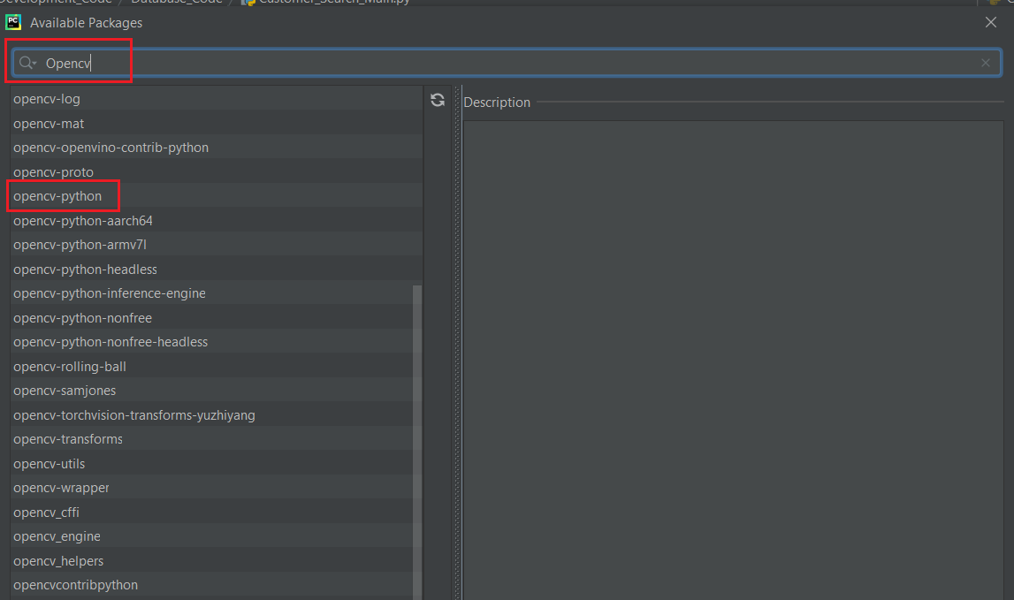

For more details related to OpenCV, please visit the [OpenCV.org](https://opencv.org/) website.