**Pip Installation**

Pip is a package management system that simplifies the installation and management of software packages written in Python, such as those found in the Python Package Index ([PyPi](https://pypi.org/)). Pip is not installed by default on Ubuntu, but the installation is straight forward.

In this tutorial, we will show you how to install Pip on Ubuntu using the apt package manager. We will also walk you through the basics of installing and managing Python packages with Pip. This process you can run for Ubuntu APP or Ubuntu OS. Both methods are the same.

**Pre-Requisites**

* A system running on Windows/Ubuntu APP/Ubuntu OS
* A user account with sudo/administration privileges
* Access to a terminal window/command-line

Before continuing with this tutorial, make sure you are logged in as root or a user with sudo/administration privileges.

There are two way you can install Pip in Ubuntu system:

1. Install Pip using Command Terminal
2. Install Pip using Shell Scripts

If you are on Windows OS, then assuming you have installed Pip while installing Python 3. In this case, go to the Command Terminal on Windows and verify it as below:

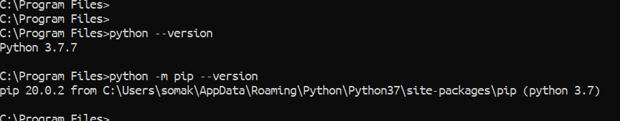

1. **Install Pip using Command Terminal**

Open a Terminal window from Ubuntu OS or open Ubuntu APP from Windows 10, and try the following commands:

$ pip3 ––version

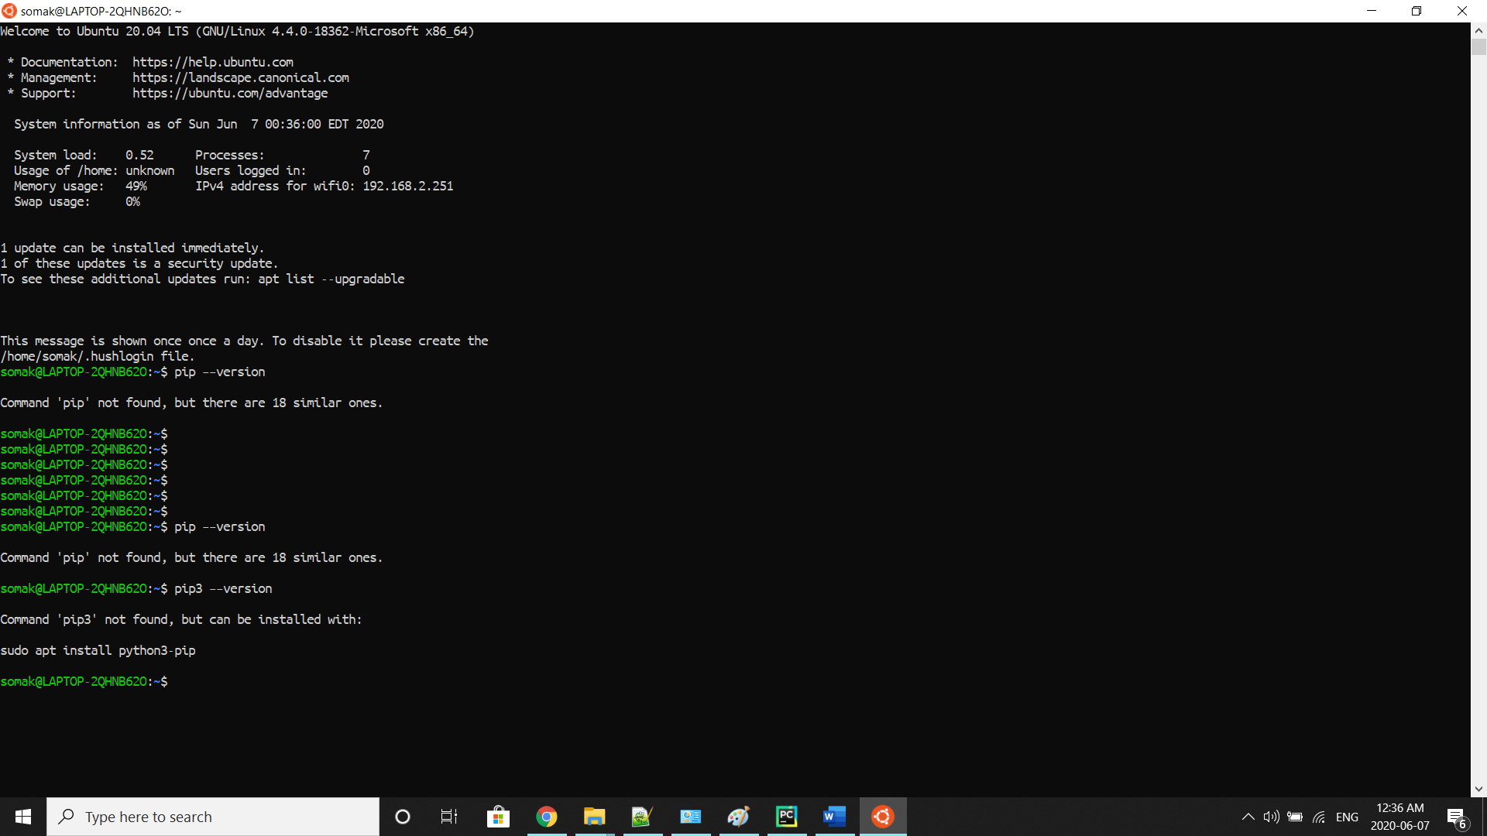

If you do not have Pip installed on your computer, then you will receive the above message, as shown in the picture. To install Pip and upgrade it on your Ubuntu OS, run the below command:

$ sudo apt install python3-pip

$ python3 -m pip install --upgrade pip

$ pip3 --version

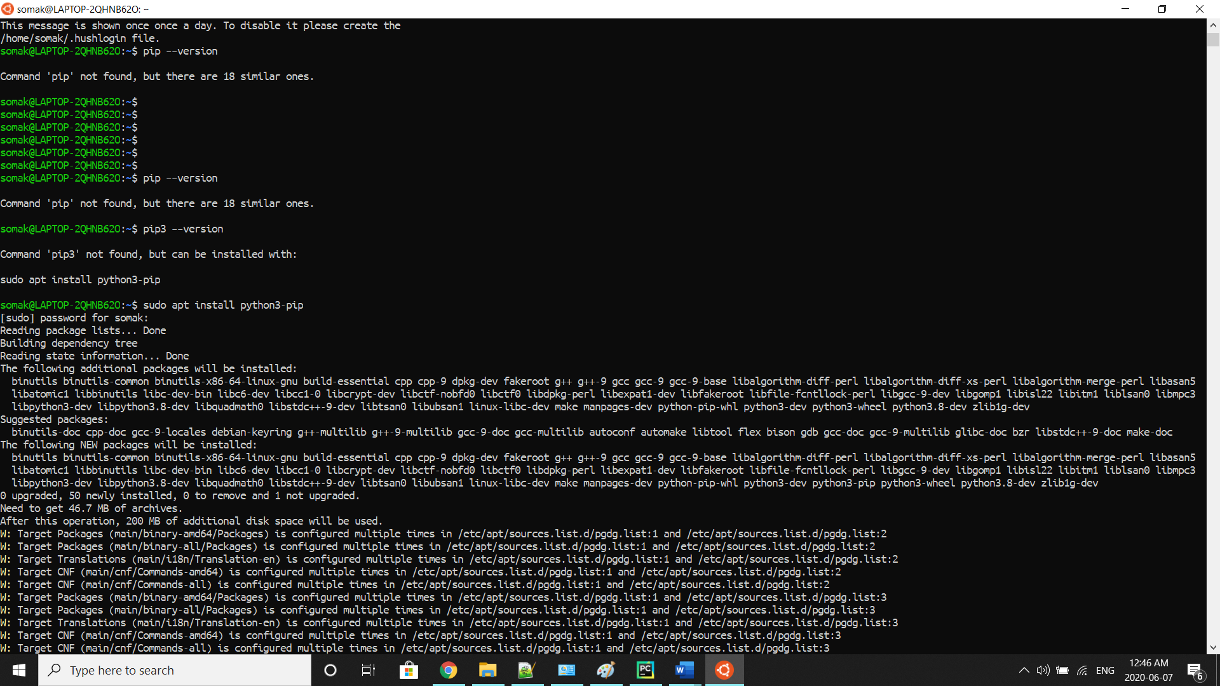

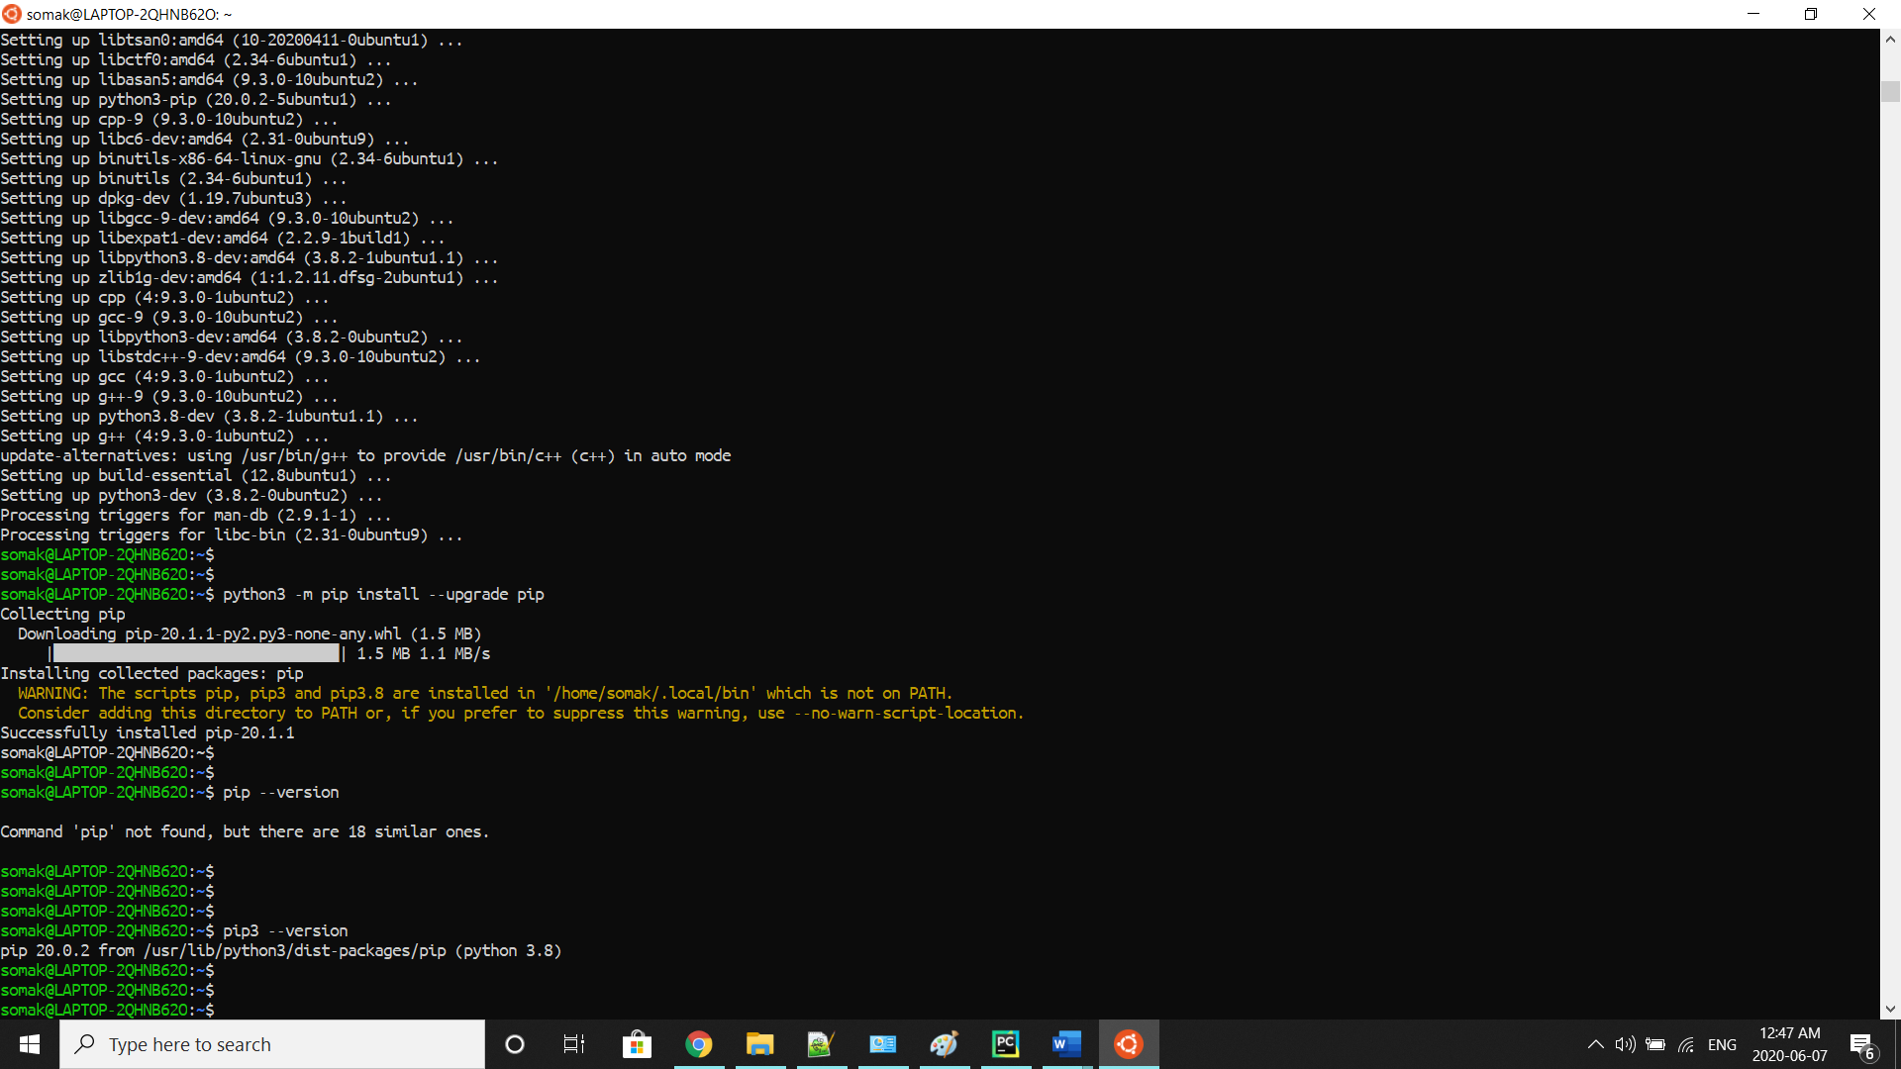



1. **Install Pip using Shell Script**

First, we need to download the Robotic-Greeter folder from the [Robotic-Greeter-GitHub](https://github.com/ripanmukherjee/Robotic-Greeter) link.

You can download it in two ways:

1. Clone it with command Terminal
2. Download it as a Zip file

Inside of the Robotic-Greeter folder, we have the shell (Unix) script, which you need to run, and this script will automatically install Pip on your computer.

1. **Using Clone method**

Go to Ubuntu APP from Windows 10 or Command Terminal from Ubuntu OS and run the following command:

$ git clone https://github.com/ripanmukherjee/Robotic-Greeter.git

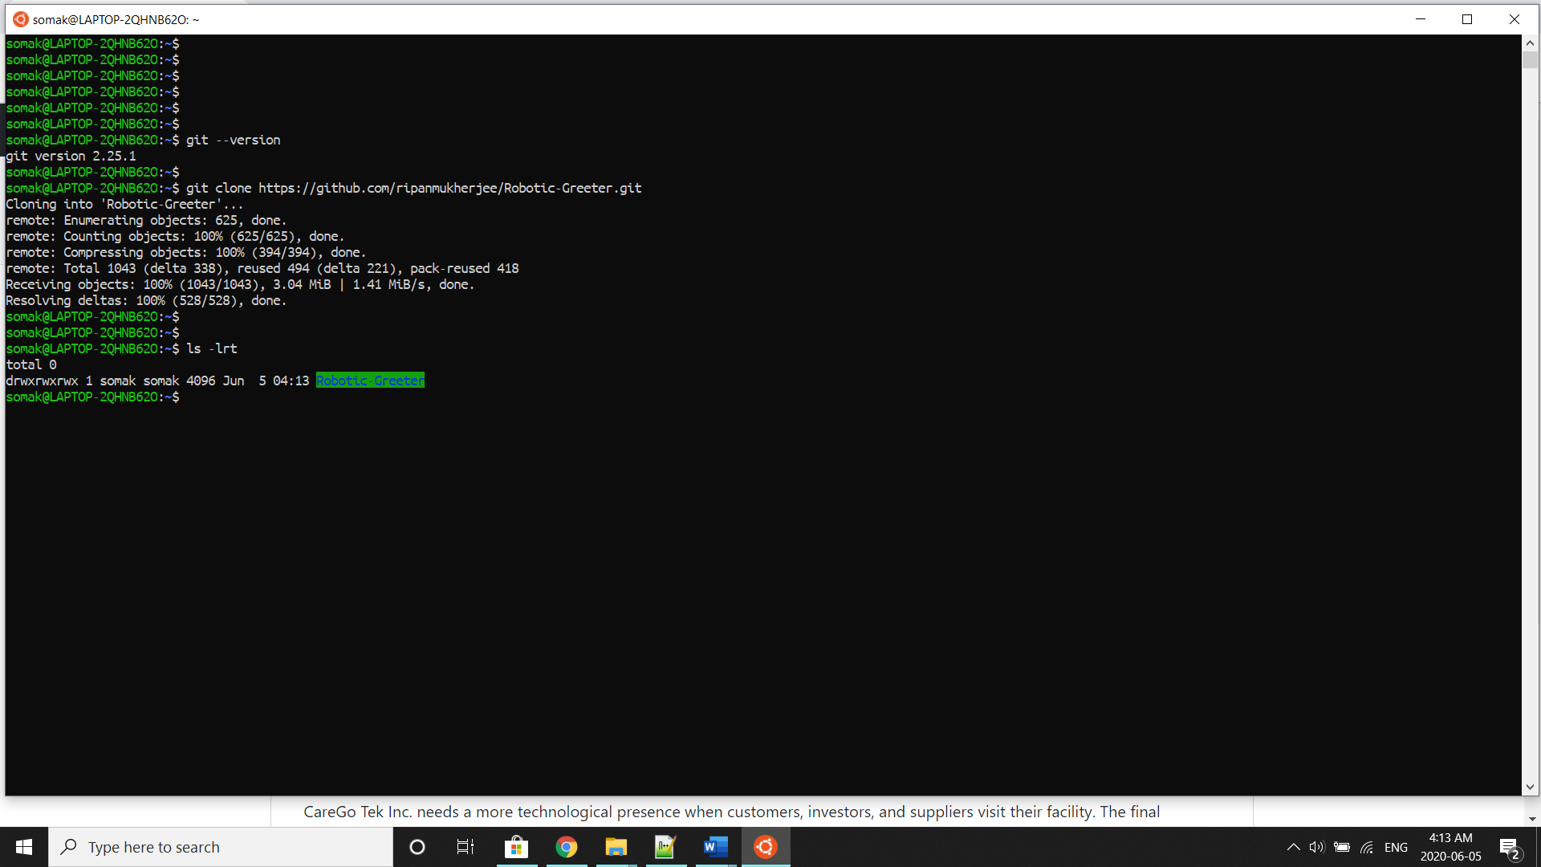

This command will automatically download the Robotic-Greeter folder on your computer.

1. **Download as Zip**

Also, you can directly download the Zip file and Unzip it. Then it would be best if you put it in the proper directory or your project directory.

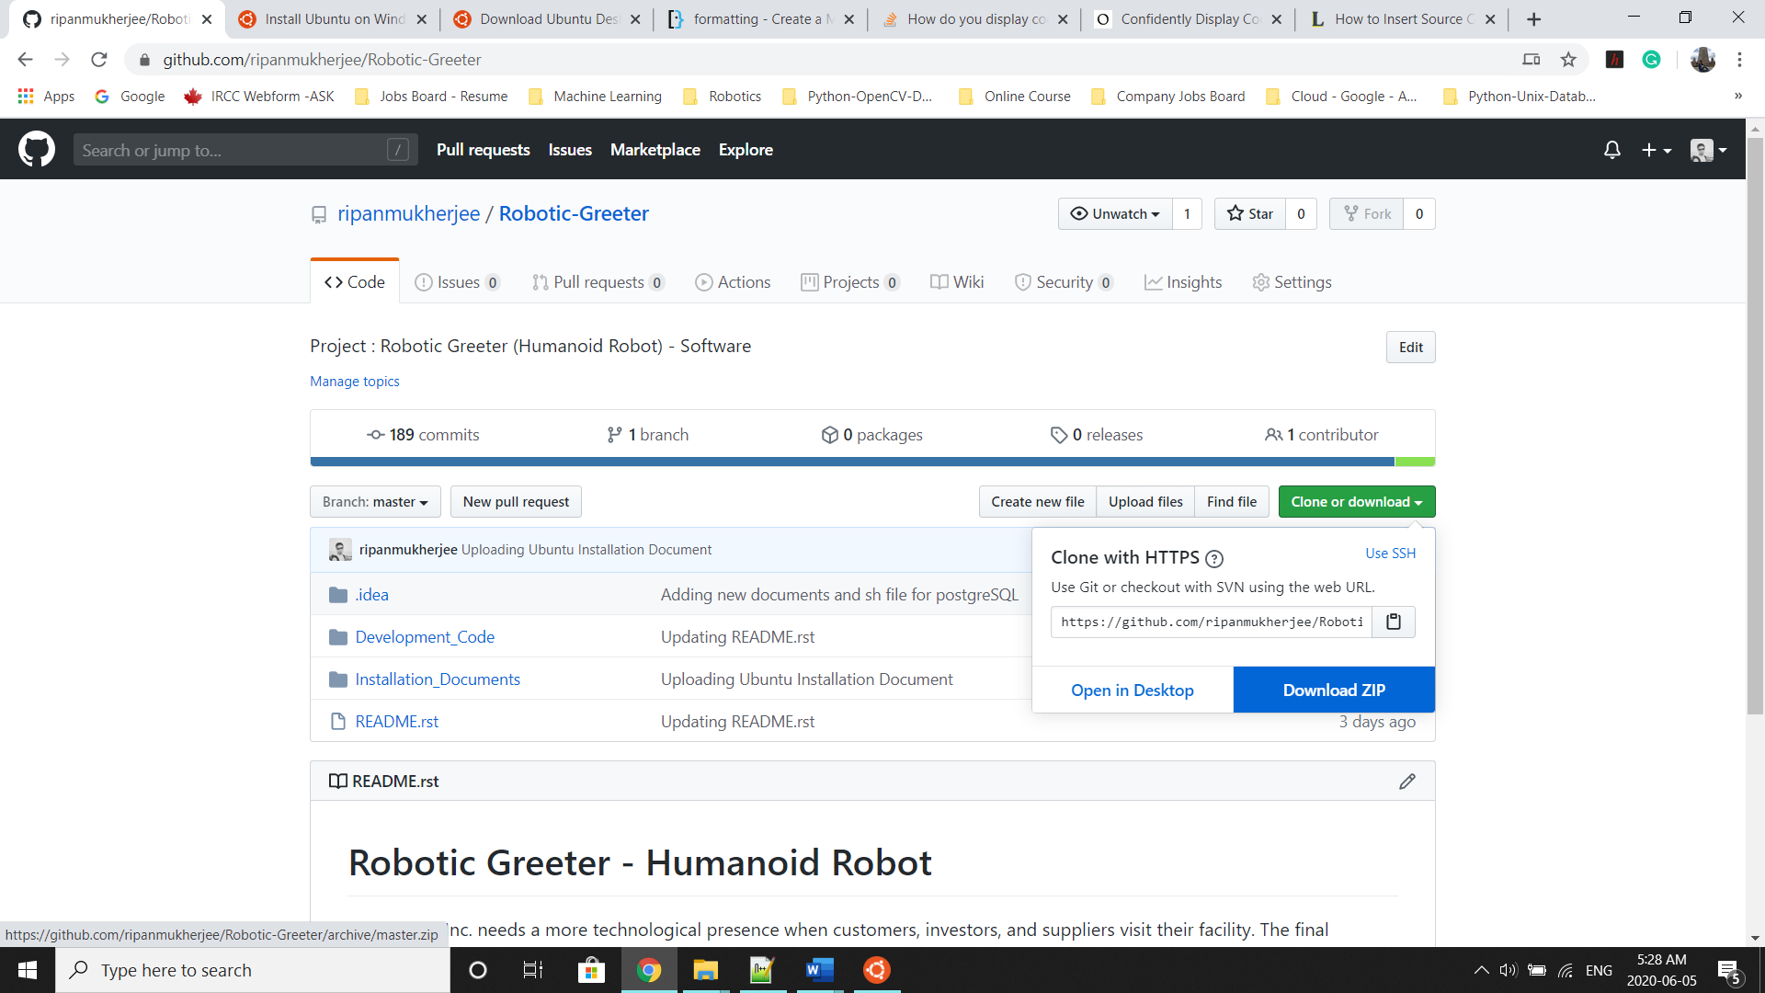

Once the download is complete, please go to the following directory from Ubuntu APP Terminal or Command Terminal on Ubuntu OS:

$ cd Robotic-Greeter/Installation_Documents/Pip_Installation

In the Pip_Installation folder, you will get **Pip_Installation.sh**script. To list the directories and files in this folder run “ls -lrt” and later change the executable permission for the file with “chmod”.

$ ls -lrt

$ chmod +x *.sh

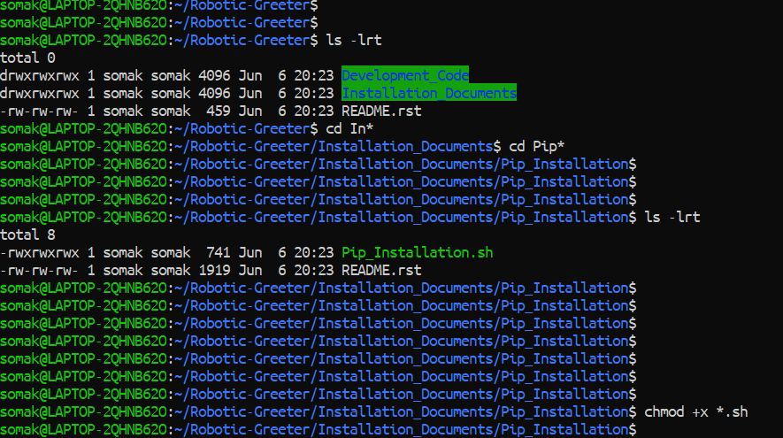

After that, run the scripts as follow:

$ sh Pip_Installation.sh

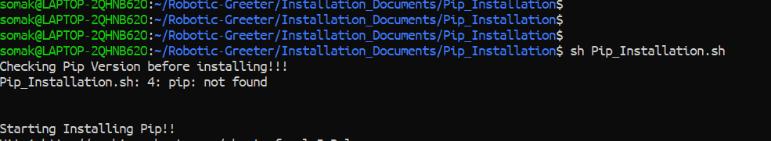

Later, you can again verify it as below:



Installation done!!

Please visit the [PyPi](https://pypi.org/) (Python Package Index) site for more Pip packages details.