**PostgreSQL & pgAdmin4 Installation**

PostgreSQL is a powerful, open-source object-relational database system with over 30 years of active development that has earned a strong reputation for reliability, feature robustness, and performance. PostgreSQL is available in all Ubuntu versions by default. However, Ubuntu "snapshots" a specific version of PostgreSQL that is supported throughout the lifetime of that Ubuntu version. Other versions of PostgreSQL are available through the PostgreSQL apt repository. You can also download and install it on Windows 10.

**Pre-Requisites**

* A system running on Windows/Ubuntu APP/Ubuntu OS
* A user account with sudo/administration privileges
* Access to a terminal window/command-line

Before continuing with this tutorial, make sure you are logged in as root or a user with sudo/administration privileges.

In this tutorial, we will show you how to install PostgreSQL and pgAdmin4on Windows and Ubuntu.

1. Install PostgreSQL & pgAdmin4 on Windows
2. Install PostgreSQL & pgAdmin4 on Ubuntu OS
3. Install psycopg2 on Windows, Ubuntu OS/APP & PyCharm

If you are working on the Windows system, please follow step 1 and step 3, but if you are working on Ubuntu OS, you follow only step 2 and step 3.

1. **Install PostgreSQL & pgAdmin4** **on Windows**

First, you need to go to the download page of [PostgreSQL installers on the Enterprise DB](https://www.enterprisedb.com/downloads/postgres-postgresql-downloads).

Second, click the download link, as shown below:

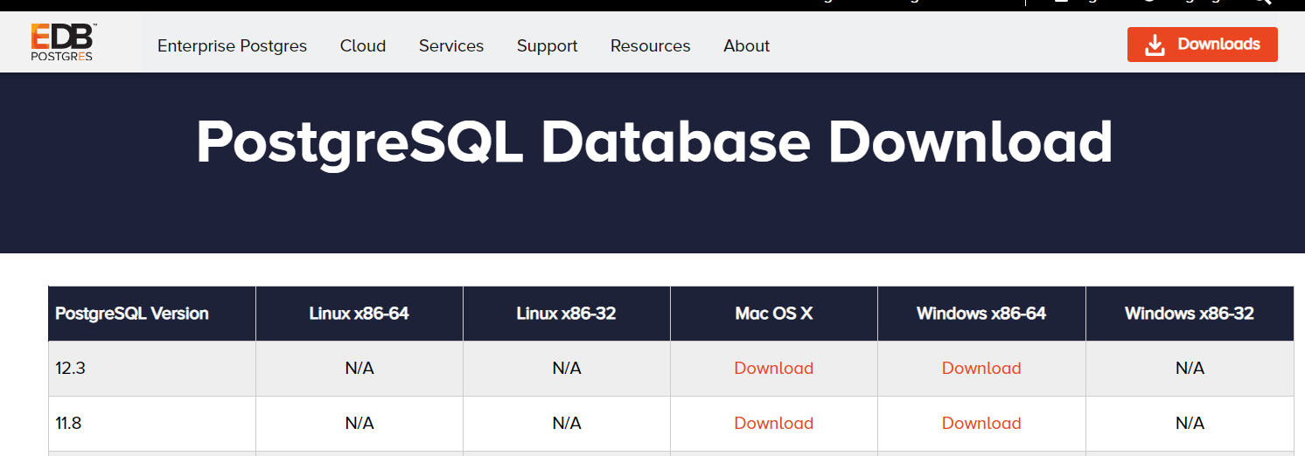

After the download complete, you need to install PostgreSQL.

* Click on the “.exe” file and click the Next button.

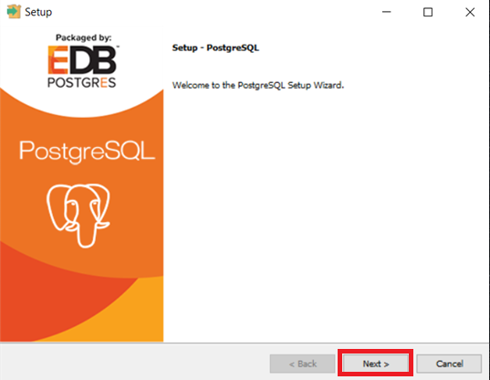

* Specify the installation folder, choose your own or keep the default folder suggested by PostgreSQL installer and click the Next button.

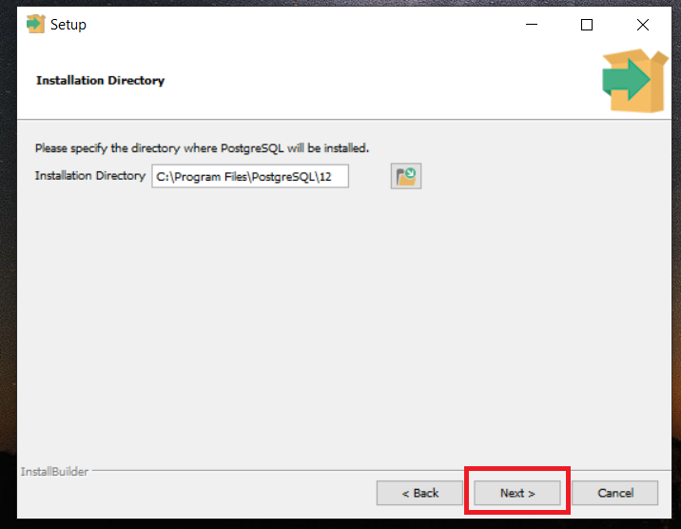

* Select all the components to install and click the Next button. pgAdmin4 comes with the same “.exe” file. Make sure to select it and click the Next button.

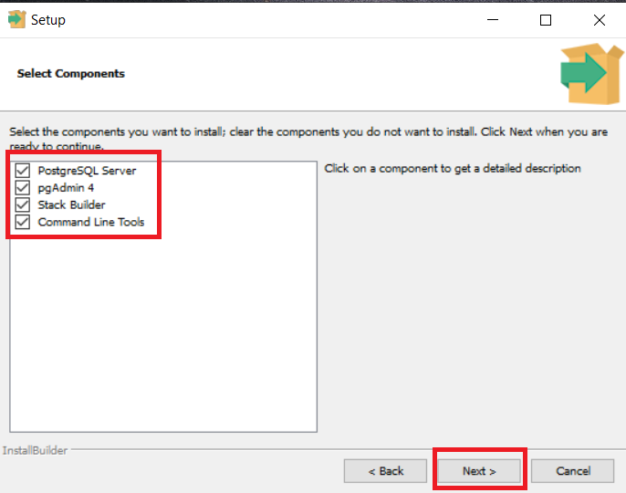

* Select the database directory to store the data. Just leave it by default or choose your own and click the Next button.

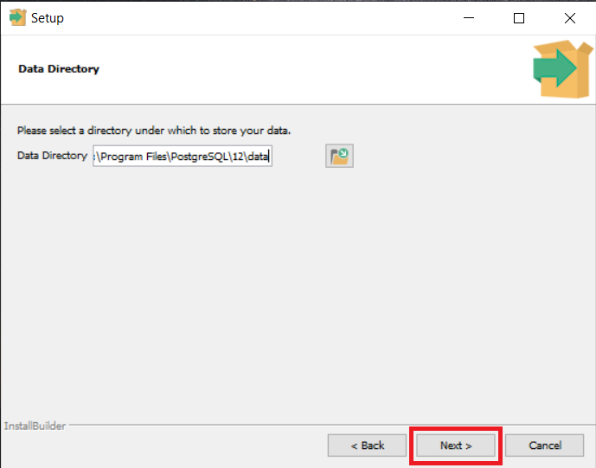

* Enter the password for the database superuser (postgres). The default username for PostgreSQL is postgres and then click the Next button. Also, you can select any password as you want. But if you do so, then please remember to change it inside the Python Database related program (for this project).

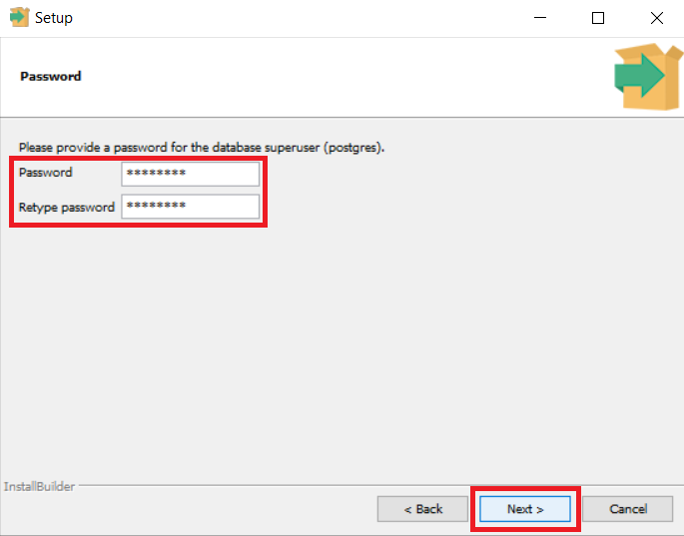

* Select port as 5432 and click the Next button

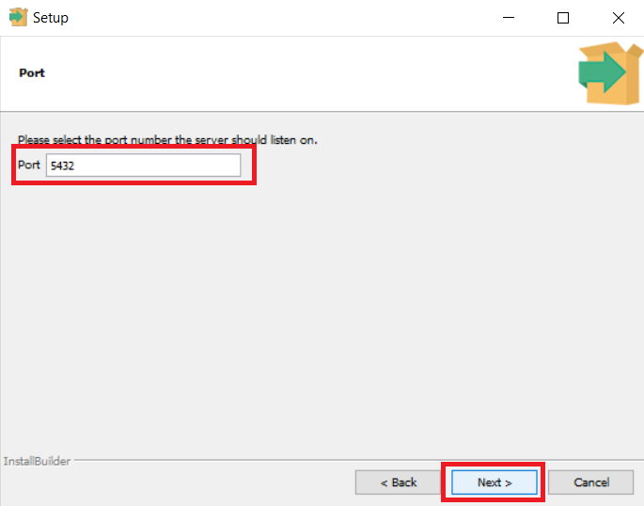

* Keep local as default and click the Next button.

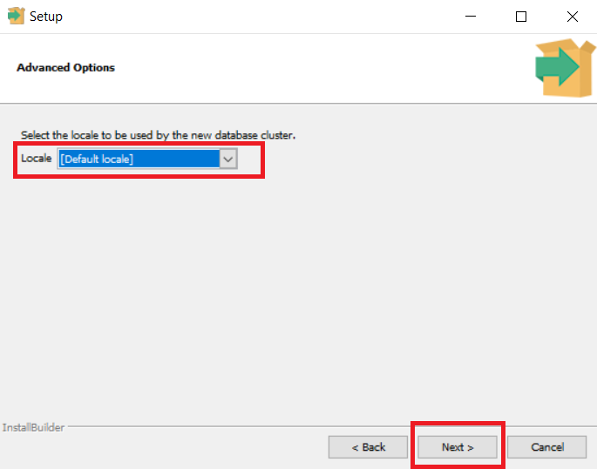

* Setup wizard will show pre-installation summary. Make sure everything is fine and click the Next button.

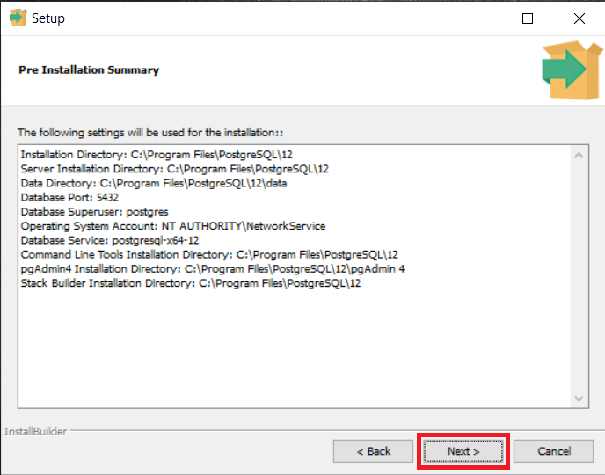

* Now set up is ready and click Next to install.

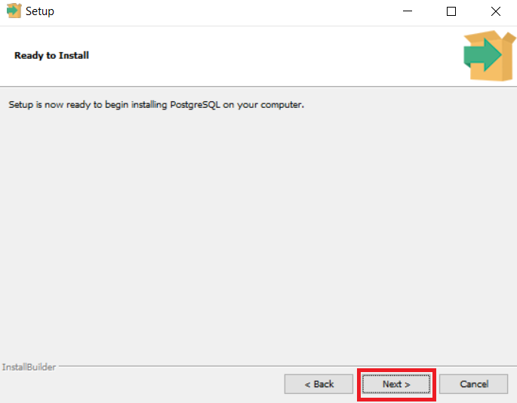

* The installation may take a few minutes to complete.

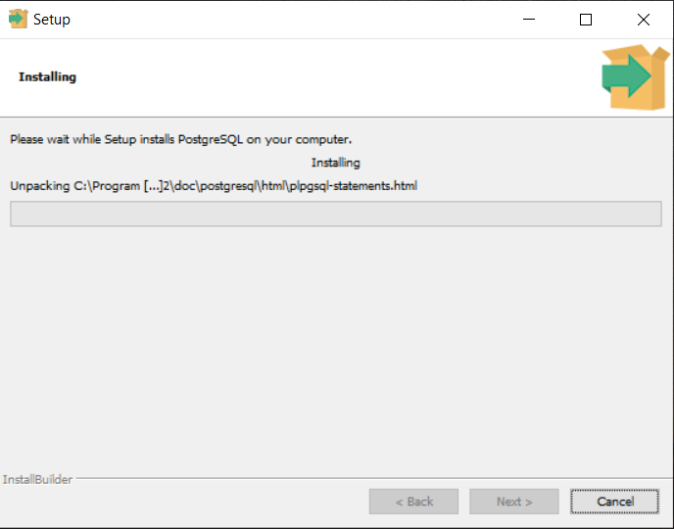

* Click the **Finish** button to complete the PostgreSQL installation.

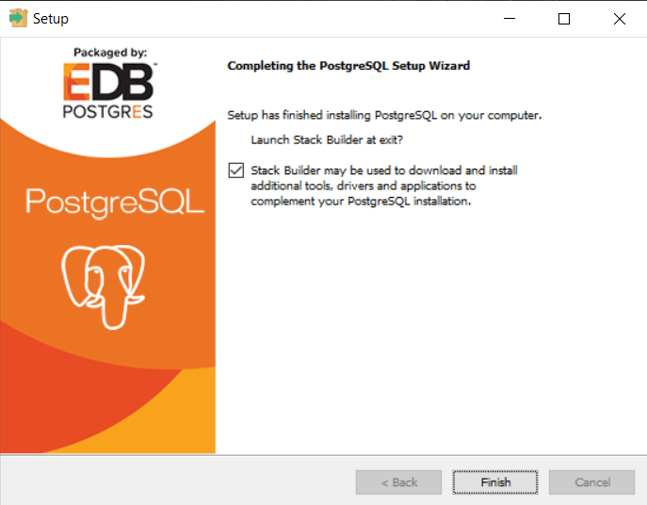

* There are several ways to verify the installation. You can try to connect to the PostgreSQL database server from any client application, e.g., psql and pgAdmin4. The quick way to confirm the installation is through the psql program.

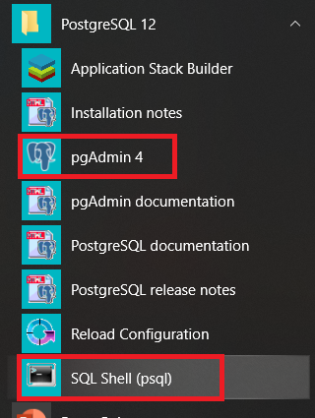

* Open SQL shell(psql) and fill up as below:

|  |  |
| --- | --- |
| Server [localhost] | localhost |
| Database [postgres] | postgres |
| Port [5432] | 5432 |
| Username [postgres] | postgres |
| Password | *The password you have selected* |

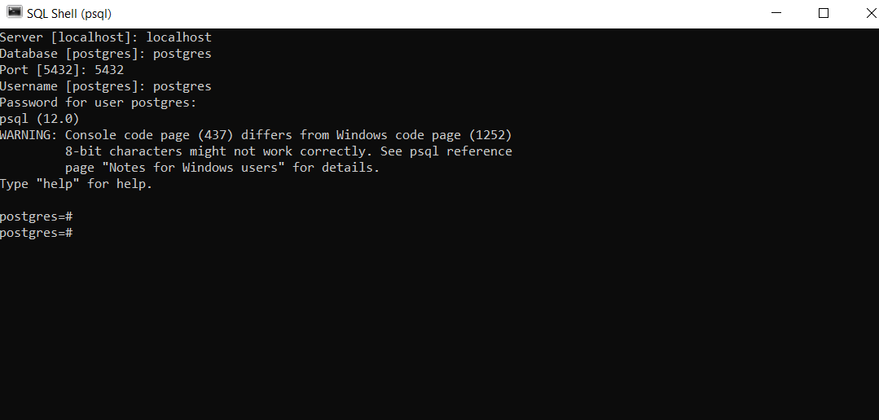

Installation done!!

Now you have successfully installed PostgreSQL database server on your local system.

1. **Install PostgreSQL & pgAdmin4** **on Ubuntu OS**

There are two way you can install the PostgreSQL and pgAdmin4 in Ubuntu system:

1. Install PostgreSQL and pgAdmin4 using Command Terminal
2. Install PostgreSQL and pgAdmin4 using shell scripts
3. **Install PostgreSQL and pgAdmin4** **using Command Terminal**

There is a perfect chance your Ubuntu has PostgresSQL installed already, but it probably will not be the latest version. To check the latest version, visit the [Ubuntu Postgres](https://www.postgresql.org/download/) site and follow the instruction. To install PostgreSQL, follow the below command:

* Create the file **/etc/apt/sources.list.d/pgdg.list** and add a line for the repository.
* Import the repository signing key and update the package lists.
* Ubuntu includes PostgreSQL by default. To install PostgreSQL on Ubuntu, use the apt-get (or other apt-driving) command.

$ sudo sh -c 'echo "deb http://apt.postgresql.org/pub/repos/apt/ bionic-pgdg main" >> /etc/apt/sources.list.d/pgdg.list'

$ wget --quiet -O - https://www.postgresql.org/media/keys/ACCC4CF8.asc | sudo apt-key add –

$ sudo apt-get update

$ sudo apt-get install postgresql-client-10

$ sudo apt-get install postgresql-10

$ sudo apt-get install postgresql-contrib

$ sudo apt-get install libpq-dev

$ sudo apt-get install postgresql-server-dev-10

$ sudo apt-get install pgadmin4

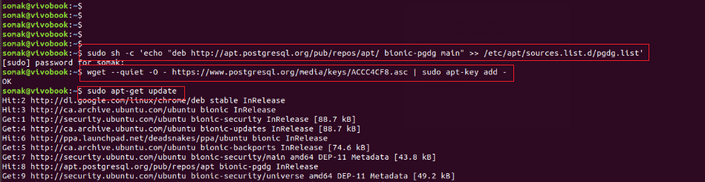

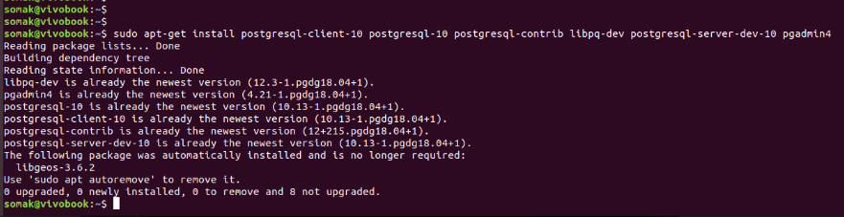

Installation done!!

This above process will install PostgreSQL and pgAdmin4 on your Ubuntu OS.

To verify PostgreSQL on Ubuntu OS run the below command:

$ sudo -u postgres psql

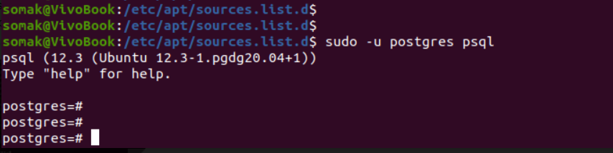

To verify pgAdmin4 on Ubuntu OS, go to activities and search for pgAdmin4.

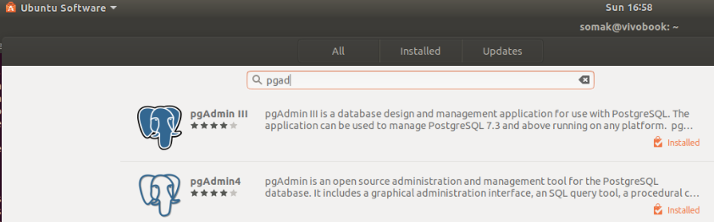

1. **Install PostgreSQL and pgAdmin4** **using Shell Script**

First, we need to download the Robotic-Greeter folder from the [Robotic-Greeter-GitHub](https://github.com/ripanmukherjee/Robotic-Greeter) link.

You can download it in two ways:

1. Clone it with command Terminal
2. Download it as a Zip file

Inside of the Robotic-Greeter folder, we have the shell (Unix) script, which you need to run, and this script will automatically install PostgreSQL and pgAdmin4 on your computer.

1. **Using Clone method**

Go to Ubuntu APP from Windows or Command Terminal from Ubuntu OS and run the following command:

$ git clone https://github.com/ripanmukherjee/Robotic-Greeter.git

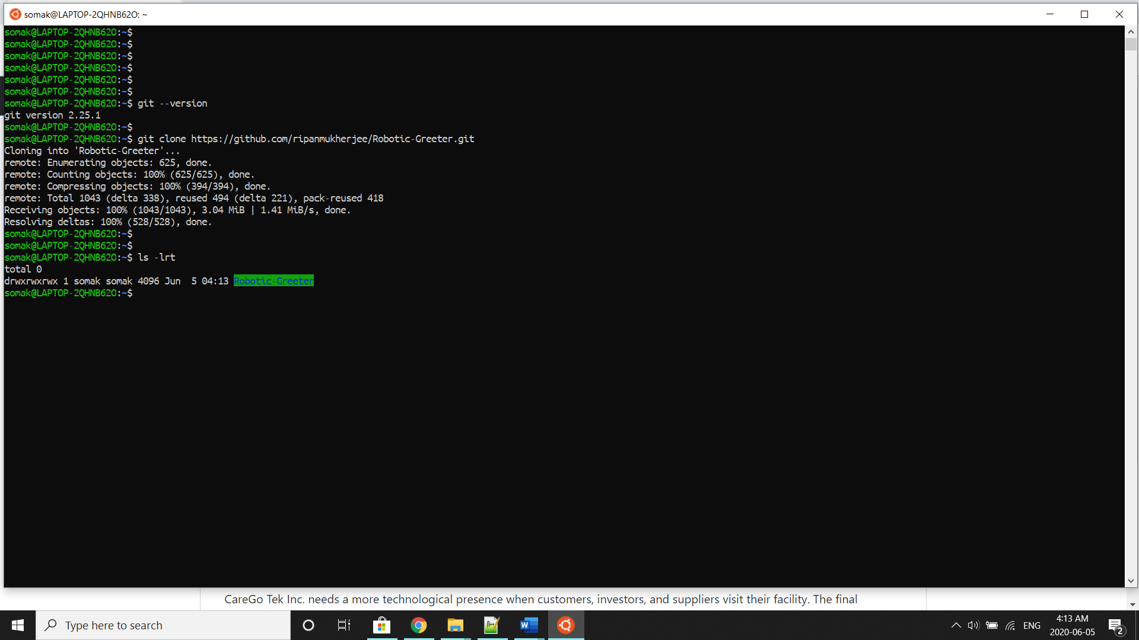

This command will automatically download the Robotic-Greeter folder on your computer.

1. **Download as Zip**

Also, you can directly download the Zip file and Unzip it. Then it would be best if you put it in the proper directory or your project directory.

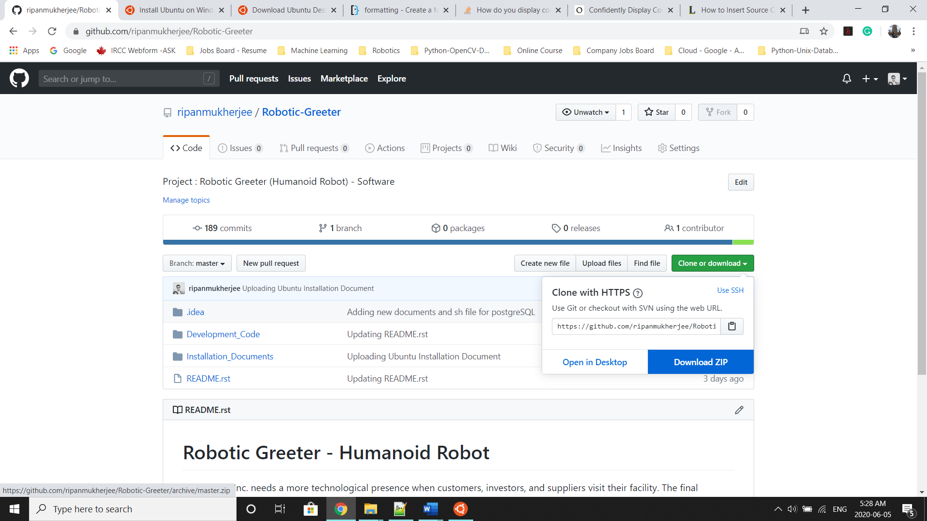

Once the download is complete, please go to the following directory from Ubuntu APP Terminal or Command Terminal on Ubuntu OS:

$ cd Robotic-Greeter/Installation_Documents/PostgreSQL_pgAdmin4_Installation

In the above folder, you will get **PostgreSQL_pgAdmin4_Installation.sh**script. To list the directories and files in this folder, run “ls -lrt” and later change the executable permission for the file with “chmod”.

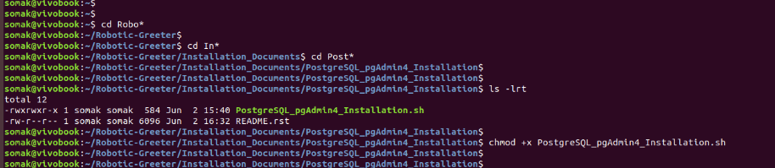

$ ls -lrt

$ chmod +x *.sh

After that, run the scripts as follow:

$ sh PostgreSQL_pgAdmin4_Installation.sh

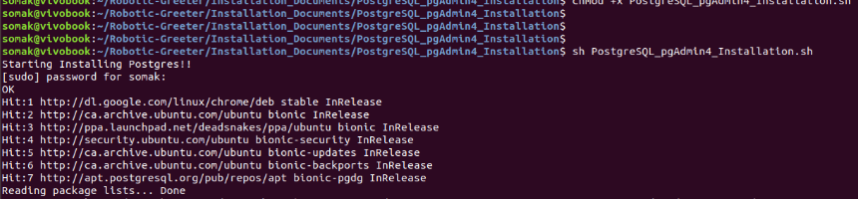

Installation done!!

1. **Install pycopg2 on Windows, Ubuntu OS/APP & PyCharm**

After you have installed PostgreSQL and pgAdmin4, you need to install psycopg2 on Windows, Ubuntu APP, and Ubuntu OS. But you need to install it through the Command Terminal. If you do not do so, then your program may give import error.:

* **Psycopg2 on Windows**

To Install psycopg2 on Windows, go to Command Terminal and type the both command:

$ python -m pip install psycopg2

$ python3 -m pip install psycopg2

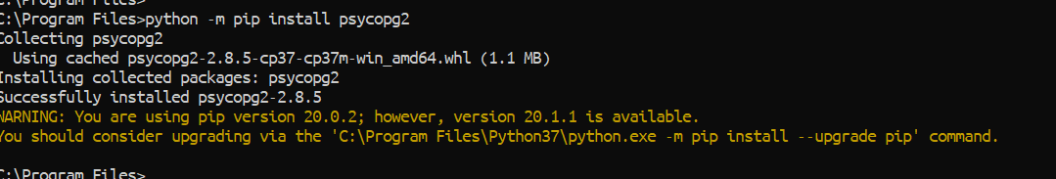

After the install is done, go to Python console and check it by importing psyopg2 as below:

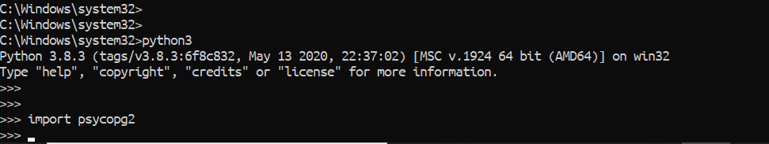

* **Psycopg2 on Ubuntu OS/APP**

Open the Ubuntu APP Terminal from the Windows start menu or open Command Terminal from Ubuntu OS and type the following command.

$ sudo apt-get install -y python3-psycopg2

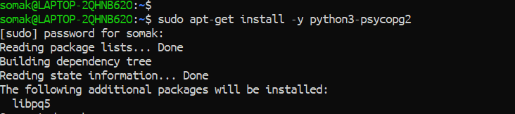

After install is done, go to Python console and check it by importing psyopg2 as below:

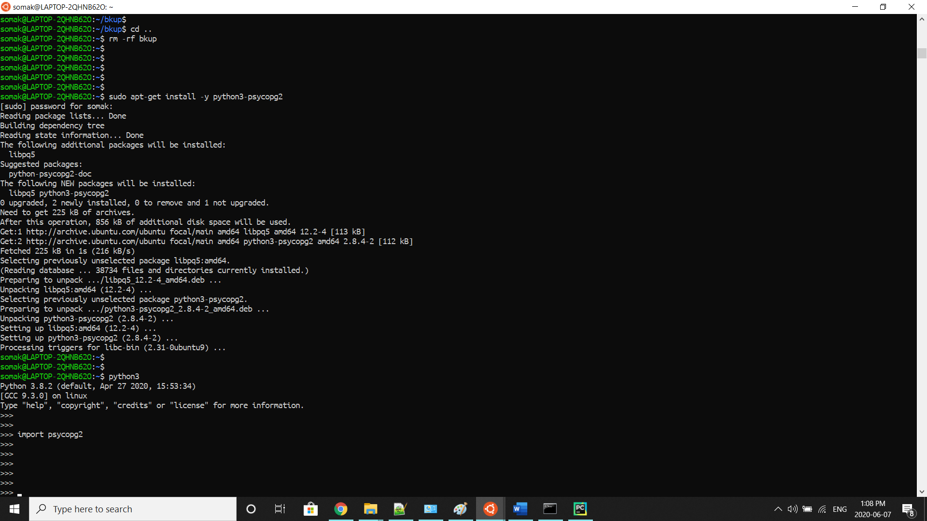

* **Psycopg2 on PyCharm CE**

Now to install pycopg2 from PyCharm do the following steps:

* Open PyCharm
* Go to Files – settings
* Click on the Project Interpreter
* Click on the “+” button
* Search “psycopg2” in Available Packages tab
* Click on install

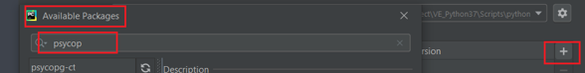

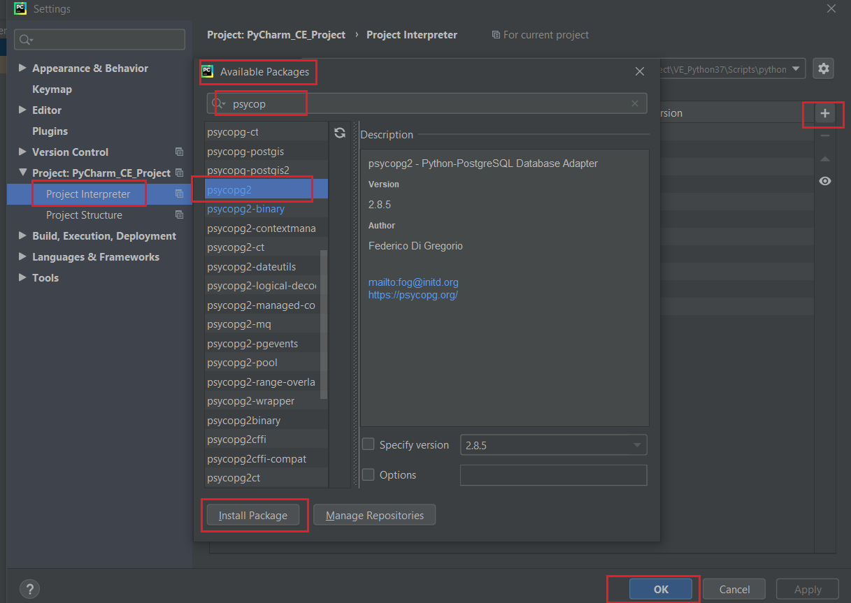

**Working with PostgreSQL & pgAdmin4**

PostgreSQL tutorial to demonstrate the unique features of PostgreSQL that make it the most advanced open-source database management system

The pgAdmin4 client features a highly customizable display that features drag-and-drop panels that you can arrange to make the best use of your desktop environment.

In this tutorial, we will demonstrate the following:

1. How to login in PostgreSQL from Windows
2. How to login in PostgreSQL from Ubuntu OS
3. Working with PostgreSQL Database using SQL Shell or psql
4. How to login in pgAdmin4 from Windows & Ubuntu OS
5. Working with PostgreSQL Database using pgAdmin4
6. **How to login in PostgreSQL from Windows**

* To login in PostgreSQL from Windows, go to start menu and search for psql or search the PostgreSQL folder. Inside the folder, you can see SQL Shell.



* Open SQL shell(psql) and fill up as below:

|  |  |
| --- | --- |
| Server [localhost] | localhost |
| Database [postgres] | postgres |
| Port [5432] | 5432 |
| Username [postgres] | postgres |
| Password | *The password you have selected* |



1. **How to login in PostgreSQL from Ubuntu OS**

* To login in PostgreSQL from Ubuntu OS, go to Command Terminal and type the below command:

$ sudo -u postgres psql



1. **Working with PostgreSQL Database using SQL Shell or psql**

You can create a new Database or Table or modify the user password by SQL Shell or psql. This following process is the same for SQL Shell (Windows) and psql (Ubuntu).

* To modify the user (username postgres (default)) password type the following command:

postgres=# alter user postgres with password 'postgres';

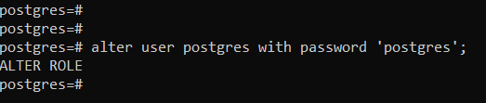

* To list the current Database, type the below command:

postgres=# \l

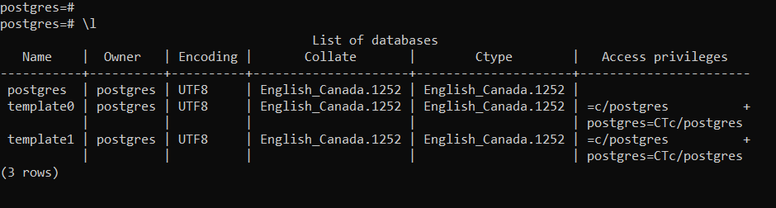

* To create a new database, or drop it, type the below command:

postgres=# create database caregodb;

postgres=# drop database caregodb;

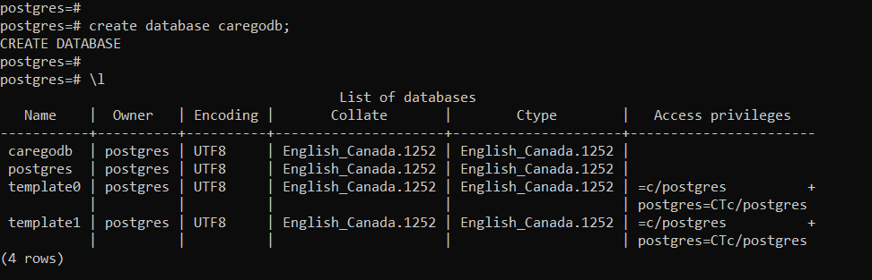

* To enter the newly created Database, type the below command:

postgres=# \c caregodb;

caregodb=# \d

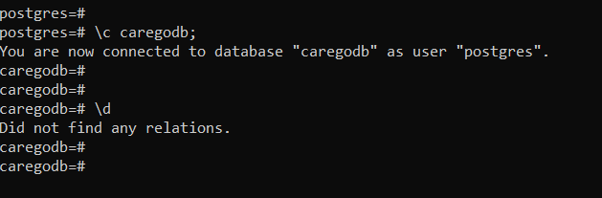

* “\d” to show if the current Database has any Tables present or not.
* To quit from Database, type the below command:

postgres=# \q

1. **How to login in pgAdmin4 from Windows & Ubuntu OS**

pgAdmin4 is a popular application to manage Postgres Databases. You can do all the above steps, such as creating a Database and creating a Table through pgAdmin4.

* To login in pgAdmin4 from Windows and Ubuntu OS are the same. For Windows, search for pgAdmin4 in the start menu and in Ubuntu OS, go to activities or Ubuntu Software, and search for pgAdmin4.





* Now, click on it and pgAdmin4 will open with new web browser as below:

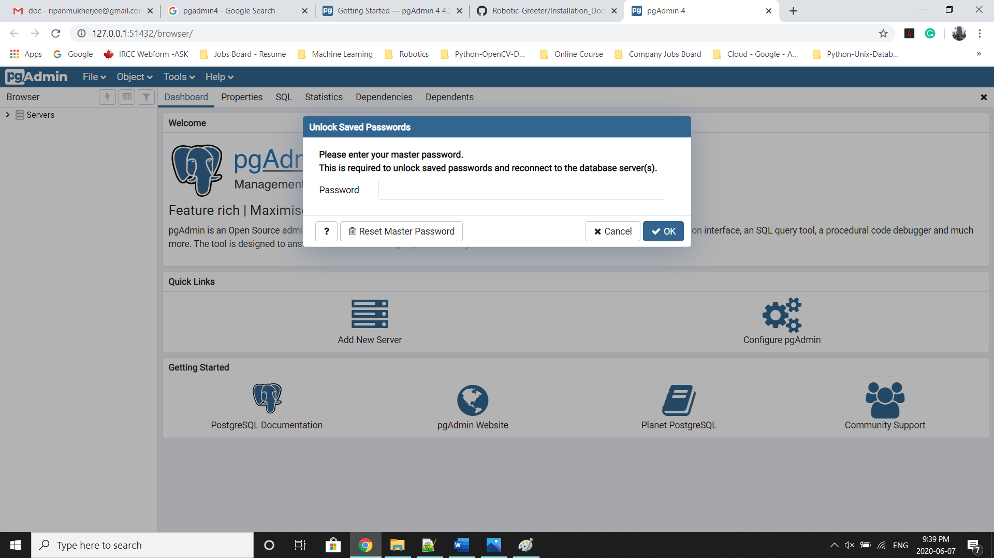

1. **Working with PostgreSQL Database using pgAdmin4**

In this part, we will demonstrate how to create a Table, insert data into the Table, and view the data from the Table.

* Once you open pgAdmin4, it will ask to insert the password. Please type your system password. It is the password with which you log in to your computer OS.
* Click on the Server (Top left), and if have create server earlier, then it will show listed server for you. If not, then open SQL Shell (Windows) and psql (Ubuntu). You can open SQL shell directly open start menu but to open psql from ubuntu, open your Command Terminal on Ubuntu and enter the following command:

$ sudo -u postgres psql



* Then , change the postgres password as your choice as below:

postgres=# alter user postgres with password 'postgres';



* Then open pgAdmin4 and right-click on server then click on Create – Server as below:

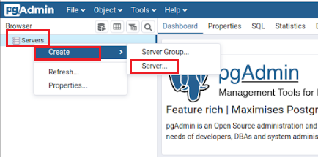

* After you have clicked on Server, this will pop-up a new screen with which you can create a new server as below.
* Go to General and Type Name as “postgres”

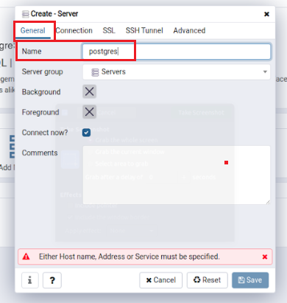

* Then go to Connection and fill the details as follow and click on Save button.

|  |  |
| --- | --- |
| Server [localhost] | localhost |
| Database [postgres] | postgres |
| Port [5432] | 5432 |
| Username [postgres] | postgres |
| Password | *The password you have selected* |

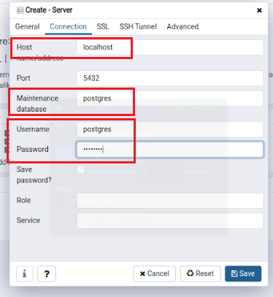

* Then, go to Server and click it again. This time it will show all the listed server you have created so far.
* Click on your created server, and it will now ask for your postgres password (As we selected earlier).

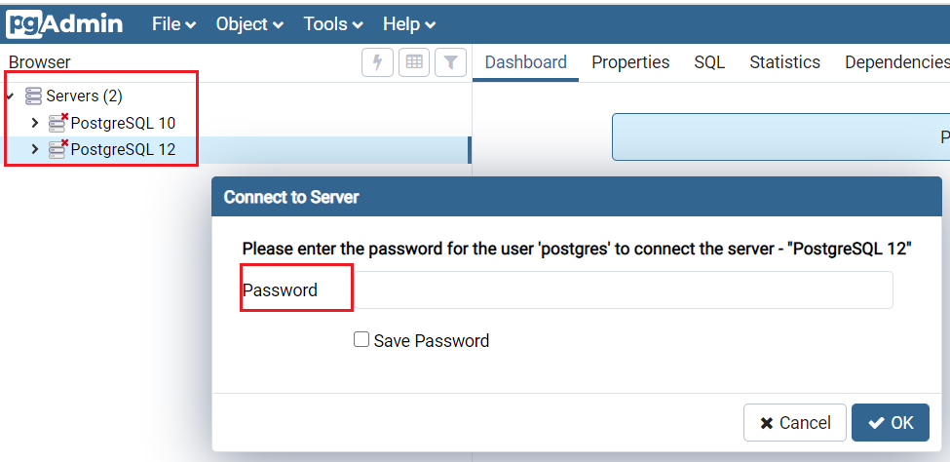

* Enter the password, and it will connect with PostgreSQL server. Now right-click on the Database option and click Create and then Database.

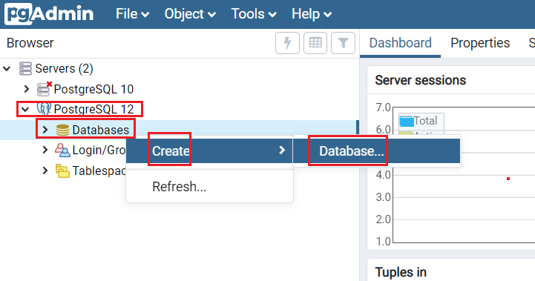

* Create the Database with name “caregodb”, and click on the Save button:

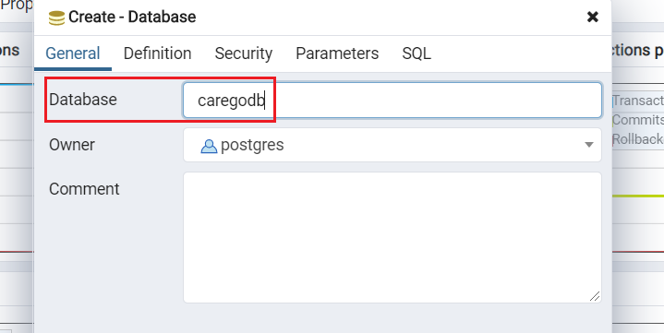

* The newly created Database will appear on the left panel. Click on it to connect. Now, to create a Table in caregodb, go to Schemas and click on Public and click on the Create and then Table.

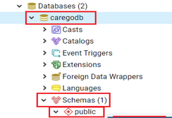

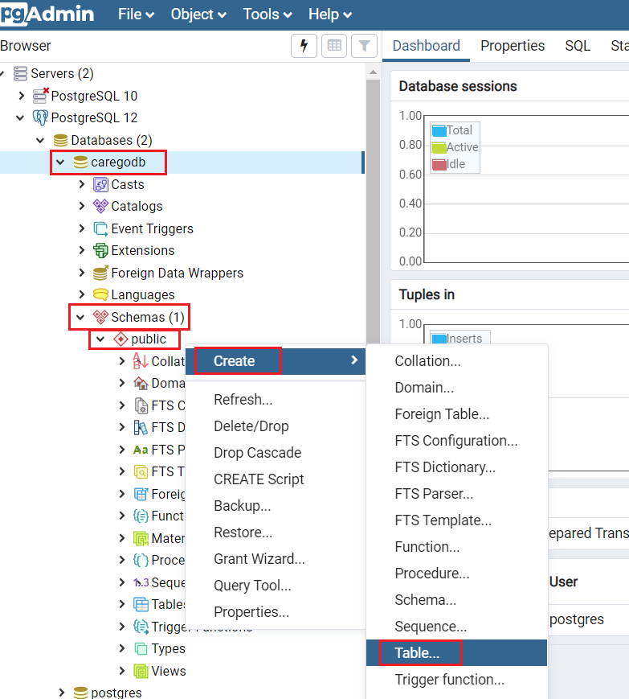

* In the Create Table tab, go to General, and type the Table name as “carego_customer_dev” as below:

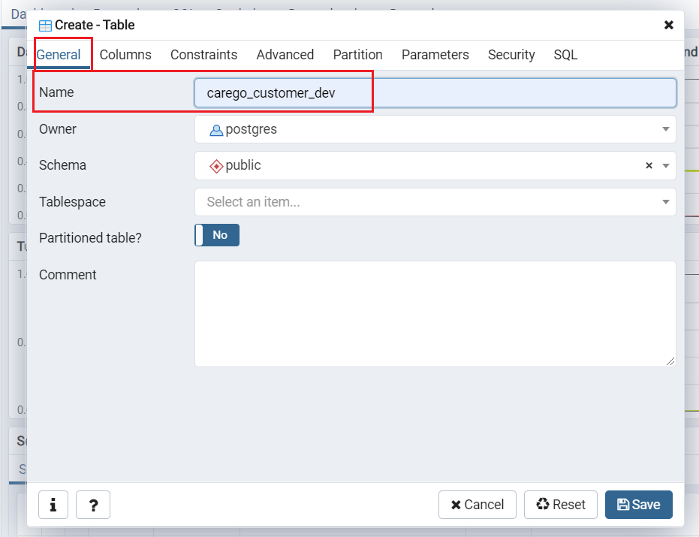

* In the Create Table tab, go to Columns and click on “+” to add the column one by one. Later click on the Save button.

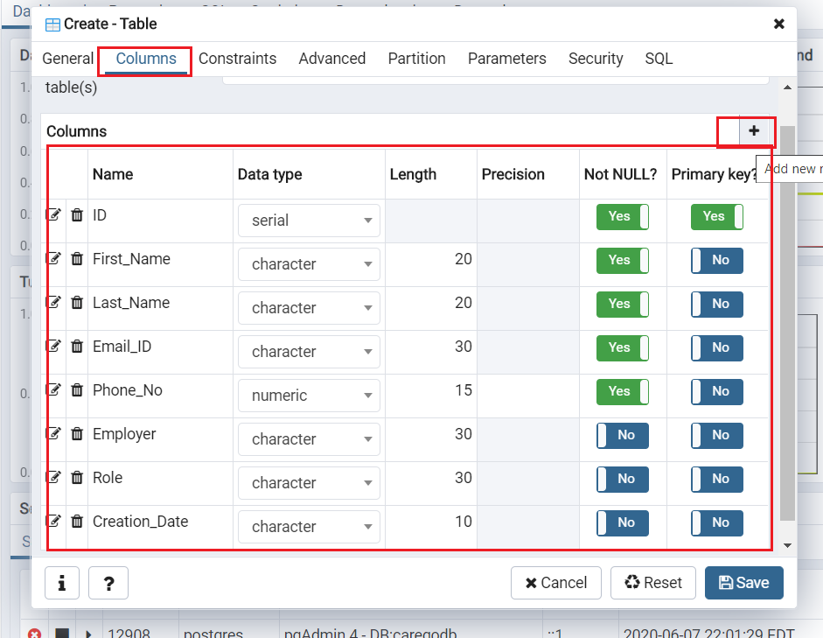

* Now, the newly created Table will appear on the left panel of pgAdmin4.

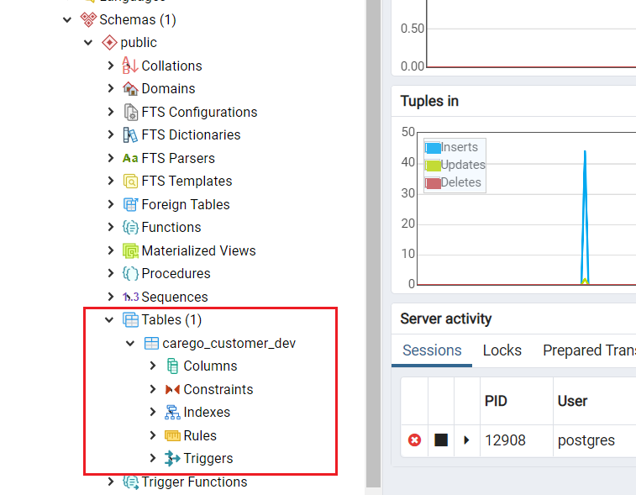

* You can also go to SQL Shell from Windows or login to psql from Ubuntu OS and verify it from backend as below:

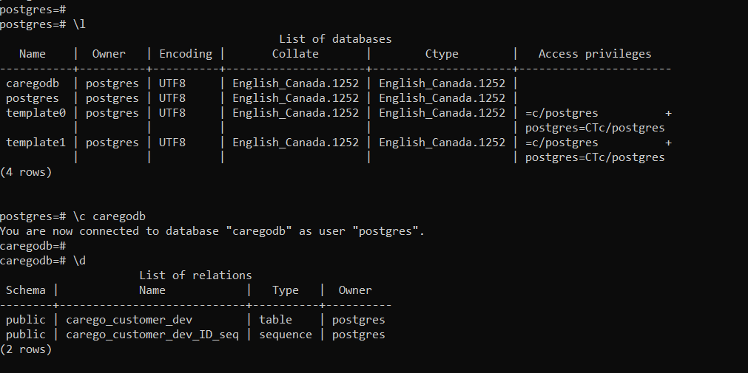

* Now, we need to create one Unique Constraint for this Table. Click on Constraints, and then on Create and select Unique Constraint.

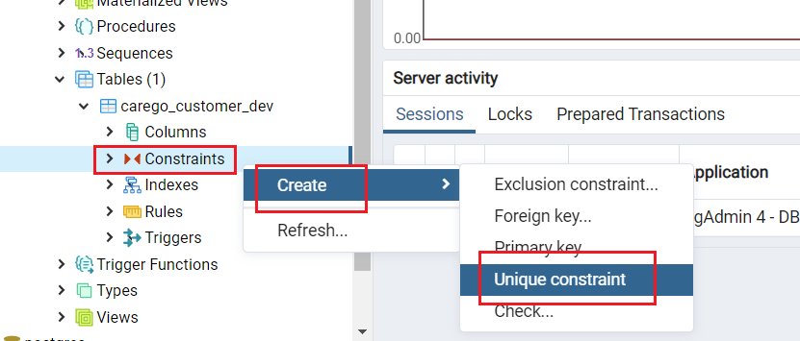

* Go to Definition and click on Columns fields. It will show all the columns, and you need to select the below mention columns. Later click on Save button and it will create Unique Constraints for this table.

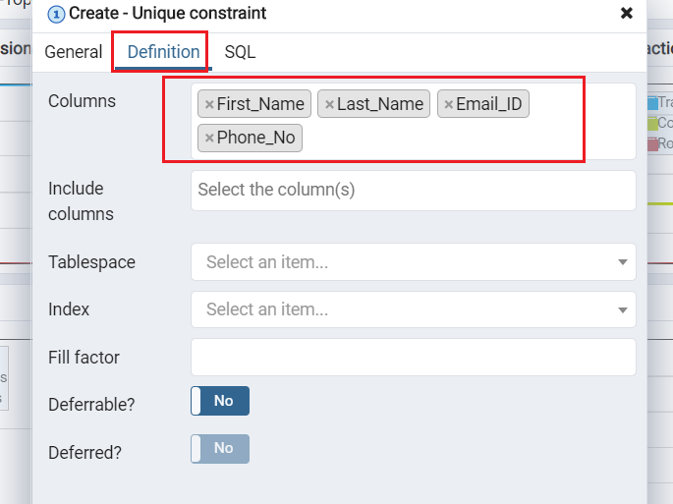

* Now you can right-click on the Table, and you will get various options such as to Inset Data, View Data, Delete Data, etc.

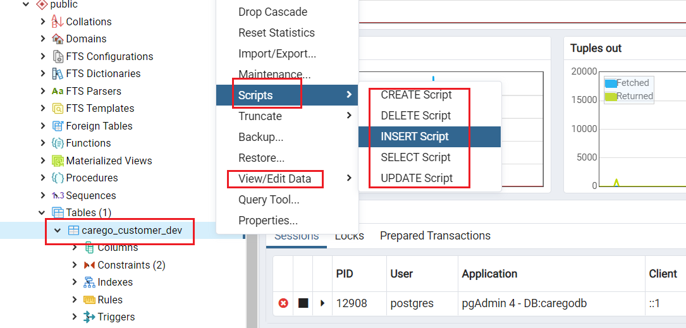

* To insert the data, click on INSERT SCRIPTS, and it will open a new tab. Since we created column “ID” as DATATYPE “SERIAL”, you do not need to enter data while writing the insert scripts. SERIAL DATATYPE is a Sequence Incremental Datatype. It will automatically insert the sequence numbers in the Table.

To run the query, click on the “red-mark” area, as shown in the below picture. Also, you can press F5 to run the query.

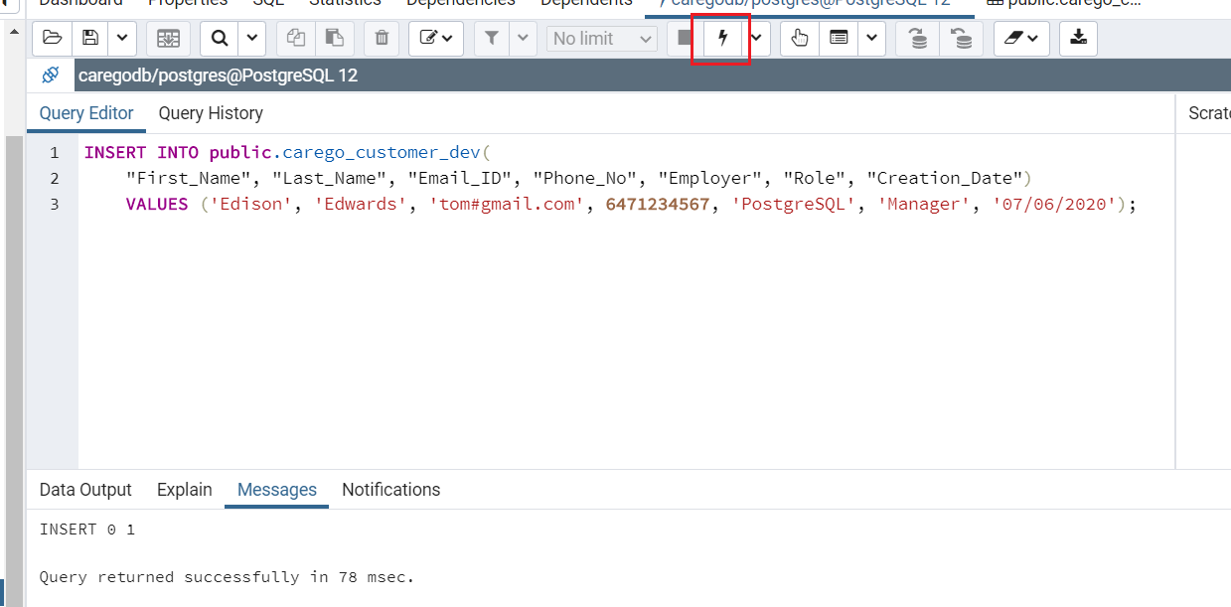

* To view the data, click on VIEW DATA.

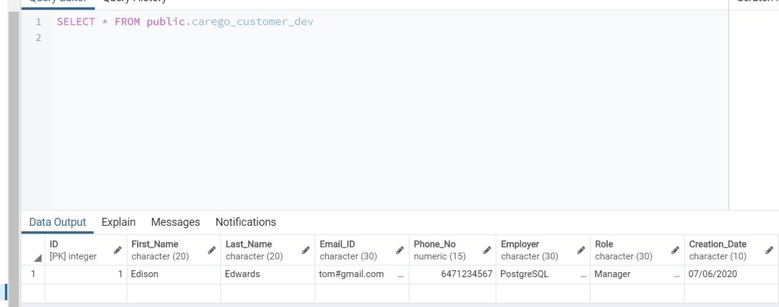

* There are many more options presents in pgAdmin4. You can always explore new things.

For more details related to PostgreSQL & pgAdmin4, please visit [PostgreSQL](https://www.postgresql.org/) website.