**PyCharm Community Edition Installation**

PyCharm is a cross-platform editor developed by JetBrains. PyCharm provides all the tools you need for productive Python development.

PyCharm is available in three editions: Professional, Community, and Edu. The Community and Edu editions are open-source projects, and they are free, but they have fewer features. PyCharm Edu provides courses and helps you learn to program with Python. The Professional Edition is commercial and provides an outstanding set of tools and features.

**Pre-Requisites**

* Connect your machine to a power source
* Make sure that you have enough space in your disk, i.e., a minimum of 5GB

It is always advisable to install Python before installing PyCharm Community edition or any other edition. In this tutorial, we will show the steps for PyCharm CE on Windows 10 and Ubuntu.

1. Install PyCharm on Windows
2. Install PyCharm on Ubuntu OS

If you are working on the Windows system, please follow step 1, but if you are working on Ubuntu OS, you follow only step 2.

1. **Install PyCharm CE on Windows 10**

* To download PyCharm, visit the [PyCharm-website](https://www.jetbrains.com/pycharm/download/) and Click the "DOWNLOAD" link under the Community Section.

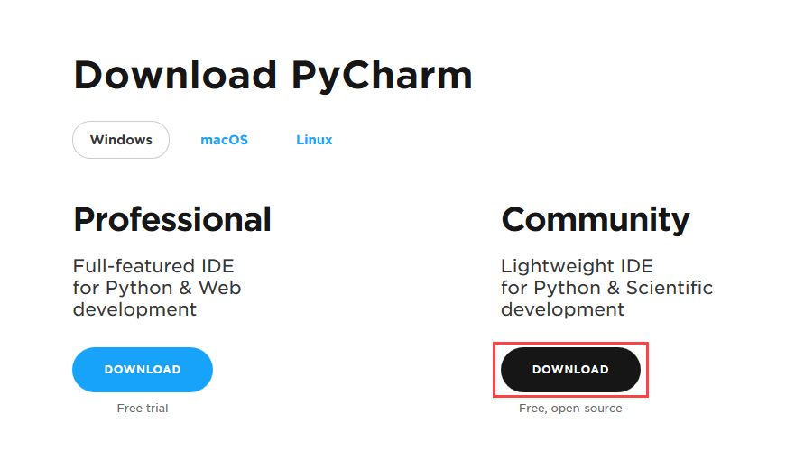

* Once the download is complete, run the “.exe” file to install PyCharm. The setup wizard will start and click on the Next button.

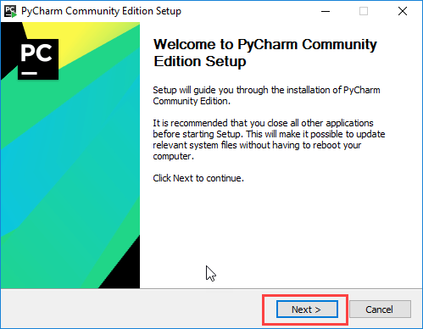

* On the next screen, change the installation path if required. Click on the Next button.

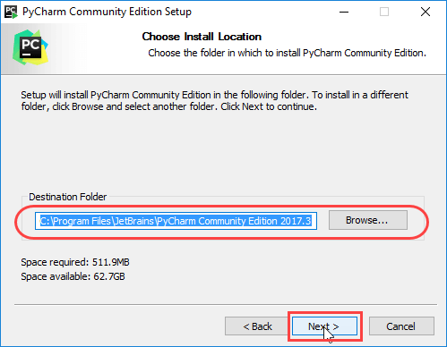

* On the next screen, you can create a desktop shortcut if you want and click on the Next button.

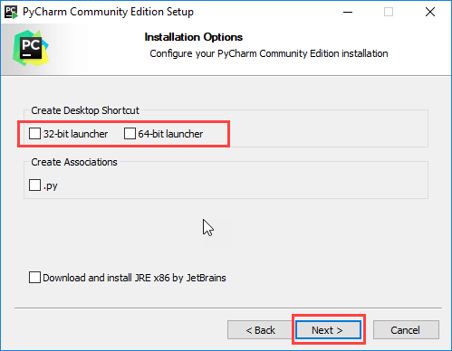

* Choose the start menu folder. Keep selected JetBrains and click on the Install button.

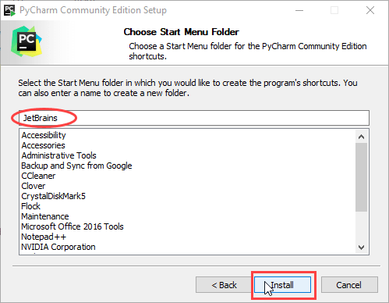

* Wait for the installation to finish.

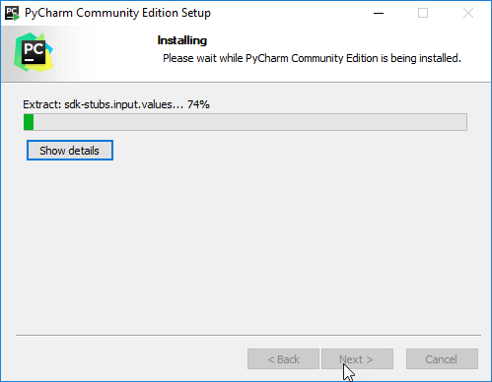

* Once the installation is over, you should receive a message screen that PyCharm is installed. If you want to go ahead and run it, click the “Run PyCharm Community Edition” box first and click on the Finish button.

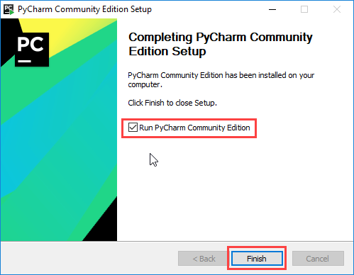

1. **Install PyCharm CE on Ubuntu**

The easiest way is to install the PyCharm Community Edition on Ubuntu OS is by downloading the PyCharm from Ubuntu Software Store, as shown in below:

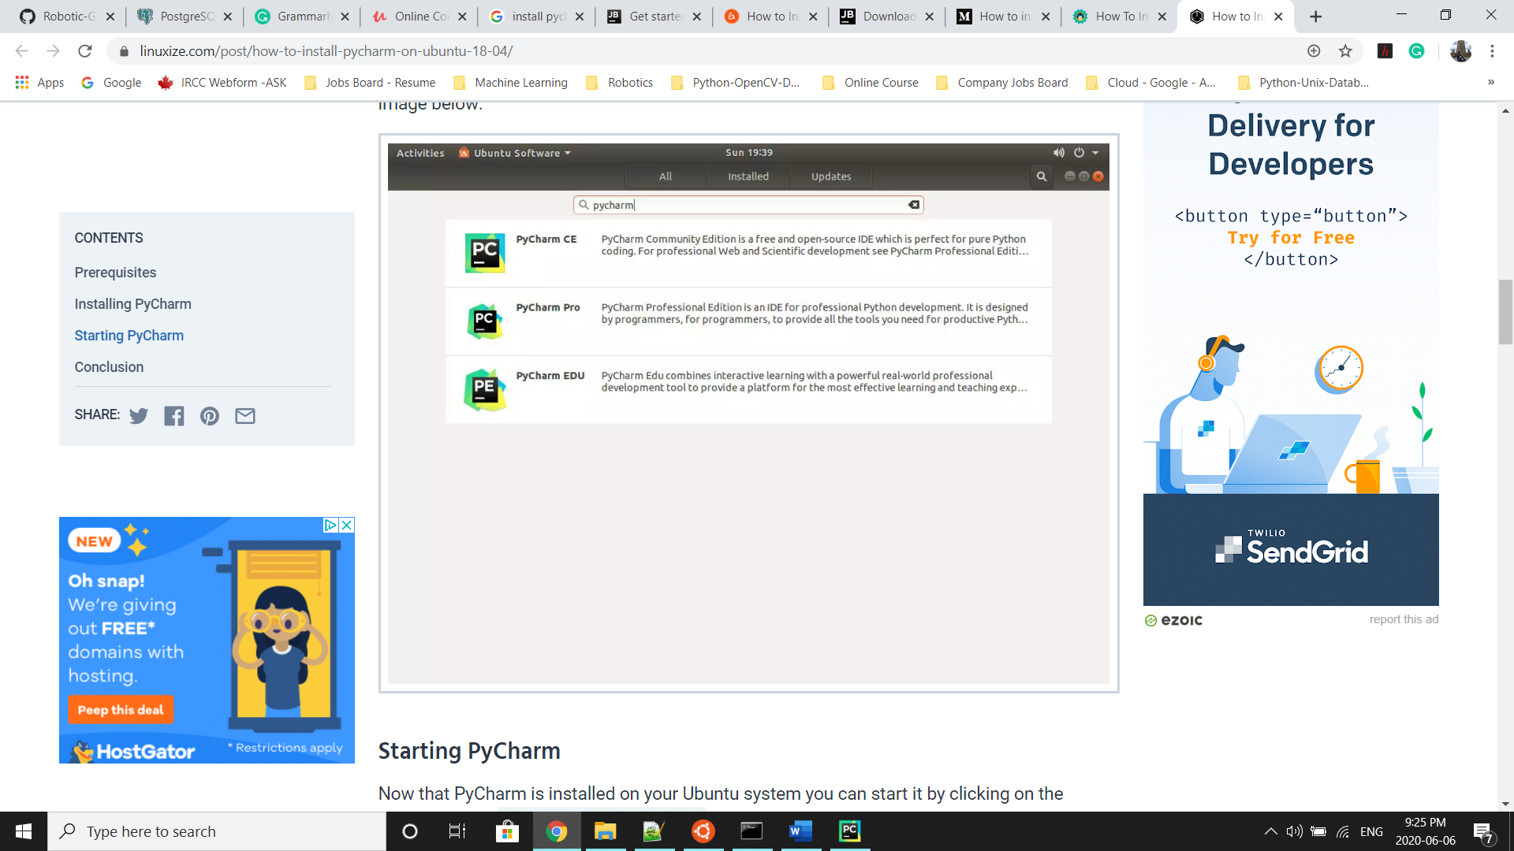

After you finish installing PyCharm on Windows 10 or Ubuntu OS, the Following screen will appear.

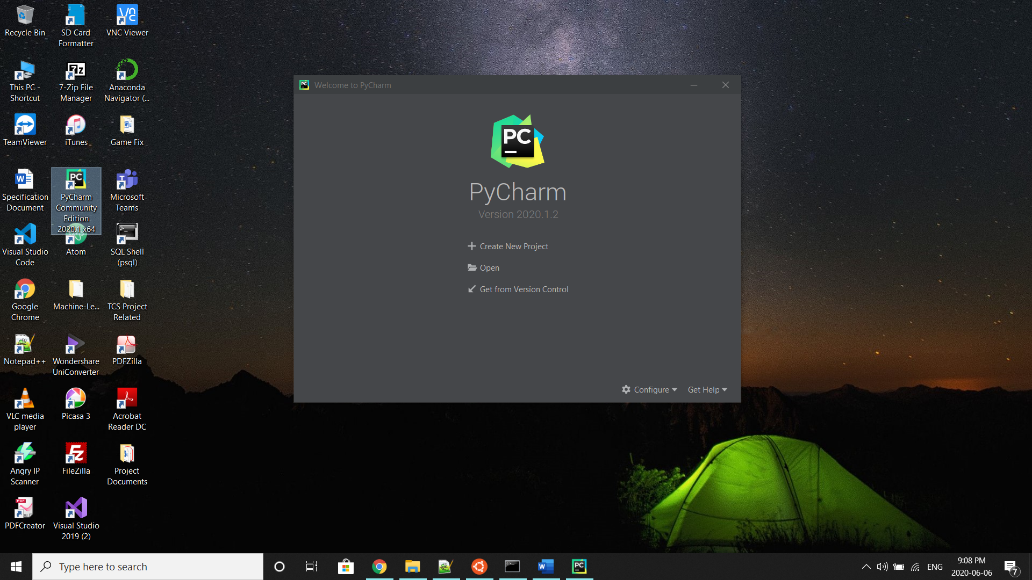

**Working with PyCharm CE**

To work with Robotic-Greeter Project on PyCharm CE, we need to download the Robotic-Greeter folder from the [Robotic-Greeter-GitHub](https://github.com/ripanmukherjee/Robotic-Greeter) link.

You can download it in two ways:

1. Clone it with command Terminal
2. Download it as a Zip file
3. **Using Clone method**

Go to Ubuntu APP from Windows 10 or Command Terminal from Ubuntu OS and run the following command:

$ git clone https://github.com/ripanmukherjee/Robotic-Greeter.git

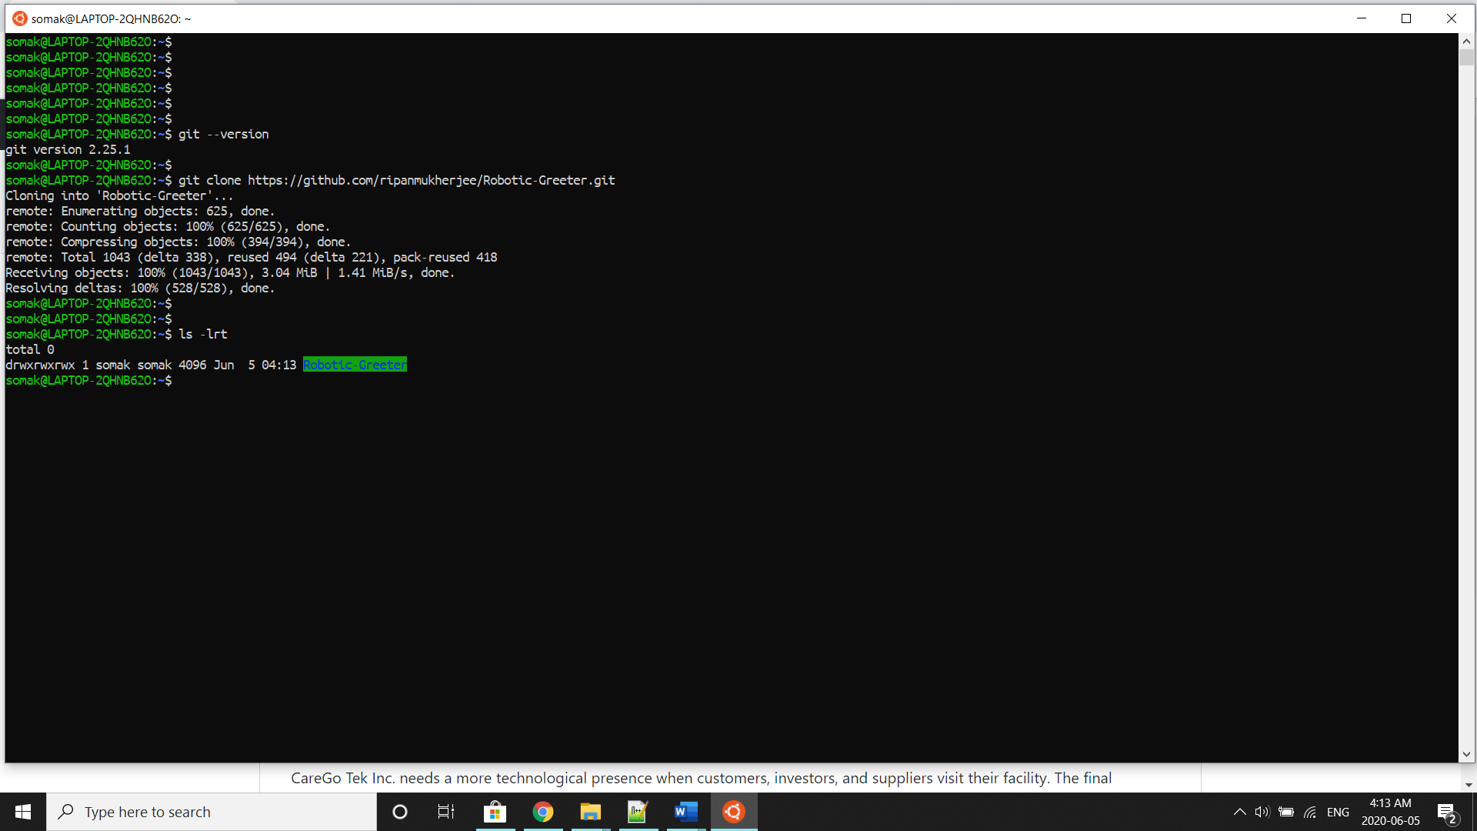

This command will automatically download the Robotic-Greeter folder on your computer.

1. **Download as Zip**

Also, you can directly download the Zip file and Unzip it. Then it would be best if you put it in the proper directory or your project directory.

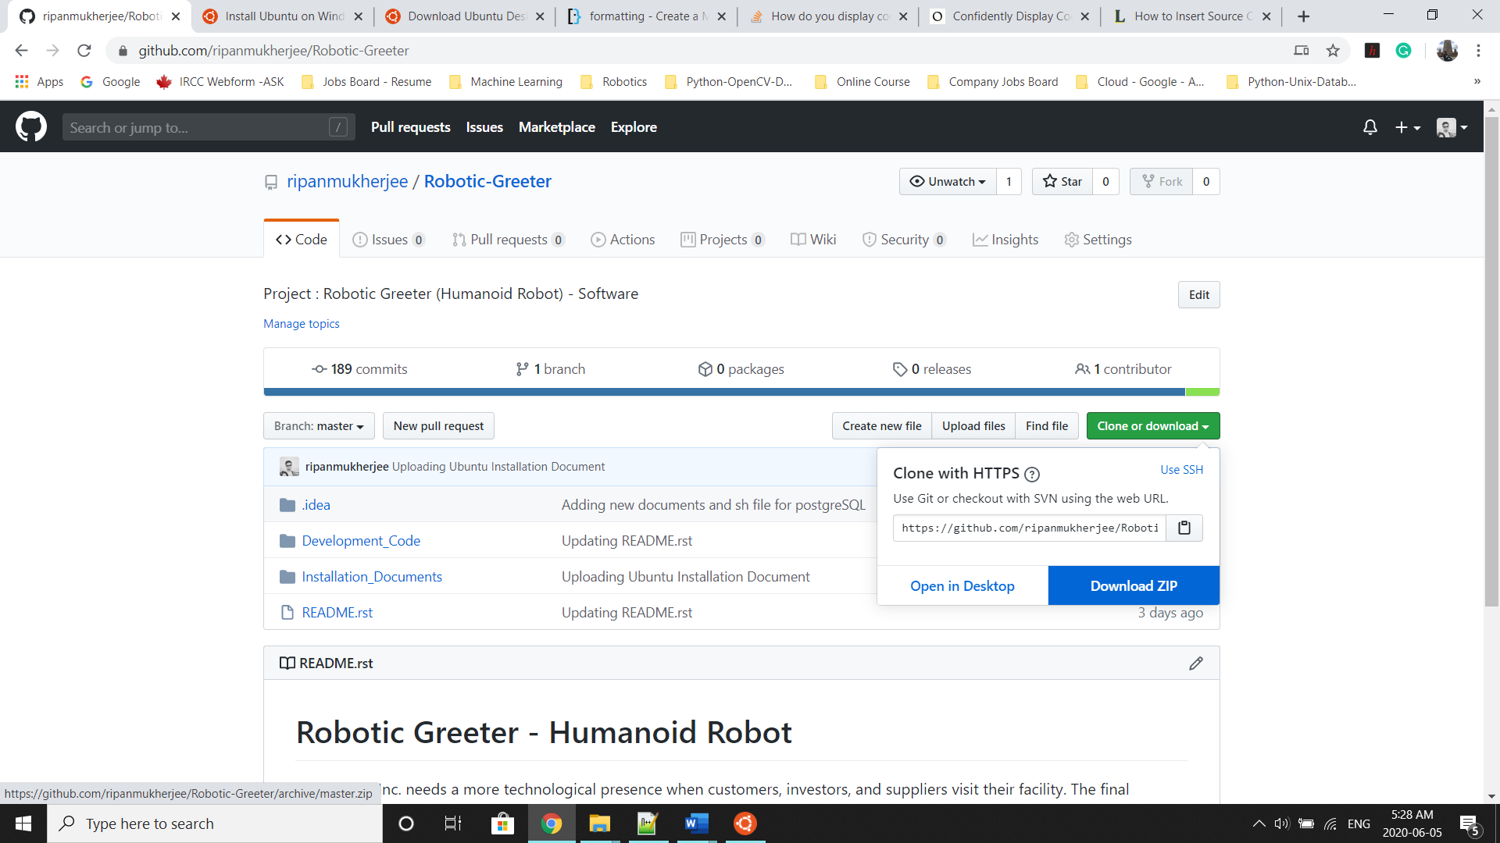

Now, we need to open this Robotic-Greeter folder via PyCharm Community Edition, add configuration with Python.exe, add GitHub Profile (optional), add packages and execute the codes.

* Open PyCharm and click on “Open” and navigate through the Robotic-Greeter directory. Also, you can click on “Create New Project” to create new one.

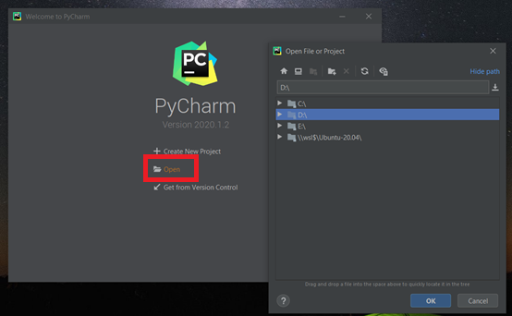

* Once the PyCharm CE opens your project, go to File and click on the Settings.

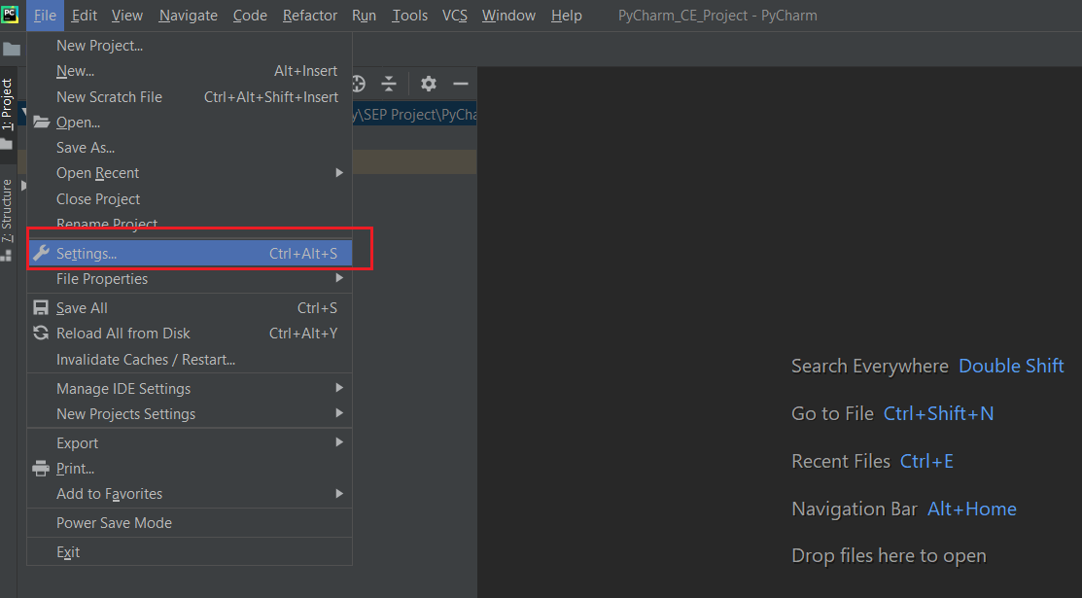

* In the Setting option, you will see Project or Python Interpreter; click on it. Initially, there will be no interpreter; to add it, click on the Add button. The Add button, you will find beside the Project Interpreter drop-down.

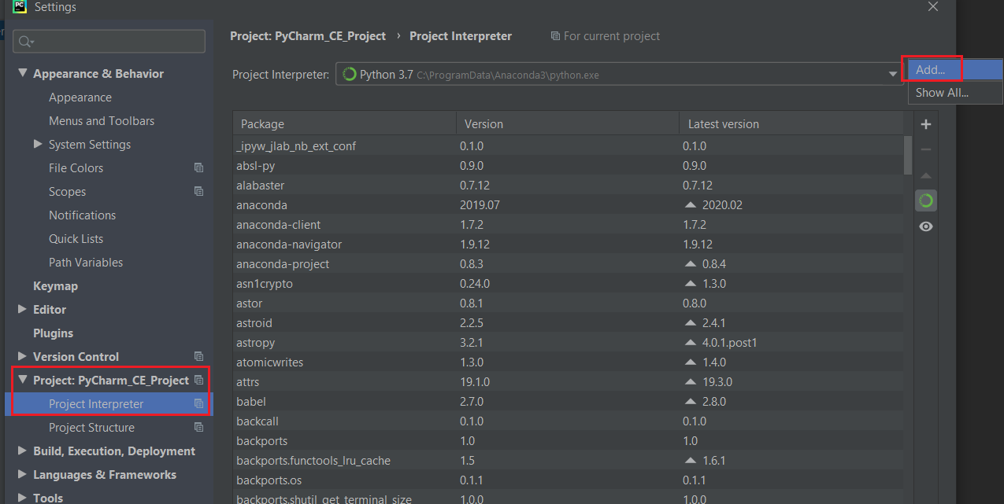

* In the Project interpreter option, you can select System Interpreter and, in the drop-down option select the Path where you installed Python.exe and click ok and then click Apply.

You can also select Virtual Environment and select the Python Path. This will create a Virtual Environment of Python inside of this folder.

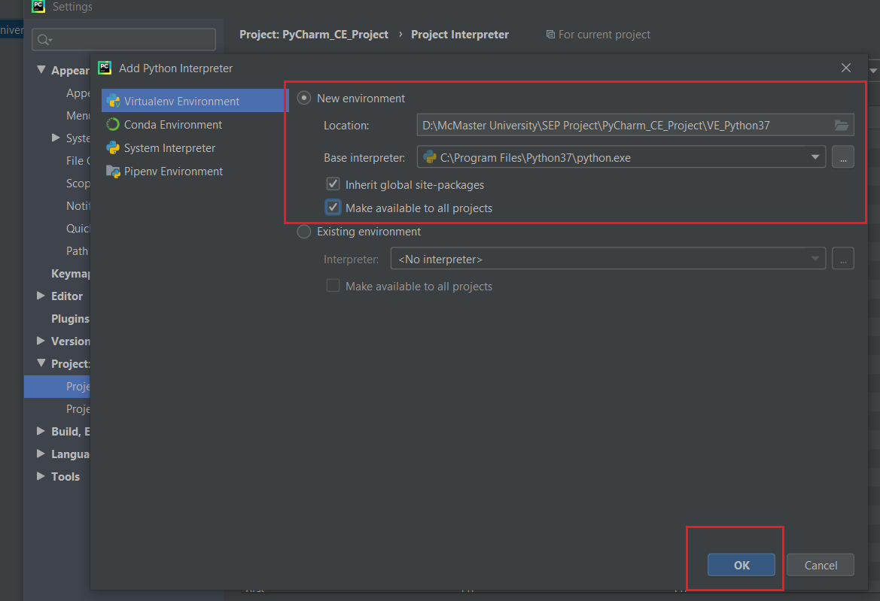

* Wait for some time and it will create a Virtual Environment for you as below:

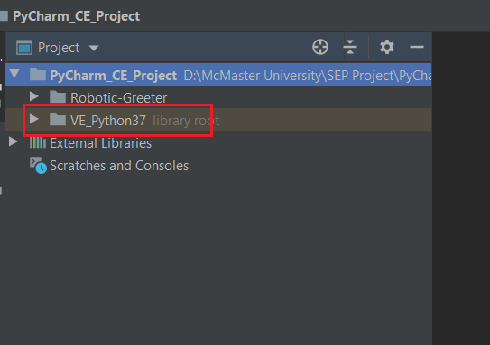

* Again, go to the Settings option and click on Project Interpreter. Now, click on “+” button as the mark in below:

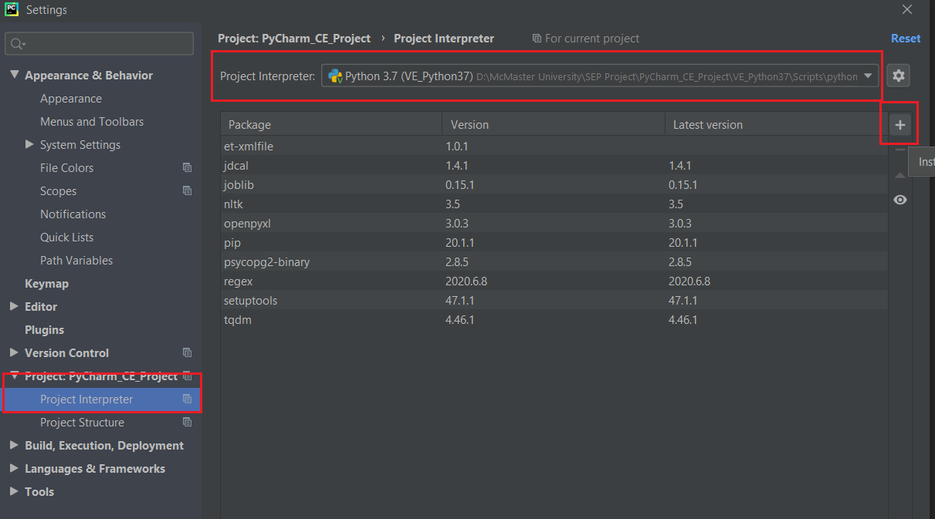

* After click on “+” button, this will open one new tab of “Available Packages”. Here you can search any Python packages you want to install through PyCharm CE.

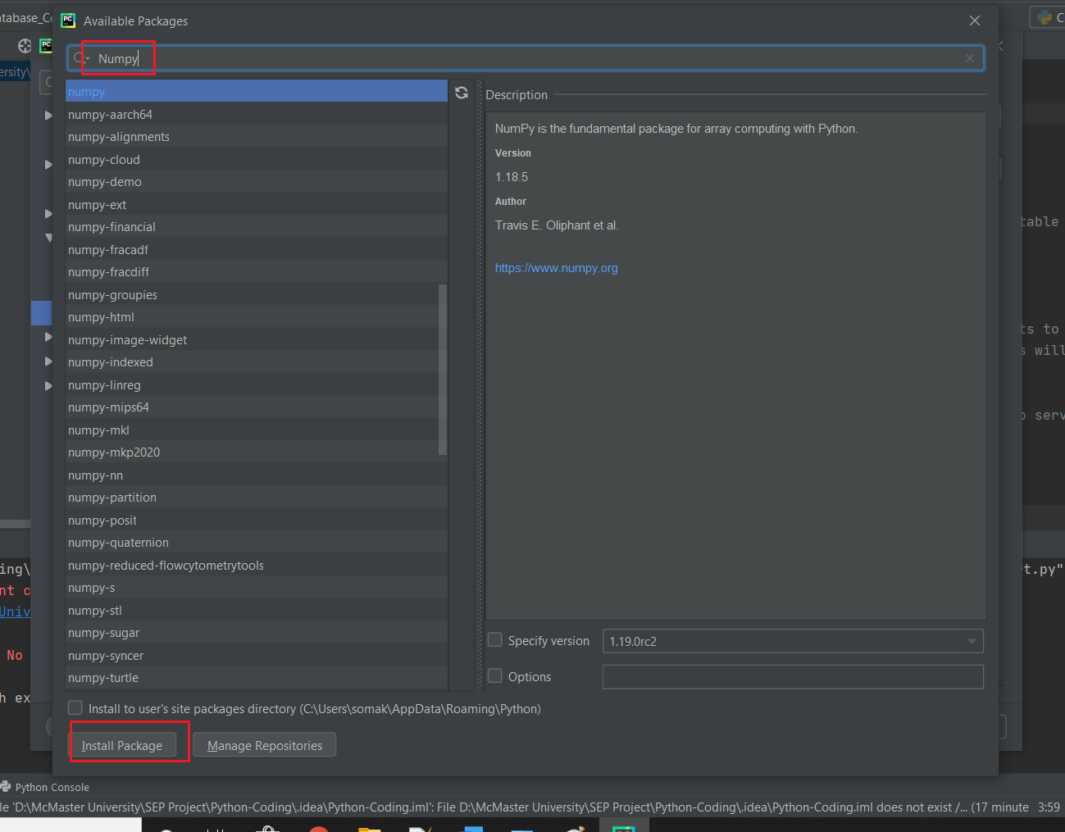

* Also, you can enable this project with your GitHub ors create a new GitHub Repository.

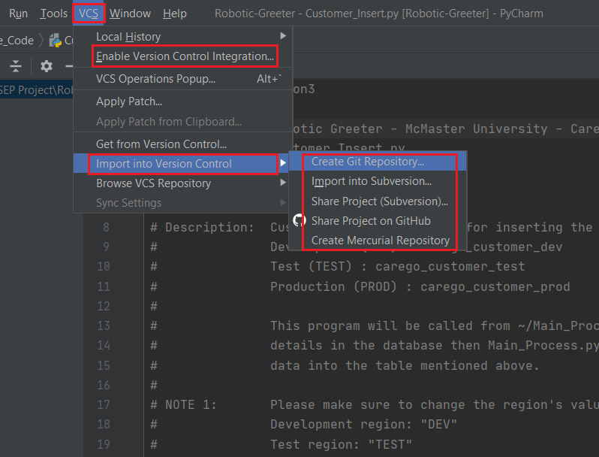

* By doing so, you can directly commit and push the new changes from PyCharm CE. Right-click on your project and click on Git.

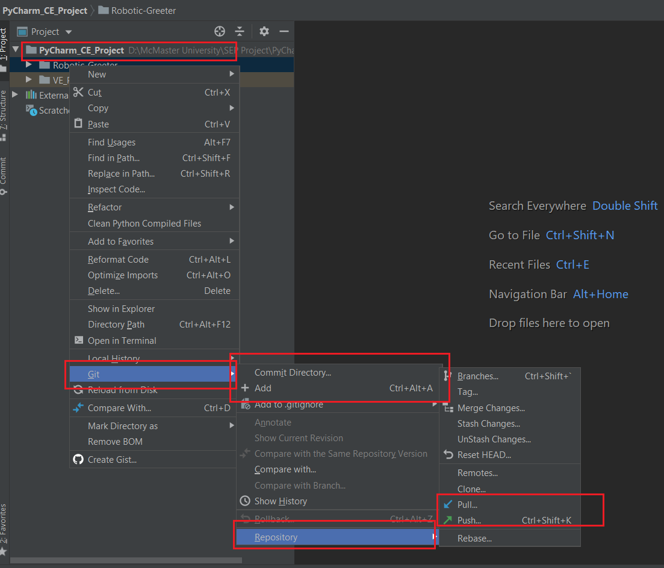

* After all the step is done, now you can open any programs from Robotic-Greeter or create a new Python program and run it.
* To execute the program right-click over the program, and you will see the run option. Click it to execute the program. Also, you can see one run button on the right side as below. You can click on it to run.

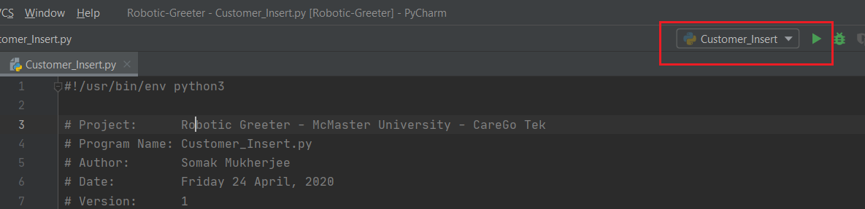

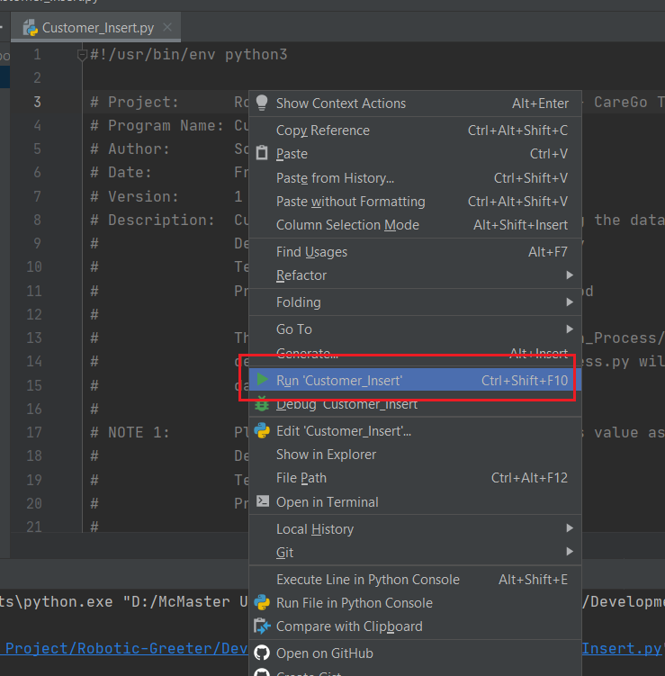

If you need some guidance getting started with the PyCharm, then please visit the [PyCharm](https://www.jetbrains.com/help/pycharm/quick-start-guide.html) website.