**PyGame & PyAudio Installation**

PyGame is a Python wrapper for the SDL library, which stands for Simple Direct Media Layer. SDL provides cross-platform access to your system’s underlying multimedia hardware components, such as sound, video, mouse, keyboard, and joystick. PyGame started life as a replacement for the stalled PySDL Project. The cross-platform nature of both SDL and PyGame means you can write games and costly multimedia Python programs for every platform that supports them!

PyAudio provides bindings for Port Audio, the cross-platform audio I/O library. You can use PyAudio to play and record audio on a variety of platforms, including Windows, Linux, and Mac. With PyAudio, playing audio is done by writing to a Stream.

**Pre-Requisites**

* A system running on Windows/Ubuntu APP/Ubuntu OS
* A user account with sudo/administration privileges
* Access to a terminal window/command-line

Before continuing with this tutorial, make sure you are logged in as root or a user with sudo/administration privileges.

In this tutorial, we will show you how to install the PyGame and PyAudio on Windows and Ubuntu.

1. Install the PyGame and PyAudio on Windows
2. Install the PyGame and PyAudio on Ubuntu APP (Windows 10) or Ubuntu OS
3. Install the PyGame and PyAudio on PyCharm

If you are working on the Windows system, please follow step 1, step 2, and step 3, but if you are working on Ubuntu OS, you follow only step 2 and step 3.

1. **Install the PyGame and PyAudio on Windows**

Windows systems typically do not have The PyGame and PyAudio module build-in. Before installing PyGame and PyAudio, make sure you have installed Python 3+ version and upgraded Pip. PyGame is easy to install on Windows but to install PyAudio; you need to do some extra steps. Let us look at how to install The PyGame and PyAudio on Windows:

* Open a Command Terminal from Windows system and verify Python & Pip as follow:

$ python –-version

$ python -m pip --version

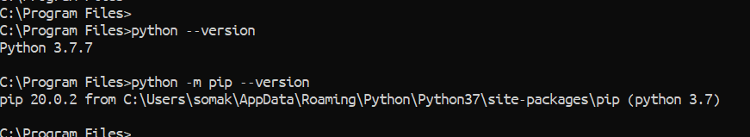

* To verify the PyGame and PyAudio, go to Python Console and type as below:

>> import pygame

>> import pyaudio

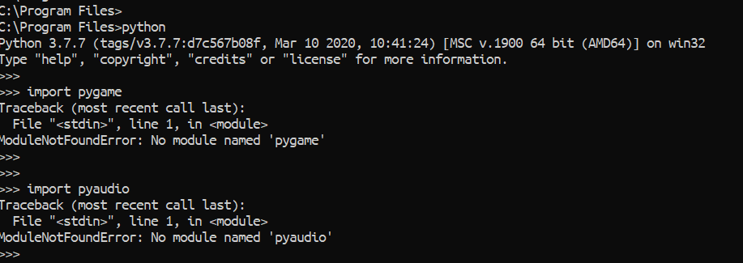

* Now to install the PyGame and to verify it, do as below:

$ python -m pip install -U pygame --user

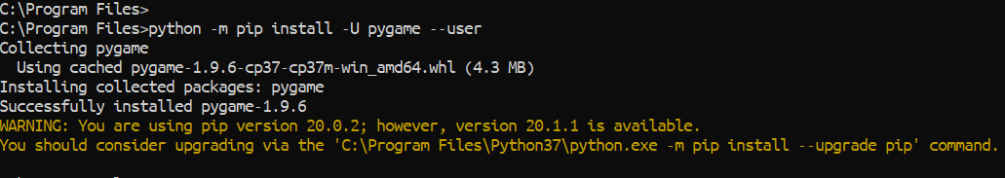

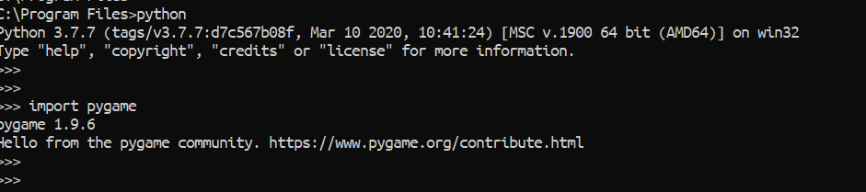

* To install the PyAudio, you need to go to [Windows Binaries for Python Extension Packages](https://www.lfd.uci.edu/~gohlke/pythonlibs/) website and search for the PyAudio. Then download all the “.whl” file.

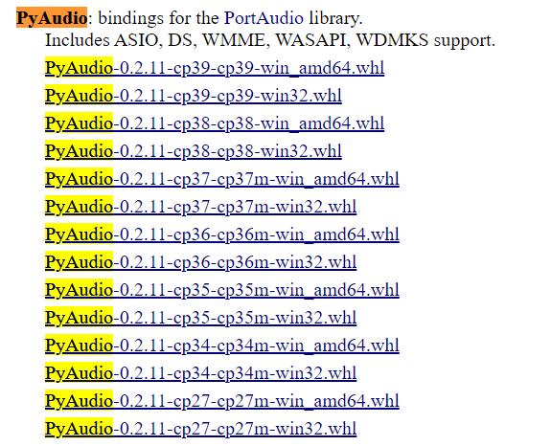

* Now copy and paste all the “.whl” files into your Python installed location. If you installed Python with Custom Installation, then you should know your Python installation Path, or if you installed without Custom Installation, then your Path should be similar like “C:\Users\XXXX\AppData\Local\Programs\Python\.”
* Inside of the Python directory/folder, you can find another PythonXX folder, and inside of this, you will get Scripts directory/folder.
* Paste all the “.whl” files inside of the Scripts directory.

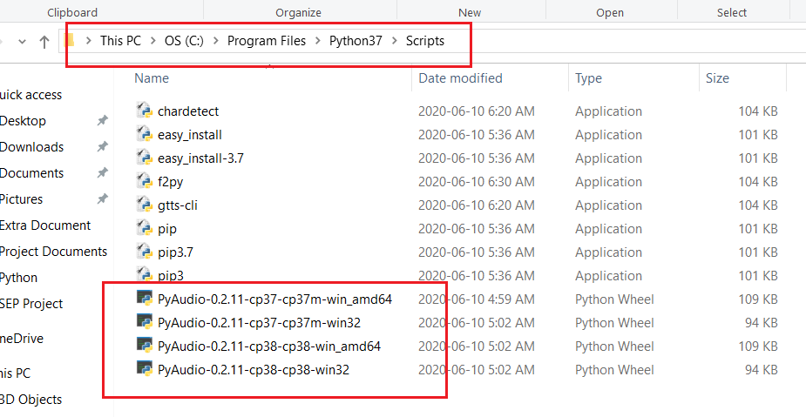

* I have installed Python3.7 with Custom Installation (as below shown picture) into “C:\Program Files\Python37” location, and for me “PyAudio-0.2.11-cp37-cp37m-win_amd64.whl” worked fine, so I just copied this file into my Scripts folder. But you may need to copy all the data initially to your Scripts folder.

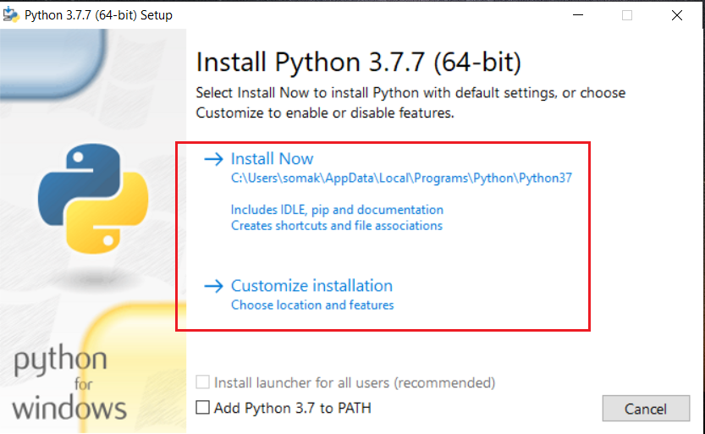

* Then open a Command Terminal from your Windows and navigate to your Python installed location Path and install the “.whl” file. Maybe you need to try with each file, but for me, “PyAudio-0.2.11-cp37-cp37m-win_amd64.whl” worked fine.

$ python -m pip install PyAudio-0.2.11-cp37-cp37m-win_amd64.whl

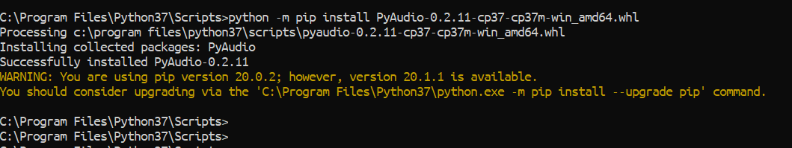

* And finally, verify it as below:

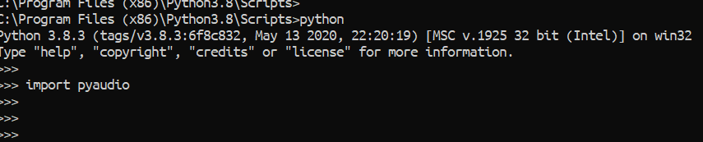

1. **Install the PyGame and PyAudio on Ubuntu APP (Windows 10) or Ubuntu OS**

There are several ways you can install the PyGame and PyAudio on the Ubuntu system, and you can use any of the process from below on Ubuntu APP or Ubuntu OS because all are the same.

1. Install the PyGame and PyAudio using Command Terminal
2. Install the PyGame and PyAudio using Shell Scripts
3. **Install the PyGame and PyAudio using Command Terminal**

To install the PyGame and PyAudio with Command Terminal, open Command Terminal from the Ubuntu OS, or Ubuntu APP from Windows.

* First, go to Python console and verify it as below:

>> import pygame

>> import pyaudio

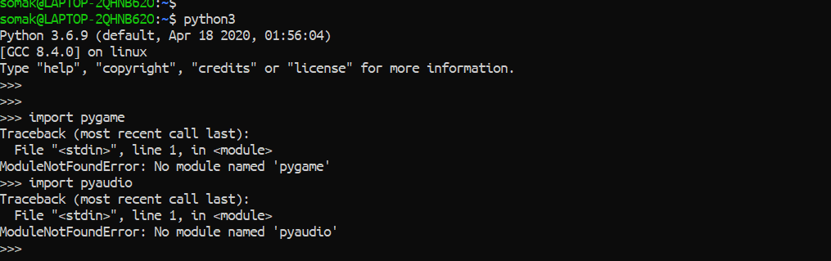

* Later, come out from the Python Console and run the below command to install the PyGame module as below:

$ python3 -m pip install -U pygame –-user

$ sudo apt-get install python3-pyaudio

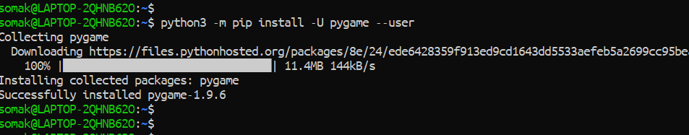

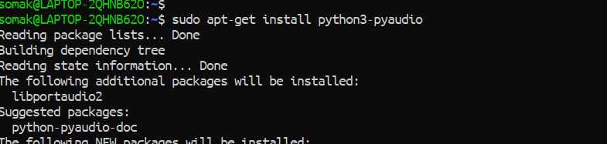

* Verify the PyGame and PyAudio module as below:

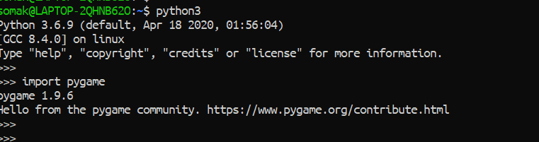

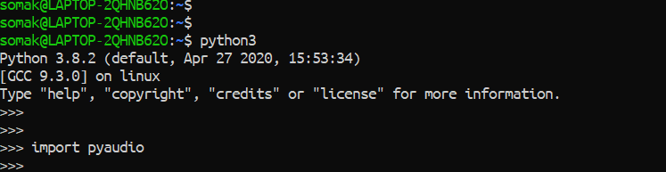

1. **Install the PyGame and PyAudio using Shell Script**

First, we need to download the Robotic-Greeter folder from the [Robotic-Greeter-GitHub](https://github.com/ripanmukherjee/Robotic-Greeter) link.

You can download it in two ways:

1. Clone it with Command Terminal
2. Download it as a Zip file

Inside of the Robotic-Greeter folder, we have the shell (Unix) script, which you need to run. This script will automatically install the PyGame and PyAudio module on your computer.

1. **Using Clone method**

Go to Ubuntu APP from Windows 10 or Command Terminal from Ubuntu OS and run the following command:

$ git clone https://github.com/ripanmukherjee/Robotic-Greeter.git

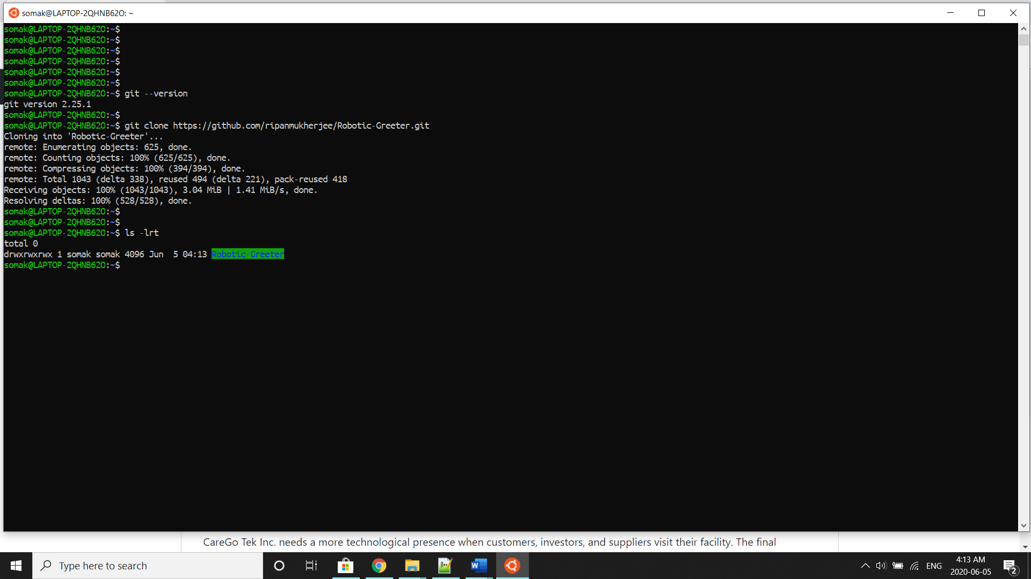

This command will automatically download the Robotic-Greeter folder on your computer.

1. **Download as Zip**

Also, you can directly download the Zip file and Unzip it. Then it would be best if you put it in the proper directory or your project directory.

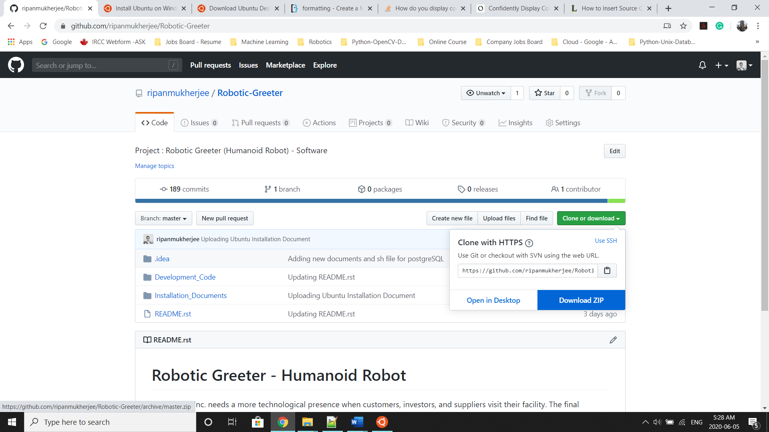

Once the download is complete, please go to the following directory from Ubuntu APP Terminal or Command Terminal on Ubuntu OS:

$ cd Robotic-Greeter/Installation_Documents/PyGame_PyAudio_Installation

In this folder, you will get ***PyGame_PyAudio*_Installation.sh**script. To list the directories and files in this folder, run “ls -lrt” and later change the executable permission for the file with “chmod.”

$ ls -lrt

$ chmod +x *.sh

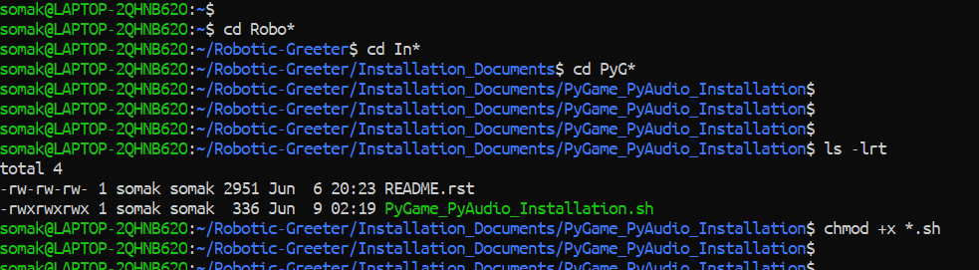

After that, run the scripts as follow:

$ sh PyGame_PyAudio_Installation.sh

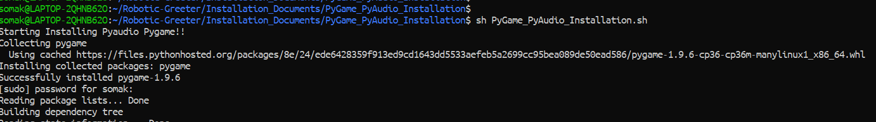

Later, you can verify it again as below:

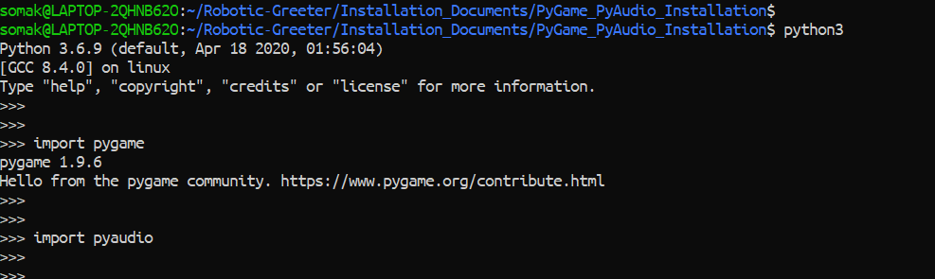

1. **Install the PyGame and PyAudio on PyCharm**

If you wish to run or execute the code from PyCharm CE, and PyCharm CE gives error regarding PyGame and PyAudio, you can also install it from PyCharm Packages as below:

Before installing the PyGame and PyAudio through PyCharm CE, it is recommended to complete all steps from “Install the PyGame and PyAudio on Windows.” If you did not complete it or the above process gave an error, then it will not work with PyCharm CE also. In that case, it is better to use Ubuntu OS than Windows.

* Go to Settings and click on Project Interpreter.
* In the Project Interpreter, click on “+” to add packages.

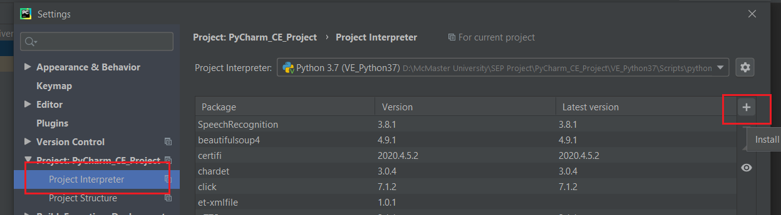

* In the Available Packages tab, you can search for “pygame” and install it.

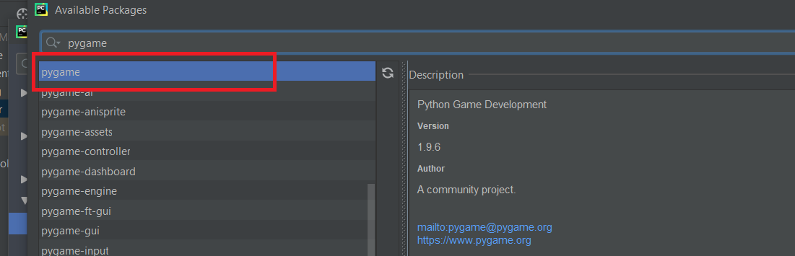

* To install PyAudio, you need to do a similar kind of step that you did while installing PyAudio on Windows. For that first, you need to go to [Windows Binaries for Python Extension Packages](https://www.lfd.uci.edu/~gohlke/pythonlibs/) website and search for PyAudio. Then download all the “.whl” file.
* Then copy all the “.whl” file to your Project’s Virtual Environment(venv) directory or System Interpreter directory. While setting up your PyCharm if you selected your Project Interpreter as Virtual Environment, then paste all the “.whl” files in Virtual Environment, but if you had chosen System Interpreter, then paste it there. Inside your project directory, there is the Virtual Environment directory. Go to that directory, and you will see another Scripts folder. Then copy all the “.whl” file inside of the Scripts folder.

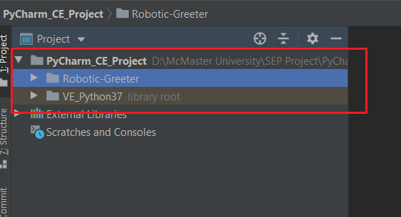

* Then, in PyCharm CE, click on the Terminal option, which you can find on the bottom of PyCharm CE.

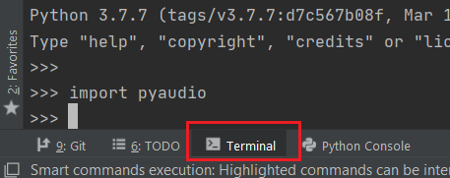

* Go to the Scripts folder from the Terminal as below:

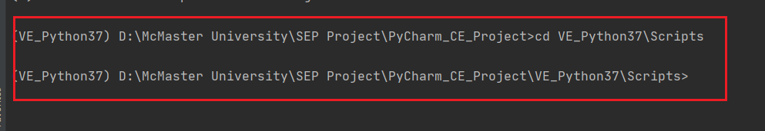

* Now, type the below command in the Terminal to install PyAudio. For me “PyAudio-0.2.11-cp38-cp38-win32.whl” worked fine, but maybe you need to try with other “.whl” file for the installation.

$ python -m pip install PyAudio-0.2.11-cp37-cp37m-win_amd64.whl

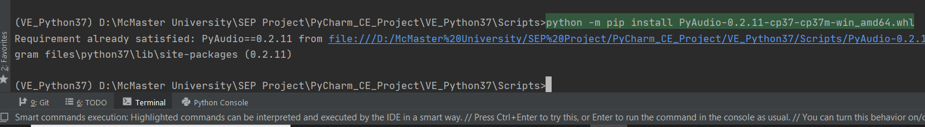

* Then verify PyAudio, from PyCharm CE as below:

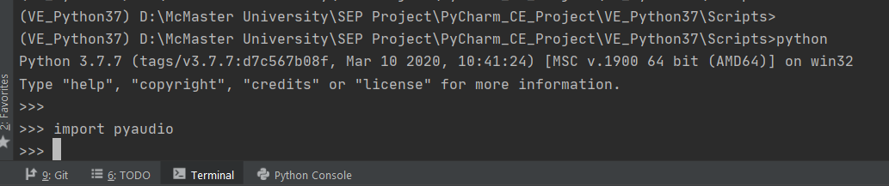

For more details related to the PyGame and PyAudio, please visit the [PyGame](https://www.pygame.org/wiki/GettingStarted) and [PyAudio](https://people.csail.mit.edu/hubert/pyaudio/) Website.