**Python Installation**

Python is an interpreted, high-level, general-purpose programming language. Created by Guido van Rossum and first released in 1991, Python's design philosophy emphasizes code readability with its notable use of significant whitespace. Its language constructs and object-oriented approach aim to help programmers write clear, logical code for small and large-scale projects.

Python is a popular programming language often used to write scripts for operating systems. It is versatile enough for use in web development and app design. In this project, we have used Python 3.7, and hence we need to install and verify it.

This tutorial will guide you through the steps required to install Python 3.7 on Windows and Ubuntu. The same instructions apply for Ubuntu 16.04/18.04/20.04 or Ubuntu APP and any other Ubuntu-based distribution, Linux Mint and Elementary OS.

**Pre-Requisites**

* A system running on Windows/Ubuntu APP/Ubuntu OS
* A user account with sudo/administration privileges
* Access to a terminal window/command-line

Before continuing with this tutorial, make sure you are logged in as root or a user with sudo/administration privileges.

In this tutorial, we will show you how to install Python on Windows and Ubuntu.

1. Install Python on Windows
2. Install Python on Ubuntu APP (Windows 10) or Ubuntu OS

If you are working on the Windows system, please follow step 1 and step 2, but if you are working on Ubuntu OS, you follow only step 2.

1. **Install Python on Windows**

It is highly unlikely that your Windows system shipped with Python already installed. Windows systems typically do not. Fortunately, installing does not involve much more than downloading the Python installer from the [python.org](https://www.python.org/) website and running it. Let us look at how to install Python 3 on Windows:

* **Download the Python 3 Installer**

Open a browser window and navigate to the Download page for Windows at [python.org](https://www.python.org/)

Underneath the heading at the top that says Python Releases for Windows, click on the link for the Latest Python 3 Release - Python 3.x.x.

Scroll to the bottom and select either Windows x86-64 executable installer for 64-bit or Windows x86 executable installer for 32-bit.

* **Run the Installer**

Once you have chosen and downloaded an installer, simply run it by double-clicking on the downloaded file. A dialog should appear that looks something like this:

* You can select Custom Installation if you want to choose the installation location.

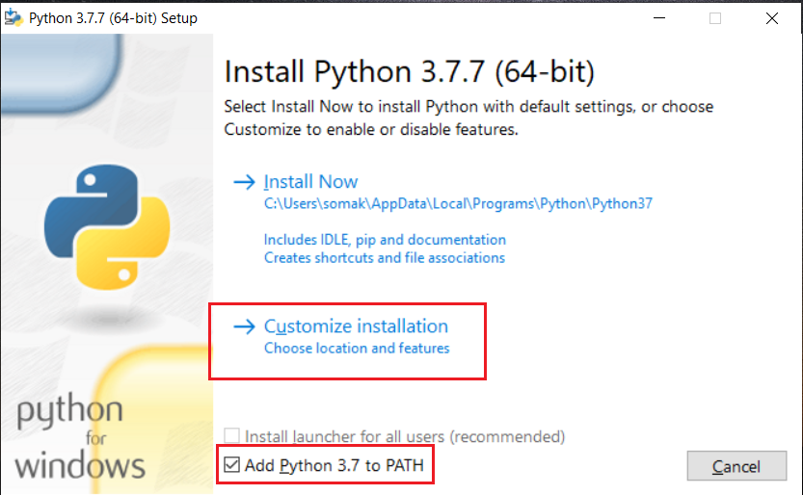

* Remember to select all the options, especially Pip because it is a relevant module which you will need to install other Python packages. Then click on the Next button.

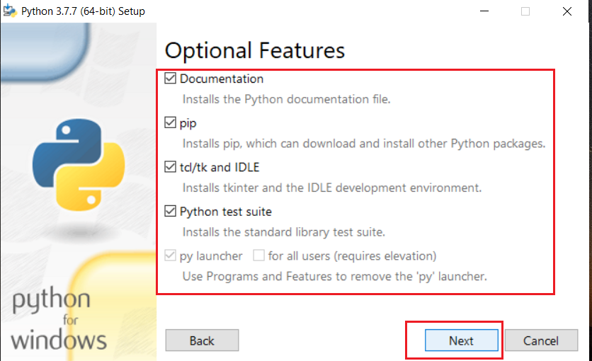

* Select all the advance options, as shown in below. Then choose the location by clicking on the browse button and later click on the Install button. This process will take a few minutes to install Python 3.7

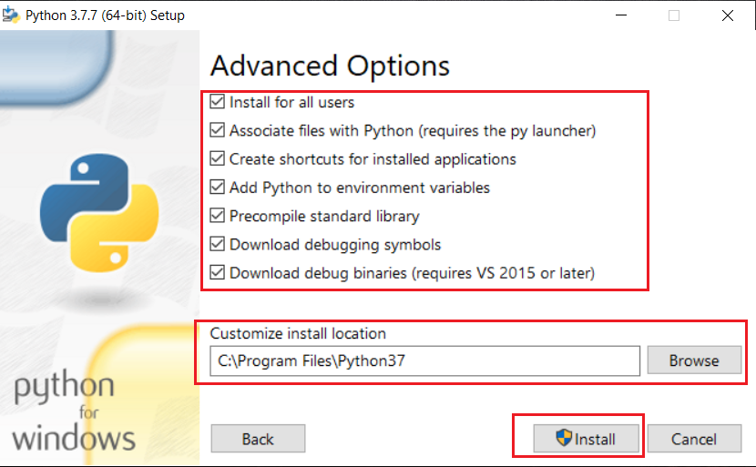

* Please wait up to installation is done. After the installation is over, you need to verify it.
* Verify it

After you have done the above steps, please open Command Terminal (cmd) and verify it as below:

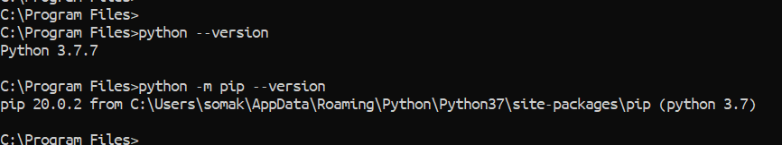

1. **Install Python on Ubuntu APP (Windows 10) or on Ubuntu OS**

There is a perfect chance your Ubuntu has Python installed already, but it probably will not be the latest version, and it may be Python 2 instead of Python 3.

There are two ways you can install Python on the Ubuntu system. You can use the any of the following two methods for Ubuntu APP or Ubuntu OS. Both processes are the same.

1. Install Python using Command Terminal
2. Install Python using Shell Scripts
3. **Install Python using Command Terminal**

To find out what version(s) you have, open a Terminal window from Ubuntu OS or open Ubuntu APP from Windows 10, and try the following commands:

$ python --version

$ python3 --version

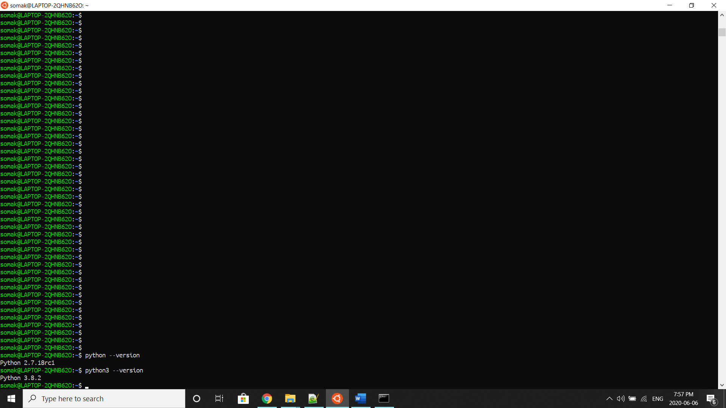

If the version shown is Python 2.x.x or a version of Python 3 that is not the latest, you will want to install the newest version. The procedure for doing this will depend on the Linux distribution you are running.

Depending on the Ubuntu version, follow the instructions below:

* Ubuntu 18.04 (and above) come with Python 3.6 (or above) by default. You should be able to invoke it with the command python3.
* Ubuntu 16.10 and 17.04 do not come with Python 3.6 (or above) by default, but it is in the Universe repository. You should be able to install it with the following commands:

$ sudo apt-get update

$ sudo apt-get install python3.7

* If you are using **Ubuntu 14.04**, Python 3.6 (or above) is not in the Universe repository, and you need to get it from a Personal Package Archive (PPA). For example, to install Python from the [“deadsnakes” PPA](https://launchpad.net/~deadsnakes/+archive/ubuntu/ppa), do the following:

$ sudo apt install software-properties-common

$ sudo add-apt-repository ppa:deadsnakes/ppa

$ sudo apt-get update

$ sudo apt-get install python3.7

* In the above command, you can replace Python3.7 to Python3.6 or Python3.8 or any latest version you want.

1. **Install Python using Shell Script**

First, we need to download the Robotic-Greeter folder from the [Robotic-Greeter-GitHub](https://github.com/ripanmukherjee/Robotic-Greeter) link.

You can download it in two ways:

1. Clone it with Command Terminal
2. Download it as a Zip file

Inside of the Robotic-Greeter folder, we have the shell (Unix) script, which you need to run, and this script will automatically install Python on your computer.

1. **Using Clone method**

Go to Ubuntu APP from Windows 10 or Command Terminal from Ubuntu OS and run the following command:

$ git clone https://github.com/ripanmukherjee/Robotic-Greeter.git

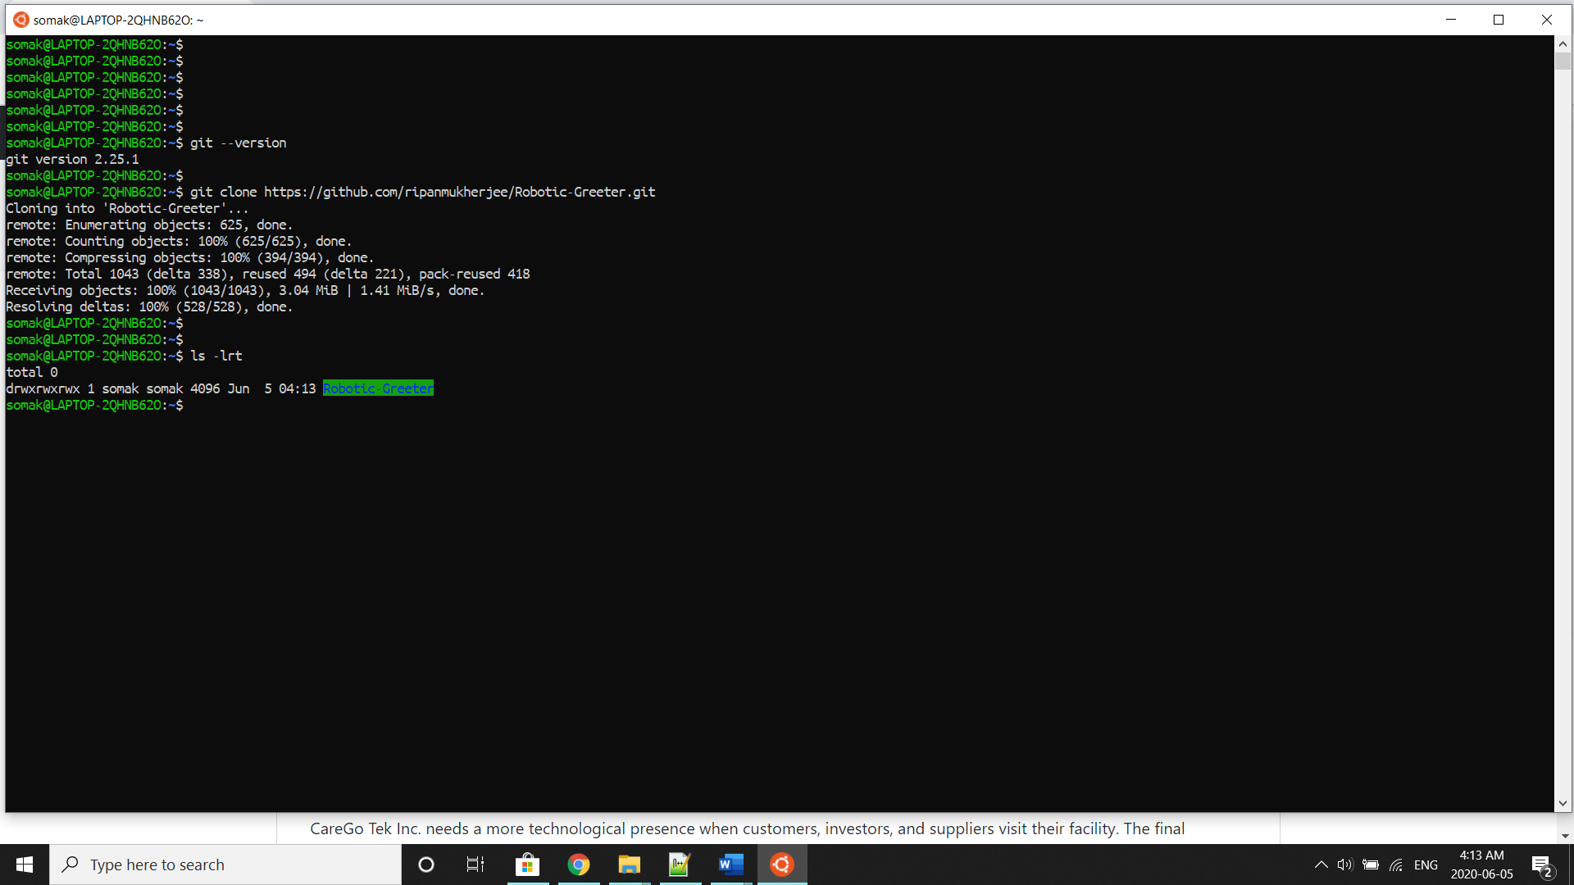

This command will automatically download the Robotic-Greeter folder on your computer.

1. **Download as Zip**

Also, you can directly download the Zip file and Unzip it. Then it would be best if you put it in the proper directory or your project directory.

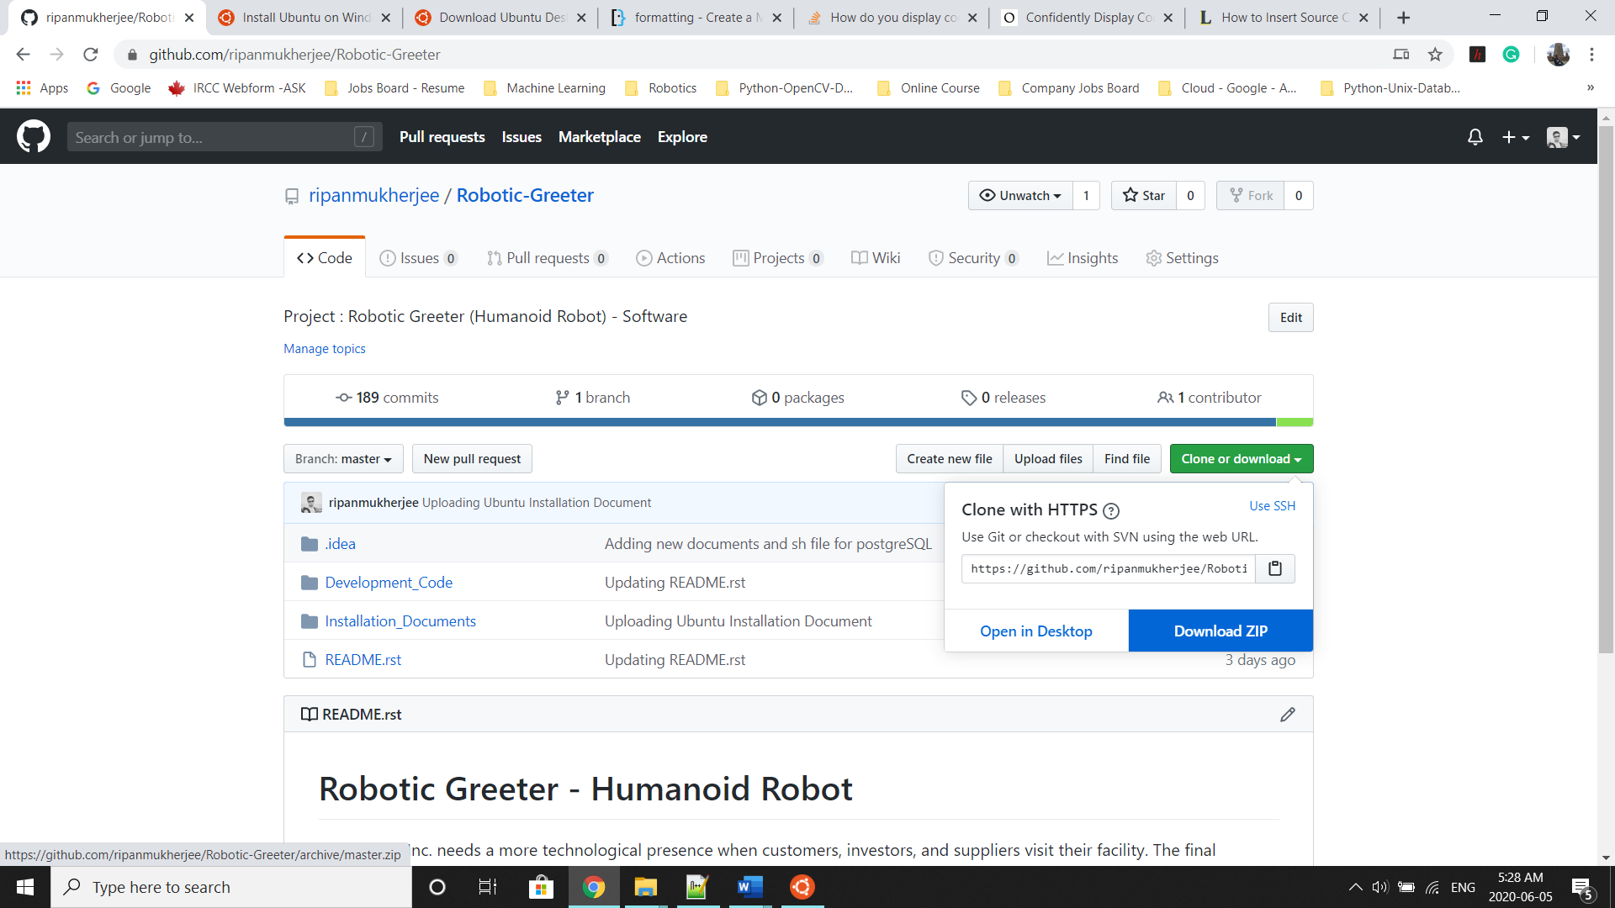

Once the download is complete, please go to the following directory from Ubuntu APP Terminal or Command Terminal on Ubuntu OS:

$ cd Robotic-Greeter/Installation_Documents/Python_Installation

In the Python_Installation folder, you will get **Python_Installation.sh**script. To list the directories and files in this folder run “ls -lrt” and later change the executable permission for the file with “chmod”.

$ ls -lrt

$ chmod +x *.sh

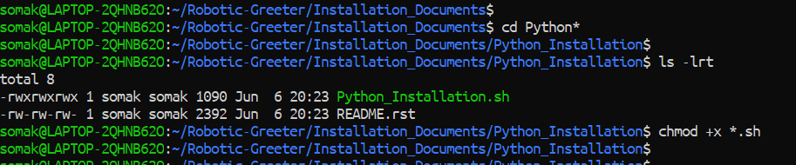

After that, run the scripts as follow:

$ sh Python_Installation.sh

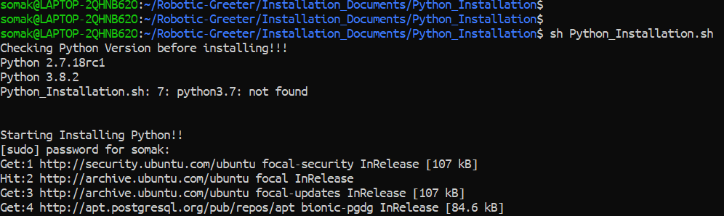

After this, you can again verify it as below:



Installation done!!

For more details related to Python, please visit the [python.org](https://www.python.org/) website.