**Speech Recognition Installation**

Speech Recognition, as the name suggests, refers to automatic recognition of human speech. Speech Recognition is one of the most essential tasks in the domain of human-computer interaction. If you have ever interacted with Alexa or have ever ordered Siri to complete a task, you have already experienced Speech Recognition.

Speech Recognition has various applications ranging from automatic transcription of speech data (like voice mails) to interacting with robots via speech.

gTTS (Google Text-to-Speech) is a Python library with Google Translate text-to-speech API. This package writes spoken mp3 data to a file, a file-like object for further audio manipulation, or stdout. It features flexible pre-processing and tokenizing, as well as automatic retrieval of supported languages.

Play sound on Python is easy. There are several modules that can play a sound file. These solutions are cross platform (Windows, Mac, Linux). The main difference is in the ease of use and supported file formats. All of them should work with Python 3. The audio file should be in the same directory as your python program unless you specify a path.

**Pre-Requisites**

* A system running on Windows/Ubuntu APP/Ubuntu OS
* A user account with sudo/administration privileges
* Access to a terminal window/command-line

Before continuing with this tutorial, make sure you are logged in as root or a user with sudo/administration privileges.

In this tutorial, we will show you how to install Speech Recognition related packages on Windows and Ubuntu.

1. Install Speech Recognition, gTTS & playsound on Windows
2. Install Speech Recognition, gTTS & playsound on Ubuntu APP (Windows 10) or Ubuntu OS
3. Install Speech Recognition, gTTS & playsound on PyCharm

If you are working on the Windows system, please follow step 1, step 2, and step 3, but if you are working on Ubuntu OS, you follow only step 2 and step 3.

1. **Install Speech Recognition, gTTS & playsound on Windows**

Windows systems typically do not have Speech Recognition, gTTS & playsound build-in. Before installing Speech Recognition, gTTS & playsound, make sure you have installed Python 3+ version and upgraded Pip. Let us look at how to install Speech Recognition, gTTS & playsound on Windows:

* Open a Command Terminal from Windows system and verify Python & Pip as follow:

$ python –-version

$ python -m pip --version

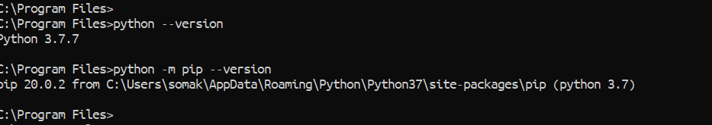

* To verify Speech Recognition, gTTS & playsound, go to Python Console and type as below:

>> import speech_recognition

>> from gtts import gTTS

>> from playsound import playsound

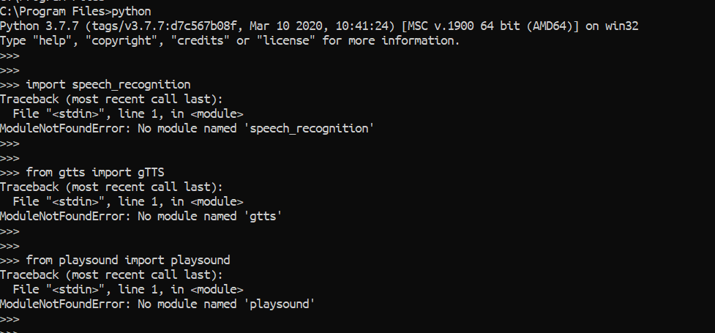

* If you do not have Speech Recognition, gTTS and playsound then running the above command will give no module error as above. Now, to install Speech Recognition, gTTS & playsound from Command Terminal, follow the below steps.

The playsound module is a cross platform module that can play audio files. This does not have any dependencies, simply install with pip in your virtual environment and run.

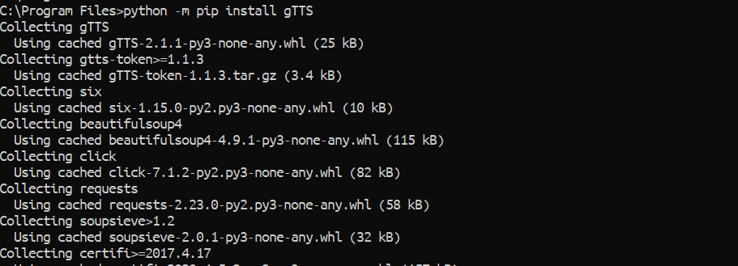

$ python -m pip install gTTS

$ python -m pip install SpeechRecognition

$ python -m pip install playsound

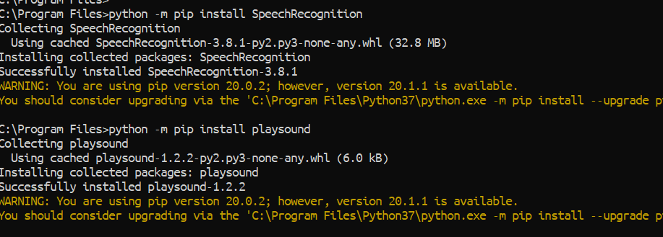

* Verify Speech Recognition, gTTS & playsound as below:

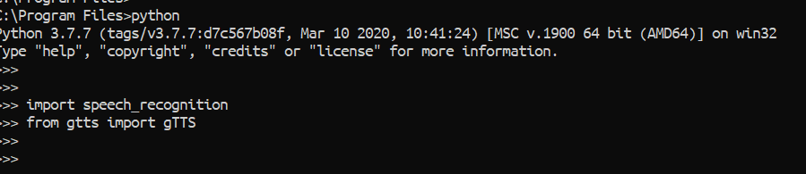

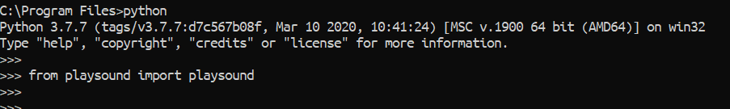

1. **Install Speech Recognition, gTTS & playsound on Ubuntu APP (Windows 10) or Ubuntu OS**

There are several ways you can install Speech Recognition, gTTS & playsound on the Ubuntu system, and you can use any of the below process on Ubuntu APP or Ubuntu OS because all are the same.

1. Install Speech Recognition, gTTS & playsound using Command Terminal
2. Install Speech Recognition, gTTS & playsound using Shell Scripts
3. **Install Speech Recognition, gTTS & playsound using Command Terminal**

To install Speech Recognition, gTTS & playsound package with Command Terminal, open Command Terminal from the Ubuntu OS, or open Ubuntu APP from Windows.

* First, go to Python console and verify it as below:

>> import speech_recognition

>> from gtts import gTTS

>> from playsound import playsound

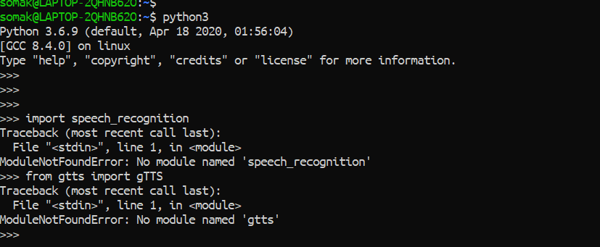

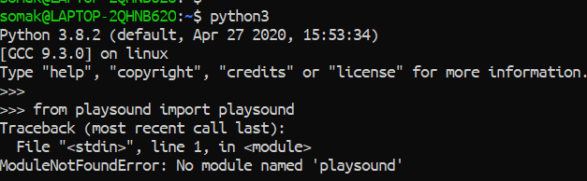

* Later, come out from the Python Console and run the below command to install Speech Recognition, gTTS and playsound:

$ pip3 install gTTS

$ pip3 install SpeechRecognition

$ pip3 install playsound

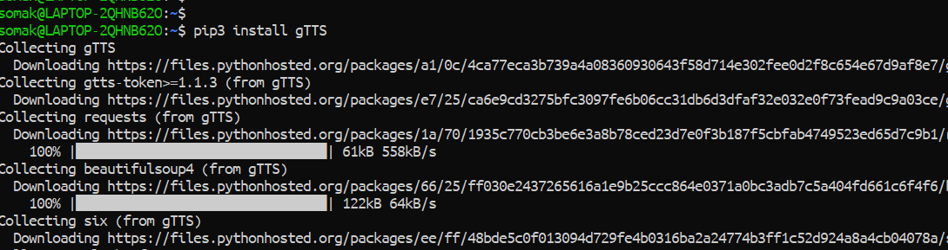

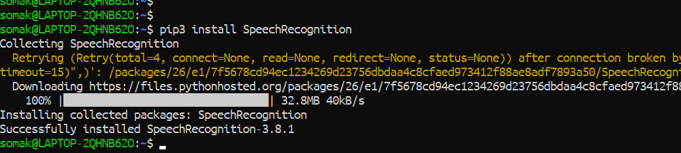

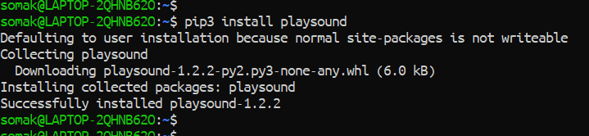

* Verify Speech Recognition, gTTS & playsound as below:

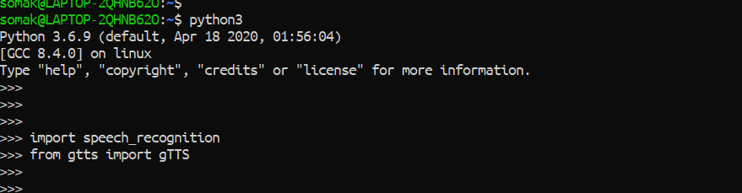

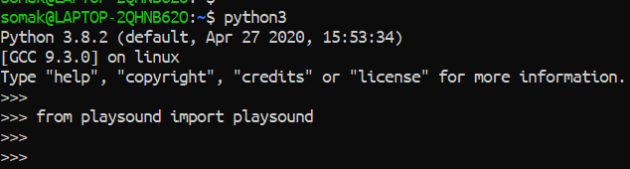

1. **Install Speech Recognition, gTTS & playsound** **using Shell Script**

First, we need to download the Robotic-Greeter folder from the [Robotic-Greeter-GitHub](https://github.com/ripanmukherjee/Robotic-Greeter) link.

You can download it in two ways:

1. Clone it with Command Terminal
2. Download it as a Zip file

Inside of the Robotic-Greeter folder, we have the shell (Unix) script, which you need to run, and this script will automatically install Speech Recognition, gTTS & playsound on your computer.

1. **Using Clone method**

Go to Ubuntu APP from Windows 10 or Command Terminal from Ubuntu OS and run the following command:

$ git clone https://github.com/ripanmukherjee/Robotic-Greeter.git

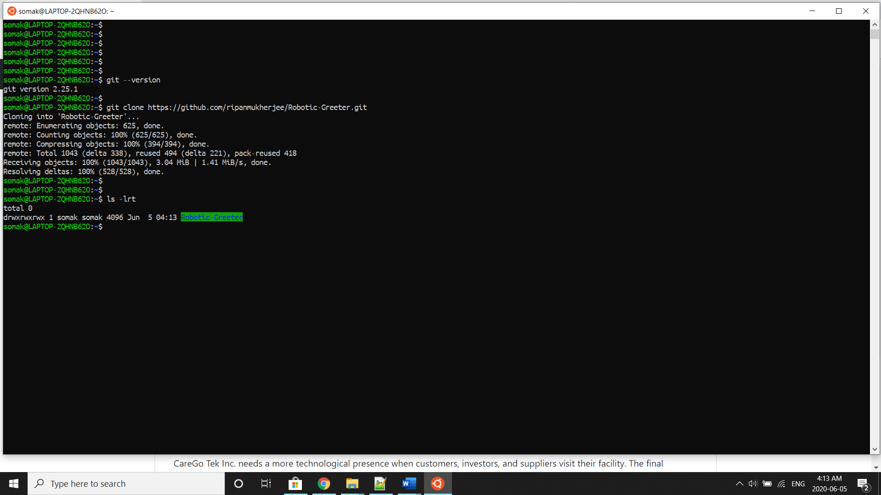

This command will automatically download the Robotic-Greeter folder on your computer.

1. **Download as Zip**

Also, you can directly download the Zip file and Unzip it. Then it would be best if you put it in the proper directory or your project directory.

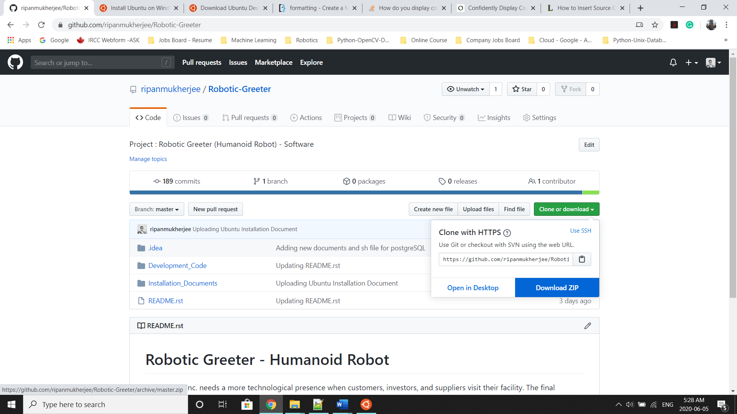

Once the download is complete, please go to the following directory from Ubuntu APP Terminal or Command Terminal on Ubuntu OS:

$ cd Robotic-Greeter/Installation_Documents/Speech_Recognition_Installation

In this folder, you will get ***Speech_Recognition*_Installation.sh**script. To list the directories and files in this folder run “ls -lrt” and later change the executable permission for the file with “chmod”.

$ ls -lrt

$ chmod +x *.sh

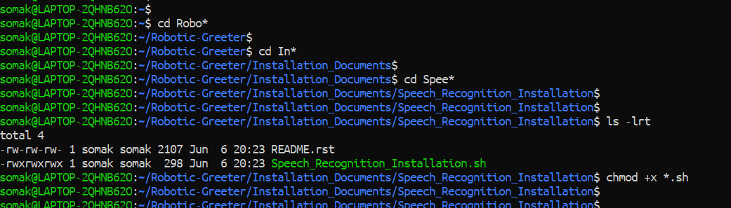

After that, run the scripts as follow:

$ sh Speech_Recognition_Installation.sh

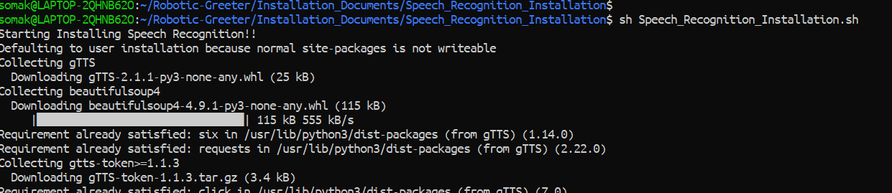

Later, you can verify it again as below:





Installation done!!

1. **Install Speech Recognition on PyCharm**

If you wish to run or execute the code from PyCharm CE, and PyCharm CE gives error regarding Speech Recognition, gTTS & playsound module, you can also install it from PyCharm Packages as below:

* Go to Settings and click on Project Interpreter.
* In the Project Interpreter, click on “+” to add packages.

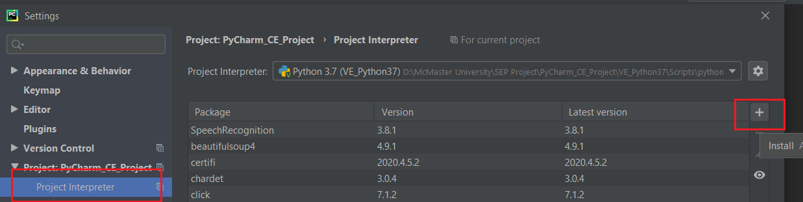

* In the Available Packages tab, search for “SpeechRecognition” and install it.

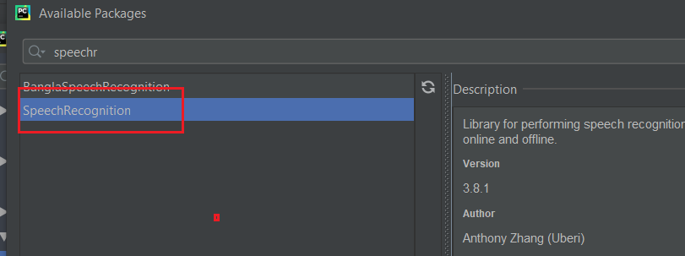

* In the Available Packages tab, search for “gTTS” and install it.

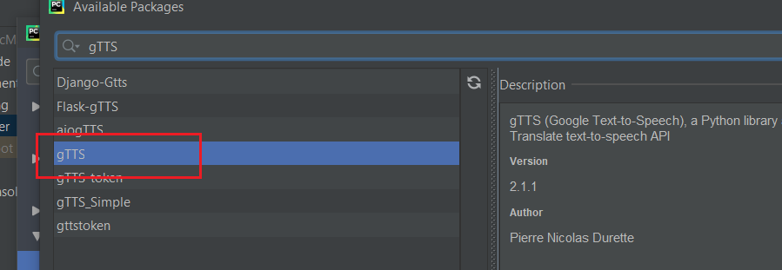

* In the Available Packages tab, search for “playsound” and install it.

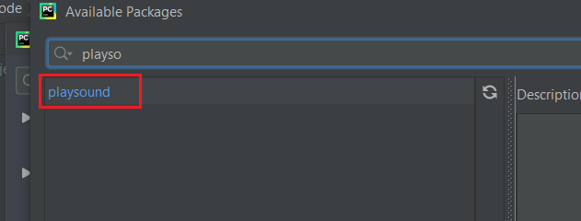

For more details related to Speech Recognition, please visit the [Speech Recognition](https://pypi.org/project/SpeechRecognition/), [gTTS](https://pypi.org/project/gTTS/) and [playsound](https://pypi.org/project/playsound/) Website.