**Ubuntu APP & Ubuntu OS Installation**

Ubuntu is a popular operating system that is open source and has easy installation. It is quite flexible thanks to its unlimited customization options, and it highly secure. For many developers, the journey on Linux begins at Ubuntu, which is why today, we will give you a tutorial on how to install Ubuntu OS along with Windows 10 and how to install Ubuntu APP on Windows 10.

**Pre-Requisites**

Following are the pre-requirements of Ubuntu LTS installation:

* Connect your machine to a power source
* Make sure that you have enough space in your disk, i.e., a minimum of 5GB
* You must have the version of Ubuntu you want to install in a USB drive
* Have a backup of your data

There are two ways you can install Ubuntu as follows:

1. Install Ubuntu OS alongside Windows 10 [dual-boot]
2. Install Ubuntu APP on Windows 10 [Single-boot]

Note: Remember that Ubuntu APP does not have all the features as Ubuntu OS, such as zenity (GNOME). Hence Ubuntu OS or any Linux OS is better to use for this project.

1. **Install Ubuntu OS alongside Windows 10 [dual-boot]**

First, make a backup of your Windows 10 operating system. Because this is a risky process, and any error during installation may leave your order into an inconsistent state.

Creating a backup of the Windows 10 operating system is a voluntary process, but it is highly recommended. Once the backup is completed, it is time to prepare the Ubuntu for installation alongside Windows 10. To make a backup of the whole Windows 10 system, you can use Windows default backup utility to create a backup and restore it in case of any error.

Now do the following steps:

* **Download Ubuntu ISO**
  1. Go to [Ubuntu-Desktop-Download](https://www.ubuntu.com/download/desktop) website.
  2. Once the URL is opened, click on the “Download” button to start the download.

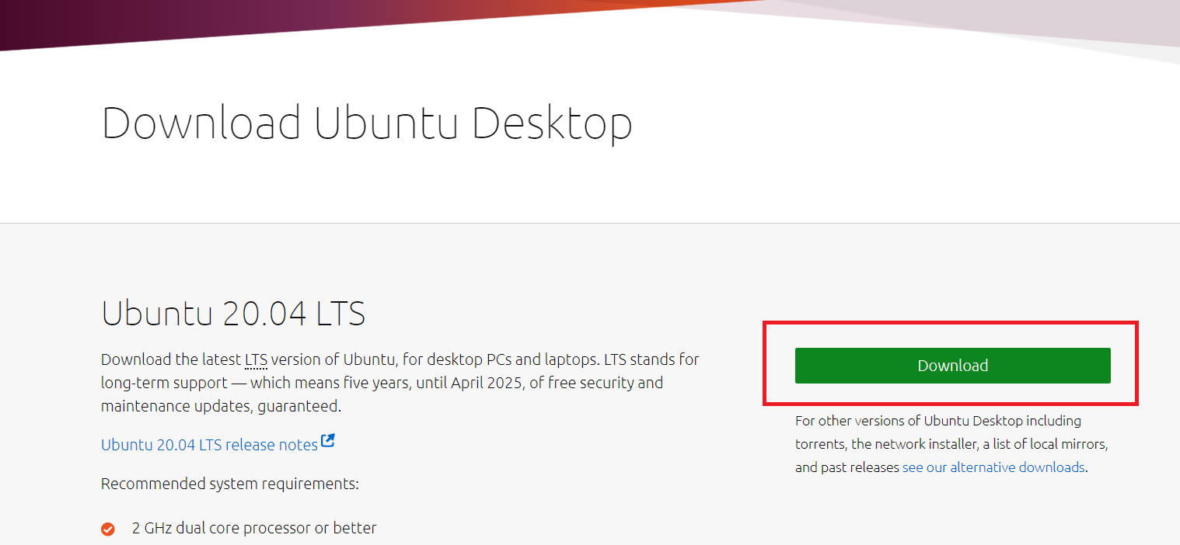

* **Create a bootable USB Drive**

1. To create a bootable USB drive, we will use a tool called “unetbootin.” If you do not have this software, then please download and install it from [here](https://unetbootin.github.io/).
2. Plugin your USB drive into your computer and format it with FAT32. If the File system is not FAT32, select the FAT32 for formatting.
3. Once the “unetbootin” has been downloaded, you need to install & run it.
4. Select the option “DISK IMAGE” and then browse & select the downloaded Ubuntu ISO path. In addition to this, select the USB drive you want the Ubuntu setup to be installed. Once done, Click OK.

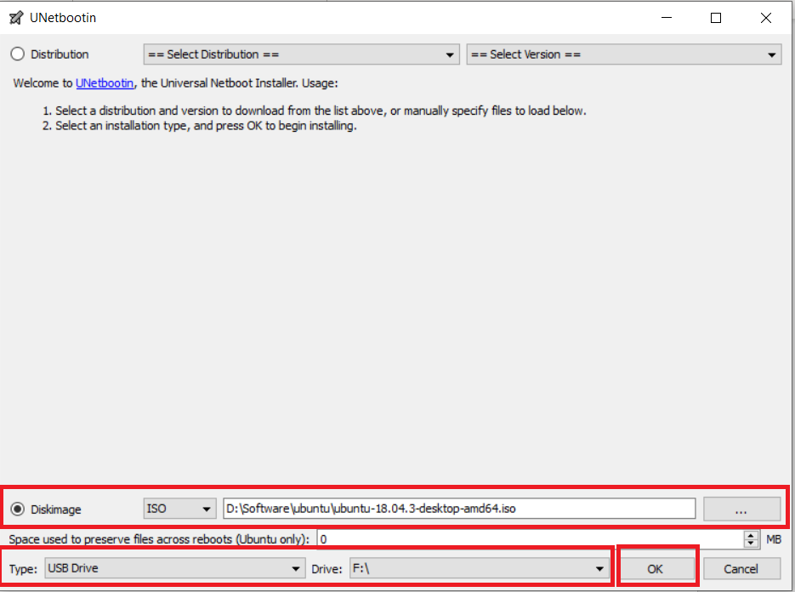

* **Shrink space for Ubuntu**

The tool we will use to shrink space for Ubuntu is the “Windows Disk management tool.” The following are the steps to use this tool.

1. Start the “Disk Management” tool by doing a right-click on the Windows start button on the bottom left on the screen and select the “Disk Management” option.
2. A window will appear like this displaying all of the available drives.
3. Right-click on the “C:” drive, which has the most prominent free space and select the “Shrink Volume” Option.
4. A window will appear, showing up the best possible size.
5. Adjust the size as per requirement and click on “Shrink.”
6. The shrinking process will be started, and a new unallocated partition is created once the shrinking process has been completed. This partition will be used to install Ubuntu.

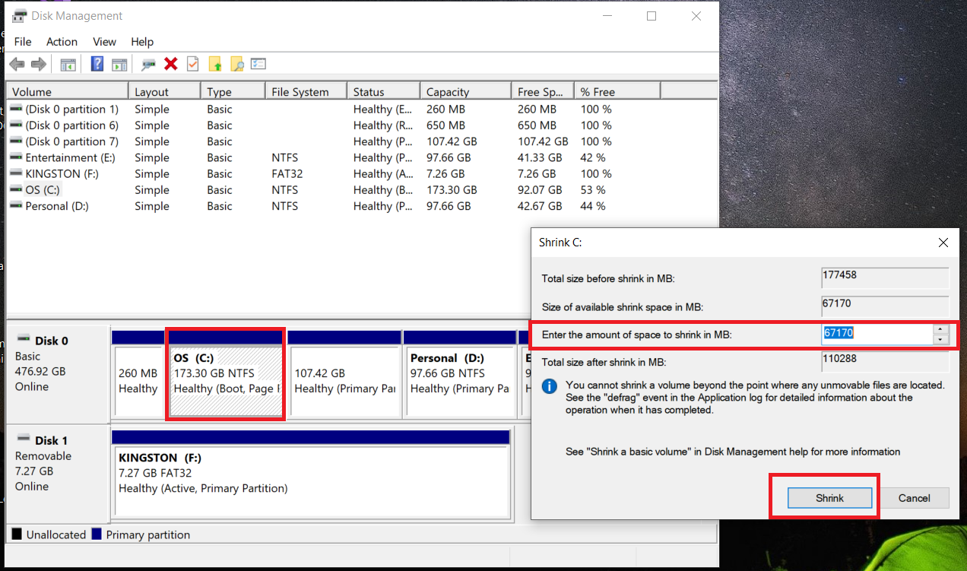

After the shrinking process is complete, it is time to run the Ubuntu OS environment and install it.

* **Run & Install the Ubuntu**

The first step to install Ubuntu is to run the Ubuntu live environment. To run the Ubuntu live environment, we have to reboot our PC and load the boot-up menu. Usually, in most of the machines, the boot-up list comes from “F12” shortcut key; however, in some devices, the boot-up menu appears from “ESC,” “F2”, “F10” key as well. For the actual confirmation, refer to the user manual of your machine.

1. Once the boot-up menu appears, select the option to boot from “USB FLASH DRIVE” and press enter.
2. The booting process will start, and once the booting process has been completed, you will have an option of how you want to use Ubuntu.
3. Select the “Try Ubuntu” option and press enter.
4. The Ubuntu live session will start. You can try the Ubuntu live session, but this live session will be destroyed once you restart your machine, so to keep it persistent and we have to install the Ubuntu in our hard disk drive.

* After clicking the Install Ubuntu option, a wizard will appear, and the Ubuntu installation process will start. Select English and click the Continue button

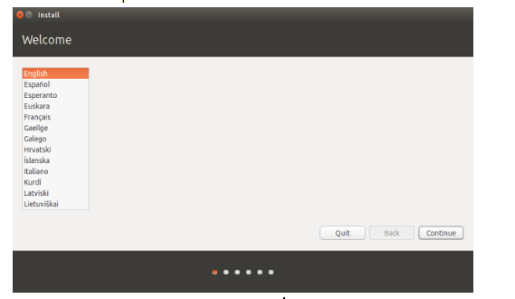

* Select install third part and click the Continue button.

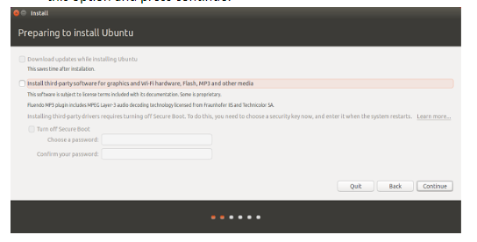

* Select Install Ubuntu alongside Windows Boot and click the Continue button.

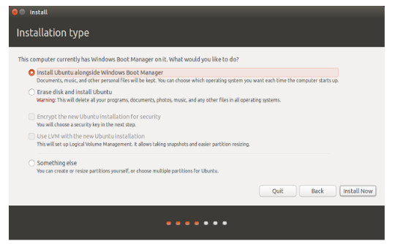

* Select your geographical region and click the Continue Button.

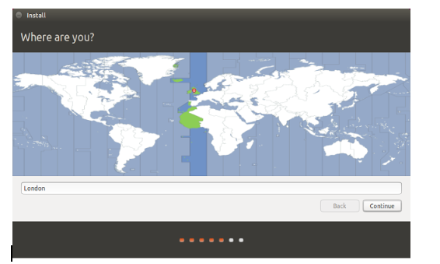

* Select the Keyboard layout and click the Continue button.

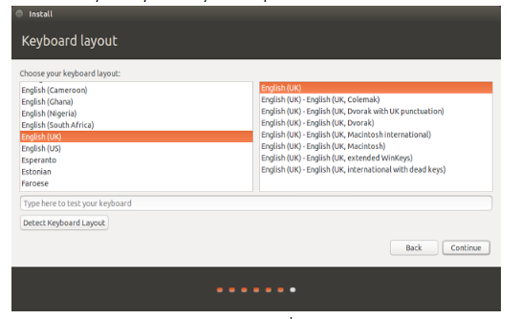

* Select username and password and click the Continue button.

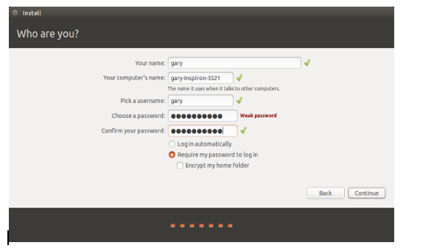

* Now Ubuntu OS will install, and it will take a few minutes.

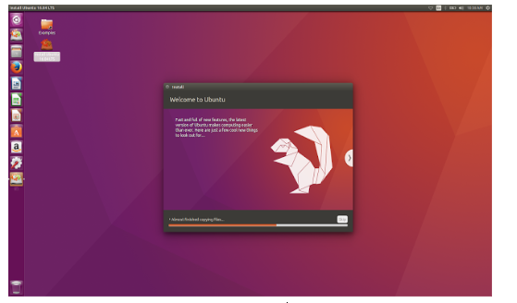

Once the setup has been completed, it will ask to reboot the system. Once the system has been reset, you can see that the bootloader will ask which operating system you want to start—select Windows or Ubuntu as per your requirement.

1. **Install Ubuntu APP on Windows 10 [Single-boot]**

The incredible Ubuntu Terminal is freely available for Windows 10.

As any Linux user knows, it’s the Command Terminal where the magic happens. It’s perfect for file management, development, remote administration, and a thousand other tasks.

The Ubuntu Terminal for Windows has many of the same features you’ll find using the Terminal on Ubuntu:

1. The unrivaled breadth of packages, updates, and security features
2. Bash, Z-Shell, Korn and other shell environments without virtual machines or dual-booting
3. Run native tools such as SSH, git, apt and dpkg directly from your Windows computer
4. A vast community of friendly, approachable users

* **Install Ubuntu APP on Windows 10**

Ubuntu can be installed from the Microsoft Store:

1. Use the Start menu to launch the Microsoft Store application.
2. Search for Ubuntu and select the first result, ‘Ubuntu,’ published by Canonical Group Limited.
3. Click on the Install button.
4. Ubuntu will be downloaded and installed automatically. Progress will be reported within the Microsoft Store application.

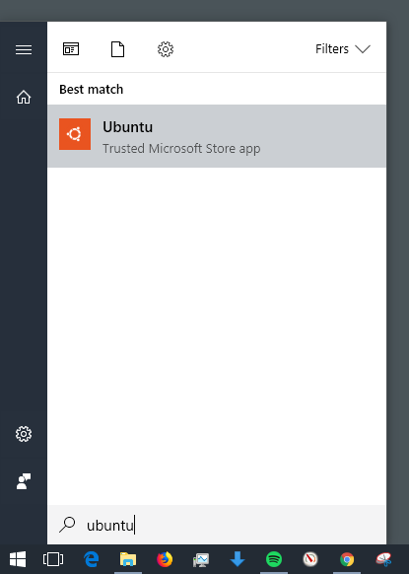

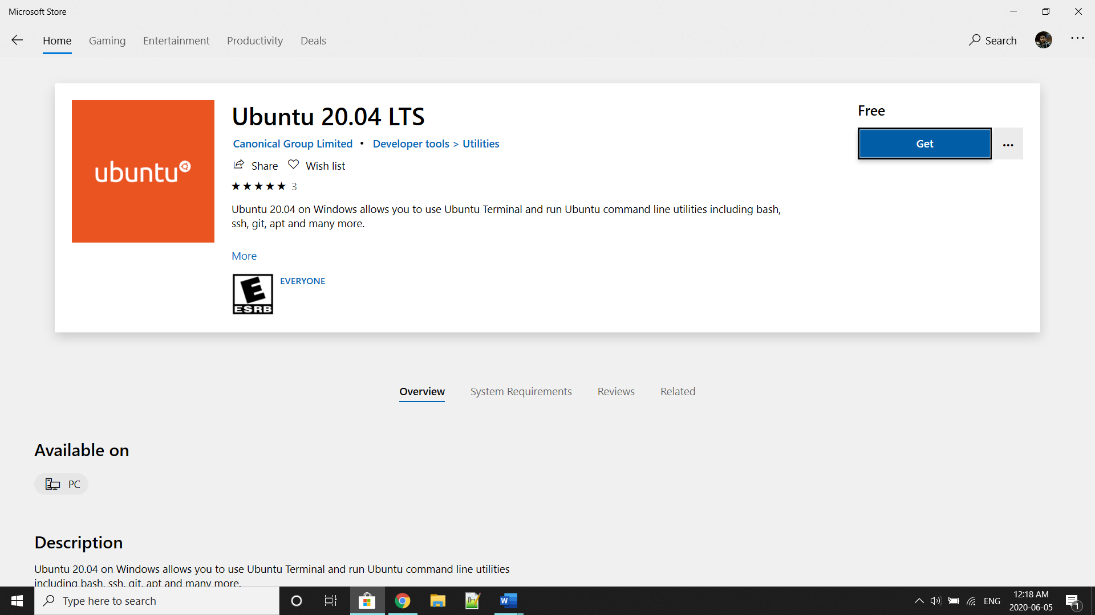

* **Launch Ubuntu on Windows 10**

When launched for the first time, Ubuntu will inform you that it is “Installing,” and you will need to wait a few moments.

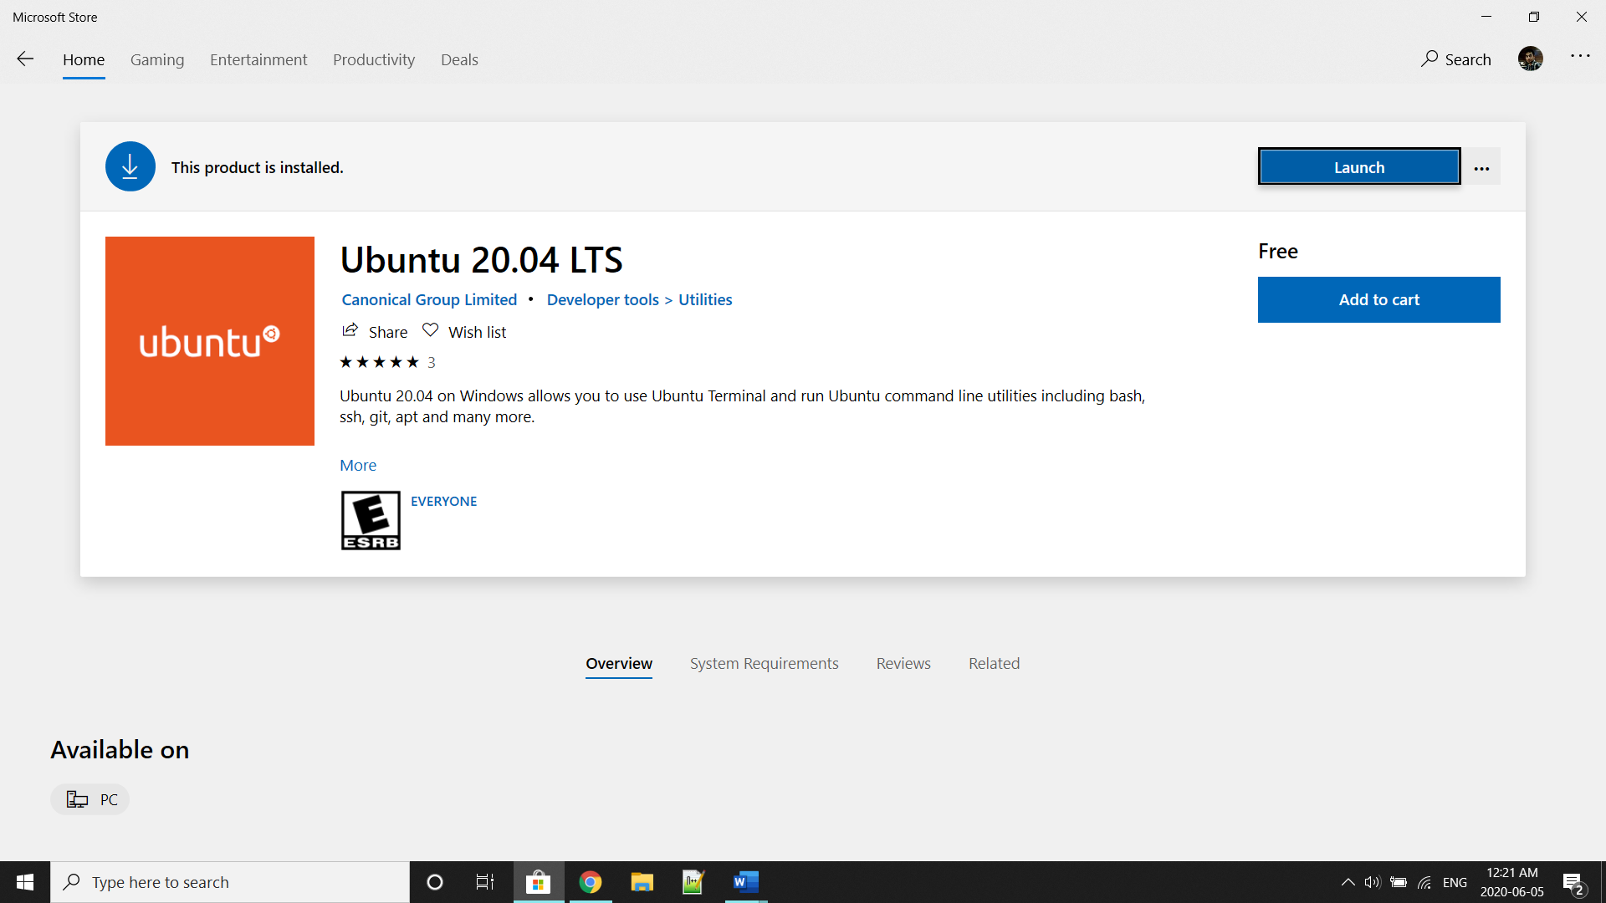

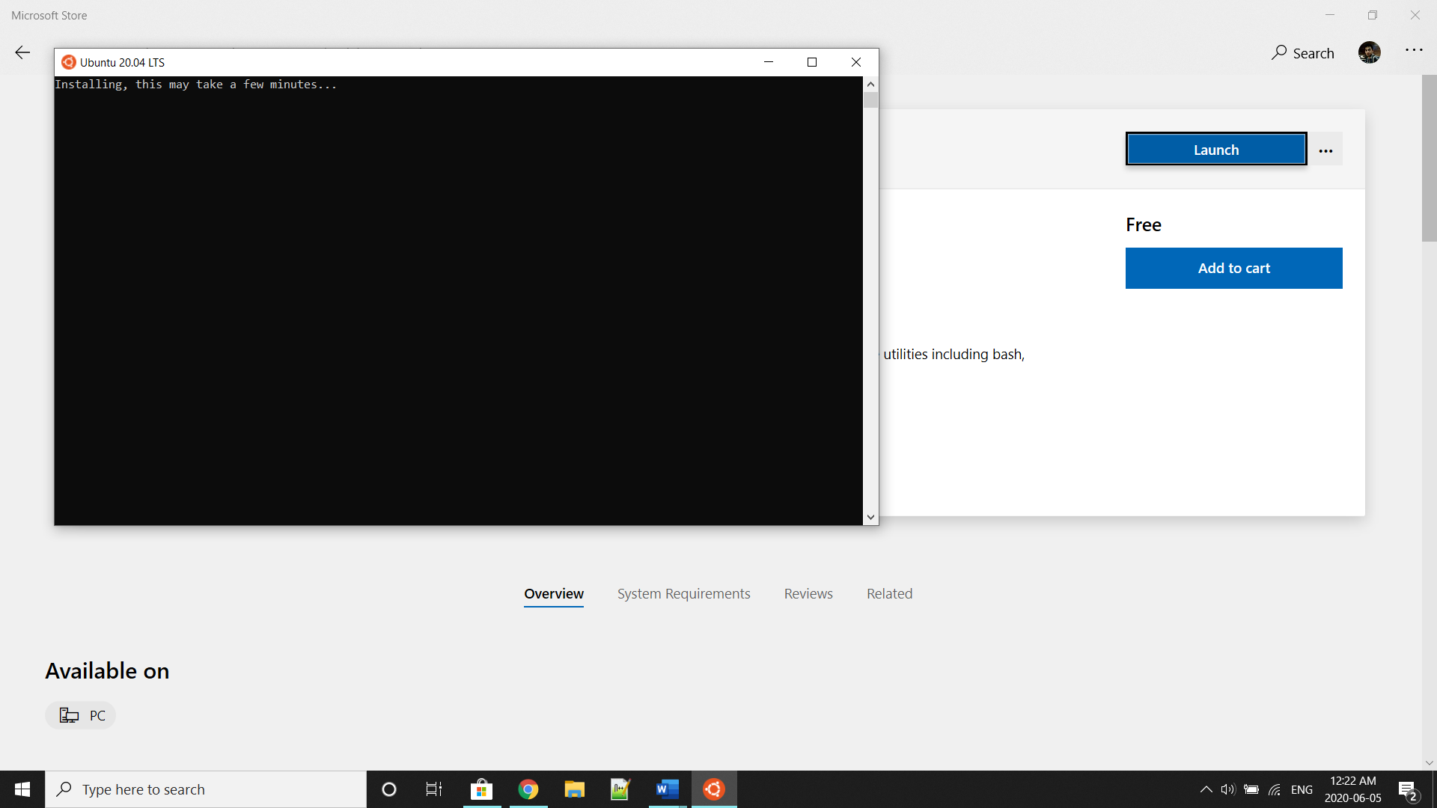

Later you will be asked for a username and password specific to your Ubuntu installation. These do not need to be the same as your Windows 10 credentials. With this step complete, you will find yourself at the Ubuntu bash command line.

Later you can right-click on the Terminal to change the properties such as you can change the font, color, etc.

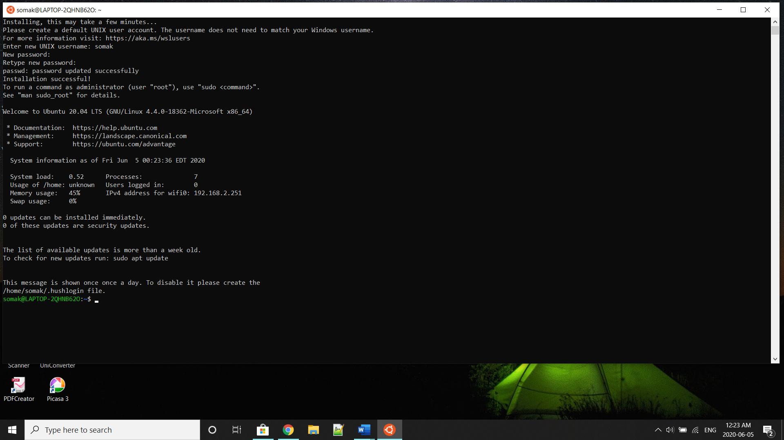

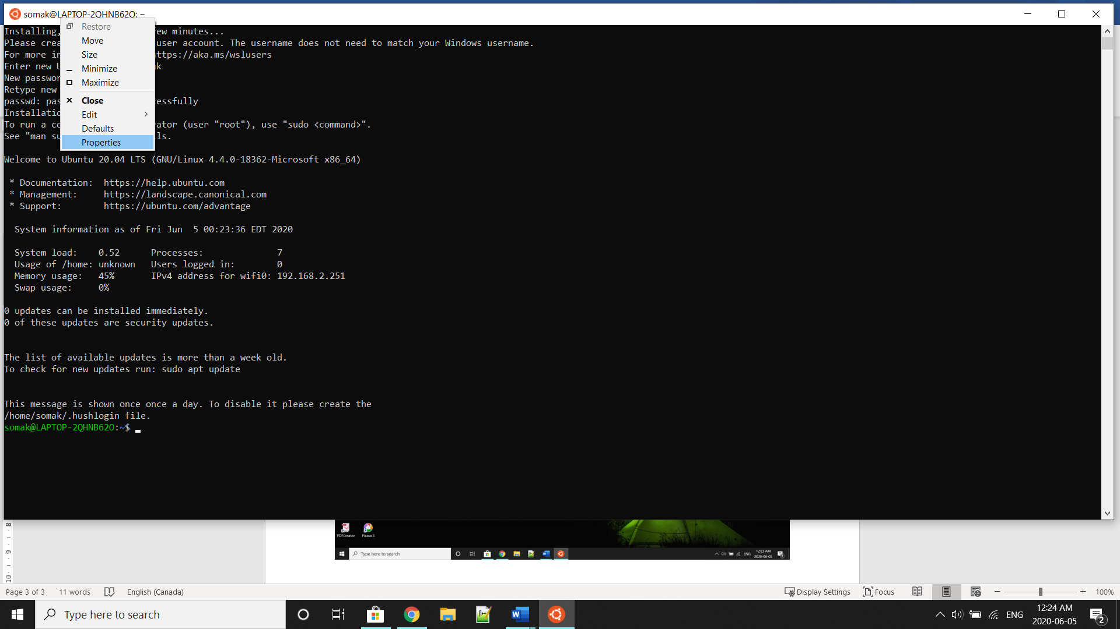

If you need some guidance getting started with the Ubuntu Terminal, then please visit the [Ubuntu](https://ubuntu.com/tutorials/tutorial-ubuntu-on-windows#1-overview) website.