**B649 Cloud Computing Project 5 Report**

**HBase Inverted Indexing**

**Team Members: Yash Ketkar (**[**yketkar@indiana.edu**](mailto:yketkar@indiana.edu)**) | Neelam Tikone (**[**ntikone@indiana.edu**](mailto:ntikone@indiana.edu)**)**

The main **steps** in running this program are:

1. We first need to configure the working environment, start Hadoop and HBase, create HBase tables and load data into HBase.



1. Thus we have uploaded records with the iu.pti.hbaseapp.clueweb09.DataLoaderClueWeb09 from the clueWeb09DataTable. Then to run the HBaseInvertedIndexing program we use the following commands.



Updated Code:

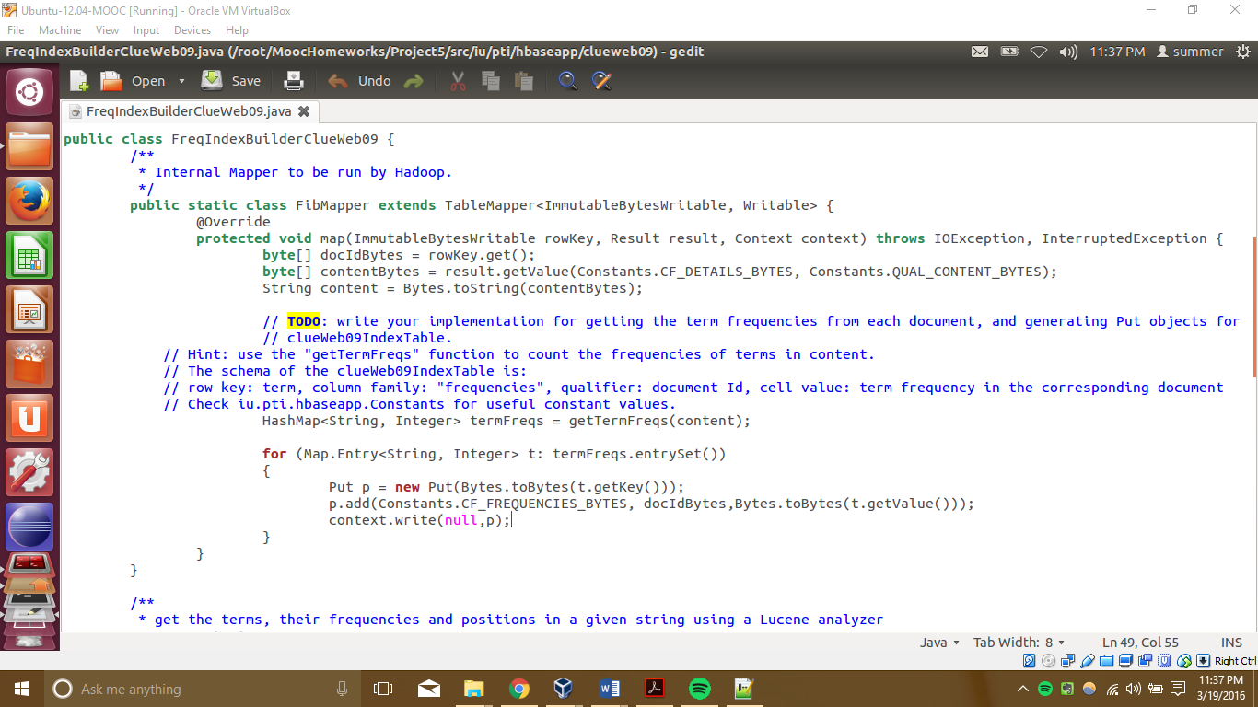

Output:

