Discover and Define

# Research

## ETS Safety Social Media Analysis

### PREPARE

#### Description of what you wish to do in your method

For the social media analysis, we will be focusing on collecting social media posts to see the public reception on the current safety of the system, and any problems they highlight.

#### Twitter posts.

##### How will you select these people or these documents (inclusion and exclusion criteria)?

Through the advanced search functionality hosted on twitter.

The search function string is;

(safe OR safety OR unsafe OR security OR Secure) (to:takeETSalert) lang:en until:2022-01-24 since:2021-01-01

##### How many people or documents?

69 twitter posts

### CONDUCT

#### If you don’t have participants, what are the steps you will do?

1: Understanding the expected usable data from the social media analysis.

* Step 1: Read “**Using Social Media for User Research**” <https://www.smashingmagazine.com/2017/03/using-social-media-user-research/>
* Step 2: Enter advanced search criteria onto the Twitter website, searching for all posts at takeETSalert.
* Step 3: Use “AwesomeScreenshot” google chrome plugin to take full screenshot of all twitter posts

2: Doing the research

* Step 1: Number each twitter post for ease of reference.
* Step 2: Add post number to a separate tally if the post is perceived to be negative, neutral or positive.
* Step 3: Add that posts directed topic(s) within the tally
* Step 4: Repeat until no more posts.

### ANALYZE

1. Look at your results and select 15-20 interesting elements (or more if relevant).
   1. Covid: No action taken against people not wearing their masks properly. Includes passengers and ETS employees.
   2. Drug use on LRT and at LRT stations, with no evidence of a response by ETS security to stop it.
   3. Homeless issue in downtown Edmonton adds to daily stress to commuters.
   4. The change in bus routes negatively impacted people's lives.
   5. Increase in rider prices makes taking the bus unaffordable.
   6. No way to use Transit Watch during a confrontation.
   7. No immediate feedback from using Transit Watch.
   8. People don’t feel like their voice is being heard.
   9. Illusion of security
   10. Security guards unable to handle physical altercations due to body-mass differences.
   11. LRT stations and bus terminals in a state of disrepair.
   12. Bike lock system is too easy for thieves to break into.
   13. No notifications if a harmful toxin is sprayed in a terminal/LRT station entrance (such as bear spray).
   14. Not-in-service buses congregating near transit stations are giving people mixed messages.
   15. Use of ticket booths involving paper and cash change is an outdated system.
   16. Pre-existing services at open LRT stations, like heating not being maintained or fixed quickly.
   17. Making complaints to ETS is not giving feedback to whether it has been heard, and restrictions will be put in place against dangerous riders.
   18. Security guards appearing to socialise on their phones when they should be working.
2. Organize them into these categories (you can create new categories if you need to):

* Phases of the service offered by ETS
* People
  1. ETS users (demographics, characteristics, emotions, etc)
     + Emotions
       - Unsafe
         * Riders feel that security guard was unable to affect the situation
       - Frustration
         * Security didn’t alert people to harmful toxin (bear spray) sprayed in area
         * Current service not working in situations it would be needed.
       - Transit watch app
  2. Other people involved with ETS
     + Community Outreach
       - Drug addicts
       - homeless people
     + Service Personnel
       - Security guards
       - Peace officers
       - Bus drivers
* Needs of users
  1. Better service
     + Existing services are ineffective
     + Affordable fair
  2. Visible Security / Staff
     + Visible security
     + Trained security
     + Better response time by security
     + “Have actual ETS security and not the private security services you have now”
  3. Communication
     + People feel unheard
     + People need to feel their is a dialogue with ETS
     + Need to feel that action is being taken
     + Better ways to contact in actual emergencies
  4. Covid
     + Follow covid restrictions
     + ETS employees follow covid restrictions
* Touchpoints/Channels (physical and digital) and devices
  1. Transit watch
  2. Security systems, ctv and alarms
* Interactions/tasks (what do users do)
* Potential safety issues for users in relation to ETS
  1. Public Opinion
     + ETS employees not dealing with problems
     + “Do the cameras work”
     + “Illusion of security”
  2. Security
     + Security ineffective in response time to resolve conflicting situations, and all information is asking to contact 911 instead of ETS services
  3. Community Outreach
     + Drug use on LRT
* Design opportunities
  1. Immediate feedback on transit watch app
  2. Create a feeling of communication with riders
  3. Move toward digital ticket purchases
     + More security around LRT station with pay gates to prevent people from abusing the current system.
  4. Parking couldn’t be found near workplace so LRT was the only option for transportation. Include more diverse methods of public transportation.

### DESIGN

1. Transit Watch mobile app for reporting
   1. Easy way to connect with transit watch instead of needing to remember the number
   2. Reporting system to allow calling TW or sending the report through text
   3. Text reporting would help user fill it out
      1. Date
         1. Option preselected today, also to pick another date
      2. Time
         1. autofilled to when report sent.
      3. Location
         1. Where is it? Bus, lrt, bus station, stop
      4. Type of crime
         1. Graffiti
            1. Can include taking a picture
         2. Harassment
            1. Include specifics
      5. Allow for comments included
      6. Give feedback message at every step, and depending on report, “we will be on it” or “help is on the way”
2. ETS app for user comments, giving ratings on how they felt on the ride.
   1. Forum based app so riders can post comments and questions with ETS staff.
3. Security drone on cctv camera giving immediate feedback and help during situations
4. Security given ability to stop altercations.
5. Lower ridership costs.
6. Have more security guards patrolling instead of 1-2.
7. Have security guards patrol at all bus stations and terminals.
8. Better notification system for when an altercation or anything considered a safety concern occurs.
9. Have better security systems for bike locks and lockers
10. Keep stations and terminals clean and repaired
11. Ensure Covid-19 guidelines are enforced everywhere (wearing a mask in public spaces) and if people refuse, do not service them.
12. Change ticket purchase to app based with many deals, favouring consistent riders.
13. LRT expands across city to all locations where recent bus route changes negatively impacted riders.
14. Expand LRT to West Edmonton Mall.
15. Have started work on LRT system in 1980s, most of track infrastructure would be built already and have connected the city.

## Comparative Analysis

### PREPARE

#### Goal and sub-goals

The main goal of this research is to gather the information that will help create a solution to improve the safety of riders on the Edmonton Public Transit System. My secondary goal for this research is to also improve ridership numbers which will also have a positive impact on perceived safety and security on the ETS

#### Description of what you wish to do in your method

I intend to compile and compare the safety and convenience technology available to the patrons of public transportation systems around the world using a spreadsheet. The spreadsheet will be separated into categories, such as; bus, train, station/terminal, other services for easy comparison and analysis. Images may be used if relevant.

#### Who?

The main documents I will be looking at are:

* Organization Reports (safety, future planning, year-end,)
* Organization Websites
* Articles—Press Releases
* Images — (google search/ images within previously mentioned material)

#### How will you select these people or these documents (inclusion and exclusion criteria)?

1. Documentation should be directly obtained from the organization's website or be created by the organization (pdf-report/ press release).
2. Some information may come from blogs or first hand accounts of using the services.
3. Information should not be over 5 years old.
4. Most information will be searched through — Google / Google Scholar / MacEwan Library / Organization Website

#### How many people or documents?

At least 5 cities

-3 documents each unless the Official website provides sufficient information

#### List of documents, people, posts or places you have selected

* Edmonton
* Vancouver
* Seoul
* Singapore
* Madrid
* London
* Montreal

## 

#### What?

### What are you going to ask them? What activity are you going to do with them? What are you going to look at in the documents? Include here the link to your questionnaire, your spreadsheet, your criteria, observation plan, and tables, etc. Include in each your criteria for analysis.

### CONDUCT

1: Compile a spreadsheet with a list of ETS services and products

* Step 1: Scrub ETS documentation, website, and presentation information
* Step 2: Compile list of ETS services based on Step one findings
* Step 3: Compile documents and websites for other cities

2: Doing the research

* Step 1: Compile documents and websites for 4 other cities
* Step 2: Add services not featured in Edmonton found in documents and websites
* Step 3: Add more cites if date is lacking or feels thin
* Step 4: Analzye the findings
* Step 5: Create visuals
* Step 6: Compare results against Social Media analysis

### ANALYZE

1. Taxi Service
2. Car Rental
3. Bike Rental
4. Bike Lane Patrol
5. Fare Discounts / Reductions
6. Short Customized Bus Routes during Rush hour
7. E scooter
8. 1st party Navigation and information App
9. Contactless Payment methods
10. Free Wifi
11. Cell Service
12. Emergency Center
13. Station Staff
14. Fare Barriers
15. Designated Waiting Areas

## **Categories**

* Phases of the service offered by ETS
  1. Taxi Service
  2. Car Rental
  3. Bike Rental
  4. E scooter
* People
  1. ETS users (demographics, characteristics, emotions, etc)
  2. Other people involved with ETS
     + Bike Lane Patrol
* Needs of users
  1. Fare Discounts / Reductions
  2. Short Customized Bus Routes during Rush hour
* Touchpoints/Channels (physical and digital) and devices
  1. Contactless Payment methods
  2. 1st party Navigation and information App
  3. Free Wifi
  4. Fare Barriers
* Interactions/tasks (what do users do)
  1. Designated Waiting Areas
* Potential safety issues for users in relation to ETS
  1. Cell Service
* Design opportunities
  1. Emergency Center

### DESIGN

Emergency Centers

* Update the emergency buttons (channels) and create a help station for riders to access that is visible
  + Fire
  + Phone
  + Overdose Kits
  + Defibulator

Specialized waiting areas

* Introduce designated waiting areas for more vulnerable riders

Specialized routes

* Budget or cheaper alternative routes for riders
* Community buses that focus on getting member to specific areas in the city
* Transit specifically for certain groups
  + Women
  + Getting groceries / activities
  + Late night busses 

More barriers for potential bad actors

* Fair gates or check points
* Doors only accessible to pass holders

Rider rewards / variable fare

* Points system with free rides
* Discount rides at certain hours

**Reading worksheet**

## Ryley Goodine

### **Source 1**: Bruce Schneier: The security mirage <https://www.ted.com/talks/bruce_schneier_the_security_mirage>

“security is two different things, it's a feeling and a reality”

“security from economic terms, it’s a trade-off of something; money, time, convenience, capabilities, fundamental liberties”

“species of storytellers, we respond more to stories than data”

“No feeling about germs, you need a model to understand them.”

“If our feelings match reality, we make better security trade-offs.”

* Four risk biases that appear frequently
  + tend to exaggerate spectacular and rare risks and downplay common risks
  + the unknown is perceived to be riskier than the familiar
  + personified risks are perceived to be greater than anonymous risks
  + People underestimate risks in situations they do control and overestimate them in situations they don't control.
* Availability heuristic
  + We estimate the probability of something by how easy it is to bring instances of it to mind.
* Feeling, model, reality; feeling and model in our head, reality is real
  + feeling = intuition
  + model = reason
* Different models based on different experiences
* models are hard to change
* Confirmation bias
  + accept data that confirms our beliefs
  + reject data that contradicts our beliefs

### **Source 2**: Applying digital to everything - Janet Hughes <https://www.youtube.com/watch?v=wy8jgRLej0U>

“All about everything, not just websites.”

“point of digital is to change everything”

“Revolution, not evolution”

“Don’t make little changes on necessary areas, make large change on everything”

* 4 stages of digital government
  + pre-digital = social media
  + rationalize = improved content, all in one place, make forms work better for people, doing things more efficiently, “simple, clearer, faster”
  + integrate = coherent, end-to-end digital services, doing things differently
  + reboot = doing different things
* What organizations need to be like in digital age
  + fast
  + open
  + diverse
  + responsive
  + experimental
  + results-orientated
* Include users all the way in design process, through government
* Large disconnect between policy makers and service people
* We know who all our users are and meet their needs
  + all = discover full range of all our users
* Users
  + have to use our services
  + directly affected by our work
  + interact with us
  + Stakeholders are not users
  + Ministers are not users
* 6 user centred practices
  + define the outcome
    - define the outcome from the point of view of your users
    - (Not as a vague statement of overall intent)
      * ~~drive forward an ambitious social mobility agenda~~
      * make it easier for unemployed young people to get a good job
      * fewer unemployed young people
    - gov tends to focus on inputs and outputs and misses the process and outcome
    - inputs -> process -> outputs -> outcome
  + understand users
    - start with user needs
      * ven diagram of:
        + practical needs

“I am a human, not a set of user needs”

* + - * + emotional needs

most have the emotion of being worried

* + - * + service-specific needs
    - what is already known?
    - what else do we need to know?
    - whats the quickest and easiest way to find out?
    - (there aren’t really any new problems)
  + test assumptions
    - “94.3% of policy failure happens because of untested assumptions”
    - individual learner accounts: untested assumptions and failed delivery
  + involve users
    - not bat shit crazy ideas
    - ask users about the problem
  + observe actual behaviour
  + deliver, test, learn, adapt
    - were used to learning, iterating and adapting digital services. Can these practices apply in other things
    - building schools example

**Source 3-7**: ETS Safety and Security

**Source 3**: <https://www.edmonton.ca/ets/safety-and-security>

* “We want everyone to feel safe every time they board a bus or train. ETS takes a multi-layered approach to safety and security, and staff in our Control Centre monitor transit service 24 hours a day, seven days a week. Your safety is our top priority.”
  + main mission goal, first thing people see on website, and what ETS is trying to communicate.
  + multilayered-approach
  + staff in control centre monitor “transit service” 24/7
* Reporting emergencies;
  + immediate assistance - call 911
  + transit watch app
    - different from immediate assistance
    - two ways to contact through cel, call or text
  + 3 specific ways to contact for vandalism listed
    - edmonton police
    - transit watch - a bit redundant
    - crime stoppers
* transit peace officers
  + different from peace officers
  + connected with control centre
  + respond with police officer and security
* community outreach transit teams
  + work with outreach workers and community agencies
  + help refer individuals on ETS property to specialized community support and services
    - financial
    - housing
    - mental health
    - substance use
* Additional security features
  + emergency phone & button
    - blue phone
      * in all LRT stations, some bus stations (not listed) and some city pedways.
      * press button on phone to IMMEDIATELY connect with ETS security personnel.
      * when phone in use, CCTV monitor and record.
      * specific mention of difference with black information phones connect with 311
    - wall-mounted red emergency button
      * located in downtown core; Winspear Centre, the Winspear pedway, the Edmonton City Centre pedway and the Westin Hotel pedway.
      * push button will connect with security and CCTV records area.
    - Legal note for collection of recorded images using ETS security cameras
  + alert system on lrt
    - let LRT Operator know if urgent or emergency situation on LRT, or you feel unsafe.
    - Yellow passenger alarm
      * in LRT car
      * press red button to activate
    - red alarm handles
      * in LRT car above alternate doors
      * pull down to activate
    - red emergency button
      * in LRT car next to door button
  + closed circuit television (camera)
    - ETS security personnel closely monitor surveillance camera
    - cameras installed
      * all buses
      * all LRT cars
      * all LRT stations
      * major transit centres
        + which ones?
      * some city pedways
        + not many then
    - When someone uses “blue phone” or “red wall button”, camera automatically monitors area, security personnel then connect with person in need of help
    - Legal note for security surveillance equipment.
* Transit Watch Program
  + Every ETS rider deserves to feel safe when riding transit. Our Transit Watch program is one way customers can report **safety concerns**;
    - harassment
    - disorder
    - suspicious behaviour
  + directly to ETS staff in our Control Centre.
  + Call or text Transit Watch at 780-442-4900, anytime.
  + **For emergencies**, immediately call 9-1-1.
    - transit watch only useable for safety concerns, not “emergency situations”
  + Drown-down options
    - “How do I report a safety concern?”
      * text message
        + discreetly report safety concerns to staff anytime of day, if emergency use 911
        + provide detail in text message

are you on a bus? which bus? Are you on a train? What LRT station is coming up next? What is the situation?

more information on kinds of details should be included.

* + - * + text message will be received by ETS staff in control centre, they will respond to you as quick as possible.

do you receive a text message back saying your text was received?

* + - * phone
        + similar as text
        + recommended to use a blue phone, and be a safe distance away; “300ft”
        + do not confront suspicious people or touch suspicious objects, packages, or substances.

should this be seperate from info how to report to ETS.

* + - “When should i text when should i call 911”
      * what is the difference between harassment, disorder, suspicious behaviour and an emergency situation.
      * mention to use 311 for general information, route schedules.
        + possible misuse of service initially.
    - “If i send a text, will it cost me money on phone bill?”
      * yes: feeling im getting from it:“look at your phone plan dumbass”
    - “can i send photos or video clips via text”
      * no. we are looking to in the future
        + possible way to include phone and video for future ideas.
    - “how fast is text response? who is responding”
      * staff monitor text line around the clock
      * confirmation text should be sent back in 1-2 minutes
      * if multiple texts, prioritize and dispatch resources
      * depending of nature of concern, can take ETS security several minutes to be on location
      * if emergency use 911
    - “what if person texting is a minor. will there be different response”
      * anyone can report safety concern regardless of age
      * “If the concern involves a minor, staff will ask questions to determine the appropriate resource to deploy. Reports should include location, nature of concern along with any other relative details which may assist (location, bus number, direction of travel or next station if on the LRT, description of people involved, and so on).”
        + facet of focus - filled out responses for quick reporting
    - “does the text message service work when their is no cell service”
      * specifying on LRT while underground cell service is spotty.
      * use help buttons on LRT instead.

### **Source 4**: <https://www.edmonton.ca/ets/safety-security-personnel-support-staff>

* Transit peace officers
  + patrol at ETS service locations; bus, LRT, station
* transit security dispatchers
  + work in control centre
* security guards
  + wear visible jackets while patrol on shift
  + generally only two security guards
  + they observe and report
* transit inspectors
  + work in control centre and patrol on foot
* lrt inspectors
  + ensure LRT working on time
* road superintendents
  + interact with all facets
* reporting safety concerns
  + text message - transit watch
  + help options on LRT - connect to LRT driver
  + phone - transit watch, blue phones
  + uniformed person - bus/LRT operator, uniformed ETS personnel, law enforcement

### **Source 5**: <https://www.edmonton.ca/ets/safety-security-tips>

* report to bus or train operator, other uniformed ETS personnel, law enforcement, or text & call transit watch.
* Listed tips
  + In the event of an emergency situation while travelling on ETS, remain calm and listen carefully to announcements and follow instructions
  + Familiarize yourself with the location of emergency exits on buses and LRT trains
  + Do not prevent bus or train doors from closing
* Escalator safety on LRT stations
  + Escalators are common throughout the LRT system and it’s important to use them safely.
  + If you are travelling with mobility aids, strollers, bicycles, baggage and other devices, you should use an elevator instead for your safety and for the safety of others. These items can also cause damage to the escalator.
  + Watch how you step on and off the escalator. Untied shoelaces, loose clothing or bags can get caught in the moving parts and an unplanned step could lead to a fall. Stay aware of your location and be ready to step on and step off at the top.
  + Please keep to the right so others can use the left side to pass. When you leave the escalator, please move out of the way so that others behind you can get off quickly and easily.
* Safe around LRT doors
  + Doors are unlocked once the train has come to a complete stop. The train cannot move again until all doors are closed and locked. Please do not block the doors or prevent them from closing.
  + Although the doors are locked and unlocked by the operator, you control when the doors open by pushing the door buttons inside or outside the vehicle.
  + On some LRT cars, doors open to the inside. Stand back to allow the doors to open.
  + A chime sounds when the doors are locked by the operator. This is also a warning that the train is about to move. The door buttons are no longer active once the operator has locked the doors. If a door is open when the chime sounds, it cannot be held open by pressing the door button.
* LRT crossing warning bells
  + Warning bells can be noisy but they are necessary to alert motorists, pedestrians, and cyclists that trains are approaching the crossing. To balance the need for safety and reduce the impact to surrounding residential communities, the City has reduced the loudness of the crossing bells by:
  + Directing the sound toward the intersection
  + Reducing the number of bells that ring at each crossing
* gate controls at above ground LRT stations
  + Once the LRT gates have been activated and the arms start to go down (Belvedere, Stadium, Health Sciences/Jubilee Station, McKernan-Belgravia, South Campus, Southgate, Century Park), for safety reasons, the LRT operator will not reopen doors for the public to board.
  + When boarding or leaving the train, make sure anyone travelling with you and your belongings are on the same side of the door as you.
* Safety on Buses
  + Stop Request
    - Stop Request is a program that allows passengers to get off a bus at a safe location other than a bus stop along the route. The program is an added measure of convenience and safety for bus passengers especially during winter. It is in effect daily after 6pm. You must let the Operator know directly (do not ring the bell) at least one stop in advance of where you wish to get off. Exit by the front door once the Operator is able to safely stop the bus.
    - Please note: The Stop Request program does not apply to ETS express or highway buses (Routes 15, 100, 540, 560, 561, 562, 580 and 747).
  + Retractable Bus Shield

### **Source 6**: <https://www.edmonton.ca/ets/TraXSafe>

* TraXSafe
  + Safety on LRT platform
  + Safety walking across LRT tracks
  + Safety driving across LRT tracks

### **Source 7**: <https://www.edmonton.ca/ets/safe-ride>

* Be Rail Safe
  + LRT safety awareness from Sep 20-26
* Transit Operators
  + specifically saying the train/bus is the operators “office”
  + be respectful
* Personal Safety
  + zero tolerance for harassment on transit.
  + This campaign helps Edmontonians become more aware of resources that provide security and emergency assistance, including how to report harassment on a bus, train, or at a transit centre or LRT station.
* Let’s Keep each other safe
  + Stop Request
  + emergency options on train
  + reporting the situation
* Sexual Harassment
  + only shows posters saying its not okay

**Source 8**: Social Media Analysis: **Using Social Media for User Research**  
<https://www.smashingmagazine.com/2017/03/using-social-media-user-research/>

* Social media is often ignored in favour of more controlled resource options in the commercial sector.
* In the academic sector it is seen as an interesting source of primary data, but it's mainly been addressed with quantitative research methods; visualising information flow and graphic peaks of activity. These aren’t as relevant in user research projects.
* “Social media platforms enable social listening. We can tap into the recent or “in the moment” experience of real issues in context, rather than asking people, for example, to recall experiences in a face-to-face interview that takes place a week afterwards. It is particularly well suited to researching instances of mundane, everyday activities (such as smartphone habits) that would otherwise be poorly remembered and inaccessible to the researcher in the lab or to popular services that have already been launched. And when we tap in, we get data in the users’ language, not the language of the researcher. This amounts to research gold, and all we need is to get a pan and jump into the river.”
* Tracking multiple keywords across multiple posts (advanced search)
* Main 4 steps.
  + Define keywords to monitor
    - Setting up search queries. These depend on accounts, phrases and hashtags
  + Choose a tool
    - Selecting a tool that searches through the posts matching the queries. For Twitter it has a built-in advanced search that performed this function well.
  + Gather data
    - Saving it into a file with screenshots or pdf posts.
  + Analyse for insight
    - Ask what this posts really means, and annotating it with additional words. Tagging it for later search use, and grouping similar data.
* Helps show what the user needs and wants.
* When a service already exists, or the project has the purpose of redesigning the service, social media analysis can be used. Prototypes and unreleased projects are not well suited for social media analysis.

**Source 9**: Research Repositories for Tracking UX Research and Growing Your ResearchOps <https://www.nngroup.com/articles/research-repositories/>

* Organise user research in a research repository.
  + Shared collection of UX related research which should:
    - Grow UX awareness and participation in UX work among leadership, product owners, and organization at large.
    - support UX research work, so UX professionals may be more productive as they plan and track research
* 2 main findings in the research repo
  + Input
    - Information for planning and conducting research
  + Output
    - Study findings and reports
* Important parts of the research repo
  + Infrastructure
    - Research team mission and vision
    - Description of research methods
    - Tools and templates for conducting and analysing research
  + Research planning
    - Strategic research plans
    - Schedules
    - Detailed research plans
    - Research requests
  + Data and insights
    - Research report
    - Research insight
    - Recording and transcriptions
    - Raw notes and artifacts
  + Not always in research repo
    - Ux-data analysis
    - Participant repo or panel
* Convenience in the repo
  + Supporting tags and keywords metadata
  + Searchable by keyword
  + Hosted in a tool people can easily access
  + Portable
* “Research repositories store and organize information about UX research. They collect not only methodology-related documents, but also research results at various levels of granularity (from individual findings to reports). Their purpose is to streamline the work of the research team and also to make research widely available and easy to consume throughout the organization.”

### **Source 10**: UX Research Cheat Sheet <https://www.nngroup.com/articles/ux-research-cheat-sheet/>

* Start UX research at any stage of the project
* Continue working on UX research throughout the project, focus most at the start, and have enough time during the final product.
* Discover, Explore, Test, Listen diagram.
* Focused Activities
* Guide on utilizing user experience research in a project
* Main topics discussed

### **Source 11**: Ethnography in UX <https://www.nngroup.com/videos/ethnography-ux/>

* “The most important thing to know and celebrate about ethnography in UX is the importance of empathy.”
* “Crucial at early stages” and helps acknowledge our biases and assumptions.
* 5 steps of rapid ethnography
  + Reframe the problem
    - Understand from user perspective
  + Collect data
    - Break down user perspective into further questions about experience with service. Help with observation and interviews.
  + Find patterns
    - Identify root of user behaviour, weight common value, and see if common themes emerge
  + Formulate key insights
    - Look for false assumptions
    - Address unmet needs
    - Understand why people do people things
  + Apply key insights to service
    - Insights tie back to service objectives
    - Inform change
    - Opportunities for improvement

**Source 12**: How to Collaborate with Stakeholders in UX Research <https://www.nngroup.com/articles/collaborating-stakeholders/>

* Getting the people who have the power to approve, or disapprove any potential solutions the research team comes up with.
* Constant communication with all members so they experience and understand UX research, and the benefits it brings.

**Source 13**: Interpreting Contradictory UX Research Findings <https://www.nngroup.com/articles/interpreting-research-findings/>

* Check methodology
* Interpret findings based on not only what users say, but why
  + Perceived usability can be different from objective usability.
  + People don't like change.

## Analyze

1. Source 11: “5 steps of rapid ethnography”
   1. Look at the problem from a different perspective, collect data to find patterns and form key insights, which will show potential solutions to the problem.
   2. This is a way to perform UX research.
2. Source 12: “Constant communication with all members so they experience and understand UX research, and the benefits it brings.”
   1. Involving decision makers and people interacting with users in the UX process which helps ensure possible situations when a solution involves something a bus driver would do.
3. Source 1: “security is two different things, it's a feeling and a reality”
   1. Two main facets to consider when looking at all the research and considering possible solutions.
   2. Does the solution provide/enhance actual security, or the feeling of security.
   3. Can we find a potential solution that does both.
4. Source 2: “94.3% of policy failure happens because of untested assumptions”
   1. Make sure during research to identify any assumptions made, and have tests ready for them.
5. Source 3: “Every ETS rider deserves to feel safe when riding transit. Our Transit Watch program is one way customers can report **safety concerns**;”
   1. How to tell which situations a rider would contact Transit Watch, and when they would call 911 for emergency. Provide examples.
6. Source 5: “Escalator safety on LRT stations”
   1. Why is this even here, most people know what to do and what not to do around elevators.
   2. Prioritising information space on safety page
7. Source 5: “Safe around LRT doors”
   1. The below text gives a detailed description of what to do, and what not to do and why around the LRT doors.
   2. This level of detail could be applied to security measures and processes.

## Design

Write or sketch 5-10 ideas or design solutions that arose from these readings.

1. Transit Watch app could be developed into an actual mobile app.
2. Increase the variety of security features.
3. Include an increased level of detail describing security measures with examples on the website.
4. Be aware of assumptions made about riders and other ETS services.
5. Remove unnecessary level of detail about elevator safety and LRT interactions for more information about security measures.
6. Give detailed information, with pictures, about the types of situations that Transit Watch can deal with, and what should be going to 911.
7. Include more digital based infrastructure in the ETS system.

# Brett Johnson

## **Source 1: The Security Mirage**

Schneier, B. (2010, October). The security mirage. TED. Retrieved February 24, 2022, from https://www.ted.com/talks/bruce_schneier_the_security_mirage

### **Quote**

“People respond to the feeling, not reality.”

“Exaggerate spectacular and rare risks, and downplay common risks.”

“If our feelings match our realities we make better security trade offs”

### **Interesting Elements / Images**

* We as designers have a choice when coming up with solutions around security or safety— to design for “security theater” or implement an actual solution.
  + Feelings are easier to appeal to but dont align with reality.
* Models allow us to see throught the cognitive bias brought about by outside factors such as culture or religion.
* There is a sort of tug or war, when it comes to models vs feelings vs reality.
  + Feelings seems to be the main contributing factor when it comes to risk assessment and trade-offs.

## **Source 2: ETS—Website.**

Transit (ETS). (n.d.). City of Edmonton. Retrieved February 24, 2022, from https://www.edmonton.ca/edmonton-transit-system-ets

### **Quote**

“[In] collaboration with community partners, takes a multi-layered approach to safety and security on transit.”

“Every ETS rider deserves to feel safe when riding transit. Our Transit Watch program is one way customers can report safety concerns, like harassment, disorder or suspicious behaviour, directly to ETS staff in our Control Centre.”

“Edmontonians take pride in looking out for one another and understand that by working together, we can maintain a safe and welcoming transit environment.”

### **Interesting Elements / Images**

* Focus on more community involvement to help solve some of the ongoing issues surrounding drugs and crime on the ETS
* There is a lot of information for the user on the safety and security services and devices ETS offers.
  + Do people use the website for more that just trip finding?
  + 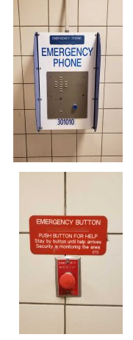 ETS services look outdated
* There are many phone numbers throughout the websites foe different services the user can access.
  + this is a bit overwhelming and confusing as to which service to call for which problem?
  + 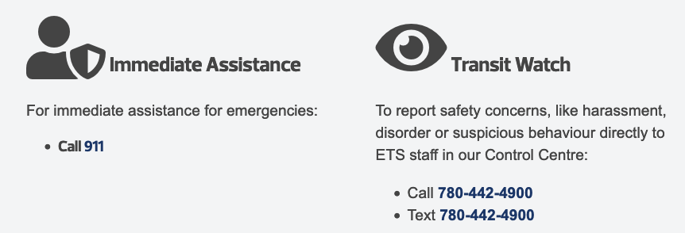
    - immediate Assistance? — don’t I always want to feel that I will be serviced immediately?

## 

## 

## 

## **Source 3: Applying Digital to Everything.**

Hughes, J. (2019, July 19). *Applying digital to everything - Janet Hughes [Camp Digital 2019]*. YouTube. Retrieved February 25, 2022, from https://www.youtube.com/watch?v=wy8jgRLej0U

### **Quote**

“How are we going to make it normal and universal … for people to put users at the heart of everything they do?.”

“No body hear is just a collection of user needs, … at any given time, you have a context, … a backstory ”

“What are the assumptions that news to be true for [the] process to actually happen?”

### **Interesting Elements / Images**

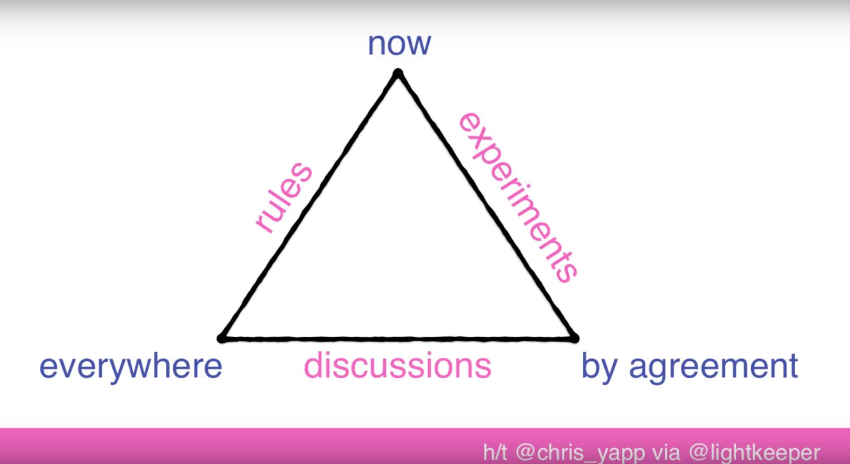

* Implementing a more user focused solution, through understanding of the meaning, process, and, outcome.

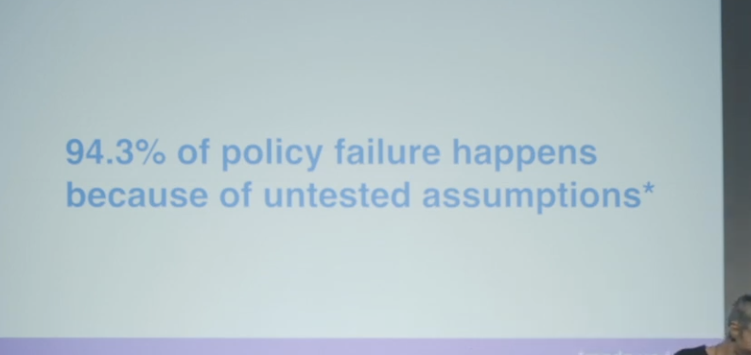

* interesting research method to count the number of assumptions you make for the user to successfully use the service /product.
  + How many assumptions (steps) does it take to make a user feel safe?
    - How do they change when the environments change.

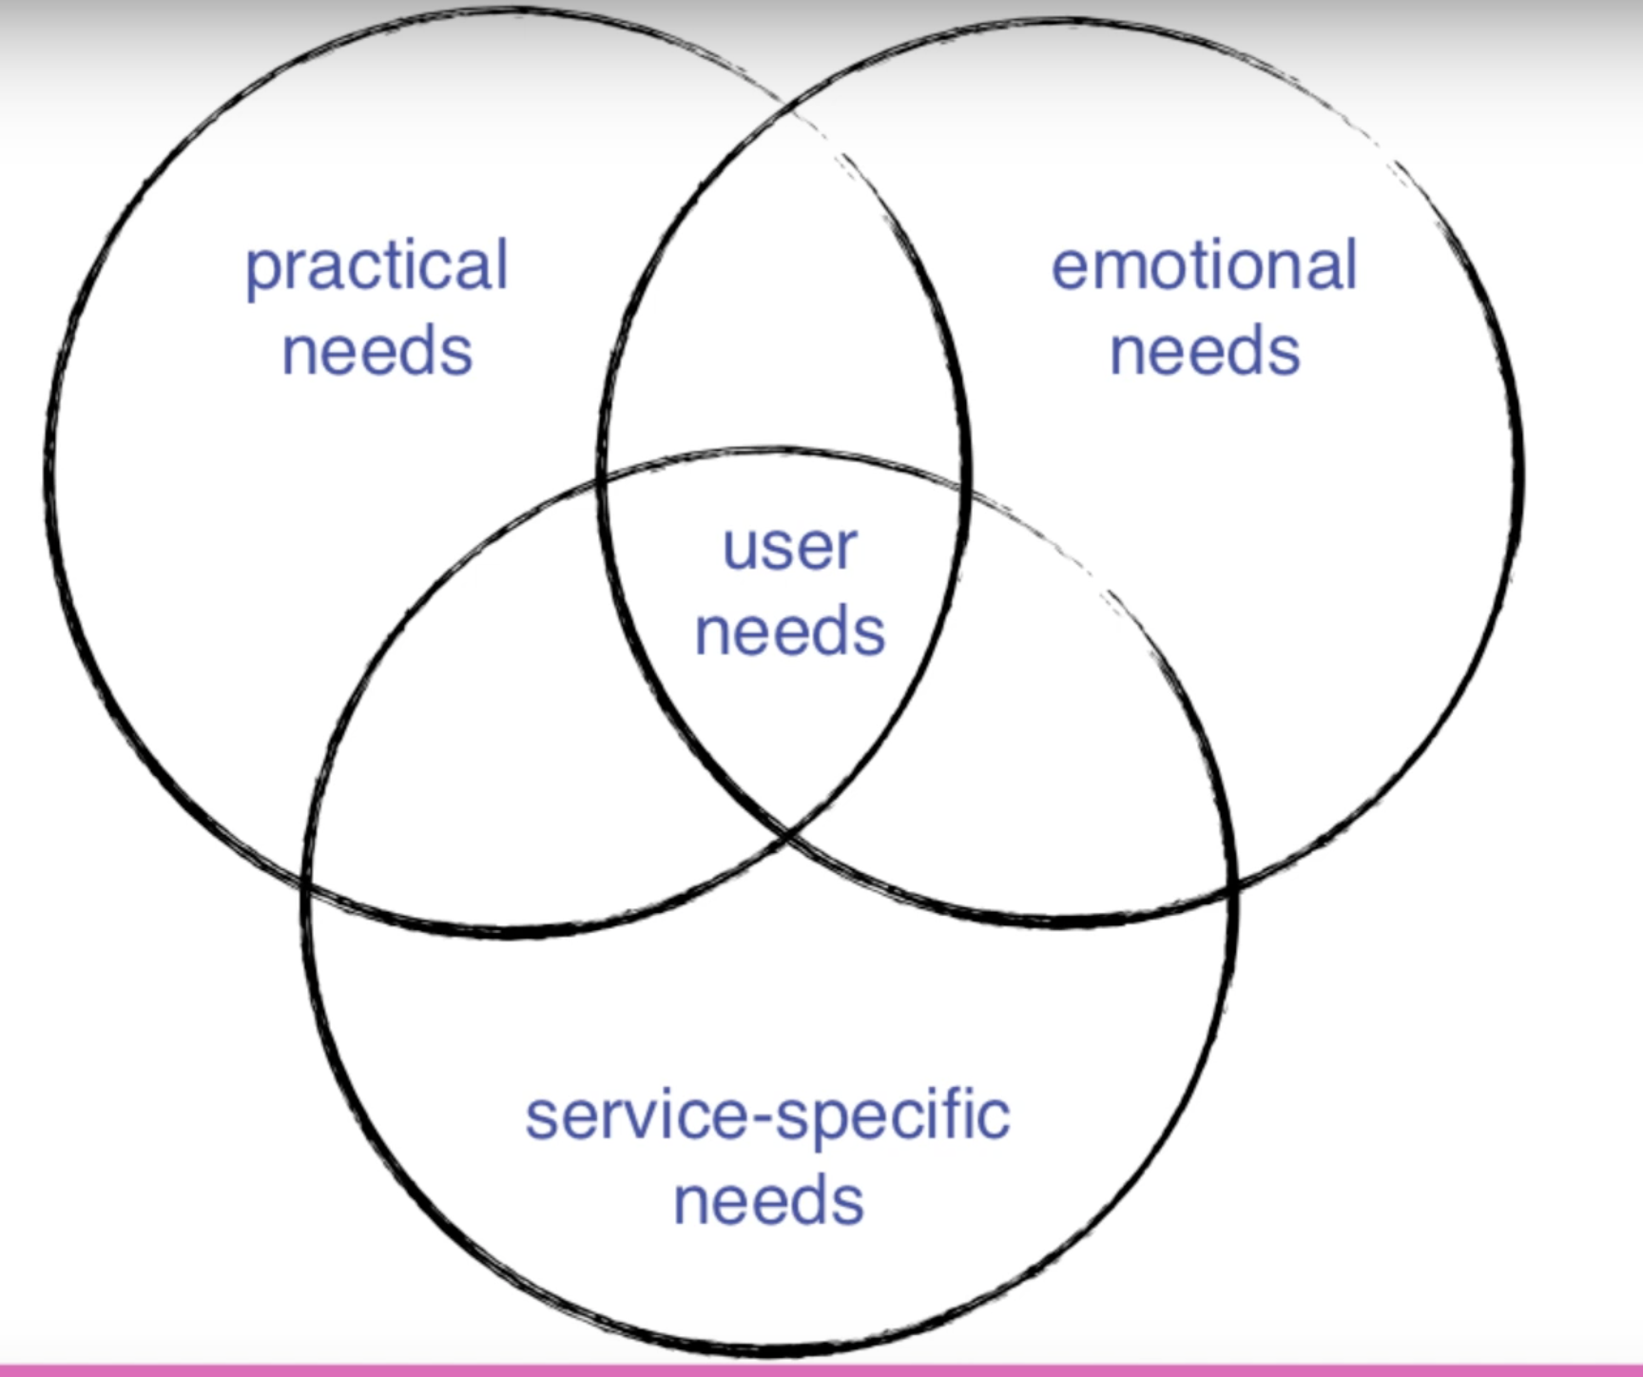

* Users needs can be more complex and broken into sub categories.
  + Safety — emotional needs
  + Security — practical needs
  + Convenience / Accessability — service specific needs

## 

## **Source 4-5: Comparative Analysis**

*Comparative analysis - Province of British Columbia*. (n.d.). Government of B.C. Retrieved February 24, 2022, from https://www2.gov.bc.ca/gov/content/governments/services-for-government/service-experience-digital-delivery/service-design/methods-and-tools/service-analysis/comparative-analysis

DaSilva, J. (2020, June 12). *A Guide to Competitive Analysis for UX Design | Adobe XD Ideas*. Adobe XD | Fast & Powerful UI/UX Design & Collaboration Tool. Retrieved February 24, 2022, from https://xd.adobe.com/ideas/process/user-research/guide-to-competitive-analysis-ux-de

### **Quotes**

“Don’t simply copy the designs... The competitors may not be using best practices. Instead, be inspired by the solutions… adapt the solutions to fit your brand, product, and users”

“what information you need in order to strategically inform your design solution.”

“competitive analysis will be imperative to grow your understanding of the basic features and functions. Understanding the landscape … helps inform your design decisions [and] helps inform the overall product strategy.”

### **Interesting Elements / Images**

* Comparative analysis can be very granular in when setting criteria, ( channels - audience, etc)
* The areas of opportunity to avoid can be identified in the analysis
* Comparative analysis is a great way to uncover the strengths and weaknesses of the compared item. It allows for a simple look into the item which identify points of interest.

## **Source 6: Womans Perception**

Chowdhury, S., & van Wee, B. (2020). Examining women's perception of safety during waiting times at public transport terminals. *Transport Policy*, *94*, 102-108. 10.1016/j.tranpol.2020.05.009

### **Quotes**

“Ethnic minority women were more likely to select “somewhat unsafe” and “not

safe at all” compared to Caucasian women.”

“ “I use my phone (e.g. talking on the phone) to feel safe while walking home at night”, almost half of the participants (49.47%) agreed with the statement.”

“feeling anxious while waiting... Around 87% of the women agreed with this statement, while no one strongly disagreeing”

### **Interesting Elements / Images**

* Wait times are a large contributing factor to anxiety in female riders.
  + this is when most incidients happen.
* Mobile devices give a sense of security to female riders
  + (Class discussion:) prepenting to use a phone as a deterrent.
* Family and friends are relieve more anxiety for female riders than security officers —although they do decrease crime overall.

# 

Questions asked in the study

# 

## **Source 7: Innovative Transport Solutions**

CIVITAS. (2014, October). INNOVATIVE URBAN TRANSPORT SOLUTIONS. Civitas.eu. Retrieved February 24, 2022, from https://civitas.eu/sites/default/files/civitas-plus-innovative-urban-transport-solutions-www-final.pdf

### **Quote**

“successful promotion of public transport is closely connected

with improving public perceptions of the safety and security of the public transport system”

“opinions held by members of the public and transport users… must be assessed in order to achieve greater acceptance and reach [and] better understanding of people’s travel patterns and how transport planning can make a positive change in travel behaviour.”

“Car sharing has proved to be a very effective and sustainable transport solution in urban areas. It targets people who have only the occasional need for a car and who do not want to own one.”

“There must also be a cultural shift that encourages city residents to actually choose and use sustainable mobility.”

### **Interesting Elements / Images**

* 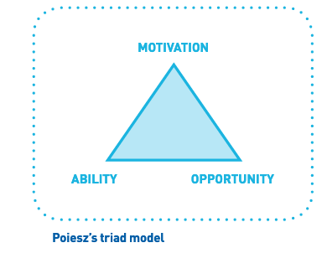
  + To change behavior in users we must present them with the ability, motivation, and opportunity to do so.
* More accecssablity to other modes of transportation are becoming a norm in EU countries and seeing success.
* 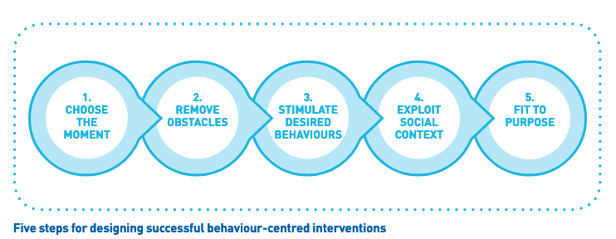

## 

## 

## **Source 8: Design Against Crime : A Human-Centred Approach to Designing for Safety and Security**

Davey, C. L., Wootton, A. B., & Press, M. P. (2017). Design against crime : A human-centred approach to designing for safety and security. Taylor & Francis Group.

### **Quotes**

“understanding these ‘causal factors’, and their relationship to offenders’ thinking and behaviour, designers can develop measures to counter them. [Devising] ways to reduce the risk of crime and antisocial behaviour without inconveniencing legitimate users”

“sometimes effective barriers can be simply psychological.”

“design measures are as much about manipulating an offender’s perception of the effort required as about adding countermeasures for the offender’s methods of attack.”

### **Interesting Elements / Images**

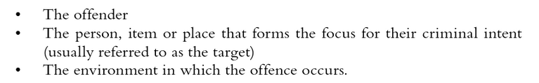

*Casual Factors*

* How can we create spaces that add a psychological barrier to the offereneder?
  + color?
  + sound
  + small physical features?
* Design solution should be created with minimal “rewards” for the offender.
  + Create something that isnt satisfying to see break / be vandalized
    - do the opposite and give spaces where vandalizatios such as graffiti is encouraged,
      * take away the sensationalization of the reward make it respectable in a new way.

## **Source 9: Design for safety: Design strategies to generate safe systems**

Leedeo Engineering. (2021, November 9). Design for safety: Design strategies to generate safe systems. Leedeo. Retrieved February 24, 2022, from https://www.leedeo.es/l/design-safety-strategies/

### **Quotes**

“Principle 2 . It is always necessary to start from learning the deficiencies of previous designs to avoid their recurrence.”

“intrinsic safety is one of the fundamental principles of the Design for Safety . It is characterized by being inherent, that is, belonging to the very nature of the product, system or installation.”

“Regarding design processes, conservatism advocates incremental product or design change to disruptive change and obviously prefers proven components over novel technologies and implementations.”

### **Interesting Elements / Images**

* The idea of intrinsic safety — having the user know the nature of the product is safe or increases safety.
  + Telling vs showing the user

# 

* + how can we eliminate the problem instead of managing it?
    - Does the product or service eliminate the issues or help in the elimination of the issue?
      * Homelessness and other societal issues may not be able to be solved by implementing solutions to tranist.

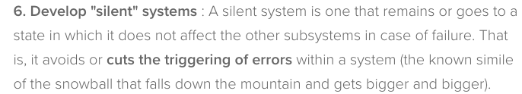

* ecosystem map could include silent systems
* Redundancy systems in the ETS
  + Mobile phones are a reliable redundancy system

## **Source 10: Safe Access Manual — India**

Shah, S. (2014). *Safe acceSS Manual*. WRI Ross Center for Sustainable Cities. Retrieved February 24, 2022, from https://wrirosscities.org/sites/default/files/Safe-Access-Manual-EMBARQ-India.pdf

### **Quotes**

“A station area is a place of connectivity where different

modes of transportation come together seamlessly and where work, live, shop and play can happen simultaneously.”

“Encourage mixed uses and discourage single land use zones”

### **Interesting Elements / Images**

* Evaluation of the implementation of the solutions is an interesting strategy to incorporate into the process. It could also be used as a research strategy when improving upon an existing solution.
  + 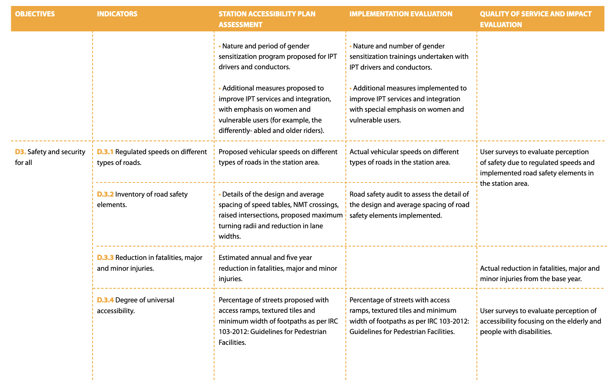
* Prioritizing certain modes of transport as the rider’s distance from a major station increases.
  + Edmonton is a sprawling city maybe there needs to be a repriortization of transit methods within certain neighborhoods.
  + 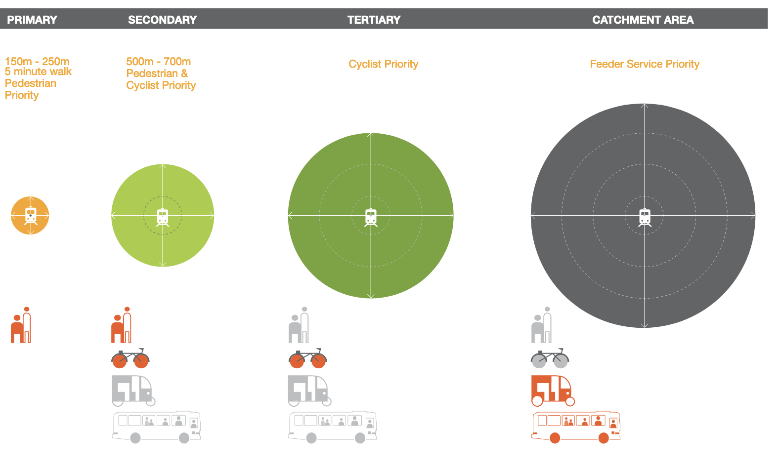
* Changing the road structure to make transit more accessible and faster than private cars by providing transit with its own separated lanes.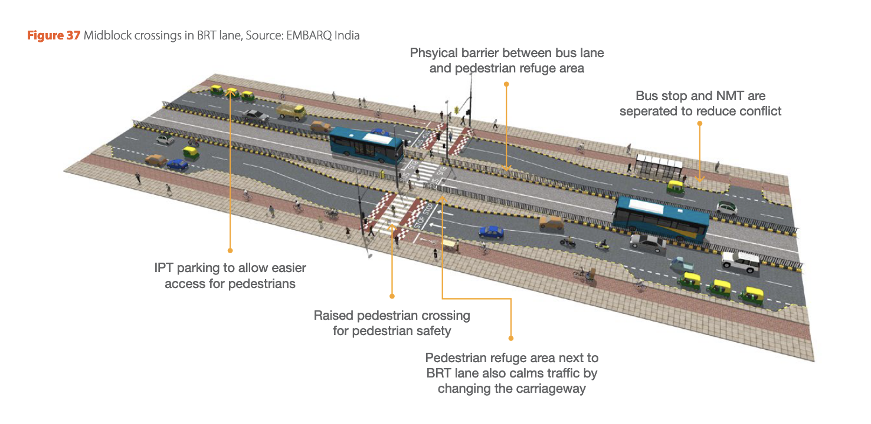

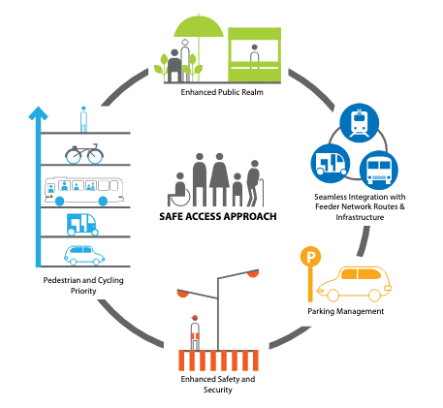

# 

# **Analyze**

## **Summary**

Community input, and a shift to more public transit-friendly city structure and focus are recurring themes throughout many of the readings. Designing for minority groups and women was another theme that was present throughout my readings, many of the proposed solutions involved well-lit areas and encouragement of others to help make riders feel safe.

It was interesting to see cities starting to design streets in a more public transit-friendly space. Changing people's perceptions by creating a city meant for public transportation.

## **Categories**

* Phases of the service offered by ETS
  + “feeling anxious while waiting... Around 87% of the women agreed with this statement, while no one strongly disagreeing” S6-Q3
* People
  + ETS users (demographics, characteristics, emotions, etc.)
    - “Exaggerate spectacular and rare risks, and downplay common risks.” S1-Q2
    - “feeling anxious while waiting... Around 87% of the women agreed with this statement, while no one strongly disagreeing” S6-Q3
    - “There must also be a cultural shift that encourages city residents to actually choose and use sustainable mobility.” S7-Q4
  + Other people involved with ETS
    - “Encourage mixed uses and discourage single land use zones” S10-Q2
* Needs of users
  + “There must also be a cultural shift that encourages city residents to actually choose and use sustainable mobility.” S7-Q4
* Touchpoints/Channels (physical and digital) and devices
  + Every ETS rider deserves to feel safe when riding transit. Our Transit Watch program is one way customers can report safety concerns, like harassment, disorder or suspicious behaviour, directly to ETS staff in our Control Centre. S2-Q2
* Interactions/tasks (what do users do)
  + “No body here is just a collection of user needs, … at any given time, you have a context, … a backstory ” S3-Q2
* Potential safety issues for users in relation to ETS
* Design opportunities
  + “design measures are as much about manipulating an offender’s perception of the effort required as about adding countermeasures for the offender’s methods of attack.” S8-Q3
  + “Regarding design processes, conservatism advocates incremental product or design change to disruptive change and obviously prefers proven components over novel technologies and implementations.” S9-Q3

# **Design**

Snow scooter / Personal transportation options

* Bike paths go underutilized in the winter
  + create a motorized vehicle for riders.
  + treaded scooter — treads work on all surfaces

Edmonton Underground

* Use more of the space within LRT stations for businesses of community outreach services
  + These corridors are already being used by individuals that could use community services, why not bring the services to them

Change in infrastructure

* Develop the streets to prioritize the movement of public transit and people than personal vehicles.
  + Frequent and reliable transportation decreases wait times which would decrease anxiety among women and minority groups.
* Automation of services like the LRT and Shuttle would allow of a 24hr system

Mobile App — Station alert system

* When an individual feels unsafe the active this app that would show the area they are in and the cameras that are actively watching them
  + the user is given feed back on their situation
* Mobile devices are already used as safety/security item, we should utilize this and develop more mobile channels for security and safety.
  + User feedback loop to create confidence in the system and thus raise the feeling of security.

Smart Stops

* increase the technology at the waiting areas
  + warmers
  + cameras
  + screens for real time information
* This may require more transportation hubs to be established
* 1-4 people lockable rooms in larger stations. accessible by mobile device.

**Raw Data**

All data and images are collected in this Drive folder.

<https://drive.google.com/drive/folders/1hzYQYE1Vqa_dN-KSVbDpSWi-t05l-RtV?usp=sharing>

**Confidentiality Agreements**

<https://drive.google.com/drive/folders/1NbV4uQwr0IJTzJHvxQwKAvLzikk7fKZc?usp=sharing>

**Appendix 1: Teamwork Planning**

**1. Names, email and phone number for each team member**

* Brett Johnson | 306-261-5186 | [Johnsonb232@mymacewan.ca](mailto:Johnsonb232@mymacewan.ca)
* Ryley Goodine | | goodiner@mymacewan.ca

**2. When are you going to meet outside of class?**

* Brett
  + Open availability
* Ryley
  + Wednesday, Thursday, Friday - all day usually works for me unless my work hours conflict. Weekends will work as well.

**3. Where are you going to meet (digital platform, room, etc)?**

* Brett
  + *** live downtown so anyplace is easily accessible for me ***
  + Digital platforms ,Discord, Google Meets,
* Ryley
  + Live on the west end so getting downtown is around a 30 minute drive, possibly an hour if taking the bus.
  + Digital platform with Discord works well.
  + Personal discord server link instead of messaging on our profile: https://discord.gg/qHzhPxJx

**4. How are you going to communicate (which platform and how often)?**

* Platforms:
  + Discord and Gmail are the primary means of communication

**5. We have created a Google Drive folder for our group**

* Yes

**6. For each team member, name 2 strengths and 2 challenges that the other team member should be aware of. Discuss how this could impact the project. I identify 1 strategy to overcome each challenge.**

* Brett
  + Strength
  + Challenge
* Ryley
  + Strength
    - Computer programming skills
  + challenge

**7. Responsibilities**

Create a list of tasks and indicate which team member is responsible for each of them.

| **Tasks** | | **Ryley** | **Brett** |
| --- | --- | --- | --- |
| **Communication** | Set up Team Meetings | [x] | [x] |
| Take Notes |  |  |
| Time/Objectives Tracking |  |  |
| Maintain Google Drive | [x] | [x] |
| Add other tasks |  |  |
| **Discover and Define phase** | Method X (Social Media Analysis) | [x] |  |
| Method Y (Comparative Analysis) |  | [x] |
| Add tasks |  |  |
|  |  |  |
|  |  |  |

**8. What will be your strategies to ensure cooperation and equal distribution of tasks?**

Constant contact over the week on discord?

**9. What is your preference for leadership** (informal, formal, individual, shared)**?**

* Brett
  + Shared leadership is my preference, seeing as we are a team of two there shouldn’t be a need for a formal leadership role in this project.
* Ryley
  + Agreed

**Appendix 2: Teamwork Assessment**

**1. Overall, how effectively has your team been working together on this project?**

| 1 | 2 | 3 | 4 | ***5*** |
| --- | --- | --- | --- | --- |
| not at all | poorly | adequately | well | ***extremely well*** |

**2. What is the percentage of work done by each member of the team** (eg. Troy: 50%, Nancy: 50% OR Troy 75%, Nancy 25%).

Ryley: 50%

Brett: 50%

**3. Create a list of tasks and indicate which team member did these tasks.**

| **Tasks** | | **Ryley** | **Brett** |
| --- | --- | --- | --- |
| **Communication** | Set up Team Meetings | [x] | [x] |
| Take Notes | [x] | [x] |
| Time/Objectives Tracking |  |  |
| Maintain Google Drive | [x] | [x] |
| Set up Discord Server | [x] |  |
| **Discover and Define phase** | Social Media Analysis Method | [x] |  |
| Comparative Analysis Method |  | [x] |
| Coded Social Media Posts | [x] | [x] |
| Code Team Affinity Diagram |  | [x] |
|  |  |  |

**4. Do you think each member of the team should get the same mark?**

***Yes*** / No

yes

**5. Please explain why** (respecting deadlines, doing weekly assigned work, quality of the work, present and active in class, prepared for in-class activities, quality of communication between teammates, etc.).

Work completed with respect to the deadlines, and we’re present and active in the group discussion during and outside of class.

**6. What do you suggest** (same mark, -5%, -10%, -20%, etc.)?

Same mark

**7. Give one specific example of something you learned from each other that you probably would not have learned on your own.**

Making the association between the feelings and opinions of ETS riders and other services and products provided by other transportation organizations; in particular, comments found on Twitter about contact payment methods and the lack of fair gates — directly correspond to the identified services and products, already being used in other transportation systems.

**8. Suggest at least one specific, practical change the team could make that would help improve everyone’s learning.**

Have a clearly outlined plan of work for the project for each stage, so collecting and analyzing information is easier to perform.