Intro
Curriculum for Robotic Arms with Python

This curriculum was developed at TTIC for high school student interns to follow over a 6 week internship period.

Students learn python programming from the basics of code structure, syntax, variables, functions, and printing, on to loops and conditionals, and further on to lists, tuples, dictionaries, objects, and classes. Students also learn graphical game programming with pygame and camera image analysis with openCV. Finally, students learn the basics of artificial intelligence through machine learning and other algorithms such as minimax.

The course is project-based throughout. The overall project that drives the course is algorithmically controlling a robotic arm to play Tic-Tac-Toe. Each lesson and activity along the way is also project-based. The course interweaves python programming, physical building, and unplugged gaming to create a rich, invigorating, and rewarding experience.

Lessons and Activities

Python:

Text-Based  Guess My Number  Pig  Rock Paper Scissors  Tic-Tac-Toe  Hangman  Mastermind  Quiz (State Capital, Periodic Table) | Graphics-Based  Pop the Balloon  Race for the Treasure  Attack of the Clones  Tic-Tac-Toe  Connect Four | Arm:  Tic-Tac-Toe

Arm:

3D Printing
Building
Wiring
Dynamixel
Leader Arm
Record Positions
Camera

Getting Started
Install Visual Studio Code:
- Search “code” in the App Center and press install
- To open a directory you can run the command “code .”
- You should trust the authors of the folder the first time you open it

Clone the GitHub repo:
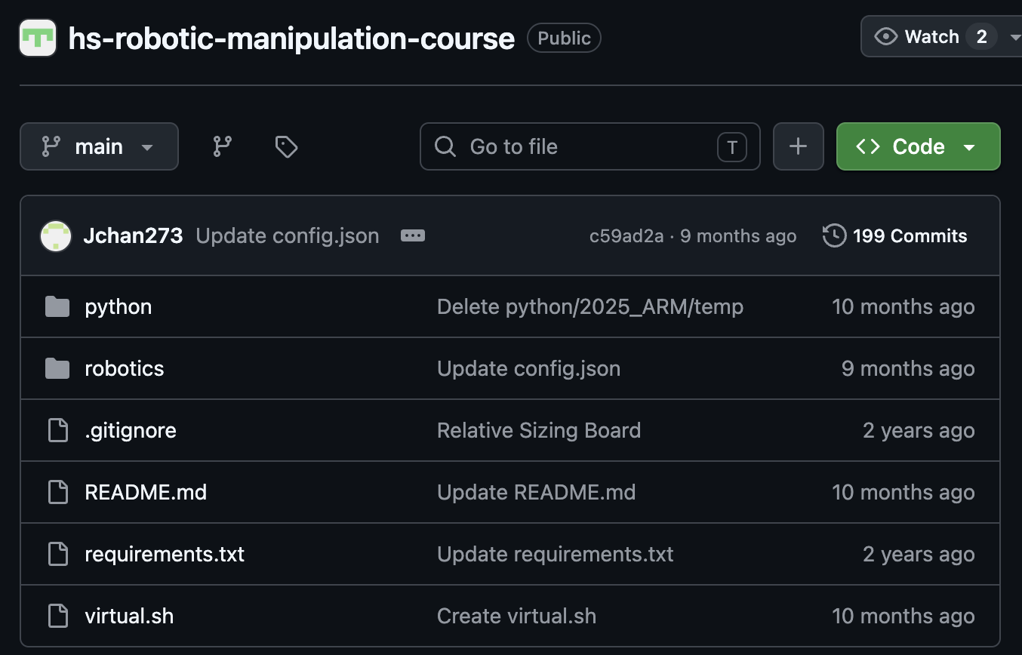

- Press green button “Code”, copy HTTPS URL.
- In a terminal window, navigate to where you want the repository to be cloned (useful commands: cd, ls, mkdir)
- Install git: run the command “sudo apt install git”
- Ctrl+Shift+V to paste the github link.

Set up virtual environment:
- Navigate to where you cloned the repository (use cd command -> “cd hs-robotic-manipulation-course”)
- Steps in readme file to activate (always activate when working with project)

Install the Dynamixel Wizard 2.0:
- sudo apt install libxcb-icccm4 libxcb-image0 libxcb-keysyms1 libxcb-render-util0
- Download Linux x64 version from link
- In the terminal, navigate using cd to the directory where the downloaded file is
- Run chmod 755 DynamixelWizard2Setup-linux-x64.run
- Run ./DynamixelWizard2Setup-linux-x64.run
- Follow the installer instructions

-----------------------------------------------------------------------------------------------------------------------------------------------------

Setting up motors in Dynamixel Wizard:
- Go to the directory where Dynamixel Wizard V2 is installed (for Ubuntu, defaults to ~/ROBOTIS).
- Run ./DynamixelWizard2 to open the wizard
- Change options to only scan IDs 0 to 15, Protocol 2.0, corresponding USB port, baudrate 57600 and 1000000.
- Scan with only one arm at a time, set IDs (1 to 6 for follower, 7 to 12 for leader)
- Take note of the device name and the corresponding arm (two types of motors is follower, one type of motors is leader)

Run record_positions.py (records each position for actions A to 8):
- Replace device name in config.json
- Run python robotics/record_positions.py -l
- Press enter to begin recording positions

If a motor stops working
- Open the Dynamixel Wizard
- Check if the ‘OL’ light is on for the motor
  - If so, reboot it and be sure not to force the motors to overclamp in the future
- Otherwise, one of the motors may be overheating or tangled in wires; unplug & untangle everything and give it some time
  - Motor 5 is particularly prone to overheating and tangling

Run position_control.py for individual positions (let’s you choose what action you are recording positions for):
- Replace device name in config.json
- Run python robotics/position_control.py -l
- Enter action name to record (A to 8)
- Press Enter to record each position

Recording tips:
- It’s generally better to have the arm be too high rather than too low, since too low will cause it to drag against the table and have a higher likelihood of misplacing pieces during gameplay

Motor 1 (Base): Left + Right -
Motor 2 (Base): Forward + Back -
Motor 3 (Elbow): Up + Down -
Motor 4 (Wrist): Up + Down -
Motor 5 (Wrist): Right + Left -
Motor 6 (Claw): Open + Close -

Home Position for Follower Arm: 2048, 1800, 1850, 1100, 2048, 2048

vision.py:
Use this file to determine which camera ID corresponds to the USB camera. On line 265, you can change the integer value of the BoardVision call until vision.py shows the USB cam output. Then, change the cam value on line 10 to match the correct value.

gamevision.py:
May need to run if you get an error about pygame Fonts
pip uninstall pygame
pip install pygame --no-cache-dir

If gamevision.py is freezing or using the wrong camera, redo the setup steps for vision.py.

Text-Based

Guess My Number
Guess My Number

Overview: The program chooses a random number between 1 and 100. Then it asks the user to guess the number. The program compares the user’s guess with the number it chose and responds “higher”, “lower”, or “you got it!”. The program repeats until the user’s guess is correct.

Goal: Students write a guess my number game.

Learning Objectives: Students will learn random, input, comparison, conditional, while, counting, output.

Duration: 1-1.5 hours

Level/prerequisite knowledge: Basic familiarity with python structure and whitespace.

Materials/Parts: None

Lesson:

Unplugged. First students pair up and play guess my number. After they play 2-5 times, they find another partner and play it again 2-5 more times. Students reflect on what they have done in groups (or pairs) and then share out to the whole class. How was the number chosen? What’s a good guessing strategy?

Plugged: Next students boot up python and get to programming. They program a while loop because they don’t know how many guesses will be needed.

Code:

import random
round = 0
playing = True
number = random.randint(1,100)

print("Guess my number between 1 and 100, inclusive.")
while playing:
round += 1
print(f"\nRound {round}")
guess = int(input("Guess: "))
if guess>number:
print("Lower")
elif guess<number:
print("Higher")
else:
print("You got it!")
playing = False
print(f"You got it in {round} rounds.")

GMN Extension
Guess My Number Extension

Overview: The program investigates 10 times, say, how many guesses are needed to guess a random number between 1 and 100. For each investigation, the program chooses a random number between 1 and 100 and guesses it using “higher”, “lower”, and the binary search algorithm.

Goal: Students write a binary search algorithm for the guess my number game to see its efficiency.

Learning Objectives: Students will learn lists, loops, binary search, output.

Duration: 1-2 hours

Level/prerequisite knowledge: Students must have already programmed Guess My Number

Materials/Parts: None

Lesson: Students write a loop around their guess my number code to run the guessing game 10 times, say. Each time, the list is created and it stores the guesses for each round of the game. The list is printed at the end of each greater loop.

The students write 2 different algorithms for the computer to guess. The first algorithm is to randomly choose a number between the updated bounds. The second algorithm is to choose the middle number between the bounds (binary search). The students reflect on the efficiency of the binary search as compared to the random search.

Possible example output (binary search), where each line is the guesses and the last number is “you got it”:

50 75 87 93 90 88
50 75 62 68 65 63 64
Etc., for 10 tries (or more, maybe 100 tries)

Further Extension: Students can program the computer to report the number of guesses for each investigation and then they could plot a frequency histogram. They could report the minimum and maximum number of guesses. They could further change the range from 1-100 to 1-1024, perhaps or other powers of 2 to see more about how the number of guesses connects to the range of values and the power of 2.

Code:

import random

def computer_guess(minimum, maximum, option):
if option == 0:
return random.randint(minimum,maximum)
else:
return (minimum+maximum)//2

for i in range(100):
guesses = []
number = random.randint(1,100)
number_of_guesses = 0
min = 1
max = 100
game_over = False
while not game_over:
number_of_guesses += 1
#guess = computer_guess(min, max, 0) # updated random
guess = computer_guess(min, max, 1) # binary search
#guess = computer_guess(1, 100, 0) # totally random
#guess = number_of_guesses # sequential
guesses.append(guess)
if guess==number:
game_over = True # Got it!
elif guess>number:
max = guess - 1 # Lower
else:
min = guess + 1 # Higher
print(guesses) # shows all the guesses
#print(len(guesses))

GMN Recursion
Guess My Number Recursion

Overview: The user chooses a random number between 1 and 100. Then the computer finds the number by guessing using the binary search algorithm in a recursive way.

Goal: Students write a guess my number game for the computer to guess the number using a recursive binary search algorithm..

Learning Objectives: Students will learn recursion as they program the guess my number game for the computer.

Duration: 1-1.5 hours

Level/prerequisite knowledge: Python experience and introduction to recursion.

Materials/Parts: None

Lesson: Students boot up python and get to programming. They program the computer to apply the binary search method recursively.

Code:

import random
number = int(input("Choose a number between 1 and 100: "))
#number = random.randint(1,100)

def get_response(guess):
if guess>number:
return "Lower"
elif guess<number:
return "Higher"
else:
return "You got it!"

def find_number(lowest,highest):
guess=(lowest+highest)//2
response=get_response(guess)
if response=="You got it!":
return guess
elif response=="Higher":
return find_number(guess+1,highest)
else: # Lower
return find_number(lowest,guess-1)

answer = find_number(1,100)
print(f'Answer is {answer}, and number was {number}.')

Pig
Pig

Overview: The program is a 2-player game of chance and strategy. On each player’s turn, they roll a die over and over until they get a 1 or decide to bank their score. Their score accumulates in their turn but adds to their overall score only if they bank. If a player rolls a 1, the turn is over and their score for that turn is lost. The winner is the first player to get greater than or equal to 100 points.

Goal: Students write the pig game.

Learning Objectives: Students will learn random, input, comparison, conditional, while, counting, output.

Duration: 1-1.5 hours

Level/prerequisite knowledge: Basic familiarity with python structure and whitespace.

Materials/Parts: A die, a sheet of paper, and a pencil for each pair of students.

Lesson:

Unplugged. First students pair up and play pig. After they play 2-5 times, they find another partner and play it again 2-5 more times. Students reflect on what they have done in groups (or pairs) and then share out to the whole class. What’s a good strategy for when to bank?

Plugged: Next students boot up python and get to programming. They program nested while loops because they don’t know how many rounds will be needed, and they don’t know how many rolls will be needed for each turn in each round.

Code:

import random

scores = [0,0]
names = ["Player 1", "Player 2"]
round = 0
playing = True
print("Let's play pig! Try to bank 100 points or more.")
print("If you roll a 1 you lose your round total.")

while playing:
round = round + 1
print(f'\nRound {round}:')
for i in range(2):
round_total = 0
print(f'\n{names[i]}, your turn.')
rolling = True
roll_number = 0
while rolling:
roll_number = roll_number + 1
print(f'Your total score would be {scores[i]+round_total} if you banked.')
choice = input("Would you like to roll (r) or bank (b)? ")
if choice == 'r':
print(f'\nYou chose to roll. This is roll number {roll_number}.')
die_roll = random.randint(1,6)
print(f'You rolled a {die_roll}.')
if die_roll != 1:
round_total = round_total + die_roll
print(f'Your new round total is {round_total}.')
else:
print(f'Your turn is over. Your round total of {round_total} is lost.')
rolling = False
elif choice == 'b':
print('\nYou chose to bank.')
scores[i] = scores[i] + round_total
print(f'{names[i]}: Your score is {scores[i]} points.')
rolling = False
else:
print("Please choose 'r' or 'b'")
if (scores[i]>=100):
playing = False
print(f'{names[0]}: You banked {scores[0]} points in {round} rounds.')
print(f'{names[1]}: You banked {scores[1]} points in {round} rounds.')
if scores[0]>scores[1]:
print(f'{names[0]}, you won!')
elif scores[1]>scores[0]:
print(f'{names[1]}, you won!')
else:
print("Whoa! Cool! It's a tie. You both won!")

Pig Extension
Pig Extension

Overview: The program is a 2-player game of chance and strategy. On each player’s turn, they roll a die over and over until they get a 1 or decide to bank their score. Their score accumulates in their turn but adds to their overall score only if they bank. If a player rolls a 1, the turn is over and their score for that turn is lost. The winner is the first player to get greater than or equal to 100 points. In this extension, the player plays against the computer. The extension is to investigate what are good strategies for the computer to use to try to win.

Goal: Students write the pig game to compete against the computer. They try different strategies for the computer to guess and investigate what strategy seems to work the best.

Learning Objectives: Students will learn to write a function for the computer choice.

Duration: 1-1.5 hours

Level/prerequisite knowledge: Students must have already programmed the pig game.

Materials/Parts: None

Lesson: Next students boot up python and get to programming. They program nested while loops because they don’t know how many rounds will be needed, and they don’t know how many rolls will be needed for each turn in each round.

Code:

import random

def get_computer_choice(total_for_round,which_roll_number):
if total_for_round>=15 or which_roll_number>=4:
return 'b'
return 'r'

score = [0,0]
names = ["Player 1", "Computer"]
round = 0
playing = True
print("Let's play pig! Try to bank 100 points or more. If you roll a 1 you lose your round total.")

while playing:
round = round + 1
print(f'\nRound {round}:')
for i in range(2):
round_total = 0
print(f'\n{names[i]}, your turn.')
rolling = True
roll_number = 0
while rolling:
roll_number = roll_number + 1
print(f'Your total score would be {score[i]+round_total} if you banked.')
if i==0: # human player
choice = input("Would you like to roll (r) or bank (b)? ")
else: # computer player
choice = get_computer_choice(round_total,roll_number)
if choice == 'r':
print(f'You chose to roll. This is roll number {roll_number}.')
die_roll = random.randint(1,6)
print(f'You rolled a {die_roll}.')
if die_roll != 1:
round_total = round_total + die_roll
print(f'Your new round total is {round_total}.')
else:
rolling = False
elif choice == 'b':
print('You chose to bank.')
score[i] = score[i] + round_total
rolling = False
else:
print("Please choose 'r' or 'b'")
if (score[i]>=100):
playing = False
print(f'{names[0]}: You banked {score[0]} points in {round} rounds.')
print(f'{names[1]}: You banked {score[1]} points in {round} rounds.')
if score[0]>score[1]:
print(f'{names[0]}, you won!')
elif score[1]>score[0]:
print(f'{names[1]}, you won!')
else:
print("Whoa! Cool! It's a tie. You both won!")

Rock Paper Scissors
Rock Paper Scissors

Overview: The program plays rock paper scissors, computer vs. player, in a best 2 out of 3 competition.

Goal: Students write the rock paper scissors game.

Learning Objectives: Students will learn random, input, comparison, conditional, while, counting, output.

Duration: 1-1.5 hours

Level/prerequisite knowledge: Basic familiarity with python structure and whitespace.

Materials/Parts: None

Lesson:

Unplugged. First students pair up and play rock paper scissors in a best 2 out of 3 competition. After they play, the winners of each pair play each other, and so on until there is one winner. It’s nice to run the whole group competition again without the first winner, and so forth to get maybe 3 winners. Then they can play each other for 1st, 2nd, and 3rd place. Students reflect with each other on how the game went and then share out to the whole class.

Plugged: Next students boot up python and get to programming. They program a while loop because they don’t know how many rounds will be needed (because it is best 2 out of 3 and because there are often ties).

Code:

import random
options = ['r','p','s']
# Dictionary {key:value}
d = {'r':"rock", 'p':"paper", 's':"scissors"}

wins=[0,0]
game_over = False
round = 0

print("\nLet's play rock paper scissors! Best 2 out of 3 wins.")
while not game_over:
round += 1
print(f'\nRound {round}:')
playing = True
while playing:
computer = random.choice(options)
player = input("Choose rock (r), paper (p), or scissors (s): ")
if ( (computer=='r' and player =='s') or
(computer=='s' and player =='p') or
(computer=='p' and player =='r') ):
print(f'Computer wins because {d[computer]} beats {d[player]}.')
wins[1] += 1
playing = False
elif ( (computer=='s' and player =='r') or
(computer=='p' and player =='s') or
(computer=='r' and player =='p') ):
print(f'Player wins because {d[player]} beats {d[computer]}.')
wins[0] += 1
playing = False
elif computer==player:
print(f'Tie! Both computer and player chose {d[computer]}.')
else:
print("Please type 'r', 'p', or 's'.")
if wins[0]==2:
print("\nCongratulations! You beat the computer.")
game_over=True
elif wins[1]==2:
print("\nOh, no! The computer beat you.")
game_over=True
else:
print("\nThe game continues....")
print("\nThanks for playing rock paper scissors.\n")

RPS Extension
Rock Paper Scissors Extension: Rock Paper Scissors Lizard Spock

Overview: The program plays Rock Paper Scissors Lizard Spock, computer vs. player, in a best 2 out of 3 competition. This game is an expanded five-gesture version of the classic game, invented by Sam Kass and Karen Bryla and popularized by the TV show The Big Bang Theory.

Each gesture wins against two options and loses to two options.
🪨 Rock crushes Scissors and crushes Lizard.
📄 Paper covers Rock and disproves Spock.
✂️ Scissors cuts Paper and decapitates Lizard.
🦎 Lizard poisons Spock and eats Paper.
🖖 Spock smashes Scissors and vaporizes Rock.

Goal: Students write the rock paper scissors lizard spock game.

Learning Objectives: Students will learn random, input, comparison, conditional, while, counting, output.

Duration: 1-1.5 hours

Level/prerequisite knowledge: Students must have already written the rock paper scissors game.

Materials/Parts: None

Lesson: Students boot up python and get to programming. They program a while loop because they don’t know how many rounds will be needed (because it is best 2 out of 3 and because there are often ties).

Code:

Tic-Tac-Toe
Tic-Tac-Toe

Overview: The program hosts a 2-player tic-tac-toe game where players take turns playing X or O by choosing the square 0-9. The game is over when one player or the other gets 3 in a row (tic, tac, toe) in a row, column, or diagonal or when all the squares are full with neither player having 3 in a row. The former is a victory for that player, while the latter is a tie known as “cat’s game.”

Goal: Students write a tic-tac-toe game.

Learning Objectives: Students will learn random, input, comparison, conditional, lists, while, counting, output.

Duration: 2-3 hours

Level/prerequisite knowledge: Familiarity with python structure, whitespace, variables, and lists.

Materials/Parts: Paper and pencils for the students to play each other on paper. Alternatively red X’s and blue O’s to place on tic-tac-toe grids.

Lesson:

Unplugged. First students pair up and play tic-tac-toe After they play 2-5 times, they find another partner and play it again 2-5 more times. Students reflect on what they have done in groups (or pairs) and then share out to the whole class. How were the plays chosen? What’s a good playing strategy?

Plugged: Next students boot up python and get to programming. They program a while loop because they don’t know how many plays will be needed. They write helper functions to keep the code clean.

players=["X","O"]
board = []
for i in range(9):
board.append(" ")

def print_board() -> None:
# prints the board, such as
# | |
#---------
# | X |
#---------
# | | O
# with spaces for empty squares
# and X or O for that play

def get_play() -> int:
# gets the play 0-8

def find_winner() -> str:
# returns “X” or “O” if either wins and “N” if no winner (yet?)

Code:

players=["X","O"]
board = []
for i in range(9):
board.append(" ")

def print_board() -> None:
print(board[0] + " | " + board[1] + " | " + board[2])
print("---------")
print(board[3] + " | " + board[4] + " | " + board[5])
print("---------")
print(board[6] + " | " + board[7] + " | " + board[8])

def get_play() -> int:
played=False
while not played:
play = int(input("Where would you like to play (0-8)? "))
if play>=0 and play<=8 and board[play]==" ":
played=True
return play

def find_winner() -> str:
if board[0]!=" " and board[0]==board[1]==board[2]:
return board[0]
if board[3]!=" " and board[3]==board[4]==board[5]:
return board[3]
if board[6]!=" " and board[6]==board[7]==board[8]:
return board[6]
if board[0]!=" " and board[0]==board[3]==board[6]:
return board[0]
if board[1]!=" " and board[1]==board[4]==board[7]:
return board[1]
if board[2]!=" " and board[2]==board[5]==board[8]:
return board[2]
if board[0]!=" " and board[0]==board[4]==board[8]:
return board[0]
if board[2]!=" " and board[2]==board[4]==board[6]:
return board[2]
return "N"

print("\nLet's play Tic-Tac-Toe! It's a 2-player game.\n")
playing = True
print_board()
while playing:
for i in range(2):
print(f"\nPlayer {players[i]}, your turn.")
board[get_play()]=players[i]
print_board()
winner = find_winner()
if winner!="N" or board.count(" ")==0:
playing = False
break
print()
if winner!="N":
print(f"Congratulations to Player {winner}! You won!")
else:
print("It's a tie. No one won. It's a cat's game.")
print()

TTT Extension 1
Tic-Tac-Toe Extension 1: Play vs Computer

Overview: The program challenges a player to a game of tic-tac-toe.

Goal: Students write a tic-tac-toe game with the computer as a player. The computer should have two levels of play. The first level of play should be random. The second level of play should be to try to win first or block second, and if there is neither such move to then play randomly.

Learning Objectives: Students will learn random, input, comparison, conditional, lists, while, counting, output.

Duration: 2 hours

Level/prerequisite knowledge: Students must have already programmed the tic-tac-toe game.

Materials/Parts: None

Lesson: Students boot up python and get to programming. They write a new helper function for the computer to choose its play. The first level of play should be random. The second level of play should be to try to win first or block second, and if there is neither such move to then play randomly.

def get_computer_play() -> int:

Code:

import random

players=["X","O"]
board = []
for i in range(9):
board.append(" ")

def print_board() -> None:
print(board[0] + " | " + board[1] + " | " + board[2])
print("---------")
print(board[3] + " | " + board[4] + " | " + board[5])
print("---------")
print(board[6] + " | " + board[7] + " | " + board[8])

def get_play() -> int:
played=False
while not played:
play = int(input("Where would you like to play (0-8)? "))
if play>=0 and play<=8 and board[play]==" ":
played=True
return play

def get_computer_play() -> int:
empties=[]
play = -1
# try to win
for i in range(9):
if board[i]==" ":
empties.append(i)
for empty in empties:
board[empty]=players[1]
if find_winner()==players[1]:
play=empty
board[empty]=" "
break
board[empty]=" "
# try to block
if play == -1:
for empty in empties:
board[empty]=players[0]
if find_winner()==players[0]:
play=empty
board[empty]=" "
break
board[empty]=" "
# choose randomly
if play == -1:
play = random.choice(empties)
return play

def find_winner() -> str:
if board[0]!=" " and board[0]==board[1]==board[2]:
return board[0]
if board[3]!=" " and board[3]==board[4]==board[5]:
return board[3]
if board[6]!=" " and board[6]==board[7]==board[8]:
return board[6]
if board[0]!=" " and board[0]==board[3]==board[6]:
return board[0]
if board[1]!=" " and board[1]==board[4]==board[7]:
return board[1]
if board[2]!=" " and board[2]==board[5]==board[8]:
return board[2]
if board[0]!=" " and board[0]==board[4]==board[8]:
return board[0]
if board[2]!=" " and board[2]==board[4]==board[6]:
return board[2]
return "N"

print("\nLet's play Tic-Tac-Toe! It's a 2-player game.\n")
playing = True
print_board()
while playing:
for i in range(2):
if i==0:
print(f"\nPlayer {players[i]}, your turn.")
board[get_play()]=players[i]
else:
print(f"\nPlayer {players[i]}, your turn.")
board[get_computer_play()]=players[i]
print_board()
winner = find_winner()
if winner!="N" or board.count(" ")==0:
playing = False
break
print()
if winner!="N":
print(f"Congratulations to Player {winner}! You won!")
else:
print("It's a tie. No one won. It's a cat's game.")
print()

Hangman
Hangman

Overview: The program chooses a random movie title, and the player has to guess the letters. If the player has 6 wrong guesses, they lose.

Goal: Students write a hangman game.

Learning Objectives: Students will learn string slicing.

Duration: 1-1.5 hours

Level/prerequisite knowledge: Basic familiarity with python structure, whitespace, and loops.

Materials/Parts: Pencil and paper.

Lesson:

Unplugged. First students pair up and play hangman. After they play 2-5 times, they find another partner and play it again 2-5 more times. Students reflect on what they have done in groups (or pairs) and then share out to the whole class. How were the letters chosen? What’s a good letter guessing strategy?

Plugged: Next students boot up python and get to programming. They program a while loop because they don’t know how many guesses will be needed. They have to slice strings to compare letter by letter.

Code:

import random
answers=["a league of their own","interstellar","mission impossible",
"superman","legally blonde","black panther","tron"]
answer=random.choice(answers)
# player must guess all the letters before making 6 wrong guesses

current=""
for i in range(len(answer)):
if answer[i:i+1]==" ":
current+=" "
else:
current+="_"

misses=0
playing = True
while playing:
correct_guess=False
print("\nGuess my movie title with fewer than 6 wrong guesses.")
print(current)
letter = input("\nWhat letter would you like to guess? ")
previous = current
current = ""
for i in range(len(answer)):
if answer[i:i+1]==letter:
current+=letter
correct_guess=True
else:
current+=previous[i:i+1]
if not correct_guess:
misses+=1
print("Sorry, that guess is not one of the letters.")
print(f"That is wrong guess #{misses}.")
if current==answer:
playing=False
print("Congratulations! You got it.")
elif misses==6:
playing=False
print("Sorry, you didn't get before making 6 wrong guesses.")
print("It was " + answer + ".")

Hangman Extension
Hangman Extension

Overview: The program chooses a random movie title, and the program has to guess the letters. If the program has 6 wrong guesses, it loses.

Goal: Students write a hangman game for the computer to play.

Learning Objectives: Students will learn reading files and machine learning percentages.

Duration: 1-1.5 hours

Level/prerequisite knowledge: Students must have already written the hangman program

Materials/Parts: Letter frequency table https://pi.math.cornell.edu/~mec/2003-2004/cryptography/subs/frequencies.html

E,12.02
T,9.1
A,8.12
O,7.68
I,7.31
N,6.95
S,6.28
R,6.02
H,5.92
D,4.32
L,3.98
U,2.88
C,2.71
M,2.61
F,2.3
Y,2.11
W,2.09
G,2.03
P,1.82
B,1.49
V,1.11
K,0.69
X,0.17
Q,0.11
J,0.1
Z,0.07

Lesson: Students boot up python and get to programming. They adapt their program to have a function where the computer guesses. Read in the file, which has the letters in order of their frequency. Then try two different methods for guessing. In the first method, just get the first letter off the list. In the second method, get a random letter off the list. What do you observe? How could we make the program smarter?

def get_letter() -> str:
# first try getting the first letter from the frequency list
# try again with getting a random letter off the list

Code:

lines = []
with open("letter_frequency.csv") as file:
for line in file:
line = line.strip() #or some other preprocessing
lines.append(line) #storing everything in memory!

elements = []
for line in lines:
pair=line.split(",")
elements.append(pair[0])

def get_letter() -> str:
#return elements.pop(random.randint(0,len(elements)-1))
return elements.pop(0)

Element Symbols
Element Symbols

Overview: The program loads a file with a list of elements and their symbols into a dictionary. Then the computer quizzes the user on the symbols and elements.

Goal: Students write a quiz game.

Learning Objectives: Students will learn file i/o, dictionaries.

Duration: 1-1.5 hours

Level/prerequisite knowledge: Basic familiarity with python structure, whitespace, loops and conditionals..

Materials/Parts: File

Lesson:

Unplugged. First students pair up and quiz each other on 10 of the symbols of elements. Whoever gets the most right wins. After they play 2-3 times, they find another partner and play it again 2-3 more times. Students reflect on what they have done in groups (or pairs) and then share out to the whole class.

Plugged: Next students boot up python and get to programming. They program to read the list from the file and make it into a dictionary for the quiz.

Code:

import random
# file of elements from https://www.bodycote.com/list-chemical-symbols/

lines = []
with open("elements.csv") as file:
for line in file:
line = line.strip() #or some other preprocessing
lines.append(line) #storing everything in memory!

elements={}
for line in lines:
pair=line.split(",")
elements[pair[0]] = pair[1]

print("\nWelcome to element symbol quiz!")
print("I will quiz you on 10 elements.")
score = 0
for i in range(10):
symbol=random.choice(list(elements.keys()))
name=elements[symbol]
del elements[symbol]
answer = input(f"\nWhat is the symbol for {name}? ")
if answer==symbol:
print("\nYes! You got it.")
score+=1
else:
print(f"\nAlas, no, it was {symbol}.")
print(f"\nYou got {score} out of 10.\n")

State Capitals
State Capitals

Overview: The program loads a file with a list of states and their capitals into a dictionary. Then the computer quizzes the user on the capitals of the states.

Goal: Students write a quiz game.

Learning Objectives: Students will learn file i/o, dictionaries.

Duration: 1-1.5 hours

Level/prerequisite knowledge: Basic familiarity with python structure, whitespace, loops and conditionals..

Materials/Parts: File

Lesson:

Unplugged. First students pair up and quiz each other on 10 of the capitals of states. Whoever gets the most right wins. After they play 2-3 times, they find another partner and play it again 2-3 more times. Students reflect on what they have done in groups (or pairs) and then share out to the whole class.

Plugged: Next students boot up python and get to programming. They program to read the list from the file and make it into a dictionary for the quiz.

Code:

import random
# file of state capitals from
# https://www.britannica.com/topic/list-of-state-capitals-in-the-United-States-2119210

lines = []
with open("state_capitals.csv") as file:
for line in file:
line = line.strip() #or some other preprocessing
lines.append(line) #storing everything in memory!

state_capitals={}
for line in lines:
pair=line.split(",")
state_capitals[pair[0]] = pair[1]

print("\nWelcome to state capitals quiz!")
print("I will quiz you on the capitals of 10 states.")
score = 0
for i in range(10):
state=random.choice(list(state_capitals.keys()))
capital=state_capitals[state]
del state_capitals[state]
answer = input(f"\nWhat is the capital of {state}? ")
if answer==capital:
print("\nYes! You got it.")
score+=1
else:
print(f"\nAlas, no, it was {capital}.")
print(f"\nYou got {score} out of 10.\n")

Graphics-Based

Pop the Balloon
Pop the Balloon

Overview: Following along with Coding with Sphere, we’ll make a simple pop program using pygame.
https://youtu.be/dz9_-2G6o3o?si=C4taJGFlXbd6f1AF

Goal: Make a graphics program with python’s pygame where the user clicks the balloon and it moves to a random place.

Learning Objectives: Students will learn pygame basics.

Duration: 1-1.5 hours

Level/prerequisite knowledge: Basic python structure, variables, and functions.

Materials/Parts: A balloon for each group (maybe more than one, if the one the group uses gets popped).

Lesson:

Unplugged: Students in small groups hit a balloon to each other. In their small groups, students discuss how a computer video game would determine if a mouse cursor “hit” a balloon or not. The students also discuss how we know where on the screen the balloon is and where on the screen the mouse cursor is. A few groups share out to the whole class.

Plugged: Students get to coding by following along with Coding with Sphere
https://youtu.be/dz9_-2G6o3o?si=C4taJGFlXbd6f1AF
Students can choose the different colors of the background and the balloon, and they can choose the size of the balloon as well.

Code:

import pygame
import sys
import math
import random

width = 1280
height = 720
radius = 30
score = 0

circle_pos = (random.randint(0, width), random.randint(0, height))

pygame.init()
clock = pygame.time.Clock()
screen = pygame.display.set_mode((width,height))
font = pygame.font.Font(None, 30)

def check_circle_collision() -> bool:
mouse_pos = pygame.mouse.get_pos()
if math.sqrt( (mouse_pos[0] - circle_pos[0])**2 + (mouse_pos[1] - circle_pos[1])**2 ) < radius:
return True
return False

while True:
events = pygame.event.get()
for event in events:
if event.type == pygame.QUIT:
pygame.quit()
sys.exit()
if event.type == pygame.MOUSEBUTTONDOWN:
if event.button == 1: # left click
if check_circle_collision():
score += 1
circle_pos = (random.randint(0,width), random.randint(0,height))
score_surface = font.render(f'Score: {score}', True, "black")

screen.fill('lightblue')
pygame.draw.circle(screen,"purple",circle_pos,radius)
screen.blit(score_surface,(50,50))
pygame.display.update()
clock.tick(60) # limits FPS to 60

Pop the Balloon Extension
Pop the Balloon Extension

Overview: We will extend our pop the balloon game to have many different balloons that move around. We will only get points for clicking the balloon of a certain color. The game is over when all the balloons of that color have been popped.

Goal: Students write a more advanced pop the balloon game, using classes.

Learning Objectives: Students will learn classes and instantiation as they build on their pygame basics.

Duration: 1-1.5 hours

Level/prerequisite knowledge: Basic python structure, variables, and functions. Students must have already programmed the pop the balloon game.

Materials/Parts: None

Lesson: Students improve their pop the balloon game by using a class for a balloon. An instantiated balloon knows its color, size, and position, and how it glides around randomly. The player is challenged to click all the balloons of a certain color. In the image, there are 3 red balloons remaining to be clicked.

Image:

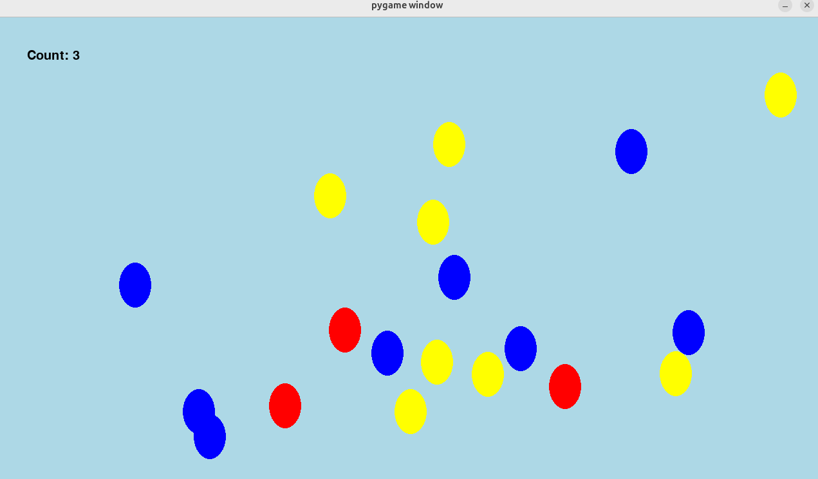

Code:

import pygame
import sys
import math
import random

width = 1280
height = 720
radius = 30
wx = 50
wy = 70

pygame.init()
clock = pygame.time.Clock()
screen = pygame.display.set_mode((width,height))

font = pygame.font.Font(None, 30)

class Balloon():
def __init__(self, color):
self.color = color
self.position = (0,0)
self.glide_time = 0
self.delta_x = 0.0
self.delta_y = 0.0

def get_color(self):
return self.color

def set_position(self, position):
self.position = position

def draw(self):
pos = (self.position[0]-wx//2,self.position[1]-wy//2)
pygame.draw.ellipse(screen,self.color,(pos,(wx,wy)))
def check_collision(self, mouse_pos):
if math.sqrt( (mouse_pos[0] - self.position[0])**2 + (mouse_pos[1] - self.position[1])**2 ) < radius:
return True
return False

def glide(self,seconds):
if self.glide_time==0:
self.glide_time=seconds
new_pos = (random.randint(0, width), random.randint(0, height))
self.delta_y = (new_pos[1]-self.position[1])/seconds
self.delta_x = (new_pos[0]-self.position[0])/seconds
self.position = (self.position[0]+self.delta_x, self.position[1]+self.delta_y)
self.glide_time = self.glide_time - 1

count = 8
colors = ["red","blue","yellow"]
balloons = []
for i in range(8):
for j in range(3):
balloons.append(Balloon(colors[j]))

for balloon in balloons:
balloon.set_position((random.randint(0, width), random.randint(0, height)))

while True:
clock.tick(60)
events = pygame.event.get()
for event in events:
if event.type == pygame.QUIT:
pygame.quit()
sys.exit()
if event.type == pygame.MOUSEBUTTONDOWN:
if event.button == 1: # left click
mouse_pos = pygame.mouse.get_pos()
index = -1
i = 0
for balloon in balloons:
if balloon.get_color()=="red" and balloon.check_collision(mouse_pos):
index = i
i += 1
if index != -1:
balloons.pop(index)
count -= 1
if (count!=0):
score_surface = font.render(f'Count: {count}', True, "black")
else:
score_surface = font.render("You Won!",True,"black")

screen.fill('lightblue')
for balloon in balloons:
balloon.glide(random.randint(90,120))
balloon.draw()
screen.blit(score_surface,(50,50))
pygame.display.update()

Race for the Treasure
Race for the Treasure

Overview: Students will make three characters: player 1, player 2, treasure. The game is a graphical game played with the keyboard. Player 1 uses keys wasd to move, while player 2 uses arrow keys. The players race to capture the treasure. Whichever player gets to the treasure first gets a point. The treasure then vanishes and reappears in a random location on the screen. The players race again. When one player gets 10 points, that player is the winner.

Goal: Students write a more advanced pop the balloon game, using classes.

Learning Objectives: Students will build on their pygame basics to make a fun two player game with the keyboard. Students build their familiarity with the coordinates on the screen.

Duration: 1-1.5 hours

Level/prerequisite knowledge: Understanding of pygame, classes, functions, and variables.

Materials/Parts: Three characters are needed as transparent png files. Students can make their characters in piskelapp, for example. We recommend using a 64x64 canvas and saving your work to your computer. You can make player 2 a different color scheme of player 1 if you wish (like Mario and Luigi). Each character is just one frame in its own file, exported as a png spritesheet.

Lesson: Students program the game so that the images are controlled as described above.

Images:

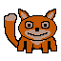
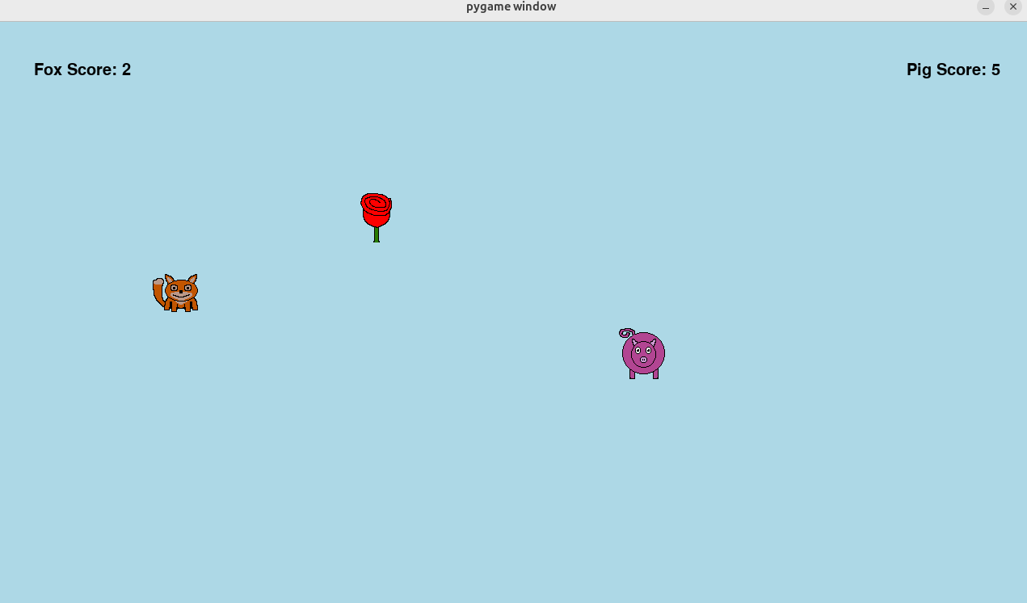

Code:

import pygame
import sys
import math
import random

width = 1280
height = 720
step = 25

pygame.init()
clock = pygame.time.Clock()
screen = pygame.display.set_mode((1280,720))

font = pygame.font.Font(None, 30)

surface1 = pygame.image.load("Fox.png")
player1 = pygame.transform.scale(surface1, (64, 64))
p1_rect = player1.get_rect()
p1_rect.center = (100,height//2)
p1_score = 0
surface2 = pygame.image.load("Pig.png")
player2 = pygame.transform.scale(surface2, (64, 64))
p2_rect = player1.get_rect()
p2_rect.center = (width-100,height//2)
p2_score = 0
treasure = pygame.image.load("Rose.png")
t_rect = player1.get_rect()
t_rect.center = (width//2,height//2)

running = True

while running:
clock.tick(60)
events = pygame.event.get()
for event in events:
if event.type == pygame.QUIT:
running = False
elif event.type == pygame.KEYDOWN:
if event.key == pygame.K_UP:
p2_rect.move_ip(0,-step)
if event.key == pygame.K_DOWN:
p2_rect.move_ip(0,step)
if event.key == pygame.K_LEFT:
p2_rect.move_ip(-step,0)
if event.key == pygame.K_RIGHT:
p2_rect.move_ip(step,0)
if event.key == pygame.K_w:
p1_rect.move_ip(0,-step)
if event.key == pygame.K_s:
p1_rect.move_ip(0,step)
if event.key == pygame.K_a:
p1_rect.move_ip(-step,0)
if event.key == pygame.K_d:
p1_rect.move_ip(step,0)

hit = pygame.Rect.collidelist(t_rect,[p1_rect,p2_rect])
if hit!=-1:
t_rect.update((random.randint(64,width-64),random.randint(64,height-64)), (64,64) )
if hit==0:
p1_score += 1
else:
p2_score += 1
if p1_score < 10 and p2_score < 10:
p1_score_surface = font.render(f'Fox Score: {p1_score}', True, "black")
p2_score_surface = font.render(f'Pig Score: {p2_score}', True, "black")
else:
if p1_score < 10:
p1_score_surface = font.render(f'Fox Loses: {p1_score}', True, "black")
p2_score_surface = font.render(f'Pig Wins: {p2_score}', True, "black")
else:
p1_score_surface = font.render(f'Fox Wins: {p1_score}', True, "black")
p2_score_surface = font.render(f'Pig Loses: {p2_score}', True, "black")
screen.fill('lightblue')
screen.blit(player1,p1_rect)
screen.blit(player2,p2_rect)
screen.blit(treasure,t_rect)
screen.blit(p1_score_surface,(50,50))
screen.blit(p2_score_surface,(width-150,50))
pygame.display.flip()
pygame.quit()
sys.exit()

Attack of the Clones
Attack of the Clones

Overview: Students will make three characters: hero, villain, collectible. The game is a graphical game played with the keyboard. The hero uses arrow keys. Whichever player gets to the treasure first gets a point. The treasure then vanishes and reappears in a random location on the screen. The players race again. When one player gets 10 points, that player is the winner.

Goal: Students write a more advanced pop the balloon game, using classes.

Learning Objectives: Students will build on their pygame basics to make a fun two player game with the keyboard. Students build their familiarity with the coordinates on the screen.

Duration: 1-1.5 hours

Level/prerequisite knowledge: Understanding of pygame, classes, functions, and variables.

Materials/Parts: Three characters are needed as transparent png files. Students can make their characters in piskelapp, for example. We recommend using a 64x64 canvas and saving your work to your computer. You can make player 2 a different color scheme of player 1 if you wish (like Mario and Luigi). Each character is just one frame in its own file, exported as a png spritesheet.

Lesson: Students program the game so that the images are controlled as described above.

Image:



Code:

import pygame
import sys
import math
import random

width = 1280
height = 720
step = 25

pygame.init()
clock = pygame.time.Clock()
screen = pygame.display.set_mode((1280,720))

font = pygame.font.Font(None, 30)

surface1 = pygame.image.load("Fox.png")
player1 = pygame.transform.scale(surface1, (64, 64))
p1_rect = player1.get_rect()
p1_rect.center = (100,height//2)
p1_score = 0
surface2 = pygame.image.load("Pig.png")
player2 = pygame.transform.scale(surface2, (64, 64))
p2_rect = player1.get_rect()
p2_rect.center = (width-100,height//2)
p2_score = 0
treasure = pygame.image.load("Rose.png")
t_rect = player1.get_rect()
t_rect.center = (width//2,height//2)

running = True

while running:
clock.tick(60)
events = pygame.event.get()
for event in events:
if event.type == pygame.QUIT:
running = False
elif event.type == pygame.KEYDOWN:
if event.key == pygame.K_UP:
p2_rect.move_ip(0,-step)
if event.key == pygame.K_DOWN:
p2_rect.move_ip(0,step)
if event.key == pygame.K_LEFT:
p2_rect.move_ip(-step,0)
if event.key == pygame.K_RIGHT:
p2_rect.move_ip(step,0)
if event.key == pygame.K_w:
p1_rect.move_ip(0,-step)
if event.key == pygame.K_s:
p1_rect.move_ip(0,step)
if event.key == pygame.K_a:
p1_rect.move_ip(-step,0)
if event.key == pygame.K_d:
p1_rect.move_ip(step,0)

hit = pygame.Rect.collidelist(t_rect,[p1_rect,p2_rect])
if hit!=-1:
t_rect.update((random.randint(64,width-64),random.randint(64,height-64)), (64,64) )
if hit==0:
p1_score += 1
else:
p2_score += 1
if p1_score < 10 and p2_score < 10:
p1_score_surface = font.render(f'Fox Score: {p1_score}', True, "black")
p2_score_surface = font.render(f'Pig Score: {p2_score}', True, "black")
else:
if p1_score < 10:
p1_score_surface = font.render(f'Fox Loses: {p1_score}', True, "black")
p2_score_surface = font.render(f'Pig Wins: {p2_score}', True, "black")
else:
p1_score_surface = font.render(f'Fox Wins: {p1_score}', True, "black")
p2_score_surface = font.render(f'Pig Loses: {p2_score}', True, "black")
screen.fill('lightblue')
screen.blit(player1,p1_rect)
screen.blit(player2,p2_rect)
screen.blit(treasure,t_rect)
screen.blit(p1_score_surface,(50,50))
screen.blit(p2_score_surface,(width-150,50))
pygame.display.flip()
pygame.quit()
sys.exit()

Tic-Tac-Toe GUI
Tic-Tac-Toe GUI

Overview: Students will make the red x and blue o and then program the tic-tac-toe game as a two player game.

Goal: Students write a tic-tac-toe game, using pygame.

Learning Objectives: Students will build on their pygame basics to make a fun connect four game where they compete against the computer.

Duration: 3-5 hours

Level/prerequisite knowledge: Understanding of pygame, functions, lists, and variables..

Materials/Parts: Two game pieces are needed as transparent png files. Students can make their red x and blue o in piskelapp, for example. We recommend using a 64x64 canvas and saving your work to your computer. Each token is just one frame in its own file, exported as a png spritesheet. Alternatively, students can make their red x and blue o in google slides. After exporting each slide as a jpg, bring the jpg’s into photopea to remove the background and export as png files.

Lesson: Students program the tic-tac-toe game so that the red x and blue o game pieces are played as described above. Each player, on their turn, will type the square number to place their game piece in the square of their choosing.

Image:
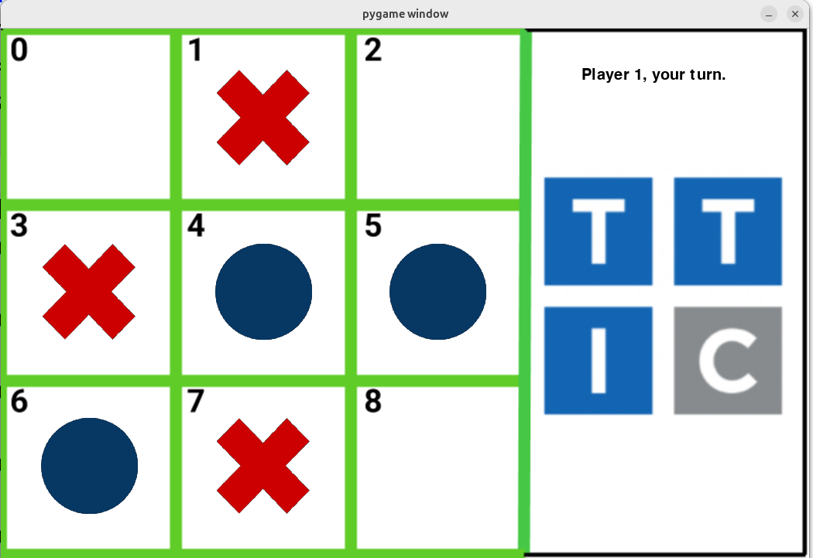
Code:

import pygame
import sys
import random

board=[]
for i in range(9):
board.append(" ")
players=["X","O"]
random.shuffle(players)
names=["Player 1", "Player 2"]

def find_winner():
if board[0]==board[1]==board[2] and board[0]!=" ":
return board[0]
if board[3]==board[4]==board[5] and board[3]!=" ":
return board[3]
if board[6]==board[7]==board[8] and board[6]!=" ":
return board[6]
if board[0]==board[3]==board[6] and board[0]!=" ":
return board[0]
if board[1]==board[4]==board[7] and board[1]!=" ":
return board[1]
if board[2]==board[5]==board[8] and board[2]!=" ":
return board[2]
if board[0]==board[4]==board[8] and board[0]!=" ":
return board[0]
if board[2]==board[4]==board[6] and board[2]!=" ":
return board[2]
return "N"

width = 1044
height = 685
pygame.init()
clock = pygame.time.Clock()
screen = pygame.display.set_mode((width,height))
font = pygame.font.Font(None, 30)
bg_surface = pygame.image.load("board.png")
bg = pygame.transform.scale(bg_surface, (1044, 685))
surface1 = pygame.image.load("x_piece.png")
player1 = pygame.transform.scale(surface1, (128, 128))
surface2 = pygame.image.load("o_piece.png")
player2 = pygame.transform.scale(surface2, (128, 128))

if players[0]=="X":
pieces=[player1,player2]
else:
pieces=[player2,player1]

surface1 = font.render(
f'{names[0]}, your turn.', True, "black")
surface2 = font.render(
f'{names[1]}, your turn.', True, "black")
surfaces=[surface1,surface2]

locations = [(50,50),(275,50),(500,50),
(50,275),(275,275),(500,275),
(50,500),(275,500),(500,500)]

running = True
playing = True
i=0 # turns
while running:
clock.tick(60)
while playing:
message_surface=surfaces[i]
play=-1
events = pygame.event.get()
for event in events:
if event.type == pygame.QUIT:
playing = False
running = False
elif event.type == pygame.KEYDOWN:
if event.key == pygame.K_0 and board[0]==" ":
play = 0
elif event.key == pygame.K_1 and board[1]==" ":
play = 1
elif event.key == pygame.K_2 and board[2]==" ":
play = 2
elif event.key == pygame.K_3 and board[3]==" ":
play = 3
elif event.key == pygame.K_4 and board[4]==" ":
play = 4
elif event.key == pygame.K_5 and board[5]==" ":
play = 5
elif event.key == pygame.K_6 and board[6]==" ":
play = 6
elif event.key == pygame.K_7 and board[7]==" ":
play = 7
elif event.key == pygame.K_8 and board[8]==" ":
play = 8

screen.blit(bg,(0,0))
screen.blit(message_surface,(750,50))
if play!=-1:
board[play]=players[i]
play=-1
i+=1
if i == 2:
i = 0
j=0
for spot in board:
if spot==players[0]:
screen.blit(pieces[0],locations[j])
elif spot==players[1]:
screen.blit(pieces[1],locations[j])
j+=1
pygame.display.flip()
winner = find_winner()
if winner!="N" or board.count(" ")==0:
playing = False
if winner!="N":
if winner==players[0]:
message_surface=font.render(
f'{names[0]}, you won!', True, "black")
else:
message_surface=font.render(
f'{names[1]}, you won!', True, "black")
else:
message_surface=font.render(
"It's a cat's game.", True, "black")
screen.blit(message_surface,(750,620))
pygame.display.flip()
pygame.time.delay(3500)
running = False
pygame.quit()
sys.exit()

Connect Four
Connect Four

Overview: Students will make two tokens and then program the connect four game with the computer playing with a minimax algorithm.

Goal: Students write an advanced connect four game, using pygame.

Learning Objectives: Students will build on their pygame basics to make a fun connect four game where they compete against the computer.

Duration: 4-10 hours

Level/prerequisite knowledge: Understanding of pygame, functions, lists, variables, and minimax.

Materials/Parts: Two tokens are needed as transparent png files. Students can make their tokens in piskelapp, for example. We recommend using a 64x64 canvas and saving your work to your computer. Each token is just one frame in its own file, exported as a png spritesheet. Alternatively, students can make their tokens in google slides. After exporting each slide as a jpg, bring the jpg’s into photopea to remove the background and export as png files.

Lesson: Students program the connect four game so that the tokens are played as described above. The player will click the mouse to drop their token in the column of their choosing.

Image:

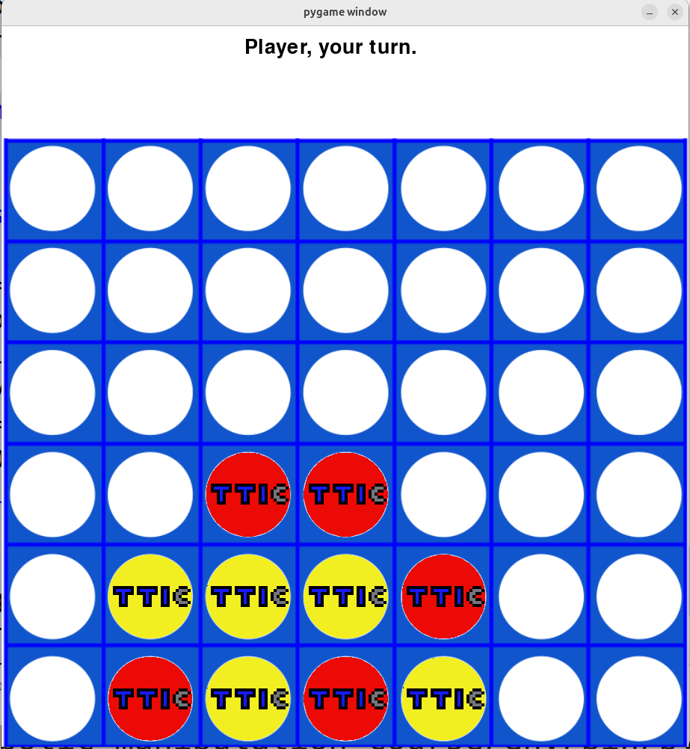

Code:

import pygame
import sys
import random

players=["R","Y"]
random.shuffle(players)
names=["Player", "Computer"]

width = 919
height = 814
size = 128
offset = 150
game_height = height + offset
the_ys = [0,0,0,0,0,0]
the_xs = [0,0,0,0,0,0,0]
locations = []
h = 688 + offset
for i in range(6):
row=[]
w = 6
for j in range(7):
row.append((w,h))
w += 131
locations.extend(row)
h -= 137
for i in range(6):
the_ys[i]=(688 + offset) - 137*i
for j in range(7):
the_xs[j]=6+131*j

board = []
k=0
for i in range(6):
row = []
for j in range(7):
row.append(" ")
k+=1
board.append(row)

def print_board():
for i in range(5,-1,-1):
print(board[i])

def get_possible_plays():
plays=[]
for j in range(7):
if board[5][j]==" ":
plays.append(j)
return plays

def minimax(is_maximizing, maximizing_player, depth):
"""
Minimax algorithm implementation
Returns the best score possible for the current board state
"""
ai_player = players[maximizing_player]
human_player = players[(maximizing_player+1)%2]
# Base cases
winner = find_winner()
if winner == ai_player:
return float("inf")
if winner == human_player:
return float("-inf")
if board_is_full():
return 0
if depth == 4:
return utility_value(maximizing_player)

# minimax algorithm
plays = get_possible_plays()
if is_maximizing:
best_score = float("-inf")
for play in plays:
# Make a calculating move
j = update_board(play,ai_player)
# Recursively call minimax
# with the next depth and the minimizing player
score = minimax(False, maximizing_player, depth + 1)
# Reset the move
board[j][play] = " "
# Update the best score
best_score = max(score, best_score)
return best_score
else:
# if it is the minimizing player's turn (human),
# we want to minimize the score
best_score = float("inf")
for play in plays:
# Make a calculating move
j = update_board(play,human_player)
# Recursively call minimax with
# the next depth and the maximizing player
score = minimax(True, maximizing_player, depth + 1)
# Reset the move
board[j][play] = " "
# Update the best score
best_score = min(score, best_score)
return best_score

def get_computer_play(i) -> int:
intelligence = 2
plays=get_possible_plays()
random.shuffle(plays)
if intelligence == 0:
return random.choice(plays)
elif intelligence == 1:
# Win if we can win
for play in plays:
j = update_board(play,players[i])
if find_winner() == players[i]:
board[j][play] = " "
return play
board[j][play]=" "
k = (i + 1) % 2
# Block if we can't win
for play in plays:
j = update_board(play,players[k])
if find_winner() == players[k]:
board[j][play] = " "
return play
board[j][play] = " "
# Otherwise random
return random.choice(plays)
else:
# Win if we can win
for play in plays:
j = update_board(play,players[i])
if find_winner() == players[i]:
board[j][play] = " "
return play
board[j][play]=" "
k = (i + 1) % 2
# Block if we can't win
for play in plays:
j = update_board(play,players[k])
if find_winner() == players[k]:
board[j][play] = " "
return play
board[j][play] = " "
# Otherwise minimax
best_score = float("-inf")
best_move = plays[0]
for play in plays:
j = update_board(play,players[i])
score = minimax(False, i, 0)
board[j][play]=" "
if score >= best_score:
best_score = score
best_move = play
return best_move

def update_board(play,token):
found_row = False
j=0
while not found_row:
if board[j][play] == " ":
board[j][play] = token
found_row = True
else:
j+=1
return j

def check_win(nums):
for i in range(len(nums)-3):
if (nums[i]==nums[i+1]==nums[i+2]==nums[i+3] and
nums[i]!=" "):
return nums[i]
return "N"

def count_triples(nums,token):
count = 0
for i in range(len(nums)-3):
if (nums[i]==nums[i+1]==nums[i+2]==token
or nums[i]==nums[i+1]==nums[i+3]==token
or nums[i]==nums[i+2]==nums[i+3]==token
or nums[i+1]==nums[i+2]==nums[i+3]==token):
count += 1
return count

def count_doubles(nums,token):
count = 0
for i in range(len(nums)-2):
if (nums[i]==nums[i+1]==token
or nums[i]==nums[i+2]==token):
count += 1
return count

def count_sequences(i):
token = players[i]
doubles = 0
triples = 0
for row in board:
doubles += count_doubles(row,token)
triples += count_triples(row,token)
for j in range(7):
col = []
for i in range(6):
col.append(board[i][j])
doubles += count_doubles(col,token)
triples += count_triples(col,token)
diags=[ [board[3][0],board[2][1],board[1][2],board[0][3]],
[board[4][0],board[3][1],board[2][2],board[1][3],board[0][4]],
[board[5][0],board[4][1],board[3][2],board[2][3],board[1][4],board[0][5]],
[board[5][1],board[4][2],board[3][3],board[2][4],board[1][5],board[0][6]],
[board[5][2],board[4][3],board[3][4],board[2][5],board[1][6]],
[board[5][3],board[4][4],board[3][5],board[2][6]],
[board[0][3],board[1][4],board[2][5],board[3][6]],
[board[0][2],board[1][3],board[2][4],board[3][5],board[4][6]],
[board[0][1],board[1][2],board[2][3],board[3][4],board[4][5],board[5][6]],
[board[0][0],board[1][1],board[2][2],board[3][3],board[4][4],board[5][5]],
[board[1][0],board[2][1],board[3][2],board[4][3],board[5][4]],
[board[2][0],board[3][1],board[4][2],board[5][3]] ]
for diag in diags:
doubles += count_doubles(diag,token)
triples += count_triples(diag,token)
return doubles,triples

def get_score(i):
doubles, triples = count_sequences(i)
return 1000*triples + 100*doubles

def utility_value(i):
win = find_winner()
if win!="N":
if win==players[1] and i==1:
return float("inf")
elif win==players[0] and i==0:
return float("-inf")
elif win==players[1] and i==0:
return float("inf")
else: # win==players[0] and i==1
return float("-inf")
if board_is_full():
return 0
if i==0:
return -get_score(i)
return get_score(i)

def find_winner():
for row in board:
win = check_win(row)
if win!="N":
return win
for j in range(7):
col = []
for i in range(6):
col.append(board[i][j])
win = check_win(col)
if win!="N":
return win
diags=[ [board[3][0],board[2][1],board[1][2],board[0][3]],
[board[4][0],board[3][1],board[2][2],board[1][3],board[0][4]],
[board[5][0],board[4][1],board[3][2],board[2][3],board[1][4],board[0][5]],
[board[5][1],board[4][2],board[3][3],board[2][4],board[1][5],board[0][6]],
[board[5][2],board[4][3],board[3][4],board[2][5],board[1][6]],
[board[5][3],board[4][4],board[3][5],board[2][6]],
[board[0][3],board[1][4],board[2][5],board[3][6]],
[board[0][2],board[1][3],board[2][4],board[3][5],board[4][6]],
[board[0][1],board[1][2],board[2][3],board[3][4],board[4][5],board[5][6]],
[board[0][0],board[1][1],board[2][2],board[3][3],board[4][4],board[5][5]],
[board[1][0],board[2][1],board[3][2],board[4][3],board[5][4]],
[board[2][0],board[3][1],board[4][2],board[5][3]] ]
for diag in diags:
#print(diag)
win = check_win(diag)
if win!="N":
return win
return "N"

def board_is_full():
for i in range(7):
if board[5][i]==" ":
return False
return True

pygame.init()
clock = pygame.time.Clock()
screen = pygame.display.set_mode((width,game_height))
font = pygame.font.Font(None, 40)
bgo_surface = pygame.image.load("board_c4_overlay.png")
bg_overlay = pygame.transform.scale(bgo_surface, (width, height))
#bg_surface = pygame.image.load("board_c4.png")
#bg = pygame.transform.scale(bg_surface, (width, height))
surface1 = pygame.image.load("Red.png")
player1 = pygame.transform.scale(surface1, (size, size))
surface2 = pygame.image.load("Yellow.png")
player2 = pygame.transform.scale(surface2, (size, size))

if players[0]=="R":
pieces=[player1,player2]
else:
pieces=[player2,player1]

surface1 = font.render(f'{names[0]}, your turn.', True, "black")
surface2 = font.render(f'{names[1]}, your turn.', True, "black")
surfaces=[surface1,surface2]

def move_token_into_position(i,play):
found_row = False
j=0
while not found_row:
if board[j][play] == " ":
found_row = True
else:
j+=1
steps = 25
y_0 = offset-50
y_final = the_ys[j]
delta_y = 30
steps = int((y_final-y_0)/delta_y)
y = y_0
for k in range(steps):
if k!=0:
pygame.draw.rect(screen,'white',(the_xs[play],y-delta_y,size+8,size+8))
pygame.draw.rect(screen,'white',(0,50,width,offset-50))
screen.blit(pieces[i],(the_xs[play],y))
screen.blit(bg_overlay,(0,offset))
y += delta_y
pygame.time.delay(10)
pygame.display.flip()

def update():
pygame.draw.rect(screen,'white',(0,0,width,game_height))
screen.blit(message_surface,(325,15))
j=0
for row in board:
for spot in row:
if spot==players[0]:
screen.blit(pieces[0],locations[j])
elif spot==players[1]:
screen.blit(pieces[1],locations[j])
j+=1
screen.blit(bg_overlay,(0,offset))
pygame.display.flip()

running = True
playing = True
quit = False
i=0 # turns
while running:
clock.tick(60)
while playing:
message_surface=surfaces[i]
play=-1
events = pygame.event.get()
for event in events:
if event.type == pygame.QUIT:
playing = False
quit = True
elif event.type == pygame.MOUSEBUTTONDOWN:
if event.button == 1: # left click
mouse_pos = pygame.mouse.get_pos()
play = int((mouse_pos[0])/130)
elif event.type == pygame.KEYDOWN:
if event.key == pygame.K_0 and board[5][0]==" ":
play = 0
elif event.key == pygame.K_1 and board[5][1]==" ":
play = 1
elif event.key == pygame.K_2 and board[5][2]==" ":
play = 2
elif event.key == pygame.K_3 and board[5][3]==" ":
play = 3
elif event.key == pygame.K_4 and board[5][4]==" ":
play = 4
elif event.key == pygame.K_5 and board[5][5]==" ":
play = 5
elif event.key == pygame.K_6 and board[5][6]==" ":
play = 6
if names[i]=="Computer":
update()
#pygame.time.delay(100)
play = get_computer_play(i)
if play!=-1:
move_token_into_position(i,play)
update_board(play,players[i])
play=-1
i = (i + 1) % 2
update()
#print_board()
winner = find_winner()
if winner!="N" or board_is_full():
playing = False
if winner!="N":
if winner==players[0]:
message_surface=font.render(
f'{names[0]}, you won!', True, "black")
else:
message_surface=font.render(
f'{names[1]}, you won!', True, "black")
else:
message_surface=font.render(
"It's a tie.", True, "black")
if not quit:
update()
pygame.time.delay(2500)
running = False
pygame.quit()
sys.exit()

