Web based Health Insurance Claim Service System
Start Date | October 21, 2018

Prepared by
Name | Designation | Signature & Date
S. M. Zamshed Farhan | Sr. Programmer, IT
Md. Fahad Khan | Programmer, IT

Reviewed by
Name | Designation | Signature & Date
Md. Abdur Razzak Ali Sorker | Sr. Manager, Apps. Dev, Integration & Maintenance.

Approved by
Name | Designation | Signature & Date
Tanvir Azad Chowdhury | Head, Information Technology
Mr. Syed Monjurul Islam | Deputy Executive Director

icddr,b is going to introduce web based Health Insurance Claim Service System to track bill submissions & reimbursements from all the eligible staffs and their dependants. Primarily this web application will be accessed internally in icddr,b network. Later, on demand, it will be made public facing.

Requirement Summary

This system will have the following functionality.

- Input claim form (Figure 1)
- Input reimbursement form (Figure 2)
- Based on input Management can generate Medical Bill Reimbursement Check list Report (Figure 3)

Requirement Details

- Input Claim Form

Employee ID, Name of Employee and Name of the patient will be populated from ERP. Other input needs to provide manually in claim form.

SL. | Emp. Id. | Name of Emp. | Name of the Pt. | Contact no | Date | Head of Expense Type * | Date of Bill  Claim. | Claim No. | Bill Amount (claimed)

Figure 1: Claim Form

* Head of Expense Type should be

- Consultation
- Medication & Accessories
- Investigations & Procedural
- Hospitalization

If Head of Expense Type is “Hospitalization” then two new input should be enable named as Hospital Name & Surgery involved with yes/ options.

- Input Reimbursement Details Form

User needs to input reimbursement data manually in reimbursement details form. This can be done by using claim number or employee number.

Reimbursement Amount | Date of bill Reimbursement | Comment
Figure 2 : Input reimbursement Form

- Medical Bill Reimbursement Check list Report

Based on the information collected by Input Claim Form and Input Reimbursement Details Form, management can generate Medical Bill Reimbursement Check list Report by searching Employee ID, Date of Bill Reimbursement, Contact Number and Date of Bill Submit. Report Template provided below.

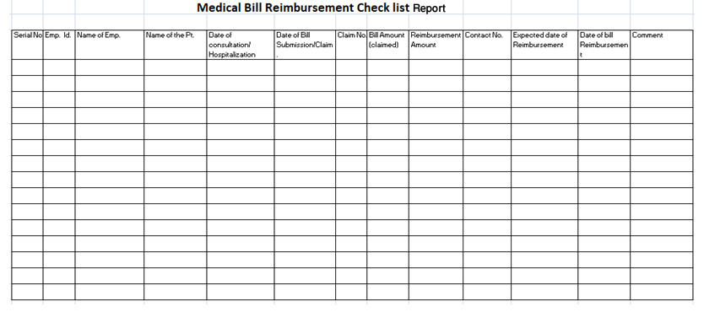
Figure 3: Reimbursement checklist report

