**A Dive into the Losses**

To stay at the top of the game, a business aims to maximize their profits. One of the main pushbacks of this aim is that of losses; especially persistent and recurring losses. In this notebook we shall analyze the business' losses so as to help the business maximize profits through understanding and thereafter minimizing their losses.

Our dataset is a Global Superstore dataset based on sales and was found on Kaggle. It offers multiple interesting dimensions to explore like order priority, product category, ship mode, location details, product segment and time series information. Our main KPI's for this Dataset were that of Total Sales, Profit and Quantity.

**We aim to minimize the “Sum of Loss” and the difference between profit and loss.**

**Quarter of highest loss:**

**Quarter of most spread losses:**

**Let us check why Q4 of 2015 experienced such high levels of losses, so that we can avoid them in future.**

“Returns” table consists of IDs of customers that returned their order. We will create a relationship between the two tables: Returns and Orders. And create a new Column of “Returned” in the Orders table. This will allow us to get insights of customers who returned their orders.

Using the Modeling feature of Power BI, I have created a relationship between the Order IDs in the “Orders" table and "Returns" table.

**Next I made a new calculated column in "Orders" table using DAX:**



This inserts a Yes to all orders returned, and a No to those not returned.

The orders returned carry a cost with them, we will now check how much of losses were down to those orders returned in Q4 of 2015.

**Returned:**

The ones that Returned, accounted to around 47% of average losses, which shows that the products that are returned are a source of losses.

We can see that for products that were returned, office supplies are the greatest number of categories returned. And the Asia Pacific market accounts for most of these returns, which suggests that this market must be studied as to why to they return our products. Only the market LATAM, has a low proportion of returns hence we should study the market and try to provide similar levels of services in other markets to avoid losses.

Lastly if we particularly look at 2015, the year whose quarter faced the highest loss we see:

**That the Returned products take higher proportion, which might mean that due to returns we incurred highest levels of loss in Q4 of 2015.**

**Let’s look if Ship modes had an impact on the losses faced in Q4 of 2015:**

In 2015 there are only losses experienced, with a very high increase in losses from Q3 to Q4, from -45k to -70k. This is the greatest change experienced amongst all years, showing that an increase in shipping mode cost might be the reason why Q4 2015 had the highest levels of losses experienced.

We can see clearly that there was a sudden peak in Number of orders via "Standard Class" from all Quarters to Q4.

The percentage of Shipments via Standard class had always been high, but particularly from Q3 to Q4 the magnitude increased by around 26%. Whereas the increase in losses from Q3 to Q4 was 177%. Which clearly shows that we incurred a high loss during Q4 of 2015.

Most probably higher orders were not catered well due to lack of space.

This can be since our superstore is global, in 2015 there was a slight inflation where due to globally economy we all suffered from higher shippment costs.

**For comparison look at the trend in 2014, some increases, some decreases, and an overall stable loss trend, with less volatility.**

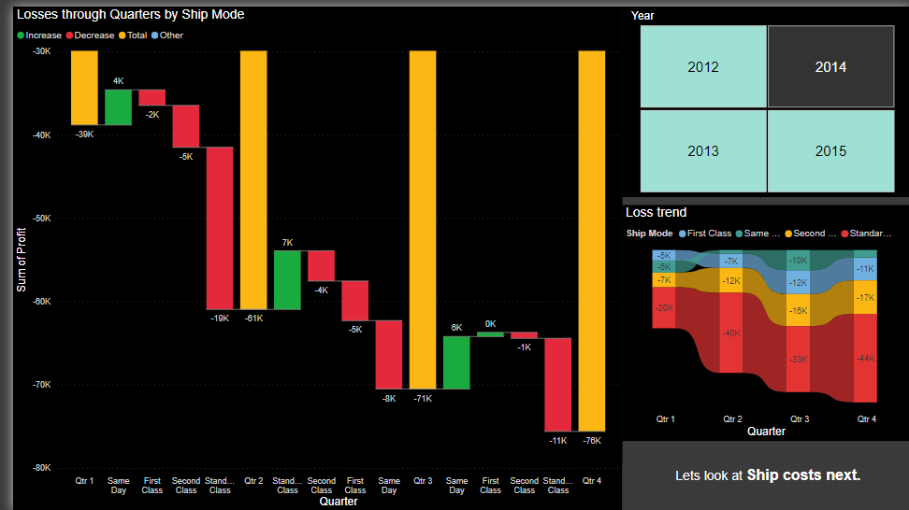

**Ship Costs:**

**When we analyse the shipping costs, and check them along different markets and ship modes we notice that: Asia Pacific accounts for the highest average ship cost. While giving less profit for simialr sales. Earlier we also analysed that Asia Pacific returns the prodcuts most, hence it is a market of loss for us. As is a region with high ship cost, high rates of returns, which means that we have to incur the shipping costs twice. There should be more focus on other markets like Europe and USCA, that give higher returns for lower costs.**

We can focus on employing RDC’s in Asia Pacific instead of direct drops and we might be able to avoid higher ship costs in long run.

**Bulk Orders minimizing loss:**

As a supermarket we often give discounts. These discounts do lead to an increase in footfall, but in some cases without awarding these discounts we can also get high orders. Let us study our data set to find an instance where, despite low discounts, we got high orders, due to bulk orders.

**Sales by region:**

**Southern US topped the sales only one quarter, and then never accounted for high sales why?**

When we further look at why Southern US topped sales in 2012 Q1, we can see that only one customer with id: SM-203201408, accounts for the sales.

We can see through this graph that all the order was from the "Home Office" segment, showing that this customer was setting their home office up.

**Was this bulk order given a discount?**

Next let's see if this bulk order from the specific customer was because of any discount offered or not.

**

We can see that 6 out of 8 of this customer’s orders were at 20% discount, which suggest that for a low discount this customer did most of their bulk order.

Avoid giving discounts to bulk orders, and milk them to maximize sales.

**Analyzing Location:**

**The Sankey charts shown are a very efficient way of peeking at what markets, what subsequent regions of these markets, and what subsequent countries of these regions contribute the most to losses. The losses shown in these Sankey’s are filytered to only show substantial loss producing countries. Asimple click on any market or region will alter the Sankeys to show you what the highest loss-producing countries are in that market/region . Once we know what countries are our main pain points, we can delve deeper into the country/region-specific causes behind these losses.**

**Forecasting:**

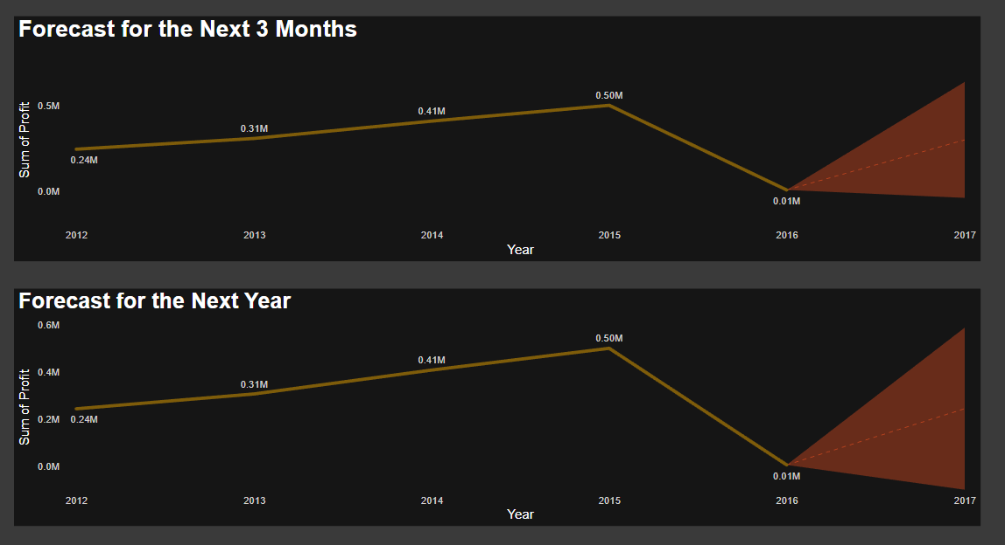

**Using Further Analyses ttols offered by Power BI, we also delved into forecasts for the upcoming quarter, as well as the upcoming year respectively. We can see that the average forecast itself is very similar to each other. However, the forecast given for the next Quarter shows higher profits than that of the entire year. A reason for that could be that the business tends to perform better in the beginning of the year and then increases in losses as we move quarters.**

