Opus 5.5 is the most powerful model Anthropic has ever shipped.
Most people are using it exactly like they used Opus 5 (or even 4.8)
That is the mistake.
The prompts that worked before now slow it down.
The habits that felt smart now waste tokens.
And the new capabilities like effort levels, time budgets, agent runs that last hours, almost nobody is using them yet.
This is the complete guide.
12 tips from Anthropic's official prompting guid and Claude Code updates.
Every prompt is copy-paste ready.
Save and run this before your next session.

The biggest change nobody mentions
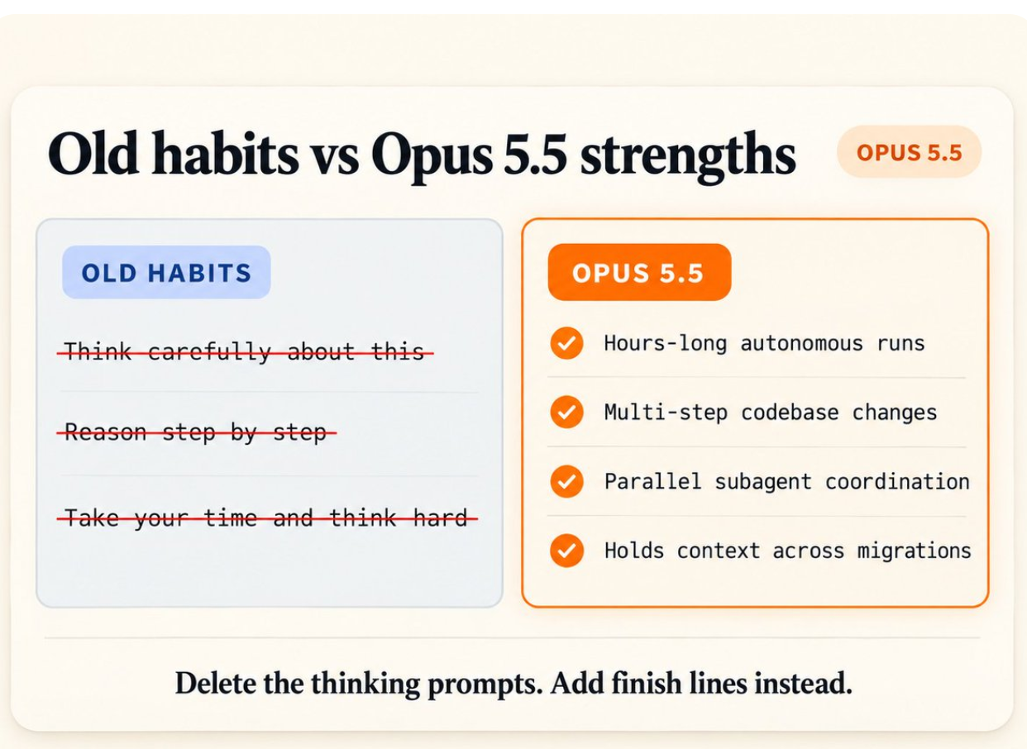

Opus 5.5 already thinks before every reply.
You do not need to ask it to.
Delete every "think carefully," "think step by step," and "reason through this" line from your prompts.
Not because they hurt.
Because they are wasted words.
Opus 5.5 is also built for long, multi-step work. Its biggest gains over Opus 5 are on tasks that run for hours, carrying a change through a large codebase until the tests pass, coordinating parallel subagents, holding context across an entire migration.
Early testers ran long coding tasks for hours with almost no oversight.
If you are still babysitting it turn by turn, you are working harder than you need to.

Tip 1 : Start at medium effort
Effort is the dial that controls how hard Opus 5.5 thinks before it answers.
Five levels: low → medium → high → xhigh → max
On Opus 5, the default was high.
On Opus 5.5, the default is medium.
And in Anthropic's own testing, Opus 5.5 at medium matches or beats Opus 5 at high on coding and knowledge-work benchmarks.
That means you are probably overpaying for thinking you do not need.

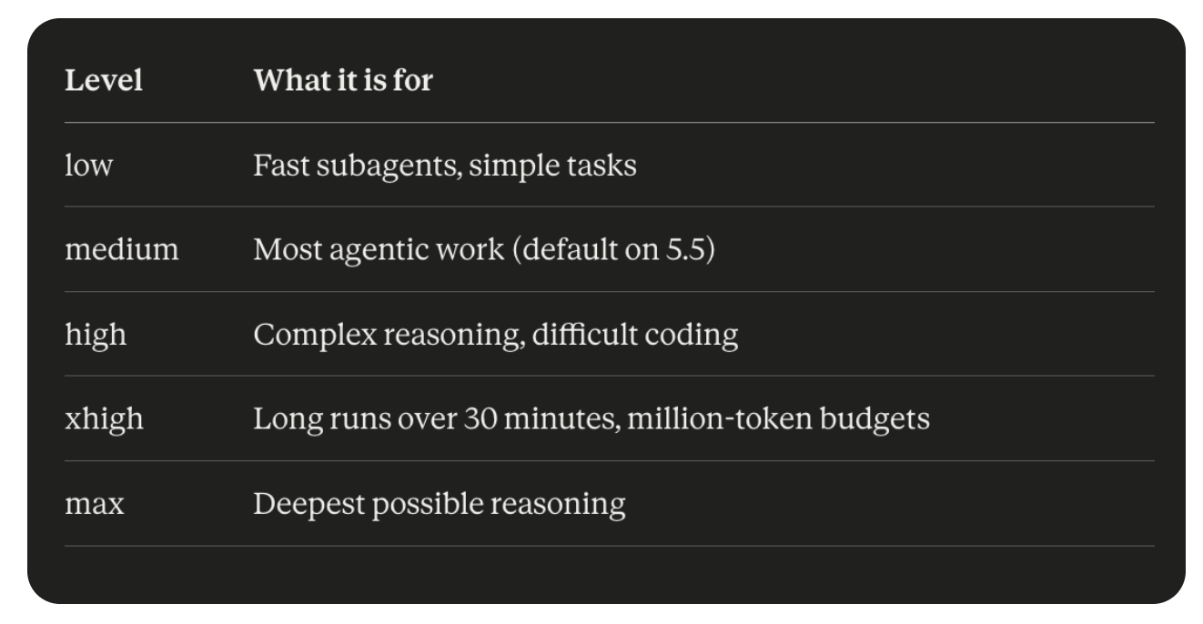
Set it explicitly. Do not inherit your Opus 5 setting.
bash
# Claude Code
claude --effort medium

# Or in settings.json
"effortLevel": "medium"

# API
"output_config": {
"effort": "medium"
}
Anthropic's advice: start at medium, run your real work for a while, move up one level only when a result falls short.
Reserve xhigh and max for work where you have actually measured a quality gain.

Tip 2 : Test your effort levels on YOUR work
Medium is the recommended start.
The right level for you depends on what you actually do.
The most reliable way to find it: run one real task at every level and compare the results side by side.
This prompt does it for you:
plaintext
I want to find the right effort level for my agent.

- Look at what I actually use you for most, then pick one real
task that makes a fair test: something I do often, with a
result I can judge by eye. Tell me the task and why you
picked it in two lines.

- Run that exact same task at every effort level, lowest to
highest. Same instructions, same files, a fresh start each
time so no run sees another.

- For each run, note how long it took and roughly how much
usage it cost.

- Build one HTML page showing every result side by side in
columns, lowest effort on the left, with time and usage at
the top of each column.

- At the bottom, give me your pick: the lowest level where
quality stops getting better.

No toy tasks. I want to see the difference on work I really do.
Run this once. Set the level it picks as your default.
Then forget about effort until you hit a task that comes back short.

Tip 3 : Use AGENTS.md in Claude Code

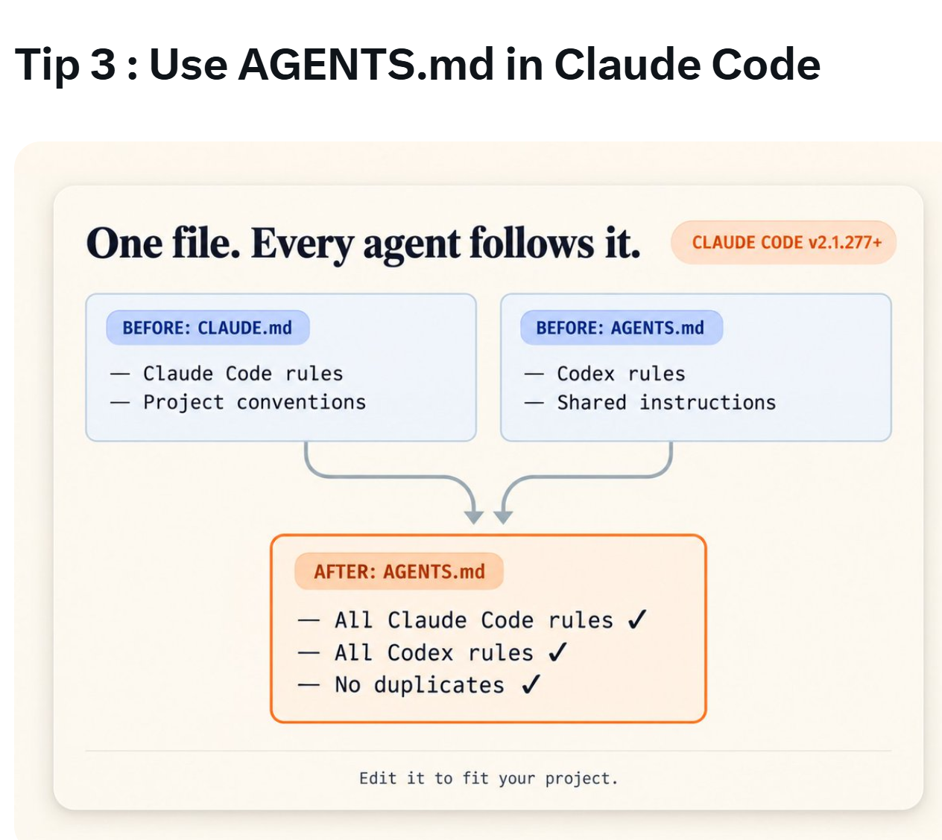
If you use Claude Code alongside any other coding agent (Codex, Cursor, Gemini CLI) you have probably kept two instructions files in sync by hand.
CLAUDE.md and AGENTS.md.
You no longer have to.
As of Claude Code version 2.1.277, if there is no CLAUDE.md in a folder, Claude automatically reads AGENTS.md instead.
One file. Every agent follows it.
Update first:
bash
claude update
claude --version
# Make sure you have 2.1.277 or later
Merge your two files into one with this prompt:
plaintext
I use Claude Code and Codex in this project.

Compare my CLAUDE.md and AGENTS.md and merge them into one
AGENTS.md that keeps every rule from both, with no duplicates.

Show me what changed.

Don't delete or rename CLAUDE.md until I say yes, because
Claude Code only reads AGENTS.md in a folder that has no
CLAUDE.md.
Toggle the behavior on or off anytime with /config.

Tip 4 : Switch effort mid-session without losing your cache
The cache is Claude's short-term memory of your conversation.
Reading from cache costs a fraction of re-reading the full conversation.
On Opus 5 and earlier models: changing effort between messages wiped the cache.
Every switch meant paying full price to re-read everything.
On Opus 5.5: you can change effort mid-conversation and keep the cache.
Drop to low effort for a quick follow-up. Step up to xhigh for one hard turn. Drop back down.
No cache reset. No full re-read. No extra cost.
In Claude Code: just change the effort level mid-session as you normally would. The cache survives.
Via API (beta):
json
{
"role": "system",
"content": [],
"output_config": { "effort": "low" }
}
Add the header mid-conversation-output-config-2026-07-01.
In one test: switching from xhigh to high mid-session read 384,114 tokens from cache and wrote only 620 new ones.
That is the difference between seconds and minutes.

Tip 5 : Use your banked usage resets
Claude now banks usage resets for you.
A reset gives you your full usage allowance back immediately.
With the Opus 5.5 launch, you likely got a free one.
Most people do not know it is there.
How to use it:
→ Open Settings
→ Go to Usage
→ Find the Resets box
→ When you run out, click "Reset for free"
Do not spend it while you still have usage left.
Save it for when you actually hit the wall.
Important: resets expire. Check the date on yours.

Tip 6 : Opus 5.5 will decline reasoning extraction requests
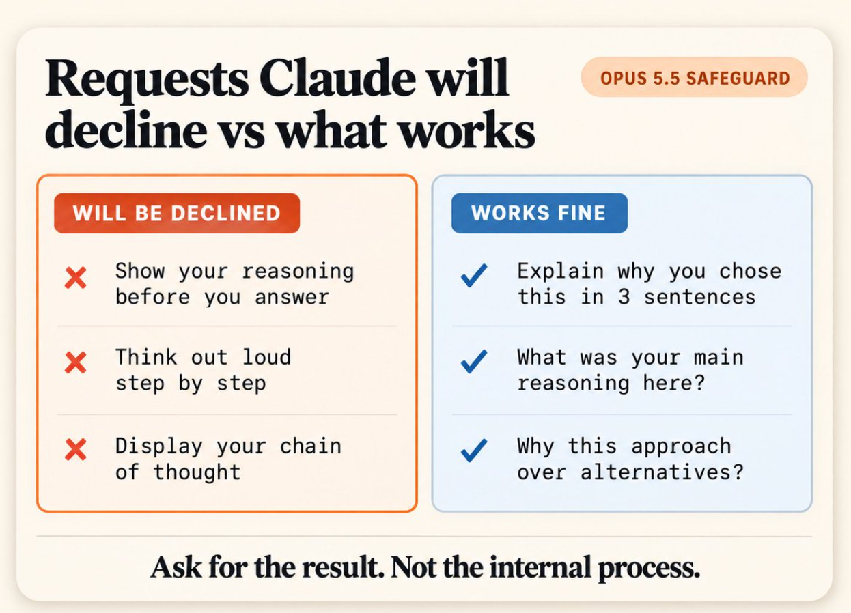

This one will break prompts you have been using for months.
Opus 5.5 runs new safety checks. One is called reasoning extraction.
If your prompt asks Claude to write out its internal thinking in the reply "show your reasoning," "think out loud," "display your chain of thought", the request can be declined.
On the API you get stop_reason: "refusal" with category reasoning_extraction.
In Claude Code you see an error with reasoning_extraction in the details.
Find and remove the affected lines:
plaintext
Search my CLAUDE.md, skills, agents, and system prompts for
any instruction that asks you to write out your reasoning or
show your thinking in your reply.

List each one with its file and line, and suggest a rewrite
that asks for the result only.

Don't change anything until I say yes.
If you want to understand its approach, ask instead:
plaintext
Explain why you chose this approach in three sentences.
That works. "Show your chain of thought" does not.

Tip 7 : Tell it earlier answers are settled
In long chats, Opus 5.5 sometimes goes back over an earlier answer while it thinks about a short follow-up.
Even a simple "what about X?" can trigger a full re-examination of something you already agreed on.
That adds thinking time and slows your later replies.
Two sentences fix it.
Add this to your CLAUDE.md or system prompt:
plaintext
Once you have answered something, treat that answer as done.
On later turns, focus your thinking on what I'm asking now,
and don't go back over an earlier answer unless I ask about
it or point out a problem with it.
In Anthropic's testing, this cut thinking on follow-up turns and made replies start sooner with no quality drop.
Or make it an on-demand skill for quick chats:
plaintext
Make me a skill called "settled". When I run it, treat every
earlier answer in this chat as done: focus your thinking on
what I'm asking now, and only go back over an earlier answer
if I ask about it or point out a problem with it.
One caution: leave this out of long analysis sessions where a later step might reveal a mistake in an earlier one. In those cases, you want Claude going back.

Tip 8 : Keep a task checklist
On long tasks with several parts, Opus 5.5 posts progress updates as it works.
Sometimes one of those updates ends its turn.
An agent running on its own can stop there (with work still open), mistaking a progress report for a finish line.
A checklist fixes this. It gives Claude, and you, a clear record of what is done and what is not.
Add this to any long task prompt:
plaintext
Before you start, write a checklist of every part of this task.
Tick each item off as you finish it.
Before you end your turn, check the list: if anything is
still open, keep going, or tell me what is blocking it.
If it still stops early, send this nudge:
plaintext
Your task list still has open items: [the open items].
Continue with them. If one is blocked, say what is blocking it.
Anthropic's guide recommends stopping after two or three automatic nudges on the same task. If it is still stuck at that point, something real is blocking it, review it rather than pushing further.

Tip 9 : Set a time budget
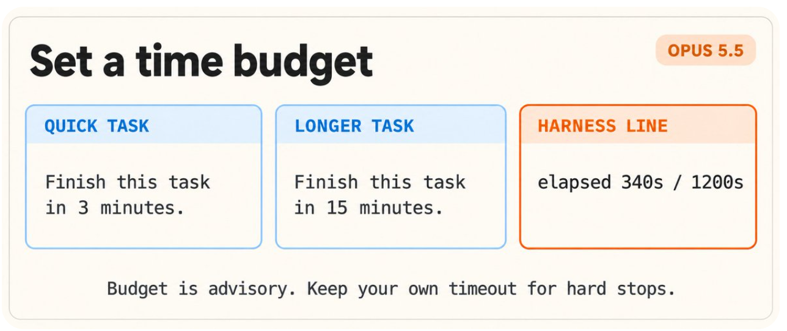

Opus 5.5 pays close attention to elapsed time.
Give it a time budget and it paces its work to finish inside it.
In Anthropic's tests, small agent teams given a time budget kept answer quality close to a single agent's while finishing considerably sooner.
The simplest version:
plaintext
Finish this task in 3 minutes.
That is the whole prompt addition. It works.
If you run your own agent harness, add the elapsed time at the end of each message you send back:
plaintext
elapsed 340s / 1200s
Claude reads this and adjusts its pace.
Honest note: the budget is advisory. Nothing hard-stops the model at the limit. If you need a guaranteed cutoff, keep your own timeout in the harness.
Under time pressure, Claude might search and verify slightly less. Set the budget a little above the time you actually want.

Tip 10 : No time budget? Send two words
Cannot guess a sensible time budget?
You can still tell Opus 5.5 that speed counts.
Add this exact sentence from Anthropic's guide to your prompt:
Time matters here: do not spend time that can be avoided, and the earlier a correct result is obtained, the better.
In Anthropic's tests of small agent teams on research tasks, this made teams finish sooner than a single agent working without it.
That is it.
Two words' worth of signal - "time matters" and the model shifts its behavior.

Tip 11 : Opus 5.5 has design defaults. Name what you don't want.
Ask Opus 5.5 for a website with no design direction and it falls back on the same handful of defaults every time:
→ Cream or off-white background
→ Italic accent words in headlines
→ Numbered "01 / 02 / 03" section labels → Monospace labels
→ Pill-shaped buttons
Telling it to "avoid a generic AI look" mostly swaps one default for another.
What actually works: name the exact styles you do not want.
plaintext
Build a personal website with placeholder content.

Do not use a cream or off-white background, italic accent
words in headlines, numbered "01/02/03" section labels,
monospace labels, or pill-shaped buttons.
Then look at what it chose instead.
If you do not like that either, add those styles to the list and run it again.
Work in rounds. Each round you know more about what to avoid.
The better long-term fix: give it your actual design system.
plaintext
Build this page with the design system in [your design file].
Use only its colors, fonts, spacing and components, and
don't add any style it doesn't define.
One design file. Every build looks like your brand.

Tip 12 : Give it crop and zoom tools for dense images
Opus 5.5 reads charts, diagrams, and screenshots better than any previous Opus model.
For most images: just attach them and ask a specific question.
"Which of these services call the billing API directly?"
No extra steps needed.
But for very dense images like technical drawings, packed dashboards, architectural diagrams, accuracy gets even better when Claude can crop and zoom into the part that matters.
Give your agent these two Python libraries:
plaintext
Install Pillow (PIL) and opencv-python in this project's
Python environment.

When I send you a dense image like a chart, diagram, or
technical drawing, use them to crop and zoom into the parts
you need, measure what matters, and check your reading
before you answer.
Why it matters:
Without tools, raising effort helps Claude read technical drawings but does little for charts.
With PIL and OpenCV, it can crop, zoom, measure, and verify its work before answering.
The guide says the model uses these tools better at higher effort levels. If you are paying for xhigh or max on visual work, this is the multiplier.

Complete Opus 5.5 checklist
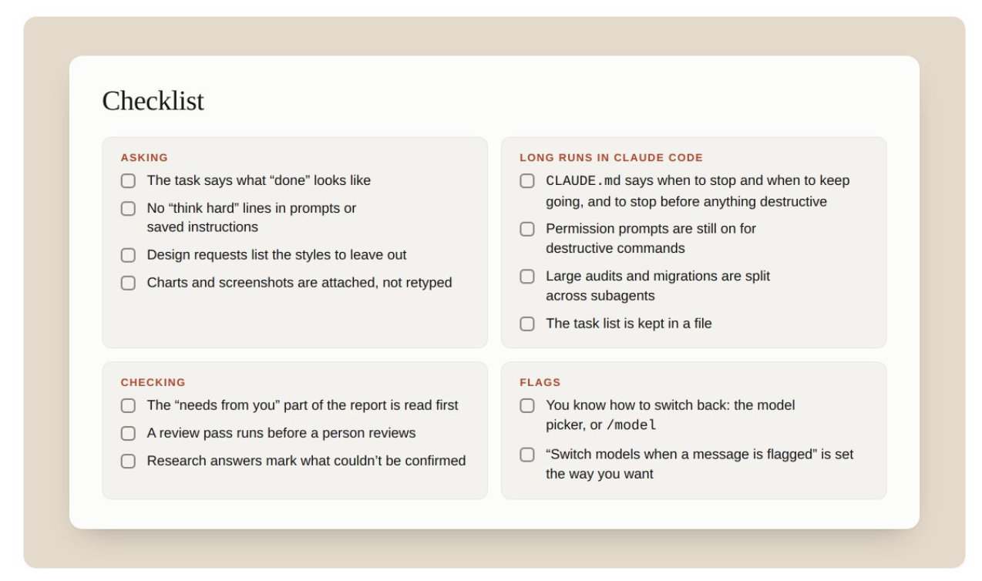

Before every long task, run through this.
Before you start:
☐ Effort set to medium (not inherited from Opus 5) ☐ "Think carefully" lines deleted from prompts ☐ Design requests list specific styles to avoid ☐ Images attached directly - not retyped
For long runs in Claude Code:
☐ CLAUDE.md says when to stop and when to keep going ☐ CLAUDE.md says to stop before anything destructive ☐ Permission prompts still on for destructive commands ☐ Big audits split across subagents ☐ Task list kept in a file (TASKS.md)
For checking results:
☐ Read "what it needs from you" before the rest of the summary ☐ Run a review pass before a human reviews ☐ Research answers mark what could not be confirmed
If a message gets flagged:
☐ Know how to switch back: model picker or /model in Claude Code ☐ "Show your reasoning" lines removed from prompts ☐ Model-switch setting configured the way you want

3 things to do right now
You do not need all 12 tips today.
Three moves give you 80% of the value in the next 30 minutes.
Move 1: Delete every "think carefully" and "think step by step" line from your saved prompts and CLAUDE.md. Opus 5.5 already thinks. You are just adding latency.
Move 2: Open Settings → Usage → check for your free reset. It expires. Use it when you actually hit the wall.
Move 3: Add the settled-answers instruction to your most-used project. Two sentences. Faster follow-ups immediately.
Everything else like effort testing, time budgets, subagent fan-outs, design system prompts, stack on top once these three are running.
The gap between people who read guides and people who actually implement them is two hours.
That is the only moat that matters.

