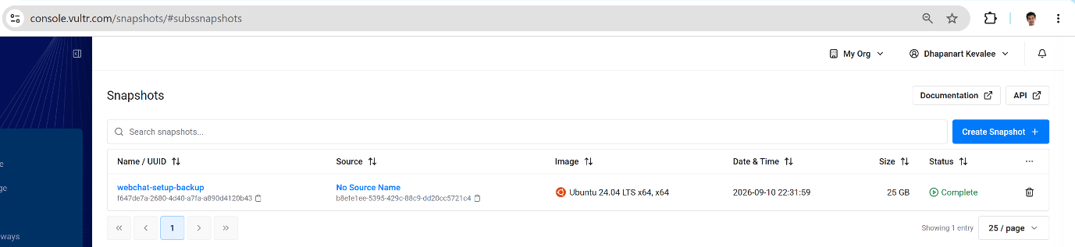
Awesome! The snapshot is now Complete (25 GB safely backed up). Your entire Ubuntu server, Webchat setup, configurations, and files are 100% preserved.

Now you can safely destroy the running Ubuntu instance to stop its hourly charges:

Step 1: Destroy the Running Ubuntu Server
In the left navigation menu, click Compute → Instances (or go back to the Instances list).
Look for the Ubuntu instance (Cloud Instance, IP 139.180.209.200).
Click the three dots (...) on the far right of that row → select Server Destroy (or click into the server and click the Trash Can icon at the top right).
Check the confirmation checkbox ("Yes, destroy this server").
Click Destroy Instance.
Its hourly billing stops immediately!

How to Restore it in the Future (When You Need It Again):
Whenever you are ready to work on or launch the Webchat stack again:

Go to Deploy → Deploy New Server.
Under "Choose Image", click the Snapshot tab.
Select webchat-setup-backup.
Click Deploy Now.
In less than 60 seconds, your exact server boots back up with all services and files intact!

