Submitted By – Pranay Nair, Siya Arora

Submitted To – Prof Benjamin Shefler

Date – April 7th, 2023

Smart Cane

Project Final Report

Contents

Executive Summary 2

Introduction 2

Product Features 3

Product Specifications 3

Operating Instructions 3

Product Design, Implementation, and Operation of the System 4

System Block Diagram 4

Software Diagram 5

Theory of Operation 5

Component Description 7

Maintenance Requirements 8

Conclusion 10

Further Developments 10

Appendix A – Source Code 12

Appendix B – Electrical Schematics 15

Appendix C – Parts List 16

Appendix D – References 17

Appendix E – Contact Information 18

# Executive Summary

The contemporary blind stick is an assistive device developed to aid visually impaired persons in securely and freely navigating their surroundings. It is driven by an Arduino Uno microcontroller and is equipped with a GPS-GSM module for precise position tracking and communication. The gadget is small and light, making it convenient to transport and use while on the road. It has various sensors that detect obstructions and offer haptic feedback to the wearer, as well as notifying the person they want to give their location. The functions of the blind stick are changeable and may be adapted to particular user demands, such as modifying the sensitivity of obstacle detection or setting giving location for anybody to assist. Overall, the contemporary blind stick is a useful and unique option for improving mobility and independence of visually impaired individuals.

# Introduction

Individuals who are visually impaired confront substantial hurdles in their daily lives, such as navigating their environment and avoiding impediments. While traditional white canes and other mobility aids can be useful, they frequently do not give enough information or feedback to allow persons to navigate their surroundings confidently and independently. To overcome this issue, we created a smart blind stick with powerful hardware components and software drivers that enable precise and dependable obstacle recognition, position tracking, and communication capabilities.

An Arduino Uno microcontroller, a GPS module, a GSM module, an ultrasonic sensor linked with a vibration sensor, and a buzzer are among the hardware components used in the smart blind stick. These components work together to deliver a consistent and user-friendly experience for visually impaired people.

The Arduino Uno microcontroller acts as the device's brain, providing the computing power required to run the device's many physical components. The GPS module offers precise position tracking data, allowing users to enter their intended destination and receive step-by-step instructions to get there. The GSM module allows the gadget to interact with cellular networks, which allows it transmit the location of the Smart Cane, whenever the command is sent to the number.

The ultrasonic sensor, in conjunction with the vibration sensor, detects barriers accurately and reliably, allowing the device to scan its environment and deliver haptic feedback to the user as they approach impediments such as walls or curbs. The buzzer gives the user with additional audible input, adding an extra layer of information to assist them navigate.

Overall, the smart blind stick is a big step forward in allowing visually impaired people to navigate their surroundings with increased confidence and freedom. The gadget delivers precise and dependable obstacle detection, position tracking, and communication capabilities by merging powerful hardware components and software drivers, all in a compact and user-friendly form factor. We will offer a full explanation of the device's hardware and software components, as well as its operating and maintenance needs, in the next sections of this report.

# Product Features

* Obstacle Detection – The Ultrasonic sensors detect any obstacles in the path of the user for up to 25cm
* Feedback – The vibration motor make the stick vibrate to alert the user of any obstacles in front of them. The buzzer makes a beeping noise at the same time to alert the user.
* Location tracking – GPS module tracks the user’s live location via satellite which is accurate up to 2.5M
* SMS Alerts – The GSM module makes it possible to send alert messages to a specified phone number via SMS which includes the user’s coordinates.
* User-friendly – The device has simple controls and mechanisms and is cost-effective without compromising quality.

# Product Specifications

* Cane: 50 inches length
* Metal Enclosure for circuit: 3"x 2.5" x 1.3" (L x B x H)
* Product Weight: 500g
* Battery: 6V (4x AAA batteries)
* Battery Life: 13 – 14 months
* System Operating Voltage: 5V
* Obstacle detection range 0 – 25 cm

# Operating Instructions

The operation instructions for the modern blind stick are as follows:

* Turn on the device by inserting the battery into the socket.
* The device will automatically connect to the GPS and GSM modules to determine your location and provide accurate location and will be ready to send emergency alerts with location.
* As you navigate, the device will use a combination of sensors to detect obstacles in your path, including ultrasonic sensor. The device will provide haptic feedback to warn you of obstacles, such as vibrating or beeping, depending on the obstacle's distance and direction.
* To adjust the sensitivity of obstacle detection, enter the desired distance in centimeters in the provided code. From here, you can adjust the sensitivity levels to your desired preference.
* To turn off the device, just remove the battery pack from its socket.
* If you encounter any issues or need further assistance, refer to the user manual or contact customer support for additional help.

# Product Design, Implementation, and Operation of the System

## System Block Diagram

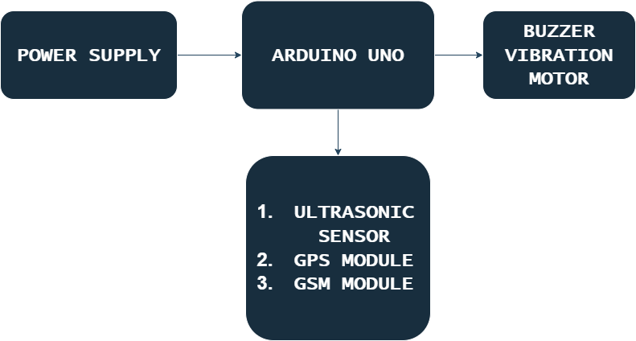

## Software Diagram

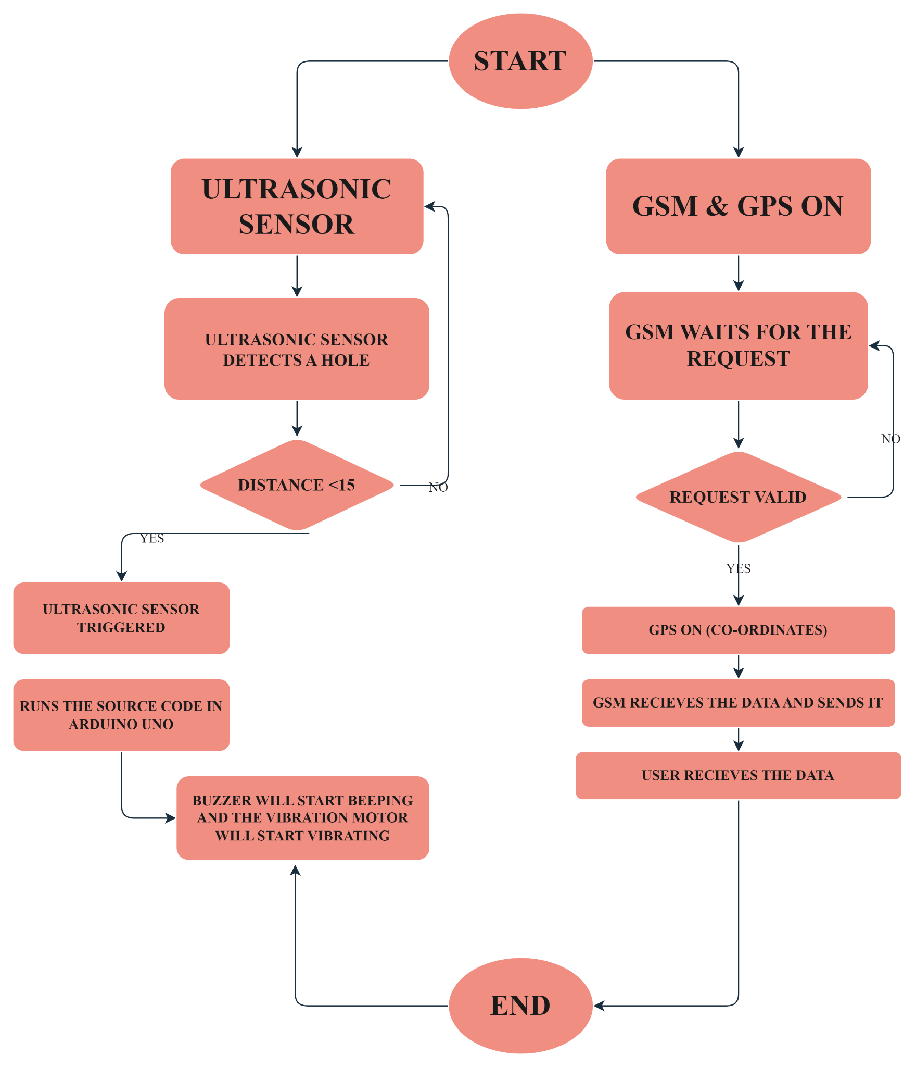

## Theory of Operation

The smart cane is designed to assist visually impaired individuals with navigating their environment safely and independently. The device incorporates a range of hardware components, including obstacle detection sensors, a GPS module, a GSM module, a haptic feedback module and a buzzer. These components work together with the device's software drivers to provide a cohesive and user-friendly experience.

When the device is turned on, it begins scanning its environment using its obstacle detection sensor. These sensor use ultrasonic waves to detect nearby obstacles, such as walls, curbs, or other objects, and provide haptic feedback to the user through a vibration motor. The sensitivity of these sensors can be adjusted through the device's settings menu to better suit the user's preferences and the surrounding environment.

The device's GPS module provides accurate location tracking data, which is used to help the user to know the exact location that they’re in.

In addition to its obstacle detection and GPS capabilities, the device incorporates a GSM module that allows it to communicate with cellular networks. This enables the device to provide additional functionality, such as sending alerts or emergency messages, or receiving notifications from other devices.

Throughout its operation, the device's hardware components and software drivers work together to provide a cohesive and reliable user experience. The device's software is designed to be user-friendly and easy to navigate, with a simple and intuitive interface. The software is also designed to be customizable, allowing users to adjust settings such as obstacle detection sensitivity, haptic feedback strength.

By combining accurate location tracking with advanced obstacle detection and communication capabilities, the Smart Cane enables visually impaired individuals to navigate their environment with greater confidence and independence. The device's compact size and portability make it easy to carry with them wherever they go, providing a practical and effective solution to improve the mobility and independence of visually impaired individuals.

## Component Description

|  |  |  |
| --- | --- | --- |
| **#** | **Component Name** | **Specifications** |
| 1. | Ping Ultrasonic Range Finder | * Voltage: +5 VDC * Measurable distances: 2cm – 700cm * Positive TTL pulse * Dimensions: 0.81 x 1.8 x 0.6 in (22 x 46 x 16 mm) * Operating temp range: +32 to +158°F (0 to * +70°C) |
| 2. | Arduino Uno | * Micro-Controller ATmega328P * Operating Voltage 5V * Input Voltage (recommended) 7-12V * Input Voltage (limits) 6-20V * Digital I/O Pins 14 (of which 6 provide PWM output) * Analog Input Pins 6 |
| 3. | SIM900A GSM MODULE | * Single supply voltage: 3.4V – 4.5V * Power saving mode: Typical power consumption in SLEEP mode is 1.5mA * Frequency bands: SIM900A Dual-band: EGSM900, DCS1800. The SIM900A can search the two frequency bands automatically. The frequency bands also can be set by AT command. * GSM class: Small MS * GPRS connectivity: GPRS multi-slot class 10 (default) , GPRS multi-slot class 8 (option) * Transmitting power: Class 4 (2W) at EGSM 900, Class 1 (1W) at DCS 1800 |
| 4. | VIBRATING MOTOR | * Rated voltage: 3.0V DC * Operating voltage range: 2.3-4.0V DC * Direction of rotation: CM (clockwise) or CCW (counter clockwise) * Rated speed: 11000 ± 2500rpm * Rated current: 80mA Max |
| 5. | NEO-6M GPS MODULE | * Operating voltage: 3.6V-5V * Operating baud rate: 9600 (can be modified) * Onboard rechargeable button battery * Onboard E2PROM can save parameter data * NEMA output format is compatible with NEO-6M * Size: 27.6mm * 26.6mm can be inserted or selected patch (with positioning holes) |
| 6. | WALKING CANE | * Provides good support * Adjustable height * Lightweight & foldable * Non-slip base * Simple and convenient to use |
| 7. | METAL ENCLOSURE | * Moisture proof * Anti-corrosion * Durable for years use |

# Maintenance Requirements

1. Keep the device clean and dry. Use a damp cloth to wipe down the device as needed, and avoid exposing it to moisture or extreme temperatures.
2. Regularly check the battery level and remove the battery when not in use. Also, if change the battery if necessary.
3. Check the sensors and haptic feedback module periodically to ensure they are functioning properly. Use the provided code to adjust the sensitivity levels of the obstacle detection sensors as needed.
4. Keep the board and speaker clean and free of debris or damage. Avoid pressing buttons too hard or using sharp objects near the device.
5. Regularly check for software updates for the Arduino IDE and install them as needed. This will ensure that the device is running at optimal performance and has the latest features and bug fixes.
6. If you encounter any issues or problems with the device, refer to the user manual or contact customer support for assistance. Do not attempt to repair or modify the device yourself, as this may cause further damage or void the warranty.
7. By following these maintenance requirements, you can help ensure that the modern blind stick continues to function properly and provides reliable assistance to visually impaired individuals.

# Conclusion

The smart blind stick is a significant tool for visually impaired people, allowing them to navigate their surroundings with increased confidence and freedom by offering precise and reliable obstacle detection, position tracking, and communication capabilities. We have documented in depth the device's hardware and software components, as well as its operating and maintenance needs, in this report.

One of the smart blind stick's primary features is its strong obstacle detecting capabilities. The gadget can detect surrounding impediments and deliver haptic feedback to the user by combining an ultrasonic sensor with a vibration sensor. This input allows the user to alter their movement and avoid obstructions, giving them a degree of safety and confidence that standard white canes and other mobility aids cannot provide.

The hardware components of the smart blind stick are powered by strong software drivers that give a user-friendly and configurable interface. The software on the device is meant to be simple to use, with a basic and straightforward interface that can be customised to the user's preferences. Users may alter numerous parameters, including as obstacle detection sensitivity, haptic feedback strength, and auditory cues, via the device's settings menu to better fit their specific needs and surroundings. In addition to its obstacle detection capabilities, the smart blind stick also incorporates accurate location tracking, enabled by its GPS module. The device's GSM module also enables it to communicate with cellular networks, providing additional functionality such as sending exact location to the guardian.

Overall, the smart blind stick is a strong and promising tool for visually impaired people, allowing them more independence and safety in their everyday lives. It has the potential to change the lives of innumerable people all over the world if it is further developed and refined.

# Further Developments

Here are some additional potential developments for the Smart Cane in more detail:

1. Machine Learning: Incorporating machine learning algorithms into the device could help improve obstacle detection accuracy and adaptability to different environments. By analyzing sensor data and learning from past experiences, the device could potentially become more effective at identifying and avoiding obstacles in a variety of settings, such as crowded streets or unfamiliar locations.
2. Bluetooth Connectivity: Adding Bluetooth connectivity to the device could enable it to communicate with other compatible devices, such as smartphones, tablets, or smart watches. This could enable the device to provide additional functionality, such as receiving notifications or alerts from other devices, or providing location data to other applications.
3. Voice Assistants: Incorporating voice assistants, such as Google Assistant or Apple Siri, could enable the device to respond to voice commands and provide spoken feedback to the user. This could provide an alternative to the keypad interface and enable users to interact with the device more conveniently.
4. Battery Life: Improving battery life could enable the device to last longer between charges and provide greater reliability and convenience to the user. This could potentially be achieved through the use of more efficient hardware components or software optimizations.
5. GSM Module Range: Increasing the range of the GSM module could enable the device to provide location data and communication capabilities over a greater distance. This could be particularly useful for users who frequently travel or live in areas with limited cellular coverage.
6. Size and Weight: Reducing the size and weight of the device could make it even more portable and convenient for users to carry with them. This could potentially be achieved through the use of more compact and efficient hardware components or through design optimizations.

# Appendix A – Source Code

#include <TinyGPS.h>

#include <SoftwareSerial.h>

const int trigPin = 9;

const int echoPin = 10;

const int vibration = 6;

int state = 0;

const int pin = 7;

float gpslat, gpslon;

TinyGPS gps;

SoftwareSerial sgps(4, 5);

SoftwareSerial sgsm(2, 3);

static const uint32_t GPSBaud = 9600;

long duration;

int distanceCm, distanceInch;

void setup()

{

Serial.begin(9600);

sgsm.begin(9600);

sgps.begin(9600);

pinMode(trigPin, OUTPUT);

pinMode(echoPin, INPUT);

pinMode(vibration, OUTPUT);

pinMode(6, OUTPUT); // Connect Vibration Pin D6

pinMode(11, OUTPUT); // Connect Buzzer Pin D11

}

void loop()

{

digitalWrite(trigPin, LOW);

delayMicroseconds(2);

digitalWrite(trigPin, HIGH);

delayMicroseconds(10);

digitalWrite(trigPin, LOW);

duration = pulseIn(echoPin, HIGH);

distanceCm= duration*0.034/2;

distanceInch = duration*0.0133/2;

Serial.println("Distance: ");

Serial.println(distanceCm);

delay (100);

if(distanceCm < 25)

{

digitalWrite(11, HIGH); // Buzzer ON

digitalWrite(6, HIGH); // Vibration ON

}

else

{

digitalWrite(11,LOW); // Buzzer OFF

digitalWrite(6,LOW); // Vibration OFF

}

sgps.listen();

while (sgps.available())

{

int c = sgps.read();

if (gps.encode(c))

{

gps.f_get_position(&gpslat, &gpslon);

}

}

sgsm.listen();

if (sgsm.available() > 0) {

String c = sgsm.readString();

c.trim();

if (c.indexOf("GET-GPS") >= 0) {

sgsm.print("\r");

delay(1000);

sgsm.print("AT+CMGF=1\r");

delay(1000);

/*Replace XXXXXXXXXX to 10 digit mobile number &

ZZ to 2 digit country code*/

sgsm.print("AT+CMGS=\"+014374213663\"\r");

delay(1000);

//The text of the message to be sent.

sgsm.print("Smart Cane Location - ");

sgsm.print("https://www.google.com/maps/?q=");

sgsm.print(gpslat, 6);

sgsm.print(",");

sgsm.print(gpslon, 6);

delay(1000);

sgsm.write(0x1A);

delay(1000);

}

delay(100);

}

}

# Appendix B – Electrical Schematics

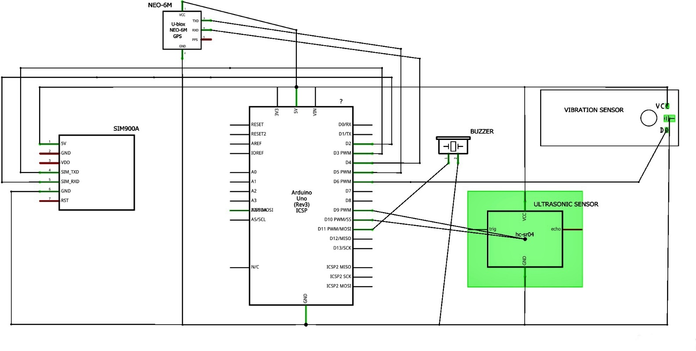

# Appendix C – Parts List

|  |  |  |  |  |
| --- | --- | --- | --- | --- |
| **Quantity** | **Part Number** | **Manufacturer Part Number** | **Description** | **Unit Price (CAD)** |
| 1 | 1050-1041-ND | A000073 | ARDUINO UNO SMD R3 ATMEGA328 | 37.89 |
| 1 | 1528-2711-ND | 3942 | ULTRASONIC SENSOR SONAR DISTANCE | 6.06 |
| 1 | 2104-IE092505-1-ND | IE092505-1 | BUZZER ELECTRO 5V 9.6MM TH | 3.85 |
| 1 | 1568-1747-ND | PRT-13839 | STOMP BOX ALUM 4.409"L X 2.402"W | 7.67 |
| 1 | - | SN12SF83QOH11452IC | GPS Module GPS NEO-6M | 14.99 |
| 1 | - | Thincoltnv31b47rk1034 | SIM900A SMS Development Board | 17.14 |
| 1 | - | VGEBY9xue5gimaw1665 | Walking Stick for Blind People and Visual Impaired | 19.99 |
| 4 | 3046-AAA-MN2400-ND | AAA-MN2400 | AAA Alkaline Manganese Dioxide 1.5 V Battery Non-Rechargeable | 0.73 |
| TOTAL |  |  |  | 110.51 |

# Appendix D – References

A. (2022a, June 15). *SMART BLIND STICK USING ARDUINO ,GSM MODULE ,GSM MODULE,ULTRASONIC SENSOR AND RAIN SENSOR.* Electronics Workshop. https://electronicsworkshops.com/2020/06/14/smart-blind-stick-using-gsm-module-gsm-moduleultrasonic-sensor-and-rain-sensor/

A. (2022b, November 18). *Smart Blind Stick Using Arduino | Ultrasonic sensor based project*. Techatronic. https://techatronic.com/smart-blind-stick-using-arduino-and-ultrasonic-sensor/

S. (2017, September 21). *Smart Blind Stick using Arduino in Proteus*. The Engineering Projects. https://www.theengineeringprojects.com/2017/09/smart-blind-stick-using-arduino-proteus.html

*Interfacing GSM and GPS Module using Arduino: A step-by-step guide tutorial for tracking — Steemit*. (n.d.). Steemit. <https://steemit.com/utopian-io/@kimp0gi/interfacing-gsm-and-gps-module-using-arduino-a-step-by-step-guide-tutorial-for-tracking>

Admin. “How to Send GPS Location via SMS Using GSM and Arduino?” *Mechatrofice*, 6 Apr. 2022, mechatrofice.com/arduino/send-gps-location-via-sms.

# Appendix E – Contact Information

Name – Siya Arora

Email – [sarora106@myseneca.ca](mailto:sarora106@myseneca.ca)

Phone No. - +1 647-510-0957

Name – Pranay Nair

Email – [ppnair@myseneca.ca](mailto:ppnair@myseneca.ca)

Phone No. - +1 437-421-3663

The contemporary blind stick is an assistive device developed to aid visually impaired persons in securely and freely navigating their surroundings. It is driven by an Arduino Uno microcontroller and is equipped with a GPS-GSM module for precise position tracking and communication. The gadget is small and light, making it convenient to transport and use while on the road. It has various sensors that detect obstructions and offer haptic feedback to the wearer, as well as notifying the person they want to give their location. The functions of the blind stick are changeable and may be adapted to particular user demands, such as modifying the sensitivity of obstacle detection or setting giving location for anybody to assist. Overall, the contemporary blind stick is a useful and unique option for improving mobility and independence of visually impaired individuals.

Visually impaired individuals face significant challenges in their daily lives, including navigating their environment and avoiding obstacles. While traditional white canes and other mobility aids can be helpful, they often do not provide enough information or feedback to enable individuals to navigate their environment with confidence and independence. To address this challenge, we have developed a smart blind stick that incorporates advanced hardware components and software drivers to provide accurate and reliable obstacle detection, location tracking, and communication capabilities.

The smart blind stick incorporates a range of hardware components, including an Arduino Uno microcontroller, a GPS module, a GSM module, an ultrasonic sensor paired with a vibration sensor, and a buzzer. These components work together to provide a cohesive and user-friendly experience, enabling visually impaired individuals to navigate their environment with greater ease and confidence.

The Arduino Uno microcontroller serves as the brain of the device, providing the necessary processing power to drive the device's various hardware components. The GPS module provides accurate location tracking data, allowing users to input their desired destination and receive step-by-step directions to guide them to their destination. The GSM module enables the device to communicate with cellular networks, providing additional functionality such as sending alerts or emergency messages.

The ultrasonic sensor paired with the vibration sensor provides accurate and reliable obstacle detection, allowing the device to scan its environment and provide haptic feedback to the user when they approach obstacles such as walls or curbs. The buzzer provides additional audio feedback to the user, providing an extra layer of information to help them navigate their environment.

Overall, the smart blind stick represents a significant step forward in enabling visually impaired individuals to navigate their environment with greater confidence and independence. By incorporating advanced hardware components and software drivers, the device provides accurate and reliable obstacle detection, location tracking, and communication capabilities, all within a compact and user-friendly form factor. In the following sections of this report, we will provide a detailed description of the device's hardware and software components, as well as its operation and maintenance requirements.