CHIP DESIGN ASSOCIATE · O-LEVEL ‘CHIP DESIGN’
Module 2 — Topic 4
RTL Design Using HDL
Tutorial & Practice Workbook
A self-study companion to the Topic 4 slide deck. It elaborates every construct the deck introduces, explains what each one becomes in hardware and why, walks through six guided tutorials at the keyboard, and ends with 60 graded exercises and full worked solutions. Every design referred to here exists as verified, runnable code in Topic4_Lab/. Nothing in this workbook requires you to look anything up elsewhere.
NOS: NIE/ELE/N0102 · Module 2 “Verilog RTL coding for Synthesis”, Topic 4 · Syllabus: introduction to Verilog syntax and constructs; designing combinational and sequential logic using HDL; writing RTL code for basic digital circuits. Practical component: RTL Design and Implementation Labs (40 h), Design Synthesis and Optimization Labs (15 h), Timing Analysis and Closure Labs (10 h).
What's inside
Part 1 The Verilog language — modules, values, types, literals, vectors, operators, width rules, procedural blocks, control flow, tasks and functions, parameters, generate, directives, system tasks, and the synthesisable subset
Part 2 Modelling logic — the inference map, combinational style, latch inference, the clocked template, blocking vs non-blocking, the event queue, reset strategy, counters, shift registers, edge detection, CDC, state machines, memory and pipelining
Part 3 Writing RTL for basic circuits — the design catalogue, verification method, testbench construction, scoreboards, randomisation, a synchronous FIFO and a complete UART, plus two real bug case studies
Part 4 Tool setup and six guided tutorials — the open-source chain, Vivado Design Suite and ModelSim, step by step at the keyboard
Part 5 60 practice exercises, graded from recall through prediction to full design
Part 6 Full worked solutions to every exercise
Part 7 Reference — glossary, command card, coding-standard checklist and the troubleshooting table

How to use this workbook
Read a section, then immediately open the matching file in Topic4_Lab/rtl/ and read the real code. Every idea here has a file behind it. When the workbook quotes a tool output, run the command yourself and compare — the outputs quoted from Icarus Verilog 12.0, Verilator 5.020 and Yosys 0.33 were really produced by those tools on this code.
Work the exercises in order within each block. The prediction exercises (“what does this become?”) are the ones that build the skill this module is actually assessing; do not skip them because they have no code to type.

Part 1 · The Verilog Language
Verilog exists to describe hardware. That sentence sounds obvious and is the single hardest thing for a newcomer with programming experience to internalise, because the language deliberately borrows C's syntax. This part covers the language systematically. Read it once end to end, then use it as a reference.

1.1 Why an HDL exists at all
Before hardware description languages, a chip was captured as a schematic: a drawing of every gate and every wire. That works up to a few thousand gates. A modern SoC has billions of transistors. Nobody draws that.
An HDL lets you describe behaviour and structure in text, which means the description can be version-controlled, diffed, reviewed, parameterised, generated by scripts and — crucially — automatically translated into gates by a synthesis tool. That last step is what makes the whole industry possible: you describe what the circuit does between clock edges, and a tool works out which gates in which technology will do it.
Verilog and VHDL are the two established HDLs. Verilog dominates in industry in Asia and North America and is what this course uses; SystemVerilog is its modern superset and adds features you will meet in verification. VHDL is more verbose, more strongly typed, and common in European and defence work. The concepts transfer completely; only the syntax differs.

Verilog is not a programming language
A program | A hardware description
Statements execute one after another | Everything described exists at once and runs continuously
A variable holds a value in memory | A signal is a wire or a register that physically exists
A function call runs code that already exists | A function call creates ANOTHER COPY of the logic
A loop repeats over time | A loop is unrolled at compile time into repeated hardware
Speed depends on how many instructions run | Speed depends on the longest path between two registers
Adding a feature costs memory | Adding a feature costs area, power and possibly timing

The habit that prevents most beginner problems
Before you type a line of Verilog, sketch the hardware: which registers exist, what logic sits between them, what feeds what. Then write the code that describes that sketch. Designers who sketch first produce clean RTL immediately. Designers who type first and hope produce latches, races and timing failures — and then spend the afternoon in a waveform viewer.

1.2 Levels of abstraction
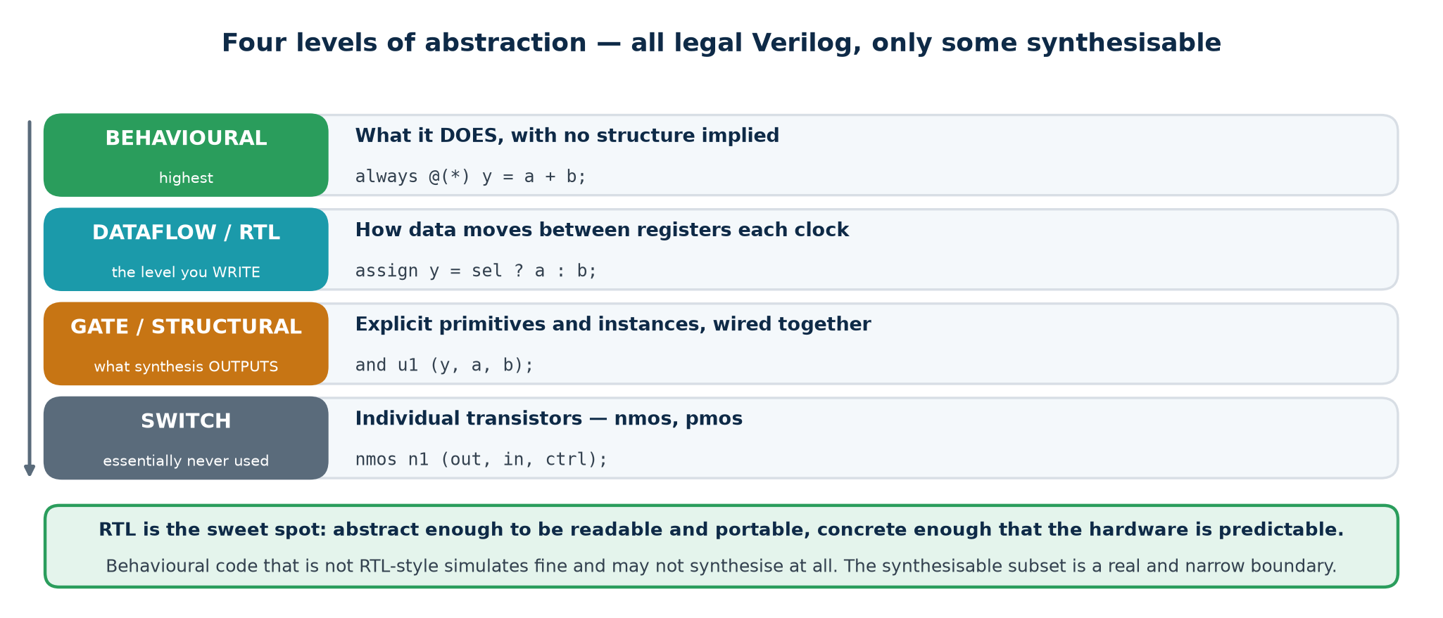
The four levels of description. Only the middle two are what you write.
All four levels below are legal Verilog and all four simulate. Only some synthesise.
Level | You describe | Synthesises? | Who writes it
Behavioural | Algorithms, with delays and file I/O | Mostly no | Verification engineers, in testbenches
RTL (register transfer) | What happens to data between clock edges | Yes — this is the target | Design engineers. You.
Gate level | Explicit AND, OR, NOT primitives and their connections | Yes, but nobody writes it | Synthesis tools, as output
Switch level | Individual transistors | No | Nobody, outside custom cell design

RTL is the sweet spot: abstract enough to read and to port between technologies, concrete enough that the hardware is predictable. You should be able to read gate-level netlists — you will look at them in synthesis reports — but you will never write one.

1.3 The module — the only unit of design
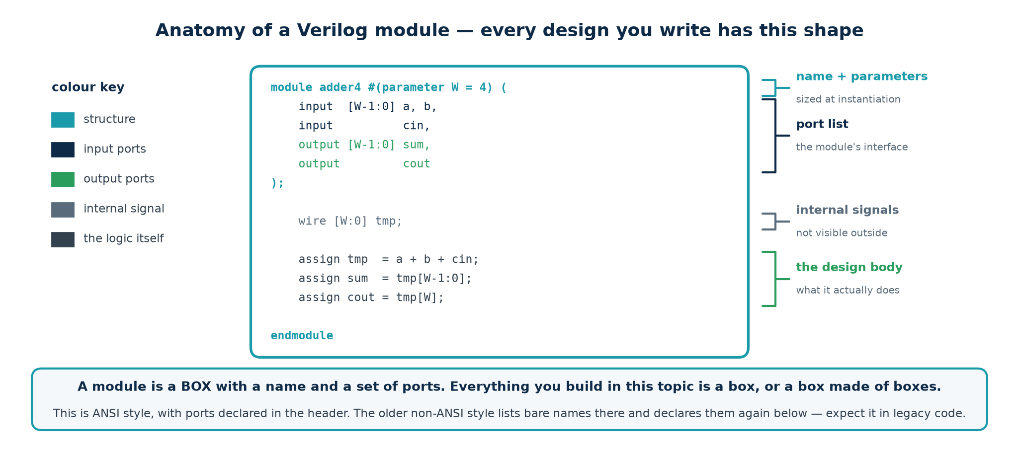
Every design you write has this shape.
A module is a box with a name, a set of ports and a body. Everything you build is a box, or a box made of boxes. There is no other unit of design in Verilog.
A complete, well-formed Verilog module
`timescale 1ns / 1ps // time unit / precision -- first line of every file
`default_nettype none // no implicit wires -- see 1.14

module adder4 #(
parameter integer W = 4 // parameters: sized at instantiation
)(
input wire [W-1:0] a, // port list: the module's interface
input wire [W-1:0] b,
input wire cin,
output wire [W-1:0] sum,
output wire cout
);

wire [W:0] tmp; // internal signals: not visible outside

assign tmp = a + b + cin; // the design body: what it actually does
assign sum = tmp[W-1:0];
assign cout = tmp[W];

endmodule

`default_nettype wire // restore the default for other files

Port directions
Direction | Meaning | Rules
input | Driven from outside, read inside | Never assign to an input inside the module
output | Driven inside, read outside | Exactly ONE thing inside may drive it
inout | Bidirectional | Only on real chip pins; needs a tri-state driver

ANSI and non-ANSI headers
Two styles exist. Use the ANSI style shown above, where direction, type and width all appear once in the header. You will meet the older non-ANSI style in legacy code:
Non-ANSI style — read it, do not write it
module adder4 (a, b, cin, sum, cout); // non-ANSI: bare names in the header
input [3:0] a, b; // ... then declared again in the body
input cin;
output [3:0] sum;
output cout;
...
endmodule

The non-ANSI form states each port twice, which means the two statements can disagree. Every modern coding standard requires ANSI headers.

1.4 Four-value logic
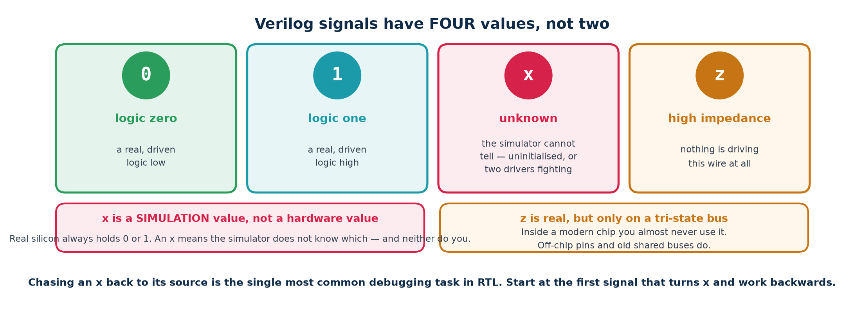
Two hardware values, and two things the simulator says.
Value | Means | Real hardware?
0 | Logic low | Yes
1 | Logic high | Yes
x | Unknown — the simulator cannot say what this is | No. Real silicon always has SOME voltage.
z | High impedance — nothing is driving this wire | Yes, on a tri-state bus or an unconnected pin

x is a simulation concept, not a hardware state. Real silicon settles on some voltage; the simulator says x when it cannot determine which. An x on your waveform is the simulator telling you that YOU have not determined it either — that the design's behaviour depends on something undefined.

Where an x comes from — the five usual suspects
1. A register that was never reset. Its power-up value is genuinely unknown, so the simulator says so.
2. A wire that nothing drives — often a typo in a port connection, which `default_nettype none would have caught.
3. A wire that TWO things drive, with different values. A multi-driver conflict resolves to x.
4. Reading past the end of a vector or outside the bounds of an array.
5. Arithmetic or logic on a value that is already x. x is contagious.
Chasing an x
Because x spreads, the signal where you NOTICED the x is almost never the signal that CAUSED it. In the waveform viewer, find the first time the suspect signal goes x, then add whatever drives it and repeat, walking backwards, until you reach the first signal that turned x on its own. That signal is the bug.
In a testbench, always compare with === and !== — the four-state comparison operators. Plain == against an x returns x, which is not true, so the check silently passes and the bug escapes.

1.5 Nets and variables — wire, reg and the great naming accident
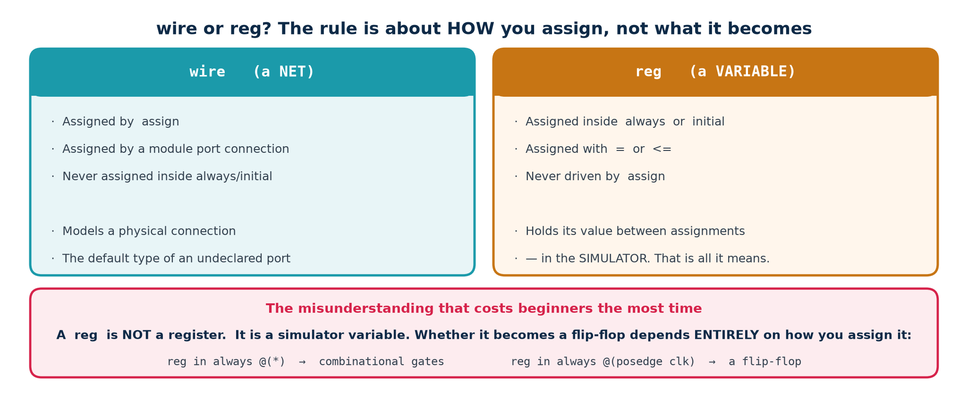
Whether it becomes a flip-flop depends on HOW you assign.
A reg is not a register. It is a variable in the simulator — a thing that holds a value between assignments. Whether it becomes a flip-flop, a piece of combinational logic, or a latch depends entirely on how and where you assign it. The keyword was named in 1985 and the name has confused students ever since.
You want | Declare it | Assign it with | You get
A wire between two things | wire | assign, or a port connection | A wire
Combinational logic in a block | reg | = inside always @(*) | Gates
A flip-flop | reg | <= inside always @(posedge clk) | A flip-flop
An output driven by assign | wire (the default) | assign | A wire
An output driven by a block | reg | inside the always block | Depends on block

Net types you will actually meet
Type | Use
wire | The default net. A simple connection with one driver.
tri | Identical to wire; the name documents that several drivers are expected.
supply0 / supply1 | A constant tie to ground or to the supply rail.
wand / wor | Wired-AND / wired-OR resolution. Rare in synthesisable RTL.

Variable types
Type | Use
reg | The general variable. Any width. Synthesisable.
integer | A 32-bit signed variable. Loop counters. Not for design signals.
real | Floating point. Simulation only — never synthesises.
time | A 64-bit unsigned value for timestamps. Simulation only.

SystemVerilog fixes this
SystemVerilog adds logic, which may be driven either by an assign or from inside a procedural block, and removes the wire/reg decision entirely. If your tool flow accepts SystemVerilog, use logic everywhere. You must still be able to READ Verilog-2001, because a very large amount of existing IP is written in it — including much of what you will be asked to maintain.

1.6 Number literals
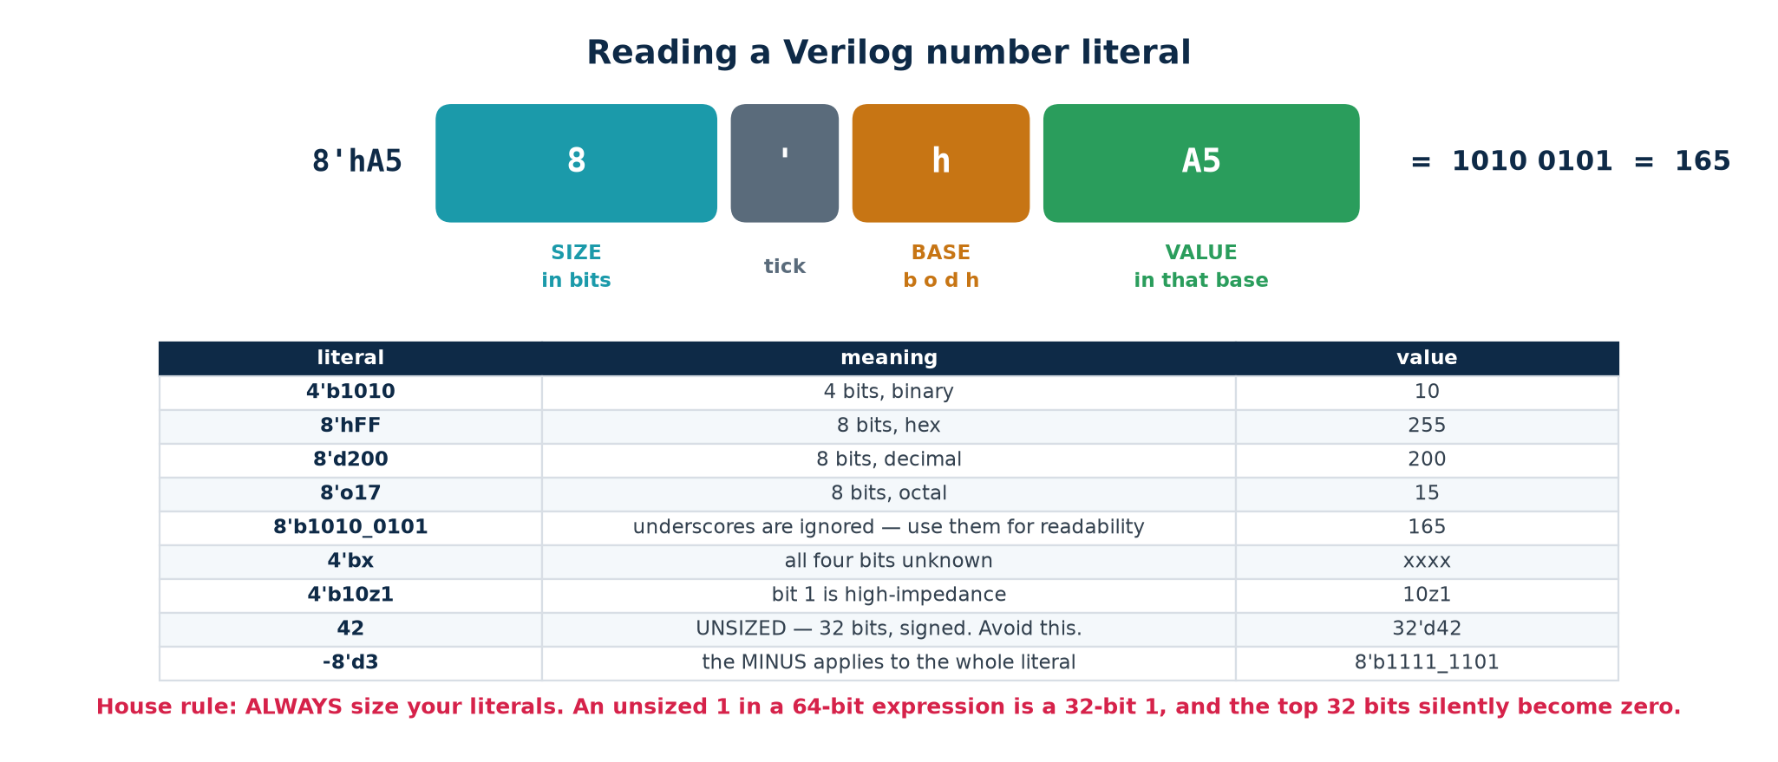
Every constant has a width as well as a value.
The general form is <width>'<radix><value>. The radix is one of b binary, o octal, d decimal, h hexadecimal. Underscores may appear anywhere in the value and are ignored — use them to group digits.
Literal | Width | Value | Note
8'd10 | 8 | 00001010 | Decimal 10 in 8 bits
8'hFF | 8 | 11111111 | 255
4'b1010 | 4 | 1010 | 10
8'b1010_1100 | 8 | 10101100 | Underscores are cosmetic
12 | 32, SIGNED | …00001100 | No width given — this is the trap
-8'd1 | 8 | 11111111 | Two's complement of 1
8'sd200 | 8, signed | 11001000 | Signed: this is −56, not 200
8'bx | 8 | xxxxxxxx | x extends to fill the width
'0 '1 'x 'z | context | all bits | SystemVerilog fill literals

The house rule: size every literal
Write 8'd0 not 0. Write {W{1'b0}} for a parameterised all-zeros. It costs three keystrokes and eliminates an entire family of silent bugs — because an unsized literal is 32 bits wide and signed, and both of those facts will eventually surprise you.

1.7 Vectors, slices, concatenation and replication
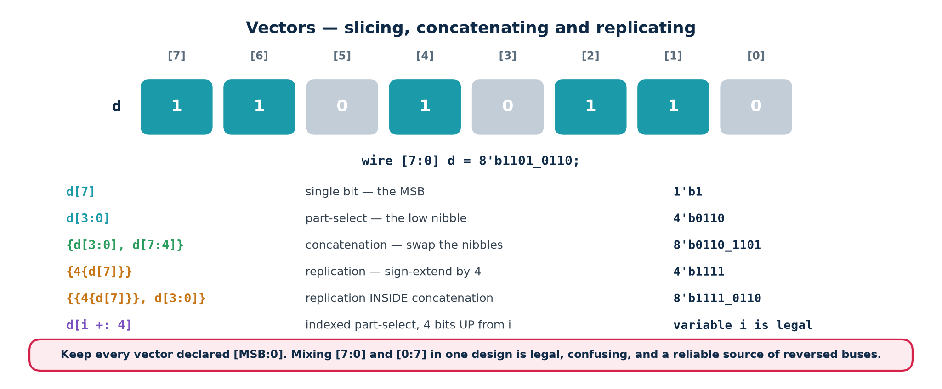
Taking buses apart and putting them back together.
Vector operations
wire [7:0] d; // 8 bits, d[7] is the MSB (use this order)
wire [0:7] e; // 8 bits, e[0] is the MSB (legal, confusing, avoid)

d[3] // one bit
d[7:4] // the top nibble -- a 4-bit value
{a, b} // concatenation: a then b, side by side
{4{2'b10}} // replication: 8'b10101010
{2'b11, {3{1'b0}}, 3'b101} // 8'b11000101 -- mix freely

d[i +: 4] // indexed part-select: 4 bits UP from i
d[i -: 4] // 4 bits DOWN from i

Arrays are not vectors
Vectors vs arrays
reg [7:0] v; // ONE 8-bit vector -- you can slice it
reg v [0:7]; // EIGHT 1-bit elements -- you index it, cannot slice
reg [7:0] m [0:255]; // 256 bytes -- a memory

v[3:0] // legal: a slice of a vector
m[17] // legal: one byte of the memory
m[17][3:0] // legal: the bottom nibble of that byte
m[3:0] // ILLEGAL: you cannot slice an array

Why indexed part-select exists
A plain slice needs constant bounds: d[i:j] is illegal when i is a signal, because the tool must know how many bits the expression produces. d[i +: 4] has a constant WIDTH (4) and a variable POSITION — which is exactly what a multiplexer does, so it synthesises to one. This is the correct idiom for 'select the nth byte of a wide bus'.

1.8 Operators
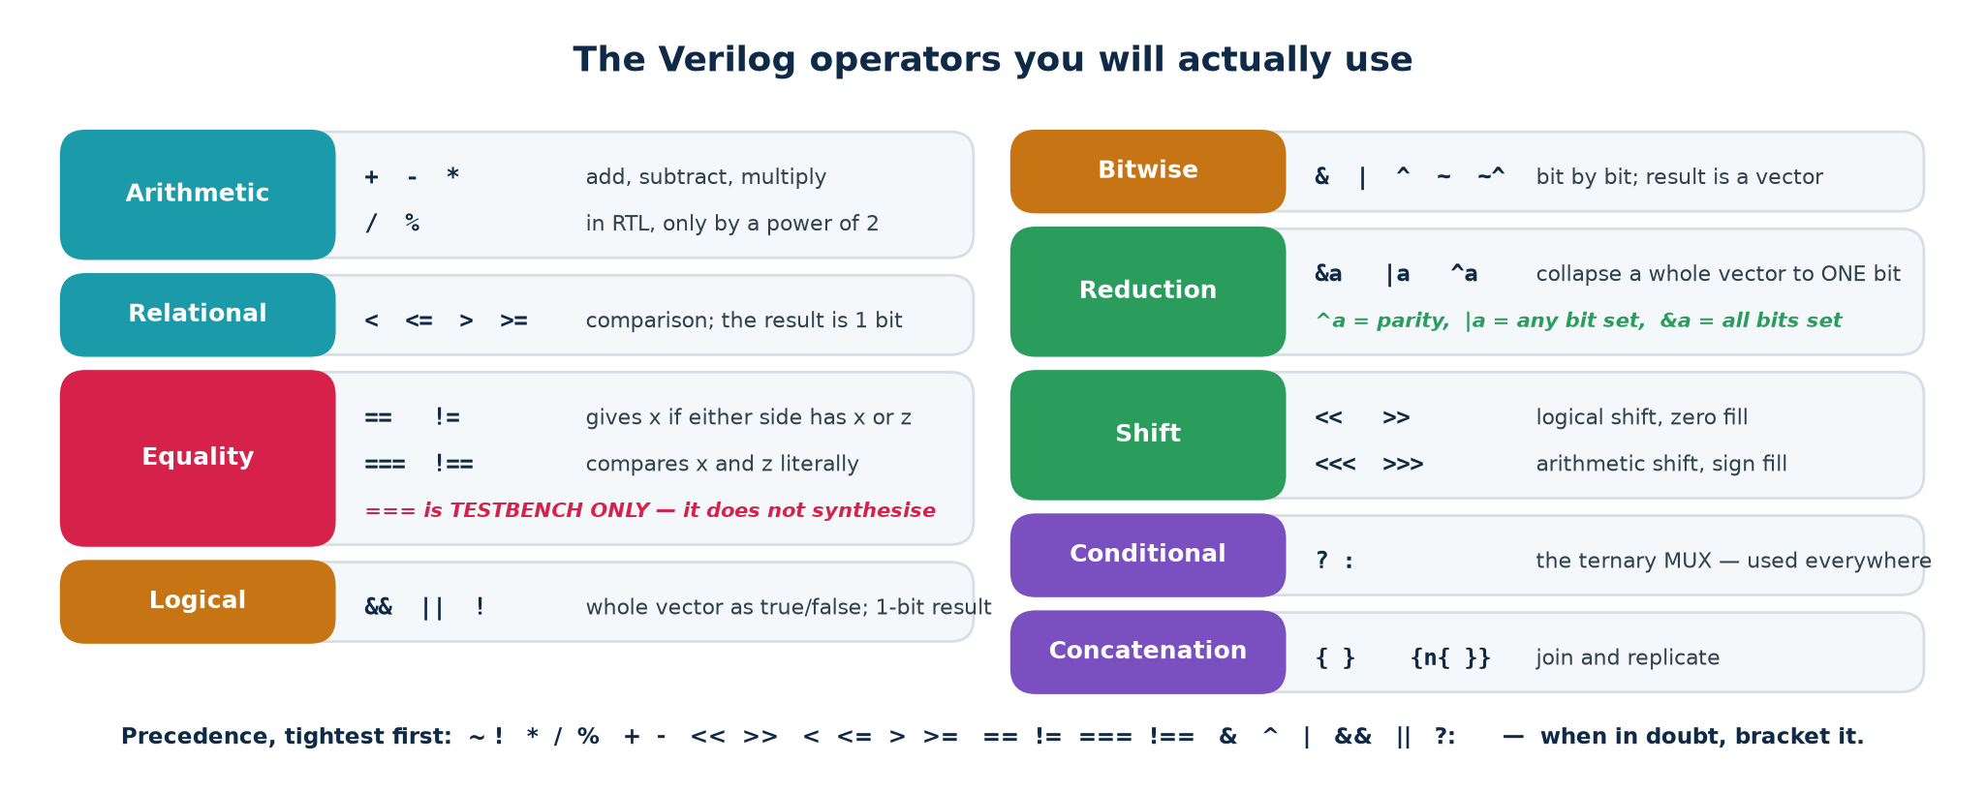
The operators you will actually use.
Class | Operators | Result width
Arithmetic | + - * / % ** | Widest operand (see 1.9)
Bitwise | ~ & | ^ ~^ | Widest operand
Logical | ! && || | 1 bit
Relational | < <= > >= | 1 bit
Equality | == != === !== | 1 bit
Reduction | & ~& | ~| ^ ~^ (unary) | 1 bit
Shift | << >> <<< >>> | Left operand
Conditional | ? : | Widest branch
Concatenation | { } { { } } | Sum of parts

Logical versus bitwise — the classic slip
&& gives one bit; & gives a vector
a = 4'b0011; b = 4'b1100;

a && b -> 1'b1 // both are non-zero, so both are 'true'
a & b -> 4'b0000 // bit by bit: 0&1, 0&1, 1&0, 1&0

!a -> 1'b0 // a is non-zero, so 'not a' is false
~a -> 4'b1100 // every bit inverted

Reduction operators are underused
Expression | Means | Hardware
|req | Is ANY bit set? | An OR tree — a 'valid' flag
&full | Are ALL bits set? | An AND tree
^data | Parity of the whole vector | An XOR tree
~|result | Is the result zero? | A NOR tree — the ALU's Z flag

Equality: == versus ===
== is the 2-state comparison: if either operand contains an x or a z the result is x. === is the 4-state comparison: it compares x against x and z against z and returns a definite 1 or 0. Use == in design code (where x should not exist and you want it to propagate if it does) and === in testbenches (where you must be able to detect an x).

Signed arithmetic
Verilog is unsigned by default. A reg [7:0] holding 8'hFF is 255, not −1. To get signed behaviour, declare reg signed [7:0] or cast at the point of use with $signed(a). Mixing signed and unsigned in one expression makes the WHOLE expression unsigned — which is why the ALU's set-on-less-than uses an explicit $signed(a) < $signed(b).

1.9 Width and sign rules — where silent bugs come from
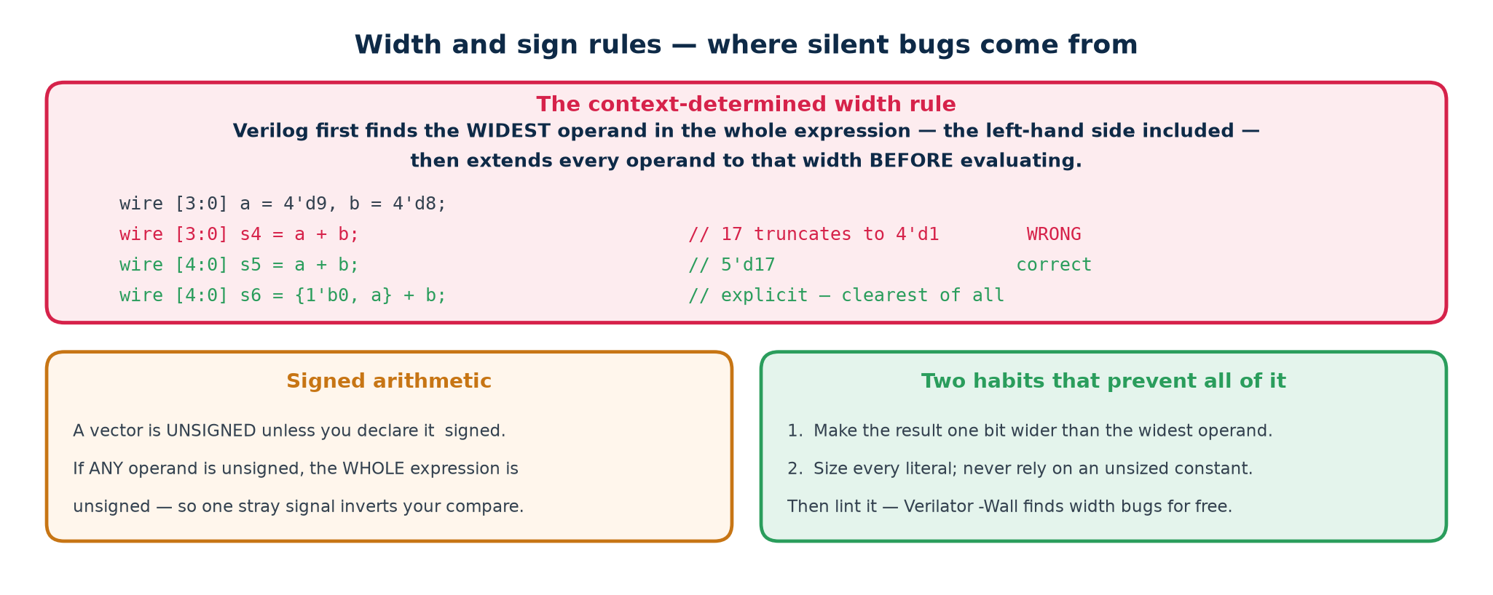
Verilog truncates silently, and never warns you.
Verilog evaluates an expression at a width determined by its context, then assigns that result to the target. If the target is narrower, the extra bits are discarded with no error, no warning and no runtime check. The simulation and the synthesised hardware agree with each other — and both are wrong.
1. The width of a self-determined expression is the width of its widest operand.
2. In an assignment, the right-hand side is evaluated at max(width of LHS, width of RHS) — so a narrow target can silently truncate.
3. An unsized literal is 32 bits, signed.
4. If ANY operand of an expression is unsigned, the whole expression is unsigned.
5. Shifts, concatenations and comparisons all follow their own rules; when in doubt, be explicit.
The truncation that catches everybody
wire [3:0] a = 4'd9, b = 4'd8;
wire [3:0] sum1 = a + b; // 17 -> truncated to 4'd1. No warning.
wire [4:0] sum2 = a + b; // 17 -> 5'd17. Correct.
wire [4:0] sum3 = {1'b0,a} + {1'b0,b}; // explicit, and always correct

A real bug from this lab
The Topic 4 UART originally wrote its bit-timing limit as CLKS_PER_BIT[CW-1:0]. With CLKS_PER_BIT = 16, CW is $clog2(16) = 4 — and 16 does not fit in 4 bits, so the expression truncated to zero.
HALF_BIT became 0, the receiver never waited half a bit before sampling, and it began sampling on bit boundaries instead of bit centres. 0x00 came back correctly; 0xFF came back as 0xF7. An intermittent, data-dependent failure — the worst kind.
The fix is to compute the limits as integers and slice them where they are USED: localparam integer FULL_BIT = CLKS_PER_BIT - 1; and then clk_cnt == FULL_BIT[CW-1:0]. See rtl/uart_rx.v.
Verilator would have reported WIDTHTRUNC on that line in one second. Lint first.

1.10 The three constructs that describe logic
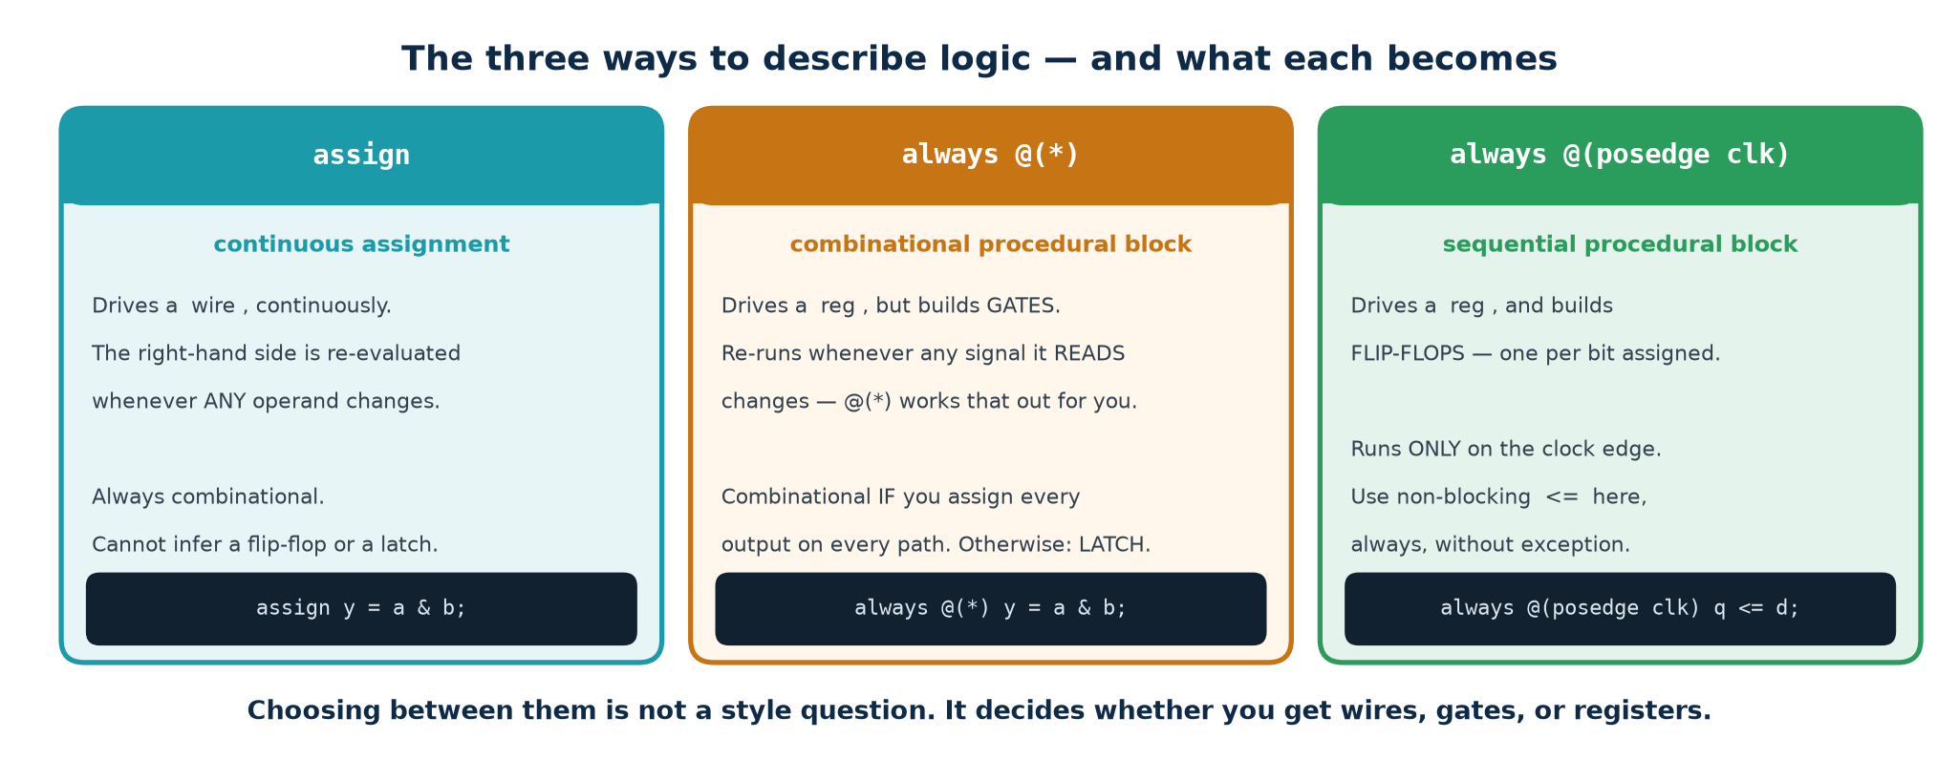
Everything synthesisable is one of these three.
Construct | Written as | Becomes | Use it for
Continuous assignment | assign y = ...; | A cloud of gates | Short combinational expressions
Combinational block | always @(*) ... = ... | A cloud of gates | Longer logic: case, if/else chains
Clocked block | always @(posedge clk) ... <= ... | Flip-flops plus gates | Anything that must remember

Continuous assignment
An assign is a permanent connection, not an instruction. It is not executed once — it is always true. Whenever anything on the right-hand side changes, the left-hand side follows in zero simulation time. Think of it as solder.
Continuous assignments
assign y = a & b; // one AND gate
assign z = sel ? p : q; // a 2:1 multiplexer
assign {co,sum} = a + b + cin; // a 9-bit result split into carry and sum
assign parity = ^data; // an XOR tree
assign any_req = |req; // an OR tree

// Order is irrelevant. These three describe ONE circuit whatever order you type them.
assign c = a ^ b;
assign e = c & d;
assign d = ~a;

▪ The left side must be a net (wire), never a reg.
▪ A wire may be driven by exactly one assign. Two drivers give x.
▪ No if, case or for — expressions only. Use the conditional operator for choices.
▪ The moment you find yourself nesting three conditional operators, rewrite it as an always @(*) block with a case statement. Unreadable RTL is where bugs live.

Procedural blocks
The forms of procedural block
always @(*) begin ... end // combinational -- gates
always @(posedge clk) begin ... end // clocked -- flip-flops
always @(posedge clk or negedge rst_n) // clocked with async reset

initial begin ... end // once, at time 0 -- SIMULATION ONLY
always begin ... end // forever -- testbench clock generation

Blocks run concurrently with each other; statements run sequentially within one block. That distinction is the whole reason hardware description works.
Sensitivity | Meaning | Note
@(*) | Re-run whenever anything READ in the block changes | Always use this for combinational logic
@(a or b or sel) | Re-run on those signals only | A hand-written list is a bug waiting for the day someone adds a signal
@(posedge clk) | Run at the instant the clock rises | Everything assigned with <= becomes a flip-flop
@(posedge clk or negedge rst_n) | Also run when the reset falls | Asynchronous reset
initial | Run once at time zero | No hardware equivalent in ASIC. FPGAs honour it for power-up values; do not rely on it.

1.11 Control flow

if / else is a priority structure
An if/else chain does not 'test conditions one after another' — nothing happens 'one after another' in a wire. It synthesises to a chain of multiplexers where the first condition has the highest priority. That chain has depth, and depth is delay.
Priority versus parallel selection
// Priority -- three multiplexers in series. Deeper, slower.
if (a) y = 2'd0;
else if (b) y = 2'd1;
else if (c) y = 2'd2;
else y = 2'd3;

// Parallel -- ONE multiplexer. Shallower, faster.
case (sel)
2'd0: y = 2'd0; 2'd1: y = 2'd1;
2'd2: y = 2'd2; 2'd3: y = 2'd3;
endcase

Use priority when the conditions genuinely overlap and one must win — an interrupt controller, a bus arbiter. Use case when they are mutually exclusive, which is most of the time.

case, casez and casex
case and casez
// case -- exact 4-state match. The workhorse. ALWAYS write a default.
case (opcode)
4'b0000: y = a + b;
4'b0001: y = a - b;
default: y = 8'd0;
endcase

// casez -- ? and z in the LABEL are don't-care. Correct for priority encoders.
casez (req)
4'b1???: grant = 2'd3;
4'b01??: grant = 2'd2;
4'b001?: grant = 2'd1;
default: grant = 2'd0;
endcase

casex is banned, and so are full_case / parallel_case
casex treats an x in the selector as a wildcard too. An uninitialised signal will then match the FIRST label and appear to work in simulation, while the synthesised hardware does something else. It conceals precisely the bug you most need to see.
full_case and parallel_case are synthesis pragmas that PROMISE the tool all cases are covered and mutually exclusive. If the promise is false, simulation and synthesis silently disagree — the hardest class of bug there is. A real default branch costs nothing and cannot lie.

Loops are unrolled, not executed
A for loop in synthesisable Verilog is a copy-paste instruction to the tool. It does not create a counter and takes no time. The bounds must be constants, and eight iterations means eight copies of the hardware.
Synthesisable loops
integer i;
always @(*) begin
cnt = 4'd0;
for (i = 0; i < 8; i = i + 1)
cnt = cnt + data[i]; // EIGHT adders in a tree, not a loop
end

// Reversing a bus: 8 wires crossed over. Zero gates, zero delay.
always @(*)
for (i = 0; i < 8; i = i + 1) rev[i] = fwd[7-i];

Synthesisable | Simulation only
for with constant start, limit and step | while — bound depends on a signal
repeat (N) with constant N | forever
Loop variable is integer or genvar | Any loop whose trip count is not known at elaboration

If you need 'repeat until a signal changes', that is a state machine or a counter. Build it explicitly; the tool cannot invent it for you.

1.12 Functions and tasks
Function versus task
// FUNCTION -- synthesisable. No time control, >=1 input, returns exactly one value.
function [3:0] bcd_digit;
input [7:0] v;
begin
bcd_digit = v % 10; // the function name IS the return variable
end
endfunction

assign d0 = bcd_digit(count); // one copy of the logic HERE ...
assign d1 = bcd_digit(other); // ... and a SECOND, independent copy here

// TASK -- may consume time, may have several outputs. Testbench use.
task send_byte(input [7:0] b);
begin
tx_data = b; tx_start = 1'b1; @(posedge clk); tx_start = 1'b0;
wait (tx_busy == 1'b0);
end
endtask

 | Function | Task
May consume time (#, @, wait) | No | Yes
Number of outputs | Exactly one (the return) | Any number, via output ports
May call a task | No | Yes
Synthesisable | Yes, if it obeys the rules | Generally no
Typical use | Shared combinational logic | Testbench stimulus sequences

The cost that must be remembered
A function call is not a subroutine call. There is no 'calling' at run time: each call site gets its own physical copy of the logic. Four calls to a 16-bit multiplier function means four multipliers on the die. If you want ONE shared unit used at different times, that is a datapath with a multiplexer in front of it and a controller to drive it — an architectural decision, not a syntax choice.

1.13 Parameters, localparam and generate
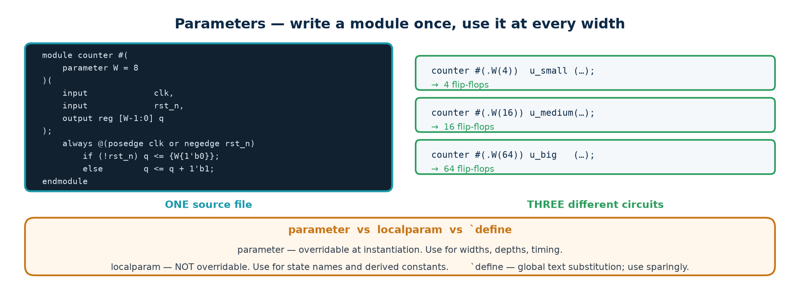
One source file, three different circuits.
Parameterisation
module counter #(parameter integer W = 8, parameter [W-1:0] MAX = {W{1'b1}})
(input wire clk, rst_n, en, output reg [W-1:0] q, output wire tc);

localparam [W-1:0] ZERO = {W{1'b0}}; // localparam CANNOT be overridden
...
endmodule

counter #(.W(4), .MAX(4'd9)) u_dig0 (.clk(clk), .rst_n(rst_n), ...); // decade counter
counter #(.W(16)) u_big (.clk(clk), .rst_n(rst_n), ...); // 16-bit counter

▪ parameter — may be overridden at instantiation. Use for widths, depths and timing constants that a user of the module should be able to set.
▪ localparam — may not be overridden. Use for state encodings, derived widths and anything whose value must stay consistent with the module's internal logic.
▪ $clog2(N) — ceiling log base 2, evaluated at elaboration. This is how you compute 'how many bits do I need to count to N'. It is one of the very few $ functions that is synthesisable.

generate
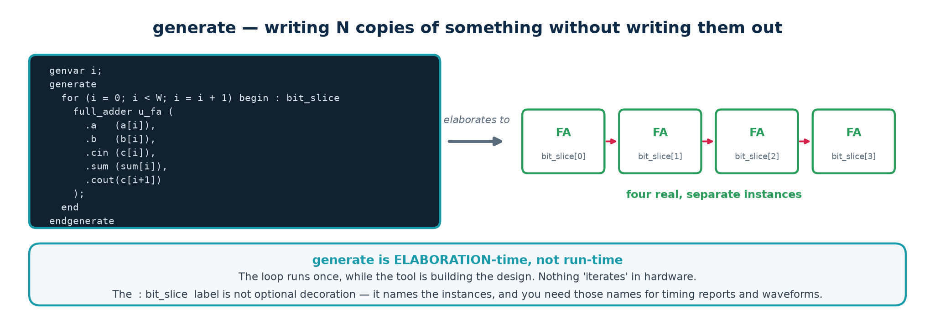
A loop that creates structure, not logic.
Topic4_Lab/rtl/adder_gen.v
genvar i;
generate
for (i = 0; i < W; i = i + 1) begin : bit_slice // the label is REQUIRED
full_adder u_fa (.a(a[i]), .b(b[i]), .cin(c[i]),
.sum(sum[i]), .cout(c[i+1]));
end
endgenerate

// Instances are named bit_slice[0].u_fa, bit_slice[1].u_fa, ...
// Use those names in $dumpvars and in timing constraints.

generate if chooses between whole implementations at elaboration — a carry-lookahead adder when W is large and a ripple adder when it is not, for example. The unselected branch is not elaborated at all, so it need not even be legal for the chosen parameter values.

1.14 Hierarchy and instantiation
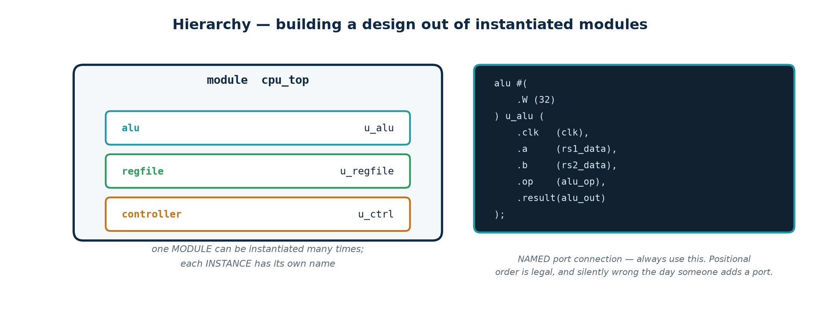
A module is a type; an instance is a physical copy.
Two instances of the same module are two separate pieces of hardware that share nothing. Instantiate by name, always.
Instantiation
// BY NAME -- do this. Order-independent, self-documenting, a typo is a compile error.
uart_tx u_tx (
.clk (clk),
.rst_n (rst_n),
.data (tx_data),
.tx (serial_out)
);

// BY POSITION -- do not. Add a port to the module and every instance silently
// connects the wrong wires.
uart_tx u_tx (clk, rst_n, tx_data, serial_out);

▪ Prefix instance names with u_ so a reader can tell an instance from a signal at a glance.
▪ Write an intentionally unconnected port explicitly as .name() so the reader can see it was deliberate.
▪ Hierarchical references (tb.u_dut.state) are legal in a testbench and invaluable for white-box checks. Never use them in design code.

1.15 Compiler directives
Directive | What it does | Note
timescale 1ns/1ps | Sets the unit and precision of delays | First line of every file: unit / precision
define NAME value | Text macro, referenced as `NAME | GLOBAL across the whole compilation — prefix names to avoid clashes
include "file.vh" | Textual inclusion | For shared parameter headers
ifdef / `ifndef / `else / `endif | Conditional compilation | Simulation-only code; ASIC vs FPGA variants
default_nettype none | Turns off implicit wire creation | Put it in EVERY file — see below
resetall | Restores all directives to their defaults | Pair it with the line above, at the end of the file
celldefine / `endcelldefine | Marks a library cell | You will see it in vendor libraries

`default_nettype none is the single most valuable line in the file
By default, a name you never declared becomes a 1-bit wire, silently. Misspell data_valid as data_vaild in a port connection and Verilog creates a new, undriven 1-bit wire and says nothing. Your design gets an x and you spend an afternoon on it.
Put `default_nettype none at the top of every file and that typo becomes a compile error naming the exact line. Every file in Topic4_Lab does this, and it costs one line.

1.16 System tasks and functions
Task | Purpose | Typical use
$display / $write | Print once, when reached | $display("%0t got %h", $time, q);
$monitor | Print whenever any argument changes | One per simulation, inside initial
$strobe | Print at the end of the current time step | Avoids seeing half-updated values
$time / $realtime | Current simulation time | Timestamping messages
$dumpfile / $dumpvars | Write a VCD waveform file | $dumpvars(0, tb); — 0 means all levels
$finish / $stop | End / pause the simulation | $finish at the end of your stimulus
$random / $urandom | Pseudo-random stimulus | Seed it, so a failure reproduces
$fatal / $error / $warning | Report, and optionally abort | Self-checking testbenches
$clog2(N) | Ceiling log2 — SYNTHESISABLE | localparam CW = $clog2(DEPTH);
$bits(x) | Width of an expression — SYNTHESISABLE | Generic code that adapts to its input
$readmemh / $readmemb | Load a memory array from a file | Initialising a ROM; supported by most FPGA flows

Format specifiers: %b %o %d %h for radix, %s for a string, %t for time, %m for the hierarchical module name. Prefix the width with 0 — %0d — to suppress the padding that otherwise makes output unreadable.

1.17 The synthesisable subset
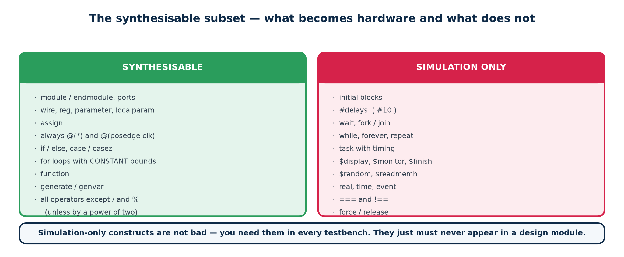
The boundary between a design and a testbench.
Verilog is a simulation language that happens to have a synthesisable subset. Write something outside it and the simulation may run perfectly while the synthesiser either rejects it or, worse, quietly ignores it — producing hardware that does not match your simulation.
Synthesisable | Not synthesisable
assign, always @(*), always @(posedge clk) | initial blocks
if / else, case, casez | casex (legal, but banned by every standard)
for and repeat with constant bounds | while, forever, and data-dependent loops
Functions without time control | Tasks with time control
parameter, localparam, generate | Delays (#5) — ignored by synthesis
Concatenation, replication, part-selects | real, time, event data types
$clog2, $bits | $display, $monitor, $random, file I/O
Arrays, for memory inference | Force / release, hierarchical references

The four that catch people out
1. Delays. #5 is ignored by synthesis. Timing comes from the clock and the technology library, never from your source code. A design that 'works' only because of a delay in the RTL will fail on silicon.
2. initial blocks. FPGA tools honour them for register power-up values; ASIC tools do not. Reset your registers with a reset signal, always.
3. Multiple always blocks driving one signal. Illegal. One signal, one driving block, no exceptions.
4. Mixing = and <= for the same variable. Legal Verilog, undefined behaviour in practice, and rejected by every lint tool.

1.18 Coding standard for this course
1. One file, one module, and the file is named after the module.
2. `default_nettype none at the top; `resetall at the bottom.
3. ANSI port headers. Instantiate by name. Prefix instances with u_.
4. Active-low signals end in _n (rst_n). Clocks are named clk.
5. Size every literal. Never write a bare 0 or 1 into a vector.
6. Combinational logic: always @(*) with = and a default assignment at the top of the block.
7. Sequential logic: always @(posedge clk) with <= only.
8. Every case has a default. Never casex. Never full_case or parallel_case.
9. One driver per signal. Reset every state-holding register.
10. Lint before you simulate; simulate before you synthesise; read the synthesis log for inferred latches every single time.
Why the log matters more than the waveform
A latch warning in the synthesis log is telling you that the hardware does not match your intent. The simulation will often pass anyway, because in simulation the latch happens to hold the value you expected. The mismatch appears on silicon, months later, in somebody else's lab. Read the log.

Part 2 · Modelling Combinational and Sequential Logic
Part 1 was the language. Part 2 is the craft: for every construct, what hardware does it produce? Synthesis is pattern matching — the tool reads your code, recognises a pattern and drops in the corresponding hardware. There is no intelligence in it, which is good news: the mapping is completely predictable once you know the patterns.

2.1 The inference map
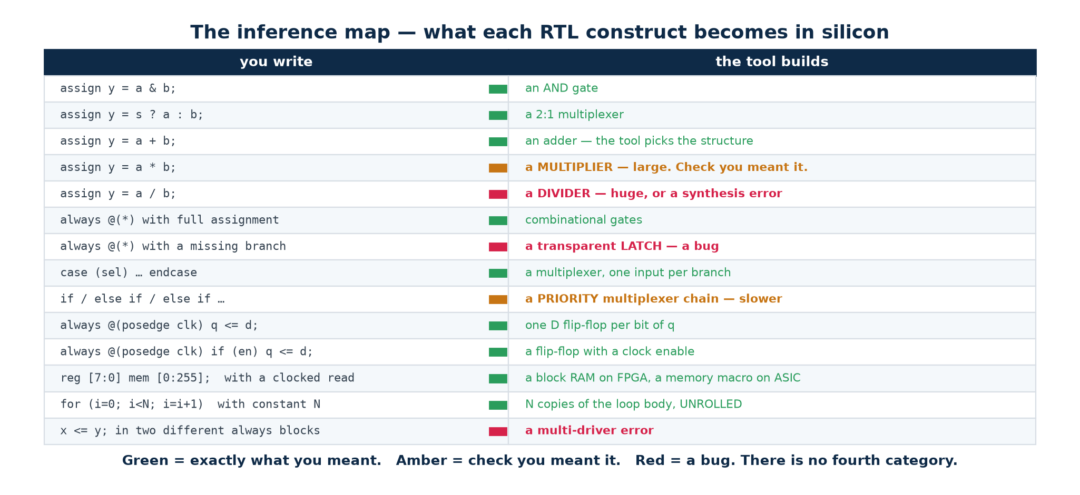
Code pattern in, hardware out.
You write | You get | Because
assign y = a & b; | An AND gate | A continuous, combinational relationship
always @(*) with every path assigned | Combinational logic | The output is a pure function of the inputs
always @(*) with a path unassigned | A LATCH | The old value must be remembered on that path
always @(posedge clk) q <= d; | A D flip-flop | The value is captured at an edge
always @(posedge clk) with if(en) | A flip-flop with a clock enable | Capture only on some edges
always @(posedge clk or negedge rst_n) | A flip-flop with an async reset | A second edge event forces a value
mem[a] <= d; q <= mem[b]; in a clocked block | A block RAM | The registered read is the pattern the tool looks for
A for loop with constant bounds | N copies of the body | Unrolled at elaboration
A function call | A copy of the function's logic per call site | There is no run time to 'call' in

The one question to ask of every line you write
“What does this become?” If you cannot answer that for a line of your own RTL, you have written something you do not understand and the tool will make its own choice. Nine times out of ten that choice is a latch, an enormous multiplexer, or a critical path you did not expect.

2.2 Combinational modelling
Three styles, one circuit. They synthesise identically — the tool flattens all of them to the same boolean function before it optimises. Choose by readability.
Three ways to write one multiplexer — Topic4_Lab/rtl/mux2.v uses style 1
// Style 1 -- continuous assignment. Best for short expressions.
assign y = sel ? b : a;

// Style 2 -- always block with if/else.
always @(*) begin
if (sel) y = b;
else y = a; // the else is what stops a latch
end

// Style 3 -- always block with case. Scales best beyond two choices.
always @(*) begin
case (sel)
1'b0: y = a;
default: y = b; // default covers 1'b1, 1'bx and 1'bz
endcase
end

2.3 Latch inference — the number one beginner bug
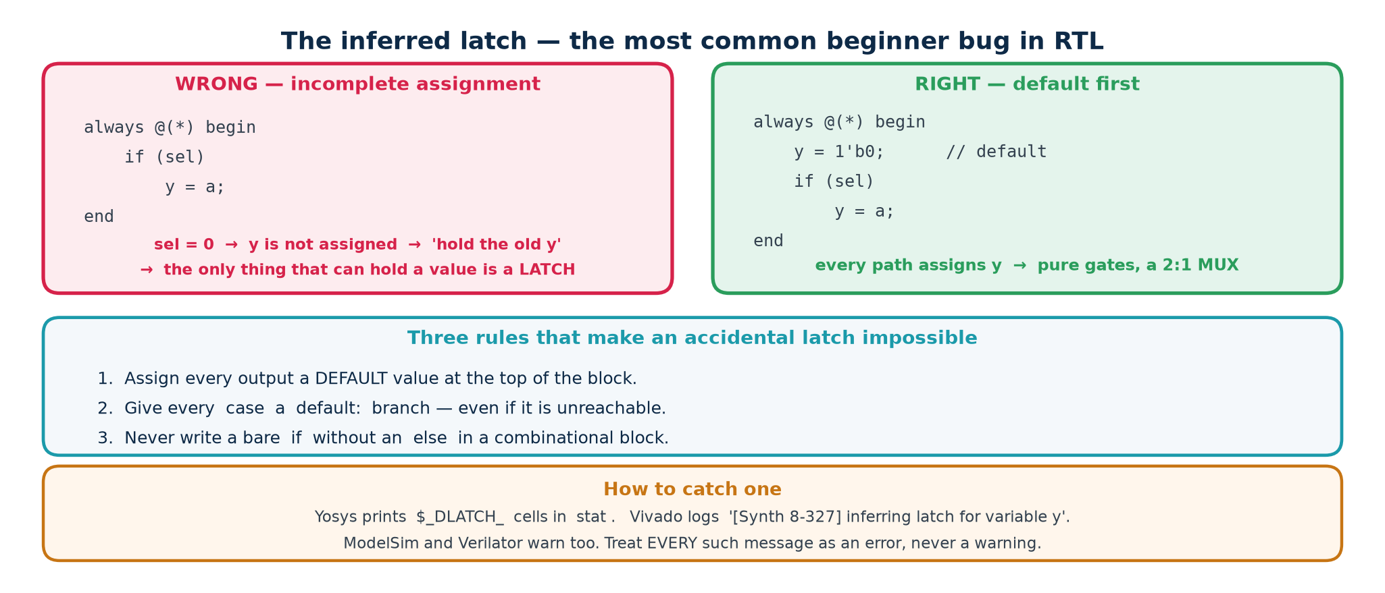
An unassigned path forces the tool to build memory.
If a combinational block does not assign a variable on every possible path, the variable must keep its old value when that path is taken. Keeping an old value is memory, and the only memory a level-sensitive block can produce is a transparent latch.

Why a latch is bad news
▪ It is transparent while enabled — data flows straight through it — so it does not isolate one cycle from the next the way a flip-flop does.
▪ Static timing analysis of latch-based paths is far harder, and many FPGA and ASIC flows simply cannot close timing on them.
▪ It was almost certainly not what you meant, which means your design does something other than what you think it does.

The two cures — use both
Both forms remove both latches
// CURE 1 -- default assignment at the top, then override.
always @(*) begin
y = 1'b0; // default: y is ALWAYS assigned
w = d[0];
if (enable) y = d[0];
case (sel)
2'b00: w = d[0];
2'b01: w = d[1];
2'b10: w = d[2];
default: ; // nothing needed: the default at the top covers it
endcase
end

// CURE 2 -- complete every branch explicitly.
always @(*) begin
if (enable) y = d[0];
else y = 1'b0; // every if has an else
case (sel)
2'b00: w = d[0]; 2'b01: w = d[1];
2'b10: w = d[2]; default: w = 1'b0; // every case has a default
endcase
end

Seeing it in a real tool report
Verified output — Topic4_Lab, run it yourself
$ yosys -p "read_verilog rtl/broken_examples.v; synth -top bad_latch; stat"

$_DLATCH_N_ 1
$_DLATCH_P_ 1 <-- two latches, exactly as predicted

Now add the else and the default, re-run the same command, and the two DLATCH lines vanish. That before-and-after is the exercise; reading about it is not.

2.4 case as multiplexer, decoder and encoder
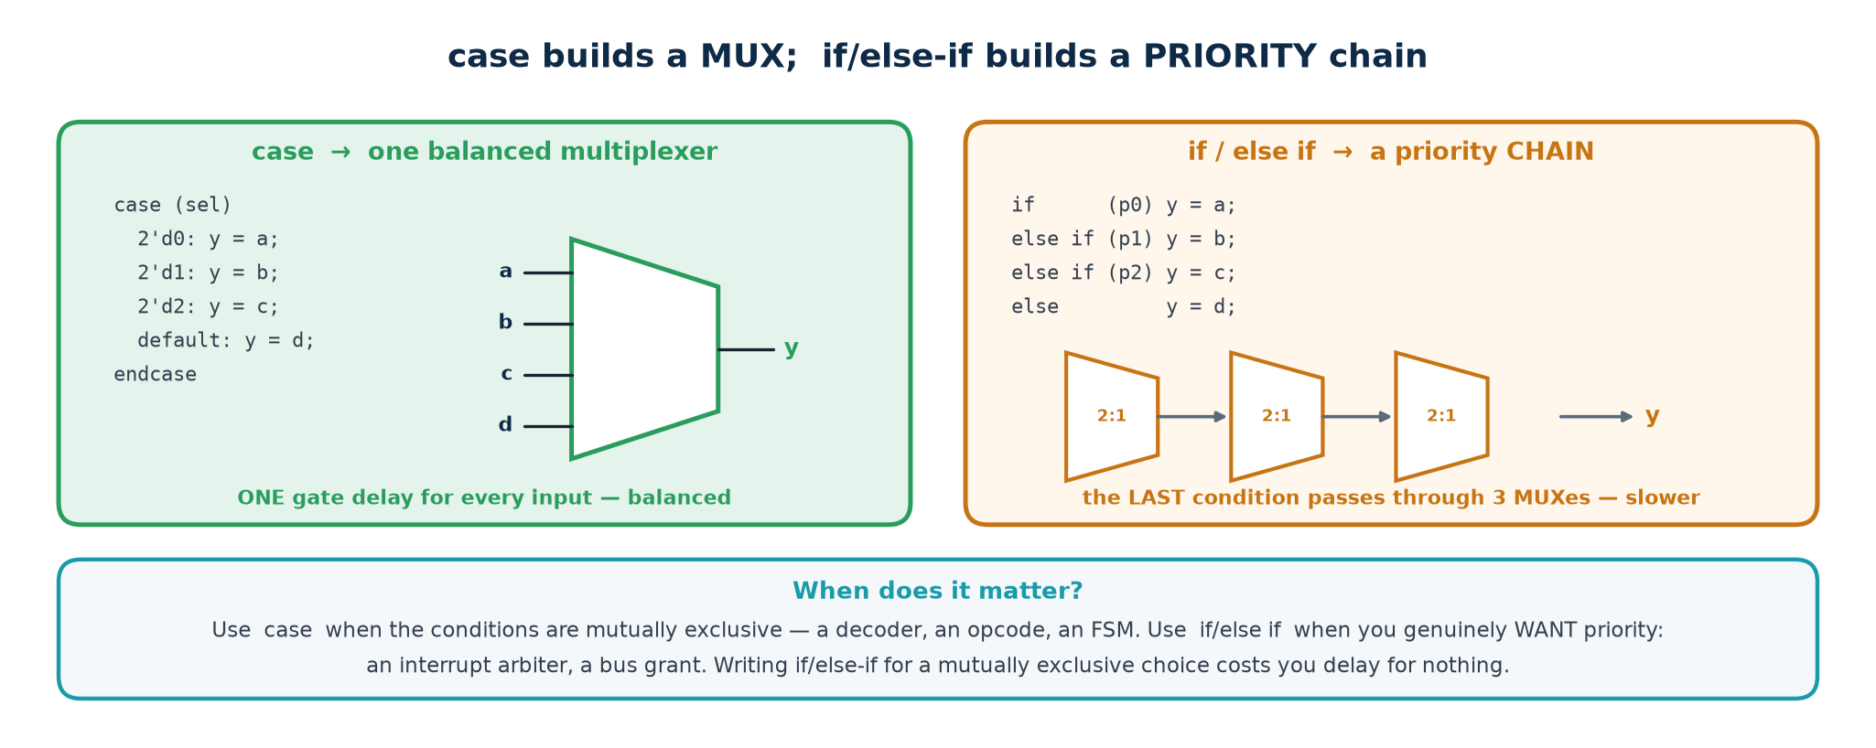
One construct, three familiar building blocks.
Decoder and priority encoder
// DECODER -- a variable INDEX on the left-hand side. Topic4_Lab/rtl/decoder3to8.v
always @(*) begin
y = 8'b0;
if (en) y[sel] = 1'b1;
end

// PRIORITY ENCODER -- casez. Topic4_Lab/rtl/priority_encoder8.v
always @(*) begin
casez (req)
8'b1???????: {valid, y} = {1'b1, 3'd7};
8'b01??????: {valid, y} = {1'b1, 3'd6};
8'b001?????: {valid, y} = {1'b1, 3'd5};
// ...
default: {valid, y} = {1'b0, 3'd0};
endcase
end

The valid bit matters: without it you cannot tell 'request 0 is active' from 'no request at all', because both produce y = 0.

2.5 Worked example — an ALU with real flags
Topic4_Lab/rtl/alu.v
wire [W:0] sum_ext = {1'b0, a} + {1'b0, b}; // ONE bit wider -> carry is free
wire [W:0] diff_ext = {1'b0, a} - {1'b0, b};

always @(*) begin
result = {W{1'b0}}; carry = 1'b0; overflow = 1'b0; // defaults -> no latch
case (op)
OP_ADD: begin
result = sum_ext[W-1:0];
carry = sum_ext[W];
overflow = (a[W-1] == b[W-1]) && (result[W-1] != a[W-1]);
end
OP_SUB: begin
result = diff_ext[W-1:0];
carry = diff_ext[W]; // borrow
overflow = (a[W-1] != b[W-1]) && (result[W-1] != a[W-1]);
end
OP_AND: result = a & b;
OP_OR : result = a | b;
OP_XOR: result = a ^ b;
OP_SLL: result = a << b[$clog2(W)-1:0];
OP_SRL: result = a >> b[$clog2(W)-1:0];
OP_SLT: result = ($signed(a) < $signed(b)) ? {{(W-1){1'b0}}, 1'b1} : {W{1'b0}};
default: begin result = {W{1'b0}}; carry = 1'b0; overflow = 1'b0; end
endcase
end

assign zero = ~|result; // reduction NOR: one operator, a whole NOR tree
assign negative = result[W-1];

Carry is not overflow
C is unsigned overflow; V is signed overflow. They are different questions about the same addition, and confusing them is a classic exam and interview trap.
8'h7F + 8'h01 = 8'h80 — no carry out at all, but a SIGNED overflow: 127 + 1 became −128.
8'hFF + 8'h01 = 8'h00 — carry out is set, but NO signed overflow: −1 + 1 = 0 is correct.
The rule for addition: V is set when the two operands have the SAME sign and the result has a different one. For subtraction: when the operands have DIFFERENT signs and the result differs from the first operand.

2.6 The clocked block
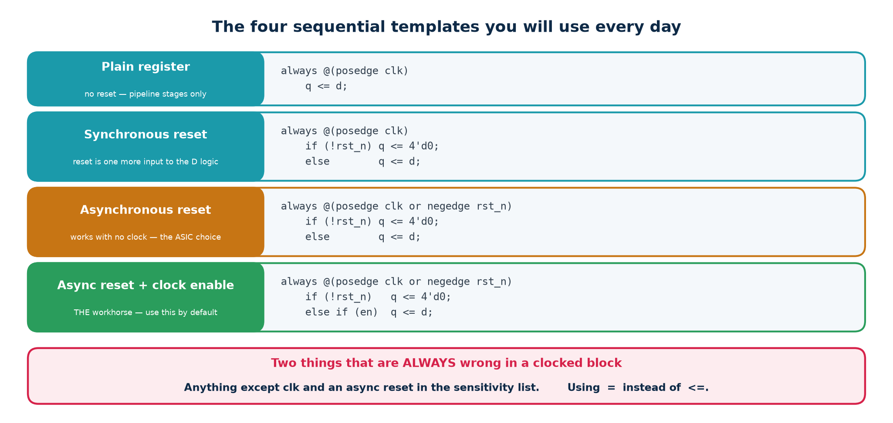
One template, used everywhere.
The sequential template — priority runs top to bottom
always @(posedge clk or negedge rst_n) begin
if (!rst_n) q <= RESET_VALUE; // asynchronous, active-low reset
else if (clr) q <= {W{1'b0}}; // synchronous clear
else if (load) q <= din; // then load
else if (en) q <= next_value; // then enable
end

Everything assigned in this block becomes a flip-flop. Nothing else in the design may assign q: one signal, one driving block, no exceptions. The order of the else-if chain IS the priority of the control signals, and it is a design decision you should make consciously.

2.7 Blocking and non-blocking assignment
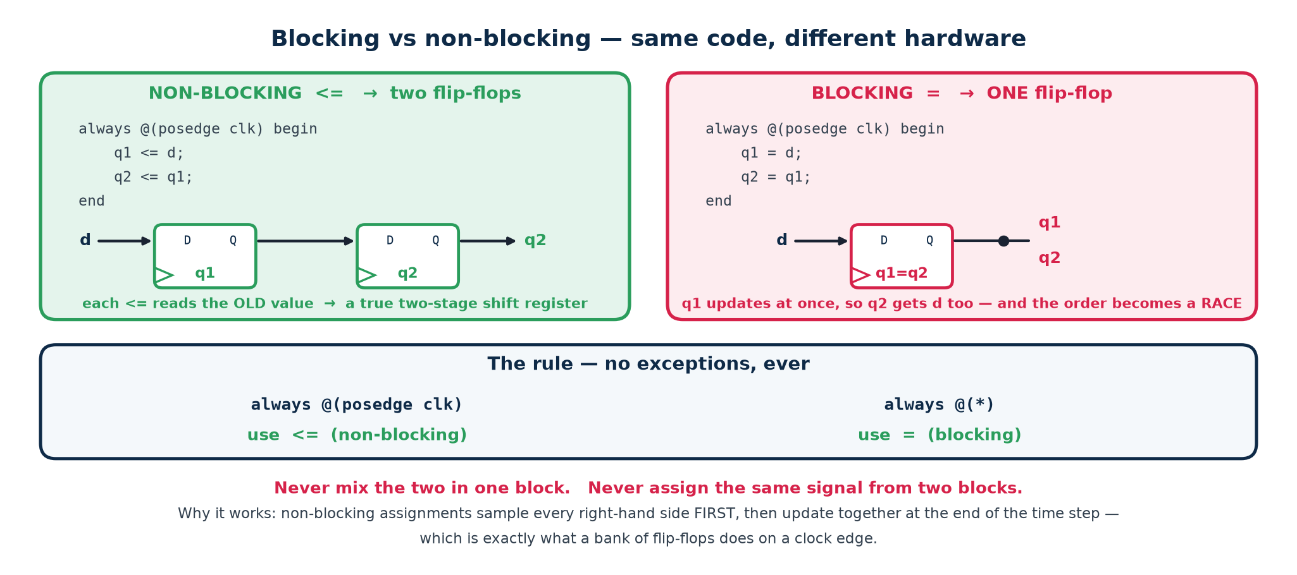
Two operators, two very different circuits.
The rule, in two lines
Inside always @(*) use =. Inside always @(posedge clk) use <=. Never mix the two for the same variable, and never use = in a clocked block.

 | Blocking = | Non-blocking <=
When the update happens | Immediately, before the next statement | At the end of the time step, after every RHS is sampled
Reads see | The value just written | The value from before the edge
Statement order matters? | Yes | No
Models | Combinational logic | A bank of flip-flops
Use in | always @(*) | always @(posedge clk)

The evidence
A three-line difference that halves the hardware
// WRONG // RIGHT
always @(posedge clk) begin always @(posedge clk) begin
q1 = d; q1 <= d;
q2 = q1; // q1 is ALREADY d q2 <= q1; // the OLD q1
end end

$ yosys -p "read_verilog rtl/broken_examples.v; synth -top bad_blocking; stat"
$_DFF_P_ 1 <-- ONE flip-flop, not two. Verified.

q2 follows d in the same cycle, so the tool sees two registers holding the same value and keeps one. Change the two = to <= and the same command reports 2. Nothing else in the file changes.
And if you swap the two lines? Write q2 = q1; q1 = d; and you get two flip-flops and correct behaviour — from the same operator. That is the real objection to blocking assignment in a clocked block: the hardware depends on the ORDER you typed the lines, which is not a property that real flip-flops have.

2.8 The stratified event queue — why <= actually works
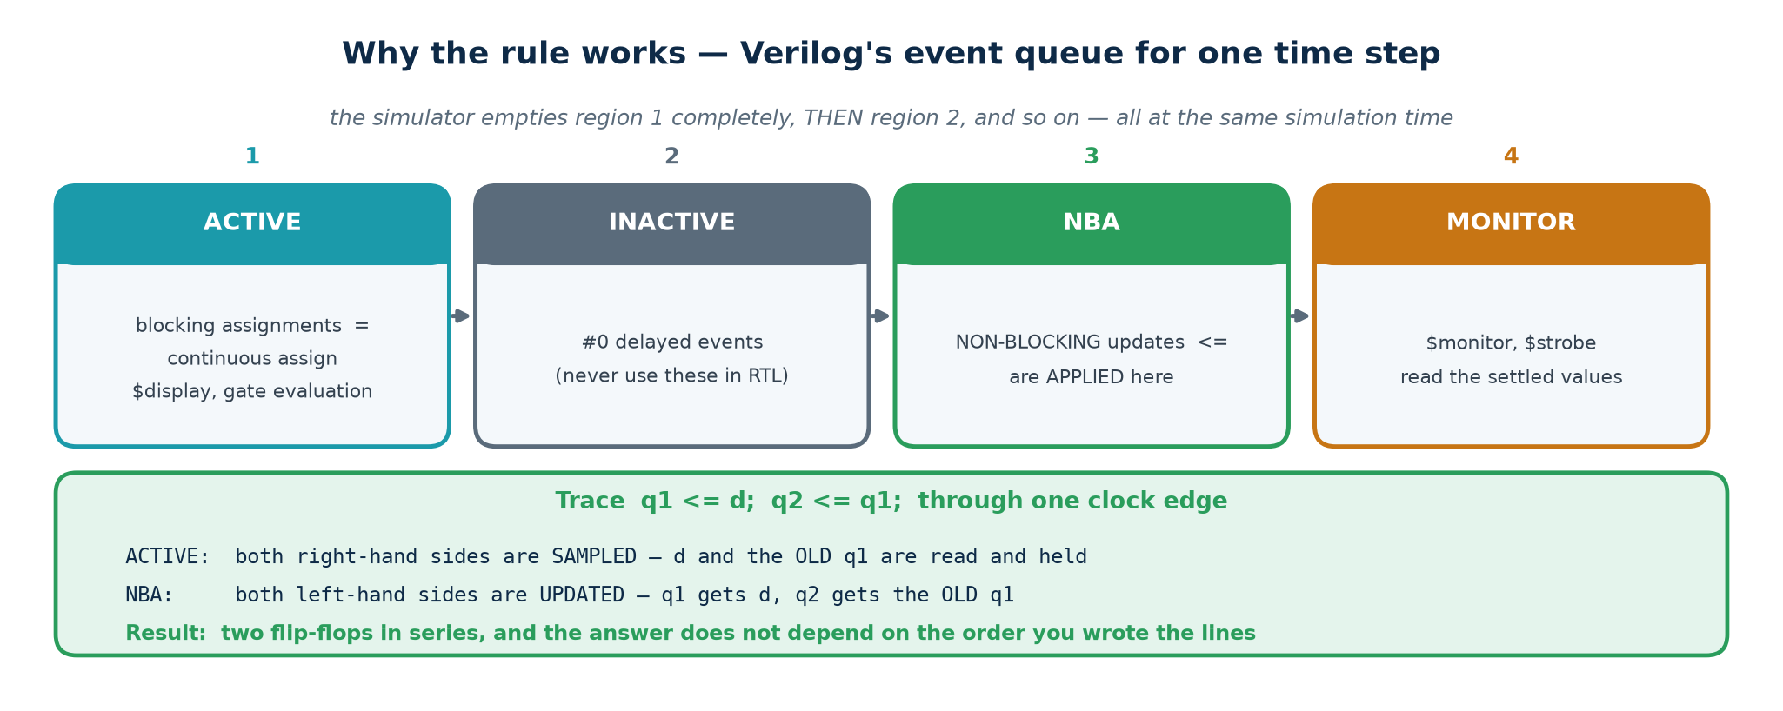
Regions within one simulation time step.
At a single simulation time step the simulator processes events in defined regions, in order. This is what the Verilog standard calls the stratified event queue.
Region | What happens there
Active | Blocking assignments; evaluation of every non-blocking RHS; continuous assignments; $display
Inactive | Anything explicitly scheduled with #0 (avoid using this)
NBA | Non-blocking assignments are APPLIED to their left-hand sides
Monitor | $monitor and $strobe — after everything has settled

Every clocked block in the design samples its inputs in the Active region, using the values that existed before the edge; every register updates in the NBA region afterwards. So no clocked block can see another block's new value within the same edge — which is precisely the behaviour of real flip-flops, and why the order in which the simulator happens to visit your always blocks cannot change the answer. Use = in a clocked block and you throw that guarantee away.

2.9 Reset strategy
 | Asynchronous reset | Synchronous reset
Written as | @(posedge clk or negedge rst_n) | @(posedge clk)
Works with no clock | Yes — safe at power-up | No
Cost | Uses the flip-flop's dedicated reset pin | Adds logic in front of the D input
Timing | Release must be synchronised | One clock domain, easy
Glitch shorter than a cycle | Is captured — may be good or bad | Is ignored

The reset-release synchroniser
An asynchronous reset asserts instantly, which is what you want. Its release, however, can occur arbitrarily close to a clock edge, so different flip-flops can leave reset on different cycles — and one of them can go metastable. The standard solution is to assert asynchronously and release synchronously:
Assert asynchronously, release synchronously — two flip-flops
reg [1:0] rst_sync;
always @(posedge clk or negedge rst_n_in) begin
if (!rst_n_in) rst_sync <= 2'b00; // asserts immediately
else rst_sync <= {rst_sync[0], 1'b1};// releases on a clock edge
end
wire rst_n = rst_sync[1]; // drive the whole design from THIS

Whichever style you choose, be consistent across a whole clock domain. Mixing styles gives you blocks that leave reset on different cycles and a system that starts in a state your simulation never produced.

2.10 Counters, shift registers and edge detection
Parameterised counter, verified
// COUNTER -- a register plus an incrementer. Topic4_Lab/rtl/counter.v
assign tc = en & (up ? (q == MAX[W-1:0]) : (q == {W{1'b0}}));
always @(posedge clk or negedge rst_n) begin
if (!rst_n) q <= {W{1'b0}};
else if (load) q <= din;
else if (en) begin
if (up) q <= (q == MAX[W-1:0]) ? {W{1'b0}} : q + 1'b1;
else q <= (q == {W{1'b0}}) ? MAX[W-1:0] : q - 1'b1;
end
end

$ yosys -p "read_verilog rtl/counter.v; synth -top counter; stat"
Number of cells: 38 $_DFF_NP0_ 4 <-- 4 bits of state, as predicted

Set MAX = 9 and the same source is a BCD decade counter. Chain two, using the first's tc as the second's enable, and you have a 0–99 counter. That is what parameterisation buys you.
Two modules you will use in almost every design
// SHIFT REGISTER -- the concatenation idiom.
always @(posedge clk or negedge rst_n)
if (!rst_n) q <= {W{1'b0}};
else if (en) q <= {q[W-2:0], sin}; // left shift, new bit in at the bottom

// EDGE DETECTOR -- one register and a gate. Topic4_Lab/rtl/edge_detect.v
always @(posedge clk or negedge rst_n)
if (!rst_n) sig_d <= 1'b0;
else sig_d <= sig;

assign rise = sig & ~sig_d; // high for exactly one clock cycle
assign fall = ~sig & sig_d;
assign any = sig ^ sig_d;

A testbench lesson from building this lab
The first edge-detector test failed. The cause was not the design: the testbench changed the input in the middle of a clock cycle, so the pulse was half a cycle wide and the check sampled it at the wrong moment.
Drive stimulus just AFTER the active clock edge, and sample just BEFORE the next one. Half of all 'the design is broken' reports are really this.

2.11 Clock domain crossing and metastability
A flip-flop needs its D input stable for a setup time before the clock edge and a hold time after it. A signal arriving from another clock domain cannot honour that, so the flip-flop can enter a metastable state: an output that is neither 0 nor 1 and settles at an unpredictable moment. You cannot prevent metastability. You can only give it time to decay, which is what a synchroniser does.
Topic4_Lab/rtl/synchroniser.v
reg [1:0] sync;
always @(posedge clk or negedge rst_n) begin
if (!rst_n) sync <= 2'b00;
else sync <= {sync[0], async_in}; // stage 0 may go metastable ...
end
assign sync_out = sync[1]; // ... stage 1 has a whole cycle to settle

▪ Two flip-flops minimum for a single-bit LEVEL signal. Three at very high clock rates.
▪ Never synchronise a multi-bit bus bit by bit. The bits will arrive on different cycles and you will read a value that never existed on the source side.
▪ For a bus, use Gray-coded pointers — only one bit changes per step, so a mis-sample returns the previous value, which is safe. That is exactly how an asynchronous FIFO works.
▪ Or use a request/acknowledge handshake, holding the data stable throughout.
▪ A pulse in a fast domain can be missed entirely by a slow one. Convert it to a level, cross it, and convert it back — or use a handshake.

2.12 State machines
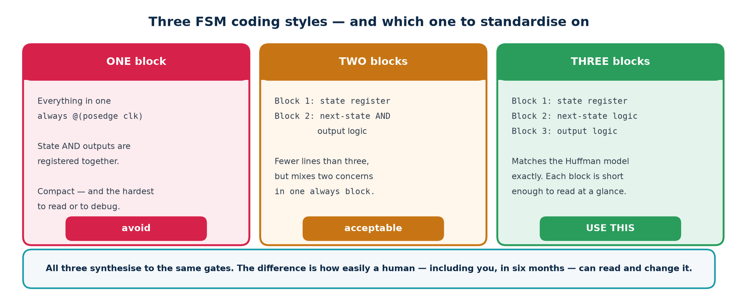
One, two or three always blocks.
Style | Blocks | Pros | Cons
One-block | 1 clocked | Compact; outputs registered automatically | Next-state and output logic tangled together
Two-block | 1 clocked + 1 combinational | State and logic clearly separated | Outputs still mixed into the combinational block
Three-block | 1 clocked + 2 combinational | State, next-state and output each separate — easiest to read and review | Slightly more typing; that is the whole cost

The three-block template
Topic4_Lab/rtl/traffic_fsm.v — verified 52 cells, 12 flip-flops
// ---- BLOCK 1 : state register (and any dwell timer) ----
always @(posedge clk or negedge rst_n) begin
if (!rst_n) begin state <= MAIN_GREEN; timer <= 8'd0; end
else if (tick) begin
if (done) begin state <= next; timer <= 8'd0; end
else timer <= timer + 1'b1;
end
end

// ---- BLOCK 2 : next-state logic (pure combinational) ----
always @(*) begin
next = state; // default -> no latch, and a safe self-loop
case (state)
MAIN_GREEN : next = MAIN_YELLOW;
MAIN_YELLOW: next = SIDE_GREEN;
SIDE_GREEN : next = SIDE_YELLOW;
SIDE_YELLOW: next = MAIN_GREEN;
default : next = MAIN_GREEN; // SAFE FSM -- recover from an illegal state
endcase
end

// ---- BLOCK 3 : output logic (Moore -- depends on state ONLY) ----
always @(*) begin
main_light = RED; side_light = RED; // defaults
case (state)
MAIN_GREEN : begin main_light = GREEN; side_light = RED; end
MAIN_YELLOW: begin main_light = YELLOW; side_light = RED; end
SIDE_GREEN : begin main_light = RED; side_light = GREEN; end
SIDE_YELLOW: begin main_light = RED; side_light = YELLOW; end
default : begin main_light = RED; side_light = RED; end
endcase
end

Twelve flip-flops: two for the state, eight for the timer, and two more the tool kept for the outputs. Predicting that number before you run the tool is the skill being trained.

Encoding
Encoding | Flip-flops for N states | Logic depth | Best for
Binary | ceil(log2 N) | Deeper | ASIC, where flip-flops cost area
Gray | ceil(log2 N) | Deeper | Pointers that cross clock domains
One-hot | N | Very shallow | FPGA, where flip-flops are plentiful

Asking for an encoding
(* fsm_encoding = "one-hot" *) reg [1:0] state, next; // or "binary"

// Verified with Yosys 0.33 on a 4-state FSM, after abc -g AND,OR,XOR,NAND,NOR:
// binary : 9 cells, 2 flip-flops
// one-hot : 9 cells, 4 flip-flops <-- more FFs, shallower next-state logic

// On a machine this small the cell counts TIE. The one-hot advantage appears when
// the state count grows and the next-state decode would otherwise get deep.
// Do not assume -- measure.

The tool may re-encode your FSM without being asked
Synthesising Topic4_Lab/rtl/traffic_fsm.v with plain synth gives 12 flip-flops. Eight of them are the timer. The other FOUR are the state — even though the source declares reg [1:0] state. The log says why:
FSM_RECODE: mapping auto encoding to `one-hot` for this FSM
The tool detected a state machine, extracted it and chose its own encoding. That is a perfectly good decision, and it is invisible unless you read the log. This is why a flip-flop count that disagrees with your prediction is worth ten minutes: sometimes you are wrong, and sometimes the tool did something reasonable that you did not know about.

Moore and Mealy
 | Moore | Mealy
Output is a function of | State only | State and inputs
Reacts to an input | One clock later | In the same cycle
Output glitches? | No — it is registered | Yes — it follows the input
Typical state count | More | Fewer
Safe to drive off-chip? | Yes | Not without registering it first
Use when | You want clean, predictable outputs | You need the earliest possible response

Topic4_Lab/rtl/seq_detect_1011.v implements both in one module so you can compare the two found outputs on the same waveform. Overlapping detection is handled by returning to the correct PARTIAL-match state rather than to IDLE — the sequence 1011011 contains two matches, not one.

2.13 Memory inference
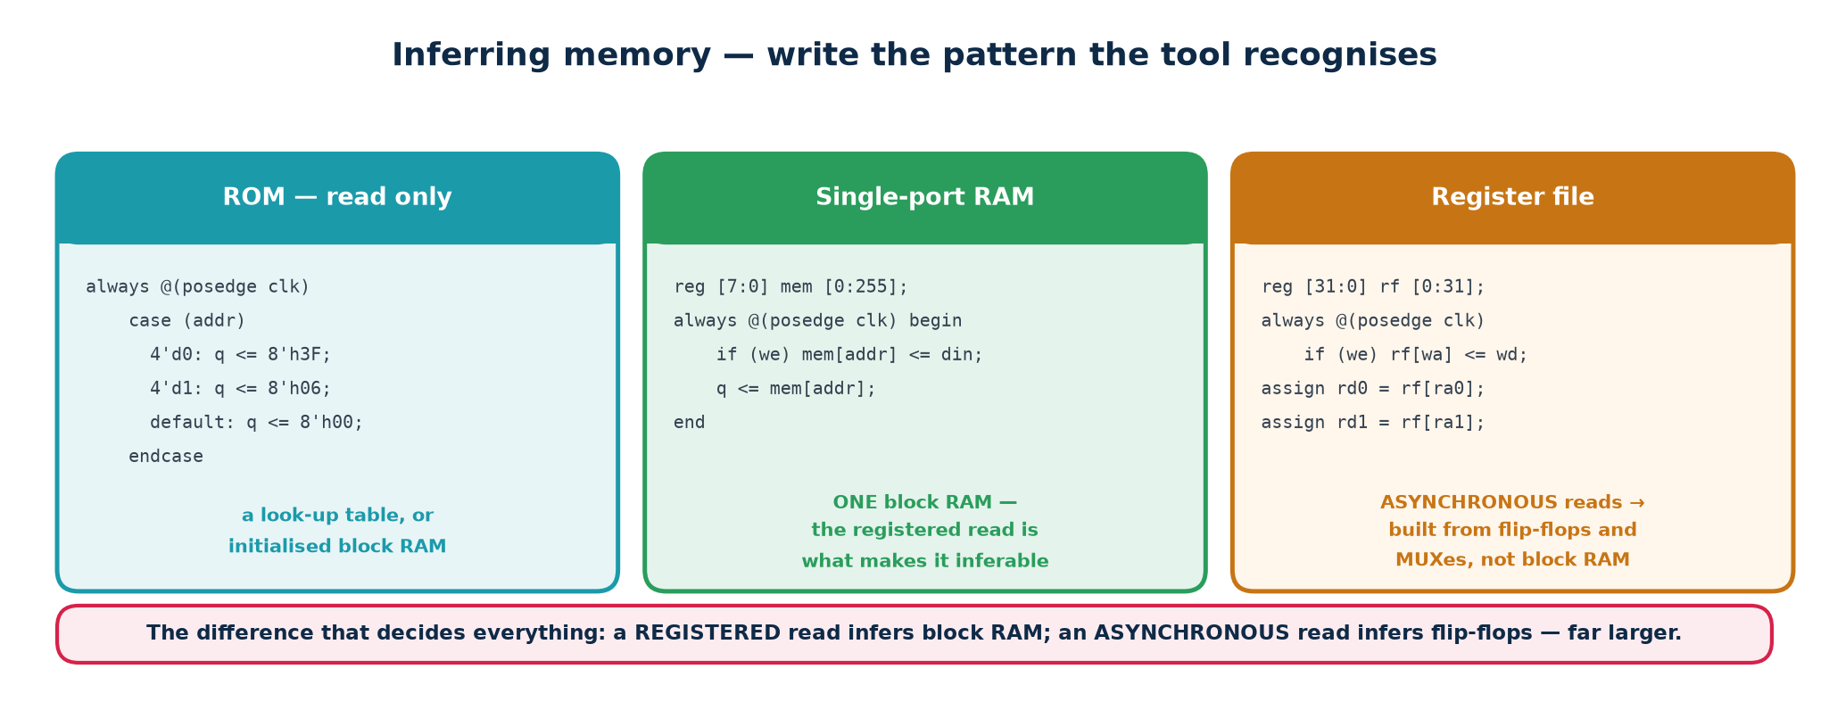
Write the pattern the tool is looking for.
Topic4_Lab/rtl/sync_ram.v — synchronous read
reg [W-1:0] mem [0:DEPTH-1];

always @(posedge clk) begin
if (we) mem[waddr] <= wdata;
rdata <= mem[raddr]; // REGISTERED read -- this is what infers block RAM
end

Write assign rdata = mem[raddr]; instead — an asynchronous read — and no FPGA block RAM can implement it, so the tool builds the whole array out of flip-flops and multiplexers. A 1 K × 8 memory that would have been one block RAM becomes 8192 flip-flops and an enormous multiplexer, and the design very likely will not fit. Same intent, wildly different silicon.
▪ Do not reset a large memory array. There is no reset on a block RAM, so a reset forces the tool to build registers instead.
▪ Read-during-write behaviour (does a read at the same address on the same cycle return the old or the new data?) differs between technologies. If it matters, write it explicitly.
▪ $readmemh("init.hex", mem); inside an initial block initialises a ROM and is supported by most FPGA flows — one of the few places initial is acceptable in design code.

2.14 Pipelining
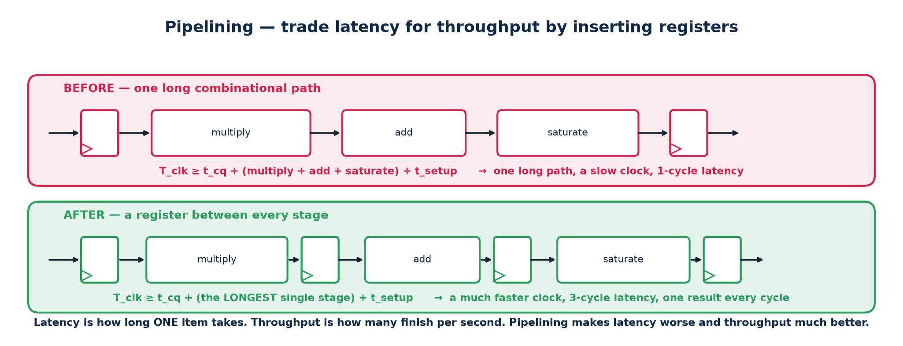
Cut a long path in half; pay one cycle of latency.
The clock period must be longer than the slowest combinational path between two flip-flops. If that path is too slow, insert a register in the middle. You now need two cycles to get an answer — but you can start a new one every cycle.
 | Effect
Throughput | One result per clock, at a much higher clock frequency
Latency | The first result arrives N cycles later
Area | The pipeline registers, plus any control signal that must be delayed to stay aligned with its data

The pipelining trap
Every signal travelling alongside the data must be delayed by the SAME number of stages. Pipeline the datapath and forget the valid bit, and your results arrive correctly but are marked valid two cycles early. Carry valid — and any tag, address or ID — through an identical register chain.

Part 3 · Writing RTL for Basic Digital Circuits
Parts 1 and 2 were the language and the craft. Part 3 is the practice: a catalogue of the standard blocks, a working method for verifying them, and two complete designs built end to end. Every file named here exists in Topic4_Lab and has been compiled, linted, simulated and synthesised.

3.1 The development loop
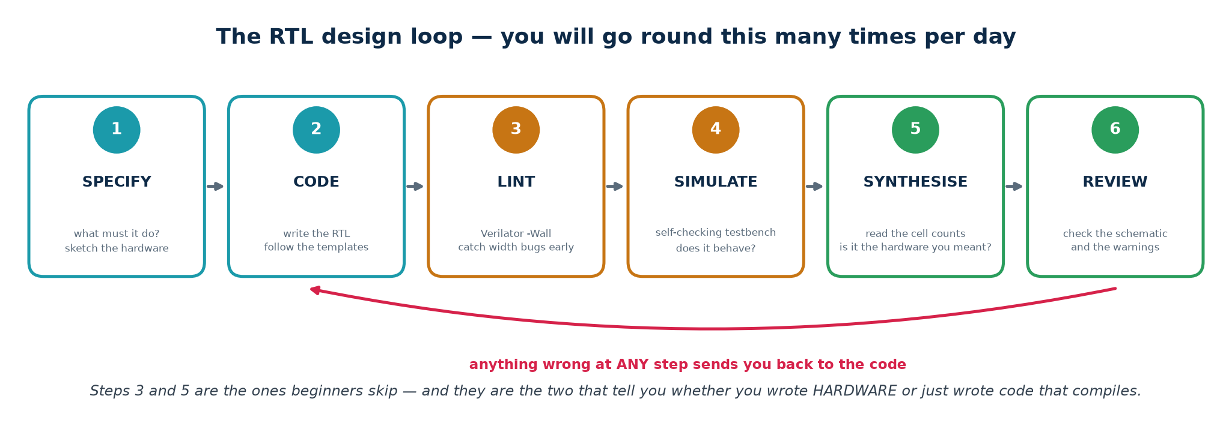
Cheapest check first, every time.
1. SPECIFY. Write down, in words, what the block does: its interface, its reset state, its throughput, its latency. If you cannot write it down you cannot design it.
2. SKETCH. Draw the registers and the logic between them. Ten minutes here saves an afternoon later.
3. CODE. Write the RTL from the sketch, following the coding standard in 1.18.
4. LINT. One second. Catches width truncation, latches, unused and undriven signals.
5. SIMULATE. A minute. Catches logic bugs. The testbench must print PASS or FAIL.
6. SYNTHESISE. Longer. Catches structural bugs: latches, unexpected flip-flop counts, designs that cannot be built.
7. READ THE LOG. Every time. The synthesis log is where the tool tells you your design does not mean what you thought.
The order matters more than the tools
Students who skip lint and go straight to the waveform viewer spend hours chasing symptoms of a truncation that Verilator names in one second. Students who leave synthesis until the end discover their beautiful, fully-verified design contains forty latches and cannot meet timing. Lint, simulate, synthesise — always in that order.

3.2 The design catalogue
Block | File | Core idiom | Lab
2:1 / 4:1 multiplexer | mux2.v mux4.v | assign y = sel ? b : a; / case | L1
3-to-8 decoder | decoder3to8.v | y = 0; if (en) y[sel] = 1'b1; | L1
8-input priority encoder | priority_encoder8.v | casez with ? wildcards | L1
8-operation ALU with flags | alu.v | defaults + case; {1'b0,a}+{1'b0,b} | L1
7-segment decoder | seven_seg.v | case on the nibble, active-low output | L1
N-bit ripple adder | adder_gen.v | generate for + full_adder instances | L1
Register with enable | reg_en.v | if (!rst_n) ... else if (en) q <= d; | L2
Shift register | shift_reg.v | q <= {q[W-2:0], sin}; | L2
Up/down counter | counter.v | q <= q + 1'b1; with wrap and load | L2
Edge detector | edge_detect.v | sig & ~sig_d | L2
CDC synchroniser | synchroniser.v | sync <= {sync[0], async_in}; | L2
Switch debouncer | debouncer.v | counter + stable-for-N-cycles | L2
Clock divider / tick | clk_divider.v | counter + terminal-count pulse | L2
Traffic-light controller | traffic_fsm.v | three-block Moore FSM + timer | L3
Vending machine | vending_fsm.v | FSM with a credit datapath | L3
1011 sequence detector | seq_detect_1011.v | Moore AND Mealy, overlapping | L3
Synchronous FIFO | sync_fifo.v | dual pointers with an extra MSB | L4
Synchronous RAM | sync_ram.v | registered read infers block RAM | L4
UART transmitter | uart_tx.v | FSMD: shifter + bit timer + FSM | L5
UART receiver | uart_rx.v | half-bit alignment, mid-bit sampling | L5
Deliberately broken | broken_examples.v | latch, blocking, truncation | all

Verified synthesis results
Design | Cells | Flip-flops
counter (4-bit, mod-10) | 38 | 4
traffic_fsm | 52 | 12
uart_tx | 120 | 27
uart_rx | 120 | 36
sync_fifo (8 × 8) | 255 | 72

Before you run the tool on your own design, write down your prediction for the flip-flop count by counting the bits of state you declared. If the tool disagrees with you by more than a few, one of you is wrong, and it is worth finding out which.

3.3 Verification — the method
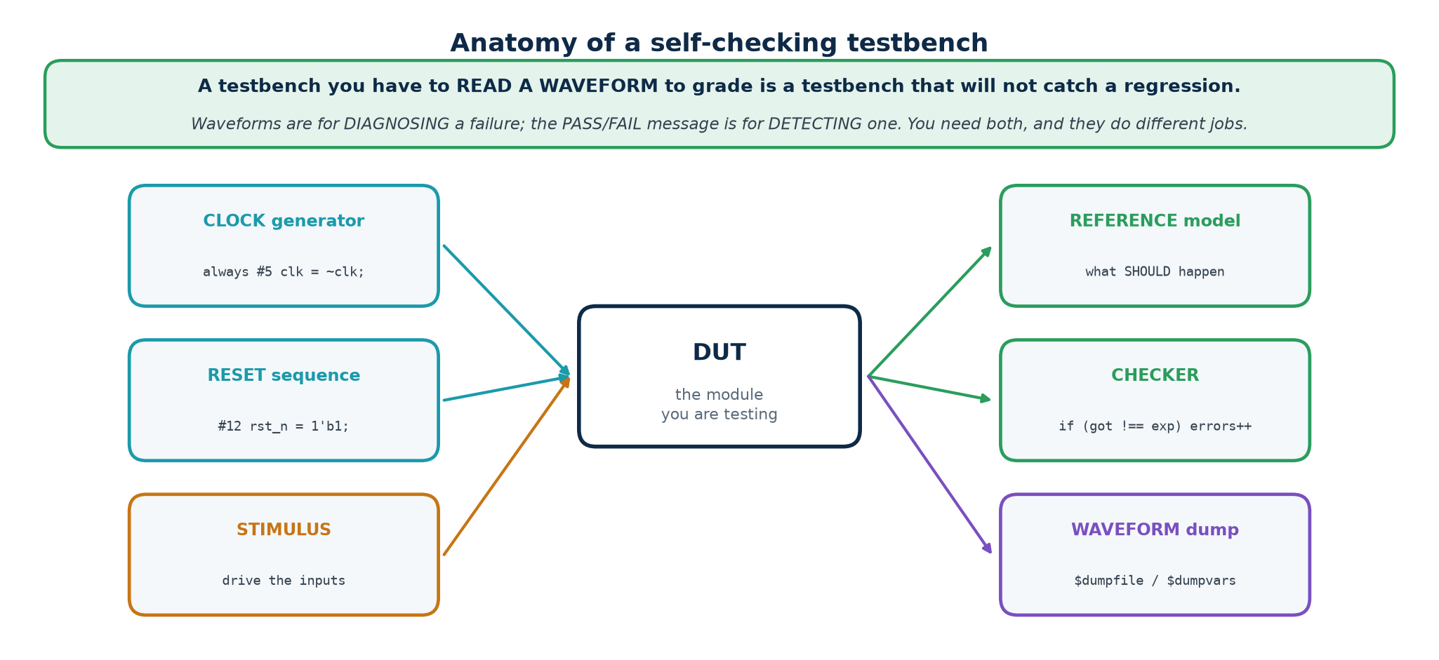
The six parts every testbench has.
A testbench is a module with no ports. It creates a clock, drives the design, and decides — automatically — whether the answers were right. It is never synthesised, so the whole language is available to you.
The rule that separates a testbench from a demonstration
A testbench must print PASS or FAIL, and its verdict must be readable by a machine. If deciding whether a run was correct requires a human to look at a waveform, you cannot put it in a regression, you cannot run it overnight, and you will stop running it entirely within a week.

Everything a testbench needs, in 24 lines
`timescale 1ns / 1ps
module tb_mux2;
reg [7:0] a, b; reg sel; wire [7:0] y;
integer errors = 0;

mux2 #(.W(8)) u_dut (.a(a), .b(b), .sel(sel), .y(y)); // 1. instantiate

// 2. ONE place that decides pass or fail
task check(input [7:0] got, input [7:0] exp, input [255:0] msg);
if (got !== exp) begin
$display("FAIL %0t: %0s got %h expected %h", $time, msg, got, exp);
errors = errors + 1;
end
endtask

initial begin
$dumpfile("mux2.vcd"); $dumpvars(0, tb_mux2); // 3. waveform dump
a = 8'hA5; b = 8'h5A;
sel = 1'b0; #1 check(y, 8'hA5, "sel=0 should pass a"); // 4. stimulus + check
sel = 1'b1; #1 check(y, 8'h5A, "sel=1 should pass b");
if (errors == 0) $display("PASS - mux2"); // 5. verdict
else $display("FAIL - %0d errors", errors);
$finish; // 6. stop
end
endmodule

Note !== and not !=. With the two-state operator, comparing against an x gives x, which is not true, so the check silently passes and the bug escapes. Always use === and !== in a testbench.

Clock and reset
Clock and reset boilerplate
// A 100 MHz clock: 10 ns period, so toggle every 5 ns.
localparam integer CLK = 10;
initial clk = 1'b0;
always #(CLK/2) clk = ~clk;

// Reset: assert before the first edge, release BETWEEN edges.
initial begin
rst_n = 1'b0;
repeat (3) @(posedge clk);
#(CLK/5) rst_n = 1'b1; // released just AFTER an edge, never ON one
end

A bug that cost real time while building this lab
The FSM testbench originally released reset exactly ON a clock edge. That is a race: reset and clock change at the same instant, the state register saw an ambiguous condition, and the state stayed x for two cycles. The sequence detector then found one match instead of two and the design looked broken. It was not.
Drive stimulus a small delay AFTER the active edge; sample a small delay BEFORE the next one. Never change an input at the same instant as the clock.

Reference models, scoreboards and randomisation
Hand-written expected values do not scale past about twenty cases. Beyond that you need a model that computes the right answer independently, and random stimulus to reach the corners you would never think of.
Topic4_Lab/tb/tb_mem.v
// A scoreboard: an independent model of what should be inside the FIFO.
reg [W-1:0] model [0:DEPTH-1];
integer mhead, mtail;
function integer mcount; mcount = mtail - mhead; endfunction

task fifo_push(input [W-1:0] dat);
begin
wr_en = 1'b1; wr_data = dat; @(posedge clk); #1 wr_en = 1'b0;
model[mtail % DEPTH] = dat; mtail = mtail + 1; // model, not DUT
end
endtask

// Randomised, but SEEDED -- so a failure reproduces exactly.
for (k = 0; k < 200; k = k + 1) begin
if (($random(seed) % 2) == 0) begin if (!full) fifo_push($random(seed)); end
else begin if (!empty) fifo_pop(); end
check1(count === mcount(), "fifo count disagrees with the scoreboard");
end

Write the model from the specification, never from the RTL
A reference model derived by reading the design under test will happily agree with the design's bugs. If the same person must write both, write the model FIRST, from the specification, before looking at the implementation again.

Coverage — what did you actually test?
A testbench that passes tells you nothing unless you know what it exercised. Even without formal coverage tools, keep a short list beside each testbench:
▪ Every state of every FSM entered at least once, and every transition taken.
▪ Every branch of every case taken, including the default.
▪ Boundaries: empty and full for a FIFO; 0 and MAX for a counter; the first and last bit of a frame.
▪ Back-to-back operations with no idle cycle between them.
▪ Reset asserted in the middle of an operation, not only at time zero.
▪ At least two different parameter values, if the module is parameterised — this is what caught the UART bug.

Debugging
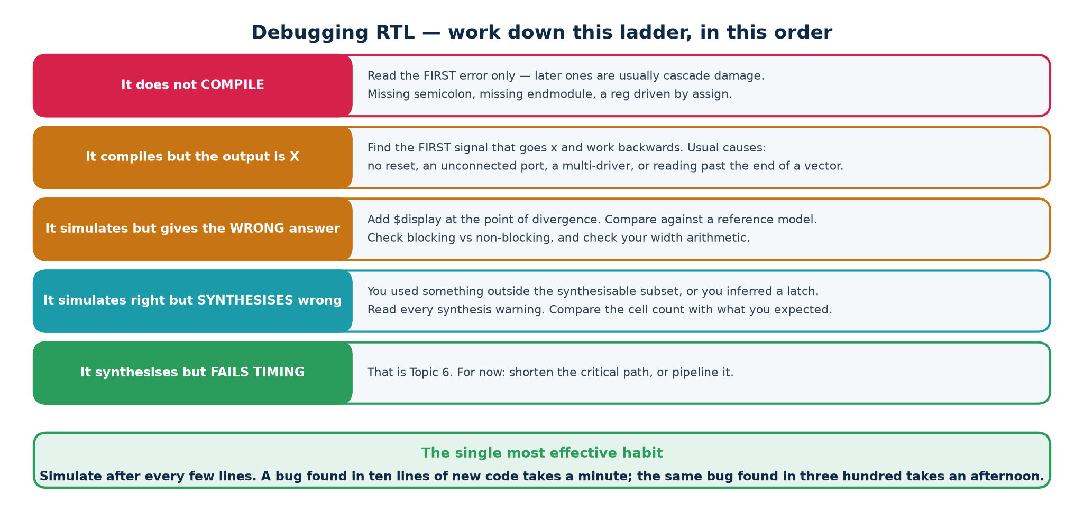
Climb from the cheapest check to the most expensive.
1. Read the error message. It usually names the file and line.
2. Run lint. Verilator will name width and latch problems in one second.
3. Read your own diff. What changed since it last worked?
4. Add $display at the point of failure and print the inputs as well as the output.
5. Open the waveform. Find the FIRST cycle where reality diverges from expectation — not the cycle where you noticed.
6. Walk backwards from that signal to whatever drives it, and repeat.
7. Synthesise. A latch or a surprising flip-flop count explains a whole class of symptoms that look like logic bugs.
8. Reduce. Cut the testbench down to the smallest case that still fails. That case is usually the explanation.
$dumpvars(0, tb); dumps every signal at every level — start there. $dumpvars(1, tb.u_dut); dumps one level of one instance, for when the VCD gets too large to open.

3.4 Design study 1 — a synchronous FIFO
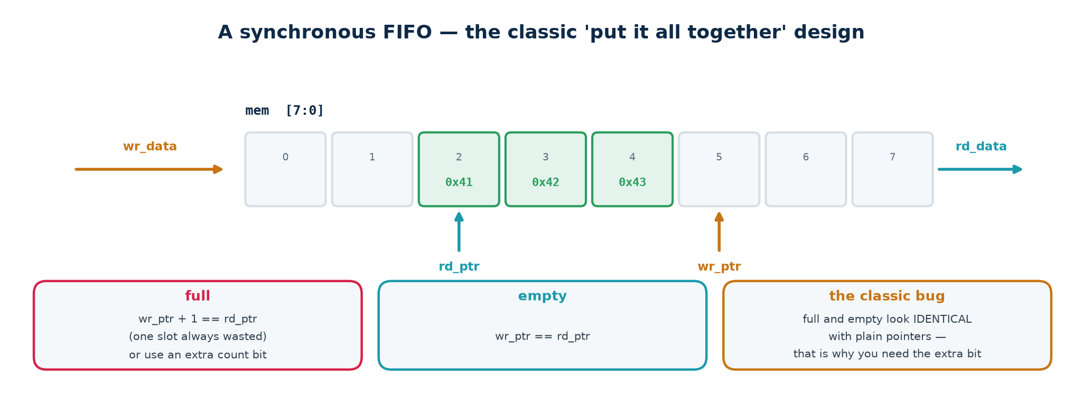
A memory and two pointers.
A FIFO is a memory plus a write pointer and a read pointer. The only genuinely hard part is distinguishing FULL from EMPTY, because in both cases the two pointers are at the same position. The classic solution is to give each pointer one extra bit.
Topic4_Lab/rtl/sync_fifo.v — verified 255 cells, 72 FF at 8 × 8
localparam integer AW = $clog2(DEPTH);
reg [W-1:0] mem [0:DEPTH-1];
reg [AW:0] wr_ptr, rd_ptr; // ONE EXTRA BIT each

wire do_wr = wr_en & ~full; // guard the pointers, not the caller
wire do_rd = rd_en & ~empty;

always @(posedge clk or negedge rst_n) begin
if (!rst_n) wr_ptr <= {(AW+1){1'b0}};
else if (do_wr) begin
mem[wr_ptr[AW-1:0]] <= wr_data;
wr_ptr <= wr_ptr + 1'b1;
end
end

assign rd_data = mem[rd_ptr[AW-1:0]]; // first-word-fall-through read
assign empty = (wr_ptr == rd_ptr); // identical, MSB included
assign full = (wr_ptr[AW] != rd_ptr[AW]) && // wrapped a different number
(wr_ptr[AW-1:0] == rd_ptr[AW-1:0]); // of times, same position
assign count = wr_ptr - rd_ptr; // subtraction wraps correctly, for free

▪ The extra MSB records how many times each pointer has wrapped. Equal in every bit means empty; equal in the address bits but different in the MSB means the writer is exactly one lap ahead — full.
▪ Guard inside the FIFO, not at the caller. A FIFO that silently corrupts itself when someone writes to it while full is a system-level bug waiting to happen.
▪ count is a plain subtraction of the extended pointers; the wraparound takes care of itself, and no separate counter register is needed.
▪ An ASYNCHRONOUS FIFO — two clock domains — needs Gray-coded pointers and synchronisers on each side. Same structure, considerably more care. That is a Topic 5 subject.

3.5 Design study 2 — a UART
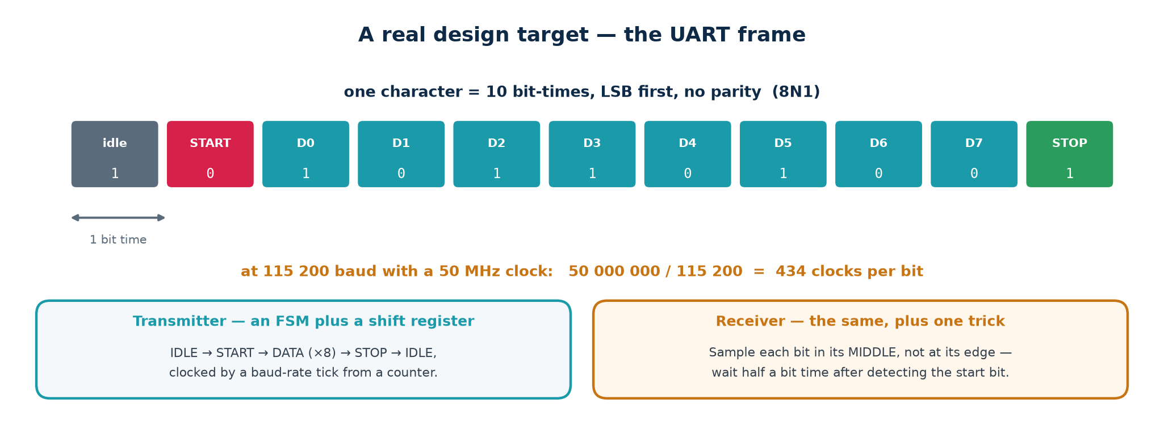
8N1: idle high, start low, eight data bits LSB first, stop high.
The UART is the capstone because it forces every idea in this topic together: combinational logic, sequential logic, an FSM, a datapath, a clock-domain crossing and a self-checking testbench. There is no clock on the wire — both ends agree a bit rate in advance and the receiver recovers timing from the start bit. That is the whole design problem.

Bit timing
CLKS_PER_BIT = f_clk / baud. At 50 MHz and 115 200 baud that is 434.03, so 434. The 0.03 error accumulates to 0.3 of a bit over the ten bits of a frame, comfortably inside the tolerance a mid-bit sample gives you.

The transmitter
A shift register, a bit counter and a four-state FSM. On a start request it loads the byte, drives the start bit low for one bit time, shifts out eight bits LSB first, then drives the stop bit high. Verified: 120 cells, 27 flip-flops.

The receiver — and its one trick
Topic4_Lab/rtl/uart_rx.v — verified 120 cells, 36 FF
// The incoming line is asynchronous. Synchronise it FIRST.
synchroniser #(.STAGES(2)) u_sync (.clk(clk), .rst_n(rst_n),
.async_in(rx), .sync_out(rx_sync));

case (state)
IDLE : begin
clk_cnt <= {CW{1'b0}}; bit_idx <= 3'd0;
if (!rx_sync) state <= START; // falling edge seen
end
START: if (clk_cnt == HALF_BIT[CW-1:0]) begin
if (!rx_sync) begin clk_cnt <= {CW{1'b0}}; state <= DATA; end // genuine
else state <= IDLE; // glitch
end else clk_cnt <= clk_cnt + 1'b1;
DATA : if (clk_cnt == FULL_BIT[CW-1:0]) begin
clk_cnt <= {CW{1'b0}};
shifter <= {rx_sync, shifter[7:1]}; // LSB arrives first
if (bit_idx == 3'd7) state <= STOP;
else bit_idx <= bit_idx + 1'b1;
end else clk_cnt <= clk_cnt + 1'b1;
STOP : if (clk_cnt == FULL_BIT[CW-1:0]) begin
rx_data <= shifter;
rx_valid <= 1'b1;
frame_error <= ~rx_sync; // stop bit must be high
state <= IDLE;
end else clk_cnt <= clk_cnt + 1'b1;
endcase

Sample in the middle, not at the edge
On seeing the start bit fall, wait HALF a bit time and re-check that the line is still low — that rejects a glitch. From then on, sample every FULL bit time and you land in the centre of every bit, with the maximum possible margin against a mismatch between the two ends' clocks.

Three separate registers hold the state: the FSM state (2 bits), the clock counter (CW bits) and the bit index (3 bits). Counting those, plus the shifter and the outputs, is how you predict 36 flip-flops before you run the tool.

3.6 Two real bugs, and what they teach

Bug 1 — width truncation in the UART
Stage | Detail
Symptom | The loopback test passed for 0x00 and 0x55 but failed for 0xFF, which came back as 0xF7. One bit, in one pattern. The transmitter was provably correct.
Cause | The bit-timing limits were written CLKS_PER_BIT[CW-1:0]. The testbench used CLKS_PER_BIT = 16 to keep runs short, so CW = $clog2(16) = 4 — and 16 does not fit in 4 bits. It truncated to ZERO. HALF_BIT became 0, so the receiver never waited half a bit and sampled on bit BOUNDARIES.
Why some bytes | Sampling on a boundary gives whichever value wins the race, which only matters when adjacent bits DIFFER. Some patterns survived and others did not: an intermittent, data-dependent failure.
Fix | Compute the limits as integers — localparam integer FULL_BIT = CLKS_PER_BIT - 1; — and slice them where they are USED. Verified at CLKS_PER_BIT = 16, 27 and 434, and clean under Verilator -Wall.

▪ A parameter used as an INDEX RANGE is not the same thing as a parameter used as a VALUE. Slicing a value that does not fit destroys it silently.
▪ Test at more than one parameter value. At 434 the bug is invisible, because 434 needs 9 bits and CW is 9. Only the short test value exposed it.
▪ Verilator would have reported WIDTHTRUNC on that expression. Lint first, always.

Bug 2 — state timing in the vending machine
The credit register was cleared as the FSM ENTERED the DISPENSE state, so the output logic — which needs the credit to compute the change — saw zero. The fix is to clear it as the machine LEAVES that state:
Topic4_Lab/rtl/vending_fsm.v
// WRONG -- cleared on entering DISPENSE, so the output logic sees 0
if (next == DISPENSE || next == REFUND) cred <= 6'd0;

// RIGHT -- cleared on leaving, so the outputs are valid while the state is active
if (state == DISPENSE || state == REFUND) cred <= 6'd0;

The lesson generalises: in a Moore machine the outputs are computed FROM the state you are currently in. Anything those outputs depend on must still be valid for the whole time you are in that state.
The meta-lesson
Both bugs were found by a self-checking testbench, in seconds, and both would have been nearly impossible to find by staring at waveforms. Neither was a syntax error; both compiled and simulated cleanly. This is what verification is FOR — not to prove that code compiles, but to prove that it means what you intended.

Part 4 · Tools and Guided Tutorials
Every flow does the same four jobs — lint, simulate, view waveforms, synthesise — and only the command names change. Learn the jobs and moving between vendors becomes a morning's work rather than a new skill.
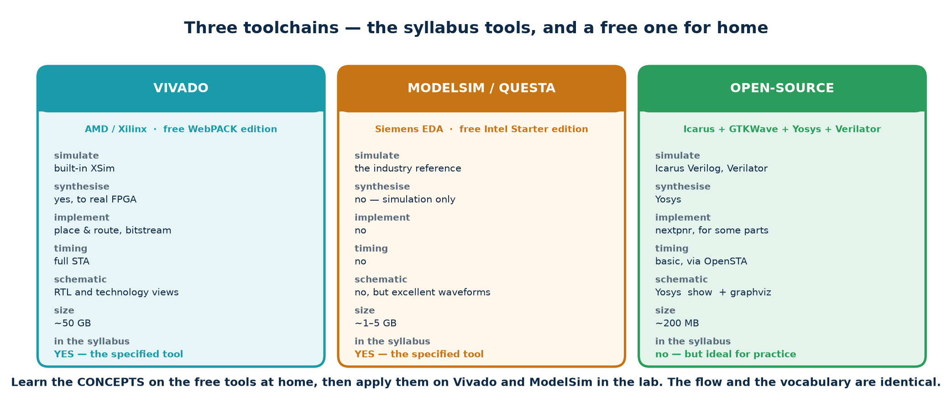
Four jobs, several tools for each.
Job | Open-source | Vendor (syllabus) | What it tells you
Lint / static check | Verilator --lint-only | Vivado report_methodology | Width bugs, latches, unused signals — in one second
Simulate | Icarus Verilog (iverilog / vvp) | ModelSim, Questa, Vivado xsim | Does it behave correctly?
View waveforms | GTKWave | ModelSim wave window, Vivado simulator | Where and when it went wrong
Synthesise | Yosys | Vivado synth_design | What hardware it becomes; area; latch warnings

Why this course uses both
The syllabus specifies Vivado Design Suite and ModelSim, and the lab machines should have them. The open-source chain installs in under a minute on any laptop, runs on Windows through WSL2, and is what students can use at home. The concepts are identical; only the command names differ.
Everything in Topic4_Lab that is quoted as verified was run under Icarus Verilog 12.0, Verilator 5.020 and Yosys 0.33. The Vivado and ModelSim scripts are working templates written from standard, version-stable commands, but they were not executed while this material was prepared, because neither tool was installed in the authoring environment. Check them against your installed version before the session: part numbers and menu names change between releases.

4.1 Installing the open-source toolchain
Copy-paste installation
# ---- Ubuntu / Debian / WSL2 ------------------------------------------------
sudo apt update
sudo apt install -y iverilog gtkwave verilator yosys graphviz

# ---- macOS (Homebrew) ------------------------------------------------------
brew install icarus-verilog gtkwave verilator yosys graphviz

# ---- Windows ---------------------------------------------------------------
# Best: install WSL2 (run wsl --install in an administrator PowerShell),
# then use the Ubuntu commands above inside it.
# Or: download the OSS CAD Suite release for Windows, unzip it, and run
# its start.bat -- it contains all four tools, already built.

# ---- verify ----------------------------------------------------------------
iverilog -V | head -1 # Icarus Verilog version 12.0
verilator --version # Verilator 5.020
yosys -V # Yosys 0.33
gtkwave --version

GTKWave on WSL2
GTKWave is a GUI application. On Windows 11, WSLg runs Linux GUIs with no extra setup — just type gtkwave dump.vcd. On Windows 10 you need an X server such as VcXsrv plus export DISPLAY=:0, or you can simply install the native Windows build of GTKWave and open the .vcd file that the WSL side wrote — the file system is shared.

4.2 Installing Vivado Design Suite
1. Create a free AMD/Xilinx account, then download the Unified Installer for Windows or Linux from the AMD downloads page.
2. Run it and choose Vivado → Vivado ML Standard. This edition is free and needs no licence file; it covers every device you will use on a training board.
3. On the device page select ONLY the family your board uses: Artix-7 for Basys 3 and Arty A7, Zynq-7000 for Zybo and PYNQ. Selecting everything costs well over 100 GB.
4. Keep the Vivado Simulator (xsim) and, on Windows, the Cable Drivers. Without the drivers the board will not be detected.
5. Disk: allow 60–100 GB for one device family. RAM: 8 GB minimum, 16 GB comfortable.
6. Linux only: after installation run the cable-driver script under <install>/data/xicom/cable_drivers/lin64/install_script/install_drivers/
7. Verify with vivado -version (source settings64.sh first on Linux).
Board | Device | Part string | Good for
Basys 3 | Artix-7 | xc7a35tcpg236-1 | Switches, LEDs, four 7-segment digits — ideal for L1–L3
Arty A7 / Nexys A7 | Artix-7 | xc7a35ticsg324-1L / xc7a100tcsg324-1 | Has a USB-UART bridge, so L5 talks to a terminal on the PC
Zybo Z7 / PYNQ-Z2 | Zynq-7000 | xc7z010clg400-1 / xc7z020clg400-1 | More than this topic needs, but the same flow

Plan the session around the installer
Do not spend a scheduled lab hour installing Vivado. Either pre-install it on the lab machines, or set the download running at the start of the session and teach the open-source flow — which installs in under a minute — while it runs. The students are here to learn RTL, not an installer.

Installation problems you will meet
▪ The installer appears to hang at 'Generating installed device list'. It is not hung; that step takes several minutes.
▪ The board is not detected: the cable drivers were skipped, or on Linux the udev rules were not installed.
▪ 'No such part' from a TCL script: the part string does not match your board. Edit it in scripts/vivado_synth.tcl.
▪ On Linux, Vivado needs libtinfo and several 32-bit libraries on some distributions; the installer's log names them.

4.3 Installing ModelSim / Questa
▪ ModelSim Intel FPGA Starter Edition is free, needs no licence, and ships with Intel Quartus Prime Lite. Questa Intel FPGA Starter is its successor; either is fine for this course.
▪ Windows: run the installer and accept the default path.
▪ Linux: ModelSim is a 32-bit application. Install the multilib packages first — lib32z1 lib32ncurses6 libxft2:i386 libxext6:i386 — or vsim will exit immediately with a missing-library error.
▪ Verify with vsim -version.

The commands that matter
ModelSim / Questa
vlib work # create the working library
vmap work work # map the logical name to it
vlog rtl/*.v tb/tb_uart.v # compile into it
vsim -voptargs=+acc work.tb_uart # elaborate and load (+acc keeps visibility)
run -all # simulate until $finish

# with the provided script:
vsim -c -gLAB=L3_fsm -do scripts/modelsim_run.do # batch, prints PASS/FAIL
vsim -do scripts/modelsim_run.do # GUI, with waveforms added

Without -voptargs=+acc the optimiser removes the very signals you want to look at, and the wave window shows almost nothing. It costs simulation speed, which does not matter at this scale.

4.4 The Vivado flow
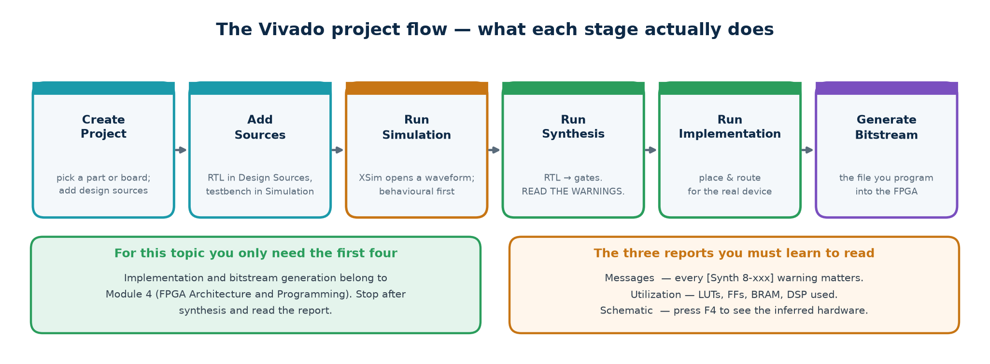
Create, add sources, simulate, synthesise, implement.
Topic4_Lab/scripts/vivado_sim.tcl and vivado_synth.tcl
# Batch simulation -- three tools, always in this order
xvlog rtl/uart_tx.v rtl/uart_rx.v rtl/synchroniser.v tb/tb_uart.v # analyse
xelab -debug typical tb_uart -s tb_uart_sim # elaborate
xsim tb_uart_sim -runall # run

# Batch synthesis
vivado -mode batch -source scripts/vivado_synth.tcl -tclargs uart_tx

What vivado_synth.tcl does
create_clock -period 20.000 -name clk [get_ports clk] # 50 MHz -- ESSENTIAL
synth_design -top uart_tx -part xc7a35tcpg236-1
report_utilization -file build/vivado/uart_tx_utilization.rpt
report_timing_summary -file build/vivado/uart_tx_timing.rpt

What to read afterwards — not the schematic
Report | Read it for
Utilization | LUTs, flip-flops, block RAMs, DSPs. Compare the flip-flop count with your own prediction from the source. A large disagreement means the tool built something you did not intend.
Timing summary | Worst negative slack (WNS). Positive means the design meets the clock you constrained; negative says by how much it misses. Without a create_clock the report is meaningless.
Messages tab | Every [Synth 8-xxx] warning. Read all of them once. Latch inference, width mismatch and unconnected-port warnings all live here.

4.5 Command reference
Task | Open-source | Vivado | ModelSim
Lint | verilator --lint-only -Wall rtl/*.v | report_methodology | vlog (warnings)
Compile | iverilog -g2005 -o sim.vvp <files> | xvlog <files> | vlog <files>
Elaborate | (part of iverilog) | xelab -debug typical <top> | (part of vsim)
Run | vvp sim.vvp | xsim <snapshot> -runall | vsim -c work.<top>; run -all
Waveforms | gtkwave dump.vcd | simulator wave window | add wave -r /*
Synthesise | yosys -p "...; synth -top X; stat" | synth_design -top X -part P | (not a synthesis tool)
Area report | stat | report_utilization | —
Timing report | (none — no timing model) | report_timing_summary | —
Find latches | grep -i latch on the log | Messages: [Synth 8-327] | —
Schematic | show -format dot ; dot -Tpng | Open Synthesized Design | (not applicable)

Guided Tutorials T1 – T6
Six tutorials, done at the keyboard, in order. Each one ends with something you can see. Total time about four hours; they are the bridge between reading Parts 1–3 and attempting the exercises in Part 5.

T1 · First simulation — a multiplexer, end to end (25 min)
Goal: compile, simulate and view a waveform, using nothing but the open-source chain.
1. Open a terminal in the Topic4_Lab folder.
2. Confirm the tools are present: iverilog -V, verilator --version, yosys -V.
3. Read rtl/mux2.v. It is nine lines. Identify the parameter, the ports and the single assign.
4. Read tb/tb_comb.v as far as the mux2 section. Find the check task, the instantiation and the $dumpfile call.
5. Lint first: verilator --lint-only -Wall -Wno-DECLFILENAME rtl/mux2.v
6. Compile: iverilog -g2005 -Wall -o build/comb.vvp rtl/mux2.v rtl/mux4.v rtl/decoder3to8.v rtl/priority_encoder8.v rtl/alu.v rtl/seven_seg.v rtl/adder_gen.v tb/tb_comb.v
7. Run: vvp build/comb.vvp You should see PASS - L1 combinational library, all checks correct
8. Open the waveform: gtkwave comb.vcd & Expand tb_comb, drag a, b, sel and y into the wave pane, and press the zoom-fit button.
9. Change sel's value in the testbench so one check must fail. Re-run. Read the FAIL message and note that it names the time, the value it got and the value it expected. Put it back.
What you should be able to do now
Compile and run a simulation from the command line, read a PASS/FAIL transcript, and get a signal onto a waveform. Everything else in this topic builds on those three things.

T2 · Seeing the hardware — synthesis and the latch (30 min)
Goal: connect code to gates, and see a latch appear and disappear.
1. Synthesise the multiplexer:
2. yosys -p "read_verilog rtl/mux2.v; synth -top mux2; stat"
3. Read the cell count. There are no flip-flops, because there is no clock — confirm that matches your expectation.
4. Now synthesise the counter: yosys -p "read_verilog rtl/counter.v; synth -top counter; stat" — 38 cells and 4 flip-flops. Before you look, predict the flip-flop count from the source. Where do the 4 come from?
5. Re-synthesise with a different width: yosys -p "read_verilog rtl/counter.v; chparam -set W 16 counter; synth -top counter; stat" — the flip-flop count follows the parameter, with no source change at all.
6. Now the interesting one: yosys -p "read_verilog rtl/broken_examples.v; synth -top bad_latch; stat" Look for $_DLATCH_N_ and $_DLATCH_P_. There are two.
7. Copy bad_latch into a new file, add the missing else and the missing default, and synthesise again. The DLATCH lines are gone.
8. Repeat for bad_blocking: it reports ONE $_DFF_P_. Change the two = to <= and it reports two.
9. Optional, if graphviz is installed: yosys -p 'read_verilog rtl/traffic_fsm.v; proc; opt; show -format dot -prefix tf' then dot -Tpng tf.dot -o tf.png and open the picture.
The habit this builds
Predict, then verify. A designer who can look at a page of RTL and describe the netlist before running the tool catches problems in review, in minutes. A designer who cannot finds them in the lab, in days.

T3 · Lint before everything (20 min)
Goal: learn what a linter catches that a simulator does not.
1. Run the lab's lint script: ./scripts/lint.sh It should print LINT CLEAN.
2. Now lint the deliberately broken file: verilator --lint-only -Wall rtl/broken_examples.v Read every message.
3. Find the WIDTHTRUNC message for bad_width. It names the file, the line, the expected width and the actual width. That single message is what would have saved an hour on the UART bug.
4. Introduce a fault of your own in a copy of rtl/counter.v: delete the reset branch, or assign q from two different always blocks, or misspell a signal name in a port connection.
5. Lint it. Note which faults the linter catches immediately, which ones only synthesis catches, and which ones only simulation catches.
6. Write down the answer to that last question in your own words. It is the most useful thing in this tutorial.

T4 · A sequential design — counters, edges and CDC (35 min)
Goal: work confidently with clocked logic and understand what a testbench must do around a clock edge.
1. Run lab 2: iverilog -g2005 -o build/seq.vvp rtl/reg_en.v rtl/shift_reg.v rtl/counter.v rtl/edge_detect.v rtl/synchroniser.v rtl/debouncer.v rtl/clk_divider.v tb/tb_seq.v && vvp build/seq.vvp
2. Open seq.vcd in GTKWave. Add clk, rst_n and the counter's q. Confirm that q changes only on rising clock edges and that reset forces it to zero immediately.
3. Add the edge detector's sig, sig_d, rise and fall. Confirm rise is exactly one clock cycle wide and occurs one cycle after sig rises.
4. Now break it deliberately: in the testbench, change the edge detector's stimulus so the input changes AT a clock edge rather than just after one. Re-run and look at the waveform. This is exactly the bug that cost time while writing this lab.
5. Change the counter's parameters in the testbench from W=4, MAX=15 to W=4, MAX=9. Re-run and confirm it now wraps at 9 — a decade counter, from the same source.
6. Look at rtl/synchroniser.v and find the two flip-flops. Add sync[0] and sync[1] to the waveform and confirm the output lags the input by two clock cycles.

T5 · A state machine from scratch (45 min)
Goal: write a three-block FSM yourself, from a written specification.
Specification. Design a module door_lock with inputs clk, rst_n, key_valid and key [1:0], and outputs unlocked and alarm. The lock opens when the sequence 2, 1, 3 is entered on consecutive valid keys. Any wrong key returns the machine to the start; three consecutive wrong keys raise the alarm until reset. unlocked stays high for four clock cycles and then the machine returns to the start.
1. Draw the state diagram on paper FIRST. Name the states. Decide which outputs belong to which state — this is a Moore machine, so the outputs come from the state alone.
2. Decide what extra state you need beyond the FSM state: a wrong-key counter and a four-cycle dwell timer. Count the flip-flops you expect.
3. Write the module using the three-block template from 2.12. Give every case a default and every combinational block a default assignment at the top.
4. Write a self-checking testbench. It must at minimum test: the correct sequence; a wrong key in each of the three positions; three wrong keys raising the alarm; reset clearing the alarm; and the unlocked pulse being exactly four cycles.
5. Lint, simulate, then synthesise. Compare the flip-flop count with your prediction from step 2.
6. Check the synthesis log for the word 'latch'. If it appears, find the branch you did not cover.
If you get stuck
Read rtl/traffic_fsm.v (a timed Moore FSM) and rtl/seq_detect_1011.v (a sequence detector with overlapping matches). Between them they contain every technique this exercise needs. Exercise 55 in Part 5 gives the coverage list your testbench must satisfy; the design itself is yours to write.

T6 · The UART capstone (60 min)
Goal: run, understand and extend a complete design that uses everything in the topic.
1. Run lab 5: iverilog -g2005 -o build/uart.vvp rtl/uart_tx.v rtl/uart_rx.v rtl/synchroniser.v tb/tb_uart.v && vvp build/uart.vvp It prints PASS.
2. Open uart.vcd. Add the tx line, rx_valid and rx_data. Find one complete frame: the idle high, the start bit low, eight data bits LSB first, the stop bit high. Count the clock cycles per bit and confirm it matches CLKS_PER_BIT in the testbench.
3. Find the receiver's clk_cnt in the waveform and watch it reach HALF_BIT once, at the start, and FULL_BIT for every bit after that. That is the mid-bit alignment.
4. Prove the design is really parameterised: change CPB in tb/tb_uart.v from 16 to 434 — the real 50 MHz / 115 200 value — and re-run. It still passes; the simulation just takes longer.
5. Now reproduce the bug. In a COPY of rtl/uart_rx.v, change the two timing comparisons back to CLKS_PER_BIT[CW-1:0] and re-run at CPB = 16. Watch some bytes fail and others pass. Then run Verilator on it and read the WIDTHTRUNC message.
6. Extend the design: add an odd parity bit to both the transmitter and the receiver, and a parity_error output. Update the testbench to check that a corrupted frame sets it.
7. Optional, on a board: connect uart_tx to the USB-UART pin, send a byte per second, and read it in a terminal at the right baud rate. There is no substitute for seeing your own RTL talk to a PC.
Why the UART is the capstone
It is the smallest design that contains all of it: combinational logic, sequential logic, a finite state machine, a datapath, a clock-domain crossing, parameterisation, and a self-checking testbench with an independent reference decoder. If a student can explain the UART line by line, they have understood Topic 4.

Part 5 · Practice Exercises
Sixty exercises in five blocks. Block A checks that you know the language; block B is the one that builds the skill this module assesses — predicting hardware from source; block C is debugging; block D is design; block E is verification and tools. Full worked solutions are in Part 6.
Block | Exercises | What it trains
A | 1–12 | Language recall — types, literals, widths, operators
B | 13–26 | Prediction — what does this code become in hardware?
C | 27–38 | Debugging — find the fault and say which tool would catch it
D | 39–52 | Design — write the RTL from a specification
E | 53–60 | Verification and tools

Block A · Language recall

Exercise 1 · reg and register
Is a variable declared reg always a register in hardware? Give one case where it is and one where it is not, with a line of code for each.

Exercise 2 · Literal width and sign
State the width and signedness of each of these literals: 8'd10, 4'b1010, 12, -8'd1, 8'sd200, 8'hFF, 8'bx.

Exercise 3 · Replication and concatenation
Evaluate and give the width of each: {3{2'b10}}, {2'b11, {3{1'b0}}, 3'b101}, {4'hA, 4'h5}.

Exercise 4 · Reduction operators
Give the single-bit result of each, for data = 8'b1101_0110: ^data, |data, &data, ~|data.

Exercise 5 · Logical versus bitwise
For a = 4'b0011 and b = 4'b1100, give the value and width of a && b, a & b, !a and ~a.

Exercise 6 · Vectors and arrays
Which of these are legal, and what does each mean?
reg [7:0] v; reg u [0:7]; reg [7:0] m [0:255];

(a) v[3:0] (b) u[3:0] (c) m[17] (d) m[17][3:0] (e) m[3:0]

Exercise 7 · Indexed part-select
Why is d[i:j] illegal when i and j are signals, while d[i +: 4] is legal? What hardware does the legal form produce?

Exercise 8 · wire or reg
For each, say whether the signal should be declared wire or reg, and why: (a) a module output driven by an assign; (b) a module output driven inside always @(posedge clk); (c) an internal signal connecting two instances; (d) a variable assigned inside always @(*).

Exercise 9 · parameter and localparam
State the difference, and give one situation where using parameter instead of localparam would allow a user of your module to break it.

Exercise 10 · Directives
What does `default_nettype none do, and what class of bug does it turn from a silent x into a compile error? Give a concrete example.

Exercise 11 · System tasks
Which of these are synthesisable: $display, $clog2, $random, $bits, $finish? For each synthesisable one, give a use in design code.

Exercise 12 · Timescale
A file begins `timescale 1ns / 1ps. A statement says #5;. How much simulated time passes? What changes if the timescale becomes `timescale 10ns / 1ns?

Block B · Predict the hardware
For each snippet: say what the synthesiser produces, and how many flip-flops (if any). Then check your answer with Yosys.

Exercise 13 · A one-liner
assign y = sel ? b : a; // a, b, y are [7:0]

Exercise 14 · A missing else
always @(*)
if (en) y = d;

Exercise 15 · Blocking in a clocked block
always @(posedge clk) begin
q1 = d;
q2 = q1;
end

Exercise 16 · The same, reordered
always @(posedge clk) begin
q2 = q1;
q1 = d;
end

Exercise 17 · A concatenation in a clocked block
always @(posedge clk)
q <= {q[6:0], sin}; // q is [7:0]

Exercise 18 · An unrolled loop
integer i;
always @(*) begin
s = 4'd0;
for (i = 0; i < 8; i = i + 1) s = s + data[i];
end

Exercise 19 · A reduction
assign z = ~|result; // result is [7:0]

Exercise 20 · A registered read
reg [7:0] mem [0:1023];
always @(posedge clk) begin
if (we) mem[waddr] <= wdata;
rdata <= mem[raddr];
end

Exercise 21 · An asynchronous read
How does this differ from exercise 20 in the hardware produced, and why does it matter on an FPGA?
reg [7:0] mem [0:1023];
always @(posedge clk) if (we) mem[waddr] <= wdata;
assign rdata = mem[raddr];

Exercise 22 · A variable index on the left
always @(*) begin
y = 8'b0;
if (en) y[sel] = 1'b1; // sel is [2:0]
end

Exercise 23 · A function called twice
function [15:0] scale; input [7:0] v; scale = v * 8'd37; endfunction
assign p = scale(a);
assign q = scale(b);

Exercise 24 · An if/else chain versus a case
Both snippets below compute the same function. Which produces the shallower logic, and why does that matter?
// (a) // (b)
if (s==2'd0) y = w; case (s)
else if (s==2'd1) y = x; 2'd0: y = w; 2'd1: y = x;
else if (s==2'd2) y = y2; 2'd2: y = y2; default: y = z;
else y = z; endcase

Exercise 25 · A counter
How many flip-flops? What is the largest value q ever holds? What would change if the comparison were q == 8'd255?
always @(posedge clk or negedge rst_n)
if (!rst_n) q <= 8'd0;
else if (en) q <= (q == 8'd199) ? 8'd0 : q + 1'b1;

Exercise 26 · A three-block FSM
Topic4_Lab/rtl/traffic_fsm.v synthesises to 52 cells and 12 flip-flops. Account for the 12 flip-flops by naming the registers in the source and their widths.

Block C · Find the bug
For each: name the fault, say what the symptom would be, and state which stage of the flow — lint, simulation or synthesis — would catch it first.

Exercise 27 · Adder
wire [3:0] a, b;
wire [3:0] sum;
assign sum = a + b;

Exercise 28 · Combinational block
always @(a or b)
y = a & b & c;

Exercise 29 · Case
always @(*)
case (sel)
2'b00: y = d0;
2'b01: y = d1;
2'b10: y = d2;
endcase

Exercise 30 · Two drivers
always @(posedge clk) q <= d;
assign q = 1'b0;

Exercise 31 · Reset
always @(posedge clk)
q <= d; // no reset anywhere in the design

Exercise 32 · Shift register
always @(posedge clk) begin
stage1 = din;
stage2 = stage1;
stage3 = stage2;
end

Exercise 33 · Parameter slice
This is the real UART bug. Explain precisely why it fails at CLKS_PER_BIT = 16 but not at CLKS_PER_BIT = 434.
localparam integer CW = $clog2(CLKS_PER_BIT);
reg [CW-1:0] cnt;
always @(posedge clk)
if (cnt == CLKS_PER_BIT[CW-1:0]) cnt <= 0; else cnt <= cnt + 1'b1;

Exercise 34 · Testbench comparison
if (y != expected) $display("FAIL");

Exercise 35 · Clock domain crossing
always @(posedge clk_b)
data_b <= data_a; // data_a is [7:0], generated in clk_a's domain

Exercise 36 · FSM
always @(*) begin
case (state)
IDLE: next = RUN;
RUN : next = DONE;
DONE: next = IDLE;
endcase
end

Exercise 37 · Testbench stimulus
always #5 clk = ~clk;
initial begin
rst_n = 0;
@(posedge clk) rst_n = 1; // released exactly on an edge
...
end

Exercise 38 · Pipeline
always @(posedge clk) begin
s1 <= a * b;
s2 <= s1 + c;
result <= s2;
end
assign result_valid = in_valid; // not delayed

Block D · Write the RTL
Write synthesisable Verilog that follows the coding standard in section 1.18. For each, also write a self-checking testbench that prints PASS or FAIL.

Exercise 39 · 4:1 multiplexer
Parameterised width W, inputs d0..d3, a 2-bit select, one output. Use a case statement.

Exercise 40 · Binary-to-Gray and Gray-to-binary
Two combinational modules, parameterised width. Gray code changes exactly one bit between consecutive values; state the formula you used.

Exercise 41 · Parity generator and checker
An 8-bit even-parity generator, and a checker that raises an error output when a 9-bit received word has the wrong parity. One operator each.

Exercise 42 · Barrel shifter
An 8-bit barrel shifter with a 3-bit shift amount and a direction input, using a generate-free single expression. Say how many multiplexer levels it produces.

Exercise 43 · Comparator
A parameterised magnitude comparator with gt, eq and lt outputs. Handle the signed case as a parameter.

Exercise 44 · Register file
A 16 × 8 register file with one write port and two read ports, all synchronous to one clock. Write port has an enable; register 0 always reads as zero.

Exercise 45 · Programmable clock divider
Given a parameter DIV, produce a single-cycle tick every DIV clocks. Do not gate the clock. State the flip-flop count as a function of DIV.

Exercise 46 · Debouncer
A switch debouncer: the output changes only when the input has been stable for N consecutive clocks. N is a parameter.

Exercise 47 · Pulse stretcher
Turn a single-cycle pulse into an output that stays high for exactly N cycles, ignoring further pulses while it is high.

Exercise 48 · Round-robin arbiter
Four requesters, one grant output, one-hot. After granting requester i, the next search starts at i+1. State whether your grant is Moore or Mealy.

Exercise 49 · Sequence detector
Detect the overlapping sequence 1101 on a serial input. Provide BOTH a Moore and a Mealy output and explain the one-cycle difference.

Exercise 50 · Stack (LIFO)
A depth-8, 8-bit stack with push, pop, full and empty. Guard the pointer inside the module. What happens on a simultaneous push and pop?

Exercise 51 · SPI master (mode 0)
Shift out 8 bits MSB first on the falling edge of sclk, sample miso on the rising edge, with a programmable clock divider and a busy output.

Exercise 52 · UART with parity
Extend Topic4_Lab's uart_tx and uart_rx to support an optional odd or even parity bit, selected by a parameter, with a parity_error output on the receiver.

Block E · Verification and tools

Exercise 53 · Self-checking conversion
Take a testbench that only prints values and convert it into a self-checking one. List the six parts from section 3.3 and say where each appears in your version.

Exercise 54 · Scoreboard
Write a scoreboard for Topic4_Lab's sync_fifo that is independent of the design, and use it with 500 randomised, seeded push/pop operations.

Exercise 55 · Coverage list
For the door_lock FSM of tutorial T5, write the coverage list: every state, every transition, and every boundary condition your testbench must exercise.

Exercise 56 · Reproduce the UART bug
Reintroduce the CLKS_PER_BIT[CW-1:0] truncation into a copy of uart_rx.v. Then write a testbench that sends all 256 byte values and counts the failures, and run it at CLKS_PER_BIT = 8, 16, 27, 32, 64, 100 and 434. Some of those values fail catastrophically and some do not fail at all. Work out the rule that separates the two groups, and prove it from the definition of $clog2.

Exercise 57 · Lint triage
Run Verilator on rtl/broken_examples.v and classify every message as: a real bug, a style warning, or a false positive. Justify each classification.

Exercise 58 · Predict then measure
For any three designs in Topic4_Lab, write down your predicted flip-flop count, then run Yosys. Where you were wrong, explain why in one sentence each.

Exercise 59 · Vendor flow
Using scripts/vivado_synth.tcl (or ModelSim's .do file), synthesise uart_tx and report: LUT count, flip-flop count, and worst negative slack at a 50 MHz constraint. Compare the flip-flop count with the Yosys figure of 27 and explain any difference.

Exercise 60 · Timing experiment
Take adder_gen.v and synthesise it at W = 4, 16 and 64 with a clock constraint. Plot the worst path delay against W. Then replace the whole module with assign sum = a + b; and compare. What does the result tell you about describing intent versus structure?

Part 6 · Worked Solutions

Block A
Solution 1
No. reg is a simulator variable, not a hardware register. It becomes a flip-flop only when it is assigned inside a clocked block.
always @(posedge clk) q <= d; // reg q -> a flip-flop
always @(*) y = a & b; // reg y -> pure combinational logic, no storage

Solution 2
8'd10 8 bits, unsigned 00001010
4'b1010 4 bits, unsigned 1010
12 32 bits, SIGNED the trap: no width means 32-bit signed
-8'd1 8 bits, unsigned bits 11111111 (two's complement of 1)
8'sd200 8 bits, SIGNED 11001000 = -56, not 200
8'hFF 8 bits, unsigned 11111111 = 255
8'bx 8 bits xxxxxxxx (x fills the width)

Solution 3
{3{2'b10}} = 6'b101010 width 6
{2'b11, {3{1'b0}}, 3'b101} = 8'b11000101 width 2+3+3 = 8
{4'hA, 4'h5} = 8'hA5 width 8

Solution 4
data = 8'b1101_0110 has five 1s.
^data = 1'b1 odd number of 1s -> parity is 1
|data = 1'b1 at least one bit is set
&data = 1'b0 not all bits are set
~|data = 1'b0 the value is not zero

Solution 5
a && b = 1'b1 1 bit: both operands are non-zero
a & b = 4'b0000 4 bits: bitwise AND of 0011 and 1100
!a = 1'b0 1 bit: a is non-zero, so 'not a' is false
~a = 4'b1100 4 bits: every bit inverted

Solution 6
(a) v[3:0] LEGAL the bottom nibble of an 8-bit vector
(b) u[3:0] ILLEGAL u is an ARRAY of 1-bit elements; you cannot slice an array
(c) m[17] LEGAL one 8-bit element of the memory
(d) m[17][3:0] LEGAL the bottom nibble of that element
(e) m[3:0] ILLEGAL again, an array cannot be sliced

Solution 7
A synthesiser must know the WIDTH of every expression at elaboration. With d[i:j] and variable bounds the width is unknown, so the expression is illegal. d[i +: 4] has a constant width of 4 and only a variable position, which is exactly what a multiplexer does — so it synthesises to a multiplexer that selects a 4-bit window out of d.
Solution 8
(a) wire -- an assign may only drive a net
(b) reg -- a procedural block may only assign a variable
(c) wire -- a plain connection between two instances, one driver
(d) reg -- assigned inside a procedural block; still combinational, not a register

Solution 9
parameter may be overridden at instantiation; localparam may not. Declaring a state encoding as a parameter lets a user write fsm #(.IDLE(3'd7)) u_f (...) and silently change the meaning of every case label inside the module, breaking logic that the module's author verified. State encodings, derived widths and internal constants should always be localparam.
Solution 10
It disables implicit net declaration. Without it, an undeclared name becomes a 1-bit wire with no driver, silently. Misspell data_valid as data_vaild in a port connection and you get an undriven wire, an x on that port, and no message at all. With the directive it is a compile error on the exact line.
Solution 11
$clog2 and $bits are synthesisable, because they are evaluated at elaboration. $display, $random and $finish are simulation only.
localparam integer AW = $clog2(DEPTH); // address width from depth
localparam integer W = $bits(some_signal); // adapt to whatever was passed in

Solution 12
With `timescale 1ns / 1ps, #5 advances time by 5 ns, rounded to the nearest picosecond. With `timescale 10ns / 1ns the same #5 advances 50 ns. Every delay in the file changes meaning — which is why the timescale should be identical in every file, or set once in a shared header.

Block B
Solution 13
One 8-bit 2:1 multiplexer — eight 2:1 multiplexer bits. No flip-flops: there is no clock.
Solution 14
A transparent latch on y, enabled by en. There is no else, so on the path where en is low y must keep its old value, and the only storage a level-sensitive block can produce is a latch. Yosys reports $_DLATCH_P_.
Solution 15
ONE flip-flop. q1 takes d; the next statement gives q2 the NEW q1, which is d. The tool sees two registers holding the same value and keeps one. Verified in Topic4_Lab as bad_blocking.
Solution 16
TWO flip-flops, and correct shift-register behaviour — from the same operator. This is the real objection to blocking assignment in a clocked block: the hardware depends on the order you typed the lines, which is not a property real flip-flops have.
Solution 17
An 8-bit shift register: 8 flip-flops. Each bit's D input is the previous bit's Q, and sin feeds bit 0.
Solution 18
An adder tree with eight one-bit addends — seven adds, which the tool will balance into a tree about three levels deep. No flip-flops. Note that s is only 4 bits, which is enough for a maximum of 8, so nothing truncates here.
Solution 19
An 8-input NOR reduction tree producing one bit: the zero flag. No flip-flops.
Solution 20
A 1 K × 8 block RAM with a registered read port and a synchronous write port. The array itself is a RAM primitive, not flip-flops; rdata is one 8-bit output register.
Solution 21
The read is asynchronous, and no FPGA block RAM can do an asynchronous read. The tool must therefore build the entire array from flip-flops — 8192 of them — plus a 1024-to-1 multiplexer per output bit. The design will very likely not fit, and if it does it will be slow. Same intent, wildly different silicon.
Solution 22
A 3-to-8 decoder with an enable. The variable index on the left-hand side, combined with the default of all zeros, is exactly the decoder pattern. No flip-flops.
Solution 23
TWO independent multipliers. A function call is not a subroutine call — each call site gets its own physical copy of the logic. If you want one shared multiplier used at different times, that is a datapath with a multiplexer and a controller.
Solution 24
(b) is shallower. The if/else chain is a priority structure and synthesises to three multiplexers in series; the case is a parallel structure and synthesises to one 4:1 multiplexer. Depth is delay, so on a critical path the difference is real — and (b) is easier to read as well.
Solution 25
Eight flip-flops (q is [7:0]). The largest value q holds is 199, because it wraps to 0 on the cycle after 199. If the comparison were q == 8'd255, the explicit wrap becomes redundant — an 8-bit counter wraps from 255 to 0 by itself — and the comparator logic would be optimised away, saving cells.
Solution 26
This is the exercise where most people get it wrong, and the reason is worth knowing. The obvious answer — 2 for the state and 8 for the timer — gives 10, not 12. The outputs are combinational (always @(*)), so they contribute nothing. The missing two come from the tool, not from your source:
timer reg [7:0] -> 8 $_DFFE_PN0P_ (enabled by tick)
state reg [1:0], RE-ENCODED one-hot -> 4 (3 $_DFF_PN0_ + 1 $_DFF_PN1_)
---
12 as reported

$ grep -i fsm build/synth_traffic_fsm.txt
FSM_RECODE pass (re-assigning FSM state encoding)
Recoding FSM `$fsm$\state$49' ... mapping auto encoding to `one-hot` for this FSM

// The DFF_PN1_ is the one-hot bit for MAIN_GREEN -- it resets to 1, the others to 0.

Block C
Solution 27
Width truncation. sum is 4 bits but a + b can produce 5. 9 + 8 gives 17, which truncates to 1. Symptom: arithmetic that is correct for small values and wrong for large ones. Caught first by LINT (Verilator WIDTHTRUNC). Fix: make sum [4:0], or write assign {cout, sum} = a + b;
Solution 28
Incomplete sensitivity list: c is read but not listed, so the block does not re-run when c changes. Symptom: simulation and synthesis disagree — synthesis builds the correct combinational logic, simulation does not. Caught first by LINT. Fix: always @(*).
Solution 29
No default, and 2'b11 is not covered, so y latches on that input. Symptom: an inferred latch in the synthesis report and a design that is hard to time. Caught first by LINT, and unmistakably by SYNTHESIS. Fix: add default: y = d0; or a default assignment at the top of the block.
Solution 30
Two drivers on q — one procedural, one continuous. This is illegal for a reg and gives x where they conflict. Caught first by the COMPILER or LINT. Fix: one signal, one driving block.
Solution 31
No reset. The flip-flop's power-up value is unknown, so q is x from time zero and the x propagates through the whole design. Symptom: everything is x and nothing works. Caught first by SIMULATION. FPGA tools may hide this by honouring an initial value; ASIC tools will not. Fix: reset every state-holding register.
Solution 32
Blocking assignments in a clocked block. All three stages collapse: stage3 receives din in the same cycle, so instead of a three-deep pipeline you get one flip-flop. Caught first by LINT (most linters flag = in a clocked block), and visibly by SYNTHESIS (one flip-flop instead of three). Fix: use <=.
Solution 33
CLKS_PER_BIT is sliced to CW bits, but CLKS_PER_BIT itself does not FIT in CW bits — CW is the width needed to count from 0 to CLKS_PER_BIT−1, one short. At 16, CW = $clog2(16) = 4 and 16 truncates to 0, so the counter compares against zero and the timing collapses. At 434, CW = $clog2(434) = 9 and 434 fits in 9 bits, so the slice loses nothing and the bug is invisible.
This is why you must test at more than one parameter value.
// Fix: compute as an integer, then slice at the point of use.
localparam integer FULL_BIT = CLKS_PER_BIT - 1;
... if (cnt == FULL_BIT[CW-1:0]) ...

Solution 34
!= is the two-state comparison. If y is x, y != expected evaluates to x, which is not true, so the check passes and the bug escapes silently. Use !== in testbenches. Caught by nothing but review — which is why it is worth knowing.
Solution 35
An 8-bit bus crossing a clock domain with no synchronisation at all. Each bit can go metastable independently and the bits can settle on different cycles, so clk_b can read a value that never existed in clk_a's domain. Fix: use Gray coding if the value is a counter or pointer, or a request/acknowledge handshake with the data held stable. Two-flop synchronisers are for SINGLE bits only. Caught by a CDC lint tool, or by review; ordinary simulation will not show it.
Solution 36
No default branch. Symptom: next latches when state is anything other than the three listed values — and, with more states than encodings, the machine can become stuck in an illegal state from which it never recovers. Caught by SYNTHESIS (latch warning). Fix: default: next = IDLE; which both removes the latch and makes the FSM safe.
Solution 37
Reset is released exactly on a clock edge — a race between the reset and the clock, so the state register sees an ambiguous condition and can stay x for cycles. Symptom: the design appears broken at the start of every run. Fix: release a small delay after the edge: @(posedge clk); #1 rst_n = 1; This exact bug cost time while building Topic4_Lab.
Solution 38
The datapath is pipelined three deep but result_valid is not delayed at all, so results are flagged valid three cycles before they exist. Fix: pass valid through an identical three-stage register chain. Every tag, address or ID travelling with the data needs the same treatment. Caught by SIMULATION, if the testbench checks valid — which is exactly why it must.

Block D
Solution 39
`default_nettype none
module mux4 #(parameter integer W = 8)(
input wire [W-1:0] d0, d1, d2, d3,
input wire [1:0] sel,
output reg [W-1:0] y);
always @(*) begin
case (sel)
2'd0: y = d0;
2'd1: y = d1;
2'd2: y = d2;
default: y = d3; // covers 2'd3, x and z -- no latch
endcase
end
endmodule
`default_nettype wire

Solution 40
Binary to Gray: g = b ^ (b >> 1). Gray to binary: each output bit is the XOR of all Gray bits from the MSB down to that position — an XOR prefix chain.
module bin2gray #(parameter integer W = 4)(
input wire [W-1:0] b, output wire [W-1:0] g);
assign g = b ^ (b >> 1);
endmodule

module gray2bin #(parameter integer W = 4)(
input wire [W-1:0] g, output reg [W-1:0] b);
integer i;
always @(*) begin
b[W-1] = g[W-1];
for (i = W-2; i >= 0; i = i - 1) b[i] = b[i+1] ^ g[i];
end
endmodule

Solution 41
assign parity_bit = ^data; // even parity: makes the 9-bit word even
assign parity_err = ^{data, parity_bit};// 1 if the received word has odd parity

Solution 42
Three multiplexer levels — one per bit of the shift amount, each shifting by 1, 2 and 4 respectively. That is what a shift operator with a variable amount synthesises to.
module barrel8 (input wire [7:0] d, input wire [2:0] amt, input wire left,
output wire [7:0] y);
assign y = left ? (d << amt) : (d >> amt);
endmodule

Solution 43
module cmp #(parameter integer W = 8, parameter SIGNED_CMP = 0)(
input wire [W-1:0] a, b, output wire gt, eq, lt);
wire s_gt = ($signed(a) > $signed(b));
wire s_lt = ($signed(a) < $signed(b));
assign eq = (a == b);
assign gt = SIGNED_CMP ? s_gt : (a > b);
assign lt = SIGNED_CMP ? s_lt : (a < b);
endmodule

Solution 44
16 × 8 = 128 flip-flops if the tool builds registers, or one small distributed RAM. Register 0 is forced to zero at the READ side so a write to it is harmless.
reg [7:0] rf [0:15];
always @(posedge clk)
if (we && (wa != 4'd0)) rf[wa] <= wd;
assign rd0 = (ra0 == 4'd0) ? 8'd0 : rf[ra0];
assign rd1 = (ra1 == 4'd0) ? 8'd0 : rf[ra1];

Solution 45
$clog2(DIV) flip-flops for the counter, plus one for the tick if you register it. Never gate the clock: produce an ENABLE and use it on the clock enable of downstream registers.
localparam integer CW = $clog2(DIV);
reg [CW-1:0] cnt;
always @(posedge clk or negedge rst_n) begin
if (!rst_n) begin cnt <= {CW{1'b0}}; tick <= 1'b0; end
else if (cnt == DIV-1) begin cnt <= {CW{1'b0}}; tick <= 1'b1; end
else begin cnt <= cnt + 1'b1; tick <= 1'b0; end
end

Solution 46
reg [1:0] sync; reg [CW-1:0] cnt; reg q;
always @(posedge clk or negedge rst_n) begin
if (!rst_n) begin sync <= 2'b00; cnt <= 0; q <= 1'b0; end
else begin
sync <= {sync[0], din}; // synchronise the asynchronous switch
if (sync[1] == q) cnt <= 0; // agrees with the output: restart
else if (cnt == N-1) begin q <= sync[1]; cnt <= 0; end // stable long enough
else cnt <= cnt + 1'b1;
end
end

Solution 47
always @(posedge clk or negedge rst_n) begin
if (!rst_n) begin cnt <= 0; y <= 1'b0; end
else if (!y && pulse_in) begin cnt <= N-1; y <= 1'b1; end
else if (y && (cnt != 0)) cnt <= cnt - 1'b1;
else if (y) y <= 1'b0;
end

Solution 48
The grant here is Mealy: it depends on req as well as on the stored pointer, so it responds in the same cycle. Register it if it leaves the chip.
reg [1:0] ptr; // where to start searching
reg [3:0] grant;
integer i; reg found;
always @(*) begin
grant = 4'b0000; found = 1'b0;
for (i = 0; i < 4; i = i + 1)
if (!found && req[(ptr + i) % 4]) begin
grant[(ptr + i) % 4] = 1'b1; found = 1'b1;
end
end
always @(posedge clk or negedge rst_n)
if (!rst_n) ptr <= 2'd0;
else if (found) ptr <= (ptr + i) % 4 + 1; // resume after the one just granted

Solution 49
The Mealy output pulses on the clock edge where the final 1 arrives; the Moore output pulses one cycle later, because it is decoded from the state the machine has just entered. Overlap is handled by returning to state S1 (a '1' seen) rather than to IDLE after a match.
localparam [2:0] S0=0, S1=1, S11=2, S110=3, S1101=4;
always @(*) begin
next = S0;
case (state)
S0 : next = din ? S1 : S0;
S1 : next = din ? S11 : S0;
S11 : next = din ? S11 : S110;
S110 : next = din ? S1101 : S0;
S1101: next = din ? S11 : S0; // OVERLAP: 1101 then 1 restarts at S11
default: next = S0;
endcase
end
assign found_moore = (state == S1101); // one cycle later
assign found_mealy = (state == S110) && din; // same cycle

Solution 50
On a simultaneous push and pop the pointer is unchanged and the pushed word replaces the popped one — decide this deliberately and document it, because both behaviours are defensible and a caller will assume one of them.
reg [7:0] mem [0:7];
reg [3:0] sp; // 4 bits for depth 8: the extra bit
wire do_push = push & ~full;
wire do_pop = pop & ~empty;
assign empty = (sp == 4'd0);
assign full = (sp == 4'd8);
always @(posedge clk or negedge rst_n) begin
if (!rst_n) sp <= 4'd0;
else begin
if (do_push) mem[sp[2:0]] <= din;
case ({do_push, do_pop})
2'b10: sp <= sp + 1'b1;
2'b01: sp <= sp - 1'b1;
default: ; // both or neither: sp unchanged
endcase
end
end
assign dout = mem[sp[2:0] - 1'b1];

Solution 51
Mode 0 means CPOL = 0 and CPHA = 0: sclk idles low, data is sampled on the rising edge and changed on the falling edge. The bit counter and the divider are two separate counters; do not try to derive one from the other.
// Sketch of the FSM: IDLE -> (start) -> SHIFT (16 half-periods) -> DONE -> IDLE
// On each divider terminal count, toggle sclk.
// sclk 0->1 (rising): shift miso into the receive register
// sclk 1->0 (falling): present the next mosi bit
// busy is high from start until the eighth rising edge has been consumed.

Solution 52
Add a PARITY parameter (0 none, 1 odd, 2 even) and one extra state to each FSM. The transmitter sends ^data (even) or ~^data (odd) after the eighth data bit; the receiver samples that bit into a register and compares.
// transmitter, in the state after the last data bit:
PARITY_ST: begin tx <= (PARITY == 1) ? ~^shifter_orig : ^shifter_orig; ... end

// receiver, in the equivalent state:
PARITY_ST: begin
par_rx <= rx_sync;
parity_error <= rx_sync !== ((PARITY == 1) ? ~^shifter : ^shifter);
end

Block E
Solution 53
The six parts: (1) instantiate the DUT; (2) one check task that is the only place a verdict is formed; (3) a waveform dump; (4) stimulus, each step followed by a check; (5) a final PASS/FAIL print driven by an error counter; (6) $finish. If your testbench has no error counter, it is not self-checking — it is a demonstration.
Solution 54
The scoreboard must be written from the FIFO's SPECIFICATION and must never read the design's internal pointers. Model it as a simple array plus head and tail indices; push and pop the model in the same tasks that drive the DUT, and compare count, empty, full and rd_data after every operation. Seed $random so a failure reproduces exactly.
Solution 55
States: START, GOT2, GOT21, UNLOCKED, ALARM. Transitions: correct key from each state; wrong key from each state; the wrong-key counter reaching 3; reset from ALARM. Boundaries: the unlocked pulse being exactly four cycles, not three or five; two wrong keys followed by a correct one (the counter must NOT reset — or must, depending on your specification: decide and test what you decided); key_valid low for many cycles between keys.
Solution 56
Measured result, running the reintroduced bug against all 256 byte values under Icarus Verilog 12.0:
CPB=8 failures=254/256
CPB=16 failures=255/256
CPB=27 failures= 0/256
CPB=32 failures=255/256
CPB=64 failures=255/256
CPB=100 failures= 0/256
CPB=434 failures= 0/256

The rule: the bug appears exactly when CLKS_PER_BIT is a power of two. CW is defined as $clog2(CLKS_PER_BIT) = ceil(log2 N), which is the number of bits needed to count from 0 to N−1. For any N that is NOT a power of two, N < 2^ceil(log2 N), so N itself still fits in CW bits and the slice loses nothing — the design works by luck. For N = 2^k, ceil(log2 N) = k and N = 2^k needs k+1 bits, so it truncates to zero and the timing collapses.
This is why 434 — the real 50 MHz / 115 200 value — hides the bug completely, while 16, chosen only to make simulations short, exposes it. A parameterised module must be tested at more than one parameter value, and at least one of them should be awkward.
Solution 57
Real bugs: WIDTHTRUNC on bad_width; the latch warnings on bad_latch; the blocking assignment in a clocked block in bad_blocking. Style warnings: DECLFILENAME (module name does not match the file), which is real but harmless in a file that deliberately holds several modules. There should be no genuine false positives — if you believe you have found one, take it seriously and prove it before you suppress it.
Solution 58
Common reasons a prediction is wrong: the tool kept an output register you did not count; the tool optimised away state you thought was needed because it is never read; a constant propagated and removed a whole counter; or you forgot that a parameterised width is bigger than the default. Each of those is worth understanding — they are how you learn to read your own RTL as hardware.
Solution 59
The counts will not match exactly. Yosys reports generic cells against a simple internal library; Vivado maps to real Artix-7 LUTs, flip-flops and carry chains, and it will often keep a couple of extra flip-flops for I/O registers or retiming. The flip-flop count should be close to 27 — within a few. A large difference means one of the two tools understood your design differently from how you did, and that is worth ten minutes of your time.
Solution 60
The ripple adder's worst path grows roughly linearly with W, because the carry must propagate through every stage. The plain + is handed to the tool as intent rather than structure, and the tool selects a carry-lookahead or carry-select implementation — or, on an FPGA, the dedicated carry chain — which grows far more slowly. Lesson: describe INTENT and let the tool choose the structure, unless you have a specific, measured reason not to.

Part 7 · Reference

7.1 Glossary
Term | Meaning
RTL | Register-transfer level — describing what happens to data between clock edges, without specifying which gates do it.
Synthesis | Translating RTL into a gate-level netlist for a target technology.
Netlist | A list of gates and flip-flops and the wires between them — what synthesis outputs.
Elaboration | Building the hierarchy and resolving parameters and generate blocks, before simulation or synthesis.
Inference | The synthesiser recognising a code pattern and producing the corresponding hardware.
Latch | Level-sensitive storage; transparent while enabled. In RTL, almost always an accident.
Flip-flop | Edge-triggered storage; captures at one clock edge and holds until the next.
Blocking (=) | Assignment that takes effect immediately. Combinational blocks only.
Non-blocking (<=) | Assignment applied at the end of the time step. Clocked blocks only.
Sensitivity list | The events that make a procedural block run.
Net / variable | wire is a net, driven continuously; reg is a variable, assigned in a procedural block.
Four-state logic | 0, 1, x (unknown) and z (high impedance).
FSM | Finite state machine — a state register plus next-state and output logic.
Moore / Mealy | Outputs from state alone / from state and inputs.
One-hot | A state encoding using one flip-flop per state, exactly one of which is 1.
FSMD | Finite state machine with a datapath — a controller plus the registers and arithmetic it steers.
Metastability | A flip-flop's output settling unpredictably after a setup or hold violation.
CDC | Clock domain crossing — moving a signal between two unrelated clocks.
Synchroniser | Two or more chained flip-flops that give metastability time to decay.
Pipelining | Inserting registers to shorten the longest combinational path.
Slack / WNS | Time left over on a timing path; worst negative slack is the worst such path.
Testbench | A port-less module that instantiates the design, drives it and checks the results automatically.
Scoreboard | An independent model of expected behaviour, written from the specification.
VCD | Value Change Dump — the waveform format $dumpvars writes and GTKWave reads.
Lint | Static analysis of source code, before simulation.
Synthesisable subset | The part of Verilog a synthesis tool can turn into hardware.

7.2 Coding-standard checklist
1. One file, one module; the file is named after the module.
2. `default_nettype none at the top; `resetall at the bottom.
3. ANSI port headers. Instantiate by name. Prefix instances with u_.
4. Active-low signals end in _n. Clocks are named clk.
5. Size every literal.
6. Combinational: always @(*), =, and a default assignment at the top of the block.
7. Sequential: always @(posedge clk), <= only.
8. Every case has a default. Never casex. Never full_case or parallel_case.
9. One driver per signal. Reset every state-holding register.
10. Every FSM has a safe default that recovers from an illegal state.
11. Anything crossing a clock domain goes through a synchroniser; buses use Gray coding or a handshake.
12. Lint, then simulate, then synthesise. Read the synthesis log for latches every time.

7.3 Troubleshooting
Symptom | Almost always means | Fix
Output is x from time zero | A register was never reset, or a wire has no driver | Reset every register; check port connections
Output is x after working | Two drivers, or reading past the end of a vector | One signal, one driving block
'Inferred latch for signal y' | A branch of always @(*) leaves y unassigned | Default assignment at the top of the block
Shift register is one flip-flop | Blocking = used in a clocked block | Use <= in every always @(posedge clk)
Result wraps at the wrong value | Width truncation on an expression | Make the target one bit wider; run Verilator
Signal not found in GTKWave | $dumpvars scope too narrow, or a stale VCD | $dumpvars(0, tb); and re-run before re-opening
Testbench passes, hardware fails | casex, full_case, or an initial block | Remove all three; reset properly
FSM stuck in an unknown state | No default branch; reset released on a clock edge | default: next = IDLE; release reset between edges
Works at one parameter, not another | A constant sliced to a width too small to hold it | Compute as an integer; slice at the point of use
Design will not fit on the FPGA | An asynchronous memory read, or a reset on a large array | Register the read; do not reset the array
Timing fails by a large margin | A long combinational path, or no clock constraint | Constrain the clock; then pipeline the path

7.4 Command card
Task | Open-source | Vivado | ModelSim
Lint | verilator --lint-only -Wall rtl/*.v | report_methodology | vlog (warnings)
Compile | iverilog -g2005 -o sim.vvp <files> | xvlog <files> | vlog <files>
Elaborate | (part of iverilog) | xelab -debug typical <top> | (part of vsim)
Run | vvp sim.vvp | xsim <snapshot> -runall | vsim -c work.<top>; run -all
Waveforms | gtkwave dump.vcd | simulator wave window | add wave -r /*
Synthesise | yosys -p "...; synth -top X; stat" | synth_design -top X -part P | (not a synthesis tool)
Area report | stat | report_utilization | —
Timing report | (none) | report_timing_summary | —
Find latches | grep -i latch on the log | Messages: [Synth 8-327] | —

7.5 Where to go next
▪ Topic 5 — synthesis, constraints and timing closure. Everything you build from here on is written in the language you have just learned; the difference is that the clock, the area and the power start to have opinions about it.
▪ The lab. Topic4_Lab/ contains 22 designs, 5 self-checking testbenches and scripts for all three toolchains. The experiments at the end of its README are worth more than any additional reading.
▪ Standards. IEEE 1364-2005 is Verilog; IEEE 1800 is SystemVerilog. You do not need to read them cover to cover, but knowing they exist — and that your tool's behaviour is defined somewhere — matters when two tools disagree.
End of Topic 4 workbook. Every design, testbench and script referred to here is in Topic4_Lab/, and every quoted tool output was produced by running the tool on that code.

