CHIP DESIGN ASSOCIATE · O-LEVEL ‘CHIP DESIGN’
Module 2 — Topic 5
RTL Simulation and Verification
Tutorial & Practice Workbook
A self-study companion to the Topic 5 slide deck. It explains every verification technique the deck introduces and why it exists, walks through seven guided tutorials at the keyboard, and ends with 60 graded exercises and full worked solutions. Every result quoted here was produced by running the code in Topic5_Lab/. Nothing in this workbook requires you to look anything up elsewhere.
NOS: NIE/ELE/N0102 · Module 2 “Verilog RTL coding for Synthesis”, Topic 5 “RTL Simulation and Verification” · Syllabus: functional verification techniques for RTL designs; introduction to test benches and testbench development; simulation and debugging of RTL designs. Practical component: validate RTL designs through simulation using test benches and debugging techniques; develop and execute test benches for comprehensive simulation and debugging of Verilog RTL code.
What's inside
Part 1 Verification fundamentals — why it dominates the schedule, the verification gap, the loop, directed versus random, the four ways to check an answer, coverage, the verification plan, and metrics
Part 2 Testbench development — the six parts, clock and reset, stimulus timing, reference models and scoreboards, constrained-random and seeds, functional coverage, assertions, layered environments, SystemVerilog, UVM and formal
Part 3 Simulation and debugging — the event engine, the stratified queue, waveform formats and viewers, a debugging procedure, chasing an x, symptom-to-cause, and simulation performance
Part 4 Tool setup and seven guided tutorials — the open-source chain, Vivado xsim and ModelSim, step by step at the keyboard
Part 5 60 practice exercises, graded from recall through diagnosis to full environment construction
Part 6 Full worked solutions to every exercise
Part 7 Reference — glossary, command card, testbench checklist and the troubleshooting table

The one idea this whole topic rests on
A testbench is not finished when it passes. It is finished when it would FAIL if the design were wrong.
Topic5_Lab contains one correct FIFO and five copies with a single realistic bug each. All five lint clean, all five synthesise, and all five pass a testbench most students would call finished. Run ./scripts/clinic.sh before you read any further — the table it prints is the argument the rest of this workbook exists to explain.

Part 1 · Verification Fundamentals
Topic 4 taught you to write RTL. This topic asks the harder question: how do you know it works? The answer is not "the simulation passed", and Part 1 is about why not.

1.1 Why verification is half the job
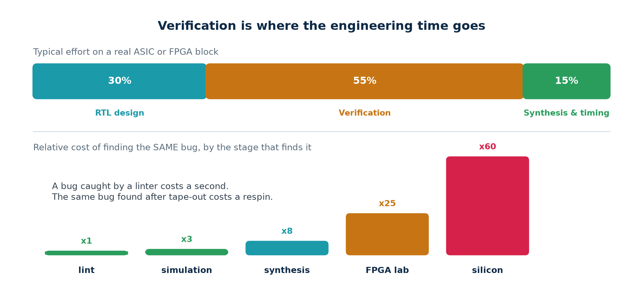
Where the effort goes, and what a bug costs by the stage that finds it.
On a typical ASIC or FPGA block, verification consumes more engineering effort than design. That is not a sign of inefficiency; it is what the economics demand. A bug is the same bug at every stage of the flow. What changes is what it costs to find and fix.
Found by | What it costs you | Relative
A linter | one second, with a file name and a line number | ×1
Simulation | a minute, plus the time to read the waveform | ×3
Synthesis | a longer run, and a structural surprise to understand | ×8
The FPGA lab | re-synthesise, re-place, re-programme, re-instrument | ×25
Silicon | a mask respin: months, and a great deal of money | ×60

The consequence for how you work
Run the cheap checks first, always, and do not skip one because you are in a hurry. A bug that a one-second lint would have named should never reach a waveform viewer, and a bug a testbench would have caught should never reach a board.

1.2 The verification gap
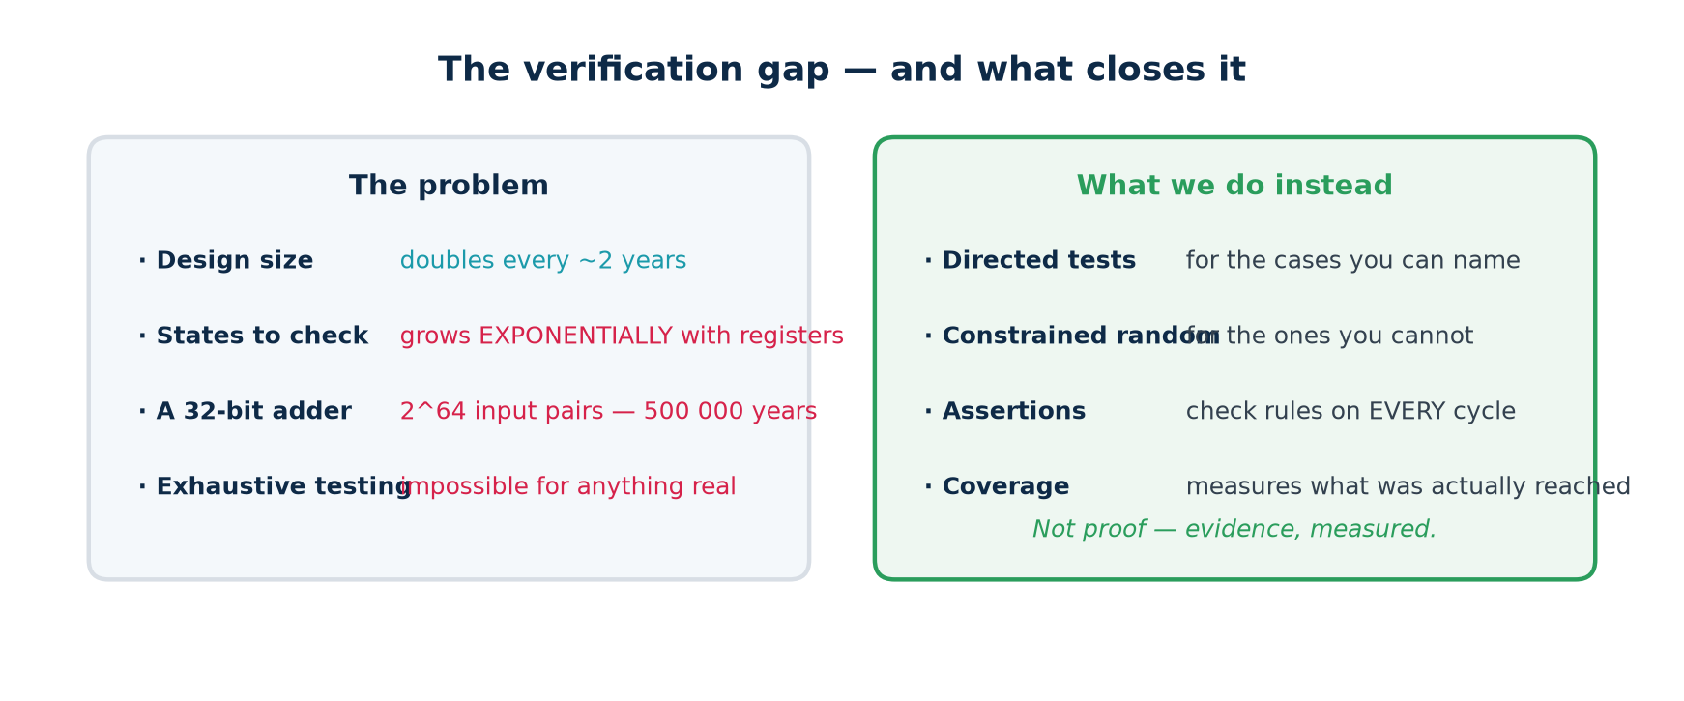
The problem, and what is done about it.
Exhaustive testing is impossible for anything real, and the arithmetic is not close. A single 32-bit adder has 2^64 input pairs; at a billion per second, testing all of them takes over 500 000 years. A design with 100 flip-flops has more reachable states than there are atoms in the observable universe. Adding one flip-flop doubles the state space; adding one engineer does not.
So verification is not proof. It is measured evidence, gathered by four means:
1. DIRECTED tests, for the cases you can name — boundaries, reset, protocol corners.
2. CONSTRAINED-RANDOM stimulus, for the cases you cannot name, generated within constraints you do specify.
3. ASSERTIONS, which state the rules so they are checked on every clock edge of every test rather than at the points you remembered to look.
4. COVERAGE, which measures what the tests actually reached — and is the only one of the four that can tell you when to stop.
Verification and validation are different questions
Verification asks: does the design do what the specification says? Validation asks: was the specification the right one? This topic is entirely about the first. The second is usually somebody else's job, and a design can pass verification perfectly while solving the wrong problem.

1.3 The verification loop
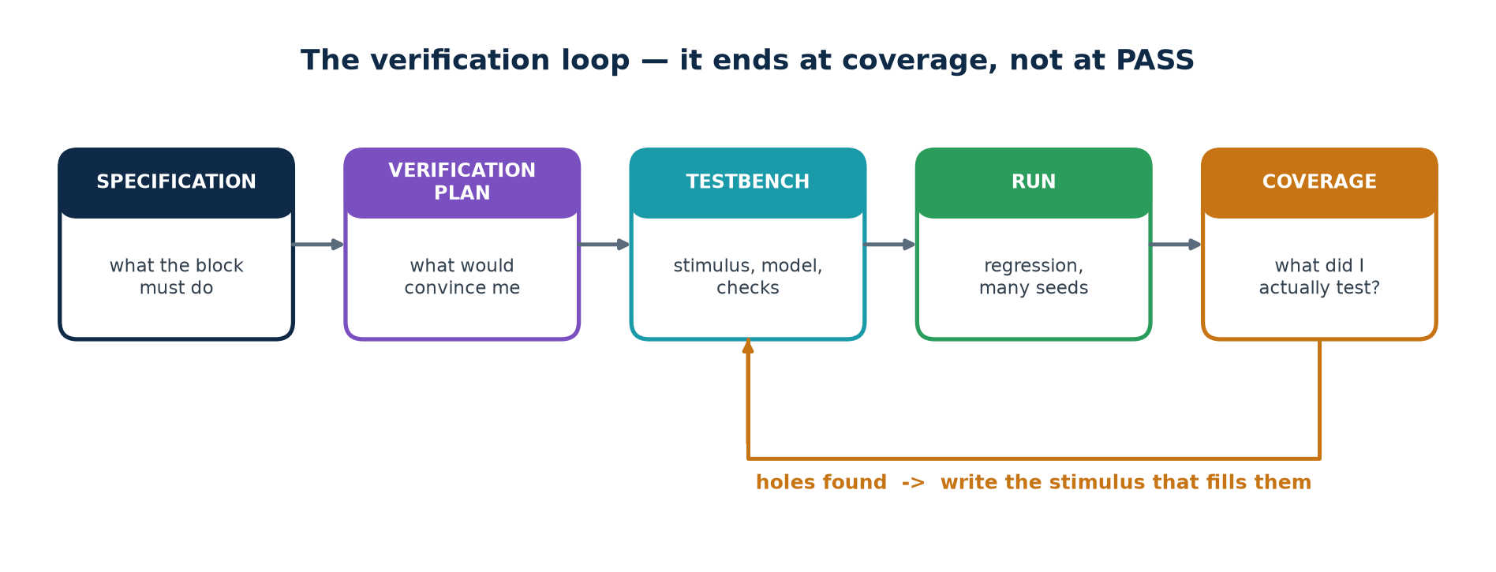
It ends at coverage, not at PASS.
Notice where the loop ends. Not at "the simulation passed" — at "coverage is closed". A pass with unmeasured coverage tells you only that nothing broke in whatever cases you happened to run, which may be very few of the interesting ones.
Notice also the feedback arrow. Coverage does not merely report; it tells you what to do next. Every MISS is a specific piece of stimulus somebody has to write. That is what makes it a loop rather than a final report, and it is why the plan comes first.

1.4 Directed and constrained-random
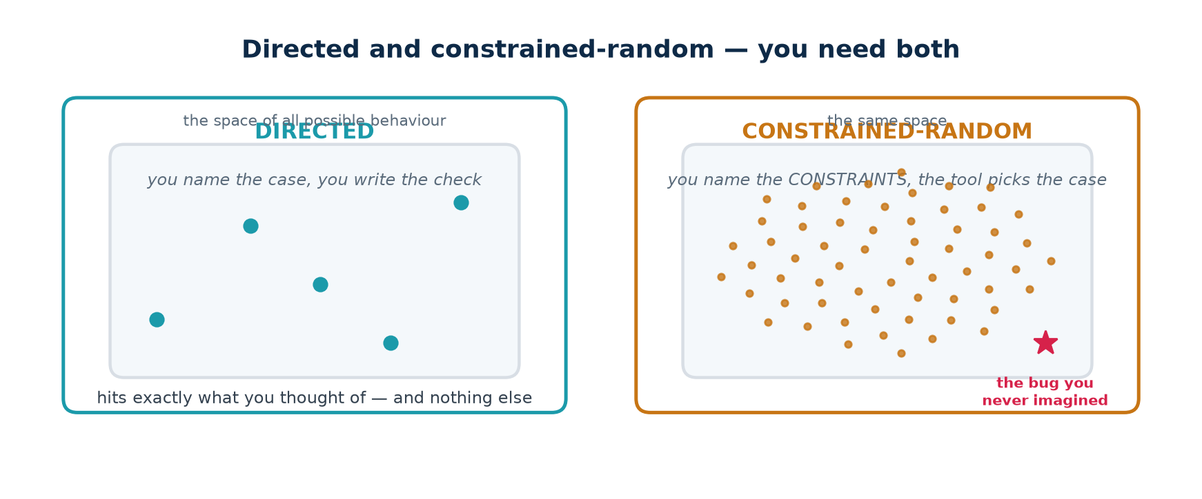
Precise darts, and a cloud that reaches further.
 | Directed | Constrained-random
You write | the case AND the expected answer | the constraints; a model gives the answer
Cost per test | high — one test, one case | low — one test, thousands of cases
Reproducible | always | yes, from the seed
Finds | what you thought of | what you did not
Debugging a failure | easy — you know what you asked for | harder — but the seed replays it exactly
Use it for | boundaries, reset, protocol corners, regressions of known bugs | volume, and the long tail of combinations

A real project uses both, in that order: directed tests first, because they are cheap and they fail fast on the obvious things; then random, to cover the combinations nobody enumerated. In Topic5_Lab, Lab V2 is the directed stage and Lab V3 the random one, and the measured difference between them is one bug out of five.

1.5 Four ways to decide whether an answer was right
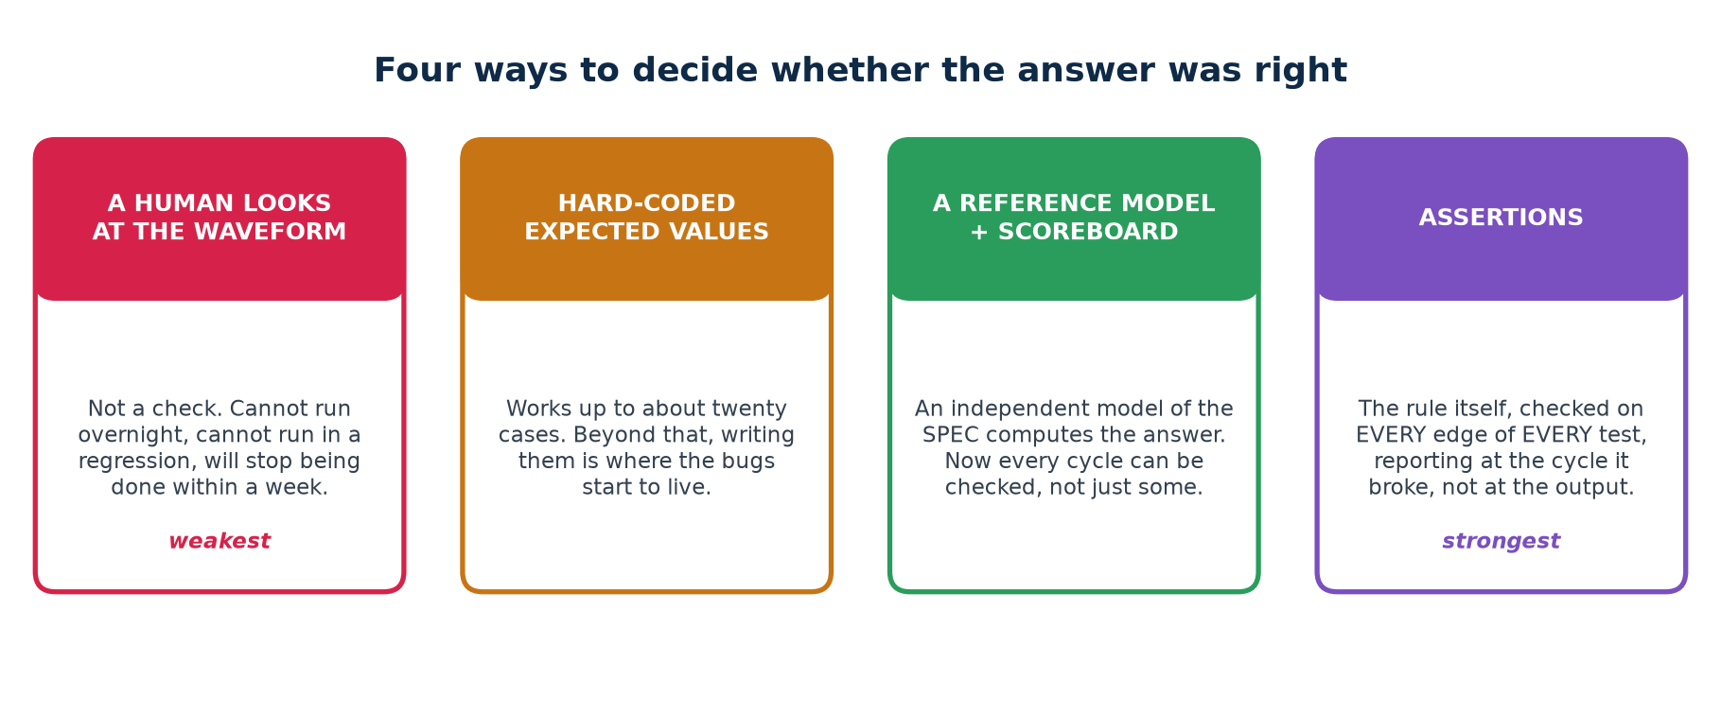
From weakest to strongest.
This is the single biggest determinant of how good a testbench is — not how many cases it runs, but how it decides whether each one was correct.
Method | Scales to | Fails when
A human reads the waveform | one run, once | always: it cannot run overnight or in a regression
Hard-coded expected values | about twenty cases | the values themselves acquire bugs, silently
A reference model + scoreboard | millions of cycles | the model was written by reading the RTL
Assertions | every cycle of every test, for ever | the rule you did not think to state

The line that separates a testbench from a demonstration
A testbench must print PASS or FAIL, and its verdict must be a line of text a machine can grep for. If deciding whether the run was correct requires a human to look at a waveform, you cannot put it in a regression, you cannot run it overnight, and you will stop running it within a week.

1.6 Coverage
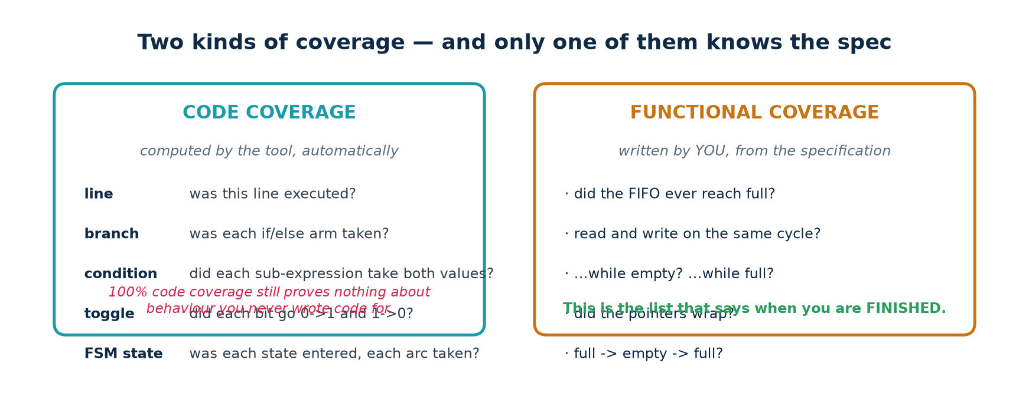
Only one of the two knows the specification.

Code coverage — computed for you
Kind | Asks
line | was this line ever executed?
branch | was each arm of each if/else and case taken?
condition (expression) | did each sub-expression take both values?
toggle | did each bit go 0→1 and 1→0?
FSM state / transition | was each state entered, and each arc taken?

Code coverage is free — the tool computes it. It is also weak on its own, and the reason is worth stating precisely: it measures the code you WROTE. It cannot measure behaviour you forgot to write code for, and it says nothing about whether the outputs were checked. A testbench that runs every line and checks nothing reports 100%.

Functional coverage — written by you
Functional coverage is a list of specification-level situations you decided in advance ought to happen, each with a counter. Nobody but you can write it, because it comes from the specification, not from the code.
▪ Did the FIFO ever reach full? Ever reach empty?
▪ Did a read and a write ever occur on the same cycle? ...while empty? ...while full?
▪ Did the pointers ever wrap?
▪ Did we ever go full → empty → full? (a sequence, not a state)
▪ Was reset ever asserted in the middle of a transfer?
Coverage holes are not failures
A hole means "this never happened during testing". That is a gap in your evidence, not a bug in the design. You close it by writing stimulus that reaches it, or by waiving it in writing with a reason — for example, because the situation is impossible by construction. What you must not do is leave it unexplained.

1.7 The verification plan
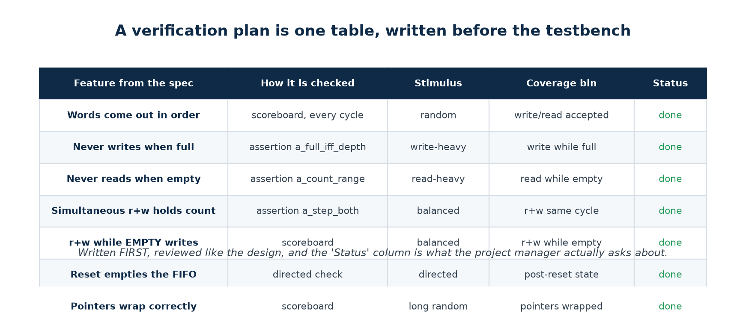
One table, written before the testbench.
A verification plan does not have to be a document. It has to be a table with one row per feature in the specification, and columns saying how each feature is checked, what stimulus reaches it, which coverage bin proves it happened, and whether that is done yet.
Write it before the testbench. A plan written afterwards documents what you happened to build. A plan written first tells you what to build, and the gaps are visible while they are still cheap to close.
Have somebody else review it. The author of a plan cannot see what the plan omits — that is the definition of an omission. This is the single cheapest quality measure available to a small team.

1.8 The stages, and what each one catches
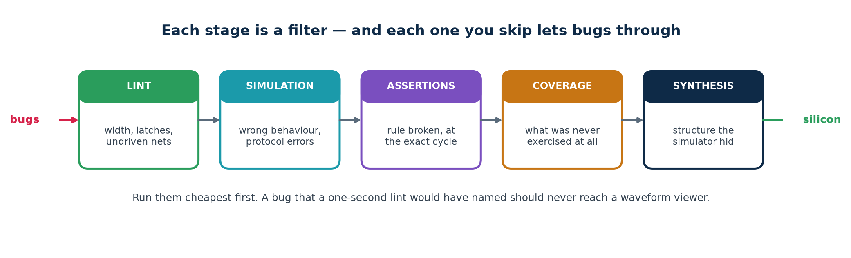
Each stage is a filter with a different mesh.
Stage | Catches | Cannot catch
Lint | width truncation, inferred latches, undriven and unused signals, incomplete sensitivity lists | anything about behaviour — it never runs the design
Simulation | wrong behaviour on the stimulus you supplied | behaviour you never stimulated; metastability
Assertions | a stated rule broken, at the cycle it breaks | a rule you did not state
Coverage | situations that never occurred at all | whether the check for that situation was correct
Synthesis | structure the simulator hid: latches, surprising flip-flop counts | functional errors
Formal | a proof, or the shortest counter-example, for a stated property | wide datapaths — it runs out of memory instead

1.9 The experiment this topic is built on
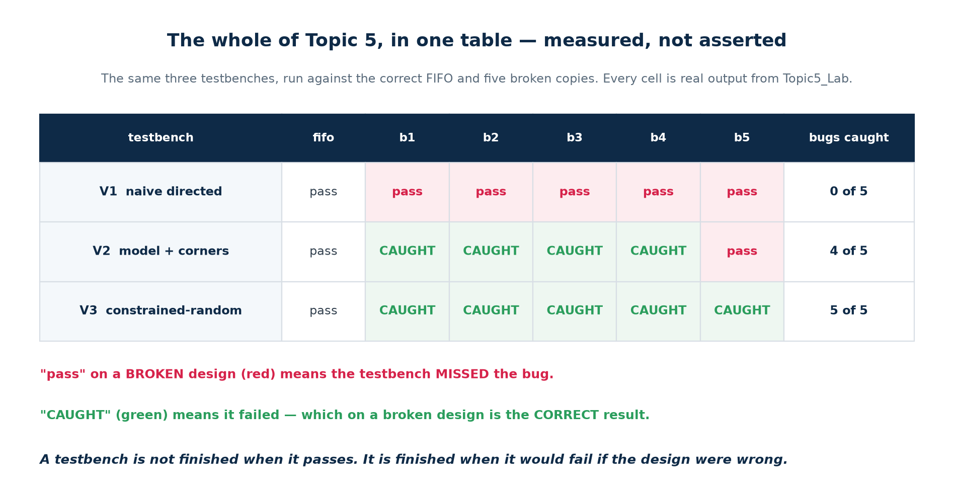
Measured, not asserted. Reproduce it with ./scripts/clinic.sh
Topic5_Lab contains one correct FIFO and five copies, each with a single realistic bug. Three testbenches of increasing strength are run against all six designs. The table is the result.
Testbench | Bugs caught | What it added
V1 naive directed | 0 of 5 | the six structural parts, and a verdict
V2 model + corners | 4 of 5 | a reference model, and the boundary cases
V3 constrained-random | 5 of 5 | weighted random stimulus, seeded

Every testbench passes on the golden design. That column matters as much as the others: a checker that fires on correct hardware is worse than no checker, because the team learns to ignore it.

What changed at each step
Step | The decision | Why it mattered
V1 → V2 | expected values now come from an independent model of the spec, and the test visits the boundaries | you can check every cycle instead of the few you wrote checks for; and the bugs were all at the boundaries
V2 → V3 | stimulus is weighted-random and seeded | the fifth bug only shows when a read and a write are asserted together on an EMPTY FIFO — nobody writes that as a directed test
V3 → V4 | a coverage model is sampled and reported | a run that passes now also says what it reached; the write-heavy profile passes and never reaches empty at all
V3 → V6 | assertions are bound to the DUT | a broken rule is reported at the cycle it breaks, by name, instead of later at an output as a wrong number

1.10 How a project decides it is finished
"We ran all the tests and they passed" is not a sign-off criterion. These are, and every one of them is a number somebody outside the team can read and challenge.
Metric | Typical sign-off bar
Functional coverage | 100% of the plan, or every hole waived in writing with a reason
Code coverage | 95–100%, with the remainder explained line by line
Assertion coverage | every assertion evaluated at least once — an assertion that never fired proves nothing
Regression pass rate | 100%, sustained over time, not "usually green"
Bug discovery rate | flattened, and staying flat, over several weeks
Bug severity trend | no high-severity findings for an agreed period

The bug-rate curve is the one experienced teams watch
If you are still finding serious bugs at the same rate as last month, you are not near the end however good the coverage number looks — it means the coverage model is missing a category. If the rate has flattened AND coverage is closed AND the regression has been green for weeks, you have as much evidence as this method can produce.

Part 2 · Testbench Development
Part 1 was the argument. Part 2 is the craft: how a testbench is actually built, in six stages, each measured against the same five broken designs.

2.1 The device under test
Everything in this part is built against one design: the small synchronous FIFO in Topic5_Lab/rtl/fifo.v. Its header comment is the specification, and every bullet in it becomes a check.
The interface contract — this IS the verification plan
// * A write is accepted on a rising clk when wr_en=1 and full=0.
// A write attempted while full is IGNORED and must not corrupt anything.
// * A read is accepted on a rising clk when rd_en=1 and empty=0.
// A read attempted while empty is IGNORED.
// * rd_data shows the OLDEST unread word at all times (first-word fall-through).
// It is only meaningful while empty=0.
// * count is the number of words currently stored, 0..DEPTH.
// * empty <=> count==0. full <=> count==DEPTH.
// * Words come out in the order they went in. No word is lost or duplicated.
// * Asynchronous active-low reset empties the FIFO.

Eight rules. A finished testbench has a check for each, and a coverage bin proving the situation actually arose. That mapping — rule to check to bin — is what a verification plan is.

And five broken copies
Variant | The bug | Realistic because
fifo_b1 | full asserts one entry late, so a DEPTH+1'th write is accepted and the oldest word is overwritten | > instead of == in a comparison
fifo_b2 | the read is not guarded, so rd_ptr advances even when empty and count underflows | a missing & ~empty on one signal
fifo_b3 | count comes from a separate register that is not updated on a simultaneous read and write | an else-if chain that looked complete
fifo_b4 | the write address is clamped instead of wrapped, so words after a wrap go to the wrong place | a conditional written for the wrong boundary
fifo_b5 | a write is dropped when wr_en and rd_en are asserted together while EMPTY | an over-eager guard added to fix something else

Do not read that table before attempting the clinic. All five lint clean, all five synthesise, and all five pass a naive testbench.

2.2 The six parts
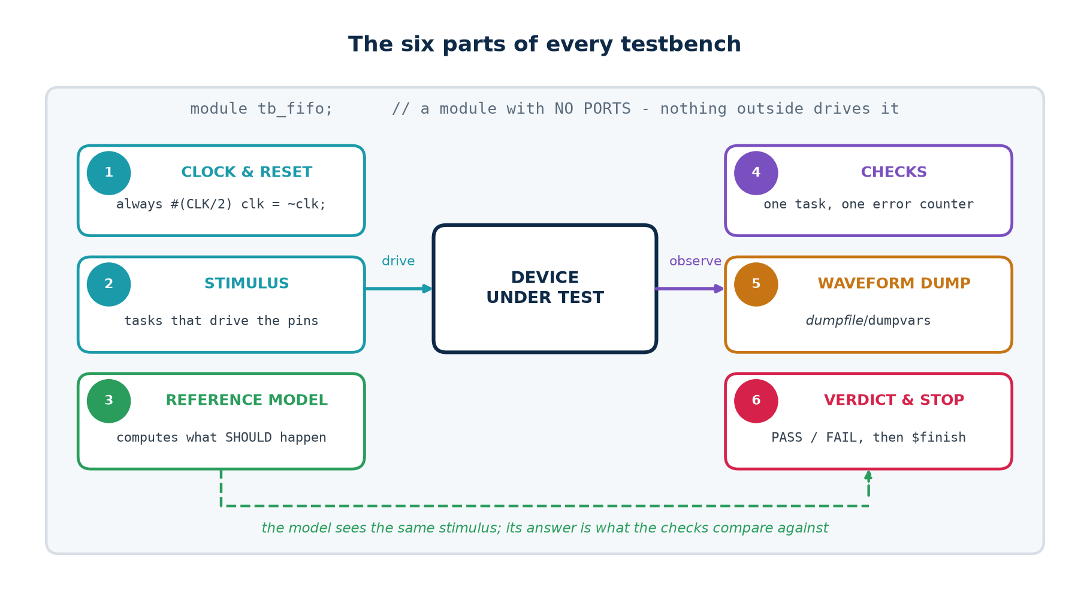
Every testbench has these, whatever the design.
1. CLOCK AND RESET. A free-running clock, and a reset asserted before the first edge and released between edges.
2. STIMULUS. Tasks that drive the pins according to the interface protocol.
3. REFERENCE MODEL. An independent computation of what should happen.
4. CHECKS. One place that compares, counts errors and reports.
5. WAVEFORM DUMP. $dumpfile and $dumpvars, so a failure can be looked at.
6. VERDICT AND STOP. A PASS or FAIL line and a $finish — plus a watchdog.
Part 6 is the one people omit
A testbench that never calls $finish runs until somebody kills it, which in a regression means the whole run hangs. Add a watchdog too — a second initial block that prints FAIL and finishes after a generous timeout — so a hung DUT FAILS rather than stalling everything behind it.

Five lines that turn a hang into a failure
initial begin // the watchdog: every testbench needs one
#(CLK * 5000);
$display("FAIL - timeout on %0s", `DUTNAME);
$finish;
end

2.3 Lab V1 — the testbench everybody writes first
V1 has all six parts and it does form its own verdict, so it is already better than a testbench that only prints values. It writes three words, reads three words, checks them, and prints PASS.
Topic5_Lab/tb/tb_v1_naive.v — the whole test
push(8'hA1); push(8'hB2); push(8'hC3);
pop(got); check(got, 8'hA1, "first word out");
pop(got); check(got, 8'hB2, "second word out");
pop(got); check(got, 8'hC3, "third word out");
if (errors == 0) $display("PASS - 3 words in, 3 words out");

Verified output
$ ./scripts/clinic.sh

V1 naive directed pass pass pass pass pass pass
fifo fifo_b1 fifo_b2 fifo_b3 fifo_b4 fifo_b5
V1 : 0 of 5 bugs caught, golden design passes (no false alarm)

It misses every bug, and the reason is not that it is short. It never fills the FIFO, never empties it past zero, never asserts read and write on the same cycle, never wraps the pointers, and never attempts a write while full or a read while empty. Three words in and three words out exercises the one path where a broken FIFO and a correct one behave identically.
State the lesson explicitly
Coverage of the SPECIFICATION, not volume of stimulus, is what makes a testbench worth having. V1 could run three million words instead of three and still catch nothing.

2.4 Clock, reset and stimulus timing
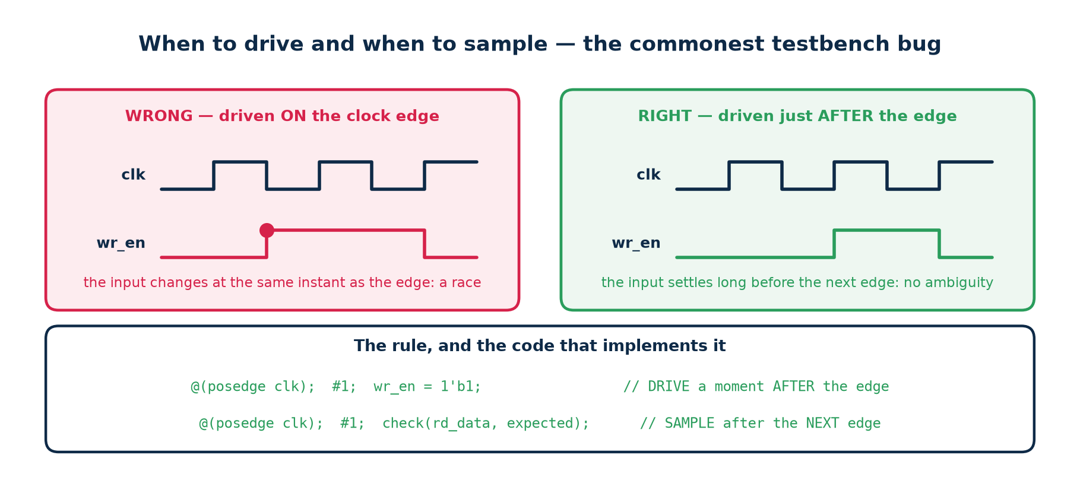
The commonest testbench bug, and the rule that prevents it.
Clock, reset, and a driver task
localparam integer CLK = 10; // 10 ns period = 100 MHz
reg clk = 1'b0;
always #(CLK/2) clk = ~clk;

initial begin
rst_n = 1'b0;
repeat (3) @(posedge clk);
#1 rst_n = 1'b1; // released just AFTER an edge, never ON one
end

// and every driver follows the same discipline:
task push(input [W-1:0] dat);
begin
@(posedge clk); #1; wr_en = 1'b1; wr_data = dat; // DRIVE after the edge
@(posedge clk); #1; wr_en = 1'b0; // SAMPLE after the next one
end
endtask

If you change an input at the same instant as the clock edge you have created a race, and which value the DUT sees is not defined — it depends on the order the simulator happens to process the two events. The design is not broken; the testbench is.
Two real examples from these labs
Topic 4, edge detector. The stimulus changed mid-cycle, so the pulse under test was half a cycle wide and the check sampled at the wrong moment. The design was correct.
Topic 4, FSM. Reset was released exactly ON a clock edge. The state register saw an ambiguous condition and stayed x for two cycles, and the sequence detector reported one match instead of two. The design was correct.

2.5 The reference model
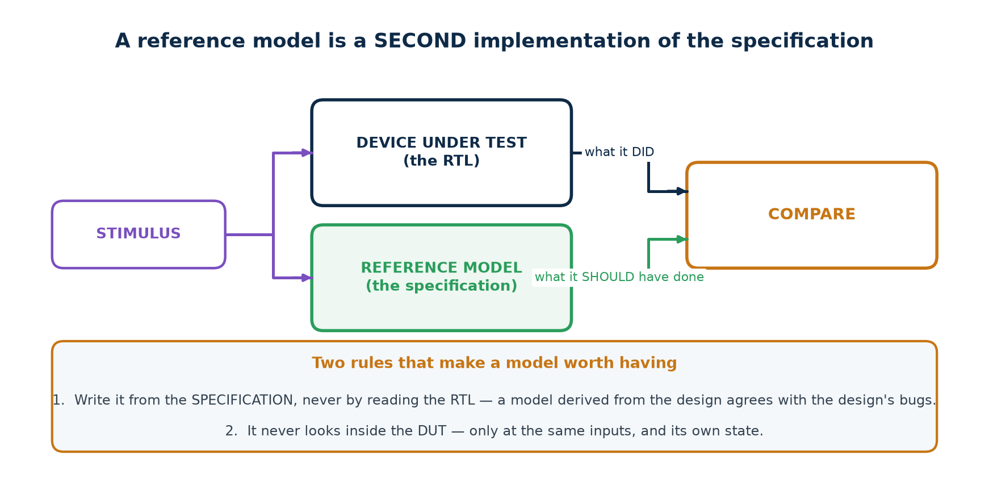
A second implementation of the specification.
Hand-written expected values do not scale past about twenty cases. A reference model is a second, independent implementation of the specification — usually far simpler than the RTL, because it need not be efficient, parallel or synthesisable.
The FIFO's model — an array and two indices
reg [W-1:0] model [0:DEPTH-1];
integer mhead, mtail; // mtail - mhead is the occupancy

function [$clog2(DEPTH):0] mcount; input dummy; mcount = mtail - mhead; endfunction
function mempty; input dummy; mempty = (mtail == mhead); endfunction
function mfull; input dummy; mfull = ((mtail-mhead) == DEPTH); endfunction
function [W-1:0] mfront; input dummy; mfront = model[mhead % DEPTH]; endfunction

Once the model exists you can compare EVERY cycle — count, empty, full and the output word — instead of only at the points where you happened to write a check.
Two rules
1. Write it from the SPECIFICATION, never by reading the RTL. A model derived from the design agrees with the design's bugs. If the same person must write both, write the model first.
2. It never looks inside the DUT. Only at the same inputs, and its own state. A white-box check is fine while debugging and fatal for reuse: the moment the design is refactored the testbench breaks, and nobody can tell whether the design did too.

A real bug — in the model
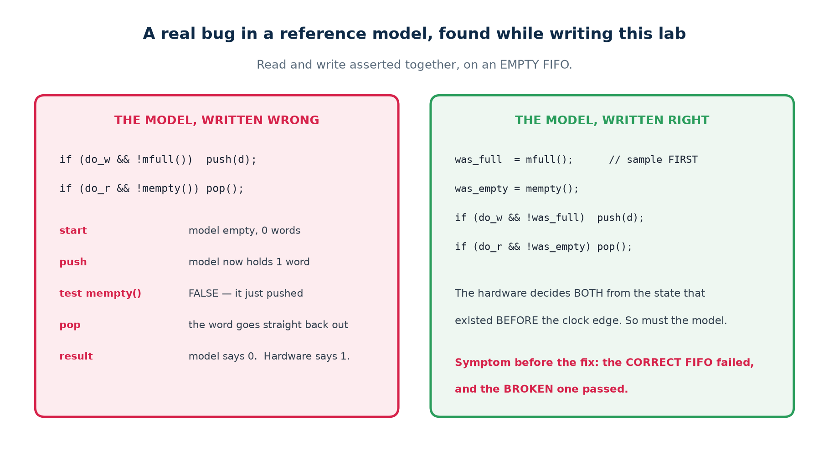
The correct FIFO failed, and a broken one passed.
This was found while writing this lab, and it is the most instructive failure in the topic. The model applied the write, then tested its own updated state to decide whether to apply the read:
Topic5_Lab/tb/tb_v2_selfcheck.v — task model_cycle
// WRONG
if (do_w && !mfull()) push(d); // model now holds one word
if (do_r && !mempty()) pop(); // ... so mempty() is FALSE, and it pops again

// RIGHT
was_full = mfull(); // sample BOTH, once, before applying either
was_empty = mempty();
if (do_w && !was_full) push(d);
if (do_r && !was_empty) pop();

On a simultaneous read and write to an EMPTY FIFO, the wrong version pushes, observes itself no longer empty, and pops the word straight back out — reporting an occupancy of 0 where the hardware correctly has 1. The golden FIFO "failed"; fifo_b5, which really does drop that write, "passed".
The general rule
Hardware evaluates every enable from the state that existed BEFORE the clock edge, all at once. A model that applies one operation and then tests its own updated state is modelling something the hardware never does. Sample first; then apply.

2.6 Lab V2 — the model plus the corners
V2 is not a longer test than V1; it is a better-chosen one. Eight directed tests, every one of them at a boundary, each compared against the model on every cycle.
Test | What it does | What it proves
T1 | check the state immediately after reset | reset really empties the FIFO
T2 | fill to exactly full | full asserts at DEPTH, and not before
T3 | a write WHILE FULL | it is ignored, and nothing is corrupted
T4 | drain to exactly empty | empty asserts at 0, and not before
T5 | a read WHILE EMPTY | it is ignored, and count does not underflow
T6 | read and write on the same cycle, held half full | occupancy is unchanged and the data is right
T7 | keep going long enough to WRAP the pointers | the addressing is correct past the end of the array
T8 | final drain | everything that went in comes out, in order

Verified output
V2 model + corners pass CAUGHT CAUGHT CAUGHT CAUGHT pass
V2 : 4 of 5 bugs caught, golden design passes (no false alarm)

2.7 Constrained-random stimulus
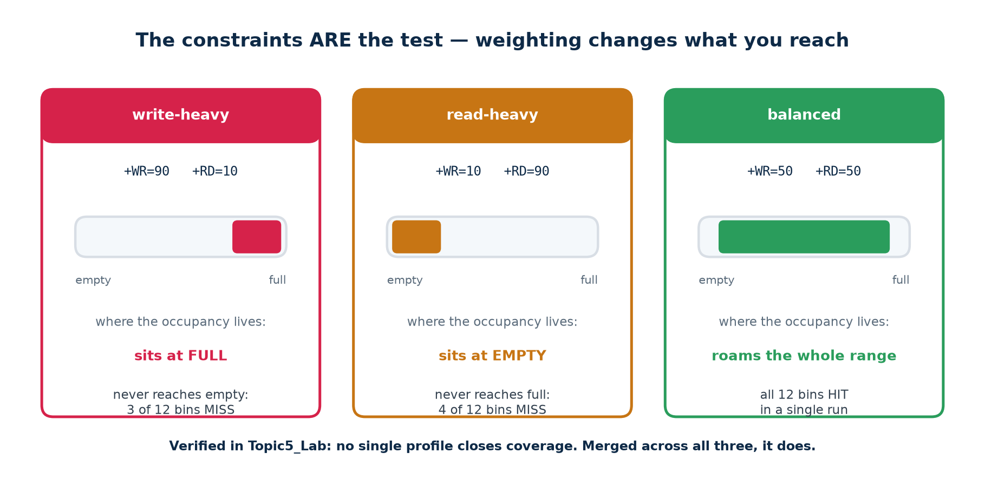
The weights are the test.
Topic5_Lab/tb/tb_v3_random.v — the whole generator
do_w = (({$random(seed)} % 100) < p_wr); // p_wr and p_rd are the CONSTRAINTS
do_r = (({$random(seed)} % 100) < p_rd);
d = $random(seed);

Constrained-random does not mean unconstrained. You still decide what the test does; you express it as weights rather than as a list of cases, and the generator produces the sequences. Change the weights and you are testing a different part of the design:
Profile | Weights | Where the occupancy lives | What it never reaches
write-heavy | +WR=90 +RD=10 | at FULL | empty; 3 of 12 bins MISS
read-heavy | +WR=10 +RD=90 | at EMPTY | full; 4 of 12 bins MISS
balanced | +WR=50 +RD=50 | the whole range | nothing — all 12 bins HIT

Seeds
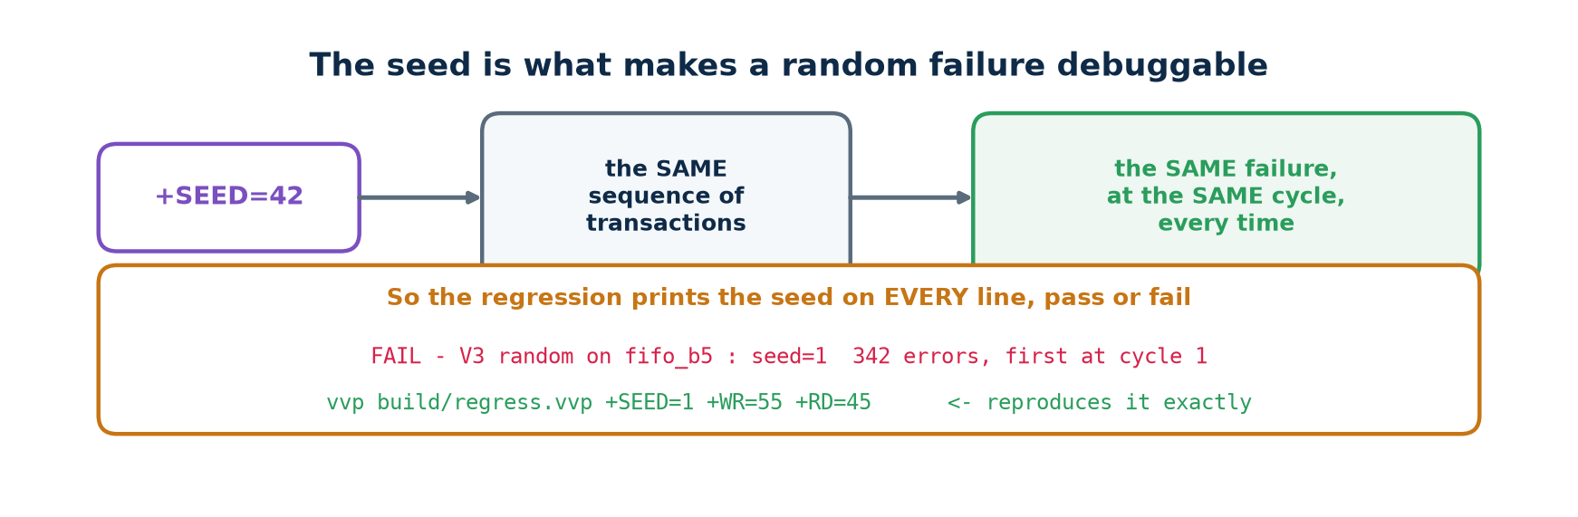
The seed is what makes a random failure debuggable.
A random failure you cannot reproduce is not a bug report; it is a rumour. The seed makes every run deterministic, so a failure can be replayed exactly — with waveforms this time. Print it on every line, pass or fail.
Two traps with random number generation
$random(seed) in Verilog UPDATES seed in place. If you print seed at the end of the run you will print the final internal state, not the seed you were given. Save the original into seed0 before the loop.
$urandom(seed) in SystemVerilog re-seeds on every call, so calling it with an argument inside a loop returns the same number for ever. This happened while writing Lab V6: the run reported PASS and had driven 9 transactions instead of 895. Seed once with void'($urandom(seed0));, then call $urandom() with no argument.
A random test that is silently not random is worse than no random test, because it is believed.

2.8 Lab V3, and the fifth bug
Verified output
V3 constrained-random pass CAUGHT CAUGHT CAUGHT CAUGHT CAUGHT
V3 : 5 of 5 bugs caught, golden design passes (no false alarm)

fifo_b5 drops a write when wr_en and rd_en are asserted together while the FIFO is EMPTY. That is a legal, sensible combination — and no directed test in V2 ever produces it, because nobody thinks to write "read and write at once, from an empty FIFO" as a test case. The random generator produced it ten times in three thousand cycles without being asked. That is the entire argument for constrained-random stimulus.

Regressions
One random run is one sample. A regression — many seeds, several profiles, run automatically after every change — is what makes it evidence.
Verified output
$ ./scripts/regress.sh 4 # 4 seeds x 3 profiles

profile seed cycles result
balanced 1 3000 pass
balanced 2 3000 pass
write-heavy 1 3000 pass
...
12 passed, 0 failed
REGRESSION CLEAN

When a run fails, the script prints the exact command that reproduces it. That one line is the difference between a bug report somebody can act on and one they cannot.

2.9 Functional coverage by hand
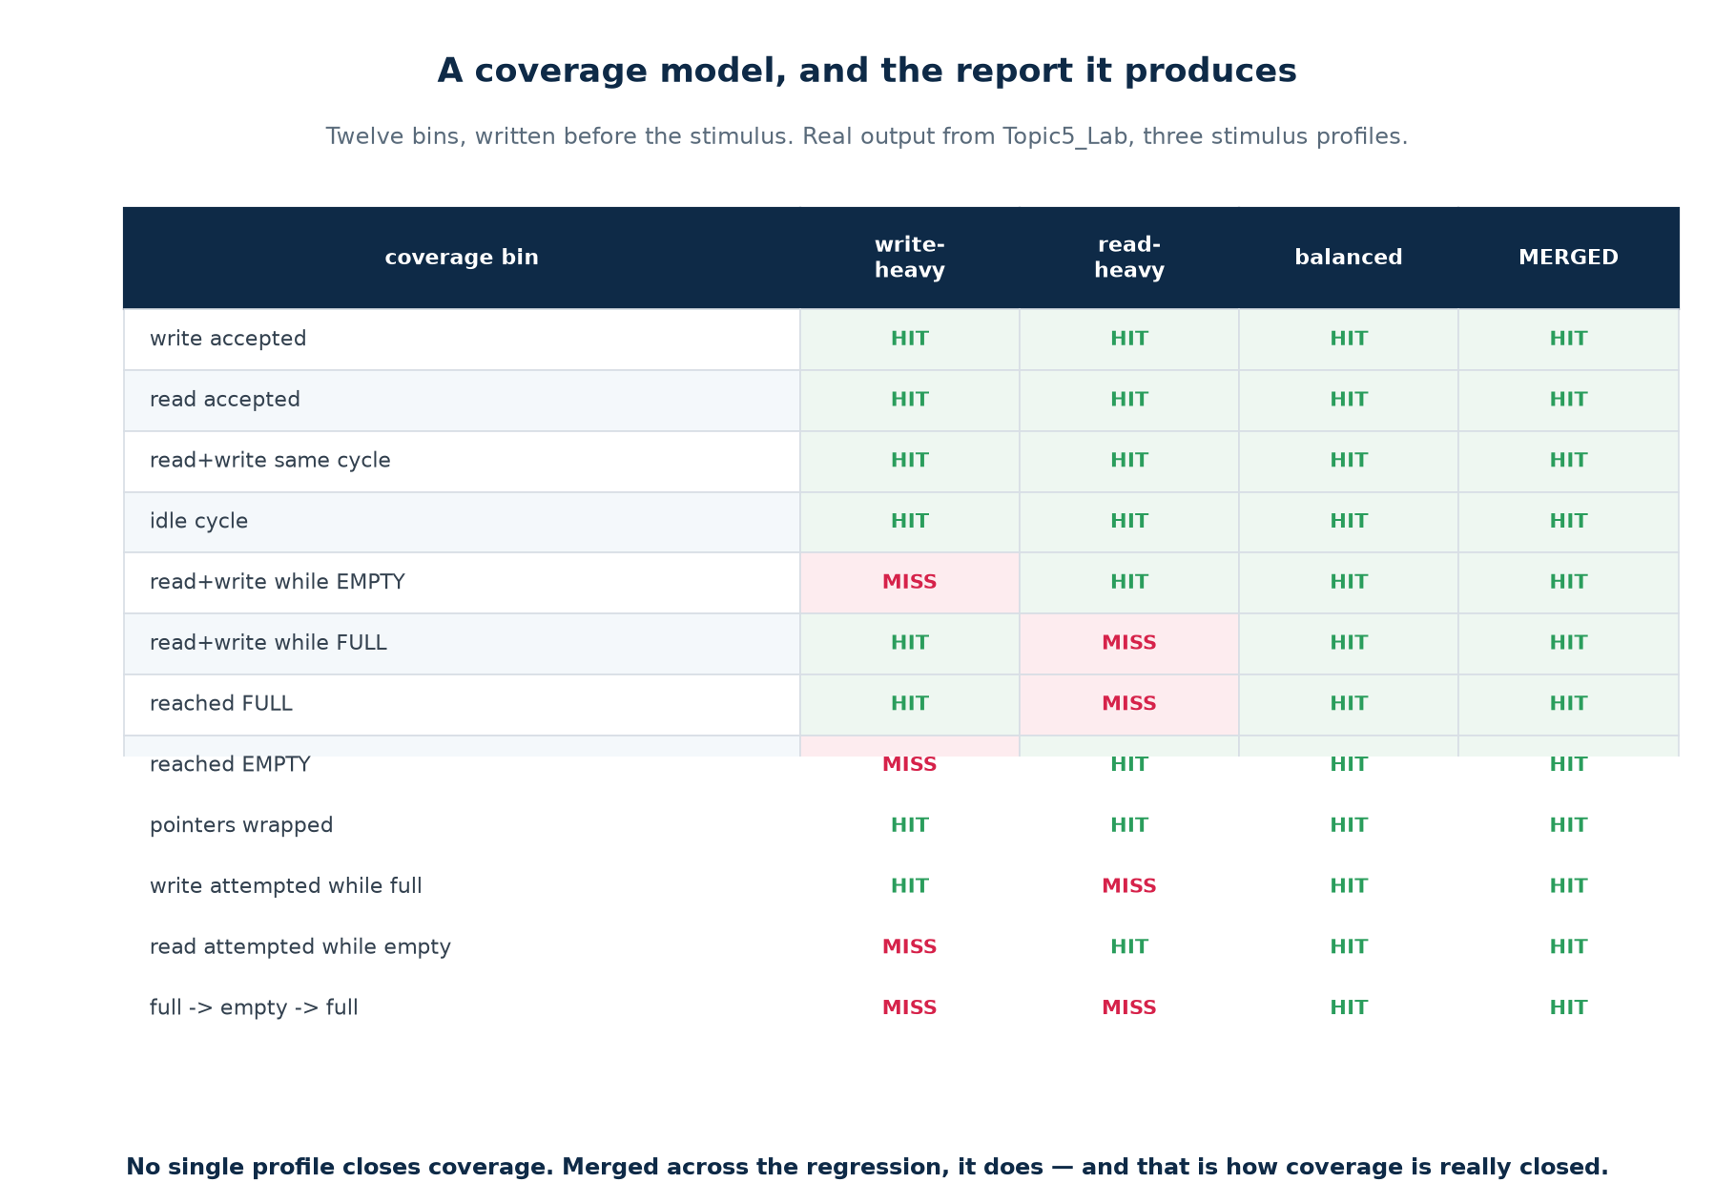
Twelve bins, three profiles, and the merge that closes them.
SystemVerilog has covergroups. Plain Verilog does not, so Lab V4 does it the long way: one counter per interesting situation, declared up front as a coverage model, sampled every cycle, and reported at the end with a HIT/MISS verdict per bin.
Topic5_Lab/tb/tb_v4_coverage.v
// 0 write accepted 6 occupancy reached DEPTH (full)
// 1 read accepted 7 occupancy reached 0 (empty)
// 2 read+write same cycle 8 pointers wrapped at least once
// 3 idle cycle 9 write attempted while full
// 4 read+write while EMPTY 10 read attempted while empty
// 5 read+write while FULL 11 a full -> empty -> full round trip

if (do_w && !was_full) cov[0] = cov[0] + 1;
if (do_w && do_r && was_empty) cov[4] = cov[4] + 1;
if (was_full) cov[6] = cov[6] + 1;

// bin 11 is a SEQUENCE, so it needs a little state machine of its own:
if (was_full) seen_full = 1;
if (seen_full && was_empty) seen_empty_after_full = 1;
if (seen_empty_after_full && was_full) begin
cov[11] = cov[11] + 1; seen_full = 1; seen_empty_after_full = 0;
end

Bin 11 is the one worth studying. "full → empty → full" is not a state; it is a sequence over time. Real coverage models are full of these — "a request followed by a retry", "back-to-back bursts", "reset in the middle of a transfer" — and they are where the interesting bugs live.

Closure is across the regression, not within one run
Verified output
$ ./scripts/coverage.sh

--- profile writeheavy (wr=90 rd=10) --- bins covered: 9 of 12 (75%)
--- profile readheavy (wr=10 rd=90) --- bins covered: 8 of 12 (66%)
--- profile balanced (wr=50 rd=50) --- bins covered: 12 of 12 (100%)

merged: 12 of 12 bins covered (100%)
COVERAGE CLOSED

No single profile closes coverage, and none has to. Each run contributes what it reached, the results are merged, and what is still missing is the specification for the next test somebody writes.

2.10 Assertions
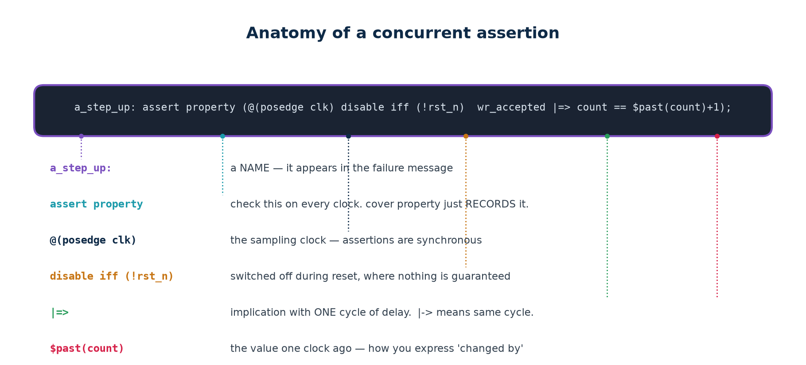
Anatomy of a concurrent assertion.
A scoreboard checks outputs at the points you compare them. An assertion states a RULE, and the simulator checks it on every clock edge of every test, reporting at the exact cycle and the exact line where it broke.
Element | Means
a_step_up: | a name — it appears in the failure message and in coverage reports
assert property | this must always hold; report if it does not
cover property | not a rule — just RECORD whether this ever happened
@(posedge clk) | the sampling clock; assertions are synchronous
disable iff (!rst_n) | switched off during reset, where nothing is guaranteed
|-> | implication, same cycle
|=> | implication, one cycle later — where a registered value shows the change
$past(x) | the value of x one clock ago — how you express "changed by"
$isunknown(x) | true if any bit of x is x or z
$onehot / $onehot0 | exactly one bit set / at most one bit set

Topic5_Lab/sva/fifo_sva.sv
a_empty_iff_zero: assert property (@(posedge clk) disable iff (!rst_n)
empty == (count == 0))
else $error("empty=%0b but count=%0d", empty, count);

a_step_up: assert property (@(posedge clk) disable iff (!rst_n)
(wr_en && !full && !(rd_en && !empty)) |=> (count == $past(count) + 1))
else $error("a write did not increase count by exactly one");

c_both_empty: cover property (@(posedge clk) disable iff (!rst_n)
wr_en && rd_en && empty);

Read the property names aloud and they are the specification: "empty if and only if count is zero", "a write steps the count up by one". That readability is the point — an assertion nobody can read is an assertion nobody will maintain.

Where to put them
In a separate module bound to the DUT's signals, as in sva/fifo_sva.sv. The design source stays clean, the assertions can be owned by the verification engineer, and they can be excluded from synthesis without touching the RTL.

Assertions and scoreboards catch different things
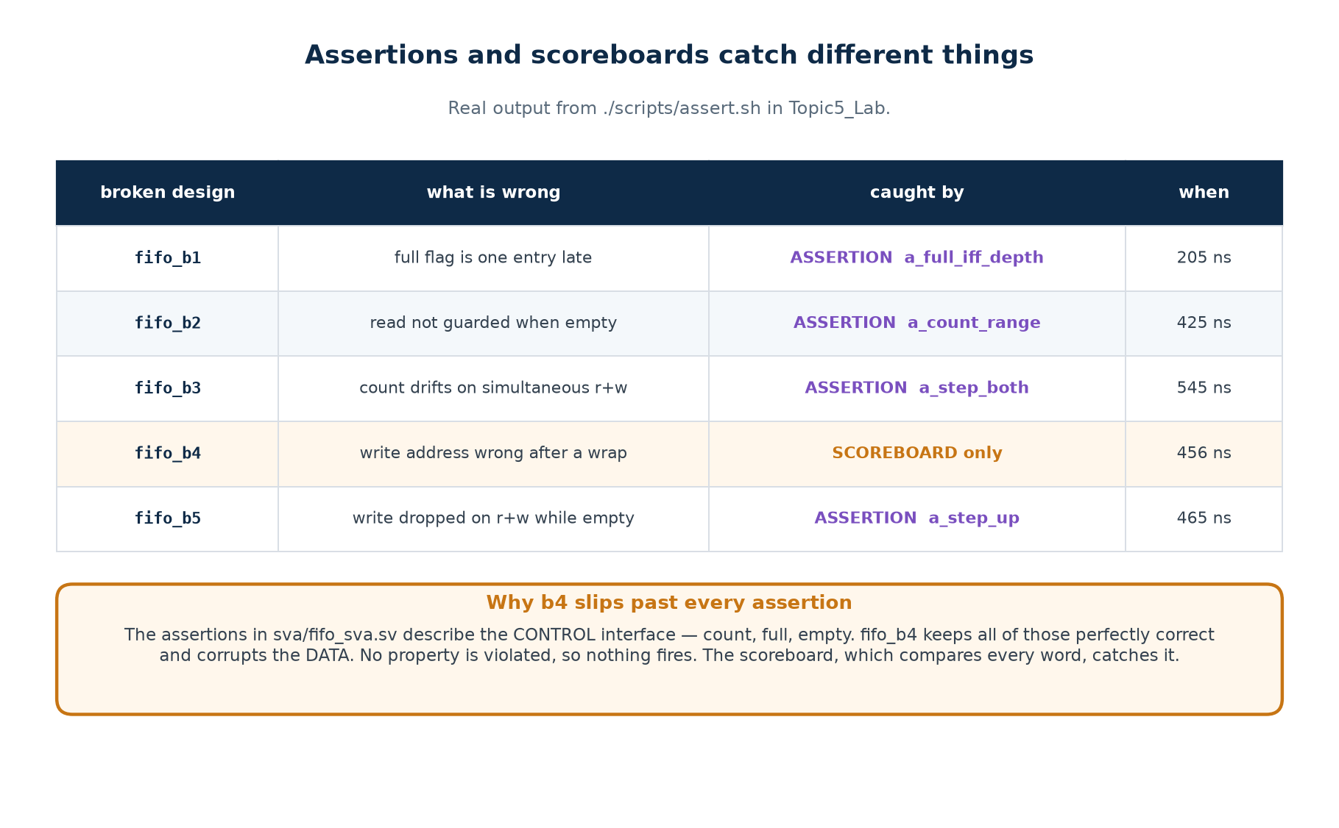
Real output from ./scripts/assert.sh
Read the fourth row carefully. Four of the five bugs are caught by a named assertion, at the exact cycle. One is not caught by any assertion at all — because the assertions in this file describe the CONTROL interface (count, full, empty) and fifo_b4 keeps all of those perfectly correct while corrupting the DATA. No property is violated, so nothing fires, and the scoreboard is what catches it.
So they are not alternatives
Assertions catch what you described. Scoreboards catch what you compared. A serious environment has both, and neither is a substitute for the other.

2.11 A layered environment
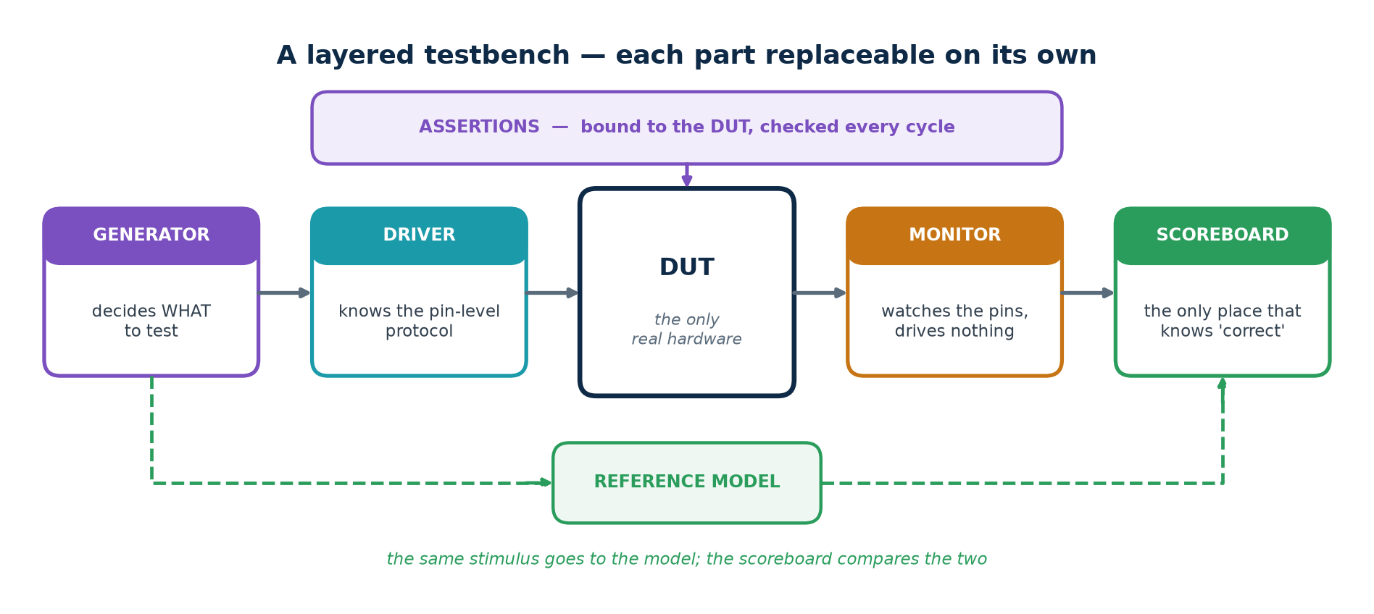
Each part replaceable on its own.
Layer | Knows about | Does NOT know about
Generator | the test intent — which scenarios matter | pins, timing, the DUT
Driver | the pin-level protocol and its timing | why this transaction was chosen
Monitor | how to observe the pins | how to drive anything
Scoreboard | what "correct" means | pins, timing, protocol
Assertions | the rules, continuously | the test that is running

A flat testbench works for one design. A layered one survives the second, because a new DUT usually needs a new driver only — the generator, monitor and scoreboard survive unchanged.
Topic5_Lab/tb/tb_v6_assert.sv — verified: 2027 checks, 895 words in, 895 out
// LAYER 3: monitor -- watches the pins and tells the scoreboard what happened.
task automatic mon_apply(bit did_wr, bit did_rd, logic [W-1:0] dat);
bit was_full = m_full(); // sample BOTH before applying either
bit was_empty = m_empty();
if (did_wr && !was_full) begin model[mtail % DEPTH] = dat; mtail++; end
if (did_rd && !was_empty) begin mhead++; end
endtask

// LAYER 2: driver -- knows the pin protocol and nothing else.
task automatic drv_cycle(bit do_w, bit do_r, logic [W-1:0] dat, string where);
@(posedge clk); #1; wr_en = do_w; rd_en = do_r; wr_data = dat;
@(posedge clk); #1; wr_en = 1'b0; rd_en = 1'b0;
mon_apply(do_w, do_r, dat);
sb_check(where);
endtask

2.12 Testbench mechanics you will need

Tasks, functions and fork/join
Testbench-only constructs
task automatic push(input [W-1:0] dat); // automatic: each call gets its own copy
begin
@(posedge clk); #1; wr_en = 1'b1; wr_data = dat;
@(posedge clk); #1; wr_en = 1'b0;
end
endtask

fork // two independent stimulus threads
begin : writer repeat (100) push($random(seed)); end
begin : reader repeat (100) pop(); end
join

fork // the standard timeout idiom (SystemVerilog)
begin wait (done); end
begin #(CLK*10000); timeout = 1; end
join_any disable fork;

automatic matters. Without it, two concurrent calls from a fork share one set of arguments and locals and corrupt each other — in a way that looks exactly like a DUT bug.

File I/O and golden vectors
When the reference is a file somebody else produced
$readmemh("vectors/stim.hex", stim); // one hex value per line
$readmemh("vectors/golden.hex", golden);
fd = $fopen("build/mismatch.log", "w");
$fdisplay(fd, "%0d sent %h got %h expected %h", i, stim[i], dut_out, golden[i]);
$fclose(fd);

Golden vectors are right when | and wrong when
a published standard supplies official test vectors (AES, CRC, a codec) | they fix the stimulus, so they cannot find the corner nobody generated
a trusted bit-exact C or MATLAB reference already exists | they rot — the file and the specification drift apart and nobody notices
you are regressing against the previous revision of the same block | a mismatch says WHICH vector failed, not which rule was broken

2.13 What to check, by kind of design
Kind of DUT | The checks that matter | Where the bugs actually are
Combinational | exhaustive if the input space is small; otherwise random against a reference function | boundaries, sign, width truncation
Registered / pipelined | output correct AND arriving at the right cycle; valid delayed with the data | latency, and control not pipelined alongside the data
Counter / timer | wrap, load, enable priority, terminal count | off-by-one at the wrap and at the reload
FSM | every state entered, every arc taken, illegal states recovered from | the arcs nobody drew, and the missing default
Memory / FIFO | order, occupancy, full, empty, simultaneous access | the boundaries — full, empty, and both at once
Protocol / bus | handshake rules as assertions, plus a checker independent of the DUT | the rule the OTHER end violates
Clock crossing | not by simulation alone — structural CDC checks and review | multi-bit buses crossing without a handshake

2.14 SystemVerilog for verification
Verilog-2005 is enough to build everything in this lab, and doing it by hand once is worth the effort — you learn what a covergroup IS by writing twelve counters. SystemVerilog then provides the same things as language features, and you will meet them in every professional environment.
Feature | What it replaces here | Tool support
logic | the wire / reg decision | everywhere
always_comb / always_ff | always @(*), and the latch you inferred by accident | everywhere
assert / cover property | hand-written checks scattered through the code | vendor: full; open-source: a subset
covergroup / coverpoint / cross | the twelve integer counters of Lab V4 | vendor tools
rand / randc + constraint | the weighted $random of Lab V3 | vendor tools
classes, mailboxes, semaphores | the layers written as tasks in Lab V6 | vendor tools
interface / modport | the long port lists in every instantiation | vendor tools
queues and associative arrays | the fixed model array and its indices | vendor tools

Constraints, written as constraints
The Lab V3 generator, expressed declaratively
class fifo_txn;
rand bit do_wr, do_rd;
rand bit [7:0] data;
constraint c_mix { do_wr dist { 1 := 55, 0 := 45 };
do_rd dist { 1 := 45, 0 := 55 }; }
constraint c_burst { (do_wr && do_rd) -> data inside {[8'h80:8'hFF]}; }
endclass

fifo_txn t = new();
repeat (2000) begin
if (!t.randomize()) $fatal(1, "constraints are unsatisfiable");
drv_cycle(t.do_wr, t.do_rd, t.data);
end

Always check what randomize() returns
An over-constrained set has no solution and randomize() returns 0. If you ignore the return value the test silently drives the same unrandomised value for ever — and passes. Check it, and $fatal on failure.

Covergroups, and the cross
Lab V4's coverage model, as a covergroup
covergroup cg_fifo @(posedge clk);
cp_op : coverpoint {wr_en, rd_en} {
bins idle = {2'b00}; bins wr = {2'b10};
bins rd = {2'b01}; bins both = {2'b11}; }
cp_occ: coverpoint count {
bins empty = {0}; bins mid = {[1:DEPTH-1]}; bins full = {DEPTH}; }
x_op_occ: cross cp_op, cp_occ; // 12 cells - and two of them were bugs
endgroup
cg_fifo cg = new();

The cross is the point. cp_op has 4 bins and cp_occ has 3, so the cross has 12 cells — and two of those cells, "both while empty" and "both while full", are exactly where two of the five planted bugs live. A cross says "this situation, in that state" in one line, which is precisely the combination that hand-written counters make tedious and that people therefore skip.

2.15 UVM, formal and CDC — what they are, and when

UVM
The Universal Verification Methodology is a SystemVerilog class library that standardises exactly the layers of Lab V6.
Lab V6 calls it | UVM calls it | What UVM adds
generator | uvm_sequence / uvm_sequencer | reusable, layered, randomisable sequences
driver | uvm_driver | a standard handshake with the sequencer
monitor | uvm_monitor | publishes transactions to any number of subscribers
scoreboard | uvm_scoreboard | standard comparison and reporting
the whole thing | uvm_env / uvm_agent | a package you can instantiate twice, or reuse next project
$display | uvm_info / uvm_error with verbosity | filterable, gradable reporting
(nothing) | the factory and config_db | swap a component or a setting without editing the environment

Worth it when the block has a real protocol interface other blocks share, when several people work on the environment at once, or when it will be reused at chip level. Not worth it when the block is a FIFO and Lab V6 verifies it in 160 lines.

Formal verification
Simulation samples the state space; formal tools search it. Given the assertions you already wrote, a formal engine tries to prove no input sequence can violate them — or produces the shortest counter-example that does.
▪ A PROVEN property holds for every input sequence, for ever. No amount of simulation adds to that.
▪ A counter-example from a formal tool is usually far easier to understand than a random failure at cycle 40 000.
▪ It works beautifully on control logic — FIFOs, arbiters, protocol adapters, CDC handshakes — and poorly on wide datapaths such as multipliers, where the engine runs out of memory instead of returning an answer.
▪ The practical point: writing assertions for simulation costs nothing extra and gives you a formal testbench for free if you later get a tool.

Clock domain crossings
Simulation alone cannot verify a clock crossing
A simulator has no model of metastability. It resolves every flip-flop to a clean 0 or 1, so a design with a genuinely broken crossing simulates perfectly and fails intermittently in the lab.
Two flip-flops and none simulate identically. A multi-bit bus crossing without a handshake simulates with all bits arriving together, which is exactly what does not happen on silicon.
CDC is therefore verified STRUCTURALLY: a dedicated checker reads the netlist, finds every path between unrelated clocks, and demands a recognised synchroniser on each. Review the crossings by eye as well.

2.16 Making a testbench reusable
How one testbench runs against six designs
`ifndef DUT
`define DUT fifo
`endif
`DUT #(.W(W), .DEPTH(DEPTH)) u_dut ( .clk(clk), .rst_n(rst_n), ... );

iverilog -DDUT=fifo_b3 -DDUTNAME=\"fifo_b3\" rtl/*.v tb/tb_v3_random.v
xvlog -d DUT=fifo_b3 ... # Vivado
vlog +define+DUT=fifo_b3 ... # ModelSim

1. Parameterise everything the DUT parameterises, and derive nothing by hand.
2. Keep the layers separate — a new DUT usually needs a new driver only.
3. Never reach inside the DUT from the scoreboard.
4. Select the DUT with a `define, so the same testbench can be pointed at a broken copy for a clinic, or at a second implementation for an equivalence check.

Part 3 · Simulation and Debugging
You cannot debug a tool you do not understand. Part 3 explains what a simulator actually does, what a waveform file really is, and how to find a bug by procedure rather than by staring.

3.1 The event-driven engine
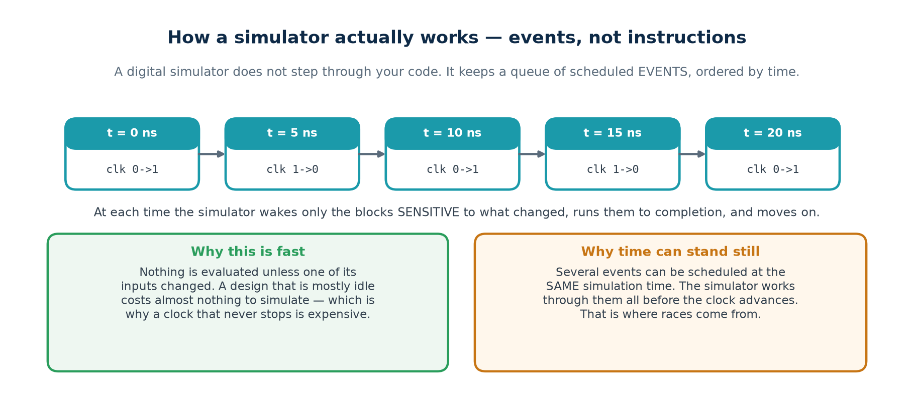
Events ordered by time, not instructions in sequence.
A digital simulator does not step through your code. It maintains a queue of scheduled EVENTS ordered by simulation time. At each time it wakes only the blocks sensitive to what changed, runs them to completion, and then advances to the next scheduled time.
▪ Nothing is evaluated unless one of its inputs changed, which is why a design that is mostly idle costs almost nothing to simulate — and why a clock that never stops is expensive.
▪ Simulation time is not wall-clock time. A million cycles may take a second or an hour, depending entirely on how much of the design is switching.
▪ Time advances only when there is nothing left to do at the current time. That is why a loop with no delay hangs: the simulator is not stuck, it is doing exactly what you wrote.
The commonest way to hang a simulation
while (!done) ; // NEVER lets time advance, so done can never change
while (!done) @(posedge clk);// correct: yields, so the rest of the design can run

3.2 Inside one time step
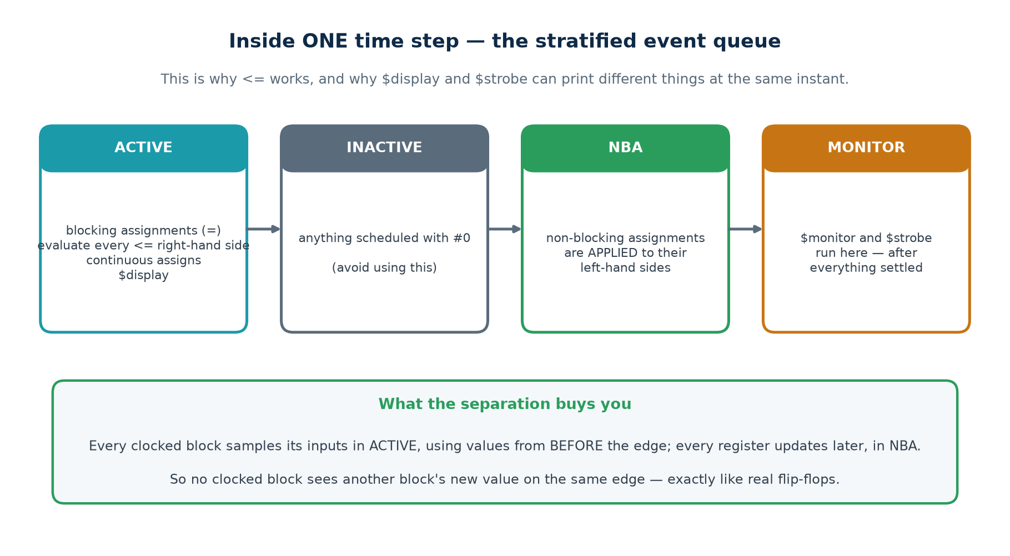
The stratified event queue.
Region | What happens there
Active | blocking assignments (=); every non-blocking right-hand side is EVALUATED; continuous assignments; $display
Inactive | anything scheduled with #0 — avoid using this
NBA | non-blocking assignments are APPLIED to their left-hand sides
Monitor | $monitor and $strobe — after everything has settled

Every clocked block samples its inputs in ACTIVE, using values from before the edge; every register updates later, in NBA. So no clocked block can see another block's new value on the same edge — exactly like real flip-flops, and the reason non-blocking assignment models them correctly.
The practical consequence you will meet first
$display runs in ACTIVE, so at a clock edge it prints the value from BEFORE the edge. $strobe runs in MONITOR, after every non-blocking update has landed, so it prints the settled value. If a printout disagrees with the waveform by exactly one cycle, this is why — and the fix is usually to use $strobe, not to change the design.

3.3 Analyse, elaborate, run
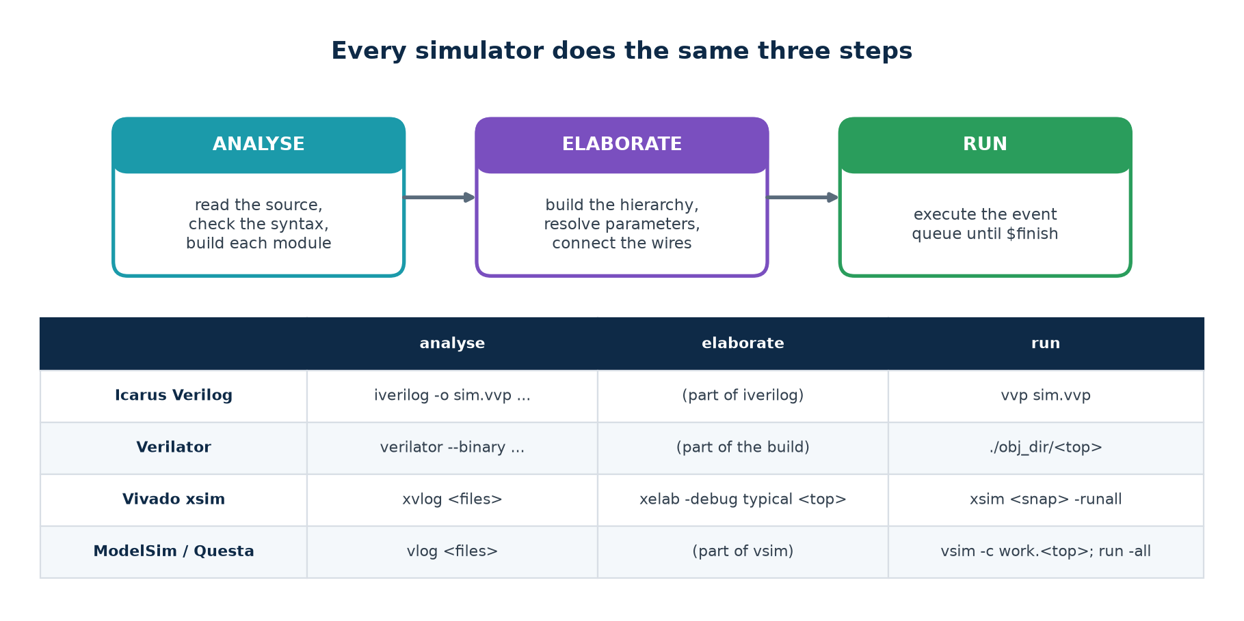
The same three steps in every tool.
Step | Errors that appear here | What it means you did
Analyse | syntax errors, undeclared names, bad literals | a typing mistake — file and line are given
Elaborate | missing modules, port mismatches, parameter problems, multiple drivers | a wiring or hierarchy mistake
Run | wrong values, x propagation, timeouts | a logic mistake — yours or the testbench's

Knowing which step failed tells you which kind of mistake you made, which is often half the diagnosis.

3.4 Waveforms
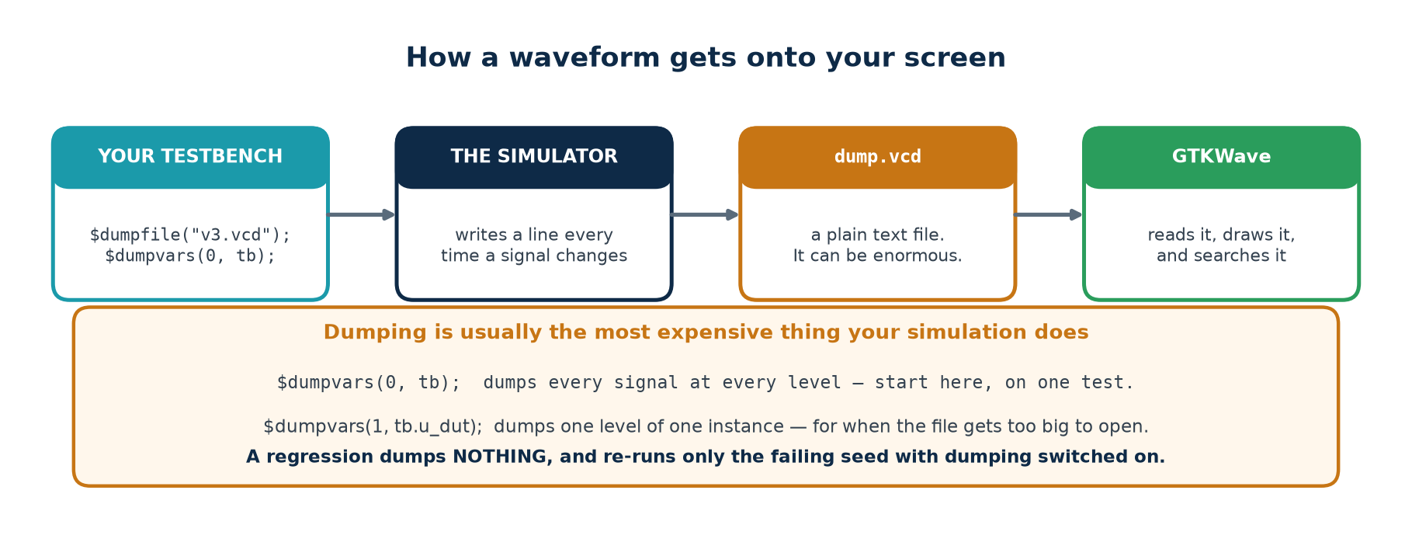
Your testbench asks for a change-log; a separate program draws it.
Format | Written by | Note
VCD | any simulator, via $dumpvars | plain text, universal, and very large
FST | Icarus (-fst), GTKWave | compressed VCD — much smaller and faster
WLF | ModelSim / Questa | native, fast, read by their own viewer
FSDB | commercial (Verdi) | the industry standard on large projects

Controlling what is dumped
$dumpfile("v3.vcd");
$dumpvars(0, tb); // level 0 = EVERYTHING below tb. Start here.
$dumpvars(1, tb.u_dut); // one level of one instance, when the file gets too big

Dumping is usually the most expensive thing your simulation does
A regression dumps nothing and re-runs only the failing seed with dumping switched on. That one habit often takes a nightly regression down to minutes.

Reading a viewer properly
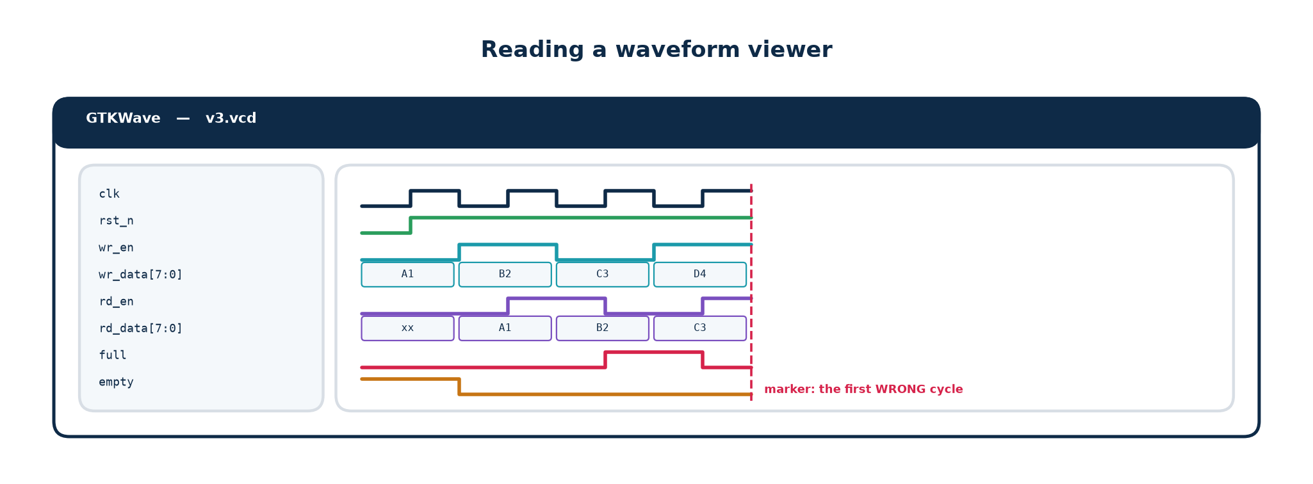
The same picture, every time, from a saved view.
1. GROUP AND ORDER the signals: stimulus at the top, DUT outputs next, internals last. A jumbled list hides the answer in plain sight.
2. SET THE RADIX. A counter in binary is unreadable; in hex the pattern is obvious. Right-click the signal to change it.
3. USE THE MARKER. Put it on the FIRST wrong cycle named in the transcript, then walk backwards signal by signal.
4. SAVE THE VIEW. File → Write Save File writes a .gtkw recording which signals are shown, in what order, at what radix, with which dividers. Commit it next to the testbench.
Everyone then sees the same picture
gtkwave v3.vcd wave/v3_fifo.gtkw

3.5 A debugging procedure
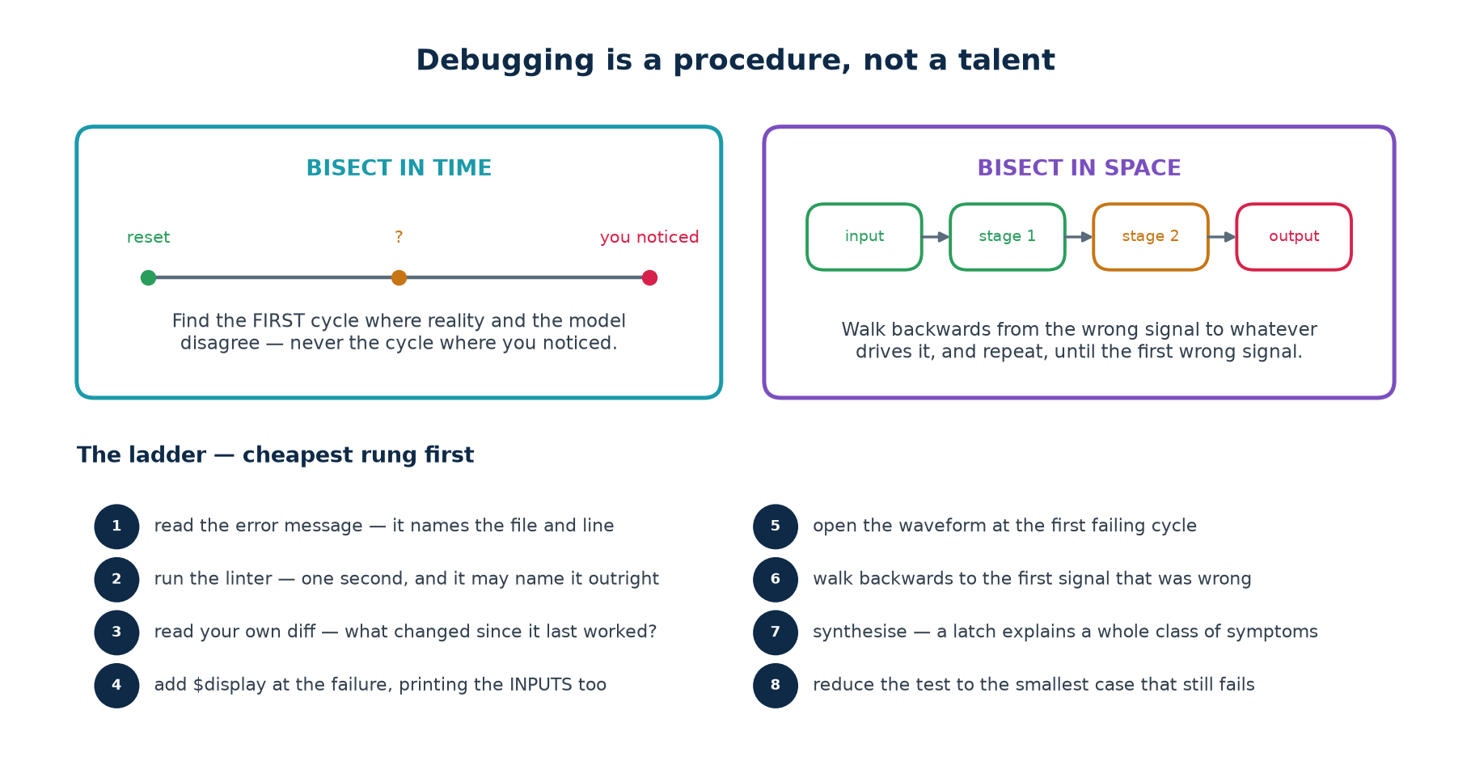
Two searches, and a ladder run in cost order.

Bisect in time
Find the FIRST cycle where reality and the model disagree — never the cycle where you noticed. A wrong output is usually many cycles downstream of its cause, and every minute spent looking at the output is a minute not spent looking at the cause. This is why the testbenches in this lab compare every cycle and report the cycle number of the first failure.

Bisect in space
Walk backwards from the wrong signal to whatever drives it, and repeat, until you reach the first signal that was wrong on its own account.

The ladder
1. Read the error message. It names the file and the line.
2. Run the linter. One second, and it may name the problem outright.
3. Read your own diff. What changed since it last worked?
4. Add $display at the point of failure, printing the INPUTS as well as the output.
5. Open the waveform at the first failing cycle — not at the end.
6. Walk backwards to the first signal that was wrong.
7. Synthesise. A latch or a surprising flip-flop count explains a whole class of symptoms that look like logic bugs.
8. Reduce. Cut the test down to the smallest case that still fails; that case is usually the explanation.

3.6 Chasing an x
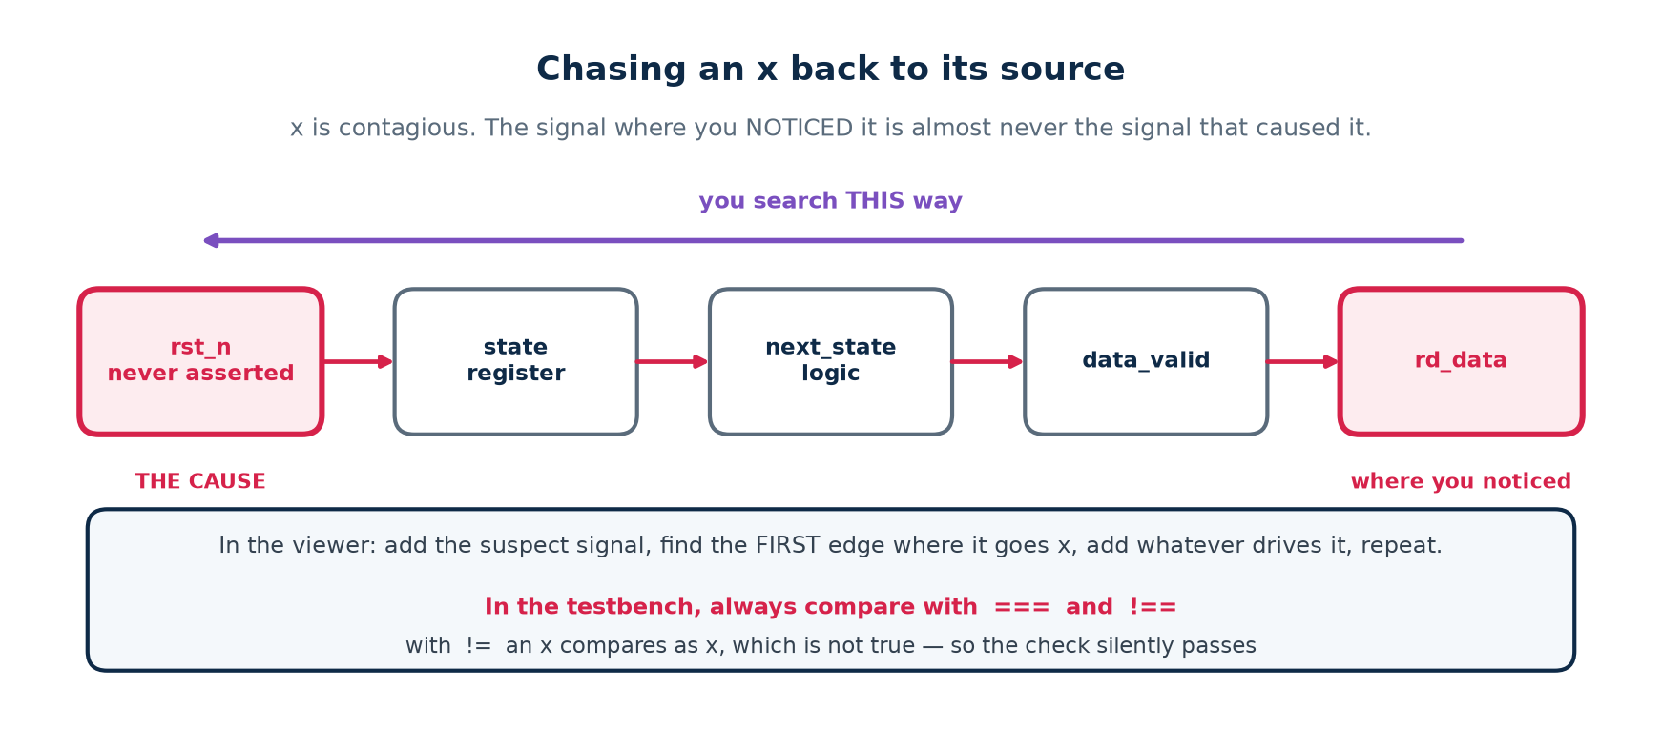
The signal where you noticed it is almost never the cause.
An x is the simulator saying "I cannot determine this". It spreads through every expression it touches, so by the time you see it on an output it may have travelled through ten signals.
Cause | Typical origin
A register that was never reset | a missing reset branch, or no reset at all
A wire nothing drives | a typo in a port connection — the classic
A wire TWO things drive | a signal assigned in two always blocks
Reading past the end of a vector or array | an index that is one too large
Arithmetic on a value that was already x | x is contagious

Two habits that between them remove most x hunts
`default_nettype none at the top of every file turns a misspelt port connection from a silent undriven wire into a compile error naming the line.
In the testbench, always compare with === and !==. With != an x compares as x, which is not true, so the check silently passes and the bug escapes.

3.7 Symptom to cause
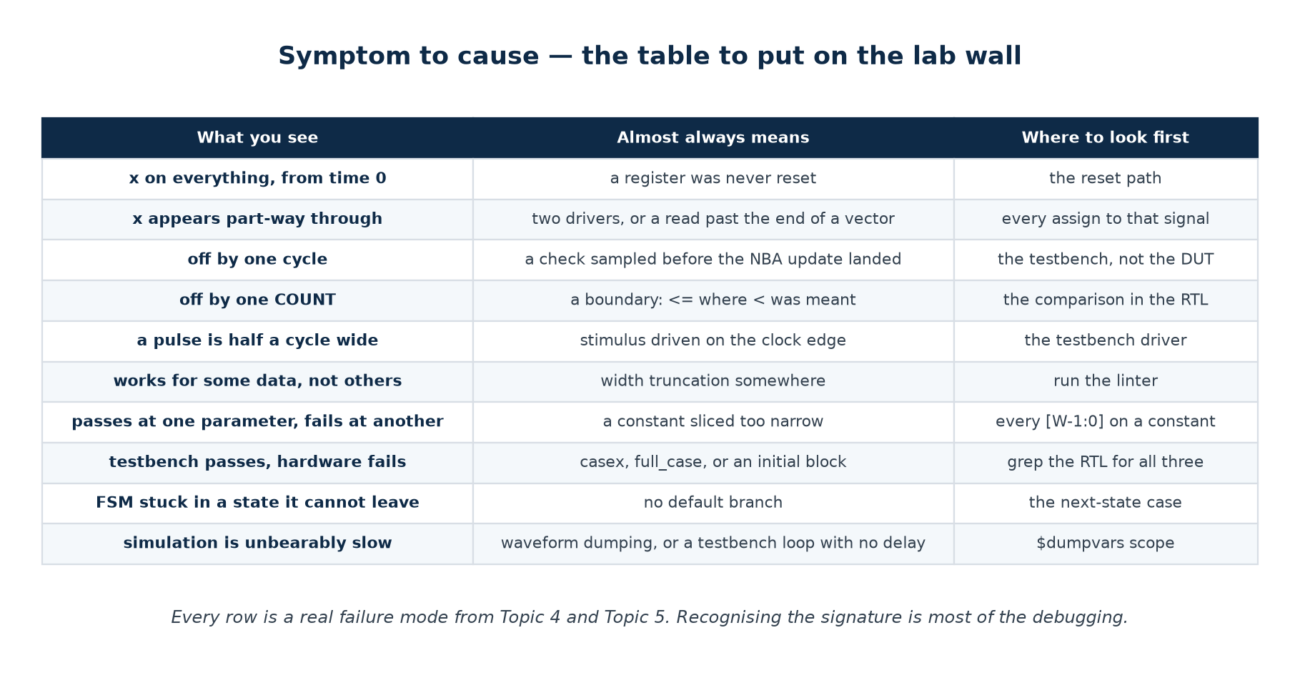
Worth printing and putting on the wall of the lab.

3.8 Simulation performance
A regression that takes all night is run once a week; a regression that takes five minutes is run on every commit. Simulation speed is therefore a verification-quality issue, not a convenience.
What costs time | Why | What to do
Waveform dumping | every signal change becomes a line of text | dump nothing in a regression; re-run the failing seed with dumping on
Dumping the whole hierarchy | $dumpvars(0, tb) includes every instance | $dumpvars(1, tb.u_dut) once you know where to look
A clock that never stops | every edge wakes every clocked block | stop the clock when idle, if the design allows it
Very fine timescale | 1 ps precision means more scheduling work | 1ns/1ps is plenty for RTL; you are not doing SPICE
$display in a hot loop | formatting and I/O are slow | print on events, not on cycles
One very long random run | it does not parallelise, and one seed is one sample | many shorter runs at different seeds

Verilator compiles the design to C++ and is often 10–100× faster than an interpreted simulator, which is why it is used for long random regressions even on projects whose sign-off simulator is a vendor tool.

Part 4 · Tools and Guided Tutorials
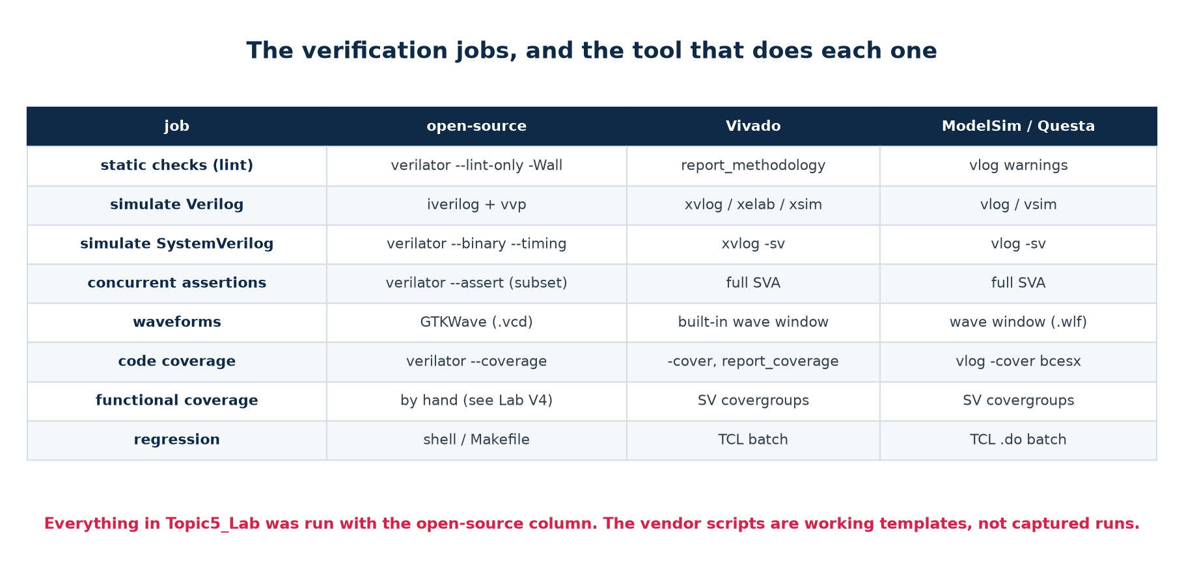
The verification jobs, and the tool that does each one.
Honesty note
Every result quoted in this workbook was produced by the open-source column — Icarus Verilog 12.0 and Verilator 5.020 — on the code in Topic5_Lab. The Vivado and ModelSim scripts in the lab are working templates that were NOT executed, because neither tool is installed in the environment this material was written in. The commands are standard and version-stable; check them against your installed release before the session.

4.1 Installing the open-source flow
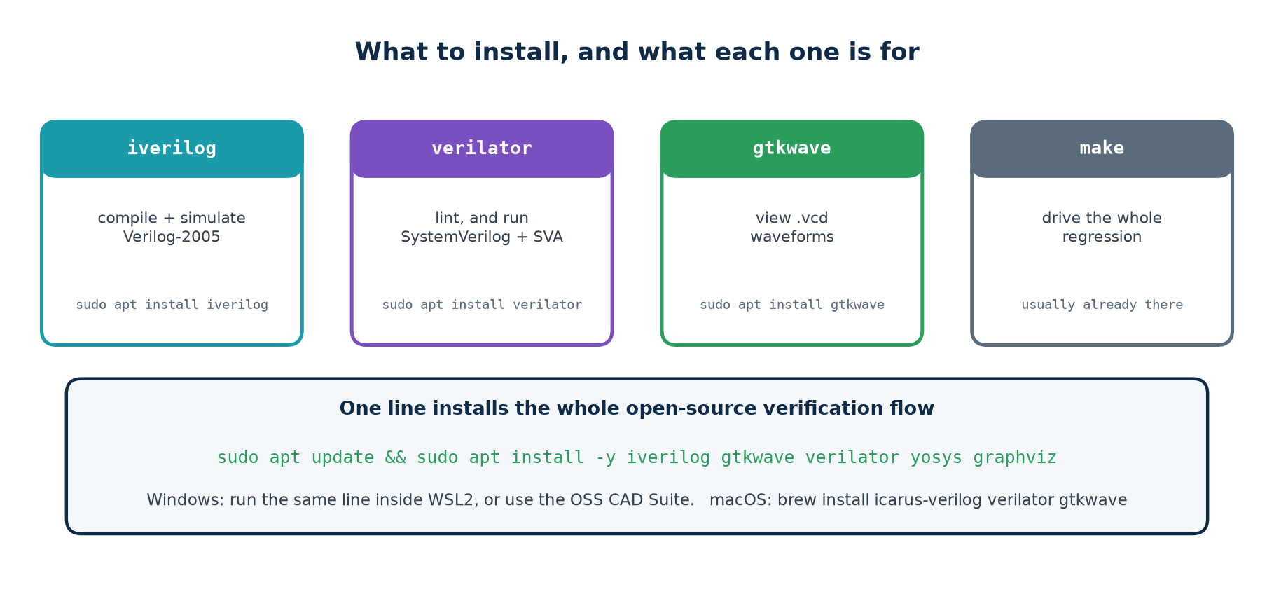
Four tools, one command.
Copy-paste installation
# ---- Ubuntu / Debian / WSL2 ------------------------------------------------
sudo apt update
sudo apt install -y iverilog gtkwave verilator yosys graphviz

# ---- macOS (Homebrew) ------------------------------------------------------
brew install icarus-verilog verilator gtkwave yosys graphviz

# ---- Windows ---------------------------------------------------------------
# Best: wsl --install in an administrator PowerShell, then the Ubuntu line.
# Or: download the OSS CAD Suite, unzip it, run start.bat.

# ---- verify ----------------------------------------------------------------
iverilog -V | head -1 # Icarus Verilog version 12.0
verilator --version # Verilator 5.020
gtkwave --version

GTKWave is a GUI. On Windows 11, WSLg runs Linux GUIs with no extra setup. On Windows 10 you need an X server such as VcXsrv plus export DISPLAY=:0, or you can install the native Windows GTKWave and open the .vcd the WSL side wrote — the file system is shared.

4.2 Vivado xsim
Topic5_Lab/scripts/vivado_sim.tcl
xvlog -d DUT=fifo_b1 -d DUTNAME=\"fifo_b1\" \
rtl/fifo.v rtl/fifo_bugs.v tb/tb_v3_random.v # analyse
xelab -debug typical tb_v3_random -s tb_v3_random_sim # elaborate
xsim tb_v3_random_sim -runall -testplusarg SEED=1 # run

# or with the provided script:
vivado -mode batch -source scripts/vivado_sim.tcl -tclargs V3 fifo_b1

▪ -d NAME=value passes a `define, exactly like -D does to iverilog.
▪ -testplusarg SEED=1 passes a plusarg, so the same seed gives the same run as under Icarus.
▪ -debug typical keeps signal visibility for the wave window.
▪ xsim supports the FULL SystemVerilog assertion language, including the ranged delay forms (a |-> ##[1:3] b) that the open-source flow cannot handle.

4.3 ModelSim / Questa
Topic5_Lab/scripts/modelsim_run.do
vlib work
vmap work work
vlog -sv +define+DUT=fifo_b3 rtl/*.v sva/fifo_sva.sv tb/tb_v6_assert.sv
vsim -voptargs=+acc -assertdebug +SEED=7 work.tb_v6_assert
assertion fail -action break -r /* # stop on the first assertion failure
run -all

# or with the provided script:
vsim -c -gLAB=V6 -gDUT=fifo_b3 -do scripts/modelsim_run.do

▪ -voptargs=+acc keeps signal visibility — without it the optimiser removes the very signals you want to look at.
▪ -assertdebug reports every assertion pass and failure, not only failures.
▪ Compile with vlog -cover bcesx to enable code coverage, then coverage report -details -file build/coverage.txt.
▪ Merge coverage across a regression with vcover merge.

Guided Tutorials V-T1 – V-T7
Seven tutorials, at the keyboard, in order. Each ends with something you can see. About five hours in total, and they are the bridge between reading Parts 1–3 and attempting the exercises.

V-T1 · Run the clinic before you understand it (20 min)
Goal: see the result that the rest of the topic explains.
1. cd Topic5_Lab and run ./scripts/lint.sh . It reports LINT CLEAN — including all five broken designs. Read the note it prints.
2. Run ./scripts/run_all.sh . Every lab passes on the golden FIFO.
3. Run ./scripts/clinic.sh . Read the matrix carefully. Write down, before reading any further, why you think V1 catches nothing.
4. Open rtl/fifo.v and read only the header comment. List every rule it states — there are eight. That list is the verification plan.
5. Now open tb/tb_v1_naive.v and mark which of the eight rules it actually tests. The answer is one and a half.

V-T2 · Build V1 yourself (35 min)
Goal: write a complete testbench from nothing, and meet all six parts.
1. Start a new file tb/my_v1.v. Do not copy tb_v1_naive.v — write it.
2. Declare the signals, instantiate the FIFO, and generate a 100 MHz clock.
3. Write the reset sequence. Release reset BETWEEN clock edges, not on one.
4. Write push() and pop() tasks that drive at #1 after the edge.
5. Write a check() task that increments an error counter and prints the time, the value and the expectation.
6. Add $dumpfile and $dumpvars, a PASS/FAIL verdict, $finish, and a watchdog.
7. Compile and run it against the golden FIFO. Then run it against fifo_b1 through fifo_b5. Record which it catches.
8. Compare your file with tb_v1_naive.v. The differences are worth ten minutes of discussion.

V-T3 · Add a model and the corners (45 min)
Goal: turn a weak testbench into one that catches four bugs out of five.
1. Copy your V1 into tb/my_v2.v.
2. Add the reference model: an array, mhead, mtail, and the four functions mcount, mempty, mfull and mfront.
3. Write model_cycle(do_w, do_r, d). Sample full and empty ONCE at the top, before applying either operation. If you skip this you will reproduce the bug described in section 2.5 — try it deliberately, once, and watch the golden FIFO fail.
4. Write compare(): check count, empty, full, and (when not empty) rd_data, against the model.
5. Replace your ad-hoc stimulus with a cycle(do_w, do_r, d) task that drives, advances the model, and compares.
6. Add the eight directed tests T1–T8 from section 2.6.
7. Run against all six designs. You should now catch four. Which one still escapes, and why?

V-T4 · Constrained-random, seeds and a regression (40 min)
Goal: catch the fifth bug, and make the result reproducible.
1. Copy your V2 into tb/my_v3.v.
2. Replace the directed body with a loop that decides do_w and do_r from $random with configurable weights, read from +WR and +RD plusargs.
3. Read the seed from +SEED and SAVE IT into seed0 before the loop. Print seed0, not seed, in the verdict.
4. Run it against fifo_b5. It should now fail. Note the cycle number of the first error.
5. Run the same seed again and confirm the failure is identical. Change the seed and confirm it is different.
6. Run ./scripts/regress.sh 6 to see a full multi-seed, multi-profile regression.
7. Deliberately break the seeding — call $random with no argument — and observe that runs are no longer reproducible. Put it back.

V-T5 · Coverage, and closing it (40 min)
Goal: measure what your test actually reached, and make the number move.
1. Run ./scripts/coverage.sh and read all three profile reports plus the merged one.
2. Run vvp build/cov.vvp +WR=95 +RD=5 +TAG=extreme . Which bins go MISS, and why?
3. Copy tb_v4_coverage.v and add a thirteenth bin: "three consecutive idle cycles". Does anything hit it? If not, what stimulus would?
4. Add a fourteenth bin that is IMPOSSIBLE by construction — for example "full and empty at the same time". Confirm it stays at zero, and write the one-line waiver you would put in the verification plan.
5. Take the write-heavy profile and add directed stimulus at the end of the run that closes its three holes. Confirm it reaches 12 of 12 on its own.

V-T6 · Assertions (45 min)
Goal: state the specification as properties, and see one fire.
1. Read sva/fifo_sva.sv. For each property, say in one sentence which line of the FIFO's header comment it encodes.
2. Run ./scripts/assert.sh . Note which assertion caught which bug, and at what time.
3. Comment out a_step_both and re-run. fifo_b3 drops from "caught by an assertion" to "caught by the scoreboard only" — later, and with a much less useful message. Put it back.
4. Add a new property: rd_data must never be x while empty is low. Run it against all six designs.
5. Now try to write an assertion that would catch fifo_b4. It is harder than the others — explain why in two sentences. (Hint: what would the property have to remember?)
6. Add a cover property for "a write immediately followed by a read". Confirm from the run that it was actually hit.

V-T7 · The debug clinic (60 min)
Goal: diagnose a bug you did not plant, from symptoms, using the procedure.
1. Have somebody else pick one of the five broken FIFOs without telling you which.
2. Run your V3 against it. Note the FIRST failing cycle and the message.
3. Predict, from the message alone, what kind of bug it is. Write the prediction down before opening anything.
4. Re-run with dumping on and open the VCD at that cycle, not at the end.
5. Add the signals in the right order: stimulus, then outputs, then the DUT's internal pointers. Walk backwards to the first signal that is wrong.
6. Name the bug and the line. Then open rtl/fifo_bugs.v and check.
7. Finally: write a bug of your own that your testbench does NOT catch, hand it to your neighbour, and see whether theirs does.
Step 7 is the point of the whole topic
Writing a bug that survives a good testbench forces you to think about what the testbench does not check — which is exactly the skill a verification plan is supposed to produce.

Part 5 · Practice Exercises
Sixty exercises in five blocks. Block B is the one that builds the skill this module assesses — judging a testbench rather than writing more of it. Full worked solutions are in Part 6.
Block | Exercises | What it trains
A | 1–12 | Concepts — what verification is, and what the terms mean
B | 13–26 | Judgement — is this testbench any good, and how do you know?
C | 27–38 | Diagnosis — symptom to cause, from real failure messages
D | 39–52 | Construction — write the testbench, the model, the coverage
E | 53–60 | Tools, regression and closure

Block A · Concepts

Exercise 1 · Verification and validation
State the difference in one sentence each, and give an example of a design that would pass verification and fail validation.

Exercise 2 · Why not exhaustive
A block has two 16-bit inputs and 40 flip-flops. Explain, with numbers, why exhaustive testing is not an option, and what you do instead.

Exercise 3 · The cost curve
The same bug is found by a linter, by simulation, and after tape-out. Describe what each costs, and what that implies about the order in which you run checks.

Exercise 4 · Passing versus proving
A testbench passes on a design you know is broken. What exactly has it told you, and what has it not?

Exercise 5 · Four checkers
Rank these from weakest to strongest and say why: hard-coded expected values; a human reading a waveform; assertions; a reference model with a scoreboard.

Exercise 6 · Code versus functional coverage
A testbench reports 100% line and branch coverage. Name three things it might still not have tested.

Exercise 7 · Coverage holes
Is a coverage hole a bug? What are the three legitimate things you can do about one?

Exercise 8 · Directed and random
For each, say which technique you would reach for FIRST and why: (a) checking reset empties a FIFO; (b) finding a bug in the interaction of three control signals; (c) regressing a bug that was fixed last week; (d) closing a coverage hole you have just identified.

Exercise 9 · Seeds
Why does a random testbench print its seed on every line, including the passing ones?

Exercise 10 · Assertions and scoreboards
Give one bug an assertion catches earlier than a scoreboard, and one it cannot catch at all. Explain the difference in one sentence.

Exercise 11 · The verification plan
Why must the plan be written before the testbench, and why must somebody other than its author review it?

Exercise 12 · Sign-off
Coverage is closed, the regression is green, and the team is still finding two high-severity bugs a week. Are you finished? What does the situation actually tell you?

Block B · Judging a testbench
For each: say what the testbench does and does not prove, and what you would add first.

Exercise 13 · Three words
push(8'hA1); push(8'hB2); push(8'hC3);
pop(got); check(got, 8'hA1);
pop(got); check(got, 8'hB2);
pop(got); check(got, 8'hC3);
$display("PASS");

Exercise 14 · No verdict
for (i = 0; i < 1000; i = i + 1) begin
drive($random);
$display("%0t in=%h out=%h", $time, din, dout);
end

Exercise 15 · The wrong comparison
if (dout != expected) begin errors = errors + 1; end

Exercise 16 · The model reads the DUT
expected = tb.u_dut.mem[tb.u_dut.rd_ptr[2:0]];
if (rd_data !== expected) errors = errors + 1;

Exercise 17 · No timeout
initial begin
reset();
wait (done);
$display("PASS");
$finish;
end

Exercise 18 · Random without weights
What fraction of cycles asserts each enable, and why is that a problem?
do_w = $random; // any non-zero 32-bit value is 'true'
do_r = $random;

Exercise 19 · Coverage that proves nothing
Two bins, both hit, 100% reported. What is wrong with this coverage model?
if (wr_en) cov_write = cov_write + 1;
if (rd_en) cov_read = cov_read + 1;
// report: both bins HIT, 100% coverage

Exercise 20 · The assertion that never fires
This assertion has never failed in ten thousand runs. Should you be pleased?
a_check: assert property (@(posedge clk) disable iff (!rst_n)
(wr_en && full && rd_en && empty) |=> (count == 0));

Exercise 21 · The over-eager checker
A colleague's testbench fires an error on the golden design about once every thousand seeds. They say it is 'probably a race in the checker' and filter the message out of the log. What is wrong with this, in two respects?

Exercise 22 · One long run
A team runs one random test for twelve hours every night, at a fixed seed. Give three separate criticisms.

Exercise 23 · Model written from the RTL
A verification engineer writes the reference model by reading the design's source, because the specification is 'out of date'. What has been lost, and what should happen instead?

Exercise 24 · The white-box scoreboard
A scoreboard checks the DUT's internal pointer values as well as its outputs. Name one benefit and two costs.

Exercise 25 · The clinic result
V2 catches 4 of 5 and V3 catches 5 of 5. A student concludes that directed testing is obsolete. Give two reasons they are wrong.

Exercise 26 · What would you add first?
You inherit a testbench with a reference model, 3000 random cycles, and no coverage, no assertions and no regression. You have one day. What do you add, in what order, and why?

Block C · Diagnosis
Each of these is a real failure message or symptom. Name the most likely cause and the first thing you would look at.

Exercise 27 · x from time zero
FAIL 0 : rd_data is not the oldest word got xx expected a1
FAIL 10 : count disagrees with the model got x expected 1

Exercise 28 · Off by one cycle
FAIL 155 : rd_data is not the oldest word got b2 expected a1
FAIL 165 : rd_data is not the oldest word got c3 expected b2
... and every subsequent cycle is also wrong by exactly one word

Exercise 29 · Passes on the golden design, fails on one bug only at high WR
Your testbench catches fifo_b1 when +WR=90 but not when +WR=50. What does that tell you about the bug, and about the testbench?

Exercise 30 · The check that never fires
if (rd_data != model_front()) errors = errors + 1;
// rd_data is x for the whole run; errors stays at 0

Exercise 31 · Half-width pulse
A one-cycle pulse from the DUT appears half a clock wide in the waveform, and a check on it fails intermittently. Design bug or testbench bug? How do you tell?

Exercise 32 · Random test drove nine transactions
2000 cycles were requested and it passed. Why is this output alarming?
scoreboard: 2022 checks, 9 words in, 9 words out
PASS - V6 layered+assertions : seed=7 cycles=2000

Exercise 33 · The golden design fails
Your V2 testbench reports FAIL on the correct FIFO, at the first cycle where a read and a write are asserted together on an empty FIFO. The broken fifo_b5 passes. What is wrong, and where?

Exercise 34 · The simulation never ends
A test hangs with no output after the reset message. Give three possible causes and how to distinguish them.

Exercise 35 · Assertion fires during reset
What is missing from the property?
%Error: fifo_sva.sv:48: Assertion failed in a_full_iff_depth: full=x but count=x
Time: 0

Exercise 36 · Coverage says 100%, a bug escaped
A bug in the full→empty→full transition escaped a testbench reporting 100% functional coverage across 11 bins. What went wrong, and what is the fix?

Exercise 37 · Works in simulation, fails on the board
A design with a signal crossing from a 100 MHz to a 27 MHz clock passes every simulation and fails intermittently on hardware. Explain, and say what would have caught it.

Exercise 38 · The regression is green but slow
A nightly regression takes nine hours; profiling shows 80% of the time in file I/O. What is almost certainly happening, and what is the one-line fix?

Block D · Construction
Write real code. Each of these should compile and run against Topic5_Lab/rtl/fifo.v or the DUT named.

Exercise 39 · A minimal self-checking testbench
Write a complete testbench for rtl/fifo.v with all six parts, including a watchdog. It must print PASS or FAIL and terminate.

Exercise 40 · The reference model
Write the FIFO reference model as an array with head and tail indices, plus mcount, mempty, mfull and mfront. Then write model_cycle(do_w, do_r, d) correctly — sampling before applying.

Exercise 41 · The eight corners
Add the eight directed tests T1–T8 from section 2.6. Confirm your testbench now catches four of the five broken designs.

Exercise 42 · Weighted random
Replace the directed body with weighted random stimulus taking +SEED, +CYCLES, +WR and +RD from plusargs, and printing the ORIGINAL seed in the verdict.

Exercise 43 · A coverage model
Implement the twelve bins of section 2.9, including bin 11 (the full→empty→full sequence). Print a HIT/MISS table and a closure verdict.

Exercise 44 · A thirteenth bin
Add a bin for 'a write immediately followed on the next cycle by a read'. Which stimulus profile hits it most often?

Exercise 45 · Assertions
Write three concurrent assertions for the FIFO that are NOT already in sva/fifo_sva.sv, and say which line of the specification each encodes.

Exercise 46 · A layered driver
Refactor your testbench into generator / driver / monitor / scoreboard, with the monitor never driving and the scoreboard never touching a pin.

Exercise 47 · A second DUT
Write a testbench for rtl/fifo.v that also works, unchanged, on a FIFO with a different DEPTH and W. What did you have to parameterise?

Exercise 48 · Plant a bug
Make a copy of rtl/fifo.v with exactly one realistic bug that your V3 testbench does NOT catch. Then extend the testbench until it does.

Exercise 49 · A shift-register testbench
Write a self-checking testbench for an 8-bit shift register with enable and synchronous clear, using a reference model. What is the model, in this case?

Exercise 50 · An FSM testbench
Write a testbench for a traffic-light FSM that checks: every state is entered; no illegal light combination ever occurs; and the machine recovers from a forced illegal state. Which of the three needs a white-box hook, and how do you keep it out of the scoreboard?

Exercise 51 · A protocol checker
Write a standalone checker module for a simple req/ack handshake: req must stay high until ack; ack must not be asserted without req; and req must fall the cycle after ack. Bind it to a DUT without editing the DUT.

Exercise 52 · A golden-vector testbench
Write a testbench that reads stimulus and expected results from two hex files, applies each vector, and writes a mismatch log. Then say what this testbench cannot find.

Block E · Tools, regression and closure

Exercise 53 · Reproduce the clinic
Run ./scripts/clinic.sh and reproduce the matrix. Then modify tb_v1_naive.v with the SMALLEST change that makes it catch at least one bug. What did you change, and why does it work?

Exercise 54 · A regression of your own
Write a shell script that runs your testbench over 10 seeds and 3 profiles, prints a table, and exits non-zero if anything fails. It must print the reproduction command for every failure.

Exercise 55 · Coverage merge
Run the three profiles of ./scripts/coverage.sh separately and merge them by hand from the build/cov_*.txt files. Confirm you get the same merged total as the script.

Exercise 56 · Assertion triage
Run ./scripts/assert.sh . For each of the five designs, state which assertion fired (or that none did) and, in one sentence, why that particular property was the one to catch it.

Exercise 57 · Waveform discipline
Build a GTKWave save file for your own testbench with signals grouped and radixes set. Commit it. Then hand your VCD and .gtkw to somebody else and time how long it takes them to find the first failing cycle.

Exercise 58 · Make it fast
Time your regression. Then remove waveform dumping from the regression path and re-time it. Report both numbers and the ratio.

Exercise 59 · The vendor flow
Run one of the labs under Vivado xsim or ModelSim using the supplied script. Report any command that needed changing for your installed version — the scripts are templates and were not executed when this material was written.

Exercise 60 · Write the verification plan
For rtl/fifo.v, write the complete verification plan as a table: one row per rule in the header comment, with columns for how it is checked, what stimulus reaches it, which coverage bin proves it, and status. Then compare it with what your testbench actually does, and list the gaps.

Part 6 · Worked Solutions

Block A
Solution 1
Verification asks whether the design does what the specification says. Validation asks whether the specification was the right one.
Example: a UART verified perfectly against a specification that says 7 data bits, when the system it plugs into sends 8. Every test passes; the product does not work.
Solution 2
Two 16-bit inputs give 2^32 = 4.3 billion combinations for the combinational part alone — feasible only if the block is purely combinational and fast to simulate. Add 40 flip-flops and the reachable state space is up to 2^40 ≈ 10^12 states, each of which must be visited in every relevant input combination: 10^12 × 4×10^9 ≈ 4×10^21 cases. At a billion per second that is over 100 000 years. Instead: directed tests at the boundaries, constrained-random for the interior, assertions for the rules, and coverage to measure what was reached.
Solution 3
Lint: one second, with a file and line. Simulation: a minute, plus reading a waveform. After tape-out: a mask respin — months and a large amount of money, with parts already at customers. Implication: run the checks in cost order, and never skip a cheap one because you are in a hurry. A bug a linter would have named should never reach a waveform viewer.
Solution 4
It has told you that the testbench does not distinguish this design from a correct one. It has told you nothing whatever about the design. In Topic5_Lab, V1 passes on all five broken FIFOs — which measures V1, not the FIFOs.
Solution 5
Weakest to strongest: a human reading a waveform (cannot run unattended, so it is not a check at all); hard-coded expected values (scales to about twenty cases, and the values acquire their own bugs); a reference model with a scoreboard (checks every cycle, scales to millions); assertions (check every cycle of EVERY test, for ever, and report at the cycle the rule broke).
The ordering is about scale and about when the failure is reported, not about how clever each one is.
Solution 6
(1) Behaviour there is no code for — a missing else, an unhandled case, a feature not implemented. (2) Whether any output was actually CHECKED: a testbench that runs every line and compares nothing reports 100%. (3) Situations, as opposed to lines: the FIFO may never have been full while a write was attempted, even though every line of the full logic executed.
Solution 7
No — a hole means the situation never occurred during testing, which is a gap in evidence rather than a defect. Three legitimate responses: write stimulus that reaches it; waive it in writing with a reason (typically that it is impossible by construction); or change the coverage model because the bin was wrong. What you may not do is leave it unexplained.
Solution 8
(a) reset empties a FIFO DIRECTED - one named case, cheap, unambiguous
(b) three interacting signals RANDOM - the combinations are what you cannot list
(c) regressing a fixed bug DIRECTED - you want that exact case, every time
(d) closing a known hole DIRECTED - you know precisely what must happen

Solution 9
Because a failure is useless unless it can be reproduced, and because you cannot know in advance which line will fail. Printing it only on failure means the passing runs cannot be re-examined later — and 'it passed last week' is a claim somebody will eventually want to check.
Solution 10
Catches earlier: any rule about the control interface — for example fifo_b3's count drifting on a simultaneous read and write, which a_step_both reports at 545 ns by name, while a scoreboard would report a count mismatch some cycles later.
Cannot catch: fifo_b4, which corrupts DATA while keeping count, full and empty perfectly correct. No property in sva/fifo_sva.sv describes the data, so nothing fires and the scoreboard is what catches it.
Assertions catch what you described; scoreboards catch what you compared.
Solution 11
Written first, it tells you what to build and the gaps are visible while they are cheap. Written afterwards, it documents what you happened to build. It must be reviewed by somebody else because the author of a plan cannot see what the plan omits — that is what an omission is.
Solution 12
No. A flat bug-discovery rate is one of the sign-off criteria, and yours is not flat. Coverage being closed while serious bugs keep arriving means the coverage MODEL is missing a category of behaviour — it is measuring the wrong thing, accurately. The action is to find out what the escaping bugs have in common and add bins for it, not to keep running the same regression.

Block B
Solution 13
Proves: three words go in and come out in order, from an empty FIFO. Does not prove: anything at a boundary — it never fills, never empties past zero, never reads and writes on the same cycle, never wraps. Add first: fill to full and drain to empty, with a reference model so every cycle is checked. That single change takes it from 0 of 5 to 4 of 5 in the lab.
Solution 14
It proves nothing at all: there is no verdict. It is a demonstration, not a test. Add an error counter, a check task, and a PASS/FAIL line. Until then it cannot be put in a regression, which means in practice it will be run once and never again.
Solution 15
It uses
!=
instead of
!==
. If dout is x, the comparison evaluates to x, which is not true, so the check silently passes. A design that outputs x for the whole run reports zero errors.
Fix: use === and !== in every testbench comparison.
Solution 16
The 'model' is reading the DUT's own memory and pointer, so it agrees with the DUT by construction and can never disagree with it. It will not detect any addressing bug, because it uses the same address. Fix: an independent model, written from the specification, that never looks inside the DUT.
Solution 17
No timeout. If done never asserts, the test hangs for ever, and in a regression it hangs everything behind it. Add a watchdog: a second initial block that prints FAIL and calls $finish after a generous delay. A hung DUT must FAIL, not stall.
Solution 18
$random returns a 32-bit value, and any non-zero value is 'true', so each enable is asserted about 4 294 967 295 times out of 4 294 967 296 — that is, essentially always. Both enables are high on essentially every cycle, so the FIFO does read+write for ever and never fills or empties.
Fix: reduce to a range and compare, as in the lab:
({$random(seed)} % 100) < p_wr
Solution 19
The bins record that a write happened and a read happened. They say nothing about the OCCUPANCY at the time, which is where the bugs are: read+write while empty, write while full, the wrap. Two hit bins reporting '100%' is worse than no coverage, because it is believed. Fix: bins for situations (state × operation), which is exactly what a covergroup CROSS expresses.
Solution 20
No. Read the antecedent:
wr_en && full && rd_en && empty
requires full and empty to be true at the same time, which never happens. The property is VACUOUSLY true — it has never actually been evaluated, so it has proved nothing.
This is why assertion coverage exists: every assertion must be shown to have been hit at least once. An assertion that never fires may be protecting you, or may be dead code.
Solution 21
First: an intermittent failure on the golden design is either a real design bug that only shows in rare orderings, or a real testbench bug. Both matter, and 'probably a race' is a hypothesis, not a diagnosis — the seed makes it reproducible, so it can be investigated properly.
Second, and worse: filtering the message trains the team to ignore that checker. From then on it is not a checker. A checker that fires on correct hardware must be fixed or removed, never muted.
Solution 22
(1) A fixed seed means twelve hours of the SAME stimulus every night — one sample, repeated, not twelve hours of coverage. (2) One long run does not parallelise; twelve one-hour runs at different seeds cover far more and finish sooner. (3) A twelve-hour turnaround means a bug introduced in the morning is found the following day at the earliest, and nobody will run it before committing.
Solution 23
The independence has been lost: a model derived from the design agrees with the design's bugs, so the scoreboard can only detect the testbench's own mistakes. What should happen: fix the specification. If the spec is out of date, that is a project problem to be escalated, not a problem to be worked around by the verification engineer — and writing the model is often exactly the exercise that exposes what the spec fails to say.
Solution 24
Benefit: when a check fails you can see immediately which internal signal is wrong, which shortens debugging. Costs: (1) the testbench now depends on the design's internal structure, so any refactor breaks it and nobody can tell whether the design broke too; (2) it can mask bugs, because a model that reads the DUT's own state agrees with it by construction. Use white-box hooks for debugging and coverage, never for the primary scoreboard comparison.
Solution 25
(1) The four bugs V2 caught were caught by DIRECTED boundary tests, and it caught them immediately and deterministically — the random test found the same four less directly. (2) A random test cannot be relied on to reach a specific named case; once you know a case matters, you write it directly so it is hit on every run, at every seed, for ever. Directed and random are instruments for different jobs.
Solution 26
In this order:
1. ASSERTIONS on the control interface — a few hours, they check every cycle of every existing test, and they report at the cycle the rule breaks.
2. COVERAGE — otherwise you have no idea whether the 3000 cycles reach anything interesting, and you cannot tell your manager anything true.
3. A REGRESSION over several seeds and profiles — cheap to script, and it turns one sample into evidence.
Assertions first because they are the highest value per hour and they improve every test that already exists.

Block C
Solution 27
x from time zero means the DUT was never reset, or the reset is not reaching it. Look first at the reset path: polarity (rst_n is active LOW), whether the testbench asserts it before the first edge, and whether the port is connected — a misspelt port name creates a silent undriven wire unless `default_nettype none is in force.
Solution 28
Every word is late by exactly one, and consistently. That is not a data bug; it is an alignment bug — either the model popped one word too early, or the testbench sampled rd_data after advancing the model instead of before. Look at the testbench first: consistent, uniform off-by-one is almost always the checker and almost never the design.
Solution 29
The bug only manifests near FULL, so it needs the write-heavy profile to be reached at all. That tells you two things: the bug is at the full boundary (fifo_b1's full flag is one entry late), and your testbench has a COVERAGE hole at +WR=50 — it is not reaching full often enough. Add a directed fill-to-full test so the case is hit at every profile and every seed.
Solution 30
Same fault as exercise 15:
!=
instead of
!==
. rd_data is x, so (x != anything) is x, which is not true, so errors never increments and the run reports PASS while the design outputs nothing but x.
The deeper lesson: the FIRST thing a testbench should check is that its outputs are not x. Add an $isunknown assertion or an explicit check.
Solution 31
Testbench bug, almost certainly. A DUT clocked on posedge can only change its outputs at a posedge, so a half-cycle-wide pulse means the STIMULUS changed mid-cycle. How to tell: look at the input in the waveform — if it changes at a time that is not just after a posedge, the driver is at fault. This exact bug occurred in the Topic 4 edge-detector lab.
Solution 32
2000 cycles were driven but only 9 words moved, which means the random decisions were not random — the same do_w/do_r pair was produced every cycle.
Cause:
$urandom(seed)
called inside the loop. In SystemVerilog that RE-SEEDS the generator every call, so it returns the same number for ever. Seed once with
void'($urandom(seed0));
then call
$urandom()
with no argument. This happened while writing Lab V6.
A random test that is silently not random is worse than none, because it is believed.
Solution 33
The reference model is wrong, not the FIFO. The model applies the write and then tests its own updated state to decide whether to pop:
on a simultaneous read and write to an empty FIFO it pushes, sees itself no longer empty, and pops the word straight back out — reporting 0 where the hardware correctly has 1. fifo_b5 really does drop that write, so it agrees with the broken model and 'passes'.
Fix: sample full and empty ONCE, before applying either operation.
was_full = mfull();
was_empty = mempty();
if (do_w && !was_full) push(d);
if (do_r && !was_empty) pop();

Solution 34
(1) No $finish and the stimulus has ended — the simulation is idle but alive; check whether time is still advancing. (2) A wait loop with no delay, so time cannot advance at all; the process is spinning. (3) The DUT never asserts the condition being waited on — a real functional bug. Distinguish them by printing $time periodically, or by checking whether the VCD keeps growing: if time is advancing it is (1) or (3); if not, it is (2).
Solution 35
The
disable iff (!rst_n)
clause is missing, or rst_n is itself x at time 0 so the disable condition cannot be evaluated. During reset nothing is guaranteed and every property must be switched off.
If rst_n is x at time 0, initialise it in the testbench before the first edge — that is part 1 of the six parts.
Solution 36
The coverage model had no bin for the SEQUENCE. Bins 0–10 in the lab are all instantaneous conditions; bin 11, 'full → empty → full', is a sequence over time and needs a small state machine to detect. A model made only of instantaneous bins reports 100% while never having exercised any interesting ordering. Fix: add sequence bins — in SystemVerilog, cover properties or transition bins.
Solution 37
The simulator has no model of metastability: it resolves every flip-flop to a clean 0 or 1, so a missing or inadequate synchroniser simulates identically to a correct one. On hardware the receiving flip-flop occasionally goes metastable and resolves unpredictably. What would have caught it: a structural CDC checker, or review — two flip-flops for a single-bit level, Gray coding or a handshake for a bus. Not simulation.
Solution 38
Waveform dumping. 80% of the time in file I/O with a green regression means every run is writing a VCD nobody will ever look at.
Fix: remove the $dumpvars from the regression path (guard it with a plusarg or an `ifdef) and re-run only the failing seed with dumping switched on. Expect the run time to fall by several times.

Block D
Solution 39
See Topic5_Lab/tb/tb_v1_naive.v for a complete worked version. The six parts: clock and reset; push/pop tasks; (no model at this stage); a check task with an error counter; $dumpfile/$dumpvars; a PASS/FAIL line, $finish, and a separate watchdog initial block. The commonest omissions in student answers are the watchdog and releasing reset between edges rather than on one.
Solution 40
reg [W-1:0] model [0:DEPTH-1];
integer mhead, mtail;
function [$clog2(DEPTH):0] mcount; input d; mcount = mtail - mhead; endfunction
function mempty; input d; mempty = (mtail == mhead); endfunction
function mfull; input d; mfull = ((mtail - mhead) == DEPTH); endfunction
function [W-1:0] mfront; input d; mfront = model[mhead % DEPTH]; endfunction

task model_cycle(input do_w, input do_r, input [W-1:0] dat);
reg was_full, was_empty;
begin
was_full = mfull(0); // SAMPLE BOTH FIRST - this is the whole point
was_empty = mempty(0);
if (do_w && !was_full) begin model[mtail % DEPTH] = dat; mtail = mtail + 1; end
if (do_r && !was_empty) mhead = mhead + 1;
end
endtask

Solution 41
See tb_v2_selfcheck.v. The eight tests are: post-reset state; fill to full; write while full; drain to empty; read while empty; simultaneous read+write held half full; enough cycles to wrap; final drain. Verified result: 4 of 5 bugs caught, golden design passes. The one that escapes is fifo_b5, because no directed test asserts read and write together while EMPTY.
Solution 42
integer seed = 1, seed0 = 1, cycles = 3000, p_wr = 55, p_rd = 45;
if (!$value$plusargs("SEED=%d", seed)) seed = 1;
seed0 = seed; // $random UPDATES seed - keep the original
if (!$value$plusargs("CYCLES=%d", cycles)) cycles = 3000;
if (!$value$plusargs("WR=%d", p_wr)) p_wr = 55;
if (!$value$plusargs("RD=%d", p_rd)) p_rd = 45;

do_w = (({$random(seed)} % 100) < p_wr);
do_r = (({$random(seed)} % 100) < p_rd);

$display("PASS - seed=%0d cycles=%0d wr=%0d rd=%0d", seed0, cycles, p_wr, p_rd);

Solution 43
See tb_v4_coverage.v. Bin 11 needs two flags: seen_full, set whenever the FIFO is full; and seen_empty_after_full, set when it is empty and seen_full is already set. When both are set and it goes full again, increment bin 11 and reset seen_empty_after_full. Everything else is a one-line condition sampled each cycle.
Solution 44
The bin is a two-cycle sequence, so it needs one flag:
The read-heavy profile hits it most often, because after a write the FIFO is non-empty and a read is very likely on the next cycle. The write-heavy profile hits it least.
reg wrote_last;
if (wrote_last && do_r && !was_empty) cov[12] = cov[12] + 1;
wrote_last <= (do_w && !was_full);

Solution 45
// 1. "rd_data is only meaningful while empty=0" - it must never be x then
a_rd_known: assert property (@(posedge clk) disable iff (!rst_n)
!empty |-> !$isunknown(rd_data));

// 2. "a write while full is IGNORED" - occupancy must not change
a_wr_at_full: assert property (@(posedge clk) disable iff (!rst_n)
(wr_en && full && !(rd_en && !empty)) |=> (count == $past(count)));

// 3. "reset empties the FIFO" - checked on the cycle after reset releases
a_reset_empty: assert property (@(posedge clk)
$rose(rst_n) |=> (count == 0 && empty));

Solution 46
See tb_v6_assert.sv. The test of a correct refactoring is mechanical: the monitor contains no assignment to any DUT input, and the scoreboard contains no reference to any DUT signal other than the outputs the monitor passed it. If either is untrue, the layers are not actually separate.
Solution 47
W and DEPTH as localparams driving everything: the signal declarations, the model array size, the loop bounds in the fill and drain tests, the count comparison width ($clog2(DEPTH)+1 bits), and the coverage bin for 'reached full'. The commonest thing students forget is the count width — an 8-deep FIFO needs 4 bits, and hard-coding [3:0] breaks silently at DEPTH=16.
Solution 48
Any bug outside what the testbench checks will do. Examples that survive a V3-class testbench:
· rd_data is correct but glitches for one delta before settling — the testbench samples after #1 and never sees it.
· the FIFO works correctly for the first 2^AW wraps and then fails — the test never runs long enough.
· an output is correct but takes an extra cycle to become valid when the FIFO goes from empty to non-empty — if the testbench never checks that transition specifically.
Each is closed by adding the corresponding check and coverage bin, which is the point of the exercise.
Solution 49
The model is a simple shadow register: on each enabled clock, shadow <= {shadow[W-2:0], sin}; on clear, shadow <= 0. It is almost the same as the design, which is fine here — the specification for a shift register genuinely is that expression. The value of the testbench is in the CONTROL: that clear beats enable, that a disabled cycle changes nothing, and that reset dominates both.
Solution 50
Entering every state and recovering from an illegal state both need to see the state register, which is internal. Keep it out of the scoreboard by separating the roles:
· The SCOREBOARD checks only the outputs — the light patterns and their durations — against a model built from the specification.
· COVERAGE may look at the internal state, because coverage measures what happened rather than deciding correctness. A hierarchical reference is acceptable there.
· Forcing an illegal state is a deliberate white-box test in its own file, clearly labelled, and it checks only that the machine returns to a legal state — which is an output-visible property.
Solution 51
module reqack_checker (input wire clk, rst_n, req, ack);
a_req_stable: assert property (@(posedge clk) disable iff (!rst_n)
(req && !ack) |=> req) else $error("req dropped before ack");
a_no_lone_ack: assert property (@(posedge clk) disable iff (!rst_n)
ack |-> req) else $error("ack without req");
a_req_falls: assert property (@(posedge clk) disable iff (!rst_n)
(req && ack) |=> !req) else $error("req did not fall after ack");
c_handshake: cover property (@(posedge clk) disable iff (!rst_n) req && ack);
endmodule

// bound alongside the DUT in the testbench, without editing the DUT:
reqack_checker u_chk (.clk(clk), .rst_n(rst_n), .req(req), .ack(ack));

Solution 52
See section 2.12 for the code. What it CANNOT find:
· any bug outside the fixed stimulus in the file — it cannot reach a corner nobody generated;
· a divergence between the file and the current specification, because nothing checks that the golden file is still right;
· which RULE was broken — a mismatch names a vector number, not a property.

Block E
Solution 53
The smallest effective change is to fill the FIFO past DEPTH and read it back. Adding this before the existing checks catches fifo_b1 and fifo_b4:
for (i = 0; i < DEPTH + 1; i = i + 1) push(8'h10 + i[7:0]);
for (i = 0; i < DEPTH; i = i + 1) begin
pop(got); check(got, 8'h10 + i[7:0], "filled then drained");
end

// It works because both bugs are at the FULL boundary, and V1 never went there.

Solution 54
See scripts/regress.sh for a worked version. The essentials: loop over profiles and seeds; capture the output; grep for ^PASS; print one line per run including the seed; accumulate a failure list; print the reproduction command; exit 1 if anything failed. The exit code is what makes it usable from a CI system.
Solution 55
Each run writes build/cov_<TAG>.txt with one line per bin: index, count, name. Merging is a sum per index:
awk '{ c[$1] += $2 } END { for (i=0;i<12;i++) print i, c[i] }' build/cov_*.txt

# Verified merged result across the three profiles: 12 of 12 bins covered.

Solution 56
fifo_b1 a_full_iff_depth 205 ns full and count disagree - the flag is the bug
fifo_b2 a_count_range 425 ns count underflowed past DEPTH - a range violation
fifo_b3 a_step_both 545 ns a simultaneous r+w changed the occupancy
fifo_b4 (none) 456 ns the CONTROL interface stays correct; only DATA
is corrupted, and no property describes the data
fifo_b5 a_step_up 465 ns a write did not increase count by exactly one

Solution 57
The point of the exercise is the timing. A colleague given a raw VCD typically takes several minutes to assemble a useful view; given a .gtkw they are looking at the right signals in seconds. That difference, multiplied by every person who ever debugs the block, is why the save file is committed.
Solution 58
Expect a large ratio — commonly 3× to 10× on a design of this size, and more on a bigger one, because dumping writes a line of text for every signal change. The exact number is what you should report; the lesson is that a regression should dump nothing by default.
Solution 59
Answers will vary by release. Things that commonly need adjusting: the exact form of the -d / +define+ argument for a string macro; whether -sv is required for the SystemVerilog files; the name of the simulation snapshot; and, in ModelSim, the multilib packages needed on a 64-bit Linux host. Record what you changed — that record is worth more to the next class than the script itself.
Solution 60
The plan has one row per rule in the header comment of rtl/fifo.v — the two-part bullets about writes and reads split into an 'accepted' row and an 'ignored' row. A correct answer looks like this (abridged):
RULE CHECKED BY STIMULUS BIN
write accepted when !full scoreboard, every cyc random write accepted
write while full ignored a_full_iff_depth + sb write-heavy wr while full
read accepted when !empty scoreboard, every cyc random read accepted
read while empty ignored a_count_range + sb read-heavy rd while empty
rd_data is the oldest word scoreboard random (implicit)
count is 0..DEPTH a_count_range all reached full
empty<=>0, full<=>DEPTH a_empty_iff_zero etc all reached empty
order preserved, none lost scoreboard + drain all wrapped
reset empties the FIFO directed T1 directed post-reset

// The commonest GAP students find in their own testbench: nothing explicitly
// checks 'no word is duplicated'. The drain at the end of V3 does check it,
// but only if the model is drained to exactly empty and compared word by word.

Part 7 · Reference

7.1 Glossary
Term | Meaning
Verification | establishing that a design does what its specification says.
Validation | establishing that the specification was the right one.
DUT | device under test — the design the testbench instantiates.
Testbench | a port-less module that instantiates the DUT, drives it, and decides automatically whether the results were correct.
Self-checking | the testbench forms its own verdict; no human reads a waveform.
Reference model | an independent implementation of the specification, written from the spec, used to compute expected results.
Golden model / vectors | a trusted external reference — a C model, or a file of expected outputs.
Scoreboard | the component that compares DUT behaviour against the model.
Driver | the layer that knows the pin-level protocol.
Monitor | the layer that observes the pins and drives nothing.
Generator / sequencer | the layer that decides which scenarios to run.
Directed test | a test whose case and expected result you wrote by hand.
Constrained-random | stimulus generated by weighted or solver-driven random choice within constraints you specify.
Seed | the number that makes a random run reproducible.
Regression | the full set of tests, run automatically after every change.
Code coverage | which lines, branches, conditions and toggles the tests reached.
Functional coverage | which specification-level situations the tests reached.
Coverage bin | one counted situation in a functional coverage model.
Cross | coverage of a combination of two or more coverpoints.
Coverage hole | a bin nothing ever hit — a gap in evidence, not a failure.
Coverage closure | every bin hit, or every remaining hole waived in writing.
Assertion | a rule stated in the design's language and checked every clock edge.
Cover property | the same syntax used to RECORD that a situation occurred.
Vacuous pass | an assertion whose antecedent never became true, so it proved nothing.
Immediate assertion | a check inside procedural code, evaluated when reached.
Concurrent assertion | a property checked on a clock, continuously.
SVA | SystemVerilog Assertions.
UVM | Universal Verification Methodology — a SystemVerilog class library that standardises the testbench layers.
Formal verification | proving a property for all input sequences, or producing a counter-example.
CDC | clock domain crossing — and a class of bug simulation cannot find.
Metastability | a flip-flop settling unpredictably after a setup or hold violation. Not modelled by any simulator.
Event queue | the simulator's ordered list of scheduled events.
Stratified regions | Active, Inactive, NBA and Monitor — the ordering within one simulation time step.
VCD / FST / WLF / FSDB | waveform file formats — plain, compressed, and vendor-native.
Watchdog | a timeout that turns a hung simulation into a FAIL.

7.2 Testbench checklist
1. Does it have all six parts, including the verdict AND a watchdog?
2. Does it print a PASS or FAIL line a machine can grep for?
3. Does it compare with === and !==, never == and !=?
4. Is reset asserted before the first edge and released BETWEEN edges?
5. Is every input driven a small delay AFTER the active edge?
6. Are expected values computed by a model written from the SPECIFICATION?
7. Does the model sample its state once, before applying any operation?
8. Does the scoreboard avoid every hierarchical reference into the DUT?
9. Are the boundary cases present: full, empty, write-while-full, read-while-empty, simultaneous read and write, and a wrap?
10. Is the stimulus seeded, and is the ORIGINAL seed printed on every result line?
11. Is there a coverage model, and does the run report HIT/MISS per bin?
12. Are there assertions for the control interface, and has each one been hit at least once?
13. Does it run in a regression across several seeds and profiles?
14. Does the regression dump no waveforms by default?
15. Would it FAIL if the design were wrong? Name a change it would not catch.

7.3 Troubleshooting
Symptom | Almost always means | Fix
Everything is x from time 0 | reset never asserted, or a misspelt DUT port | check reset polarity; `default_nettype none
A check passes when the value is x | == used instead of === | use === and !== in every check
The design looks one cycle late | sampled before the NBA update landed | sample after the NEXT edge, or use $strobe
A pulse is half a cycle wide | stimulus driven ON the clock edge | drive at #1 after the edge, never on it
Random test drove 9 transactions | $urandom(seed) called inside the loop | seed once with void'($urandom(s)), then $urandom()
Both enables high on every cycle | raw $random used as a boolean | ({$random(seed)} % 100) < weight
The CORRECT design fails | the reference model is wrong | sample full/empty once, before applying either operation
Simulation never ends | no $finish, or a wait loop with no delay | add $finish and a watchdog; put @(posedge clk) in the loop
The waveform has no signals | $dumpvars scope too narrow, or a stale VCD | $dumpvars(0, tb); and re-run before re-opening
An assertion fires at time 0 | no disable iff (!rst_n), or rst_n is x | add the disable clause; initialise rst_n
An assertion has never fired | it may be vacuous | check assertion coverage; look at the antecedent
Coverage 100% but bugs escape | the model has no SEQUENCE bins | add bins for orderings, not just states
Regression takes all night | waveform dumping on every run | dump nothing; re-run the failing seed with dumping on

7.4 Command card
Task | Open-source | Vivado | ModelSim / Questa
Lint | verilator --lint-only -Wall rtl/*.v | report_methodology | vlog (warnings)
Compile | iverilog -g2005 -o sim.vvp <files> | xvlog <files> | vlog <files>
Compile SV | verilator --binary --timing --assert | xvlog -sv | vlog -sv
Define a macro | -DDUT=fifo_b1 | -d DUT=fifo_b1 | +define+DUT=fifo_b1
Plusarg | vvp sim.vvp +SEED=1 | xsim s -testplusarg SEED=1 | vsim +SEED=1
Run | vvp sim.vvp | xsim <snap> -runall | vsim -c work.<top>; run -all
Waveforms | gtkwave dump.vcd | wave window | add wave -r /*
Assertions | --assert (subset) | full SVA | full SVA, -assertdebug
Coverage | --coverage | -cover, report_coverage | vlog -cover bcesx
Merge coverage | awk over cov_*.txt | report_coverage | vcover merge

7.5 The lab in one page
Everything, from a clean checkout
cd Topic5_Lab
make lint # one second - always first
make run # every lab against the golden FIFO: all PASS
make clinic # the V1/V2/V3 x six-designs matrix. The point of Topic 5.
make cover # coverage across three profiles, merged
make assert # assertions vs scoreboard on every broken design
make regress # multi-seed regression
make waves # run V3 and open GTKWave with the saved view

 | fifo | b1 | b2 | b3 | b4 | b5 | caught
V1 naive directed | pass | pass | pass | pass | pass | pass | 0 / 5
V2 model + corners | pass | CAUGHT | CAUGHT | CAUGHT | CAUGHT | pass | 4 / 5
V3 constrained-random | pass | CAUGHT | CAUGHT | CAUGHT | CAUGHT | CAUGHT | 5 / 5

7.6 Where this leads
▪ Topic 6 — timing constraints and analysis. The verification skills here do not stop being needed: every timing fix is a design change, and every design change has to be re-verified. That is what the regression is for.
▪ The lab. Topic5_Lab/ contains one DUT, five planted bugs, six testbenches and scripts for three toolchains. The experiments at the end of its README are worth more than any additional reading.
▪ Standards. IEEE 1800 defines SystemVerilog including assertions, constraints and covergroups. You do not need to read it end to end, but knowing your tool's behaviour is defined somewhere matters when two tools disagree.
End of Topic 5 workbook. Every design, testbench and script referred to here is in Topic5_Lab/, and every quoted tool output was produced by running the tool on that code.

