Hardware Modeling using Verilog
Lecture 01 — Introduction
Tutorial and Practice Workbook
Prof. Indranil Sengupta · Department of Computer Science and Engineering · IIT Kharagpur (NPTEL)
expanded and made hands-on for the Chip Design Associate programme · Module 2 · NOS NIE/ELE/N0102
How this workbook is organised
Part 1 The lecture itself, written out in full. Every slide the lecturer shows is covered, in his order, with the explanation expanded so that nothing has to be looked up elsewhere.
Part 2 The design flow in detail: what each step takes in, what it produces, and which tool does it.
Part 3 Installing the toolchain, on Linux, macOS or Windows, with the checks that tell you it worked.
Part 4 Five guided labs. Every command is given, and every output printed here was produced by actually running it.
Part 5 Thirty-six exercises with full worked solutions, and a reference section.

Before you start
You need a computer you can install software on, and about an hour. No licences, no university server and no vendor account are required: every tool used in this workbook is open source.
Everything in Parts 4 and 5 lives in ChipDesignAssociate/VerilogCourse/Lecture01_Lab/ in the course repository.

Part 1 · The Lecture
This part follows Lecture 01 slide by slide, in the lecturer's own order. Where he says something briefly, it is expanded; where he refers to something you may not know, it is explained. Nothing has been reordered.

1.1 What this course is for
The lecturer opens with six objectives. They are worth reading slowly, because between them they describe everything the next eight weeks will do.
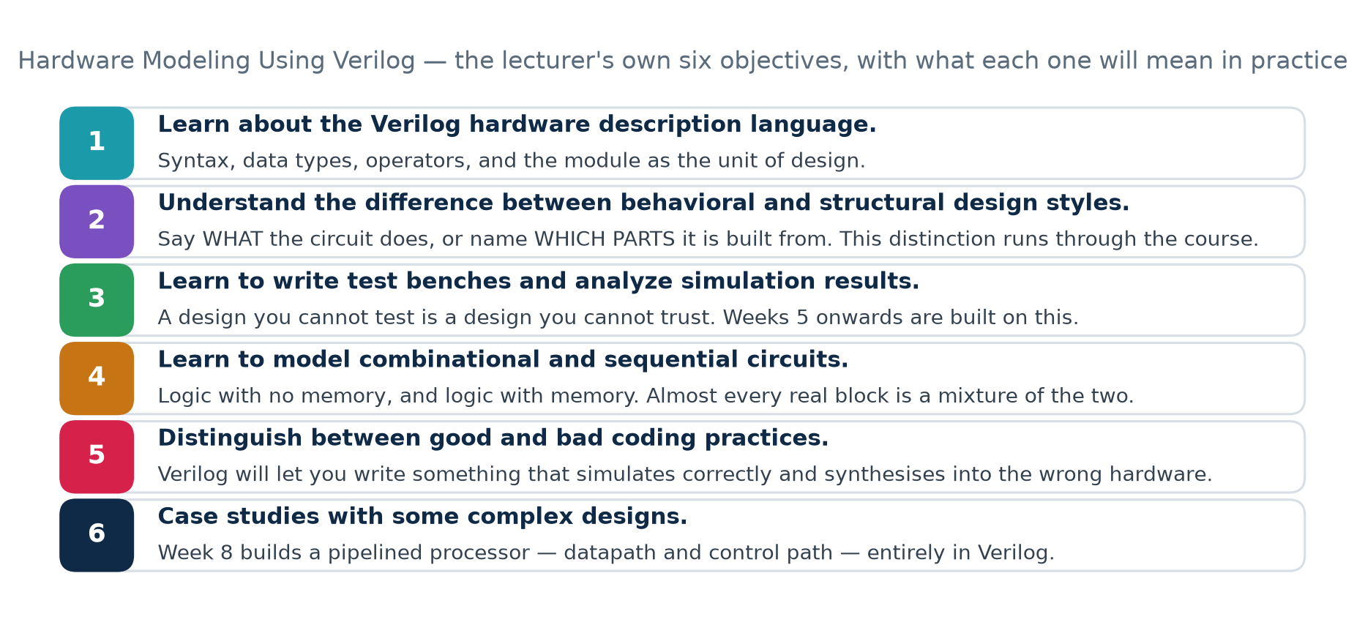
The six objectives, with what each will mean in practice

Objective 1 — learn the Verilog hardware description language
Verilog is a language in which a designer specifies the behaviour, the functionality or the structure of a hardware circuit. You will learn its syntax, its data types, its operators, and the module as the unit of design.

Objective 2 — behavioural and structural design styles
These are two different ways of saying what a circuit is, and the distinction runs through the entire course. A behavioural description says WHAT the circuit does. A structural description names WHICH PARTS it is built from and how they are wired together. Both are legal Verilog; both can describe the same circuit; and a synthesis tool turns the first into the second.

Objective 3 — test benches and simulation results
A design you cannot test is a design you cannot trust. A test bench is a piece of Verilog whose job is to drive your design with stimulus and check what comes out. It is never turned into hardware, so it may use delays, loops and printing freely. Week 5 of the course is devoted to this; you will write your first one in Lab 1 of this workbook.

Objective 4 — combinational and sequential circuits
Combinational logic has no memory: its outputs depend only on its present inputs. Sequential logic has memory: its outputs depend also on what happened before, which is held in registers and updated on a clock edge. Almost every real block is a mixture of the two.

Objective 5 — good and bad coding practices
Verilog will happily let you write something that simulates correctly on your machine and synthesises into hardware that does something different. Week 6 is about avoiding that, and the reason it needs a whole week is the subject of the next section.

Objective 6 — case studies
Week 8 builds a pipelined processor — both its data path and its control path — entirely in Verilog. Everything before it is preparation for that.

1.2 What a hardware description language is — and is not
This is the single most common beginner error, so it is worth stating plainly before anything else: Verilog is not a programming language. It looks like one. It is text, it has semicolons, it has if-statements. But what the text MEANS is completely different.
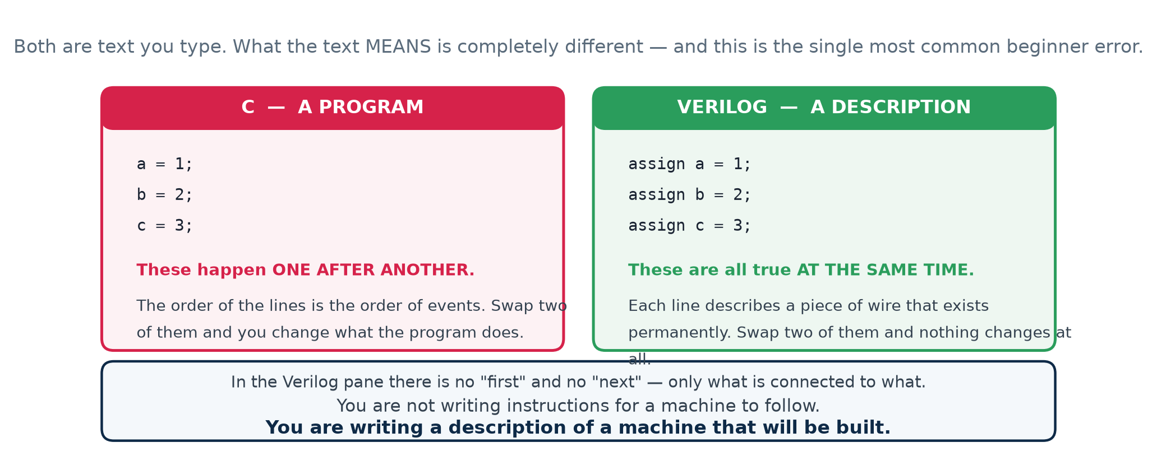
Three lines in C, and three lines in Verilog
In C, three assignments happen one after another. The order of the lines is the order of events; swap two of them and you change what the program does.
C — a sequence of events in time
a = 1;
b = 2;
c = 3;

In Verilog, those same three lines describe three pieces of wire, each permanently driven. All three statements are true at every instant the circuit is powered. There is no "first" and no "next". Swap two of them and nothing changes at all.
Verilog — a description of three wires that exist
assign a = 1;
assign b = 2;
assign c = 3;

Hold on to this
You are not writing instructions for a machine to follow. You are writing a description of a machine that will be built. Once you really believe that, most of the confusion in Weeks 2 and 3 of the course never happens.

Part 2 · The Problem, and the Answer

2.1 Why VLSI design had to become a process
A hardware description language only exists because of a problem, and the lecturer spends the first third of the lecture on that problem. It is a chain of consequences, each one caused by the one before it.
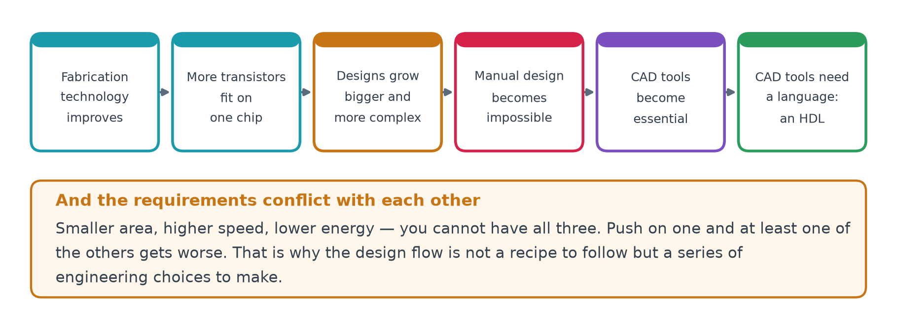
Each box is caused by the one to its left
Fabrication technology improved, so more transistors fitted on one chip. Designs therefore grew bigger and more complex. Past a certain size, designing them by hand became impossible, so computer-aided design tools became essential — and a CAD tool needs a language to read and write. That last link is where Verilog enters, and it is the only reason this course has a subject.

How big is "too big"?
The lecturer puts two chips side by side: the first commercial planar integrated circuit, and a modern processor.
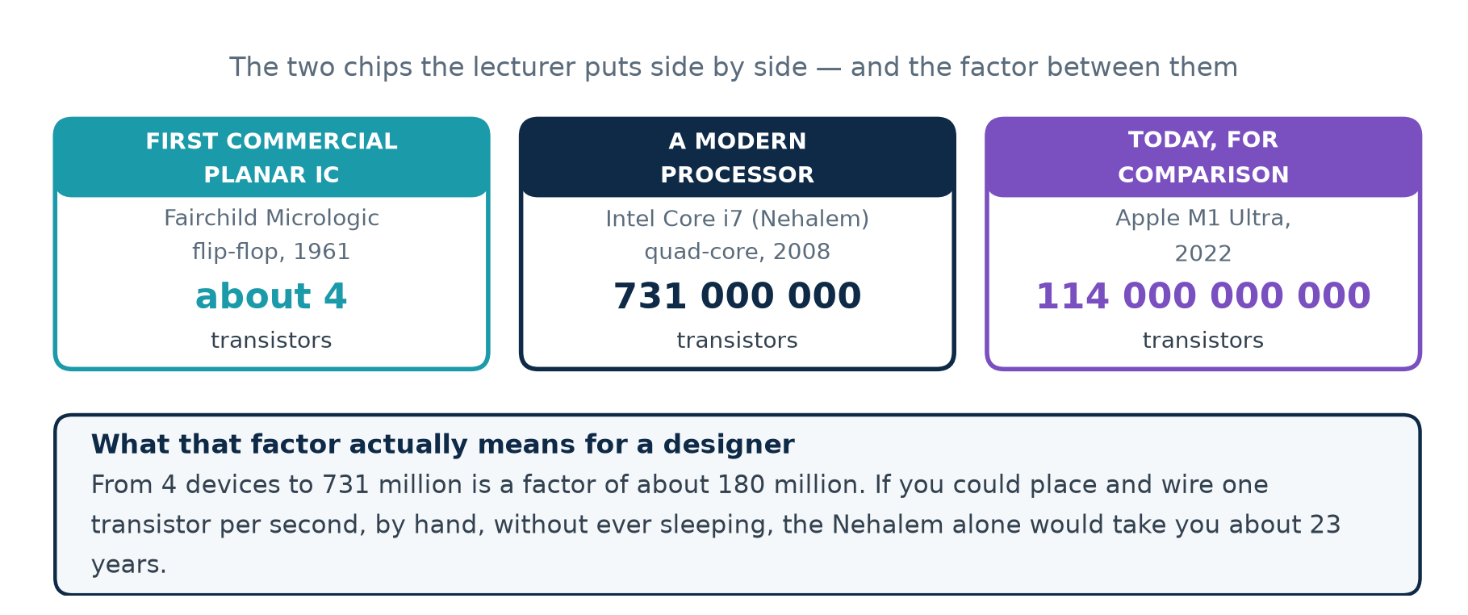
The two chips, and the factor between them
The arithmetic that settles it
If you could place and wire one transistor per second, by hand, without ever sleeping, the 731-million-transistor Nehalem die would take you about twenty-three years. And then one change to the specification would send you back to the beginning.
That is what the lecturer means by "manual design is simply ruled out". The job of a VLSI designer changed: a designer no longer places transistors, but writes a DESCRIPTION of what the circuit must do, and a program turns that description into transistors.

2.2 Moore's Law
The growth that caused all this has a name. In 1965 Gordon Moore noticed that the number of components on a chip was doubling every year; in 1975 he revised it to every two years. That is Moore's Law, and it has held for about five decades.
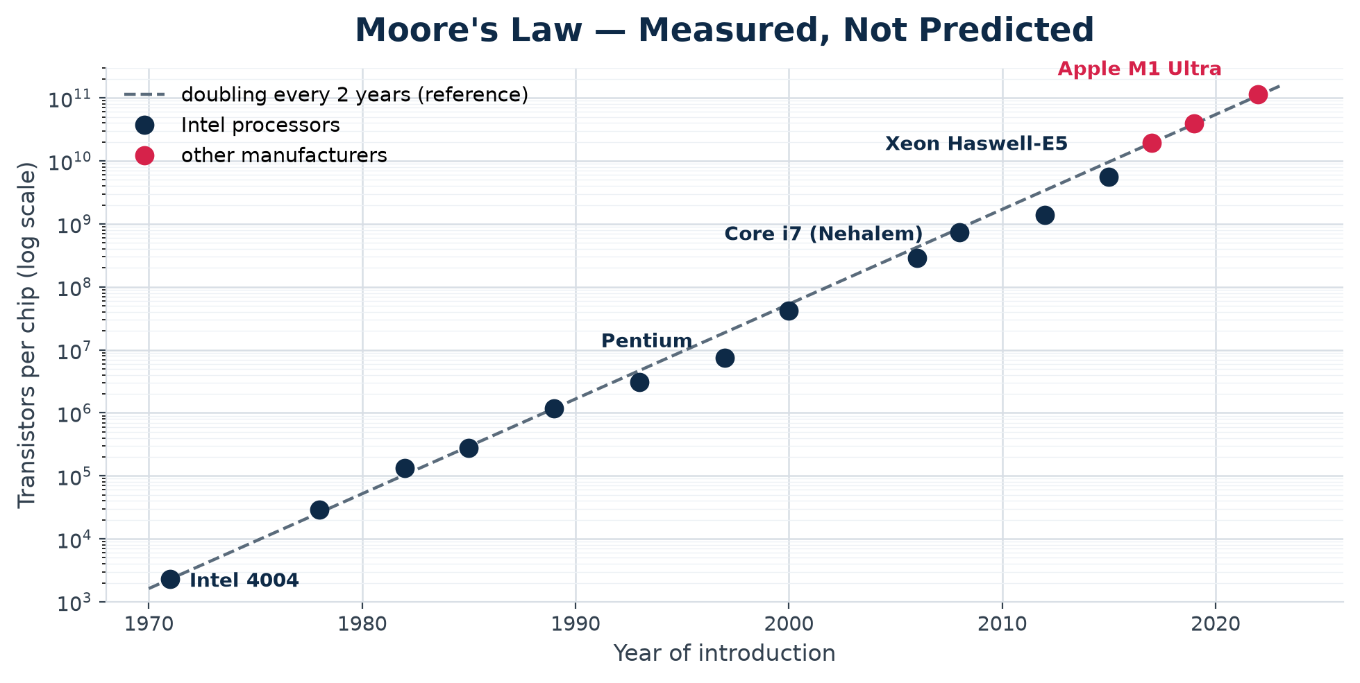
Published transistor counts, 1971–2022, on a log scale. A straight line on a log scale means constant exponential growth.

It is not a law of physics
This matters more than it sounds. Moore's Law was an observation about what the industry had been doing, and it kept coming true largely because it became a target: equipment makers, materials suppliers and chip companies all planned their roadmaps around it, so the investment arrived on schedule to make the next node happen. A self-fulfilling forecast, not a force of nature.
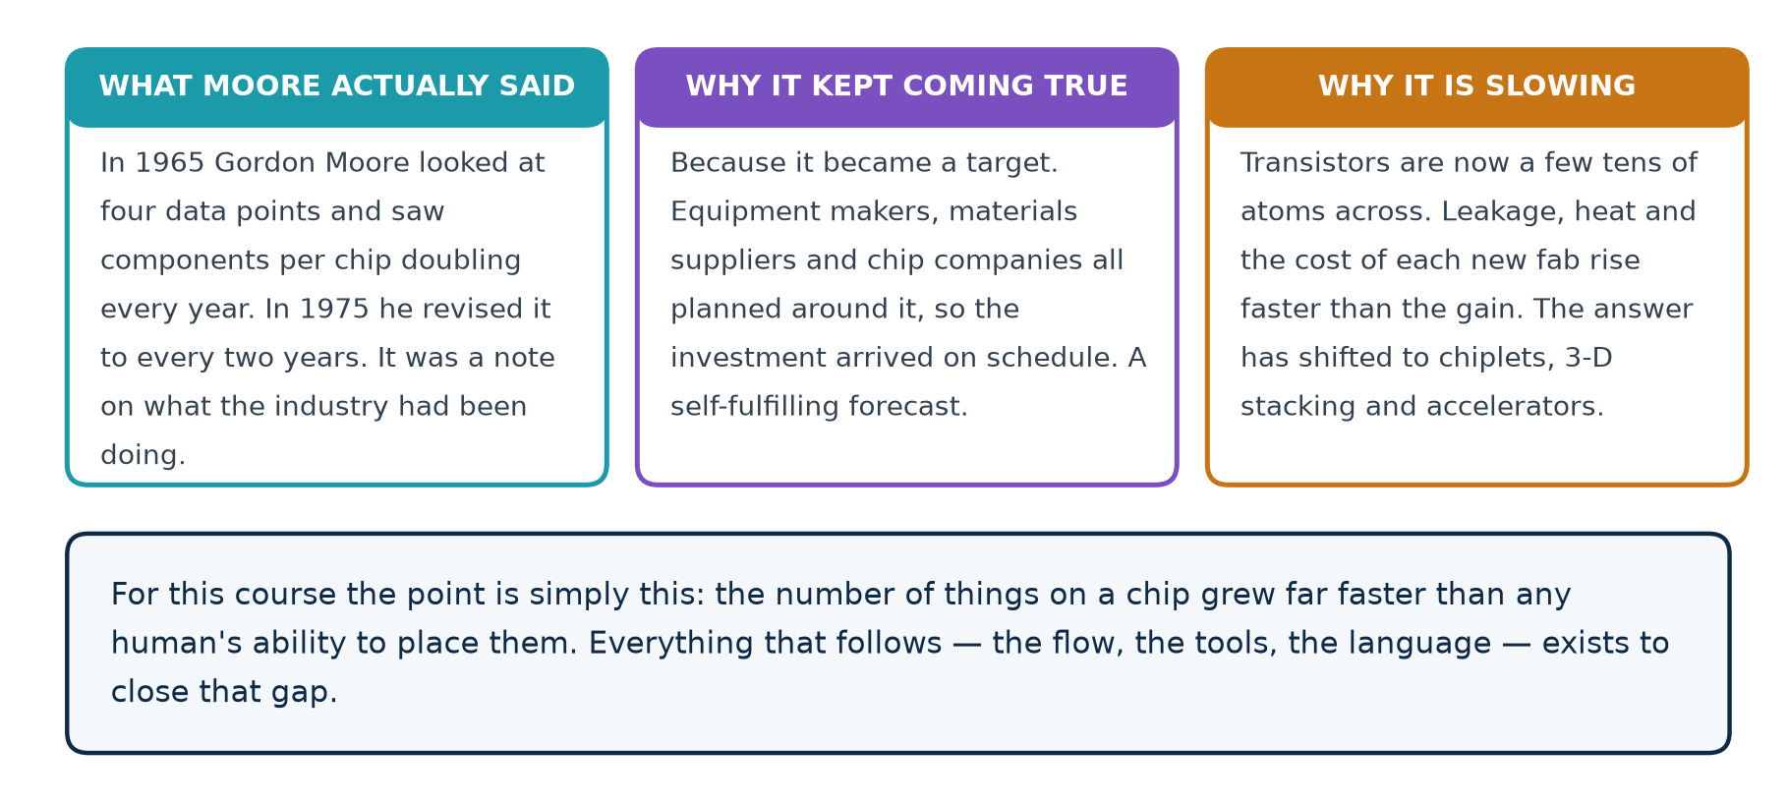

What a nanometre is
The lecture quotes "CMOS up to 22 nm, FinFET 14 nm", which was correct when it was recorded. Those node names are now marketing labels rather than measurements — no feature on a "3 nm" chip is 3 nm across. But the physical scale is worth feeling.
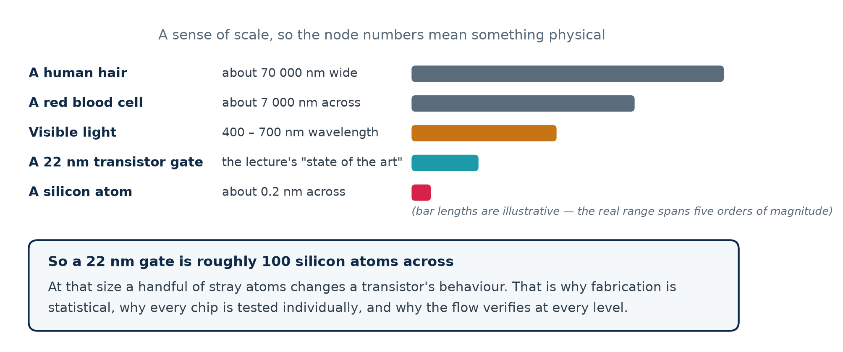
A 22 nm gate is roughly a hundred silicon atoms across. At that size a handful of stray atoms changes a transistor's behaviour, which is why fabrication is statistical rather than exact, why every chip is tested individually, and why the design flow carries a verification step at every single level.

2.3 The requirements that conflict
If one design were simply best, a tool could find it and the job would be done. The reason design is hard — and the reason it needs a human — is that the three things you want pull against each other.
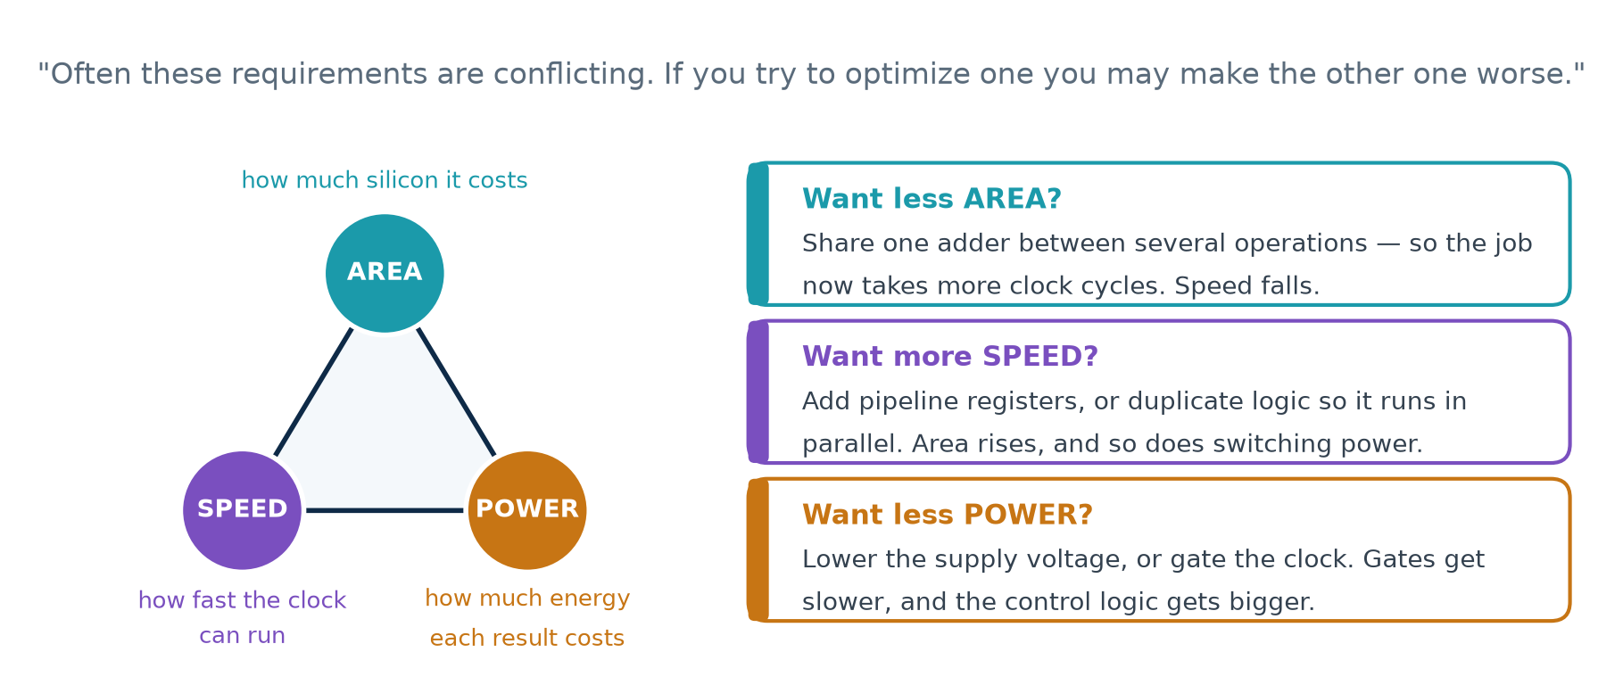
If you want… | You might… | And this gets worse
Less AREA | share one adder between several operations | speed — it now takes more clock cycles
More SPEED | add pipeline registers, or duplicate logic | area, and switching power
Less POWER | lower the supply voltage, or gate the clock | speed, and control-logic area

Why this matters for synthesis
A synthesis tool does not find THE answer, because there isn't one. It finds an answer that satisfies the constraints you gave it. Give it different constraints and you get different hardware out of the same Verilog — which you will see for yourself in Lab 4.

Part 3 · The Design Flow, Step by Step

3.1 What a design flow is
A VLSI design flow is a standardized set of design procedures: a step-by-step route from a specification down to the hardware you actually build. Each step has a defined input, a defined output and a defined way of being checked.
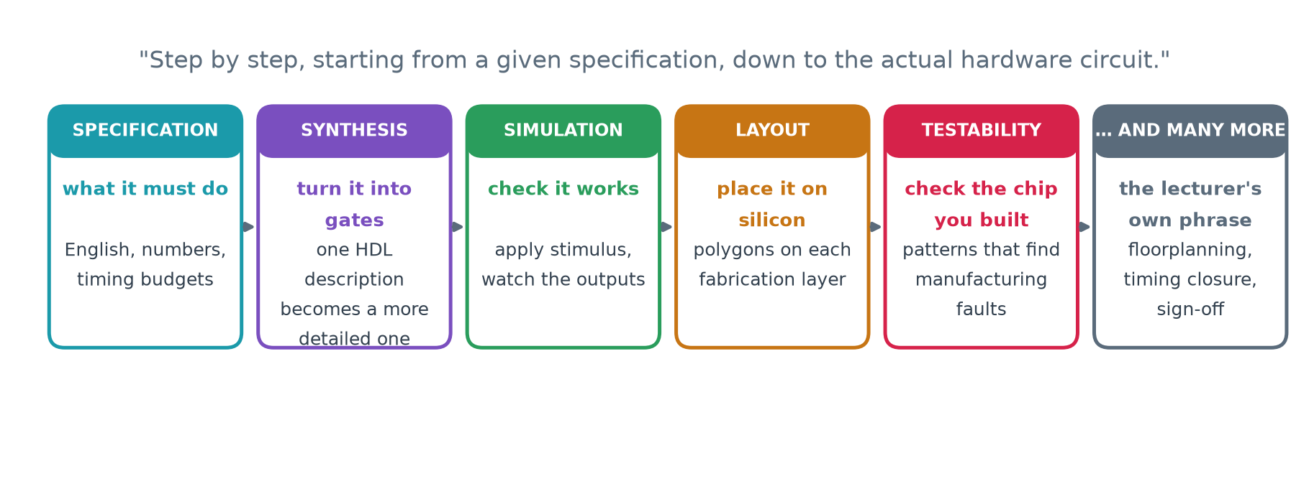
Why it had to be standardized
Dozens of engineers, several companies and a fabrication plant all work on one chip. A standard flow means the work can be divided up, and that a mistake is caught at the step that made it rather than three steps later.

3.2 What a CAD tool actually does
This is the central idea of the whole lecture, and it is worth memorising in the lecturer's own words: a CAD tool transforms its HDL input into an HDL output that contains more detailed information about the hardware.
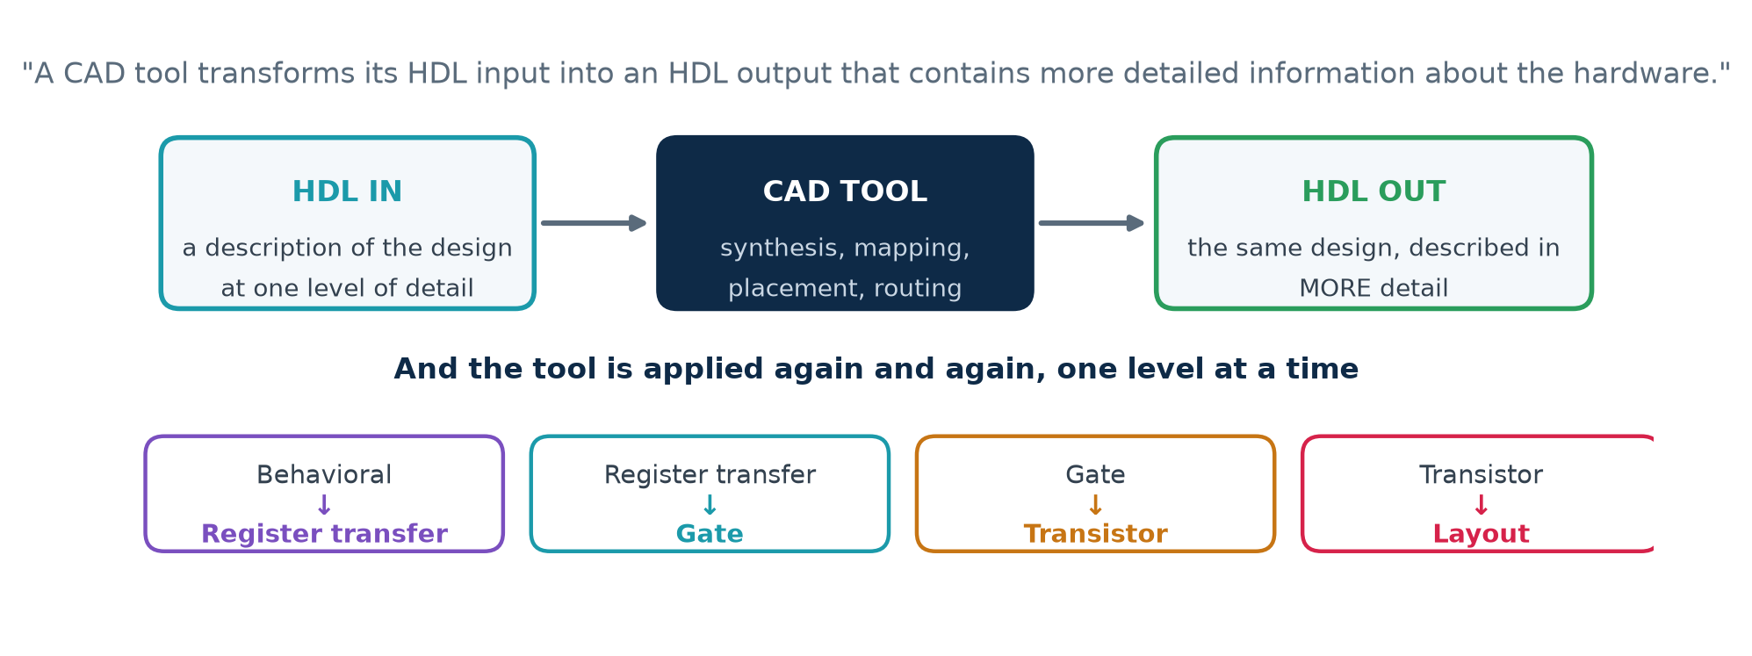
Read that carefully. Both the input and the output are hardware descriptions. Nothing is ever "compiled into a program". The design simply gets described in progressively more concrete terms, until the last description is a set of shapes a factory can print.
This transformation | Turns this | Into this
Synthesis | behaviour | register transfer level
Technology mapping | register transfer level | gates
Cell design | gates | transistors
Layout | transistors | polygons on fabrication layers

You will check this yourself
Lab 2 runs exactly these transformations on a ten-line counter, prints all three descriptions side by side, and then runs the same test bench against the first and the last to show they behave identically.

3.3 The two competing HDLs
Two hardware description languages are in common use: Verilog and VHDL. Both can describe the same hardware, and a synthesis tool will produce the same gates from either. The choice between them is a matter of house style, existing code and local convention — not of what the silicon can do.
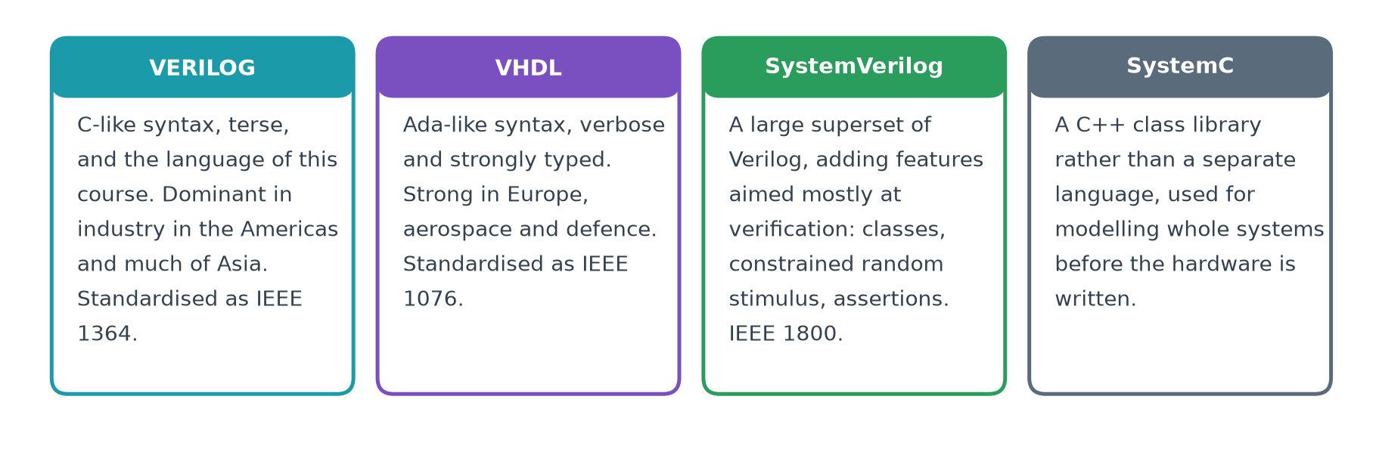
There are others. SystemVerilog is a large superset of Verilog aimed mostly at verification; SystemC is a C++ class library used for modelling whole systems before the hardware is written. This course uses Verilog.

The same counter in both languages
rtl/counter4.v
// Verilog
module counter4 (
input wire clk,
input wire rst,
output reg [3:0] q
);
always @(posedge clk) begin
if (rst) q <= 4'd0;
else q <= q + 4'd1;
end
endmodule

vhdl/counter4.vhd — the same hardware
-- VHDL
library ieee;
use ieee.std_logic_1164.all;
use ieee.numeric_std.all;

entity counter4 is
port (clk : in std_logic;
rst : in std_logic;
q : out std_logic_vector(3 downto 0));
end entity counter4;

architecture rtl of counter4 is
signal cnt : unsigned(3 downto 0) := (others => '0');
begin
process (clk)
begin
if rising_edge(clk) then
if rst = '1' then cnt <= (others => '0');
else cnt <= cnt + 1;
end if;
end if;
end process;
q <= std_logic_vector(cnt);
end architecture rtl;

VHDL is more verbose and far more strongly typed: the count is held as an unsigned value and has to be converted explicitly before it leaves the entity. Lab 5 simulates both and compares the waveforms.

3.4 The ladder
The lecturer's "simplistic view of the design flow" is a ladder. Each box is a description; each arrow is a CAD tool.
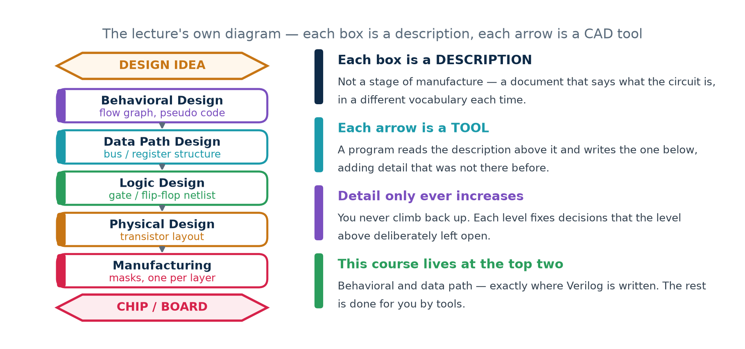
Three things are worth noticing. Each box is a document, not a stage of manufacture — it says what the circuit is, in a different vocabulary each time. Each arrow is a program that reads the description above it and writes the one below, adding detail that was not there before. And you never climb back up: each level fixes decisions that the level above deliberately left open.

One circuit, all five levels
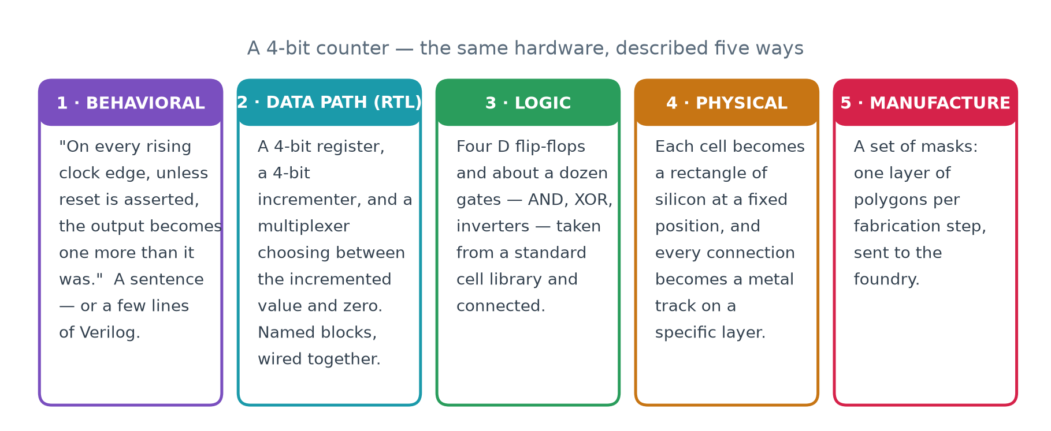
All five describe exactly the same 4-bit counter. A designer writes the first one. Tools produce the other four.

What counts as a "component" changes at each level
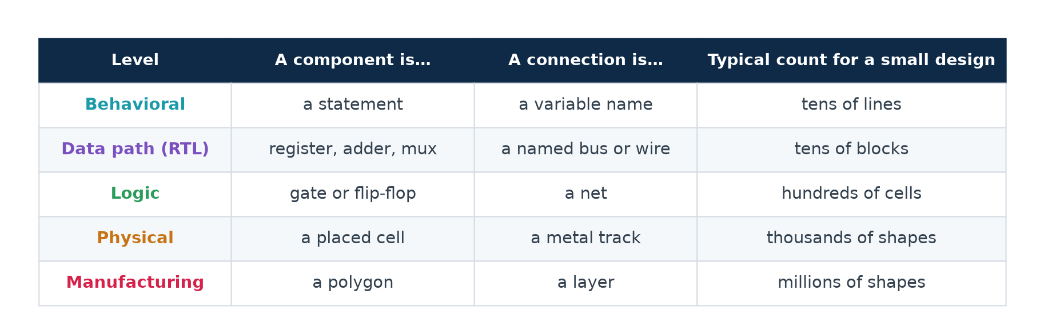
Read the last column. The number of things to keep track of grows by roughly a factor of ten at every level, which is exactly why a designer works at the top of the table and lets tools handle the bottom.

3.5 Behavioral design
At this level you specify the functionality of the design in terms of its behaviour. You say what you want, not how it is done. There are four common ways of writing it down.
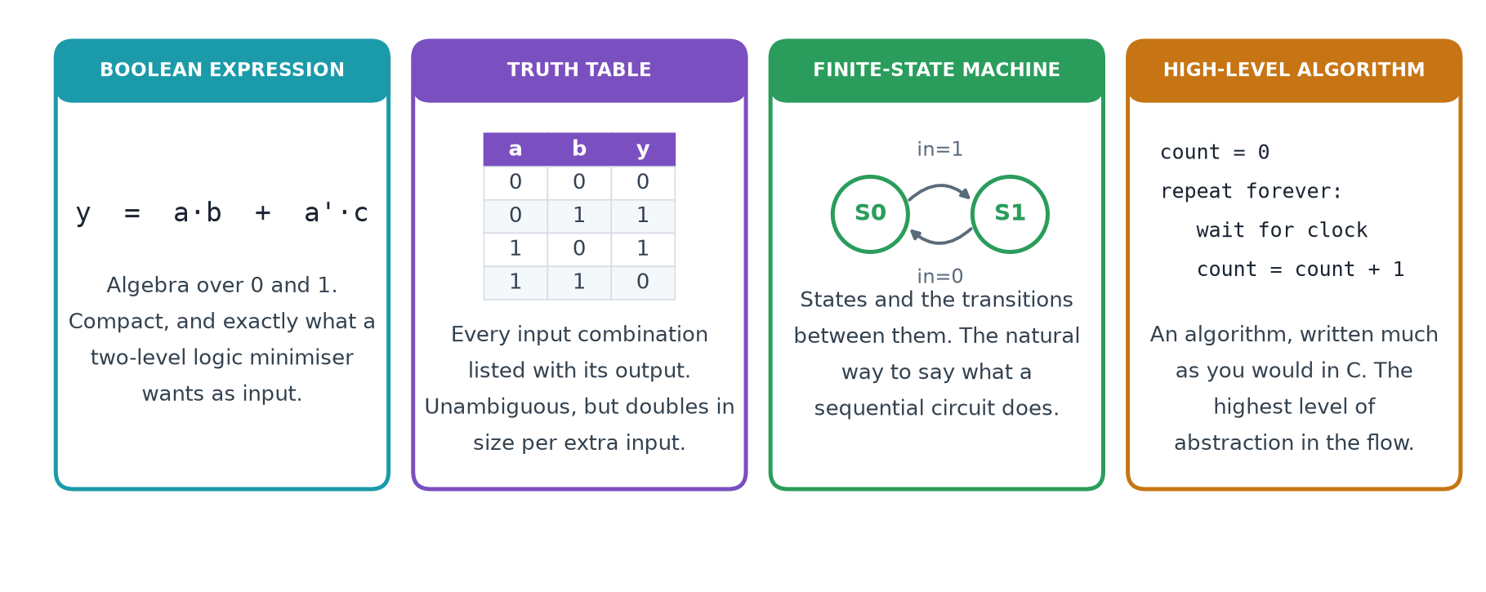
Not one of these says how the circuit is BUILT. That is what makes them behavioural, and it is why a synthesis tool is free to build them in whichever way is cheapest under the constraints you set.

3.6 Data path design, and what a netlist is
One step down, the components are no longer statements. They are registers, adders, multipliers, multiplexers, decoders and buses — things you could point at on a block diagram. This level is called register transfer level, and the name says what happens: on each clock edge, values are TRANSFERRED between REGISTERS, possibly through some logic on the way.
The output of this step is a netlist.
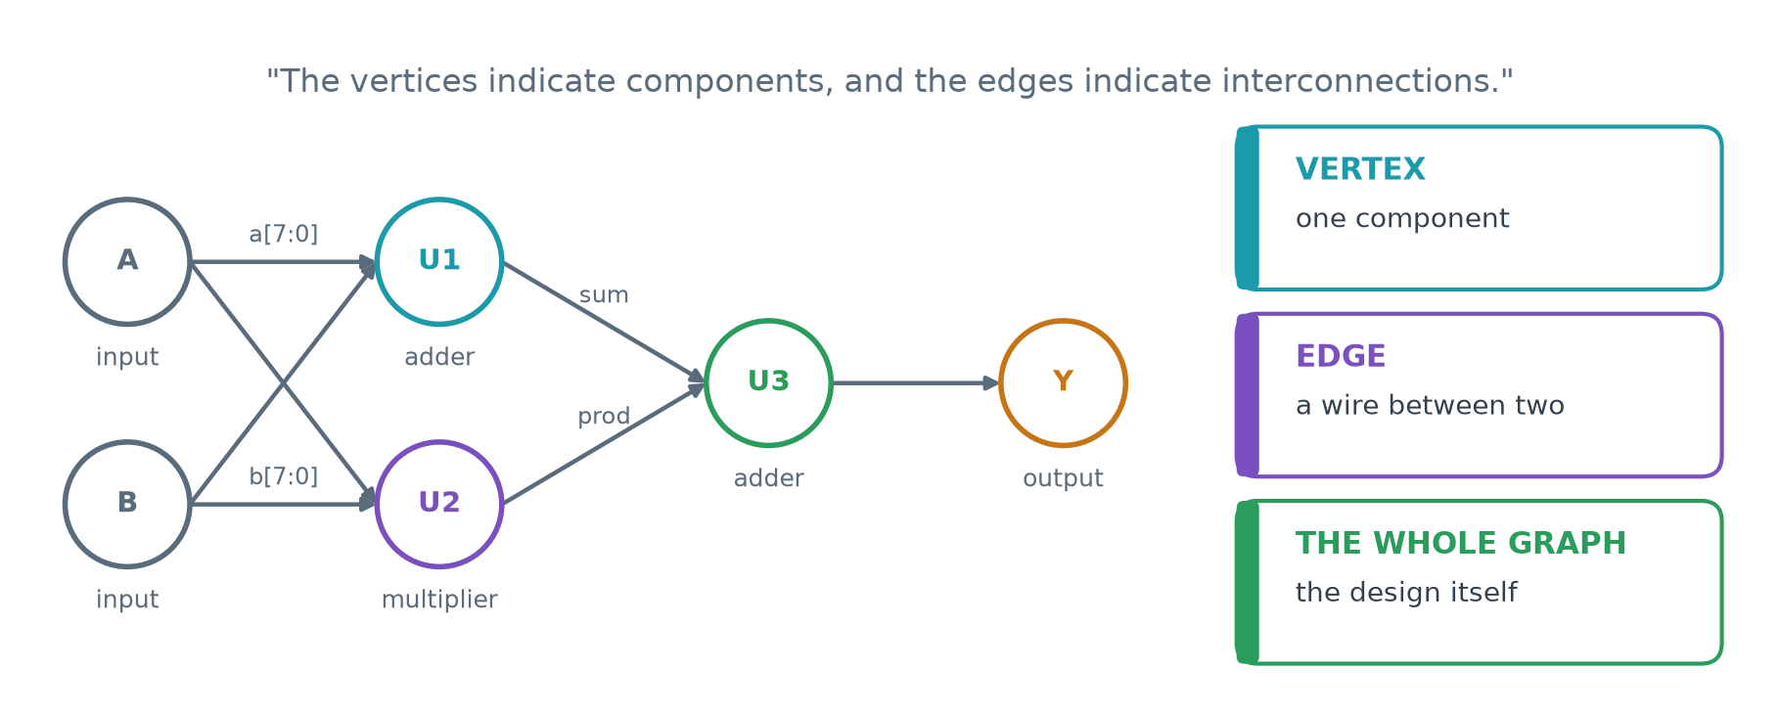
A netlist, defined
A netlist is a directed graph. Its vertices are components; its edges are the interconnections between them. The whole graph is the design.
Why a graph rather than a drawing? Because a graph is something a program can hold in memory and transform. Every CAD step after this one — optimisation, technology mapping, placement, routing — is an operation on this graph.

A netlist can be written at several levels. What changes is only what counts as a vertex.
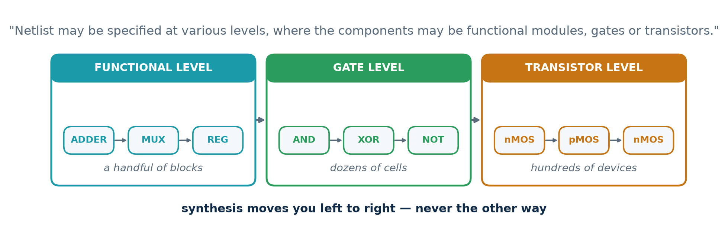

Structural and behavioural, again
The lecturer says it explicitly: a netlist specification is also referred to as a structural design. The two words mean the same thing, and that gives the clearest possible statement of what synthesis is.
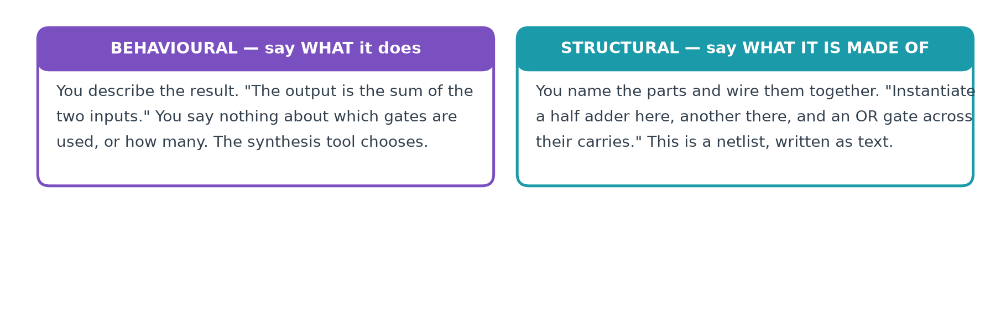
Synthesis, in one sentence
You write behavioural Verilog; the tool emits structural Verilog.

Here is the same two-bit adder written both ways. Both are legal Verilog and both describe the same hardware.
one line; the tool picks the gates
// BEHAVIOURAL - say what it does
module add2 (input a, b, cin, output sum, cout);
assign {cout, sum} = a + b + cin;
endmodule

five named gates, wired together — a netlist written as text
// STRUCTURAL - say what it is made of
module add2 (input a, b, cin, output sum, cout);
wire s1, c1, c2;
xor u1 (s1, a, b);
and u2 (c1, a, b);
xor u3 (sum, s1, cin);
and u4 (c2, s1, cin);
or u5 (cout, c1, c2);
endmodule

You will write far more behavioural code than structural. But the tool's output is always structural, which is exactly why you have to be able to read it.

3.7 Logic design and standard cells
One step down again, the netlist's components become gates and flip-flops — or, more usefully, standard cells.
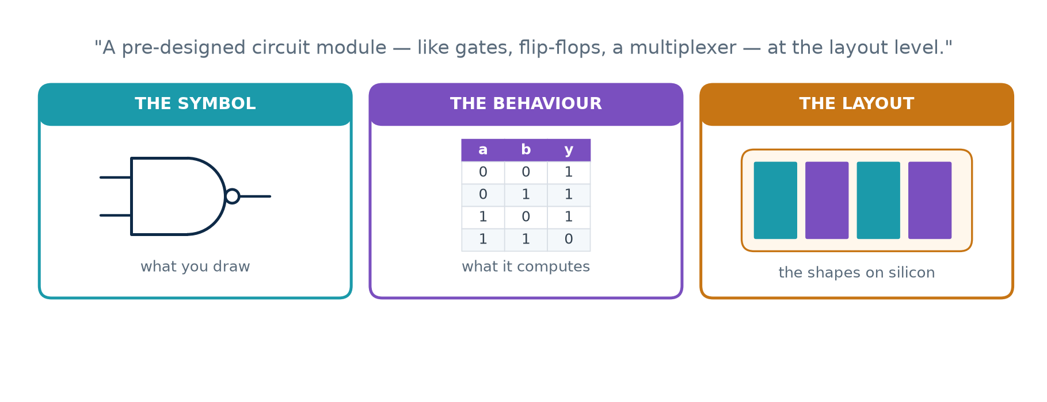
What a standard cell is
A pre-designed circuit module — a gate, a flip-flop, a small multiplexer — held in a library as all of these at once: a symbol to place, a truth table to simulate, a timing model, and a finished piece of layout.
Laying out a NAND gate correctly takes a skilled engineer a long time. Doing it once, perfectly, and then reusing it a million times is the only way the numbers work.

At this level various logic optimisation techniques are applied to obtain a cost-effective design. The lecturer warns that the goals conflict, and names three.
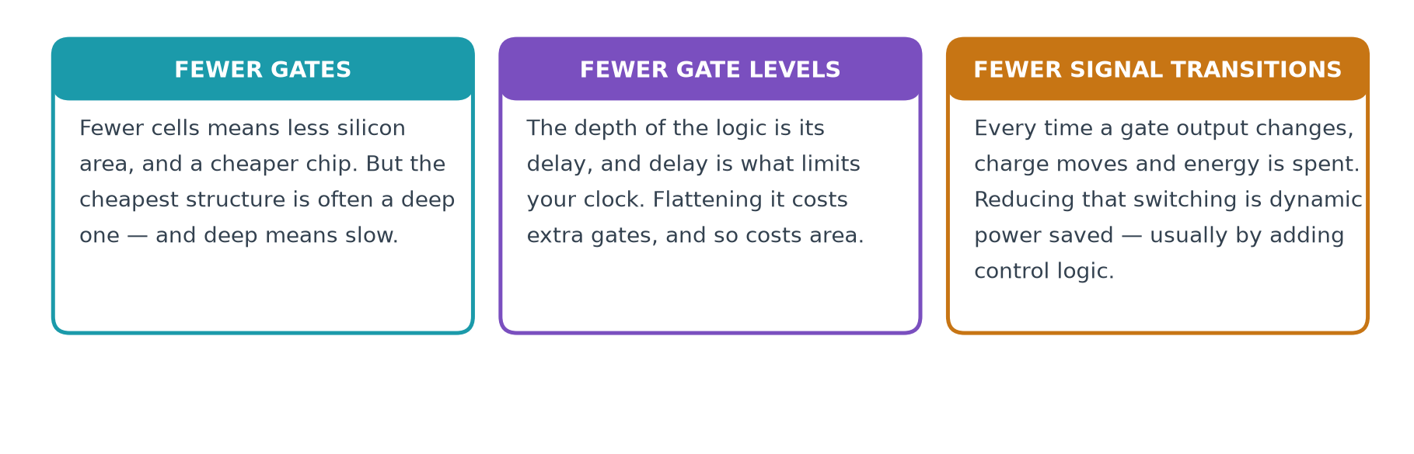

3.8 Physical design and manufacturing
The last step generates the layout that goes to the foundry. At this level the design is a very large number of regular geometric shapes — mostly rectangles — one set per fabrication layer.
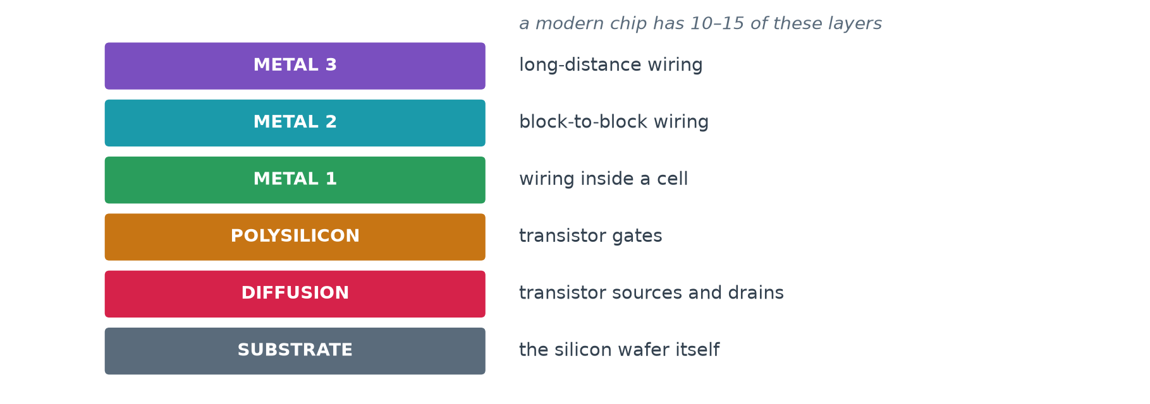
They are rectangles because they are printed photographically, layer by layer, onto a silicon wafer: regular shapes expose cleanly and etch predictably, awkward ones do not.

Or do not fabricate at all
The lecturer names the alternative: a field programmable gate array. An FPGA is a chip that has already been manufactured, full of configurable logic blocks that you program in your own laboratory. You get much greater flexibility, at the cost of speed.
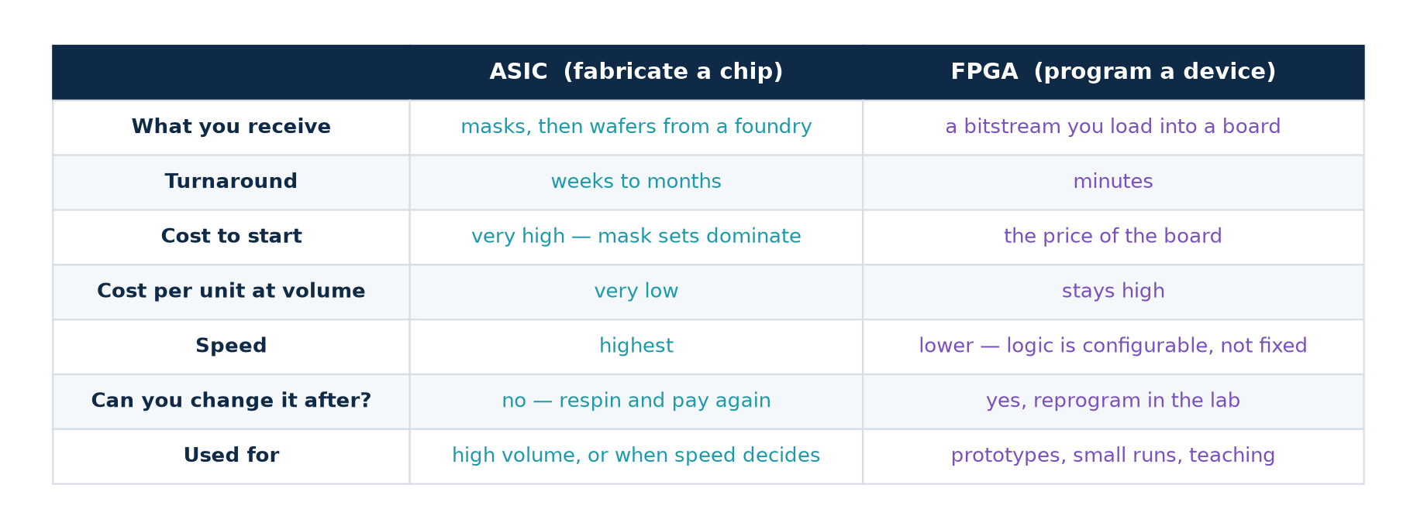

3.9 The other steps
The five rungs are not the whole flow. Three more steps run alongside them.
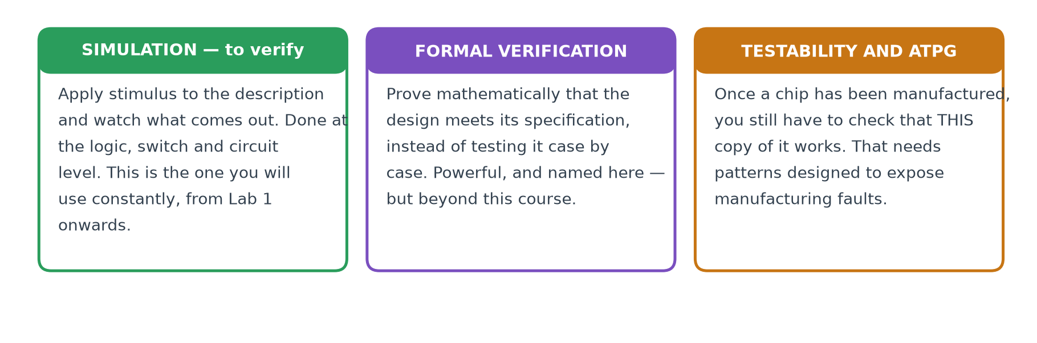
Simulation is the one you will use constantly, from Lab 1 onwards, and Week 5 of the course is devoted to writing test benches. Formal verification and testability analysis are named here but are beyond this course's scope.

3.10 Where the rest of the course sits
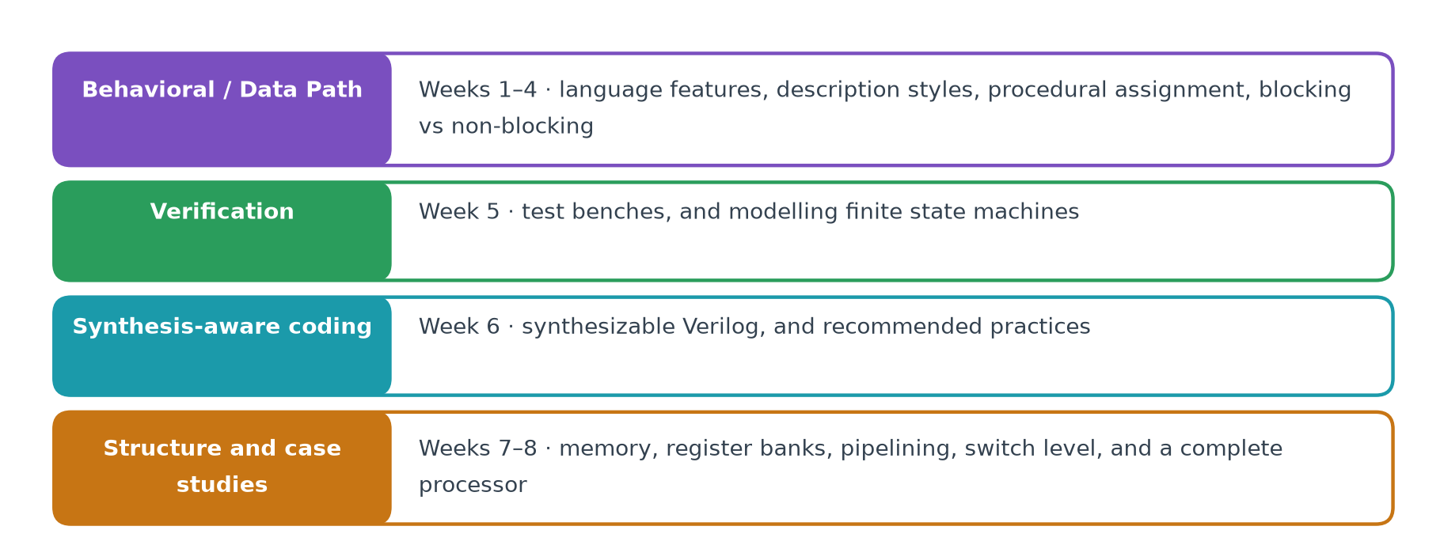
Notice what is missing: nothing after logic design. Physical design, manufacturing and test are real and essential, but in this course they are the tools' job. Your work ends at a netlist.

Part 4 · The Practical Component
Everything in this part is something you run. Every output printed below was produced by actually running the command above it, on a clean machine, with the versions named in section 4.1.

4.1 Installing the toolchain
Four programs, one for each thing the lecture says a CAD flow must do. All four are open source and run on Windows, macOS and Linux.
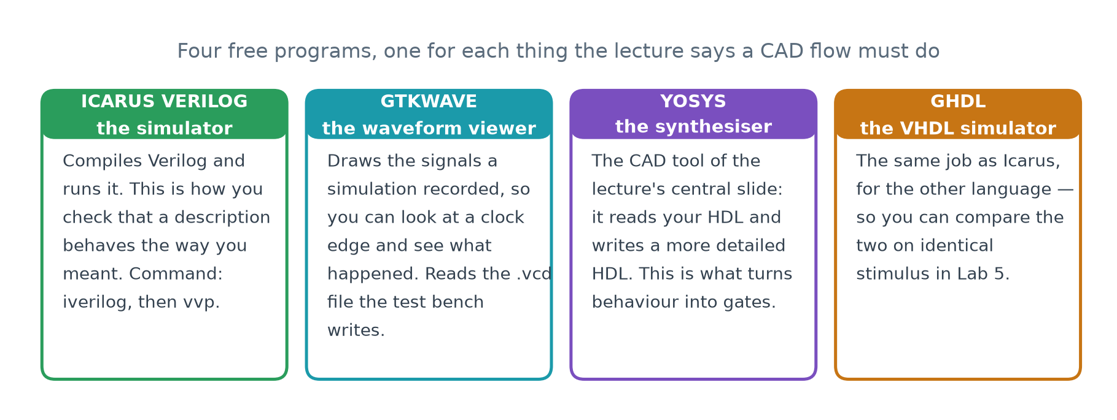
Tool | What it does | Used in
Icarus Verilog | compiles and simulates Verilog | Labs 1, 2, 5
GTKWave | draws the waveforms a simulation recorded | Lab 1
Yosys | synthesis — the CAD tool of the lecture | Labs 2, 3, 4
GHDL | compiles and simulates VHDL | Lab 5

Linux (Ubuntu or Debian)
sudo apt update
sudo apt install -y iverilog gtkwave yosys ghdl

macOS (Homebrew)
brew install icarus-verilog
brew install --cask gtkwave
brew install yosys ghdl

Windows
Use the Windows Subsystem for Linux. It gives you a real Ubuntu inside Windows, and every command in this workbook then works unchanged. Open PowerShell as Administrator and run:
wsl --install

Restart when it asks you to, open the Ubuntu application it installed, and then follow the Linux instructions above.
GTKWave on WSL
GTKWave is a graphical program and needs a display. Recent versions of Windows provide one automatically (WSLg) and GTKWave will simply open. If it complains that DISPLAY is not set, either update WSL with wsl --update , or install GTKWave natively on Windows and open the .vcd files from there — they are ordinary files in your WSL home directory.

Checking that it worked
Run all four. Each must print a version number.
the versions these labs were produced with
$ iverilog -V
Icarus Verilog version 12.0 (stable)

$ yosys -V
Yosys 0.33 (git sha1 2584903a060)

$ ghdl --version
GHDL 4.1.0 (Ubuntu 4.1.0+dfsg-0ubuntu2.1) [Dunoon edition]

$ gtkwave --version
GTKWave Analyzer v3.3.x

If a version differs
Newer is fine. A newer synthesiser may optimise slightly differently and report a different cell count from the ones printed in this workbook. That is worth noticing rather than worrying about: it demonstrates directly that optimisation has no single right answer.

Getting the lab files
cd ChipDesignAssociate/VerilogCourse/Lecture01_Lab
make # runs every lab in order

The directory contains:
Path | What is in it
rtl/counter4.v | the design, written behaviourally
rtl/tb_counter4.v | the test bench
vhdl/counter4.vhd | the same design in VHDL
vhdl/tb_counter4.vhd | the VHDL test bench
scripts/*.ys | the Yosys scripts, one per level of the flow
scripts/*.sh | the lab drivers
scripts/vcd_q.py | reads a waveform file and prints one signal
Makefile | one target per lab
out/ | everything the labs produce (created on first run)

4.2 Lab 1 — simulate a counter and look at it
What this lab proves
That you can take a description of hardware, run it, and see what it does. This is the "simulation for verification" step of the design flow.

The design
rtl/counter4.v
// counter4 - a 4-bit up counter, written BEHAVIOURALLY.
//
// Nothing here says which gates to use, or how many. It says only
// what the output must be after each rising clock edge. Choosing
// the gates is the synthesis tool's job.
module counter4 (
input wire clk,
input wire rst, // synchronous, active high
output reg [3:0] q
);
always @(posedge clk) begin
if (rst) q <= 4'd0;
else q <= q + 4'd1;
end
endmodule

Read it as a description, not as a program. It says: there is a four-bit register called q; on every rising edge of clk, it takes either zero or its own value plus one. It does not say how.

The test bench
rtl/tb_counter4.v (abridged — the full file prints each mismatch)
`timescale 1ns/1ps
module tb_counter4;
reg clk = 1'b0;
reg rst = 1'b1;
wire [3:0] q;
integer errors = 0;
integer i;
reg [3:0] expected;

counter4 dut (.clk(clk), .rst(rst), .q(q));

always #5 clk = ~clk; // 100 MHz: a 10 ns period

initial begin
$dumpfile("out/counter4.vcd");
$dumpvars(0, tb_counter4);

@(negedge clk);
if (q !== 4'd0) errors = errors + 1;
rst = 1'b0;
expected = 4'd1;

for (i = 0; i < 20; i = i + 1) begin
@(negedge clk);
if (q !== expected) errors = errors + 1;
expected = expected + 4'd1;
end

if (errors == 0)
$display("PASS counter4 counted 0..15 and wrapped");
$finish;
end
endmodule

Why expected starts at 1, not 0
The rising edge at 5 ns happens while rst is still high, so the register is cleared there. Reset is released on the falling edge at 10 ns, which means the next rising edge — at 15 ns — is already the first counting edge.
This off-by-one is the single most common mistake in a first test bench. Getting it right means thinking about WHEN each edge happens, which is exactly the habit the rest of the course needs.

Run it
$ make sim
iverilog -g2012 -o out/tb_counter4.vvp rtl/counter4.v rtl/tb_counter4.v
vvp out/tb_counter4.vvp
VCD info: dumpfile out/counter4.vcd opened for output.
PASS counter4 counted 0..15 and wrapped correctly

Two commands ran. The first, iverilog, compiled the design and the test bench into a simulation program. The second, vvp, ran it.

Look at the waveform
$ make wave

GTKWave opens. Drag clk, rst and q from the signal list into the wave window. You should see q change immediately after each rising clock edge, counting 1, 2, 3 … 15, 0, 1 …
What to notice in the waveform
q is xxxx — unknown — until the first clock edge. A Verilog reg holds x until something drives it, and a real flip-flop likewise powers up in an unpredictable state. That is why every design has a reset.
q changes AFTER the clock edge, not at it. That delay is the flip-flop's clock-to-Q time, and it is the first thing that eats into your clock period.

4.3 Lab 2 — watch a CAD tool rewrite your Verilog
What this lab proves
The central claim of Lecture 01: that a CAD tool transforms an HDL input into an HDL output containing more detail about the hardware, without changing what the circuit does.

Step 1 — the transformation, twice
$ make transform

This prints three descriptions of the same counter. The first is what you wrote:
1 — behavioural, written by a human
always @(posedge clk) begin
if (rst) q <= 4'd0;
else q <= q + 4'd1;
end

The second is what Yosys produced after synthesis. It is still Verilog, but the increment has become a named component with its own wire:
2 — register transfer level, written by Yosys
wire [3:0] _0_;
assign _0_ = q + 4'h1; // an incrementer
always @(posedge clk) // a 4-bit register
if (rst) q <= 4'h0; // with a synchronous reset
else q <= _0_;

The third is what Yosys produced after mapping to gates. Still Verilog, and now every operation is a single logic function:
3 — gate level, written by Yosys
assign _02_[0] = ~q[0];
assign _00_ = q[0] & q[1];
assign _01_ = ~(q[2] & _00_);
assign _03_[3] = ~(q[3] ^ _01_);
assign _03_[1] = q[0] ^ q[1];
assign _03_[2] = q[2] ^ _00_;

Look at what just happened
All three files are Verilog. The tool did not compile your design into something else — it re-described it, twice, each time in more detail. The third is a netlist: gates, and the wires between them.

Step 2 — and it still behaves the same
A more detailed description is only useful if it is still the same circuit. Run the SAME test bench against the gate netlist:
$ make prove

--- 1. the behavioural description (what the designer wrote) ---
PASS counter4 counted 0..15 and wrapped correctly

--- 2. synthesise it down to gates ---
wrote out/counter4_gates.v (33 lines)

--- 3. the SAME test bench, run against the gate netlist ---
PASS counter4 counted 0..15 and wrapped correctly

--- 4. compare the two waveforms, cycle by cycle ---
IDENTICAL - 22 transitions, same value at the same time.
The synthesiser changed the DESCRIPTION, not the BEHAVIOUR.

One test bench, two very different descriptions, identical output at every instant. Nothing in the lecture has to be taken on trust after this.
How the gate netlist can be simulated at all
Yosys emits primitives with names like $_AND_ and $_SDFF_PP0_. Yosys ships a file, simcells.v, that defines them as ordinary Verilog modules; the lab script finds it and passes it to Icarus along with the netlist.

4.4 Lab 3 — count the cells at each level
What this lab proves
That detail really does increase down the ladder, in a way you can put a number on.

$ make ladder

LEVEL CELLS WHAT THEY ARE
-------------------------- -------- -------------
1 Behavioural (source) - 10 lines of Verilog - no cells
2 Data path (RTL) 2 $add x1 $sdff x1
3 Logic (gates) 10 $_AND_ x1 $_NAND_ x1 $_NOT_ x1
$_SDFF_PP0_ x4 $_XNOR_ x1
$_XOR_ x2
same, for an FPGA 8 $_SDFF_PP0_ x4 $lut x4

Read it downwards. Ten lines of behaviour became two RTL components — one adder and one four-bit register, which is exactly what section 3.6 said "data path design" means. Those two became ten gate-level cells: four flip-flops, one per bit, and six logic gates to compute the next value.
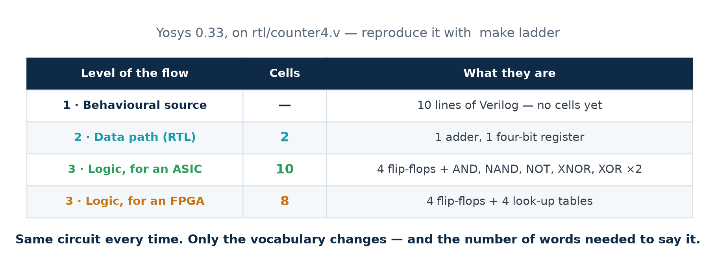
the same table, as the slide shows it
A detail worth noticing
One $sdff at RTL became four $_SDFF_PP0_ at gate level. At RTL a register is one component that happens to be four bits wide; at gate level each bit is its own flip-flop. The vocabulary changed, not the circuit.

4.5 Lab 4 — ASIC mapping against FPGA mapping
What this lab proves
That the same Verilog produces different hardware depending on what you are building it for — the flexibility-for-speed trade the lecturer names when he introduces FPGAs.

$ make target

=== mapped to logic GATES (the ASIC route) ===
Number of cells: 10
$_AND_ 1
$_NAND_ 1
$_NOT_ 1
$_SDFF_PP0_ 4
$_XNOR_ 1
$_XOR_ 2

=== mapped to 4-input LOOK-UP TABLES (the FPGA route) ===
Number of cells: 8
$_SDFF_PP0_ 4
$lut 4

The flip-flops are the same either way — one per bit of the counter. What changes is the combinational logic: six dedicated gates for silicon you will manufacture, or four look-up tables inside a chip you can buy today.
 | ASIC | FPGA
What you receive | masks, then wafers from a foundry | a bitstream you load into a board
Turnaround | weeks to months | minutes
Cost to start | very high — mask sets dominate | the price of the board
Cost per unit at volume | very low | stays high
Speed | highest | lower — logic is configurable, not fixed
Changeable after? | no — respin and pay again | yes, reprogram in the lab

Why a LUT replaces several gates
A four-input look-up table is a small memory holding sixteen bits. Program those sixteen bits and it can compute ANY function of four inputs. So a chain of two or three gates with four inputs between them collapses into one LUT — which is why the FPGA cell count is lower even though the chip is slower.

4.6 Lab 5 — the same design in two languages
What this lab proves
That the choice between Verilog and VHDL is a matter of style, not of what the hardware can do.

$ make langs

--- Verilog (Icarus) ---
PASS counter4 counted 0..15 and wrapped correctly

--- VHDL (GHDL) ---
PASS counter4 counted 0..15 and wrapped correctly

--- the whole run, including time zero ---
they differ, and ONLY here:
1,2c1
< 0.000 ns xxxx
< 5.000 ns 0000
---
> 0.000 ns 0000

--- from the end of reset onwards (15 ns) ---
IDENTICAL - 20 transitions, same value at the same time

The one difference is the most useful part of the lab
A Verilog reg holds x — unknown — until something drives it, so q reads xxxx until the reset edge at 5 ns clears it. The VHDL signal was declared with an initial value, so it reads 0000 from time zero.
The described hardware is identical. A real flip-flop also powers up in an unpredictable state, which is exactly why every design has a reset — and why the Verilog behaviour is arguably the more honest model of the two.

How the comparison is done
Icarus and GHDL write their waveform files with different timescales and different internal identifiers, so the raw files cannot be compared directly. The lab includes a small reader that normalises both to nanoseconds and to plain binary:
$ python3 scripts/vcd_q.py out/counter4.vcd q | head -4
0.000 ns xxxx
5.000 ns 0000
15.000 ns 0001
25.000 ns 0010

Two details in that script are worth knowing about, because both are easy to get wrong. Times are kept as whole femtoseconds rather than floating-point nanoseconds, because comparing floating-point times across two different timescales is unreliable. And a vector is padded on the left with 0, except that a value starting with x or z extends with that character — which is why the first line above reads xxxx and not 000x.

A note on GHDL back ends
GHDL has several code generators. With the mcode back end — the usual one on Ubuntu — ghdl -e does not write an executable file and you run the simulation with ghdl -r. With the LLVM or GCC back ends, ghdl -e produces a binary you run directly. The lab script uses ghdl -r, which works with all of them.

Part 5 · Exercises
There are 44 exercises below, in four groups. Worked solutions to every one of them begin on the next page — try each question before you look.
The ones that matter most
If you are short of time, do the concept questions on the netlist (3, 4, 8 and 9) and the whole of the lab group. Those are the ideas the rest of Module 2 is built on.

Concept questions
1. Name the five levels of the design flow, in order, from a design idea down to a finished chip.
2. What are the input and the output of a CAD tool, and how do they differ?
3. Define a netlist.
4. Why is a netlist represented as a graph rather than as a drawing?
5. What does "register transfer" refer to?
6. Give four ways of specifying the behaviour of a circuit.
7. What do all four of those have in common?
8. Why is a netlist also called a structural description?
9. State synthesis in one sentence, using the words behavioural and structural.
10. What is a standard cell?
11. Why does a standard cell library exist at all?
12. Name three logic-optimisation goals that conflict with one another.
13. State Moore's Law. Is it a law of physics?
14. Why are the shapes in a layout all regular polygons, mostly rectangles?
15. Give one advantage of an FPGA over an ASIC, and one the other way round.
16. Name three steps of the design flow that are not rungs of the ladder.
17. Why does the flow contain a verification step at every level rather than only one at the end?
18. What is the difference between combinational and sequential logic?

The language
19. Why is Verilog not a programming language, even though it looks like one?
20. What happens if you swap two assign statements in a Verilog module, and why?
21. Name two HDLs other than Verilog and VHDL, and say what each is for.
22. Will a synthesis tool produce different gates from a VHDL description than from an equivalent Verilog one?
23. What is a test bench, and why may it use constructs that are not synthesisable?
24. A test bench has no ports. Why not?

From the labs
25. Run make sim and then make wave . In the waveform, what is the value of q before the first clock edge, and why?
26. In the waveform, does q change at the clock edge or just after it?
27. Run make transform . How many of the three printed descriptions are Verilog?
28. Run make ladder . How many cells does the counter have at RTL, and what are they?
29. One $sdff at RTL became four $_SDFF_PP0_ at gate level. Explain.
30. Change the counter to 8 bits. Re-run make ladder . Did the gate count double?
31. Make the reset asynchronous — always @(posedge clk or posedge rst) — and compare the gate netlists. What changed?
32. Write a down-counter that loads 15 on reset, and compare it with the up counter.
33. Try abc -lut 6 instead of abc -lut 4 . Why do larger look-up tables not help here?
34. Map the 8-bit counter for an FPGA. Is it bigger or smaller than the ASIC mapping?
35. Open out/counter4_behav.vcd and out/counter4_gates.vcd in GTKWave together and align them. What do you expect to see?
36. Run make langs . Where do the Verilog and VHDL runs differ, and why?

Applying it
37. A colleague says "synthesis compiles Verilog into gates, like gcc compiles C into machine code". What is wrong with the analogy?
38. Your design meets its area budget but misses its clock target. Name two things you could change, and what each would cost.
39. You are asked to build 200 units of a product with a tight deadline and a modest budget. ASIC or FPGA? Justify it.
40. Why can two synthesis runs of the same Verilog produce different cell counts?
41. You read in a datasheet that a chip is built on a "3 nm" process. What does the number mean?
42. If Moore's Law is slowing, why does the design flow in this lecture still apply?
43. Where in the flow does the course you are taking stop, and why?
44. Someone shows you a Verilog file full of named gate instances and asks whether it is behavioural or structural. How do you answer?

Part 5 · Solutions
Each solution is numbered to match the exercise. Where a solution quotes a number, that number was measured by running the command, not estimated.

Concept questions
1. Name the five levels of the design flow, in order, from a design idea down to a finished chip.
Behavioral design, data path design (register transfer level), logic design, physical design, manufacturing. The lecturer draws them as a ladder with "design idea" above the first and "chip / board" below the last.
2. What are the input and the output of a CAD tool, and how do they differ?
Both are hardware descriptions written in an HDL. The output contains more detailed information about the hardware than the input. Nothing is compiled into a program; the design is simply re-described in more concrete terms.
3. Define a netlist.
A directed graph whose vertices are components and whose edges are the interconnections between them. The whole graph is the design.
4. Why is a netlist represented as a graph rather than as a drawing?
Because a graph is a data structure a program can hold in memory and transform. Every CAD step after synthesis — optimisation, technology mapping, placement, routing — is an operation on that graph.
5. What does "register transfer" refer to?
That on each clock edge, values are transferred between registers, possibly passing through some combinational logic on the way. The name describes what the level models.
6. Give four ways of specifying the behaviour of a circuit.
A Boolean expression; a truth table; a finite-state machine, as a state transition diagram or table; and a high-level algorithm written much as you would write C.
7. What do all four of those have in common?
None of them says how the circuit is BUILT — only what it must DO. That is what makes them behavioural, and it is why a synthesis tool is free to build them in whichever way is cheapest under your constraints.
8. Why is a netlist also called a structural description?
Because it names the parts and says how they are wired together, rather than describing the result. The lecturer states the equivalence explicitly: a netlist specification is also referred to as structural design.
9. State synthesis in one sentence, using the words behavioural and structural.
You write behavioural Verilog; the tool emits structural Verilog.
10. What is a standard cell?
A pre-designed circuit module — a gate, a flip-flop, a small multiplexer — held in a library as a symbol to place, a truth table to simulate, a timing model, and a finished piece of layout.
11. Why does a standard cell library exist at all?
Laying out even a NAND gate correctly takes a skilled engineer a long time. Doing it once, perfectly, and reusing it a million times is the only way a billion-transistor design is economically possible.
12. Name three logic-optimisation goals that conflict with one another.
Minimise the number of gates (area); minimise the number of gate levels (delay); minimise signal transition activity (dynamic power). Improving one usually makes at least one of the others worse.
13. State Moore's Law. Is it a law of physics?
That the number of transistors on a chip doubles roughly every two years. It is not a law of physics: it was an observation about what the industry had been doing, and it kept holding largely because it became a planning target for the whole supply chain.
14. Why are the shapes in a layout all regular polygons, mostly rectangles?
Because they are printed photographically, layer by layer, onto a silicon wafer. Regular shapes expose cleanly and etch predictably; awkward ones do not.
15. Give one advantage of an FPGA over an ASIC, and one the other way round.
An FPGA can be programmed in your own laboratory in minutes and reprogrammed afterwards, with no mask costs. An ASIC is faster, smaller and far cheaper per unit at volume, because its logic is built from dedicated transistors rather than configurable ones.
16. Name three steps of the design flow that are not rungs of the ladder.
Simulation for verification; formal verification; testability analysis and test pattern generation.
17. Why does the flow contain a verification step at every level rather than only one at the end?
Because each level is produced from the one above it by a different tool, and a mistake is far cheaper to find at the step that made it than three steps later. It is also why fabrication, which is statistical rather than exact, needs test patterns of its own.
18. What is the difference between combinational and sequential logic?
Combinational logic has no memory: its outputs depend only on its present inputs. Sequential logic has memory, held in registers and updated on a clock edge, so its outputs depend also on what happened before.

The language
19. Why is Verilog not a programming language, even though it looks like one?
Because its statements are not events in time. They are a description of hardware that exists all at once and stays there. Three assign statements describe three wires, all permanently driven; reordering them changes nothing.
20. What happens if you swap two assign statements in a Verilog module, and why?
Nothing. Each assign describes a piece of wire that exists permanently, so there is no "first" and no "next" — only what is connected to what.
21. Name two HDLs other than Verilog and VHDL, and say what each is for.
SystemVerilog, a large superset of Verilog adding classes, constrained random stimulus and assertions, aimed mostly at verification. SystemC, a C++ class library used to model whole systems before the hardware is written.
22. Will a synthesis tool produce different gates from a VHDL description than from an equivalent Verilog one?
No. Both describe the same hardware, and the tool produces the same gates from either. The choice is a matter of house style, existing code and local convention.
23. What is a test bench, and why may it use constructs that are not synthesisable?
A piece of HDL whose job is to drive a design with stimulus and check what comes out. It is never turned into hardware, so delays, loops and $display are all legitimate in it.
24. A test bench has no ports. Why not?
Because nothing drives it and nothing reads it — it sits at the top of the hierarchy and instantiates the design under test inside itself.

From the labs
25. Run make sim and then make wave . In the waveform, what is the value of q before the first clock edge, and why?
xxxx — unknown. A Verilog reg holds x until something drives it, and the first rising edge (at 5 ns, with rst still high) is what clears it. A real flip-flop likewise powers up in an unpredictable state, which is why every design has a reset.
26. In the waveform, does q change at the clock edge or just after it?
Just after. The delay is the flip-flop's clock-to-Q time, and it is the first thing that eats into the available clock period.
27. Run make transform . How many of the three printed descriptions are Verilog?
All three. That is the point of the exercise: the tool re-described the design twice, each time in more detail, and never left the language.
28. Run make ladder . How many cells does the counter have at RTL, and what are they?
Two: one $add and one $sdff. That is literally "an adder and a register", which is what data path design means.
29. One $sdff at RTL became four $_SDFF_PP0_ at gate level. Explain.
At RTL a register is a single component that happens to be four bits wide. At gate level each bit is its own flip-flop. The vocabulary changed, not the circuit.
30. Change the counter to 8 bits. Re-run make ladder . Did the gate count double?
No — it more than doubled. The 4-bit version is 10 cells (4 flip-flops and 6 gates); the 8-bit version is 22 cells (8 flip-flops and 14 gates). The flip-flops scale exactly with width, but the carry chain that computes "plus one" grows faster, because each higher bit must test more of the lower bits.
31. Make the reset asynchronous — always @(posedge clk or posedge rst) — and compare the gate netlists. What changed?
The total is still 10 cells, and the combinational logic is unchanged. What changed is the flip-flop: $_SDFF_PP0_ (synchronous reset) became $_DFF_PP0_ (asynchronous reset). The reset moved out of the logic and into the flip-flop itself.
32. Write a down-counter that loads 15 on reset, and compare it with the up counter.
Also 10 cells, but a different mix: 4 flip-flops, 1 NOT, 2 OR and 3 XNOR, against the up counter's 1 AND, 1 NAND, 1 NOT, 1 XNOR and 2 XOR. The flip-flop is $_SDFF_PP1_ — one that resets to 1 rather than 0 — because the reset value is now 4'd15. Counting down costs the same as counting up.
33. Try abc -lut 6 instead of abc -lut 4 . Why do larger look-up tables not help here?
The count stays at 8 cells — 4 flip-flops and 4 LUTs. Each next-state bit of a 4-bit counter already depends on at most four inputs, so a 4-input LUT is big enough. Making the LUTs larger cannot reduce a count that is already one LUT per bit.
34. Map the 8-bit counter for an FPGA. Is it bigger or smaller than the ASIC mapping?
Smaller in cell count: 18 cells (8 flip-flops and 10 LUTs) against 22 for the gate mapping. Cell count is not area, though — a LUT is a small memory and occupies far more silicon than the gate it imitates, which is exactly the flexibility-for-speed trade.
35. Open out/counter4_behav.vcd and out/counter4_gates.vcd in GTKWave together and align them. What do you expect to see?
Identical traces. make prove already compared them mechanically and reported 22 transitions at the same values and the same times; looking at them is the human confirmation of the same fact.
36. Run make langs . Where do the Verilog and VHDL runs differ, and why?
Only at time zero. The Verilog reg reads xxxx until the reset edge clears it; the VHDL signal was declared with an initial value and so reads 0000 from the start. From the end of reset onwards the two are identical for all 20 transitions.

Applying it
37. A colleague says "synthesis compiles Verilog into gates, like gcc compiles C into machine code". What is wrong with the analogy?
gcc produces something in a different kind of language — instructions for a processor to execute in sequence. Synthesis produces another hardware description, in the same language, of a thing that exists all at once. Nothing is ever executed.
38. Your design meets its area budget but misses its clock target. Name two things you could change, and what each would cost.
Add pipeline registers, which shortens the longest logic path but costs area and adds latency. Or let the tool duplicate logic so parts run in parallel, which costs area and switching power. Both trade area or power for speed, as the triangle predicts.
39. You are asked to build 200 units of a product with a tight deadline and a modest budget. ASIC or FPGA? Justify it.
FPGA. Mask costs dominate at low volume and would never be recovered over 200 units, and the turnaround is minutes rather than months. You accept lower clock speed and higher unit cost in exchange.
40. Why can two synthesis runs of the same Verilog produce different cell counts?
Because there is no single best answer. The tool searches for a solution satisfying the constraints it was given, and different constraints, different versions or different optimisation effort will land on different points of the area/speed/power trade.
41. You read in a datasheet that a chip is built on a "3 nm" process. What does the number mean?
Essentially nothing dimensional. Node names are now marketing labels: no feature on a "3 nm" chip measures 3 nm. They indicate a generation, not a measurement — useful for comparing roadmap steps, not for computing anything.
42. If Moore's Law is slowing, why does the design flow in this lecture still apply?
Because the flow is about managing complexity, not about transistor size. Chiplets, 3-D stacking and specialised accelerators all still need a behavioural description turned into a netlist and then into layout, with verification at each level.
43. Where in the flow does the course you are taking stop, and why?
At logic design. Physical design, manufacturing and test are real and essential but are somebody else's job — and in practice the tools'. A Verilog designer's deliverable is a netlist.
44. Someone shows you a Verilog file full of named gate instances and asks whether it is behavioural or structural. How do you answer?
Structural. It names the parts and wires them together rather than describing the result, which is exactly what a netlist is — and a netlist written as text is a structural description.

Part 6 · Reference

6.1 The flow at a glance
Level | A component is… | Produced by | Checked by
Behavioral | a statement | a human | simulation
Data path (RTL) | register, adder, mux | synthesis | simulation, equivalence
Logic | gate or flip-flop | technology mapping | simulation, static timing
Physical | a placed cell | place and route | timing, DRC, LVS
Manufacturing | a polygon | the foundry | wafer test

6.2 Commands used in this workbook
Command | What it does
iverilog -g2012 -o out/x.vvp a.v b.v | compile Verilog into a simulation
vvp out/x.vvp | run that simulation
gtkwave out/x.vcd | view the waveform it recorded
yosys -s script.ys | run a synthesis script
ghdl -a --workdir=out/ghdl x.vhd | analyse VHDL
ghdl -r --workdir=out/ghdl tb --vcd=out/x.vcd | elaborate and run it
make sim | Lab 1
make transform / make prove | Lab 2
make ladder | Lab 3
make target | Lab 4
make langs | Lab 5
make clean | delete everything under out/

6.3 Yosys commands used in the scripts
Command | What it does
read_verilog f.v | parse a Verilog file
hierarchy -top m | pick the top module, resolve the hierarchy
proc | turn always blocks into registers and logic
opt | general optimisation
techmap | map internal operators onto simple cells
abc -g AND,OR,XOR,… | map logic onto a given set of gates
abc -lut 4 | map logic onto 4-input look-up tables
opt_clean | remove unused cells and wires
write_verilog -noattr f.v | write the netlist back out as Verilog
stat | print how many cells the design now has

Reading a Yosys statistics block
Yosys prints statistics every time the stat command runs, and a script may run it more than once. Only the LAST block describes the finished netlist — which is why scripts/stat.sh extracts just that one.

6.4 Glossary
ASIC — Application-Specific Integrated Circuit — a chip manufactured for one design.
Behavioural description — A description of what a circuit does, saying nothing about which parts build it.
CAD tool — A program that reads a hardware description and writes a more detailed one.
Cell — One component of a netlist: at gate level, a gate or a flip-flop.
Clock-to-Q — The delay between a clock edge arriving at a flip-flop and its output changing.
Combinational logic — Logic whose outputs depend only on its present inputs.
Design flow — The standardized sequence of steps from a specification to a manufactured chip.
FPGA — Field Programmable Gate Array — a manufactured chip full of configurable blocks you program yourself.
HDL — Hardware Description Language. Verilog and VHDL are the two in common use.
LUT — Look-Up Table — a small memory inside an FPGA that can compute any function of its inputs.
Netlist — A directed graph whose vertices are components and whose edges are interconnections.
RTL — Register Transfer Level — the level at which the components are registers, adders, multiplexers and buses.
Sequential logic — Logic with memory, updated on a clock edge.
Standard cell — A pre-designed module held in a library as symbol, behaviour, timing model and layout.
Structural description — A description naming the parts and how they are wired. A netlist, written as text.
Synthesis — The step that turns a behavioural description into a structural one.
Technology mapping — Rewriting a netlist in terms of the cells a particular library or FPGA actually provides.
Test bench — HDL that drives a design with stimulus and checks the result. Never synthesised.
VCD — Value Change Dump — the file format a simulator writes so a waveform viewer can draw the result.

6.5 Where to go next
Lecture 02, Design Representation, takes the idea this lecture left implicit — that the same design can be looked at from different angles — and makes it the subject. It arranges the behavioural, structural and physical views as the three arms of a Y-diagram, with the highest level of abstraction at the outside and the finished layout at the centre. Every design step is then a move along one arm, or a jump from one arm to another.
Keep the lab directory
Everything from Lecture 02 onwards builds on the same toolchain. The counter, the test bench and the Makefile in Lecture01_Lab are a working template you can copy for any later design.

