CHIP DESIGN ASSOCIATE · O-LEVEL CHIP DESIGN
Module 1 — VLSI Design Fundamentals
Tutorial & Practice Workbook
A comprehensive self-study companion for the 60-hour Module 1. Work through the eight guided tutorials, attempt the 32-question practice set, then check everything against the full worked solutions.
What's inside
Part 1 — Introduction to VLSI Design: VLSI technology, its significance and applications, and the front-end / back-end design flow in detail.
Part 2 — Concept Recap: a dense refresher of all four syllabus topics, with a formula sheet.
Part 3 — 18 Guided Tutorials: step-by-step worked walk-throughs of the design flow, transistor analysis, gate design, delay, power and timing.
Part 4 — 112 Practice Problems: conceptual, logic-design, numerical, design-flow, transistor-theory, inverter, logic, layout, interconnect, packaging, logical-effort, timing-optimization and sequential-timing, graded from easy to hard.
Part 5 — Full Solutions: every problem solved in detail so you can self-assess.
How to use it
1. Read Parts 1–2 to learn and refresh the concepts from the slide deck.
2. Follow each tutorial in Part 3 — try every step before reading the answer.
3. Attempt all 64 questions in Part 4 closed-book.
4. Mark yourself with the Part 5 solutions and revisit any weak areas.

Part 1 · Introduction to VLSI Design
This opening part elaborates the two foundational themes of Module 1: an overview of VLSI technology and why it matters, and a detailed tour of the design flow split into its front-end and back-end halves. Read it carefully — everything that follows builds on these ideas.

1.1 What is VLSI technology?
VLSI (Very Large Scale Integration) is the technology of creating an integrated circuit (IC) by combining millions to billions of transistors on a single piece of silicon. When an entire system — processor, memory, interfaces — fits on one chip, it is called a System-on-Chip (SoC).
- Integration means fabricating many components together on one substrate, rather than wiring separate parts on a board.
- The transistor (specifically the MOSFET) is the elementary switch; VLSI is about organising vast numbers of them into useful logic.
- A modern SoC can contain CPU cores, a GPU, memory, signal processors and radios — all on a die a few millimetres across.

1.2 The significance of VLSI
Integration is transformative because it improves every design metric at once and because the chips it produces sit at the heart of the modern economy.

Technical advantages of integration
- Smaller size: billions of devices on a fingernail-sized die.
- Higher speed: short on-chip wires mean signals travel faster than across a board.
- Lower power: the tiny on-chip capacitances switch with very little energy.
- Lower cost: batch fabrication makes the cost per chip extremely low at high volume.
- Better reliability: fewer external connections mean fewer points of failure.

Where VLSI is used
Domain | Examples
Computing | CPUs, GPUs and memory — from laptops to data-centre servers.
Mobile & wireless | Smartphone SoCs, 5G modems, Wi-Fi and Bluetooth radios.
AI & accelerators | Neural-network chips, TPUs and edge-AI inference engines.
Automotive | Engine/EV control, ADAS, sensors and infotainment.
IoT & wearables | Ultra-low-power microcontrollers and sensor hubs.
Healthcare & comms | Medical imaging, implants, networking and satellite systems.

Economic and strategic importance
- Semiconductors are a trillion-dollar global industry that underpins all modern electronics.
- Design (front-end) and fabrication (the foundry) are increasingly separate businesses — the fabless model, where design houses outsource manufacturing.
- Nations treat chip capability as strategic infrastructure; initiatives such as India's Semiconductor Mission aim to build domestic design and fabrication talent. This course trains the design side — the skills in highest demand.

1.3 Evolution of integration
IC technology has advanced through five named eras, each defined by how many devices fit on a chip:
- SSI (Small-Scale Integration, early 1960s): ~1–10 gates — single gates and flip-flops.
- MSI (Medium-Scale Integration, late 1960s): ~10–100 gates — adders, counters, multiplexers.
- LSI (Large-Scale Integration, 1970s): ~1k–10k devices — the first microprocessors and memories.
- VLSI (Very-Large-Scale Integration, 1980s onward): tens of thousands of devices and up — a full CPU on one chip.
- ULSI / SoC (today): millions to billions of devices — an entire system on one die.
Moore's Law captures the pace: the number of transistors on a chip has roughly doubled every two years for about fifty years, driven by shrinking feature sizes (technology nodes).

1.4 The design flow: front-end
The front-end (logic design) turns an idea into a verified, technology-mapped gate-level netlist. There is no physical geometry yet — the focus is on defining and proving correct behaviour.
- Specification. Capture the required function, interfaces and PPA (power, performance, area) targets.
- Architectural design. Partition the system into blocks (datapath, control, memory) and define the micro-architecture.
- RTL coding. Describe the behaviour in Verilog/VHDL at the register-transfer level.
- Functional verification. Simulate against a testbench and measure coverage. GTKWave is used to inspect waveforms.
- Logic synthesis. Map the RTL to a gate-level netlist in a target standard-cell library. Yosys performs this.
- DFT & formal checks. Insert test/scan logic and run equivalence checking and early timing estimates.
Output: a verified gate-level netlist, handed to the back-end.

1.5 The design flow: back-end
The back-end (physical design) turns the netlist into manufacturable geometry (GDSII). The focus is on placing cells, wiring them and proving the layout meets timing and fabrication rules.
- Floorplanning. Fix the die size, block locations, power grid and I/O placement.
- Placement. Position every standard cell on the floorplan to minimise wire length.
- Clock-tree synthesis. Build a balanced clock network so all flip-flops switch together.
- Routing. Connect all cells with metal layers while honouring spacing rules.
- Extraction & STA. Extract the real R/C parasitics and sign off timing on every path. OpenSTA performs this.
- Physical verification. Run DRC and LVS, then export GDSII for the foundry. Magic is used for layout and DRC.
Output: a GDSII layout — the file a foundry uses to make photomasks.

1.6 Front-end versus back-end
Concern | Front-end: what the chip does (logic). Back-end: where everything physically goes.
Main input | Front-end: the specification. Back-end: the gate-level netlist + constraints.
Key activities | Front-end: RTL, verification, synthesis. Back-end: floorplan, place, CTS, route.
Verified by | Front-end: functional simulation, equivalence. Back-end: STA, DRC, LVS.
Primary output | Front-end: gate-level netlist. Back-end: GDSII layout.
Course tools | Front-end: Yosys, GTKWave, NGSpice. Back-end: OpenSTA, Magic.
The hand-off
Synthesis ends the front-end by emitting a gate-level netlist; the back-end consumes it. A timing problem found in back-end STA can send the design all the way back to RTL — which is why front-end quality matters so much.

Part 2 · Concept Recap
This section condenses every essential idea from the Module 1 deck into a compact reference. Skim it before the tutorials and return to it whenever a problem needs a definition or formula.

2.1 VLSI and the design flow (quick recap)
- VLSI = millions–billions of transistors on one chip (see Part 1 for the full treatment).
- Design metrics (PPA): Power, Performance and Area, plus cost and reliability, are constantly traded off.
- Flow in one line: Specification → RTL → verification → synthesis (front-end) → floorplan → place → CTS → route → sign-off → GDSII (back-end).
- Abstraction levels (system, RTL, gate, transistor, layout) manage complexity; the Gajski–Kuhn Y-chart shows the behavioural, structural and physical domains.
- ASIC vs FPGA: an ASIC is custom and fixed (lowest unit cost at high volume, high NRE); an FPGA is re-programmable (low NRE, fast prototyping, higher unit cost).

2.2 CMOS transistor theory
This expanded section covers the MOSFET in depth across its three themes: how it operates, how we model its characteristics, and how it has scaled.

Fundamentals of MOSFET operation
A MOSFET has four terminals — Gate, Source, Drain, Body. The gate sits over a thin oxide; the gate-to-source voltage controls a channel at the silicon surface. As the gate voltage on an NMOS rises it passes through accumulation → depletion → inversion, and at threshold (V_th) a conducting channel forms.
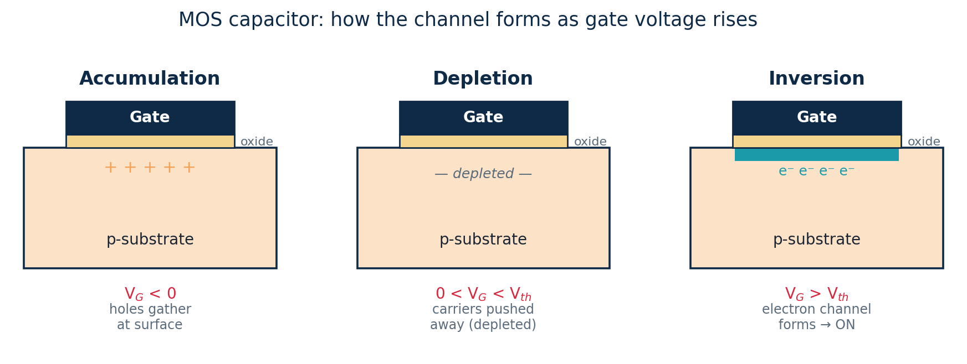
Type | Turns ON when | Passes well | Role in CMOS
NMOS | V_GS > V_th (gate high) | a strong 0 | Pull-down (to GND)
PMOS | V_GS < V_tp (gate low) | a strong 1 | Pull-up (to V_DD)
- Enhancement vs depletion: enhancement-mode devices are off at V_GS = 0 and must be turned on — these are used in CMOS. Depletion-mode devices conduct at V_GS = 0.
- Threshold voltage V_th is set by oxide thickness, channel doping and the gate material; typical |V_th| ≈ 0.3–0.7 V.

MOSFET characteristics and modeling
The first-order (square-law / Shockley) model gives one equation per region:
- Cutoff (V_GS < V_th): I_D ≈ 0.
- Triode/linear (V_DS < V_GS − V_th): I_{D} = k·[(V_{GS}−V_{th})V_{DS} − V_{DS}²/2].
- Saturation (V_DS ≥ V_GS − V_th): I_{D} = ½·k·(V_{GS}−V_{th})²·(1+λV_{DS}).
Here k = µ·C_ox·(W/L) is the transconductance parameter: µ is carrier mobility (electrons faster than holes), C_ox is oxide capacitance per area, and W/L is the designer's main sizing knob. The two standard plots are the output characteristic (I_D vs V_DS for stepped V_GS) and the transfer characteristic (I_D vs V_GS, showing V_th).
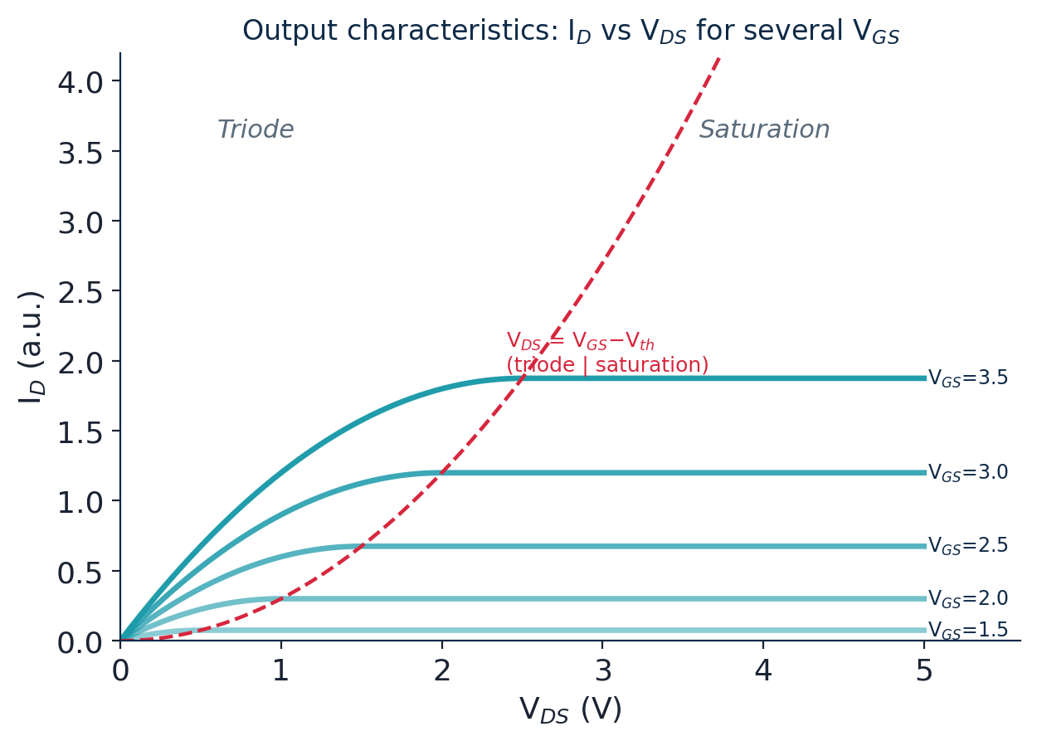
- Capacitances: gate caps (C_gs, C_gd, C_gb) and junction caps (C_jsb, C_jdb) must be charged each switch — they set delay (≈0.69·R·C) and dynamic power (∝ C·V²·f).
- Second-order (non-ideal) effects: channel-length modulation (λ), body effect (V_th rises with source-body bias), velocity saturation, sub-threshold leakage and DIBL — the reasons the simple equations are approximations.

Scaling trends and technology advancements
- Moore's Law (empirical): transistor count per chip doubles roughly every two years — it predicts density, not speed.
- Dennard (constant-field) scaling (physics): shrinking all dimensions and the supply by a factor S keeps the electric field — and hence power density — constant, so each node was smaller and faster at the same power. It broke down around 2005 (the 'power wall'), which is why clock speeds stalled and multi-core and accelerators took over.
Under ideal constant-field scaling by S: dimensions and V_DD ÷ S, delay ÷ S (faster), power per device ÷ S², density × S², and power density stays constant.
- Technology nodes have shrunk from ~1 µm (1980s) to a few nm today; the 'node' is now largely a marketing label rather than a literal gate length.
- Short-channel effects that scaling brings include velocity saturation, DIBL, higher leakage and increased V_th variability.
To keep scaling working, the device itself evolved so the gate controls the channel from more sides:
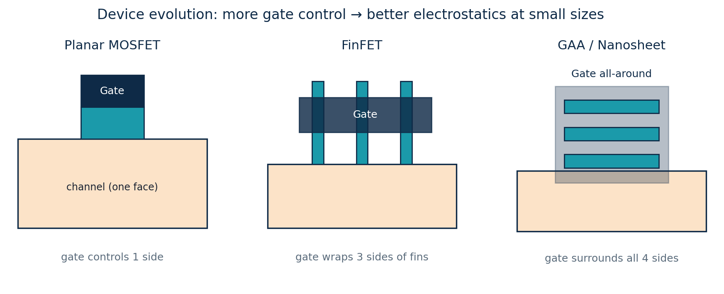
- Planar → FinFET → GAA: planar (gate on 1 side) → FinFET (~22 nm, gate on 3 sides) → gate-all-around / nanosheet (~2 nm, gate on all 4 sides). Material and process advances — strained silicon, high-k/metal gate and EUV lithography — also help keep Moore's Law alive.

2.3 CMOS inverter characteristics
This expanded section covers the inverter across its three themes: operation and the transfer curve, robustness and power, and how it is sized and optimised.

Operation and the voltage transfer characteristic
- Inverter: a PMOS pull-up and an NMOS pull-down share input and output. Exactly one network conducts at a time → full output swing and near-zero static power.
- VTC: the Voltage Transfer Characteristic (V_out vs V_in) passes through five regions A–E; the steep central region (both devices saturated) gives high voltage gain.
- Switching threshold V_M is where V_in = V_out. For a balanced inverter V_M ≈ V_DD/2; making the PMOS relatively wider raises V_M, a wider NMOS lowers it.
- Voltage gain is the VTC slope near V_M; a good inverter has |gain| ≫ 1, which regenerates weak logic levels back to full V_DD / 0 and lets gates cascade.
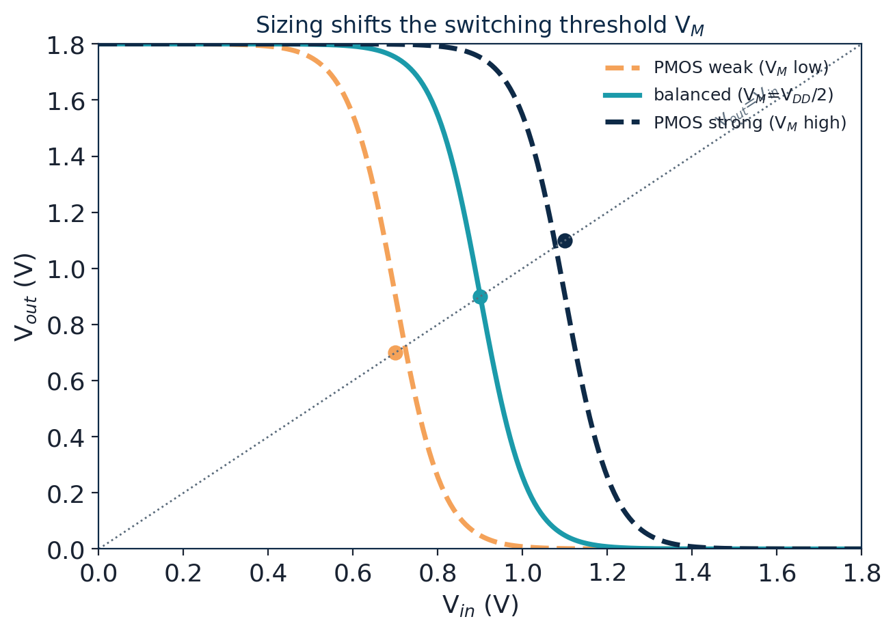

Noise-margin analysis and power consumption
- Unity-gain points: V_IL and V_IH are the inputs where the VTC slope = −1. Below V_IL the input is safely 0; above V_IH safely 1.
- Noise margins: NM_{H} = V_{OH} − V_{IH} and NM_{L} = V_{IL} − V_{OL}. Larger (and balanced) margins → more tolerance to crosstalk, IR drop and supply droop → more robust logic.
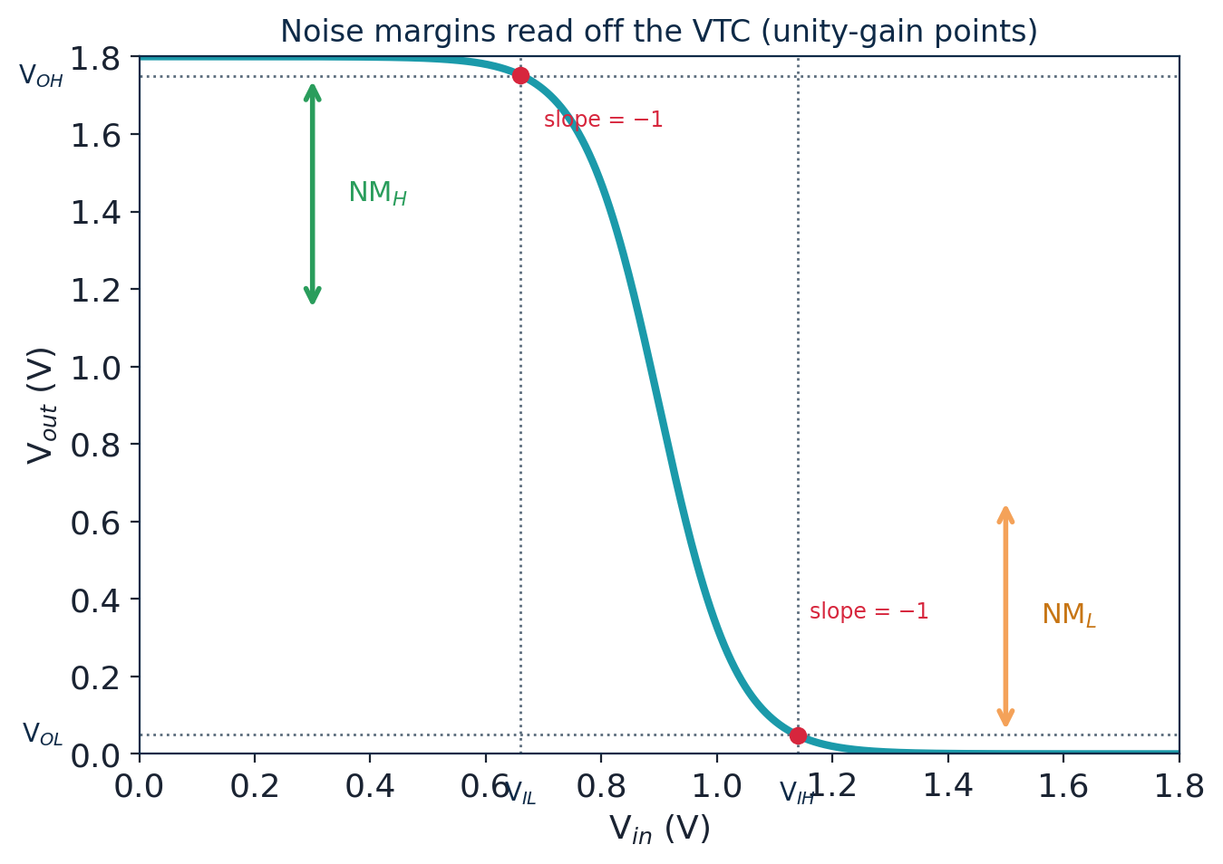
Power has three components:
- Dynamic (switching): P = α·C·V_{DD}²·f — charging/discharging load caps; usually dominant. Energy per switch = ½·C·V_DD².
- Short-circuit: a brief V_DD-to-GND current while both transistors conduct during the input transition; kept small by fast input edges.
- Static (leakage): sub-threshold and gate-oxide currents that flow even when idle; a growing fraction at advanced nodes.
- Low-power techniques: voltage scaling (biggest lever), clock gating, power gating, multi-V_th cells and minimal sizing.

Inverter sizing and optimization
- The β ratio: because holes are ~2–3× slower than electrons, an equal-width PMOS is weaker. Sizing W_p/W_n ≈ 2–3 centres the VTC (V_M ≈ V_DD/2) and equalises rise and fall delays.
- Sizing for delay: widening a gate lowers its R (faster) but raises the capacitance it presents upstream — so up-sizing only helps when driving a large external load.
- Driving big loads: use a chain of inverters that grows geometrically. A fan-out-of-4 (FO4) taper — each stage ~4× the previous — is close to the minimum-delay design and is a common delay unit.
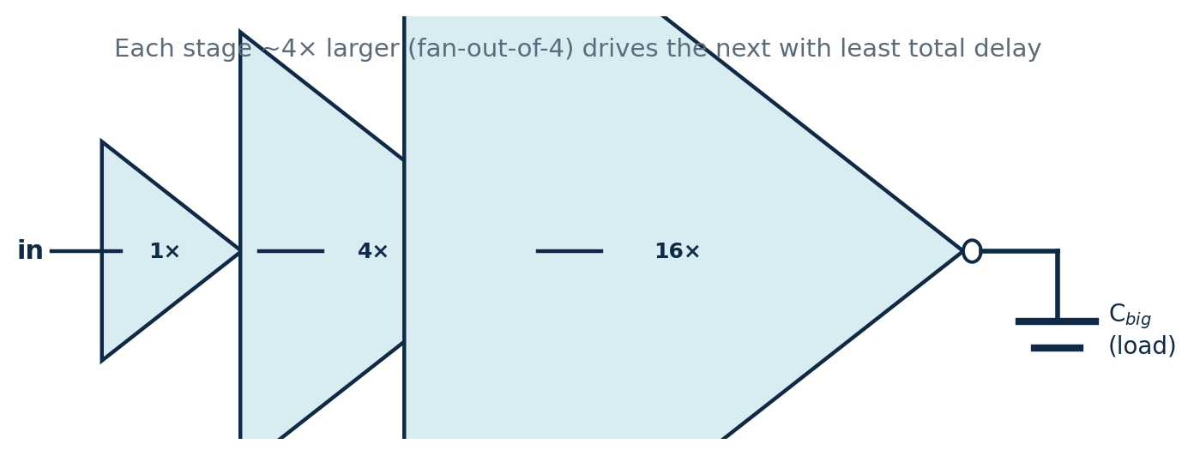
- Optimal number of stages: too few → each stage has huge fan-out (slow); too many → fixed per-stage overhead dominates (slow). Minimum delay occurs near a per-stage effort of ≈ 4 (the mathematical optimum is e ≈ 2.7).

2.4 CMOS logic design
This expanded section covers logic design across its three themes: the basic gates, the systematic combinational-design method, and complex multi-input functions.

Basic logic gates: AND, OR, NAND, NOR
The standard gates, their Boolean expressions and truth values:
A | B | AND | OR | NAND | NOR | XOR
0 | 0 | 0 | 0 | 1 | 1 | 0
0 | 1 | 0 | 1 | 1 | 0 | 1
1 | 0 | 0 | 1 | 1 | 0 | 1
1 | 1 | 1 | 1 | 0 | 0 | 0
- Naturally inverting: static CMOS gates always invert, so NAND and NOR are the native gates. A plain AND or OR = NAND/NOR followed by an inverter (so AND costs 6 transistors versus 4 for a NAND).
- Universality: NAND and NOR are each universal — any function can be built from one gate type. NOT = a NAND with inputs tied; AND = NAND then NAND-as-inverter; OR follows from De Morgan's laws.
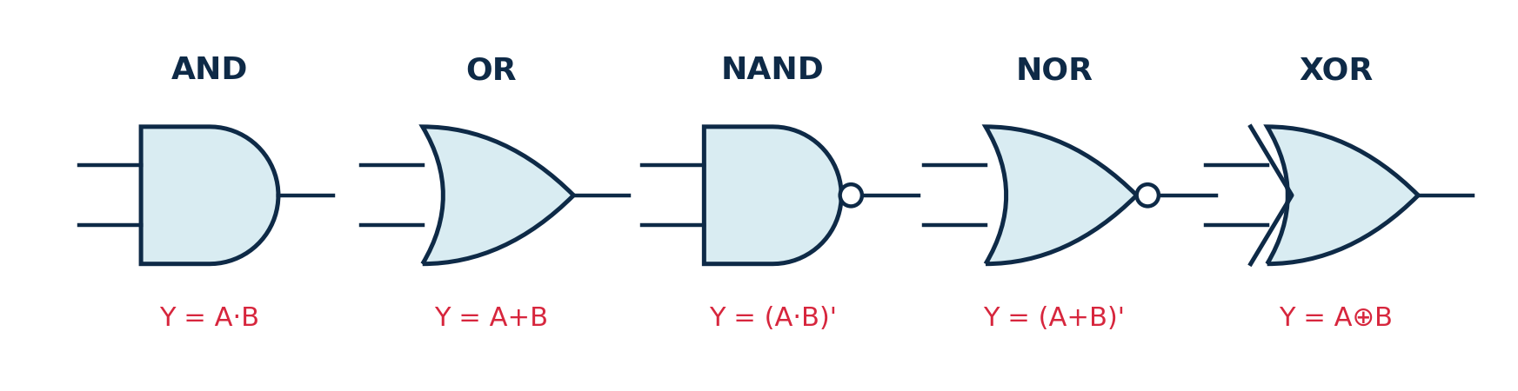

Combinational logic design using CMOS
- Two networks: a Pull-Down Network (NMOS) drives logic 0; a Pull-Up Network (PMOS) drives logic 1. Exactly one conducts for any input.
- Duality: PUN and PDN are duals — series in one network becomes parallel in the other.
Design recipe: (1) write the output as Y = (expression)′; (2) build the PDN — AND→NMOS in series, OR→NMOS in parallel; (3) build the PUN as the dual with PMOS; (4) count transistors (2 per input) and verify the truth table.
- Worked block — 2:1 MUX: Y = S·A + S′·B. Build it either as one static AOI-style gate plus an output inverter, or with two transmission gates (~6 transistors) that select A or B. Larger blocks (adders, decoders) are assembled from such gate-level pieces.
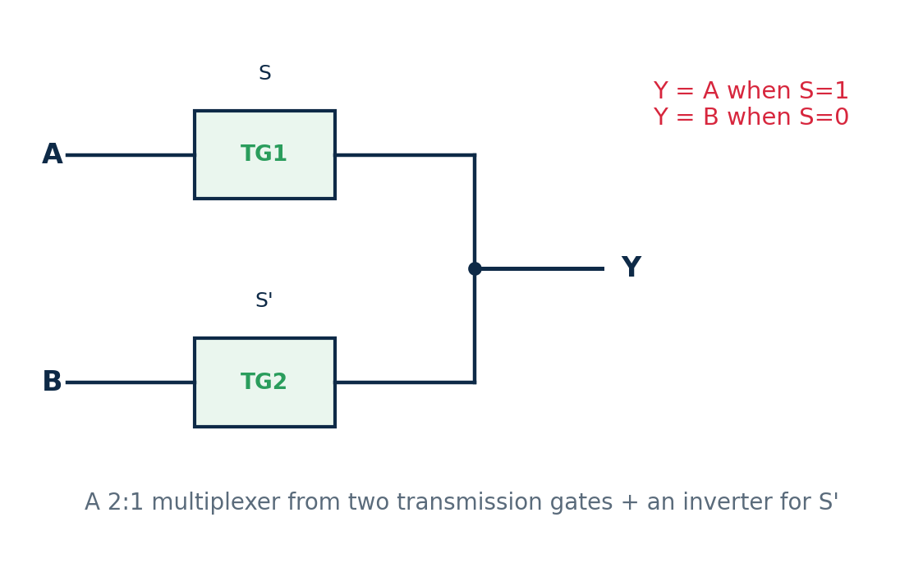
- Worked block — half adder: Sum = A ⊕ B (an XOR) and Carry = A·B (an AND). It is the smallest arithmetic block and the building piece of larger adders.
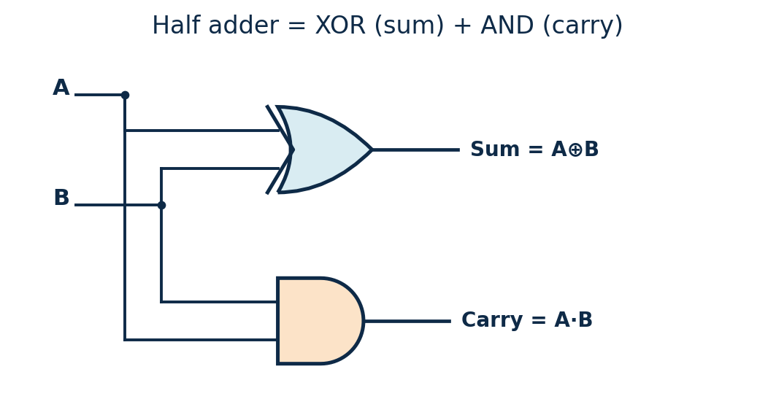

Designing complex logic functions
- AOI / OAI gates: an AND-OR-Invert gate realises Y = (A·B + C)′ in 6 transistors; the OR-AND-Invert gate Y = ((A+B)·C)′ is its dual. Both pack multi-level logic into one stage with far fewer transistors than separate gates (~14).
- Mapping any function: any inverting function becomes one complex gate — map AND→series and OR→parallel in the PDN, then take the dual for the PUN.
- Factor to minimise transistors: e.g. Y = (A·B + A·C)′ factors to (A·(B+C))′, shrinking the stack from 4 to 3 series NMOS.
- Practical limits: keep series stacks to ≈ 4 transistors (fan-in limit), prefer AOI over OAI (PMOS in series is slow), and split very large functions into several gates (multi-level logic).
- Transmission-gate logic: an NMOS+PMOS pass gate passes both 0 and 1 cleanly and builds multiplexers, XOR and latches compactly — an efficient alternative to fully static gates.
- Multi-level example — full adder: Sum = A ⊕ B ⊕ Cin and Cout = A·B + Cin·(A ⊕ B), built from 2 XOR + 2 AND + 1 OR (or two half adders plus an OR). Chaining n full adders gives an n-bit ripple-carry adder — the core of an ALU.
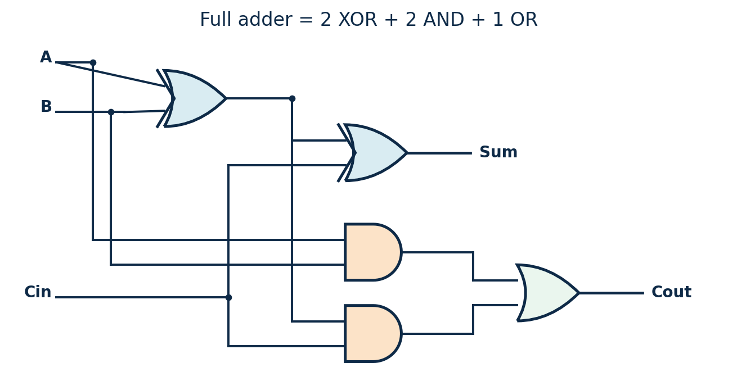

2.5 Transistor-level schematics and layouts
This expanded section covers the physical-design themes: transistor-level design techniques, schematic and layout considerations, and design rules, metal layers and routing.

Transistor-level design techniques
- Schematic & netlist: the circuit is first captured as a transistor schematic (and an equivalent SPICE netlist) that fixes every device, its W/L and which nets it connects; it is simulated in NGSpice before any layout.
- Shared diffusion: ordering transistors so adjacent source/drain regions abut into one continuous diffusion strip removes contacts and gaps — a smaller, faster cell with less capacitance.
- Euler path: the transistor ordering that keeps the diffusion unbroken is found from an Euler path through the gate network. Series devices (as in a NAND) naturally share their middle node.
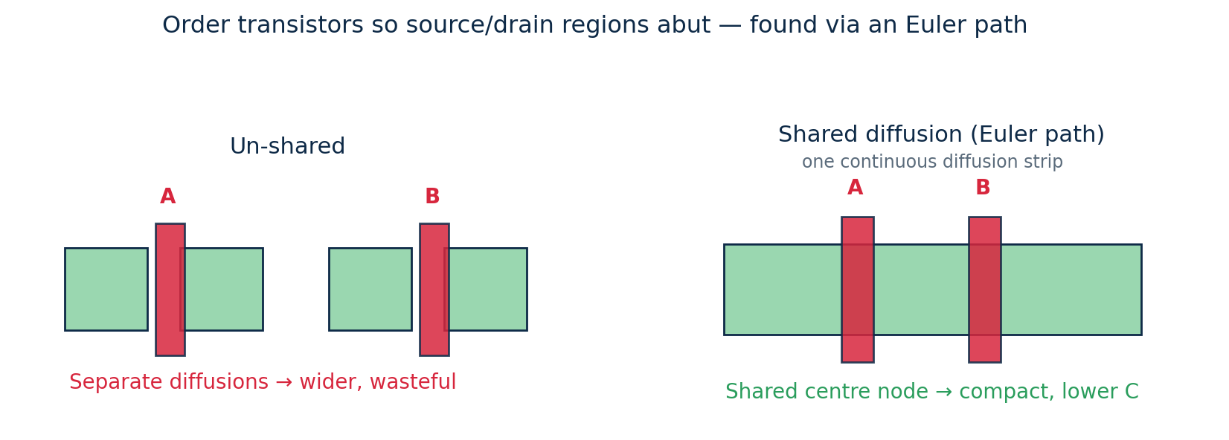

Schematic design and layout considerations
- Schematic vs layout: a schematic shows connectivity (what connects to what); a layout shows the physical polygons on stacked mask layers (well, diffusion, poly, contacts, metal) that are actually fabricated.
- Stick diagrams are a quick colour-coded plan of a layout (green diffusion, red poly, blue metal); where poly crosses diffusion, a transistor forms. They fix topology before full layout.
- Inverter layout: PMOS (p+ in the n-well, by V_DD) on top, NMOS (n+, by GND) below, one shared poly gate as the input, and metal-1 for the V_DD/GND rails and the shared output.
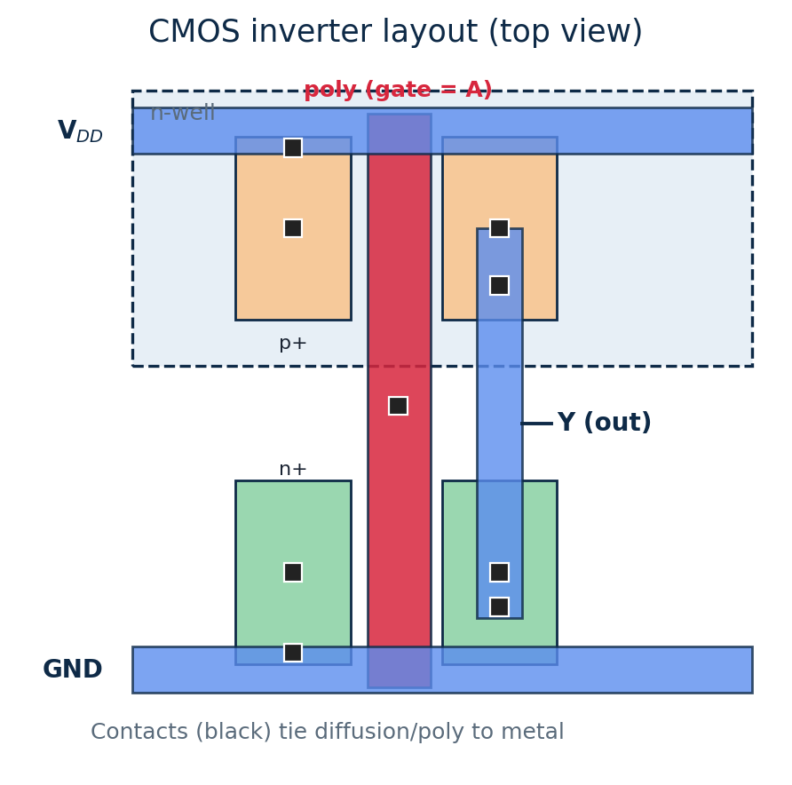
- Standard cells: modern chips use a library of fixed-height cells that snap into rows sharing V_DD/GND rails; they are pre-characterised for timing/power and enable automatic place-and-route. Full-custom layout is reserved for critical blocks.

Design rules, metal layers and interconnect routing
- Design rules (often expressed in λ) set minimum widths, spacings and enclosures so the layout can be manufactured with good yield.
- DRC vs LVS: DRC (Design Rule Check) asks “can this be made?”; LVS (Layout vs Schematic) extracts a netlist from the layout and asks “did we draw the right circuit?” Both must be clean before tape-out (Magic runs DRC here).
- Metal stack: wiring runs on several stacked metal layers (M1, M2 … 10+). Lower metals are thin/dense for local connections; upper metals are thick/wide for global routing, power grids and clocks. Vias connect adjacent layers.
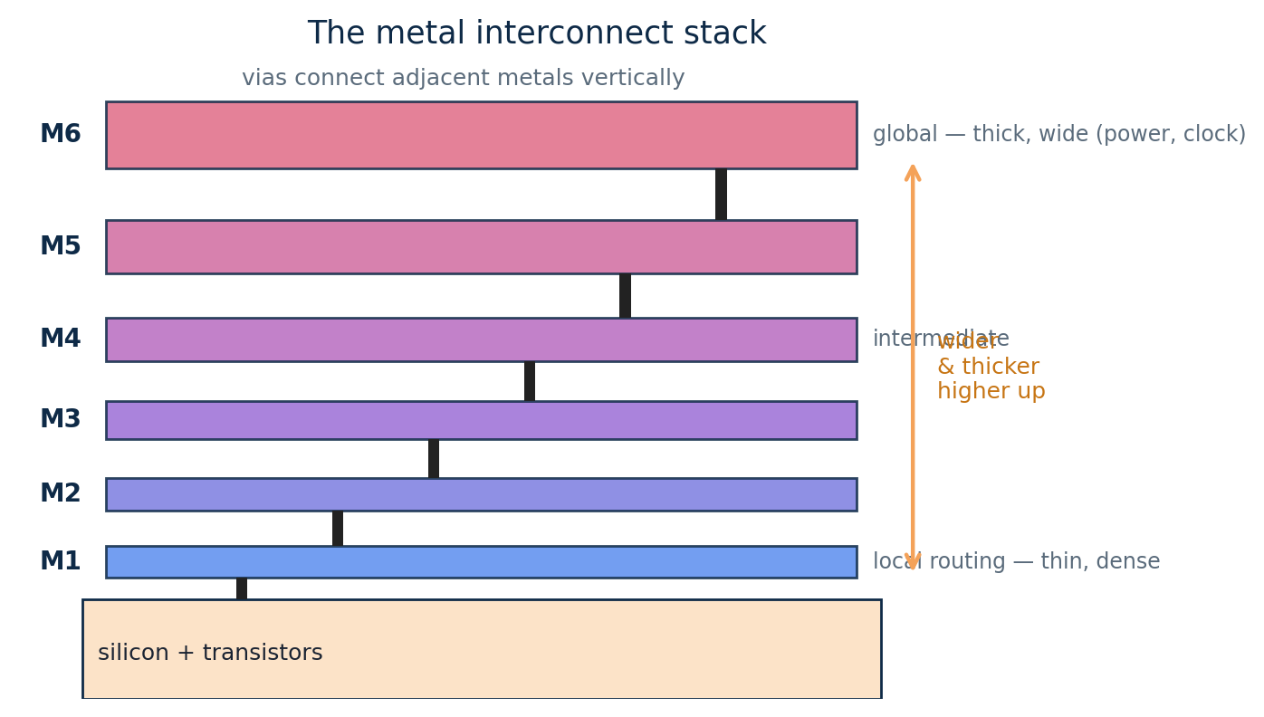
- Routing: connects all placed cells using preferred directions (one layer horizontal, the next vertical) joined by vias, aiming for 100% connection, met timing and minimum wire length.

2.6 On-chip wire modeling
This section covers interconnect across its three themes: what on-chip wires are, the parasitics they add and their impact, and how wires are modelled and simulated.

Introduction to on-chip interconnects
- An interconnect is the metal wire that carries a signal between gates; a modern chip holds kilometres of it across many metal tiers.
- Wire hierarchy: local wires (M1–M2) are short and thin; intermediate (M3–M4) cross a block; global/semi-global (M5–M6+) are long and thick (lower resistance) for chip-wide signals, power and clocks.
- The interconnect problem: transistors got faster every node while wires got relatively slower (thinner → more R), so interconnect now dominates delay, power and area on many paths.
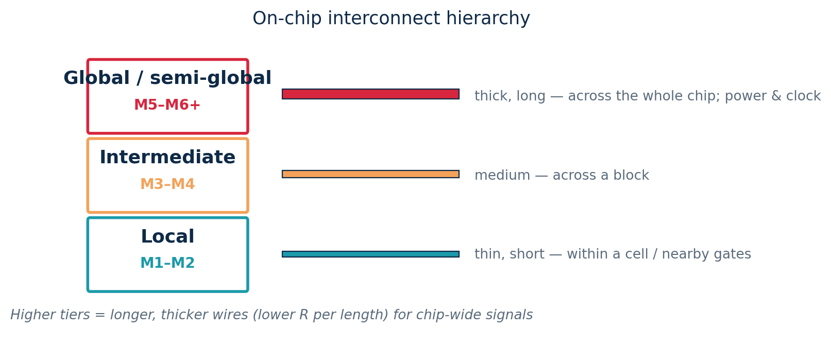

Wire parasitics and their impact on performance
- Resistance R = ρ·L /(W·t) = R_sheet·(L/W) — long, thin wires are resistive.
- Capacitance has three parts: area (to the plane below), fringe (edge fields) and coupling (to side neighbours). As wires pack closer, coupling C dominates and is data-dependent.
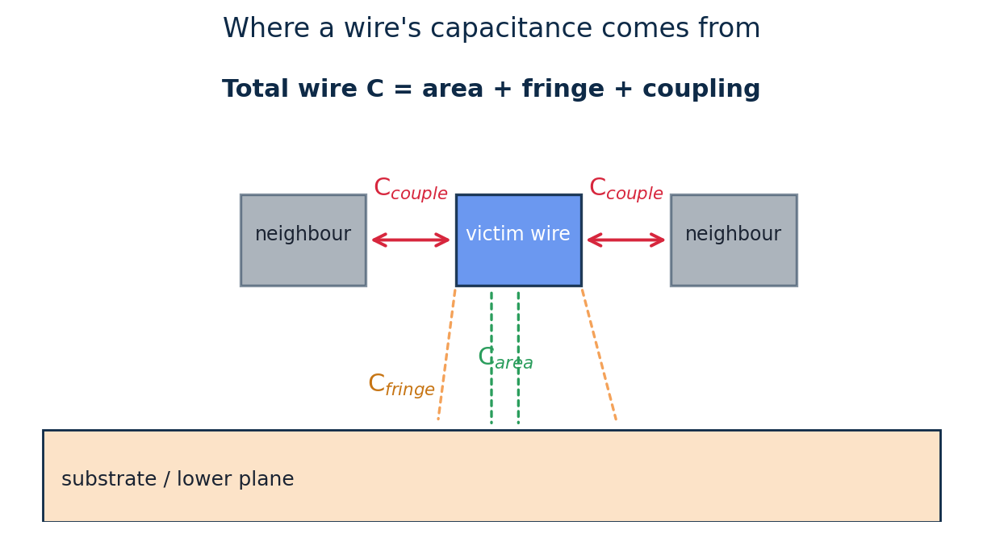
- Four impacts: (1) propagation delay — wire RC adds to the path; (2) crosstalk — coupling injects noise from an aggressor onto a victim; (3) IR drop — power-grid resistance lowers local V_DD; (4) electromigration — high current density slowly moves metal atoms, a long-term failure.

Modeling and simulation of on-chip wires
- Lumped R, C: treat the whole wire as one R and one C — simple and pessimistic, good for short nets.
- π-model (C/2 · R · C/2): a good single-segment fit for medium nets.
- Distributed / Elmore: an R–C ladder; the most accurate, with delay growing as length². Elmore delay sums, for each capacitor, the shared upstream resistance × that capacitance.
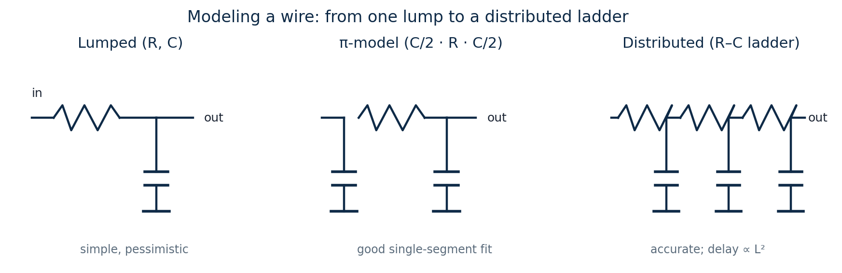
- Repeaters (buffers): splitting a long wire into k segments with buffers turns its L² delay growth into linear growth — a standard back-end optimisation with an optimal repeater size and spacing.
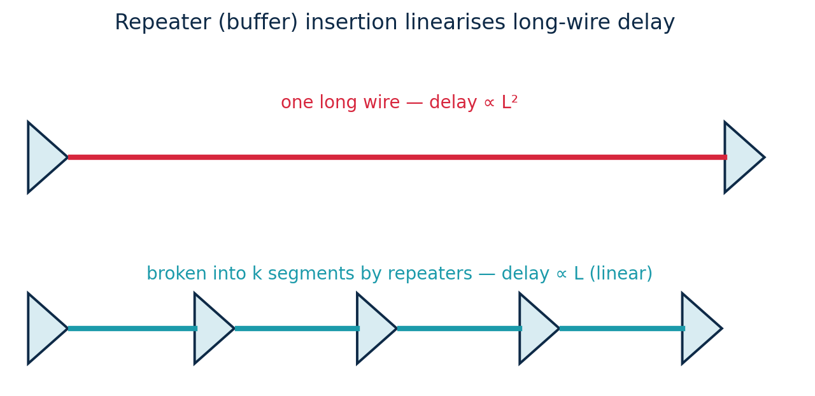
- Extraction & simulation: parasitic extraction (e.g. in Magic) computes R and C for every net from the layout geometry; the resulting RC netlist is then simulated in NGSpice (or fed to static timing) to confirm the real delay.

2.7 Delay, power and timing essentials
- Propagation delay (RC model): t_{p} ≈ 0.69 · R · C. Lower R (wider devices) or lower C (lighter load) → faster.
- Elmore delay on an RC tree: each node's delay = Σ (shared upstream resistance × downstream capacitance).
- Power: dynamic P = α·C·V_{DD}²·f (usually dominant), plus short-circuit and static/leakage. Energy per switch = ½·C·V_{DD}².
- Timing: for a synchronous path, T ≥ t_{cq} + t_{logic} + t_{setup}. Slack = required − arrival; the smallest-slack (critical) path sets the maximum clock frequency.

2.8 Bonding, packaging and assembly
A bare die cannot be used on its own. This section covers how a die becomes a usable component across three themes: packaging and assembly, the bonding diagram, and packaging trends.

Packaging technologies and assembly processes
- Why package? a bare die is fragile and has microscopic pads. A package gives it four things: mechanical protection, electrical connections (signal and power), a heat-removal path, and a board-usable footprint.
The assembly process, step by step:
- 1–2 Wafer & back-grind: the finished wafer is thinned from the back so the die is flatter and dissipates heat better.
- 3 Dicing (sawing): a diamond saw (or laser) cuts the wafer into individual dies along the scribe lines.
- 4 Die attach: each good die is picked and glued onto the leadframe paddle (or substrate) with epoxy.
- 5 Wire bonding: fine gold/copper wires join the die's bond pads to the package leads (or, for flip-chip, the die is bumped and flipped — see 2.8 bonding).
- 6 Encapsulation: the assembly is sealed in epoxy mould compound (or a ceramic/metal lid) for protection.
- 7–8 Mark, trim & form: laser-mark the part number, trim the leadframe and bend the leads to shape; final test follows.
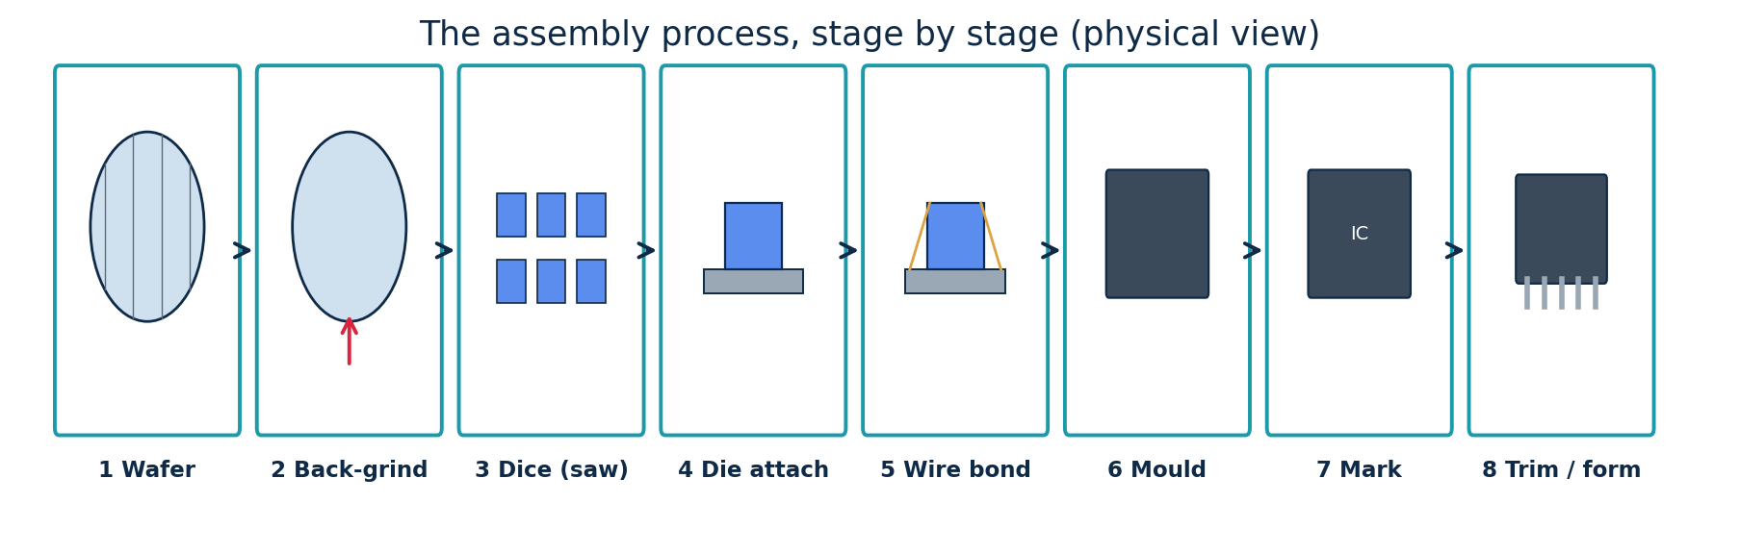
Anatomy of a package. Inside a typical wire-bonded plastic package sit the silicon die, the die-attach adhesive that bonds it to the leadframe/paddle and conducts heat, the bond wires that carry signals to the leads, the mould compound that seals everything, and the leads (or balls) the board solders to.
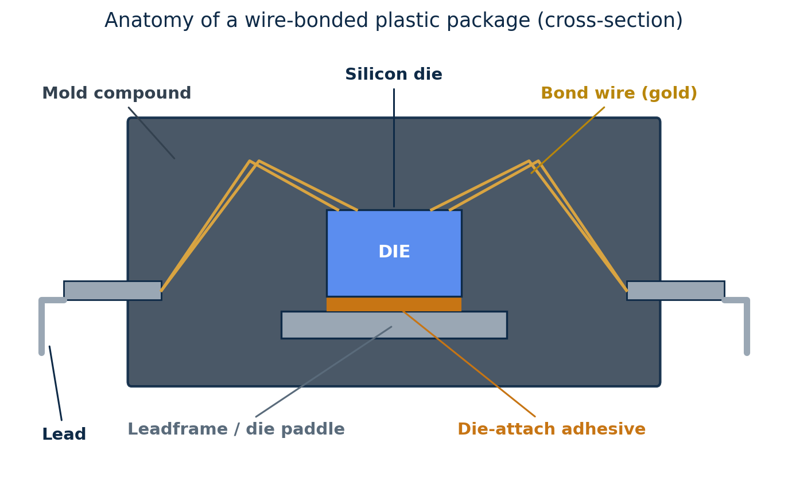
Package families evolved with rising pin counts: DIP (through-hole, legacy) → QFP (leads on four sides) → BGA (solder-ball array underneath, high pin count) → CSP/WLP (chip-scale, near die size) → 2.5D/3D (multiple dies on an interposer or stacked). The trend is more pins, smaller size and higher integration.
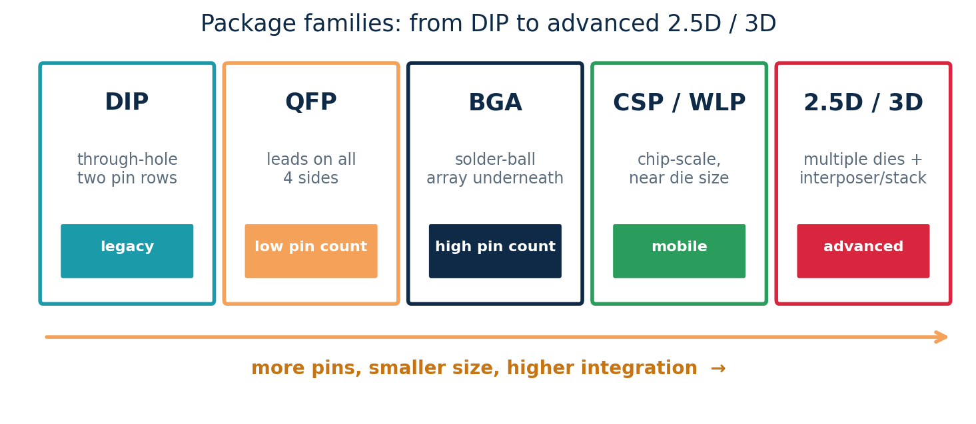
Classifying packages. Any package can be read along three axes: by mounting (through-hole vs surface-mount — the latter is denser and dominant today); by I/O location (peripheral leads on the edges vs area-array balls underneath, which give far more I/O); and by material (cheap plastic vs hermetic ceramic for high-reliability use).
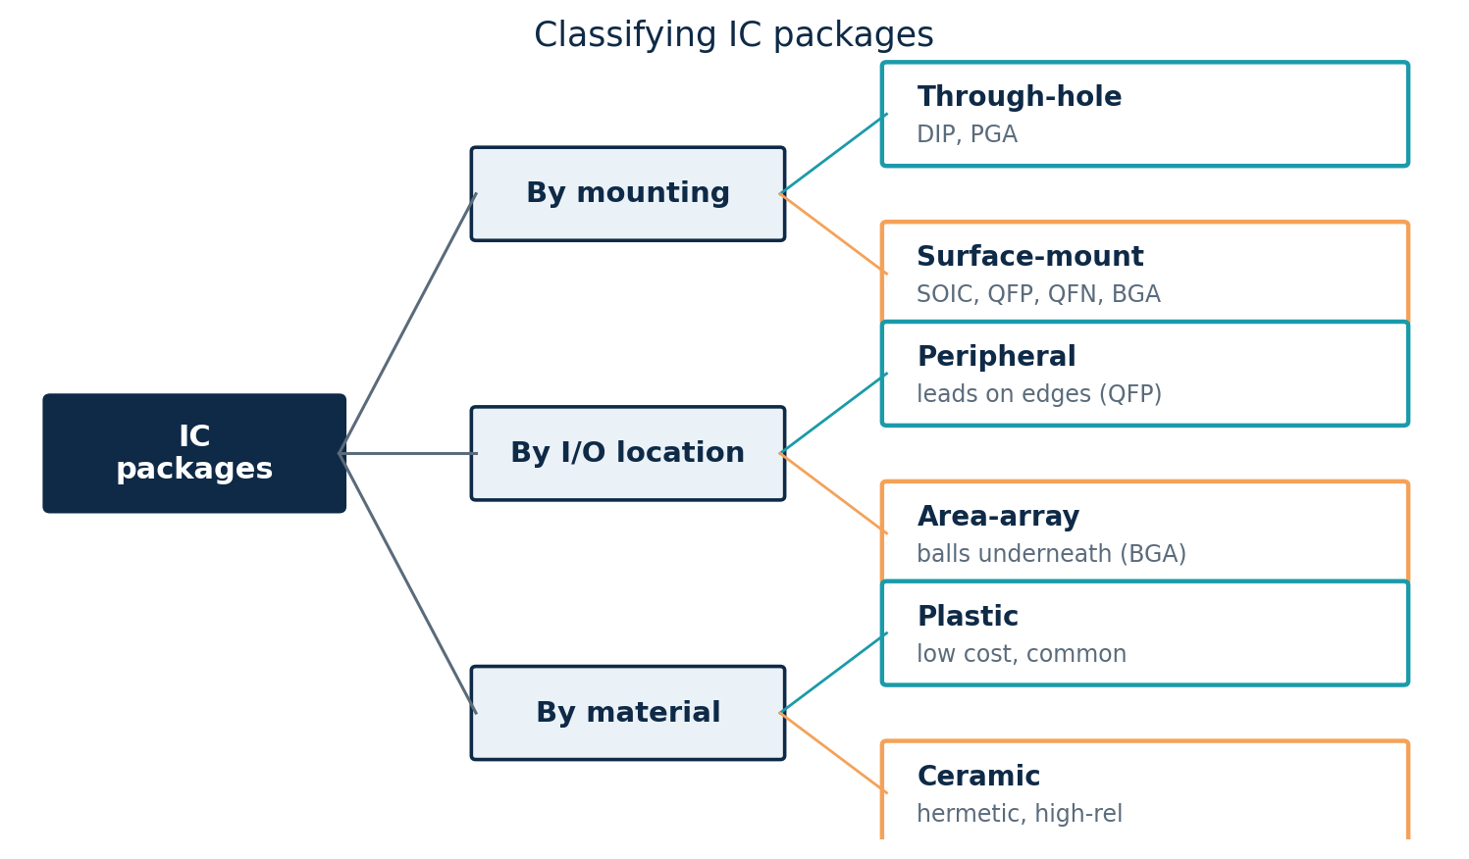
Levels of packaging. Packaging is a hierarchy: Level 0 is the bare die, Level 1 the single-chip package, Level 2 the populated board (PCB), and Level 3 the finished system. Each level adds interconnect (bond wires/bumps, solder joints, connectors), and every hop adds delay, loss and cost.
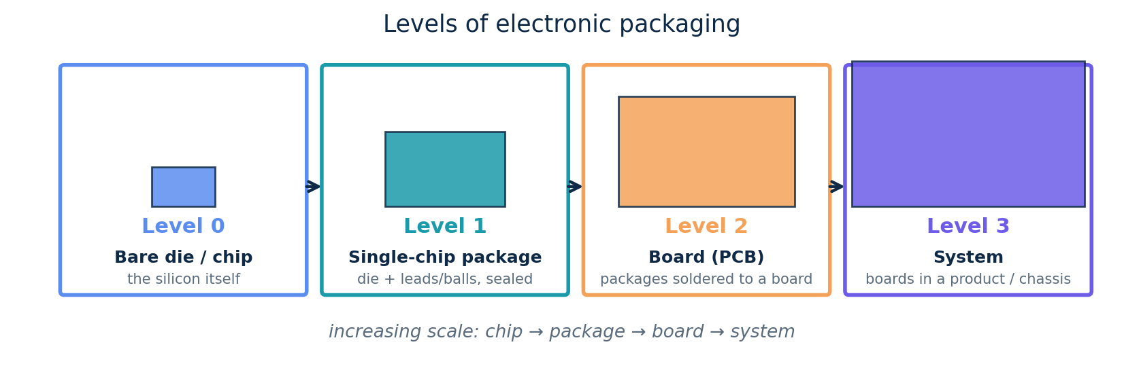
How a wire bond is made. The bonding step is itself a precise four-stage process (thermosonic ball-stitch bonding): (1) an electric spark forms a free-air ball at the capillary tip; (2) the ball is welded onto the die pad with heat, force and ultrasound (the first/ball bond); (3) the capillary loops the wire across to the lead; (4) the wire is crushed onto the lead (the second/stitch or wedge bond) and broken off. Wedge bonding with aluminium wire is the other main method.
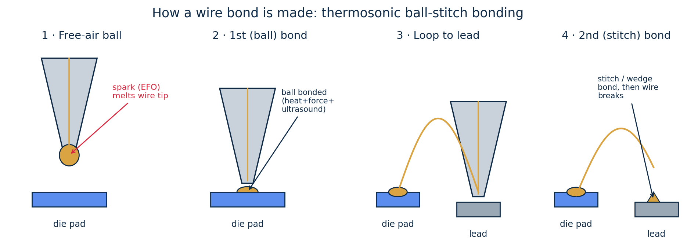
Through-hole vs surface-mount. Through-hole (THT) leads pass through drilled holes and solder on the far side — strong but bulky. Surface-mount (SMT) parts sit on surface pads with no holes, so both board sides can be populated at finer pitch and assembled automatically; SMT now dominates and enables the QFP/QFN/BGA families, while THT survives for connectors and power.
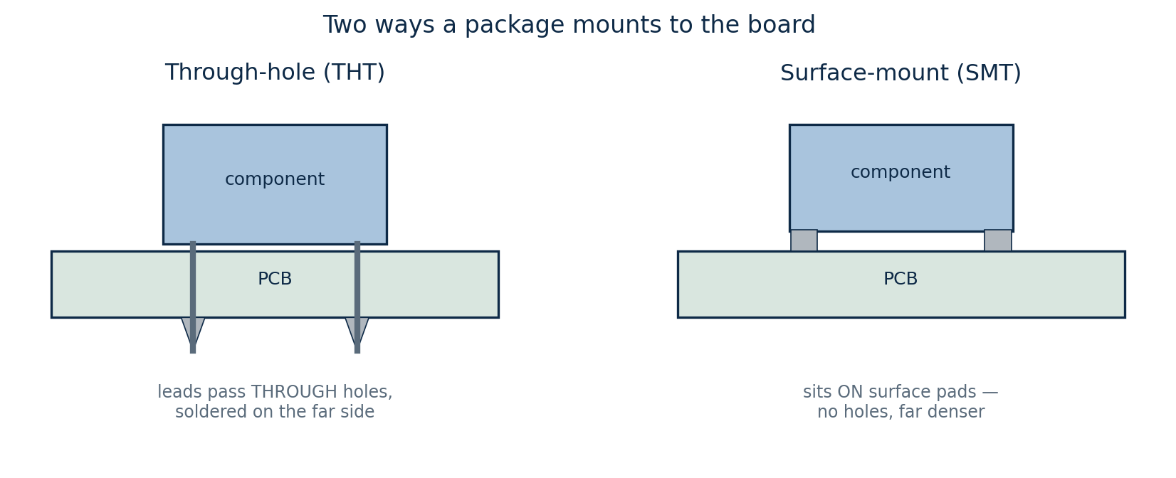
Package types at a glance. Common families, with indicative pin counts and uses: DIP (through-hole, 8–64, legacy/prototyping); SOIC (SMT, 8–32, small ICs); QFP (SMT, 32–256, MCUs/ASICs); QFN (SMT, 16–64, compact/low-cost); PGA (through-hole, 100–1000+, older CPUs); BGA (SMT, 100–2000+, high-pin SoCs); and WLCSP (SMT, 4–200, mobile/chip-scale). Moving across this list, mounting becomes surface-mount, pitch shrinks and pin count climbs.
Wafer-level & advanced assembly. Instead of dicing first and packaging each die, wafer-level packaging (WLP) builds the package on the whole wafer. Fan-in (WLCSP) keeps the package the size of the die with balls inside the die footprint — ideal for low pin counts and tiny mobile parts. Fan-out (FOWLP) embeds the die in mould and uses a redistribution layer (RDL) to spread the I/O beyond the die, allowing more balls and acting as a stepping stone toward 2.5D/3D integration.
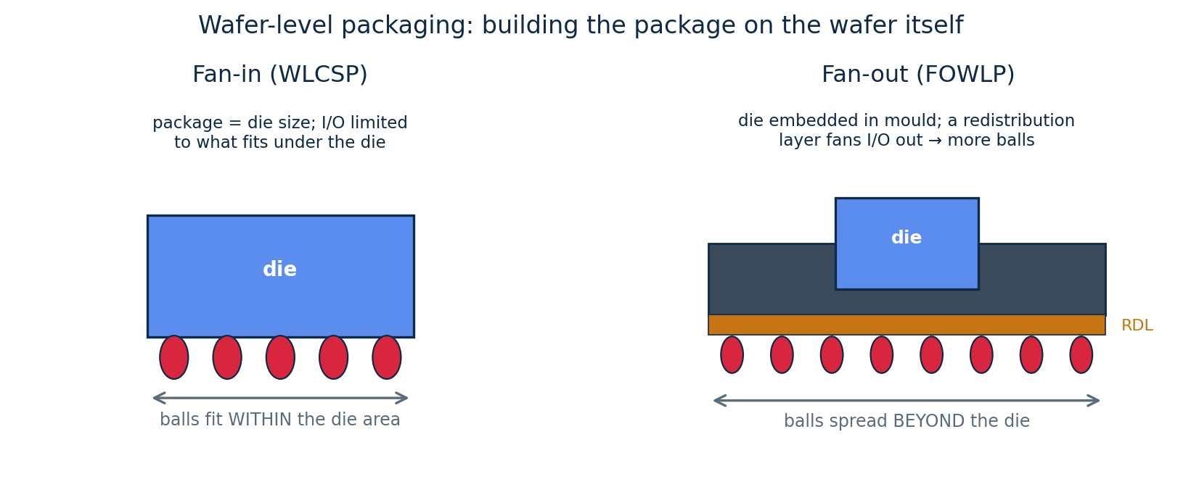

Bonding diagram design and considerations
- Two connection methods: wire bonding (die face-up; thin gold/copper wires arc from edge pads to the substrate — cheap and mature) and flip-chip (die face-down on an area array of solder bumps — more I/O, shorter links, better electrical and thermal performance).
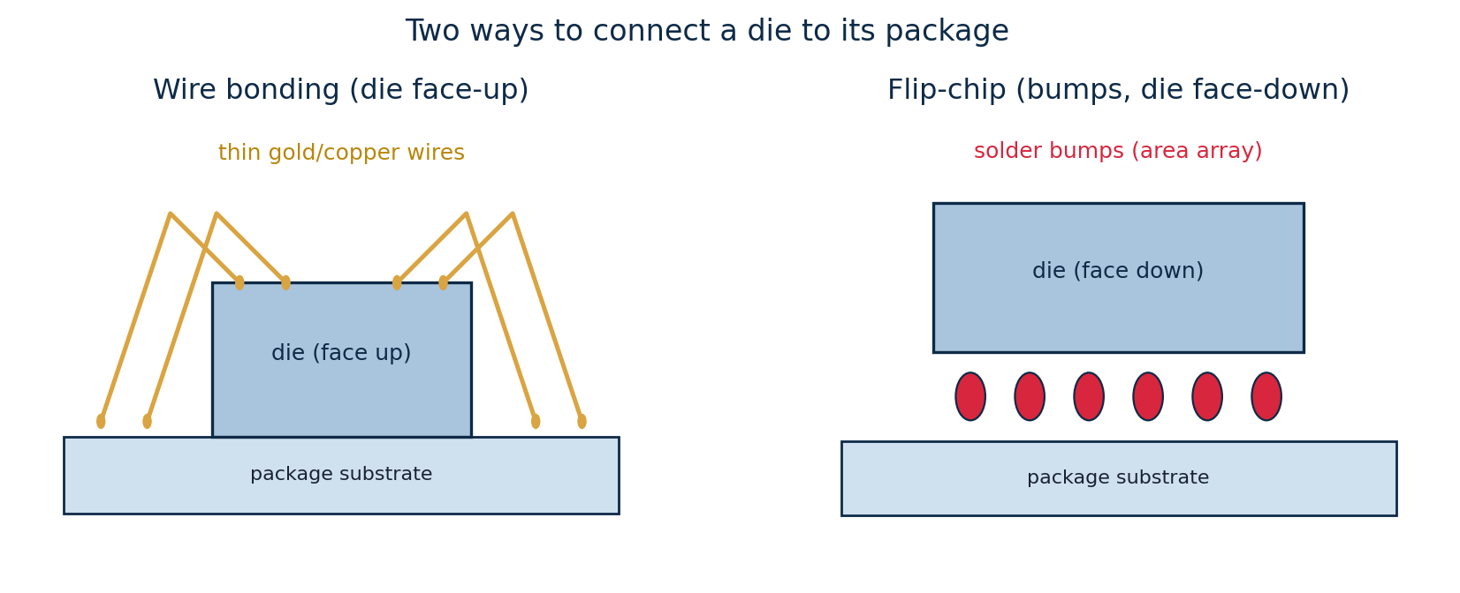
- The bonding diagram maps every die pad to its package pin and shows each bond wire — the contract between the chip designer and the assembly house.
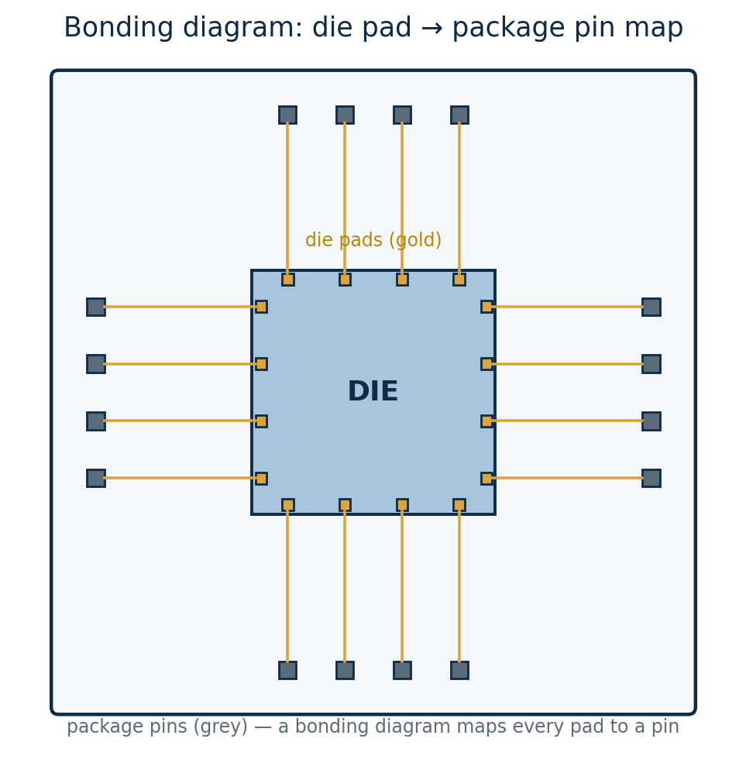
- Key considerations: distribute pads for short, even wires; avoid crossing/long bonds; use multiple V_DD/GND bonds to cut inductance and IR drop; watch bond-wire inductance (ground bounce) on fast I/O; and assign pins to suit board routing.

Packaging trends and challenges
- Trends: heterogeneous integration (CPU + memory + analog + chiplets in one package), 2.5D interposers, 3D die stacking (e.g. HBM memory via through-silicon vias) and System-in-Package — packaging is now a primary performance lever as single-die scaling slows.
- Challenges: removing heat from dense/stacked dies (thermal), signal and power integrity (inductance, ground bounce, IR drop), mechanical stress and warpage from thermal-expansion mismatch, known-good-die test before costly stacking, and the rising cost of advanced packaging.

2.9 Gate delays and logical effort
Logical effort is a simple hand-analysis method for estimating gate delay, sizing gates for speed, and reasoning about the speed–power trade-off.

Gate delay modeling and estimation
- The linear delay model: a gate's delay is d = g·h + p, measured in units of an inverter's basic delay τ. The straight line has slope g and intercept p.
- g — logical effort: how much worse than an inverter the gate is at producing output current (a property of the gate's topology).
- h — electrical effort (fanout): h = C_out / C_in, the load capacitance divided by the gate's own input capacitance.
- p — parasitic delay: the intrinsic self-load delay, independent of fanout; g·h is the effort delay.
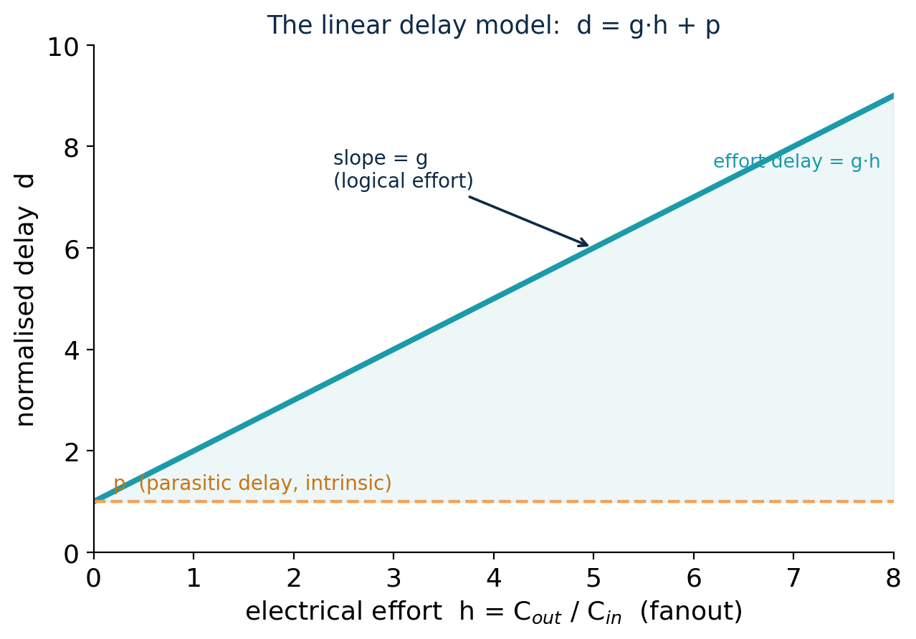
Worked estimate. A NAND2 (g = 4/3, p = 2) driving a load 3× its input cap (h = 3): d = (4/3)(3) + 2 = 4 + 2 = 6 τ. An inverter (g = 1, p = 1) at the same fanout gives d = 3 + 1 = 4 τ — clearly faster, because its g and p are smaller.
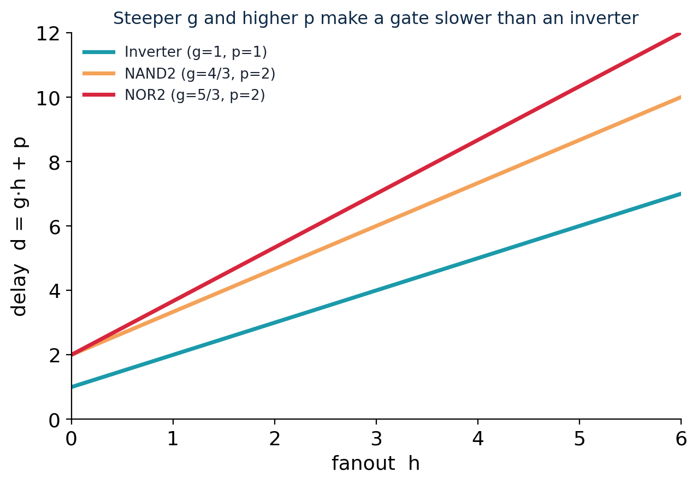

Introduction to logical effort analysis
- Reference gate: the inverter has g = 1. Every other gate has g > 1 because series transistors must be widened to keep drive strength, raising input capacitance.
- Typical values: INV = 1; NAND2 = 4/3; NOR2 = 5/3; NAND3 = 5/3; NOR3 = 7/3; XOR2 ≈ 4. NOR is worse than NAND because it stacks the weak PMOS — a reason to prefer NAND-based logic.
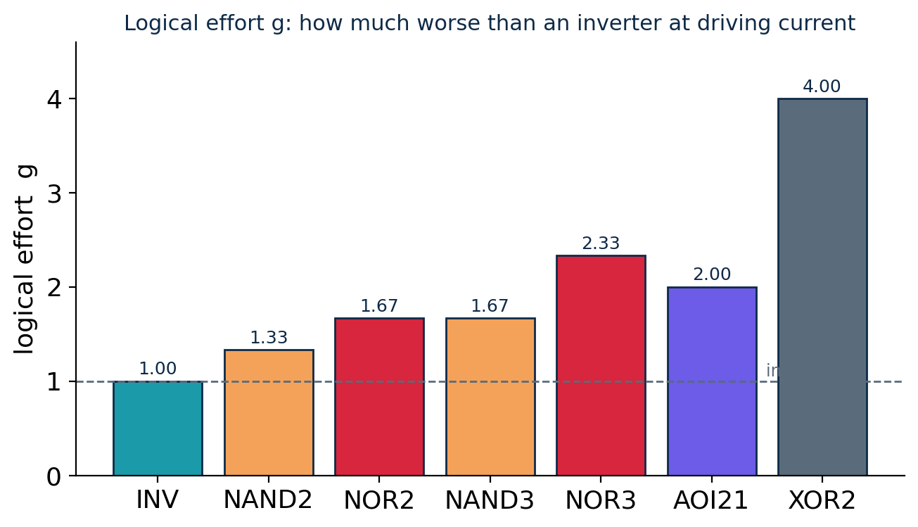
- Path effort: for a chain of gates, F = G·B·H, where G = product of the stage logical efforts, B = branching effort, and H = C_L/C_in (overall electrical effort).
- Minimum-delay sizing: the path is fastest when every one of the N stages carries equal stage effort f = F^(1/N) (best ≈ 4); stages are then sized back-to-front from C_in = g·C_out/f.
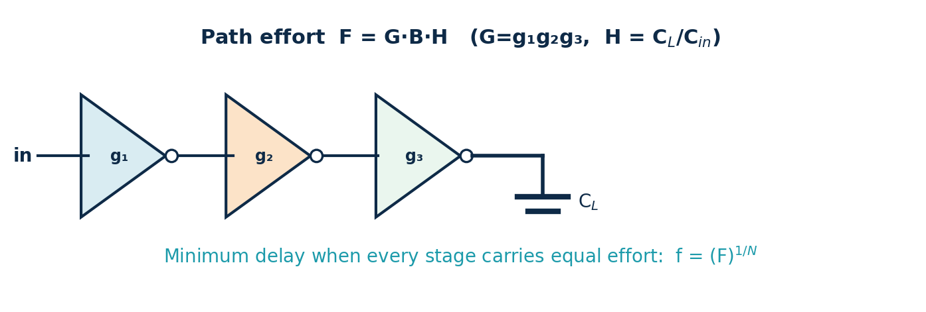

Delay–power trade-off using the P/N ratio
- The P/N ratio β = W_p/W_n sets how strong the PMOS pull-up is relative to the NMOS pull-down. Because holes are ~2× slower, an equal-width PMOS (β = 1) is weaker.
- β ≈ 2: equal rise and fall times, a symmetric VTC and balanced noise margins — the choice for general standard cells.
- β ≈ √2 (≈ 1.4): minimum average gate delay — the speed-optimal point.
- β = 1: smallest PMOS → least area, input capacitance and dynamic power, at the cost of a slower rise and an asymmetric VTC.
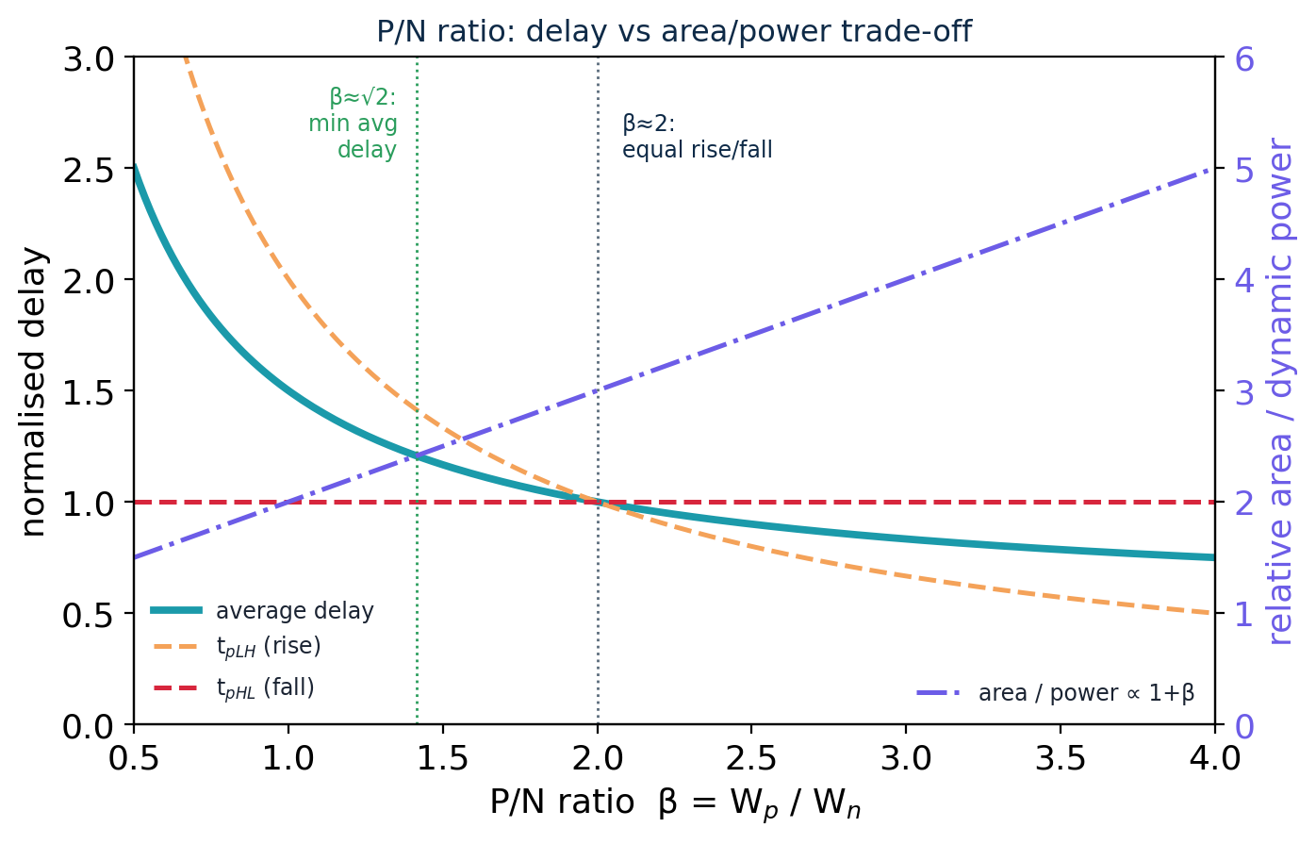
Choosing β. Area and dynamic power scale roughly as (1 + β), so a larger β buys speed and symmetry but costs energy on every switch. Use β ≈ 1–1.5 for low-power/dense logic, β ≈ 2 for balanced cells, and size up only on the speed-critical paths that need it.

2.10 Combinational critical-path optimization
A circuit's clock speed is limited by its slowest combinational path. This section covers finding that path and the techniques used to shorten it.

Identifying critical paths
- The critical path is the longest-delay path from any input (or register) to any output (or register); its delay sets the fastest usable clock.
- Arrival time: at each gate, arrival = max(arrivals of its inputs) + that gate's delay. Propagating this forward from the inputs gives the arrival at every node; the largest output arrival is the critical path.
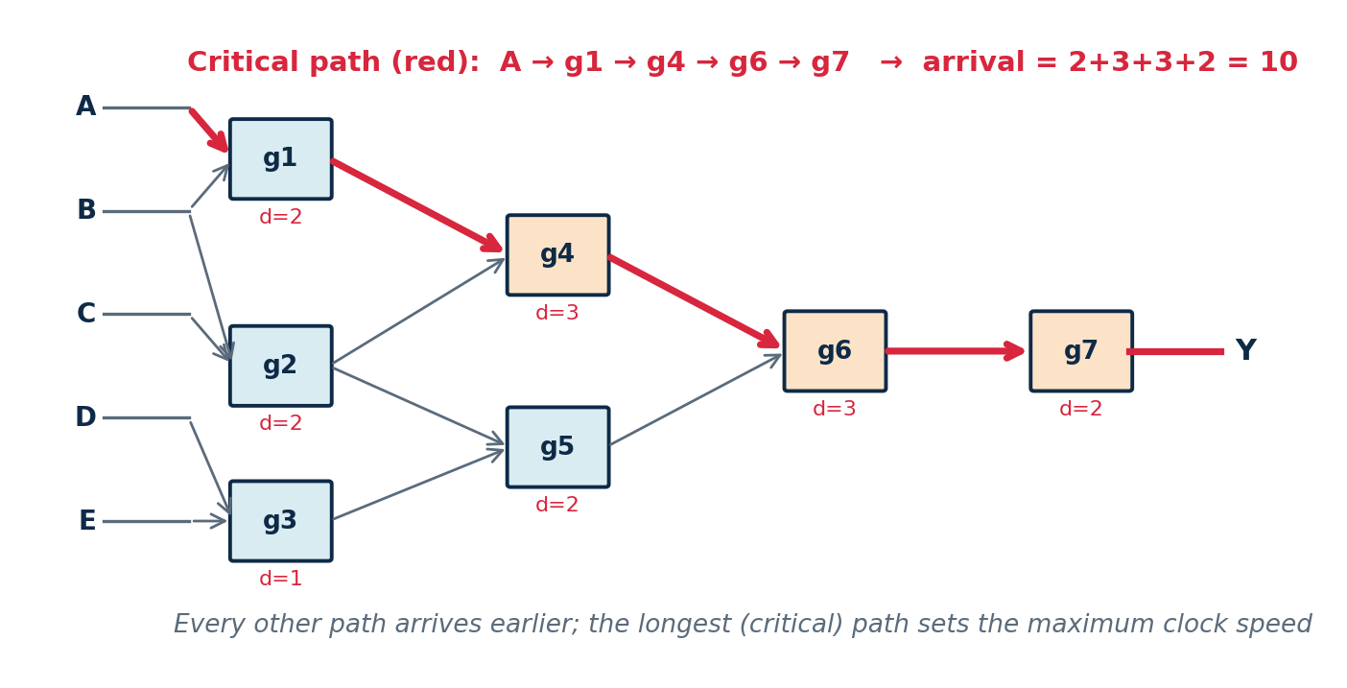
- Static Timing Analysis (STA): tools find the critical paths of millions of paths automatically, without simulation vectors. A forward pass gives arrival times; a backward pass gives required times.
- Slack = required − arrival. Negative slack is a timing violation; the critical path is the one with the worst (most negative) slack. STA also identifies false and multicycle paths so they are not optimised needlessly.
- The timing equation: T_clk ≥ t_cq + t_logic + t_setup, where t_logic is the combinational critical-path delay — the only term that logic optimisation can shrink. Lowering t_logic raises the clock frequency.

Gate sizing and logic restructuring
- Gate sizing: widen the transistors of the gates on the critical path so they drive their load faster (lower output resistance). Size only the critical gates — the cost is more area, input capacitance and power, and a larger gate also loads the stage before it (diminishing returns). Logical effort gives the optimal sizes.
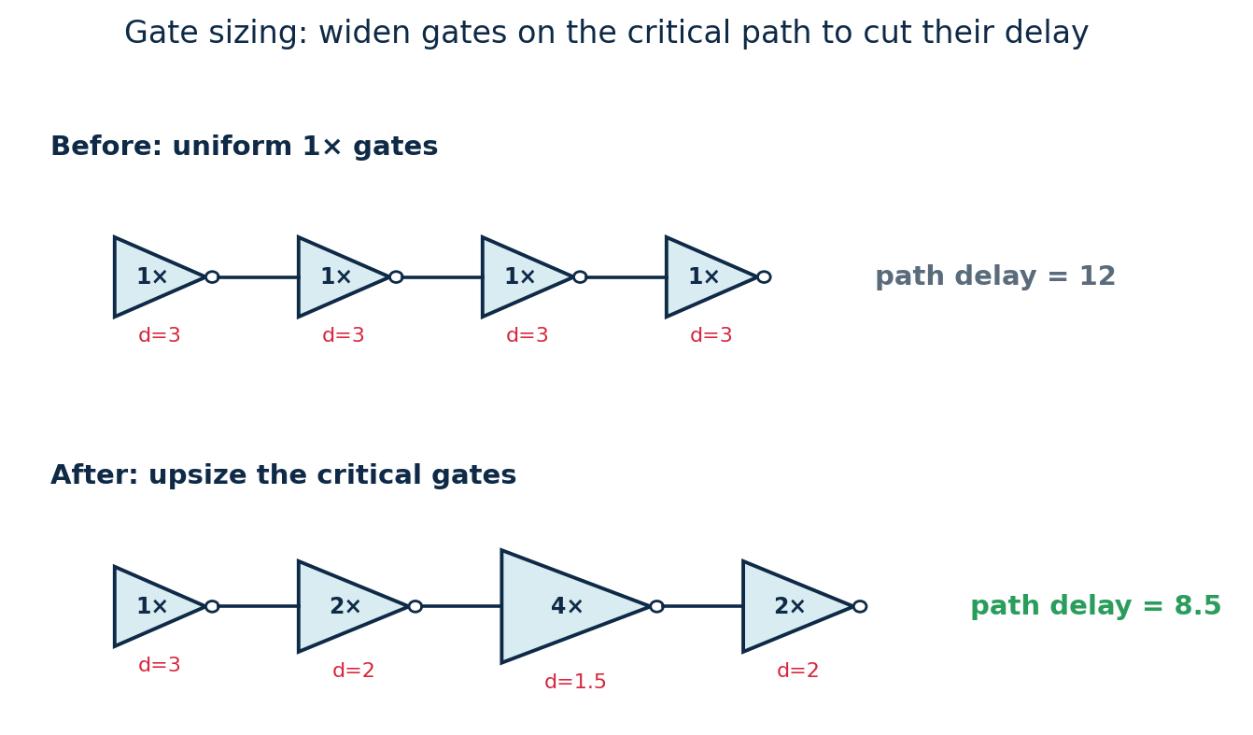
- Logic restructuring: change the logic itself so the critical signal passes through fewer levels. Re-associating a deep chain into a balanced tree keeps the same function with less depth.
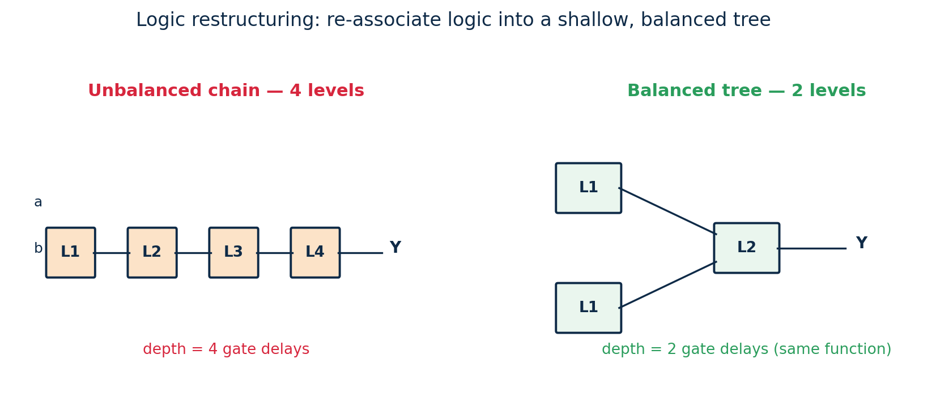
- Other techniques: factoring to shorten a late-arriving input's path, buffer/repeater insertion on long heavily-loaded nets, and cloning/duplication to split a high-fanout driver. A key idea is to route the latest-arriving signal through the fewest remaining gates.

Timing optimization for performance
- It is an iterative loop: find the worst (negative-slack) path, apply a fix, re-run STA, repeat until all slack is non-negative — this is timing closure.
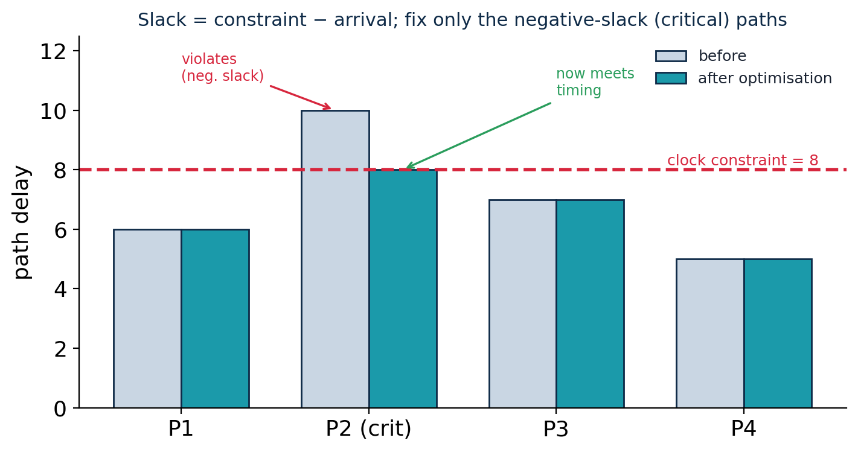
- The toolbox: gate sizing, logic restructuring, buffer insertion, pipelining (insert a register to split t_logic), retiming (move registers to balance stages), and V_th / V_DD tuning (faster cells on critical paths).
- Fix only what matters: speeding up a non-critical path does nothing for the clock; effort goes where slack is negative, and fixing one path often exposes the next-worst one — always balancing speed against area and power.

2.11 Timing in sequential circuits
Real chips store state. This section introduces flip-flops and registers, the setup/hold timing they impose, and how to optimise sequential timing.

Sequential circuits: flip-flops and registers
- Combinational vs sequential: combinational logic depends only on its present inputs; sequential logic also depends on stored state held in flip-flops and updated by a common clock (a synchronous system).
- D flip-flop: copies its input D to the output Q on the rising clock edge and holds it until the next edge — a 1-bit memory whose output is stable between edges.
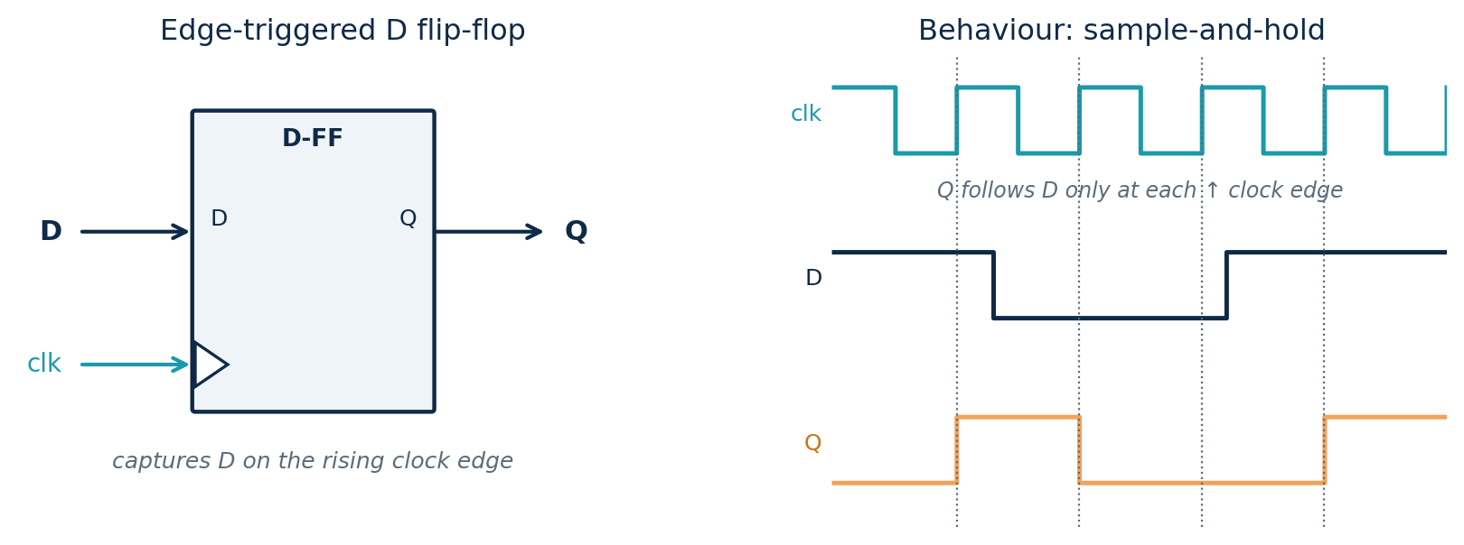
- Latch vs flip-flop: a latch is level-sensitive (transparent the whole time the clock is high); a flip-flop is edge-triggered (samples D only at the clock edge). Two latches on opposite clock phases (master–slave) make one edge-triggered flip-flop.
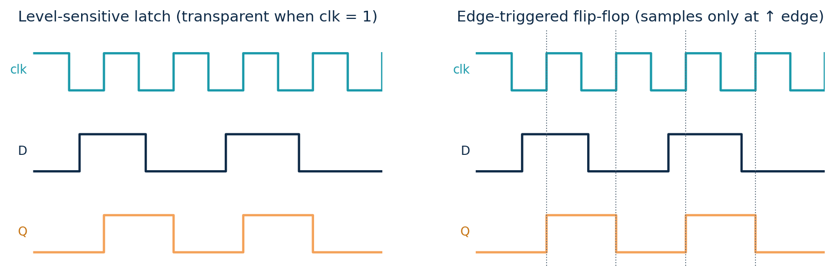
Inside the flip-flop (master–slave). An edge-triggered flip-flop is two latches in series on opposite clock phases. While clk = 0 the master latch tracks D and the slave holds; on the rising edge the master freezes and the slave passes that value to Q. The result is a single output change exactly at the edge — and the master's last value before the edge is precisely why setup time exists.
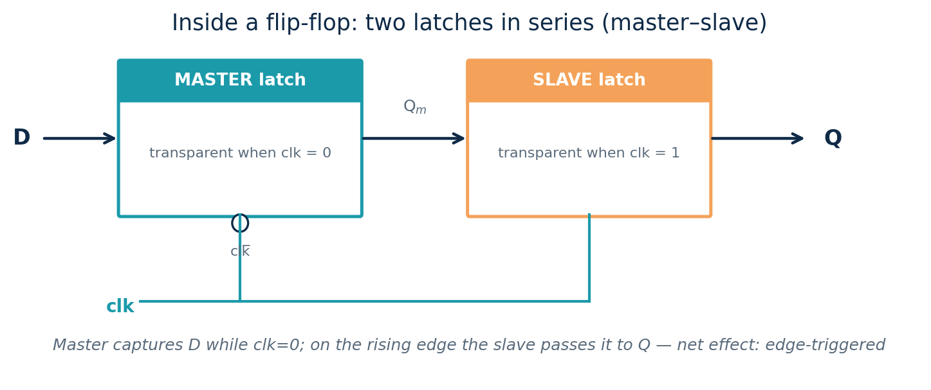
Flip-flop types. The same edge-triggered storage comes in four classic forms: D (Q⁺ = D, used for data storage and registers — by far the most common), T (toggles when T = 1, used in counters), JK (set/reset with J = K = 1 toggling, no invalid state) and SR (S sets, R resets, S = R = 1 invalid — the underlying latch primitive). D dominates because it maps directly onto how synthesis tools build registers and is easy to time.
- Register: N flip-flops sharing one clock, storing an N-bit word — the basic parallel store.
- Shift register: flip-flops chained Q→D so that on each clock edge every bit moves one position; used for serial-to-parallel conversion and fixed delays.
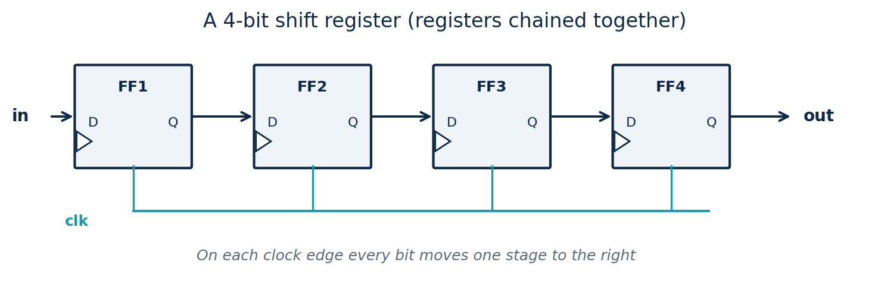
- Counters and state machines are also built from flip-flops (toggle flip-flops that count edges; a state register plus next-state logic).

Setup and hold time analysis
- Setup time t_setup: the data must be stable for t_setup before the clock edge.
- Hold time t_hold: the data must remain stable for t_hold after the clock edge.
- Violations → metastability: if data changes inside the setup/hold window the flip-flop can enter a metastable state where its output is undefined for a time; synchronizers (two flip-flops in series) reduce the risk for asynchronous inputs.
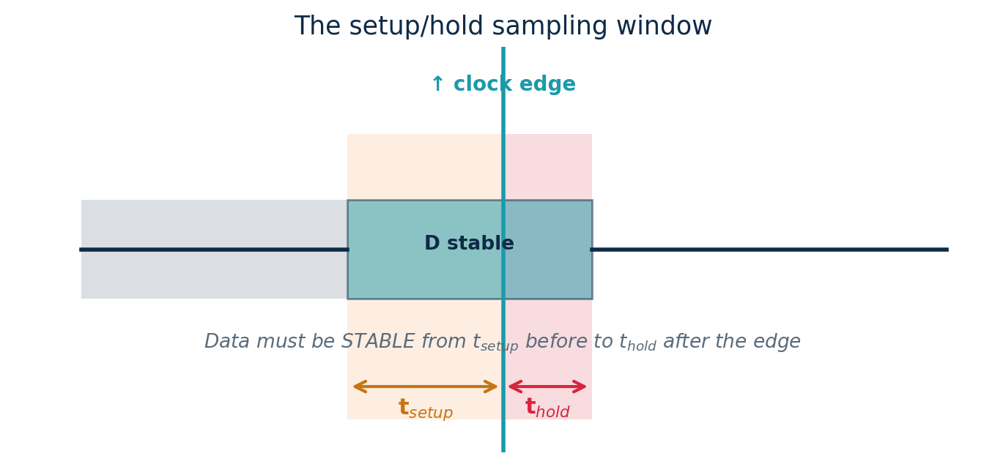
Reading a timing diagram. Drawing clock, data and output together shows exactly where the three quantities live: t_cq (clock-to-Q) is the delay from the edge until Q is valid; t_setup is how long D must already be steady before the edge; t_hold is how long it must stay steady after. Together t_setup and t_hold define a keep-out window around the edge in which D must not change.
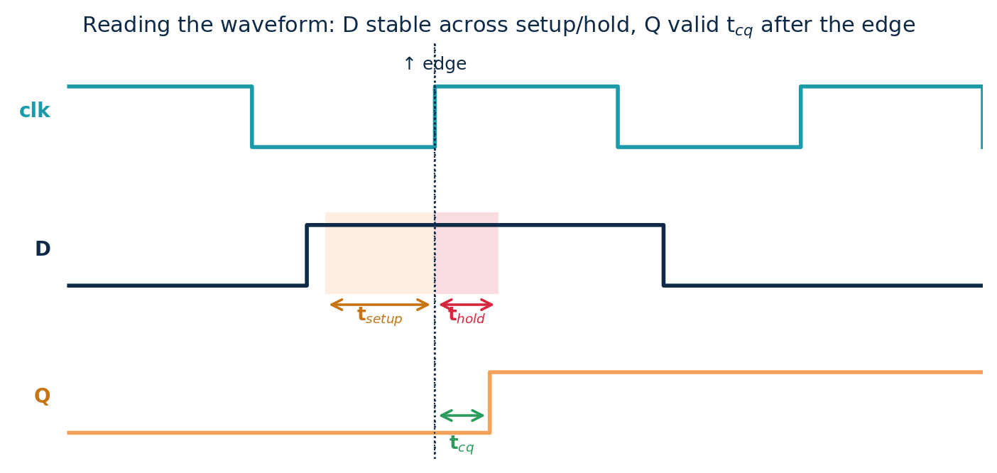
- Register-to-register path: with combinational logic between two flip-flops, two constraints apply.
- Setup (max-delay): T_clk ≥ t_cq + t_logic + t_setup — this sets the fastest clock.
- Hold (min-delay): t_cq + t_logic(min) ≥ t_hold — independent of the clock period, fixed with min-delay buffers.
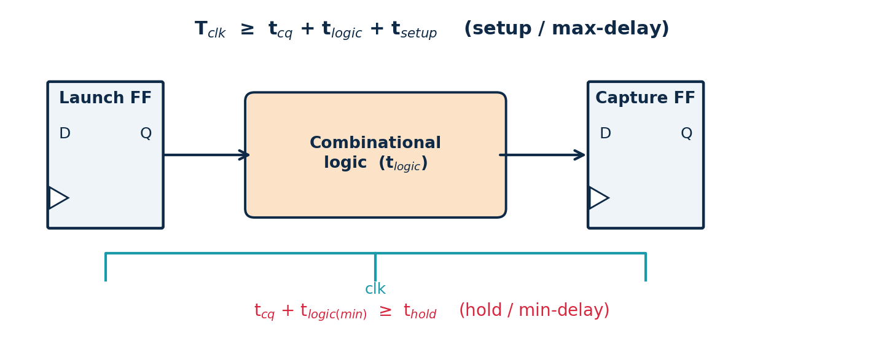
Worked example. With t_cq = 50 ps, t_logic = 300 ps and t_setup = 40 ps: T_clk ≥ 50 + 300 + 40 = 390 ps, so f_max ≈ 1/390 ps ≈ 2.56 GHz.
Clock skew in the equations. If the clock reaches the capture flip-flop a time δ later than the launch flip-flop, the budgets shift: setup becomes T_clk + δ ≥ t_cq + t_logic + t_setup (skew relaxes setup), while hold becomes t_cq + t_logic(min) ≥ t_hold + δ (skew tightens hold). Skew is therefore a double-edged sword, which is why clock-tree design works to minimise it.
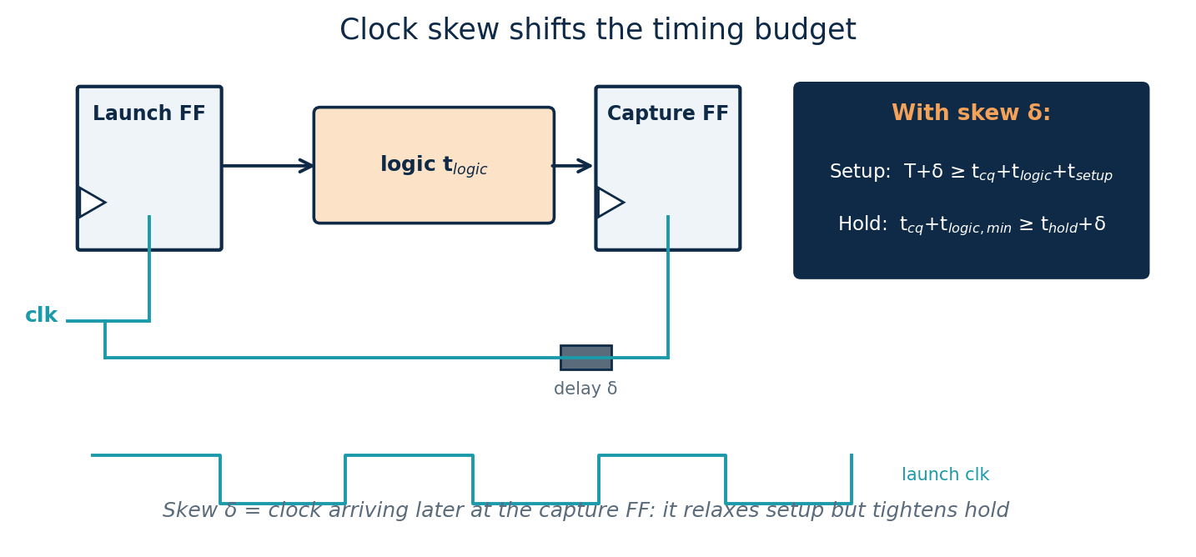

Sequential timing considerations and optimization
- Clock skew: the clock arrives at different flip-flops at slightly different times, relaxing setup but eating into hold margin; it must be budgeted.
- Clock jitter: cycle-to-cycle variation of the clock edge shrinks the usable period, so a margin is kept.
- Metastability and synchronizers: an asynchronous input (from another clock domain or the outside world) can violate setup/hold and leave a flip-flop hovering between 0 and 1. A two-flip-flop synchronizer gives the first flip-flop a full clock cycle to resolve, making the probability of a metastable value reaching the logic astronomically small (large MTBF). Synchronise every signal that crosses a clock domain.
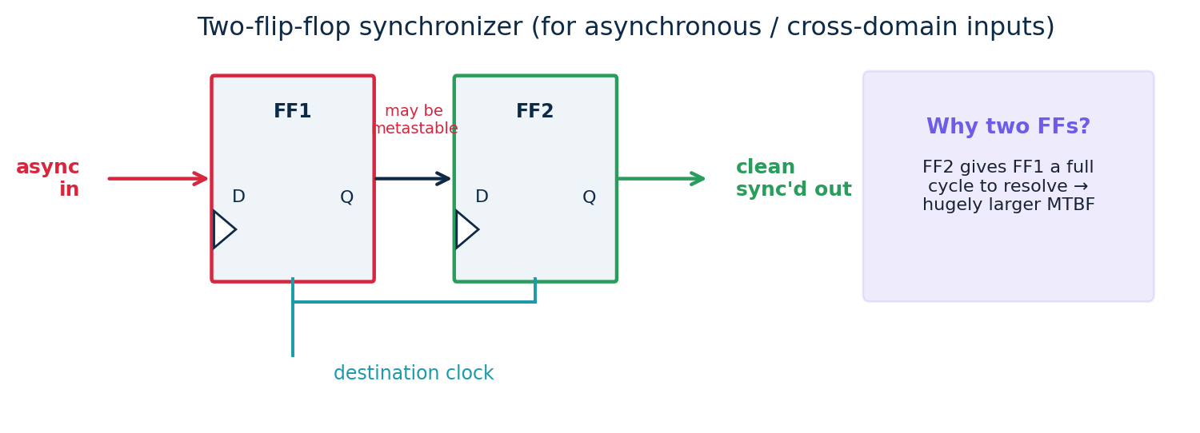
- Optimization: pipelining inserts registers to split deep logic into shorter stages → smaller t_logic, faster clock and higher throughput (at the cost of latency); retiming moves existing registers across logic to balance stage delays; the gate-level techniques (sizing, restructuring) from 2.10 also apply.
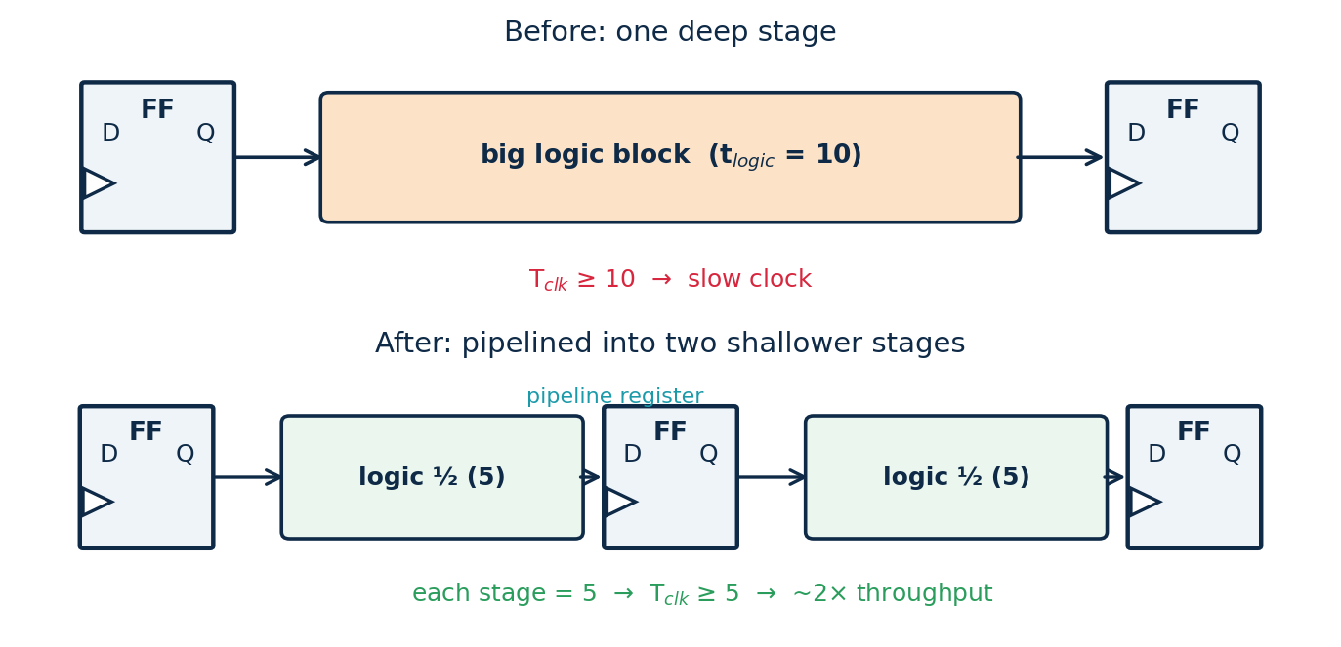

Formula sheet
Quantity | Formula
Saturation current | I_{D} = ½ · k · (V_{GS} − V_{th})²
Triode current | I_{D} = k · [(V_{GS}−V_{th})V_{DS} − V_{DS}²/2]
Propagation delay | t_{p} ≈ 0.69 · R · C
Elmore delay | τ_{i} = Σ R_{ik} · C_{k}
Dynamic power | P_{dyn} = α · C · V_{DD}² · f
Energy / switch | E = ½ · C · V_{DD}²
Noise margins | NM_{H} = V_{OH}−V_{IH} ; NM_{L} = V_{IL}−V_{OL}
Logical-effort delay | d = g · h + p
Setup constraint | T ≥ t_{cq} + t_{logic} + t_{setup}
Max frequency | f_{max} = 1 / (critical-path delay)

Part 3 · Guided Tutorials
Eighteen worked tutorials take you from the design flow and a single transistor to a full timing check. Try each numbered step yourself before reading the explanation, and redraw every diagram by hand.

Tutorial 1 — Analyse the CMOS inverter
Goal: confirm the inverter outputs the complement of its input, and see why static power is negligible.
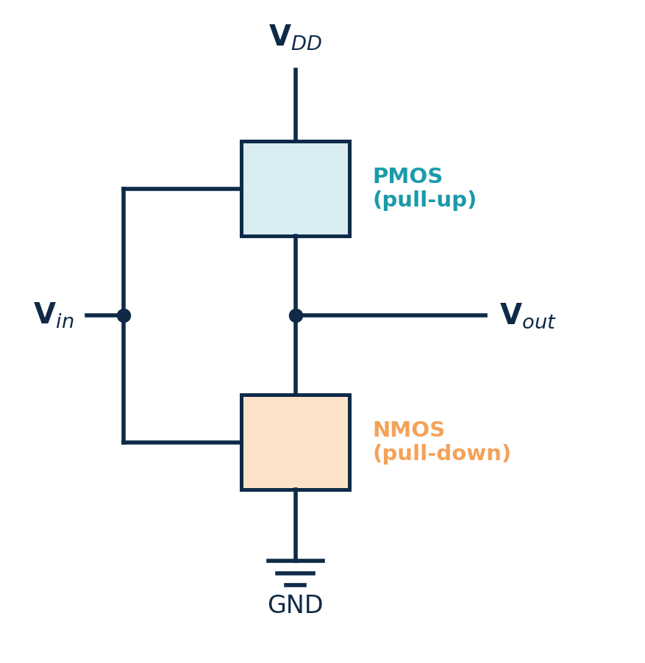
- Apply V_{in} = 0 (low). The PMOS gate sees 0 → PMOS ON; the NMOS gate sees 0 → NMOS OFF. The output is pulled up to V_{DD} = logic 1.
- Apply V_{in} = 1 (high). PMOS OFF, NMOS ON → the output is pulled to GND = logic 0.
- Note the steady-state current. In both cases exactly one network conducts and the other is open, so there is no DC path from V_{DD} to GND → static power ≈ 0.
- Tabulate and confirm the behaviour is inversion:
Vin | PMOS | NMOS | Vout
0 | ON | OFF | 1
1 | OFF | ON | 0
Takeaway
The inverter is the simplest complementary gate. The same pull-up / pull-down idea, generalised, builds every static CMOS gate.

Tutorial 2 — Build a 2-input NAND gate
Goal: derive the transistor network for Y = (A·B)′ from first principles.
- State when the output is 0. For NAND, Y = 0 only when A = 1 AND B = 1.
- Build the pull-down network. “AND” of conditions → NMOS transistors in series: two NMOS between output and GND.
- Build the pull-up by duality. Series in the PDN becomes parallel in the PUN → two PMOS in parallel between V_{DD} and output.
- Count and verify. 4 transistors total. Check all four input combinations against the truth table.
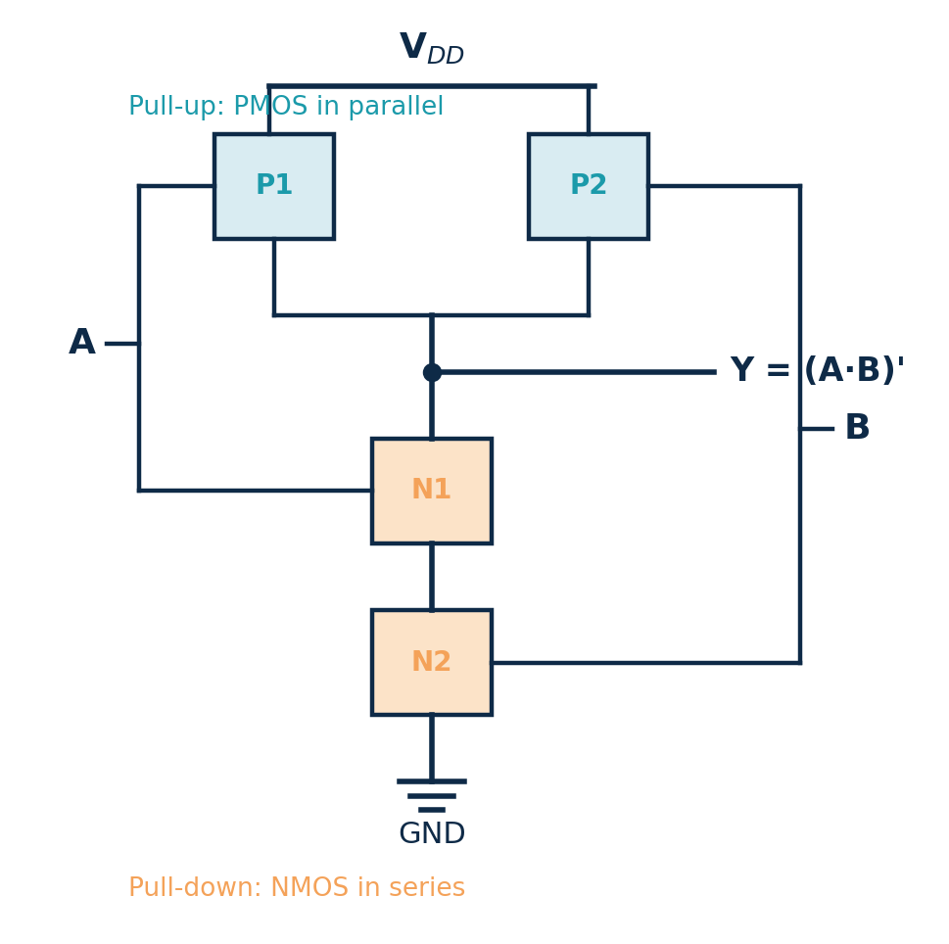
A | B | Y
0 | 0 | 1
0 | 1 | 1
1 | 0 | 1
1 | 1 | 0
Takeaway
NAND = NMOS in series, PMOS in parallel. An n-input NAND needs 2n transistors. NAND is the preferred building block because series PMOS (as in NOR) is slow.

Tutorial 3 — Build a 2-input NOR gate
Goal: derive the network for Y = (A+B)′ and contrast it with the NAND.
- Output is 0 when A OR B is 1. “OR” → NMOS transistors in parallel for the pull-down (two NMOS in parallel to GND).
- Dual pull-up. Parallel becomes series → two PMOS in series from V_{DD} to output.
- Verify. Output is 1 only when A = 0 and B = 0.
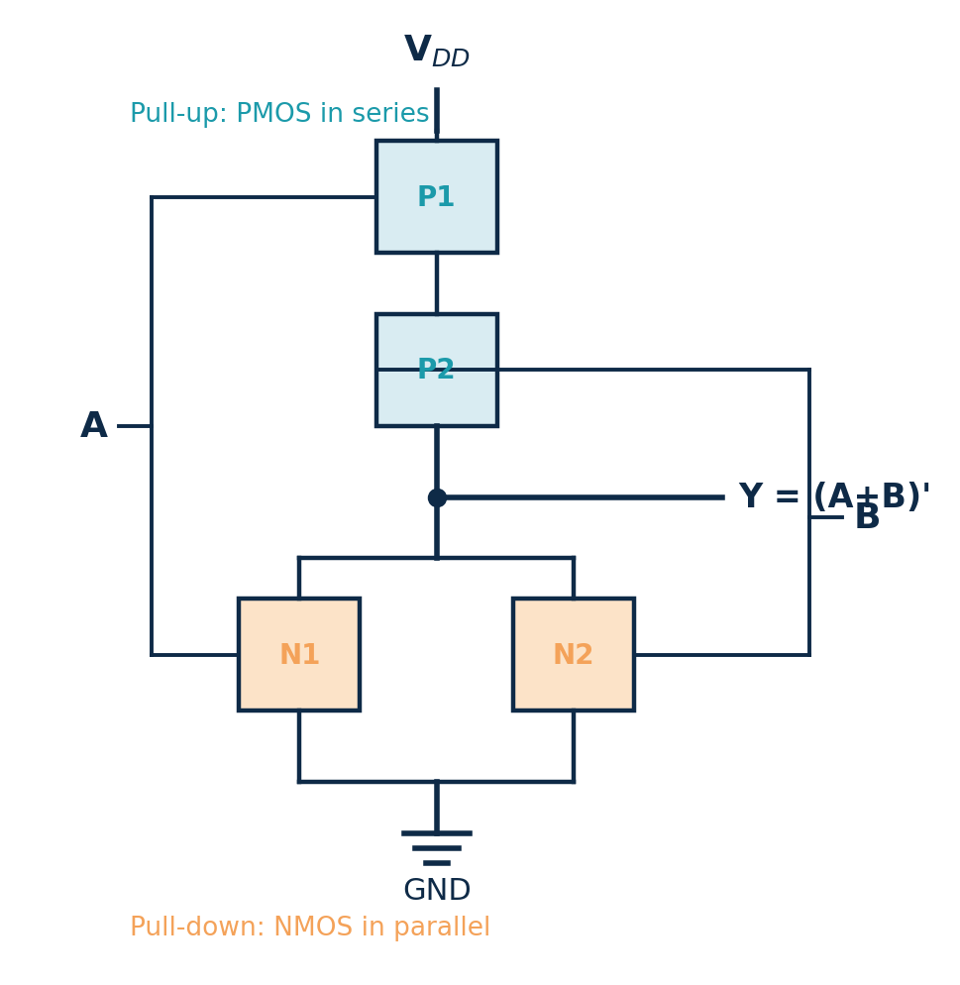
A | B | Y
0 | 0 | 1
0 | 1 | 0
1 | 0 | 0
1 | 1 | 0
Takeaway
NOR is the mirror image of NAND: NMOS parallel, PMOS series. The two PMOS in series make the pull-up weaker/slower, which is why NAND-based logic is generally faster.

Tutorial 4 — Design a complex (AOI) gate
Goal: realise Y = (A·B + C)′ in a single static gate.
- Read the expression inside the inversion: (A·B) + C.
- Build the PDN. A·B → A in series with B; the “+ C” → that branch in parallel with a C transistor.
- Build the PUN as the dual. Swap every series for parallel: (A ∥ B) in series with C, using PMOS.
- Count. 3 NMOS + 3 PMOS = 6 transistors — versus ~14 if built from separate AND, OR and INV gates.
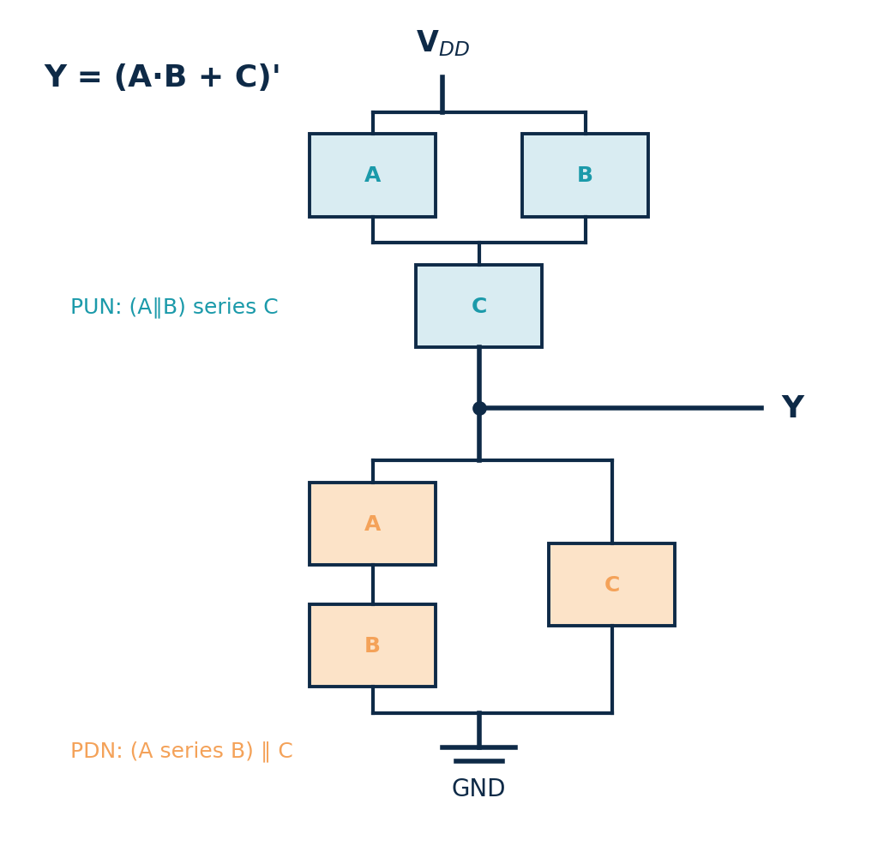
Takeaway
Complex AOI/OAI gates implement sum-of-products logic with fewer transistors and less delay than discrete gates. This is a key reason synthesis tools love them.

Tutorial 5 — Compute inverter propagation delay
Goal: use the RC model to find the delay of an inverter driving a capacitive load.
Given: on-resistance R_{on} = 12 kΩ, load capacitance C_{L} = 25 fF.
- Write the model: t_{p} ≈ 0.69 · R · C.
- Compute R·C = (12×10³ Ω)(25×10⁻¹⁵ F) = 3.0×10⁻¹⁰ s.
- t_{p} = 0.69 × 3.0×10⁻¹⁰ = 2.07×10⁻¹⁰ s = 207 ps.
- Sanity check: if the load doubles to 50 fF, the delay doubles to 414 ps — delay is linear in C.
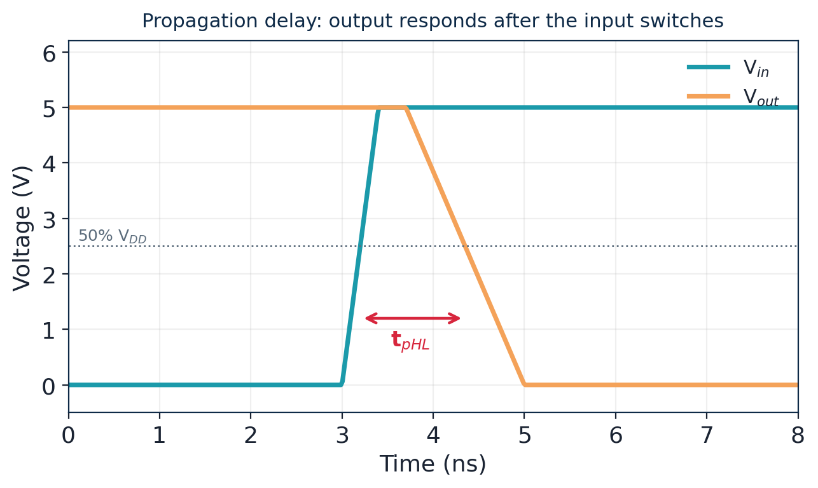
Takeaway
Delay scales with both R and C. Designers speed up a path by widening transistors (lower R), reducing fan-out/wire load (lower C), or inserting buffers.

Tutorial 6 — Estimate dynamic power
Goal: compute the switching power of a block and see the effect of supply voltage.
Given: total switched capacitance C = 5 pF, V_{DD} = 1.2 V, clock f = 1 GHz, activity factor α = 0.2.
- Formula: P_{dyn} = α · C · V_{DD}² · f.
- Substitute: P = 0.2 × (5×10⁻¹²) × (1.2)² × (1×10⁹).
- (1.2)² = 1.44, so P = 0.2 × 5×10⁻¹² × 1.44 × 10⁹ = 1.44 mW.
- Voltage insight: halving V_{DD} to 0.6 V cuts dynamic power ~4× (the V² term) to ≈ 0.36 mW.
Takeaway
Dynamic power depends on the square of the supply, so voltage scaling is the single most powerful knob for saving switching energy.

Tutorial 7 — Elmore delay of an RC wire
Goal: estimate the delay of a wire modelled as two RC segments.
Given: R₁ = R₂ = 1 kΩ and C₁ = C₂ = 10 fF (a wire split into two equal π-segments).
- Elmore rule: each capacitor is multiplied by the resistance it shares on the path from the source.
- Node 1 sees R₁; node 2 sees R₁+R₂. τ = R₁(C₁+C₂) + (R₁+R₂)C₂.
- Substitute: τ = 1k·(20f) + 2k·(10f) = 20×10⁻¹² + 20×10⁻¹² = 40 ps.
- Scaling: with more, finer segments the un-buffered delay grows with length². Buffer insertion breaks this into near-linear pieces.
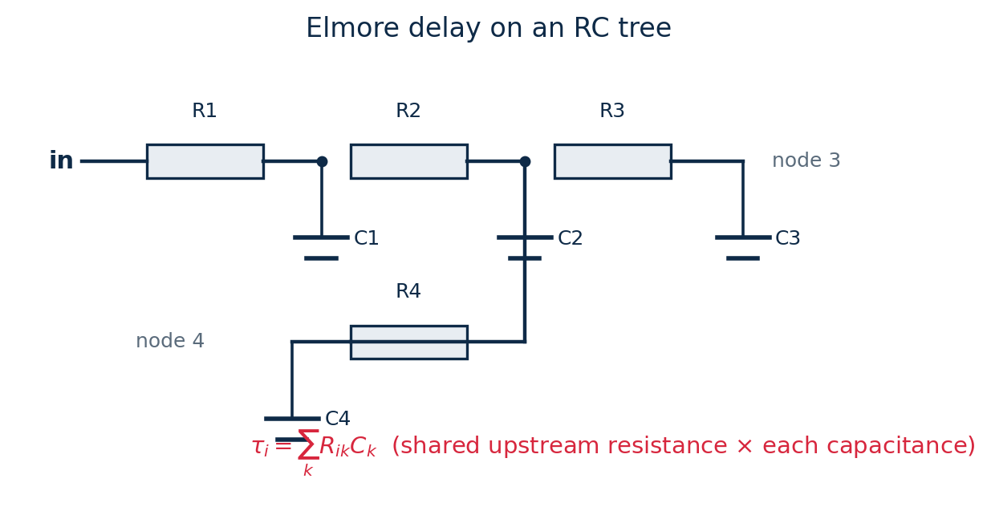
Takeaway
Elmore delay gives a fast, reasonably accurate hand-estimate for RC trees without solving differential equations.

Tutorial 8 — Setup/hold check and maximum frequency
Goal: decide whether a synchronous path meets timing, and find the fastest clock it can run at.
Given: clock period T = 1 ns; clock-to-Q t_{cq} = 0.1 ns; combinational logic t_{logic} = 0.6 ns; setup t_{setup} = 0.1 ns.
- Setup constraint: data must arrive by T − t_{setup}. Required arrival ≤ 1.0 − 0.1 = 0.9 ns.
- Actual arrival = t_{cq} + t_{logic} = 0.1 + 0.6 = 0.7 ns.
- Slack = required − arrival = 0.9 − 0.7 = +0.2 ns → PASS.
- Maximum frequency: the minimum period is t_{cq}+t_{logic}+t_{setup} = 0.8 ns, so f_{max} = 1/0.8 ns = 1.25 GHz.
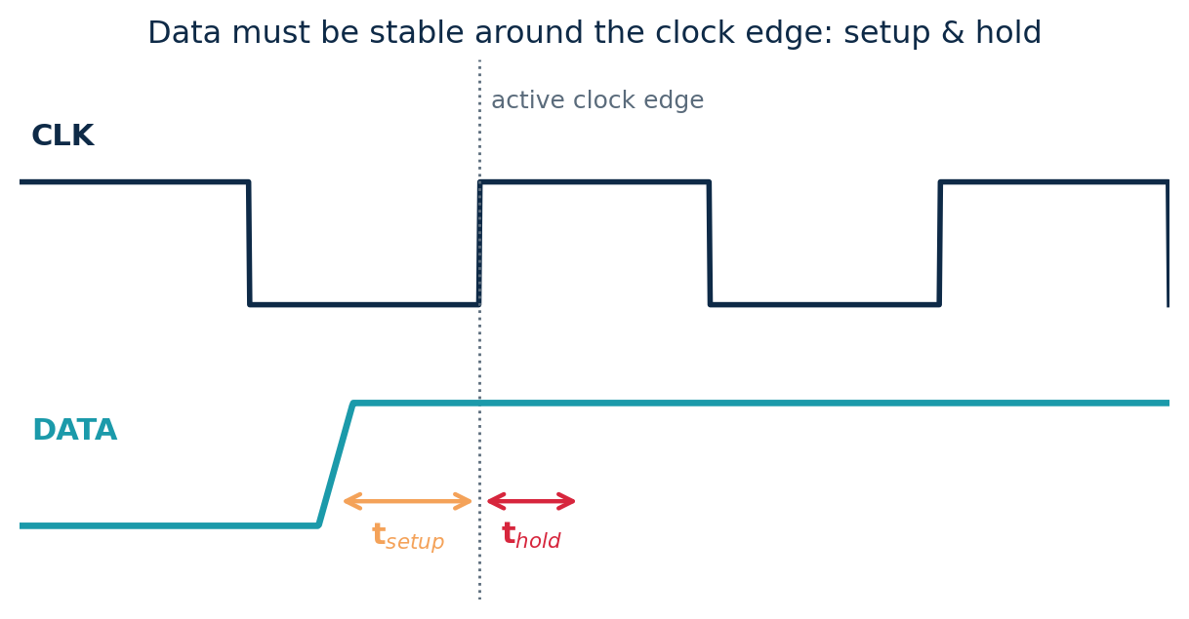
Takeaway
Positive slack means timing is met. The smallest-slack path in the whole chip is the critical path and it fixes the maximum clock frequency — exactly what Static Timing Analysis (Module 3) automates.

Tutorial 9 — Trace a design through the flow
Goal: take a jumbled list of design activities, sort them into front-end and back-end, and put each in the right order.
Given tasks (shuffled): routing; RTL coding; floorplanning; logic synthesis; functional verification; clock-tree synthesis; specification; DRC/LVS; placement; STA sign-off.
- Separate by concern. Front-end = behaviour/logic; back-end = physical geometry.
- Order the front-end: specification → RTL coding → functional verification → logic synthesis.
- Mark the hand-off: synthesis emits the gate-level netlist that the back-end consumes.
- Order the back-end: floorplanning → placement → clock-tree synthesis → routing → STA sign-off → DRC/LVS.
- State each output: front-end → verified netlist; back-end → GDSII for the foundry.
Takeaway
Knowing which half an activity belongs to tells you where to look when something goes wrong: a wrong result is usually a front-end (logic) issue, while a timing or spacing violation is usually a back-end (physical) issue.

Tutorial 10 — Operating region & drain current
Goal: for a given bias, decide the MOSFET's region and compute the drain current with the square-law model.
Given: an NMOS with k = µ·C_{ox}·(W/L) = 200 µA/V² and V_{th} = 0.5 V. Find I_{D} for V_{GS} = 1.5 V at (a) V_{DS} = 2.0 V and (b) V_{DS} = 0.5 V.
- Compute the overdrive: V_{ov} = V_{GS} − V_{th} = 1.5 − 0.5 = 1.0 V. (Since V_{GS} > V_{th}, the device is on.)
- Case (a): compare V_{DS} with V_{ov}. 2.0 ≥ 1.0 → saturation.
- I_{D} = ½·k·V_{ov}² = ½ × 200µ × 1.0² = 100 µA.
- Case (b): 0.5 < 1.0 → triode. I_{D} = k·[V_{ov}·V_{DS} − V_{DS}²/2] = 200µ × [1.0×0.5 − 0.5²/2] = 200µ × 0.375 = 75 µA.
- Sizing check: doubling W/L doubles k to 400 µA/V², so the saturation current in (a) doubles to 200 µA — drive current scales with W/L.
Takeaway
Always find the region first (compare V_DS with the overdrive V_GS − V_th), then apply the matching equation. Current grows with the square of overdrive in saturation and with W/L in both regions.

Tutorial 11 — Inverter sizing & a buffer chain
Goal: size an inverter for equal rise/fall, then design a buffer chain to drive a large load.
Part A — the β ratio. An NMOS of width W has on-resistance R_{n} = 10 kΩ; a PMOS of the same width has R_{p} = 20 kΩ (holes are ~2× slower).
- For equal rise and fall the pull-up and pull-down resistances must match: set R_{p} = R_{n}.
- Resistance ∝ 1/width, so double the PMOS width: R_{p} → 20k/2 = 10 kΩ. Hence W_p / W_n = 2.
- This also centres the VTC at V_{M} ≈ V_{DD}/2, giving balanced noise margins.
Part B — a buffer chain. A minimum-size inverter (input cap C_{in}) must drive a load C_{L} = 64·C_{in}.
- Path effort F = C_{L}/C_{in} = 64.
- Pick a per-stage effort of ≈ 4 (near optimum). Number of stages N = log₄(64) = 3.
- Size the stages geometrically: 1× → 4× → 16×, with the 16× stage driving the 64× load. Each stage sees a fan-out of 4.
Takeaway
Two rules cover most inverter sizing: use W_p/W_n ≈ 2 for a balanced gate, and taper a buffer chain at ~4× per stage (FO4) to drive a big load with the least delay.

Tutorial 12 — Design a complex CMOS gate
Goal: realise the function Y = (A·B + A·C)′ as a single static gate, using factoring to minimise transistors.
- Write the output in inverted form. It already is: Y = (A·B + A·C)′, so the bracket f = A·B + A·C goes in the pull-down network.
- Factor f to share transistors. A·B + A·C = A·(B + C). The literal A is common, so it need appear only once.
- Build the PDN (NMOS). A·(B+C): transistor A in series with the parallel pair (B ∥ C) — three NMOS instead of four.
- Build the PUN as the dual (PMOS). Swap series↔parallel: A in parallel with the series pair (B series C).
- Count and check. 3 NMOS + 3 PMOS = 6 transistors. Verify: Y = 0 only when A = 1 and (B = 1 or C = 1).
Compare: the unfactored form A·B + A·C would have used 4 series-path NMOS (two stacks), so factoring saved transistors and shortened the worst-case stack — both faster and smaller.
Takeaway
To design any inverting function: put it in the PDN (AND→series, OR→parallel), take the dual for the PUN, and always factor first to share devices and keep series stacks short.

Tutorial 13 — Plan a gate layout with an Euler path
Goal: plan a compact layout for a 3-input NAND by finding a transistor ordering that shares diffusion, and identify the layers used.
Given: a 3-input NAND, Y = (A·B·C)′ — three NMOS in series (pull-down) and three PMOS in parallel (pull-up).
- List the pull-down network. NMOS A, B, C in series from the output node to GND: GND–A–B–C–Y.
- Find an Euler path. Walk the series chain in one pass, A → B → C, so the NMOS sit in the order A, B, C with each shared source/drain region abutting the next — one continuous n-diffusion strip.
- Mirror for the PMOS. The three parallel PMOS share both their source (V_DD) and drain (Y) diffusions, so they also form one continuous p-diffusion strip above the n-well boundary.
- Use one poly strip per input. Each of A, B, C is a single vertical poly line crossing both the p-diffusion (PMOS) and the n-diffusion (NMOS) — 3 poly columns total.
- Assign layers. diffusion (devices), poly (gates), contacts (diffusion/poly → metal), and metal-1 for the V_DD / GND rails and the output Y. Run DRC and LVS to sign it off.
Takeaway
Sharing diffusion via an Euler-path ordering gives a minimum-width cell; gates are poly, devices are diffusion, and metal carries the rails and output — exactly how standard-cell libraries are drawn.

Tutorial 14 — Wire delay and repeater insertion
Goal: estimate a long wire's delay with the Elmore model, then show why inserting a repeater helps.
Given: a wire modelled as two equal RC segments, each with R = 2 kΩ and C = 20 fF (so R₁ = R₂ = 2 kΩ, C₁ = C₂ = 20 fF).
- Write the Elmore delay. Each capacitor is multiplied by the resistance it shares with the source: τ = R₁(C₁+C₂) + (R₁+R₂)C₂.
- Substitute. τ = 2k×(40f) + 4k×(20f) = 80 ps + 80 ps = 160 ps.
- Note the L² growth. Doubling the wire length (four segments of the same size) roughly quadruples this delay — the hallmark of distributed RC.
- Insert a repeater. Place a buffer at the midpoint, splitting the wire into two independent halves. Each half now has only half the length, so about one-quarter of the delay; the two halves add linearly instead of quadratically.
- Compare. Two half-wires (≈ ¼ delay each) plus the buffer's own delay beat the single L² wire once the wire is long enough — which is exactly when repeaters are used.
Takeaway
Elmore delay (each C × its shared upstream R) gives a fast hand-estimate; because un-buffered delay grows as L², breaking long wires with repeaters to make the delay linear is one of the most important interconnect optimisations.

Tutorial 15 — Plan a bonding diagram & choose a package
Goal: for a small chip, decide a connection method, sketch the bonding plan, and pick a package family.
Given: a digital die with 48 signal I/O plus several V_DD/GND pads, targeting a low-cost consumer product.
- Count the pins. 48 signal + (say) 8 power/ground = ~56 connections — a moderate pin count.
- Choose a connection method. For low cost and this pin count, wire bonding (die face-up, pads on the die edge) is the natural choice; flip-chip would be reserved for much higher I/O or performance.
- Place the pads. Spread the 56 pads evenly around the four die edges so bond wires are short and roughly equal in length, with no crossings.
- Strengthen power. Assign several parallel V_DD and GND bonds (not just one each) to lower the bond-wire inductance and IR drop that cause ground bounce on fast switching.
- Pick a package family. ~56 pins, low cost, peripheral leads → a QFP (leads on four sides) fits well; a BGA would be chosen only if the pin count or board density were higher.
- Draw the bonding diagram. Map each die pad to its package pin and show every wire — this is the hand-off to the assembly house, and the pin assignment should also suit the board's routing.
Takeaway
Match the connection method and package to the pin count, cost and performance: wire-bond + QFP for moderate, low-cost parts; flip-chip + BGA (or 2.5D/3D) when I/O, speed or integration demand it. Always reinforce power/ground bonds and keep wires short.

Tutorial 16 — Gate delay & logical-effort path sizing
Goal: estimate a gate's delay with the linear model, then size a multi-stage path for minimum delay.
Part A — single-gate delay. A NAND2 gate (g = 4/3, p = 2) drives a capacitance equal to 3× its own input capacitance (h = 3).
- Apply the model: d = g·h + p = (4/3)(3) + 2.
- Compute: (4/3)(3) = 4, so d = 4 + 2 = 6 τ (six inverter delays).
- Compare with an inverter (g = 1, p = 1) at the same h = 3: d = 3 + 1 = 4 τ — the NAND is slower because both its g and p are larger.
Part B — size a path. A path of inverting gates must drive a load C_{L} = 64·C_{in}. Assume all gates are inverters (G = 1) and no branching (B = 1).
- Path effort F = G·B·H = 1·1·64 = 64.
- Best stage effort ≈ 4, so number of stages N = log₄(64) = 3.
- Each stage effort f = 64^(1/3) = 4; size the stages 1× → 4× → 16× (the 16× stage drives the 64× load).
- Estimated path delay D = N·f + Σp = 3×4 + 3×1 = 12 + 3 = 15 τ (using p = 1 per inverter).
Takeaway
d = g·h + p turns delay into simple arithmetic. For a path, spread the total effort F evenly across N stages (stage effort ≈ 4) and size back-to-front — that gives the minimum-delay design.

Tutorial 17 — Find and optimise a critical path
Goal: compute arrival times to locate the critical path, then apply two techniques to speed it up.
Given: a small network. Two paths reach output Y: Path 1 = A → g1(d=2) → g4(d=3) → g6(d=3) → g7(d=2); Path 2 = D → g3(d=1) → g5(d=2) → g6(d=3) → g7(d=2).
- Compute arrival times. Path 1 = 2+3+3+2 = 10; Path 2 = 1+2+3+2 = 8.
- Identify the critical path. The larger arrival wins: Path 1 = 10 is critical; Path 2 has 2 units of slack relative to it.
- Check the constraint. If the clock budget for logic is 8 units, Path 1 has slack = 8 − 10 = −2 (a violation); Path 2 has slack = 0.
- Technique 1 — gate sizing. Upsize the two slowest critical gates (g4 and g6) so each drops ~1 unit: arrival becomes 2+2+2+2 = 8 → meets timing.
- Technique 2 — restructuring. Alternatively, if g4→g6 is a deep AND chain, re-associate it into a balanced tree so the critical signal sees one fewer level, also cutting ~1–2 units — often cheaper in area than sizing.
- Re-analyse. After the fix, recompute arrivals; here Path 2 (now 8) becomes the new worst path — confirming you stop only when every path's slack ≥ 0.
Takeaway
Optimisation is targeted: find the longest path by arrival times, fix only it (size the critical gates or flatten the logic), then re-analyse — because fixing one path simply promotes the next one to critical.

Tutorial 18 — Setup/hold analysis of a register path
Goal: find the maximum clock frequency of a flip-flop-to-flip-flop path and check the hold constraint.
Given: clock-to-Q delay t_{cq} = 60 ps, combinational logic delay t_{logic} = 250 ps (max) and 30 ps (min), setup time t_{setup} = 40 ps, hold time t_{hold} = 50 ps.
- Write the setup (max-delay) constraint. T_{clk} ≥ t_{cq} + t_{logic} + t_{setup}.
- Substitute. T_{clk} ≥ 60 + 250 + 40 = 350 ps.
- Find f_max. f_{max} = 1 / 350 ps ≈ 2.86 GHz.
- Write the hold (min-delay) constraint. t_{cq} + t_{logic(min)} ≥ t_{hold}.
- Check it. 60 + 30 = 90 ps ≥ 50 ps ✓ — the hold constraint is satisfied (and note it does not depend on the clock period).
- Push the speed. To go faster, reduce t_{logic} by sizing/restructuring, or pipeline the logic so each stage has less delay.
Takeaway
The setup equation T_clk ≥ t_cq + t_logic + t_setup sets the maximum clock; the hold equation t_cq + t_logic(min) ≥ t_hold is checked separately and is independent of clock speed. Lower t_logic (by optimisation or pipelining) to raise f_max.

Part 4 · Practice Problems
Attempt all 112 problems without looking at the solutions. They are grouped into conceptual, logic-design and numerical sets and roughly ordered easy → hard.

Section A · Conceptual (Q1–Q11)
- Define VLSI and give two everyday products that contain a System-on-Chip.
- List the seven stages of the VLSI design flow in order, and mark which are front-end and which are back-end.
- Name the three PPA design metrics and give one example of a trade-off between two of them.
- Explain, in terms of which network conducts, why a CMOS gate dissipates almost no power in steady state.
- State the condition (in terms of V_{GS} and V_{th}) for an NMOS and for a PMOS to be ON.
- For an NMOS with V_{th} = 0.7 V, give the operating region in each case: (a) V_{GS} = 0.5 V, V_{DS} = 1 V; (b) V_{GS} = 2 V, V_{DS} = 0.5 V; (c) V_{GS} = 2 V, V_{DS} = 2 V.
- Define NM_{H} and NM_{L} and explain why larger noise margins make a circuit more robust.
- Name the five regions (A–E) of the inverter VTC and say which one provides the high voltage gain.
- List, in order from bottom to top, four fabrication layers used in a CMOS process and state what each is for.
- What do DRC and LVS each check, and why are both needed before tape-out?
- Explain why an un-buffered long on-chip wire has delay that grows with the square of its length, and how buffer insertion helps.

Section B · Logic design (Q12–Q20)
- Sketch the transistor-level pull-up and pull-down networks for a 2-input NAND gate and label the series/parallel arrangement.
- Do the same for a 2-input NOR gate, and state which gate is generally faster and why.
- How many transistors does a 3-input NAND need? Describe its PDN and PUN.
- Design the PDN and PUN for the AOI gate Y = (A·B + C)′ and give the total transistor count.
- Design a gate that implements Y = (A + B·C)′ (an OAI gate). Describe both networks and count the transistors.
- A student proposes building an inverter from two NMOS transistors. Explain why standard CMOS uses one NMOS and one PMOS instead.
- Explain what a transmission gate is, why it needs both an NMOS and a PMOS, and give one circuit where it is useful.
- Fill in the output column of the truth table for Y = (A·B)′ and confirm it matches a NAND.
- For the gate Y = (A·B + C·D)′, state the pull-down and pull-up structures and the transistor count.

Section C · Numerical: delay, power & timing (Q21–Q32)
- A gate has on-resistance R = 5 kΩ and drives C = 20 fF. Estimate its propagation delay with the RC model.
- If the load capacitance on a gate doubles while R is unchanged, what happens to t_{p}? Justify with the RC model.
- A driver of R = 8 kΩ charges a wire C = 30 fF and then a gate input of 10 fF. Treat the total as lumped and find t_{p}.
- A 2-segment wire has R₁ = R₂ = 2 kΩ, C₁ = C₂ = 5 fF. Compute the Elmore delay to the far node.
- An un-buffered wire has a delay of 100 ps. Estimate its delay if the length is tripled (same width and technology).
- A block switches C = 2 pF at V_{DD} = 1.0 V and f = 500 MHz with activity α = 0.3. Find the dynamic power.
- Compute the energy drawn from the supply each time a 4 fF node is charged to V_{DD} = 1.2 V.
- A design runs at 1.0 V and 800 MHz. If V_{DD} is reduced to 0.8 V (frequency unchanged), by what factor does dynamic power change?
- A NAND2 (g = 4/3, p = 2) drives an electrical effort h = 3. Use d = g·h + p to find its delay in units, and compare with an inverter (g = 1, p = 1) at the same h.
- A path has t_{cq} = 0.12 ns, t_{logic} = 0.70 ns, t_{setup} = 0.08 ns and runs on a 1 ns clock. Compute the setup slack and say whether it passes.
- For the path in Q30, what is the maximum clock frequency the circuit can support?
- A critical path has delay 0.95 ns. A designer reduces the logic delay so the new path delay is 0.75 ns. Give the old and new maximum frequencies.

Section D · VLSI technology & the design flow (Q33–Q40)
- Define VLSI technology and explain what is meant by a System-on-Chip (SoC).
- Name the five eras of IC integration in order and give the approximate device count of each.
- List four technical advantages that integration (VLSI) provides over building a system from discrete components.
- Give four distinct application domains of VLSI chips, with one concrete example product in each.
- Explain the difference between the front-end and the back-end of the VLSI design flow, and name the artifact that is handed off between them.
- Put these front-end stages in the correct order: logic synthesis, specification, functional verification, RTL coding, architectural design.
- Put these back-end stages in the correct order: routing, floorplanning, DRC/LVS, placement, clock-tree synthesis, STA sign-off.
- Classify each of the following as front-end or back-end: (a) writing a Verilog testbench, (b) clock-tree synthesis, (c) logic synthesis with Yosys, (d) running DRC in Magic, (e) STA in OpenSTA.

Section E · CMOS transistor theory (Q41–Q48)
- Describe the three surface conditions of an NMOS MOS capacitor as the gate voltage increases from negative to above V_{th}, and say in which one the channel forms.
- State the three operating regions of a MOSFET with the condition (in terms of V_{GS}, V_{DS}, V_{th}) that defines each.
- Write the saturation-region drain-current equation and explain each symbol, including the transconductance parameter k.
- An NMOS has k = 250 µA/V² and V_{th} = 0.4 V. For V_{GS} = 1.4 V and V_{DS} = 1.5 V, find the region and I_{D}.
- For the same device, find I_{D} when V_{GS} = 1.4 V and V_{DS} = 0.2 V.
- Name the main parasitic capacitances of a MOSFET and explain why they matter for speed and power.
- Explain the difference between Moore's Law and Dennard scaling, and state what happened around 2005.
- List the device-structure evolution from planar transistors to today's leading devices, and state what improves at each step.

Section F · CMOS inverter characteristics (Q49–Q56)
- Sketch (or describe) the CMOS inverter VTC, label its five regions A–E, and state which region gives the high voltage gain.
- Define the switching threshold V_{M} and explain how widening the PMOS changes it.
- Define V_{IL} and V_{IH} in terms of the VTC slope, and write the formulas for NM_{H} and NM_{L}.
- An inverter has V_{OH} = 1.8, V_{OL} = 0.0, V_{IH} = 1.05, V_{IL} = 0.75 V. Compute both noise margins and comment on the balance.
- Name the three components of CMOS power and state which is usually dominant. Why does short-circuit power fall with faster input edges?
- A block switches C = 3 pF at V_{DD} = 1.0 V and f = 1 GHz with activity α = 0.15. Find the dynamic power, then the new power if V_{DD} is reduced to 0.8 V.
- Holes are about twice as slow as electrons. What W_{p}/W_{n} ratio gives equal rise and fall times, and what does this do to V_{M}?
- A minimum inverter must drive a load 125× its input capacitance. Using a per-stage effort of ~5, how many buffer stages are needed and what is the size taper?

Section G · CMOS logic design (Q57–Q64)
- Complete the output column for a 2-input NAND, NOR and XOR for all four input combinations.
- Explain why static CMOS gates are naturally inverting, and how many transistors a 2-input AND therefore needs.
- What does it mean for a gate to be universal? Show how to make a NOT and an AND using only NAND gates.
- State the four-step recipe for designing a static CMOS gate from a Boolean expression.
- Design the pull-down and pull-up networks for a 3-input NAND, and give the transistor count.
- Design a static gate for the AOI function Y = (A·B + C·D)′: describe both networks and count the transistors.
- Factor Y = (A·C + B·C)′ to minimise transistors, then describe the resulting pull-down network.
- Write the Boolean function of a 2:1 multiplexer and give two ways to implement it in CMOS.

Section H · Transistor-level schematics & layouts (Q65–Q72)
- State what a transistor-level schematic (and its netlist) captures, and which course tool simulates it.
- Explain shared (abutted) diffusion and why an Euler-path transistor ordering is used to achieve it.
- Give two differences between a schematic and a layout of the same gate.
- In an inverter layout, where do the PMOS and NMOS sit, what forms the input, and what does metal-1 carry?
- What is a standard cell, and why do all cells in a library share the same height?
- Explain the difference between DRC and LVS, and state which question each answers.
- Describe the metal interconnect stack: how do lower and upper metal layers differ, and what are vias for?
- Why do routers use alternating preferred directions on successive metal layers, and name two goals of routing.

Section I · On-chip wire modeling (Q73–Q80)
- What is an on-chip interconnect, and how do local, intermediate and global wires differ?
- Explain the “interconnect problem”: why does wire delay matter more at advanced nodes than it used to?
- Give the formula for a wire's resistance in terms of sheet resistance, and compute R for R_{sheet} = 0.1 Ω/□, L = 300 µm, W = 0.3 µm.
- Name the three components of a wire's capacitance and say which tends to dominate as wires are packed closer.
- List the four ways wire parasitics degrade a design, with one sentence on each.
- A wire is modelled as two equal segments with R = 1 kΩ and C = 15 fF each. Compute the Elmore delay τ = R₁(C₁+C₂) + (R₁+R₂)C₂.
- Compare the lumped, π and distributed wire models by accuracy and typical use, and explain how a repeater changes a long wire's delay.
- Describe how the real wires in a layout are turned into R and C values and then simulated, naming the course tools involved.

Section J · Bonding, packaging & assembly (Q81–Q88)
- List the four things a package must provide for a die.
- Put the assembly steps in order: bonding, dicing, die attach, encapsulation, test & mark, wafer.
- Name four package families in order of increasing pin count / integration, with one feature of each.
- Compare wire bonding and flip-chip: how is the die oriented in each, what makes the connection, and which gives more I/O?
- What is a bonding diagram, and what does it map?
- Give three considerations when designing a bonding diagram.
- Why are multiple bond wires used for power and ground rather than a single wire each?
- Name two packaging trends and two packaging challenges.

Section K · Gate delays & logical effort (Q89–Q96)
- Write the linear gate-delay model and define each of its three terms (g, h, p).
- For a gate with g = 5/3 and p = 2 driving a fanout of h = 3, compute the normalised delay d.
- Define logical effort g. Why is the inverter's g = 1 and every other gate's g greater than 1?
- Why is the logical effort of a NOR gate higher than that of a NAND gate of the same number of inputs?
- Write the path-effort expression F = G·B·H and define G, B and H.
- A path has total effort F = 125. Using a stage effort of about 5, how many stages give minimum delay, and what is the size taper?
- Define the P/N ratio β. What value gives equal rise/fall, and what value gives minimum average delay?
- Explain the delay–power trade-off set by β: what does a designer gain and lose by moving from β = 1 to β = 2?

Section L · Critical-path optimization (Q97–Q104)
- Define the critical path of a combinational circuit and state what it determines.
- Two paths reach an output: P1 with gate delays 2, 3, 1, 2 and P2 with 1, 2, 4, 2. Compute each arrival time and identify the critical path.
- Define arrival time, required time and slack, and state which path is critical in terms of slack.
- What is Static Timing Analysis (STA), and what advantage does it have over running simulation vectors?
- Explain gate sizing as a timing-optimisation technique, and give one cost of upsizing a gate.
- Explain logic restructuring (tree balancing) and why it can beat gate sizing for a deep chain of gates.
- Why is it pointless to speed up a non-critical path, and what happens after you fix the current critical path?
- List four timing-optimisation techniques beyond gate sizing.

Section M · Sequential circuit timing (Q105–Q112)
- State the difference between a combinational and a sequential circuit.
- Describe what a D flip-flop does, and what a register is.
- Give two differences between a level-sensitive latch and an edge-triggered flip-flop.
- Define setup time and hold time, and say what can happen if either is violated.
- Write the setup (max-delay) timing constraint for a flip-flop-to-flip-flop path and name each term.
- For t_cq = 60 ps, t_logic = 240 ps and t_setup = 50 ps, compute the minimum clock period and the maximum frequency.
- Write the hold (min-delay) constraint and explain why it does not depend on the clock period.
- Explain clock skew and clock jitter, and describe how pipelining improves sequential performance.

Part 5 · Full Solutions
Compare your work against these. If an answer differs, re-read the matching concept in Part 1/2 or the relevant tutorial before moving on.

Section A
Q1.
VLSI = Very Large Scale Integration: combining millions–billions of transistors on a single silicon chip to build a complete system. Examples: a smartphone application processor (SoC) and a smart-watch / TV / car-infotainment chip.
Q2.
Specification → RTL design → Functional verification → Logic synthesis → Physical design → Sign-off → GDSII/fabrication. Front-end = specification through synthesis (logic); back-end = physical design through GDSII (geometry).
Q3.
Power, Performance and Area. Trade-off example: widening transistors raises performance (lower resistance, faster) but costs area and power (more capacitance) — so speed is bought with power and area.
Q4.
In steady state exactly one of the pull-up (PMOS) or pull-down (NMOS) networks conducts while the other is fully off. With no continuous path from V_{DD} to GND, no DC current flows, so static power is almost zero (only tiny leakage).
Q5.
NMOS is ON when V_{GS} > V_{th} (gate sufficiently high). PMOS is ON when V_{GS} < V_{tp} (gate sufficiently low, V_{tp} negative).
Q6.
Overdrive = V_{GS} − V_{th}. (a) V_{GS}=0.5 < 0.7 → cutoff (off).
(b) overdrive = 2−0.7 = 1.3 V; V_{DS}=0.5 < 1.3 → triode/linear.
(c) overdrive = 1.3 V; V_{DS}=2 ≥ 1.3 → saturation.
Q7.
NM_{H} = V_{OH}−V_{IH} (high-side) and NM_{L} = V_{IL}−V_{OL} (low-side). They measure how much noise a signal can absorb and still be interpreted correctly; larger margins mean more injected noise (crosstalk, IR drop) is tolerated before a 1 is misread as 0 or vice-versa.
Q8.
A: NMOS off (output high). B: NMOS saturated. C: both transistors saturated. D: PMOS saturated. E: PMOS off (output low). Region C (both saturated) gives the steep transition and the high voltage gain.
Q9.
Bottom→top: (1) n-well — houses PMOS; (2) active/diffusion — the n+/p+ source/drain regions; (3) polysilicon — transistor gates and short interconnect; (4) metal layers (with contacts/vias) — the main wiring. Each layer corresponds to one photomask.
Q10.
DRC (Design-Rule Check) verifies the layout obeys the foundry's minimum width/spacing rules so it can be manufactured reliably. LVS (Layout-vs-Schematic) verifies the drawn layout actually implements the intended schematic. A layout can be DRC-clean yet wrong (LVS fail) or correct yet unmanufacturable (DRC fail), so both checks are required.
Q11.
Both the wire's resistance and its capacitance grow with length, and the distributed RC delay is proportional to R×C, hence to length². Inserting buffers splits a long wire into shorter segments; each segment's delay grows with its (smaller) length², and the total becomes roughly linear in length, which is much faster for long nets.

Section B
Q12.
PDN: two NMOS in series between output and GND (conducts only when A=1 AND B=1). PUN: two PMOS in parallel between V_{DD} and output. 4 transistors; Y = (A·B)′.
Q13.
PDN: two NMOS in parallel to GND; PUN: two PMOS in series to V_{DD}. Y = (A+B)′. NAND is generally faster because NOR stacks PMOS in series, and PMOS (hole conduction) is the weaker device, so a series PMOS pull-up is slow.
Q14.
A 3-input NAND needs 6 transistors (2n with n=3): three NMOS in series for the PDN and three PMOS in parallel for the PUN. Y = (A·B·C)′.
Q15.
Y = (A·B + C)′. PDN: A in series with B, that branch in parallel with C. PUN (dual): A in parallel with B, that group in series with C. 6 transistors (3 NMOS + 3 PMOS).
Q16.
Y = (A + B·C)′. PDN: A in parallel with the series pair (B·C). PUN (dual): A in series with the parallel pair (B ∥ C). Total = 6 transistors (3 NMOS + 3 PMOS).
Q17.
Two NMOS cannot form a proper inverter: an NMOS passes a strong 0 but only a weak 1 (it loses a threshold drop), so the output high level is degraded and the gate can leak. A PMOS pull-up restores a full, strong logic 1, and the complementary pair guarantees one network is always off — giving rail-to-rail swing and near-zero static power.
Q18.
A transmission gate is an NMOS and a PMOS in parallel, driven by complementary control signals (C and C′). It needs both because a lone NMOS passes a weak 1 and a lone PMOS a weak 0; together they pass both logic levels cleanly. Useful in multiplexers, latches and XOR gates.
Q19.
Outputs for A,B = 00,01,10,11 are 1, 1, 1, 0. Y is 0 only when both inputs are 1, which is exactly a NAND.
Q20.
Y = (A·B + C·D)′. PDN: (A series B) in parallel with (C series D). PUN (dual): (A parallel B) in series with (C parallel D). Total = 8 transistors (4 NMOS + 4 PMOS).

Section C
Q21.
t_{p} = 0.69·R·C = 0.69 × (5×10³) × (20×10⁻¹⁵) = 0.69 × 1.0×10⁻¹⁰ = 69 ps.
Q22.
It doubles. Since t_{p} ≈ 0.69·R·C is linear in C, doubling C with R fixed doubles the delay — which is why heavy fan-out and large wire loads slow a gate.
Q23.
Total C = 30 + 10 = 40 fF. t_{p} = 0.69 × (8×10³) × (40×10⁻¹⁵) = 0.69 × 3.2×10⁻¹⁰ = ≈ 221 ps.
Q24.
τ = R₁(C₁+C₂) + (R₁+R₂)C₂ = 2k·(10f) + 4k·(5f) = 20×10⁻¹² + 20×10⁻¹² = 40 ps.
Q25.
Un-buffered wire delay ∝ length², so tripling length multiplies delay by 3² = 9 → ≈ 900 ps. In practice buffers would be inserted to keep this near-linear.
Q26.
P = α·C·V_{DD}²·f = 0.3 × (2×10⁻¹²) × (1.0)² × (5×10⁸) = 0.3 × 2×10⁻¹² × 5×10⁸ = 0.30 mW.
Q27.
E = ½·C·V_{DD}² = ½ × (4×10⁻¹⁵) × (1.2)² = ½ × 4×10⁻¹⁵ × 1.44 = ≈ 2.88 fJ.
Q28.
Dynamic power ∝ V_{DD}². Ratio = (0.8/1.0)² = 0.64, so power drops to 64% of the original — a 36% reduction.
Q29.
NAND2: d = g·h + p = (4/3)(3) + 2 = 4 + 2 = 6 units. Inverter: d = (1)(3) + 1 = 4 units. The inverter is faster at the same fan-out, as expected from its lower logical effort and parasitic delay.
Q30.
Arrival = t_{cq} + t_{logic} = 0.12 + 0.70 = 0.82 ns. Required = T − t_{setup} = 1.00 − 0.08 = 0.92 ns. Slack = 0.92 − 0.82 = +0.10 ns → PASS.
Q31.
Minimum period = t_{cq}+t_{logic}+t_{setup} = 0.12 + 0.70 + 0.08 = 0.90 ns. f_{max} = 1 / 0.90 ns ≈ 1.11 GHz.
Q32.
Old f_{max} = 1/0.95 ns ≈ 1.05 GHz. New f_{max} = 1/0.75 ns ≈ 1.33 GHz — a ~27% frequency gain from shortening the critical path.

Section D
Q33.
VLSI (Very Large Scale Integration) is the technology of placing millions–billions of transistors on a single silicon chip. A System-on-Chip goes further: it integrates an entire system — processor core(s), memory, interfaces and often radios — onto that one chip rather than spreading them across a board.
Q34.
SSI (~1–10 gates) → MSI (~10–100 gates) → LSI (~1k–10k devices) → VLSI (tens of thousands+) → ULSI/SoC (millions–billions).
Q35.
Any four of: smaller size (huge device density), higher speed (short on-chip wires), lower power (tiny capacitances), lower cost per chip at volume (batch fabrication), and better reliability (fewer external connections / failure points).
Q36.
Any four, e.g.: Computing (laptop/server CPU), Mobile (smartphone SoC), AI (neural-network accelerator/TPU), Automotive (ADAS controller), IoT/wearables (low-power microcontroller), Healthcare/comms (medical imaging or 5G modem).
Q37.
The front-end defines and verifies the chip's logic (specification → RTL → verification → synthesis), producing a gate-level netlist. The back-end turns that netlist into physical geometry (floorplan → place → CTS → route → sign-off → GDSII). The artifact handed off between them is the gate-level netlist.
Q38.
Specification → architectural design → RTL coding → functional verification → logic synthesis.
Q39.
Floorplanning → placement → clock-tree synthesis → routing → STA sign-off → DRC/LVS.
Q40.
(a) front-end (verification); (b) back-end (physical/CTS); (c) front-end (synthesis); (d) back-end (physical verification); (e) back-end (timing sign-off).

Section E
Q41.
As V_{G} rises: accumulation (V_G < 0 — majority holes gather at the surface), then depletion (0 < V_G < V_th — carriers pushed away leaving a depleted region), then inversion (V_G > V_th — an electron channel forms). The channel forms in inversion.
Q42.
Cutoff: V_{GS} < V_{th} (I_D ≈ 0). Triode/linear: V_{GS} > V_{th} and V_{DS} < V_{GS}−V_{th}. Saturation: V_{GS} > V_{th} and V_{DS} ≥ V_{GS}−V_{th}.
Q43.
I_{D} = ½·k·(V_{GS}−V_{th})². Here k = µ·C_{ox}·(W/L): µ is carrier mobility, C_{ox} is the oxide capacitance per unit area, and W/L is the transistor aspect ratio. (V_{GS}−V_{th}) is the overdrive voltage; current grows with its square.
Q44.
Overdrive = 1.4 − 0.4 = 1.0 V. V_{DS} = 1.5 ≥ 1.0 → saturation. I_{D} = ½ × 250µ × 1.0² = 125 µA.
Q45.
V_{DS} = 0.2 < 1.0 → triode. I_{D} = k·[V_{ov}·V_{DS} − V_{DS}²/2] = 250µ × [1.0×0.2 − 0.02] = 250µ × 0.18 = 45 µA.
Q46.
Gate capacitances C_{gs}, C_{gd}, C_{gb} and junction capacitances C_{jsb}, C_{jdb}. They must be charged/discharged on every transition, so they set the propagation delay (≈0.69·R·C) and the dynamic power (∝ C·V_{DD}²·f).
Q47.
Moore's Law is the empirical observation that transistor count per chip doubles ~every two years (a density trend). Dennard scaling is the physics rule that shrinking dimensions and voltage together keeps power density constant, so chips got faster at the same power. Around 2005 Dennard scaling broke down (the 'power wall'): voltage stopped scaling, frequencies stalled, and the industry shifted to multi-core and accelerators.
Q48.
Planar (gate controls one side) → FinFET (~22 nm; gate wraps three sides of a fin) → gate-all-around / nanosheet (~2 nm; gate surrounds all four sides). Each step gives the gate more electrostatic control of the channel, reducing leakage and allowing further scaling.

Section F
Q49.
The VTC falls from V_OH (output high) to V_OL (output low) as V_in rises. Region A: NMOS off, output high. B: NMOS saturated. C: both transistors saturated — the steep middle. D: PMOS saturated. E: PMOS off, output low. Region C (both saturated) provides the high voltage gain.
Q50.
V_{M} is the input voltage at which V_in = V_out (both devices saturated). Widening the PMOS strengthens the pull-up, so it holds the output high for larger inputs — V_{M} increases (moves toward V_DD).
Q51.
V_{IL} and V_{IH} are the inputs where the VTC slope = −1 (unity gain). NM_{H} = V_{OH} − V_{IH} and NM_{L} = V_{IL} − V_{OL}.
Q52.
NM_{H} = 1.8 − 1.05 = 0.75 V; NM_{L} = 0.75 − 0.0 = 0.75 V. Equal and sizeable → a well-balanced, robust inverter (V_M centred).
Q53.
Dynamic (switching), short-circuit, and static (leakage). Dynamic is usually dominant. Short-circuit power flows only while both transistors conduct during the transition; a faster input edge spends less time in that window, so less charge crosses from V_DD to GND.
Q54.
P = α·C·V_{DD}²·f = 0.15 × 3×10⁻¹² × 1.0² × 1×10⁹ = 0.45 mW. At 0.8 V: ratio = 0.8² = 0.64, so P = 0.45 × 0.64 = 0.288 mW.
Q55.
Match pull-up and pull-down strength: since the PMOS is ~2× weaker, use W_p/W_n ≈ 2. This equalises rise and fall and centres V_{M} at ≈ V_DD/2.
Q56.
Path effort F = 125. With stage effort ≈ 5, N = log₅(125) = 3 stages. Taper 1× → 5× → 25× (the 25× stage drives the 125× load), each stage seeing a fan-out of 5.

Section G
Q57.
For A,B = 00, 01, 10, 11 → NAND = 1, 1, 1, 0; NOR = 1, 0, 0, 0; XOR = 0, 1, 1, 0.
Q58.
In static CMOS the conducting output network connects the output to a rail through transistors that pull it the opposite way to the inputs, so the gate inverts. A 2-input AND is therefore a NAND (4 transistors) plus an inverter (2) = 6 transistors.
Q59.
A universal gate can build any logic function on its own. With NANDs: NOT = a NAND with both inputs tied to the same signal (output = (A·A)′ = A′). AND = one NAND to give (A·B)′, followed by a second NAND wired as an inverter, giving A·B.
Q60.
(1) Write Y = (expression)′. (2) Build the PDN with NMOS: AND→series, OR→parallel. (3) Build the PUN as the dual (series↔parallel) with PMOS. (4) Count transistors (2 per input) and verify the truth table.
Q61.
Y = (A·B·C)′. PDN: three NMOS in series to GND. PUN: three PMOS in parallel to V_DD. Total = 6 transistors.
Q62.
Y = (A·B + C·D)′. PDN: (A series B) in parallel with (C series D). PUN (dual): (A parallel B) in series with (C parallel D). Total = 8 transistors (4 NMOS + 4 PMOS).
Q63.
A·C + B·C = (A + B)·C. The pull-down network is C in series with the parallel pair (A ∥ B) — three NMOS instead of four, with a shorter worst-case stack.
Q64.
Y = S·A + S′·B. Two implementations: (a) a static gate realising Y′ = (S·A + S′·B)′ (AOI-style) followed by an inverter; or (b) two transmission gates — one passes A when S = 1, the other passes B when S = 0 — plus an inverter for S′ (~6 transistors).

Section H
Q65.
A transistor-level schematic (and its SPICE netlist) captures every device, its W/L size, and exactly which nets each terminal connects to — the full connectivity and electrical design. It is simulated in NGSpice to verify function, delay and power before layout.
Q66.
Shared (abutted) diffusion is when two adjacent transistors share one source/drain region, forming a single continuous diffusion strip. This removes a contact and a spacing gap, making the cell smaller and lowering capacitance. An Euler path through the gate network gives the transistor ordering that keeps that diffusion strip unbroken.
Q67.
Any two: a schematic shows connectivity (symbols and nets) while a layout shows physical polygons on mask layers; a schematic says nothing about size or position whereas a layout fixes both; a layout (not a schematic) is what is actually fabricated and must pass DRC.
Q68.
The PMOS sits on top (p+ in the n-well, near V_DD); the NMOS below (n+, near GND). A single vertical poly strip crossing both diffusions forms the shared gate = the input. Metal-1 carries the V_DD and GND rails and the shared output node Y.
Q69.
A standard cell is a pre-designed, pre-characterised layout for a logic function (INV, NAND, DFF, …) from a library. All cells share the same height so they abut into rows that share continuous V_DD/GND rails, which is what makes automatic place-and-route possible.
Q70.
DRC (Design Rule Check) verifies the layout obeys all geometric rules — it answers “can this be manufactured?” LVS (Layout vs Schematic) extracts a netlist from the layout and compares it to the schematic — it answers “did we draw the right circuit?”
Q71.
Wiring uses several stacked metal layers. Lower layers (M1–M3) are thin and dense for short, local connections; upper layers are thick and wide for low-resistance global routing, power grids and clocks. Vias are the vertical connections between adjacent metal layers.
Q72.
Alternating directions (one layer horizontal, the next vertical) lets wires cross on different layers without shorting and greatly increases routing capacity. Two goals of routing: achieve 100% connectivity while meeting timing, and minimise wire length and via count (also avoiding congestion).

Section I
Q73.
An interconnect is the metal wire that carries a signal between gates. Local wires (M1–M2) are short and thin (within a cell or between nearby gates); intermediate wires (M3–M4) cross a block; global/semi-global wires (M5–M6+) are long and thick (lower resistance) for chip-wide signals, power and clocks.
Q74.
Transistors got faster at every technology node, but wires got relatively slower — shrinking them makes them thinner, raising resistance, while capacitance does not fall as fast. As a result interconnect RC now dominates delay (and a large share of power) on many paths, whereas in older nodes the wire was almost free.
Q75.
R = ρ·L /(W·t) = R_{sheet}·(L/W). Squares = L/W = 300/0.3 = 1000, so R = 0.1 × 1000 = 100 Ω.
Q76.
Area (to the plane below), fringe (edge fields) and coupling (to side neighbours). As wires are packed closer together, coupling capacitance dominates (and it is data-dependent, since it depends on what the neighbour does).
Q77.
(1) Propagation delay — the wire's RC adds to the path; (2) crosstalk — coupling injects noise from a switching aggressor onto a victim net; (3) IR drop — resistance in the power grid lowers the local V_DD and slows gates; (4) electromigration — high current density slowly moves metal atoms, a long-term reliability failure.
Q78.
τ = R₁(C₁+C₂) + (R₁+R₂)C₂ = 1k×(30f) + 2k×(15f) = 30 ps + 30 ps = 60 ps.
Q79.
Lumped (one R, one C) is simplest and pessimistic — short nets; π-model (C/2·R·C/2) gives a good single-segment fit — medium nets; distributed/Elmore (R–C ladder) is most accurate — long nets and RC trees, with delay ∝ L². A repeater splits a long wire into segments so its delay grows linearly with length instead of as L².
Q80.
Parasitic extraction (e.g. in Magic) reads the layout geometry and process data to compute R and C for every net, producing an RC-annotated netlist. That netlist is then simulated in NGSpice (or fed to static timing) so the tools use the real wire R and C — closing the loop between the drawn layout and actual performance.

Section J
Q81.
A package provides: mechanical protection of the die; electrical connections for signal and power; a heat-removal path (thermal); and a board-usable footprint (pins/balls the PCB can connect to).
Q82.
Wafer → dicing → die attach → bonding → encapsulation → test & mark.
Q83.
Any reasonable ordering, e.g.: DIP (through-hole, two pin rows, legacy) → QFP (leads on four sides, low pin count) → BGA (solder-ball array underneath, high pin count) → 2.5D/3D (multiple dies on an interposer or stacked, highest integration). CSP/WLP (near die size) also fits between QFP and BGA for mobile.
Q84.
Wire bonding: die face-up; thin gold/copper wires arc from edge pads to the substrate. Flip-chip: die face-down on an area array of solder bumps. Flip-chip gives more I/O (the whole die area, not just the edge) and shorter, better-performing connections.
Q85.
A bonding diagram is the drawing that maps every die pad to its package pin and shows each bond wire — the hand-off between the chip designer and the assembly house.
Q86.
Any three: spread pads for short, even wires; avoid crossing or overly long bonds; use multiple V_DD/GND bonds to cut inductance and IR drop; manage bond-wire inductance (ground bounce) on fast I/O; and choose a pin assignment that suits board routing.
Q87.
Each bond wire has inductance and resistance. Putting several in parallel lowers the effective inductance and resistance of the power/ground connection, reducing IR drop and ground bounce when many outputs switch at once — a single wire would be too inductive.
Q88.
Trends (any two): heterogeneous integration / chiplets, 2.5D interposers, 3D die stacking (e.g. HBM via TSVs), System-in-Package. Challenges (any two): thermal/heat removal, signal & power integrity (inductance, ground bounce, IR drop), mechanical stress/warpage, known-good-die test, and cost.

Section K
Q89.
d = g·h + p (in units of an inverter's basic delay τ). g = logical effort, how much worse than an inverter the gate is at driving current (topology property); h = electrical effort or fanout = C_out/C_in; p = parasitic delay, the fixed self-load delay. g·h is the effort delay.
Q90.
d = g·h + p = (5/3)(3) + 2 = 5 + 2 = 7 τ.
Q91.
Logical effort g is the ratio of a gate's input capacitance to that of an inverter delivering the same output current. The inverter is the reference, so its g = 1; other gates need series transistors widened to keep drive strength, which raises input capacitance and makes g > 1.
Q92.
A NOR stacks PMOS transistors in series in the pull-up. Because holes are slower, those PMOS must be made very wide to keep drive strength, which greatly increases input capacitance. A NAND stacks the stronger NMOS instead, so it needs less widening — hence g(NOR) > g(NAND), and NAND-based logic is preferred.
Q93.
F = G·B·H. G = product of the logical efforts of all stages; B = branching effort (off-path load along the way); H = overall electrical effort = C_L/C_in.
Q94.
N = log₅(125) = 3 stages. Each stage effort = 125^(1/3) = 5, so the taper is 1× → 5× → 25× (the 25× stage drives the 125× load).
Q95.
β = W_p/W_n, the PMOS-to-NMOS width ratio. β ≈ 2 gives equal rise and fall times (symmetric VTC); β ≈ √2 (≈1.4) gives the minimum average delay.
Q96.
Raising β from 1 to 2 strengthens the PMOS pull-up: the gain is a faster, more symmetric rise (equal rise/fall, balanced noise margins). The loss is larger PMOS width → more area, input capacitance and dynamic power (roughly ∝ 1+β), paid on every switching event. So speed/symmetry is traded against area and energy.

Section L
Q97.
The critical path is the longest-delay path from any input (or register) to any output (or register) in the combinational logic. It determines the minimum clock period (maximum frequency) at which the circuit can operate.
Q98.
P1 arrival = 2+3+1+2 = 8; P2 arrival = 1+2+4+2 = 9. The larger wins, so P2 (arrival 9) is the critical path; P1 has 1 unit of slack relative to it.
Q99.
Arrival time = when a signal actually reaches a node (forward pass); required time = when it must arrive to meet the clock (backward pass); slack = required − arrival. The critical path is the one with the worst (most negative, or smallest) slack.
Q100.
STA computes the arrival and required times (and slack) of every path analytically from gate/wire delays, finding the critical paths without test vectors. It is exhaustive (covers all paths) and far faster than simulation, which only checks the specific patterns applied.
Q101.
Gate sizing widens the transistors of gates on the critical path so they have lower output resistance and drive their load faster. Cost (any one): more area, input capacitance and power; a larger gate also loads the previous stage, giving diminishing returns.
Q102.
Logic restructuring rebuilds the same function with fewer logic levels — e.g. re-associating a deep chain into a balanced tree. Delay falls with the number of levels, so flattening a long chain removes whole gate delays from the path, often more cheaply (less area/power) than sizing, which only trims each gate a little.
Q103.
The clock is limited by the longest path, so making a shorter path faster changes nothing. After fixing the current critical path, the next-worst path becomes critical; you iterate until every path has non-negative slack (timing closure).
Q104.
Any four: logic restructuring (tree balancing, factoring, cloning); buffer/repeater insertion; pipelining (insert a register to split t_logic); retiming (move registers to balance stages); and V_th / V_DD tuning (faster cells on critical paths).

Section M
Q105.
A combinational circuit's outputs depend only on its present inputs (no memory). A sequential circuit's outputs depend on both the present inputs and stored state, held in flip-flops and updated by a clock.
Q106.
A D flip-flop copies its input D to its output Q on the rising clock edge and holds that value until the next edge (a 1-bit memory). A register is N flip-flops sharing one clock, storing an N-bit word.
Q107.
Any two: a latch is level-sensitive (transparent the whole time the clock is high) whereas a flip-flop is edge-triggered (captures only at the clock edge); a latch's output can change any time the clock is high, a flip-flop's at most once per cycle; a flip-flop is built from two latches (master–slave) and is the default for synchronous design.
Q108.
Setup time = the data must be stable for t_setup before the clock edge; hold time = it must stay stable for t_hold after the edge. Violating either can drive the flip-flop metastable, leaving its output undefined for a time.
Q109.
T_clk ≥ t_cq + t_logic + t_setup: t_cq = clock-to-Q delay of the launching flip-flop, t_logic = combinational delay between the flip-flops, t_setup = setup time of the capturing flip-flop.
Q110.
T_clk(min) = 60 + 240 + 50 = 350 ps; f_max = 1/350 ps ≈ 2.86 GHz.
Q111.
Hold: t_cq + t_logic(min) ≥ t_hold. It compares signals launched and captured on the same clock edge, so it depends only on the path's own delays, not on how long the clock period is — a slower clock does not fix a hold violation.
Q112.
Clock skew is the clock arriving at different flip-flops at slightly different times; clock jitter is cycle-to-cycle variation of the edge — both reduce usable timing margin. Pipelining inserts registers to split deep logic into shorter stages, cutting t_logic so the clock can run faster (higher throughput, at the cost of added latency).
End of Module 1 workbook · Next: Module 2 — Verilog RTL Coding for Synthesis

