CHIP DESIGN ASSOCIATE · O-LEVEL ‘CHIP DESIGN’
Module 2 — Topic 6
Timing Constraints and Analysis
Tutorial & Practice Workbook
A self-study companion to the Topic 6 slide deck. It explains every timing concept the deck introduces and why it exists, walks you through building a working static timing analyser from nothing, and ends with 62 graded exercises and full worked solutions. Every number quoted in this workbook was produced by running the code in Topic6_Lab/. Nothing here requires you to look anything up elsewhere.
NOS: NIE/ELE/N0102 · Module 2 “Verilog RTL coding for Synthesis”, Topic 6 “Timing Constraints and Analysis” · Syllabus: introduction to timing constraints in RTL design; timing analysis and optimization techniques; setup and hold time violations and resolution. Practical component: Timing Analysis and Closure Labs (10 h) — timing analysis using industry-standard tools, constraint development and application, timing closure techniques; Design Synthesis and Optimisation Labs (15 h).
What's inside
Part 1 The physics — why a flip-flop has a sampling window, what setup and hold really mean, where clock skew and jitter come from, and the one equation the whole topic rests on
Part 2 Constraints — create_clock, uncertainty, input and output delay, false paths, multicycle paths, and the order to write and debug a constraint file
Part 3 Static timing analysis — the delay model, the timing graph, the forward and backward sweeps, and how to read any timing report
Part 4 Optimisation — the seven fixes for a setup violation, in cost order, with measured results for each
Part 5 Setup and hold violations — why they are opposite, why the clock cannot fix hold, and a diagnosis procedure
Part 6 Tools — installation, the open-source flow, Vivado, OpenSTA, and how SDC maps onto XDC
Part 7 Seven guided tutorials at the keyboard: you build the Liberty file, the timing graph, the engine, then use it on real violations
Exercises 62 graded exercises across seven parts, every one with a worked solution and the exact command to check it

How to use this workbook
Read a part, then do its tutorial with the terminal open. The tutorials are written to be typed, not skimmed — every command is one you run, and every output shown is one you will see.
Exercises marked [H] are hand calculations: do them on paper before you run anything. Exercises marked [C] need the computer. Exercises marked [W] ask you to write something down and defend it — these are the ones that turn a student into an engineer.
If a number you measure disagrees with a number printed here, do not assume the workbook is right. Find out which of you is wrong. That investigation is worth more than the answer.

Part 1 · What a Flip-Flop Actually Does

1.1 The mental model you have, and the one you need
Until now you have thought of a flip-flop like this: at the rising edge of the clock, D is copied to Q. That model is good enough to write correct RTL and it is what a zero-delay simulator implements. It is also, physically, not true.
A real flip-flop is a pair of cross-coupled latches. For it to settle into a definite state, the value on D must be still for a short interval around the clock edge — before it and after it. Change D inside that interval and the flop does not cleanly capture either the old value or the new one. It may take an unbounded time to settle, or settle to the wrong value. This is called metastability, and it is what timing analysis exists to prevent.
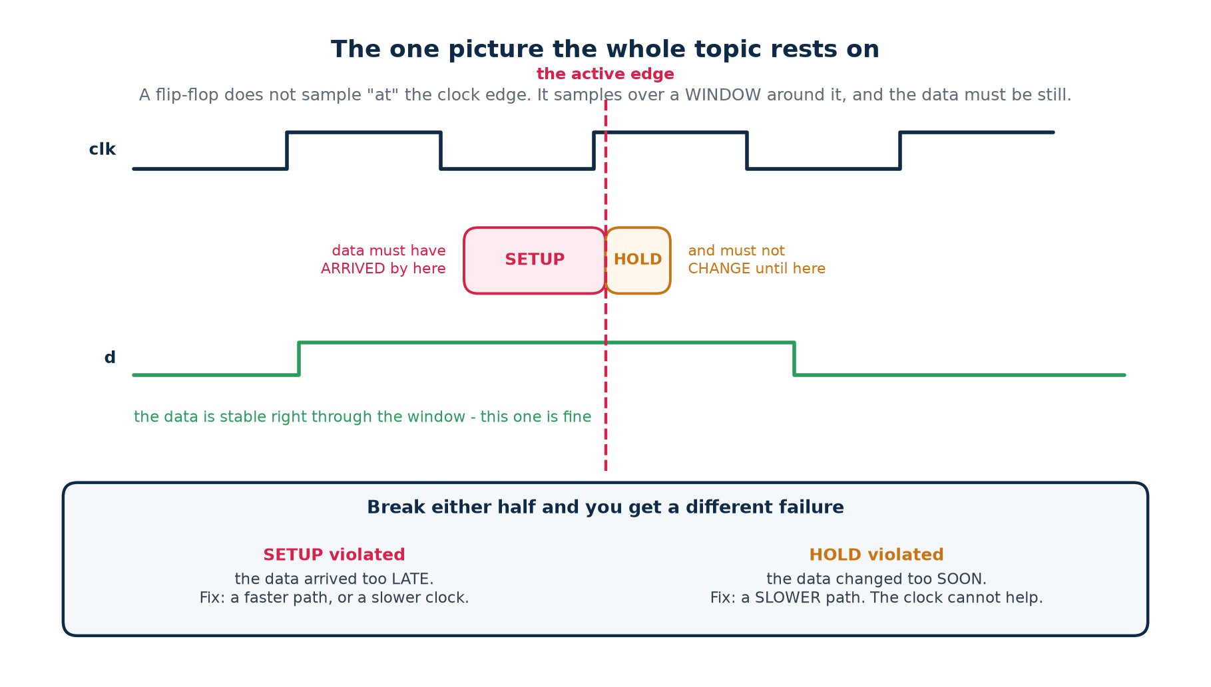
The sampling window. Everything in this topic follows from this picture.

The two halves of the window
Name | What it requires | Symbol in a datasheet | Typical value
Setup time | D stable BEFORE the clock edge | t_su, t_setup | 0.02 – 0.2 ns
Hold time | D stable AFTER the clock edge | t_h, t_hold | 0.00 – 0.1 ns, sometimes negative
Clock-to-Q | how long after the edge Q is valid | t_co, t_cq | 0.05 – 0.3 ns

Hold time can be negative — and it is not a typo
Inside the cell, the clock takes a little time to reach the input latch. If that internal clock delay is longer than the latch's own requirement, D is allowed to change slightly BEFORE the external clock edge and still be captured correctly. The datasheet then quotes a negative hold time. A negative hold time is free margin: it makes hold violations harder to create.

1.2 The two failures, and why they are not variations of one thing
Break the first half of the window and you have a setup violation: the data arrived too late, so the flop captured whatever was there before — the previous value. Break the second half and you have a hold violation: the data changed too soon after the edge, so the flop captured the NEW value, a whole clock cycle early.
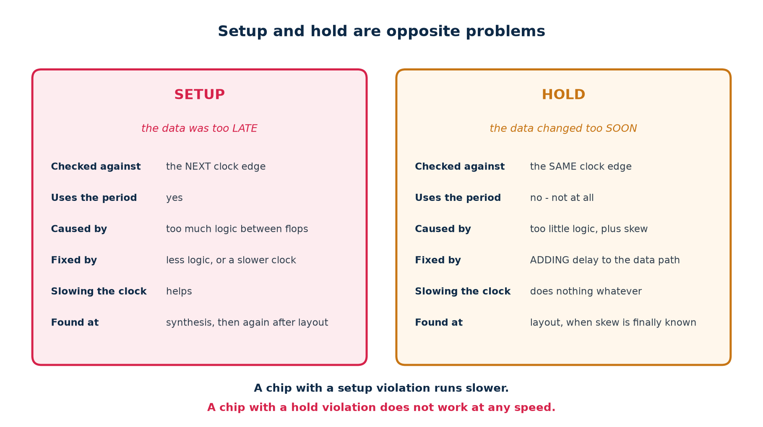
They look similar in a report and behave nothing alike in silicon.
The difference that decides everything you do next
A setup violation means the chip is too slow. Run the clock slower and it works. You have shipped a product that is less competitive, but it is a working product.
A hold violation means the chip is broken. There is no clock frequency at which it works — not 1 MHz, not 1 Hz. The data races the clock edge and wins, and slowing the clock does not change the race. A hold violation that reaches silicon is a re-spin.

1.3 Where the time goes: the four parts of a path
Between one flip-flop and the next, four things consume time. Every timing number you will ever compute is a combination of these four.
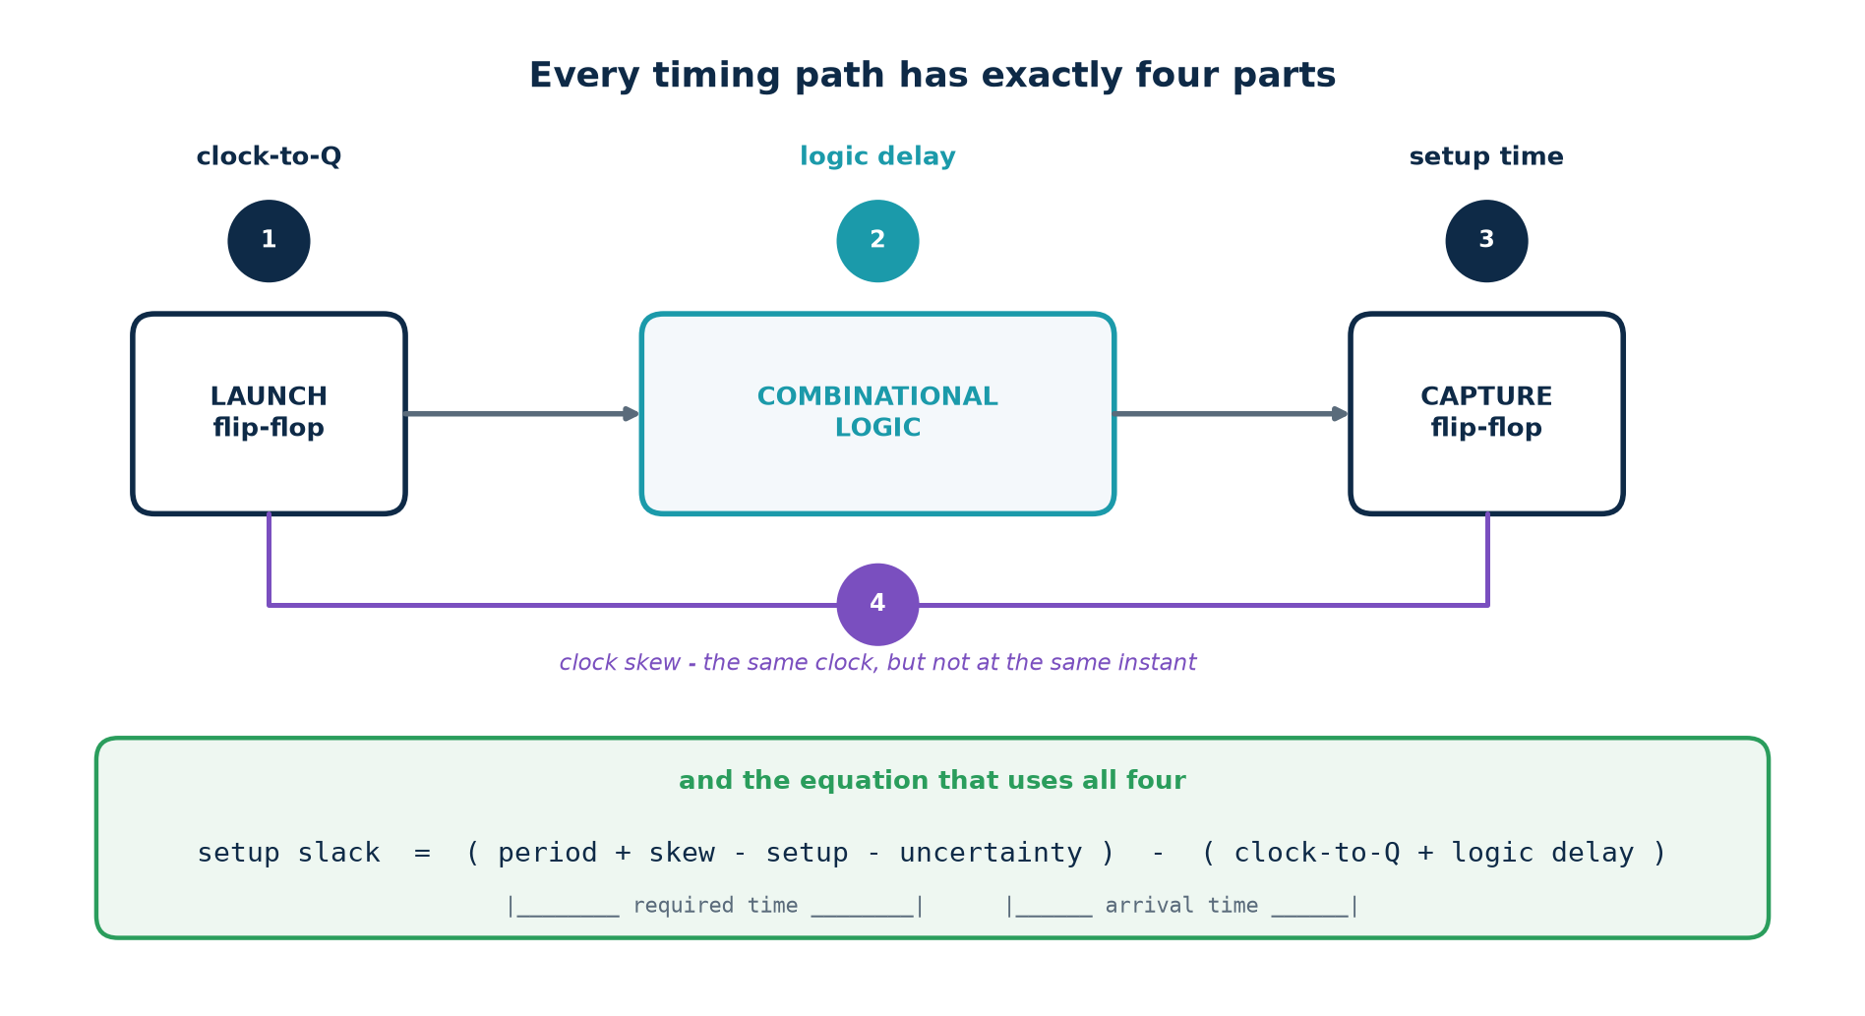
1. Clock-to-Q (t_cq). The launching flop does not present its new output at the instant of the edge. It takes 0.145 ns in the library used throughout this workbook.
2. Logic delay. Every gate between the two flops, plus the wires between them. In a 32-bit ripple-carry adder this is 32 gate delays in series — it dominates everything else.
3. Setup time (t_su). The capturing flop needs the data early. This is subtracted from the time you have, so it behaves exactly like extra logic delay.
4. Clock skew. The two flops do not see the same clock edge at the same instant, because the clock reached them through different amounts of wire and buffering.

1.4 The equation
Put those four together and you get the setup check. It is worth writing this out once in full, because every timing report you ever read is this equation with the numbers filled in.
the setup check
arrival time = clock-to-Q + logic delay
(when the data actually turns up at the capture flop's D pin)

required time = period + skew - setup - uncertainty
(the latest it could have turned up and still been captured)

setup slack = required time - arrival time

= ( period + skew - setup - uncertainty )
- ( clock-to-Q + logic delay )

And the hold check, which is deliberately laid out the same way so you can see what is missing from it:
the hold check
arrival time = clock-to-Q + logic delay <-- the SHORTEST path now

required time = skew + hold + uncertainty

hold slack = arrival time - required time

# Note two things:
# 1. the clock period does not appear anywhere in the hold check
# 2. the subtraction is the other way round

Read those two boxes until the difference is obvious
Setup wants the arrival time to be small. Hold wants it to be large. Every fix you apply to one makes the other worse. That tension is the whole of timing closure.
And because the period is in one equation and not the other, the clock frequency is a lever for setup and no lever at all for hold.

1.5 Slack, WNS and TNS
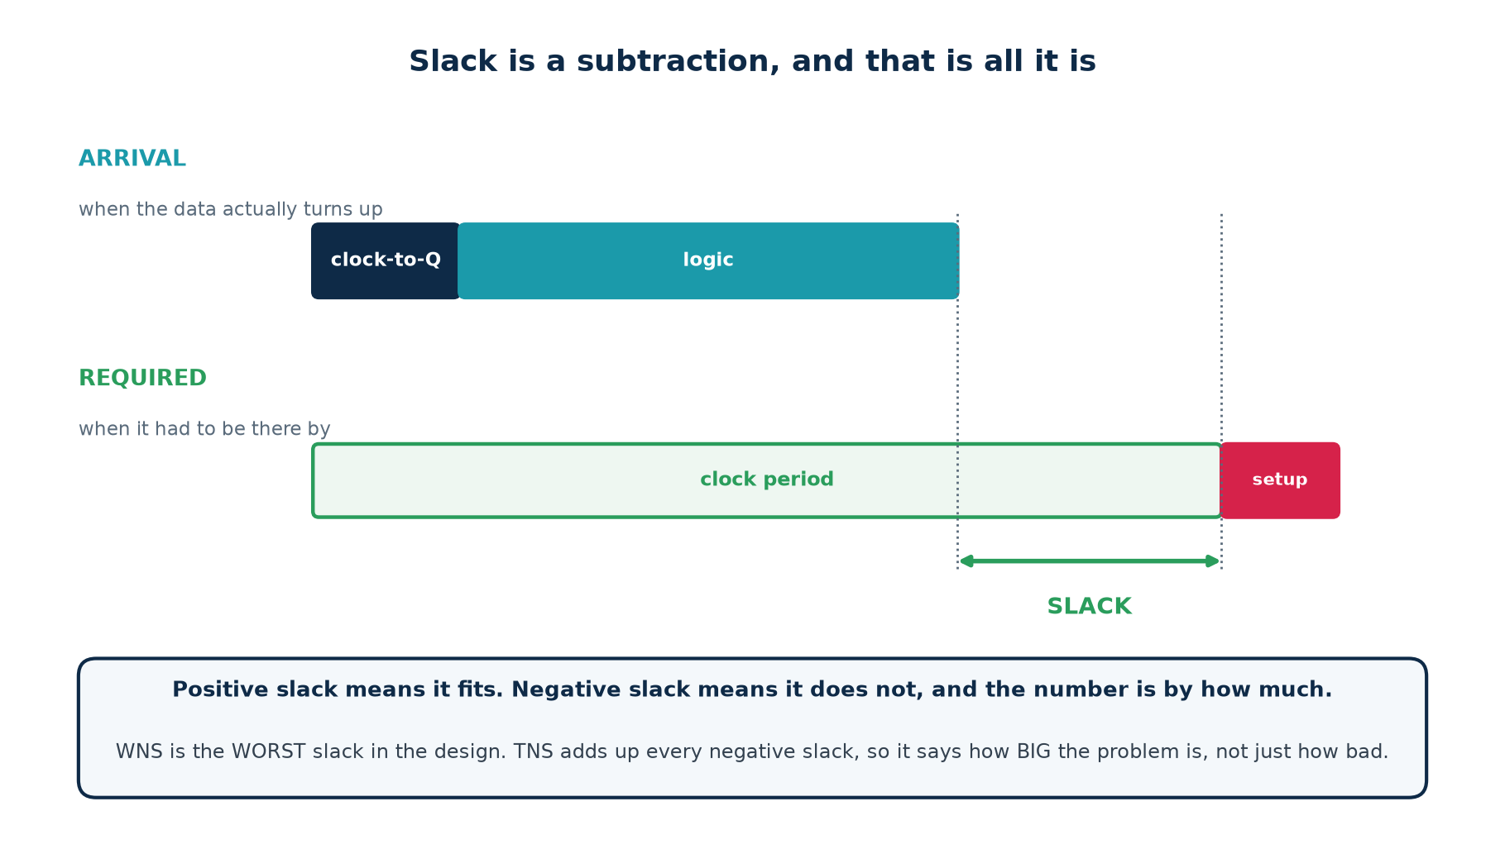
Slack is computed at every endpoint in the design — every flip-flop's D pin and every output port. A design with a million flops produces a million slack numbers. Two summary numbers are extracted from that list:
Number | Definition | What it tells you
WNS | the worst (most negative) slack in the design | how bad the worst single path is
TNS | the sum of every negative slack | how many paths are bad, and by how much in total
Fmax | 1 / (longest path delay) | the highest clock frequency the design can run at

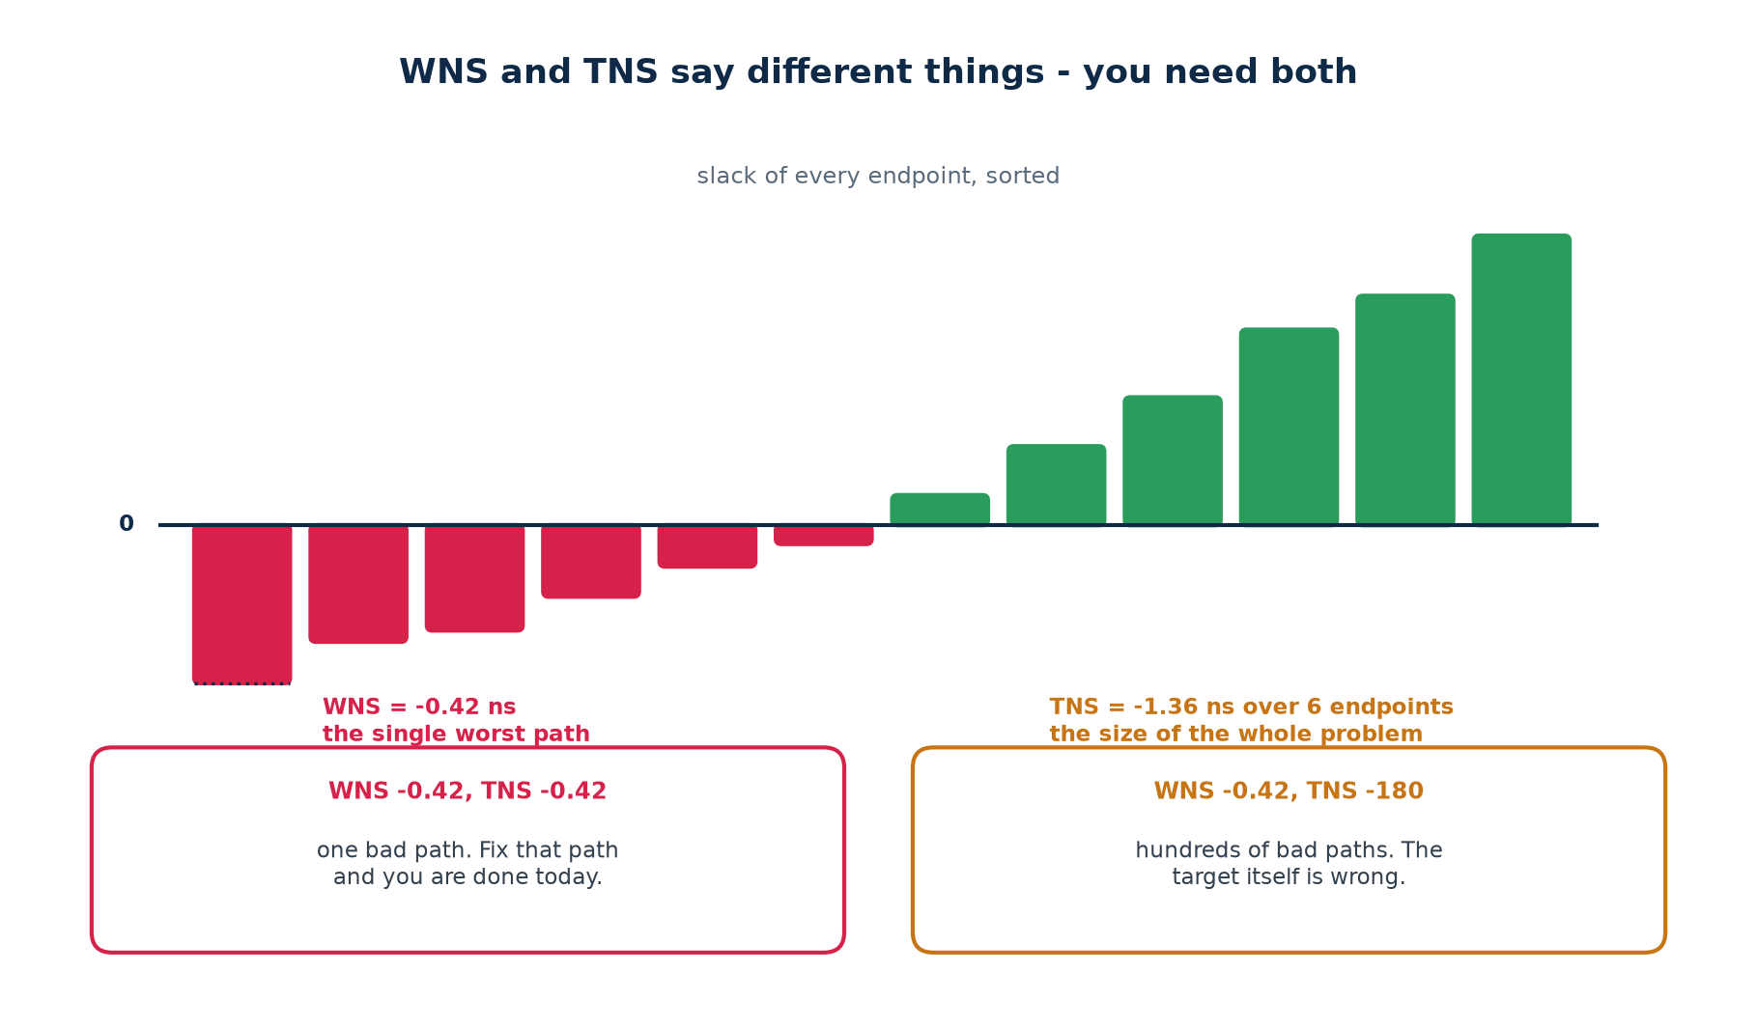
Why you need both numbers
WNS −0.42, TNS −0.42. One path is bad. Find it, fix it, and you are finished this afternoon.
WNS −0.42, TNS −180. The same worst path, but hundreds of others are failing too. No local fix will help. Either the frequency target is wrong for this technology, or the architecture puts too much work in one cycle. This is a design review, not a debugging session.

1.6 Clock skew: the same clock, at different instants
A clock signal has to reach every flip-flop on the chip. It does so through a tree of buffers and a great deal of wire. Two flops at opposite corners of a die may see the same edge tens or hundreds of picoseconds apart. That difference is skew.
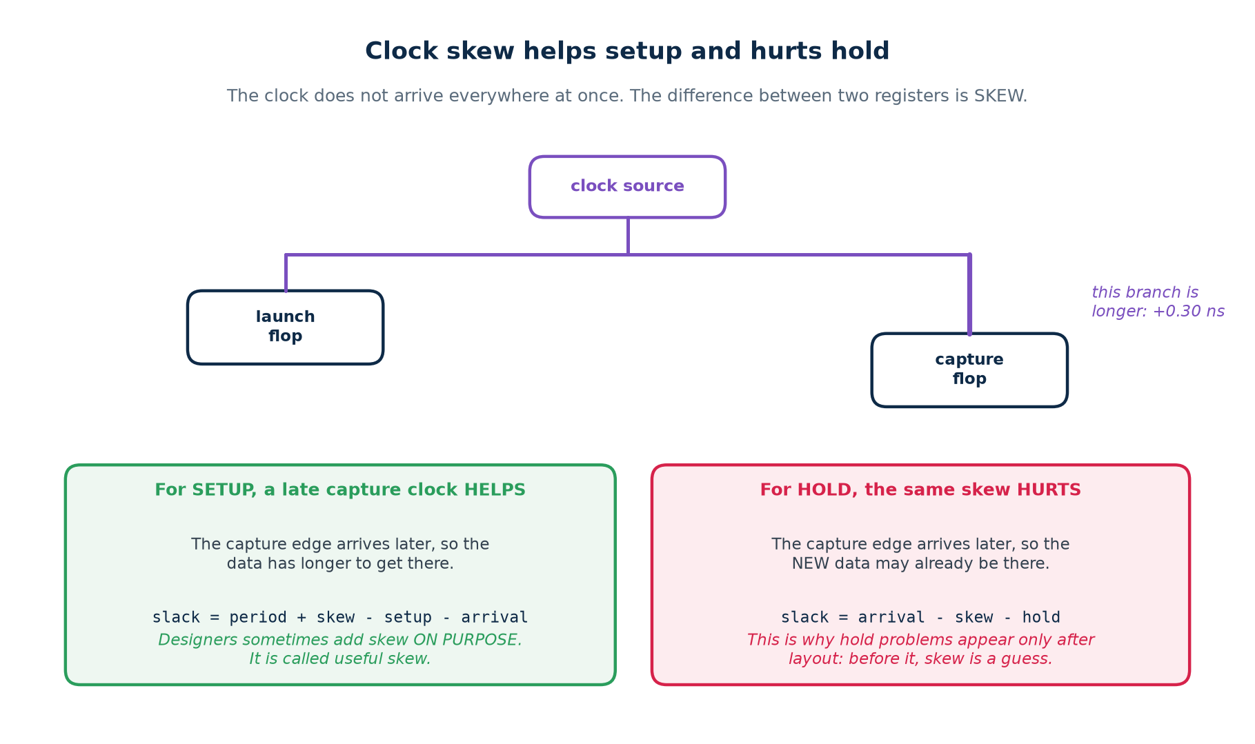
Skew is signed, and its sign depends on which flop you are looking at. If the CAPTURE flop's clock arrives late relative to the launch flop's:
▪ Setup gets easier. The capture edge happens later, so the data has more time to arrive. The skew adds to the required time.
▪ Hold gets harder. The capture edge happens later, so the NEW data from the launch flop may already have arrived by the time the capture flop looks. The skew is subtracted from the hold margin.
Useful skew
Because skew helps setup, tools sometimes add it deliberately: delay the clock to a flop that is on a tight path, and steal margin from the next stage, which had some to spare. This is called useful skew or clock-tree scheduling. It is a real technique, and it is also the reason hold violations sometimes appear on paths you never touched.

1.7 Jitter and uncertainty
Skew is a fixed difference: the same on every cycle. Jitter is a random one — the clock edge does not land in exactly the same place every cycle, because the oscillator and the PLL that produce it are not perfect. And before place-and-route runs, the clock tree does not exist at all, so its skew is not merely unknown — it is undefined.
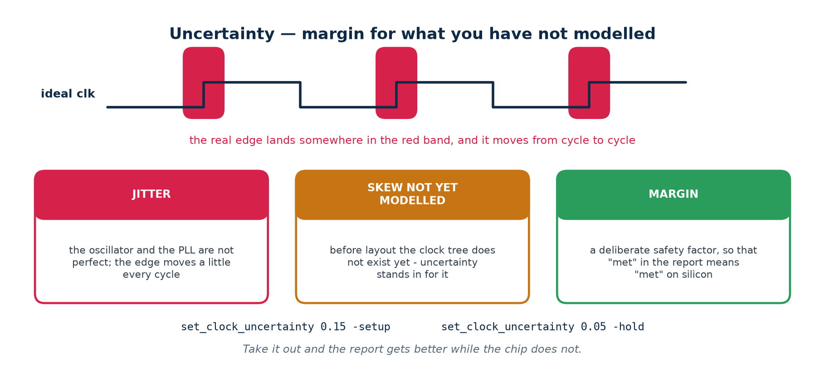
Both are handled by one constraint:
set_clock_uncertainty 0.150 -setup [get_clocks sys_clk]
set_clock_uncertainty 0.050 -hold [get_clocks sys_clk]

Design stage | Typical setup uncertainty | Why that number
FPGA, post-synthesis | 0.10 – 0.20 ns | no clock tree yet; jitter unknown
FPGA, post-place-and-route | 0.02 – 0.05 ns | the tool now models the real tree; only jitter remains
ASIC, before clock-tree synthesis | 0.15 – 0.30 ns | skew placeholder plus on-chip variation margin
ASIC, sign-off | jitter + OCV derating | the tree is built and characterised

The temptation, and why to resist it
When a design misses timing by 0.08 ns and the uncertainty is 0.15 ns, reducing the uncertainty to 0.05 makes the report pass instantly. It also makes the report a work of fiction. The margin was there to cover jitter and unmodelled skew; those did not go away because you edited a file.
Reduce uncertainty only when you can point at the measurement that justifies the smaller number.

1.8 PVT corners: the same netlist on different silicon
Two chips from the same wafer are not identical, and the same chip behaves differently at 0 °C and 125 °C, or at 0.9 V and 1.1 V. Timing is therefore not analysed once but at several corners — combinations of process, voltage and temperature.
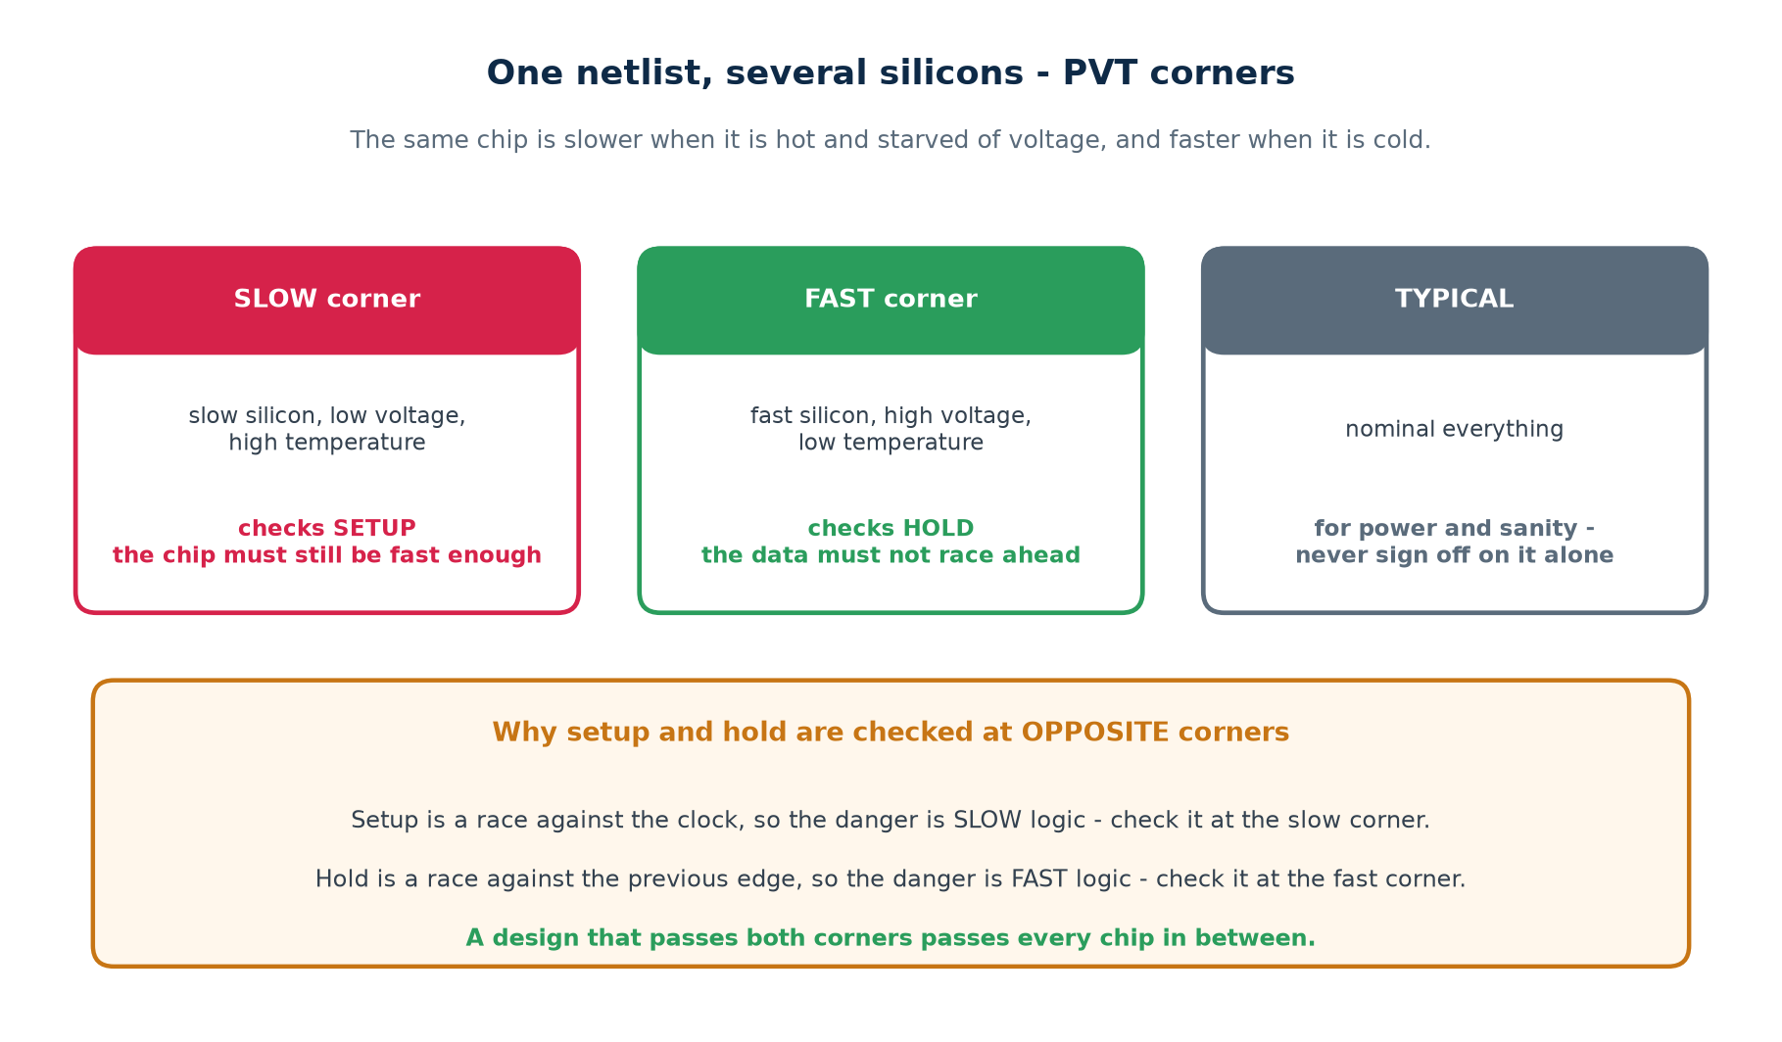
Corner | Process | Voltage | Temperature | Signs off
SLOW / worst | slow | minimum | maximum | SETUP
FAST / best | fast | maximum | minimum | HOLD
TYPICAL | nominal | nominal | nominal | nothing on its own

The logic is straightforward once you see it. Setup is a race between the data and the next clock edge, so the danger is the data being slow — check it where the logic is slowest. Hold is a race between the new data and the capture flop's hold requirement on the SAME edge, so the danger is the data being fast — check it where the logic is fastest. A design that passes both extremes passes everything in between.

1.9 Vocabulary you now own
Term | One-line definition
setup time | how long D must be stable before the clock edge
hold time | how long D must stay stable after the clock edge
clock-to-Q | delay from the clock edge to a valid Q
arrival time | when data actually reaches a pin, from the clock edge
required time | the latest (setup) or earliest (hold) it may arrive
slack | required − arrival for setup; arrival − required for hold
WNS | the worst negative slack in the design
TNS | the sum of all negative slacks
Fmax | 1 / longest path delay
critical path | the path with the worst slack
clock skew | fixed difference in clock arrival between two registers
clock jitter | random cycle-to-cycle variation in the clock edge
uncertainty | margin covering jitter and unmodelled skew
metastability | the undefined state a flop enters if the window is broken
PVT corner | a process/voltage/temperature combination to analyse at

Part 1 self-check — answer these before moving on
1. Why can a hold violation not be fixed by slowing the clock?
2. A flop has a negative hold time of −0.02 ns. Is that good or bad for you?
3. Skew of +0.3 ns on the capture clock: what happens to setup slack, and to hold slack?
4. Your WNS is −0.05 ns and your TNS is −0.05 ns. What kind of problem is this?
5. Why is setup signed off at the slow corner and hold at the fast corner?

Part 2 · Timing Constraints

2.1 Why a tool needs to be told anything at all
Synthesis is an optimisation problem, and an optimisation problem needs an objective. Given no objective, a synthesiser will produce something correct and make no effort to make it fast — and, worse, the timing report it produces afterwards will be silent, because a report can only report on checks that were actually performed.
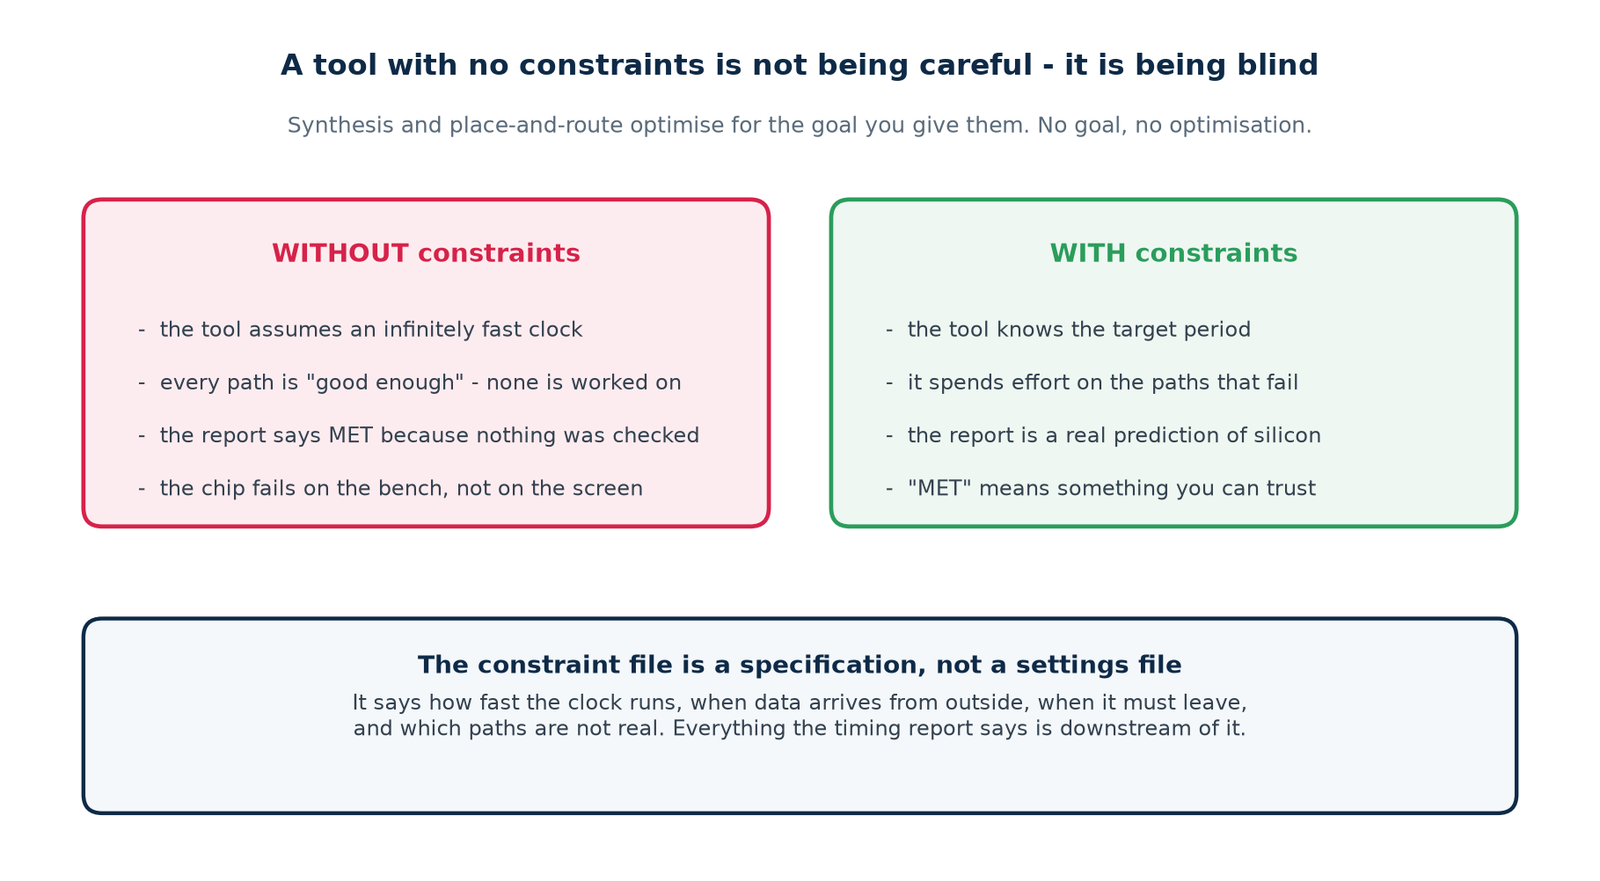
The most dangerous artefact in this field
A clean timing report on an unconstrained design. It does not say the design is fast. It says nothing at all, in a format that looks exactly like good news. Engineers have shipped chips on the strength of such reports.

2.2 The four questions every constraint file answers
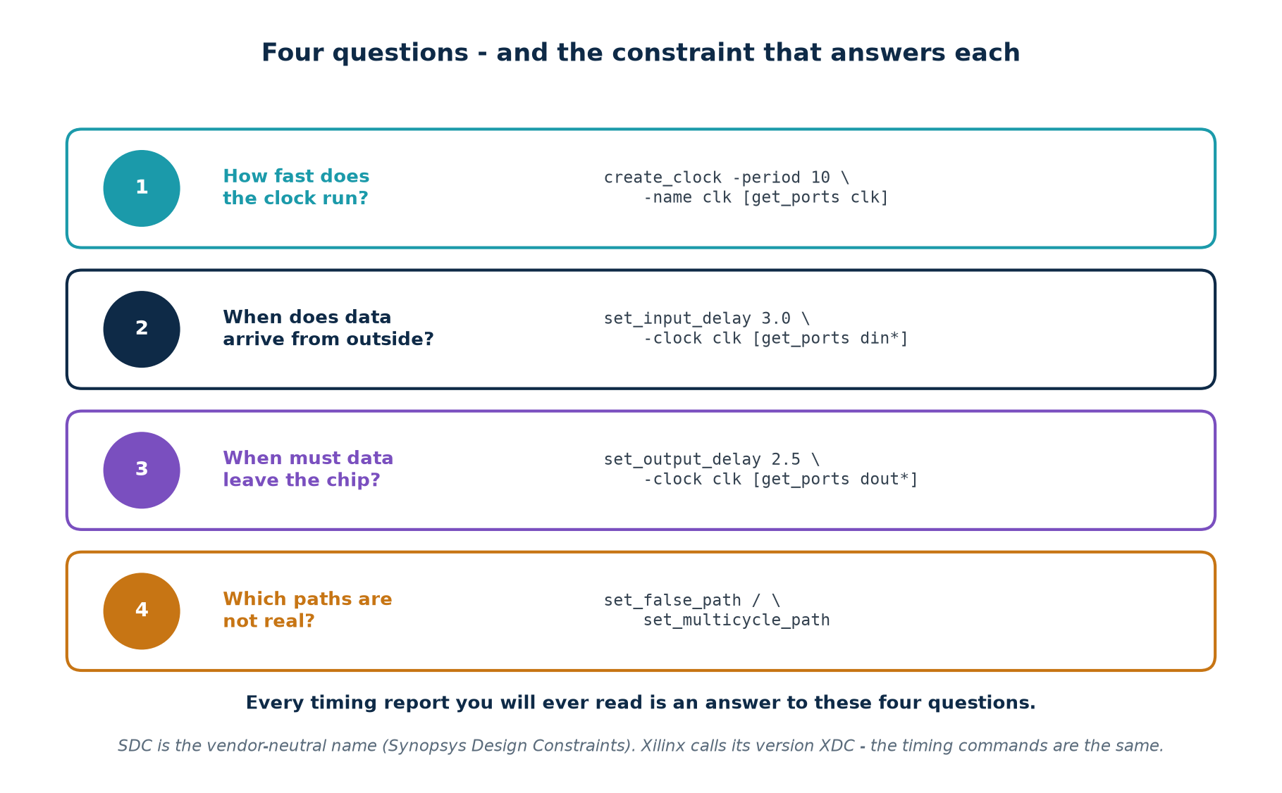
The format is called SDC — Synopsys Design Constraints. It is a set of Tcl commands, and it is genuinely portable: Synopsys, Cadence, Intel Quartus and OpenSTA all read it. Xilinx uses XDC, which is SDC plus commands for physical constraints such as pin placement; the timing half is identical.

2.3 create_clock
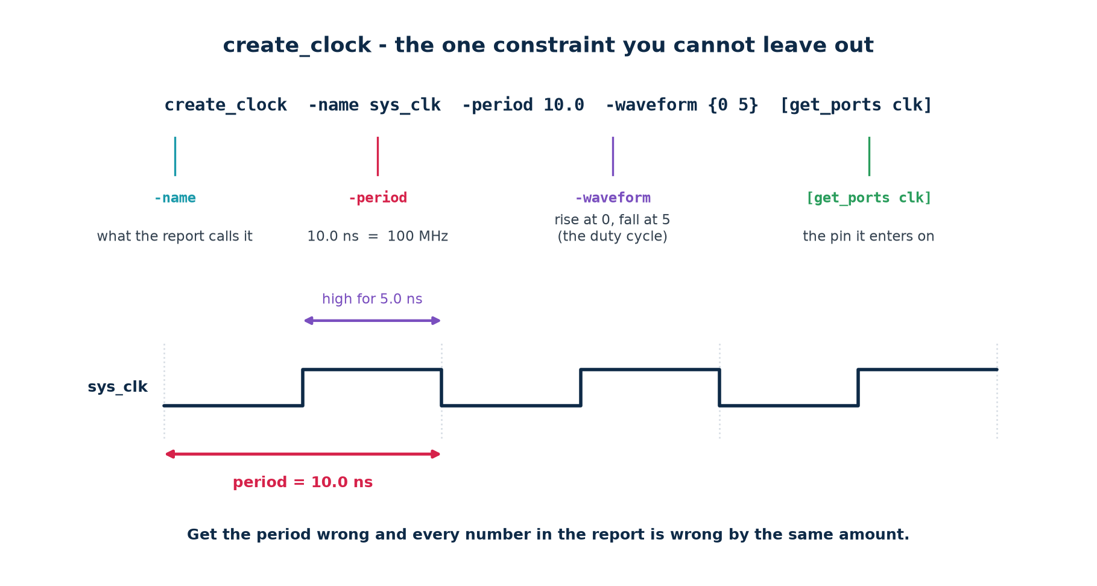
create_clock -name sys_clk -period 10.000 -waveform {0.000 5.000} [get_ports clk]

# -name what this clock is called in every report from now on
# -period 10.0 ns = 100 MHz. Everything downstream is measured against it.
# -waveform rise at 0.0, fall at 5.0 - a 50% duty cycle. Omit it and you get
# a 50% duty cycle by default.
# [get_ports] the pin the clock physically enters on

Generated clocks
If your design divides or multiplies a clock, the result is a new clock and the tool must be told. Declare it as create_generated_clock, never as a second create_clock — a generated clock keeps its relationship to its source, so paths between the two domains are still analysed. Two independent create_clock commands tell the tool the domains are unrelated, which is usually a lie.
# a divide-by-2 built from a toggling flop
create_generated_clock -name clk_div2 -source [get_ports clk] \
-divide_by 2 [get_pins div_reg/Q]

# an MMCM/PLL output on an FPGA - the tool usually derives these for you
create_generated_clock -name clk_200 -source [get_pins mmcm/CLKIN1] \
-multiply_by 2 [get_pins mmcm/CLKOUT0]

The failure mode to memorise
A register clocked by a signal you never declared as a clock has no timing checks at all. Not failing checks — no checks. The report is clean and the domain is completely unanalysed. This is why the unconstrained-endpoint count matters more than the WNS.

2.4 Clock uncertainty
set_clock_uncertainty 0.150 -setup [get_clocks sys_clk] # jitter + unbuilt skew
set_clock_uncertainty 0.050 -hold [get_clocks sys_clk] # jitter only

# uncertainty is SUBTRACTED from the setup budget and ADDED to the hold
# requirement - it makes both checks harder, which is the point

Part 1 covered where the numbers come from. The one thing to add here is that setup and hold uncertainty are usually different: unmodelled skew hurts setup at one end of the design and hold at the other, but jitter affects both, so the setup number is typically larger before layout and the two converge afterwards.

2.5 Input and output delay
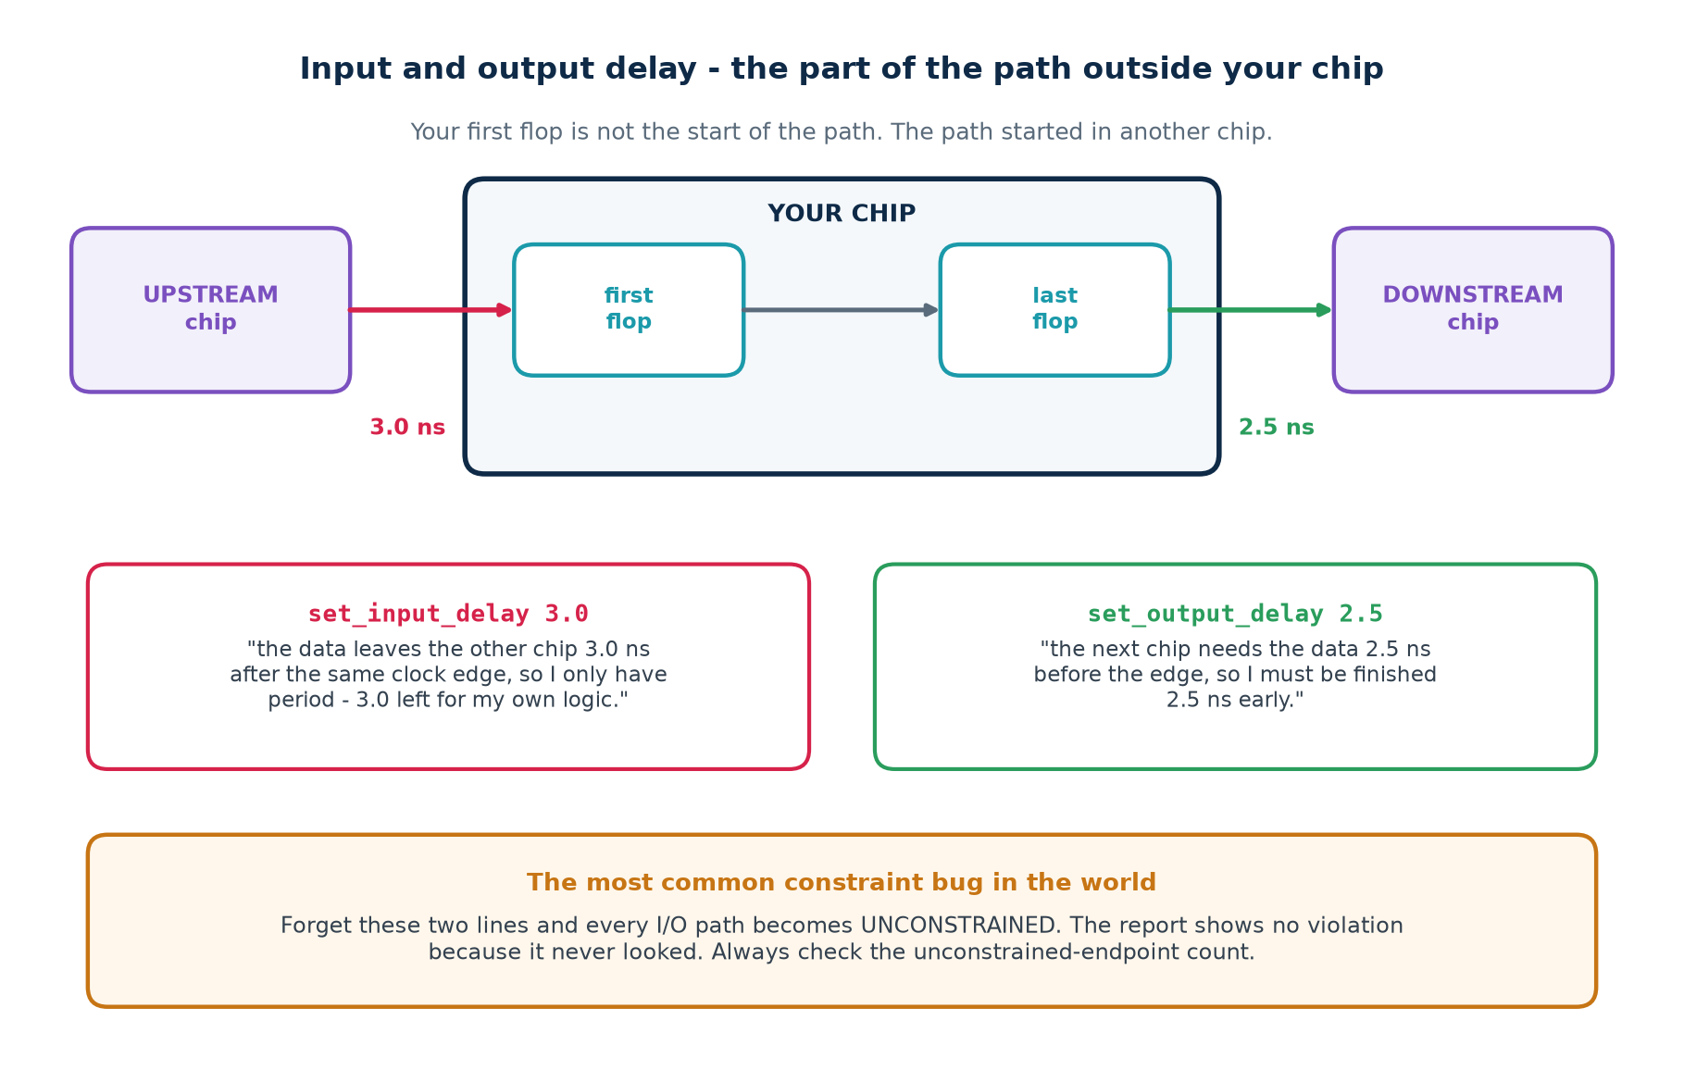
Your chip is not the whole system. Data arriving on a pin left another chip some time after the shared clock edge, and data leaving on a pin has to reach the next chip before its clock edge. Those two intervals are part of the timing path and the tool cannot see them.
constraints/io.sdc
# INPUT: the upstream device's clock-to-out, plus the board trace delay.
# 'the data leaves the other chip 3.0 ns after the same edge, so I have
# period - 3.0 left for my own logic before the next edge.'
set_input_delay -clock sys_clk -max 3.0 [get_ports {din[*] valid}]
set_input_delay -clock sys_clk -min 0.5 [get_ports {din[*] valid}]

# OUTPUT: the downstream device's setup requirement, plus the trace delay.
# 'the next chip needs it 2.5 ns before its edge, so I must be finished early.'
set_output_delay -clock sys_clk -max 2.5 [get_ports {dout[*] ready}]
set_output_delay -clock sys_clk -min 0.2 [get_ports {dout[*] ready}]

 | -max | -min
used by | the setup check | the hold check
means | the LATEST the data can arrive / must leave | the EARLIEST it can change
comes from | upstream clock-to-out (max) + trace | upstream clock-to-out (min) + trace
if you omit it | setup on that port is unchecked | hold on that port is unchecked

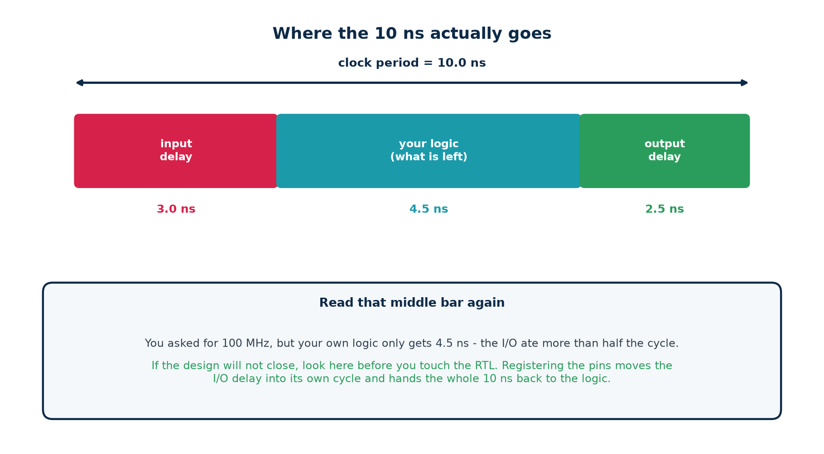
The rule of thumb that closes more designs than any other
Register every input and every output. A flop immediately behind each input pin and immediately before each output pin costs one cycle of latency and makes both boundary paths trivially short. The entire I/O timing problem disappears and your logic gets the whole period. Do this unless you have a measured reason not to.

2.6 Exceptions: false paths
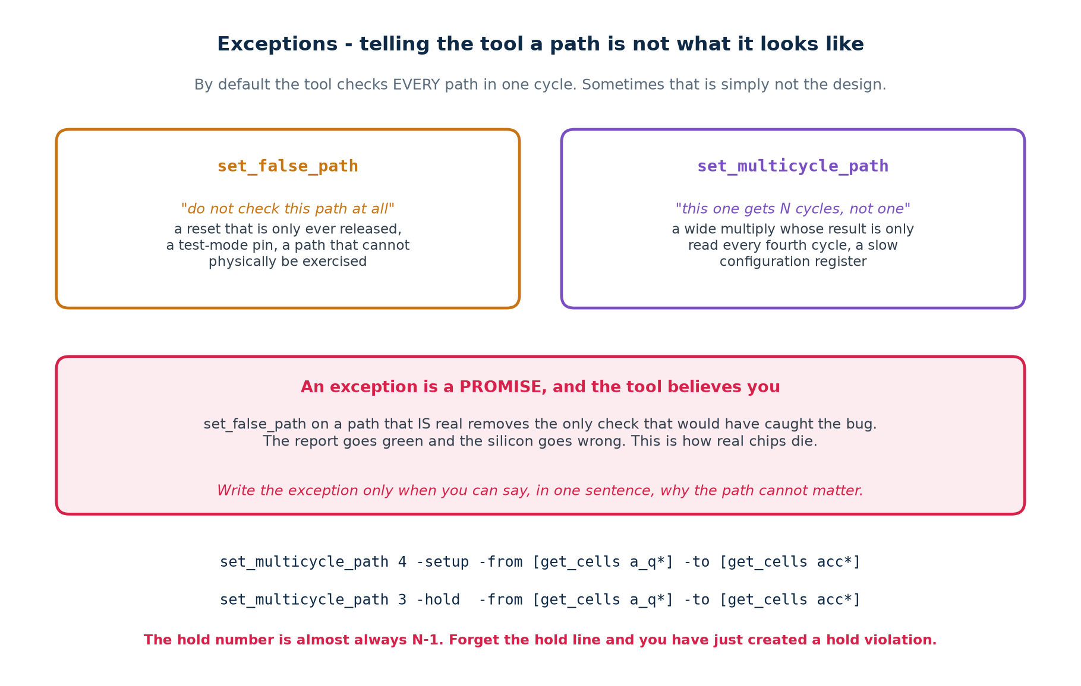
An exception tells the tool that the default assumption — every path must complete in one clock cycle — does not apply here. The tool accepts this without verification. You are making an assertion about your design and the tool is taking your word for it.

The three legitimate uses of set_false_path
# 1. an asynchronous reset: asserted at any time, released synchronously.
# The assertion edge is not a timed event; the release edge IS.
set_false_path -from [get_ports rst_n]

# 2. a configuration register written at boot and read only when quiescent
set_false_path -from [get_cells cfg_mode_reg]

# 3. genuinely unrelated clocks. Use set_clock_groups, not a pile of false paths -
# it covers both directions and every path between them, now and in future.
set_clock_groups -asynchronous -group [get_clocks sys_clk] \
-group [get_clocks usb_clk]

What a false path costs you when it is wrong
It removes the only check that would have caught the bug. The report goes green. The design ships. The failure appears in the field, at one temperature and one voltage, on some units and not others — which is the hardest class of bug there is to reproduce.
The discipline: every set_false_path line gets a comment on the line above it saying, in one sentence, why the path cannot matter. If you cannot write that sentence, you do not have a false path — you have a violation you have not understood yet.

2.7 Exceptions: multicycle paths
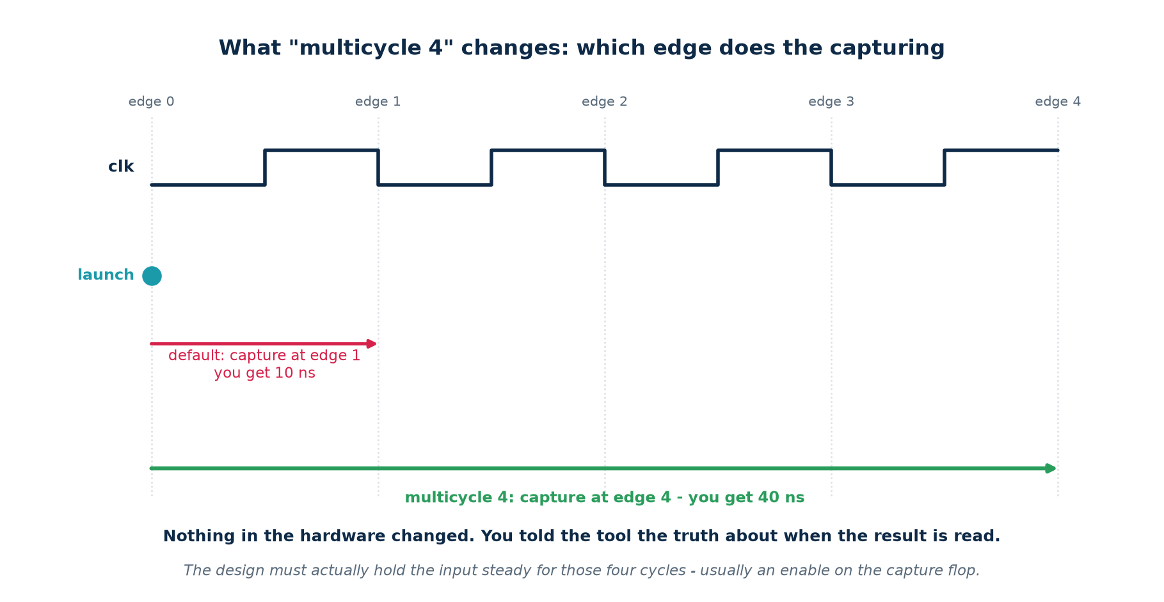
Some results are genuinely not needed next cycle. A wide multiplier whose output is read once every four cycles has four cycles to compute, and telling the tool to check it in one is asking for a violation that does not exist.
set_multicycle_path 4 -setup -from [get_cells a_q*] -to [get_cells acc*]
set_multicycle_path 3 -hold -from [get_cells a_q*] -to [get_cells acc*]

Why the hold number is N−1
The -setup line moves the capture edge four cycles later. Left alone, the hold check would then measure against that same distant edge and demand that the data stay stable for nearly four cycles — an enormous and entirely artificial hold requirement that place-and-route would try to satisfy by inserting hundreds of buffers. The -hold N−1 line moves the hold check back to one edge after the launch, where it belongs.
Forgetting the hold line is a self-inflicted wound
You will not see it immediately: pre-layout there is little skew, so the absurd hold requirement may still pass. It appears after clock-tree synthesis, as hundreds of hold violations on a path you had already declared finished.

The part everyone forgets: the hardware must agree
rtl/slow_path.v
// The SDC exception is a CLAIM about this design. Make the claim true.
reg [1:0] phase;
always @(posedge clk) phase <= phase + 1'b1;
wire tick = (phase == 2'b11); // one cycle in four

always @(posedge clk) begin
if (tick) acc <= a_q + b_q; // the ENABLE is what makes it legal
end

// a_q and b_q must ALSO be steady across all four cycles. If they change
// every cycle, the multicycle claim is false and the accumulator will
// sometimes latch a half-computed sum. The report will still be green.

 | Without the exception | With it
worst slack | −1.193 ns | +0.392 ns
what the tool times | a 32-bit ripple add in one cycle | across four cycles
what you would do next | pipeline something that never needed it | ship what you already had

2.8 Writing the file, and debugging it
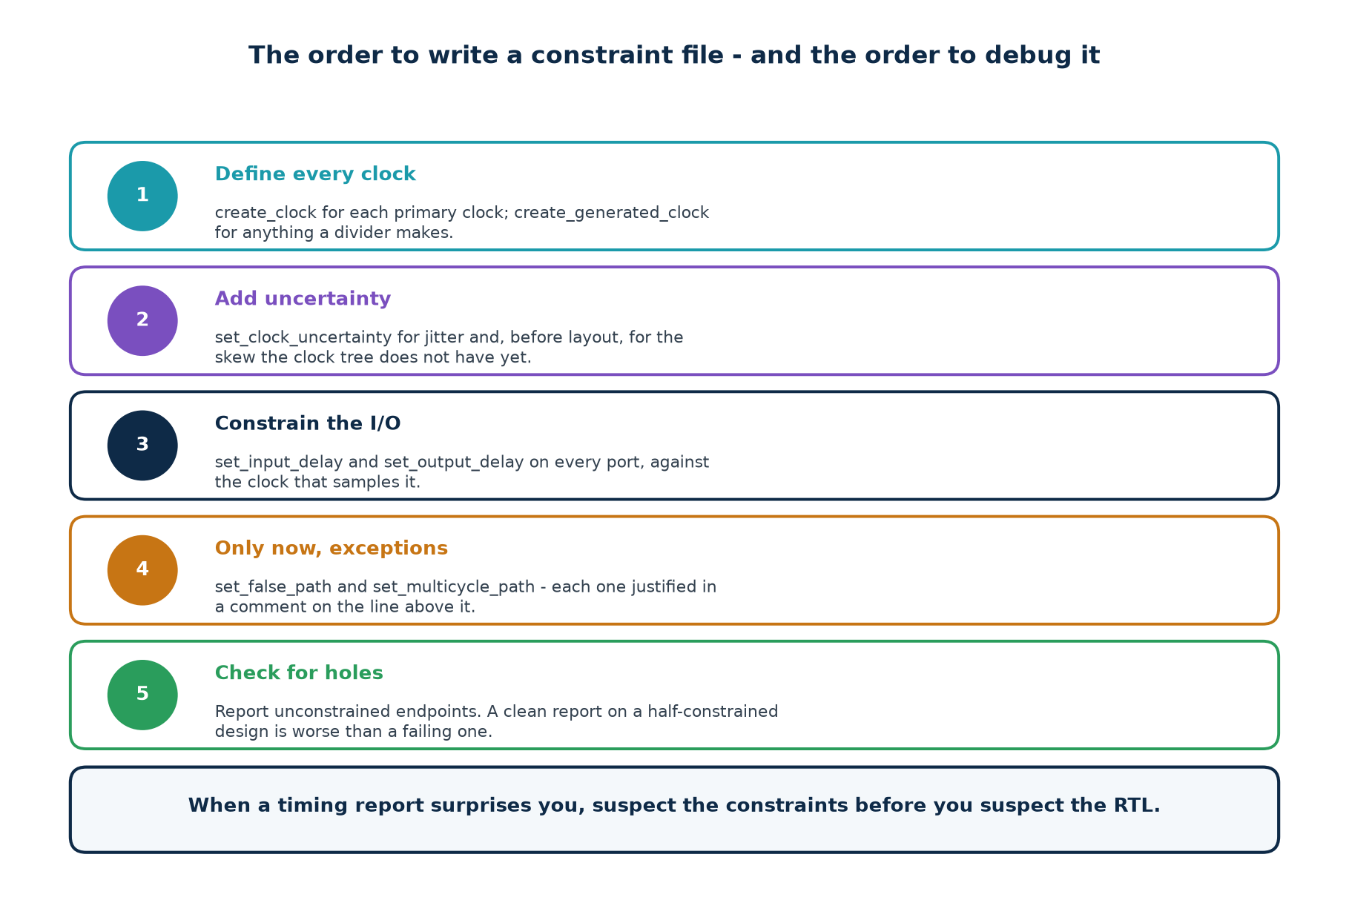
The order matters because each step depends on the one before. You cannot constrain an I/O against a clock you have not declared, and you cannot write a sensible exception before you know which paths exist.

A complete file, annotated
# ==================================================== constraints/add32.sdc
# ---- clocks -------------------------------------------------------------
create_clock -name clk -period 5.000 [get_ports clk]
set_clock_uncertainty 0.100 -setup [get_clocks clk]
set_clock_uncertainty 0.030 -hold [get_clocks clk]

# ---- boundary -----------------------------------------------------------
set_input_delay -clock clk -max 1.20 [get_ports {a[*] b[*]}]
set_input_delay -clock clk -min 0.30 [get_ports {a[*] b[*]}]
set_output_delay -clock clk -max 1.00 [get_ports {sum[*] cout}]
set_output_delay -clock clk -min 0.20 [get_ports {sum[*] cout}]

# ---- exceptions ---------------------------------------------------------
# cfg_mode is written by software at boot and read only when the core is
# halted; no path from it can be exercised while the clock is running.
set_false_path -from [get_cells cfg_mode_reg]

# ---- environment --------------------------------------------------------
set_max_fanout 16 [current_design]

The last check, on every single run
Report the number of unconstrained endpoints. It should be zero. A design with WNS +2.0 ns and 400 unconstrained endpoints is in far worse shape than one with WNS −0.1 ns and none — the first has not been analysed.

Part 3 · How Static Timing Analysis Works

3.1 Why it is called static
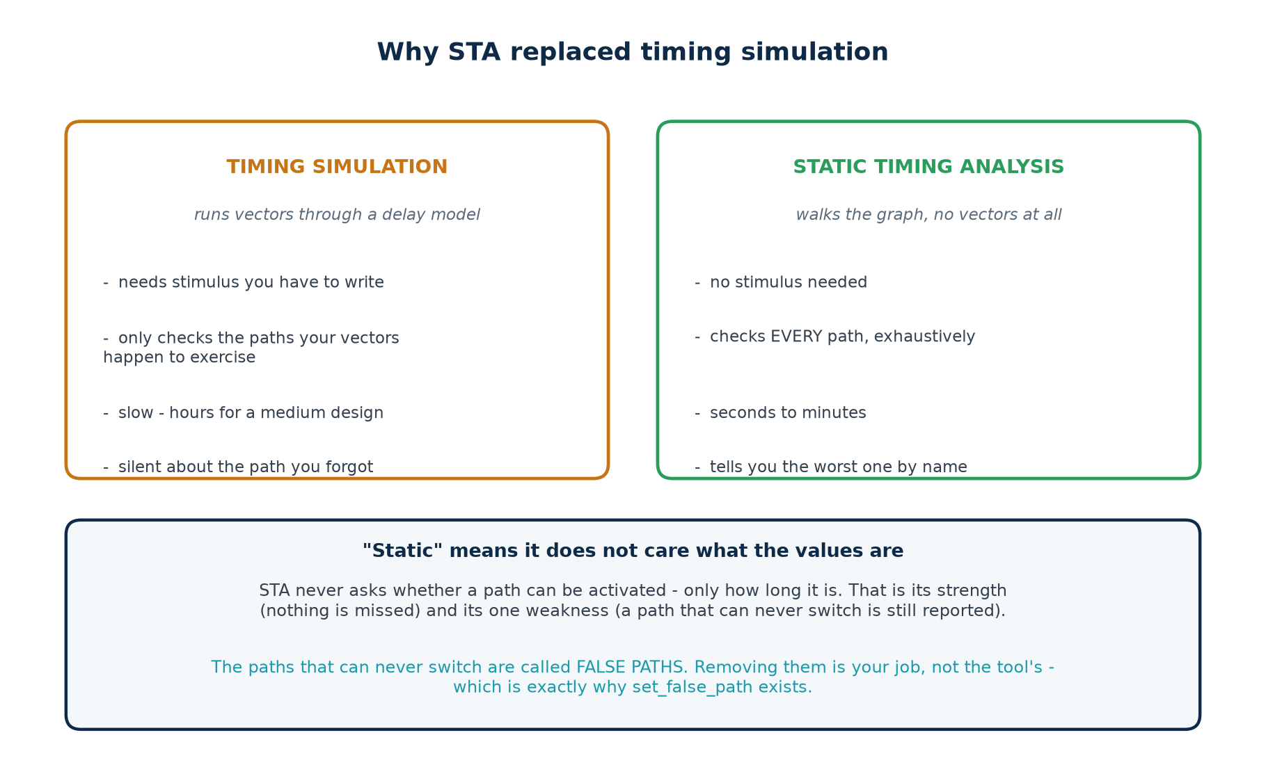
Timing simulation applies vectors to a netlist annotated with delays and watches what happens. It is accurate and it is nearly useless at scale: it only exercises the paths your vectors happen to reach, it takes hours, and it is completely silent about the path you forgot to stimulate.
Static timing analysis asks a different question. It never asks what the data values are — only how long each path is. That is why it needs no stimulus, why it cannot miss a path, and why it finishes in minutes on a design that would take a simulator a week.
It buys that with one weakness. A path that can never actually switch — because two of its inputs are mutually exclusive, say — is still measured and still reported. Removing those is your job, which is exactly why set_false_path exists.

3.2 The delay model
Before a tool can add up a path it needs a number for each cell. Those numbers live in a Liberty file — extension .lib — produced by the foundry from SPICE characterisation of every cell in the library.
lib/cda_edu.lib — the library you write in Tutorial 1
cell (XOR2) {
area : 4.0 ;
cda_intrinsic : 0.088 ; /* ns with no load at all */
cda_load_factor : 0.018 ; /* extra ns per unit of output capacitance */
cda_input_cap : 1.5 ; /* what this cell presents to its driver */
pin (A) { direction : input ; }
pin (B) { direction : input ; }
pin (Y) { direction : output ; function : "(A^B)" ; }
}

cell (DFF) {
cda_clk_to_q : 0.145 ;
cda_setup : 0.090 ;
cda_hold : 0.035 ;
cda_input_cap : 1.6 ;
}

cell delay = intrinsic + load_factor x (total input capacitance on the output net)

How this differs from a real Liberty file
A production .lib holds a two-dimensional table for each arc, indexed by input transition time (slew) and output load, with 5×5 or 7×7 entries interpolated at lookup. The arithmetic that follows is identical — arrival, required, slack — only the lookup is bigger. The simplification here costs you accuracy and costs you nothing in understanding.

3.3 The timing graph
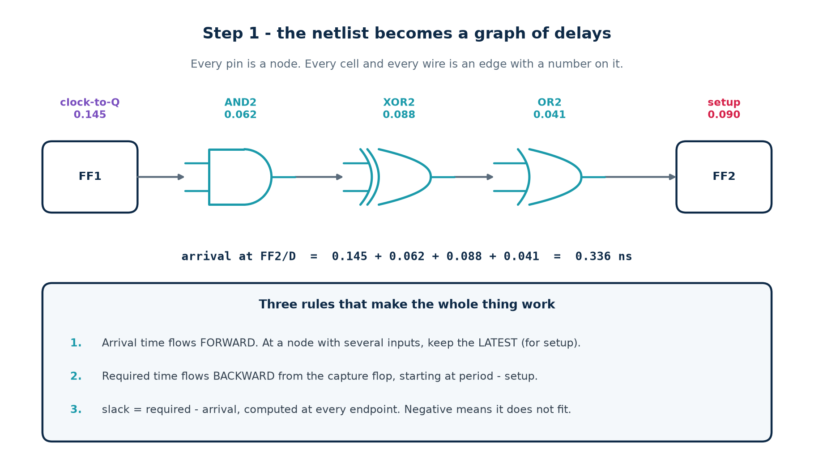
The netlist becomes a directed graph. Every pin is a node. Every cell contributes an arc from each input pin to each output pin it affects, carrying that cell's delay. Every net contributes arcs from its driver to each of its loads.
The arc convention that makes reports readable
Charge the cell's delay on the arc INSIDE the cell — input pin to output pin — computed with the load on that cell's output net. Charge clock-to-Q at the flop's Q pin. Give net arcs a delay of zero.
Do it any other way and every line of your report attributes a delay to the wrong cell. This is the single most common bug when people write their first analyser, and Tutorial 2 has you get it right deliberately.

3.4 The two sweeps
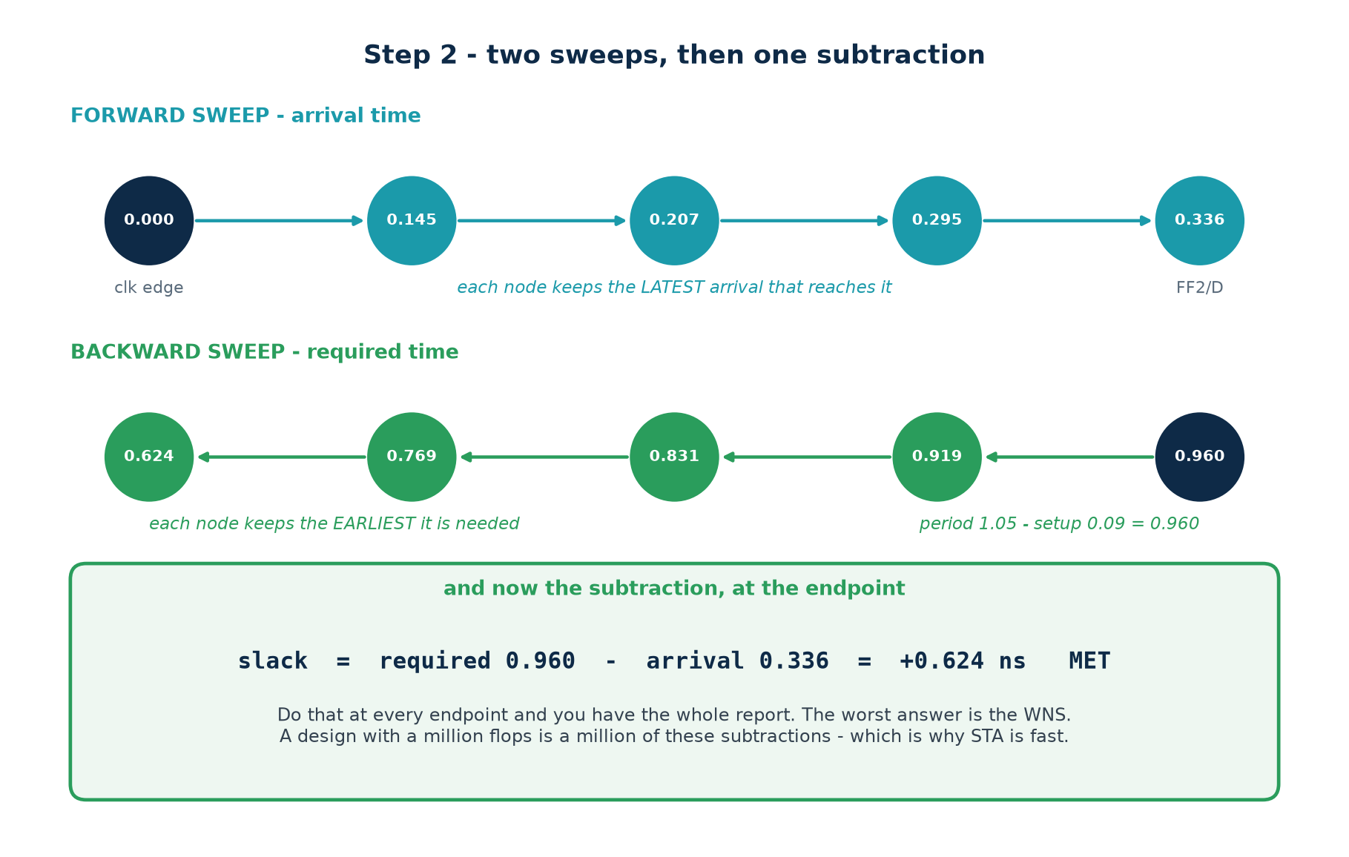
1. Forward, for arrival time. Visit the nodes in topological order. At each node, arrival = max over all incoming arcs of (source arrival + arc delay). The max is what makes it the setup check; the min, computed at the same time, is what makes it the hold check.
2. Backward, for required time. Start at each endpoint with required = period − setup − uncertainty + skew, and walk backwards subtracting arc delays, keeping the minimum at each node.
3. Subtract. slack = required − arrival, at every endpoint. The most negative answer is the WNS.
sta/sta.py — the whole algorithm, in fifteen lines
def propagate(self):
for n in self._order(): # topological order
for arc in n.fanin:
src, dly = arc.src, arc.delay
n.amax = max(n.amax, src.amax + dly) # LATEST -> setup
n.amin = min(n.amin, src.amin + dly) # EARLIEST -> hold

def setup_slack(self, ep):
required = self.period + self.skew(ep) - ep.cell.setup - self.uncert_setup
return required - ep.amax

def hold_slack(self, ep):
required = self.skew(ep) + ep.cell.hold + self.uncert_hold
return ep.amin - required

Why every node carries two numbers
 | amax (setup) | amin (hold)
propagates | the latest arrival | the earliest arrival
asks | did it get there in time? | did it stay put long enough?
compares against | the NEXT clock edge | the SAME clock edge
uses the period | yes | no
signed off at | the slow corner | the fast corner

3.5 A path computed by hand
This is the calculation you must be able to do before you trust any tool. The design is three flip-flops with one XOR between two of them; the library is the one above.
path: p_reg/Q -> u12/A -> u12/Y -> q_reg/D

1. p_reg/Q DFF clk-to-Q is 0.145. Its output net drives u12/A, whose
input capacitance is 1.5. The DFF load_factor is 0.013.

0.145 + 0.013 x 1.5 = 0.1645 ns

2. u12 (XOR2) intrinsic 0.088, load_factor 0.018. Its output net drives
q_reg/D, whose input capacitance is 1.6.

0.088 + 0.018 x 1.6 = 0.1168 ns

3. arrival at q_reg/D = 0.1645 + 0.1168 = 0.2813 ns

4. required = period 1.000 - setup 0.090 - uncertainty 0.000
= 0.910 ns

5. slack = 0.910 - 0.281 = +0.629 ns MET

Check this against the machine
$ make tiny prints the same numbers. If your arithmetic and the engine ever disagree, one of you has a bug — and finding out which is the most valuable hour you will spend in this topic.

3.6 Reading a timing report
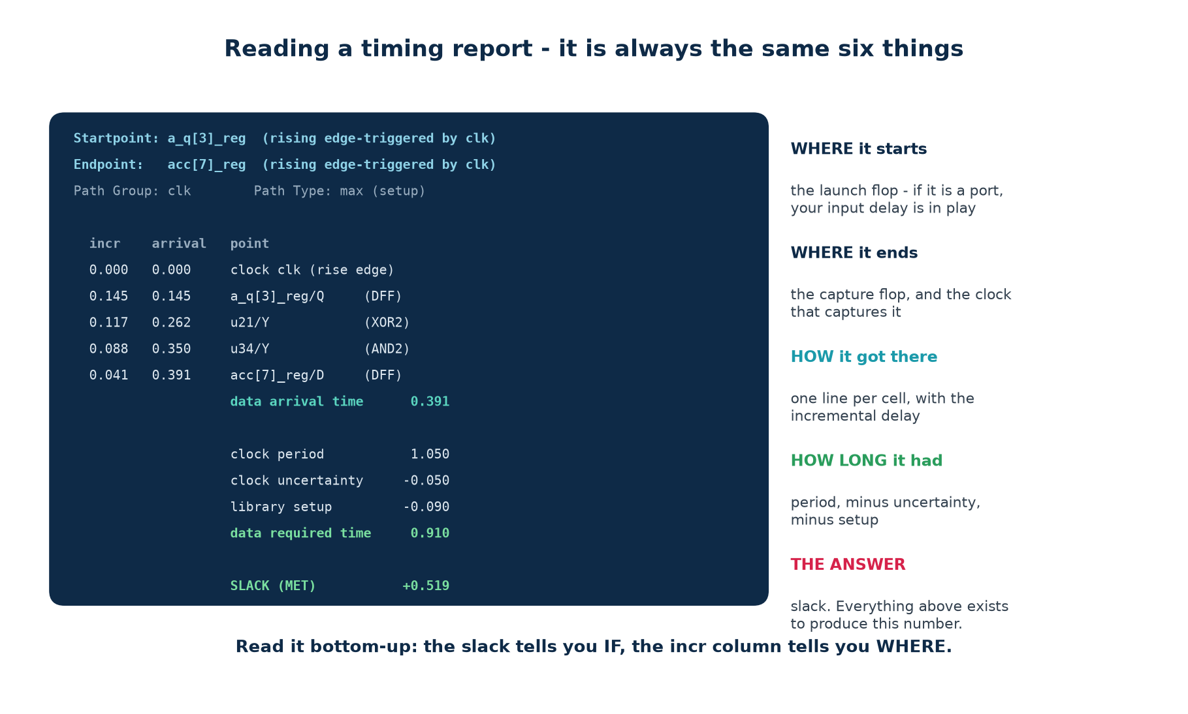
Every timing report from every tool contains the same six things, in roughly the same order. Once you can find all six, PrimeTime, Vivado, Quartus and your own engine all become the same document with different formatting.
Look at | If it says | Then
SLACK | positive | this path is fine — move to the next
SLACK | negative | the magnitude tells you how hard the fix is
Startpoint | a port, not a flop | your input delay is in play
largest incr | one cell dominating | that cell or its load is the problem
largest incr | fifty small cells | the path is too deep — restructure or pipeline
TNS vs WNS | roughly equal | one bad path; a local fix
TNS vs WNS | TNS much larger | systemic; review the target
unconstrained | not zero | fix that before believing anything else

A habit that makes you fast
Do not read the whole report. Read the slack, then the startpoint and endpoint names, then the largest incr line. Three numbers will tell you what class of problem you have in about twenty seconds, and the class determines the fix.

3.7 Path groups
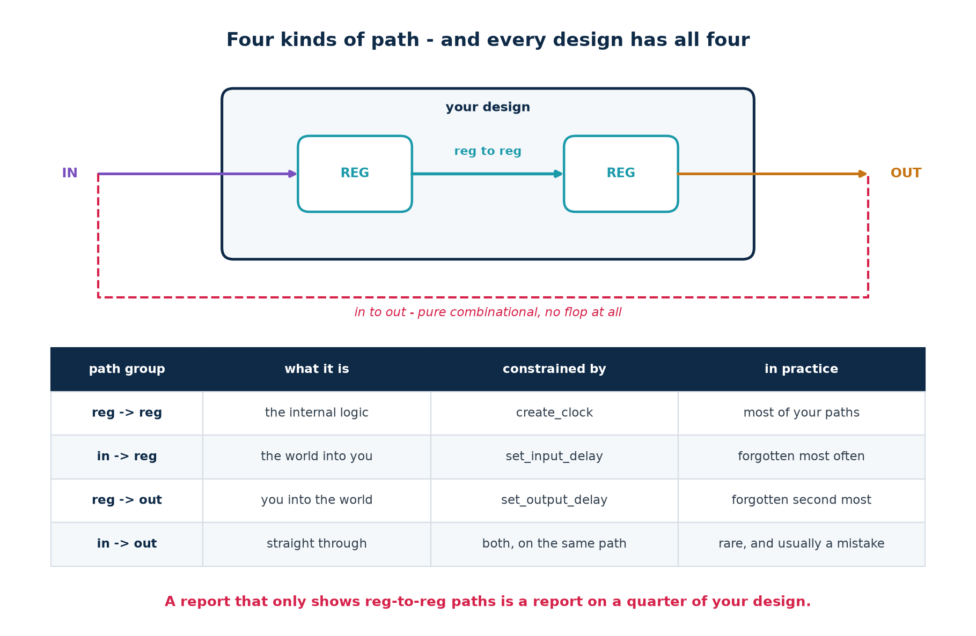
Reports are usually organised by path group, and it is worth checking that all four appear. Reg-to-reg paths are the ones people look at; in-to-reg and reg-to-out are the ones that go unconstrained; in-to-out paths are rare and usually indicate that something should have been registered.

3.8 Fmax
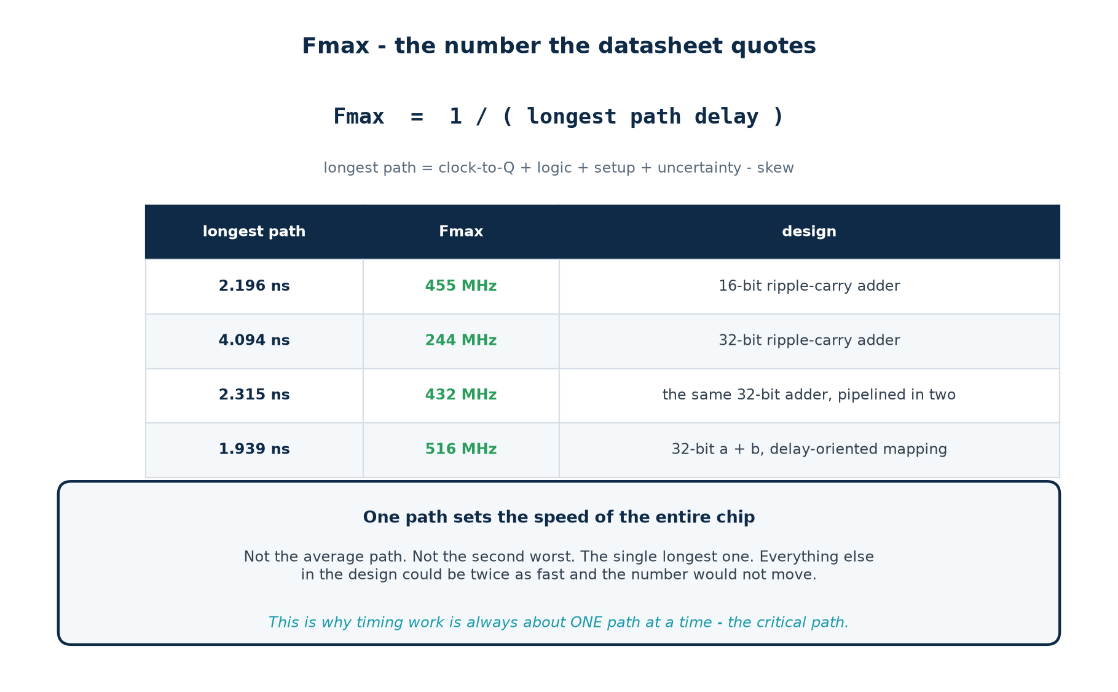
Fmax is set by exactly one path. Every other path in the design could be twice as fast and the number would not move. That is why timing work is always about one path at a time — and why fixing the critical path often reveals a second one, almost as bad, immediately behind it.
Part 3 self-check
1. Why does STA need no test vectors?
2. A node has three incoming arcs. Which arrival time does it keep, and why does the answer differ for setup and hold?
3. Where is a cell's delay charged, and computed with which load?
4. Your report shows WNS +1.2 ns and 260 unconstrained endpoints. What do you do first?
5. Compute the slack for the p_reg → q_reg path if the period is 0.5 ns instead of 1.00 ns.

Part 4 · Optimisation Techniques

4.1 The menu, in cost order
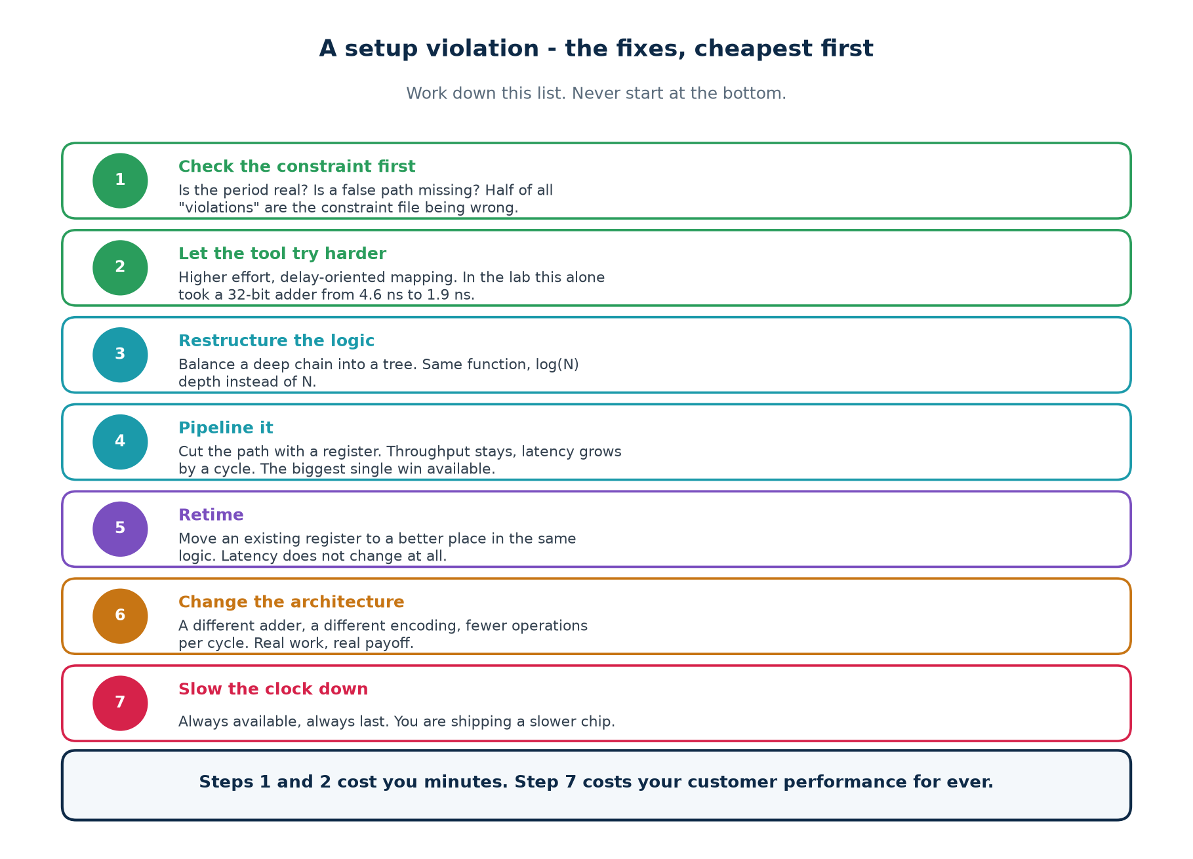
When a setup path fails, work down this list. The order is not arbitrary: each step costs more engineering time and more design disruption than the one above it, and the first two are so cheap that skipping them is never justified.

4.2 Fix 1 — check the constraint before you touch the design
Roughly half of all reported violations are not design problems. They are constraint problems, and the design was fine all along. Spending a week pipelining a path that a single false-path line would have removed is the most expensive mistake in this topic.
The report says | Suspect | Confirm in one minute by
a huge violation on a reset path | a missing false path | reading the startpoint — is it rst_n?
every I/O path fails by the same amount | I/O delay too large | comparing it with the upstream datasheet
a path you know is slow fails | a missing multicycle path | checking whether the capture flop has an enable
a path between two clocks fails | missing set_clock_groups | asking whether the two clocks are related at all
WNS is almost exactly −(period) | an undeclared generated clock | report_clocks — is anything missing?
nothing fails and you do not believe it | unconstrained endpoints | reporting the count; it should be zero

4.3 Fix 2 — let the tool try harder, and the result nobody expects
Synthesis has an effort dial. On the open-source flow it is which technology-mapping mode ABC runs in; in Vivado it is the synthesis strategy; in an ASIC flow it is compile_ultra versus compile. Turning it up is free. Here is what it did to a 32-bit adder in the lab:
# the SAME RTL: assign {cout, sum} = a_q + b_q;

$ ABC=abc make fmax # default, area-oriented mapping
longest path 4.615 ns -> 217 MHz

$ ABC='abc -fast' make fmax # delay-oriented mapping
longest path 1.939 ns -> 516 MHz

# and for comparison, the hand-written structural ripple-carry chain:
longest path 4.094 ns -> 244 MHz (area-oriented mapping)

Read the third number again
Under area-oriented mapping the plain a + b is SLOWER than the hand-written ripple chain: 4.615 ns against 4.094 ns. Under delay-oriented mapping it is 2.4× faster than either. Both netlists were proved equivalent to the RTL over 400 random vectors before those numbers were quoted.
The lesson: “describe intent, not structure” is only half the rule. The other half is “then check what your tool did with it”. The same source file is a slow design or a fast one depending on one option you may never have set.

4.4 Fix 3 — restructuring
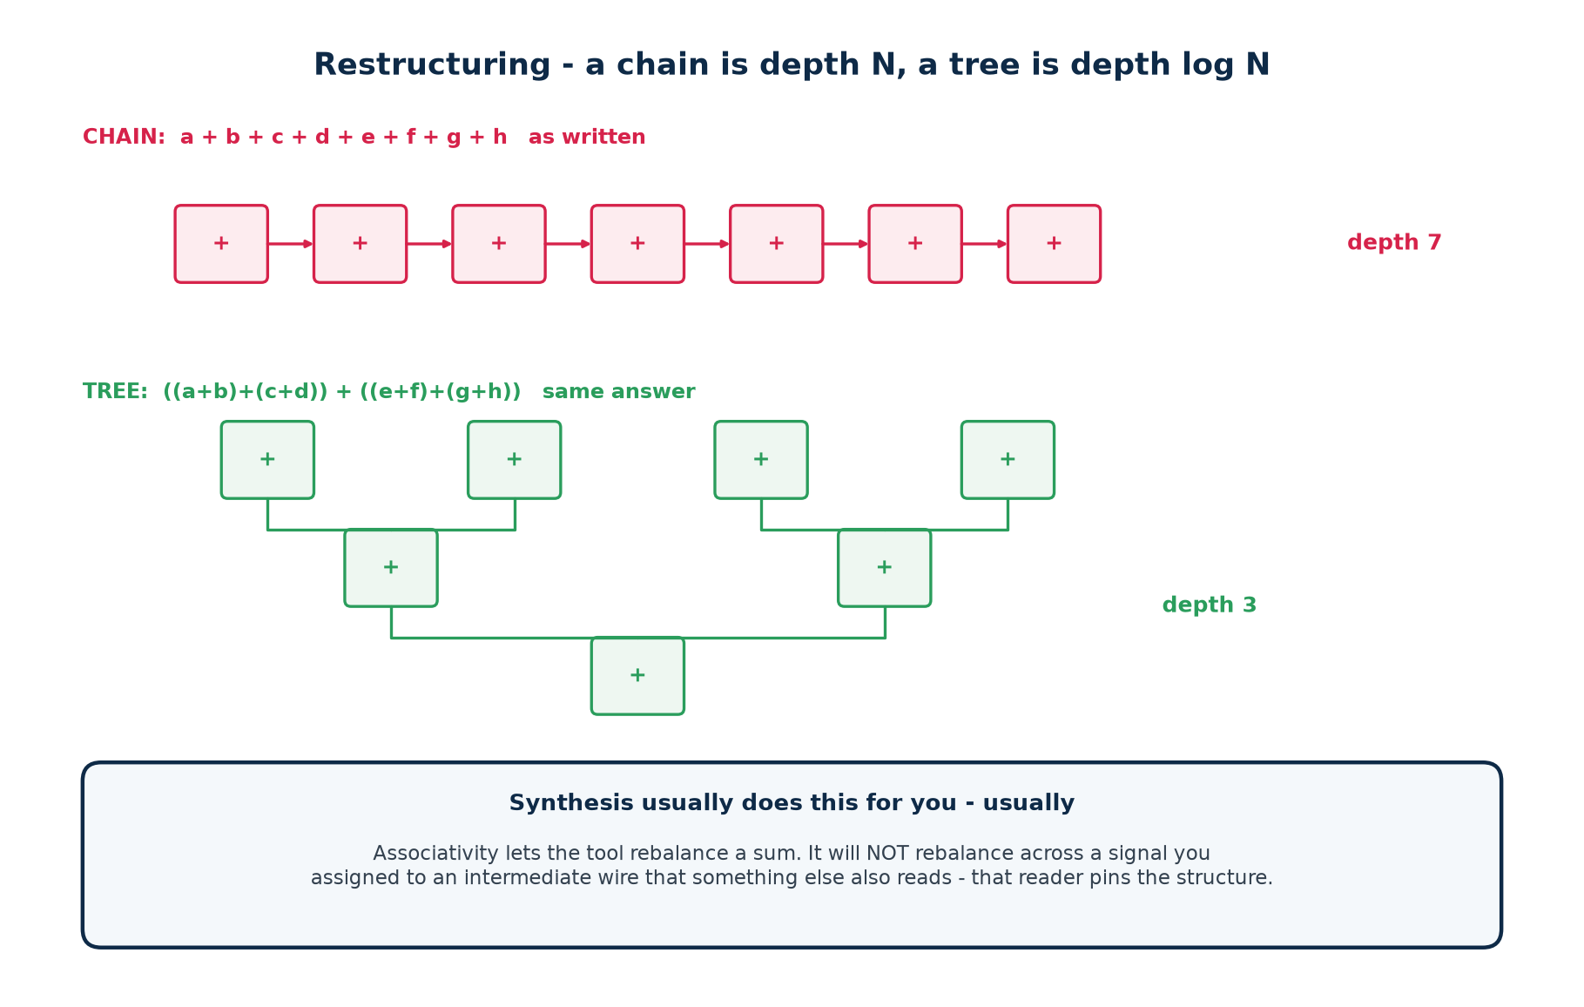
A chain of N operations has depth N. The same operations arranged as a balanced tree have depth ⌈log₂ N⌉. For eight additions that is 7 levels against 3. Synthesis will usually do this for you, because addition is associative and the tool knows it.
What stops the tool doing it
Assign an intermediate result to a named wire that something else also reads, and that reader pins the structure — the tool can no longer rebalance across it, because doing so would change the value on that wire.
Practical rule: if a sum must be fast, do not publish its intermediate results. Compute the whole expression in one assignment and let the tool choose the shape.

4.5 Fix 4 — pipelining
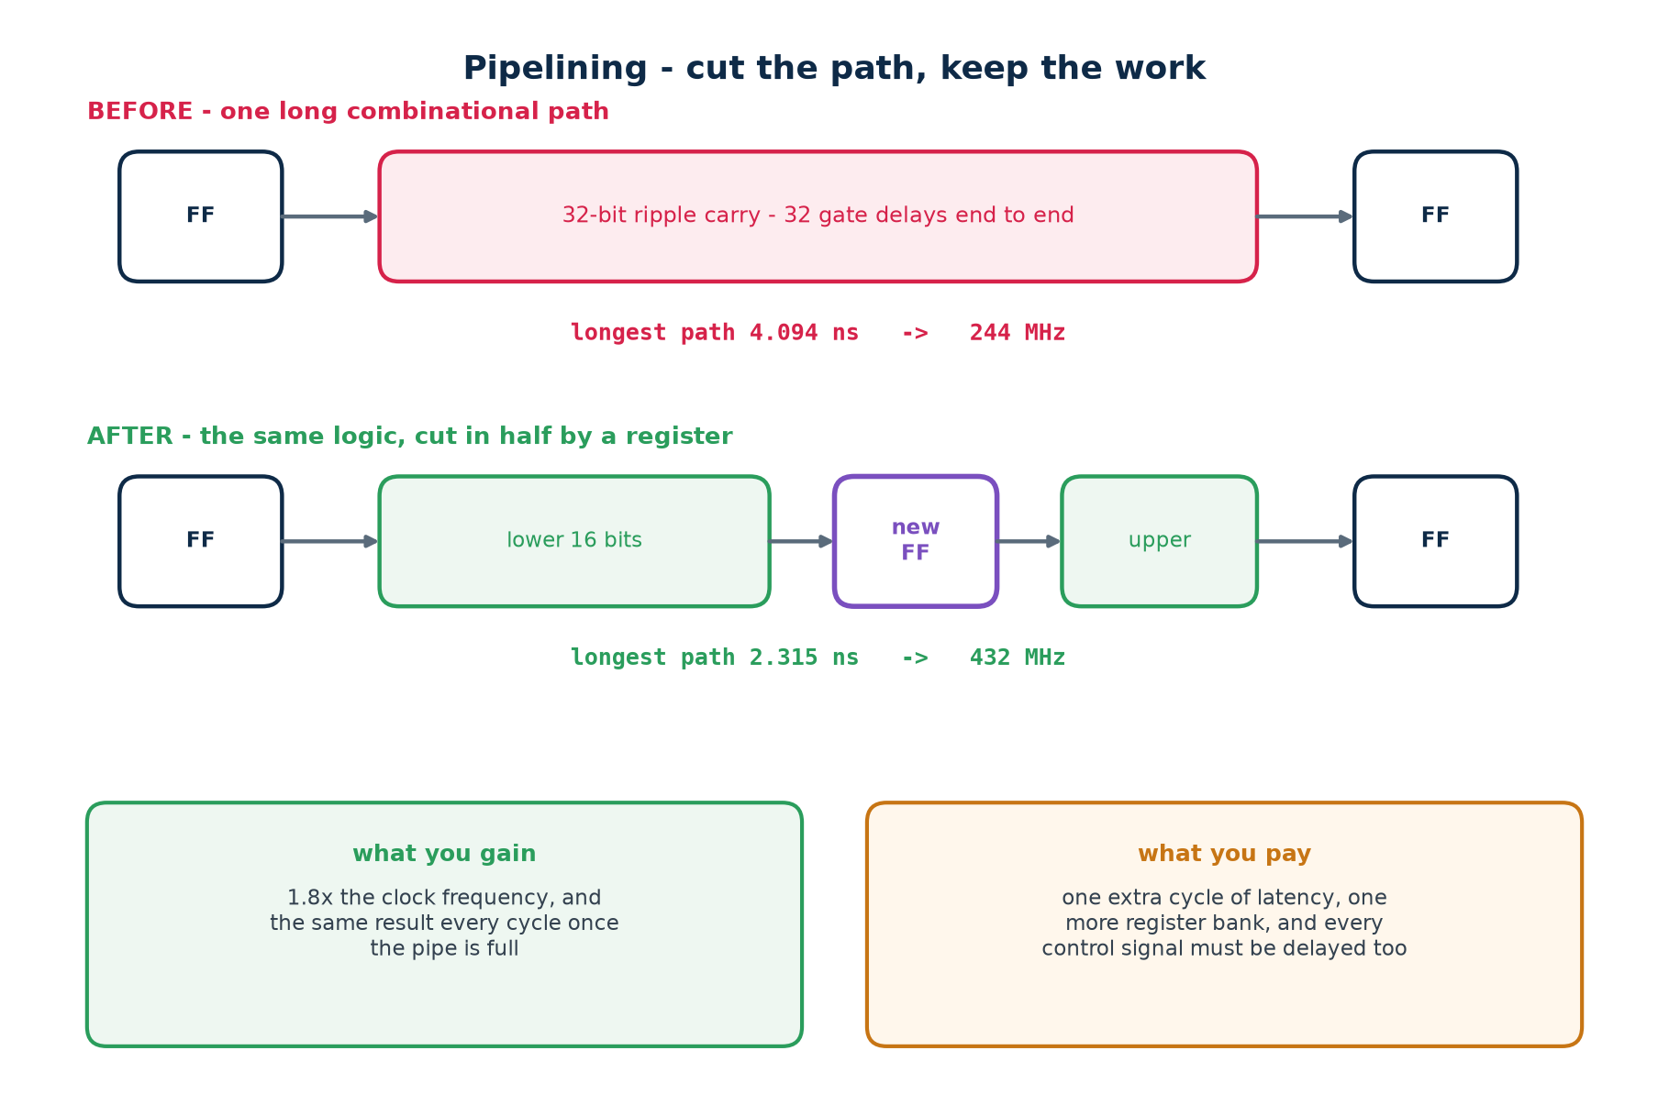
Cutting a long combinational path with a register is the largest single win available. The work per cycle halves, so the clock can roughly double; throughput is unchanged once the pipe is full. What you pay is one extra cycle of latency, one more bank of registers, and — the part people forget — the obligation to delay everything that travels alongside the data.
rtl/add_ripple_pipe.v
// BEFORE - the whole 32-bit carry chain in one cycle
always @(posedge clk) {cout, sum} <= a_q + b_q;

// AFTER - cut at bit 16.
always @(posedge clk) begin
{cmid_q, sl_q} <= a_q[15:0] + b_q[15:0]; // stage 1
ah_q <= a_q[31:16]; // <- the easy lines to forget: the upper operands
bh_q <= b_q[31:16]; // must be delayed to MEET the carry

{cout, sum} <= {ah_q + bh_q + cmid_q, sl_q}; // stage 2
end

The classic pipelining bug
You cut the datapath and forget to delay something beside it — an operand, a valid flag, a write enable, a destination address. The design then meets timing beautifully and computes the wrong answer, because stage 2 is combining this cycle's control with last cycle's data.
Every optimisation must be followed by verification. make verify runs all three adder netlists against a reference over 500 random vectors for exactly this reason.

4.6 Fix 5 — retiming
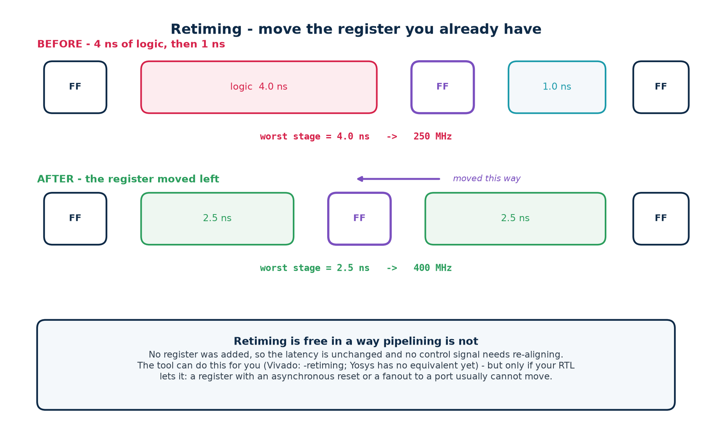
Retiming moves an existing register across logic rather than adding a new one. If one stage is 4 ns and the next is 1 ns, moving the register between them makes both 2.5 ns and the clock can run 1.6× faster. Latency does not change at all, so nothing beside the datapath needs re-aligning — which makes it strictly cheaper than pipelining when it is available.
 | Pipelining | Retiming
adds a register | yes | no
changes latency | yes, by one cycle | no
control signals | must all be delayed to match | unchanged
how much it can win | roughly a factor of 2 per cut | only up to the balance of existing stages
tool support | you write it | Vivado: synth_design -retiming

A register cannot always move. One with an asynchronous reset, one whose output drives a port directly, and one that a testbench or a debug probe observes by name are all usually pinned in place.

4.7 Fixes 6 and 7 — architecture, and the clock
If the first five have not closed the design, the problem is not in the implementation. Either the work assigned to one cycle is genuinely too large — a different adder structure, a different encoding, fewer operations per cycle — or the frequency target was never achievable in this technology and should be renegotiated.
Reducing the clock frequency is always available and always last. It works, immediately and completely, and it means shipping a slower product. Make that a decision someone takes deliberately, not one that happens because the deadline arrived.

4.8 The measured results, in one table
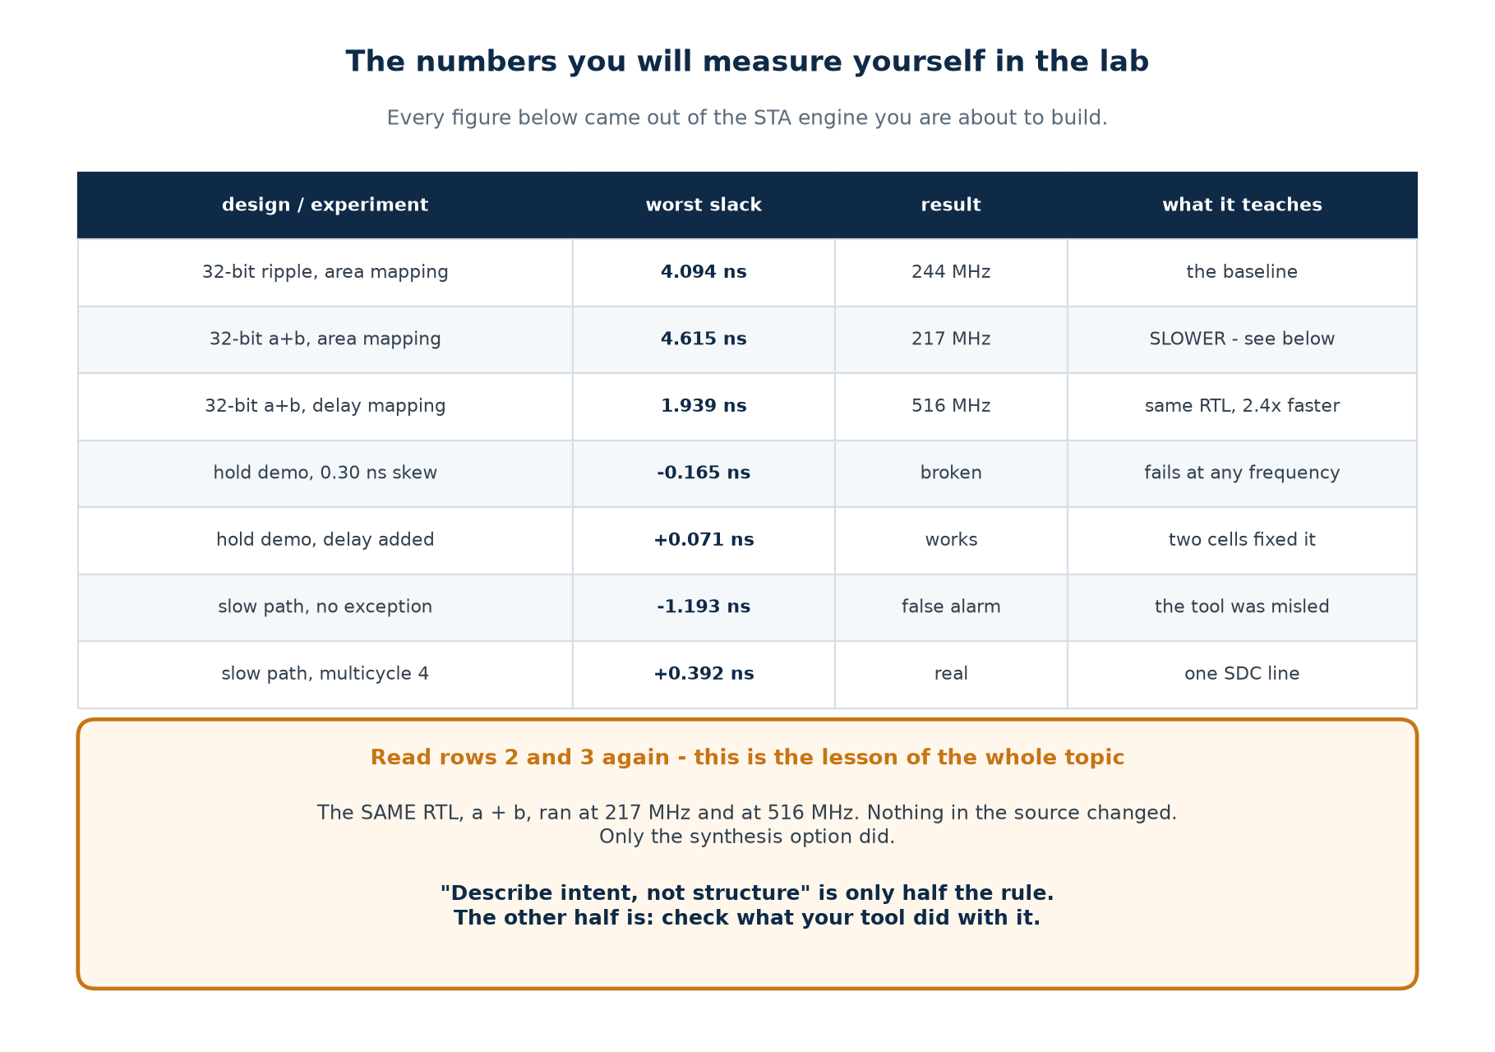
Part 4 self-check
1. Why is “check the constraint” the first step and not the third?
2. The same RTL gave 217 MHz and 516 MHz. What changed, and what did not?
3. Why can a named intermediate wire make a sum slower?
4. What must you do to every control signal when you pipeline a datapath?
5. When is retiming strictly better than pipelining, and when is it unavailable?

Part 5 · Setup and Hold Violations, and Their Resolution

5.1 Diagnosing which one you have
Every report labels the path type: max (setup) or min (hold). Read that label first, because the two failures need opposite fixes and applying the wrong one makes the problem worse rather than merely failing to help.


5.2 Setup violations
Symptom | Most likely cause | First thing to try
one path fails, the rest are fine | a genuinely long path | read its incr column
one cell has a huge incr | high fanout or a weak driver | set_max_fanout, or let the tool buffer
fifty small cells in one path | the logic is too deep | restructure, then pipeline
everything fails by a similar amount | the period is too aggressive | sanity-check the target against the technology
fails only after place-and-route | routing delay, not logic | floorplanning; keep the path local
fails only at the slow corner | correct behaviour | that is the corner you sign off at

The number that tells you how much work it is
Express the slack as a fraction of the period. −0.05 ns on a 5 ns period is a 1% problem: a higher effort setting will usually find it. −2.5 ns on the same period is a 50% problem: no option will close that, and you are looking at pipelining or a different architecture. Do this arithmetic before you promise anyone a date.

5.3 Hold violations
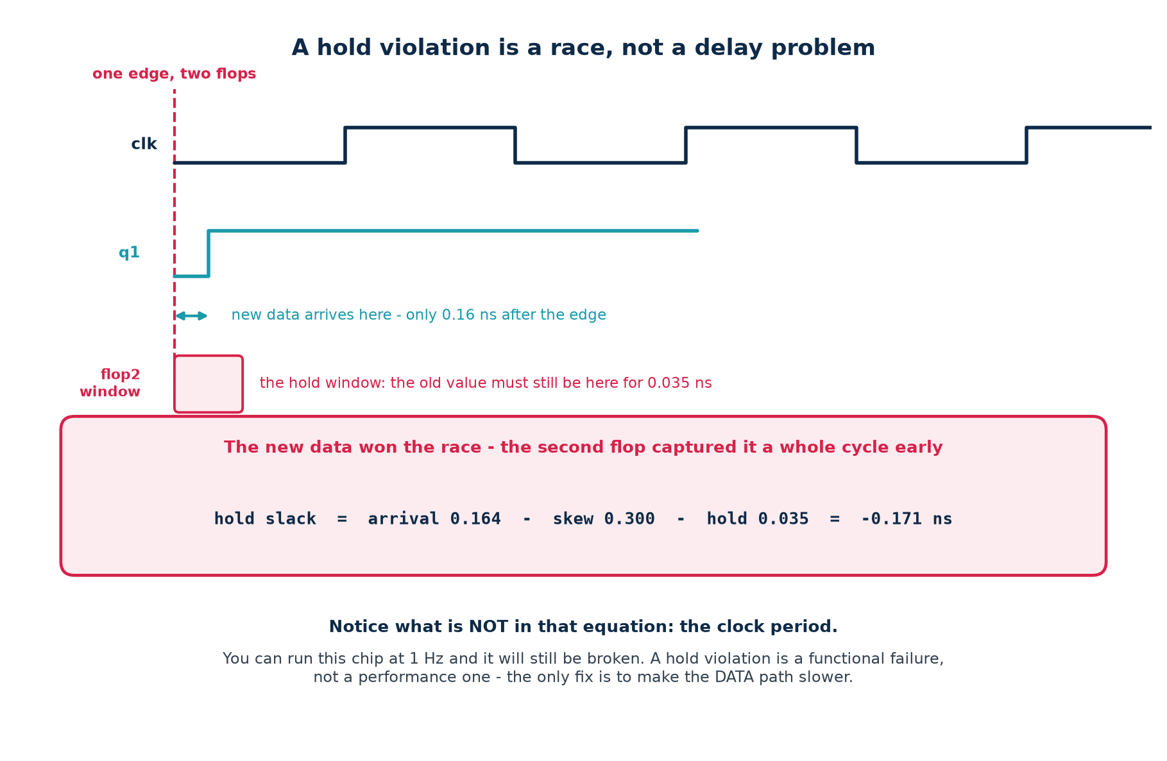
A hold violation is a race. The launching flop produces its new value, and that value travels to the capture flop faster than the capture flop's hold requirement allows. Because both flops are triggered by the SAME edge, the clock period plays no part in the race at all.
hold slack = arrival 0.164 - skew 0.300 - hold 0.035 = -0.171 ns

# measured in the lab: make hold
# hold_demo 0.30 ns skew, no logic between the flops -> -0.165 ns VIOLATED
# hold_fixed same skew, two delay cells inserted -> +0.071 ns MET

Why slowing the clock cannot help
Look at the equation above: the period is not in it. Slow the clock to 1 Hz and the launch edge and the capture edge are still the same edge, and the new data still arrives 0.164 ns after it. A hold violation is a functional failure, not a performance one.

5.4 Fixing hold
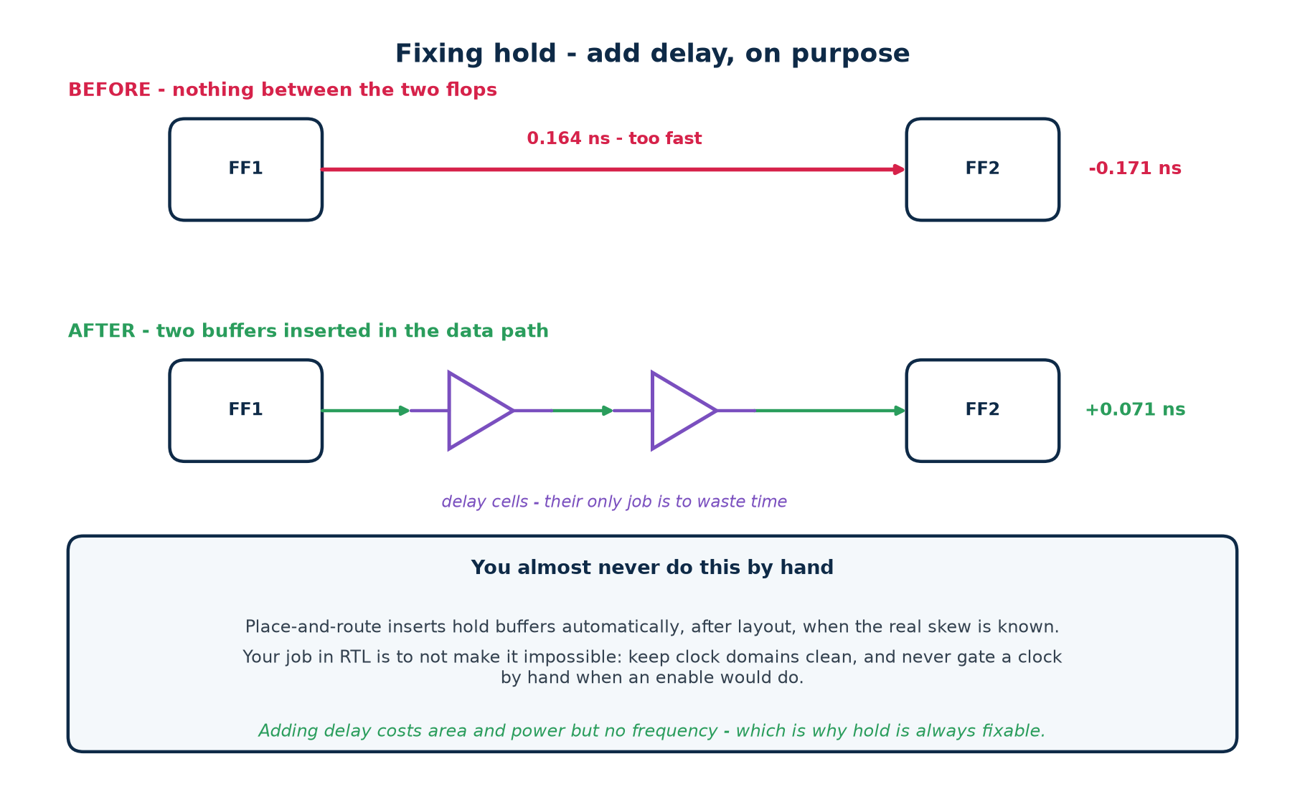
The only fix is to make the DATA path slower — to insert delay between the two flops. That costs area and power and no frequency at all, which is why hold is always fixable and setup sometimes is not.

Who does the fixing
Place-and-route, automatically, after layout — because only then does the real clock skew exist. The tool inserts hold buffers on the paths that need them. You will almost never do this by hand, and you should be suspicious of any flow that asks you to.

What your RTL can do to make it impossible
▪ Gating a clock by hand. An AND gate in the clock path adds skew you cannot control and the clock-tree synthesiser cannot balance. Use a clock enable on the flop instead — every FPGA and every standard cell library has one.
▪ Crossing clock domains without a synchroniser. No amount of buffering fixes a genuinely asynchronous crossing; you need two flops in the destination domain, and the crossing needs a false path or clock group so the tool stops trying to time it.
▪ Using both clock edges in one path. Launching on the falling edge and capturing on the rising edge halves the budget for both checks.

5.5 An honest note on how the lab demonstrates the hold fix
// rtl/hold_fixed.v
// dly_sel is a real input port, tied to zero by the testbench.
assign d0 = q1 ^ dly_sel[0]; // two XOR gates in the data path
assign d1 = d0 ^ dly_sel[1]; // functionally a no-op when dly_sel == 0

// Why not a chain of buffers marked (* keep *) ?
// opt_clean removes them. keep_hierarchy combined with -flatten removes
// them too. Only logic that a real input can influence survives
// optimisation - so the delay is built from gates fed by a real port.

What this shows and what it does not
It honestly shows: that adding delay to the data path converts a hold violation into a met one, and by exactly how much (−0.165 → +0.071 ns).
It is not a style to copy. Writing XOR gates into your datapath to fix hold is not engineering. In a real flow, place-and-route inserts hold buffers with knowledge of the actual clock tree. This is a teaching device and it is labelled as one.

5.6 The diagnosis procedure
Step | Do this | Because
1 | Read the unconstrained-endpoint count | a clean report on half a design is worthless
2 | Is it setup or hold? Read the path type | the two need opposite fixes
3 | Read the startpoint and endpoint by name | the names often identify the problem
4 | Ask whether the path is real | half of all violations are constraint bugs
5 | Look at the largest incr in the path | one big cell or fifty small ones — different fixes
6 | Compare WNS with TNS | one path, or the whole design?
7 | Apply the cheapest fix that could work | and re-run before trying the next
8 | Change ONE thing per run | or you will not know what helped

Step 8 is the one people skip
Under deadline pressure it is tempting to change the period, the effort level and the RTL all in one run. When the slack moves you will not know which change did it, and when it moves the wrong way you will not know what to undo.

5.7 Timing closure
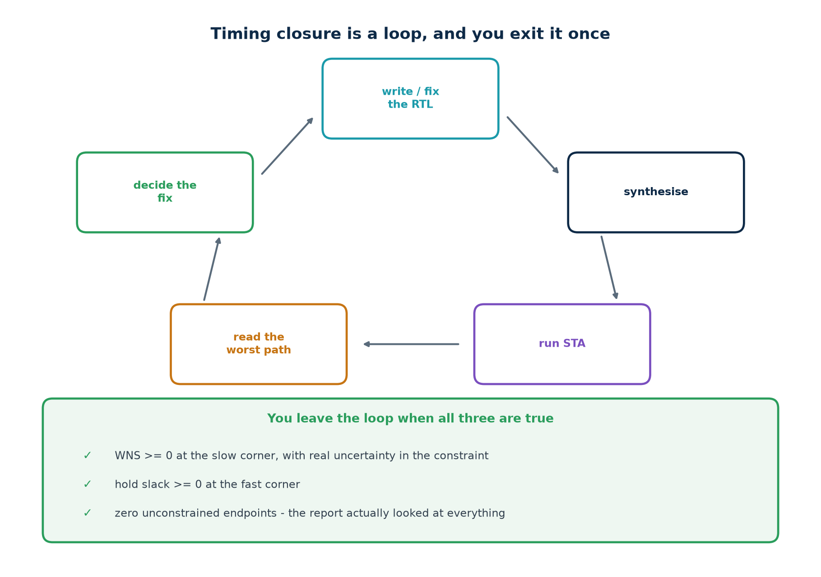
A design is closed when all three of these are true at once. Two out of three is not closed:
1. WNS ≥ 0 at the slow corner, with realistic uncertainty in the constraint.
2. Hold slack ≥ 0 at the fast corner.
3. Zero unconstrained endpoints — the report actually looked at everything.

5.8 Ten ways to get a green report and a broken chip
# | The mistake | What it costs
1 | no constraint file at all | every path unchecked
2 | clock declared, I/O not | every boundary path unchecked
3 | a generated clock never declared | a whole domain unchecked
4 | set_false_path used to silence a real path | a field failure
5 | multicycle -setup without the -hold line | hold violations you created
6 | multicycle claimed with no enable in the RTL | wrong data captured
7 | uncertainty reduced to make the report pass | no margin on silicon
8 | signing off setup at the typical corner | fails on slow silicon
9 | ignoring hold because the clock is slow | fails at every speed
10 | never checking the unconstrained count | all of the above, silently

Nine of those ten produce a report that says everything is fine. That is the point of the list.
Part 5 self-check
1. You have a hold violation on a 100 MHz design. Your colleague suggests dropping to 50 MHz. What do you say?
2. Why do hold violations appear suddenly after clock-tree synthesis?
3. Setup slack is −0.05 ns on a 5 ns period. How big a problem is that, and why does the ratio matter more than the number?
4. Name three things in RTL that make hold violations harder to fix.
5. Which of the ten mistakes above would your current project catch?

Part 6 · Tools

6.1 The landscape
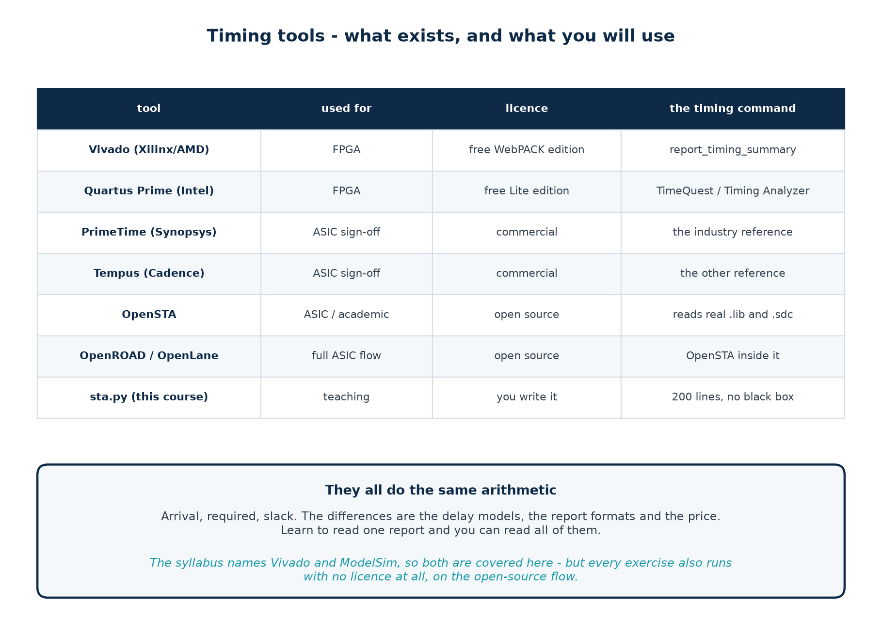
They all compute arrival, required and slack. The differences are the delay models, the report format and the price. Learn to read one report and you can read all of them.

6.2 Installing what you need
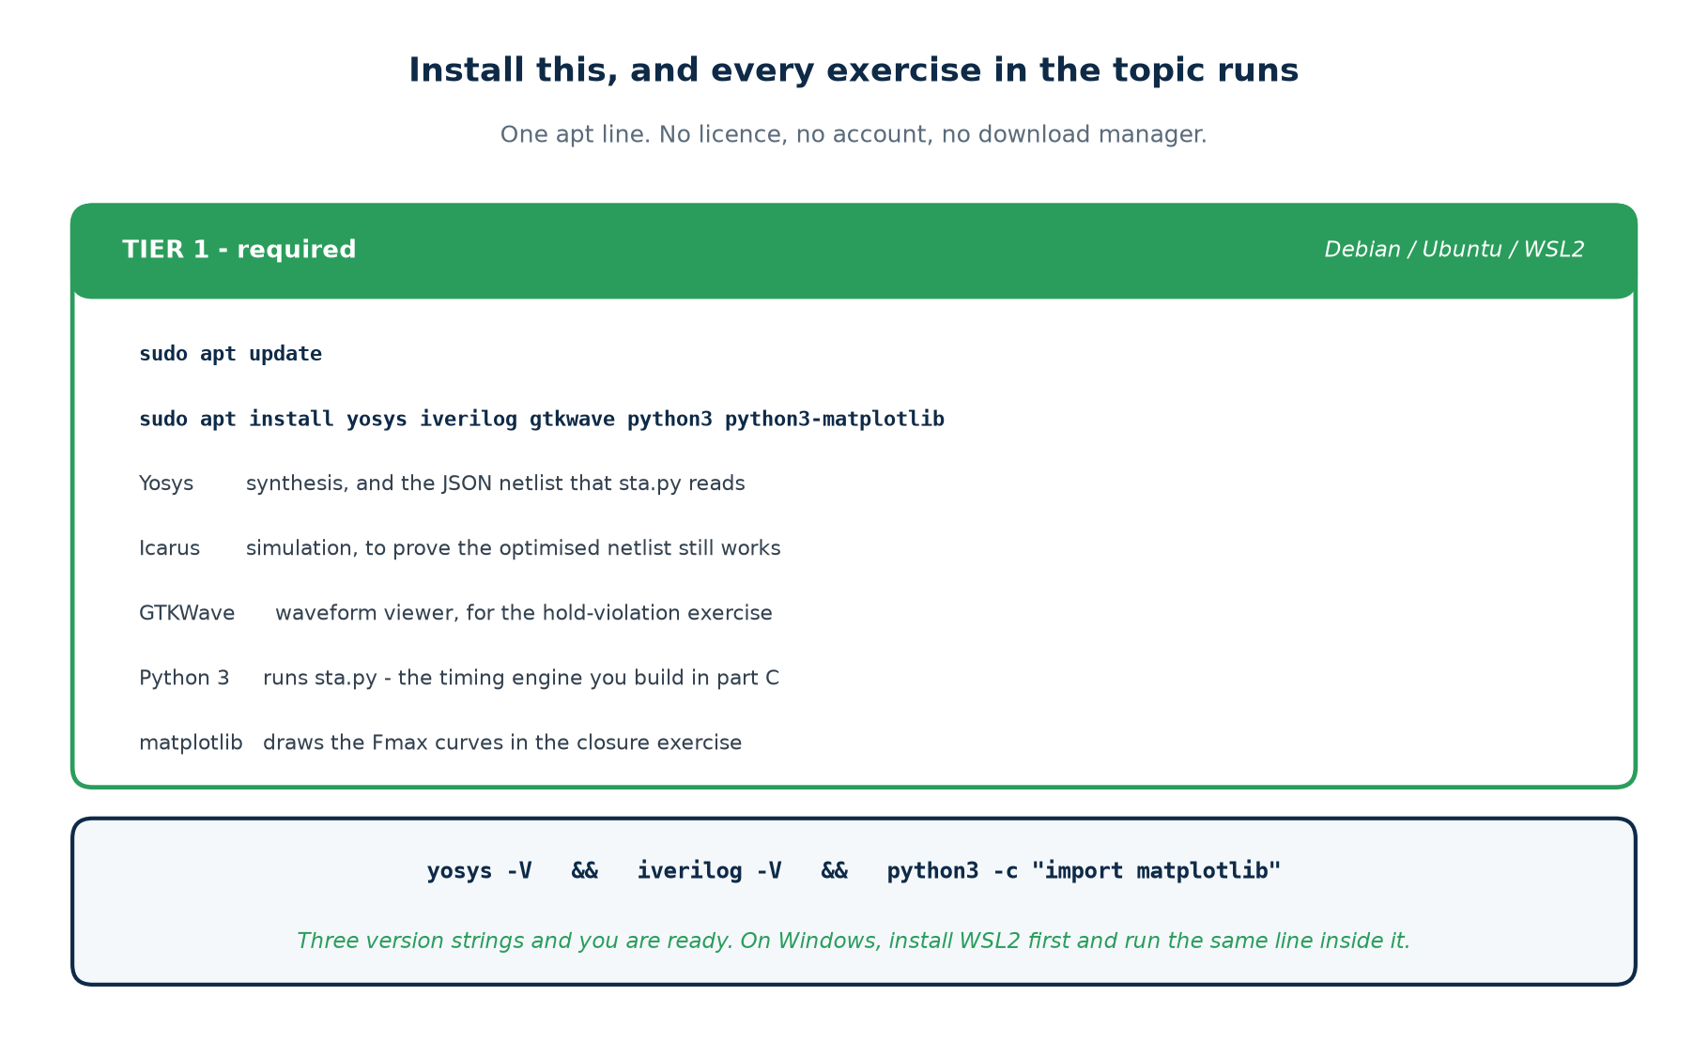
Tier 1 — Debian, Ubuntu or WSL2. This is all 57 of the 62 exercises need.
sudo apt update
sudo apt install yosys iverilog gtkwave python3 python3-matplotlib

# verify:
yosys -V && iverilog -V && python3 -c "import matplotlib; print('ok')"

On Windows, install WSL2 first (wsl --install from an elevated PowerShell), then run the same lines inside the Ubuntu shell it gives you. On macOS, brew install yosys icarus-verilog covers the first two; matplotlib comes from pip.
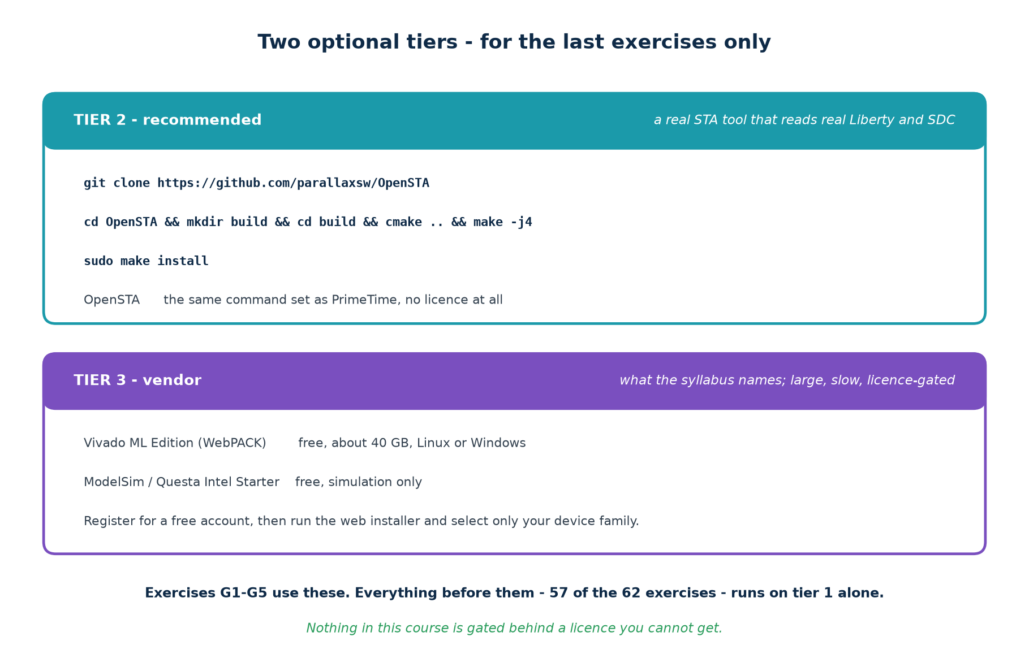
# Tier 2 - OpenSTA, a real STA tool with the PrimeTime command set
git clone https://github.com/parallaxsw/OpenSTA
cd OpenSTA && mkdir build && cd build
cmake .. && make -j4 && sudo make install

# it needs these first:
sudo apt install cmake g++ swig bison flex libeigen3-dev tcl-dev libtcl

Vivado, step by step
Step | What to do | Watch out for
1 | create a free AMD/Xilinx account | the download will not start without one
2 | download the Unified Installer (web installer, ~200 MB) | not the full 40 GB archive
3 | choose Vivado ML Edition, then Vivado ML Standard | Standard is the free one; no licence file needed
4 | deselect every device family except Artix-7 | this cuts 40 GB to about 8 GB
5 | on Linux, install the cable drivers afterwards | only needed to program a real board
6 | verify with vivado -version | then everything runs headless

You do not need a development board. Every timing exercise here is a synthesise-and-report exercise; Vivado will target a device it has never been connected to and give you a real timing report for it.

6.3 The open-source flow
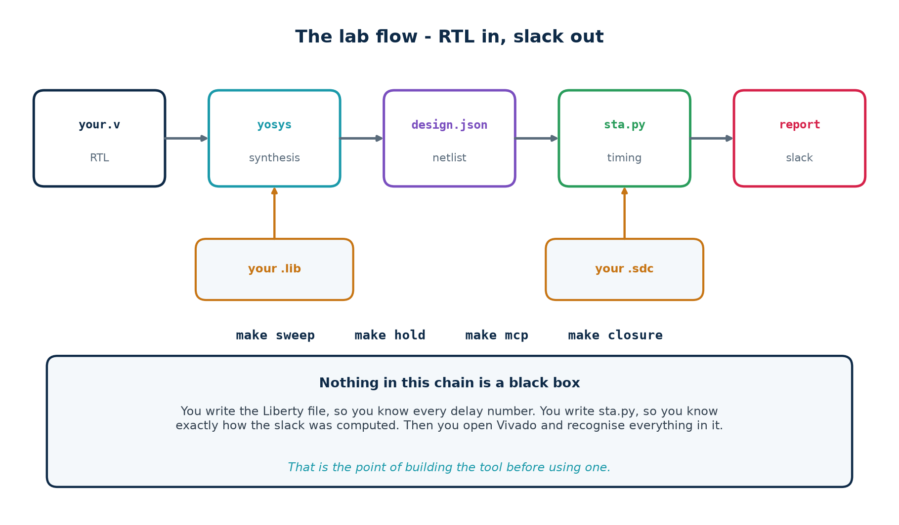
make lib # read the Liberty file and print the cell table
make tiny # three flops - a report you can check by hand
make sweep # Fmax against width, for three adder styles
make closure # the full closure story, with the Fmax curves
make hold # a hold violation, then the same design fixed
make mcp # a false violation, then the multicycle path that removes it
make verify # prove every optimised netlist still computes the right answer
make # all of the above, ending in 'Topic 6 lab complete'

6.4 The same flow in Vivado
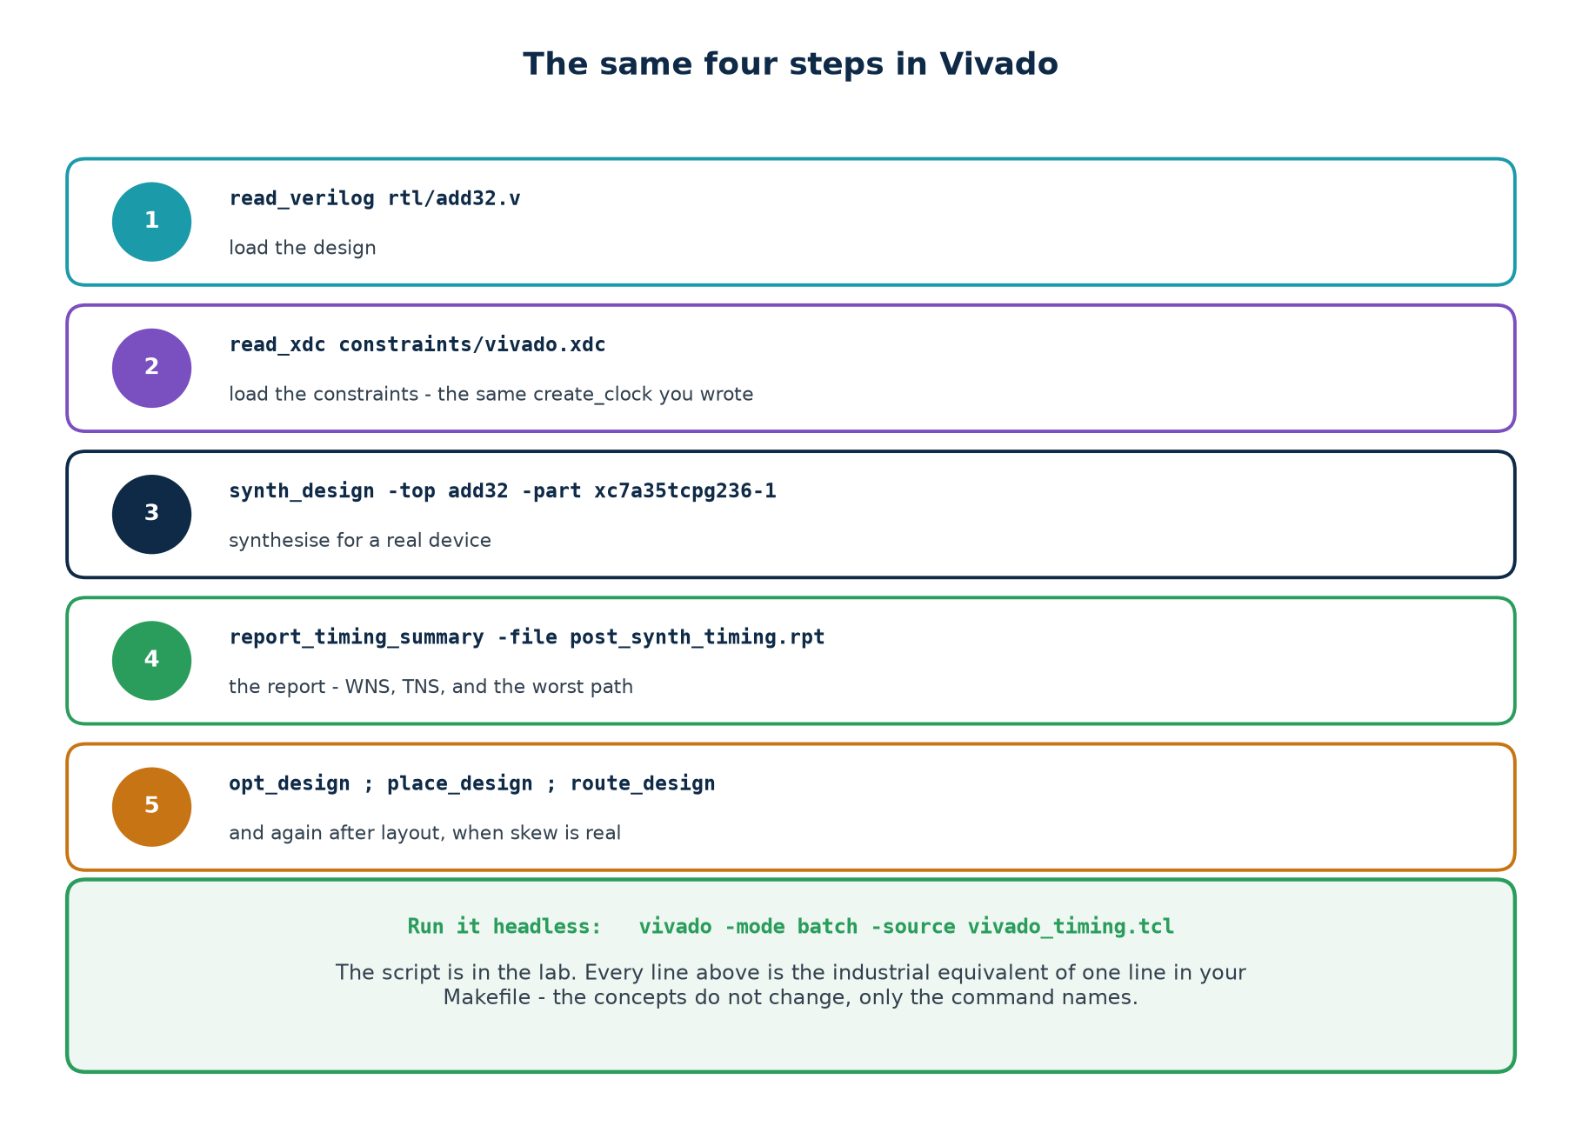
# scripts/vivado_timing.tcl - vivado -mode batch -source scripts/vivado_timing.tcl
set part xc7a35tcpg236-1

read_verilog [glob rtl/*.v]
read_xdc constraints/vivado.xdc
synth_design -top add32 -part $part -flatten_hierarchy rebuilt

report_timing_summary -file rpt/post_synth_summary.rpt
report_timing -delay_type max -max_paths 10 -file rpt/post_synth_setup.rpt
report_timing -delay_type min -max_paths 10 -file rpt/post_synth_hold.rpt

opt_design ; place_design ; route_design
report_timing_summary -file rpt/post_route_summary.rpt

puts "WNS = [get_property SLACK [get_timing_paths -delay_type max]]"

What to expect from the comparison
The absolute numbers will not match your engine's. They cannot: a 28 nm FPGA fabric is not the fictional library in lib/cda_edu.lib. What will match is the structure of the report, which path is critical, and the direction and rough proportion of every change you make to the constraints.
If you can explain why the numbers differ — pointing at the delay model rather than shrugging — you have understood this topic.

6.5 SDC and XDC
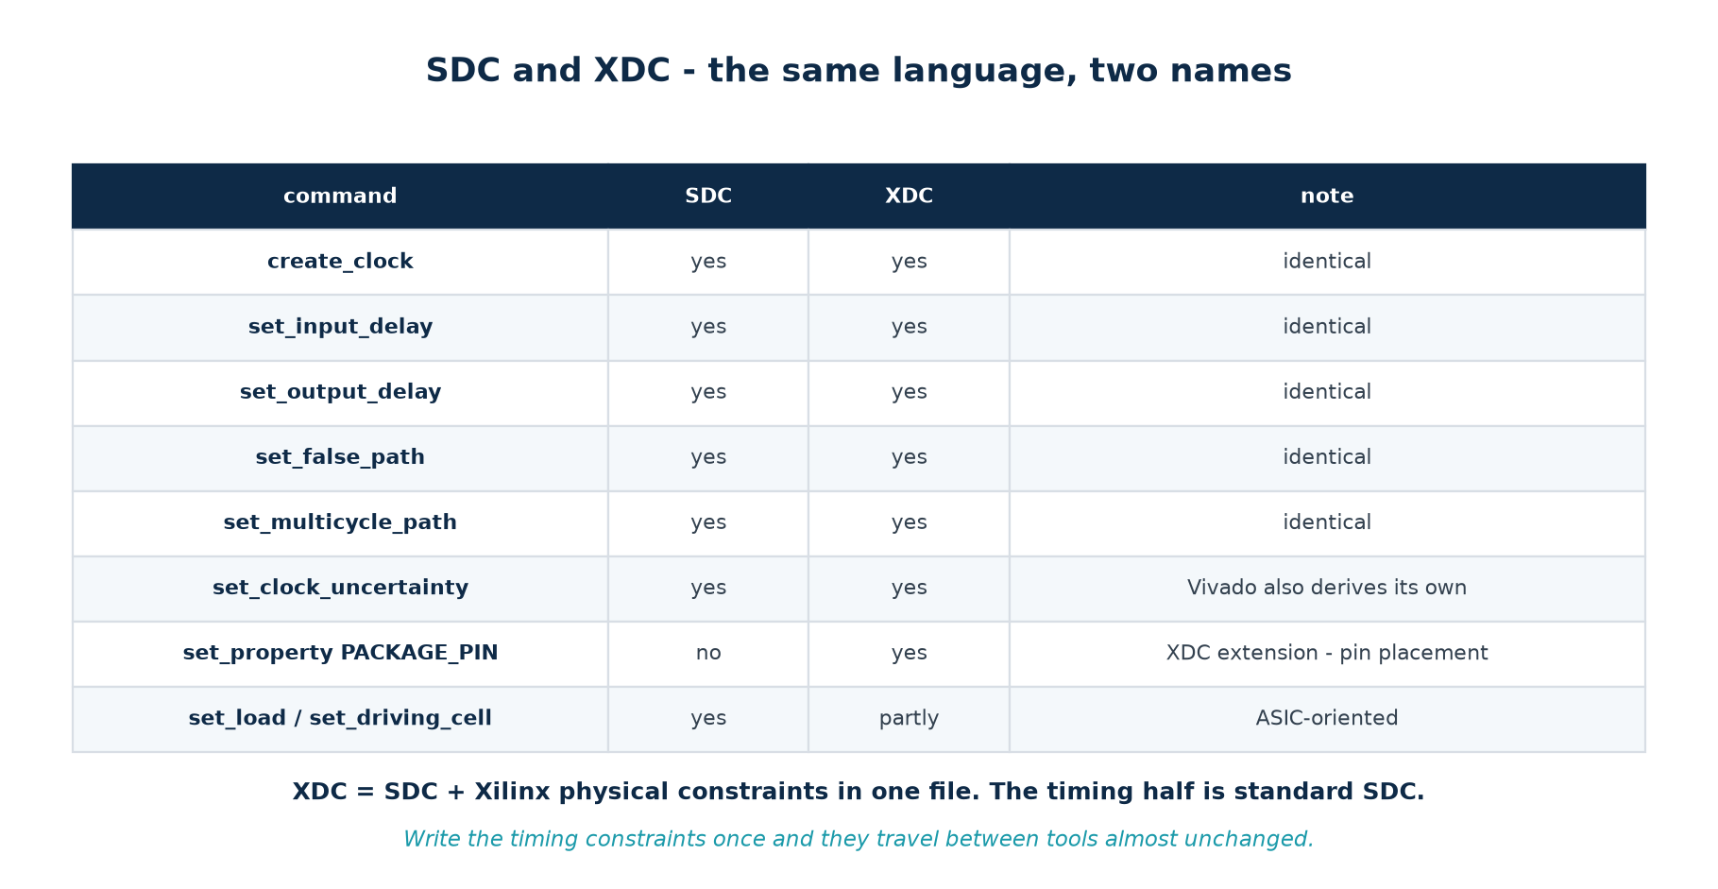
# constraints/vivado.xdc - the timing half is identical to the SDC file
create_clock -name clk -period 5.000 [get_ports clk]
set_input_delay -clock clk -max 1.20 [get_ports {a[*] b[*]}]
set_output_delay -clock clk -max 1.00 [get_ports {sum[*] cout}]

# the XDC-only half: physical constraints, which SDC has no concept of
set_property PACKAGE_PIN W5 [get_ports clk]
set_property IOSTANDARD LVCMOS33 [get_ports clk]

Part 6 self-check
1. Which single apt line gives you everything the first 56 exercises need?
2. What does OpenSTA give you that your own engine does not?
3. Why does the Vivado installer offer to install 40 GB, and how do you avoid it?
4. Name one command that exists in XDC and not in SDC, and say why.
5. Your engine says 516 MHz and Vivado says 180 MHz on the same RTL. Is something wrong?

Part 7 · Seven Guided Tutorials
Before you start
Install tier 1 (Part 6.2) and open a terminal in Topic6_Lab/. Type the commands; do not copy and paste them. The point of a tutorial is the twenty seconds between typing something and understanding why it did what it did.
Each tutorial ends with a Checkpoint — a specific output you should see. If you do not see it, stop and find out why before moving on. The tutorials build on each other.

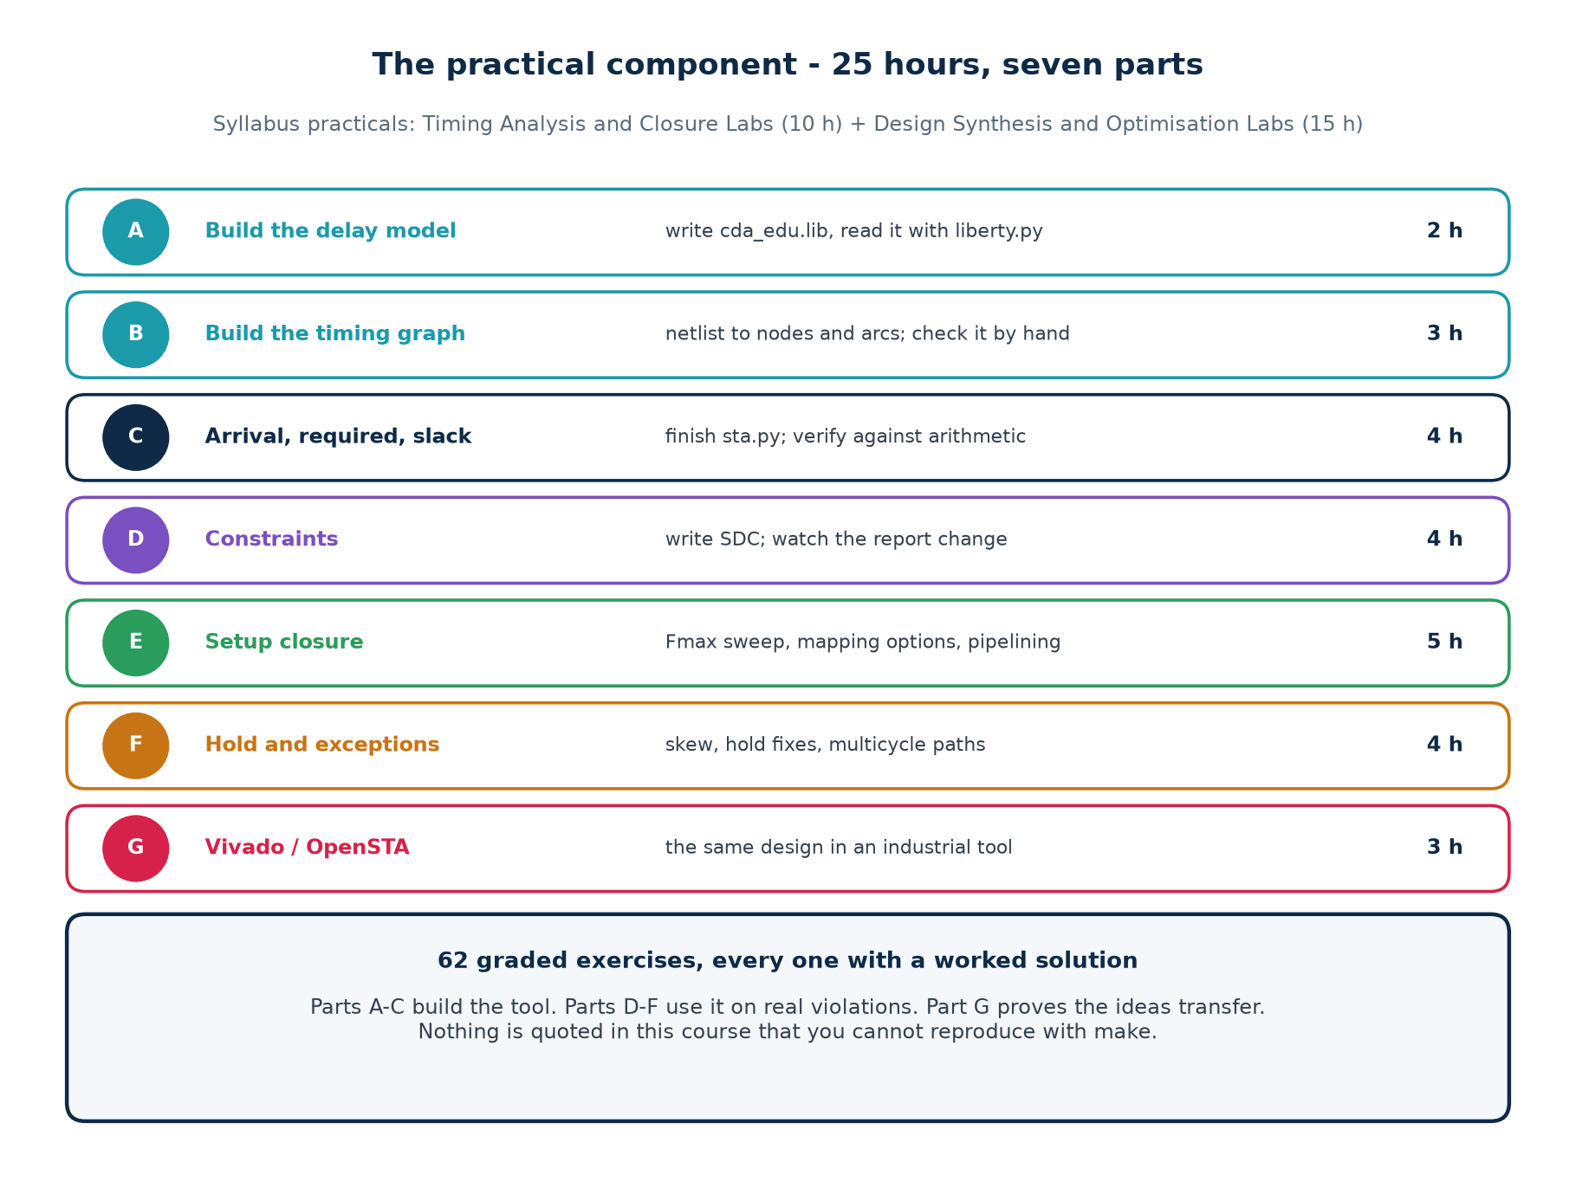

Tutorial 1 · The delay model (2 hours)
You cannot analyse timing without numbers for each cell, and you cannot trust an analysis whose numbers you have never seen. So the first thing you build is the library.

Step 1 — look at what a Liberty file is
$ cd Topic6_Lab
$ head -40 lib/cda_edu.lib

It is a nested, brace-delimited format. Each cell (NAME) { ... } block describes one standard cell. Real foundry libraries use the same syntax and run to tens of megabytes; this one is 191 lines and describes 14 cells.

Step 2 — read the model
cell (XOR2) {
area : 4.0 ;
cda_intrinsic : 0.088 ; /* ns, unloaded */
cda_load_factor : 0.018 ; /* ns per unit of capacitance on Y */
cda_input_cap : 1.5 ; /* what this cell presents to its driver */
pin (Y) { direction : output ; function : "(A^B)" ; }
}

The delay of any cell is intrinsic + load_factor × output_load, where the output load is the sum of the input capacitances of everything the cell drives. Three numbers per cell; that is the entire model.

Step 3 — run the reader
$ make lib

14 cells read from cda_edu.lib

cell type intrinsic load/ld clk->Q setup cap
------------------------------------------------------------------
AND2 comb 0.053 0.012 - - 1.20
DFF FF 0.000 0.013 0.145 0.090 1.60
INV comb 0.021 0.012 - - 1.00
XOR2 comb 0.088 0.018 - - 1.50
... (14 rows)

Step 4 — do the arithmetic yourself
An INV drives two XOR2 inputs. What is its delay?
load = 1.5 + 1.5 = 3.0
delay = 0.021 + 0.012 x 3.0 = 0.057 ns

Now the same INV driving eight XOR2 inputs: load 12.0, delay 0.165 ns — nearly three times as slow. That is fanout, and it is why set_max_fanout exists.
Checkpoint 1
make lib prints a 14-row table. You can state, for any cell in it, what its delay would be driving three DFF inputs — and check your answer against the formula.

Tutorial 2 · The timing graph (3 hours)

Step 1 — look at the design
$ cat rtl/tiny.v

module tiny (input clk, input din, output q);
reg p, r, qq;
always @(posedge clk) begin
p <= din;
r <= din;
qq <= p ^ r; // one XOR between two flops - hand-checkable
end
assign q = qq;
endmodule

Step 2 — synthesise it and look at the netlist
$ ./scripts/synth.sh tiny
$ python3 -c "import json;d=json.load(open('build/tiny.json'));\
print(list(d['modules']['tiny']['cells'].keys()))"

['$auto$ff.cc:266:slice$89', '$abc$95$auto$blifparse.cc:...$97', ...]

Yosys names are unreadable, and that is a real problem
A report full of $abc$95$auto$blifparse.cc:492:parse_blif$97/Y is a report nobody reads. The engine has a short() function that turns those into u97/Y, and recovers register names from the JSON netnames section so a flop appears as q_reg rather than a hash. Making a tool's output legible is not cosmetic work — an unreadable report does not get read, and a report that does not get read finds no bugs.

Step 3 — build the graph, and get the arcs right

One node per pin. For each cell, one arc from every input pin to every output pin, carrying the cell's delay computed with the load on that output net. For each net, arcs from the driver to every load, carrying zero. For a flip-flop, the clock-to-Q delay is charged at the Q pin.

Step 4 — draw it on paper first
Before running anything, draw the graph for tiny.v by hand. Three flops, one XOR, one output port. Count the nodes; count the arcs. Then run the engine and compare.
$ python3 sta/sta.py build/tiny.json tiny -p 1.0 --paths 1

Checkpoint 2
Your hand-drawn graph and the engine's agree on the number of nodes and the number of arcs, and you can point at the arc that carries the XOR's delay and say which net's load was used to compute it.

Tutorial 3 · Arrival, required, slack (4 hours)
This is the tutorial the whole topic exists for. When you finish it you will have written a static timing analyser, and no vendor's timing report will ever be a black box again.

Step 1 — the forward sweep
def propagate(self):
for n in self._order(): # topological order
for arc in n.fanin:
src, dly = arc.src, arc.delay
n.amax = max(n.amax, src.amax + dly) # LATEST -> setup
n.amin = min(n.amin, src.amin + dly) # EARLIEST -> hold

Two numbers per node, not one. Keep only the max and your hold analysis is silently wrong.

Step 2 — the checks
def setup_slack(self, ep):
required = self.period + self.skew(ep) - ep.cell.setup - self.uncert_setup
return required - ep.amax

def hold_slack(self, ep):
required = self.skew(ep) + ep.cell.hold + self.uncert_hold
return ep.amin - required

Step 3 — compute the answer on paper, before you run it
path: p_reg/Q -> u97/B -> u97/Y -> q_reg/D

1. p_reg/Q 0.145 + 0.013 x 1.5 = 0.164 (DFF clk->Q, driving XOR2 A=1.5)
2. u97/Y 0.088 + 0.018 x 1.6 = 0.117 (XOR2, driving DFF D=1.6)

arrival at q_reg/D = 0.164 + 0.117 = 0.281 ns

3. required = period 1.000 - setup 0.090 = 0.910 ns
4. slack = 0.910 - 0.281 = +0.629 ns MET

Step 4 — now run it
$ make tiny

==========================================================================
SETUP TIMING REPORT design=tiny clock clk period=1.000 ns (1000.0 MHz)
==========================================================================

Path 1 endpoint q_reg/D (DFF)
startpoint p_reg
incr arrival pin
0.000 0.000 clock edge at p_reg
0.164 0.164 p_reg/Q (DFF)
0.000 0.164 u97/B (XOR2)
0.117 0.281 u97/Y (XOR2)
0.000 0.281 q_reg/D (DFF)
0.910 required (period - setup)
0.629 SLACK MET

--------------------------------------------------------------------------
endpoints analysed : 2
UNCONSTRAINED : 2 endpoint(s) not checked - no input/output
delay was set for them. Unchecked is not passed.
WNS (worst slack) : +0.629 ns MET
TNS (total neg) : +0.000 ns over 0 failing endpoint(s)
longest path : 0.371 ns
Fmax : 2693.2 MHz
--------------------------------------------------------------------------

Notice the UNCONSTRAINED line
Two endpoints were not checked, because no input or output delay was set for them. The report says so, in as many words. Most commercial reports say the same thing but bury it in a summary section, which is why so many engineers have never noticed it.
“Unchecked is not passed” is the single most useful sentence in this workbook.

Checkpoint 3
Your paper arithmetic and the engine agree to three decimal places, and you can explain every line of the report — including which library number produced each incr value.

Tutorial 4 · Constraints (4 hours)
Now change constraints and watch the report move. Do them one at a time and write down the prediction before each run.
Change | Predict, then measure
period 1.0 → 0.5 ns | slack falls by 0.5; the path does not change
period 1.0 → 0.35 ns | slack goes negative; the same path is now critical
add set_clock_uncertainty 0.15 -setup | every setup slack drops by 0.15
add set_input_delay for the first time | new paths appear that were not there before; unconstrained count falls
remove it again | unconstrained count rises AND the WNS improves
set_clock_skew 0.30 on the capture register | setup slack improves; hold slack collapses
set_false_path on the critical path | the WNS jumps to the next-worst path

$ python3 sta/sta.py build/tiny.json tiny -p 0.5
$ python3 sta/sta.py build/tiny.json tiny -p 0.35
$ python3 sta/sta.py build/add32.json add32 -c constraints/add32.sdc
$ python3 sta/sta.py build/hold_demo.json hold_demo \
-c constraints/hold_skew.sdc --hold

The two runs that teach the most
Removing the input delay makes the WNS better and the analysis worse. Removing a check always improves the number.
Adding a false path on the critical path does the same thing, more dramatically. Write down, in your own words, why an engineer under deadline pressure might do this and how you would catch it in review.

Checkpoint 4
You predicted the direction and rough size of every change above before running it, and you were right at least five times out of seven. Where you were wrong, you know why.

Tutorial 5 · Setup closure (5 hours)

Step 1 — the Fmax sweep
$ make sweep

=== Fmax vs width: hand-written carry chain ===
W cells longest(ns) Fmax(MHz) ns/bit
-------------------------------------------------------
4 30 0.773 1293.7 0.1933
8 62 1.247 801.9 0.1559
16 126 2.196 455.4 0.1373
32 254 4.094 244.3 0.1279
64 510 7.889 126.8 0.1233

=== Fmax vs width: a + b, delay-driven mapping ===
W cells longest(ns) Fmax(MHz) ns/bit
-------------------------------------------------------
4 33 0.831 1203.4 0.2077
8 74 1.183 845.3 0.1479
16 159 1.547 646.4 0.0967
32 332 1.939 515.7 0.0606
64 681 2.318 431.4 0.0362

The ns/bit column is the interesting one. For the hand-written chain it converges on a constant — the delay is linear in width, because a ripple-carry adder is a chain. For the tool's version it keeps falling — the tool built something with logarithmic depth, a carry-lookahead or carry-select structure, from a source file that never mentioned one.

Step 2 — the closure table
$ make closure

design cells area-mapped cells delay-mapped
longest Fmax longest Fmax
----------------------------------------------------------------------------
add_ripple 254 4.094 244 254 5.258 190
add_ripple_pipe 303 2.315 432 303 2.906 344
add_fast 268 4.615 217 332 1.939 516

Three things in that table are worth an argument
1. add_fast under area mapping (4.615 ns) is SLOWER than the hand-written ripple chain (4.094 ns). The idiomatic code lost.
2. add_fast under delay mapping (1.939 ns) is 2.4× faster than itself. The RTL did not change; one option did.
3. add_ripple gets WORSE under delay mapping (5.258 ns). The mapper has nothing left to decide — the structure is already fixed by the source — so the extra effort only shuffles the same slow chain.

Step 3 — verify before you believe any of it
$ make verify

PASS - all three adders agree with the reference over 500 vectors

An optimisation you have not verified is not an optimisation. This is not ceremony: the pipelined version is genuinely easy to get wrong, and the testbench compares it against a reference delayed by the correct number of cycles for each design.

Step 4 — break it deliberately
Open rtl/add_ripple_pipe.v and delete the two lines that delay the upper operands (ah_q <= a_q[31:16]; and its partner). Re-run make sweep — the timing is unchanged, possibly better. Now run make verify — it fails. This is the classic pipelining bug and you should meet it under controlled conditions before you meet it at work.
Checkpoint 5
You can explain, without looking, why the ripple chain's ns/bit is constant and the tool's is falling; you have reproduced the 2.4× speed-up; and you have broken the pipeline and watched verify catch it.

Tutorial 6 · Hold violations and exceptions (4 hours)

Step 1 — create a hold violation
$ cat constraints/hold_skew.sdc
create_clock -period 3.0
set_clock_skew 0.30 -regs dout_reg # the capture clock arrives 0.30 ns late

$ make hold
WNS (worst slack) : -0.165 ns VIOLATED (hold_demo, 0.30 ns skew)
WNS (worst slack) : +0.071 ns MET (hold_fixed, same skew)

Two flops, nothing between them, and 0.30 ns of skew on the capture clock. The new data arrives 0.164 ns after the launch edge; the capture flop needs the old value for 0.035 ns after ITS edge, which is 0.300 ns later. The data lost the race by 0.171 ns.

Step 2 — change the period and watch nothing happen
$ python3 sta/sta.py build/hold_demo.json hold_demo -p 3.0 --hold
$ python3 sta/sta.py build/hold_demo.json hold_demo -p 30.0 --hold
$ python3 sta/sta.py build/hold_demo.json hold_demo -p 300.0 --hold

# the hold slack is -0.165 ns in all three runs.

A hundred-fold reduction in clock frequency and the violation is exactly the same size. If you needed one demonstration of why hold is different from setup, this is it.

Step 3 — the multicycle path
$ make mcp

=== a long path captured one cycle in four, at 3 ns ===
--- without the multicycle promise ---
WNS (worst slack) : -1.193 ns VIOLATED
TNS (total neg) : -6.555 ns over 11 failing endpoint(s)
--- with set_multicycle_path 4 ---
WNS (worst slack) : +0.392 ns MET
TNS (total neg) : +0.000 ns over 0 failing endpoint(s)

Eleven failing endpoints became zero, and no RTL changed. The design was always correct; the analysis was wrong, because nobody had told the tool that the accumulator is only enabled one cycle in four.

Step 4 — make the promise false
Open rtl/slow_path.v and remove the if (tick) enable, so the accumulator loads every cycle. The multicycle constraint is now a lie. Re-run make mcp — the report is still green, because the tool believed you. Write down what would happen in silicon.
Checkpoint 6
You have produced a hold violation, shown that the clock period does not affect it, fixed it with added delay, removed 11 false violations with one SDC line, and then made that line a lie and watched the report stay green.

Tutorial 7 · The same design in an industrial tool (3 hours)
Requires tier 3 (Vivado) or tier 2 (OpenSTA) from Part 6.2. If you have neither, read this tutorial anyway — the comparison is the point, and the outputs are reproduced below.

Step 1 — Vivado, headless
$ vivado -mode batch -source scripts/vivado_timing.tcl
$ grep -A4 'Design Timing Summary' rpt/post_synth_summary.rpt

Step 2 — compare against your engine
What to compare | Expect | Why
absolute WNS | different | a real FPGA fabric is not cda_edu.lib
which path is critical | the same | the structure of the design is the same
effect of halving the period | the same shift | slack is linear in period
effect of the multicycle path | the same direction | the exception means the same thing everywhere
report layout | the same six things | every STA tool reports the same things

Step 3 — OpenSTA on the same netlist
$ sta
% read_liberty lib/cda_edu.lib
% read_verilog build/add32_netlist.v
% link_design add32
% read_sdc constraints/add32.sdc
% report_checks -path_delay max -digits 3

OpenSTA uses the PrimeTime command set, so what you learn here transfers directly to the tool most ASIC teams sign off with. It will not read cda_edu.lib — that file uses custom cda_* attributes, which are convenient for a teaching analyser and are not part of the Liberty standard. Generate the standards-compliant view first:
$ make stdlib
wrote lib/cda_edu_std.lib - 14 cells, 753 lines
braces balanced : yes
required groups : all present
delay numbers match : yes, every cell
PASS - structurally sound and numerically identical to cda_edu.lib.

# then read THAT file in OpenSTA:
% read_liberty lib/cda_edu_std.lib

The generated file expresses the same straight-line delay model as a 2×5 lookup table — the smallest form every Liberty reader accepts — with correct unateness on every input pin and proper setup/hold constraint groups on the flip-flops. The delay numbers are identical, so an OpenSTA report and a sta.py report on the same netlist can be compared cell by cell.
What make stdlib does and does not prove
The self-check verifies that the file is brace-balanced, that every cell carries the groups a Liberty reader requires, and that every delay number matches cda_edu.lib exactly. It cannot prove OpenSTA will accept it — only OpenSTA can do that, and it is not installed in every environment. If you have it, confirm with sta -no_splash -exit -x 'read_liberty lib/cda_edu_std.lib'.

Step 4 — write the comparison
One page. What matched, what did not, and why. This is the deliverable that shows you understood the topic rather than memorised a procedure. An answer that says “the numbers were different” is not an answer; an answer that says “the numbers were different because the FPGA's LUT delay is 0.12 ns where our XOR2 is 0.088, and routing adds delay our model has none of” is.
Checkpoint 7
You have run the same design through two tools, and you can account for the difference between them in terms of the delay model rather than dismissing it as “different tools give different answers”.

Exercises
How to read the tags
[H] hand calculation — do it on paper before you touch a keyboard. [C] computer — run it and record what you see. [W] write it down — a short paragraph you can defend in review.
Every exercise has a worked solution starting on the next page. Do not read it until you have written something down, even if what you write is wrong. A wrong answer you committed to teaches more than a right answer you read.

Part A · The delay model
6 exercises · 2 hours
A1 [H] A DFF (clk→Q 0.145, load_factor 0.013) drives one XOR2 input (cap 1.5). What is the clock-to-Q arc delay?
A2 [H] The same DFF now drives four XOR2 inputs. What is the delay, and by what factor did it grow?
A3 [H] An INV (0.021 / 0.012 / cap 1.0) drives eight INV inputs. Compare its delay with the single-load case.
A4 [C] Run make lib. Which cell has the largest intrinsic delay, and which has the largest load_factor?
A5 [W] Why does a Liberty file give a cell an input capacitance as well as a delay?
A6 [W] Real Liberty files use a 2-D table indexed by input slew and output load. What does the slew axis capture that this model ignores?

Part B · The timing graph
8 exercises · 3 hours
B1 [H] How many nodes does a 2-input XOR gate contribute to the timing graph, and how many arcs?
B2 [H] Where is a cell's delay charged — on the net arc into it, or on the arc inside it? Why does the choice matter?
B3 [H] Why do net arcs carry zero delay in this model, and what is the real answer?
B4 [C] Synthesise tiny.v and count the cells in build/tiny.json. Draw the graph by hand first, then compare node and arc counts.
B5 [W] Yosys names a cell $abc$95$auto$blifparse.cc:492:parse_blif$97. Why does the engine shorten this, and why is that not merely cosmetic?
B6 [C] Find the reg_label logic in sta.py. How does it recover the name 'q_reg' from the JSON?
B7 [H] A node has three fan-in arcs with source arrivals 0.20, 0.31 and 0.28 and arc delays 0.05, 0.02 and 0.04. Give amax and amin.
B8 [W] Why must the graph be traversed in topological order, and what does it mean if you cannot produce one?

Part C · Arrival, required, slack
10 exercises · 4 hours
C1 [H] p_reg/Q → u97 (XOR2) → q_reg/D. Compute the arrival at q_reg/D.
C2 [H] With a 1.000 ns period and setup 0.090, what is the required time and the slack?
C3 [H] Same path, period 0.35 ns. Slack?
C4 [H] At what period does that path have exactly zero slack, and what Fmax does that correspond to?
C5 [C] Run make tiny. Confirm your C1–C4 answers against it.
C6 [H] Add 0.15 ns of setup uncertainty to C2. What happens to the slack, and why exactly that much?
C7 [W] Why does every node carry both amax and amin?
C8 [C] The report ends with 'UNCONSTRAINED: 2 endpoint(s) not checked'. Which two, and how would you remove the line?
C9 [W] Your engine says +0.629 and a commercial tool says +0.41 on the same RTL. Is one of them wrong?
C10 [W] TNS is 'the sum of every negative slack'. Why not the average?

Part D · Constraints
12 exercises · 4 hours
D1 [H] Write create_clock for a 250 MHz clock on a port named clk_in, named core_clk.
D2 [H] A design has a divide-by-4 built from flops. Why is a second create_clock the wrong answer?
D3 [C] Run sta.py on tiny with -p 1.0, then 0.5, then 0.35. Tabulate the slack and confirm it is linear in the period.
D4 [W] Removing set_input_delay improves the WNS. Explain that to a manager in two sentences.
D5 [H] An upstream chip has a clock-to-out of 2.2 ns max and the board trace adds 0.3 ns. Your period is 8 ns. Write the constraint and say how much is left for your logic.
D6 [H] The downstream chip needs data 1.8 ns before its edge; the trace adds 0.4 ns. Write the output constraint.
D7 [W] Give one legitimate and one illegitimate use of set_false_path, and state the test that separates them.
D8 [C] Run make mcp. How many failing endpoints does the multicycle path remove, and how much RTL changed?
D9 [H] You write set_multicycle_path 6 -setup. What hold line must follow, and what happens if you omit it?
D10 [W] What must be true of the RTL before a multicycle path is honest?
D11 [C] Edit constraints/add32.sdc to set the period to 2.0 ns. What breaks, and is it the design or the constraint?
D12 [W] Order these by how much damage a mistake in each does: create_clock, set_input_delay, set_false_path. Justify the order.

Part E · Setup closure
12 exercises · 5 hours
E1 [C] Run make sweep. What is the ns/bit for the 64-bit ripple chain, and what does the trend tell you?
E2 [C] What is the ns/bit for the 64-bit a+b under delay mapping, and why is the trend different?
E3 [H] From the sweep, predict the 128-bit ripple delay. Then say how much confidence you have in the prediction.
E4 [C] Run make closure. Why is add_fast SLOWER than add_ripple under area-oriented mapping?
E5 [C] Why does add_ripple get WORSE under delay mapping (5.258 ns)?
E6 [W] State the lesson of E4 and E5 in one sentence, and say what it implies for your coding style.
E7 [C] Pipeline add_ripple at the halfway point. What Fmax do you get, and what did you pay?
E8 [C] Delete the two lines in add_ripple_pipe.v that delay the upper operands. What happens to the timing, and what happens to make verify?
E9 [H] A path is 6.2 ns and the target period is 5.0 ns. Express the problem as a percentage and say which fixes are plausible.
E10 [H] A path is 5.05 ns against a 5.0 ns target. Same question.
E11 [W] Why is 'reduce the clock frequency' listed last rather than banned?
E12 [W] You improve WNS from −0.30 to −0.05 and TNS from −140 to −138. What actually happened?

Part F · Hold and exceptions
9 exercises · 4 hours
F1 [H] Write the hold equation and point at what is missing compared with setup.
F2 [C] Run make hold. Why is the violation −0.165 ns?
F3 [C] Run hold_demo at 3 ns, 30 ns and 300 ns. Explain the result.
F4 [H] How much delay must be added to hold_demo's data path to reach zero slack, and how much did the two XOR cells actually add?
F5 [W] Why does place-and-route fix hold rather than synthesis?
F6 [W] Name three things in RTL that make hold violations harder to fix and say why each one hurts.
F7 [C] Remove the if (tick) enable from slow_path.v and re-run make mcp. What does the report say, and what would silicon do?
F8 [W] Explain why hold_fixed.v uses XOR gates fed by a real port rather than a chain of buffers with (* keep *).
F9 [H] A path has setup slack +0.02 ns and hold slack +0.01 ns. Is it safe? What would you do?

Part G · Industrial tools
5 exercises · 3 hours
G1 [C] Run scripts/vivado_timing.tcl. Which path does Vivado call critical, and is it the same one your engine picked?
G2 [C] Compare Vivado's post-synthesis and post-route WNS. Which is worse, and why is that expected?
G3 [C] Apply the multicycle path in XDC rather than SDC. What changed in the syntax, and what changed in the effect?
G4 [C] Run make stdlib, then read the generated library in OpenSTA. What did the generator have to add that cda_edu.lib does not contain?
G5 [W] Write the one-page comparison: what matched between your engine and the industrial tool, what did not, and why.

Worked Solutions
Every answer below was checked against the lab. Where a number is quoted it came from a real run; where a judgement is asked for, the solution gives the reasoning that earns the marks rather than a single word.

Part A
A1 A DFF (clk→Q 0.145, load_factor 0.013) drives one XOR2 input (cap 1.5). What is the clock-to-Q arc delay?
0.145 + 0.013 × 1.5 = 0.1645 ns. Round as the engine does: 0.164 ns.
A2 The same DFF now drives four XOR2 inputs. What is the delay, and by what factor did it grow?
Load = 4 × 1.5 = 6.0. Delay = 0.145 + 0.013 × 6.0 = 0.223 ns — 1.36× the single-load figure. The intrinsic term does not scale, which is why fanout hurts fast cells more than slow ones.
A3 An INV (0.021 / 0.012 / cap 1.0) drives eight INV inputs. Compare its delay with the single-load case.
Single load: 0.021 + 0.012 × 1.0 = 0.033 ns. Eight loads: 0.021 + 0.012 × 8.0 = 0.117 ns — 3.5× slower. This is the argument for set_max_fanout.
A4 Run make lib. Which cell has the largest intrinsic delay, and which has the largest load_factor?
XNOR2 has the largest intrinsic (0.091 ns); XOR2 and XNOR2 share the largest load_factor (0.018 ns per unit load). Complex functions cost both.
A5 Why does a Liberty file give a cell an input capacitance as well as a delay?
Because a cell's delay depends on what it drives. The input capacitance is what this cell contributes to its DRIVER's load — so the same number appears in two different calculations: once as this cell's own delay, once as part of the upstream cell's.
A6 Real Liberty files use a 2-D table indexed by input slew and output load. What does the slew axis capture that this model ignores?
A slowly-rising input takes longer to cross the switching threshold, so the cell responds later and its own output transition is slower — which then slows the NEXT cell. Slew propagates. Ignoring it makes this model optimistic on long, lightly-driven nets.

Part B
B1 How many nodes does a 2-input XOR gate contribute to the timing graph, and how many arcs?
Three nodes (A, B, Y) and two arcs (A→Y and B→Y), each carrying the cell delay computed with the load on Y.
B2 Where is a cell's delay charged — on the net arc into it, or on the arc inside it? Why does the choice matter?
On the arc inside it, input pin to output pin. Charge it on the incoming net arc and every report line attributes a delay to the wrong cell: you would read 'u34/A 0.088' when the 0.088 belongs to u21's output.
B3 Why do net arcs carry zero delay in this model, and what is the real answer?
Because the wire's RC delay is folded into the driving cell's load term. In reality a long net has its own delay, which after routing can exceed the cell delays entirely — which is why post-route timing differs from post-synthesis.
B4 Synthesise tiny.v and count the cells in build/tiny.json. Draw the graph by hand first, then compare node and arc counts.
Three DFFs and one XOR2. Your drawing should have the same node count as the engine reports; if it does not, you have most likely forgotten the clock pins or the output port.
B5 Yosys names a cell $abc$95$auto$blifparse.cc:492:parse_blif$97. Why does the engine shorten this, and why is that not merely cosmetic?
An unreadable report does not get read, and a report that does not get read finds no bugs. Legibility is a functional requirement of a diagnostic tool.
B6 Find the reg_label logic in sta.py. How does it recover the name 'q_reg' from the JSON?
By looking up the flop's Q net in the netnames section and appending _reg to the signal name — the same convention every commercial synthesiser uses.
B7 A node has three fan-in arcs with source arrivals 0.20, 0.31 and 0.28 and arc delays 0.05, 0.02 and 0.04. Give amax and amin.
Candidates: 0.25, 0.33, 0.32. amax = 0.33 (setup); amin = 0.25 (hold).
B8 Why must the graph be traversed in topological order, and what does it mean if you cannot produce one?
A node's arrival is only correct once every predecessor is final. If no topological order exists there is a combinational loop — the design has a cycle with no register in it, which STA cannot analyse and which is almost always a bug.

Part C
C1 p_reg/Q → u97 (XOR2) → q_reg/D. Compute the arrival at q_reg/D.
0.145 + 0.013×1.5 = 0.164; 0.088 + 0.018×1.6 = 0.117; total 0.281 ns.
C2 With a 1.000 ns period and setup 0.090, what is the required time and the slack?
Required 1.000 − 0.090 = 0.910 ns. Slack 0.910 − 0.281 = +0.629 ns, MET.
C3 Same path, period 0.35 ns. Slack?
Required 0.350 − 0.090 = 0.260. Slack 0.260 − 0.281 = −0.021 ns, VIOLATED.
C4 At what period does that path have exactly zero slack, and what Fmax does that correspond to?
Period = arrival + setup = 0.281 + 0.090 = 0.371 ns → 2695 MHz. The engine reports 2693.2 MHz from unrounded internals.
C5 Run make tiny. Confirm your C1–C4 answers against it.
The report prints arrival 0.281, required 0.910, slack +0.629, longest path 0.371, Fmax 2693.2 MHz.
C6 Add 0.15 ns of setup uncertainty to C2. What happens to the slack, and why exactly that much?
Slack falls to +0.479. Uncertainty is subtracted from the required time, so it moves the slack one-for-one — a useful sanity check that a tool is applying it.
C7 Why does every node carry both amax and amin?
Setup needs the latest possible arrival; hold needs the earliest. Propagating only the max makes the hold check use the wrong number, and it will be wrong quietly.
C8 The report ends with 'UNCONSTRAINED: 2 endpoint(s) not checked'. Which two, and how would you remove the line?
The output port q and the input port din: no output/input delay was set. Add set_input_delay and set_output_delay and the count goes to zero.
C9 Your engine says +0.629 and a commercial tool says +0.41 on the same RTL. Is one of them wrong?
Neither, necessarily. Different libraries, different wire models, possibly different uncertainty. What SHOULD match is which path is critical and how the slack responds to a change in period. Chase a discrepancy in those, not in the absolute number.
C10 TNS is 'the sum of every negative slack'. Why not the average?
An average hides the count. Two designs with average slack −0.2 ns are very different if one has three failing endpoints and the other three thousand. TNS preserves that, and the pair (WNS, TNS) tells you both how bad and how many.

Part D
D1 Write create_clock for a 250 MHz clock on a port named clk_in, named core_clk.
create_clock -name core_clk -period 4.000 [get_ports clk_in]
D2 A design has a divide-by-4 built from flops. Why is a second create_clock the wrong answer?
Two independent create_clock commands tell the tool the domains are unrelated, so paths between them are either unchecked or checked against a meaningless relationship. create_generated_clock keeps the derived relationship intact.
D3 Run sta.py on tiny with -p 1.0, then 0.5, then 0.35. Tabulate the slack and confirm it is linear in the period.
+0.629, +0.129, −0.021. Each 0.5 ns of period is 0.5 ns of slack: the arrival time did not change, only the budget.
D4 Removing set_input_delay improves the WNS. Explain that to a manager in two sentences.
It did not make the design faster; it stopped the tool from checking those paths, so the worst one is no longer in the list. The improvement is in the report, not in the silicon.
D5 An upstream chip has a clock-to-out of 2.2 ns max and the board trace adds 0.3 ns. Your period is 8 ns. Write the constraint and say how much is left for your logic.
set_input_delay -clock clk -max 2.5 [get_ports din*]. You have 8.0 − 2.5 = 5.5 ns, minus your own setup time and uncertainty.
D6 The downstream chip needs data 1.8 ns before its edge; the trace adds 0.4 ns. Write the output constraint.
set_output_delay -clock clk -max 2.2 [get_ports dout*].
D7 Give one legitimate and one illegitimate use of set_false_path, and state the test that separates them.
Legitimate: a configuration register written only at boot, when the core is halted. Illegitimate: a path that fails and nobody has time to fix. The test: can you write one sentence explaining why the path cannot be exercised? If not, it is not a false path.
D8 Run make mcp. How many failing endpoints does the multicycle path remove, and how much RTL changed?
Eleven failing endpoints go to zero, and no RTL changed at all. The design was always correct; the analysis was wrong.
D9 You write set_multicycle_path 6 -setup. What hold line must follow, and what happens if you omit it?
set_multicycle_path 5 -hold. Omit it and the hold check measures against the distant capture edge, demanding nearly six cycles of data stability — hundreds of artificial hold violations after clock-tree synthesis.
D10 What must be true of the RTL before a multicycle path is honest?
The capture register must actually be enabled only every Nth cycle, and its data inputs must be stable across all N cycles. Without the enable the constraint is a claim about hardware that does not exist.
D11 Edit constraints/add32.sdc to set the period to 2.0 ns. What breaks, and is it the design or the constraint?
The adder path fails by a large margin. At 2.0 ns a 32-bit ripple chain genuinely does not fit — this one is the design, and the fix is pipelining or a different adder, not a constraint edit.
D12 Order these by how much damage a mistake in each does: create_clock, set_input_delay, set_false_path. Justify the order.
set_false_path is worst — it silently removes a real check. create_clock is next: a wrong period scales every number, but at least every path is still analysed. set_input_delay is least damaging because its absence is visible in the unconstrained count, if you look.

Part E
E1 Run make sweep. What is the ns/bit for the 64-bit ripple chain, and what does the trend tell you?
0.1233 ns/bit, converging downward towards a constant. Constant ns/bit means delay is linear in width — the definition of a ripple chain.
E2 What is the ns/bit for the 64-bit a+b under delay mapping, and why is the trend different?
0.0362, and still falling. Falling ns/bit means sub-linear depth — the tool built a carry-lookahead or carry-select structure from a source file that never mentioned one.
E3 From the sweep, predict the 128-bit ripple delay. Then say how much confidence you have in the prediction.
About 0.123 × 128 ≈ 15.7 ns. High confidence: the ns/bit has converged, and a chain has no mechanism to become sub-linear. The a+b prediction would be far less safe, since its ns/bit is still moving.
E4 Run make closure. Why is add_fast SLOWER than add_ripple under area-oriented mapping?
4.615 ns against 4.094 ns. Area-oriented mapping optimises cell count, and the cheapest structure for a+b is a ripple chain built from slightly worse cells than the hand-written one. Idiomatic code lost, on that setting.
E5 Why does add_ripple get WORSE under delay mapping (5.258 ns)?
The source already fixes the structure, so the mapper has nothing to restructure. The extra effort only re-covers the same chain, and lands on a slightly worse covering. More effort is not monotonically better.
E6 State the lesson of E4 and E5 in one sentence, and say what it implies for your coding style.
"Describe intent, not structure" is only half the rule; the other half is "and check what your tool did with it". Write a + b, then measure — do not assume either that the tool will do well or that hand-coding will do better.
E7 Pipeline add_ripple at the halfway point. What Fmax do you get, and what did you pay?
2.315 ns → 432 MHz, from 4.094 ns → 244 MHz: 1.8×. You paid one cycle of latency and 49 extra cells.
E8 Delete the two lines in add_ripple_pipe.v that delay the upper operands. What happens to the timing, and what happens to make verify?
Timing is unchanged or slightly better — the design got smaller. make verify fails: stage 2 now combines this cycle's upper operands with last cycle's carry. This is why timing results mean nothing without functional verification.
E9 A path is 6.2 ns and the target period is 5.0 ns. Express the problem as a percentage and say which fixes are plausible.
24% over. That is beyond what an effort setting will find (typically a few percent) and within reach of one pipeline cut (which roughly halves the path). Restructuring might do it if the path is a deep chain.
E10 A path is 5.05 ns against a 5.0 ns target. Same question.
1% over. Try the constraint first, then a higher effort setting. Pipelining this would be enormous overkill and would cost a cycle of latency for 0.05 ns.
E11 Why is 'reduce the clock frequency' listed last rather than banned?
Because it always works, and sometimes it is the right engineering answer — a product that ships at 180 MHz beats one that never ships at 200. It is last because it should be a decision someone takes deliberately, not one that happens by default when the deadline arrives.
E12 You improve WNS from −0.30 to −0.05 and TNS from −140 to −138. What actually happened?
You fixed one path and nothing else. The WNS looks much better because the single worst path improved; TNS shows that the other ~500 failing endpoints are untouched. This design has a systemic problem and you have been polishing one corner of it.

Part F
F1 Write the hold equation and point at what is missing compared with setup.
hold slack = arrival − skew − hold − uncertainty. The clock period is absent. That single absence is why the clock frequency is not a lever for hold.
F2 Run make hold. Why is the violation −0.165 ns?
Arrival 0.164 (clk→Q into an unloaded net), minus skew 0.300, minus hold 0.035 = −0.171; the engine reports −0.165 from unrounded internals.
F3 Run hold_demo at 3 ns, 30 ns and 300 ns. Explain the result.
The hold slack is identical in all three. Both flops are triggered by the same edge, so the period never enters the race.
F4 How much delay must be added to hold_demo's data path to reach zero slack, and how much did the two XOR cells actually add?
0.165 ns to reach zero. The two XORs added enough for +0.071, so about 0.236 ns — consistent with two XOR2 delays of roughly 0.117 each.
F5 Why does place-and-route fix hold rather than synthesis?
Synthesis has no clock tree, so it does not know the skew, so it cannot know which paths will fail hold. Place-and-route builds the tree, measures the skew and inserts buffers where they are actually needed.
F6 Name three things in RTL that make hold violations harder to fix and say why each one hurts.
Hand-gated clocks (add uncontrolled skew the CTS cannot balance); unsynchronised clock-domain crossings (no buffering can fix a genuinely asynchronous capture); using both clock edges in one path (halves the budget for both checks).
F7 Remove the if (tick) enable from slow_path.v and re-run make mcp. What does the report say, and what would silicon do?
The report is still green — the tool believed the constraint. Silicon would latch a half-computed sum on the cycles the adder has not finished, producing wrong results intermittently and data-dependently.
F8 Explain why hold_fixed.v uses XOR gates fed by a real port rather than a chain of buffers with (* keep *).
opt_clean deletes buffers whose output is a copy of their input, and keep_hierarchy with -flatten deletes them too. Only logic a real input can influence survives. It is a teaching device, not a style to copy — in a real flow place-and-route inserts hold buffers with knowledge of the actual clock tree.
F9 A path has setup slack +0.02 ns and hold slack +0.01 ns. Is it safe? What would you do?
Technically met, practically not. Both margins are smaller than typical on-chip variation. Ask what uncertainty was used; if it was optimistic, this path is a silicon failure waiting for a temperature change.

Part G
G1 Run scripts/vivado_timing.tcl. Which path does Vivado call critical, and is it the same one your engine picked?
It should be the same path — the design's structure is the same. The absolute numbers will differ substantially because the FPGA fabric is not cda_edu.lib.
G2 Compare Vivado's post-synthesis and post-route WNS. Which is worse, and why is that expected?
Post-route is worse. Post-synthesis uses estimated wire delays; routing adds real ones. A design that only just closes post-synthesis usually fails post-route.
G3 Apply the multicycle path in XDC rather than SDC. What changed in the syntax, and what changed in the effect?
Nothing in either — set_multicycle_path is standard SDC and XDC accepts it unchanged. That is the point of the exercise.
G4 Run make stdlib, then read the generated library in OpenSTA. What did the generator have to add that cda_edu.lib does not contain?
Lookup-table templates, per-pin timing_sense (unateness), proper cell_rise/cell_fall and rise/fall_transition groups, an ff() group on each flop with clocked_on and next_state, and setup_rising/hold_rising constraint groups. The custom cda_* attributes are convenient but are not part of the standard.
G5 Write the one-page comparison: what matched between your engine and the industrial tool, what did not, and why.
A good answer names the delay model as the source of the difference and gives a number — e.g. an Artix-7 LUT delay against this library's XOR2 at 0.088 ns, plus routing delay the model has none of. A poor answer says 'different tools give different answers' and stops.

Reference Card

The equations
SETUP arrival = clk_to_q + logic (the LONGEST path)
required = period + skew - setup - uncertainty
slack = required - arrival

HOLD arrival = clk_to_q + logic (the SHORTEST path)
required = skew + hold + uncertainty
slack = arrival - required

Fmax = 1 / (longest path delay)
WNS = min(slack) over all endpoints
TNS = sum(slack) over endpoints where slack < 0

cell delay = intrinsic + load_factor x (output load)

The constraints
create_clock -name clk -period 10.0 -waveform {0 5} [get_ports clk]
create_generated_clock -name div2 -source [get_ports clk] \
-divide_by 2 [get_pins div_reg/Q]

set_clock_uncertainty 0.15 -setup [get_clocks clk]
set_clock_uncertainty 0.05 -hold [get_clocks clk]

set_input_delay -clock clk -max 3.0 [get_ports din*]
set_input_delay -clock clk -min 0.5 [get_ports din*]
set_output_delay -clock clk -max 2.5 [get_ports dout*]
set_output_delay -clock clk -min 0.2 [get_ports dout*]

set_false_path -from [get_ports rst_n]
set_clock_groups -asynchronous -group [get_clocks a] -group [get_clocks b]

set_multicycle_path N -setup -from [get_cells x*] -to [get_cells y*]
set_multicycle_path N-1 -hold -from [get_cells x*] -to [get_cells y*]

set_max_fanout 16 [current_design]

The commands
# the lab
make lib make stdlib make tiny make sweep
make closure make hold make mcp make verify

python3 sta/sta.py build/<top>.json <top> [-c file.sdc] [-p PERIOD]
[--paths N] [--hold] [--csv]

# Vivado, headless
vivado -mode batch -source scripts/vivado_timing.tcl
report_timing_summary -file rpt/summary.rpt
report_timing -delay_type max -max_paths 10
report_timing -delay_type min -max_paths 10

# OpenSTA
read_liberty lib/cda_edu_std.lib ; read_verilog netlist.v
link_design <top> ; read_sdc constraints.sdc
report_checks -path_delay max -digits 3

The diagnosis, in eight steps
Step | Do this
1 | read the unconstrained-endpoint count — it must be zero
2 | setup or hold? read the path type
3 | read the startpoint and endpoint by name
4 | ask whether the path is real
5 | look at the largest incr in the path
6 | compare WNS with TNS
7 | apply the cheapest fix that could work
8 | change ONE thing per run

The seven fixes for a setup violation, cheapest first
# | Fix | Costs you
1 | check the constraint | minutes
2 | raise the synthesis effort / delay-oriented mapping | minutes, area
3 | restructure the logic | an hour, and a re-verification
4 | pipeline | a cycle of latency, and every parallel signal
5 | retime | nothing, when it is available
6 | change the architecture | real design work
7 | slow the clock | your product's performance, permanently

The one line to remember
Unchecked is not passed. A timing report is a verdict on your design AND your constraints, and only one of those two is usually the problem.

