CHIP DESIGN ASSOCIATE · O-LEVEL ‘CHIP DESIGN’
Module 2 — Topic 3
Digital Logic Design Principles
Tutorial & Practice Workbook
A self-study companion to the Topic 3 slide deck. It elaborates every concept in the deck, adds the derivations the slides only quote, walks through four guided tutorials at the keyboard, and ends with 46 graded exercises and full worked solutions. Nothing here requires you to look anything up elsewhere.
NOS: NIE/ELE/N0102 · Module 2, Topic 3 (4 hours + lab) · Syllabus: combinational and sequential logic design concepts; Boolean algebra and logic gates; flip-flops, registers and state machines.
What's inside
Part 1 Boolean algebra and logic gates — binary, gates, laws, De Morgan, canonical forms, Karnaugh maps
Part 2 Combinational logic — design procedure, adders, MUX, decoders, comparators, ALU, hazards, timing
Part 3 Sequential logic — clocks, latches, flip-flops, timing, metastability, registers, counters, state machines
Part 4 Guided tutorials T1–T4 — Logisim-Evolution, Icarus Verilog, GTKWave, Yosys
Part 5 46 practice exercises, graded from recall to design
Part 6 Full worked solutions to every exercise
Part 7 Glossary, formula sheet and further reading

How to use this workbook
Read a section of Part 1–3 immediately after the matching slides, while the diagram is still fresh. Do the tutorial in Part 4 at a keyboard, not on paper — the whole point is that the tool agrees with your prediction. Attempt the Part 5 exercises before opening Part 6; an exercise you have read the answer to teaches you nothing.
Symbols used throughout: A' or Ā means NOT A; A·B or AB means A AND B; A+B means A OR B; A⊕B means A XOR B. Q⁺ means 'the next value of Q'.

Part 1 · Boolean Algebra and Logic Gates
This part builds the mathematics that every digital circuit obeys, and connects it to the physical gates that implement it. Work through it in order — each section uses the one before.

1.1 Why digital? The two-valued abstraction
A digital circuit is an analog circuit that we have agreed to misread. The wire genuinely carries a continuous voltage; we simply declare two bands and design so that a signal never rests between them.
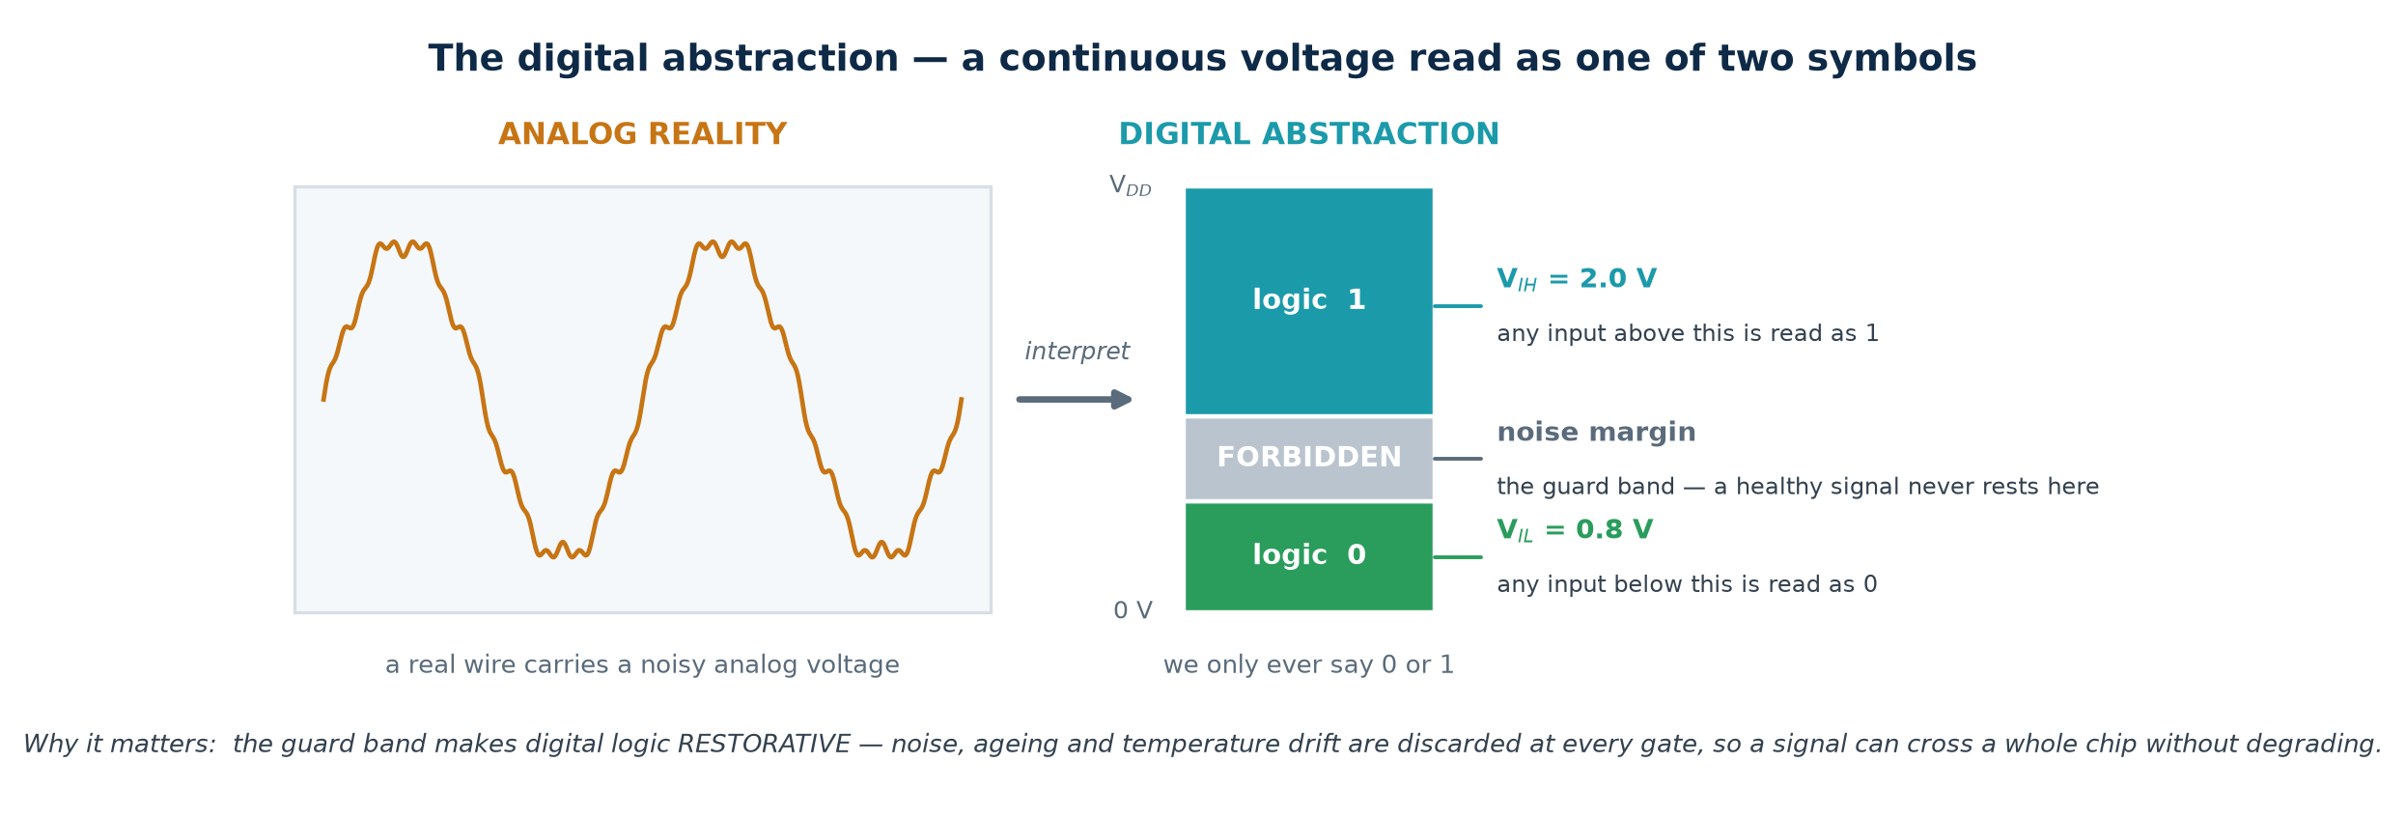
Figure 1.1 — a continuous voltage, read as one of two symbols

The four threshold voltages
Symbol | Name | Meaning
V_OL | output low | the highest voltage a driver produces when outputting 0
V_OH | output high | the lowest voltage a driver produces when outputting 1
V_IL | input low | the highest voltage a receiver still reads as 0
V_IH | input high | the lowest voltage a receiver still reads as 1

Noise margins. NM_L = V_IL − V_OL and NM_H = V_OH − V_IH. These are how much interference a signal can pick up and still be read correctly. For a 3.3 V CMOS family with V_OL = 0.4, V_IL = 0.8, V_IH = 2.0, V_OH = 2.4, the margins are 0.4 V both ways.
Why this matters more than it looks
Digital logic is RESTORATIVE: every gate outputs a clean, full-swing level regardless of how degraded its input was, provided the input stayed outside the forbidden band. Noise, ageing, temperature drift and IR drop are therefore thrown away at every stage instead of accumulating. That single property is what makes a signal able to cross a chip through thousands of gates and arrive intact — and it is why analog design is hard and digital design scales.

1.2 Number systems and codes
Hardware stores bits. What those bits MEAN is a convention you choose and must apply consistently. The same eight bits 1011 0100 are 180 unsigned, −76 signed, 0xB4 in hex, or part of a BCD pair.
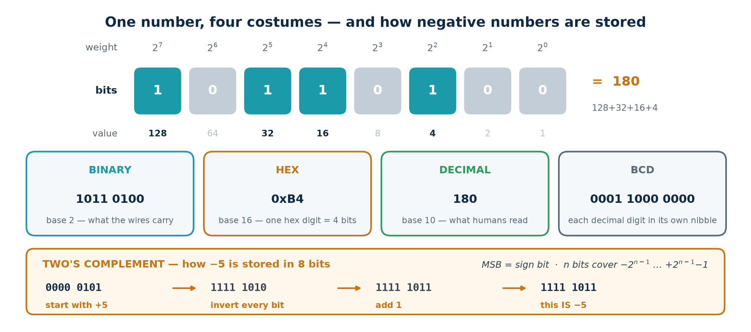
Figure 1.2 — one number, four representations

Positional notation
In any base b, the value of a digit string is Σ dᵢ · bⁱ. In binary the weights are powers of two, so 1011 0100 = 128 + 32 + 16 + 4 = 180.

Binary ↔ hexadecimal
Because 16 = 2⁴, one hex digit is exactly one nibble. Group the bits in fours from the RIGHT and translate each group: 1011 0100 → B 4 → 0xB4. This is why register maps, opcodes and memory dumps are always written in hex — it is binary you can read.

Two's complement — the only signed format you will use
1. Write the magnitude in binary: +5 in 8 bits is 0000 0101.
2. Invert every bit: 1111 1010.
3. Add one: 1111 1011. That is −5.
For n bits the range is −2ⁿ⁻¹ … +2ⁿ⁻¹−1 — note the asymmetry: 8 bits cover −128 … +127. The MSB is the sign bit. The great virtue is that ONE adder handles both addition and subtraction, and there is only one representation of zero.
Overflow: the trap in signed arithmetic
Carry-out and overflow are NOT the same thing. Carry-out (C) signals unsigned overflow. Signed overflow (V) is Cₙ ⊕ Cₙ₋₁ — the carry INTO the sign bit differs from the carry OUT of it.
Example: 0111 1111 (+127) + 0000 0001 (+1) = 1000 0000 which reads as −128. C = 0 but V = 1. Adding two positives gave a negative.
In Verilog: declare reg signed [7:0] x; or the tool assumes unsigned and your comparisons silently invert.

Gray code
Successive values differ in exactly ONE bit: 000, 001, 011, 010, 110, 111, 101, 100. Convert binary to Gray with G = B ⊕ (B >> 1). Used for Karnaugh-map ordering, for FIFO pointers crossing clock domains, and for shaft encoders — anywhere a multi-bit value might be sampled mid-transition, because only one bit can be caught in flight.

BCD
Each decimal digit in its own 4-bit nibble: 180 → 0001 1000 0000. Six of the sixteen codes are wasted, but decimal display and exact decimal arithmetic become trivial. The mod-10 counter you build in Part 3 is a BCD counter.

1.3 Boolean algebra: variables, operators, laws
Boolean algebra was formalised by George Boole in 1854 and applied to switching circuits by Claude Shannon in his 1937 master's thesis — arguably the most consequential master's thesis ever written. It is an algebra over exactly two values with three primitive operators.
Operator | Notations | Result is 1 when…
AND | A·B A∧B AB A&B | BOTH inputs are 1
OR | A+B A∨B A|B | AT LEAST ONE input is 1
NOT | A' Ā ¬A ~A | the input is 0

Precedence: NOT binds tightest, then AND, then OR. So A + B·C means A + (B·C). Verilog uses the same order. When in doubt, bracket it.

The truth table
A truth table lists the output for every input combination. For n inputs there are 2ⁿ rows: 2 inputs → 4 rows, 4 → 16, 10 → 1 024, 16 → 65 536. That exponential is exactly why we need algebra and K-maps instead of exhaustive tables, and why exhaustive simulation stops being feasible above about 20 inputs.
Functional equivalence. Two circuits are equivalent if and only if their truth tables agree on every row, however differently they are drawn. Equivalence checking — a signoff step you will meet in Topic 6 — automates precisely this comparison between your RTL and the synthesised netlist.

The laws, with their duals
Law | OR form | AND form
Identity | A + 0 = A | A · 1 = A
Null / Dominance | A + 1 = 1 | A · 0 = 0
Idempotent | A + A = A | A · A = A
Complement | A + A' = 1 | A · A' = 0
Involution | (A')' = A | —
Commutative | A + B = B + A | A · B = B · A
Associative | A + (B+C) = (A+B) + C | A · (B·C) = (A·B) · C
Distributive | A · (B+C) = A·B + A·C | A + (B·C) = (A+B) · (A+C)
Absorption | A + A·B = A | A · (A+B) = A
Simplification | A + A'·B = A + B | A · (A'+B) = A · B
De Morgan | (A+B)' = A' · B' | (A·B)' = A' + B'
Consensus | AB + A'C + BC = AB + A'C | (A+B)(A'+C)(B+C) = (A+B)(A'+C)

Duality — how to halve what you memorise
Swap every AND ↔ OR and every 0 ↔ 1 in a true Boolean statement and the result is also true. That is why the two columns above are mirror images. Learn one column and derive the other.
Watch out: A + B·C = (A+B)·(A+C) has NO counterpart in ordinary arithmetic (3 + 4×5 ≠ (3+4)×(3+5)). Verify it once on all eight rows and you will trust it thereafter.

Proving a law: perfect induction
'Perfect induction' just means 'check every row'. Because there are only 2ⁿ rows, this is a complete proof, not a sample. Here is absorption, A + A·B = A:
A | B | A·B | A + A·B | A
0 | 0 | 0 | 0 | 0
0 | 1 | 0 | 0 | 0
1 | 0 | 0 | 1 | 1
1 | 1 | 1 | 1 | 1

Columns 4 and 5 match on every row, so the law holds. Intuition: if A is 1 the first term already makes the expression 1; if A is 0 neither term can be 1. B never gets a say.

1.4 The logic gates
A gate is a physical circuit — in CMOS, a handful of transistors — that computes one Boolean operator. Learn to read these symbols instantly; schematics, synthesis reports and datasheets all assume you can.
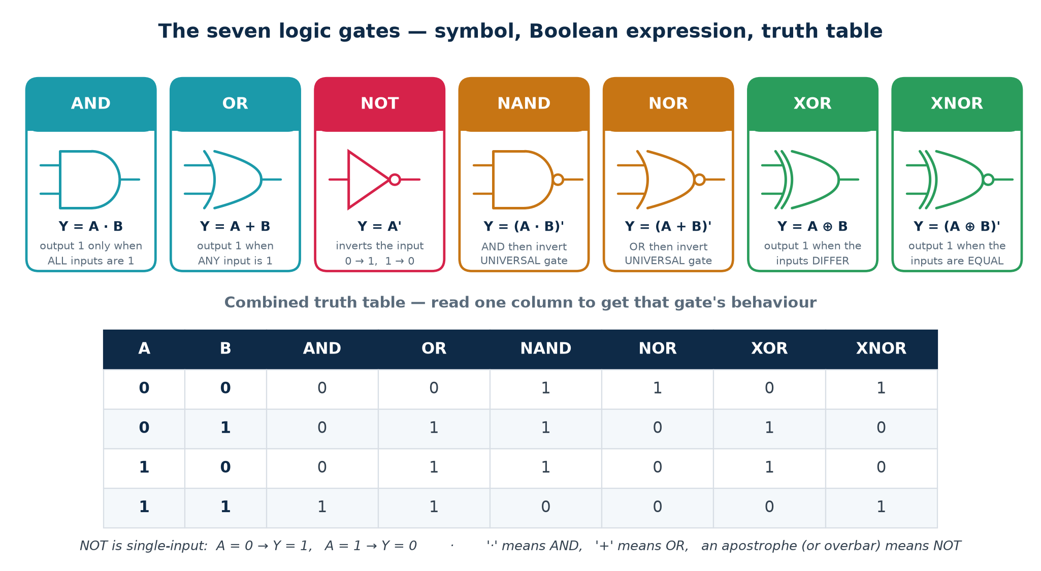
Figure 1.3 — the seven gates, their expressions and truth table

What a gate costs in CMOS
Gate | Transistors (static CMOS) | Note
Inverter (NOT) | 2 | 1 PMOS + 1 NMOS
NAND-2 / NOR-2 | 4 | the natural CMOS primitives
AND-2 / OR-2 | 6 | NAND/NOR followed by an inverter
XOR-2 / XNOR-2 | 8–12 | several implementations exist
D flip-flop | 20–28 | two latches plus clock buffering

This is why standard-cell libraries are dominated by NAND, NOR and inverter cells, and why a synthesised netlist rarely contains a literal AND gate — inversion is free in CMOS, and non-inversion costs you two extra transistors.

1.5 Universal gates
A gate is UNIVERSAL if any Boolean function can be built from copies of it alone. NAND and NOR are the only two-input gates with this property. AND, OR and XOR are not, because none of them can produce a NOT.
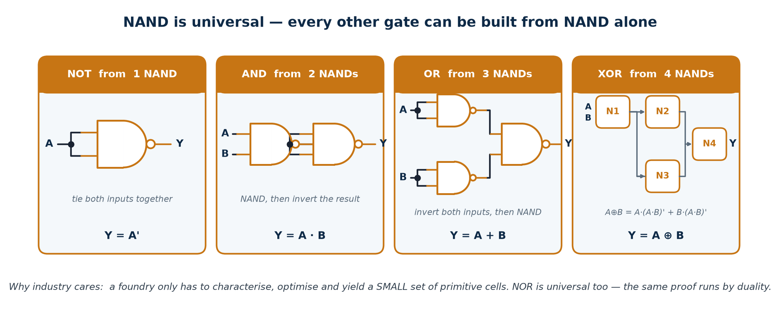
Figure 1.4 — NOT, AND, OR and XOR built from NAND alone
The proof is constructive. Build NOT, AND and OR from the gate; then, since every Boolean function has a sum-of-products form built only from NOT, AND and OR, every function can be built. The NOR construction follows by duality.
Target | From NAND | From NOR
NOT A | A NAND A | A NOR A
A AND B | (A NAND B) NAND (A NAND B) | (A NOR A) NOR (B NOR B)
A OR B | (A NAND A) NAND (B NAND B) | (A NOR B) NOR (A NOR B)

1.6 De Morgan's theorems and bubble pushing
(A · B)' = A' + B' and (A + B)' = A' · B' — 'break the bar, change the operator'. Both generalise to n variables.
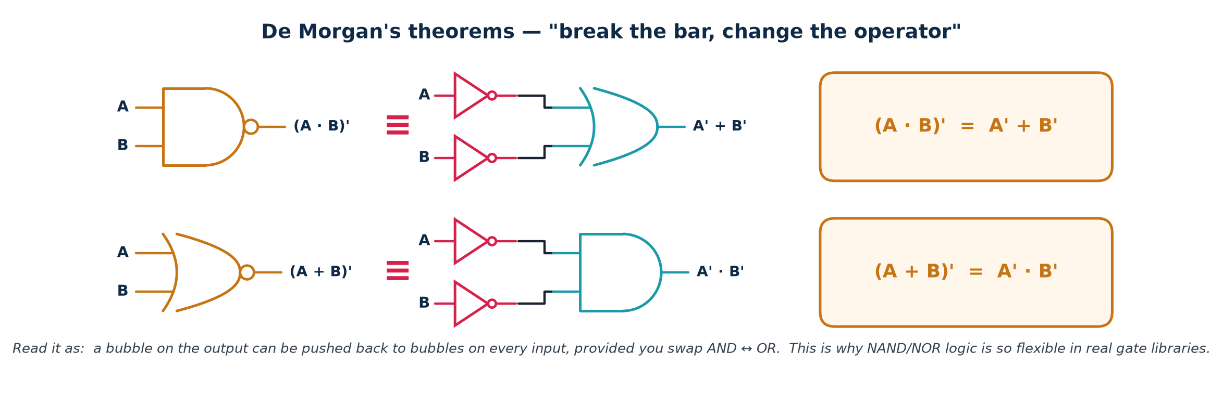
Figure 1.5 — the two identities, shown as equivalent circuits

Bubble pushing
Read graphically, De Morgan says a bubble (inversion) on a gate's OUTPUT can be moved to bubbles on all of its INPUTS provided you swap AND ↔ OR. This is how you convert an AND-OR network into an all-NAND network without changing behaviour, which is exactly what technology mapping does inside a synthesis tool.
Where you will actually use it: active-low signals
A signal named rst_n, cs_n or we_n is ASSERTED when it is LOW. Specifications written in active-low language turn into positive logic through De Morgan, and getting it wrong is one of the most common junior-engineer bugs.
Example: 'assert busy when neither channel is idle' → busy = (idle_a + idle_b)' = idle_a' · idle_b' — an AND of the two active-low idles, not an OR.

1.7 Canonical forms: SOP and POS
Given any truth table you can write down two exact expressions immediately, with no thinking required. They are called canonical because they are unique for a given function. They are also usually far from minimal.
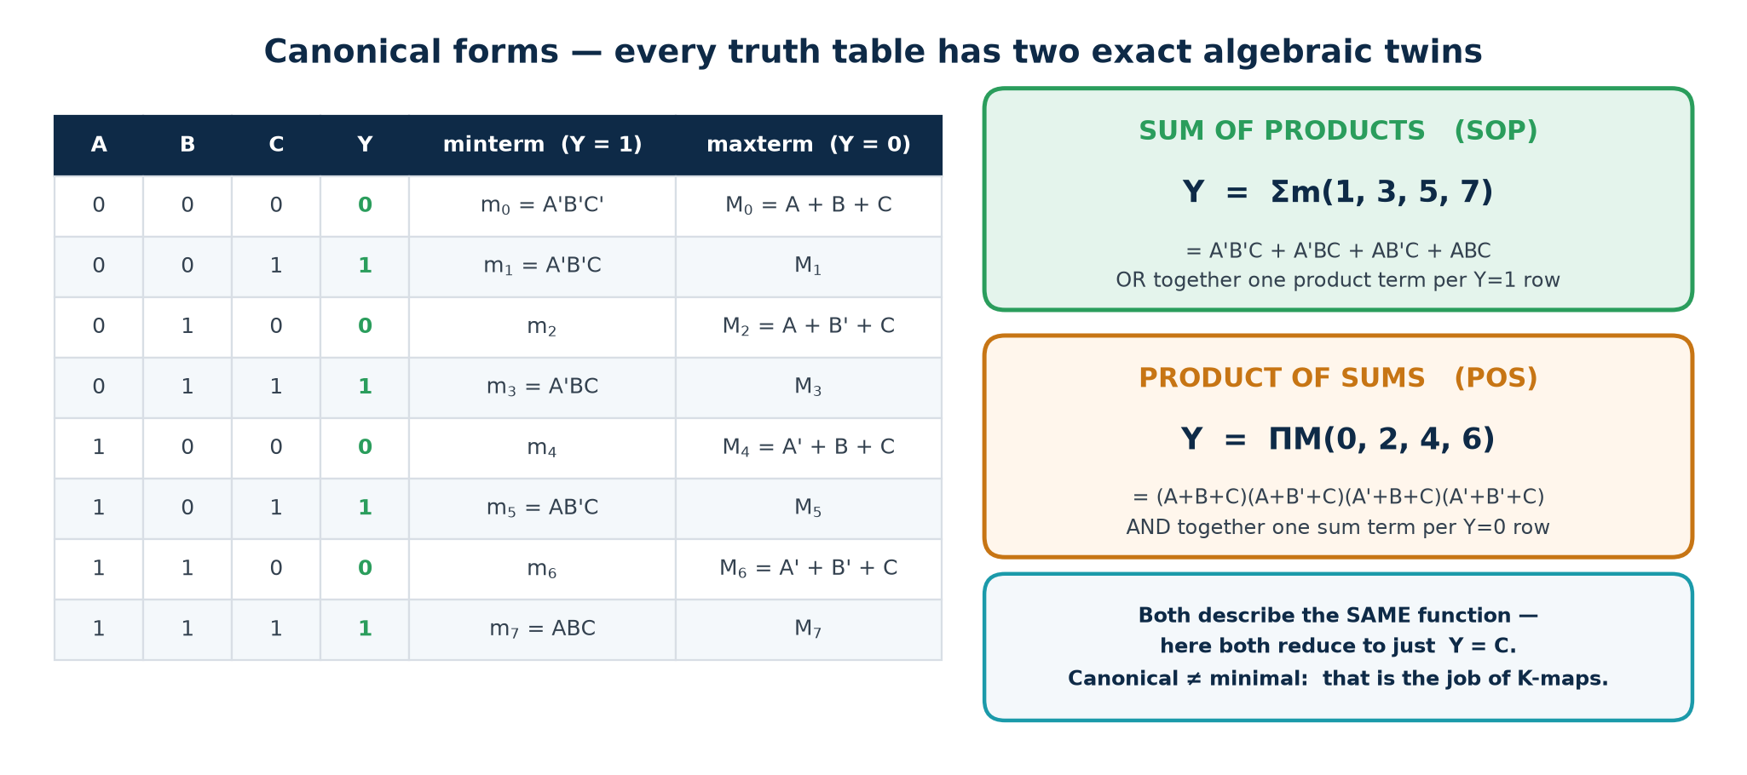
Figure 1.6 — the two canonical twins of one truth table

Minterms and maxterms
▪ Minterm mᵢ is the AND term that is 1 for exactly ONE input combination. Write each variable plain if its bit is 1, complemented if 0. For ABC = 101, m₅ = A·B'·C.
▪ Maxterm Mᵢ is the OR term that is 0 for exactly ONE combination. The complement rule is REVERSED: for ABC = 101, M₅ = A' + B + C'.
▪ Relationship: Mᵢ = (mᵢ)'. A function's minterm set and maxterm set are complementary subsets of the same 2ⁿ indices.

Writing them down
1. SOP: OR together one minterm for every row where Y = 1. Y = Σm(1,3,5,7).
2. POS: AND together one maxterm for every row where Y = 0. Y = ΠM(0,2,4,6).
3. Both describe the same function. In the example above, both reduce to Y = C.
Canonical is not minimal. Getting from canonical to minimal is what the next section is for.

1.8 Karnaugh maps
A K-map is a truth table redrawn so that physically adjacent cells differ in exactly one variable. That turns the algebraic law X·Y + X·Y' = X into a visual one: any legal group of adjacent 1s collapses into a shorter product term.
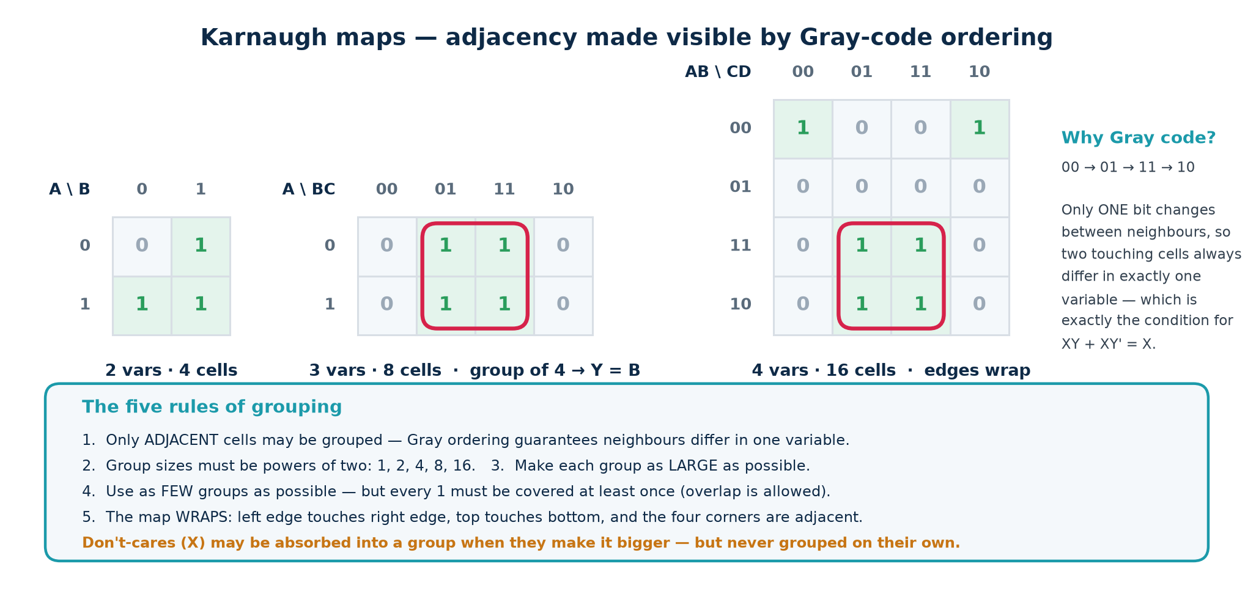
Figure 1.7 — 2-, 3- and 4-variable maps, and the grouping rules

The five rules
1. Only ADJACENT cells may be grouped. Gray-code ordering is what guarantees that neighbours differ in exactly one variable.
2. Group sizes must be powers of two: 1, 2, 4, 8, 16. A group of size 2ᵏ eliminates k variables.
3. Make every group as LARGE as possible — a bigger group kills more variables.
4. Use as FEW groups as possible, but every 1 must be covered at least once. Groups may overlap.
5. The map WRAPS. Left edge touches right edge, top touches bottom, and the four corners are mutually adjacent. Topologically it is a torus.

Vocabulary you will be examined on
▪ Implicant — any legal group (any product term that covers only 1s).
▪ Prime implicant — an implicant that cannot be made any larger.
▪ Essential prime implicant — the only prime implicant covering some particular minterm. It must appear in every minimal solution, which is why you circle these first.
▪ Don't-care (X) — an input combination that cannot occur, or whose output nobody reads. You may treat each one as 0 or 1, whichever makes your groups bigger. Never cover an X for its own sake.

Worked example with don't-cares
F(A,B,C,D) = Σm(0,1,2,5,8,9,10) + d(3,7).
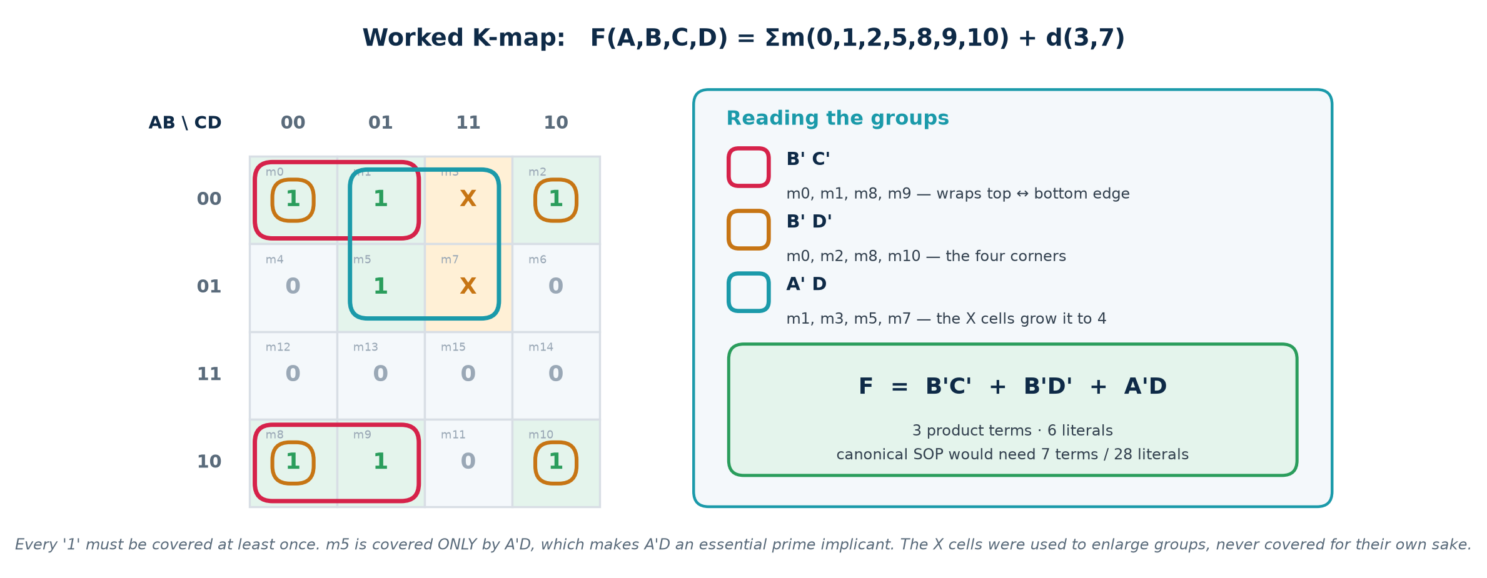
Figure 1.8 — grouping, including two don't-cares
1. Fill the map from the minterm list; mark 3 and 7 as X.
2. Find the essential prime implicants. m5 is covered ONLY by the group {m1,m3,m5,m7} = A'D, so A'D is essential — and note it only reached size 4 because the two X cells were absorbed.
3. Cover the rest with the fewest, largest groups: B'C' = {m0,m1,m8,m9} (wrapping top to bottom) and B'D' = {m0,m2,m8,m10} (the four corners).
4. Read each group: keep the variables that stay constant across it, drop those that change.
5. F = B'C' + B'D' + A'D — 3 terms, 6 literals, against 7 terms and 28 literals for the canonical SOP.
6. Verify: check that every original 1 is covered and no 0 is.

Five-variable maps and beyond
A 5-variable map is drawn as two 4-variable maps side by side, one for E = 0 and one for E = 1; cells in the same position on the two maps are adjacent. Six variables needs four maps and most people stop being reliable. Past that, use the algorithms in §1.9.

1.9 Beyond K-maps — what tools actually do
Method | How it works | Scales to | Where you meet it
Karnaugh map | visual grouping on a Gray-coded grid | ≤ 5–6 vars | exams, whiteboards, intuition
Quine–McCluskey | tabular; enumerates ALL prime implicants, then solves a covering problem | ≤ ~15 vars | the exact algorithm K-maps approximate
Espresso | heuristic expand / reduce / irredundant loop | hundreds | the classic two-level minimiser
ABC / AIG rewriting | multi-level: And-Inverter Graphs, cut rewriting, SAT sweeping | millions | inside Yosys and every commercial tool
BDD | canonical decision-diagram form | varies wildly | equivalence checking, formal verification

Quine–McCluskey in outline
1. List all minterms (and don't-cares) grouped by the number of 1s in their binary code.
2. Compare every term in group k with every term in group k+1. Any pair differing in one bit combines; write the combined term with a dash in that position and tick both parents.
3. Repeat on the new list until nothing more combines. Every UNTICKED term is a prime implicant.
4. Build a prime-implicant chart: rows are prime implicants, columns are minterms (not don't-cares). A column with a single tick identifies an ESSENTIAL prime implicant.
5. Select all essentials, delete the minterms they cover, then solve the remaining covering problem — by inspection, or by Petrick's method for an exact answer.
So why learn K-maps at all?
Because you must be able to read what the tool produced and judge whether it is right. A synthesis report showing 4 000 gates for a function you know needs 40 means your RTL is wrong — an unintended latch, a runaway loop, a missing don't-care, a mis-sized bus. Minimisation intuition is your only defence against silently accepting bad hardware.

What minimisation buys you
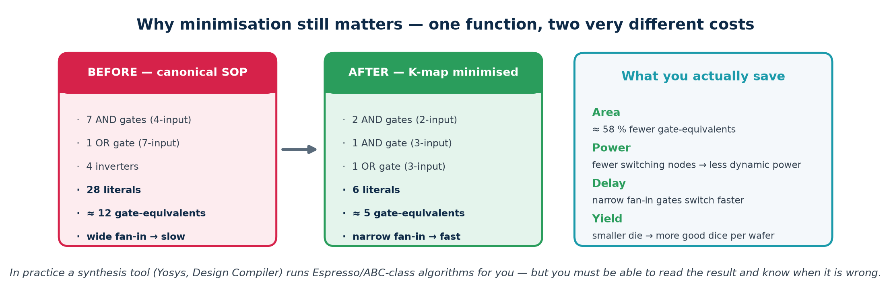
Figure 1.9 — the same function, before and after minimisation
Assume a 28 nm library where one gate-equivalent (GE) ≈ 0.5 µm², and a 2-input gate switching at 500 MHz burns ≈ 0.6 µW. Going from 12 GE to 5 GE saves 3.5 µm² and 4.2 µW per instance. Multiply by 200 000 instances on a real SoC and that is 0.7 mm² of die and 0.84 W — the difference between a product that ships and one that does not.
Numbers are illustrative and chosen to show the method; always use your own library's datasheet.

Part 2 · Combinational Logic Design
Combinational logic has no memory: its output is a pure function of its present inputs. Everything in this part is a pattern you will meet again in Verilog in Topic 4, and again in a timing report in Topic 6.

2.1 The defining property
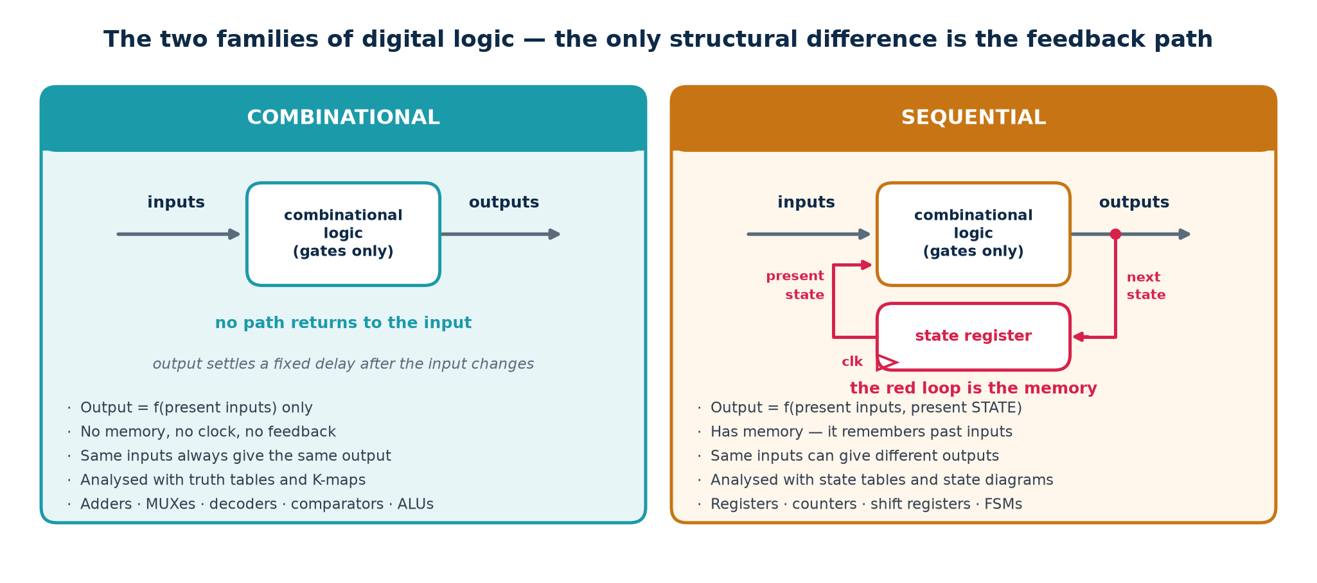
Figure 2.1 — the only structural difference is the feedback path
 | Combinational | Sequential
Output depends on | present inputs only | present inputs AND stored state
Memory | none | yes — in flip-flops or latches
Clock | not needed | required (in synchronous design)
Feedback | none — the graph is acyclic | yes, through a storage element
Analysed with | truth tables, K-maps | state tables, state diagrams
Typical blocks | adder, MUX, decoder, ALU | register, counter, FSM

Definitions worth memorising verbatim
Combinational: the output at any instant depends ONLY on the inputs at that instant, after a bounded settling delay.
Sequential: the output depends on the present inputs AND on the sequence of past inputs, summarised in a finite amount of stored state.

2.2 The seven-step design procedure
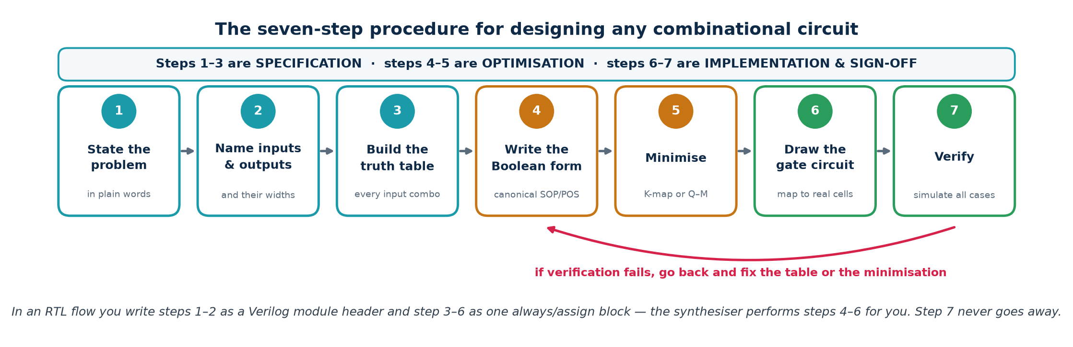
Figure 2.2 — follow this every time

Worked micro-example
Problem: light a warning LED when at least two of three sensors read high.
1. State it: 'W = 1 when two or more of A, B, C are 1.'
2. Name the ports: inputs A, B, C (1 bit each); output W (1 bit).
3. Truth table: W = 1 for ABC = 011, 101, 110, 111 — four of the eight rows.
4. Canonical SOP: W = A'BC + AB'C + ABC' + ABC.
5. K-map → W = AB + BC + AC. This is the MAJORITY function.
6. Circuit: three 2-input ANDs feeding one 3-input OR.
7. Verify: simulate all eight input cases against the table.
Where the bugs actually are
Almost every combinational bug is created at step 3. A missing row, a case nobody thought about, or an input combination the specification never mentioned. When you cannot enumerate the rows because there are too many, enumerate the CATEGORIES of behaviour instead, and make sure every input maps into exactly one.

2.3 Adders
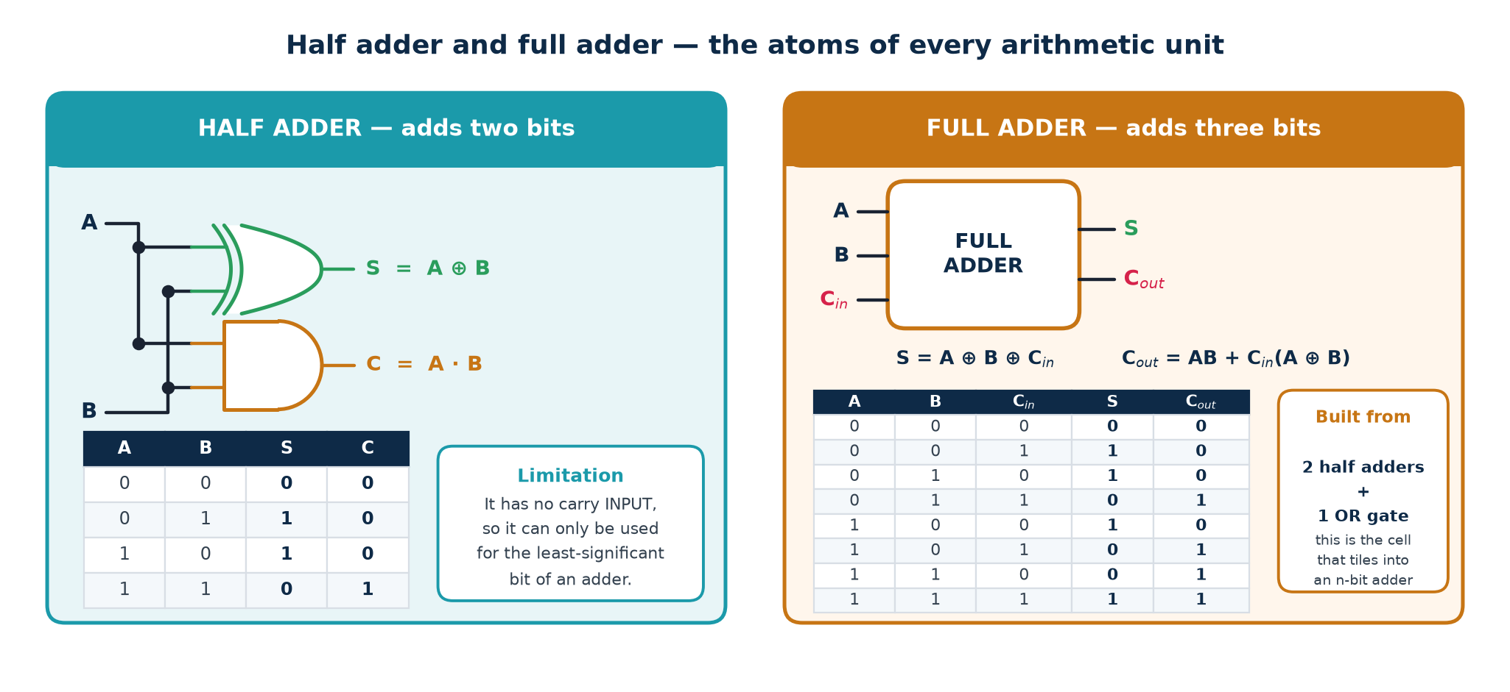
Figure 2.3 — half adder and full adder

Half adder
S = A ⊕ B, C = A · B. It cannot accept a carry IN, so it is only usable for the least-significant bit.

Full adder
S = A ⊕ B ⊕ Cin, Cout = A·B + Cin·(A ⊕ B). Derive Cout from the truth table: Cout is 1 whenever at least two of the three inputs are 1 — the majority function again, which is why the two derivations look identical.
Built from two half adders: the first adds A and B, the second adds that sum to Cin, and an OR gate combines the two carries. Cout = C₁ + C₂ (the two carries can never both be 1).

Ripple-carry adder
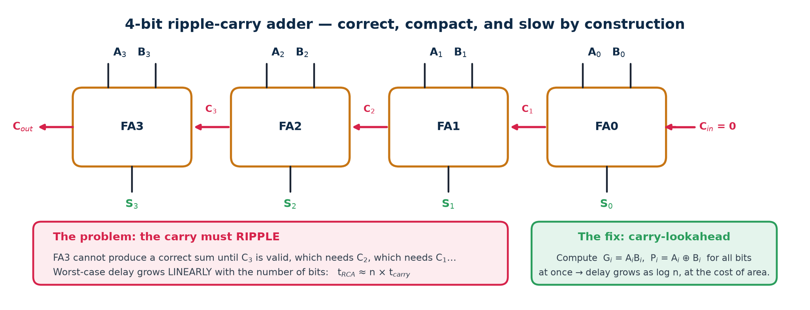
Figure 2.4 — 4-bit ripple carry, and why it is slow
Chain n full adders, Cout to Cin. Minimal area, trivially correct, and its delay grows LINEARLY with n:
t_adder = (n − 1) · t_carry + t_sum

The critical path runs from the least-significant inputs, through every carry stage, to the MOST-significant SUM — not to the final carry-out. Getting that endpoint right is a classic exam discriminator.

Carry-lookahead
Define two signals per bit:
▪ Generate Gᵢ = Aᵢ · Bᵢ — this bit produces a carry regardless of Cin.
▪ Propagate Pᵢ = Aᵢ ⊕ Bᵢ — this bit passes an incoming carry through.
Then Cᵢ₊₁ = Gᵢ + Pᵢ·Cᵢ. Expanding the recursion removes the dependence on the previous carry entirely:
Carry equations for a 4-bit lookahead block
C1 = G0 + P0.C0
C2 = G1 + P1.G0 + P1.P0.C0
C3 = G2 + P2.G1 + P2.P1.G0 + P2.P1.P0.C0
C4 = G3 + P3.G2 + P3.P2.G1 + P3.P2.P1.G0 + P3.P2.P1.P0.C0

Every carry is now two gate levels from the inputs, so delay grows as log n when lookahead blocks are themselves cascaded — at the cost of considerably more area and much higher fan-in. Other schemes you will hear named: carry-select, carry-skip, and the Brent–Kung and Kogge–Stone parallel-prefix adders.
In RTL you write assign {cout, sum} = a + b + cin; and the synthesiser picks a structure to meet your timing constraint. Knowing the structures is how you understand why the area exploded when you tightened the clock.

Subtraction comes free
A − B = A + (−B) = A + B' + 1. Feed B through XOR gates controlled by a sub signal (XOR with 1 inverts, XOR with 0 passes through) and tie the same sub to Cin. One adder now performs both operations — which is exactly the ADDER/SUBTRACTOR block in the ALU.

2.4 Multiplexers and de-multiplexers
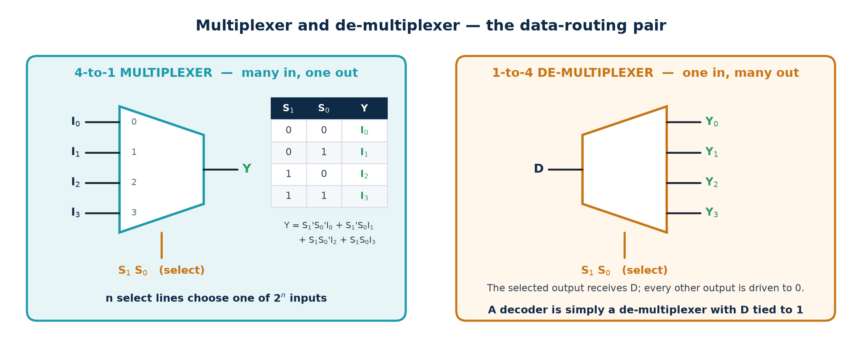
Figure 2.5 — the data-routing pair
A multiplexer is a controllable switch: n select lines choose one of 2ⁿ data inputs. It is the single most common structure in real hardware, because every if, every case, every shared bus and every function select becomes a MUX after synthesis.
4:1 MUX as a sum of products
Y = S1'.S0'.I0 + S1'.S0.I1 + S1.S0'.I2 + S1.S0.I3

The MUX as a universal logic element
A 2ⁿ:1 MUX implements ANY function of n variables: wire the truth-table output column to the data inputs and the variables to the select lines. No minimisation needed at all.
Halving it. An n-variable function actually needs only a 2ⁿ⁻¹:1 MUX. Use n−1 variables as select, then read the truth table in PAIRS of rows: each pair needs 0, 1, the last variable, or its complement on that data input.
This is literally how an FPGA works
An FPGA logic cell is a small SRAM — typically a 6-input look-up table, which is a 64:1 MUX with programmable data bits — plus a flip-flop. Programming an FPGA means writing truth tables into those SRAM cells.
Consequence for your RTL: on an FPGA a 6-input function and a 2-input function cost the SAME single LUT, so splitting logic into tiny pieces buys nothing and can cost you levels of delay. On an ASIC the opposite is true. Know your target before you optimise.

De-multiplexer
The reverse: one input routed to one of 2ⁿ outputs, with all others driven to 0. A decoder is simply a de-multiplexer with its data input tied to 1.

2.5 Decoders, encoders and priority encoders
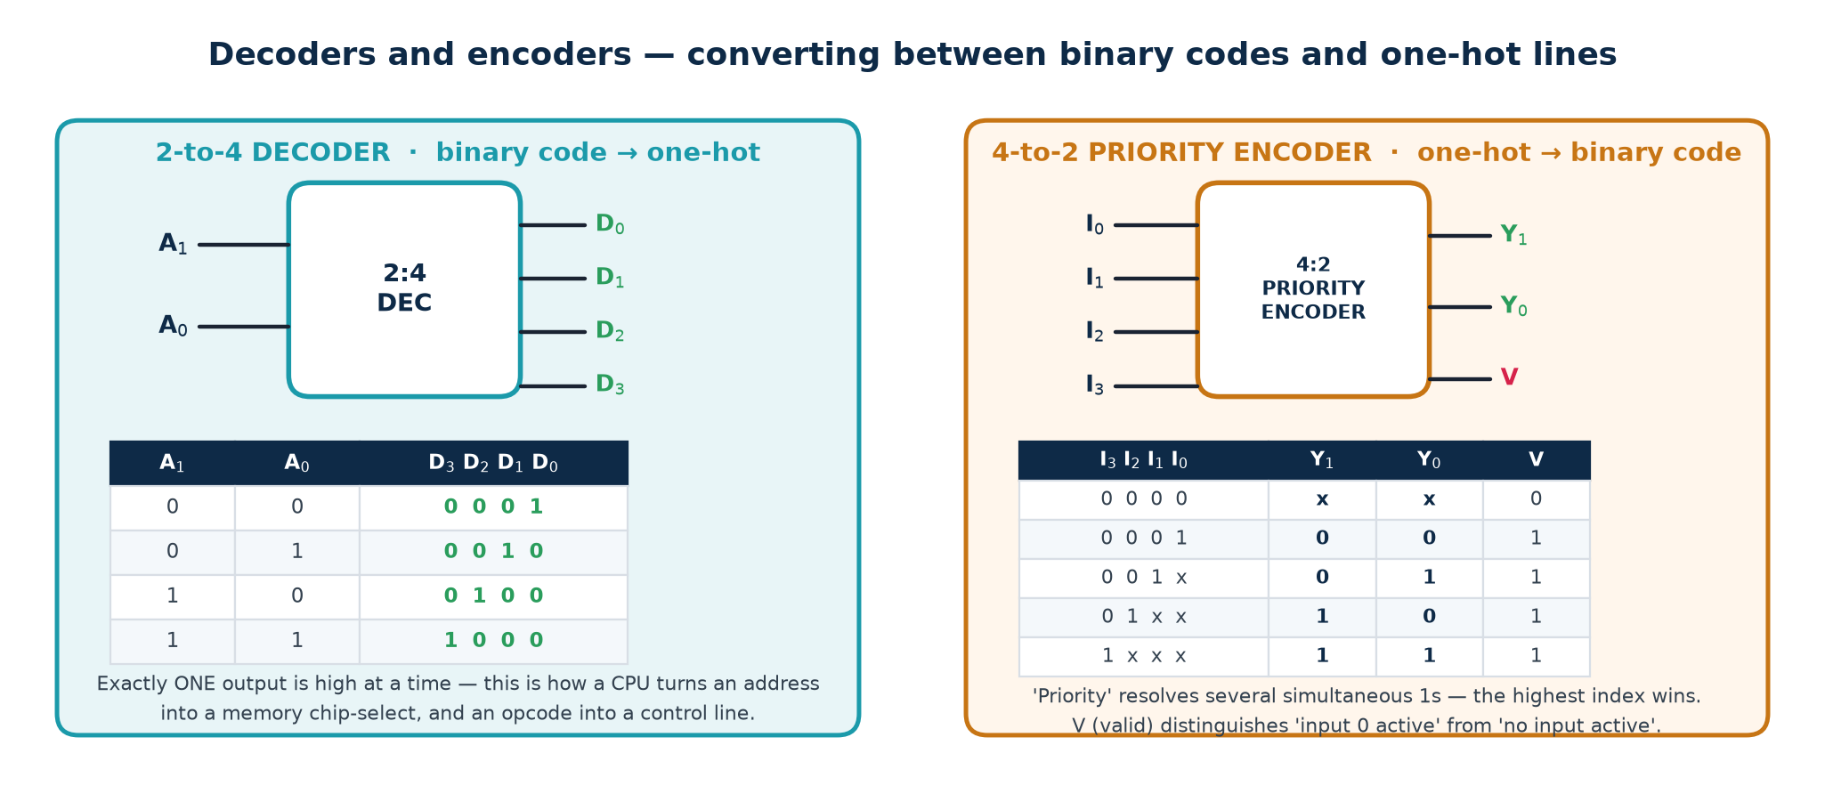
Figure 2.6 — converting between codes and one-hot lines
Decoder: binary code in, one-hot out. Exactly one output is asserted. Used for memory chip-select, instruction decode and control-line generation. Real decoders have an ENABLE pin, which is how several are cascaded — two 2:4 decoders plus one 1:2 make a 3:8 decoder.
Encoder: one-hot in, binary code out. A PLAIN encoder assumes exactly one input is high; if two are, it outputs the OR of their codes, which is simply wrong.
Priority encoder: resolves simultaneous inputs by a fixed priority — highest index wins. A separate VALID output distinguishes 'input 0 is active' (code 00, V = 1) from 'nothing is active' (code 00, V = 0). Interrupt controllers and bus arbiters are priority encoders.

2.6 Comparators, parity and other standard cells
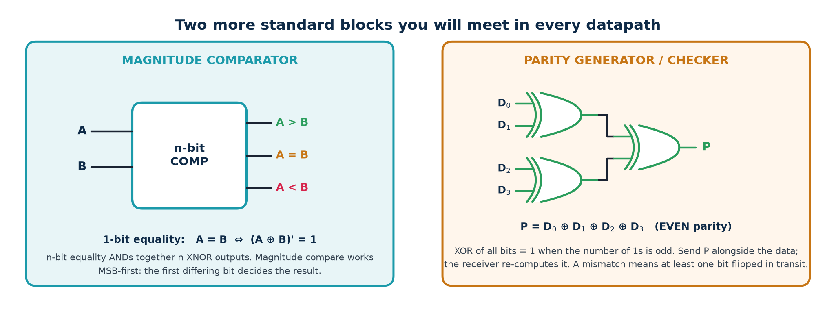
Figure 2.7 — magnitude comparator and parity tree

Comparator
1. 1-bit equality: e = (A ⊕ B)' — XNOR IS the equality gate. This is the single most useful gate identity in the whole topic.
2. n-bit equality: AND together all n of those XNOR outputs.
3. Magnitude: work MSB-first. A > B if, at the highest bit position where they differ, A has a 1. Formally A>B = A₃B₃' + e₃(A₂B₂') + e₃e₂(A₁B₁') + e₃e₂e₁(A₀B₀').

Parity
P = D₀ ⊕ D₁ ⊕ … ⊕ Dₙ₋₁ is the EVEN parity bit: it is 1 when the number of 1s in the data is odd, so that data+parity always has an even number of 1s. The receiver re-computes it; a mismatch means at least one bit flipped.
Its limit: parity detects any ODD number of errors and MISSES every even number. It cannot correct anything. For real protection use Hamming codes or ECC — the same XOR-tree idea with more check bits, arranged so the syndrome identifies which bit flipped.

Others in every library
▪ Barrel shifter — a MUX per output bit; shifts or rotates by any amount in one cycle.
▪ Binary ↔ Gray converters — G = B ⊕ (B>>1); B = successive XORs of G from the MSB.
▪ Leading-zero counter / priority encoder — used in floating-point normalisation.
▪ Population count (ones counter) — a tree of adders.

2.7 The arithmetic logic unit
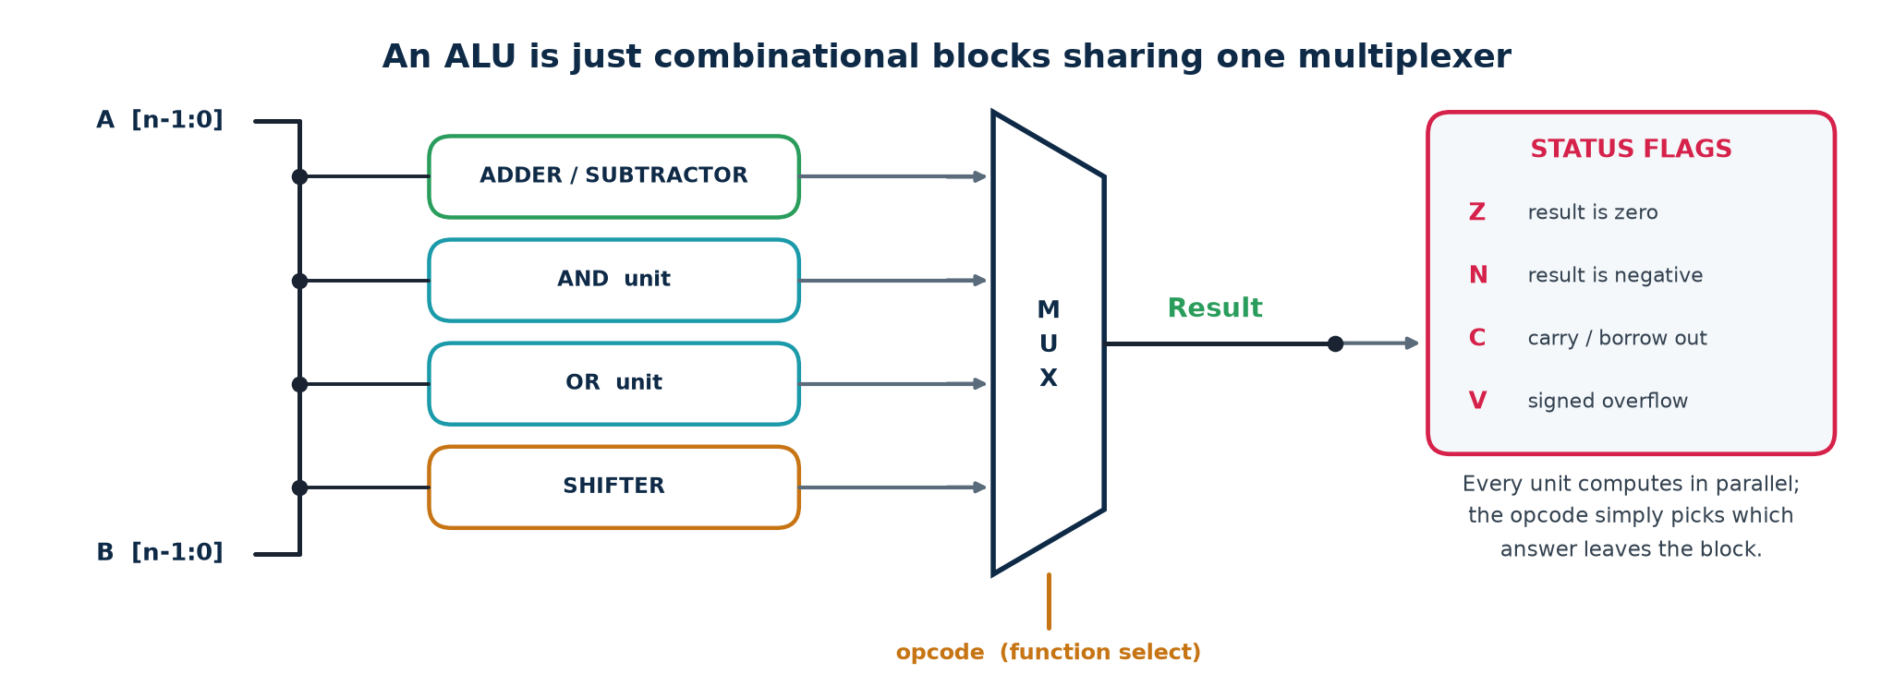
Figure 2.8 — an ALU is combinational blocks sharing one MUX
Structurally trivial: run every operation in parallel on the same operands and let the opcode select which answer leaves the block. It wastes power computing results you discard, and it is fast, regular and easy to verify — which usually wins.

The status flags
Flag | Name | Computed as | Meaning
Z | zero | NOR of every result bit | the result is exactly zero
N | negative | the MSB of the result | sign bit in two's complement
C | carry | carry out of the MSB | UNSIGNED overflow / borrow
V | overflow | Cₙ ⊕ Cₙ₋₁ | SIGNED overflow

C and V are not the same flag
Adding 0111 1111 (+127) and 0000 0001 (+1) gives 1000 0000, which reads as −128. Carry-out is 0, so C = 0. But the carry INTO the sign bit was 1 and the carry OUT was 0, so V = 1.
Unsigned code reads C and ignores V. Signed code reads V and ignores C. Reading the wrong one is a classic source of silent arithmetic bugs.

2.8 What limits combinational speed
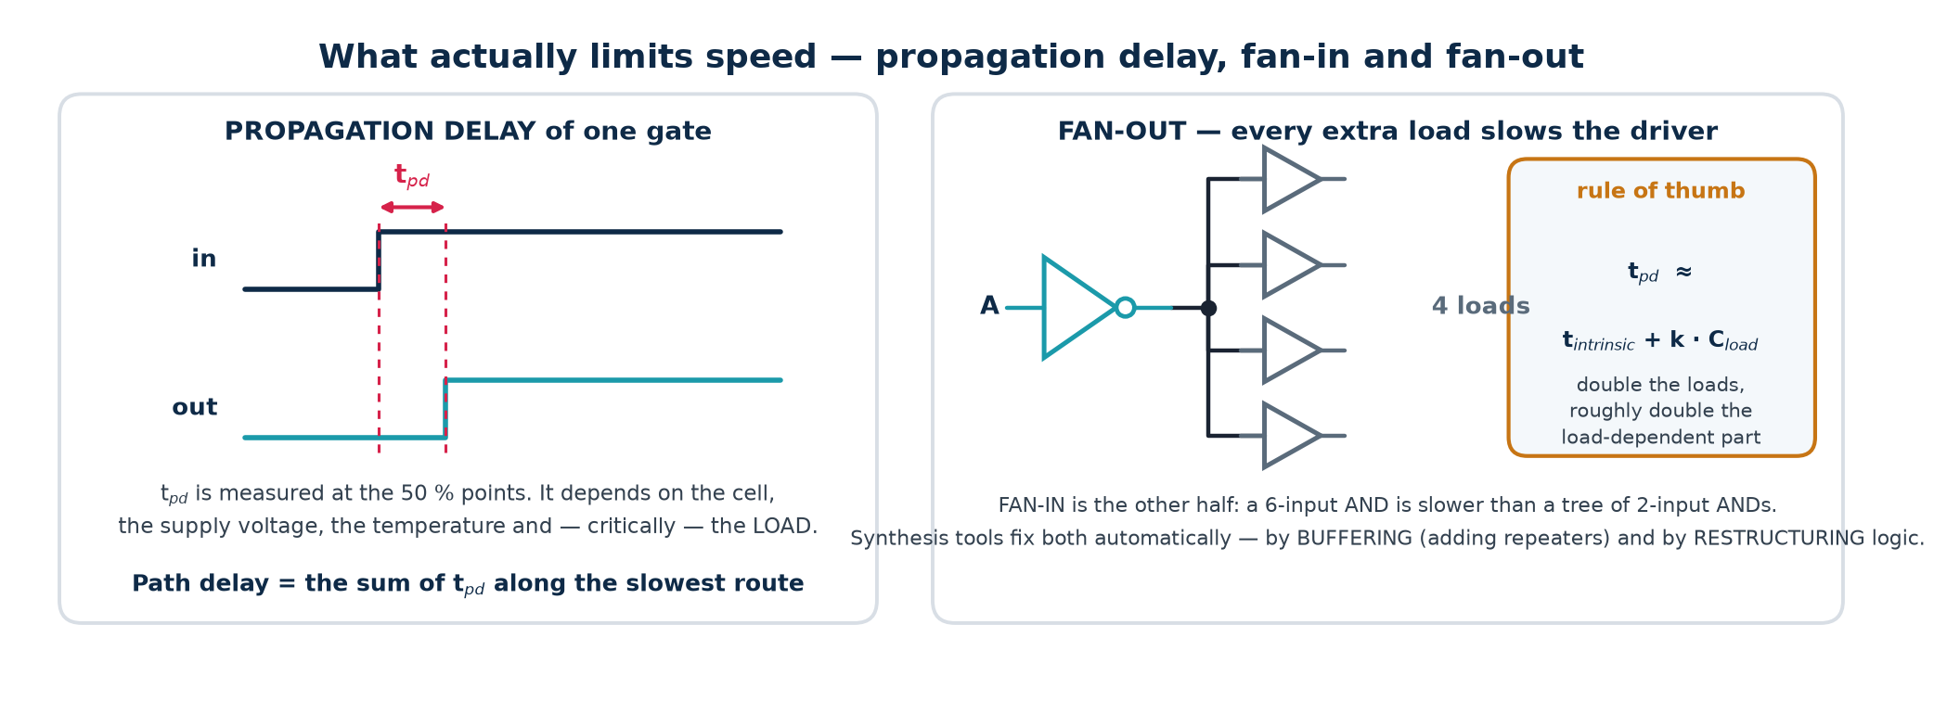
Figure 2.9 — propagation delay, fan-in and fan-out
Term | Definition
Propagation delay t_pd | time from an input change to the corresponding output change, measured at the 50 % points
Contamination delay t_cd | the MINIMUM delay — how soon the output can start to change; matters for hold checks
Fan-in | number of inputs on one gate
Fan-out | number of gate inputs one output drives
Critical path | the slowest input-to-output route through the block

Why fan-out costs time. Each load adds gate capacitance. Charging more capacitance through the same driver resistance takes longer, so delay rises roughly linearly with load: t_pd ≈ t_intrinsic + k·C_load. The fixes are buffering (inserting repeaters) and upsizing the driver.
Why fan-in costs time. A static CMOS gate stacks transistors in series, one per input, so a 6-input NAND is far slower than a balanced tree of 2-input NANDs. The fix is logic restructuring, which synthesis does automatically — provided you did not write the expression in a way that forces a chain.

2.9 Hazards and glitches
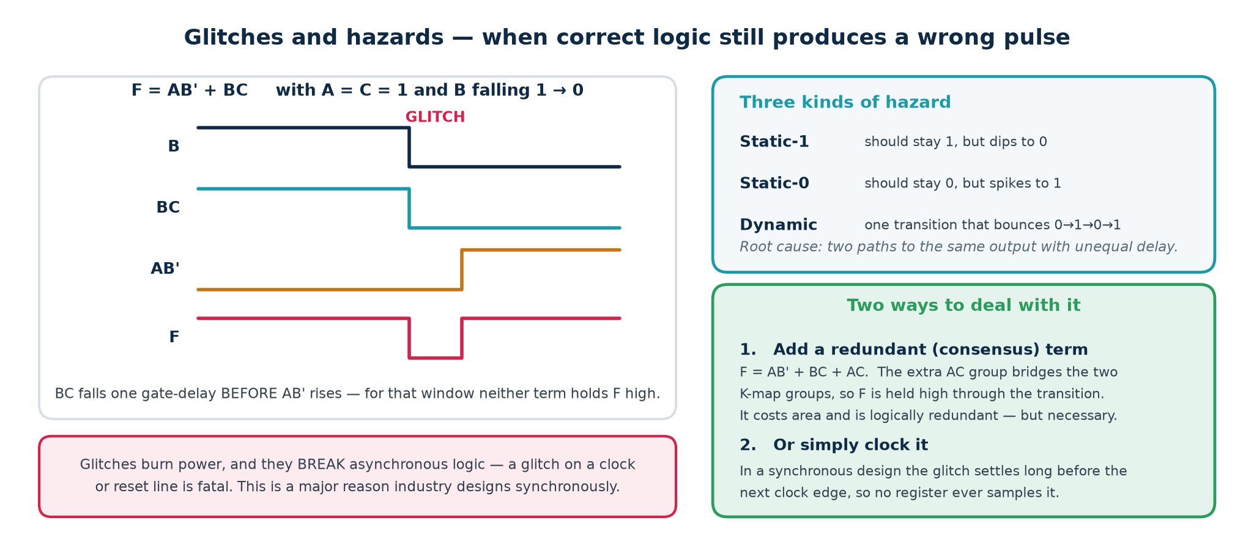
Figure 2.10 — correct logic, wrong transient
A hazard is a momentary wrong output caused purely by unequal path delays. The steady-state logic is perfectly correct; only the transient is wrong.
Type | Symptom | Cause
Static-1 | output should stay 1 but dips to 0 | two AND terms hand over with a gap
Static-0 | output should stay 0 but spikes to 1 | the dual situation in POS form
Dynamic | one transition that bounces 0→1→0→1 | three or more unequal paths to the output

Removing a static-1 hazard
Take F = A·B' + B·C with A = C = 1 and B falling. The B·C term releases before the A·B' term arrives, so F dips. On the K-map the two groups are ADJACENT but do not OVERLAP — that gap is the hazard. Add the consensus term that bridges them:
F = A·B' + B·C + A·C

The A·C term is logically redundant — it changes nothing about the steady-state function — but it holds F high through the transition. Redundant terms cost area and are the one case where you deliberately do NOT minimise.
Where a glitch is harmless, and where it kills the chip
Harmless: driving the D input of a flip-flop, provided it settles before the next clock edge. This is the normal case, and it is the main argument for synchronous design.
Fatal: on a clock line, a reset line, an asynchronous set/clear, a memory write-enable, or any signal leaving the chip. NEVER generate a clock from combinational logic — use a clock enable on the flip-flop instead.

2.10 Combinational logic in Verilog
Three correct ways, and one way to get it catastrophically wrong.
Combinational always blocks
// 1. Continuous assignment - always safe, always combinational
assign y = (a & b) | (~a & c);

// 2. always @(*) with BLOCKING assignments and a DEFAULT
always @(*) begin
y = 1'b0; // default first: kills every latch
case (sel)
2'b00: y = i0;
2'b01: y = i1;
default: y = 1'b0;
endcase
end

// 3. WRONG - incomplete assignment infers a transparent LATCH
always @(*) begin
if (enable) y = d; // no else -> 'hold y' -> latch
end

The three rules
1. Use = (blocking) in combinational blocks. Never <=.
2. Assign every output on every path. A default assignment at the top of the block is the easiest way to guarantee this.
3. Use always @(*), never a hand-written sensitivity list — an incomplete list makes simulation and synthesis disagree.
How to catch an inferred latch
Yosys: $_DLATCH_ cells appear in the stat report. Commercial tools print 'inferred latch for signal y'.
Treat every such warning as an ERROR. There is no case anywhere in this course where you want an unintended latch. The lab includes rtl/broken_latch.v specifically so you can see what one looks like in a report.

Part 3 · Sequential Logic, Flip-Flops, Registers and State Machines
Sequential logic is where TIME enters the design. Everything here follows from one structural change: a feedback path through a clocked storage element.

3.1 The clock
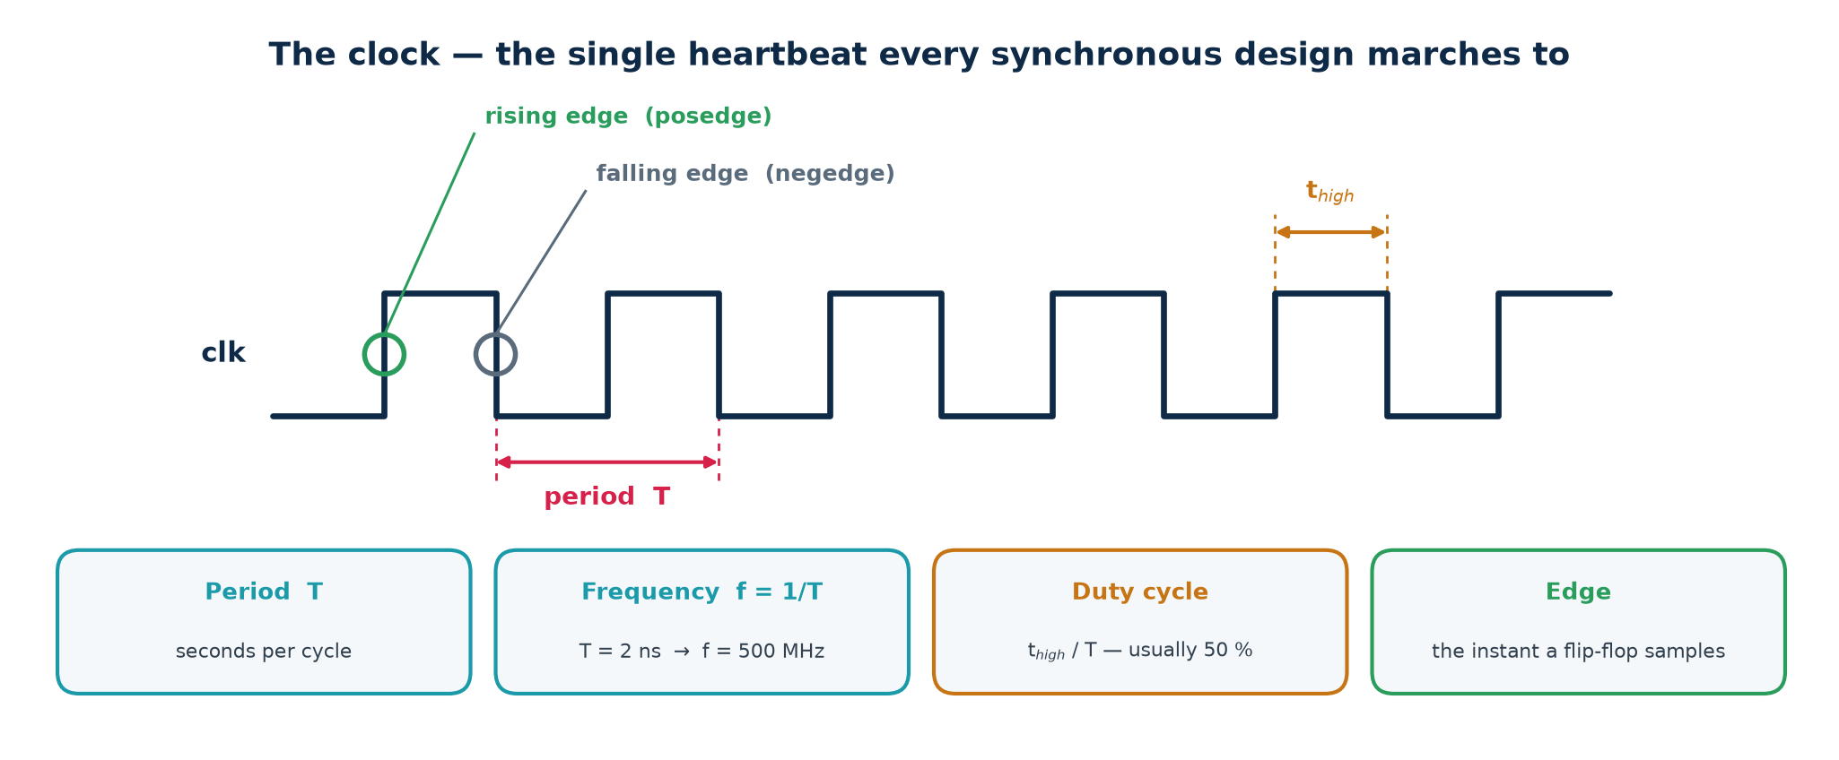
Figure 3.1 — period, frequency, duty cycle, edges
Quantity | Definition | Example
Period T | seconds per cycle | 2 ns
Frequency f | f = 1 / T | 500 MHz
t_high | time the clock spends high | 1 ns
Duty cycle | t_high / T, usually 50 % | 50 %
Rising edge | 0 → 1 transition (posedge) | the sampling instant
Falling edge | 1 → 0 transition (negedge) | rarely used for sampling

Conversions to have at your fingertips: T = 10 ns → 100 MHz. T = 2 ns → 500 MHz. T = 400 ps → 2.5 GHz. f = 3.2 GHz → T = 312.5 ps.
Two rules that are never broken in RTL
1. Never generate a clock in combinational logic. A glitch on a clock line is fatal, and a gated clock breaks static timing analysis. Use a clock ENABLE on the flip-flop instead — the tool will insert a proper integrated clock gate if power demands it.
2. Never mix posedge and negedge of the same clock without a documented reason. You halve every timing budget and confuse every tool in the flow.

3.2 Latches — the first memory
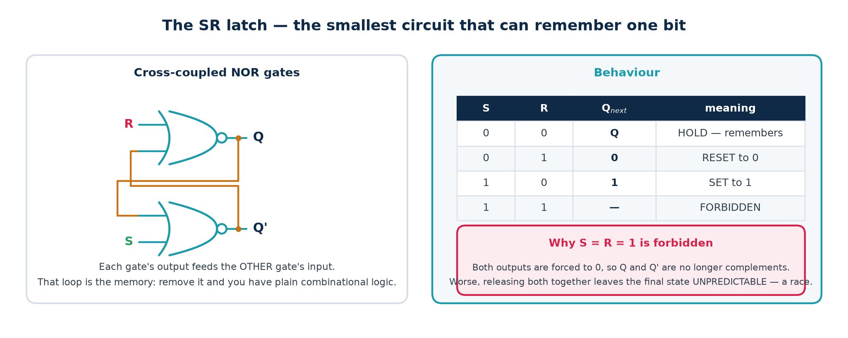
Figure 3.2 — cross-coupled NOR gates remember one bit

The SR latch
Two NOR gates, each feeding the other's input. The loop has two stable configurations, and it stays in whichever one you last pushed it into.
S | R | Q⁺ | Meaning
0 | 0 | Q | HOLD — remembers the previous value
0 | 1 | 0 | RESET to 0
1 | 0 | 1 | SET to 1
1 | 1 | — | FORBIDDEN

Why S = R = 1 is forbidden. Both NOR outputs are forced to 0, so Q and Q' are no longer complements — the latch's whole invariant is violated. Worse, if both inputs are released at the same instant the loop settles unpredictably: the two gates race, and which one wins depends on picosecond-level manufacturing variation.
A NAND version exists with active-low inputs (S̄R̄); its forbidden combination is 0,0. The NAND version with a pull-up on each input is the standard hardware de-bouncer for a mechanical switch.

Gated SR and D latches
Add an enable: gate S and R with EN so the latch only responds while EN is high. Then tie R = S' and you have a D latch — one data input, no forbidden state. The D latch is TRANSPARENT while EN is high: its output tracks D continuously.

3.3 Latch versus flip-flop — the distinction that matters most
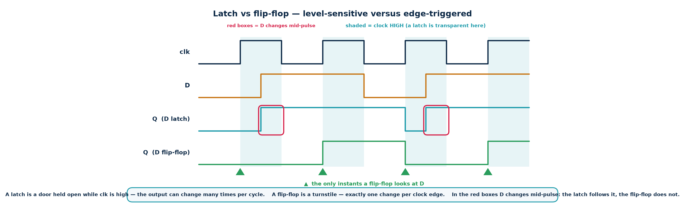
Figure 3.3 — level-sensitive versus edge-triggered
 | Latch | Flip-flop
Sensitive to | the LEVEL of its enable | the EDGE of its clock
Transparent | whenever EN is asserted | never
Output changes | possibly many times per cycle | exactly once per clock edge
Area | smaller (~half) | larger — two latches inside
Timing analysis | hard — time borrowing, transparency windows | straightforward — one equation per path
Use it when | almost never in RTL; deliberately in some custom design | always

How edge-triggering is built
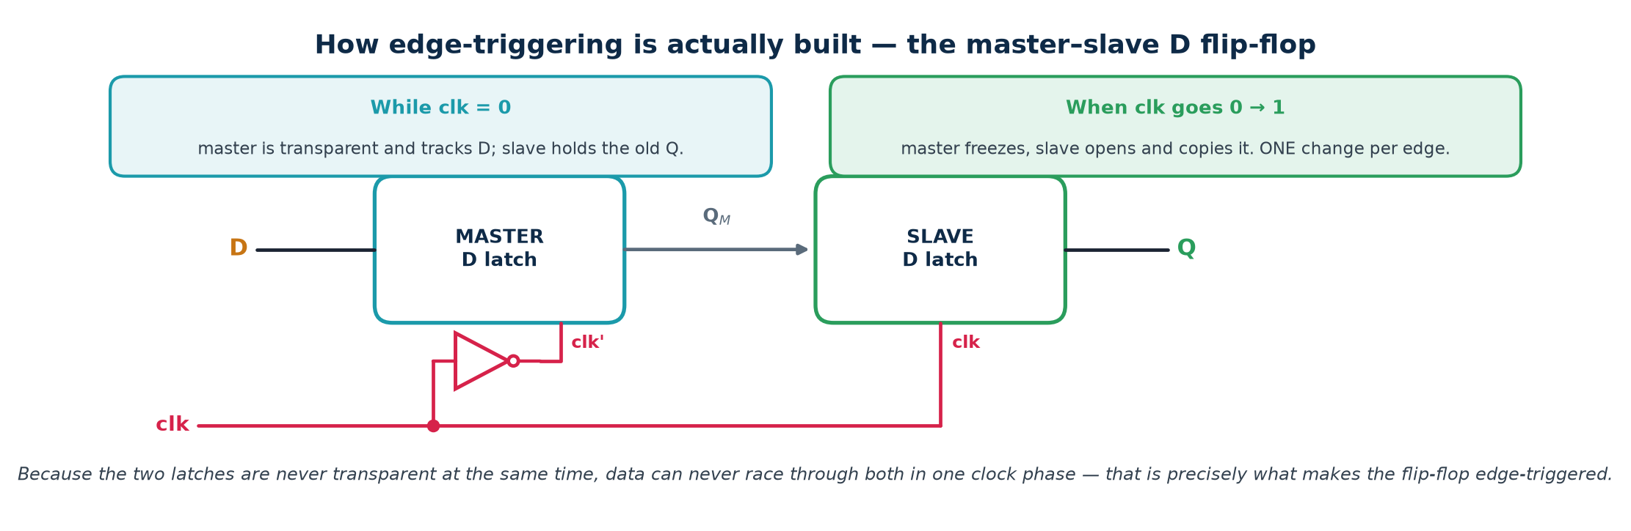
Figure 3.4 — the master–slave D flip-flop
Two D latches in series on OPPOSITE clock phases. While clk = 0 the master is transparent and tracks D, and the slave holds the old Q. When clk rises the master freezes and the slave opens, copying whatever the master had captured. Because the two are never transparent simultaneously, data can never race through both in one phase — and that, precisely, is what 'edge-triggered' means.
This also explains the timing parameters. Setup time is how long the master latch needs to capture reliably; hold time is how long the input must persist before the master actually closes; clock-to-Q is the delay through the slave. They are not arbitrary datasheet numbers — they are properties of this structure.

3.4 The flip-flop family
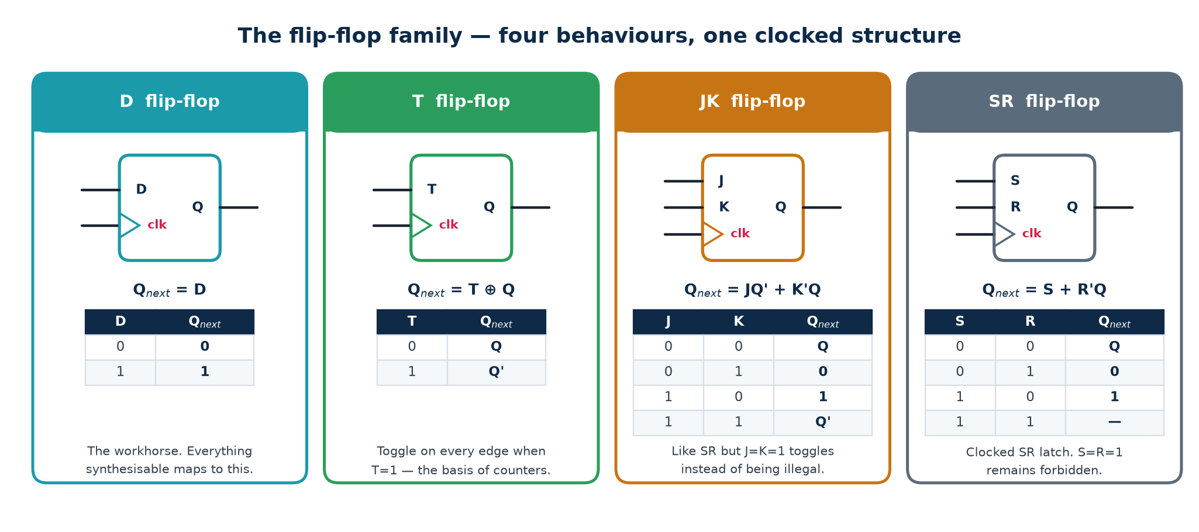
Figure 3.5 — D, T, JK and SR

Characteristic equations
Type | Characteristic equation | Behaviour
D | Q⁺ = D | copy the input
T | Q⁺ = T ⊕ Q | toggle when T = 1, hold when T = 0
JK | Q⁺ = J·Q' + K'·Q | set / reset / hold / toggle — no forbidden state
SR | Q⁺ = S + R'·Q (SR ≠ 11) | set / reset / hold; 11 forbidden

Excitation table — the table you use to DESIGN
A characteristic table answers 'given the inputs, what is the next state?'. An EXCITATION table answers the reverse: 'to make this transition happen, what inputs do I need?'. You analyse with the first and design with the second.
Q → Q⁺ | D | T | J K | S R
0 → 0 | 0 | 0 | 0 × | 0 ×
0 → 1 | 1 | 1 | 1 × | 1 0
1 → 0 | 0 | 1 | × 1 | 0 1
1 → 1 | 1 | 0 | × 0 | × 0

The × entries are don't-cares, and they are exactly why JK-based designs minimise so well on paper — every don't-care is a free K-map grouping opportunity.

Converting one flip-flop to another
1. Write the excitation table of the flip-flop you HAVE, beside the characteristic table of the one you WANT.
2. K-map the required inputs of the available flip-flop as functions of (present state, desired inputs).
3. Add that logic in front.
4. Two you should just remember: D = T ⊕ Q (D-FF used as a T-FF) and T = D ⊕ Q (T-FF used as a D-FF).
Why the D flip-flop won
It has no forbidden state, no toggle surprise, and its next state IS its input — so synthesis can map any next-state equation directly onto it with no conversion logic. Standard-cell libraries therefore contain dozens of D flip-flop variants (with and without reset, set, enable, scan) and no JK at all. If you need a T or JK, build it from a D plus a couple of gates.

3.5 Reset
At power-up every flip-flop holds an unknown value. Reset forces the design into a known starting state. Choosing the wrong style, or releasing reset carelessly, produces bugs that appear only on real silicon.
The two templates — memorise both exactly
// ASYNCHRONOUS reset - reset is in the sensitivity list
always @(posedge clk or negedge rst_n)
if (!rst_n) q <= 1'b0;
else q <= d;

// SYNCHRONOUS reset - reset is just another input to the D logic
always @(posedge clk)
if (!rst_n) q <= 1'b0;
else q <= d;

 | Asynchronous | Synchronous
Takes effect | immediately, clock or no clock | only on a clock edge
At power-up | works before the PLL has locked | useless — there is no clock yet
Timing analysis | needs recovery / removal checks | ordinary setup / hold
Glitch on the reset line | propagates straight into the design | filtered — only sampled at the edge
Area | usually free (the cell has the pin) | adds a gate in the data path

What industry actually does: the reset synchroniser
Assert asynchronously, DE-assert synchronously. Two flip-flops clocked by the destination clock, with their asynchronous reset pins tied to the raw reset. The output is a reset that asserts the instant the raw signal drops (so it works with no clock) but releases cleanly on a clock edge (so no flip-flop can violate its recovery time).
Recovery and removal are setup and hold for the reset pin: recovery is how long before the clock edge the reset must be de-asserted; removal is how long after. A raw asynchronous release violates both.
On FPGAs a global reset costs routing and is often unnecessary, because the bitstream initialises every flip-flop. On an ASIC it is mandatory.

3.6 Timing: setup, hold and clock-to-Q
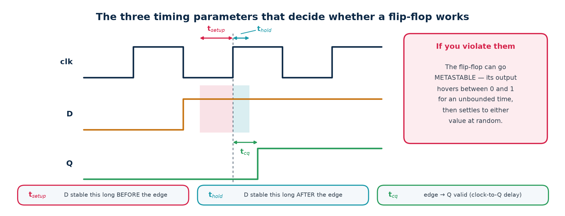
Figure 3.6 — the three parameters from the datasheet
Parameter | Meaning | Violated when
t_setup | D must be stable this long BEFORE the edge | the data path is too SLOW
t_hold | D must stay stable this long AFTER the edge | the data path is too FAST
t_cq | delay from the edge until Q is valid | — (a cost, not a constraint)

The timing path
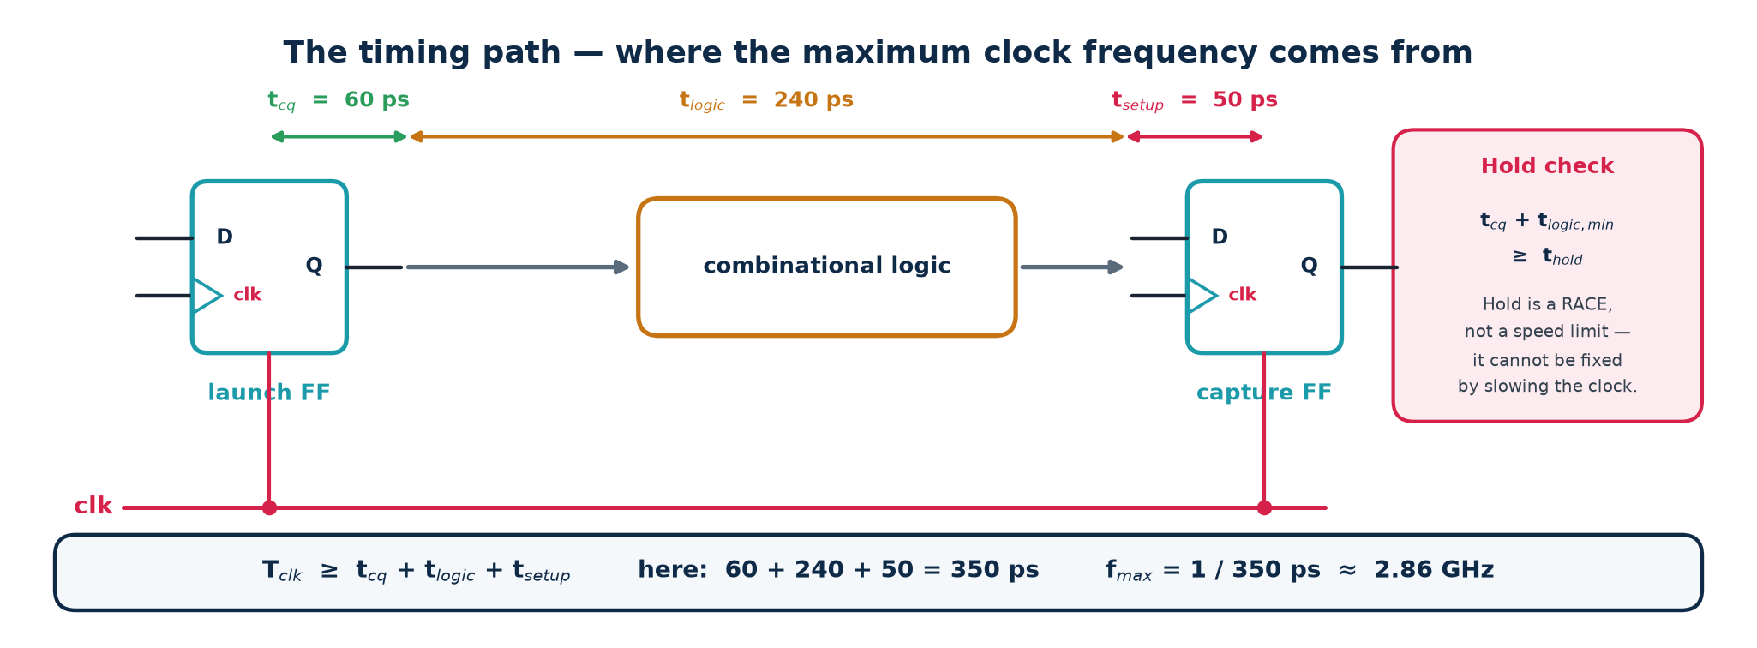
Figure 3.7 — launch flip-flop, logic, capture flip-flop
The two checks
SETUP (max delay): T_clk ≥ t_cq + t_logic,max + t_setup + t_jitter − t_skew
HOLD (min delay): t_cq + t_logic,min ≥ t_hold + t_skew
Setup sets your maximum frequency. Hold is a RACE and is frequency-independent — a hold violation is broken at DC and cannot be fixed by slowing the clock. You fix hold by ADDING delay (buffers) to the short path.

Slack = available time − required time. Positive slack means the requirement is met with margin; negative slack is a violation, and the number tells you by how much. Timing signoff is 'no negative slack on any path'.

Worked timing calculation
Given t_cq = 60 ps, t_setup = 50 ps, t_hold = 40 ps, skew = 25 ps (capture clock arrives LATE), jitter = 15 ps, t_logic,max = 240 ps, t_logic,min = 30 ps, and a target of 2.0 GHz:
Do setup and hold as two separate calculations, never together
SETUP
T_req = t_cq + t_logic,max + t_setup + t_jitter - t_skew
= 60 + 240 + 50 + 15 - 25
= 340 ps -> f_max = 1/340 ps = 2.94 GHz
Target 2.0 GHz means T_target = 500 ps
SETUP SLACK = 500 - 340 = +160 ps PASS

HOLD
Required: t_cq + t_logic,min >= t_hold + t_skew
60 + 30 >= 40 + 25
90 >= 65
HOLD SLACK = 90 - 65 = +25 ps PASS

The sign of skew — the classic exam mistake
A LATE capture clock gives the data path more time, so it HELPS setup. But it also means the capture flip-flop samples later, giving the next launch more chance to corrupt it, so it HURTS hold. That is why t_skew appears with opposite signs in the two inequalities. Get the sign wrong and both answers are wrong.

3.7 Metastability and clock-domain crossing
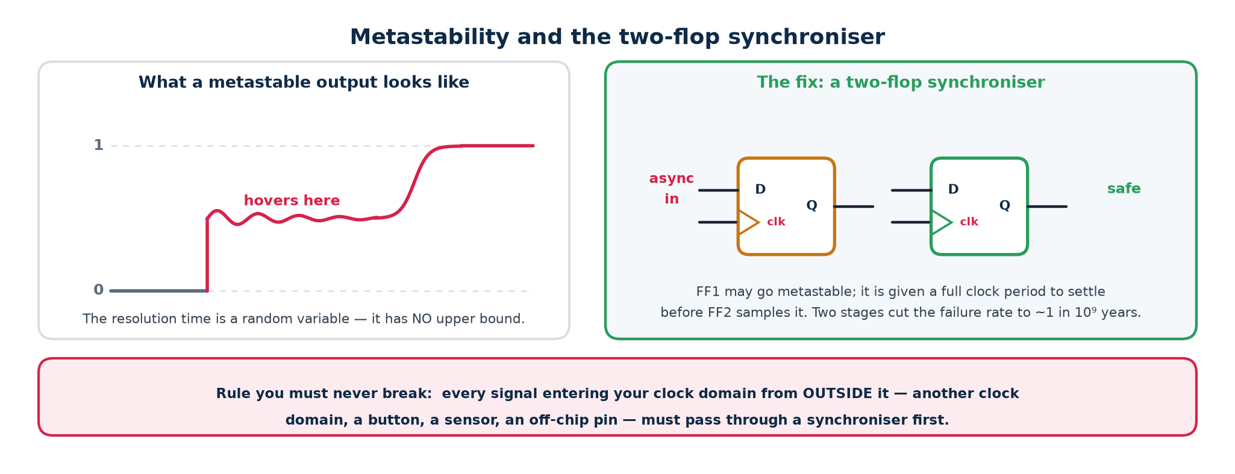
Figure 3.8 — the failure, and the standard fix
If data changes inside the setup/hold window, the flip-flop may enter a METASTABLE state: its output hovers at an invalid intermediate voltage, then resolves to 0 or 1 at random after an unbounded time. It cannot be prevented — only made astronomically unlikely.
MTBF = e^(t_r / τ) / (T₀ · f_clk · f_data)
t_r is the resolution time you allow (usually one clock period); τ and T₀ are library constants; f_clk and f_data are the clock and data-change rates.

Because t_r sits inside an exponential, adding ONE more synchroniser flip-flop typically moves MTBF from seconds to millions of years. That is why two stages is the universal minimum, and three are used for very high-speed or safety-critical crossings.
The rule you must never break
Every signal entering your clock domain from outside it — another clock domain, a push-button, a sensor, an off-chip pin — MUST pass through a synchroniser first.
For a BUS you cannot just synchronise each bit. Different bits will resolve on different cycles and you will read a value that never existed. Use a Gray-coded pointer (only one bit changes per step), or a handshake, or an asynchronous FIFO.
CDC bugs are the leading cause of silicon respins, precisely because they are intermittent and pass every simulation.

3.8 Clock skew and jitter
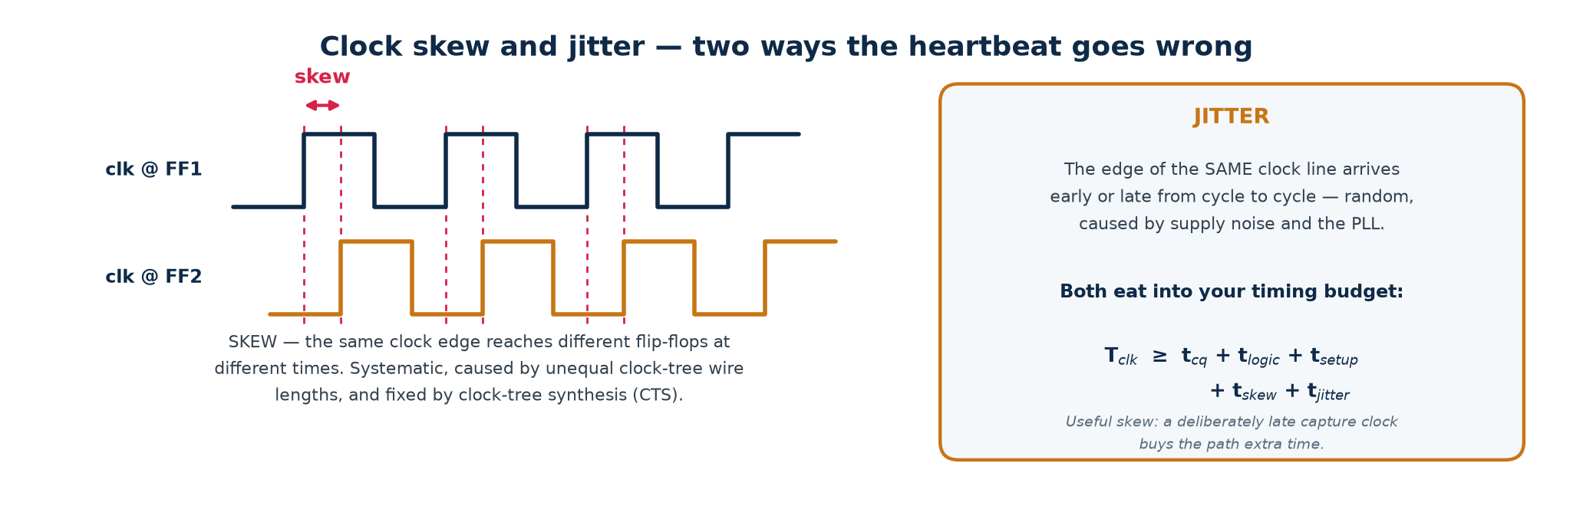
Figure 3.9 — two ways the heartbeat goes wrong
▪ Skew — a FIXED difference in edge arrival time between flip-flops, caused by unequal clock-tree path lengths and loads. Fixed by clock-tree synthesis (CTS), which inserts buffers to balance every branch to within tens of picoseconds.
▪ Jitter — a RANDOM cycle-to-cycle variation in edge arrival, caused by PLL noise, supply droop, crosstalk and temperature. It cannot be designed out; it is budgeted as clock uncertainty in the SDC constraints and paid for out of every clock period.
▪ Useful skew — deliberately delaying a capture clock to borrow time for a slow path from the following stage. Powerful, and dangerous: it tightens the hold check on that same path.

3.9 Registers and shift registers
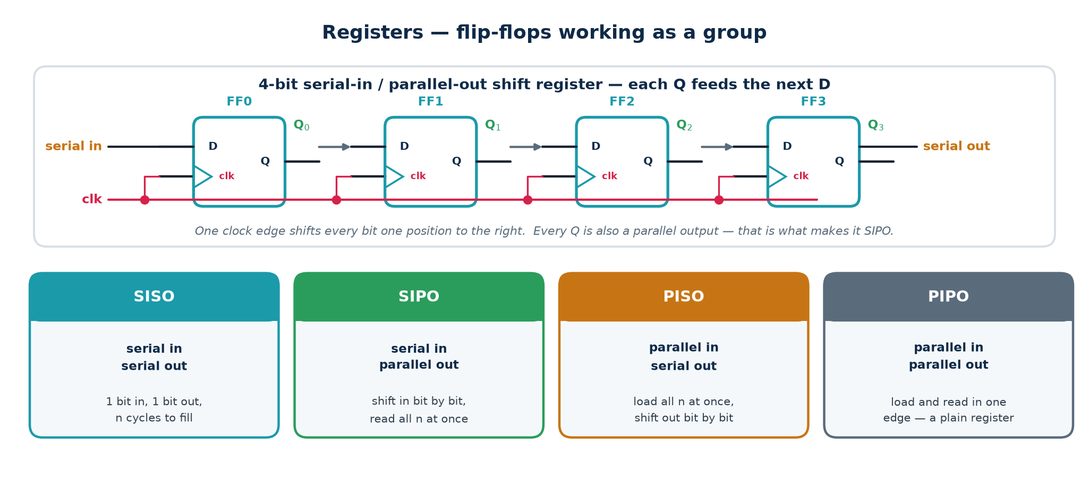
Figure 3.10 — n flip-flops sharing one clock
A register is simply n flip-flops on one clock. Wire each Q to the next D and you have a shift register.
Mode | Name | Behaviour
SISO | serial in, serial out | 1 bit in, 1 bit out; n cycles to traverse
SIPO | serial in, parallel out | shift in bit by bit, read all n at once
PISO | parallel in, serial out | load all n at once, shift out bit by bit
PIPO | parallel in, parallel out | load and read in one edge — a plain register

Where they are actually used
▪ Serialisation — SPI, UART, JTAG: PISO on the transmitter, SIPO on the receiver.
▪ Delay lines — pipeline balancing, so two datapaths arrive at the same stage.
▪ Synchronisers — a 2-bit shift register IS the standard 2-flop synchroniser.
▪ Scan chains — during manufacturing test every flip-flop on the chip is rewired into one giant shift register, so test patterns can be loaded and results read out serially. This is how a chip is tested at all.
▪ LFSRs — add an XOR feedback tap and you get a pseudo-random sequence generator or a CRC engine. An n-bit maximal LFSR cycles through 2ⁿ−1 states (all except all-zeros) in a scrambled order.

3.10 Counters
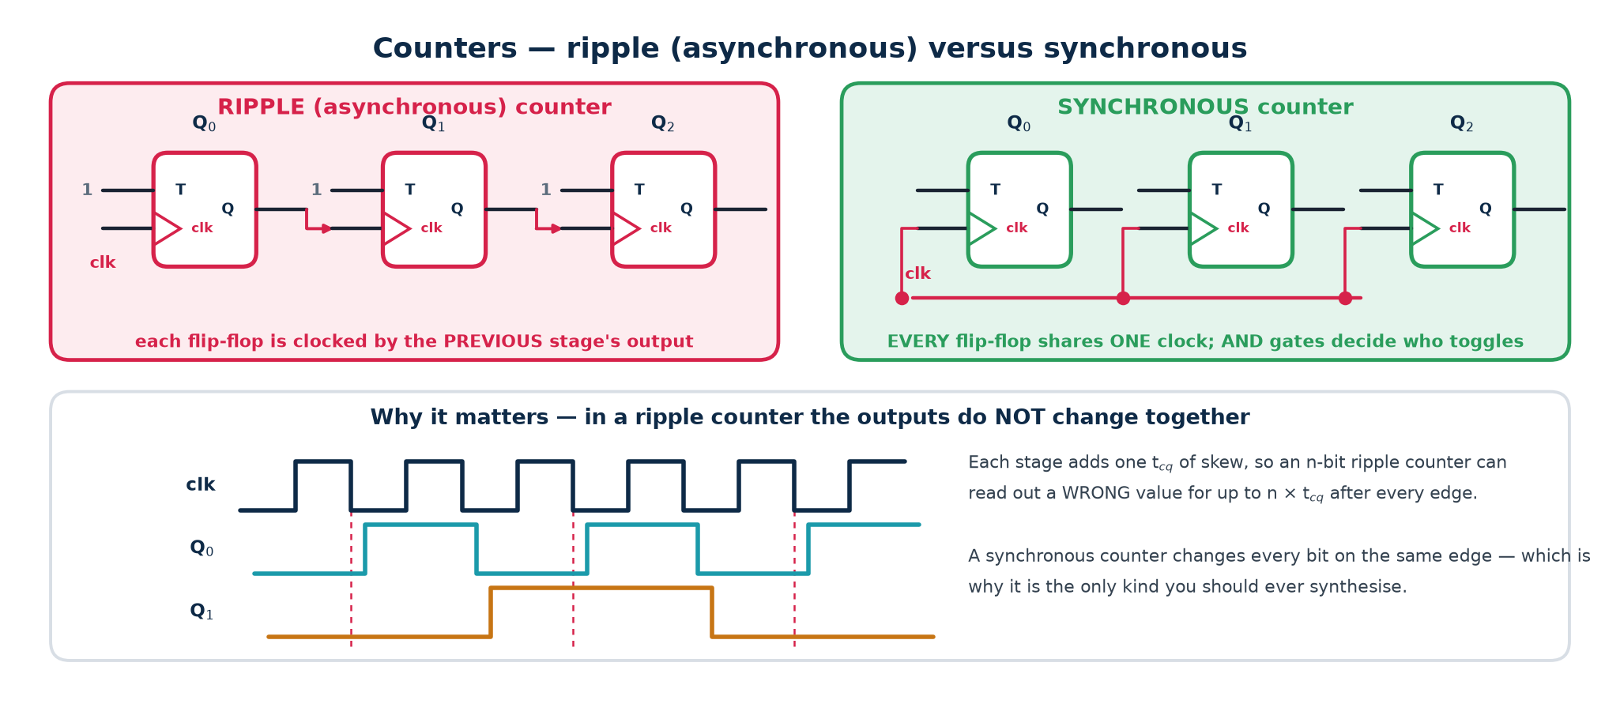
Figure 3.11 — ripple versus synchronous
Ripple (asynchronous): each flip-flop is clocked by the previous stage's output. Simple and small — and each stage adds one t_cq of skew, so an n-bit ripple counter can read out a WRONG value for up to n·t_cq after every edge. It also creates a second clock domain out of a data signal, which breaks static timing analysis entirely.
Synchronous: every flip-flop shares one clock; AND gates decide which bits toggle. All bits change together. This is the only kind you should ever synthesise.

Varieties
▪ Up / down / up-down; loadable; with enable.
▪ Mod-N — divide by N, wrapping at N−1. A mod-10 counter is a BCD counter.
▪ Ring counter — a one-hot shift register; N states from N flip-flops; self-starting only if you force a legal state.
▪ Johnson (twisted-ring) counter — feed back the INVERTED last bit; 2N states from N flip-flops, and only one bit changes per step.
▪ LFSR — 2ⁿ−1 states, maximal length, extremely cheap, but not in numeric order.

Worked design: mod-10 (BCD) up-counter
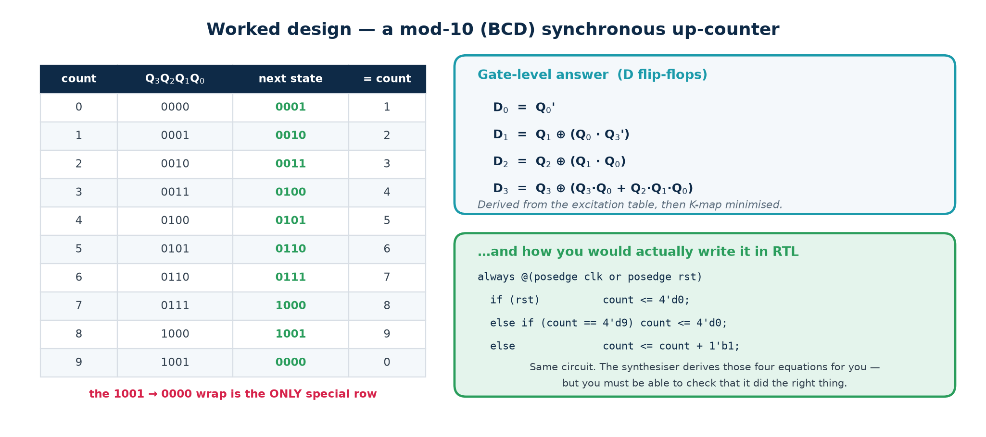
Figure 3.12 — state table, gate equations, and the RTL
1. Write the state table: 0000 … 1001, then wrap to 0000.
2. For each bit, tabulate Qᵢ → Qᵢ⁺.
3. Since D = Q⁺ for a D flip-flop, the D column IS the next-state column.
4. K-map each Dᵢ over Q₃Q₂Q₁Q₀, treating states 1010–1111 as don't-cares.
5. Read off the minimal SOP.
The four next-state equations
D0 = Q0'
D1 = Q1 XOR (Q0 . Q3')
D2 = Q2 XOR (Q1 . Q0)
D3 = Q3 XOR (Q3.Q0 + Q2.Q1.Q0)

Check one row by hand. At count 9 (Q = 1001): D0 = Q0' = 0. D1 = Q1 ⊕ (Q0·Q3') = 0 ⊕ (1·0) = 0. D2 = Q2 ⊕ (Q1·Q0) = 0 ⊕ 0 = 0. D3 = Q3 ⊕ (Q3Q0 + Q2Q1Q0) = 1 ⊕ (1+0) = 0. Next state 0000. Correct.
The trap: unreachable states are not impossible states
States 1010–1111 are unreachable in normal operation, but a glitch, a single-event upset or a marginal reset can land the counter in one of them. Because we treated them as don't-cares, the tool may have mapped them anywhere — including into a loop the counter can never leave.
A SAFE counter forces any illegal state explicitly back to 0000. In RTL that is a default branch, exactly as in a safe FSM.

3.11 Finite state machines
An FSM is the formal name for a circuit that remembers where it is in a sequence. Formally it is a six-tuple (S, S₀, X, Y, δ, λ): a finite set of states, a start state, an input alphabet, an output alphabet, a next-state function δ, and an output function λ.

The three pieces of hardware
1. STATE REGISTER — n flip-flops holding the present state.
2. NEXT-STATE LOGIC — combinational; computes δ(present state, inputs).
3. OUTPUT LOGIC — combinational; computes λ.
Drawn with the state register in a feedback loop, this is the HUFFMAN MODEL of a sequential circuit. Every sequential circuit, however complicated, reduces to it.

What counts as a 'state'
A state is an equivalence class of input HISTORIES: two histories are the same state if the machine will behave identically from now on. This is why a '1011' detector needs five states and not thirty-two — you only have to remember how much of the pattern currently matches, not what you actually received.
What FSMs cannot do. Finite states means finite memory, so an FSM cannot count arbitrarily high or match arbitrarily deep nesting. For that you add a datapath — a counter, a stack — alongside it, which is the FSMD idea in §3.14.

Moore versus Mealy
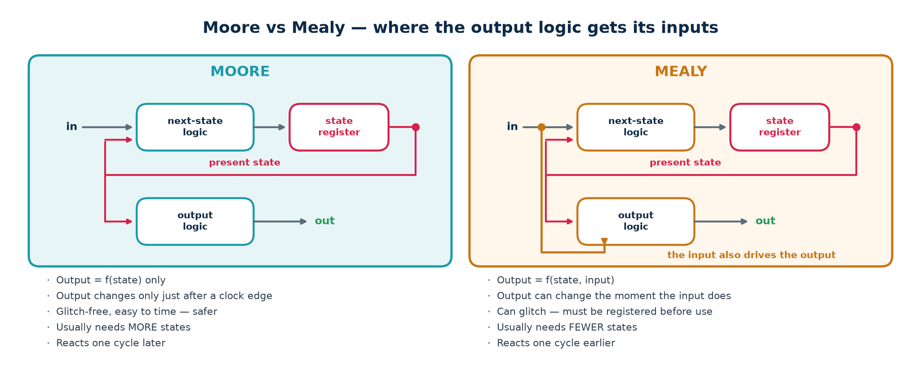
Figure 3.13 — where the output logic gets its inputs
 | Moore | Mealy
Output is | λ(state) | λ(state, input)
Output changes | only just after a clock edge | the moment the input does
Glitches | none — comes straight off flip-flops | possible — combinational
State count | usually more | usually fewer
Reaction time | one cycle later | same cycle
Drawn on the diagram | output written INSIDE the state bubble | output written ON the transition arc

Which should you use?
Default to Moore. Its outputs come straight off flip-flops, so they are glitch-free and trivially timeable. Use Mealy when you genuinely need the one-cycle-earlier response — and then REGISTER the Mealy output before it leaves the block, which of course turns it back into a Moore output one cycle later. That is not a contradiction; it is the point.

3.12 The FSM design procedure
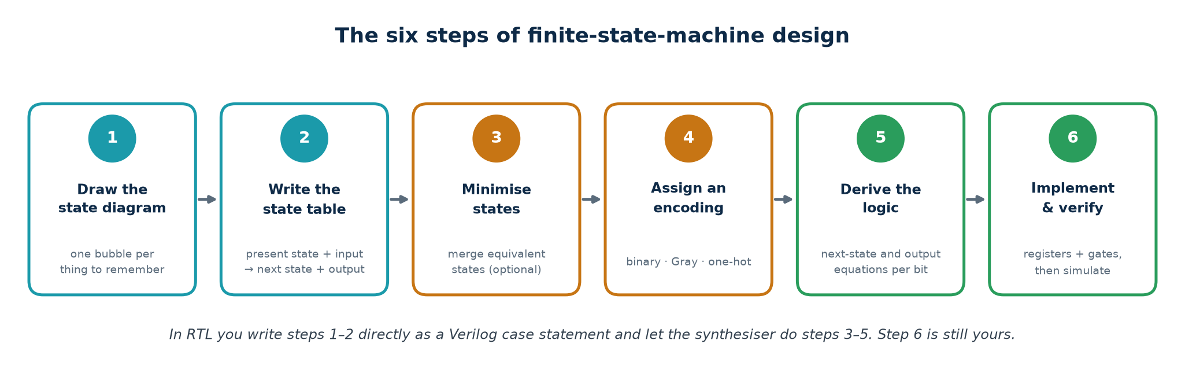
Figure 3.14 — six steps, in this order
1. Draw the state diagram — one bubble per thing the machine must remember.
2. Write the state table — present state + input → next state + output.
3. Minimise states (optional; merge equivalent states).
4. Assign an encoding — binary, Gray or one-hot.
5. Derive the next-state and output equations, one per state bit.
6. Implement and verify.
Two checks to run on the diagram BEFORE writing any code
Completeness: from every state, is there exactly one outgoing arc for EVERY possible input value? A missing arc is an undefined transition — in hardware, an inferred latch or a lock-up. For s states and one binary input there must be exactly 2s arcs; count them.
Determinism: is there AT MOST one arc per input value? Two arcs labelled '1' leaving one state is not a circuit, it is a contradiction.

State encoding
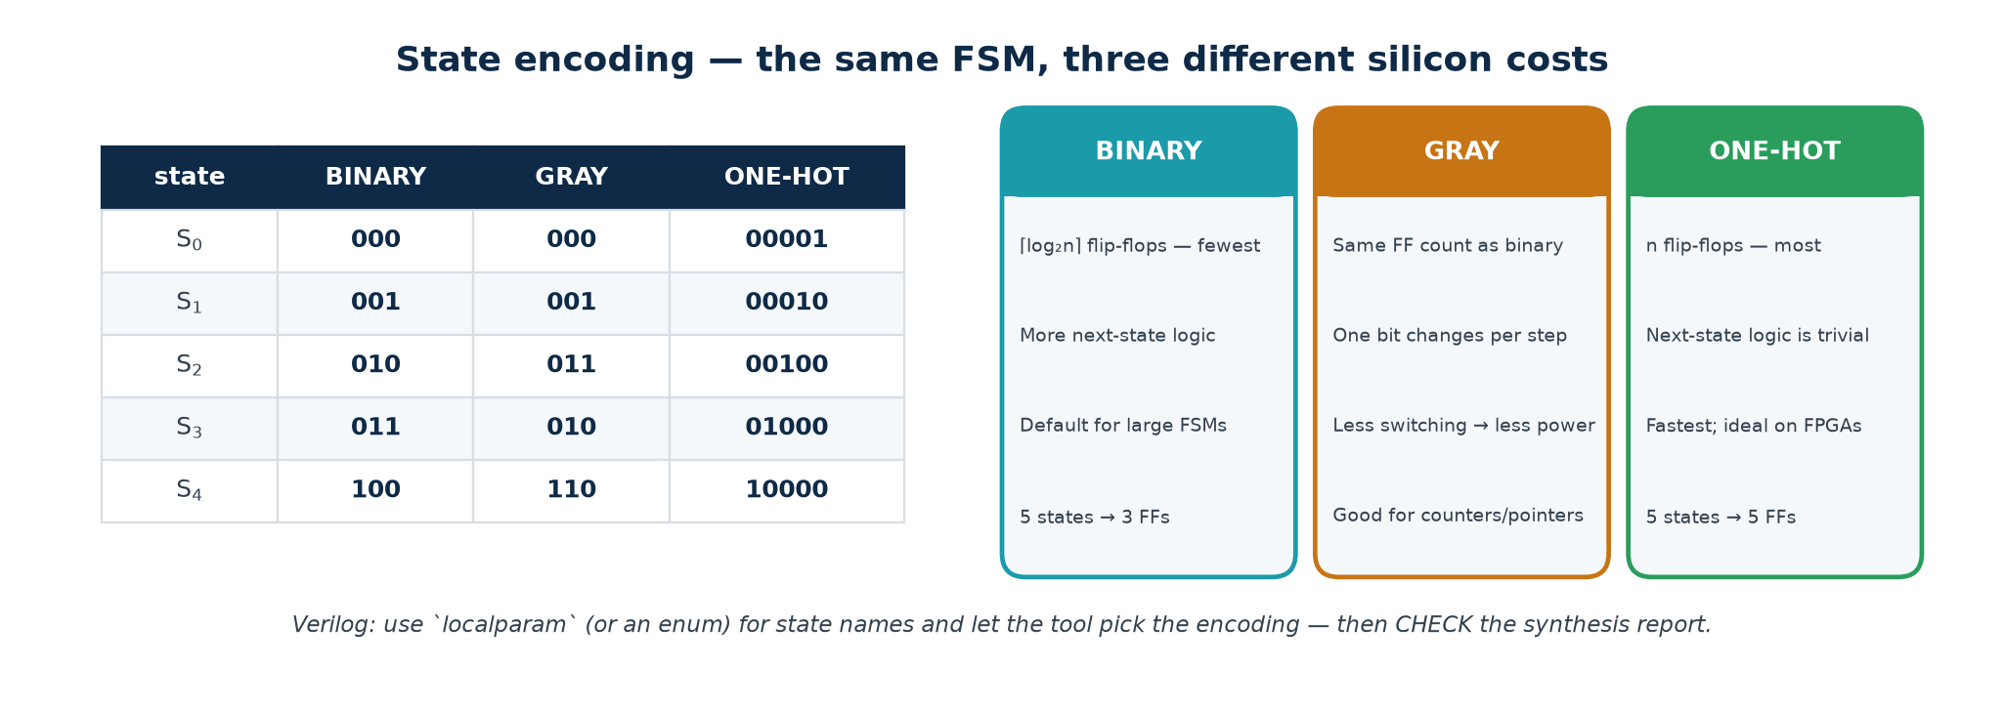
Figure 3.15 — three encodings, three silicon costs
Encoding | Flip-flops for n states | Next-state logic | Best for
Binary | ⌈log₂ n⌉ — fewest | most complex | large FSMs on an ASIC
Gray | ⌈log₂ n⌉ | similar to binary | low power; crossing clock domains
One-hot | n — most | trivial, one level deep | FPGAs; speed-critical FSMs

In Verilog: declare state names with localparam (or an enum in SystemVerilog) and let the tool choose the encoding — then CHECK the synthesis report to see what it actually chose.

3.13 Worked FSM: the '1011' sequence detector
Specification. A serial input X arrives one bit per clock. Assert Z whenever the last four bits received were 1, 0, 1, 1. Overlapping sequences count, so the stream 1011011 contains TWO occurrences.

Step 1 — the state diagram
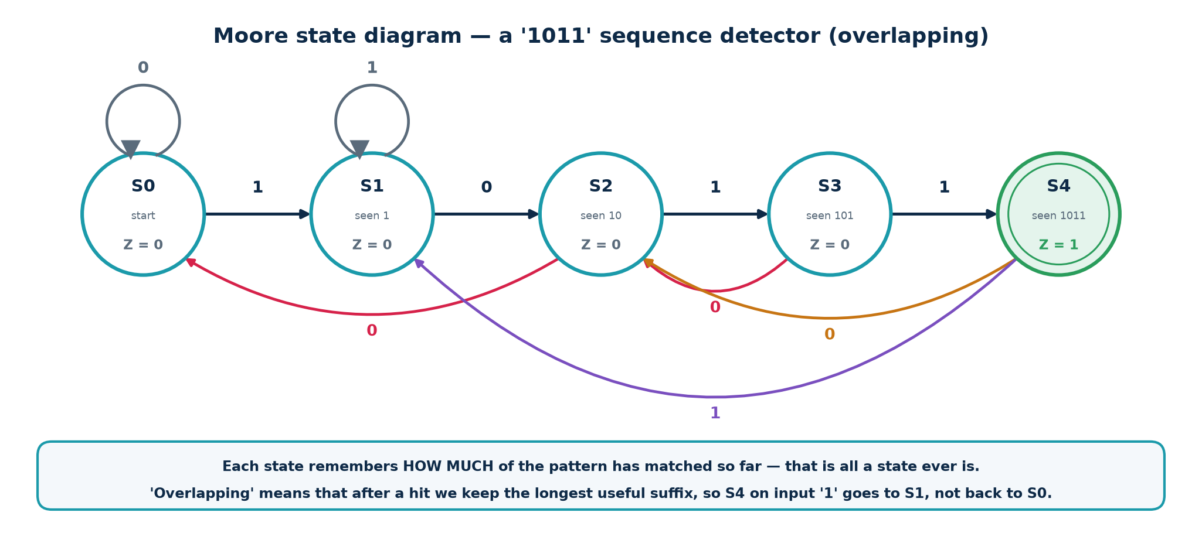
Figure 3.16 — the Moore machine, five states
How the states were chosen. Ask: 'what is the longest PREFIX of 1011 that is currently a SUFFIX of what I have received?' That question has exactly five answers — none, 1, 10, 101, 1011 — so there are five states, and the answer to the question IS the state. This suffix-matching insight generalises to any pattern detector.

Step 2 — the state table
Present state | Encoding Q₂Q₁Q₀ | Next (X=0) | Next (X=1) | Z
S0 (start) | 000 | S0 000 | S1 001 | 0
S1 (seen 1) | 001 | S2 010 | S1 001 | 0
S2 (seen 10) | 010 | S0 000 | S3 011 | 0
S3 (seen 101) | 011 | S2 010 | S4 100 | 0
S4 (seen 1011) | 100 | S2 010 | S1 001 | 1

Steps 4–5 — encoding and equations
Derived next-state and output equations
K-map each D bit over Q2 Q1 Q0 X, treating codes 101/110/111 as don't-cares:

D2 = Q1 . Q0 . X only S3 (011) with X=1 reaches S4
D1 = X' . (Q2 + Q0) + Q1 . Q0' . X
D0 = X . (Q1 . Q0)'

Z = Q2 S4 is the only code with Q2 = 1

Always re-check row by row. S3 = 011 with X = 1: D₂ = 1·1·1 = 1; D₁ = 0·(…) + 1·0·1 = 0; D₀ = 1·(1·1)' = 0. Next state 100 = S4. Correct. Note that Z = Q₂ fell out for free because the encoding was chosen well — a different assignment would have needed real output logic.

Step 6 — the RTL
The three-always-block template — use this shape for EVERY FSM
module seq_detect_1011 (input clk, input rst_n, input x, output reg z);

localparam S0=3'd0, S1=3'd1, S2=3'd2, S3=3'd3, S4=3'd4;
reg [2:0] state, next;

// ---- BLOCK 1 : state register (sequential, non-blocking) ----
always @(posedge clk or negedge rst_n)
if (!rst_n) state <= S0;
else state <= next;

// ---- BLOCK 2 : next-state logic (combinational, blocking) ----
always @(*) begin
next = state; // default: no inferred latch
case (state)
S0: next = x ? S1 : S0;
S1: next = x ? S1 : S2;
S2: next = x ? S3 : S0;
S3: next = x ? S4 : S2;
S4: next = x ? S1 : S2; // overlapping: reuse the suffix
default: next = S0; // SAFE FSM
endcase
end

// ---- BLOCK 3 : output logic (Moore - state only) ----
always @(*) z = (state == S4);

endmodule

Why three blocks and not one. It separates the clocked element from the combinational logic, so the synthesised hardware matches the Huffman model exactly. It makes the reset behaviour explicit, keeps each block short enough to read, and makes latch inference impossible so long as you keep the default assignment. One-block FSMs are legal and much harder to debug.

Moore versus Mealy on the same stream
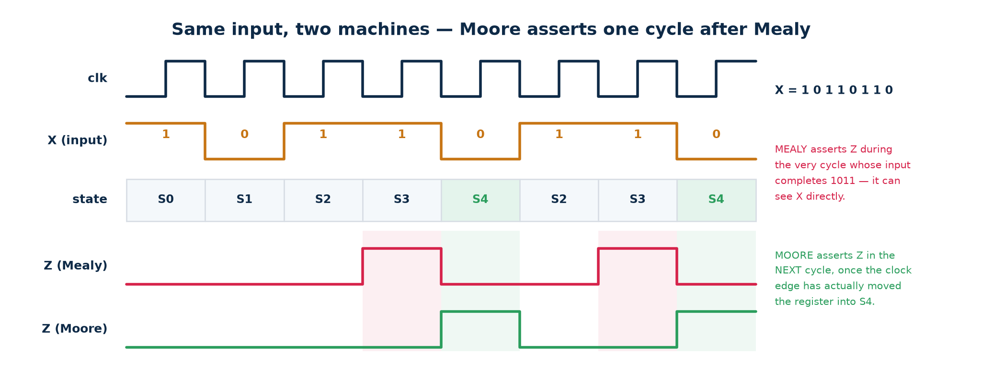
Figure 3.17 — Moore asserts one cycle after Mealy
Both machines see the fourth bit complete the pattern. Mealy asserts Z DURING that cycle, combinationally, the moment X goes high while the state is S3. Moore asserts Z in the NEXT cycle, once the clock edge has actually moved the register into S4. Overlapping means the trailing '11' is reused, so the pattern completes again on bit 7 and both machines fire a second time.

Five ways an FSM goes wrong in silicon
Failure | What happens | Prevention
Unreachable / illegal states | 5 states in 3 bits leaves codes 101–111 existing in hardware but not in your diagram; a glitch or SEU lands you there | a `default` branch that returns to a safe state
Deadlock / lock-up | a group of states with no path back to normal operation; only a reset recovers | prove reachability — from every state a path to S0 must exist
Incomplete transitions | a state with no arc for some input; in RTL this becomes an inferred latch | assign `next` a default value at the top of the block
Unregistered Mealy output | a glitchy combinational output drives a clock enable or a memory write | register the output, or use Moore
Asynchronous input into the FSM | a button or another clock domain violates setup/hold and the FSM enters an illegal state | two-flop synchroniser on EVERY asynchronous input

3.14 Sequential logic in Verilog: blocking versus non-blocking
This is the single most common Verilog error in the industry. Both versions below simulate; only one synthesises to what you meant, and simulation and hardware then disagree — the worst class of bug there is.
Same intent, different hardware
// CORRECT - non-blocking (<=) gives a true two-stage shift register
always @(posedge clk) begin
q1 <= d;
q2 <= q1; // q2 gets the OLD q1 -> two flip-flops in series
end

// WRONG - blocking (=) makes q1 update immediately
always @(posedge clk) begin
q1 = d;
q2 = q1; // q2 gets d -> ONE flip-flop, and a race in simulation
end

The rule — no exceptions
Non-blocking <= in every always @(posedge clk) block.
Blocking = in every always @(*) block.
Never mix the two in one block. Never assign the same signal from two blocks.
Why the rule exists: non-blocking assignments all sample their right-hand sides first and then update together at the end of the time step — which is exactly what a bank of flip-flops does on a clock edge. Blocking assignments execute in order, like software, which models a wire, not a register.

3.15 Controller plus datapath — the FSMD view
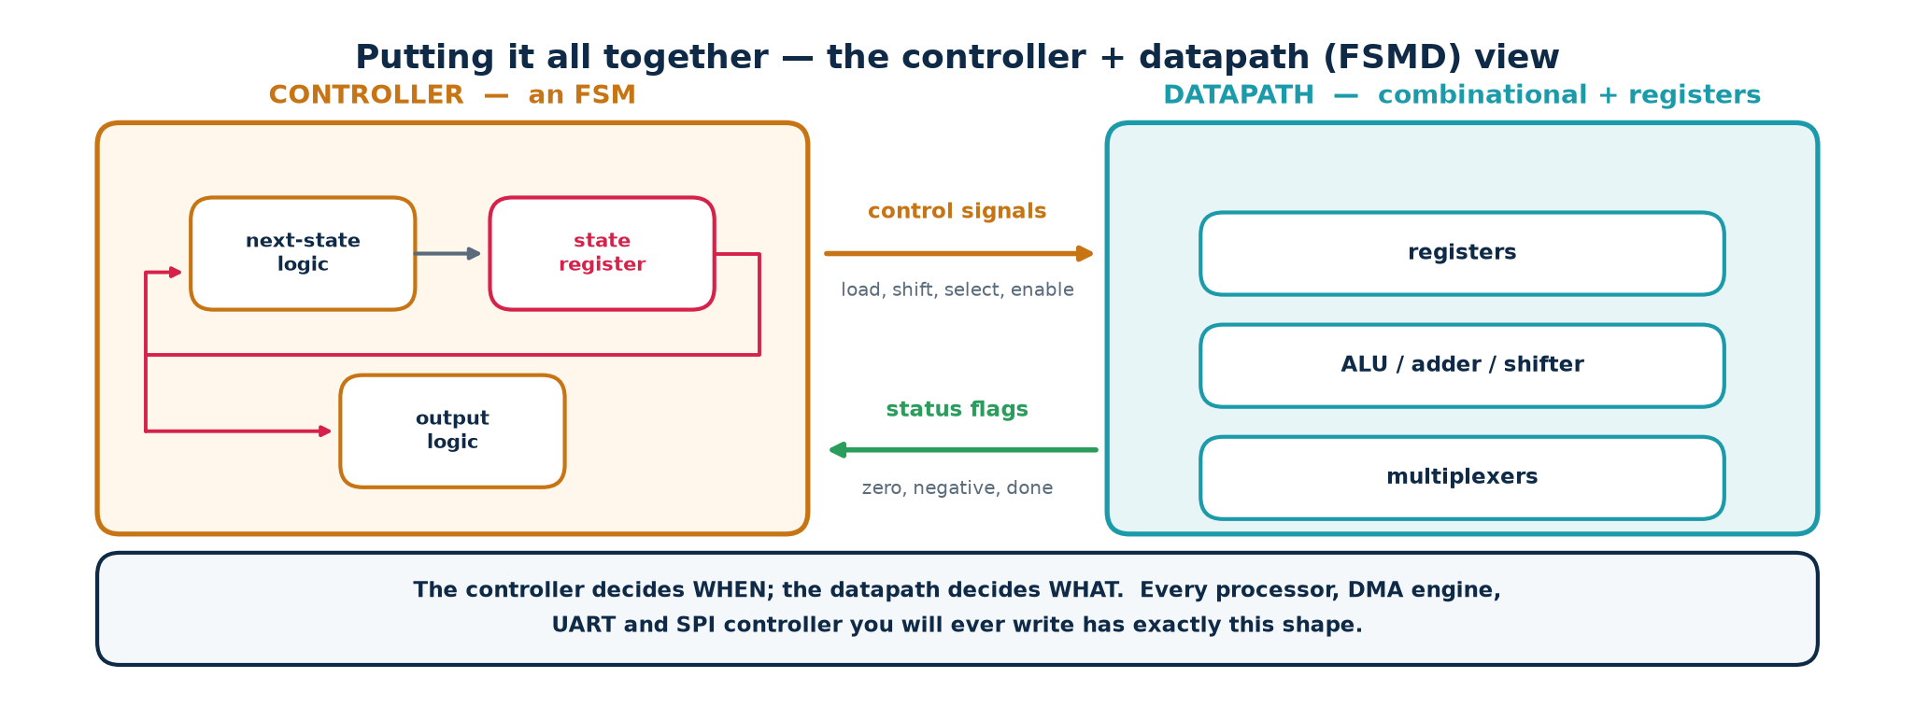
Figure 3.18 — how every non-trivial block is organised
The combinational blocks from Part 2 form the DATAPATH; the FSM from Part 3 forms the CONTROLLER. Control signals (load, shift, select, enable) go one way; status flags (zero, negative, done, terminal count) come back. The controller decides WHEN; the datapath decides WHAT.

A concrete example you can build in an afternoon
A serial (shift-and-add) multiplier.
▪ Datapath: a shift register holding the multiplier, an adder, an accumulator register, and a counter for the loop.
▪ Controller: an FSM with states IDLE → LOAD → ADD/SHIFT (looping) → DONE.
▪ The interface: the FSM asserts load, add_en and shift_en; the counter asserts a 'terminal count' status flag that tells the FSM when to leave the loop.
Every processor, DMA engine, UART, SPI controller and memory controller you will ever write has exactly this shape.

Part 4 · Guided Tutorials
Everything from here is done at a keyboard. The tools are free, open-source, cross-platform and take about fifteen minutes to install. Every command and every expected output in this part has been run and verified.

4.0 Installing the toolchain
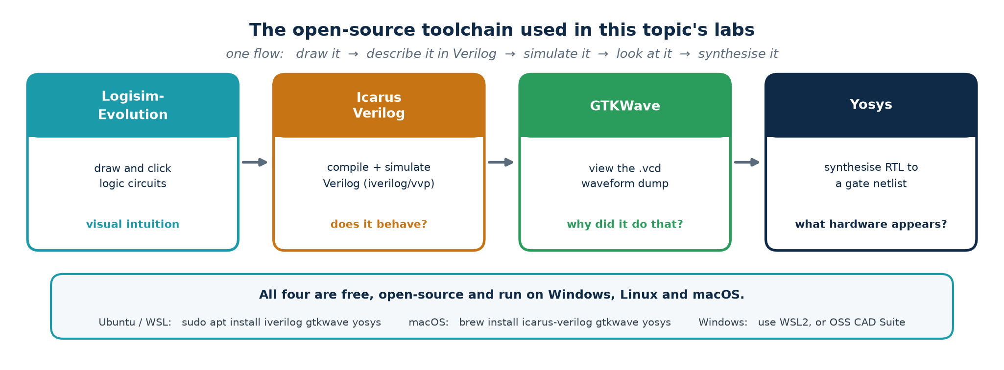
Figure 4.1 — one flow: draw it, describe it, simulate it, look at it, synthesise it
Tool | What it is for | Answers the question
Logisim-Evolution | draw and click logic circuits | what does this circuit DO?
Icarus Verilog | compile and simulate Verilog | does my code behave correctly?
GTKWave | view the .vcd waveform dump | why did it do that?
Yosys | synthesise RTL to a gate netlist | what hardware did I actually write?

Ubuntu, Debian or WSL
Linux / WSL install
sudo apt update
sudo apt install -y iverilog gtkwave yosys graphviz default-jre

# Logisim-Evolution: download the .jar from its GitHub releases page, then
java -jar logisim-evolution.jar

Windows
1. Open PowerShell as Administrator and run wsl --install -d Ubuntu.
2. Reboot, open the Ubuntu terminal, and follow the Linux commands above.
3. For GTKWave graphics use WSLg (Windows 11) or install VcXsrv (Windows 10).
4. Alternative without WSL: download the OSS CAD Suite ZIP, unzip it, and run environment.bat before using the tools.

macOS
macOS install via Homebrew
/bin/bash -c "$(curl -fsSL https://raw.githubusercontent.com/Homebrew/install/HEAD/install.sh)"
brew install icarus-verilog gtkwave yosys graphviz temurin

Verify before the lab, not during it
Each of these must print a version
iverilog -V | head -1 # Icarus Verilog version 11.x or 12.x
vvp -V | head -1 # the Icarus runtime engine
gtkwave --version | head -1 # GTKWave Analyzer v3.3.x
yosys -V # Yosys 0.3x
java -version # openjdk 17 or later

Troubleshooting
'command not found' after apt succeeded → close and reopen the terminal.
GTKWave opens but shows nothing → you forgot $dumpfile and $dumpvars in the testbench.
Yosys says 'read_verilog: syntax error' → Icarus accepts some non-standard code that Yosys rejects. Fix the RTL; do not work around it.
Simulation runs forever → you have no $finish , or a clock generator with no timescale.

4.1 Tutorial T1 — Logisim-Evolution: see the logic before you code it
Goal. Build three circuits by clicking, poke the inputs, and watch the wires change colour. Thirty minutes here saves hours of confusion later.
Deliverable. Three .circ files plus a screenshot of each truth table.

T1.1 A half adder from scratch (10 min)
1. Launch: java -jar logisim-evolution.jar
2. From the toolbar place two Input pins. Right-click each → Edit label → name them A and B.
3. From the Gates library in the left-hand tree, drag in one XOR gate and one AND gate.
4. Place two Output pins and label them S and C.
5. Wire A and B to BOTH gates. Connect XOR → S and AND → C.
6. Select the poke tool (the hand). Click A and B to toggle them and read S and C.
7. Verify all four rows against the half-adder truth table in §2.3.
What you should notice
Wires are green when carrying 0, bright green when carrying 1, and RED when they are in conflict — two outputs driving one wire. Red wires are the visual equivalent of an X in simulation, and you will meet the same failure in Verilog when two always blocks drive the same signal.

T1.2 A 4-bit ripple-carry adder (15 min)
1. Project → Add Circuit… and name it full_adder. Build it from two half adders and an OR gate, as in Figure 2.3.
2. Return to the main circuit. Your full_adder now appears in the project tree — drag in four copies.
3. Chain them: Cout of stage i to Cin of stage i+1. Tie the first Cin to a constant 0.
4. Drive A and B from two 4-bit input pins (set Data Bits = 4 in the pin's properties) and split them with a Splitter from the Wiring library.
5. Test: 5 + 3 should give 8 with Cout = 0. Then try 15 + 1 and confirm Cout goes high while the sum wraps to 0.

T1.3 The '1011' detector (20 min)
1. Place a 3-bit Register and a Clock, both from the Memory / Wiring libraries.
2. Implement the three next-state equations from §3.13 with gates, feeding the register's D input.
3. Drive X from an input pin and take Z from the register's Q2 bit.
4. Simulate → Tick Enabled. Set X by hand before each tick and step through 1, 0, 1, 1.
5. Watch Z pulse. Then continue with 0, 1, 1 and confirm the OVERLAPPING second detection.
Checkpoint question
In T1.3, what happens if you change X at the same moment you tick the clock? Relate your answer to §3.7. (Logisim will usually resolve it one way or the other deterministically — real silicon will not.)

4.2 Tutorial T2 — Icarus Verilog and GTKWave
Goal. Take the circuit you clicked together in T1, describe it in Verilog, prove it correct with a self-checking testbench, and look at the waveform.
The design
// ---------- rtl/full_adder.v ----------
`timescale 1ns / 1ps
module full_adder (input a, input b, input cin, output sum, output cout);
assign sum = a ^ b ^ cin;
assign cout = (a & b) | (cin & (a ^ b));
endmodule

A self-checking testbench
// ---------- tb/tb_full_adder.v ----------
`timescale 1ns / 1ps
module tb_full_adder;
reg a, b, cin; wire sum, cout;
integer i; integer errors = 0;

full_adder dut (.a(a), .b(b), .cin(cin), .sum(sum), .cout(cout));

initial begin
$dumpfile("fa.vcd"); $dumpvars(0, tb_full_adder); // waveform dump
for (i = 0; i < 8; i = i + 1) begin
{a, b, cin} = i[2:0]; #10;
if ({cout, sum} !== (a + b + cin)) begin
$display("FAIL a=%b b=%b cin=%b", a, b, cin);
errors = errors + 1;
end
end
if (errors == 0) $display("PASS - all 8 cases correct");
$finish;
end
endmodule

Three commands
iverilog -g2012 -o fa.out rtl/full_adder.v tb/tb_full_adder.v # compile
vvp fa.out # run -> 'PASS - all 8 cases correct'
gtkwave fa.vcd & # view the waveform

Reading the waveform in GTKWave
1. The left pane (SST) is the design hierarchy. Click tb_full_adder.
2. The signals appear below it. Select them all and click Insert.
3. Press the 'zoom fit' button (the magnifier with the square) to see the whole run.
4. Right-click a bus → Data Format → Decimal or Hex to make multi-bit signals readable.
5. File → Write Save File saves your signal selection, so you do not rebuild it every time.
Why the testbench checks itself
A testbench you have to read a waveform to grade is a testbench that will not catch a regression. Self-checking means the CI system, the marker, and you at 2 a.m. all get the same one-word answer. Waveforms are for DIAGNOSING a failure, not for detecting one.

Extend it. Build a 4-bit adder from four instances and check every one of the 512 input combinations in a triple-nested loop. The lab folder already contains this as tb/tb_adder4.v.

4.3 Tutorial T3 — flip-flop, shift register, counter
Goal. See with your own eyes that a flip-flop samples only on the edge, that non-blocking assignment builds a real shift register, and that a mod-10 counter wraps at nine.
The three designs (full sources are in Topic3_Lab/rtl/)
// dff.v
always @(posedge clk or negedge rst_n)
if (!rst_n) q <= 1'b0;
else q <= d;

// shift4.v
always @(posedge clk or negedge rst_n)
if (!rst_n) q <= 4'b0000;
else q <= {q[2:0], sin}; // shift left, sin enters at bit 0

// bcd_counter.v
always @(posedge clk or negedge rst_n)
if (!rst_n) cnt <= 4'd0;
else if (en) begin
if (cnt == 4'd9) cnt <= 4'd0;
else cnt <= cnt + 4'd1;
end

Compile and run
iverilog -g2012 -o seq.out rtl/dff.v rtl/shift4.v rtl/bcd_counter.v \
tb/tb_sequential.v
vvp seq.out
gtkwave seq.vcd &

What to look for in the waveform
1. q changes ONLY at rising clk edges. The testbench deliberately moves d in the middle of a high phase; the flip-flop completely ignores it.
2. sr_q[3] lags sin by exactly four clock cycles — count the edges.
3. cnt runs …8, 9, 0, 1… and never reaches 10, and it freezes while en is low.

Three experiments that teach the lesson
1. Break the shift register. Change <= to = in shift4.v, re-run ./scripts/synth_all.sh and count the flip-flops. The blocking version collapses to ONE, because q[1] is updated before q[2] reads it.
2. Break the counter. Delete the if (cnt == 4'd9) line and watch the counter run to 15 — you now have a mod-16 counter.
3. Prove the enable. Hold en low for three cycles and confirm the count does not move.
Deliverable. One annotated GTKWave screenshot per design, with the key transition circled and one sentence explaining it.

4.4 Tutorial T4 — the FSM, end to end
Goal. Close the loop. Take the FSM you designed on paper, run it, then ask Yosys what hardware it actually becomes — and check that the answer matches your state diagram.
Four steps
# ---- Step 1 : simulate ----
iverilog -g2012 -o fsm.out rtl/seq_detect_1011.v \
rtl/seq_detect_1011_mealy.v tb/tb_seq_detect.v
vvp fsm.out # -> 'PASS - both detectors found exactly two overlapping matches'
gtkwave fsm.vcd &

# ---- Step 2 : synthesise and read the statistics ----
yosys -p 'read_verilog rtl/seq_detect_1011.v; \
synth -top seq_detect_1011; \
abc -g AND,OR,XOR,NAND,NOR; stat'

# ---- Step 3 : look at the schematic Yosys produced ----
yosys -p 'read_verilog rtl/seq_detect_1011.v; proc; opt; \
show -format dot -prefix fsm'
dot -Tpng fsm.dot -o fsm.png

# ---- or just run the whole lab ----
cd Topic3_Lab && ./scripts/run_all.sh && ./scripts/synth_all.sh

What the stat report should tell you
Line | Expected | If it differs
Number of cells | 18 | your equations or your case statement differ from ours
$_DFF_PN0_ | 3 | three flip-flops = your 3-bit state register
combinational cells | 15 | AND, NAND, NOR, NOT, OR
$_DLATCH_ | ZERO | a latch means a default assignment is missing — a BUG

Three experiments, each with a real and different answer
1. See a latch. Synthesise rtl/broken_latch.v and find $_DLATCH_N_ and $_DLATCH_P_ in the cell list. Add a default assignment at the top of each always block and watch both disappear.
2. Change the encoding. Synthesise rtl/seq_detect_1011_onehot.v. The only difference from the original is a (* fsm_encoding = "one-hot" *) attribute on the state register — and you get 14 cells with 5 flip-flops instead of 18 cells with 3. More registers, less combinational logic: exactly the trade-off in §3.12.
3. Find out why Yosys will not re-encode this FSM for you. Run:
Experiment 3
yosys -p 'read_verilog rtl/seq_detect_1011.v; hierarchy -top seq_detect_1011; \
proc; opt; fsm_detect'

# Yosys replies:
# Not marking seq_detect_1011.state as FSM state register:
# Circuit seems to be self-resetting.

A real engineering trade-off, not a tool bug
The default: next = S0; branch that makes your FSM SAFE is exactly what makes Yosys decide the circuit is self-resetting, so it declines to extract and re-encode it.
Delete that line, re-synthesise, and the tool now extracts the FSM and one-hot encodes it by itself — 14 cells, 5 flip-flops. You have traded illegal-state recovery for automatic optimisation.
Which is right? For anything safety-related, keep the default and force the encoding with the attribute instead. That is what the _onehot variant does.

This is the whole point of the topic. You predicted the hardware from the state diagram, and the tool agreed with you — and where it disagreed, you could say exactly why.

4.5 Lab deliverables and marking rubric
Deliverable | Evidence required | Marks
T1 — Logisim circuits | half_adder.circ, adder4.circ, fsm1011.circ + one screenshot each | 15
T2 — Full adder simulation | full_adder.v, tb_full_adder.v, console showing PASS, GTKWave screenshot | 15
T3 — Sequential designs | dff.v, shift4.v, bcd_counter.v, three annotated waveform screenshots | 20
T4 — FSM end to end | seq_detect_1011.v, testbench, waveform showing TWO Z pulses, Yosys stat output | 25
Written answers | Part 5 exercises E1–E46 with working shown | 15
Viva | explain one design of the examiner's choosing at the whiteboard | 10

Pass criteria
50 % overall, with a COMPULSORY pass in T4. A student who cannot take a finite state machine from a state diagram to a verified, synthesised netlist has not met the terminal outcome for this topic. Resubmission of T4 is permitted once.

Part 5 · Practice Exercises
Attempt every exercise before opening Part 6. An exercise whose answer you have already read teaches you nothing. Show your working — in an examination the method carries most of the marks.

Section A · Boolean algebra and logic gates
E1. Convert to binary, hex and BCD: (a) 45 (b) 200 (c) 255.
E2. Write −37 and −1 in 8-bit two's complement, and state the range an 8-bit two's-complement number can represent.
E3. Add 0111 1111 and 0000 0001 as 8-bit two's-complement numbers. State the values of C and V and explain the difference.
E4. Prove A + A'·B = A + B by perfect induction, then again algebraically.
E5. Prove De Morgan's second theorem (A + B)' = A'·B' by perfect induction, and state the n-variable generalisation.
E6. Simplify F = A·B·C + A·B·C' + A·B'·C + A'·B·C and name the resulting function.
E7. Why is NAND universal but AND is not? Give the construction for NOT, AND and OR from NAND.
E8. Minimise F(A,B,C,D) = Σm(0,2,5,7,8,10,13,15) with a K-map.
E9. Minimise F(A,B,C,D) = Σm(1,3,7,11,15) + d(0,2,5) and state which prime implicants are essential.
E10. A function has V_OL = 0.4 V, V_IL = 0.8 V, V_IH = 2.0 V, V_OH = 2.4 V. Compute both noise margins and say which is the weaker.
E11. Write the canonical SOP and POS for the 3-input function that is 1 exactly when an odd number of inputs is 1.
E12. Explain duality, and give the dual of A + A'·B = A + B.

Section B · Combinational logic
E13. Derive the full-adder equations from its truth table and show that Cout is the majority function.
E14. A 4-bit ripple-carry adder has t_carry = 90 ps and t_sum = 120 ps. Find the worst-case delay, then repeat for 16 and 32 bits.
E15. The adder of E14 sits between two registers with t_cq = 60 ps and t_setup = 50 ps. Find f_max for n = 4 and for n = 32.
E16. Define generate and propagate, and write C3 for a carry-lookahead adder.
E17. Implement F(A,B,C) = Σm(1,2,4,7) with (a) an 8:1 MUX and (b) a 4:1 MUX.
E18. Why is a plain 4:2 encoder broken, and what does the V output of a priority encoder add?
E19. Design a 1-bit equality comparator and extend it to 4 bits. How would you add a greater-than output?
E20. Name the three kinds of hazard, and remove the static-1 hazard from F = A·B' + B·C.
E21. Where is a glitch harmless and where is it fatal? Give two of each.
E22. Explain why a 6-input NAND is slower than a tree of 2-input NANDs, and why adding loads slows a driver.
E23. What hardware does this infer, and why is it a bug?
E24. Distinguish the C and V flags of an ALU and give an example where they differ.

Section C · Sequential logic and state machines
E25. State three differences between a latch and a flip-flop, and say which you should infer in RTL.
E26. Why is S = R = 1 forbidden on an SR latch? What happens on release?
E27. Explain how a master-slave structure produces edge-triggering.
E28. Give the characteristic equation of each of the D, T, JK and SR flip-flops.
E29. Define setup and hold time. Why can slowing the clock fix one but not the other?
E30. Given t_cq = 60 ps, t_logic = 240 ps, t_setup = 50 ps, find T_clk(min) and f_max.
E31. Repeat E30 including a clock skew of 25 ps (capture clock LATE) and 15 ps of jitter. Then perform the hold check with t_hold = 40 ps and t_logic,min = 30 ps.
E32. What is metastability, and why does a two-flop synchroniser work? Why can you not simply synchronise each bit of a bus?
E33. Distinguish clock skew from jitter. Give one cause and one remedy for each.
E34. Design a 4-bit SIPO shift register. How many cycles until the first bit appears at q[3]? Name three real uses.
E35. Why should you never write a ripple counter in RTL?
E36. Design a mod-10 synchronous counter. Give the state table and the next-state equations for D flip-flops.
E37. Compare Moore and Mealy machines on five points, and say which you should default to.
E38. Draw the Moore state diagram for a NON-overlapping '1011' detector and say how it differs from the overlapping one.
E39. Give the state table for the overlapping 1011 Moore detector with the encoding S0=000 … S4=100, and derive Z.
E40. Compare binary, Gray and one-hot encoding for a 9-state FSM. Which would you choose on an FPGA and on an ASIC?
E41. Name five ways an FSM fails in silicon and give the prevention for each.
E42. Explain why the code below builds ONE flip-flop rather than two.
E43. When would you choose an asynchronous reset, and what is a reset synchroniser?
E44. Sketch the FSMD architecture and identify what crosses each way.
E45. A design has a 100 MHz clock and a 30 MHz asynchronous input that changes on every one of its own edges. Using tau = 50 ps, T0 = 20 ps, estimate the MTBF of a single flip-flop given 5 ns of resolution time, then for a two-flop synchroniser giving 10 ns.
E46. You inherit an RTL block whose synthesis report shows 4 200 cells for a function you believe needs about 40 gates, plus 12 $_DLATCH_ cells. List, in order, what you would check.

Part 6 · Worked Solutions
Full solutions to every exercise in Part 5. Where a numerical answer is asked for, the method is shown line by line — copy the method, not the number.

Section A · Boolean algebra and logic gates
E1. Convert to binary, hex and BCD: (a) 45 (b) 200 (c) 255.
(a) 45 = 0010 1101 = 0x2D ; BCD 0100 0101
(b) 200 = 1100 1000 = 0xC8 ; BCD 0010 0000 0000
(c) 255 = 1111 1111 = 0xFF ; BCD 0010 0101 0101

E2. Write −37 and −1 in 8-bit two's complement, and state the range an 8-bit two's-complement number can represent.
+37 = 0010 0101 ; invert -> 1101 1010 ; +1 -> 1101 1011 = -37
+1 = 0000 0001 ; invert -> 1111 1110 ; +1 -> 1111 1111 = -1
Range: -128 ... +127 (that is -2^7 ... +2^7 - 1). Note the asymmetry:
there is one more negative value than positive, because 0 uses a positive code.

E3. Add 0111 1111 and 0000 0001 as 8-bit two's-complement numbers. State the values of C and V and explain the difference.
0111 1111 (+127) + 0000 0001 (+1) = 1000 0000, which reads as -128.
Carry out of the MSB = 0, so C = 0.
Carry INTO the sign bit = 1, carry OUT of it = 0, so V = Cn XOR Cn-1 = 1.
C flags UNSIGNED overflow; V flags SIGNED overflow. Here the unsigned
interpretation (127 + 1 = 128) is perfectly correct, so C is 0; the signed
interpretation is wrong, so V is 1. They are different questions.

E4. Prove A + A'·B = A + B by perfect induction, then again algebraically.
Truth table (columns A+A'B and A+B):
A B | A'B | A+A'B | A+B
0 0 | 0 | 0 | 0
0 1 | 1 | 1 | 1
1 0 | 0 | 1 | 1
1 1 | 0 | 1 | 1 -> identical on all four rows.

Algebraically: A + A'B = (A + A')(A + B) [distributive, second form]
= 1 . (A + B) [complement]
= A + B [identity]

E5. Prove De Morgan's second theorem (A + B)' = A'·B' by perfect induction, and state the n-variable generalisation.
A B | A+B | (A+B)' | A' B' | A'.B'
0 0 | 0 | 1 | 1 1 | 1
0 1 | 1 | 0 | 1 0 | 0
1 0 | 1 | 0 | 0 1 | 0
1 1 | 1 | 0 | 0 0 | 0 -> columns 4 and 6 match.

Generalisation: (A + B + C + ...)' = A' . B' . C' . ...
and dually (A . B . C . ...)' = A' + B' + C' + ...

E6. Simplify F = A·B·C + A·B·C' + A·B'·C + A'·B·C and name the resulting function.
F = AB(C + C') + AB'C + A'BC group the first two terms
= AB + AB'C + A'BC complement and identity
= A(B + B'C) + A'BC factor A
= A(B + C) + A'BC simplification law B + B'C = B + C
= AB + AC + A'BC
= B(A + A'C) + AC factor B
= B(A + C) + AC simplification law again
= AB + BC + AC

F = AB + BC + AC -- the MAJORITY function: 1 when two or more inputs are 1.
Cost: 12 literals and 4 AND gates before, 6 literals and 3 AND gates after.

E7. Why is NAND universal but AND is not? Give the construction for NOT, AND and OR from NAND.
A gate is universal if every Boolean function can be built from it alone. Every
function has an SOP form, which needs NOT, AND and OR - so it is enough to build
those three.

NOT A = A NAND A
A AND B = (A NAND B) NAND (A NAND B)
A OR B = (A NAND A) NAND (B NAND B) [De Morgan]

AND is NOT universal because no combination of AND gates can ever produce a 1
from all-1 inputs turned into 0 - formally, AND is monotone: raising any input
from 0 to 1 can never lower the output. NOT is not monotone, so NOT cannot be
built from AND alone. The same argument rules out OR.

E8. Minimise F(A,B,C,D) = Σm(0,2,5,7,8,10,13,15) with a K-map.
Plot the 1s. Two groups of four cover everything:
* m5, m7, m13, m15 -> B = 1, D = 1 with A and C free -> B.D
* m0, m2, m8, m10 -> B = 0, D = 0 with A and C free -> B'.D'

F = B.D + B'.D' = (B XOR D)' = B XNOR D

Two literals. The function is simply 'B equals D' - a 1-bit comparator.

E9. Minimise F(A,B,C,D) = Σm(1,3,7,11,15) + d(0,2,5) and state which prime implicants are essential.
Ones: 1,3,7,11,15. Don't-cares: 0,2,5.

Group 1: m3,m7,m11,m15 -> C.D (C=1, D=1, A and B free). Covers 3,7,11,15.
Group 2: m0,m1,m2,m3 (uses X at 0 and 2) -> A'.B' Covers 1 and 3.

F = C.D + A'.B'

Essential prime implicants: BOTH.
* m11 and m15 are covered only by C.D, so C.D is essential.
* m1 is covered only by A'B' (m1 is not in C.D since C=0 there), so A'B' is
essential too.
The don't-cares were used to enlarge A'B' from a pair to a group of four; they
were never covered for their own sake.

E10. A function has V_OL = 0.4 V, V_IL = 0.8 V, V_IH = 2.0 V, V_OH = 2.4 V. Compute both noise margins and say which is the weaker.
NM_L = V_IL - V_OL = 0.8 - 0.4 = 0.4 V
NM_H = V_OH - V_IH = 2.4 - 2.0 = 0.4 V

They are equal here, so neither is weaker - the family is balanced. In a real
library they are rarely equal, and the SMALLER one determines how much noise the
signal can actually tolerate.

E11. Write the canonical SOP and POS for the 3-input function that is 1 exactly when an odd number of inputs is 1.
This is 3-input XOR (odd parity). Y = 1 for ABC = 001, 010, 100, 111.

SOP: Y = Sm(1,2,4,7) = A'B'C + A'BC' + AB'C' + ABC
POS: Y = PM(0,3,5,6) = (A+B+C)(A+B'+C')(A'+B+C')(A'+B'+C)

Minimal form: Y = A XOR B XOR C - which no K-map will find, because XOR is a
checkerboard on the map and has NO adjacent pairs. This is a standing limitation
of two-level minimisation.

E12. Explain duality, and give the dual of A + A'·B = A + B.
Duality: swap every AND with every OR and every 0 with every 1. If the original
statement is a Boolean identity, so is the result.

Dual of A + A'.B = A + B is A . (A' + B) = A . B

Note that duality is NOT the same as complementation: it transforms one true
identity into another true identity, it does not compute the inverse function.

Section B · Combinational logic
E13. Derive the full-adder equations from its truth table and show that Cout is the majority function.
S = 1 on rows with an ODD number of 1s -> S = A XOR B XOR Cin
Cout = 1 on rows with TWO OR MORE 1s -> Cout = AB + A.Cin + B.Cin

That last expression IS the majority function of three inputs. It can also be
written Cout = A.B + Cin.(A XOR B), which shares the XOR already computed for S
and therefore costs fewer gates - which is why libraries use that form.

E14. A 4-bit ripple-carry adder has t_carry = 90 ps and t_sum = 120 ps. Find the worst-case delay, then repeat for 16 and 32 bits.
The critical path runs from A0/B0 through every carry to the LAST SUM:
t_adder = (n-1) . t_carry + t_sum

n = 4 : 3 x 90 + 120 = 390 ps
n = 16 : 15 x 90 + 120 = 1470 ps
n = 32 : 31 x 90 + 120 = 2910 ps

Delay is linear in n, so achievable frequency is roughly inverse-linear. This is
exactly the calculation that forces a move to carry-lookahead or to pipelining.

E15. The adder of E14 sits between two registers with t_cq = 60 ps and t_setup = 50 ps. Find f_max for n = 4 and for n = 32.
T_clk >= t_cq + t_adder + t_setup

n = 4 : 60 + 390 + 50 = 500 ps -> f_max = 2.00 GHz
n = 32 : 60 + 2910 + 50 = 3020 ps -> f_max = 331 MHz

An eightfold increase in width costs a sixfold drop in frequency.

E16. Define generate and propagate, and write C3 for a carry-lookahead adder.
G_i = A_i . B_i this bit GENERATES a carry regardless of C_in
P_i = A_i XOR B_i this bit PROPAGATES an incoming carry

Recursively C_{i+1} = G_i + P_i . C_i. Expanding:

C3 = G2 + P2.G1 + P2.P1.G0 + P2.P1.P0.C0

Every carry is now two gate levels from the inputs, so delay grows as log n when
lookahead blocks are cascaded - at the cost of much more area and higher fan-in.

E17. Implement F(A,B,C) = Σm(1,2,4,7) with (a) an 8:1 MUX and (b) a 4:1 MUX.
(a) 8:1 MUX. Use A,B,C as S2,S1,S0 and tie the data inputs to the truth-table
output column: I0=0 I1=1 I2=1 I3=0 I4=1 I5=0 I6=0 I7=1.

(b) 4:1 MUX. Use A,B as S1,S0 and read the table in PAIRS of rows:
AB=00 : C=0 -> 0, C=1 -> 1 => I0 = C
AB=01 : C=0 -> 1, C=1 -> 0 => I1 = C'
AB=10 : C=0 -> 1, C=1 -> 0 => I2 = C'
AB=11 : C=0 -> 0, C=1 -> 1 => I3 = C

In general an n-variable function needs only a 2^(n-1):1 MUX. This function is
3-input XOR, which is why the pattern alternates.

E18. Why is a plain 4:2 encoder broken, and what does the V output of a priority encoder add?
A plain encoder assumes EXACTLY ONE input is high. If I1 and I2 are both high it
outputs the bitwise OR of their codes (01 | 10 = 11), which is the code for I3 -
an input that is not even active. The answer is not just imprecise, it is wrong.

A PRIORITY encoder resolves the ambiguity by a fixed rule (highest index wins).

V (valid) is needed because the all-zero input and 'input 0 active' both produce
the code 00. V = 0 means 'nothing is active'; V = 1 with code 00 means 'input 0'.

E19. Design a 1-bit equality comparator and extend it to 4 bits. How would you add a greater-than output?
1-bit: e = (A XOR B)' = A XNOR B. XNOR IS the equality gate.
4-bit: EQ = e3 . e2 . e1 . e0 AND all four bit-equalities together.

Greater-than works MSB-first: A > B if, at the highest bit where they differ, A
has the 1.
GT = A3.B3' + e3.(A2.B2') + e3.e2.(A1.B1') + e3.e2.e1.(A0.B0')

and LT = (GT + EQ)'. In Verilog you simply write A > B and let synthesis build
this - but you must recognise the structure in the timing report.

E20. Name the three kinds of hazard, and remove the static-1 hazard from F = A·B' + B·C.
Static-1 : the output should stay 1 but momentarily dips to 0.
Static-0 : the output should stay 0 but momentarily spikes to 1.
Dynamic : one intended transition that bounces, e.g. 0->1->0->1.

With A = C = 1 and B falling 1->0: the B.C term releases before the A.B' term
arrives, so F dips. On the K-map the two groups are adjacent but do not overlap.
Add the consensus term that bridges them:

F = A.B' + B.C + A.C

A.C is logically redundant but holds F high through the transition. This is the
one case where you deliberately do NOT minimise.

E21. Where is a glitch harmless and where is it fatal? Give two of each.
HARMLESS (it settles before the next clock edge):
* driving the D input of a flip-flop
* driving a purely combinational output that is itself registered downstream

FATAL:
* on a clock line - the receiving flip-flops see extra edges
* on an asynchronous reset or set - the design resets spuriously
* on a memory write-enable - random corruption
* on any signal leaving the chip

This is the core argument for synchronous design: it makes the whole class of
harmless glitches genuinely harmless.

E22. Explain why a 6-input NAND is slower than a tree of 2-input NANDs, and why adding loads slows a driver.
FAN-IN: a static CMOS NAND stacks its NMOS transistors in SERIES, one per input.
Six in series means roughly six times the pull-down resistance, so the output
discharges far more slowly. A balanced tree of 2-input gates has more gates but
a much shorter series stack per gate.

FAN-OUT: each load adds gate capacitance. Delay is roughly
t_pd = t_intrinsic + k . C_load
so doubling the loads roughly doubles the load-dependent part. The fixes are
buffering (repeaters) and upsizing the driver - both of which synthesis does
automatically, provided the timing constraint tells it to.

E23. What hardware does this infer, and why is it a bug?
always @(*) begin
if (enable) y = d;
end

It infers a transparent D LATCH. When enable is 0 the block assigns nothing to y,
so Verilog says 'keep the old value' - and the only hardware that can keep an old
value is a storage element.

It is a bug because (a) you did not intend a storage element, (b) a latch is
level-sensitive and very hard to time, and (c) static timing analysis will now
report paths you never designed. Fix it with a default:

always @(*) begin
y = 1'b0;
if (enable) y = d;
end

E24. Distinguish the C and V flags of an ALU and give an example where they differ.
C = carry out of the MSB. It is the correct overflow indicator for UNSIGNED
arithmetic.
V = Cn XOR Cn-1. It is the correct overflow indicator for SIGNED arithmetic.

Example (8-bit): 0111 1111 + 0000 0001 = 1000 0000.
Unsigned: 127 + 1 = 128, which fits in 8 bits. C = 0. Correct.
Signed: +127 + 1 gave -128. V = 1. Wrong.

Counter-example the other way: 1111 1111 + 0000 0001 = 0000 0000.
Unsigned: 255 + 1 = 256 does not fit. C = 1.
Signed: -1 + 1 = 0, perfectly correct. V = 0.

Section C · Sequential logic and state machines
E25. State three differences between a latch and a flip-flop, and say which you should infer in RTL.
1. A latch is LEVEL-sensitive (transparent while its enable is asserted); a
flip-flop is EDGE-triggered (samples at one instant).
2. A latch's output can change many times per clock cycle; a flip-flop's changes
at most once per edge.
3. A latch is roughly half the area; a flip-flop is two latches internally.

Infer FLIP-FLOPS. An unintended latch is always a bug; timing analysis of latches
requires time-borrowing analysis that most flows do not do by default.

E26. Why is S = R = 1 forbidden on an SR latch? What happens on release?
With both inputs asserted, both NOR outputs are forced to 0, so Q and Q' are no
longer complements - the latch's defining invariant is broken.

On simultaneous release both gates begin to rise together and the cross-coupled
loop must settle into one of its two stable states. Which one it picks depends on
picosecond-level differences in transistor strength and wire delay, so the result
is genuinely unpredictable and not reproducible between chips - a RACE.

E27. Explain how a master-slave structure produces edge-triggering.
Two D latches in series driven by OPPOSITE clock phases.
clk = 0 : master transparent (tracks D), slave opaque (holds old Q).
clk 0->1: master freezes, capturing whatever D was; slave opens and copies it.
clk = 1 : master opaque, slave transparent but its input is now frozen.

Because the two latches are NEVER transparent at the same time, data cannot race
through both in one clock phase. The output therefore changes exactly once per
rising edge - which is the definition of edge-triggered.

E28. Give the characteristic equation of each of the D, T, JK and SR flip-flops.
D : Q+ = D
T : Q+ = T XOR Q
JK : Q+ = J.Q' + K'.Q
SR : Q+ = S + R'.Q valid only while S.R = 0

Useful conversions: D = T XOR Q (D-FF used as a T-FF)
T = D XOR Q (T-FF used as a D-FF)

E29. Define setup and hold time. Why can slowing the clock fix one but not the other?
t_setup: the data must be STABLE for this long BEFORE the active clock edge.
t_hold : the data must REMAIN stable for this long AFTER the active clock edge.

Setup is a MAX-DELAY check: T_clk >= t_cq + t_logic,max + t_setup. Lengthening
T_clk directly increases the left-hand side, so slowing the clock fixes it.

Hold is a MIN-DELAY check: t_cq + t_logic,min >= t_hold. T_clk does not appear
at all. It is a RACE between two paths launched by the SAME edge, so it is broken
at any frequency, including DC. The only fix is to ADD delay to the short path.

E30. Given t_cq = 60 ps, t_logic = 240 ps, t_setup = 50 ps, find T_clk(min) and f_max.
T_clk(min) = t_cq + t_logic + t_setup = 60 + 240 + 50 = 350 ps
f_max = 1 / 350 ps = 2.857 GHz ~= 2.86 GHz

If the design must run at 2.0 GHz (T = 500 ps), the setup slack is
500 - 350 = +150 ps -> PASS with margin.

E31. Repeat E30 including a clock skew of 25 ps (capture clock LATE) and 15 ps of jitter. Then perform the hold check with t_hold = 40 ps and t_logic,min = 30 ps.
SETUP (a late capture clock HELPS setup, so skew is subtracted):
T_req = t_cq + t_logic,max + t_setup + t_jitter - t_skew
= 60 + 240 + 50 + 15 - 25 = 340 ps -> f_max = 2.94 GHz

HOLD (a late capture clock HURTS hold, so skew is added to the requirement):
t_cq + t_logic,min >= t_hold + t_skew
60 + 30 >= 40 + 25
90 >= 65 -> hold slack = +25 ps, PASS

Note the OPPOSITE SIGNS of t_skew in the two checks. Getting that wrong makes
both answers wrong, and it is the single most common exam error on this topic.

E32. What is metastability, and why does a two-flop synchroniser work? Why can you not simply synchronise each bit of a bus?
Metastability: if data changes inside the setup/hold window, the flip-flop's
output can hover at an invalid intermediate voltage for an unbounded time before
resolving randomly to 0 or 1. It cannot be prevented, only made unlikely.

A two-flop synchroniser gives the first flip-flop a full clock period to resolve
before the second samples it. Because resolution time appears in an EXPONENT
MTBF = e^(t_r/tau) / (T0 . f_clk . f_data)
one extra stage typically moves MTBF from seconds to millions of years.

A BUS cannot be synchronised bit by bit: different bits will resolve on different
cycles, so you can read a value that never existed on the source side (e.g. 0111
-> 1000 read as 1111). Use a Gray-coded pointer (only one bit changes per step),
a request/acknowledge handshake, or an asynchronous FIFO.

E33. Distinguish clock skew from jitter. Give one cause and one remedy for each.
SKEW is a FIXED difference in edge arrival time between different flip-flops.
Cause : unequal clock-tree wire length and load.
Remedy : clock-tree synthesis (CTS) inserts buffers to balance every branch.

JITTER is a RANDOM cycle-to-cycle variation in edge arrival on the SAME line.
Cause : PLL noise, supply droop, crosstalk, temperature.
Remedy : it cannot be designed out - it is budgeted as clock uncertainty in the
SDC constraints and paid for out of every clock period.

E34. Design a 4-bit SIPO shift register. How many cycles until the first bit appears at q[3]? Name three real uses.
always @(posedge clk or negedge rst_n)
if (!rst_n) q <= 4'b0000;
else q <= {q[2:0], sin};

Four clock cycles: the bit enters at q[0] on cycle 1 and reaches q[3] on cycle 4.

Uses: (1) deserialising SPI/UART/JTAG data; (2) pipeline delay balancing; (3) the
two-flop synchroniser IS a 2-bit shift register; (4) scan chains for manufacturing
test; (5) with an XOR tap, an LFSR for pseudo-random generation or CRC.

E35. Why should you never write a ripple counter in RTL?
A ripple counter clocks each stage from the previous stage's OUTPUT. That has
three consequences:
1. Every stage adds one t_cq of skew, so an n-bit counter can read out a WRONG
intermediate value for up to n . t_cq after every edge.
2. It creates a new clock domain out of a DATA signal. Static timing analysis
cannot analyse it without special constraints, and usually just gives up.
3. Any glitch on a stage output becomes a spurious clock edge downstream.

Always use one clock and an enable instead.

E36. Design a mod-10 synchronous counter. Give the state table and the next-state equations for D flip-flops.
States 0000..1001; from 1001 the next state is 0000. Codes 1010..1111 are
unreachable and treated as don't-cares.

Since D = Q+ for a D flip-flop, the D column IS the next-state column. K-mapping
each bit gives:

D0 = Q0'
D1 = Q1 XOR (Q0 . Q3')
D2 = Q2 XOR (Q1 . Q0)
D3 = Q3 XOR (Q3.Q0 + Q2.Q1.Q0)

Check at count 9 (1001): D0 = 0; D1 = 0 XOR (1.0) = 0; D2 = 0 XOR 0 = 0;
D3 = 1 XOR (1.1 + 0) = 0. Next state 0000. Correct.

In RTL you would simply write:
if (cnt == 4'd9) cnt <= 4'd0; else cnt <= cnt + 1'b1;

E37. Compare Moore and Mealy machines on five points, and say which you should default to.
Moore Mealy
Output is f(state) f(state, input)
Changes just after a clock edge the moment the input changes
Glitches none (straight off FFs) possible (combinational)
State count usually more usually fewer
Reacts one cycle later same cycle

Default to MOORE. Its outputs are registered, so they are glitch-free and
trivially timeable. Use Mealy only when you need the one-cycle-earlier response,
and then register the output before it leaves the block.

E38. Draw the Moore state diagram for a NON-overlapping '1011' detector and say how it differs from the overlapping one.
States S0..S4 exactly as before, except for the transitions OUT of the accepting
state S4. In the NON-overlapping machine a detection consumes the pattern, so:

overlapping : S4 --1--> S1 S4 --0--> S2
non-overlapping: S4 --1--> S0 S4 --0--> S0

On the stream 1011011 the overlapping machine fires TWICE (it reuses the trailing
'11'); the non-overlapping machine fires ONCE.

E39. Give the state table for the overlapping 1011 Moore detector with the encoding S0=000 … S4=100, and derive Z.
Present Q2Q1Q0 Next(X=0) Next(X=1) Z
S0 000 S0 000 S1 001 0
S1 001 S2 010 S1 001 0
S2 010 S0 000 S3 011 0
S3 011 S2 010 S4 100 0
S4 100 S2 010 S1 001 1

Z = Q2, because S4 is the only state whose code has Q2 = 1. Choosing the encoding
so that the output falls out for free is worth doing deliberately.

Next-state equations (codes 101-111 as don't-cares):
D2 = Q1 . Q0 . X
D1 = X' . (Q2 + Q0) + Q1 . Q0' . X
D0 = X . (Q1 . Q0)'

E40. Compare binary, Gray and one-hot encoding for a 9-state FSM. Which would you choose on an FPGA and on an ASIC?
9 states:
binary : ceil(log2 9) = 4 flip-flops, most next-state logic
Gray : 4 flip-flops, similar logic, but only one bit toggles per step
one-hot : 9 flip-flops, next-state logic only one level deep

FPGA -> one-hot. Flip-flops are abundant and effectively free; LUT DEPTH is what
limits your clock, and one-hot next-state logic is shallow.

ASIC with many states -> binary, to keep register area down.
Low-power or a signal crossing clock domains -> Gray, because only one bit
changes per transition (less switching energy, and safe to sample).

E41. Name five ways an FSM fails in silicon and give the prevention for each.
1. Unreachable/illegal states - 5 states in 3 bits leaves codes 101-111 in the
hardware. A glitch or SEU lands you there. Fix: a `default` branch returning
to a safe state.
2. Deadlock - a group of states with no path back. Fix: prove reachability from
every state to the start state.
3. Incomplete transitions - a state with no arc for some input; in RTL this
becomes an inferred latch. Fix: default assignment at the top of the block.
4. Unregistered Mealy output driving a clock enable or a write strobe. Fix:
register the output, or use Moore.
5. An asynchronous input fed straight into the FSM. Fix: two-flop synchroniser
on EVERY asynchronous input.

E42. Explain why the code below builds ONE flip-flop rather than two.
always @(posedge clk) begin
q1 = d;
q2 = q1;
end

Blocking assignments execute in order, like software. q1 takes the value of d
IMMEDIATELY, so the next line assigns that same value to q2. Both registers get d,
so the optimiser merges them - one flip-flop, not a two-stage shift register.

Worse, the simulation result depends on the order the simulator happens to
evaluate always blocks, so simulation and synthesis can disagree.

Fix: use non-blocking <= in every clocked block. Then both right-hand sides are
sampled first and both registers update together, which is exactly what real
flip-flops do on a clock edge.

E43. When would you choose an asynchronous reset, and what is a reset synchroniser?
Choose ASYNCHRONOUS reset when the design must be forced to a known state with NO
clock running - which includes every power-up, before the PLL has locked.

The danger is the RELEASE: an asynchronous de-assertion can violate the
flip-flop's recovery and removal times (the reset-pin equivalents of setup and
hold), which can itself put the flip-flop into a metastable state.

A RESET SYNCHRONISER solves both: two flip-flops clocked by the destination clock,
with their asynchronous reset pins tied to the raw reset. The output asserts the
instant the raw signal drops (works with no clock) but releases cleanly on a
clock edge. Assert asynchronously, de-assert synchronously.

E44. Sketch the FSMD architecture and identify what crosses each way.
+---------------+ control signals +---------------+
| CONTROLLER | ----------------> | DATAPATH |
| (an FSM) | | registers, |
| | <---------------- | ALU, MUXes |
+---------------+ status flags +---------------+

Controller -> datapath: load, shift, select, enable, opcode.
Datapath -> controller: zero, negative, carry, overflow, done, terminal count.

The controller decides WHEN; the datapath decides WHAT. Every processor, DMA
engine, UART and SPI controller has exactly this shape.

E45. A design has a 100 MHz clock and a 30 MHz asynchronous input that changes on every one of its own edges. Using tau = 50 ps, T0 = 20 ps, estimate the MTBF of a single flip-flop given 5 ns of resolution time, then for a two-flop synchroniser giving 10 ns.
MTBF = e^(t_r/tau) / (T0 . f_clk . f_data)

Denominator = 20e-12 x 100e6 x 30e6 = 6.0e4 (per second)

One stage, t_r = 5 ns: e^(5000/50) = e^100 ~= 2.7e43
MTBF = 2.7e43 / 6.0e4 = 4.5e38 s

Two stages, t_r = 10 ns: e^(10000/50) = e^200 ~= 7.2e86
MTBF = 7.2e86 / 6.0e4 = 1.2e82 s

Both look enormous because tau is generous here; the POINT is the ratio. Doubling
the resolution time SQUARED the MTBF, because t_r sits in an exponent. That is
why one extra flip-flop is such a cheap and effective fix - and why using a
realistic (much larger) tau for a fast process can make a single stage genuinely
unsafe.

E46. You inherit an RTL block whose synthesis report shows 4 200 cells for a function you believe needs about 40 gates, plus 12 $_DLATCH_ cells. List, in order, what you would check.
1. The 12 latches first - they are a definite bug and often the root cause.
Find every combinational always block and check that each output is assigned
on EVERY path. Add default assignments at the top of each block.
2. Check bus widths. A missing width on a parameter or a literal (e.g. writing 1
where you meant 1'b1 in a wide expression) can silently create 32-bit logic.
3. Check for accidental multipliers or dividers. A single `*` or `/` in RTL can
become thousands of gates. Look for `%` too.
4. Check loop bounds in generate/for constructs - an off-by-one or a parameter
that did not get overridden can replicate logic hundreds of times.
5. Check that don't-care conditions were actually declared. Logic minimised
without them can be several times larger.
6. Only then look at the timing constraint. An over-tight clock makes the tool
duplicate and upsize logic aggressively; relax it and re-run to see how much
of the area is timing-driven rather than functional.

Part 7 · Reference

7.1 Formula sheet
Everything you should be able to reproduce from memory
BOOLEAN
A + 0 = A A . 1 = A identity
A + 1 = 1 A . 0 = 0 null
A + A = A A . A = A idempotent
A + A' = 1 A . A' = 0 complement
A + A.B = A A . (A+B) = A absorption
A + A'.B = A + B A . (A'+B) = A.B simplification
(A+B)' = A'.B' (A.B)' = A'+B' De Morgan
AB + A'C + BC = AB + A'C consensus

ARITHMETIC
half adder : S = A XOR B C = A.B
full adder : S = A XOR B XOR Cin Cout = A.B + Cin.(A XOR B)
ripple adder delay : t = (n-1).t_carry + t_sum
lookahead : G = A.B , P = A XOR B , C(i+1) = G + P.C(i)
two's complement : negate = invert all bits, then add 1
n-bit signed range : -2^(n-1) ... +2^(n-1) - 1
signed overflow V = Cn XOR C(n-1)

TIMING
setup : T_clk >= t_cq + t_logic,max + t_setup + t_jitter - t_skew
hold : t_cq + t_logic,min >= t_hold + t_skew
slack : available - required (positive = met)
f_max : 1 / T_clk(min)
MTBF : e^(t_r/tau) / (T0 . f_clk . f_data)

FLIP-FLOPS
D : Q+ = D T : Q+ = T XOR Q
JK : Q+ = J.Q' + K'.Q SR : Q+ = S + R'.Q (SR != 11)
D from T : D = T XOR Q T from D : T = D XOR Q

ENCODING (n states)
binary / Gray : ceil(log2 n) flip-flops one-hot : n flip-flops

7.2 Glossary
Absorption — A + A·B = A. One of the two laws that make K-map grouping work.
Canonical form — SOP or POS written directly from the truth table; unique but rarely minimal.
Contamination delay — The minimum delay through a gate — how soon its output can start to change. Used in hold checks.
Critical path — The slowest input-to-output route through a block; it sets the maximum frequency.
CDC — Clock-domain crossing. Any signal passing between two unrelated clocks; must be synchronised.
Don't-care (X) — An input combination that cannot occur or whose output is never read. Free optimisation.
Duality — Swap AND↔OR and 0↔1; a true Boolean identity stays true.
Essential prime implicant — The only prime implicant covering some particular minterm; must appear in every minimal cover.
Excitation table — Tells you which flip-flop inputs produce a required state transition. Used to DESIGN.
Fan-in / fan-out — Number of inputs on a gate / number of loads driven by one output.
FSMD — Finite state machine with datapath — a controller FSM plus a datapath, exchanging control signals and status flags.
Gate equivalent (GE) — Area unit: the area of one 2-input NAND cell in that technology.
Gray code — An ordering in which successive values differ in exactly one bit.
Hazard — A transient wrong output caused by unequal path delays; the steady-state logic is still correct.
Huffman model — The canonical picture of a sequential circuit: combinational logic plus a state register in a feedback loop.
Implicant — Any product term covering only 1s of the function.
Jitter — Random cycle-to-cycle variation in clock-edge arrival.
Latch — Level-sensitive storage: transparent for as long as its enable is asserted.
LFSR — Linear-feedback shift register: a shift register with XOR feedback, producing a pseudo-random sequence.
Literal — A variable or its complement. A and A′ are two literals.
Mealy machine — Output depends on state AND input; fewer states, reacts immediately, can glitch.
Metastability — An invalid intermediate flip-flop output after a setup/hold violation; resolves at random after an unbounded time.
Minterm / maxterm — The AND term true for exactly one row / the OR term false for exactly one row.
Moore machine — Output depends on state only; glitch-free, reacts one cycle later.
MTBF — Mean time between failures — the standard measure of synchroniser reliability.
Noise margin — How much interference a signal can absorb and still be read correctly.
One-hot — A state encoding using one flip-flop per state, exactly one of which is 1.
Prime implicant — An implicant that cannot be combined into any larger group.
Propagation delay t_pd — Time from an input change to the corresponding output change, at the 50 % points.
Recovery / removal — Setup and hold, but for the reset pin: how long before/after the clock edge reset must be de-asserted.
Restoring logic — The property that every gate outputs a clean full-swing level, so noise never accumulates.
Safe FSM — One whose default branch returns any illegal state code to a known good state.
Setup / hold time — How long data must be stable before / after the active clock edge.
Skew — Fixed difference in clock-edge arrival time between flip-flops; caused by the clock tree.
Slack — Available time minus required time. Positive means met; negative is a violation.
SOP / POS — Sum of products / product of sums.
Synchroniser — Two or three cascaded flip-flops that reduce metastable failure to a negligible rate.
State — An equivalence class of input histories — everything the circuit needs to remember.
Universal gate — NAND or NOR — enough on its own to build any Boolean function.

7.3 Where to go next
▪ Topic 4 — RTL Design Using HDL (6 h). Every construct there maps onto something here: truth tables become assign and always @(*); MUXes become case; flip-flops become always @(posedge clk); state diagrams become the three-block template.
▪ Topic 5 — RTL Simulation and Verification (6 h). The self-checking testbenches from Part 4 grow into coverage-driven verification.
▪ Topic 6 — Timing Constraints and Analysis (4 h). The setup and hold arithmetic in §3.6 done automatically over every path, from SDC constraints.

Classic references, if you want to read further
▪ M. Morris Mano & Michael Ciletti, Digital Design — the standard undergraduate text for Boolean algebra, K-maps and FSM design.
▪ Neil Weste & David Harris, CMOS VLSI Design — for the transistor-level costs quoted in §1.4.
▪ David Harris & Sarah Harris, Digital Design and Computer Architecture — the clearest treatment of timing, metastability and the FSMD architecture.
▪ Clifford Cummings' SNUG papers on non-blocking assignments and clock-domain crossing — freely available, and still the definitive practical guidance.
End of the Module 2 · Topic 3 workbook. Next: Topic 4 — RTL Design Using HDL.

