CHIP DESIGN ASSOCIATE · O-LEVEL ‘CHIP DESIGN’
Module 3 — Topic 1
Overview of VLSI STA
Tutorial & Practice Workbook
A self-study companion to the Topic 1 slide deck. It explains every concept the deck introduces and why it exists, walks you through seven guided tutorials at the keyboard, and ends with 58 graded exercises and full worked solutions. Every number quoted here was produced by running the code in Topic1_Lab/. Nothing in this workbook requires you to look anything up elsewhere.
NOS: NIE/ELE/N0103 · Module 3 “Static Timing Analysis of VLSI Circuits”, subtopic 1 “Overview of VLSI STA” · Syllabus: introduction to timing analysis; combinational circuit timing — races and hazards; sequential circuit timing — setup and hold timing; maximum frequency of operation; practical examples of setup and hold time violations and their solution; timing constraints for synthesis; circuit synthesis and timing analysis. Module duration: 25 h theory, 35 h practical.

Terminal Outcomes
After completion of Module 3, the student shall be able to:
Module 3 terminal outcomes (NOS NIE/ELE/N0103)
1. Understand static timing analysis — what a timing path is, how arrival, required and slack are computed, and how to read any timing report.
2. Understand ECO fixes and timing closure for VLSI circuits — how to diagnose a violation, choose a fix, and drive a design to a state where every check passes at every corner.

This subtopic builds outcome 1 and supplies the vocabulary and the diagnostic habits that outcome 2 depends on: you cannot write an engineering change order for a violation you cannot classify. Subtopic 2 covers timing performance; subtopic 3 covers the EDA flow, the ECO loop and sign-off.

Key Learning Outcomes
Theory — you will be able to | Practical — you will be able to
Describe the key components of STA: timing paths, constraints and timing reports | Conduct static timing analysis using industry-standard tools to analyse timing paths in VLSI circuits
Analyse timing issues in combinational circuits, including races and hazards | Identify and resolve timing issues such as setup and hold time violations through practical exercises
Discuss how timing constraints influence the synthesis process and timing optimisation | Implement timing constraints in EDA tools and analyse their impact on circuit timing during synthesis
Evaluate timing performance metrics such as maximum frequency of operation and clock skew | Evaluate the effects of clock skew on a real design

Each outcome is assessed by something you run
make analyse, make glitch, make capture → races and hazards in combinational circuits
make synth, make setup → constraints, synthesis, and their impact
make hold, make fmax → setup, hold, clock skew, maximum frequency
vivado/zynq_sta.tcl → STA using an industry-standard tool on a Zynq-7000

What's inside
THEORY
Part 1 What timing analysis is — why a truth table is not enough, the three questions timing asks, and the difference between a hazard and a glitch
Part 2 Races and hazards — the mechanism, the three kinds, the function hazard you cannot fix, the adjacency rule, the consensus term, where it stops working, and races
Part 3 Sequential circuit timing — the sampling window, setup and hold, maximum frequency of operation derived, and real violations with their solutions
Part 4 Timing constraints for synthesis, and circuit synthesis and timing analysis as one loop
PRACTICAL
Part 5 Tools and installation — which tool answers which question, and one apt line that runs the whole lab
Part 6 Seven guided tutorials, A to G, at the keyboard
Exercises 58 graded exercises across seven parts, every one with a worked solution
Reference The equations, the rules, and the commands, on two pages

How to use this workbook
Read a part, then do its tutorial with a terminal open. Exercises marked [H] are hand calculations — do them on paper first. [C] need the computer. [W] ask you to write something down and defend it.
If a number you measure disagrees with a number printed here, do not assume the workbook is right. Find out which of you is wrong — that investigation is worth more than the answer.

Part 1 · What Timing Analysis Is

1.1 A truth table is a promise about settled values
A truth table says: once everything has stopped moving, the output will be this. Every row, every time. That is what your RTL simulation checks, and it is a real guarantee — but it is a guarantee about the destination, not about the journey.
Real gates take real time. Between the moment an input changes and the moment the output settles, the circuit is in a state the truth table does not describe. Two things can go wrong there, and neither one is visible in a zero-delay simulation:
1. The output passes through a wrong value on its way to the right one. This is a hazard, and it is the subject of Part 2.
2. The output arrives after the flip-flop needed it. This is a setup violation, and it is the subject of Part 3.
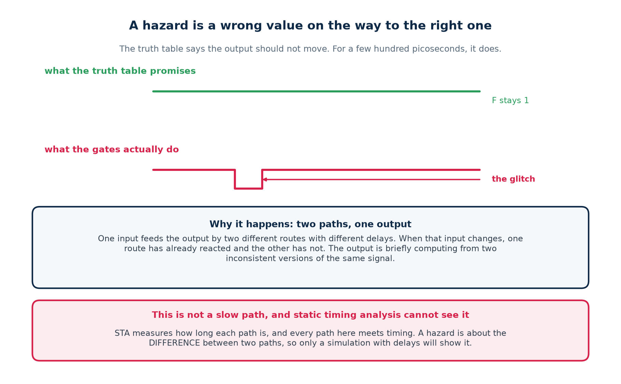

1.2 The three questions
The question | The failure if the answer is no | Answered by
Did the data arrive before the capturing edge needed it? | setup violation — the chip runs, but only slower | static timing analysis
Did the data stay put long enough after that edge? | hold violation — the chip does not work at all | static timing analysis
Did the output pass through a wrong value on the way? | a hazard — harmless or fatal depending on where the signal goes | simulation with delays

The first two are about ONE path. The third is about TWO.
Setup and hold ask how long a path is. A hazard asks what happens when two paths of different length reconverge on the same output — so no measurement of any single path can detect one.
This is why static timing analysis is structurally blind to hazards, and why this topic uses two different tools on the same circuit.

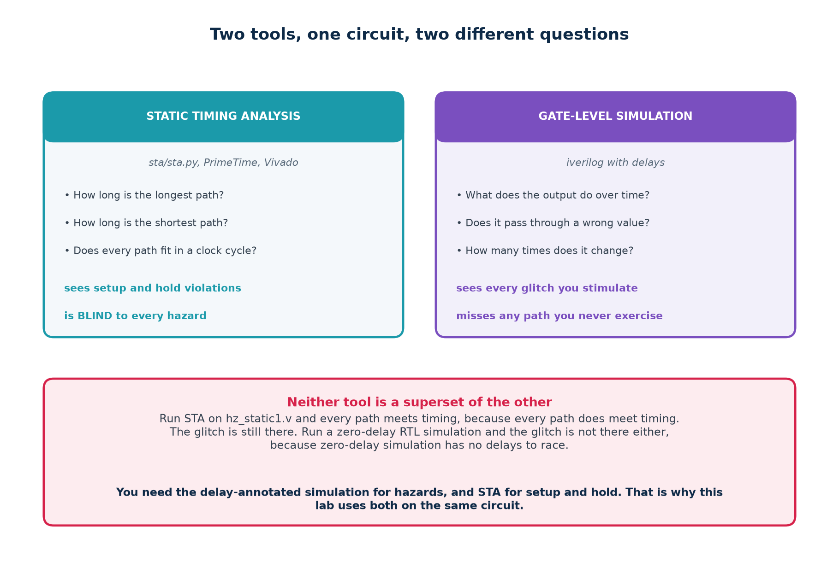

1.3 Hazard and glitch are not the same word
 | HAZARD | GLITCH
what it is | a property of the circuit | an event in one simulation
it means | there EXISTS an assignment of gate delays for which this output misbehaves | on this run, with these delays, the output actually did misbehave
how you find it | by inspecting the logic — no simulation needed | by simulating with delays, on the transitions you stimulated
it is | either there or not | may or may not show up

Why the distinction earns its keep
A circuit with a hazard may run for years without glitching, because the delays happened to fall the right way. Then the process moves, or the temperature changes, or somebody re-synthesises — and it starts failing in the field.
You remove hazards, not glitches.

1.4 Vocabulary
Term | One-line definition
combinational logic | output depends only on the present inputs
sequential logic | output depends on inputs and on stored state
propagation delay | how long a gate takes to react to its input
timing path | a route from a start point to an end point, with a delay
arrival time | when the data actually reaches a pin
required time | when it had to be there for the check to pass
slack | required minus arrival; negative means it does not fit
setup time | how long D must be stable before the clock edge
hold time | how long D must stay stable after the clock edge
clock-to-Q | delay from the clock edge until Q is valid
clock skew | the same edge reaching two registers at different instants
clock jitter | cycle-to-cycle variation in the edge position
glitch | a momentary wrong value on an output
hazard | a circuit's potential to glitch, given unlucky delays
race | two signals changing where the order decides the outcome
consensus term | the redundant product term that removes a static hazard
Fmax | one divided by the longest path delay

Part 1 self-check
1. Which is a property of the circuit — a hazard or a glitch?
2. Why can no measurement of a single path detect a hazard?
3. Name the two failures a zero-delay simulation cannot show you.
4. A circuit has run correctly for two years. Does that prove it has no hazard?

Part 2 · Combinational Circuit Timing: Races and Hazards

2.1 The mechanism
One input reaches the output by two different routes with different delays. When that input changes, one route has already reacted and the other has not, so for a short interval the output is computed from two inconsistent versions of the same signal.
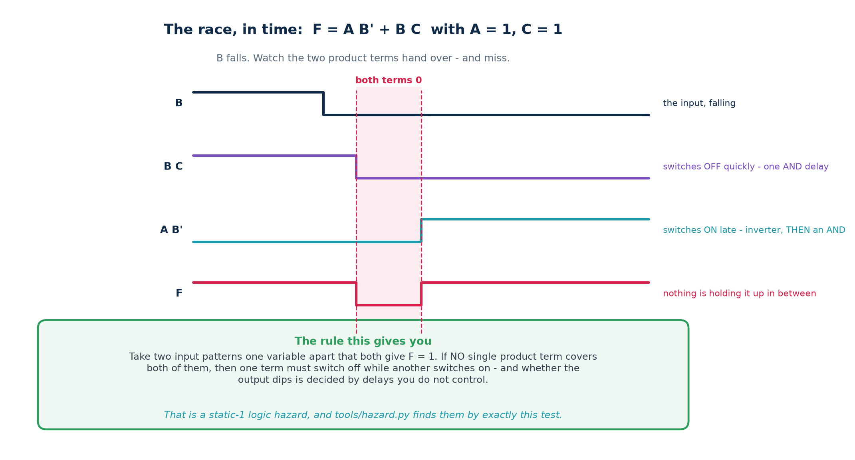
F = A B' + B C with A = 1 and C = 1, as B falls.
Follow the four traces. B falls. The term B C switches off almost at once — it is one AND gate away from B. The term A B' cannot switch on until B has been through the inverter and then an AND gate. For the interval between those two events, both terms are 0, and the OR gate has nothing holding its output up.

2.2 The three kinds, and the one you cannot fix
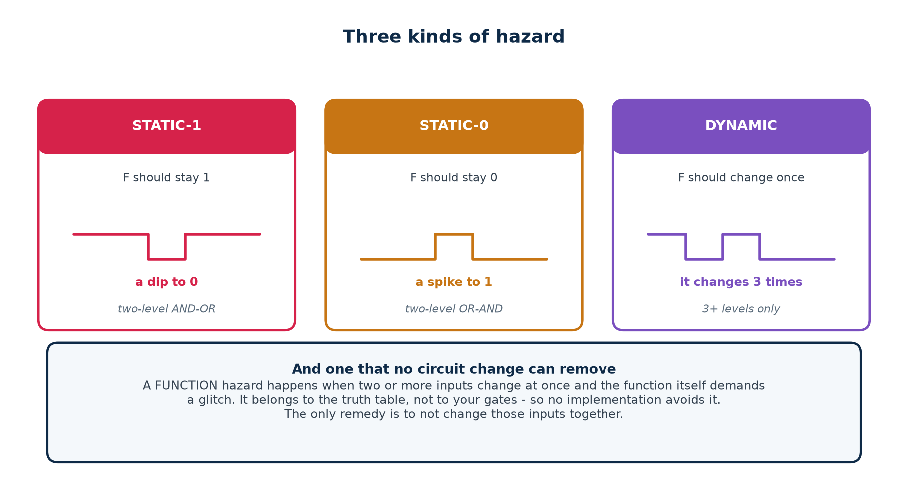
Kind | The output should | It actually | Can occur in
static-1 | stay at 1 | dips to 0 | two-level AND-OR
static-0 | stay at 0 | spikes to 1 | two-level OR-AND
dynamic | change once | changes three or more times | three or more levels

The function hazard
Everything else in this part assumes one input changes at a time. Let two change at once and a different problem appears. Consider F = A B' + B C with A = 1, C = 0, going from B=1 to B=0 and C=0 to C=1 simultaneously:
start A=1 B=1 C=0 -> F = 0
end A=1 B=0 C=1 -> F = 1

In between the circuit must pass through either
A=1 B=1 C=1 (F = 1) or A=1 B=0 C=0 (F = 1)
depending which input the wiring happens to deliver first.

Why no implementation can remove it
The intermediate states are real: the inputs genuinely do pass through them, because they do not change at exactly the same instant. Every correct implementation of this function must produce the function's value in those states. The glitch is in the truth table, not in the gates.
The only remedy is to not change those inputs simultaneously — which, in a synchronous design, is exactly what a common clock guarantees.

2.3 The adjacency rule
The rule, in one sentence
Take two input patterns that differ in exactly ONE variable and both give F = 1. If no single product term covers both of them, the circuit has a static-1 logic hazard on that transition.

F = A B' + B C A=1, C=1, and B changes

B=1 : F = 1, held up by B C
B=0 : F = 1, held up by A B'

Does one term cover BOTH?
A B' needs B=0 -> covers only the second
B C needs B=1 -> covers only the first
No. So the output is handed from one term to the other.

The reasoning behind the rule is worth stating explicitly, because it is what makes the rule trustworthy. If some term is 1 for both patterns, that term does not change during the transition, so it holds the output up throughout and no assignment of delays can produce a dip. If no term does, then one term must switch off while another switches on, and the order in which that happens is decided by delays you do not control.

The same rule on a K-map
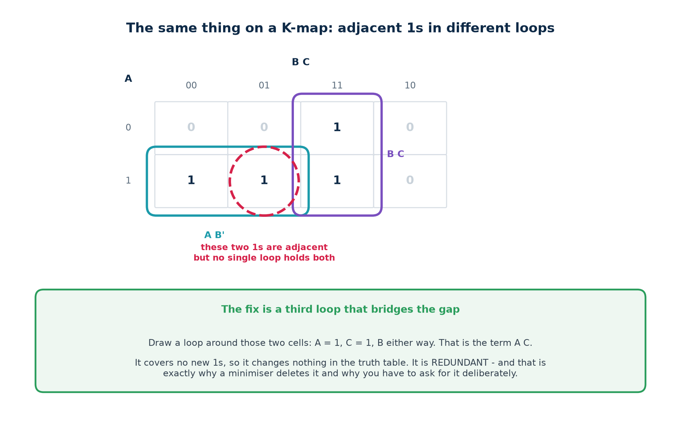
Two 1-cells side by side with no single loop around both. Adjacent 1s in different loops is exactly "two patterns one variable apart covered by no single term", drawn instead of written.

2.4 The consensus term
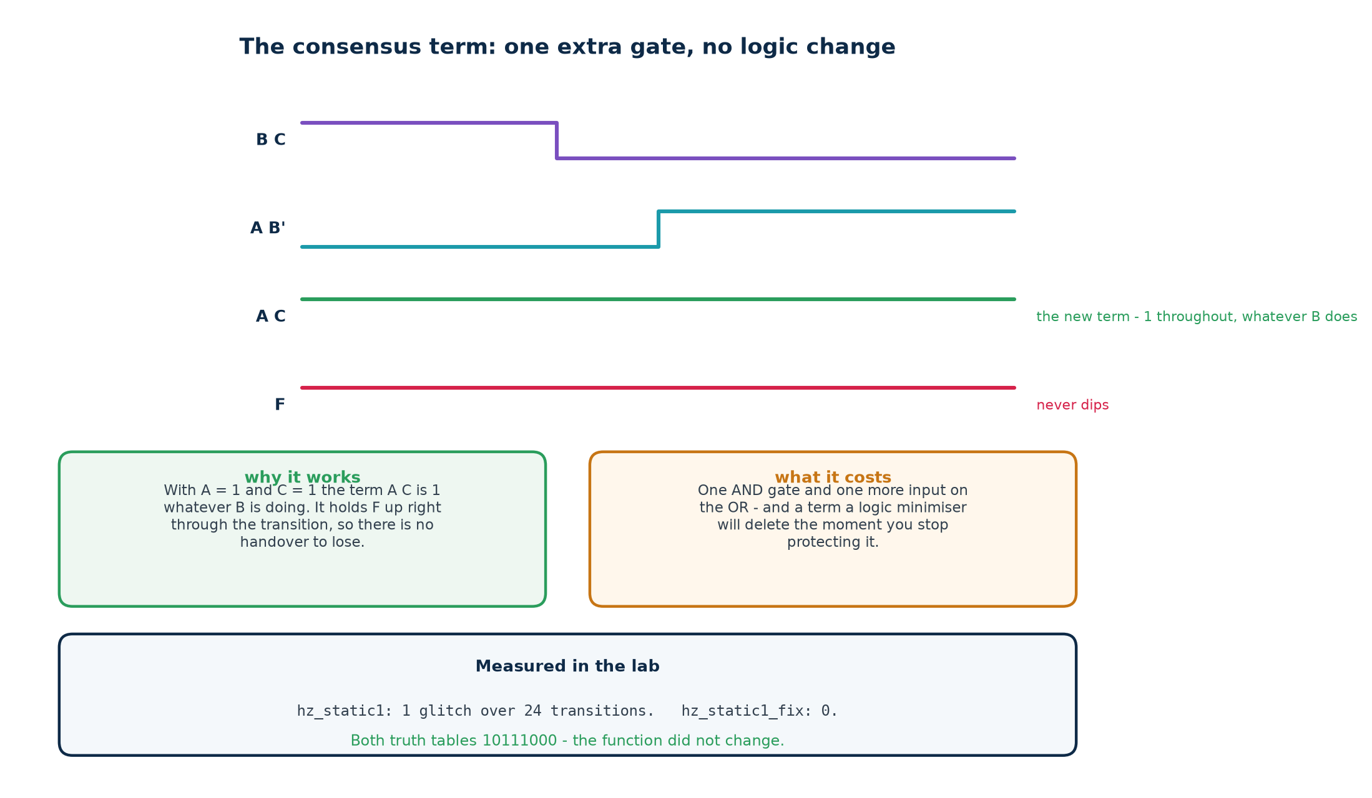
The fix is to add a product term that covers both patterns. To construct it: write down every variable the two patterns agree on, at the value they agree on, and drop the one that changed. For A=1, C=1 with B changing, that gives A C.
Redundant is not a criticism — it is the requirement
The consensus term covers no new 1s, so the truth table is identical. That is not a flaw: a term that changed the function would not be a fix, it would be a bug. The only way to hold the output up without altering what the circuit computes is to add cover that is already covered.
And it is also why the fix is fragile: removing redundancy is precisely what a logic optimiser exists to do. Part 4 measures exactly that.

2.5 Doing it in code, and checking the rule is right
$ python3 tools/hazard.py "A B' + B C"

1 static-1 logic hazard(s) found:

B changes 1 -> 0 with A=1, C=1
before the change, the output is held up by : B C
after the change, the output is held up by : A B'
no single term covers both, so the handover is a race.
ADD the redundant term: A C

hazard-free cover:
F = A B' + B C + A C

checking the proposed cover:
remaining static-1 hazards : 0
truth table unchanged : yes

The adjacency rule is a claim about logic. Whether an output glitches is a fact about time. Those are different things, so the analyser's self-test checks one against the other rather than trusting the textbook:
$ python3 tools/hazard.py --selftest

D. the combinatorial rule agrees with a delay simulation
(random functions; the rule and the timeline must never differ)
static-1 transitions cross-checked PASS (got True, want True)
disagreements between rule and simulation PASS (got 0, want 0)

E. the suggested fix always works, and never changes the function
fixes that left a hazard behind PASS (got 0, want 0)
fixes that altered the truth table PASS (got 0, want 0)

SELF-TEST PASSED

What section D actually proves
It generates hundreds of random covers. For every single-variable transition between two 1-cells it asks the covering rule, and separately builds a timeline with randomised per-gate switching times to see whether an instant exists when every term is off. Over several thousand transitions the two answers never differed.
Note the word randomised. An earlier version of that check used one fixed delay profile and reported a disagreement — because a fixed profile only ever exposes the glitch in one direction. A hazard is the POSSIBILITY of a dip, so the check has to search delay assignments, not assume one.

2.6 Measuring it: the glitch detector
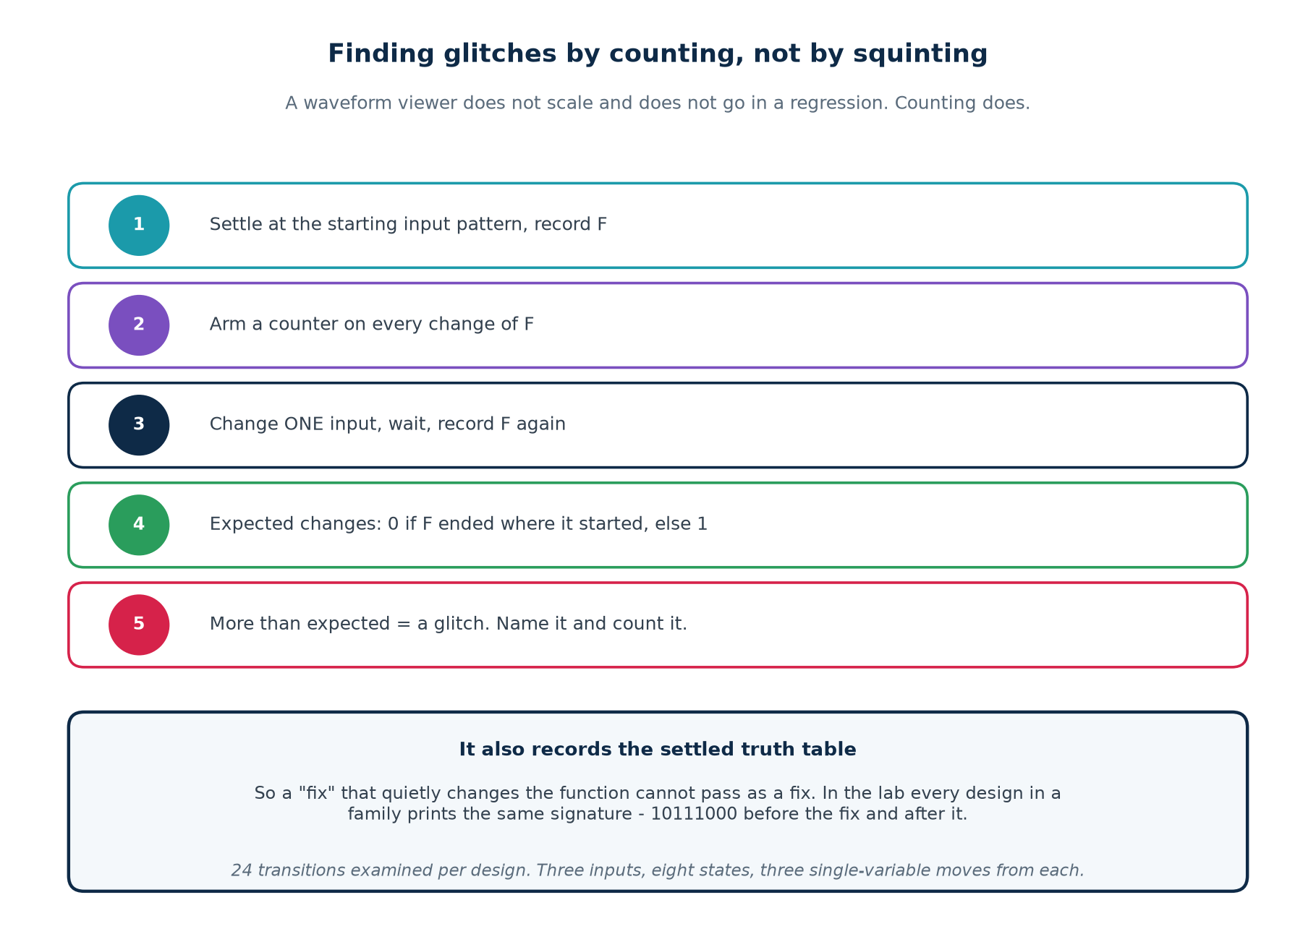
Looking for glitches by eye in a waveform viewer does not scale, does not go in a regression, and does not tell you when you have finished. The detector in hazards/tb_hazard.v walks every single-variable input transition, counts how many times the output changes, and compares that with how many times it should:
▪ steady value before == steady value after → expect 0 changes
▪ steady value before != steady value after → expect 1 change
▪ more than expected → a glitch, named and counted
It also records the settled truth table, so that a "fix" which quietly changes the function cannot pass as a fix.

2.7 The results, and the surprise in row five
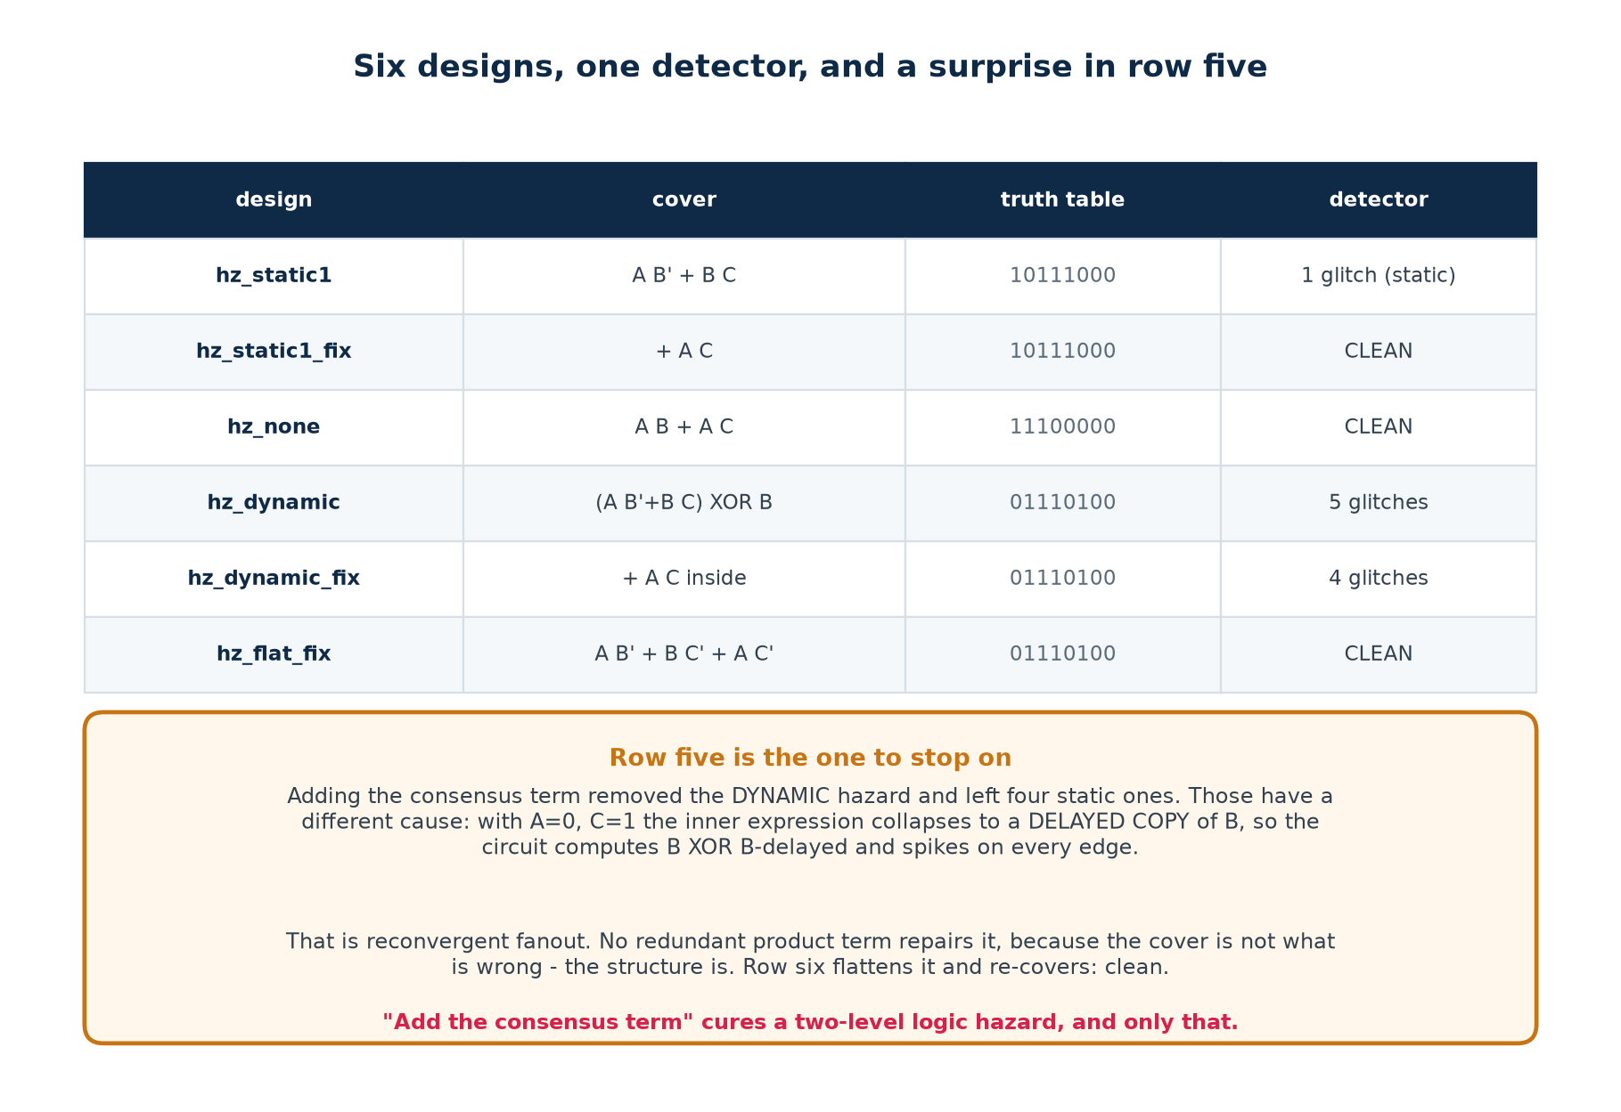
Six designs, 24 transitions examined in each. The first three rows behave exactly as the theory predicts: the textbook cover glitches once, the consensus term clears it, and the control is clean. Rows four to six are where it gets interesting.

Why hz_dynamic_fix went from 5 glitches to 4, not to 0
hz_dynamic feeds the hazardous expression into an XOR where B reconverges by a faster route. Adding the consensus term inside removed the dynamic hazard and left four static ones. Those have a different cause entirely:
with A=0, C=1 : s = A B' + B C + A C = 0 + B + 0 = B
with A=1, C=0 : s = A B' + B C + A C = B' + 0 + 0 = B'

so f = s XOR b is computing B XOR B-delayed,
which spikes on every edge of B, whatever the cover looks like.

The limit of the technique
That is reconvergent fanout with unequal path delays. No redundant product term can repair it, because the cover is not what is wrong — the structure is. hz_flat_fix.v flattens the function to two levels and re-covers it, and the detector reports CLEAN.
"Add the consensus term" cures a two-level logic hazard, and only that. Knowing the limit of a technique is part of knowing the technique.

2.8 Does a glitch actually matter?
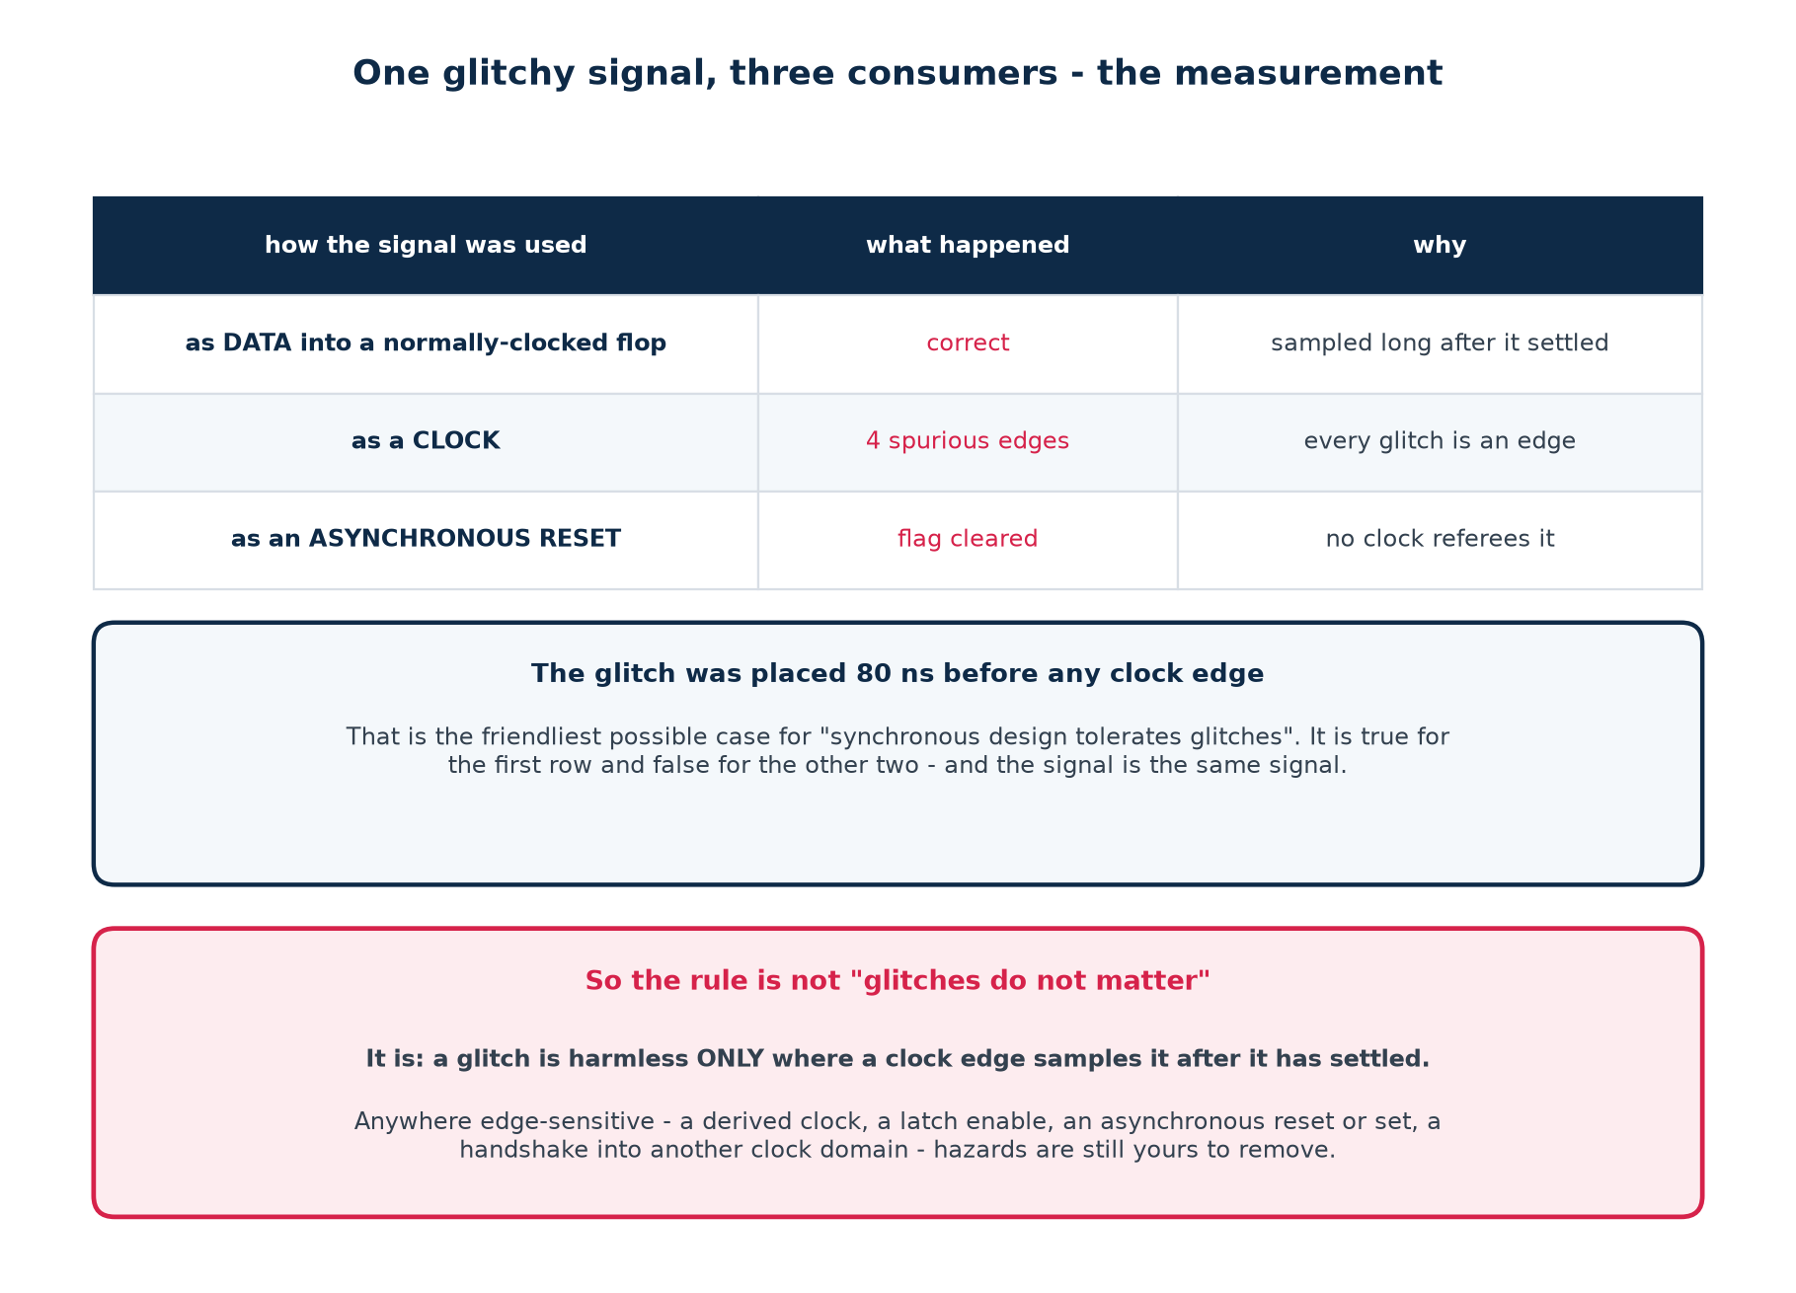
One glitchy signal was fed to three consumers, with the glitch placed 80 ns before any clock edge — the friendliest possible case for the usual reassurance that synchronous design tolerates glitches. It is true for the first consumer and false for the other two.
The rule, stated properly
A glitch is harmless ONLY where a clock edge samples the signal after it has settled.
Safe: data into a normally-clocked flip-flop; combinational logic between two registers in the same clock domain.
Unsafe: logic driving a clock (every glitch is a clock edge); an asynchronous reset or set; a latch enable, since a latch is transparent while its enable is high; a handshake crossing into another clock domain.
And everywhere, a cost: every glitch charges and discharges capacitance. On a wide bus that switches spuriously, glitch power is real and measurable.

2.9 Races
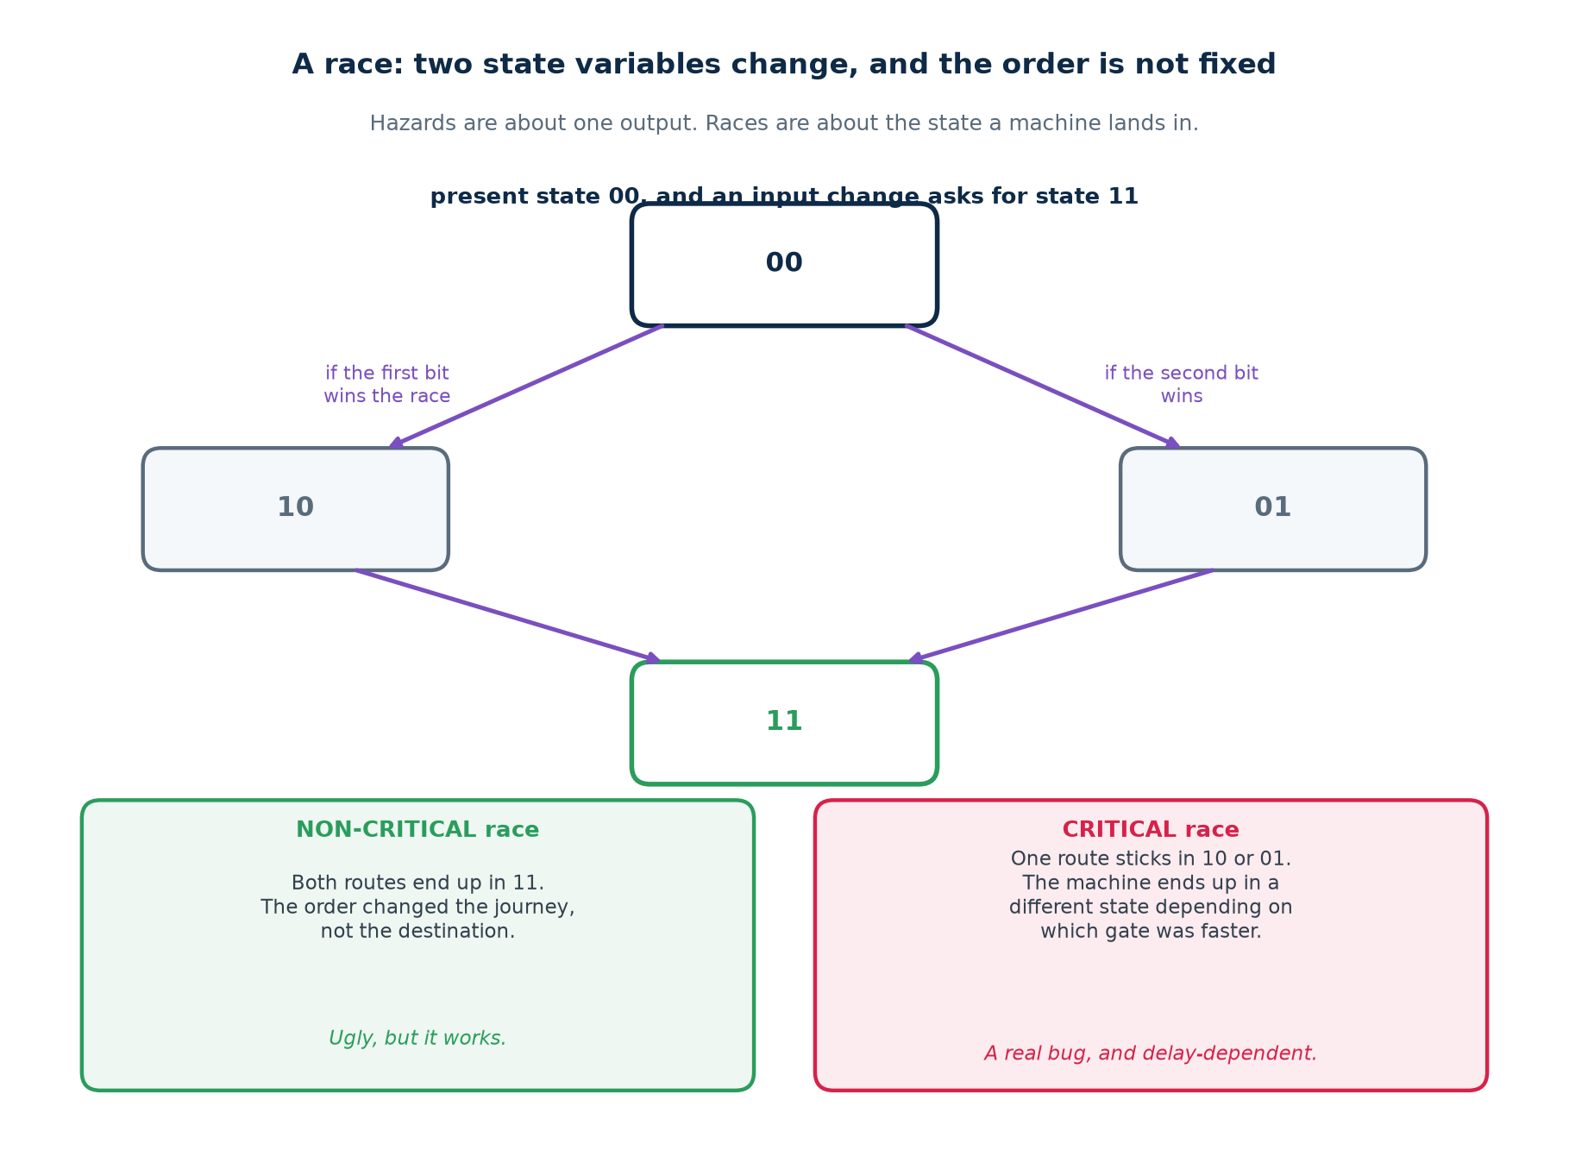
A hazard is about one output taking a wrong value. A race is about a state machine landing in the wrong state, because two or more state variables changed in response to one input change and the order was not fixed.
Name | What happens | Is it a bug?
Non-critical race | the variables change in either order and the machine still reaches the intended state | no — untidy, but correct
Critical race | the final state depends on which variable changed first | yes, and it is delay-dependent
Essential hazard | an input change races its own inverted copy through the feedback path, so the machine effectively sees the input twice | yes — cured by delay in the feedback, not by logic

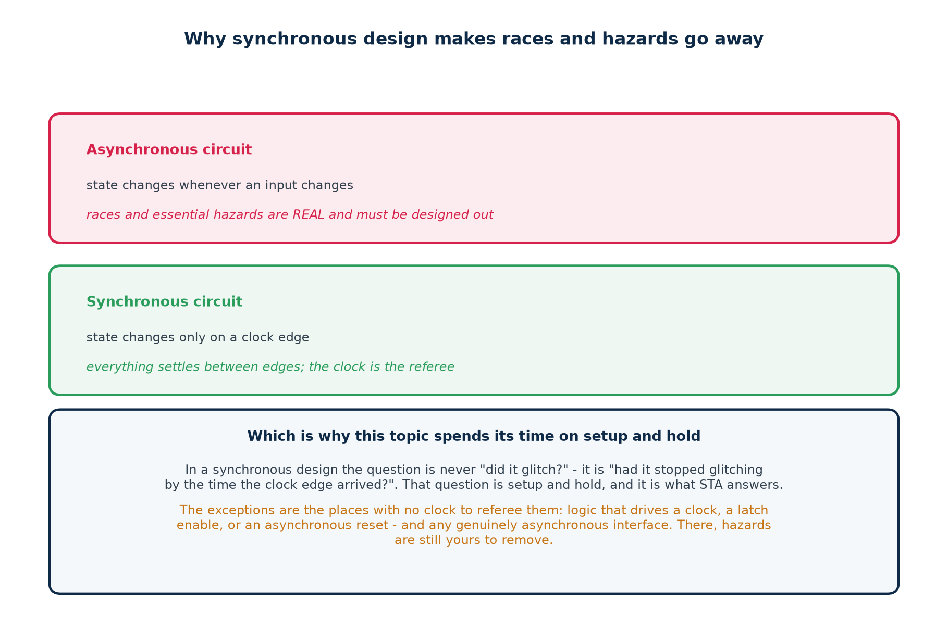
What synchronous design buys you, and what it does not
All three of those need state to change in response to an input change. Put a clock in charge and state changes only on an edge, by which time everything has settled — so an entire class of problem disappears.
What it does not buy you is the boundaries: logic that drives a clock, a latch enable or an asynchronous reset, and any genuinely asynchronous interface. There is no clock refereeing those, and hazards there are still yours to remove.

Part 2 self-check
1. State the adjacency rule from memory.
2. How do you construct the term that fixes a static-1 hazard?
3. Why can a two-level AND-OR circuit not have a static-0 hazard?
4. hz_dynamic_fix still glitches four times. Why does the consensus term not help?
5. Give three places where a glitch is genuinely dangerous.
6. What is the difference between a critical and a non-critical race?

Part 3 · Sequential Circuit Timing

3.1 The sampling window
Once a clock is in charge, the question stops being "did it glitch?" and becomes "had it finished glitching by the time the edge arrived?". That question is setup and hold.
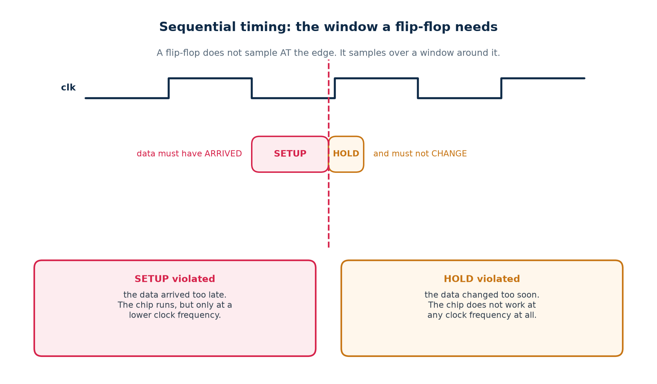
A flip-flop is a pair of cross-coupled latches. For it to settle into a definite state, D must be still for a short interval around the clock edge — before it and after it. Change D inside that window and the flop may take an unbounded time to settle, or settle to the wrong value. That is metastability, and it is what these checks exist to prevent.
Name | What it requires | Typical value
setup time | D stable BEFORE the clock edge | 0.02 – 0.2 ns
hold time | D stable AFTER the clock edge | 0.00 – 0.1 ns, sometimes negative
clock-to-Q | how long after the edge before Q is valid | 0.05 – 0.3 ns

A negative hold time is not a typo
Inside the cell, the clock takes a little time to reach the input latch. If that internal delay exceeds the latch's own requirement, D may change slightly before the external clock edge and still be captured correctly. A negative hold time is free margin — it makes hold violations harder to create.

3.2 The four terms, and one asymmetry
Term | What it is | Who sets it
clock-to-Q | delay from the launching edge until Q is valid | the library cell
logic delay | every gate and wire between the two flops | your design, and synthesis
setup time | how early the capturing flop needs the data | the library cell
clock skew | difference in clock arrival between the two flops | the clock tree, after layout
uncertainty | jitter, plus skew not yet modelled | you, in the constraint file

setup: t_cq + t_logic <= T + t_skew - t_setup - t_unc
hold: t_cq + t_logic >= t_skew + t_hold + t_unc

# The clock period T is in the first line and NOWHERE in the second.
# Everything surprising about hold follows from that one asymmetry.

The sign on skew
A capture clock that arrives LATE gives the data more time, so it helps setup — and it eats hold margin by exactly the same amount. Every clock-tree decision trades one against the other, which is why skew is sometimes added deliberately ("useful skew") and why doing so is never free.

3.3 Maximum frequency of operation
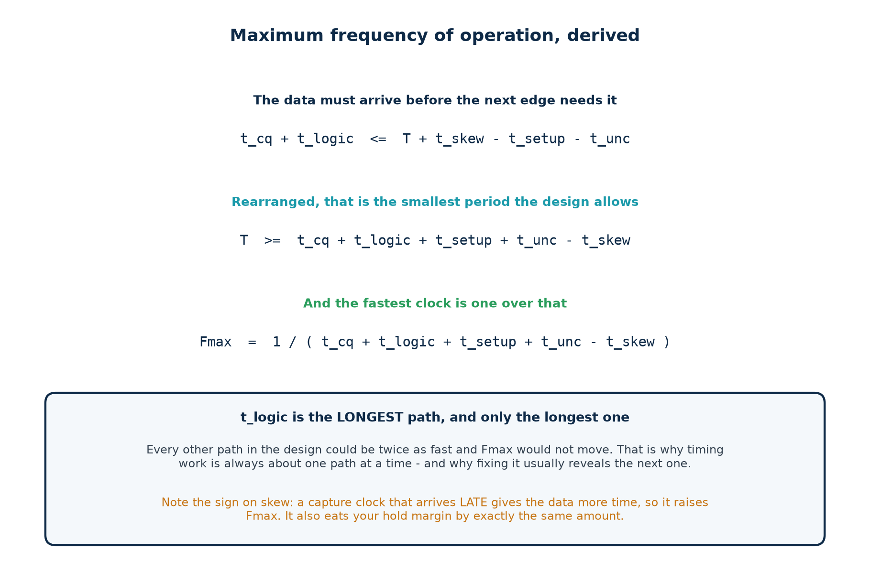
Fmax is not a number you look up; it is the setup inequality rearranged. Start from the requirement that the data must arrive before the next edge needs it, solve for the period, and invert.

Worked, with real numbers
A path in the teaching library:

clock-to-Q (DFF) 0.145 ns
logic: one XOR2 driving a flop D pin 0.117 ns
setup time (DFF) 0.090 ns
uncertainty 0.000 ns
skew 0.000 ns
-----------
minimum period 0.352 ns

Fmax = 1 / 0.352 ns = 2841 MHz

Add 0.15 ns of uncertainty and the same path gives 1992 MHz.
The circuit did not change. Your honesty about the clock did.

An Fmax figure without its assumptions is marketing
Always ask three things: which PVT corner, how much uncertainty, and post-synthesis or post-route? The same netlist will produce numbers a factor of two apart depending on the answers.

3.4 Fmax is set by one stage
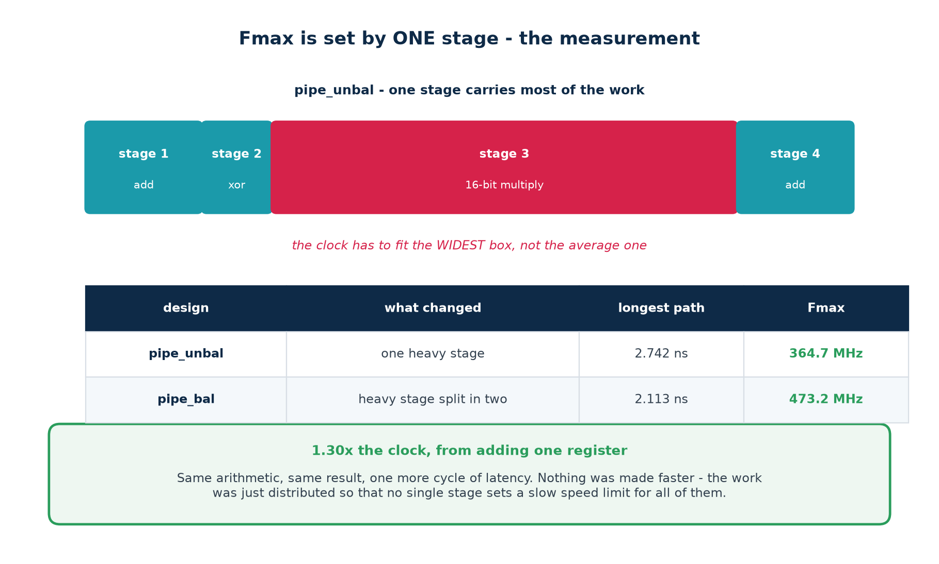
Every other path in the design could be twice as fast and the number would not move. In the lab, pipe_unbal puts a 16-bit multiply in one stage and three light stages around it. Splitting that one stage in two took Fmax from 364.7 MHz to 473.2 MHz — a factor of 1.30, from moving work rather than from making anything faster.
 | What you gain | What you pay
pipelining | a shorter longest path, so a faster clock; throughput unchanged once the pipe is full | one more cycle of latency; one more register bank; every control signal beside the data must be delayed to match

The classic pipelining bug
You cut the datapath and forget to delay a valid flag, an operand or an address alongside it. Timing improves and correctness quietly does not — stage 2 is now combining this cycle's control with last cycle's data.
Every optimisation needs a functional re-check. A faster design that computes the wrong answer is not faster.

3.5 A real setup violation, and its solution
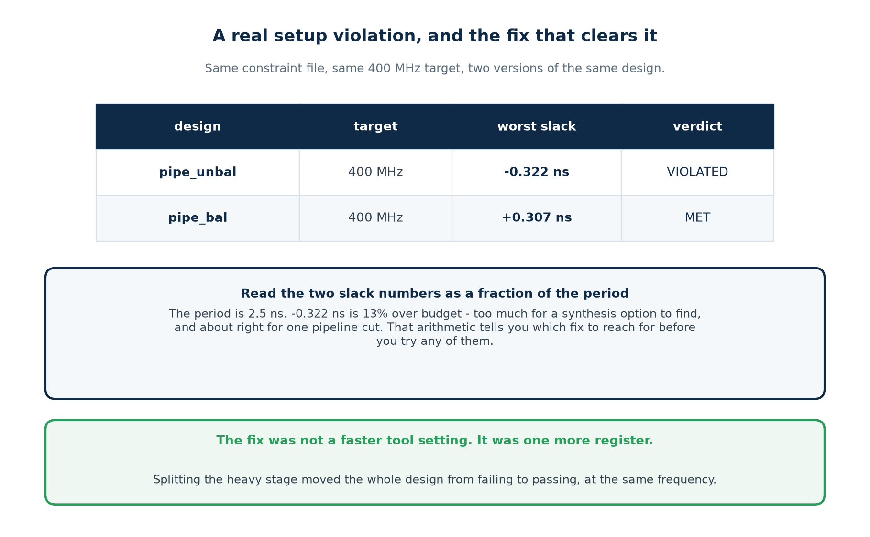
Same constraint file, same 400 MHz target, two versions of the same arithmetic. Before reaching for a fix, size the problem as a fraction of the period — that arithmetic tells you which fix is even plausible.
Slack as a fraction of the period | What it usually means | Where to start
under about 2% | the tool nearly got there | check the constraint, then raise synthesis effort
2% to 10% | a genuinely long path | restructure the logic, or retime
10% to 40% | too much work in one cycle | pipeline it
over about 40% | the target is wrong for this technology | renegotiate the frequency, or change architecture

The measured case
−0.322 ns on a 2.5 ns period is 13% over budget: out of reach of a synthesis option, and about right for one pipeline cut — which is exactly what fixed it (+0.307 ns MET). Doing this arithmetic first saves you from trying the cheap fixes on a problem too big for them.
And change one thing per run, or you will not know which change helped.

3.6 A real hold violation, and why the clock cannot help
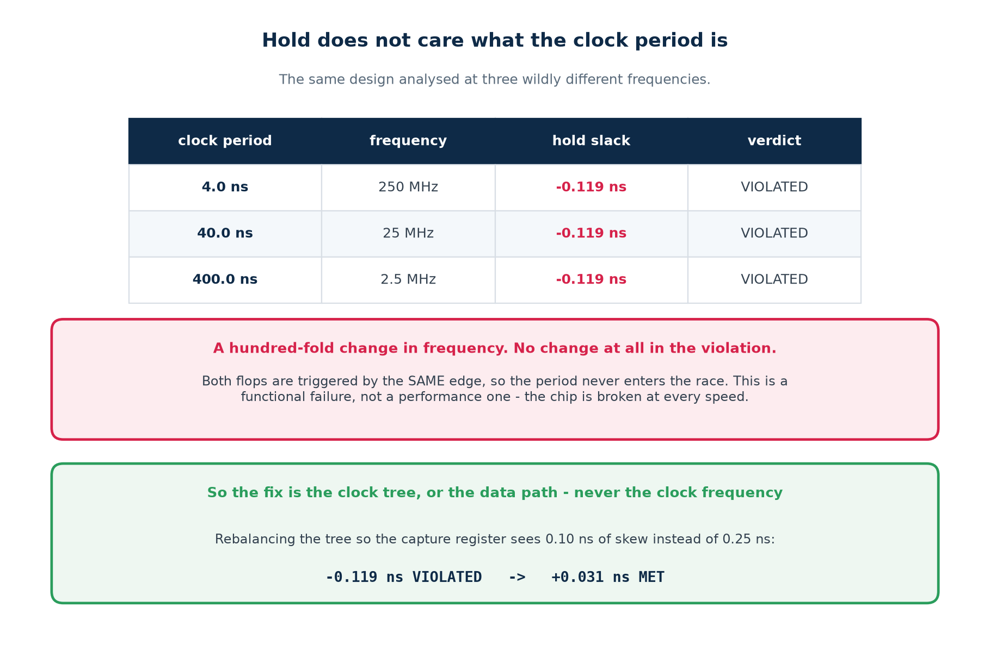
The same design was analysed at 4 ns, 40 ns and 400 ns. The hold slack was −0.119 ns in all three: a hundred-fold change in clock frequency, and not one picosecond of change in the violation. Both flops are triggered by the same edge, so the period never enters the race.
 | SETUP violation | HOLD violation
what happened | the data arrived too late for this clock | the data changed too soon after the same edge
slow the clock | fixes it | does nothing whatsoever
the chip | works, at a lower frequency | does not work at any speed
found at | synthesis, and again after layout | only once a real clock tree exists
reaching silicon | a slower product | a re-spin

So the fix is never the clock frequency. It is the clock TREE — rebalance it so the capture register sees less skew — or the data path: insert delay. Measured in the lab, dropping skew from 0.25 ns to 0.10 ns took the slack from −0.119 ns to +0.031 ns.
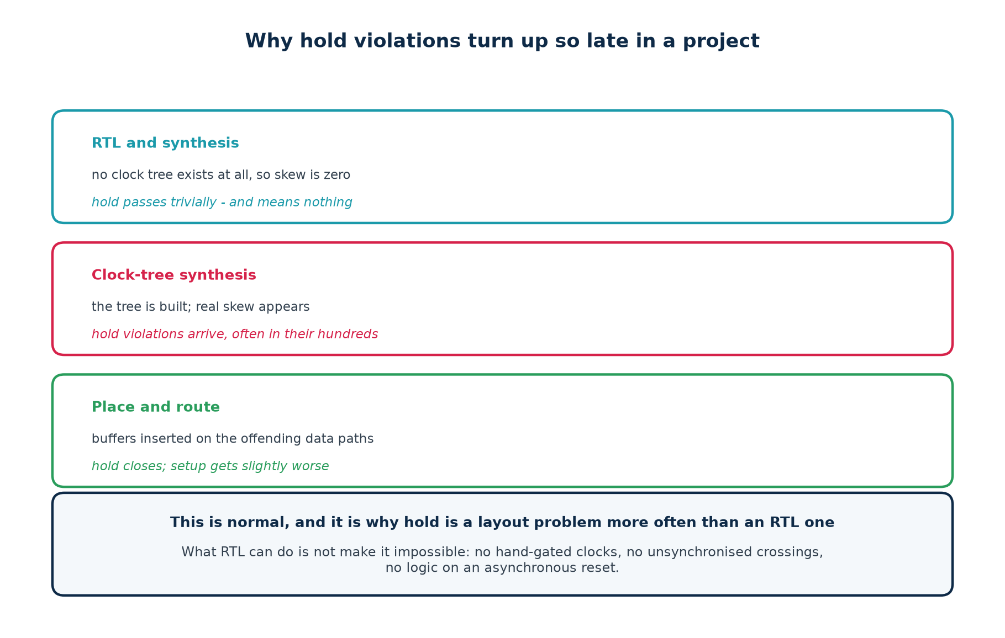
What RTL can do about hold: not make it impossible
No hand-gated clocks — use a clock enable; every FPGA and every standard cell library has one. No unsynchronised clock-domain crossings. No logic on an asynchronous reset. Beyond that, hold is place-and-route's job, and it has the one thing you do not: the real clock tree.

3.7 Practical examples of violations, and their solutions
Symptom in the report | Likely cause | Solution
one path fails, the rest are fine | a genuinely long path | restructure or pipeline that path
one cell has a huge incremental delay | high fanout, or a weak driver | set_max_fanout; let the tool buffer it
fifty small cells in one path | the logic is too deep | balance into a tree, then pipeline
every path fails by a similar amount | the period is too aggressive | check the target against the technology
fails only after place-and-route | routing delay, not logic | floorplan; keep the path local
fails only at the slow corner | correct behaviour | that is the corner you sign off at
hold fails on a short path after CTS | clock skew | rebalance the tree; insert hold buffers
hold fails everywhere, at every speed | a structural problem | look for gated clocks and domain crossings
a huge violation on a reset path | a missing false path | constrain it — this is not a design bug

Part 3 self-check
1. Write the setup inequality, then the hold inequality. What is missing from the second?
2. Skew of +0.25 ns on the capture clock: what happens to setup slack, and to hold slack?
3. A path fails by 0.05 ns on a 5 ns period. How big a problem is that, and why does the ratio matter more than the number?
4. Why do hold violations appear suddenly after clock-tree synthesis?
5. Your colleague proposes fixing a hold violation by halving the clock frequency. What do you say?

Part 4 · Timing Constraints for Synthesis

4.1 A constraint file is an input, not a report setting
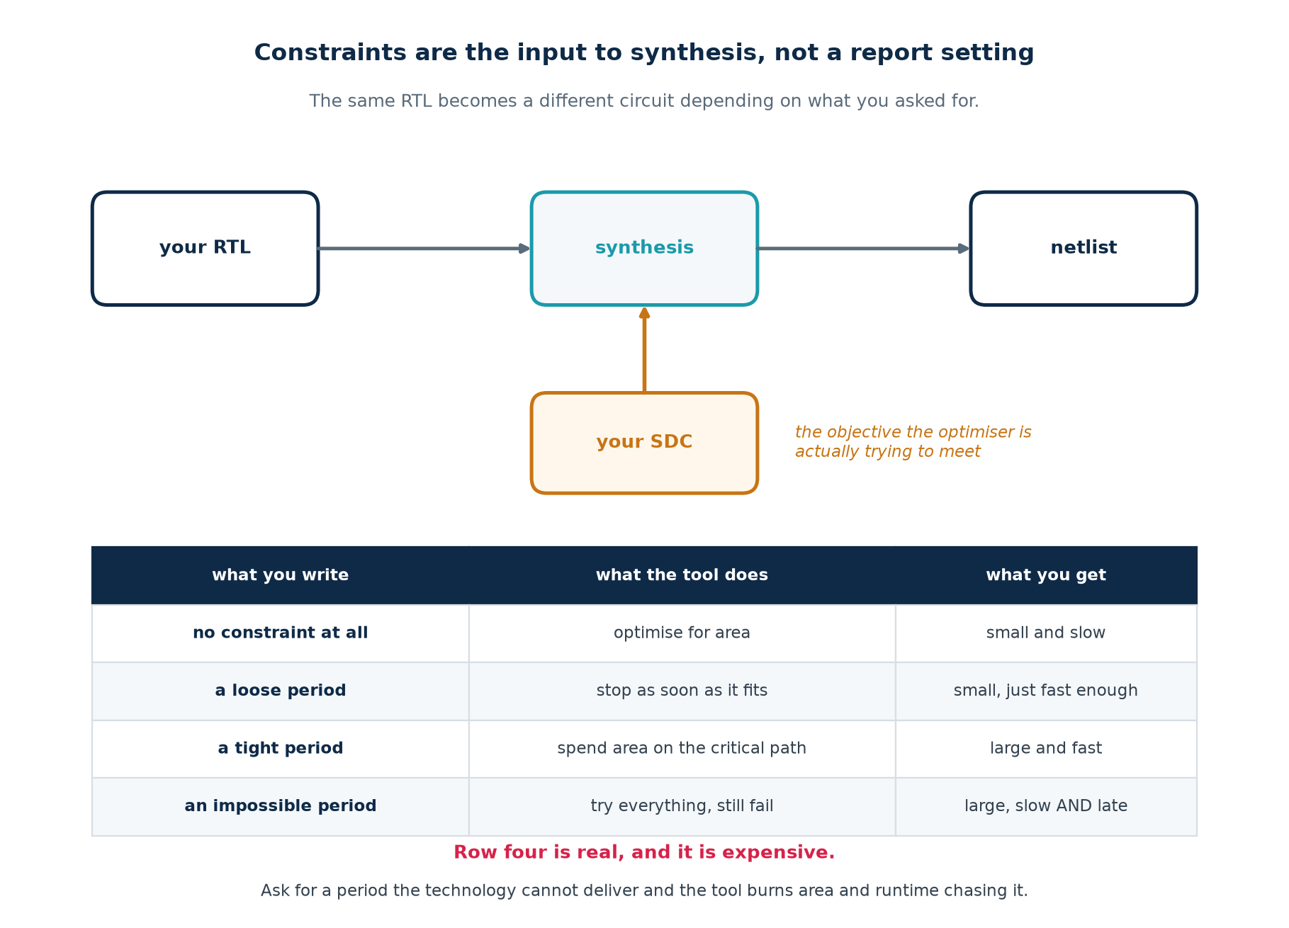
Synthesis is an optimisation problem, and an optimisation problem needs an objective. The constraint file supplies it. Give the tool no objective and it will optimise for area, because that is the default cost function — and the timing report it produces afterwards will be silent, because a report can only report on checks that were performed.

4.2 The minimum honest constraint set
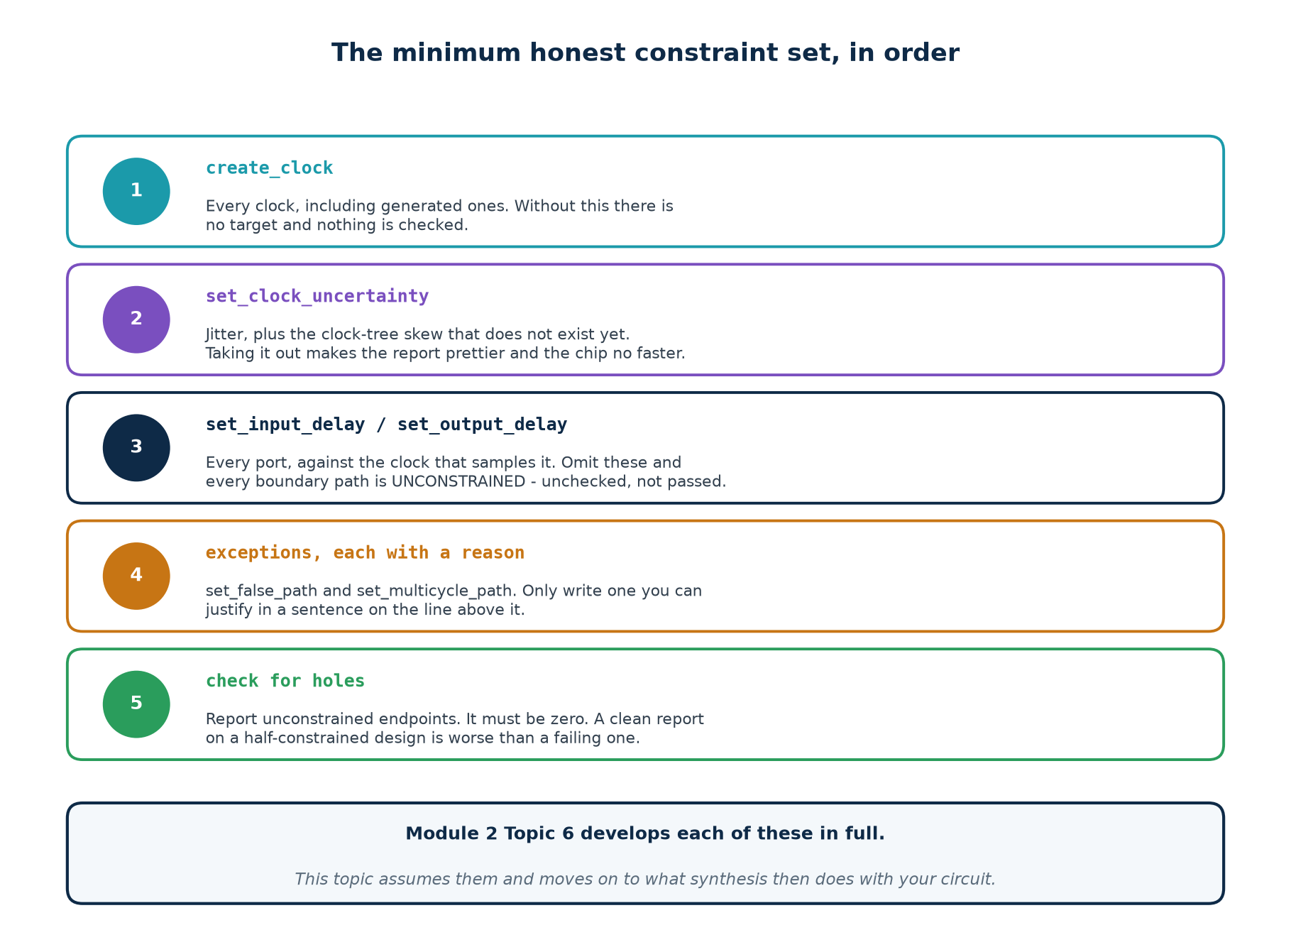
# ==================================================== constraints/pipe.sdc
# ---- clock ------------------------------------------------------------
# 400 MHz. pipe_unbal cannot make this; pipe_bal can. That is the experiment.
create_clock -period 2.500

# jitter, plus a placeholder for the clock-tree skew that does not exist yet
set_clock_uncertainty 0.080 -setup
set_clock_uncertainty 0.020 -hold

# ---- boundary ---------------------------------------------------------
# Without these two lines every path touching a port is UNCONSTRAINED,
# and the analyser says so. Run without them once and read the warning.
set_input_delay 0.40 -clock clk
set_output_delay 0.35 -clock clk

The line to check on every single run
The count of unconstrained endpoints. It must be zero. A design with WNS +2.0 ns and four hundred unconstrained endpoints is in far worse shape than one with WNS −0.1 ns and none — the first has not been analysed at all.
Unchecked is not passed.

Module 2 Topic 6 develops each of these commands in full: generated clocks, where the I/O delay numbers come from, false paths and multicycle paths. This part assumes them and asks what synthesis does once you have written them.

4.3 What synthesis does to a hazard fix
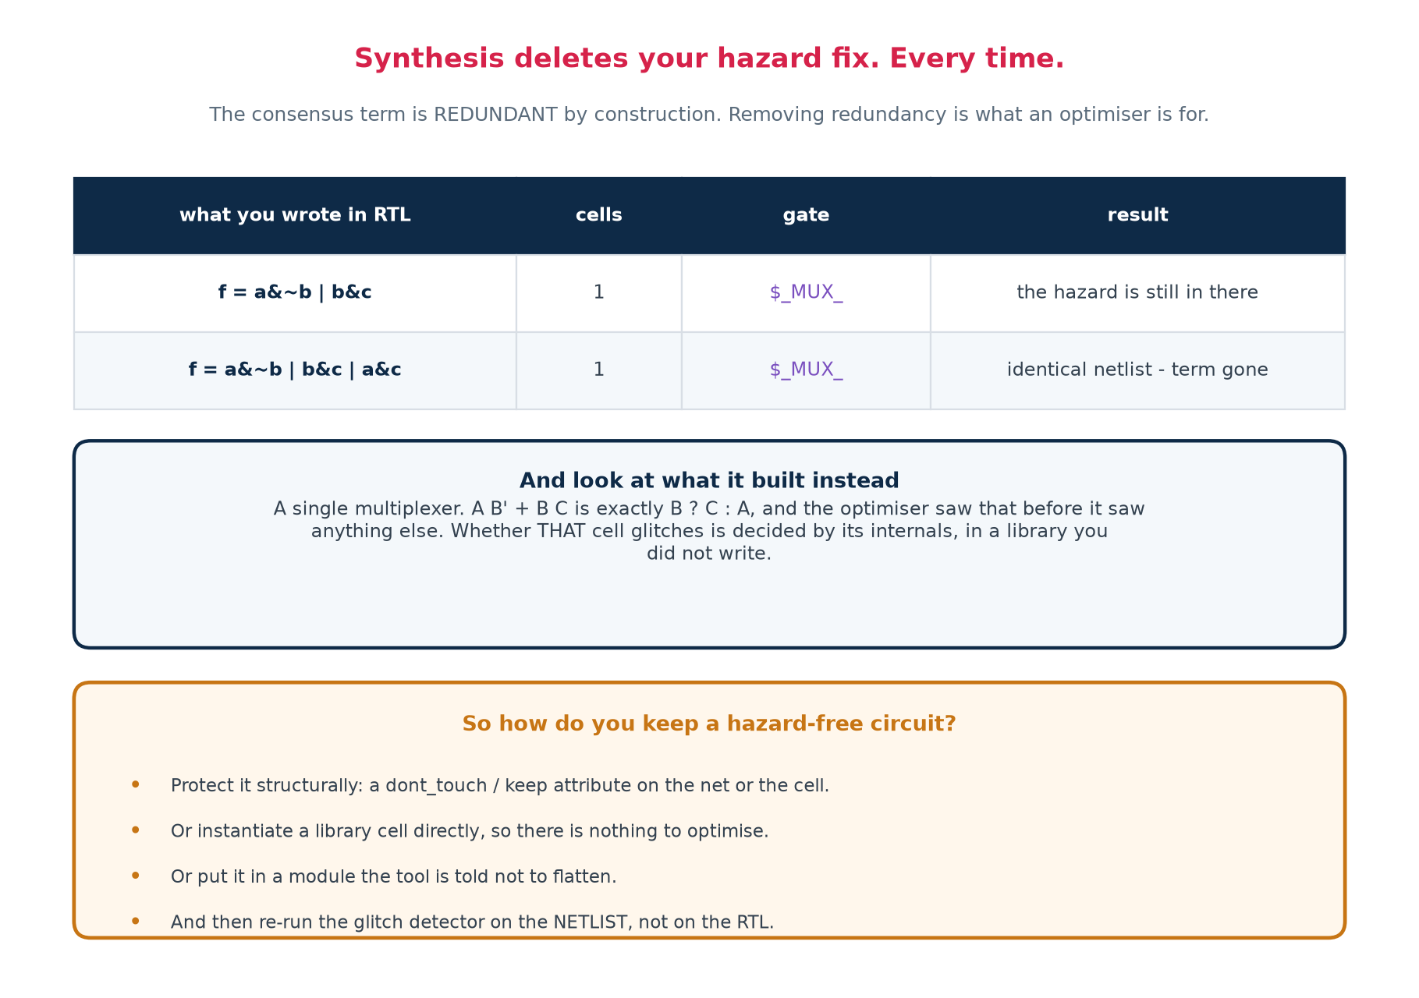
Part 2 taught you to add a redundant term to remove a hazard. Here is what happens when you write that term in RTL and synthesise it:
$ make synth

RTL written cells gates
------------------------------- ----- ---------------
f = a&~b | b&c 1 {'$_MUX_': 1}
f = a&~b | b&c | a&c (fixed) 1 {'$_MUX_': 1}

The two netlists are IDENTICAL. The consensus term was deleted.

And look at what it built instead: a single multiplexer. A B' + B C is exactly B ? C : A, and the optimiser saw that before it saw anything else. Whether that cell glitches is decided by its internals, in a library you did not write.
Reconciling Part 2 with Part 4
What not to conclude: "hazard analysis is pointless because the tool undoes it", or "just write RTL and trust synthesis". The second one ships broken asynchronous interfaces.
What to conclude: hazard-freedom is a property of the NETLIST, not of your source. So where you genuinely need it, protect it structurally — a dont_touch or keep attribute, an instantiated library cell, or a module the tool is told not to flatten — and then re-run the glitch detector on the post-synthesis netlist, not on the RTL.
And on the vast majority of nets — everything sampled by a clock — you do not need it at all.

4.4 Circuit synthesis and timing analysis as one loop
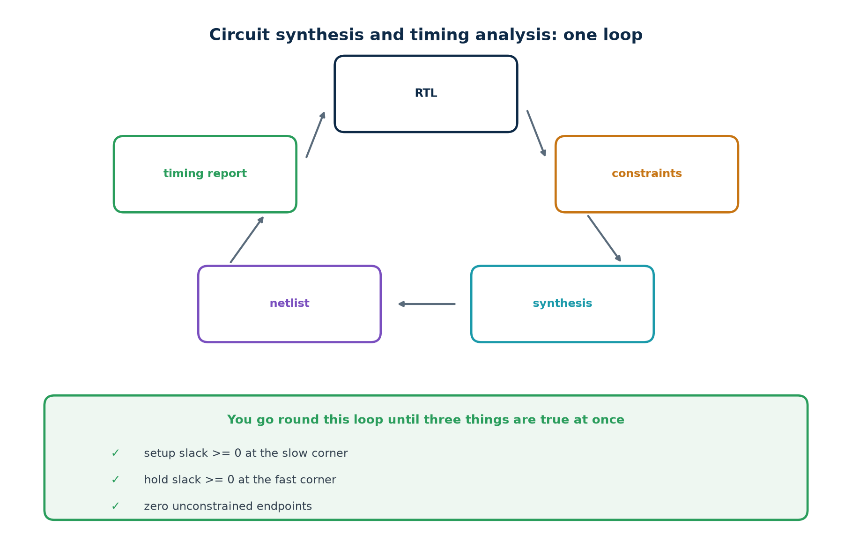
RTL, constraints, synthesis, netlist, timing report, and back to one of the first two. You leave the loop once, when all three of these hold together:
1. Setup slack ≥ 0 at the slow corner, with realistic uncertainty.
2. Hold slack ≥ 0 at the fast corner.
3. Zero unconstrained endpoints.
Two out of three is not closure.

4.5 Everything here is a trade
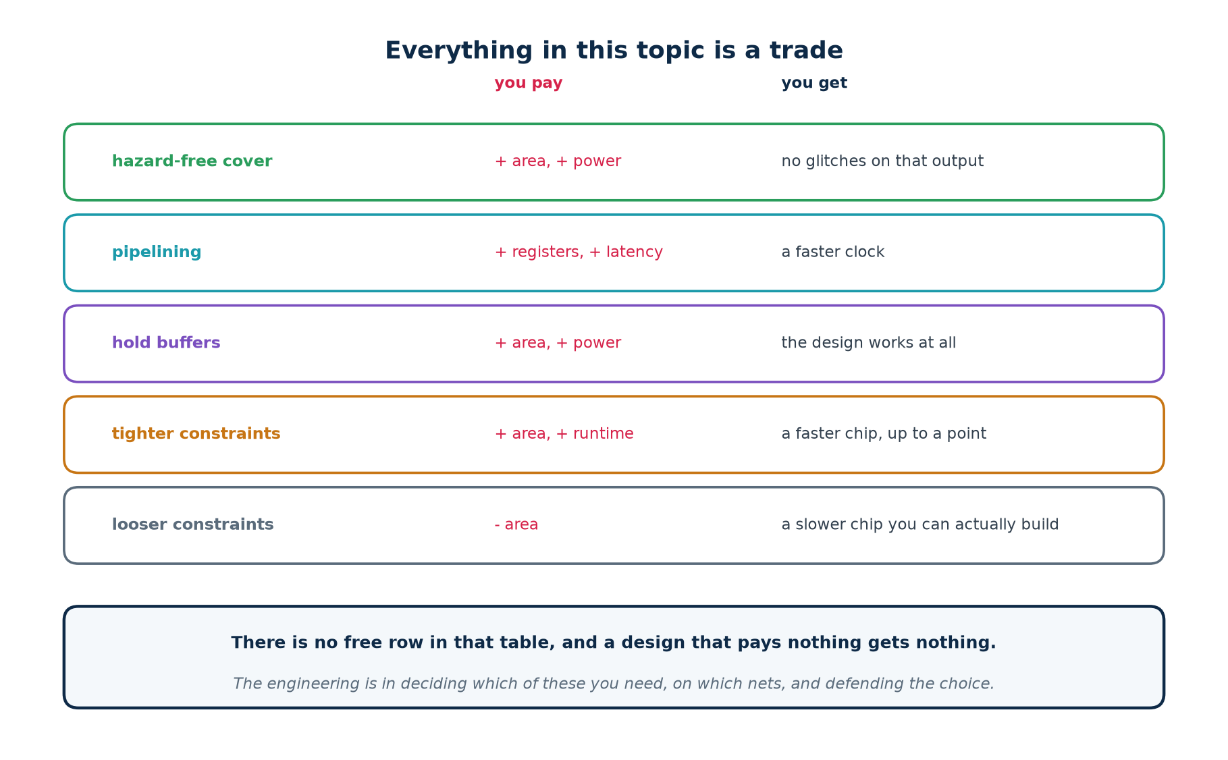
Part 4 self-check
1. What does a constraint file do to synthesis?
2. What circuit do you get with no constraints at all, and why?
3. What did synthesis do to the consensus term, and why was that predictable?
4. Where does hazard-freedom have to be verified?
5. Name the three conditions for leaving the synthesis/analysis loop.

Part 5 · Tools and Installation

5.1 Which tool answers which question
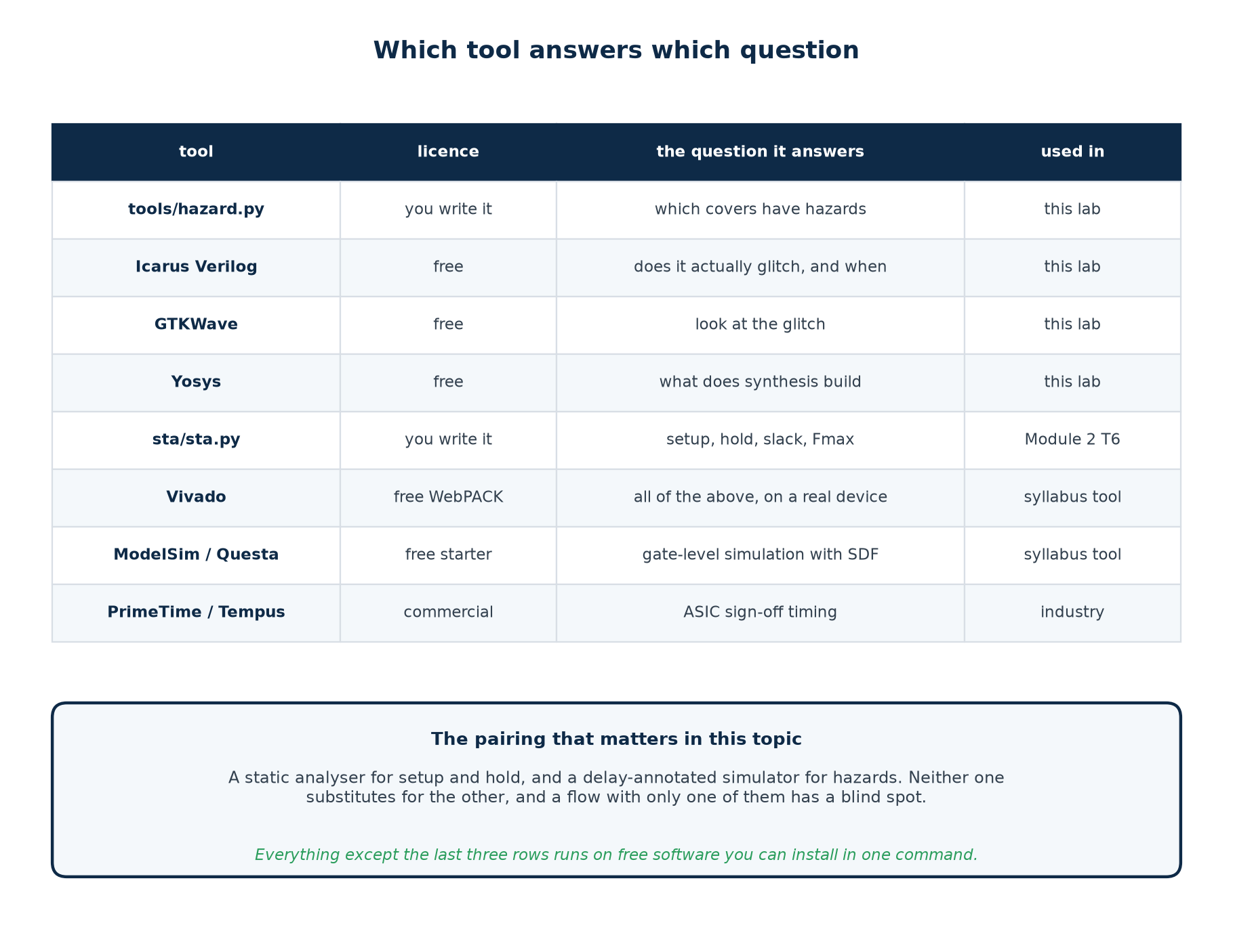
The pairing that matters in this topic
A static analyser for setup and hold, and a delay-annotated simulator for hazards. Neither substitutes for the other, and a flow with only one of them has a blind spot you will not notice until silicon.

5.2 Installing the free toolchain
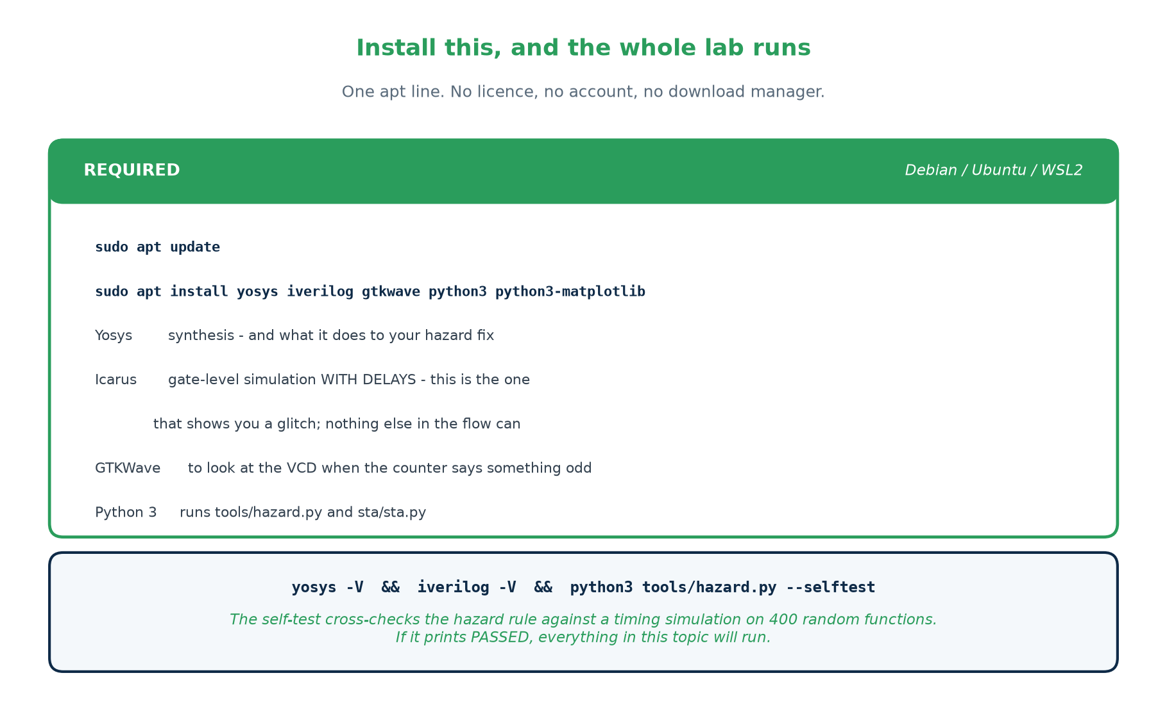
Debian, Ubuntu or WSL2. This is all 53 of the 58 exercises need.
sudo apt update
sudo apt install yosys iverilog gtkwave python3 python3-matplotlib

# verify - the third command is the real test:
yosys -V && iverilog -V && python3 tools/hazard.py --selftest

On Windows, install WSL2 first (wsl --install from an elevated PowerShell), then run the same lines inside the Ubuntu shell it gives you. On macOS, brew install yosys icarus-verilog covers the first two.

5.3 The vendor tools the syllabus names
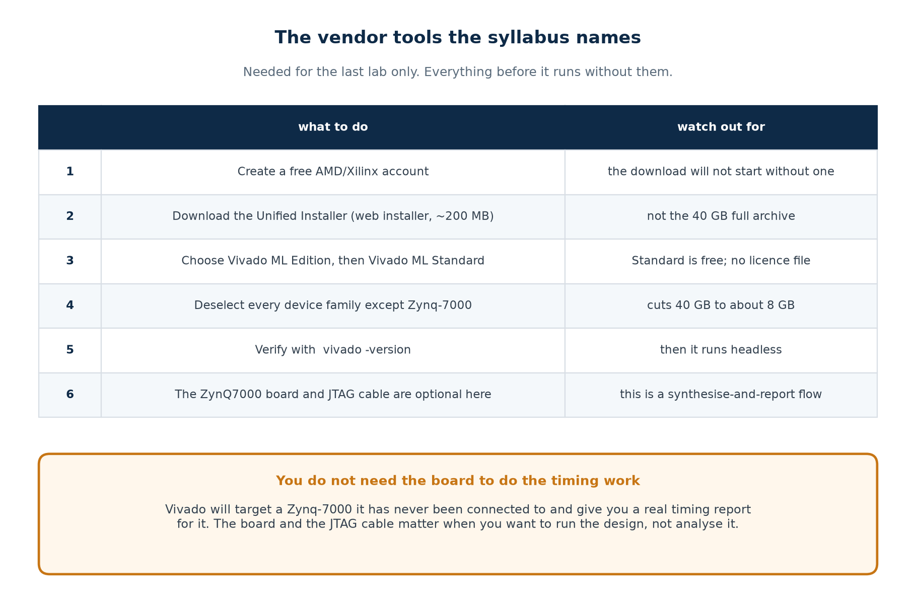
The syllabus lists a ZynQ7000 SoC evaluation board, Vivado, and a JTAG cable. Only Vivado is needed for the lab work, and only for tutorial G. The board and the cable matter when you want to run a design; timing analysis is a synthesise-and-report activity, and Vivado will happily target a Zynq-7000 it has never been connected to.
An honest note about tutorial G
vivado/zynq_sta.tcl has NOT been executed in the environment these materials were built in — Vivado is not installable there. It is written against the documented command set and is the one file in this lab whose output is not reproduced in the README. Run it and record what you get; that is part of the exercise.

5.4 The lab flow
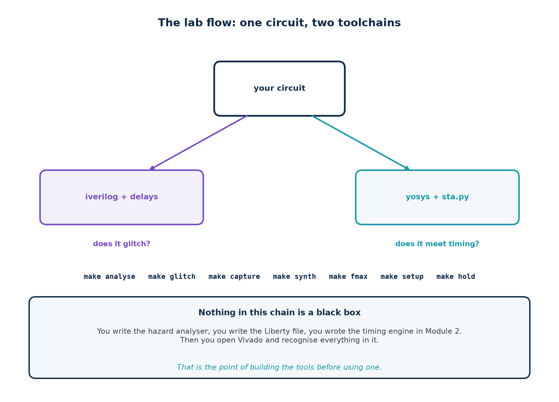
make analyse # find hazards in a two-level cover, and prove the fix
make glitch # gate-level simulation: watch the glitch, and watch it go
make capture # what a glitch does to a flop as data / clock / reset
make synth # what synthesis does to a hazard fix (it deletes it)
make fmax # Fmax of an unbalanced pipeline, and of a balanced one
make setup # a real setup violation at 400 MHz, and its fix
make hold # a hold violation, and why the clock period cannot help
make # all of the above

Part 6 · Seven Guided Tutorials
Before you start
Install the toolchain from Part 5 and open a terminal in Topic1_Lab/. Type the commands; do not paste them. The point of a tutorial is the twenty seconds between typing something and understanding why it did what it did.
Each tutorial ends with a Checkpoint — a specific thing you should be able to see or say. If you cannot, stop and find out why before moving on.

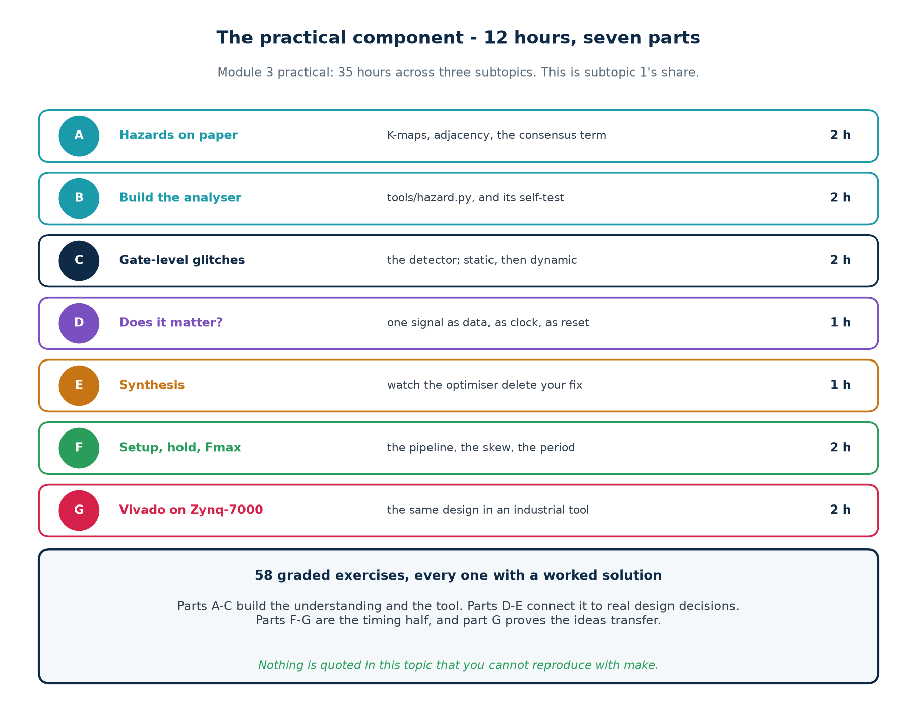

Tutorial A · Hazards on paper (2 hours)
Before any tool touches this, do it by hand. The rule is short enough to hold in your head, and holding it in your head is the point.

Step 1 — draw the map
Draw the K-map for F = A B' + B C with A down the side and B C across the top. Fill in the four 1-cells. Draw the loop for each product term.

Step 2 — find the adjacency
Look for two 1-cells that are neighbours but sit in different loops. There is exactly one such pair. Write down which two cells, and which variable differs between them.

Step 3 — derive the fix
Write down every variable the two cells agree on, at the value they agree on. Drop the one that changed. That product is the term to add.

Step 4 — prove it did not change anything
Write out both truth tables, eight rows each, and check them row by row. If they differ anywhere, you have not written the consensus term — you have written a bug.
Checkpoint A
You can state the adjacency rule without looking, derive A C from the two cells, and show that F is unchanged on all eight rows.

Tutorial B · Build the analyser (2 hours)

Step 1 — see what it does
$ python3 tools/hazard.py "A B' + B C"

1 static-1 logic hazard(s) found:
B changes 1 -> 0 with A=1, C=1
ADD the redundant term: A C

checking the proposed cover:
remaining static-1 hazards : 0
truth table unchanged : yes

Step 2 — read the core of it
Open tools/hazard.py and find static1_hazards(). It is the adjacency rule, transcribed:
for vec in every input vector:
if F(vec) != 1: continue
for each variable i:
other = vec with bit i flipped
if F(other) != 1: continue
spanning = [t for t in terms if t covers vec and t covers other]
if not spanning:
report a hazard, and prescribe the shared literals as the fix

Step 3 — run the self-test and read section D
$ python3 tools/hazard.py --selftest

D. the combinatorial rule agrees with a delay simulation
static-1 transitions cross-checked PASS
disagreements between rule and simulation PASS (got 0, want 0)

SELF-TEST PASSED

Section D is the part worth studying. can_glitch() builds a timeline with randomised per-term switching times and looks for an instant when every term is off. It never refers to the covering rule, so the two are genuinely independent — and over several thousand transitions on random functions they never disagreed.

Step 4 — try to break it
Feed it functions of your own. A single product term. A function whose minimal cover is already hazard-free. A B + A B' — which is just F = A written badly, and which does have a hazard. Predict each answer before you run it.
Checkpoint B
The self-test prints PASSED, and you can explain in your own words what section D proves and why a single fixed delay profile would not have proved it.

Tutorial C · Gate-level glitches (2 hours)

Step 1 — predict, then measure
From the analyser's output you know the hazard is on B falling with A = 1 and C = 1 — that is the input pattern 111 going to 101. Write that prediction down. Then:
$ make glitch

=== glitch detector: hz_static1 ===
ABC 111 -> 101 (B changed) f: 1 -> 1 changes=2 expected=0 STATIC GLITCH

transitions examined : 24
transitions glitching: 1
RESULT: 1 GLITCH(ES), worst had 2 surplus change(s)
TRUTH(ABC=000..111) = 10111000

One glitch, on exactly the transition the analyser named, out of 24 examined. A logic rule predicted a physical measurement.

Step 2 — apply the fix and re-measure
hz_static1_fix reports CLEAN, with the same truth signature 10111000. Same function, no glitch.

Step 3 — the multi-level case
Now hz_dynamic, which feeds the hazardous expression into an XOR where B reconverges by a faster route:
design | detector result
hz_dynamic | 5 glitches — 4 static, 1 dynamic
hz_dynamic_fix | 4 glitches — the dynamic one is gone
hz_flat_fix | CLEAN

Step 4 — work out why the fix only got half way
This is the exercise, not a demonstration. Substitute A=0 and C=1 into s = A B' + B C + A C and see what s becomes. Then work out what f = s XOR b is computing. Write your answer down before reading section 2.7 of this workbook again.
Checkpoint C
You predicted the glitching transition before simulating and were right; and you can explain why the four surviving glitches in hz_dynamic_fix are not a cover problem.

Tutorial D · Does it matter? (1 hour)
$ make capture

1. f as DATA, sampled by the clean clock
final d_sampled = 1 <- correct, glitch never seen
2. f as a CLOCK
edges at power-up = 1 (legitimate: f settled x -> 1)
edges after that = 4 <- should be 0
3. f as an ASYNCHRONOUS RESET
r_flag = 0 <- should be 1; a glitch reset it

Four glitches produced four spurious clock edges and cleared a flag that nothing should have cleared. The glitch was placed 80 ns before any clock edge, which is the friendliest possible case for the usual reassurance.

Try these
▪ Move the B transitions to 5 ns before the clock edge instead of 20 ns after it. Does the DATA column still hold? At what point does it stop holding?
▪ Replace the asynchronous reset with a synchronous one and re-measure.
▪ List three signals in a design you have written yourself that are edge-sensitive or level-sensitive rather than clock-sampled.
Checkpoint D
You can state the rule as "a glitch is harmless only where a clock edge samples it after it has settled" — and name at least three places in a real design where that condition does not hold.

Tutorial E · What synthesis does about it (1 hour)
$ make synth

RTL written cells gates
f = a&~b | b&c 1 {'$_MUX_': 1}
f = a&~b | b&c | a&c (fixed) 1 {'$_MUX_': 1}

The two netlists are IDENTICAL. The consensus term was deleted.

Try these
▪ Add a (* keep *) attribute to the consensus term's wire and re-run. Does it survive? Does the netlist still contain a MUX?
▪ Write the glitch detector against the post-synthesis netlist rather than the RTL. What does it report?
▪ Explain, in writing, why the tool chose a multiplexer. Check your answer by writing out the truth table of B ? C : A.
Checkpoint E
You can say where hazard-freedom has to be verified, and why verifying it on the RTL proves nothing at all.

Tutorial F · Setup, hold and Fmax (2 hours)
$ make fmax
pipe_unbal Fmax : 364.7 MHz
pipe_bal Fmax : 473.2 MHz

$ make setup # target 400 MHz
pipe_unbal WNS : -0.322 ns VIOLATED
pipe_bal WNS : +0.307 ns MET

$ make hold
period 4.0 ns WNS : -0.119 ns VIOLATED
period 40.0 ns WNS : -0.119 ns VIOLATED
period 400.0 ns WNS : -0.119 ns VIOLATED

skew 0.25 ns WNS : -0.119 ns VIOLATED
skew 0.10 ns WNS : +0.031 ns MET

Try these
▪ Before running make setup, compute −0.322 ns as a percentage of the 2.5 ns period and predict which class of fix will be needed. Then check the table in section 3.5.
▪ Run the hold analysis at 4000 ns. Predict the answer first.
▪ Find the skew value at which hold_demo is exactly on the boundary. What does that tell you about the margin you have?
▪ Remove set_input_delay from pipe.sdc and re-run. The WNS improves. Explain to a manager, in two sentences, why that is bad news.
Checkpoint F
You have reproduced all six numbers, and you can explain why the hold slack did not move across a hundred-fold change in clock frequency.

Tutorial G · The same design on a Zynq-7000 (2 hours)
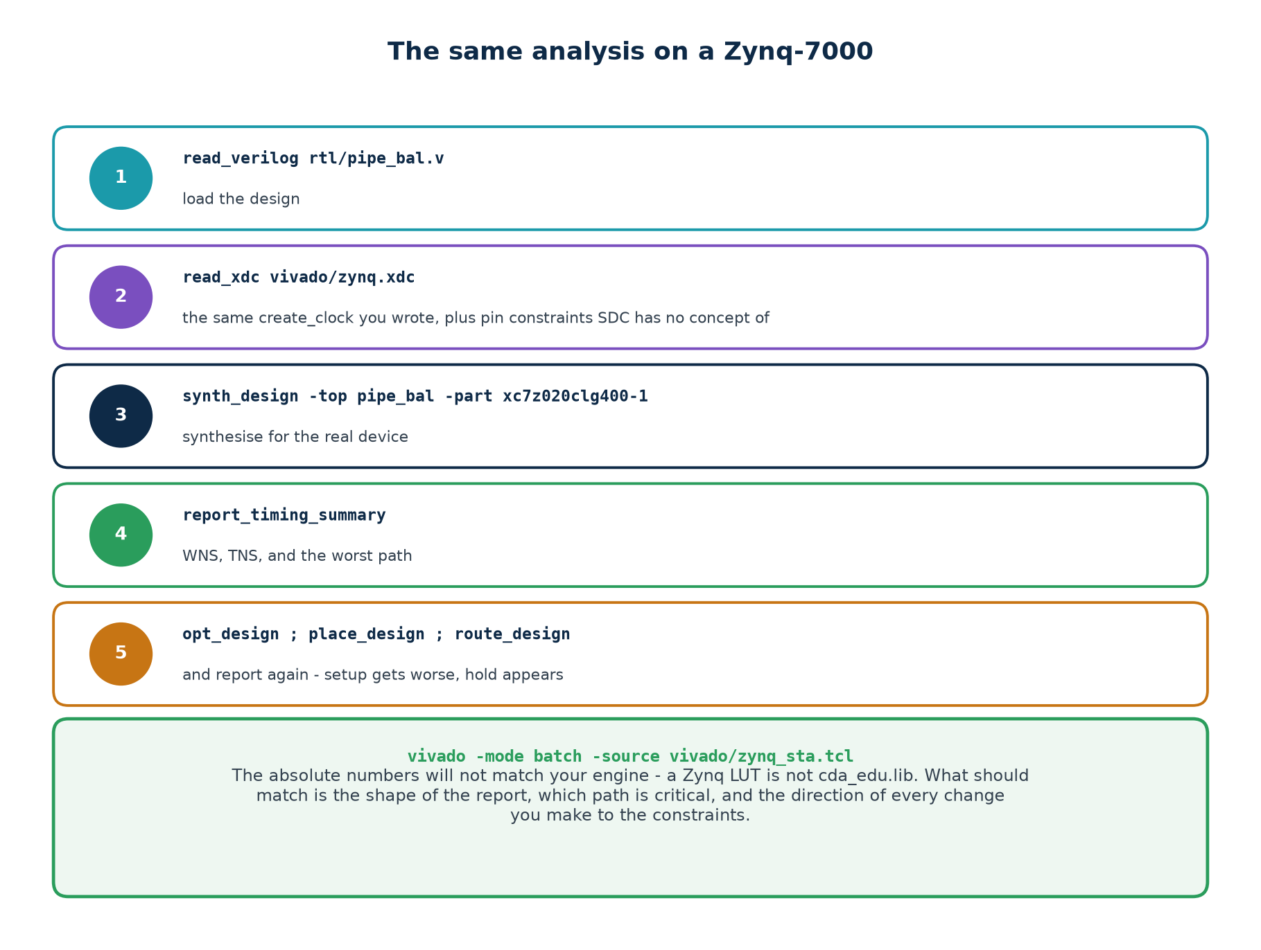
$ vivado -mode batch -source vivado/zynq_sta.tcl

# then compare, in vivado/rpt/ :
# post_synth_summary.rpt against ./scripts/sta.sh pipe_bal
# post_route_summary.rpt against post_synth_summary.rpt

What to compare | Expect | Why
absolute WNS | different | a Zynq LUT is not lib/cda_edu.lib
which path is critical | the same | the design's structure is the same
post-synth vs post-route setup | post-route is worse | synthesis estimated the wiring; routing measured it
post-route hold | a number that did not exist before | only now is there a real clock tree

The deliverable
One page: what matched between your engine and Vivado, what did not, and why. An answer that says "different tools give different answers" is not an answer. An answer that says "the numbers differ because an Artix-class LUT delay is around 0.1 ns where our XOR2 is 0.088 ns, and because routing adds delay our model has none of" is.
Checkpoint G
You have run the same design through two toolchains and can account for the difference in terms of the delay model, rather than dismissing it.

Exercises
How to read the tags
[H] hand calculation - do it on paper before you touch a keyboard. [C] computer - run it and record what you see. [W] write it down - a short paragraph you could defend in a review.
Every exercise has a worked solution starting on the next page. Do not read it until you have written something down, even if what you write turns out to be wrong.

Part A · Hazards on paper
10 exercises · 2 hours
A1 [H] Draw the K-map for F = A B' + B C and mark the loop for each product term. Which two 1-cells are adjacent but share no loop?
A2 [H] Derive the consensus term for that pair from first principles.
A3 [H] Write out the truth tables of A B' + B C and A B' + B C + A C. How many rows differ?
A4 [H] F = A B + A B' is just F = A written badly. Does it have a static-1 hazard?
A5 [H] Can a circuit consisting of one product term ever have a static-1 hazard? Prove your answer.
A6 [W] Why can a two-level AND-OR circuit have static-1 but not static-0 hazards?
A7 [H] F = A B' + B C' + A' C. Find every static-1 hazard by hand, then check with the tool.
A8 [W] What is a function hazard, and why can no implementation remove it?
A9 [H] Give an input pattern and pair of simultaneous changes on F = A B' + B C that exhibits a function hazard.
A10 [W] A colleague says "just minimise the logic and there will be no hazards". Respond.

Part B · The analyser
8 exercises · 2 hours
B1 [C] Run the self-test. How many independent checks does section D perform, and what would a failure there mean?
B2 [W] Why does can_glitch() randomise the per-term switching times instead of using one fixed delay profile?
B3 [C] Feed the analyser a single product term, then a two-term cover you believe is safe. Confirm both report zero.
B4 [C] Add a --pos example of your own and check the static-0 dual.
B5 [W] The analyser prints "truth table unchanged: yes" after proposing a fix. Why is that check worth the code it takes?
B6 [C] Modify hazard.py to report, for each hazard, how many delay assignments out of 60 actually produced a dip. Does it matter whether that number is 1 or 60?
B7 [H] For F with four variables and three terms, how many single-variable transitions between 1-cells must the analyser examine, in the worst case?
B8 [W] The analyser only handles two-level covers. What would make the multi-level case hard?

Part C · Gate-level glitches
12 exercises · 2 hours
C1 [H] From the analyser's output, predict which of the 24 transitions in hz_static1 will glitch. Write it down before simulating.
C2 [C] Run make glitch. Did your prediction match? How many surplus changes did the detector count?
C3 [C] hz_static1_fix reports CLEAN. Confirm the truth signature is unchanged, and say why that matters.
C4 [H] In hz_static1.v the inverter has delay 4 and the ANDs have delay 2. Compute when each product term switches after B falls, and how wide the glitch is.
C5 [C] Set the inverter delay to 0 in hz_static1.v and re-run. What happens, and what does it tell you?
C6 [C] Make the AND feeding B C slower than the inverter path. Does the glitch move, vanish, or change direction?
C7 [C] Run make glitch on hz_dynamic. How many transitions glitch, and how many are dynamic?
C8 [H] Why does a dynamic hazard need three or more reconverging paths?
C9 [C] hz_dynamic_fix reports 4 glitches, not 0. Substitute A=0, C=1 into the inner expression and say what s becomes.
C10 [W] Explain why hz_flat_fix is clean when hz_dynamic_fix is not.
C11 [H] Derive the flattened function of hz_dynamic from its truth table and confirm it is A B' + B C'.
C12 [W] The detector examines 24 transitions. What is it NOT examining, and could that hide a real problem?

Part D · Does it matter
6 exercises · 1 hour
D1 [C] Run make capture. How many spurious clock edges did four glitches produce?
D2 [H] Why was the DATA consumer unaffected?
D3 [C] Move the input transitions to 2 ns before the clock edge. Does the DATA consumer still behave?
D4 [C] Replace the asynchronous reset with a synchronous one and re-measure.
D5 [W] State the rule about when a glitch is harmless, precisely.
D6 [W] Name three signals in a design you have written that are not clock-sampled, and say what would happen if each glitched.

Part E · Synthesis
6 exercises · 1 hour
E1 [C] Run make synth. How many cells did each version produce?
E2 [H] Verify that A B' + B C equals B ? C : A over all eight rows.
E3 [W] Why was the deletion predictable?
E4 [C] Add a keep attribute to the consensus term and re-run. Did it survive?
E5 [C] Run the glitch detector against the post-synthesis netlist instead of the RTL. What do you find?
E6 [W] Where must hazard-freedom be verified, and why is verifying it on RTL worthless?

Part F · Setup, hold and Fmax
11 exercises · 2 hours
F1 [H] Write the setup inequality and the hold inequality. Which term appears in only one?
F2 [H] From the library: clk-to-Q 0.145, one XOR2 path 0.117, setup 0.090, no skew or uncertainty. Compute the minimum period and Fmax.
F3 [H] Add 0.15 ns of setup uncertainty to F2. Recompute.
F4 [C] Run make fmax. What is the ratio between the two designs, and what produced it?
F5 [H] -0.322 ns on a 2.5 ns period. Express as a percentage and predict which class of fix is needed.
F6 [C] Run make setup and confirm both numbers.
F7 [C] Run the hold analysis at 4, 40 and 400 ns. Explain the result.
F8 [H] Predict the hold slack at 4000 ns before running it.
F9 [C] Reduce the skew from 0.25 ns to 0.10 ns. What happens, and what real engineering activity does that model?
F10 [C] Find the skew at which hold_demo sits exactly on the boundary.
F11 [W] Remove set_input_delay from pipe.sdc. The WNS improves. Explain to a manager in two sentences why that is bad news.

Part G · Industrial tools
5 exercises · 2 hours
G1 [C] Run vivado/zynq_sta.tcl. Which path does Vivado call critical, and is it the same one your analyser picked?
G2 [C] Compare post-synthesis and post-route WNS. Which is worse, and why is that expected?
G3 [C] Look at the post-route hold slack. Why is there a meaningful number there that did not exist before?
G4 [W] Write the one-page comparison: what matched, what did not, and why.
G5 [W] Vivado is not installed in the environment these materials were built in, so zynq_sta.tcl's output is not reproduced anywhere. What should you do with a script in that situation?

Worked Solutions
Every answer below was checked against the lab. Where a number is quoted it came from a real run; where a judgement is asked for, the solution gives the reasoning that earns the marks rather than a single word.

Part A
A1 Draw the K-map for F = A B' + B C and mark the loop for each product term. Which two 1-cells are adjacent but share no loop?
Cells A=1,B=0,C=1 and A=1,B=1,C=1. A B' loops the A=1,B=0 row; B C loops the B=1,C=1 column; neither covers both of those cells.
A2 Derive the consensus term for that pair from first principles.
The two cells agree on A=1 and C=1 and differ in B. Keep the agreements, drop the variable that changed: A C.
A3 Write out the truth tables of A B' + B C and A B' + B C + A C. How many rows differ?
None. Both are 10111000 reading ABC = 000 to 111. That is what redundant means, and it is what makes the term a fix rather than a bug.
A4 F = A B + A B' is just F = A written badly. Does it have a static-1 hazard?
Yes. A=1,B=0 and A=1,B=1 both give 1, and no single term covers both: A B needs B=1, A B' needs B=0. The fixing term is A - which is the minimal cover. Un-minimised logic is not automatically safe.
A5 Can a circuit consisting of one product term ever have a static-1 hazard? Prove your answer.
No. Any two 1-cells are both covered by that single term, since it is the only term and it must cover every 1. Something is always holding the output up.
A6 Why can a two-level AND-OR circuit have static-1 but not static-0 hazards?
The output is 0 only when every AND is 0. For a static-0 glitch some AND would have to go momentarily high, but each AND's inputs come straight from literals - on a single-variable change only the terms containing that variable move, and a term that is 0 at both endpoints cannot be 1 in between. The dual argument gives static-0 hazards in OR-AND circuits.
A7 F = A B' + B C' + A' C. Find every static-1 hazard by hand, then check with the tool.
Run python3 tools/hazard.py "A B' + B C' + A' C". Do it on paper first; the point of the exercise is that the two agree.
A8 What is a function hazard, and why can no implementation remove it?
It occurs when two or more inputs change at once and the function's own value in the intermediate states forces a glitch. The inputs really do pass through those states, and every correct implementation must produce the function's value in them. The remedy is procedural: do not change those inputs together.
A9 Give an input pattern and pair of simultaneous changes on F = A B' + B C that exhibits a function hazard.
A=1: go from B=1,C=0 (F=0) to B=0,C=1 (F=1). The intermediates B=1,C=1 and B=0,C=0 both give F=1, so the output may reach 1 early. Whether that matters depends on the consumer.
A10 A colleague says "just minimise the logic and there will be no hazards". Respond.
Minimisation and hazard-freedom are different goals and often opposed: the minimal cover of A B' + B C has no consensus term, and that IS the hazard. A hazard-free cover is generally larger than a minimal one.

Part B
B1 Run the self-test. How many independent checks does section D perform, and what would a failure there mean?
It cross-checks every static-1 transition over 400 random covers - several thousand transitions. A disagreement would mean either the covering rule or the timing model is wrong, and you would not know which until you investigated.
B2 Why does can_glitch() randomise the per-term switching times instead of using one fixed delay profile?
Because a hazard is the POSSIBILITY of a dip. With one fixed profile the glitch only appears in one direction of the transition, so a fixed-profile check disagrees with the covering rule and looks like a bug in the rule. Searching delay assignments asks the right question.
B3 Feed the analyser a single product term, then a two-term cover you believe is safe. Confirm both report zero.
A B C reports none. A B + A C reports none: the only adjacent 1-cell pairs are spanned by one of the two terms.
B4 Add a --pos example of your own and check the static-0 dual.
(A + B)(B' + C) reports one static-0 hazard. The reasoning mirrors the SOP case on the 0-cells.
B5 The analyser prints "truth table unchanged: yes" after proposing a fix. Why is that check worth the code it takes?
Because a proposed fix that alters the function is the worst possible outcome: it silences the symptom and introduces a functional bug. A tool that does not check its own output will eventually emit one.
B6 Modify hazard.py to report, for each hazard, how many delay assignments out of 60 actually produced a dip. Does it matter whether that number is 1 or 60?
It does not change whether the hazard exists - one assignment is enough. It is informative about how likely you are to SEE it in a given simulation, which is exactly why simulation alone is not a reliable hazard finder.
B7 For F with four variables and three terms, how many single-variable transitions between 1-cells must the analyser examine, in the worst case?
At most 16 x 4 / 2 = 32 ordered pairs, of which only those with F=1 at both ends are candidates. The cost is exponential in the number of variables, which is why this approach suits small covers and not whole designs.
B8 The analyser only handles two-level covers. What would make the multi-level case hard?
In a multi-level circuit an input can reach the output by many paths of different lengths, and an internal signal may itself be hazardous. You can no longer decide the question by looking at a cover, because there is no single cover - hz_dynamic is the demonstration.

Part C
C1 From the analyser's output, predict which of the 24 transitions in hz_static1 will glitch. Write it down before simulating.
ABC 111 -> 101, i.e. B falling with A=1 and C=1. The detector reports exactly that one.
C2 Run make glitch. Did your prediction match? How many surplus changes did the detector count?
It matches. changes=2, expected=0, so two surplus changes: the dip down and the recovery.
C3 hz_static1_fix reports CLEAN. Confirm the truth signature is unchanged, and say why that matters.
Both report 10111000. Without that check, a 'fix' that broke the function would also report CLEAN - a circuit stuck at a constant never glitches.
C4 In hz_static1.v the inverter has delay 4 and the ANDs have delay 2. Compute when each product term switches after B falls, and how wide the glitch is.
B C switches off at 0 + 2 = 2 ns. A B' switches on at 4 + 2 = 6 ns. The output is unheld from 2 ns to 6 ns, so the glitch is about 4 ns wide - the inverter delay.
C5 Set the inverter delay to 0 in hz_static1.v and re-run. What happens, and what does it tell you?
The glitch disappears, because both terms now switch at the same instant. It tells you the glitch depends on delays you do not control - the hazard is still in the logic, and a different library or a different route brings it back.
C6 Make the AND feeding B C slower than the inverter path. Does the glitch move, vanish, or change direction?
It vanishes for B falling and appears for B rising instead. The hazard is direction-independent; the glitch is not.
C7 Run make glitch on hz_dynamic. How many transitions glitch, and how many are dynamic?
Five: four static and one dynamic (ABC 111 -> 101, changes=3 where 1 was expected).
C8 Why does a dynamic hazard need three or more reconverging paths?
The output must change three times. Each extra change needs another path arriving at a different time; with only two paths there are only two switching instants, which can produce at most one spurious excursion - a static hazard.
C9 hz_dynamic_fix reports 4 glitches, not 0. Substitute A=0, C=1 into the inner expression and say what s becomes.
s = 0 + B + 0 = B. So f = s XOR b is B XOR B-delayed, which spikes on every edge of B regardless of the cover.
C10 Explain why hz_flat_fix is clean when hz_dynamic_fix is not.
Flattening removes the reconvergence: there is no longer an internal signal that is a delayed copy of an input arriving at the same gate as the input itself. The flattened function A B' + B C' is then covered hazard-free by adding A C'.
C11 Derive the flattened function of hz_dynamic from its truth table and confirm it is A B' + B C'.
s XOR B has minterms A'BC', AB'C', AB'C, ABC'. Grouping: AB'C' + AB'C = A B'; A'BC' + ABC' = B C'. So F = A B' + B C'.
C12 The detector examines 24 transitions. What is it NOT examining, and could that hide a real problem?
It examines only single-variable changes from a settled state. It does not examine simultaneous changes (function hazards) or transitions from a state the circuit has not settled in. Both can hide real behaviour, which is why the detector complements the analyser rather than replacing it.

Part D
D1 Run make capture. How many spurious clock edges did four glitches produce?
Four - one per glitch. The report separates the legitimate power-up edge (x -> 1) from the four that followed.
D2 Why was the DATA consumer unaffected?
The glitch happened 80 ns before the sampling edge and lasted about 4 ns, so the signal was long settled by the time the flop looked at it.
D3 Move the input transitions to 2 ns before the clock edge. Does the DATA consumer still behave?
No - now the flop samples during or just after the glitch, and may capture the wrong value or go metastable. That is the boundary the setup check exists to enforce.
D4 Replace the asynchronous reset with a synchronous one and re-measure.
r_flag survives: a synchronous reset is only examined at the clock edge, by which time the glitch is gone. This is the standard reason to prefer synchronous reset where the design allows it.
D5 State the rule about when a glitch is harmless, precisely.
A glitch is harmless only where a clock edge samples the signal after it has settled. Anywhere edge-sensitive or level-sensitive - a derived clock, an asynchronous reset or set, a latch enable, a domain crossing - it is not.
D6 Name three signals in a design you have written that are not clock-sampled, and say what would happen if each glitched.
Answers vary. A good answer names real signals and traces the consequence: a glitching clock enable double-counts; a glitching async reset loses state; a glitching handshake sends a spurious request.

Part E
E1 Run make synth. How many cells did each version produce?
One each, and the same cell: a $_MUX_. The netlists are identical, so the consensus term was deleted.
E2 Verify that A B' + B C equals B ? C : A over all eight rows.
B=0 selects A; B=1 selects C. Both columns match the SOP on every row.
E3 Why was the deletion predictable?
The consensus term is logically redundant by construction, and removing redundancy is precisely what a logic optimiser is for. Any tool that did not delete it would be failing at its job.
E4 Add a keep attribute to the consensus term and re-run. Did it survive?
Record what you observe. Attribute handling varies by tool and version, which is itself the lesson: protection has to be verified, not assumed.
E5 Run the glitch detector against the post-synthesis netlist instead of the RTL. What do you find?
You are now testing what will actually be built. Whether the MUX glitches depends on that cell's internal implementation - which you did not write and cannot see from the RTL.
E6 Where must hazard-freedom be verified, and why is verifying it on RTL worthless?
On the netlist. The RTL is an input to an optimiser that is free to restructure anything that does not change the function - and hazard-freedom is exactly a property that does not change the function.

Part F
F1 Write the setup inequality and the hold inequality. Which term appears in only one?
setup: t_cq + t_logic <= T + skew - setup - unc. hold: t_cq + t_logic >= skew + hold + unc. The clock period T appears only in the setup check.
F2 From the library: clk-to-Q 0.145, one XOR2 path 0.117, setup 0.090, no skew or uncertainty. Compute the minimum period and Fmax.
0.145 + 0.117 + 0.090 = 0.352 ns, so Fmax = 2841 MHz.
F3 Add 0.15 ns of setup uncertainty to F2. Recompute.
0.502 ns, so 1992 MHz. The circuit did not change - only how honest the constraint is.
F4 Run make fmax. What is the ratio between the two designs, and what produced it?
364.7 to 473.2 MHz, a factor of 1.30, produced by splitting the one heavy stage into two. No logic was made faster.
F5 -0.322 ns on a 2.5 ns period. Express as a percentage and predict which class of fix is needed.
12.9%. Too large for a synthesis effort setting; about right for one pipeline cut - which is what fixed it.
F6 Run make setup and confirm both numbers.
pipe_unbal -0.322 ns VIOLATED; pipe_bal +0.307 ns MET, same constraint file.
F7 Run the hold analysis at 4, 40 and 400 ns. Explain the result.
-0.119 ns in all three. Both flops use the same edge, so the period is not in the hold equation at all.
F8 Predict the hold slack at 4000 ns before running it.
-0.119 ns. Anything else would mean the period had crept into the hold check, which would be a bug in the analyser.
F9 Reduce the skew from 0.25 ns to 0.10 ns. What happens, and what real engineering activity does that model?
-0.119 ns becomes +0.031 ns. It models rebalancing the clock tree so the capture register is reached sooner - a place-and-route activity, not an RTL one.
F10 Find the skew at which hold_demo sits exactly on the boundary.
Around 0.13 ns. Knowing the margin tells you how much clock-tree imbalance the design can absorb before this path fails.
F11 Remove set_input_delay from pipe.sdc. The WNS improves. Explain to a manager in two sentences why that is bad news.
The design did not get faster; the tool stopped checking those paths, so the worst one is no longer in the list. The improvement is in the report, not in the silicon.

Part G
G1 Run vivado/zynq_sta.tcl. Which path does Vivado call critical, and is it the same one your analyser picked?
It should be the same path - the structure of the design is unchanged. The absolute numbers will differ substantially.
G2 Compare post-synthesis and post-route WNS. Which is worse, and why is that expected?
Post-route. Synthesis estimates wire delay; implementation measures it. A design that only just closes post-synthesis usually fails post-route.
G3 Look at the post-route hold slack. Why is there a meaningful number there that did not exist before?
Because only after implementation is there a real clock tree, and therefore real skew for the hold check to work against.
G4 Write the one-page comparison: what matched, what did not, and why.
A good answer names the delay model as the source of the difference and quotes numbers. A poor answer says 'different tools give different answers' and stops.
G5 Vivado is not installed in the environment these materials were built in, so zynq_sta.tcl's output is not reproduced anywhere. What should you do with a script in that situation?
Treat it as untested and verify it yourself before relying on it. Reporting that distinction honestly - this ran, that did not - is part of engineering practice, and it is why the lab README says so explicitly.

Reference Card

Hazards
STATIC-1 HAZARD (two-level AND-OR)
Two input patterns one variable apart, both giving F = 1,
covered by NO single product term.

THE FIX
Add the product of the literals both patterns agree on,
dropping the variable that changed. It is redundant by design.

STATIC-0 HAZARD the dual, in a two-level OR-AND circuit
DYNAMIC HAZARD 3+ levels; the output changes 3+ times instead of once
FUNCTION HAZARD 2+ inputs change at once; no implementation can fix it

THE LIMIT
The consensus term cures a two-level LOGIC hazard and nothing else.
Reconvergent fanout needs restructuring, not a redundant term.

Sequential timing
setup: t_cq + t_logic <= T + t_skew - t_setup - t_unc
hold: t_cq + t_logic >= t_skew + t_hold + t_unc

slack (setup) = required - arrival slack (hold) = arrival - required

Fmax = 1 / ( t_cq + t_logic + t_setup + t_unc - t_skew )

The clock period T is in the setup check and NOT in the hold check.
Late capture clock: helps setup, hurts hold, by the same amount.
Setup signs off at the SLOW corner; hold at the FAST corner.

The rules worth memorising
Rule | Consequence
STA measures one path; a hazard needs two | static analysis is blind to hazards - simulate with delays
A glitch is harmless only where a clock edge samples it after it settles | clocks, async resets, latch enables and CDC are all unsafe
The consensus term is redundant by construction | synthesis will delete it; verify on the netlist, not the RTL
Fmax is set by one stage | balance the stages before optimising any of them
The clock period is not in the hold equation | slowing the clock never fixes a hold violation
Unchecked is not passed | report unconstrained endpoints on every run; it must be zero

Commands
# the lab
make analyse make glitch make capture make synth
make fmax make setup make hold make

python3 tools/hazard.py "A B' + B C" # find hazards, prescribe a fix
python3 tools/hazard.py --pos "(A+B)(B'+C)" # the static-0 dual
python3 tools/hazard.py --selftest # cross-check the rule itself

iverilog -g2005 -DDUT=hz_static1 -DDUTNAME=\"hz_static1\" \
-o build/hz.vvp hazards/tb_hazard.v hazards/hz_static1.v
vvp build/hz.vvp

./scripts/sta.sh pipe_bal constraints/pipe.sdc # setup
./scripts/sta.sh hold_demo constraints/hold_skew.sdc --hold

# Vivado on a Zynq-7000, headless
vivado -mode batch -source vivado/zynq_sta.tcl

The one line to leave with
"It simulates correctly" and "it meets timing" are two different claims, and neither one implies the other.

