Implementation Analysis

**Ripunjay Narula**1, **andSamvit Swaminathan** 1,

1 Computer Architecture and Organization

# Introduction

This is a Number Plate Recognition process. The aim is to extract the Number Plate from image of vehicle provided in the given format (.jpg, .png, etc). This is usually helpful for catching people from running away by jumping signals or violating traffic rules.

# Requirements

To run the following process, we require:

1.Matlab Software 2.Image of vehicle with number plate on it in given format 3.A little knowledge on Image Processing 4.Coding in Matlab

# Procedure

1. We must first write the code given below in Matlab soft- ware.

clc

clear all; close all; imtool close all; workspace;

[FileName,PathName] = uiget- file(’*.jpg;*.png;*.gif;*.tif’,’Select a image’); I=imread(strcat(PathName,FileName)); figure(1); imshow(I);

Igray = rgb2gray(I); [rows cols] = size(Igray);

Idilate = Igray; for i = 1:rows for j = 2:cols-1 temp

= max(Igray(i,j-1), Igray(i,j)); Idilate(i,j) = max(temp, Igray(i,j+1)); end end I = Idilate;

figure(2); imshow(Igray); figure(3); title(’Dilated Image’) imshow(Idilate); figure(4); imshow(I); difference = 0; sum = 0;

total*sum* = 0; *difference* = *uint*32(*difference*);

disp(’Processing Edges Horizontally...’); max*horz* = 0; *maximum* = 0; *f ori* = 2 : *cols* sum = 0; for j = 2:rows if(I(j, i) > I(j-1, i))

difference = uint32(I(j, i) - I(j-1, i)); else difference = uint32(I(j-1, i) - I(j, i));

end if(difference > 20) sum = sum + difference; end end horz1(i) = sum;

if(sum > maximum)

max*horz* = *i*; *maximum* = *sum*; *end*

total*sum* = *totalsum* + *sum*; *endaverage* =

*totalsum/cols*;

figure(5);

subplot(3,1,1); plot (horz1);

title(’Horizontal Edge Processing Histogram’); xla- bel(’Column Number ->’); ylabel(’Difference ->’);

sum = 0; horz = horz1; for i = 21:(cols-21) sum = 0;

for j = (i-20):(i+20)

sum = sum + horz1(j); end horz(i) = sum / 41; end subplot(3,1,2); plot (horz);

title(’Histogram after passing through Low Pass Filter’); xla- bel(’Column Number ->’); ylabel(’Difference ->’); disp(’Filter out Horizontal Histogram...’);

for i = 1:cols if(horz(i) < average) horz(i) = 0; for j = 1:rows I(j, i) = 0; end

end end subplot(3,1,3);

plot (horz); title(’Histogram after Filtering’); xlabel(’Column Number ->’);

ylabel(’Difference ->’); difference = 0; total*sum* = 0;

difference = uint32(difference); disp(’Processing Edges Ver- tically...’); maximum = 0; max*vert* = 0;

for i = 2:rows sum = 0; for j = 2:cols

if(I(i, j) > I(i, j-1)) difference = uint32(I(i, j) - I(i, j-1)); end

if(I(i, j) <= I(i, j-1)) difference = uint32(I(i, j-1) - I(i, j)); end if(difference > 20) sum = sum + difference;

end end vert1(i) = sum;

if(sum > maximum) max*vert* = *i*; *maximum* = *sum*; end total*sum* = *totalsum* + *sum*; *end*

average = total*sum/rows*; *f igure*(6)*subplot*(3*,* 1*,* 1);

plot (vert1);

title(’Vertical Edge Processing Histogram’); xlabel(’Row Number ->’); ylabel(’Difference ->’);

disp(’Passing Vertical Histogram through Low Pass Filter...’); sum = 0;

vert = vert1; for i = 21:(rows-21) sum = 0; for j = (i-20):(i+20)

sum = sum + vert1(j); end

vert(i) = sum / 41; end subplot(3,1,2); plot (vert);

title(’Histogram after passing through Low Pass Filter’); xla- bel(’Row Number ->’); ylabel(’Difference ->’);

disp(’Filter out Vertical Histogram...’);

for i = 1:rows if(vert(i) < average) vert(i) = 0;

for j = 1:cols I(i, j) = 0; end end end subplot(3,1,3); plot (vert);

title(’Histogram after Filtering’); xlabel(’Row Number ->’); ylabel(’Difference ->’); figure(7), imshow(I);

j = 1;

for i = 2:cols-2

if(horz(i) = 0 horz(i-1) == 0 horz(i+1) == 0) column(j) = i; column(j+1) = i; j = j + 2;

elseif((horz(i) = 0 horz(i-1) == 0) || (horz(i) = 0 horz(i+1)

== 0)) column(j) = i; j = j+1; end end

j = 1;

for i = 2:rows-2

if(vert(i) = 0 vert(i-1) == 0 vert(i+1) == 0) row(j) = i; row(j+1) =i; j = j +2;

elseif((vert(i) = 0 vert(i-1) == 0) || (vert(i) = 0 vert(i+1) == 0)) row(j) = i;

j = j+1; end end

[temp column*size*] = *size*(*column*); if(mod(column*size,* 2)) column(column*size* + 1) = *cols*; end

[temp row*size*] = *size*(*row*); if(mod(row*size,* 2)) row(row*size* + 1) = *rows*; end

for i = 1:2:row*sizef orj* = 1 : 2 : *columnsize*

if( ((max*horz >*= *column*(*j*)*maxhorz <*= *column*(*j* + 1))(*maxvert >*= *row*(*i*)*maxvert <*= *row*(*i* + 1))))

for m = row(i):row(i+1)

for n = column(j):column(j+1) I(m, n) = 0;

end end end end end figure(8), imshow(I); imshow(I);

1. After running the above code, run it.
2. Then it will ask you to input the image of the vehicle in given format.
3. Once that is done, it will give 8 images as output.
4. The 8th image is the one with the number plate

# Analysis

The 8 images that were obtained were:

1. The original image that was uploaded by the user.

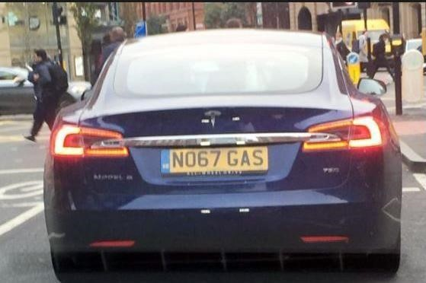

1. The same image in Black and White.

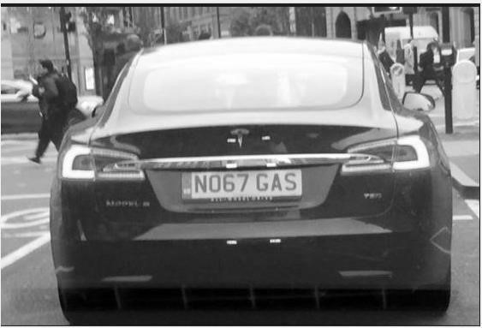

1. It is the dilated image of the 2nd image

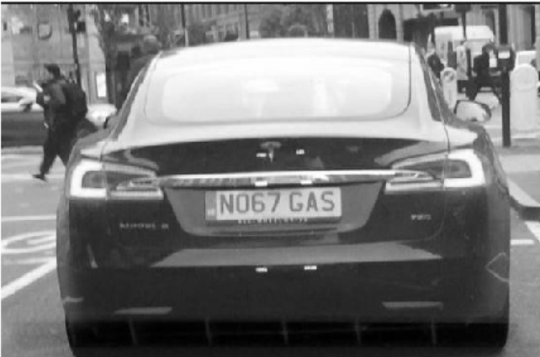

1. It shows the dilated image again with a reformation.

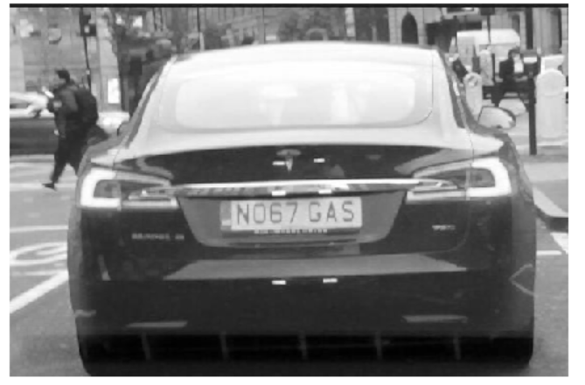

1. This shows 3 graphs after Processing Edges Horizontally through filter:

*Horizontal Edge Processing Histogram

*Histogram after passing through Low Pass Filter

*Histogram after Filtering

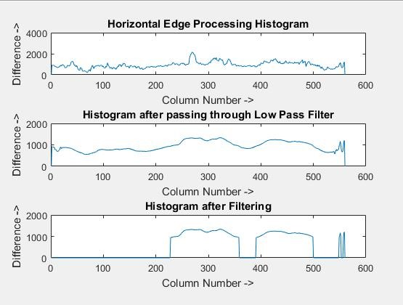

1. This shows 3 graphs after Processing Edges Vertically through filter:

*Vertical Edge Processing Histogram

*Histogram after passing through Low Pass Filter

*Histogram after Filtering

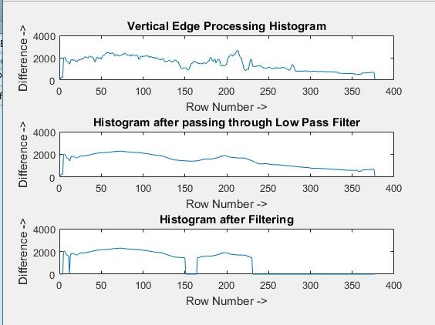

1. Shows the respective image in block structures after removing parts which do not contain the parts of the number plate. It removes parts of the image which do not contain regions of the number plate.

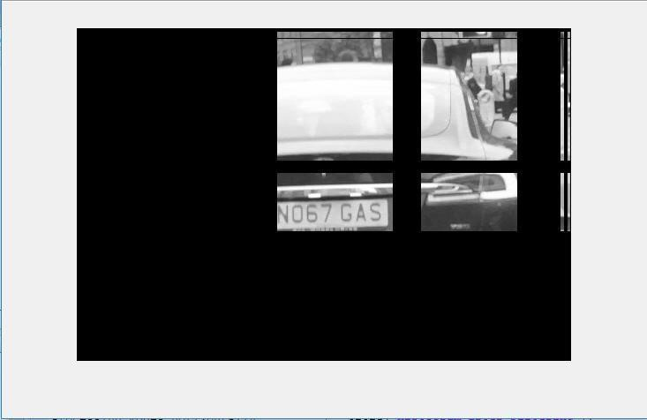

1. This is the final image of the number plate. This is the result of our process.

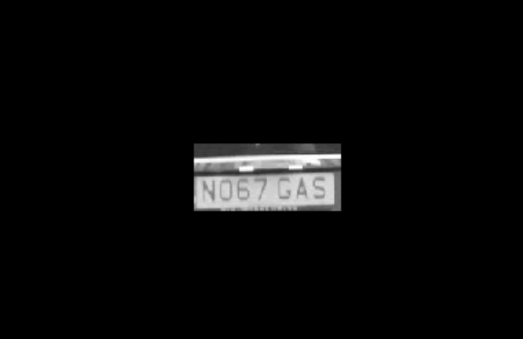

**Conclusion**

This was an implementation of the concepts and techniques of Machine Learning to recognize the number plates of vehicles on roads. This will help the Crime Departments throughout the world and will help in the benefit of the society.

This uses the concepts of Machine Learning just like Google’s Tensor Processing Unit which was our main focus in the research.