***Ripunjay Narula (19BCE0470)***

**JAVA PROGRAMMING LAB**

**15-07-2020**

1. Read the radius and print the area of a circle

import java.util.Scanner;

public class circle

{

public static void main(String[] args) {

Scanner sc=new Scanner(System.in);

double r=sc.nextDouble();

System.out.println("Area of circle: "+(3.14*r*r));

}

}

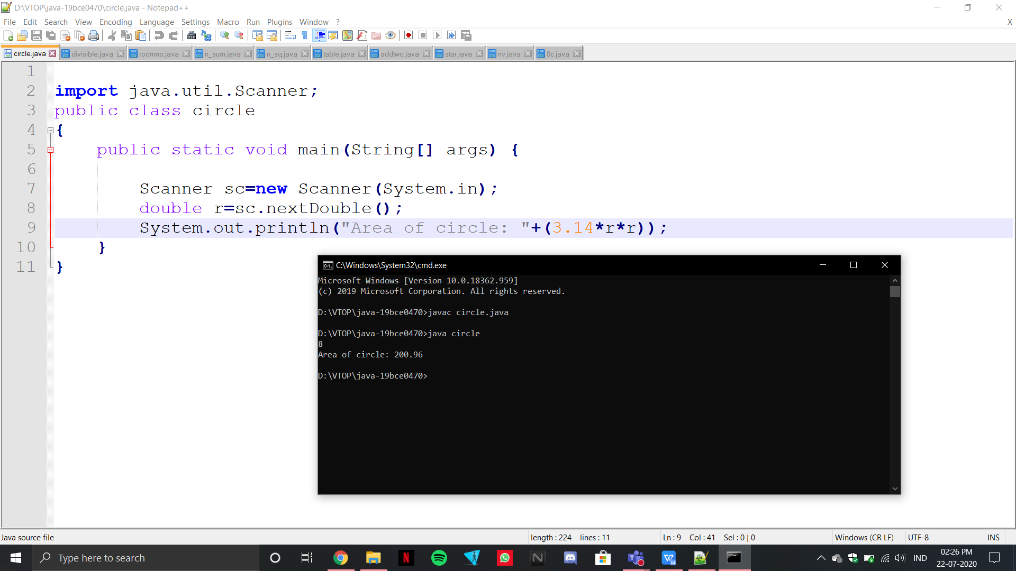

1. Read the number and check whether it is divisible by 3 and 5.

import java.util.Scanner;

public class divisible

{

public static void main(String[] args) {

Scanner sc=new Scanner(System.in);

System.out.println("Enter the number: ");

double n=sc.nextDouble();

if(n%3==0 && n%5==0)

{

System.out.println("The number is divisible by 3 and 5");

}

else

{

System.out.println("The number is not divisible by 3 and 5");

}

}

}

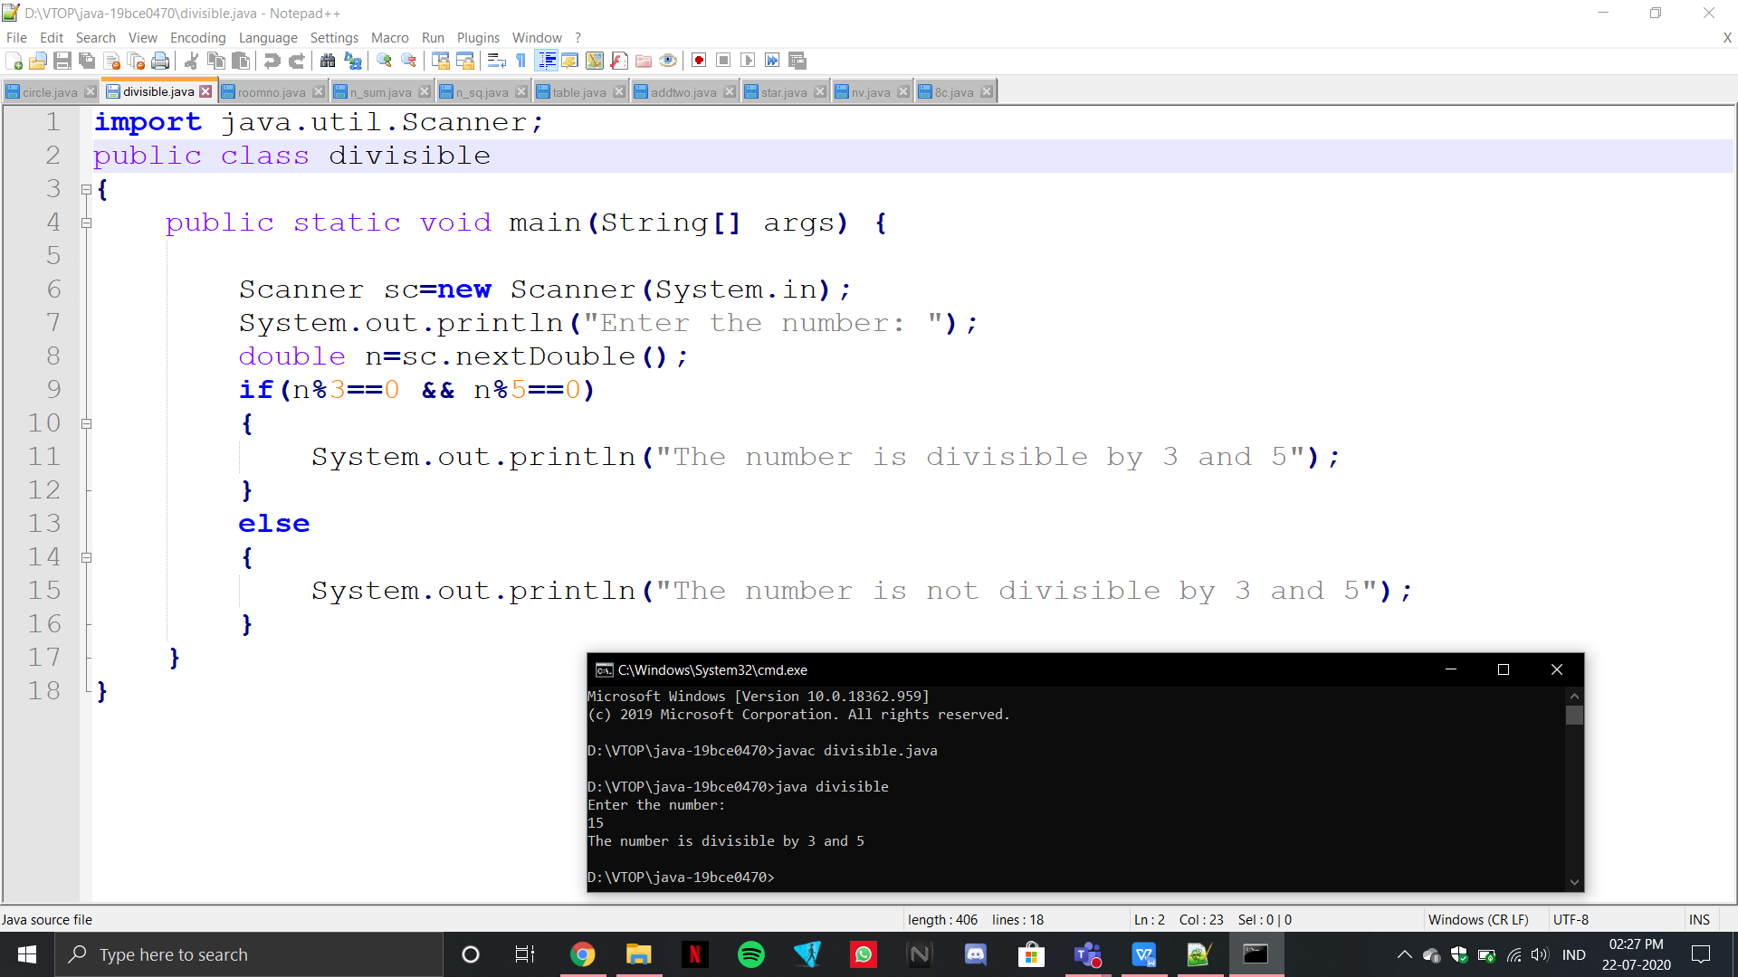

1. Display Subject Name based on room number. If the user enters 604 then display Java Programming , If the user enters 605 then display Python programming for any other input display Invalid input to the user

import java.util.Scanner;

public class roomno

{

public static void main(String[] args) {

Scanner sc=new Scanner(System.in);

System.out.println("Enter the Room Number: ");

int n=sc.nextInt();

if(n==604)

{

System.out.println("Java Programming");

}

else if(n==605)

{

System.out.println("Python Programming");

}

else

{

System.out.println("Invalid Input");

}

}

}

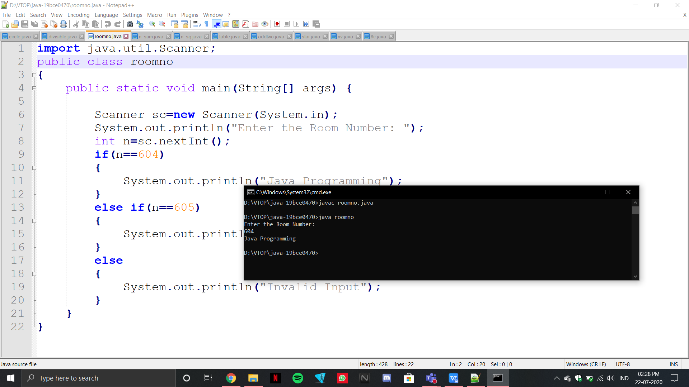

1. Print the sum of first n numbers. If n is 3 then print the sum of 1+2+3 to the user. Get n from the user

import java.util.Scanner;

public class n_sum

{

public static void main(String[] args) {

Scanner sc=new Scanner(System.in);

System.out.println("Enter the number n: ");

int n=sc.nextInt();

int x=0;

int i;

for(i=0;i<=n;i++)

{

x=x+i;

}

System.out.println("The sum of all numbers upto n is: "+x);

}

}

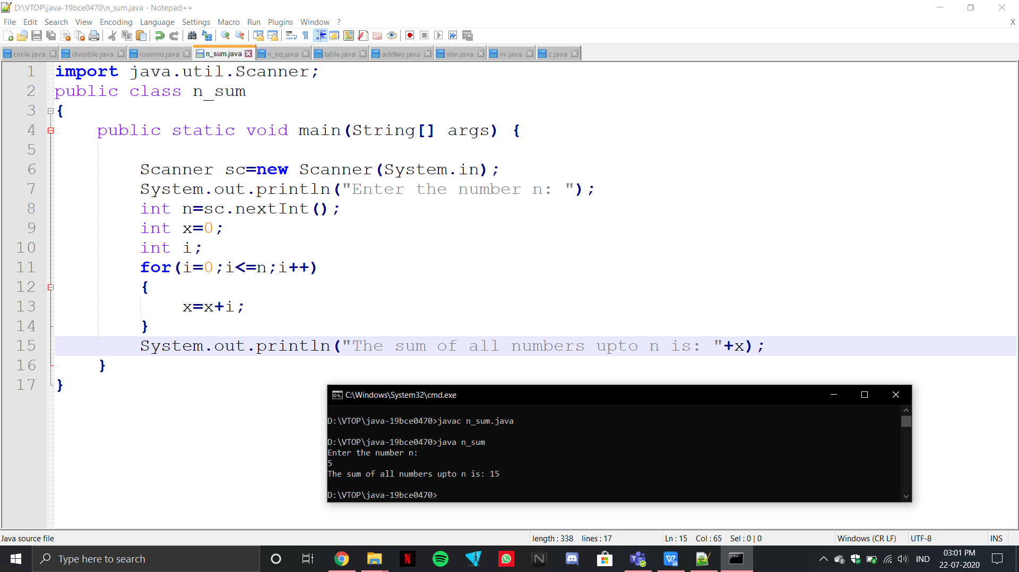

1. Print the sum of the series 12+22+32 up to n terms

import java.util.Scanner;

public class n_sq

{

public static void main(String[] args) {

Scanner sc=new Scanner(System.in);

System.out.println("Enter the number n: ");

int n=sc.nextInt();

int a=0;

int i;

for(i=0;i<=n;i++)

{

a=a+(i*i);

}

System.out.println("The sum of squares of all numbers upto n is: "+a);

}

}

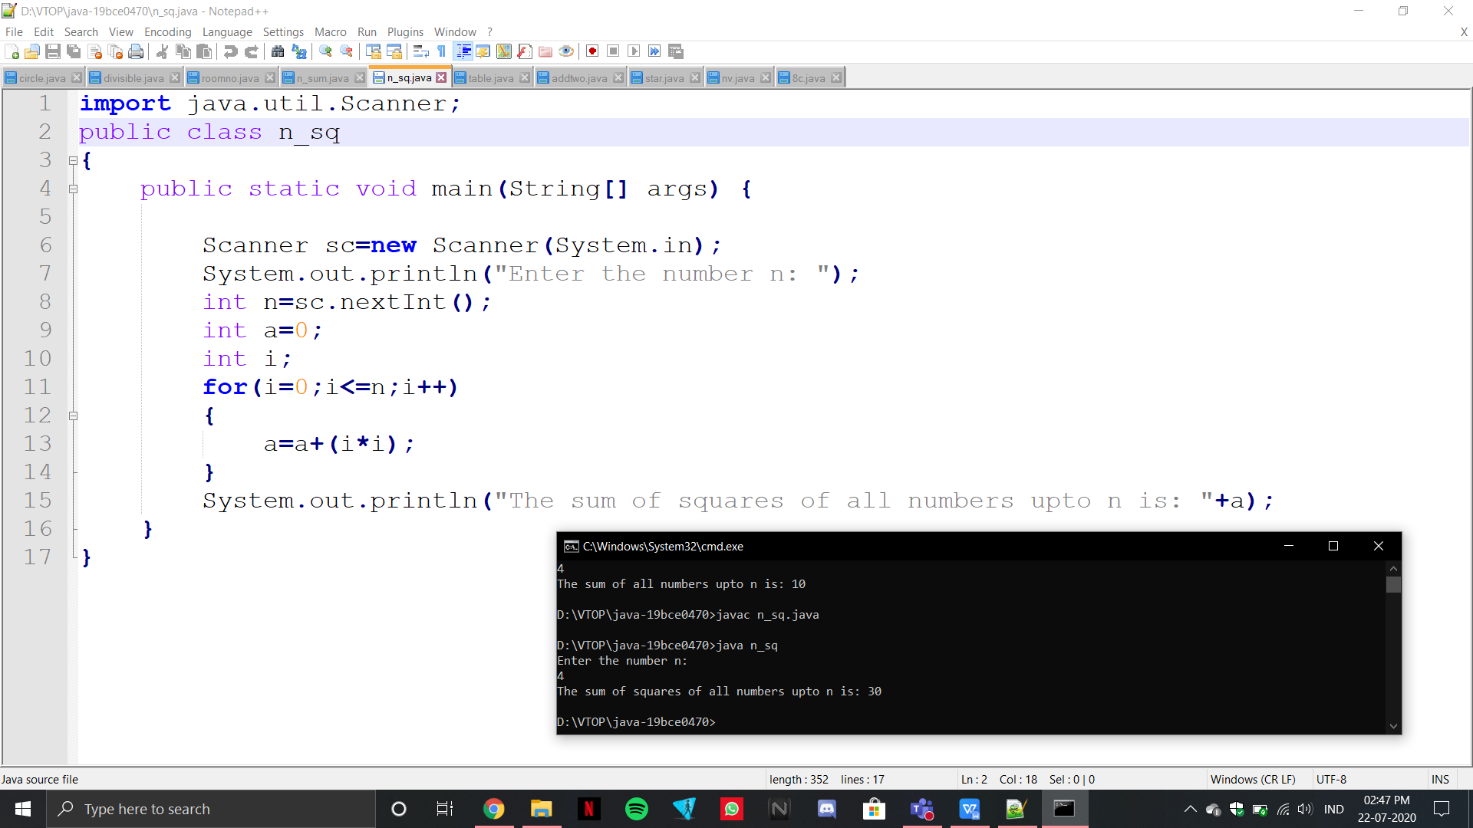

1. Print the multiplication table by getting the n from the user.

import java.util.Scanner;

public class table

{

public static void main(String[] args) {

Scanner sc=new Scanner(System.in);

System.out.println("Enter the number n: ");

int n=sc.nextInt();

int i;

int k;

for(i=1;i<=10;i++)

{

k=n*i;

System.out.println(n+" x "+i+" is: "+k);

}

}

}

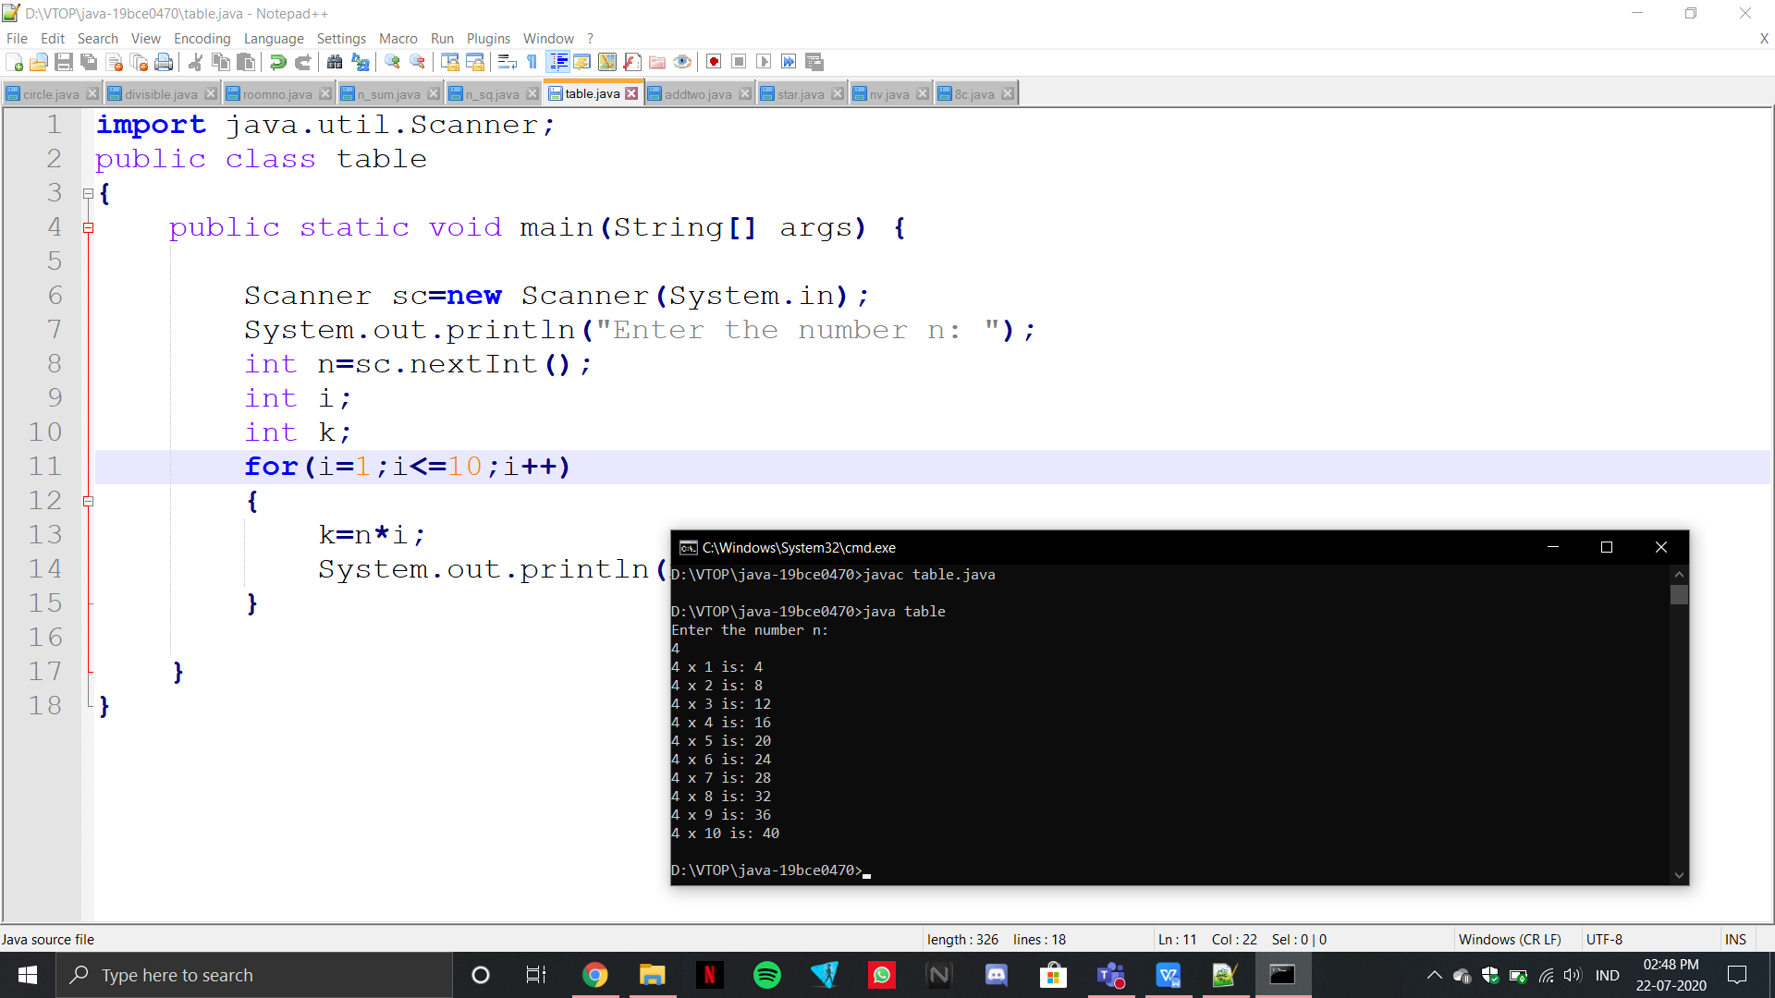

1. Provide the option of adding two numbers to the user until the user wants to exit.

import java.util.Scanner;

public class addtwo

{

static Scanner scan = new Scanner(System.in);

static String ask = null;

public static void main(String args[])

{

add();

while (true)

{

System.out.print("Do You Want to Continue (Y/N) ?");

ask = scan.next();

if (ask.equalsIgnoreCase("Y"))

add();

else if (ask.equalsIgnoreCase("N"))

{

break;

}

else{

System.out.print("Try Again With (Y/N) only :(");

}

}

}

public static void add()

{

int m,n,x;

System.out.print("Enter the first number: ");

m = scan.nextInt();

System.out.print("Enter the second number: ");

n = scan.nextInt();

x=m+n;

System.out.println(x);

}

}

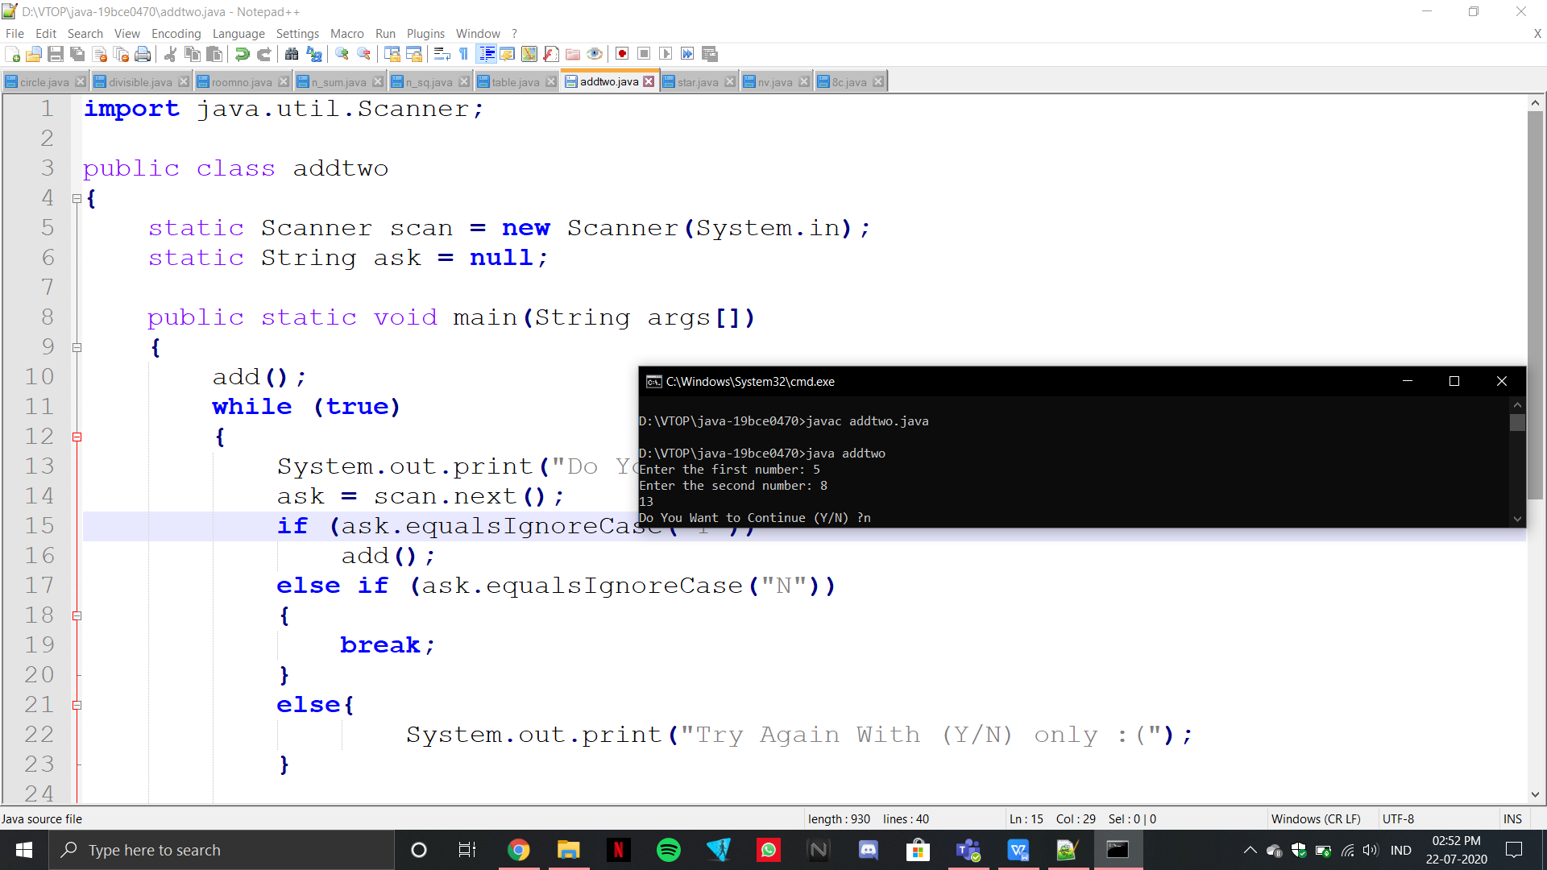

8. Print this pattern for n lines

(a)

*

**

***

****

import java.util.Scanner;

public class star

{

public static void main(String[] args)

{

Scanner sc=new Scanner(System.in);

System.out.println("Enter the number of steps: ");

int n=sc.nextInt();

int i,j;

for(i=1;i<=n;i++)

{

for(j=1;j<=i;j++)

{

System.out.print("* ");

}

System.out.println("");

}

}

}

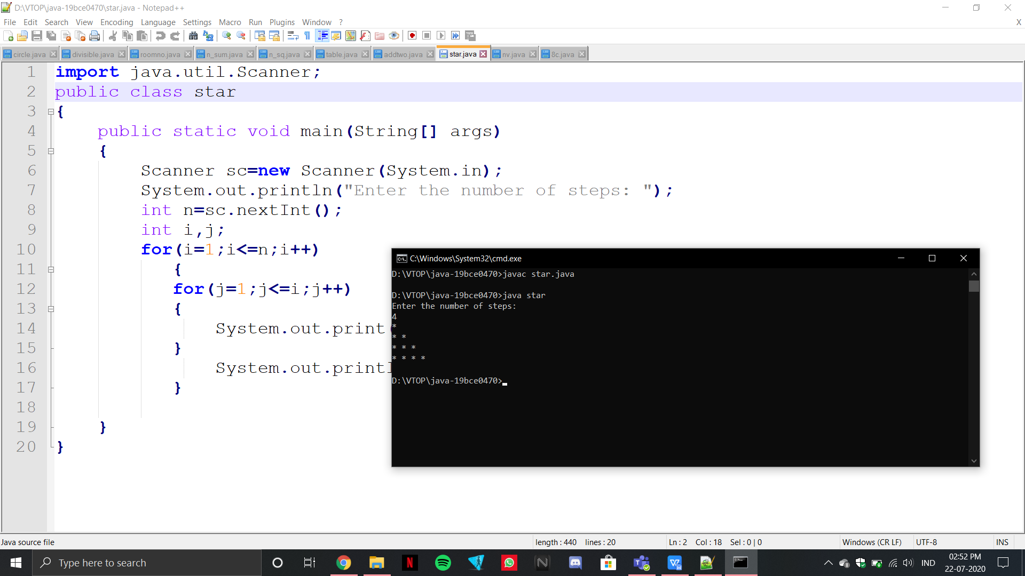

(b)

1234

123

12

1

import java.util.Scanner;

public class nv

{

public static void main(String[] args)

{

Scanner sc=new Scanner(System.in);

System.out.println("Enter the number of steps: ");

int n=sc.nextInt();

int i,j;

for(i=n;i>=1;i--)

{

for(j=1;j<=i;j++)

{

System.out.print(j);

}

System.out.println("");

}

}

}

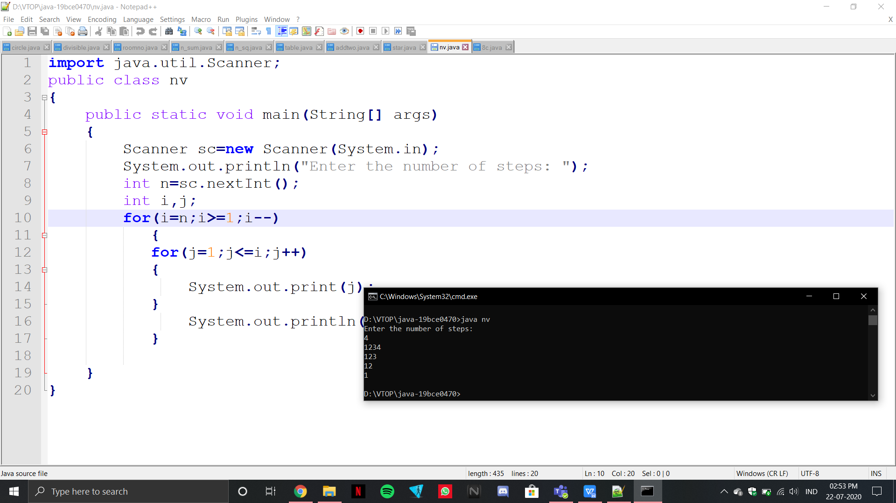

(c) 1

12

123

1234

1234

123

12

1

import java.util.Scanner;

public class c

{

public static void main(String[] args)

{

Scanner sc=new Scanner(System.in);

System.out.println("Enter the number of steps: ");

int n=sc.nextInt();

int i,j;

for(i=1;i<=n;i++)

{

for(j=1;j<=i;j++)

{

System.out.print(j);

}

System.out.println("");

}

for(i=n;i>=1;i--)

{

for(j=1;j<=i;j++)

{

System.out.print(j);

}

System.out.println("");

}

}

}

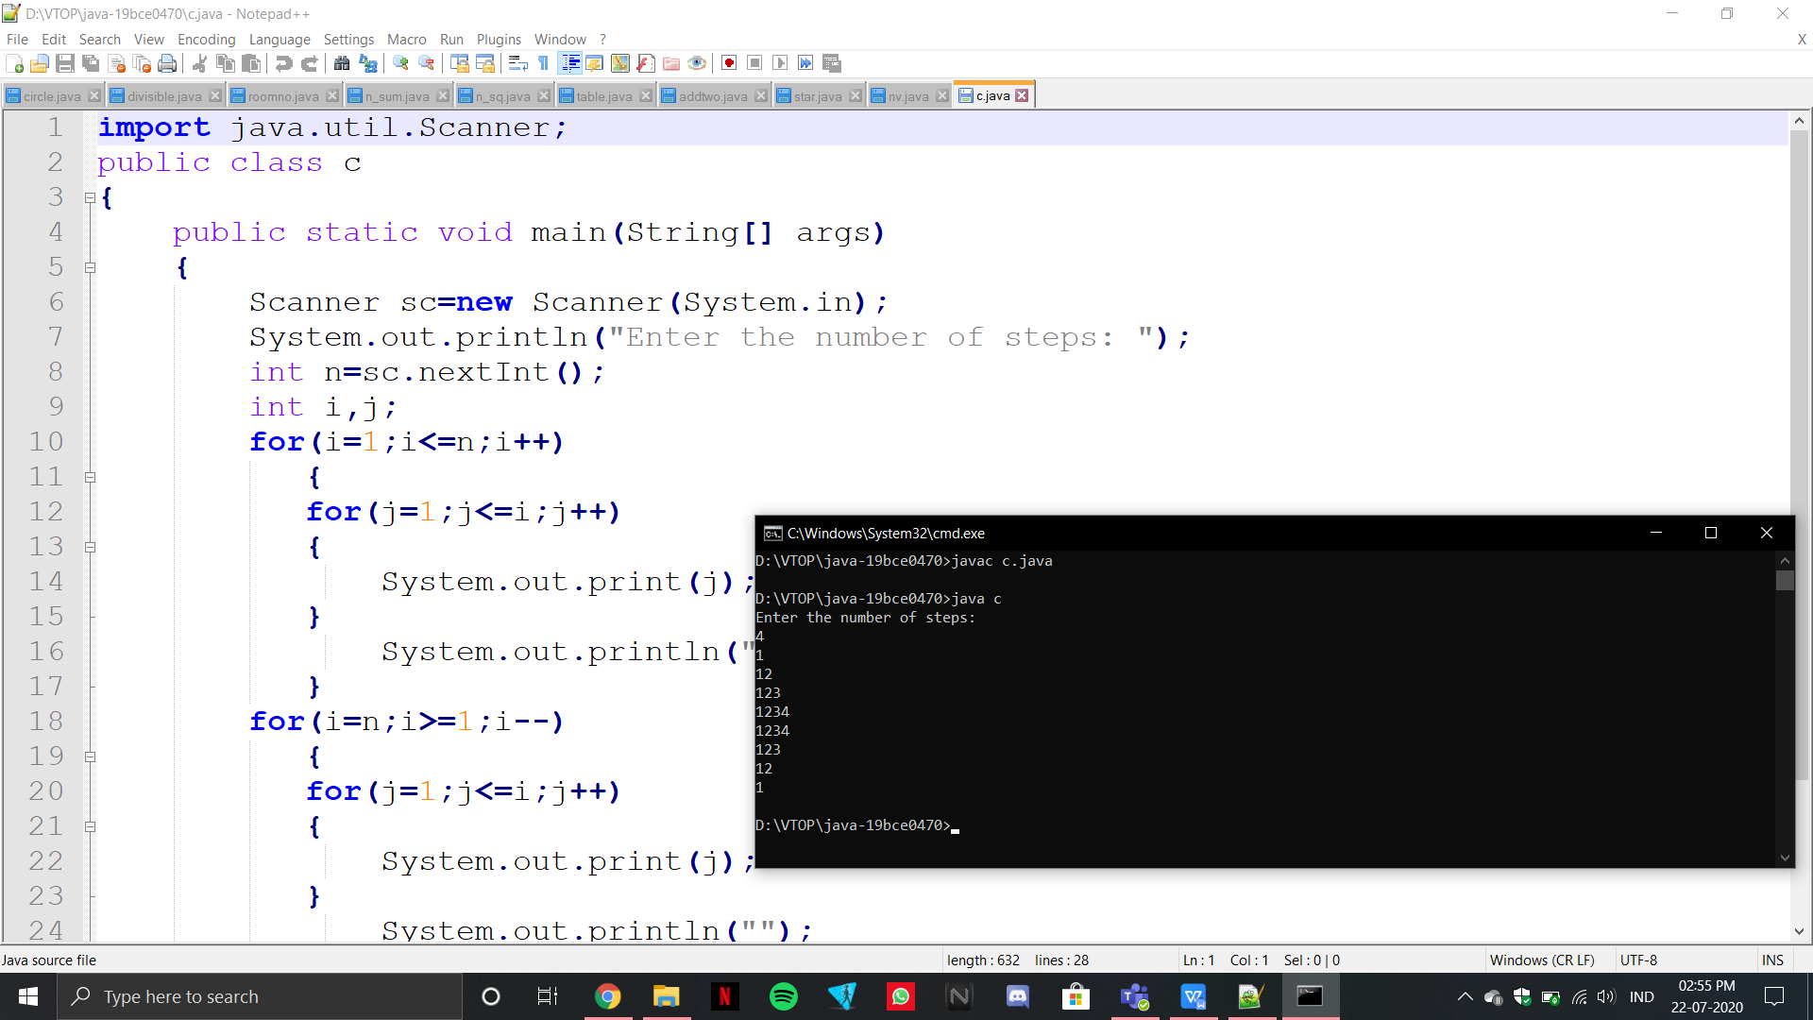

**22-07-2020**

import java.util.Scanner;

public class sum_row

{

public static void main(String[] args) {

int r, c, sum;

Scanner sc=new Scanner(System.in);

System.out.println("Enter the number of rows: ");

r=sc.nextInt();

System.out.println("Enter the number of columns: ");

c=sc.nextInt();

System.out.println("Enter array elements : ");

int m[][]=new int[r][c];

for(int i=0; i<r;i++)

{

for(int j=0; j<c;j++)

{

m[i][j]=sc.nextInt();

}

}

for(int i = 0; i < r; i++){

sum = 0;

for(int j = 0; j < c; j++){

sum = sum + m[i][j];

}

System.out.println("Sum of row " + (i+1) +": " + sum);

}

}

}

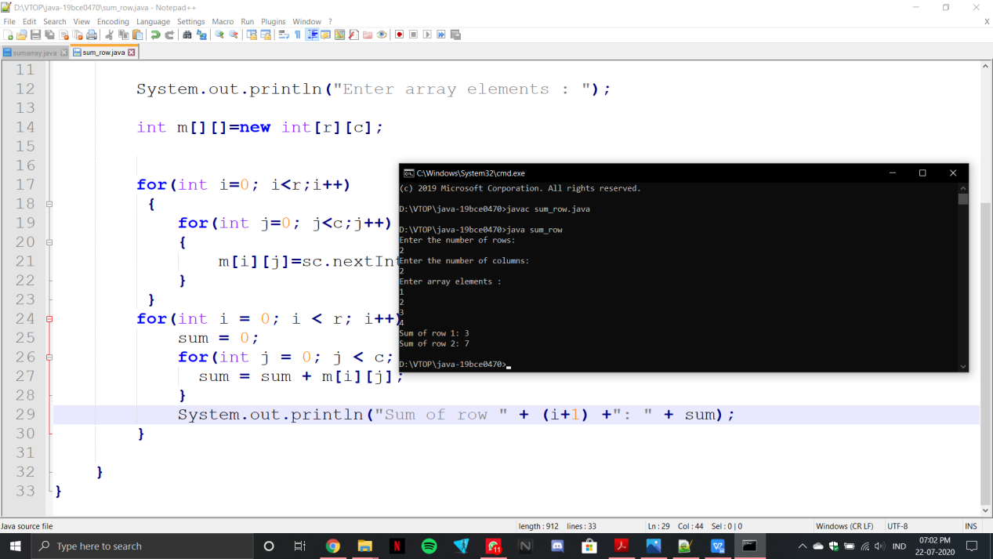

import java.util.Scanner;

public class sumarray

{

public static void main (String[]args)

{

Scanner sc = new Scanner (System.in);

System.out.println ("Enter number of rows for m1: ");

int r1 = sc.nextInt ();

System.out.println ("Enter number of columns for m1: ");

int c1 = sc.nextInt ();

int[][] m1 = new int[r1][c1];

System.out.println ("Enter number of rows for m2: ");

int r2 = sc.nextInt ();

System.out.println ("Enter number of columns for m2: ");

int c2 = sc.nextInt ();

int[][] m2 = new int[r2][c2];

System.out.println ("Enter number of rows for m3: ");

int r3 = sc.nextInt ();

System.out.println ("Enter number of columns for m3: ");

int c3 = sc.nextInt ();

int[][] m3 = new int[r3][c3];

for (int i = 0; i < r1; i++)

{

for (int j = 0; j < c1; j++)

{

m1[i][j] = sc.nextInt();

}

}

for (int i = 0; i < r2; i++)

{

for (int j = 0; j < c2; j++)

{

m2[i][j] = sc.nextInt();

}

}

for(int i=0;i<r3;i++){

for(int j=0;j<c3;j++){

m3[i][j]=m1[i][j]+m2[i][j];

System.out.print(m3[i][j]+" ");

}

}

}

}

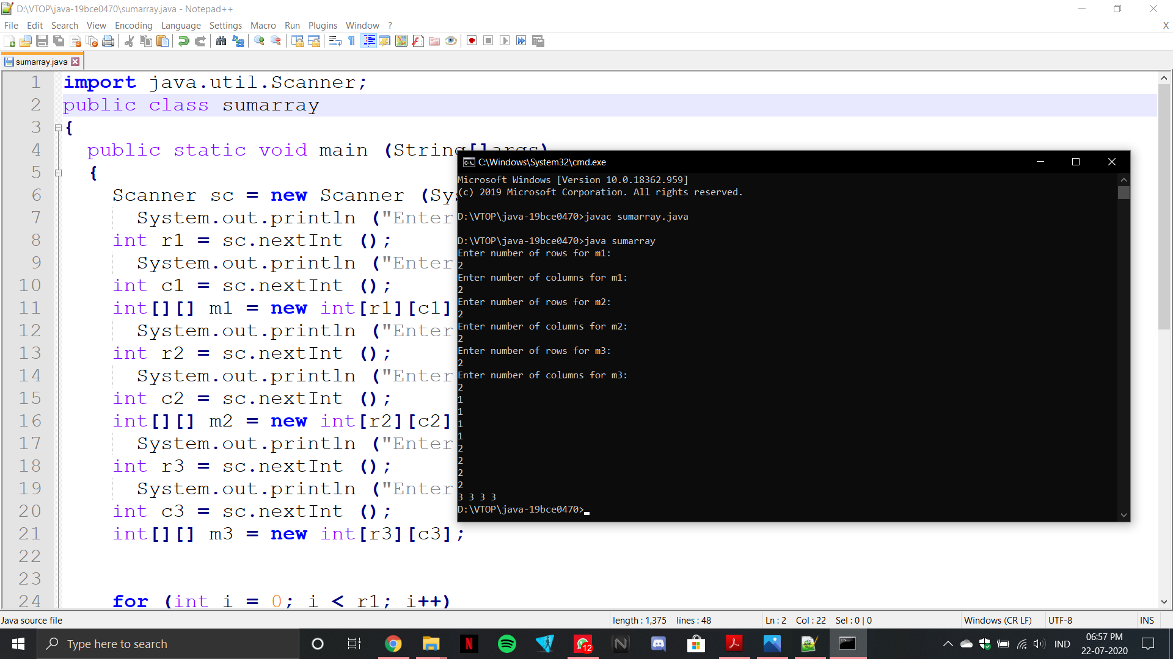

3.

import java.util.Scanner;

public class transpose

{

public static void main(String args[])

{

int i, j;

Scanner s = new Scanner(System.in);

System.out.println("Enter the number of rows: ");

int r = s.nextInt();

System.out.println("Enter the number of columns: ");

int c = s.nextInt();

int arr[][] = new int[r][c];

System.out.println("Enter the elements of the matrix: ");

for(i=0;i<r;i++)

{

for(j=0;j<c;j++)

{

arr[i][j] = s.nextInt();

System.out.print(" ");

}

}

System.out.println("The matrix is: ");

for(i=0;i<r;i++)

{

for(j=0; j<c;j++)

{

System.out.print(arr[i][j]+"\t");

}

System.out.println(" ");

}

System.out.println("The transpose of the matrix is: ");

for(i=0;i<c;i++)

{

for(j=0;j<r;j++)

{

System.out.print(arr[j][i]+"\t");

}

System.out.println(" ");

}

}

}

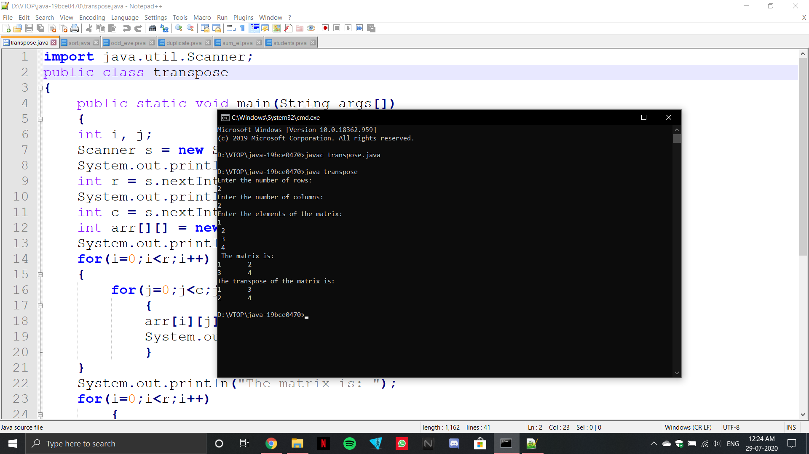

4.

import java.util.Scanner;

public class sort {

public static void main (String [] args) {

Scanner sc=new Scanner(System.in);

System.out.println("Enter the number of elements in the array: ");

int n;

n=sc.nextInt();

int arr[]=new int[n];

System.out.println("Enter elements of the array: ");

for (int i=0;i<n;i++) {

arr[i]=sc.nextInt();

}

int t;

for (int i=1;i<n; i++) {

for (int j=i;j>0;j--) {

if (arr[j]<arr[j - 1]) {

t=arr[j];

arr[j]=arr[j-1];

arr[j-1]=t;

}

}

}

System.out.println("The sorted array is: ");

for (int i=n-1;i>=0;i--) {

System.out.println(arr[i]);

}

}

}

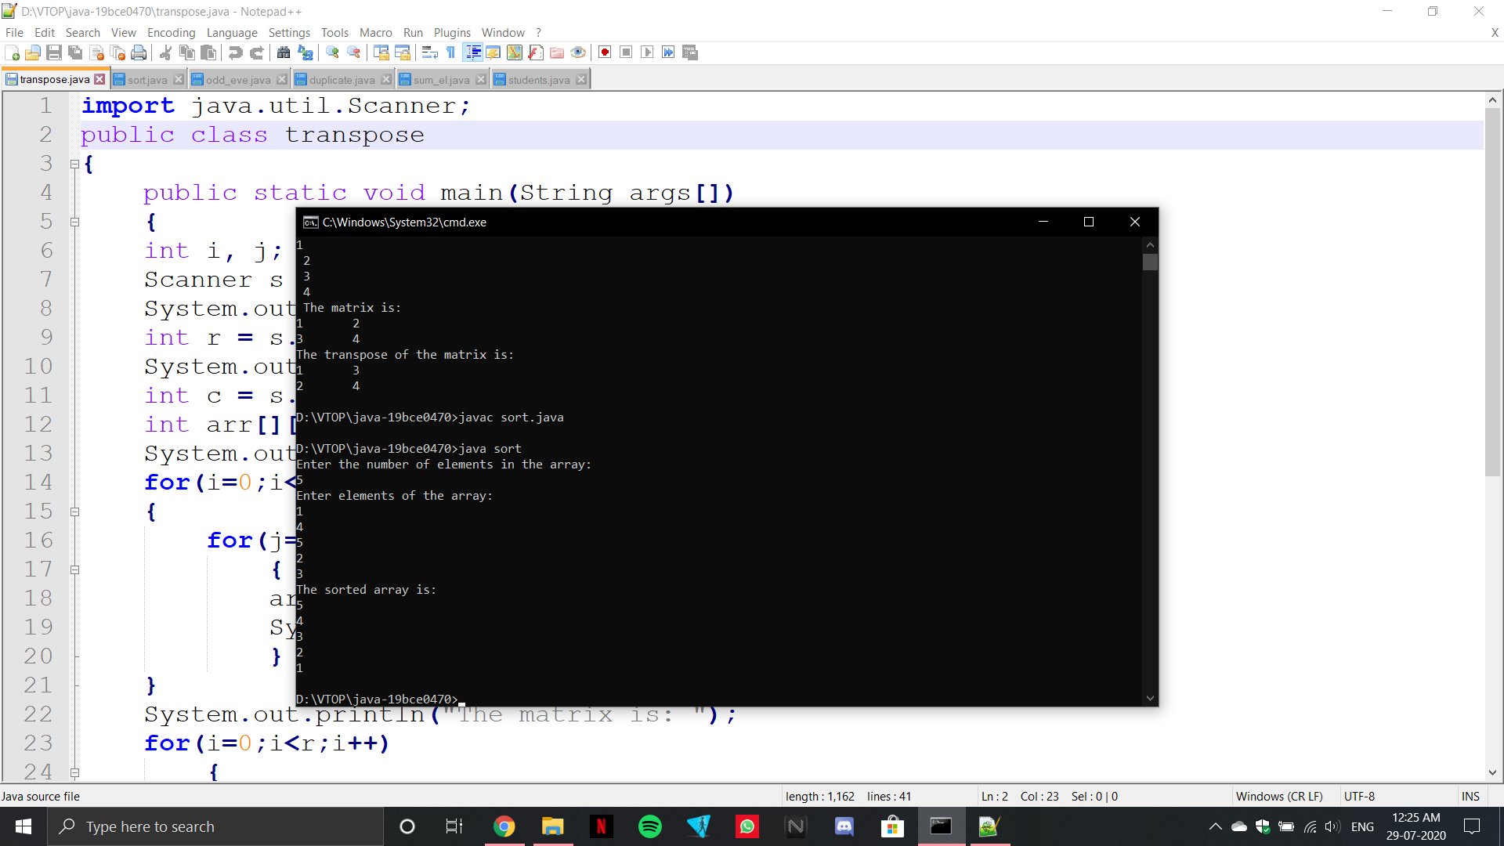

import java.util.Scanner;

public class odd_eve

{

public static void main(String[] args) {

Scanner sc=new Scanner(System.in);

int n;

int i;

System.out.println("Enter size of array: ");

n=sc.nextInt();

int arr[]=new int[n];

System.out.println("Enter the elements of the array: ");

for(i=0;i<n;i++)

{

arr[i]=sc.nextInt();

}

System.out.println("Even");

for(i=0;i<n;i++)

{

if(arr[i]%2==0)

{

System.out.println(arr[i]);

}

}

System.out.println("Odd");

for(i=0;i<n;i++)

{

if(arr[i]%2!=0)

{

System.out.println(arr[i]);

}

}

}

}

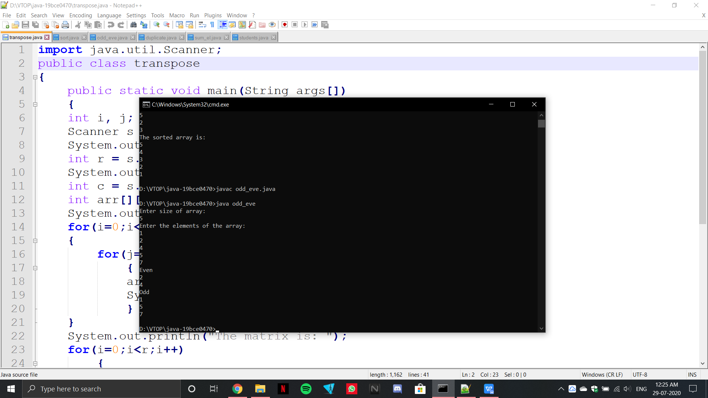

import java.util.Scanner;

public class duplicate

{

public static void main(String[] args) {

Scanner sc=new Scanner(System.in);

int n;

int i;

System.out.println("Enter the number of elements in array: ");

n=sc.nextInt();

int arr[]=new int[n];

System.out.println("Enter the elements of the array: ");

for(i=0;i<n;i++)

{

arr[i]=sc.nextInt();

}

for(i=0;i<n;i++)

{

if(arr[i]==arr[i+1])

{

n=n-1;

}

}

System.out.println("The length of new array: ");

System.out.println(n);

}

}

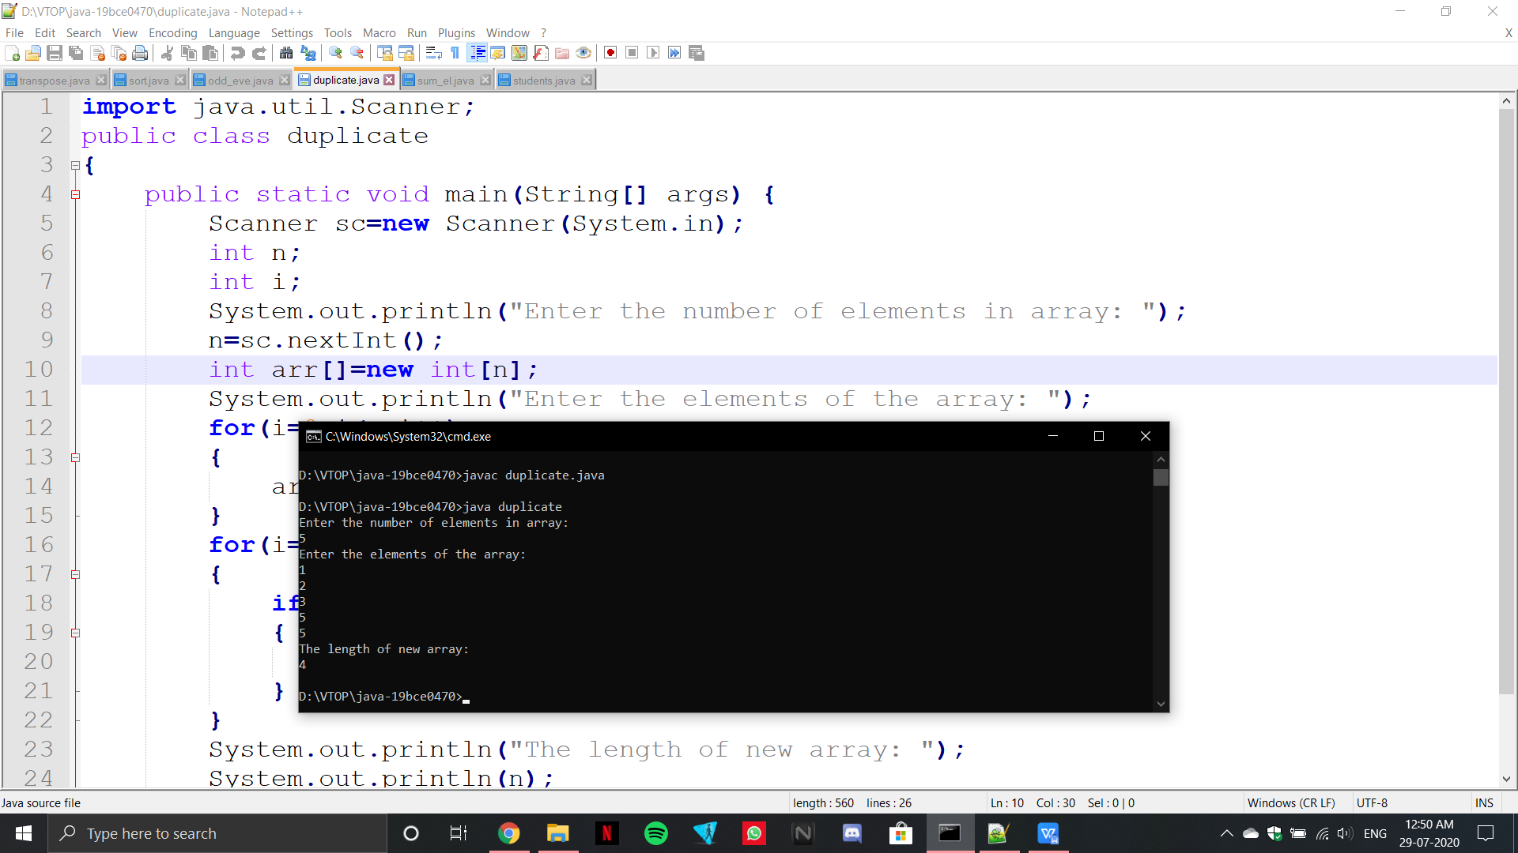

import java.util.Scanner;

public class sum_el

{

static void pair(int arr[], int input)

{

System.out.println("Pairs of elements whose sum is "+input+" are : ");

for (int i = 0; i < arr.length; i++)

{

for (int j = i+1; j < arr.length; j++)

{

if(arr[i]+arr[j] == input)

{

System.out.println(arr[i]+" + "+arr[j]+" = "+input);

}

}

}

}

public static void main(String[] args)

{

Scanner sc= new Scanner(System.in);

System.out.println("Enter number of elements in the array: ");

int n= sc.nextInt();

int arr[]= new int[n];

System.out.println("Enter elements in the array: ");

for (int i = 0; i < n; i++)

{

arr[i]=sc.nextInt();

}

System.out.println("Enter input number for checking: ");

int input= sc.nextInt();

pair(arr, input);

}

}

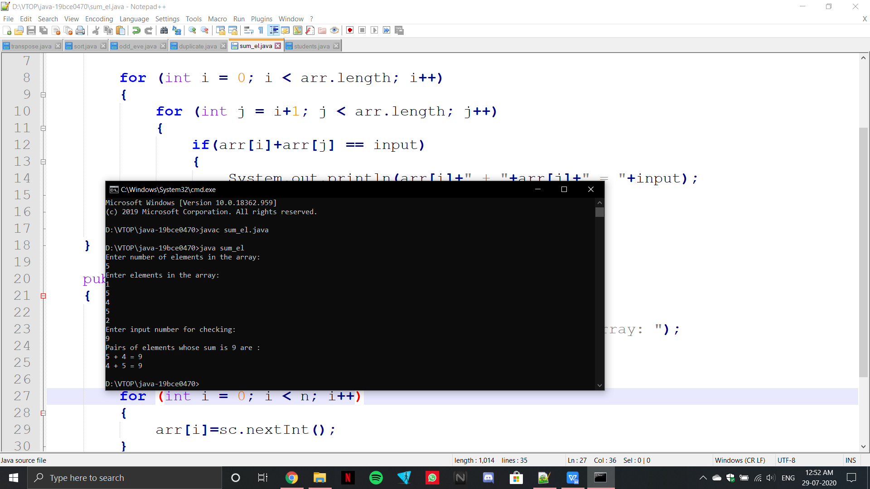

import java.util.Scanner;

public class students

{

public static void main(String arr[])

{

Scanner sc= new Scanner(System.in);

int c,k;

int batch;

int s=0;

System.out.println("Enter the number of batches: ");

batch=sc.nextInt();

int a[][]=new int[batch][];

for(int i=0;i<batch;i++)

{

System.out.println("Enter the number of slow learners in the batch "+(i+1));

c=sc.nextInt();

if(c%4==0)

k=c/4;

else

k=c/4+1;

a[i]=new int[k];

for(int j=0;j<k;j++)

{

if(c>4)

{

a[i][j]=4;

c=c-4;

}

else

{a[i][j]=c;

c=0;

}

}

}

System.out.println("\nThe Number of tutors for each batch: ");

for(int i=0;i<batch;i++)

{

for(int n:a[i])

{

System.out.print(n+"\t");

if(n==4)

s++;

}

System.out.println();

}

System.out.println("\nThe number of tutors with exactly 4 students are: "+s);

}}

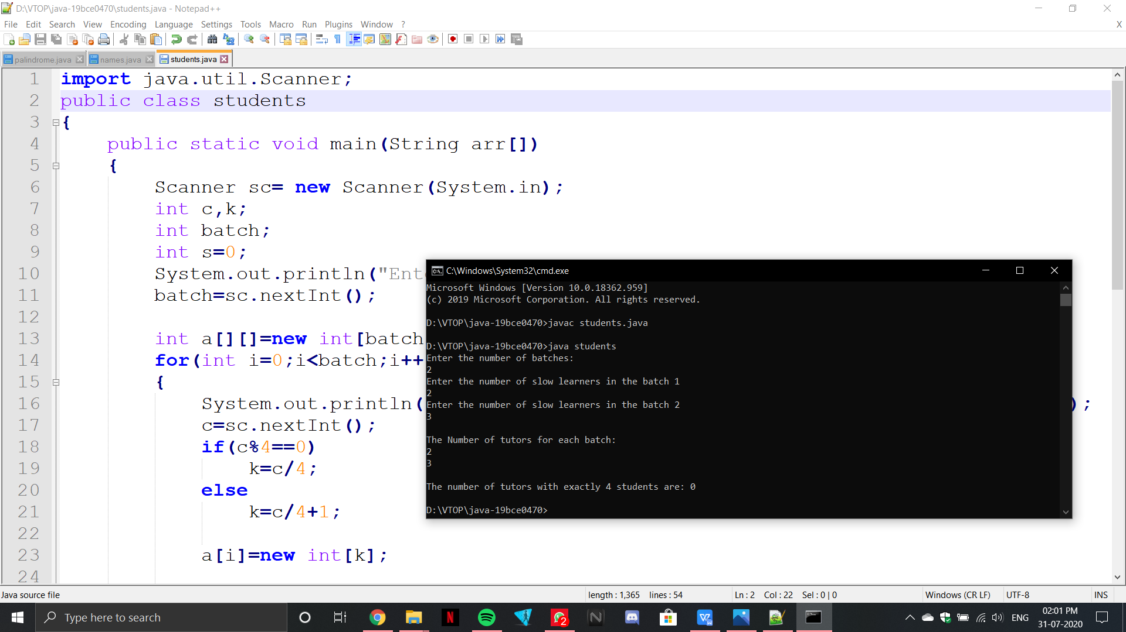

**29-07-2020**

import java.util.Scanner;

public class palindrome {

Scanner sc= new Scanner(System.in);

static boolean palindrome(String str)

{

int i=0;

int j=str.length()-1;

while(i < j) {

if(str.charAt(i)!= str.charAt(j))

return false;

i++;

j--;

}

return true;

}

public static void main(String[] args)

{ Scanner sc= new Scanner(System.in);

System.out.print("Enter the string: ");

String str = sc.nextLine();

if (palindrome(str))

System.out.print("It is a palindrome");

else

System.out.print("It is not a palindrome");

}

}

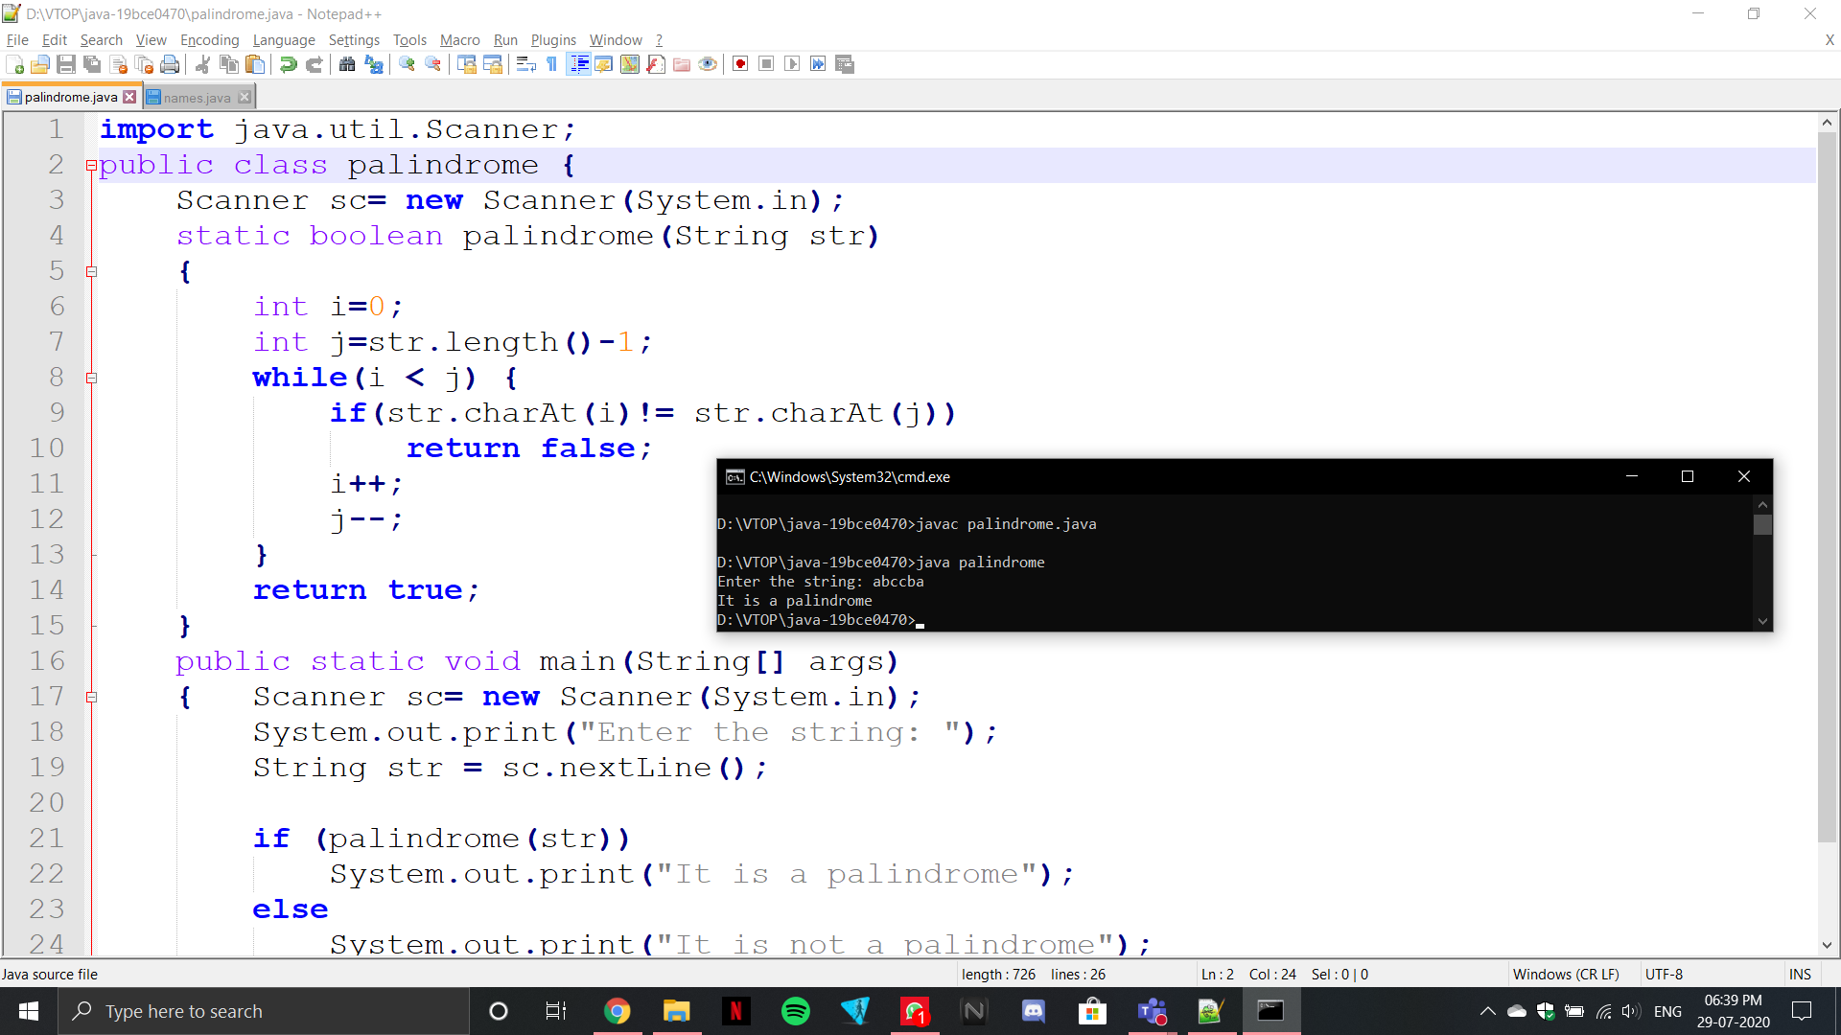

import java.util.Scanner;

public class names

{

public static void main(String[] args)

{

int n;

String temp;

Scanner sc = new Scanner(System.in);

System.out.print("Enter number of names: ");

n = sc.nextInt();

String names[] = new String[n];

Scanner sc2 = new Scanner(System.in);

System.out.println("Enter all the names: ");

for(int i=0; i<n; i++)

{

names[i] = sc2.nextLine();

}

for (int i=0; i<n; i++)

{

for (int j= i+1; j<n; j++)

{

if (names[i].compareTo(names[j])<0)

{

temp = names[i];

names[i] = names[j];

names[j] = temp;

}

}

}

System.out.print("Sorted List: ");

for (int i = 0; i<n; i++)

{

System.out.print(names[i] + " ");

}

}}

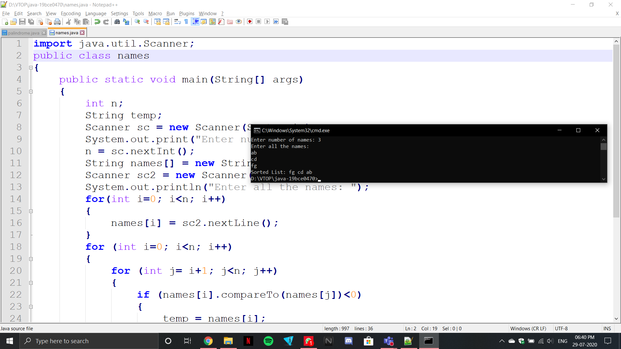

3.

import java.util.Scanner;

import java.util.Arrays;

public class strsort

{

public static String sort(String str)

{

char arr[]=str.toCharArray();

Arrays.sort(arr);

return new String(arr);

}

public static void main(String[] args)

{

Scanner sc=new Scanner(System.in);

System.out.println("Enter the string you want to sort: ");

String str=sc.nextLine();

String t=sort(str);

System.out.println("Sorted string: "+t);

}

}

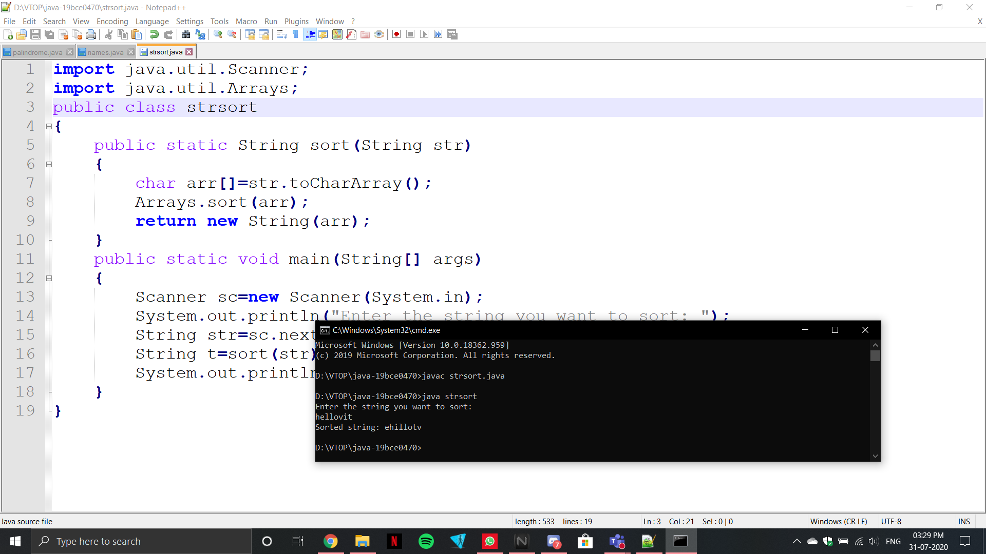

4.

import java.util.Scanner;

public class anagram

{

public static String sort(String s)

{

char[] arr = s.toCharArray();

for(int i=0;i<arr.length;i++)

{

for(int j=i+1;j<arr.length;j++)

{

if(arr[i]>arr[j])

{

char temp;

temp=arr[i];

arr[i]=arr[j];

arr[j]=temp;

}

}

}

String str = String.valueOf(arr);

return str;

}

public static boolean check(String str1, String str2)

{

if(str1.length()!=str2.length())

{

return false;

}

else

{

str1=sort(str1);

str2=sort(str2);

for(int i=0;i<str1.length();i++)

{

if(str1.charAt(i)!=str2.charAt(i))

return false;

}

}

return true;

}

public static void main(String[] args)

{

Scanner input = new Scanner(System.in);

System.out.println("Enter 1st string: ");

String str1= input.nextLine();

System.out.println("Enter 2nd string: ");

String str2= input.nextLine();

if(check(str1.toLowerCase(),str2.toLowerCase()))

{

System.out.println("They are anagram");

}

else{

System.out.println("They are not anagram");

}

}

}

