***Ripunjay Narula (19BCE0470)***

**JAVA PROGRAMMING LAB**

***Digital Assignment***

**File Handling**

1)

StringFormatter.java:

public class StringFormatter {

public static String capitalizeWord(String str){

String words[]=str.split("\\s");

String capitalizeWord="";

for(String w:words){

String first=w.substring(0,1);

String afterfirst=w.substring(1);

capitalizeWord+=first.toUpperCase()+afterfirst+" ";

}

return capitalizeWord.trim();

}

}

TestStringFormatter.java:

public class TestStringFormatter {

public static void main(String[] args) {

System.out.println(StringFormatter.capitalizeWord("String 1 ok"));

System.out.println(StringFormatter.capitalizeWord("String 2 great"));

}

}

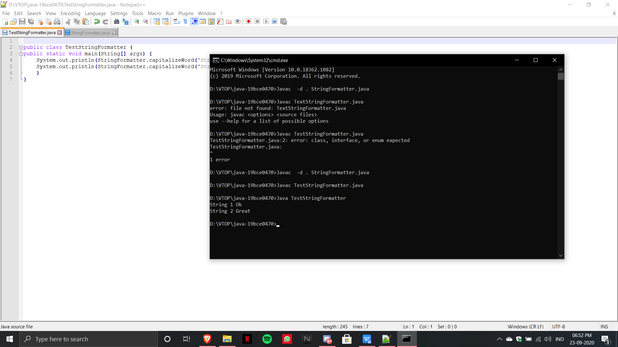

2)

import java.io.*;

import java.util.*;

public class ReverseContent

{

public static void main(String args[])

{

try

{

BufferedReader br=new BufferedReader(new FileReader("D:/VTOP/java-19bce0470/java.txt"));

String s=null;

while((s=br.readLine()) != null)

{

StringBuilder input= new StringBuilder();

input.append(s);

input=input.reverse();

System.out.println(input);

}

}

catch(Exception e){

System.err.println("Error: Target File Cannot Be Read");

}

}

}

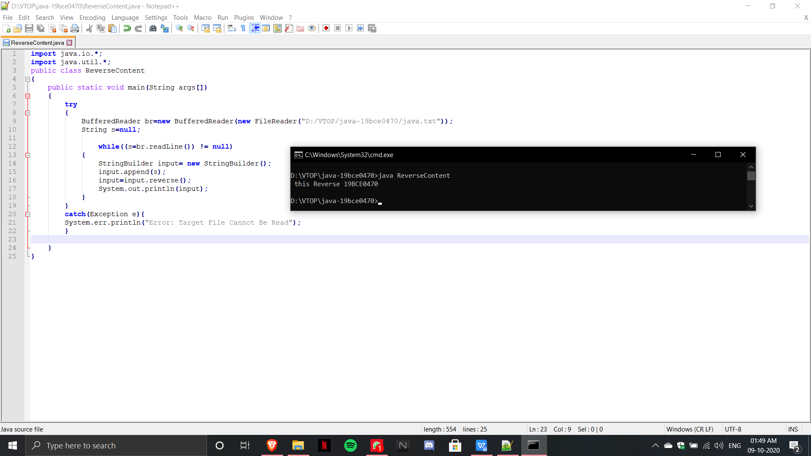

3)

import java.io.*;

import java.util.Scanner;

public class Employee implements Serializable

{

String EmpId;

String Name;

float Salary;

String Address;

Employee(String EmpId, String Name, float Salary,String Address)

{

this.EmpId=EmpId;

this.Name=Name;

this.Salary=Salary;

this.Address=Address;

}

public static void main(String args[])

{

try

{

Scanner input= new Scanner(System.in);

System.out.println("Enter EmpId");

String EmpId=input.nextLine();

System.out.println("Enter Name");

String Name=input.nextLine();

System.out.println("Enter Address");

String Address=input.nextLine();

System.out.println("Enter Salary");

float Salary=input.nextFloat();

Employee e=new Employee(EmpId,Name,Salary,Address);

FileOutputStream fout=new FileOutputStream("Employee.txt");

ObjectOutputStream out=new ObjectOutputStream(fout);

out.writeObject(e);

out.flush();

ObjectInputStream in=new ObjectInputStream(new FileInputStream("Employee.txt"));

Employee read=(Employee)in.readObject();

System.out.println(read.EmpId+" "+read.Name+" "+read.Salary+" "+read.Address);

in.close();

}

catch(Exception e){

System.err.println("Error: Target File Cannot Be Read");

}

}

}

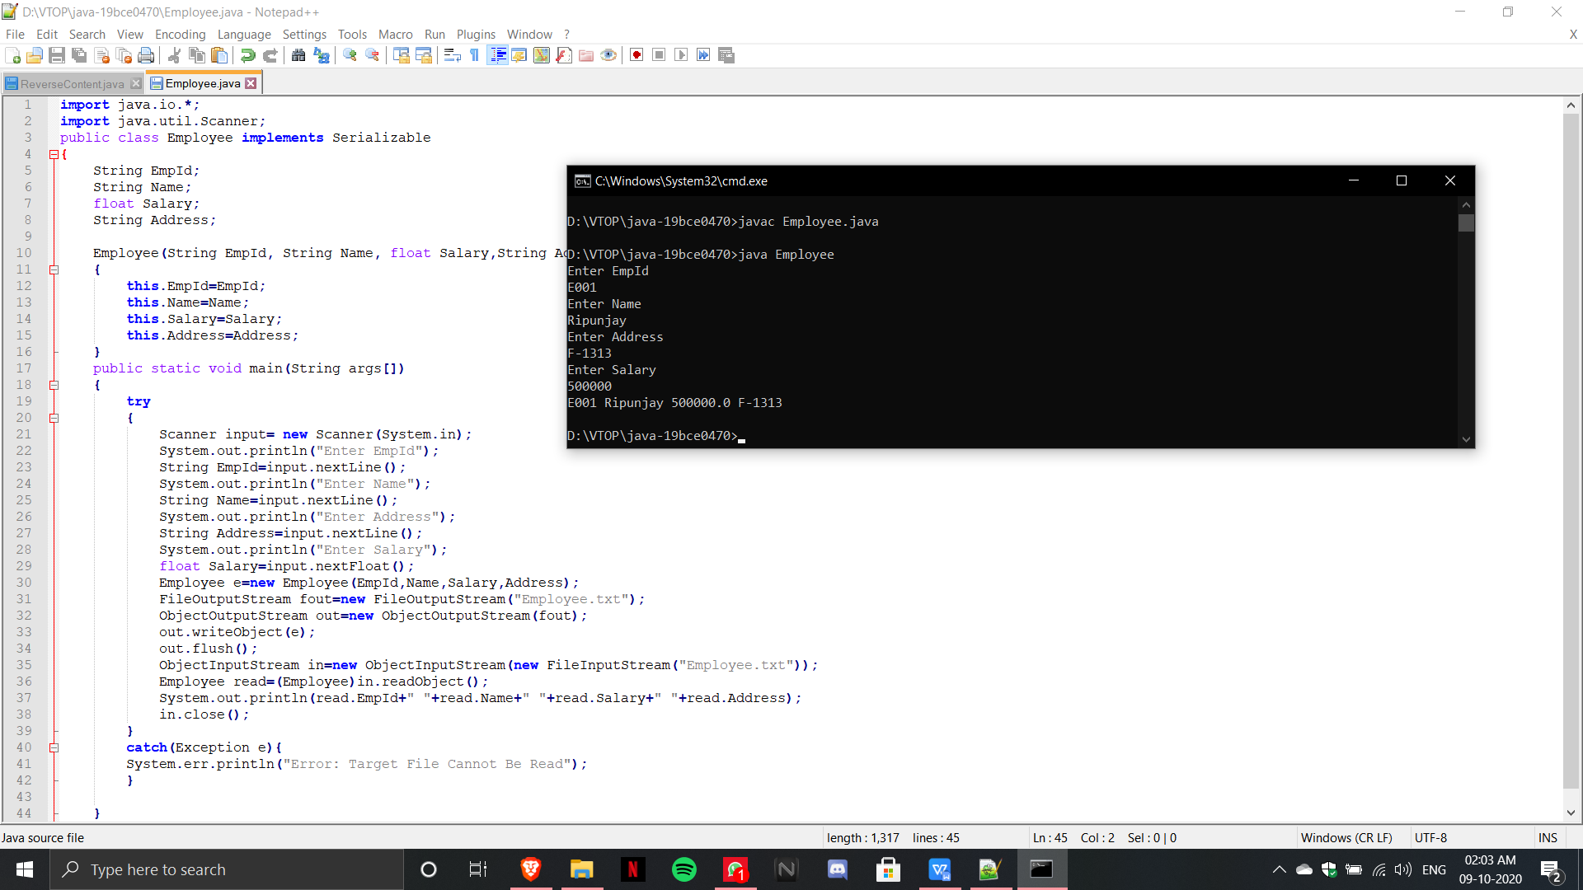

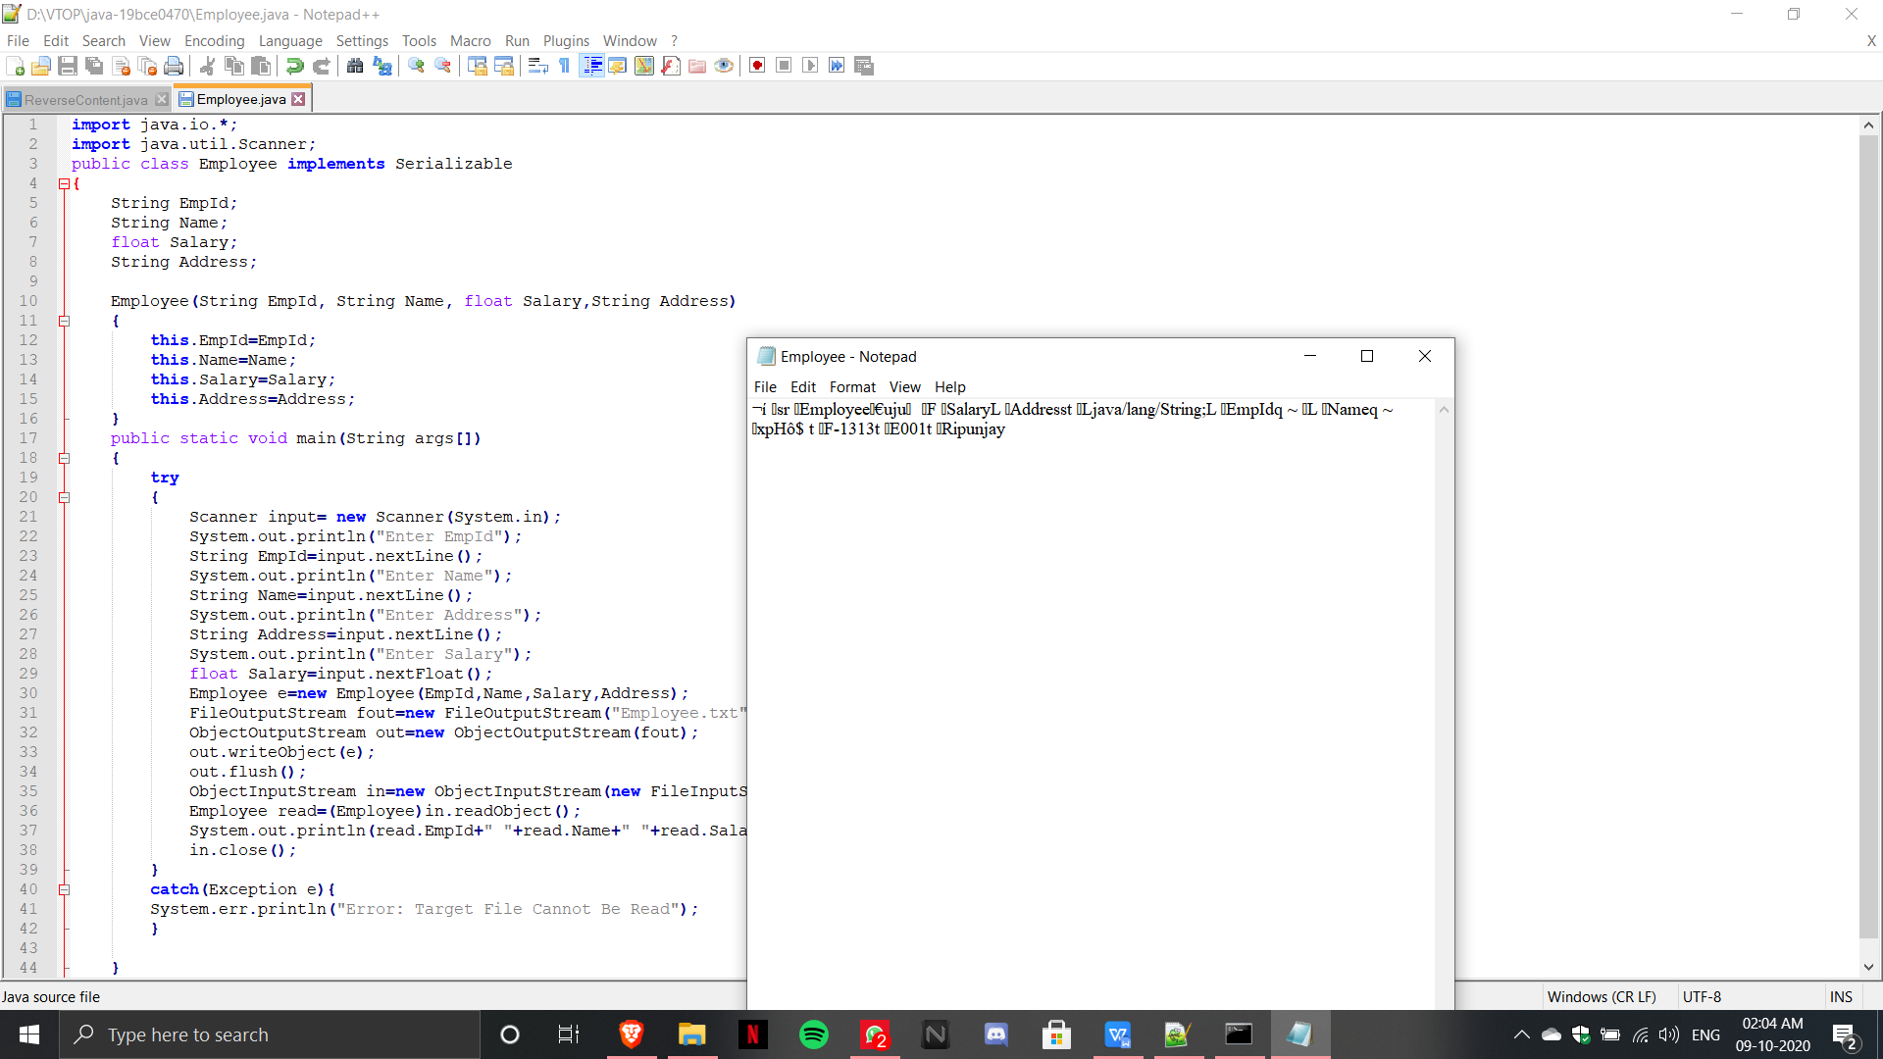

4)

import java.io.*;

public class LCase

{

public static void main(String args[])

{

try

{

BufferedReader br=new BufferedReader(new FileReader("D:/VTOP/java-19bce0470/LowerCase.txt"));

String s=null;

while((s=br.readLine()) != null)

{

System.out.println(s.toLowerCase());

}

}

catch(Exception e){

System.err.println("Error: Target File Cannot Be Read");

}

}

}

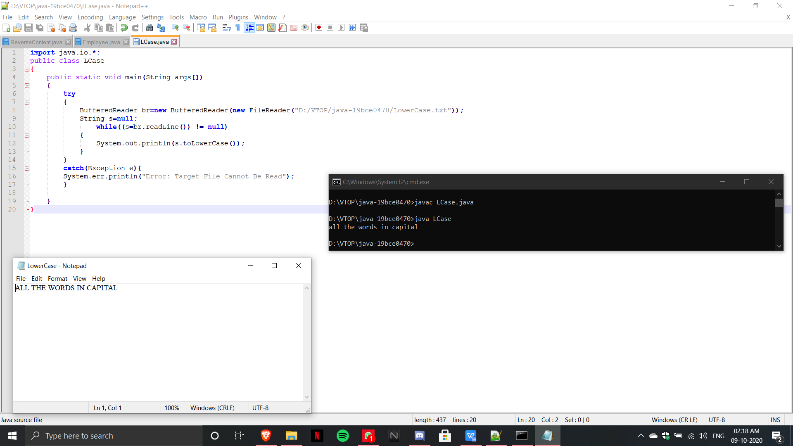

5)

import java.io.*;

public class FileCharacterCount

{

public static void main(String args[])

{

try

{

BufferedReader br=new BufferedReader(new FileReader("D:/VTOP/java-19bce0470/LowerCase.txt"));

String s=null;

int count=0;

while((s=br.readLine()) != null)

{

count+=s.length();

}

System.out.println("Character Count of File is: "+count);

}

catch(Exception e){

System.err.println("Error: Target File Cannot Be Read");

}

}

}

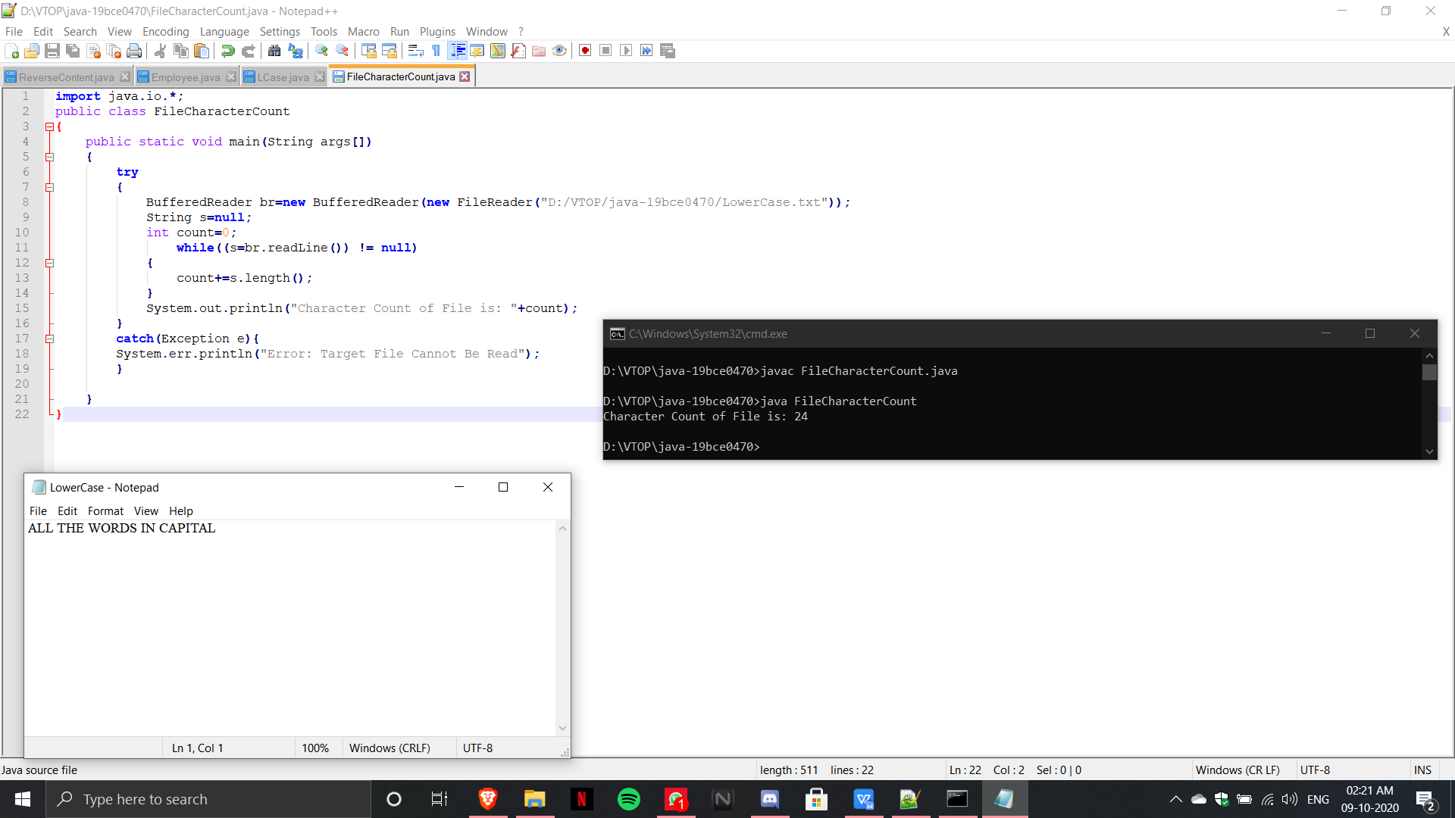

6)

import java.io.*;

public class MergeLines

{

public static void main(String args[])

{

try

{

BufferedReader br1=new BufferedReader(new FileReader("D:/VTOP/java-19bce0470/file1.txt"));

BufferedReader br2=new BufferedReader(new FileReader("D:/VTOP/java-19bce0470/file2.txt"));

BufferedWriter bw=new BufferedWriter(new FileWriter("D:/VTOP/java-19bce0470/file3.txt"));

String s=null;

while((s=br1.readLine()) != null)

{

bw.write(s);

}

while((s=br2.readLine()) != null)

{

bw.write(s);

}

br1.close();

br2.close();

bw.close();

System.out.println("Success");

}

catch(Exception e){

System.err.println("Error: Target File Cannot Be Read");

}

}

}

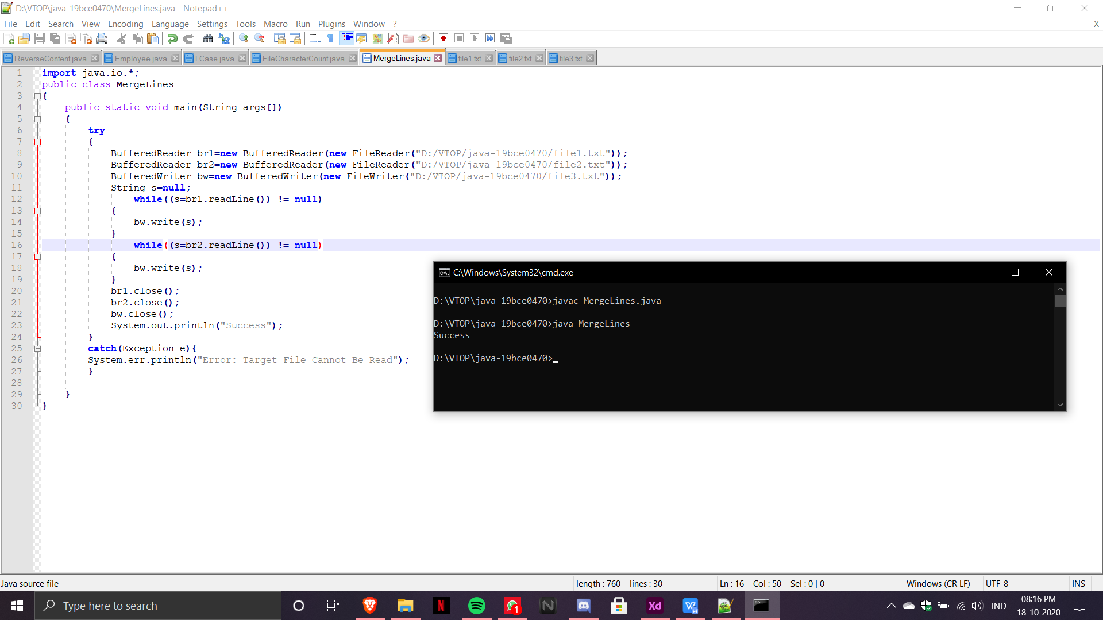

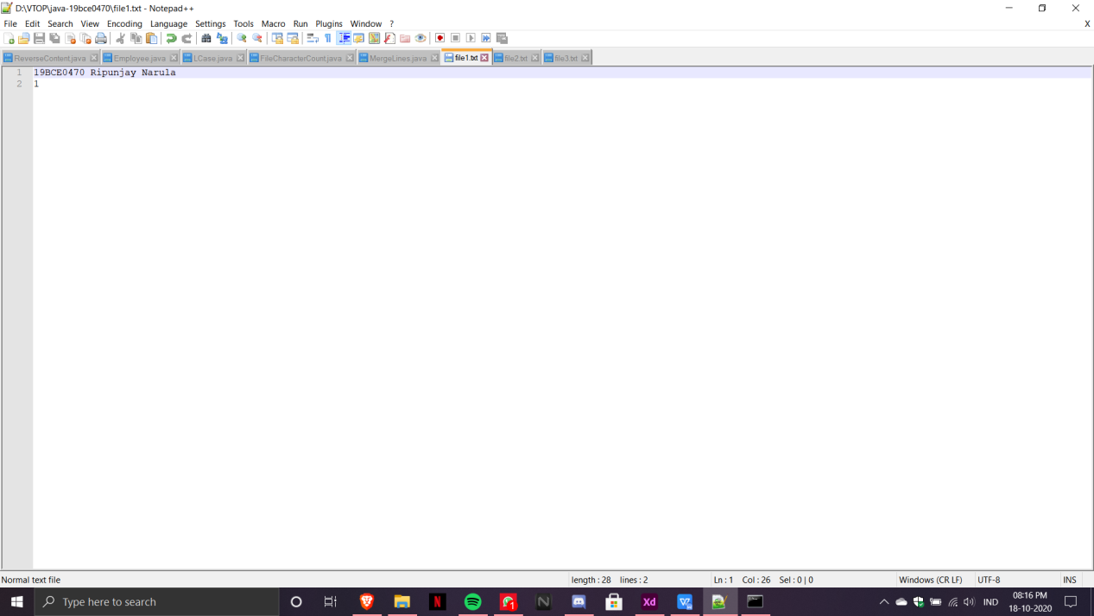

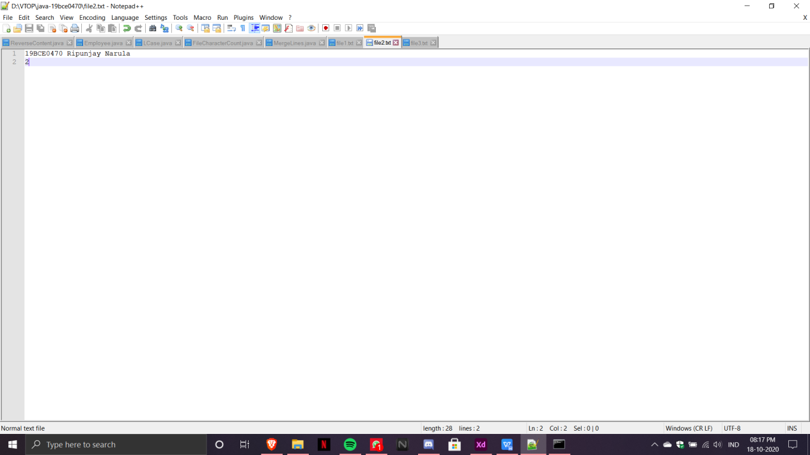

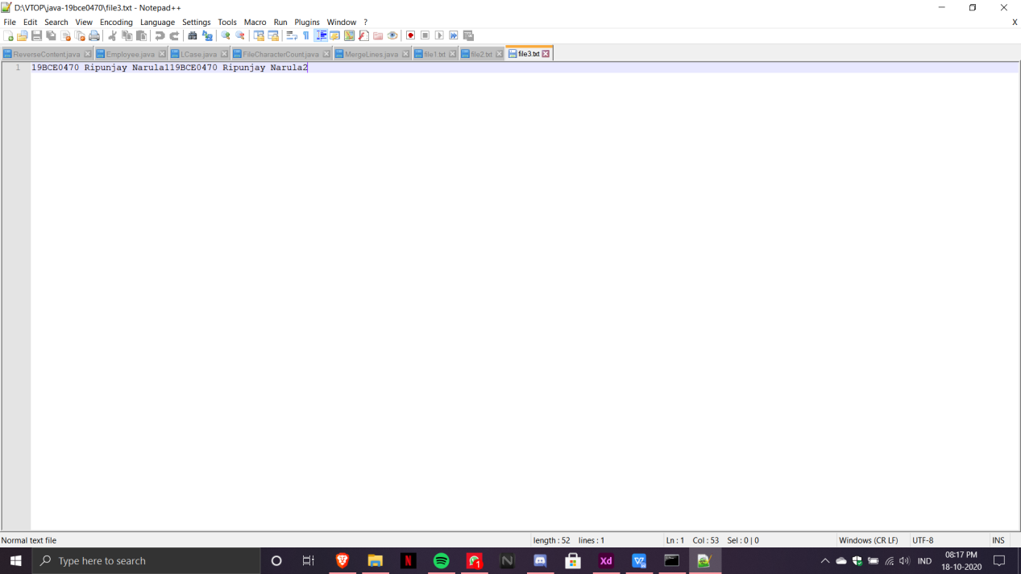

7)

import java.io.*;

public class collectstats

{

public static void main(String args[])

{

try

{

BufferedReader br=new BufferedReader(new FileReader("D:/VTOP/java-19bce0470/statsfile.txt"));

String s=null;

int count=0;

int countb=0;

int countsemi=0;

while((s=br.readLine()) != null)

{

if (s.trim().isEmpty())

{

countb++;

}

else if(s.endsWith(";"))

{

countsemi++;

}

else

{

}

count++;

}

System.out.println("The Statistics are:");

System.out.println(" Total Lines: "+count);

System.out.println("no. of Blank SLines: "+countb);

System.out.println("no. of Lines Ending with Semicolon: "+countsemi);

}

catch(Exception e){

System.err.println("Error: Target File Cannot Be Read");

}

}

}

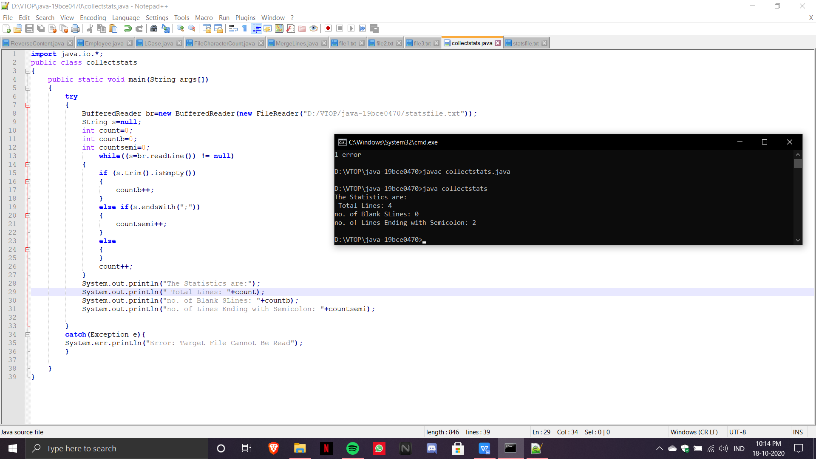

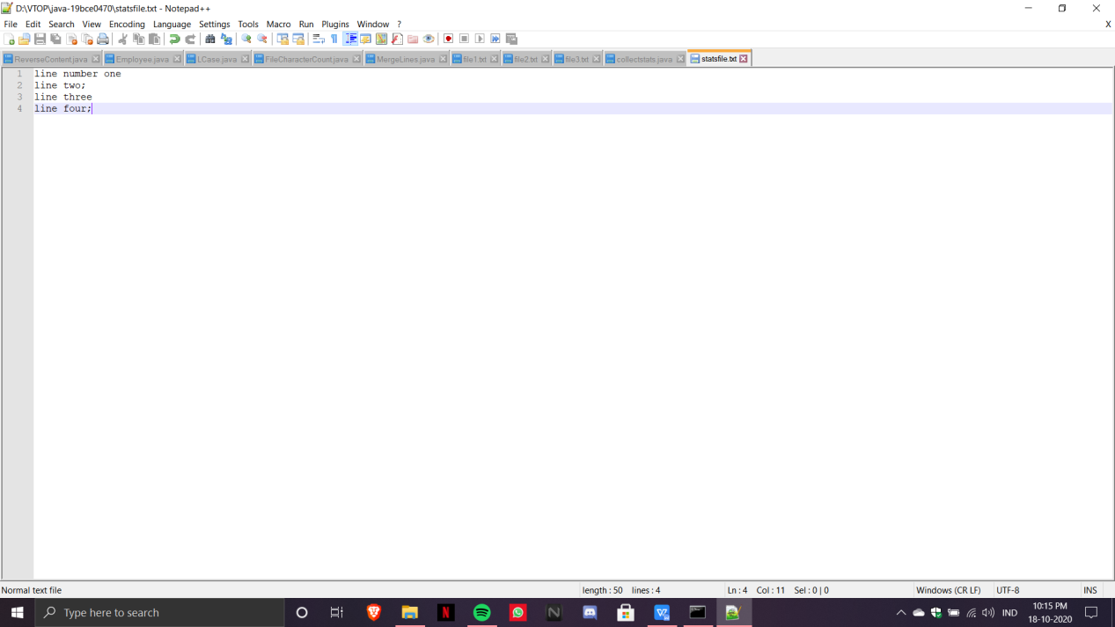

**Serialisation and Collection**

1)

import java.io.*;

import java.util.Scanner;

public class Employee implements Serializable

{

String EmpId;

String Name;

float Salary;

String Designation;

Employee(String EmpId, String Name, float Salary,String Designation)

{

this.EmpId=EmpId;

this.Name=Name;

this.Salary=Salary;

this.Designation=Designation;

}

public static void main(String args[])

{

try

{

Scanner input= new Scanner(System.in);

FileOutputStream fout=new FileOutputStream("Employee_Data.txt");

ObjectOutputStream out=new ObjectOutputStream(fout);

Employee e[]=new Employee[3];

for(int i=0;i<3;i++)

{

System.out.println("Enter EmpId: ");

String EmpId=input.nextLine();

System.out.println("Enter Name: ");

String Name=input.nextLine();

System.out.println("Enter Designation: ");

String Designation=input.nextLine();

System.out.println("Enter Salary: ");

float Salary=input.nextFloat();

input.nextLine();

e[i]=new Employee(EmpId,Name,Salary,Designation);

out.writeObject(e[i]);

}

out.flush();

ObjectInputStream in = new ObjectInputStream(new FileInputStream("Employee_Data.txt"));

while (true) {

try {

Employee read = (Employee) in.readObject();

if(read.Salary<50000){

System.out.println(read.EmpId+" "+read.Name+" "+read.Salary+" "+read.Designation);

}

} catch (EOFException exp) {

break;

}

}

in.close();

}

catch(Exception e){

System.err.println("Error: Target File Cannot Be Read");

}

}

}

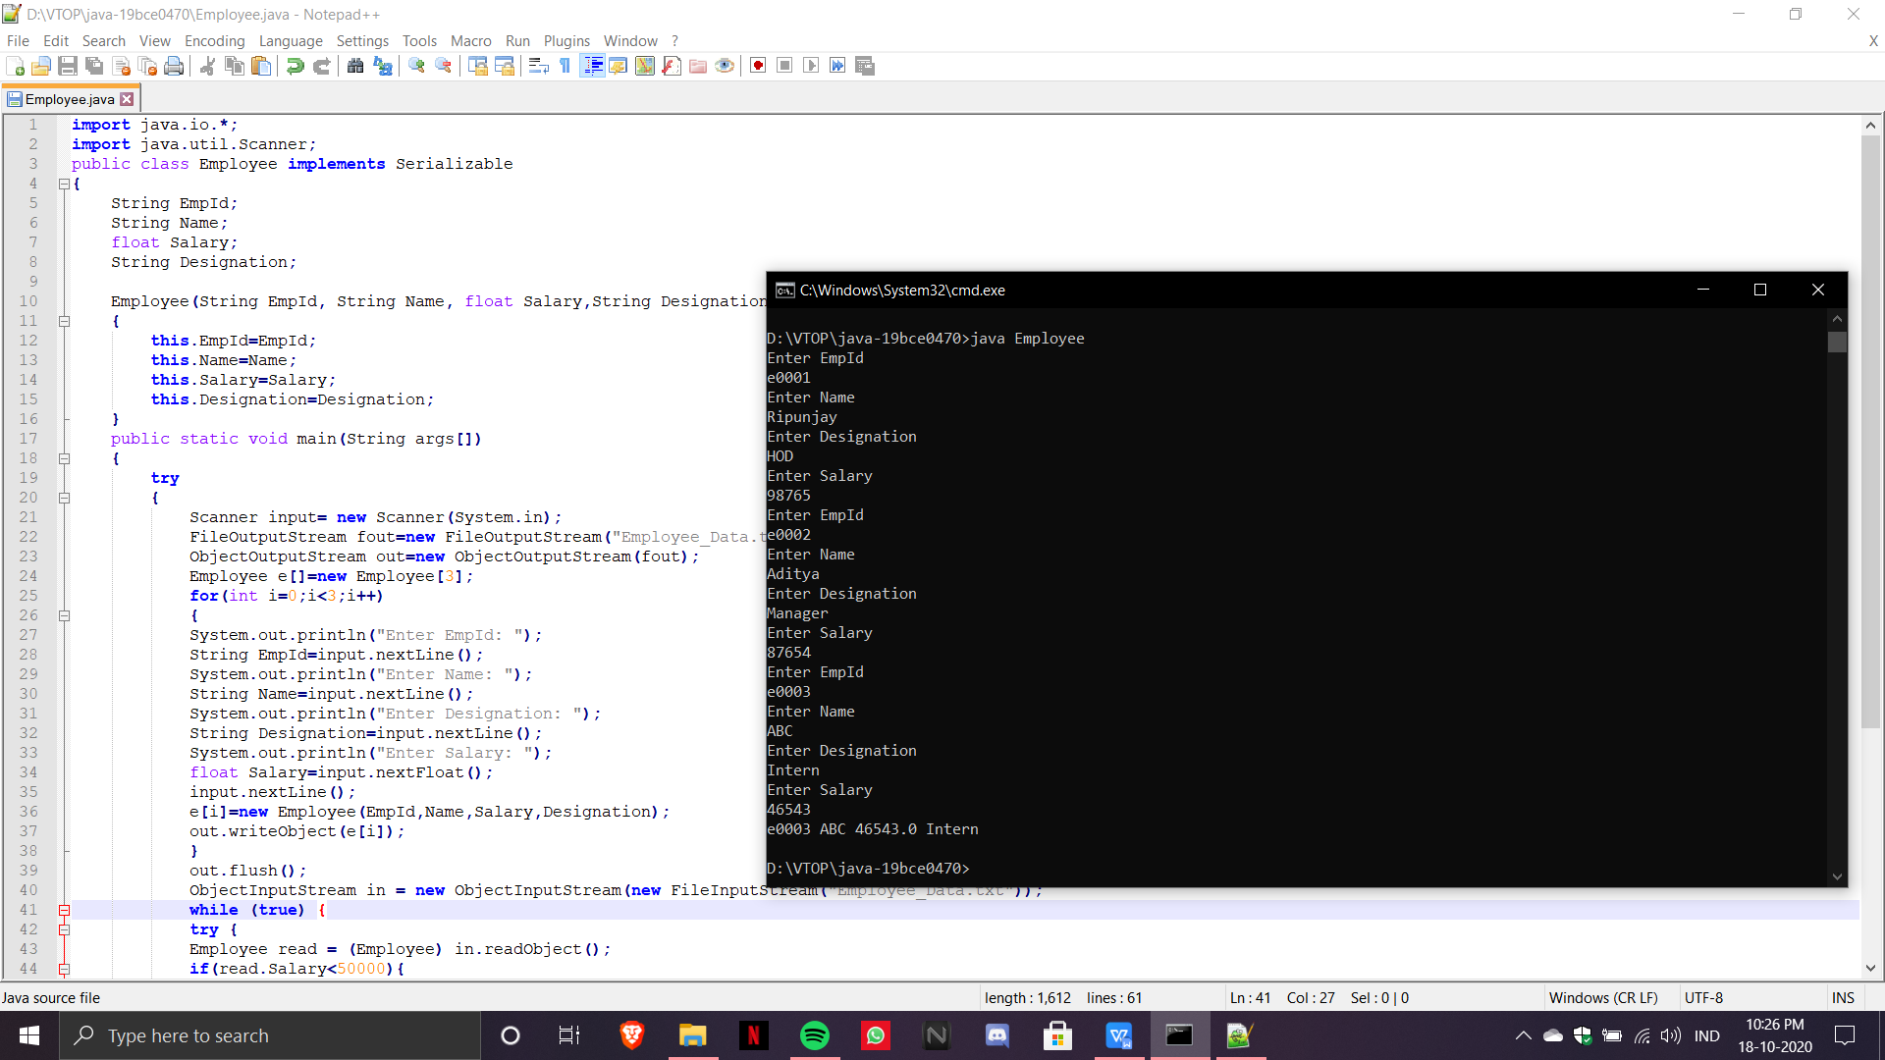

2)

import java.io.*;

import java.util.Scanner;

class Loan implements Serializable

{

String CustomerName;

String Address;

int Age;

float Salary;

float LoanAmount;

String LoanType;

Loan(String CustomerName,String Address,int Age,float Salary,float LoanAmount,String LoanType)

{

this.CustomerName=CustomerName;

this.Address=Address;

this.Age=Age;

this.Salary=Salary;

this.LoanAmount=LoanAmount;

this.LoanType=LoanType;

}

public static void main(String args[])

{

try{

Scanner input= new Scanner(System.in);

FileOutputStream fout=new FileOutputStream("Loan.txt");

ObjectOutputStream out=new ObjectOutputStream(fout);

Loan l[]= new Loan[3];

for(int i=0;i<3;i++)

{

System.out.println("Enter Customer's Name: ");

String CustomerName= input.nextLine();

System.out.println("Enter Address: ");

String Address= input.nextLine();

System.out.println("Enter Loan Type: ");

String LoanType=input.nextLine();

System.out.println("Enter Age: ");

int Age=input.nextInt();

System.out.println("Enter Salary: ");

float Salary= input.nextFloat();

System.out.println("Enter Loan Amount: ");

float LoanAmount= input.nextFloat();

input.nextLine();

l[i]= new Loan(CustomerName,Address,Age,Salary,LoanAmount,LoanType);

out.writeObject(l[i]);

}

out.flush();

ObjectInputStream in = new ObjectInputStream(new FileInputStream("Loan.txt"));

while (true) {

try {

Loan read = (Loan) in.readObject();

if(!((read.CustomerName).matches("[A-Za-z]+")))

{

System.out.println("Name Invalid");

}

else if(read.Age<18)

{

System.out.println("Invalid! Minimum Age not met");

}

else if(read.Salary<20000)

{

System.out.println("Invalid! Minimum Salary not met");

}

else if((read.Salary*100000)/2162>=read.LoanAmount)

{

System.out.println("Invalid! Exceeds eligible loan amount");

}

else if(((read.LoanType).equals("housing"))||((read.LoanType).equals("vehicle"))||((read.LoanType).equals("personal")))

{

System.out.println("Invalid Loan Type");

}

else{

System.out.println("Valid");

}

} catch (EOFException exp) {

break;

}

}

in.close();

}

catch(Exception e)

{

e.printStackTrace();

System.err.println("Error: Target File Cannot Be Read");

}

}

}

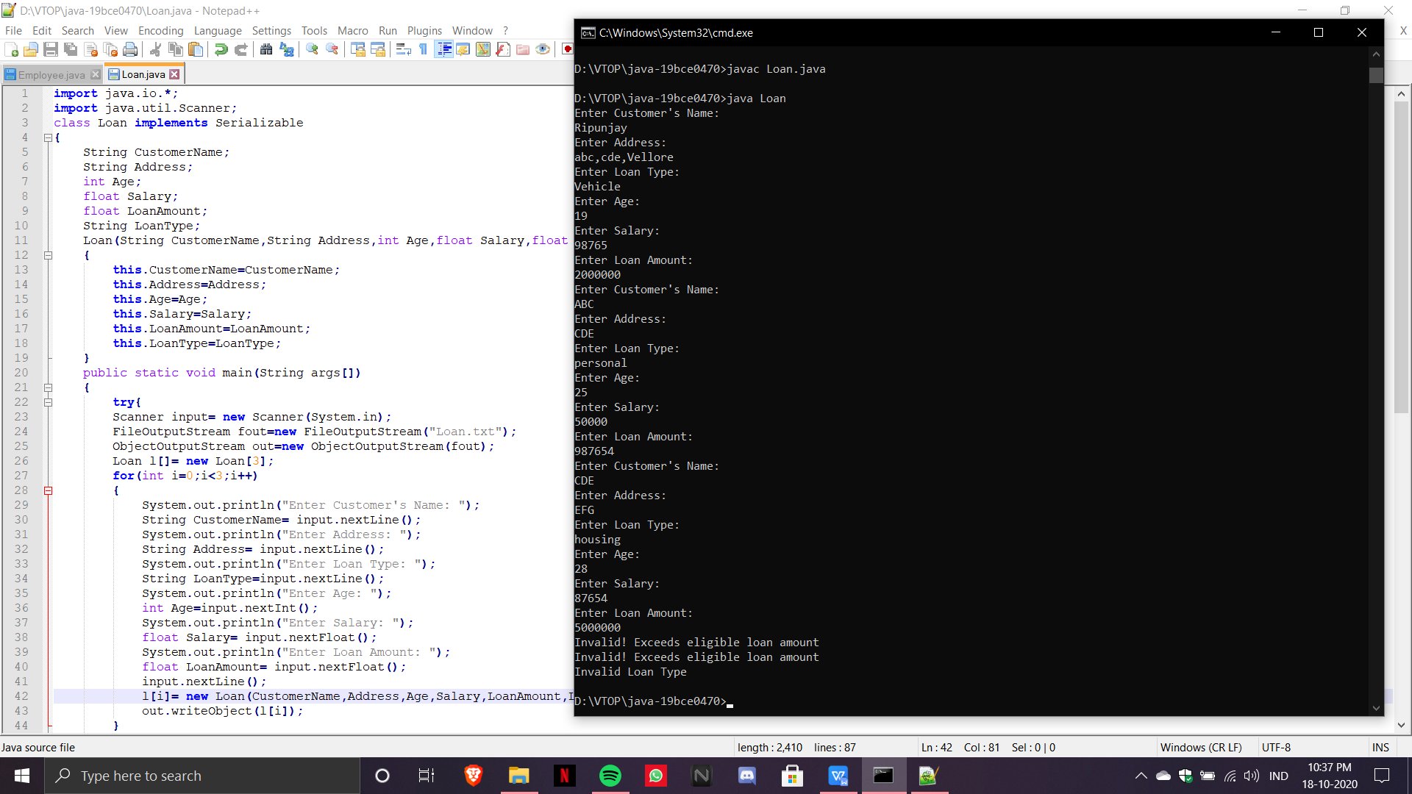

3)

import java.util.*;

class StudArrayList

{

String StudentID;

String Name;

int marks1;

int marks2;

int marks3;

StudArrayList(String StudentID, String Name, int marks1,int marks2,int marks3)

{

this.StudentID=StudentID;

this.Name=Name;

this.marks1=marks1;

this.marks2=marks2;

this.marks3=marks3;

}

public static void main(String args[])

{

Scanner input= new Scanner(System.in);

StudArrayList s[]= new StudArrayList[5];

ArrayList<StudArrayList> alist= new ArrayList<StudArrayList>();

for(int i=0;i<5;i++)

{

System.out.println("Enter StudentID: ");

String StudentID=input.nextLine();

System.out.println("Enter Name: ");

String Name=input.nextLine();

System.out.println("Enter marks for subject 1: ");

int marks1=input.nextInt();

System.out.println("Enter marks for subject 2: ");

int marks2=input.nextInt();

System.out.println("Enter marks for subject 3: ");

int marks3=input.nextInt();

input.nextLine();

s[i]=new StudArrayList(StudentID,Name,marks1,marks2,marks3);

alist.add(s[i]);

}

for(StudArrayList l: alist)

{

System.out.println("Student StudentID: "+l.StudentID);

System.out.println("Student Name: "+l.Name);

System.out.println("Student marks 1: "+l.marks1);

System.out.println("Student marks 2: "+l.marks2);

System.out.println("Student marks 3: "+l.marks3);

}

}

}

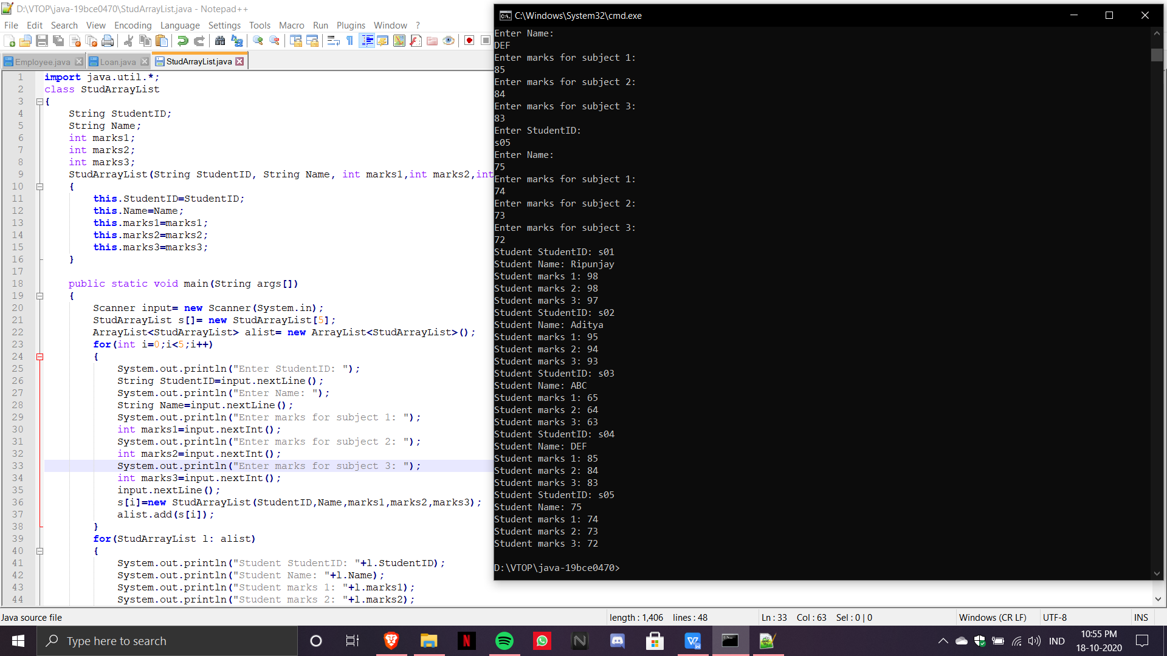

**JDBC**

1.1.Write a Java program to perform the following (i) Create a FACULTY table with the following fields empid, facultyname, DOB, Dateofjoining and designation. (ii) Insert 5 faculty details on to the table (iii) Retrieve all the faculty details. (iv) Retrieve the faculty information whose designation is Senior professor

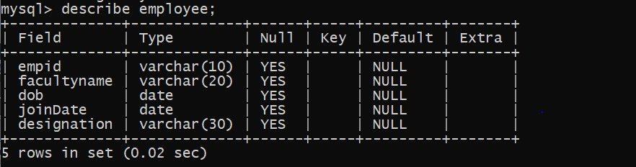

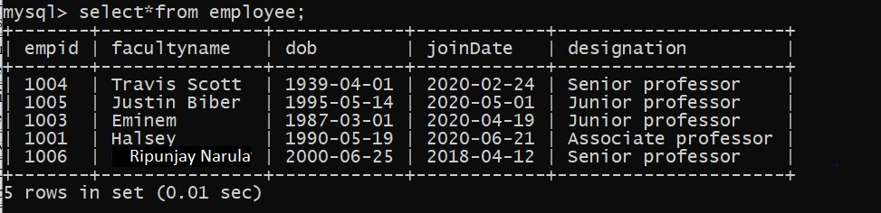

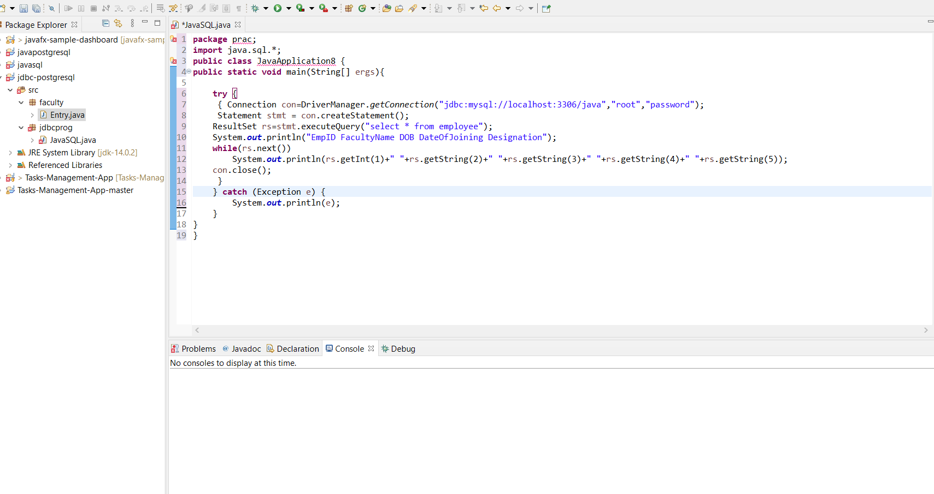

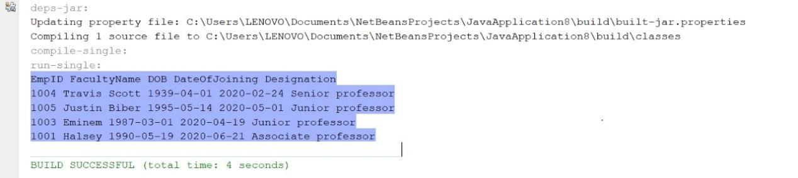

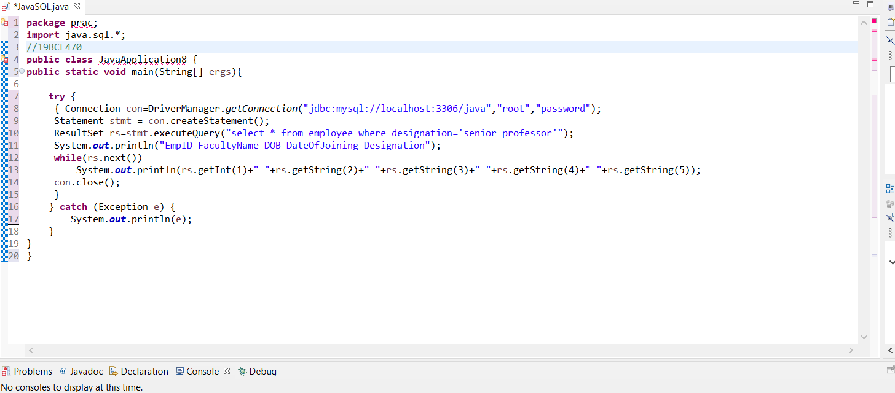

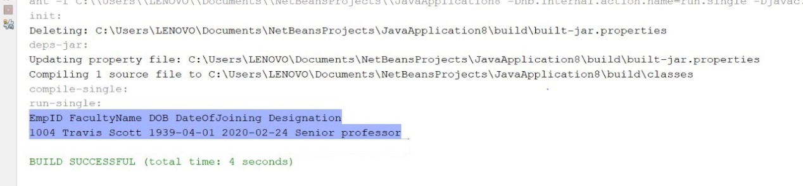

**Servlet Code**

1. Design a Signup form using HTML and write a servlet code to print welcome message only if the password and confirm password are same otherwise print Password mismatch message in the same HTML form.

HTML FILE:

<html>

<body>

<form action="servlet/Register" method="post">

Name:<input type="text" name="userName"/><br/><br/>

Email Id:<input type="text" name="userEmail"/><br/><br/>

Password:<input type="password" name="userPass"/><br/><br/>

Confirm_Password:<input type="password" name="userPass_c"/><br/><br/>

<input type="submit" value="register"/>

</form>

</body>

</html>

JAVA FILE:

import java.io.*;

import java.sql.*;

import javax.servlet.ServletException;

import javax.servlet.http.*;

public class Register extends HttpServlet {

public void doPost(HttpServletRequest request, HttpServletResponse response)

throws ServletException, IOException {

response.setContentType("text/html");

PrintWriter out = response.getWriter();

String n=request.getParameter("userName");

String e=request.getParameter("userEmail");

String p=request.getParameter("userPass");

String p=request.getParameter("userPass_c");

try{

Class.forName("oracle.jdbc.driver.OracleDriver");

Connection con=DriverManager.getConnection(

"jdbc:oracle:thin:@localhost:1521:xe","system","oracle");

PreparedStatement ps=con.prepareStatement(

"insert into registeruser values(?,?,?,?)");

ps.setString(1,n);

ps.setString(2,p);

ps.setString(3,e);

ps.setString(4,c);

int i=ps.executeUpdate();

if(i>0)

out.print("Welcome");

}catch (Exception e2) {System.out.println("Password mismatch");}

out.close();

}

}

