***Ripunjay Narula 19BCE0470***

**1 Write a java Program to check whether given string is palindrome or not**

import java.util.Scanner;

public class palindrome {

Scanner sc= new Scanner(System.in);

static boolean palindrome(String str)

{

int i=0;

int j=str.length()-1;

while(i < j) {

if(str.charAt(i)!= str.charAt(j))

return false;

i++;

j--;

}

return true;

}

public static void main(String[] args)

{ Scanner sc= new Scanner(System.in);

System.out.print("Enter the string: ");

String str = sc.nextLine();

if (palindrome(str))

System.out.print("It is a palindrome");

else

System.out.print("It is not a palindrome");

}

}

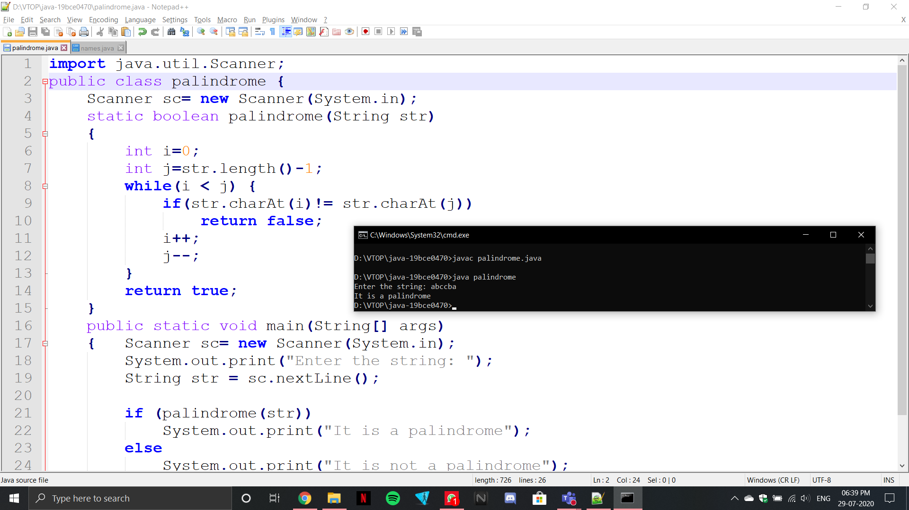

**2 Write a java program to sort the names in descending order**

import java.util.Scanner;

public class names

{

public static void main(String[] args)

{

int n;

String temp;

Scanner sc = new Scanner(System.in);

System.out.print("Enter number of names: ");

n = sc.nextInt();

String names[] = new String[n];

Scanner sc2 = new Scanner(System.in);

System.out.println("Enter all the names: ");

for(int i=0; i<n; i++)

{

names[i] = sc2.nextLine();

}

for (int i=0; i<n; i++)

{

for (int j= i+1; j<n; j++)

{

if (names[i].compareTo(names[j])<0)

{

temp = names[i];

names[i] = names[j];

names[j] = temp;

}

}

}

System.out.print("Sorted List: ");

for (int i = 0; i<n; i++)

{

System.out.print(names[i] + " ");

}

}

}