**Ripunjay Narula**

**19BCE0470**

**Q-2**

1. Write a Java program that prints all real solutions to the quadratic equation ax2+bx+c = 0. Read in a, b, c and use the quadratic formula. If the discriminate b2-4ac is negative, throw an exception and display a message stating that there are no real solutions.

**Code:**

import java.util.*;

import java.io.*;

public class labfat1

{

public static void main (String args[]) throws exception e

{

System.out.println("Enter the cofficients a,b,c of quadratic equation ax^2 + bx + c = 0 and where a not 0 ");

Scanner sc = new Scanner(System.in);

double a=sc.nextInt();

if (a==0)

{

System.out.println("a can not be zero");

}

else

{

double b=sc.nextInt();

double c=sc.nextInt();

double z=b*b-4*a*c;

EquationCheck ob=new EquationCheck();

if (z<0)

{

System.out.println("There are no real solutions");

}

else if(z==0)

{

System.out.println("The solutions are real and equal");

ob.check(a,b,c);

ob.display();

}

else

{

System.out.println("The solutions are real and distinct");

ob.check(a,b,c);

ob.display();

}

}

}

}

class EquationCheck

{

double a;

double b;

double c;

double x1;

double x2;

void check(double a,double b,double c)

{

this.a=a;

this.b=b;

this.c=c;

double z=Math.pow( b*b-4*a*c , 0.5 );

x1=(-b-z)/(2*a);

x2=(-b+z)/(2*a);

}

void display()

{

System.out.println(x1);

System.out.println(x2);

}

}

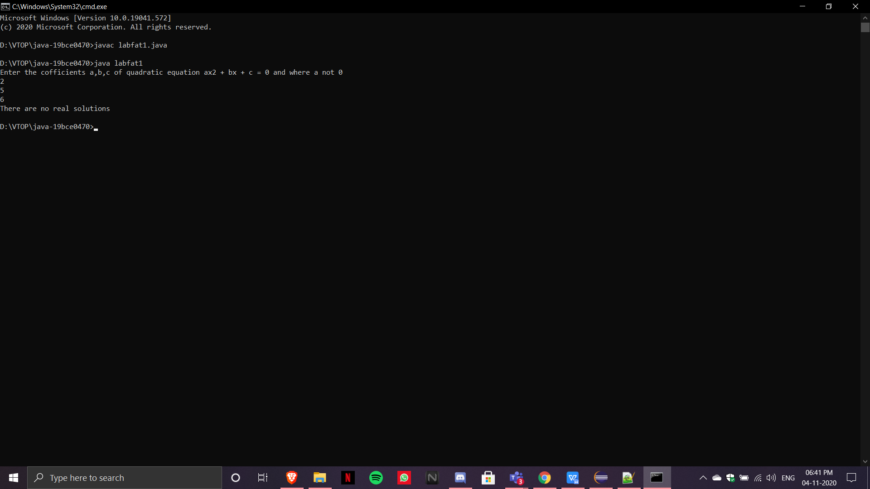

b.Create an employee table with the following fields empid, empname, DOB, Dateofjoining and designation.Insert 5 faculty details on to the table, Retrieve all the employee details and retrieve the employee information whose designation is Manager and having maximum number of experience.

**Codes:**

create table employee_java(

-> empid varchar(10) NOT NULL,

-> empname varchar(50) NOT NULL,

-> DOB date NOT NULL,

-> Dateofjoining date NOT NULL,

-> Designation varchar(50) NOT NULL

-> );

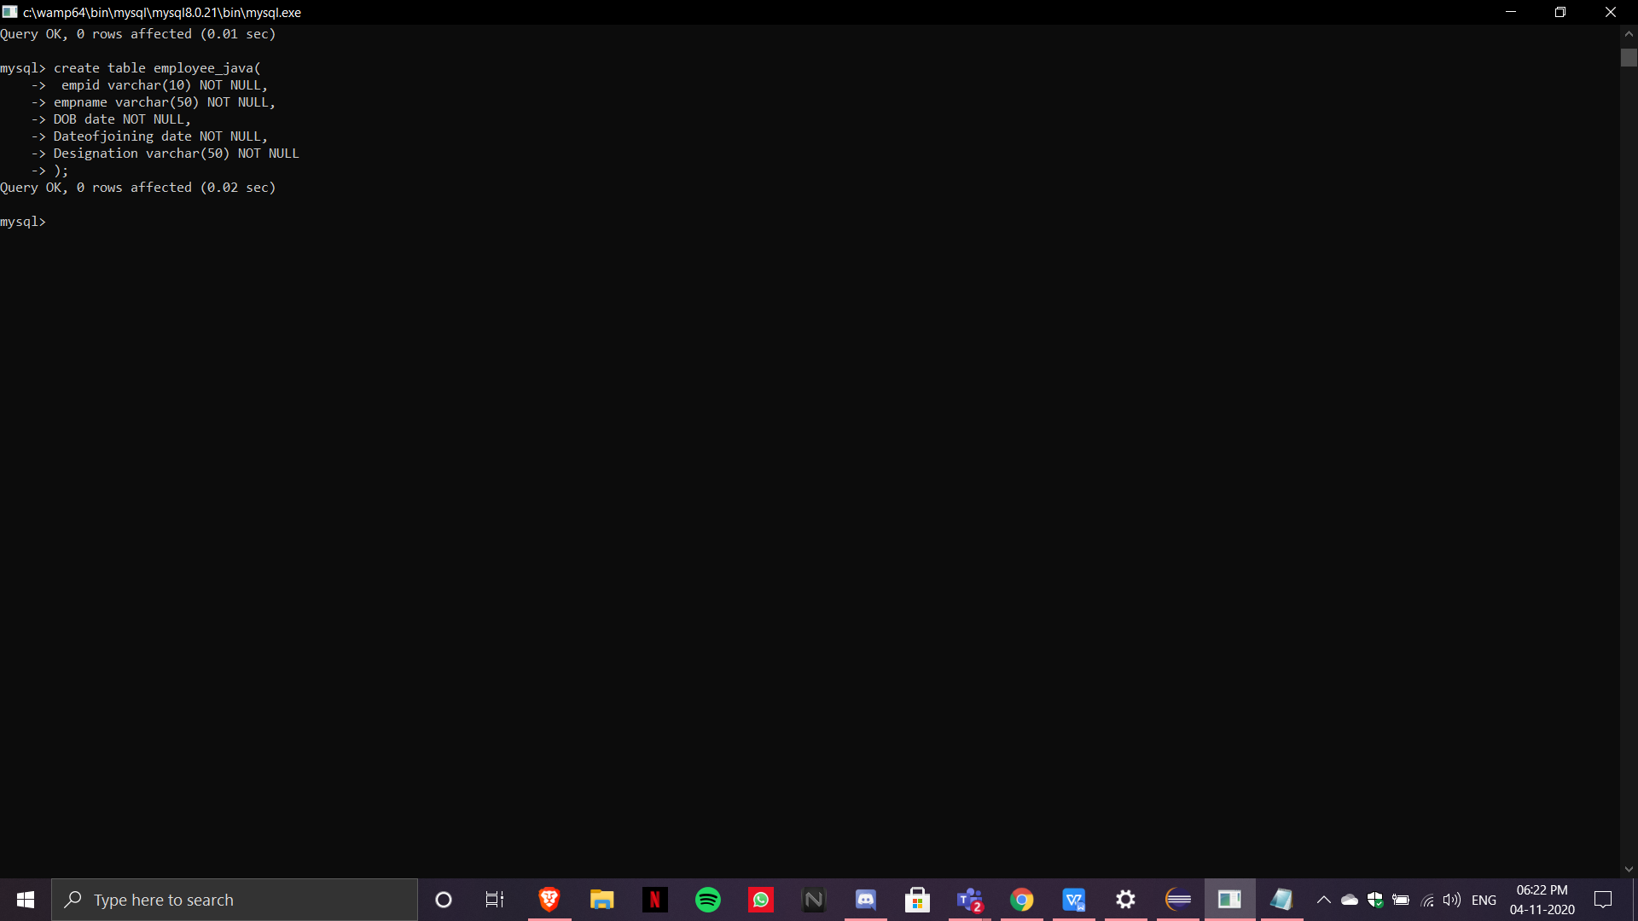

INSERT INTO employee_java VALUES('e101', 'Ripunjay', '2001-06-30', '2019-11-01', 'Manager'),('e102', 'Apoorva', '2001-02-07', '2019-11-02', 'Executive'),('e103', 'Grihit', '2001-03-21', '2019-11-03', 'Editor'),('e104', 'Shivansh', '2001-07-10', '2019-11-04', 'SDE'),('e105', 'Shaarang', '2001-05-09', '2019-11-05', 'Intern');

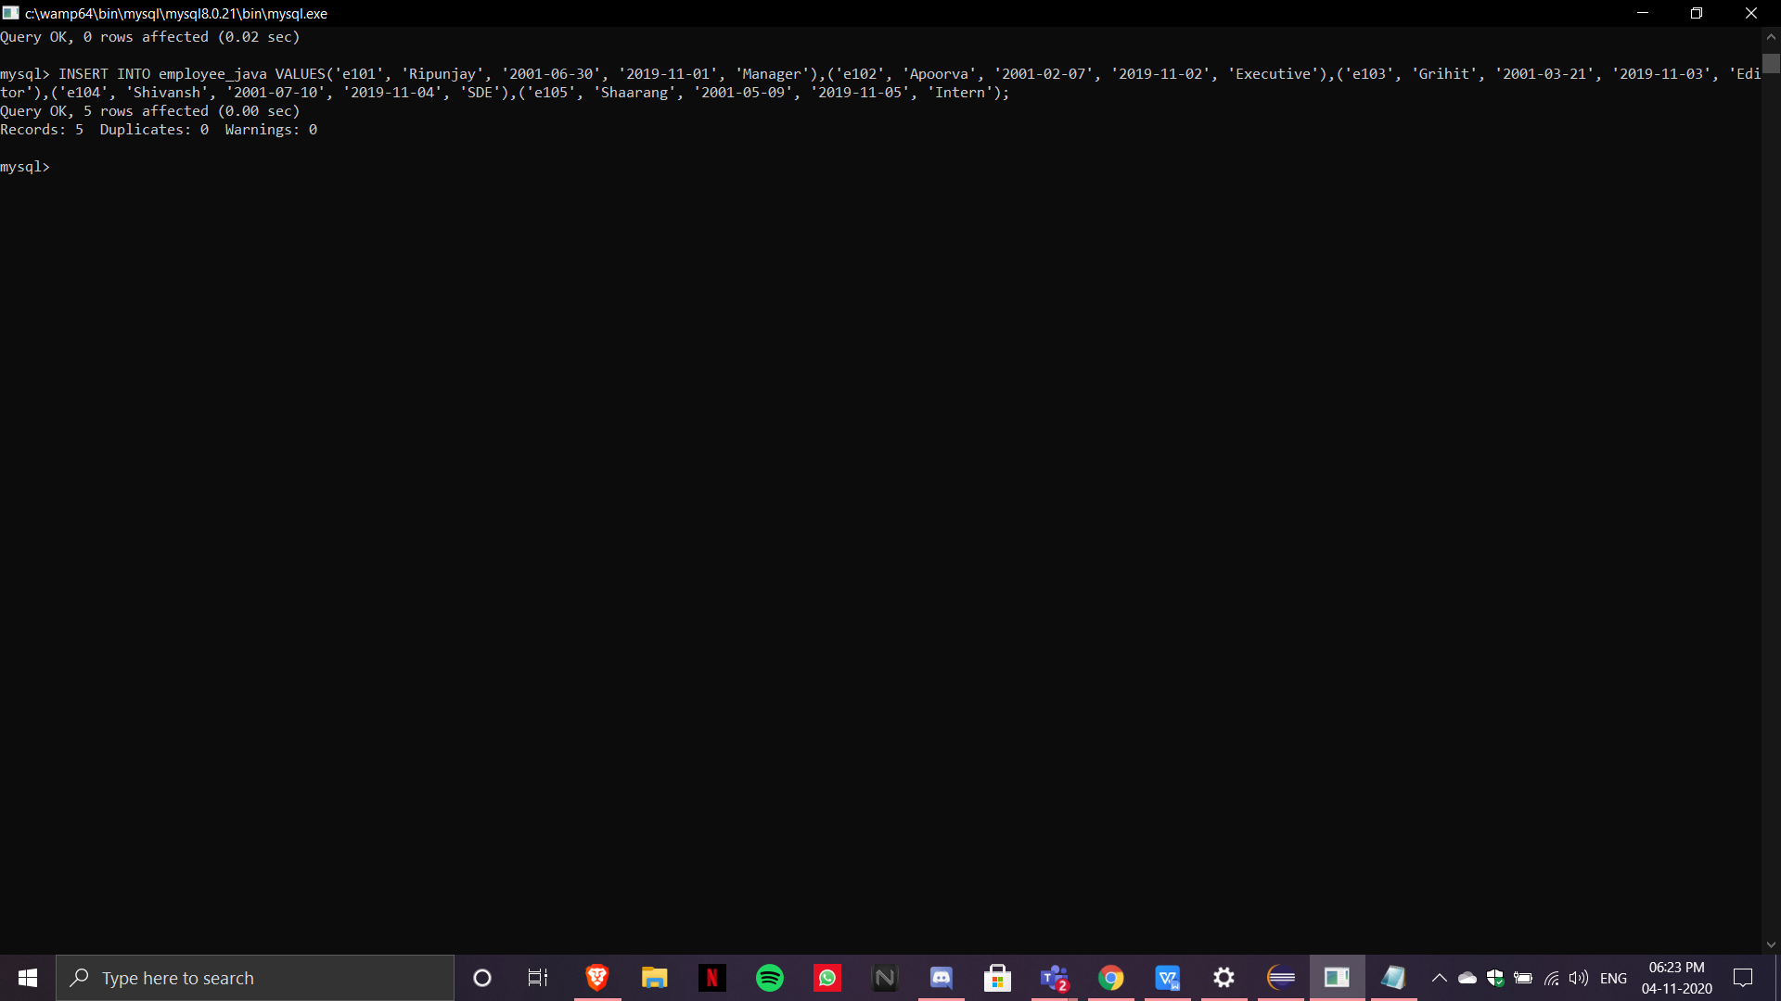

**import** java.sql.Connection;

**import** java.sql.DriverManager;

**import** java.sql.ResultSet;

**import** java.sql.SQLException;

**import** java.sql.Statement;

**public** **class** emp {

**public** **static** **void** main(String[] args) **throws** ClassNotFoundException, SQLException{

// **TODO** Auto-generated method stub

Class.*forName*("com.mysql.cj.jdbc.Driver");

Connection con = DriverManager.*getConnection*("jdbc:mysql://localhost/test","root","");

Statement s1=con.createStatement();

String sql="select * from employee_java where Designation='Manager' AND (SELECT MIN(Dateofjoining) FROM employee_java)";

ResultSet res=s1.executeQuery(sql);

**while**(res.next()) {

System.***out***.println(res.getString(2));

}

}

}

