**DATABASE MANAGEMENT SYSTEMS**

**(EPJ Component)**

**Register Number 1: 19BCE0629**

**Name 1: Samvit Swaminathan**

**Register Number 2: 19BCE0470**

**Name 2: Ripunjay Narula**

**EPJ Slot: L45+L46**

**Project Title: Shopping Portal for shops**

**Mobile Number: +91 9676570705**

**Project type: Application**

**Phase I:**

**Requirement Analysis**

**INTRODUCTION**

The following database management system represents the working of an online shopping portal as a company-oriented system. It helps the company in tracking the records of every customer and any product they sell. The company stores all the details of the customers, keeps a record of all the payments made, their respective orders and all the offers they provided. The product can be found even in the inventory and can be seen by the financial firm too. This will also help the shops to increase their business during COVID-19 situation and cover the loss they faced during the lockdown.

Here every customer detail will be recorded i.e. name, age, email ID, password, address, phone number etc. Each customer shall have a customer ID to uniquely identify their transactions.

A list of products purchased by a customer is available and identified using product ID. The product history from the inventory could also be traced via stock-type. For analysis, finance firm uses composite primary keys to identify and rectify the records. For transparency policy the company also maintains supplier records with a unique supplier ID. Thus, a particular ID is provided to all the users in their respective fields due to which tracking them will be easy.

For checking the transaction details company can rectify the payments made by a customer with the help of a unique payment ID. Through payment details, the company can track the offers applied for the payment and the discount gained.

The placed order will be mentioned in order table with unique order ID and will also show order date and expected date of product delivery.

The branch of the shop will also be mentioned with its address and pin code.

To track the spread of COVID-19, the details of the delivery person will also be mentioned along with his/her phone number so that they can be contacted and informed of the spread.

The design for this company-oriented database management system is made by keeping in mind:

* Persistence in database
* Removing anomalies and performing various operations
* Usage of minimum amount of memory
* To avoid redundancy
* Smooth database and easy tracking methodology
* Providing concurrent user interface

# DATA AND FUNCTIONAL REQUIREMENTS

**Customer details**:

The website is based around them. They are also the biggest part of our website. This is where a client’s information is stored. This will store basic info of the customer, such as a unique ID, name, age, username, address, phone number, contact email, password.

**Product details**:

This stores the information about the product. This has a unique ID, name, price, brand.

**Order details**:

Any order that is placed on this website needs to be stored as an invoice for future references. The order may include a unique order ID, order date, and expected date of delivery of the order.

**Delivery Person details:**

The information of the person who will be delivering your product to you will be listed so that if you catch COVID-19 disease, it can be tracked and required measures taken.

**Branch Details:**

The branch of the shop from which your order is being delivered will be shown with its address and pin code so that if you like, you can personally go and shop from there.

**Payment details:**

The details about payments done for the orders will be stored here. We store the unique payment ID, amount paid and mode of payment (type).

**Supplier details:**

The details about the suppliers, i.e. the person/company that wishes to sell their products through this website, will be stored here. The details stored will be name, supplier ID and their address.

**Inventory details:**

The suppliers’ inventory information will be stored here. The stock type, stock name and stock number will constitute this data.

**Finance firm**:

This is the finance department’s data. The details stored here will be firm type, firm ID and the tax associated with the purchase.

**Oﬀers:**

This will cover the oﬀer and discounts of various types that are available on a product. Here we will store the coupon number and the discount received on application of this coupon.

## Functional requirements:

**Data retrieval:**

1. Customers can access products and view the details.
2. Customers can also view their order and payment details.
3. The list of products included in a stock can be retrieved.
4. The list of stocks that a supplier provides can be retrieved.
5. The list of orders place by a customer can be retrieved.
6. The list of offers availed by a customer can be retrieved.
7. The list of stocks that a finance firm facilitates can be retrieved.
8. The list of different payments that availed a oﬀer can be retrieved.

**Data modification:**

1. A customer can modify his/her details such as the address or phone number, if it needs an update.
2. A product’s details can be changed, such as its price.
3. An oﬀer can be modified if the discount it offers changes.
4. A finance firm can change its details, such as the tax it levies.

**Data removal:**

1. A customer can delete his/her account and the data associated with it.
2. An order can be deleted if the customer wishes to cancel it.
3. A product can be deleted from the database if it is no longer available.
4. A supplier can delete their account if they no longer wish to supply their products to the company.

**DOMAIN RESTRAINTS**

* Customer ID: String starting with ‘C’ followed by 5 digits
* Customer username: String which is unique and consists of 8 characters.
* Customer name: String
* Customer address: String of length around 50
* Customer contact number: String of length “10”
* Customer email ID: String of the form "[xyz@example.com](mailto:xyz@example.com)"
* Customer password: String consisting of a combination of letters and digits, with at least one uppercase letter, one lowercase letter, and one digit.
* Product ID: String starting with ‘PR’ followed by 4 numbers
* Product name: String
* Product price: Floating value/ Number
* Branch Pin Code: 6 digit long number
* Product brand: String recognizing a brand
* Supplier ID: String starting with ‘S’ followed by 5 numbers
* Order ID: String starting with ‘O’ followed by 5 numbers
* Order date: Date
* Expected delivery date: Date
* Payment ID: String starting with ‘P’ followed by 5 numbers
* Amount paid: Number
* Payment type: String
* Coupon number: String starting with ‘DIS’ followed by 5 numbers
* Discount percent: Number greater than zero and less than 100
* Supplier name: String
* Stock type: String
* Stock number: Integer value/ Number
* Firm type: String
* Tax percent: Number that lies between 0 and 100
* Delivery Person’s Phone Number: should be 10 digits long number

**ENTITY RELATIONS**

1. The relationship PLACED_BY exists between CUSTOMER and ORDER. Cardinality ratio is 1:N for CUSTOMER to ORDER.
2. The relationship PAID exists between ORDER and PAYMENT. Cardinality ratio is 1:1 for ORDER to PAYMENT.
3. The relationship APPLIED_FOR exists between OFFER and PAYMENT. Cardinality ratio is 1:N for OFFER to PAYMENT.
4. The relationship REDEEMS exists between OFFER and STUDENT. Cardinality ratio is N:M for OFFER to STUDENT.
5. The relationship ACCESSES exists between CUSTOMER and PRODUCT. Cardinality ratio is M:N for CUSTOMER to PRODUCT.
6. The relationship INCLUDES exists between STOCK and PRODUCT. Cardinality ratio is 1:N for STOCK to PRODUCT.
7. The relationship SUPPLIES exist between STOCK and SUPPLIER. Cardinality ratio is N:1 for STOCK to SUPPLIER.
8. The relationship FACILITATES exists between STOCK and FINANCE_FIRM. Cardinality ratio is N:1 for STOCK to FINANCE_FIRM.
9. The relationship BRANCH_DETAILS exists between ORDER and BRANCH. Cardinality ratio is 1:1 for ORDER to BRANCH.
10. The relationship DEL_BOY_DETAILS exists between ORDER and DELIVERY. Cardinality ratio is N:1 for ORDER to DELIVERY.

**ER DIAGRAM**

DEL_BOY_DETAILS

PASSWORD

EMAIL_ID

DELIVERY_DATE

NAME

ORDER_ID

CUSTOMER_ID

ADDRESS

ORDER

PLACED_BY

CUSTOMER

ORDER_DATE

PRODUCT_ID

PHONE_NO

REDEEMS

USERNAME

PAID

BRANCH_DETAILS

PRODUCT_ACCESSED

AMOUNT

ACCESSES

TYPE

PAYMENT

PRODUCT_ID

BRAND

PRODUCT

PAYMENT_ID

P_NAME

PRICE

APPLIED_FOR

INCLUDES

COUPON_NO

OFFER

OFFER_REDEEMED

STOCK

DISCOUNT

DISCOUNT

NO_OF_ITEMS

STOCK _NO

STOCK _TYPE

BR_PINCODE

BRANCH

SUPPLIES

FACLIITATES

BR_ADDRESS

DEL_PHONE

DELIVERY

DEL_NAME

FIRM_TYPE

FINANCIAL FIRM

SUPPLIER

TAX

FIRM_ID

SUPPLIER_ID

S_NAME

S_ADDRESS

**ER DIAGRAM REDUCTION TO SCHEMA:**

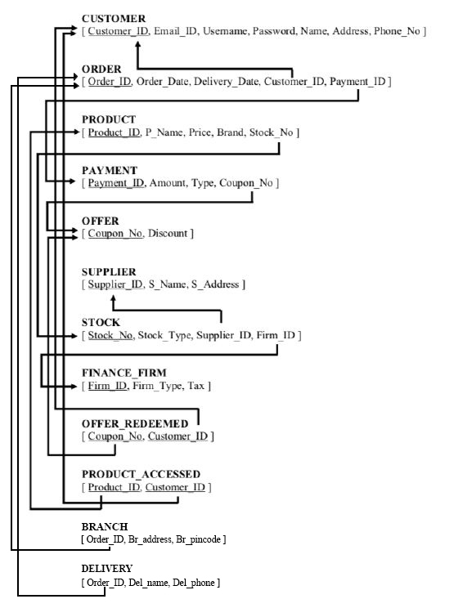

**NOTE**: BRANCH and DELIVERY are only till the pandemic extends so they are not permanent and can be removed without affecting the working of the shop/business that much.

**RULES FOR CONVERTING ER DIAGRAM INTO SCHEMA:**

* **Entity type becomes a table**
* **Every single-valued attribute becomes a element of the table**
* **A key attribute of the entity type represented by the primary key**
* **The multivalued attribute is represented by a separate table**
* **Derived attributes are not considered in the table**

**Phase II**

**ORDER:**

|  |  |  |  |  |
| --- | --- | --- | --- | --- |
| **Order_ID** | **Order_Date** | **Delivery_Date** | **Customer_ID** | **Payment_ID** |
| **O00001** | **12-AUG-2020** | **20-AUG-2020** | **C00001** | **P00001** |
| **O00002** | **12-AUG-2020** | **14-AUG-2020** | **C00002** | **P00002** |
| **O00003** | **13-AUG-2020** | **20-AUG-2020** | **C00003** | **P00003** |
| **O00004** | **14-AUG-2020** | **17-AUG-2020** | **C00004** | **P00004** |
| **O00005** | **14-AUG-2020** | **15-AUG-2020** | **C00001** | **P00005** |

**CHECKING FOR FUNCTIONAL DEPENDENCIES:**

**{Order_ID} --> {Order_Date}**

**{Order_ID, Customer_ID} --> {Payment_ID}**

**{Order_ID} --> {Payment_ID}**

**{Order_ID} --> {Delivery_Date}**

**{Order_ID } --> {Customer_ID}**

**First Normal Form- If a relation contain composite or multi-valued attribute, it violates first normal form, or a relation is in first normal form if it does not contain any composite or multi-valued attribute. A relation is in first normal form if every attribute in that relation is singled valued attribute.**

**=> Table is in 1NF**

**Second Normal Form- Second Normal Form (2NF) is based on the concept of full functional dependency. Second Normal Form applies to relations with composite keys, that is, relations with a primary key composed of two or more attributes. A relation with a single-attribute primary key is automatically in at least 2NF. A relation that is not in 2NF may suffer from the update anomalies.**

**=> Table is not in 2NF**

|  |  |
| --- | --- |
| **Order_ID** | **Order_Date** |
| **O00001** | **12-AUG-2020** |
| **O00002** | **12-AUG-2020** |
| **O00003** | **13-AUG-2020** |
| **O00004** | **14-AUG-2020** |
| **O00005** | **14-AUG-2020** |

|  |  |  |
| --- | --- | --- |
| **Order_ID** | **Customer_ID** | **Payment_ID** |
| **O00001** | **C00001** | **P00001** |
| **O00002** | **C00002** | **P00002** |
| **O00003** | **C00003** | **P00003** |
| **O00004** | **C00004** | **P00004** |
| **O00005** | **C00001** | **P00005** |

|  |  |
| --- | --- |
| **Order_ID** | **Delivery_Date** |
| **O00001** | **20-AUG-2020** |
| **O00002** | **14-AUG-2020** |
| **O00003** | **20-AUG-2020** |
| **O00004** | **17-AUG-2020** |
| **O00005** | **15-AUG-2020** |

**{Order_ID} --> {Order_Date}**

**{Order_ID} --> {Payment_ID}**

**{Order_ID, Customer_ID} --> {Payment_ID}**

**{Order_ID} --> {Delivery_Date}**

**{Order_ID } --> {Customer_ID}**

**=> Now it is 2NF**

**Third Normal Form- A relation that is in First and Second Normal Form and in which no non-primary-key attribute is transitively dependent on the primary key, then it is in Third Normal Form (3NF).**

**=> Table is in 3NF.**

**Boyce-Codd Normal Form- A relation is in BCNF, if and only if, every determinant is a Form (BCNF) candidate key.**

**=>Table is in BCNF.**

**\*NOTE: The decomposition is completely lossless.**

**FINAL NORMALIZED SCHEMA:**

