

Optimising a Whipper trebuchet



June 19, 2020

By James Forster

Contents

Introduction 2

History 2

How it works 3

Traditional trebuchet: 3

Whipper trebuchet (Floating axle): 3

The goal 3

How and what data will be recorded 3

The Arm x 4

Hypothesis **Error! Bookmark not defined.**

Sling calculations 5

Maximum tension 5

Maximum velocity 5

Maximum throwing distance 7

Testing standard deviation 8

Setup 8

The experiment 8

Results 9

Conclusion 9

Improvements 9

The exploration of the balancing point of a whipper trebuchet 10

The goal 10

Assumptions 10

Variables 10

Moments 11

Clockwise moments 11

Anti-clockwise moments 11

Solving for theta 12

A large assumption 13

A functional function 14

Conclusion 15

Working out the number of possible configurations 16

The main experiment 25

Control variables 25

Method for collecting data 26

Example video 4

Results 26

Analysis 26

References: 26

# Introduction

My whipper trebuchet project began on the 22nd of April 2020 when I made the first part, the frame 1.0. At that point I was a complete novice with no experience with anything similar to a trebuchet and only armed with the tools I had to my disposal and a little bit of experience in actually using them.

The end goal of the whole project was to conduct a main experiment to collect data on different setups of the trebuchet and how that effected the velocity of the projectile.

I think one of the biggest difficulties was making my trebuchet so small and intricate and all the problem that entailed compared to a larger trebuchet.

It has thoroughly surprised me how much more intricate and difficult this project became than what I had originally predicted, but I think it’s just in my nature not to give up when faced with such a challenge. It also helped that I was completely enthralled by the project, and had not much else to do sometimes due to the lack of a physical school from the covid-19 situation. At one point it got so bad that all I was thinking of when I woke up and went back to bed, was trebuchet.

This project was split into two main components, the development of the trebuchet itself, and the scientific datalogging and analysis. I estimate I have spent between 50 and 100 hours building, developing, testing and documenting my whipper trebuchet and which you can read in the document called “the build”. In it, I go over the entire process of developing my trebuchet and explaining all the problems I faced and how I overcome them.

The other component is more varied and includes everything else that I have done for this project all of which is documented here.

# History

The noun ‘Trebuchet’ originally came from the old French word ‘trebuchier’ meaning to overturn, topple or overthrow [1]. The idea of trebuchets is believed to have originated from the technological tradition that began in ancient china however its actual origin and early development are still very unknown.

The machine is known to have come into wide-spread use after the year 1200 and large strides were made to increase its overall ability and performance. In the sketchbook of a man called Villard de Honnecourt, produced between 1220 and 1240, It depicted the designs of a traditional trebuchet with the counter-weight box having the maximum counter-weight capacity of thirty tons! With that sort of counter-weight it would be possible to throw a 60kg projectile up to 365m! [2]

# How it works

## Traditional trebuchet:

Figure 1 – Traditional trebuchet

The Traditional trebuchet works by using a large arm or beam attached to a pivot point as shown in figure 1. When the counter-weight is released the gravitational potential energy stored in the counter-weight is converted into the kinetic energy of the projectile and it is thrown.

## Whipper trebuchet (Floating axle):

****The Whipper trebuchet gets its name from the sound it makes when it is fired. It is more advanced than the traditional trebuchet due to having a second arm and pivot. The main differences are that the main arm is usually a lot smaller than a traditional trebuchet to allow it to rotate a whole 360o around its pivot without hitting its frame or the floor.

Figure 2 – Whipper trebuchet

It is also designed for a lot lighter projectile to counterweight ratio as to focus on maximum exit velocity of the projectile rather than overall momentum as in a Traditional trebuchet.

# The goal

My plan is to attempt to optimise, or to find the value with gives me the highest output, two main aspects of the whipper trebuchet that I have built with the goal of getting the furthest throw.

# How and what data will be recorded

For this aspect of the optimisation the dependant variable will be the exit velocity of the projectile (a marble) as the faster it is moving when released the farther it will go. This also means I do not have to record each time how far the projectile goes, which would be very tedious and less accurate as things such as wind could skew the results. The velocity itself will be recorded using a piece of video analysis software called Tracker [3] and a high speed, 240 frames per second camera.

The software I am using, called Tracker, allows me to open up a video and once calibrated using something of known length in the video (such as a metre rule) I can then set up a set of coordinate axes and then manually click the location of the marble for every frame after its exit from the sling carriage. The software will then generate a table of data with three columns; time, the x-value and the y-value.

I will then import that data into a spreadsheet where I can calculate the velocity, or rate of change of displacement, which will be my dependant variable.

# The Arm x

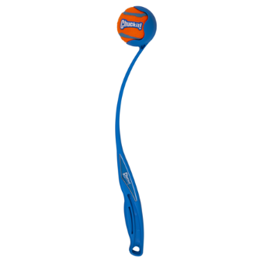The first aspect I would like to optimise is the ratio of three different arm lengths shown in Figure 3. The arm x is similar to a traditional lever except instead of magnifying force its purpose it to magnify linear velocity using the same angular velocity.

Imagine how far you could throw a tennis ball with just your arm and then imagine how far you could throw a tennis ball with one of the toys shown in Figure 4.

Figure 3 – labelled whipper trebuchet

This is all because of the circular motion equation:

This shows that linear velocity is directly proportional to the radius of the circle, so, if you were to double the length x for example and the angular velocity remained constant the velocity of the end of the arm x would also double and hence the projectile would most likely be flung at a higher speed.

Figure 4 – ball throwing toy

I am of course simplifying as the angular velocity would likely not stay the same as the force required to accelerate longer main arms would be greater than that required to accelerate shorter ones.

With this idea in mind, to achieve the furthest distance throw I will be keeping the length x constant throughout this part of the optimisation as in theory the longer x is the faster the ball will be travelling at its release and hence the further it will go and therefore to throw further you just have to make a larger and larger trebuchet which is not the subject of this study.

The sling length as I am informed­ [4] works with the release pin angle to affect the angle of release and therefore the trajectory of the projectile. Because of this I will be keeping it at a typical length in relation to the length of arm x for this experiment; about the same length.

# Example videos

I have a total of 10GB of high frame rate footage I have accumulated of all the testing I have done and so I have uploaded only a few hand-picked examples which showcase different issues occurring as well as an ideal shot and in which stage of development they were from, early, middle or modern.

All the videos are available here: <https://www.youtube.com/channel/UCgpELEDiv4Xiv-tezl3iTbw>

# Sling calculations

## Maximum tension

During the build of my trebuchet for the sling, I used fishing line which on the box it came in was labelled to be rated for up to 3.90kg ±0.01kg, which I assume means the maximum mass it could hold in earth’s gravity. I can do some cool calculations with this number and it all starts by using the equation:

By taking at being 9.81ms-2 ±0.05ms-1 I calculate max tension as being:

With and uncertainty of:

38.259N of tension for only 0.2mm of diameter! With a few circular motion equations, I can calculate the maximum velocity of the projectile before it breaks the fishing line.

## Maximum velocity

The best that I can measure the mass of my marble is unfortunately only using a pair of kitchen scales which has an uncertainty of ±1g so the marble has a mass of 5g ±1g. The length of the sling has changed a lot due to multiple problems but the most after the most recent change it is 12.5cm ±1mm on the fixed line and 13.5cm ±1mm on the looped line from the tip of the loop when under slight tension. For simplicity I will simply pretend that they are both 13cm ±0.2mm. I can now substitute into the last equation along with a force of 76.518N ±0.5862N (because there are two lines so it can take twice the force):

And the uncertainty:

This uncertainty is much higher than I like, the bottleneck of uncertainty per se is the scales I used to get the mass of the mass, if I had a scientific precision balance which often go to a hundredth of a gram then my uncertainty would have been:

Which is a LOT better than before so if you have a high precision balance you don’t mind lending me then I would be very grateful.

Alongside the uncertainty in the calculations there were a few assumptions that may also affect the result that I haven’t mentioned yet. The first is that I assumed that the centripetal force was coming wholly from the tension in the fishing line which is not true for vertical circular motion as weight is also a component. The point where the projectile is moving fastest and so therefore the most centripetal force is required is just before the release usually. Depending on the release angle the projectile is normally very near vertically above the release pin when it is at its point of release. This means that the weight is acting nearly straight toward the centre of the circle. This means that the actual maximum centripetal force would theoretically be:

The weight of the marble can be calculate using:

With an uncertainty of:

Which when substituted into our previously used equation leaves:

With an uncertainty of:

As you can see the difference is VERY small, an increase of 0.031% from out previous calculation, so we can pretty much ignore that factor as it is WELL within the uncertainty percentage with or without a high precision balance.

The second assumption I made is that the loop on the end of the non-fixed line was just simply one line whereas it is actually two, however, due to it being so small it would have a very small significance and also well within the uncertainty percentage.

The third assumption I made is to ignore the weight of the carriage itself as when I tried weighing it on my kitchen scales the reading did not change from 0g so I can infer that it is <0.5g and so wouldn’t make that much of a difference and definitely would have been within the uncertainty percentage, however, if I had more precise equipment then I would have taken it into account.

The fourth and final assumption I made is to ignore air resistance, this is also very unlikely to make that much of a difference as for one: the marble itself is spherical and quite dense so would have a very small surface area to mass ratio and for two: the carriage and sling are made of very thin wires or strands for the fishing line and so would have a very small cross-sectional area. This would then result in a small coefficient of drag and so I can judiciously ignore air resistance as it would be within the uncertainty percentage.

## Maximum throwing distance

If we were to launch the marble at the optimal angle for distance (45°) with the maximum calculated velocity (44.6ms-1) and from a height of:

Then, by taking upwards as the positive direction, with a few calculations the total distance travelled horizontally when it hits the ground can be calculated.

Vertical component:

This means that my marble will stay airborne for 6.5 seconds before it hits the ground, which we can then use to calculate the horizontal distance it would travel in that time which would be:

Horizontal component:

Now while that is an extraordinary result please note that I have ignored air resistance in these calculations and that it would have a large effect on the result. Also remember that this is at the maximum tension that my sling can retain and my actual result might come nowhere near.

# Testing standard deviation

## Setup

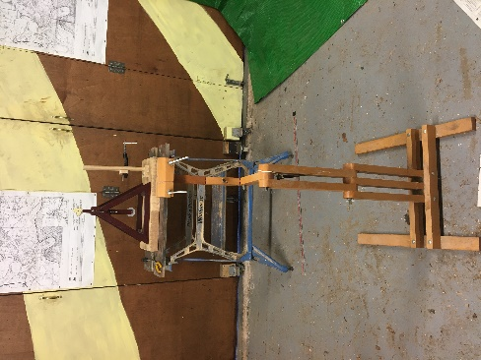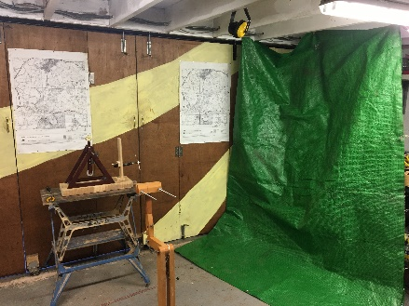For this experiment I had a stand for my camera pointed at the trebuchet itself which was secured into a moveable workbench. It was pointed at a tarpaulin I put up to catch the projectile so I wouldn’t lose it or smash it as glass is known for that mildly annoying property.

Figure 4

Figure 5

## The experiment

Seeing as normal trebuchets are quite violent let alone whipper trebuchets, I needed to test how repeatable my trebuchet is when no settings are changed. So, I did a small experiment where I put on some medium sized secondary arms and then did ten shots back to back without changing anything. There were two obvious misfires that I could see when actually firing it so I repeated those shots as I would when it comes to the real thing. I then took that video file and split it into the ten smaller videos of the ten good shots and then used Tracker to get the co-ordinates of the projectile out of the ten videos and then exported it into excel to process that data into the average velocity of the projectile for the ten different shots.

To get the average velocity I first worked out the distance moved between every pair of adjacent frames with the equation:

I then divided that distance by the amount of time elapsed after one frame. Since I was using a 240fps camera that would be . I then found the mean of all those individual velocities to find the average velocity.

When doing the test, I noticed that the main axle of the trebuchet had come out of one side of the frame. When reviewing the footage, I found that it was this way for shots 3 all the way through 8. I do not exactly know how the main axle manages to come out of the holes in the frame but I guess it has something to do with it not being perfectly parallel with the ground or maybe even the spiral pattern in the metal rod that comes from its manufacturing process.

## Results

As you can see in graph 1, the results are fairly repeatable except for shot 6 and possibly shot 7 which I would say are outliers. The main reason I think for their low velocity is because that those shots were toward the end of the main axle having come out of the frame so it could have been the most off centre and wobbly for those shots. This is also backed up by the fact that the highest velocity shots came from the shot where the main axle was not out of one side of the frame.

Graph 1

The second reason for the outliers and differences in all of the shots could have been from different release points and therefore release angles. I did not think it necessary to check for repeatability in release angle at this point as it was secondary to velocity at this stage but I can always go back and do it if I thinks it becomes necessary.

One interesting thing I found from doing this experiment, is that way the projectile came off the tarpaulin I set up to catch the projectile happened in such a way that for nearly every shot the marble went to the same place after its ricochet.

I found it very funny how my trebuchet manages to fire and even fire reasonably well with the main axle only attached of one end and I also feel very proud of myself that the build quality allows it.

I may indeed be criticised for doing over half of my repeatability test with my trebuchet in such a state but I couldn’t be bothered to do it again so sue me.

## Conclusion

To conclude this experiment, the main objective was to decide how many shots to do per setting of the trebuchet. My goal is to have the number of shots allow me to take an accurate reading but if I do too many shots per setting then the experiment itself will take far too long and I will be sad, bored and then become sadder.

Upon review of the results for this experiment I have decided to do three shots per setting as it is the oddest integer larger than one and so will allow me to tell if there is an outlier. I will also fix the issue of the main axle being able to come out of the frame for all future experiments.

## Improvements

Another thing I leant of in this small experiment, is the auto tracker function in the software I am using, Tracker. This function uses a very clever algorithm to automatically decide the location of the projectile after being given just one keyframe. Although as I suspected the algorithm di not like it when the colour of the background behind the marble suddenly changed from light to dark and would often go astray or simply throw and error. So, in future experiments I will create a solid background colour using a white bedsheet for high contrast with my dark coloured marble for better results.

The use of this auto-tracker function will also massively speed up the process of analysing the footage as I only have to manually select the location of the marble in one frame, the keyframe, rather than every frame and the algorithm will do the rest.

# The exploration of the balancing point of a whipper trebuchet

## The goal

One evening when I was pondering the utmost value of cream soda and other such meaningful absolutes, A thought came across my noggin, of the balancing point of a whipper trebuchet.

My goal became this: Achieve a function that could take an input of the settings of the current trebuchet setup and then calculate the predicted angle that the main arm is at the balancing point of the whipper trebuchet, a real stunner I know.

### Assumptions

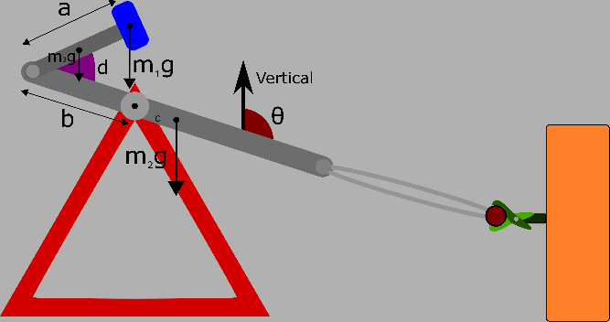To first approach this problem, I did what all my teachers have always told me to do; draw a diagram and label everything.

Now for this function I will making a few assumptions. First, I will assume that the centre of mass of the main arm itself will always be either exactly at the fulcrum or on the firing pin side, for most traditional trebuchets the main arm is not a uniform shape so it is often quite tricky to tell where the centre of mass will be. On one hand the firing pin end is usually thinner to reduce air resistance but on the other hand it is usually longer too, so where the centre of mass falls is very dependent on the specifics of the individual main arm. For my trebuchet, the firing pin assembly is quite heavy comparatively and so means that the centre of mass is on that side of the main arm.

Figure 6

Although it must be said that I’m pretty sure that it wouldn’t cause an issue in the equations if the centre of mass was in fact on the other side of the main fulcrum as long as it is measured with the positive direction being toward the firing pin.

The second assumption I have made is that the sling does not have any weight. This is simply because the sling weighs so little that it would have no significant effect on the outcome so I will ignore it.

The third assumption is that there the various pins and bolts around the trebuchet have no weight.

The fourth assumption is that there are no ramps to hold the secondary arms at the angle *d* or if there are that they do not have a weight.

The fifth assumption I have made is that the secondary is uniform as my secondary arms are. This means that the centre of mass will always fall at the midpoint of the secondary arm.

## Variables

All the variables for this function should be explained by the diagram but I will list them here anyway.

* *a* – the distance from the secondary fulcrum to the centre of mass of the counterweight
* *b* – the distance from the primary fulcrum to the secondary fulcrum
* *c* – the distance of the centre of mass of the main arm to the primary fulcrum
* *d* – the angle that the secondary arm makes with the main arm
* *m­­1* – the mass of the counterweight
* *m­­2* – the mass of the main arm
* *m­­3* – the mass of the secondary arms
* θ – the angle the main arm makes with the vertical axis

## Moments

### Clockwise moments

I will start this problem from the very basics of moments calculations, what is a moment?

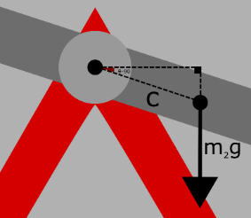Moment – the force multiplied by the perpendicular distance between the fulcrum and the line of action of the force.

To begin I will calculate the clockwise moment:

**Total Clockwise Moments:**

Notice how the clockwise moments actually depend on θ, this become more prevalent later.

Figure 7

### Anti-clockwise moments

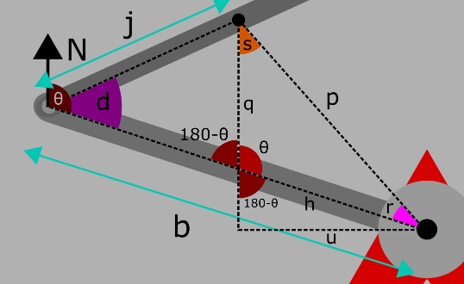The counter-clockwise moments are a lot more complicated and not only because there are two of them.

Figure 8

That took lots of cream soda and patience but I believe that is it, that is the perpendicular distance between the line of action of the weight force from the centre of mass of the secondary arm to the main fulcrum, or as I have named it; *u*.

Before I use *u* to find the moment provided by the weight of the secondary arms, I feel like I’m on a bit of a roll and so I will go on to find out the perpendicular distance between the line of action of the weight of the counterweight and the main fulcrum. I will call it *v* as it is the letter after *u* in the alphabet.

The only difference between the equations for *u* and *v* is that *j* is different because it goes from to .

Now comes the substitution so I can get an equation for *u* in terms of just my pre-declared variables, and I have to say, it’s not pretty.

Yes, that blurry equation is in fact the equation for *u*. And this one is the equation for *v*:

As you can probably tell, these equations would be a real pain to simplify by hand so I decided to cheat and use a website [5] which was the only web-based simplifier that I could get to work out of the 15 or so that I tried, including wolfram alpha. Once it had been simplified fully it became no better than it is currently and so I decided to just use the other lettered equations as intermediators for now.

So now that I have *u* and *v*,I can now calculate the total anticlockwise moments, yay!

**Total Anti-Clockwise Moments:**

### Solving for theta

Because we know that our system is in equilibrium, we can say that:

**Total Anti-Clockwise Moments = Total Clockwise Moments**

And therefore:

Or the fully substituted but otherwise blurry form:

Now in some way I can guess that equation can be re-arranged and solved for θ but, to quote Socrates,

“The only true wisdom is in knowing you know nothing.”

This equation is vastly beyond my ability to solve for θ while keeping everything in variable form, I would love to see the solutions if someone else can do it but for now I will have to take a different approach.

Instead of leaving everything in massive variable form I will attempt to simplify it by substituting in some actual values of my trebuchet and then I can find out if my equations are likely to even work at all.

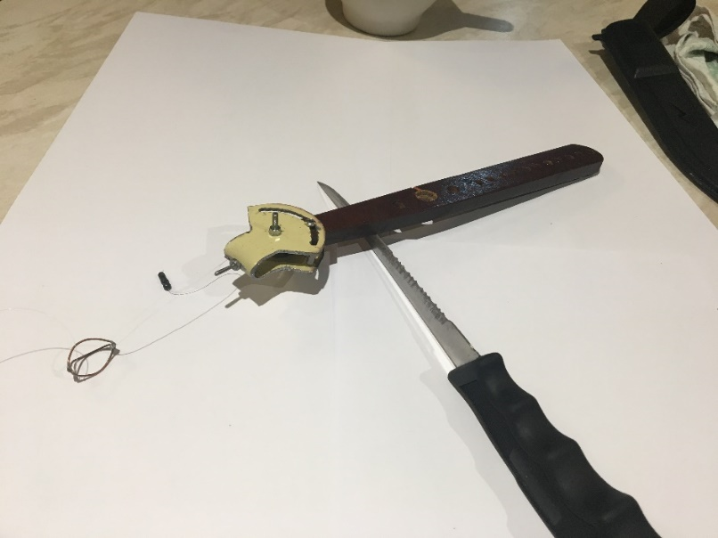The first step is to gather my variables and I will start with the one that was the most fun; c. The reason it was so fun is because to find the centre of mass, I got the idea to try and balance the whole main arm on a knife’s edge, and then measure the distance from the balance point to the main fulcrum point which would be c. Which meant it was another excuse to allow me the use of a knife ever since I was banned for the incident with the lemon and three pancakes. I am of course joking, my parents never found out about the incident with the lemon and three pancakes, and they never will…

Figure 9

The rest of the variables were more mundane to work out, they are shown in table 1.

|  |  |
| --- | --- |
| a | 0.08m |
| b | 0.1m |
| c | 0.039m |
| d | 45° |
| m1 | 0.232kg |
| m2 | 0.075kg |
| m3 | 0.033kg |

Table 1

Then comes the substitution:

Which is as far as I got with that idea so no, they are still above my ability even with using real numbers.

### A large assumption

There is just one trick I’ve left up my sleeves this whole time, however, I didn’t want to use it because it makes a big and ugly, in my opinion, assumption. The assumption is this: the only mass on the trebuchet is the counterweight. This then ignores the weight of both the main arm and the secondary arms but, that isn’t too bad as the counterweight is usually where most of the weight of a trebuchet comes from and so it could be that the other weights are not so significant as the weight from the counterweight. Although it would depend on the materials used to build the trebuchet arms themselves.

If we make this assumption then we can say that for the system to be in equilibrium the centre of mass of the counterweight must be directly above the main fulcrum. Therefore:

This seems very realistic because if θ was 180° then the trebuchet would be completely vertical and so be in equilibrium. However, the equations are not sentient and so shouldn’t predict that when the trebuchet is vertical that *d* would change to 180° and so I think that this solution is wrong.

I will not rearrange this anymore as it would get messy really quick but now, I will try to use this to calculate θ for my current setup.

Substituting values back in gives:

Which, surprise surprise, get me nowhere closer to working out θ.

### A functional function

“Failure is only the opportunity to begin again, this time more intelligently.”-Thomas Edison

Next, I will try again but this time with a much simpler diagram and many less triangles.

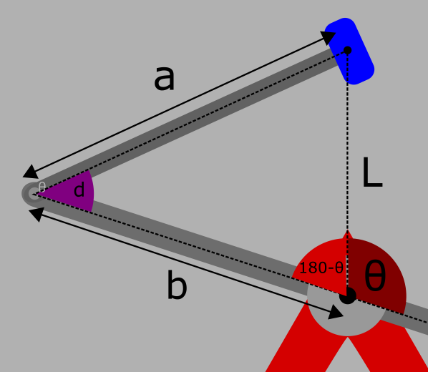For this simplified model it is quite easy to calculate θ compared to previously. All that’s needed are the sine, cosine and angles on a straight-line rules.

Figure 10

There, that was much easier.

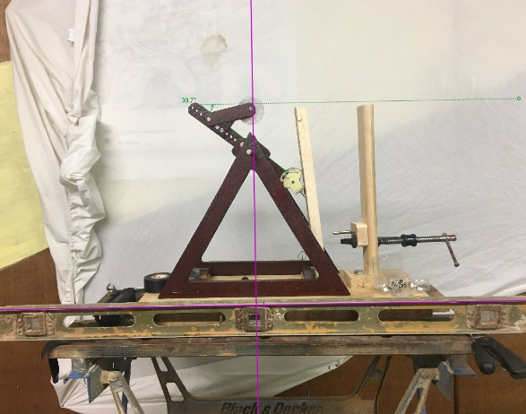Next, to see if it works. First, I will plug in my known values to find θ.

Figure 11

Now I will compare that with the actual value gained from balancing my trebuchet with the same setup. To do this I first balanced the trebuchet at the balancing point and then took a picture of it next to a spirit level which will act as my horizontal axis to compare to.

The actual value of θ came out to be 128.7° which gives a percentage error of:

I have two main emotional responses from this result. The first is happiness that one of my equations is actually good for something other than filling pages. The second is heartache that it is still so darn accurate despite all the trouble I went to too take into account as many variables as I could. This is also probably because the moment created by the main arm weight will somewhat balance out the moment created by the secondary arm weight.

For my personal use, I will create a single equation for my latest, simplest and only functional function for θ.

First, I need to remove *L* by substitution:

Then, substitute constants other than *a* and *b*:

And finally, simplify:

### Conclusion

That concludes the exploration of the balancing point of a whipper trebuchet.

I now have an equation that I can easily use to find the rotation of the main arm at balancing point without having to actually change to a specific setting on the real trebuchet and find out. I have accomplished my goal, cue the confetti.

# Working out the number of possible configurations

Before I do the main experiment, I need to know all the possible settings for my trebuchet so I know in what order to the settings for the main experiment.

## Limitation 1

The first limitation is that there are only a finite number of values both *a* and *b* can have as there are only so many hoxles in the main arm and only so many secondary arms. So first I will define *a* and *b* as .

## Limitation 2

The second limitation is that there is a maximum on the summation of *a* and *b*: the height of the frame. This is so the trebuchet will not hit the frame when it rotates. Which then forms the inequality:

Figure 12

Since r is a constant for me (0.0255m), I can simplify the equation to:

## Limitation 3

The third limitation is that *a* must be a certain length before it sits flat with the various ramps I have whose purpose is to hold the secondary arm at 45°. It just so happens that the minimum secondary arm settings, or *a*, for every ramp is 7cm so:

## Limitation 4

The fourth limitation is there is a minimum length for *b* as the secondary fulcrum cannot be inside the main bearing housings or where the bearings themselves are. The closest I can get a hole for the secondary fulcrum to the main fulcrum, that is a natural number, is 4cm so:

So, the set of all possible of all possible combinations *C* is defined by:

Or:

The cardinality, or total combinations, of *C* works out to be:

All of the combinations and limitations so far have been based on floating axle (whipper) trebuchet setups. There are also some possible standard trebuchet setups that do not involve a secondary arm.

I am reluctant to add them to as they are not strictly a part of this study, however, I think it would still be interesting as a side objective to see how the whipper trebuchet setups stack up to a standard trebuchet setup. That paired with how easy it is for me to do a standard trebuchet setup on my current trebuchet build makes it only too enticing for me to resist adding them to the main experiment so I will add them to a separate set of all possible standard setups as well as relabel as the set of all possible *whipper* trebuchet setups.

For these standard setups:

Which immediately violates limitation 1 (because zero is not a natural number apparently) and 3, limitation 4 must also be slightly adjusted, but, limitation 2 is unchanged, hurray.

The closest I could get the centre of the counterweight to the main fulcrum, that is a natural number, is 6cm so:

Behold , the set of all standard trebuchet setups:

Or:

If I were to do three repeats per setting then for my main experiment it would require me to fire the trebuchet over 300 times! And that’s ignoring misfires! It’s a good thing I prefer quality over mundane sacrifices such as time and energy.

It’s worth noting here also that in the main experiment I will be doing the setups in order of in descending order as I will be cutting of each setting on the main arm after using it.

# Testing the effects of changing the angle of the firing pin

## The setup

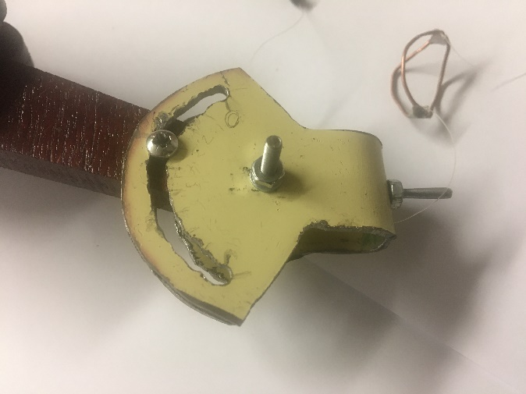The setup for this experiment was the same as the setup for the standard deviation experiment except that I put up a bedsheet so that I would have a high contrast background so the auto-tracker function could work much better.

I also drew on some settings onto my firing pin assembly that would be my independent variable for this experiment. I didn’t have a protractor at the time and could think of an accurate way to do it easily so I simply drew it on as shown.

It’s not a perfect solution but at the time I couldn’t think of a better way to do it quickly and easily. And in my defence, this is not the main experiment so sacrifices must be made so that no sacrifices have to be made for the main experiment. Sacrifice to stop sacrifice.

## Analysis improvements

A big side objective for this experiment was reducing the time taken per shot for analysis. Previously, analysing each shot would take around four or five minutes to import the correct portion of the large video file into tracker to mark the location of the projectile in each frame. Next, I would then extract the time-coordinate data from the tracker program into a spreadsheet and then turn that data into an average velocity. It would be very bad if it took the same time for the main experiment due to the sheer number of shots that I’m expecting to record.

The second thing after the bedsheet that I planned to use to shorten the time spent analysing each shot was in the spreadsheet aspect of the analysis. This took up a large amount of time as I would have to apply a large amount of operations to variable amount of data. So, to fix this issue I wrote a python script that would take the text file that tracker exported and then do all the calculations for me and write it out to a csv file. This is also where I added some angle calculation for each shot which would be a dependant variable for this experiment.

I also wrote a script that I could run with a keybind that would rename the bad default VLC record output with a more linear numbering system. VLC is the software I am using to take a smaller subclip of the much larger video for each individual shot. I did try more professional editing software such as Vegas pro 14.0 and some others but they didn’t support the 240fps that I needed and VLC was easy to use if not a bit inconvenient that the record button only records starting roughly 4 seconds after you hit it.

After these improvements I think I probably averaged around two minutes per shot.

## The experiment

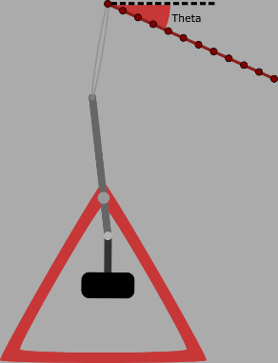The need for this experiment was due to the fragile release problem described in the build document. To summarise, it is to see how the release angle, Theta, and exit Velocity, changes with the angle setting on the firing pin.

Theta is in the interval:

Measured clockwise from the positive x–axis because it made the programming the trigonometric functions slightly easier. I went from setting 0 up to setting 4 in 0.5 increments. I also repeated setting 3 and 3.5 as they as the first time the shot had a very different outcome to the neighbouring setting. So, a total of ten shots.

## The results

|  |  |  |
| --- | --- | --- |
| Angle setting | Velocity | Theta |
| 0 | 6.41 | -76.6 |
| 0.5 | 6.49 | -59.8 |
| 1 | 5.36 | -51.3 |
| 1.5 | 6.18 | -48.5 |
| 2 | 6.17 | -43.2 |
| 2.5 | 6.26 | -32.5 |
| 3 | 6.06 | -20.85 |
| 3.5 | 6.08 | -15.2 |

As you can see from this chart there are two obvious anomalies, the first shot with setting 3.5 and the shot with setting 4.

I am not too sure why at some point in the angle setting there is such a difference in Theta but it must be something to do with the fishing line being able to slip or roll off the firing pin before the carriage is in an actual release position compared to the firing pin.

One way I might be able to improve this phenomenon is by making the firing pins coefficient of static friction much larger, or in other words, less slippy.

Another strange thing slightly less obvious that the outliers, is the difference in theta between the two shots at setting 3. Seeing as either could be more normal for that setting I will average them.

After removing the outliers and averaging the two shots at setting 3.5 we are left with a fairly straight if a bit wavy graph.

Although interesting, this graph isn’t really that relevant to the main objective of this experiment. This is because for this experiment, all other trebuchet settings were kept constant. I believe that this is likely to also have an effect on Theta so I can’t trust this graph to be true for any other trebuchet settings and I don’t have the time to test whether or not it would either.

This graph on the right, however, is very significant. This column chart shows the exit velocity changed with thh angle setting.

As you can see, apart from setting 1 which is likely a slight misfire, there is very little difference in the exit velocity of the projectile between shots despit how much the angle of the firing pin changed.

This completely took me by surprise as I had previously thought that the release angle would greatly change the exit velocity but even over a change of 61.4° the standard deviation (ignoring setting 1) is 0.150 .

This is also very good news for my main experiment aslong as I can now in good faith record the exit velocities from all different settings of my trebuchet arms knowing that as long as the sling doesn’t slip, that that exit velocity is unrelated of the angle at which is was thrown. It is also very easy to tell when the sling slips as the release angle is wildly different from the average shot.

I think it is a bit strange that my trebuchet exels at throwing the projectile between near vertically downwards and horizontally. I think this is because at the moment the sling is just slightly longer than the main arm and so reaches a release position relative to the firing pin much later in the shot and is thrown more downwards.

## Improvements

For the main experiment, which I think this experiments results have now given the green light for, I will slightly shorten the sling which I think will increase Theta and maybe give me some more room to work with however if it ends up increasing the rate of misfired from the sling loop slipping then I can always make the firing pin less slippy or even just revert back to a slightly longer sling.

One a bit of a side note I believe that one of the reasons for the slightly wavy graph of theta against angle setting may be because of the current state of my firing pin assembly in that the firing pin and the pivot the firing pin is rotating around have a 4cm separation which means that if I rotate the firing pin assembly not only do I change the orientation but it also changes the location of the firing pin quite considerably to the extent that when the firing pin was at 45° the firing pin was roughly 2cm closer to the main fulcrum and 2cm outwards from the main arm which is very likely to affect the performance of the trebuchet. So to fix this ready for the main experiment I will need to reduce the distance between the firing pin and the pivot.

I think I will also make a way to show what the current trebuchet setup is as when applying the auto tracker function in tracker there is no audio as it processes only the frames taken from the video. This meant to find out which shot I was doing I would need to also watch the actual video in real time with audio and listen to my sarcastic self call out what the current setup was. This is quite tricky and annoying so I will make a display similar to how a clapperboard is used in the film industry except without the clapper bit and static in the frame. It would mean I would have to update it when recording the main experiment but it would make the analysis stage a lot easier.

# Theory behind the static friction required to slip the fishing line off the firing pin

## The problem

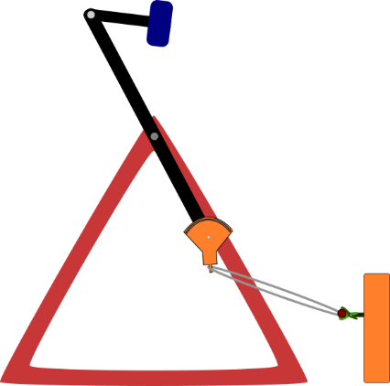This problem initially came to my attention when needing to separate different setups depending on the angle of the main arm of the trebuchet at its balancing point so that a carriage release system could be chosen but I decided to find that angle practically after some indecision around the position of the carriage release system in relation to the firing pin for the main experiment. After much too long pondering the problem I decided that the matter wasn’t worth so much of my time so I moved on but the physics in the following section is still interesting to me nonetheless.

The problem I needed to solve first would be what angle, theta, does the component of the tension anti-parallel to the friction force on the fishing line become equivalent to the friction force for a given constant tension. Or in other words at what angle, theta, for a given constant force does the fishing line loop slip off the firing pin.

## Predictions

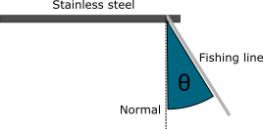Without using any maths or equations my instincts would tell me that the larger the tension force the smaller theta as there is more force to overcome friction, but at the same time, the larger the tension the greater the friction as there would be more force pressing the fishing line and stainless steel firing pin together. So, it then becomes a question of how the frictional force changes with increased normal contact force and whether that increases faster, slower, or at the same rate as the component of the force anti-parallel to the frictional force?

In such a case I don’t know how theta will change with changing tension or even if it will change at all.

## Calculation

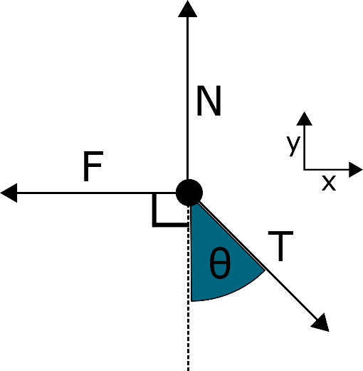To start this problem, I will draw a free body diagram modelling the point of the fishing line in contact with the firing pin and create a coordinate system.

The Friction acts parallel to the firing pin so θ is measured from the normal to the firing pin.

As the point is not moving relative to the firing pin at the start the friction is known specifically as static friction. When two objects are moving the relative to each other the friction is known specifically as kinetic friction.

After reading up on the topic I found out that static friction is directly proportional to the normal contact force acting on the object in question. The constant of proportionality is a unitless constant known as the coefficient of static friction and it varies depending on the materials of the two objects.

This makes sense as you would expect objects like stainless steel to have a smaller coefficient of static friction than wood.

As the firing pin is parallel to the x-axis, we know the point mass will be stationary on the y-axis therefore:

We can then substitute that into our new equation for static friction:

We also are trying to find the angle at which the point mass first starts to move which is when the y-component of the is equal to the friction so:

Which we can then substitute into the left side of our other equation:

And rearranged:

As if by magic it just so happens that the angle at which the point mass starts moving does not care about the size of the tension which also solves the question I posed in my prediction that the component of the force anti-parallel to the frictional force increases at the same rate as the frictional force at the “critical angle” per se.

Now, if I want to find out this critical angle of my setup of fishing line on a smooth stainless-steel bolt then I will need to find out the coefficient of static friction for stainless steel on plastic. Unfortunately, plastics varies a lot so there are really slippy plastics and really non-slippy plastics so there is no general coefficients for drag that I can find on the internet for plastic, however, I did find a very large table of coefficients for lots and lots of different materials in various pairings and conditions such as lubricated or dry. [6]

In this table the closest matches to my scenario are:

|  |  |  |  |
| --- | --- | --- | --- |
| Material 1 | Material 2 | Condition |  |
| Plexiglas | Steel | Clean and Dry | 0.4 – 0.5 |
| Polystyrene | Steel | Clean and Dry | 0.3-0.35 |
| Polyethylene | Steel | Clean and Dry | 0.2 |
| Polyethylene | Steel | Lubricated and Greasy | 0.2 |
| Polytetrafluoroethylene (PTFE) | Steel | Clean and Dry | 0.05 – 0.2 |

Unfortunately, I cannot find the specific material that my fishing line (fox match one plus 0.2mm) is made of, however, I have found out that most modern fishing lines are made of various artificial substances including nylon, polyvinylidene fluoride, polyethylene, Dacron and UHMWPE with nylon being the most common.

I would guess that the Polyethylene – Steel combination is the most similar to my situation but to find out the real value I will need to do an experiment.

## The experiment

For this setup I just used my high-speed camera to record me slowly increase the angle that I was pulling the fishing line on the firing pin until the fishing line suddenly sprung off the firing pin. I repeated this several times. Then, later when analysing the footage, I would find the frame before the fishing line started moving and measured the angle that that the fishing line made with the firing pin. I repeated this for every time and recorded the angle in a table.

I then had to take these angles away from 90° as what I measured was the acute angle between the firing pin and the fishing line and the angle in the equations is the angle between the normal to the firing pin and the fishing line.

The testing conditions were far from perfect however as the firing pin had a slight taper out toward the top which meant the angle of the firing pin change minutely depend on the position of the fishing line of the firing pin. Also, the footage was not amazing either as it is only 720p and the firing pin is quite small so it was quite hard to perfectly measure the angle between the firing pin and the fishing line especially since the firing pin was not always the same angle at all points on it.

This experiment was very straight forward compared to previous experiments so it did not take me long at all.

## The results

The results are just as varied as I had expected due to the imperfect testing conditions but due the fairly large number of repeats I can be happy that the mean of 31.0° is reasonably near to the true value.

We can now use this experiment value for the critical angle of my fishing line on stainless steel to calculate the coefficient of static friction for this setup.

To calculate our uncertainty we first need to find out our absolute uncertainty in our critical angle. The range in our values for the critical angle is:

And so our critical angle is:

As the tan gradient of the tan function at is increasing from 0° to 90° we will use the upper bound to calculate the uncertainty in the value of :

And so our final value for the coefficient of static friction of my setup is:

Now, I would have gone on to use this value to calculate a pivotal rotation around which the setups could have been sorted, however, I have solve such an issue mathematically as it not as useful as real practical experimentation especially since the maths involved is just downright boring.

# An update on the effect of the firing pin on release angle

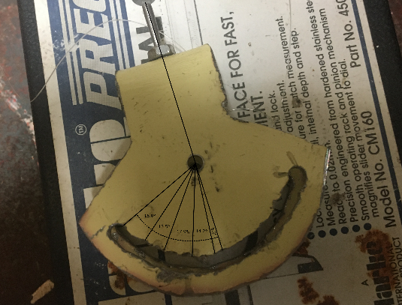It was at this point that I was looking at some pictures of the hand drawn firing pin settings I made and I wondered how if the wavy angle setting vs release angle graph here could have been caused by my lazy hand drawn settings.

|  |  |  |
| --- | --- | --- |
| Angle setting | Actual firing pin angle | increment |
| 0.0 | 66.8 | 8.0 |
| 0.5 | 58.8 | 8.0 |
| 1.0 | 50.8 | 6.7 |
| 1.5 | 44.1 | 6.8 |
| 2.0 | 37.3 | 8.9 |
| 2.5 | 28.4 | 9.0 |
| 3.0 | 19.4 | 7.1 |
| 3.5 | 12.3 | 7.1 |
| 4.0 | 5.2 | 5.2 |

First I took a picture of my firing pin settings from above and measured the angles digitally between the settings, shown in table 5. As you can see the increments are not very consitent which is a disadvantage of drawing measurement marks by eye.

Now for the interesting part which is to now plot Theta vs the reale firing pin angle.

My opinion is that this is a straighter graph than the previous but I am highly biased. Another though I had is one of the reasons for a waivy graph could be down to an imperfection is my current firing pin assembly in that the firing pin pivots almost 4cm from the pivot itself which may effect lots of things such as release angle or even release velocity. For this reason I have added it to my to-do list to make a firing pin assembly with a much shorter distance between the firing pin and its pivot. Either way it is never a good idea to draw things you plan to analyse by eye.

# Computing the two groups of trebuchet setups

The two groups of trebuchet setups are split from my set of all possible setups. They are split based on their predicted rotation at their balancing points. Now, I will find this value for this angle that I will the split the setups upon.

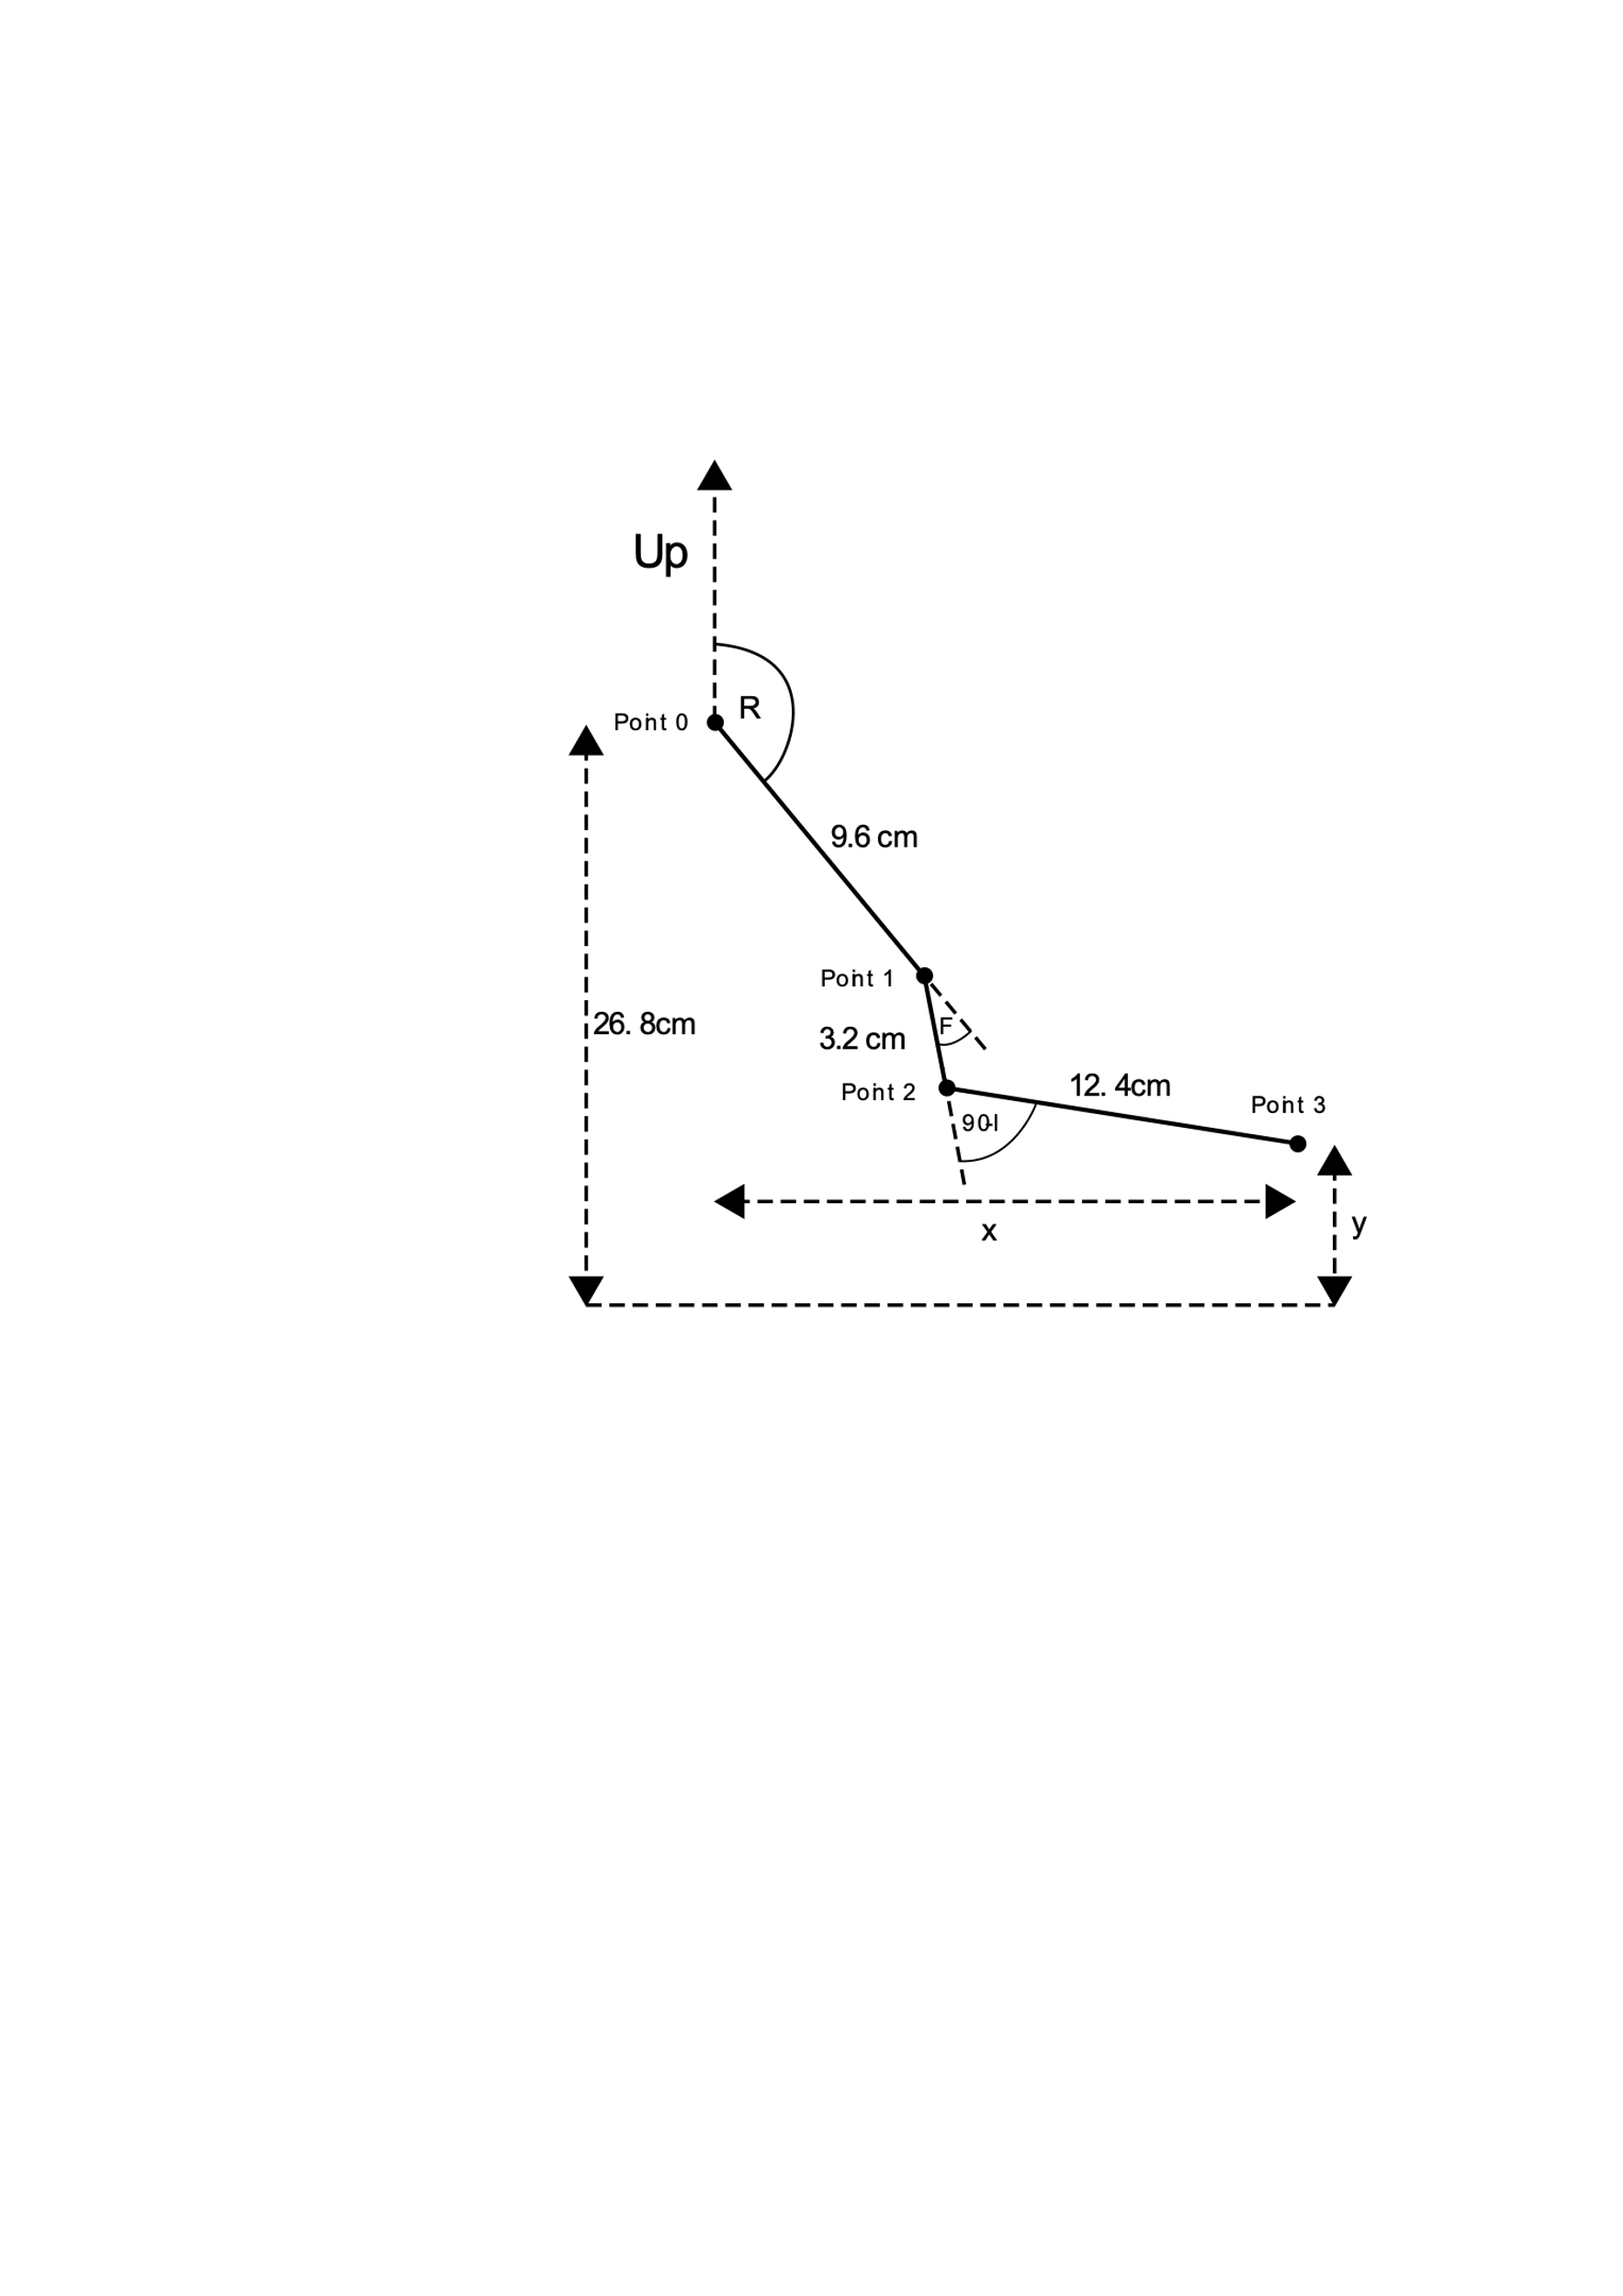Represented in this diagram is the rotation angle, R, the firing pin angle, F, and , where is the critical angle worked out previously. I called it because I am dealing with multiple angles so it doesn’t make much sense to use θ and is the next unused letter of the word Critical with being the set of all possible trebuchet setup combinations. It may be easier mathematically to measure the vertical distance between the main fulcrum and the location of the projectile as the value y, however, it will be much easier for me to later to measure the distance from the floor to the projectile so I have set y as the distance from the base of the trebuchet.

I found out that the firing pin angle, F, is generally preferred to be 45° [7], however it is one of the main components that effects the release angle of the projectile and when I did my experiment testing the effects of changing F I found that for my specific trebuchet setup up to setting 3.5 of my hand drawn settings resulted in a stable increase of the release angle with the increase in the firing pin settings from 0 to 3.5 in a relatively linear fashion. After setting 3.5 the trebuchet began to misfire.

I also found in that experiment that the firing pin angle had very little impact on the final velocity of the projectile so in that case it shouldn’t really matter what I set my firing angle to when the final velocity is my dependant variable. However when the projectile goes near vertically down for the really low settings I found it much harder in the later analysis stage of the experiment to find the velocity of the projectile as the distance that the projectile travelled in the frame of the video was much smaller as the frame of the video is landscape.

This is also without mentioning that after that experiment I purposely changed the length of the sling which is known to have a large effect on the release angle of the projectile which makes the setting vs release angle values now unusable.

Seeing as the release angle isn’t really that important other than being roughly horizontal, I will do some trial and error to find a setting that both throws roughly horizontal and is resistant to misfires.

The position of the carriage release system compared to the trebuchet, denoted by and x and y, have an effect on R so to work out R I will need to have values for x and y.

It must also be noted that I had planned for y to be constant while x is varied to adjust for the different balancing points of the different trebuchet setups so that the GPE of the projectile for each shot remained the same. However I changed my mind and instead have decided to try to keep the carriage in line with the firing pin regardless of the change in the initial GPE of the projectile as it will allow for a much larger group of setups in the first group and the initial GPE of the projectile is not worth the energy spent trying to control it.

With a now abstracted diagram I can start to do some calculations. First off, we will try to work out y:

Vertical displacement between Point 0 and Point 1 is:

Vertical displacement between Point 1 and Point 2 is:

Vertical displacement between Point 2 and Point 3 is:

## Calculating the limits of the rotation for all possible trebuchet setups.

I had already done this in the build document because I innocently yet very wrongly believed if I could find a position for the carriage release system that worked for the minimum rotation then I could then simply adjust the horizontal position of the carriage release system for all the other setups. This is however completely and utterly impossible due to the fact that the sin graph doesn’t stray above one or below minus one which makes sense when you think about the scenario.

In any case the calculations I made are still correct and can be used so I will go through them.

The maximum that θ reaches is when *a* is minimised and *b* is maximised, which makes a lot of sense when you imagine the corresponding trebuchet setup. The minimum that θ reaches occurs when *b* is minimised and *a* is maximised. I have also had to manually corrected an issue I had with the sine function for the minimum value of θ by not taking it away from 180.

**Minimum (4, 19) :**

**Maximum (16, 7) :**

## Limitations continued

With the limits found for R I now could go ahead and use the maximum value for R to calculate the lowest position of the firing pin, however, there may be a scenario that produces an even greater value for R than I have calculated. This is possible because it is not a member of C. This is because it violates many of the limitations described when defining C.

I am talking of, non-whipper, standard trebuchet setups.

With y now found all I need now are the values for and F. I have recently worked out as 31.0° ± 4° but the microsecond that I began thinking about how to find out F I had a large epiphany. F may not be constant.

F may not be constant.

F, may, not, be, constant.

Queue the dramatic music because this is intense. F affects the release angle of the projectile; it is currently unknown to me if the main and secondary arm settings also affect the release angle or not. Considering that trebuchets are very sensitive mechanisms it would not be so unimaginable that the main and secondary arm settings do indeed quite affect the release angle of the projectile. This is not an issue for the reliability of the main experiment as I showed that the release angle of the projectile had very little effect on the final velocity of the projectile, however, if the release angle changes so much that the trebuchet begins the misfire then it becomes a very real problem. This is because the only way to fix the release angle of the trebuchet is to change the angle of the firing pin. This then means in the general cascading way problems are that all of the work on working out R will have been for nothing as I have assumed this whole time that F would be constant.

Now with baited breath I now must go and test this theory over a range of trebuchet setups to see how well they retain their release angle and if it’s good enough.

I have judged this section discontinued as I would rather practically find the pivotal angle and its boring.

# The conditional nature of the correctness of the rule of sines for principal solutions for my specific triangle problem type.

That title was a lot of fun to write and hopefully I will be able this problem if you weren’t able to instantly grasp it just from the title.

When I first tried to graph the rotation of the balancing point for all the different setups there was a strange vertex in the some of the curves and at the time, I was unsure of why it was there at the time and so just left it without thinking about it too much. Jumping forward in time a bit, I later tried by hand on a bit of paper to solve an angle on a triangle to find the angle of the main arm of the trebuchet at balancing point for the setting of 4cm on the main arm and 19cm on the secondary arm. Using the current equations, I had made it would output 125.1°. To put that into context the settings of 16cm on the main arm and 7cm on the secondary arm outputted 155.9°. At first glance that looks like what you would expect from the two edge – cases of the trebuchet setups as the larger angle is for the settings with the most expected rotation. Once I dug a bit deeper things started to stop making sense. Firstly, when I tried the equation with a main arm of 6cm and a secondary arm of 10cm it outputted 98.6° which is completely unexpected since the two prior setups are supposed to hold the bounds for the rotation of the trebuchet at balancing point, and yet this standard looking setup is outside its range. Secondly when I tried imagining the scenario of the 4cm main arm and the 19cm secondary arm I expected the rotation of the main arm to be way way smaller, probably even less than 90° and yet my equation outputted 125.1°.

So, just like with any equation that I think isn’t working as it should I pick some parameters and work through the problem logically and graphically by hand on paper until I either realise the issue with the equation or I spot an incorrect assumption. That or I get the same answer as my equations and I repeat the whole process repeatedly until I am either unable to remain conscious from which the existential dreams begin, or I find the issue.

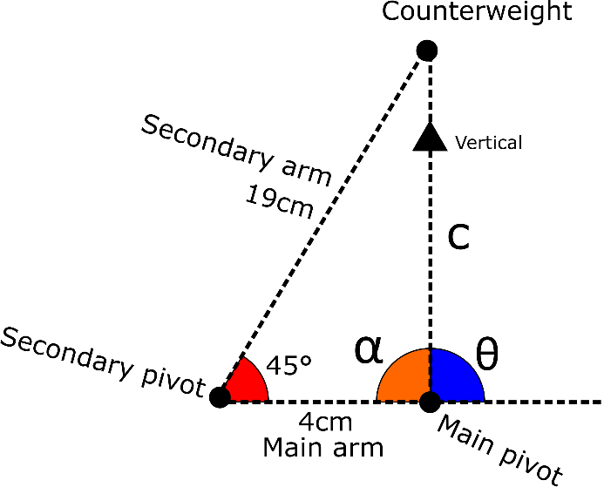Using abstraction, I could strip all the unnecessary information from this problem until I was left with the simple triangle diagram shown.

The goal is to find the angle θ that is the angle that the main arm makes with the vertical.

Anyone who knows the cosine rule could probably tell you that step one is to find out the value of so I did.

The next step is the rule of sines now that we have an angle and its paired angle, 45°, as well as the paired side of the angle we next want to calculate, α.

The final, and easiest in my opinion, is to take out answer away form 180° to find θ as they are on a straight line.

This is one of those situations where you get the same answer as your equation that you think to still be wrong so you commence the loop of despair until a reason presents itself.

After finding nothing wrong with my working I drew the triangle to scale and found that I had worked out perfectly correctly, and yet, the α of my triangle was vastly different to the value that I had calculated with the rule of sines. There is one specific triangle case where there are actually two ways of drawing it with a known angle and two sides, however, there is a very slight difference between it and my triangle case in that the two side length that I know are on either side of the known angle whereas for the ambiguous case one known side length is opposite the know angle. This difference means that there is only one way to draw my triangle and yet the rule of sines returned me an incorrect angle.

Just to absolutely obliterate any chances of this angle being possible I tried substituting my values into one of Mollweide’s formula which use all six aspects of a triangle and can be used to check the consistency of a triangle’s solution.

After drawing my triangle to scale I found that α must be obtuse and that it was about 125.1° which just so happens to be another solution to the equation:

The reason the calculation returned α as 54.91° and not 125.1° is because 54.91° is the principal value for the sine function. As the range for the principal values for the sine function is between -90° and 90° it means that whatever value for you try to a calculator or computer will always give a value between -90 and 90.

This means that you couldn’t possibly use the sine rule natively to find an obtuse angle as it will instead give you the principal solution which may be inaccurate for some triangles.

Now that I knew the core of the problem, I could start to create a solution, well more of a workaround as you will see why.

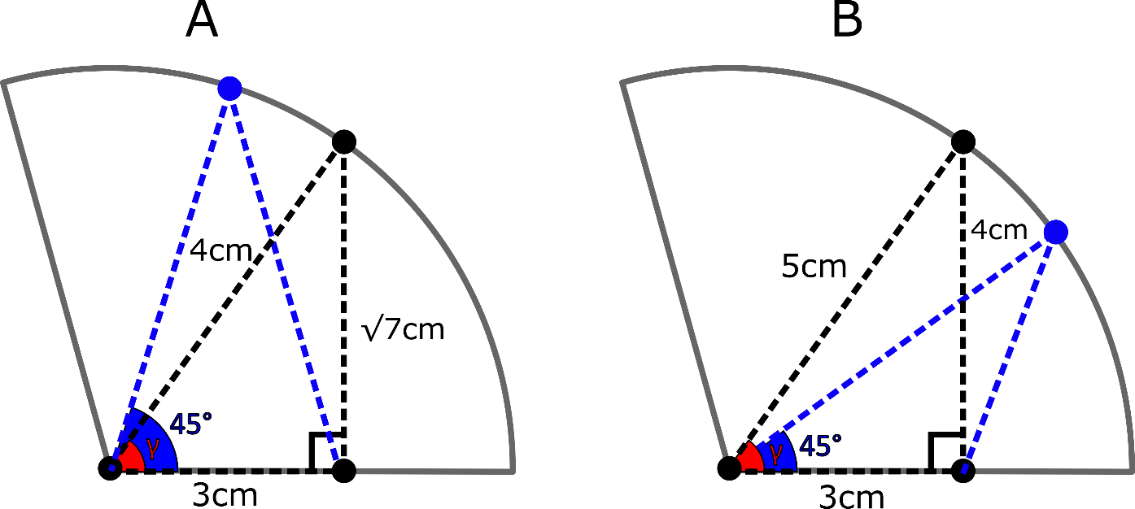So, my equation is sometimes right and sometimes wrong but how can I find out which ones will be wrong so I can fix it? Well, the problem only occurs when α is obtuse the question then becomes when is α obtuse? To solve this, I will consider two different right – angled triangles and their transformations.

To calculate the angle for both cases is very simple and just requires the use of the inverse tan function.

Case A:

Case B:

Notice how in case A: , and in case B: . To transform these two triangles into the triangles we really want with a while also keeping the two sides either side of the same, we have to move the top vertex along the arc shown. For case A we have to move it to the left and for case be we have to move it to the right. Most importantly notice the affect of this transformed triangle on in each case. In case A that angle has become acute and in case B it has become obtuse.

From this when can infer that if then the important angle will be obtuse and if then will be acute. Therefore:

is acute when:

Because , will always be positive and seeing as the tan function is strictly increasing between 0° and 90°, we can say:

The only two variables side lengths we know are the adjacent and the hypotenuse so we must employ good ol’ Pythagoras, but first, let me variablise our know lengths. Let us say that our adjacent side is of length and our hypotenuse is of length .

As we know and are length, they will always be positive.

And there you have it, an inequality that will tell you when α will be acute. The same process can be used to form an inequality for checking for obtuseness however it is not needed as if is not acute, then it must be obtuse so we can simply use this inequality to find out whether will be acute or obtuse.

To go back to the original problem, the inverse sin function will always give us the principal solution which is in the range which cannot be correct when is obtuse so instead we must find the correct angle which as (because we are dealing with lengths) will lie in the second quadrant so the correct angle will be:

To conclude:

When :

When :

I still feel like it is a bit of a workaround as now a simple triangle problem has become conditional, for principal values, which makes graphing slightly harder as well as mass calculations as they now require a conditional aspect.

I hope you might now be able to understand the title of this section slightly better now.

Just as I was about to conclude this section, I remembered the slightly less used rearrangement of the cosine rule for working out an angle given all three sides. So, I just had to try this other method to see if I got different results.

The first step is still the same in using the cosine rule to calculate so I will copy the value of

And would you look at that, the principal value is in fact correct. This is because unlike the inverse sine and inverse tan functions the inverse cosine function has a different range of principal values due to the shape of the cosine graph. The range of principal values for the inverse cosine function is , which means it can absolutely output a principal value that is obtuse.

With this non-conditional method, I can now form a new equation that uses the cosine rule twice to find and then find by taking it from 180°.

With that I now have a non-conditional equation for the rotation of my trebuchet at balancing point which is a good way to end this section, on a high note.

# The path of the counterweight

The problem came from an issue in the design of my trebuchet when the counterweight would hit the carriage release system and it got me wondering about the cool path that the counterweight took when released.

Firstly, it is necessary to note that the counterweight will always want to be vertically below its pivot as that is the point of least GPE and so the most stable.

Secondly, as part of the design of a whipper trebuchet is that the secondary arm which holds the counterweight is stopped from rotating past a certain angle. For my trebuchet I have set this angle as so that is what I will use for this problem.

Finally, when the secondary arm is vertical the angle between the main arm and secondary arm and the angle between the main arm and the vertical are the same because on parallel lines alternate angle are equal.

The secondary arm first becomes vertical when is at so:

When the secondary arm is not vertical it is because it is resting on something that stops it from rotating which for me happens when so:

Seeing as I am only worried about the path of the counterweight, I only need to know the distance of the counterweight from the main axle at some given angle .

Using the cosine rule the distance is:

So for the two regions of this becomes:

With now calculated I can calculate using the sine rule:

## Visualisation

As and are constants, when is also constant and the path of the counterweight where c is constant does of course trace a circle. This was easy to imagine as well when I was just messing with my trebuchet but it was the next region that I was really curious about.

Being a human as I am, I find it quite tricky to accurately imagine complex curves so I will try to implement some sort of coordinate system to graph this curve.

Usually, when graphing you work with the x and y coordinates of any given point and their relationships but for my equation it instead uses the angle of any given point from the vertical and its distance from the origin. This immediately strikes me as exactly the same as the argument and modulus of a complex number.

So, I will take the general complex number in modulus – argument form:

I can then set the modulus as and the as because arguments are measured of the x-axis:

Before I started this problem, I didn’t know how to plot the locus of , this was mainly because I didn’t know the name “parametric equations”. These are equations where the x and y coordinates depend on another variable which in my case is .

So, before I found out how to plot parametric equations using standard graphing software, I had written some code to graph it out using a graphing module for python called matplotlib. This also later had the benefit of allowing me conditional control of variables such I could correct the equation for depending on the value of . Before I show the graph I got, I will first show the parametric equations for the positions of the counterweight as I believe they are a lot simpler to think about than the unnecessary addition of complex numbers.

Position of the counterweight:

On a side note by representing a point as a magnitude and angle are known as polar coordinates, which I also found out.

On another side note when I first coded my equations I made a mistake by setting argument of the complex number as: instead of which gave ended up giving me a cardioid. I got very excited about that as the kind of curve that I had imagined the counterweight taking was very similar to a circle but not a circle, just like the round portion of a cardioid. However, it was not to be as it didn’t make any sense for the rest of the graph to be shaped like the non – round portion of a cardioid.

So, without further ado the complete graph for the position of the counterweight for and is:

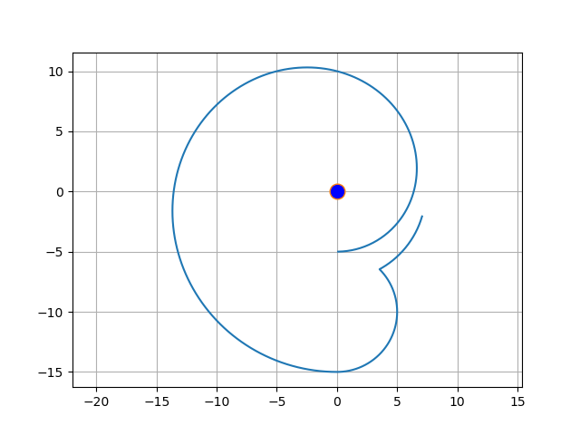This remarkably embryo looking graph was completely unexpected form me and at firs, I thought I had messed up the equations again but as I looked closer I noticed that this graph is in fact correct, but for only for . So, if I only show that part of the graph it looks like this.

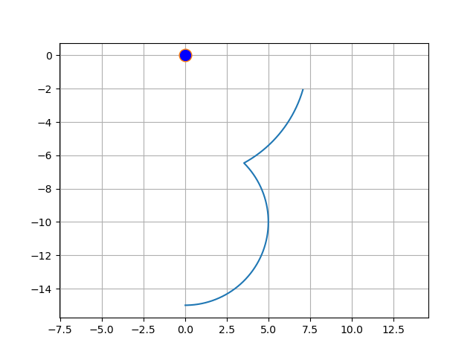Now this is the graph I expected as it shows two arcs of two different circles. The first circles is centred around the main pivot with a radius of when A is 45° hence distance is constant whereas the second circle occurred when begins to change as the counterweight is always underneath the second pivot which goes in a circle, so, the counterweight also traces the same circle just translated downwards by .

When I first saw this, I wondered why the graph started as some random point instead of vertically above the main pivot like it ends below it. The reason this happens because in my equations I have varied θ which is not the angle to the counterweight but the angle of the main arm as that was easier to work with and so where my graph starts is where the counterweight starts when .

Now, the purpose of this exploration was to find the maximum distance outwards the counterweight travels based on its main and secondary arm lengths. We know and can now see that the counterweight will always follow a path made up of the arcs of two circles so I will now define the two circles:

First circle:

Centre: Radius:

Second circle:

Centre: Radius:

The path of the counterweight switches to the second circle where the circles first intersect so I can say with reasonable confidence that the maximum distance horizontally that the counterweight travels outwards is the largest of the radii of the two circles as they are both centred with an x – coordinate of 0. As the counterweight is not a point but a circle for me, we can state the maximum distance outwards of a particular trebuchet setup is as follows.

Maximum horizontal distance:

That would have been the end of the story if not for my stupid conscience. It would endlessly nag me: “hey, hey, hey, you can’t assume stuff like the weight always being below the second pivot, hey, hey.” And “hey, hey, I bet momentum plays a big role in the path of the counterweight, hey.”

To dissolve the nagging of my conscience I had to take on another approach which may have ended up becoming too much fun.

## Accurately simulating a whipper trebuchet

Although with my mathematical equation now I could make some semi-decent predictions on the maximum horizontal distance, however, the actual path of the counterweight can easily be very different to the fact that real life is in terms of stuff like forces and energy which my model did not consider and I think the best example of this is newtons first law of motion applied to my situation.

To make this simulation I used Unity and then wrote a script that for every frame of the simulation would output the coordinates of the counterweight to a csv file so I could side by side compare the two paths, my mathematical model vs the simulation. I made sure to keep the main arm length and the secondary arm lengths the same for both my model and the simulation with , . I also extended the first circle of my mathematical model so both models would have the same range of θ: .

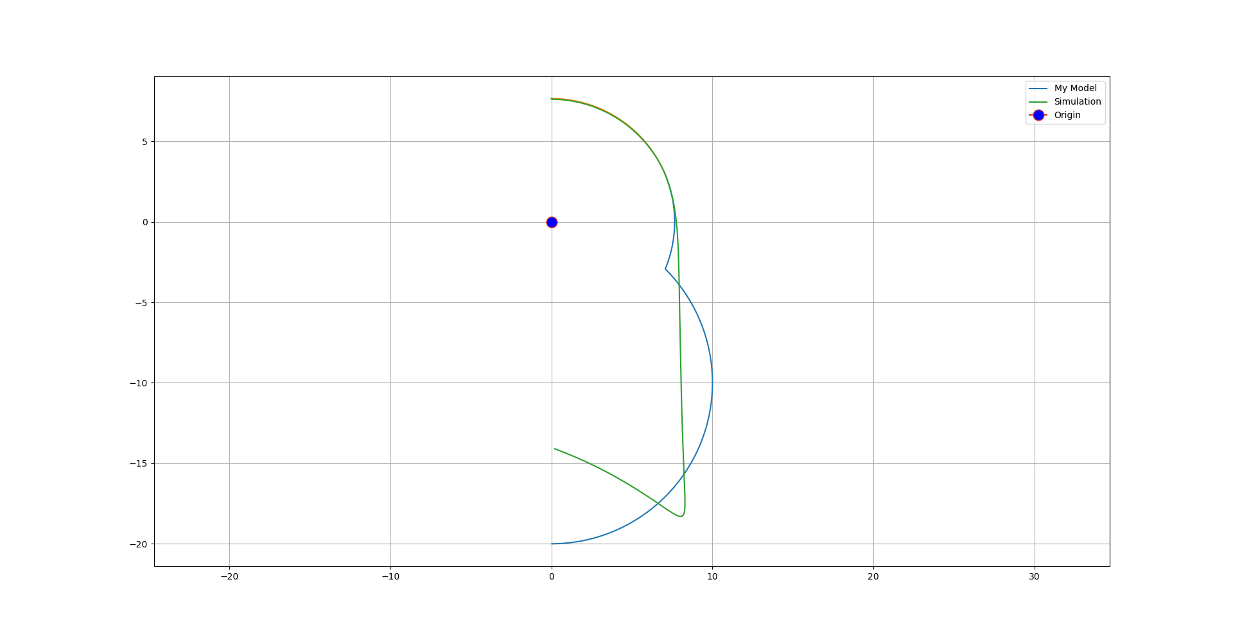

The path the simulation was a slight amplification of the effect I expected after working with an actual whipper trebuchet for several months. I believe the reason behind the path is this; The counterweight always wants to continue in the direction its already moving unless acted upon by an external force (newtons first law of motion). So, at the beginning of its journey the counterweight wants to move down due to its weight, but, it is stopped by the angle limit of 45° and so it starts rotating around the main pivot. At a certain point, the counterweight has more horizontal velocity than the point it would be at if held at 45° to the second pivot and so it rotates as it is free to around the second pivot anti-clockwise so it can retain this horizontal velocity. This results in the counterweight taking a straight path which as it came from a circular path is a tangent. There is the case thought that at this critical point where the counterweight want to move in a straight line that the secondary pivot is in the second quadrant and so for the counterweight to move in a straight line it must slow its vertical velocity which it also doesn’t like to do so it doesn’t move in a straight line yet and tangents off somewhere when the secondary pivot is in the first quadrant.

I think this is the gist of the situation, however, I have undoubtedly made many false assumptions as this situation is very complicated when you start to consider things like the tension in the joints and so on which would take a lot of time to consider and possibly model so I will simply leave the explanation at that as wrong as it may be. This is also the reason I have given up on my model and focused on the simulation as this is not the main topic of this paper.

After seeing this graph, it came to me one way to one up this whole graph, by adding in the actual path of my counterweight on my trebuchet with the same setup.

So, I went and recorded the firing of the trebuchet three times with the same setup which I could then process with tracker to export the coordinates of the counterweight for each frame and plot them on a graph.

The trebuchet setup I used was and as that was what was on the trebuchet at the time. I also had to rerun the simulation and change the parameters for my model for these settings which resulted in the following graph.

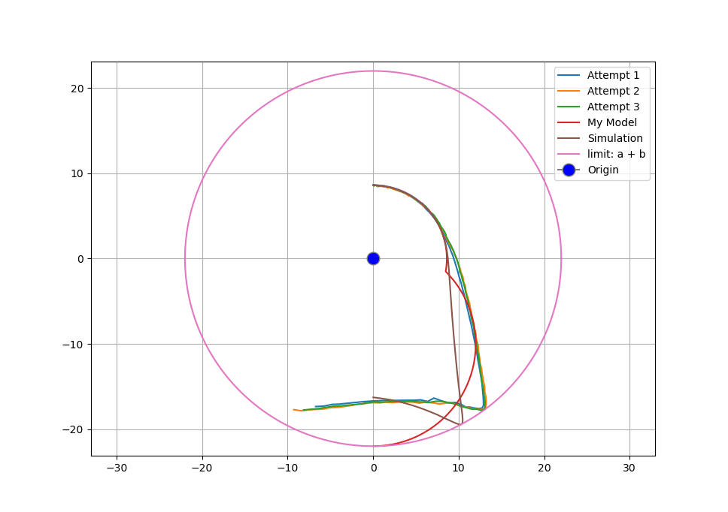

As you can see the real-life counterweight path is very similar to the simulations apart from the simulation tangents off slightly sooner. At first I thought that this was likely due to the vast amount of things settings available for the objects in the simulation such as friction, air resistance, mass and so on which all would have to be tuned to match my trebuchet for it to have a fair chance to be considered a truly realistic simulation, but, I increased the mass of the counterweight by a factor of 5 and just by chance it nearly perfectly matched my actual counterweight path. The only problem was that the increased mass caused the counterweight to start flexing and bouncing on its 45° angle limit so to solve this I changed the velocity iterations from 8 to 40 which stopped the counterweight bouncing which then changed its path so I then had to tune the mass until it followed the same path as the actual counterweight which ended up working even better than before as you can see in this graph

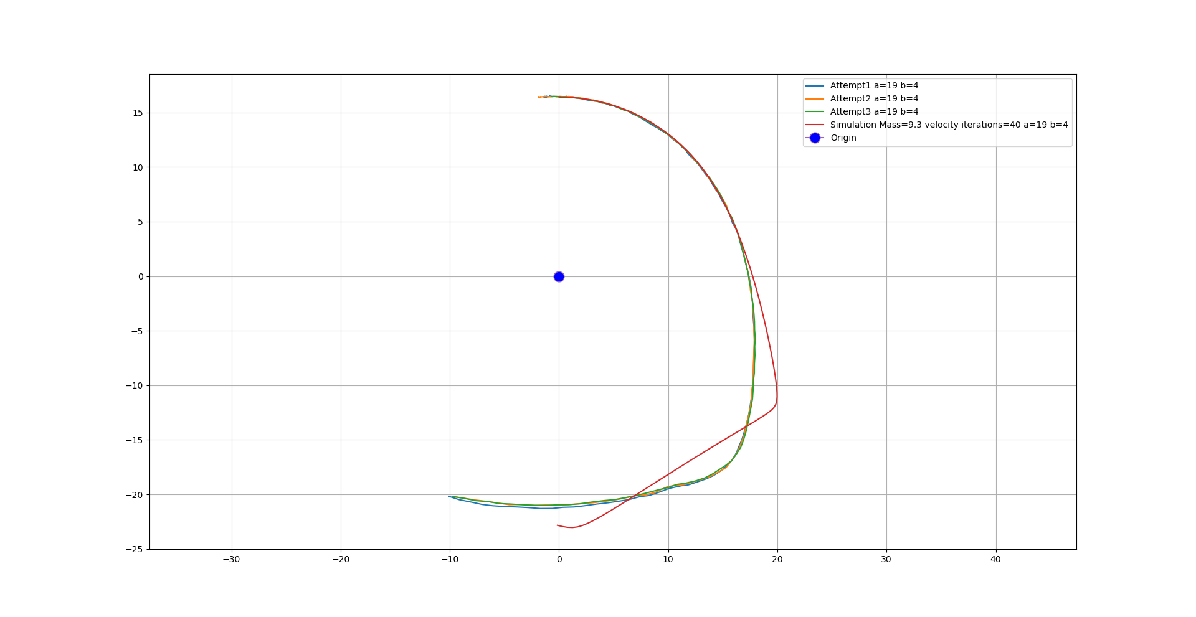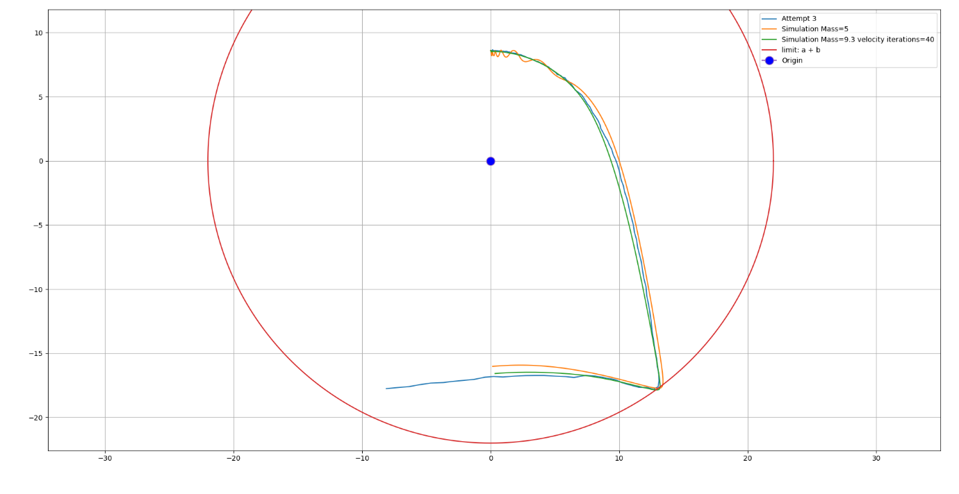The reason I tuned the simulation to try to follow the real-life path is that hopefully the same tuning should hold up for other trebuchet setups. So, the next thing I did was to take the two limits of all my possible setups and record three firings each and then process the videos with tracker to get the path of the counterweight. Then I also ran my simulation with the same setup and then graphed them all.

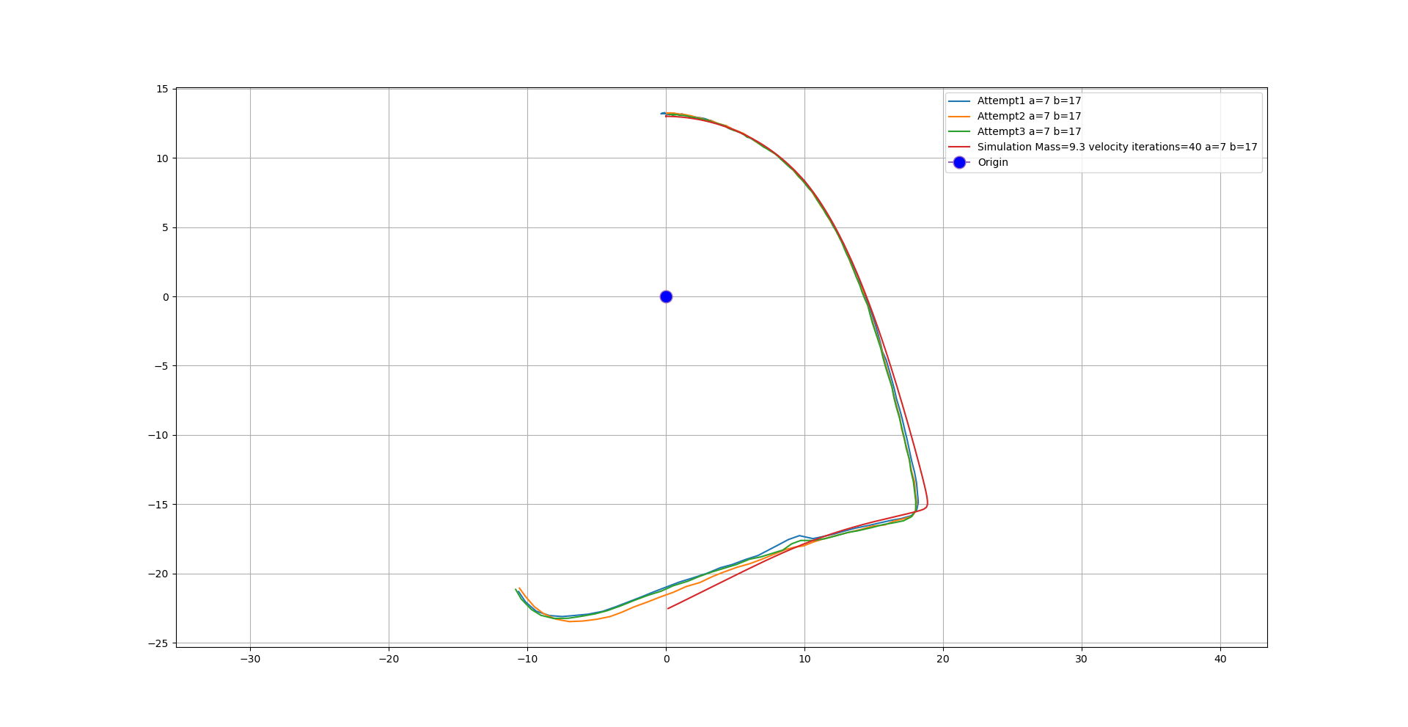For a=19, b=4 the simulation was a bit off the real path but for a=7, b=17 the simulation was showed a nearly identical path which was really quite impressive.

## The standard setups

Up until now I have completely ignored the standard, no secondary arm, partly because I forgot about them but mainly because they are really boring and not really worth investigating. That being said they will still be a part of the main experiment and so it worth mentioning them.

The standard setups have the counterweight directly attached to the main arm at a certain distance so it would not take much imagination to conclude that the path that the counterweight would take would be a circle of radius centred around the main fulcrum.

## The position of the firing pin at release

To fix the brutal counterweight problem I will add a buffer of some line but to know how much line I need to add I need to know a few things. I need to know how far out the counterweight travels out horizontally as well as the radius of the counterweight. These will decide the minimum horizontal distance that the carriage release system must be from the main axle. Then I almost must know the horizontal distance of the firing pin from the main axle at release.

This is all assuming that the buffer line will be parallel to the horizontal at release however if it is not parallel then the buffer will need to be longer.

Also note that in this definition the buffer is including the sling length.

To solve the first issue, for the whipper trebuchet setups, I could just calculate the maximum horizontal distance of the counterweight using my model, however, as I have shown my model is not very good so instead, I will use the simulation. I could record this value for real with my trebuchet but there are over 90 different possible setups and so I will instead write a script that will automate the whole process and output the results in a spreadsheet for me.

For the standard setups the maximum horizontal distance of the counterweight I will simply set as as that is the radius of the counterweights circular path.

Solving the horizontal distance of the firing pin from the main axle at release issue is really easy as it mainly just relies on the angle of the main arm at balancing point, as the length of the main arm is constant. The horizontal distance of the firing pin at balancing point will be:

Where is the length from the main pivot to the firing pin.

To equation for the buffer distance is simply the (max x-distance of the counterweight + the radius of the counterweight) – the x-distance of the firing pin at release.

To find the length of the physical buffer line distance itself we need to take of the length of the sling as that is included in my definition of the buffer.

What I found from doing this for all of my possible trebuchet setups is that only a small number of setups actually require a buffer line. To be exact 23 setups needed a buffer with 16 of them being the standard trebuchet setups (all but 2 of the standard setups) and the rest from a mix of high total setups from both ends of the starting rotation spectrum.

Of these setups the one with the largest value for the buffer line distance is unsurprisingly for the standard trebuchet setup of a=0, b=23 with a buffer line distance of 15.7cm.

The smallest value for the buffer line distance is more interestingly for the a=7, b=5 setup with a buffer line distance of -12.5cm. It being negative means that there is that there is 12.5cm of clearance between the counterweight and where the carriage was at release point.

To conclude, this one of the much longer sections mainly due to the fact I pretty much had to learn how to use unity and I had to learn C# to write scripts for the simulation such as outputting the coordinates of the counterweight each frame. Despite the time spent or the questionable unimportance of the path of the counterweight for solving the original problem I am very happy with what I have learnt and I also now have a cool simulation that I can use if I ever need it in the future.

# Testing the effects of changing the angle of the firing pin 2

There are several reasons for this experiment and why I found it important.

The first reason is that I now have a brand new, improved firing ping assembly for which the distance between the bottom of the firing pin and the pivot around which the firing pin rotates is over 4 times less what it was when I did the first version of this experiment. I now think that this large separation which provides a large translation effect when rotation the firing pin is responsible for the wavy firing pin angle vs release angle graph and can’t have helped for the other dependant variables either. So, to set the record straight I want to do experiment again in which I can have more trust in my results.

The second reason for why I am doing this experiment is because I am the closest I have ever been to the main experiment and I need to know if I can use the same firing pin setting for every trebuchet setup and if so what it should be, if not then I will likely just have to find it by trial and error during the main experiment.

The third reason is because I am not happy with the current system of using VLC to take smaller sub-clips of the main video as it means I have to watch the whole of the clip through which adds time as well as an issue with that VLC only starts recording from the first keyframe after you hit record which is really annoying as that can often be up to four seconds after you hit the record button.

## The editing problem

I decided that I wanted to extract a new smaller video for every trebuchet firing as that would make it really quick to analyse later on.

The first idea I had to split the large files into lots of smaller ones was to use existing editing software, however, nothing I could find would handle 240fps video as an out output so next I moved on to editing videos using python with a module called moviepy as it allowed any fps as an output. The problem then became: how do I get times for all of the different sub-clips that I wanted to extract from the main video? To solve this I made another program that would take the current time every time I pressed a key which I could use when watching the main video to get all of the start/finish times for all the sub-clips. While this solved the issue it meant I had to watch the whole main clip through to obtain the times, I could have reduced this time by speeding up the video and then making sure that all the times I obtained were also suitably adjusted for that speed but if I made a mistake it would be quite annoying to fix so instead I came up with another solution to this problem.

The idea was to go back to using existing editing software but the trick was the fact that the only limitation was that they can’t export at such a high frame rate but I could get around that limitation by slowing the video down after importing the 240fps video so that it would become 60fps which they can easily export. The only change I would have to make is manually setting the frame rate in Tracker to 240fps instead of the 60fps it would detect.

The main advantage of this method is that by using editing software the time taken to get all of the sub-clips is even shorter as you can scrub through a video instead of having to watch it through linearly as I had to do with my previous solution.

## The setup

The only difference from the first firing pin experiment are some of the parts of the trebuchet setup as I have a new firing pin assembly a new plank and a new carriage release system with two-axis measurements for recording the firing position for each shot as well as there is a buffer line between the carriage and the release system firing pin.

For the firing pin since it is the part that will be acting as the independent variable for this experiment, I need to know its angle relative to the the main arm. I have learnt from the last experiment that it is worth the effort on this step to make sure that the marking I will make on the firing pin assembly are precise as they will have a direct effect on the results of this experiment.

So, I used a protractor to make the markings and I can say with good confidence that the markings are correct to 1° of accuracy.

Since, I am now using the actual angle of the firing pin I need to know where that angle should be measure from. It makes the most sense to me to measure that angle from the angle it would be if pointing straight up parallel to the main arm so that’s what I will do.

## The experiment

In this experiment I the independent variables are the angle of the firing pin, the main arm length and the secondary arm length. The dependant variables are the release velocity and the release angle.

# The main experiment

## Control variables

For this optimisation the control variables are:

* The counterweight’s mass
* The projectile
* The sling length
* The length x
* Release pin angle
* The angle of the Arm z makes with arm y at release (shown as θ in figure 3)

## Method for collecting data

This method is now outdated and will be replaced -

|  |  |  |
| --- | --- | --- |
| Step | Instruction | Notes |
| 1 | Make y as small as possible |  |
| 2 | Make z as small as possible |  |
| 3 | Record the shot with 240fps camera | Remember to start/stop the video camera after every shot to create separate videos for every shot. |
| 4 | Name the video with x and y lengths used and which iteration |  |
| 5 | Repeat steps 3 and 4 three times | This is for better accuracy later on as the |
| 6 | Increase z by 1cm then go to step 3 unless you cannot increase z anymore |  |
| 7 | Make z as small as possible |  |
| 8 | Increase y by 1cm then go to step 3 unless you cannot increase y anymore |  |
| 9 | Finished | Pat yourself on the back, Good job! |

## Results

|  |  |  |  |
| --- | --- | --- | --- |
|  |  |  |  |
|  |  |  |  |
|  |  |  |  |

## Analysis

# References:

[1] – trebuchet (n.), URL: <https://www.etymonline.com/word/trebuchet>, Last accessed 19/06/20

[2] – Chevedden, Paul. (2000). The Invention of the Counterweight Trebuchet: A Study in Cultural Diffusion. Dumbarton Oaks Papers. 54. 10.2307/1291833.

[3] – Tracker, version 5.1.5 (2020), comPADRE, URL: <https://physlets.org/tracker/>, Last accessed: 19/06/20

[4] – Mike. (2010), *Tuning a trebuchet for maximum distance – a look at the components and variables*, URL: <https://www.mikesenese.com/DOIT/2010/12/tuning-a-trebuchet/#:~:text=Sling%20length%20and%20pin%20angle,lobbing%20projectiles%20over%20tall%20objects.>, Last accessed: 19/06/20

[5] – Quick Math, URL: <https://quickmath.com/webMathematica3/quickmath/algebra/simplify/basic.jsp>, Last accessed: 19/06/20

[6] – The Engineering ToolBox, URL: <https://www.engineeringtoolbox.com/friction-coefficients-d_778.html>, Last accessed: 18/07/20

[7] – The Hurl, URL: <http://thehurl.wikidot.com/tuning>, Last accessed:20/07/20