MCP Gateway Architecture & Technical Integration Requirements
Scope: Claude/MCP Client -> Zuplo MCP Gateway -> MCP Server/Tool Handler -> Downstream API reference only | ISAM provides enterprise OIDC login

1. Working Assumptions and Scope Boundary
Area | Definition
In scope | MCP client connection, Zuplo MCP Gateway, IBM ISAM OIDC login, MCP Server/Tool Handler, downstream API shown only as a reference dependency.
Out of scope for now | APIC, downstream API credential strategy, downstream API authorization, and any token propagation past the MCP server.
Preferred pattern | Zuplo owns the MCP-facing OAuth boundary; IBM ISAM remains the enterprise OIDC IdP; Zuplo issues the MCP access token used by Claude.
Key confirmation | Confirm with Zuplo whether the gateway fully handles CIMD for MCP clients while federating to ISAM as a conventional OIDC provider.

2. Target Architecture View
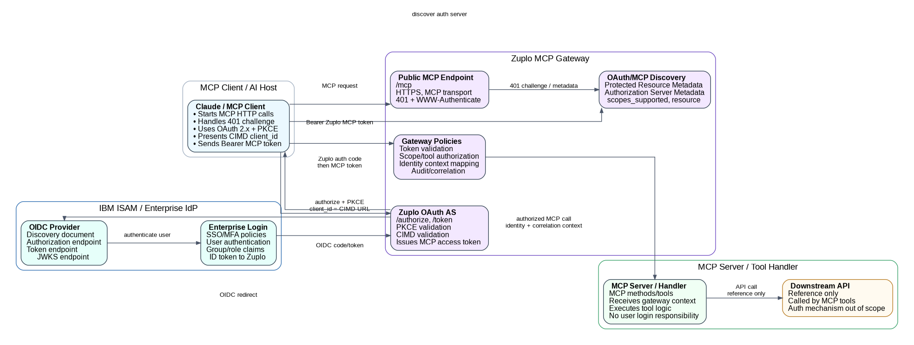
Figure 1 - Target architecture. Downstream API is included as reference only; APIC and downstream auth are intentionally excluded.

3. Component Responsibilities and Technical Requirements
Technology / Team | Role | What it does | What the team must provide / configure
Claude / MCP Client | MCP client, OAuth public client | HTTP MCP transport; handles 401 challenge; reads protected-resource metadata; reads authorization-server metadata; starts Authorization Code + PKCE; presents CIMD client_id URL where supported; stores/sends Bearer MCP token. | MCP endpoint URL; supported redirect URI; CIMD metadata URL; accepted scopes; PKCE S256; resource parameter support.
Zuplo MCP Gateway | MCP Resource Server + MCP-facing OAuth Authorization Server + Gateway policy layer | Public HTTPS MCP endpoint; protected-resource metadata; authorization/token endpoints; PKCE validation; CIMD/pre-registration handling; OIDC federation to ISAM; short-lived MCP token issuance; resource/audience binding; scope/tool authorization; audit/correlation. | Gateway host; TLS cert/DNS; Zuplo project/env; route to MCP server; OIDC client config from ISAM; policy config; token lifetime; scopes; logs sink.
IBM ISAM | Enterprise OIDC IdP | Authenticates enterprise user; enforces SSO/MFA/policies; hosts OIDC discovery; authorization endpoint; token endpoint; JWKS; issues ID token and/or access token to Zuplo; provides claims/groups. | Issuer URL; /.well-known/openid-configuration; auth URL; token URL; JWKS URL; client ID; client secret; redirect URI https://<gateway-host>/__zuplo/oauth/callback; scopes/claims; signing algorithm; group mapping.
MCP Server / Handler | Tool runtime behind gateway | Exposes tools/resources/prompts; receives authorized MCP calls from Zuplo; consumes identity/correlation context if forwarded by gateway; executes tool logic; calls downstream API as needed. | Private endpoint or controlled ingress from Zuplo; agreed identity headers/context; correlation ID handling; tool names/descriptions; error model; timeout limits.
Downstream API | Business/API dependency - reference only | Receives calls from MCP Server/Handler after tool execution starts. Authentication/authorization for this API is not defined in this document. | API base URL and contract only if needed by MCP implementation; downstream auth deliberately deferred.

4. Configuration Checklist by Team
Team | Required actions
ISAM team | Create Zuplo as an OIDC confidential/web application; provide issuer, discovery, authorization URL, token URL, JWKS URL, client ID, client secret, allowed redirect URI, supported scopes, claims/groups, signing algorithm, token lifetimes, MFA/SSO policy constraints.
Zuplo team | Configure MCP Gateway route; configure mcp-oauth-inbound/generic OIDC provider; set resource identifier; publish protected resource metadata; define scopes; configure CIMD/pre-registration behavior; issue short-lived MCP token; define tool authorization policies; emit audit/correlation logs.
MCP server team | Expose MCP server endpoint reachable only through Zuplo or controlled network path; define tools/list and tools/call behavior; accept gateway identity/correlation context; implement tool-level logging and safe error responses; do not implement browser login.
Network/security team | Approve DNS/TLS; inbound path to Zuplo gateway; outbound Zuplo-to-ISAM URLs; Zuplo-to-MCP connectivity; firewall allowlists; key/cert handling; log retention path.
Client/Claude team | Confirm MCP remote server support; redirect URI requirements; CIMD metadata behavior; PKCE support; scope/resource parameter behavior; user-facing consent/login expectations.

5. Detailed Sequence Flow
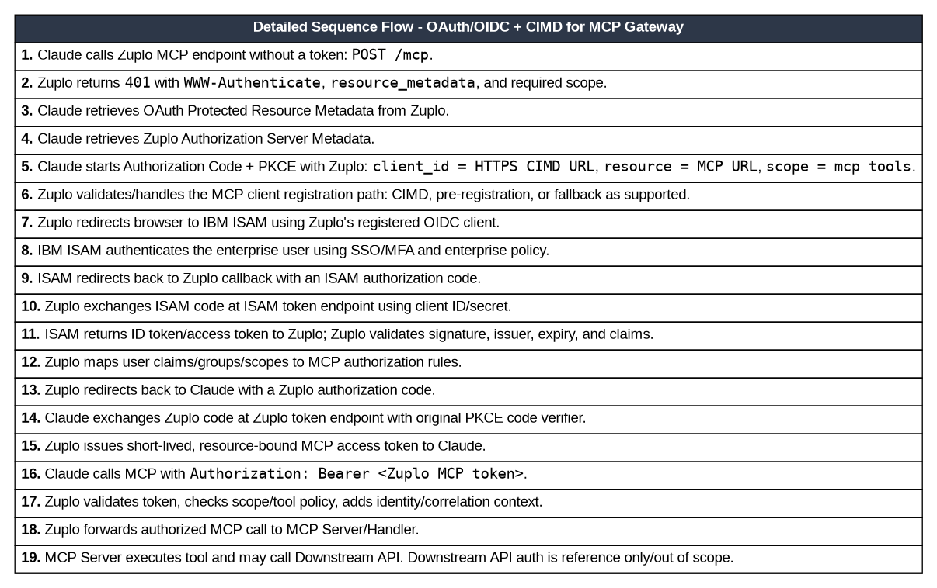
Figure 2 - Detailed authentication and MCP invocation sequence. APIC is excluded; downstream API remains a reference endpoint.

6. Endpoint and Token Contract
Endpoint / Contract | Example / Placeholder | Purpose
Zuplo MCP endpoint | https://<gateway-host>/mcp | Entry point used by Claude/MCP client. Returns 401 challenge when token is missing/invalid.
Protected Resource Metadata | https://<gateway-host>/.well-known/oauth-protected-resource[/path] | Advertises MCP resource identifier, authorization server(s), and supported scopes.
Zuplo Authorization Server Metadata | https://<gateway-host>/.well-known/oauth-authorization-server | Advertises authorize/token endpoints, PKCE methods, CIMD support if applicable.
Zuplo authorize endpoint | https://<gateway-host>/oauth/authorize | Receives Claude authorization request with client_id, redirect_uri, code_challenge, resource, scope, state.
Zuplo token endpoint | https://<gateway-host>/oauth/token | Exchanges Zuplo authorization code + PKCE verifier for Zuplo MCP access token.
Zuplo OIDC callback | https://<gateway-host>/__zuplo/oauth/callback | Registered redirect URI in ISAM for Zuplo as the OIDC client.
ISAM discovery | https://<isam-issuer>/.well-known/openid-configuration | Source of issuer, auth/token endpoints, JWKS URI, supported scopes/claims.
ISAM authorize/token/JWKS | Provided by ISAM discovery or manually | Used only between Zuplo and ISAM for enterprise login/federation.
Token | Direction | Purpose / Boundary
ISAM ID token | ISAM -> Zuplo | Enterprise user authentication/identity. Zuplo validates issuer/JWKS/expiry and extracts claims. Not used by Claude for MCP calls.
ISAM access token | ISAM -> Zuplo | Optional/IdP-side token depending on ISAM/OIDC setup. Should not become the MCP bearer token unless explicitly choosing a pass-through design.
Zuplo MCP access token | Zuplo -> Claude -> Zuplo | Short-lived token scoped/resource-bound to the MCP gateway/server. This is the token Claude sends on MCP requests.
Internal/downstream credential | MCP Server -> Downstream API | Reference only/out of scope. Do not assume token propagation from Claude/Zuplo to downstream API.

7. Security Controls and Decisions to Confirm
Control / Decision | Requirement
Token boundary | Do not pass ISAM tokens or Zuplo MCP tokens through to downstream APIs by default. Treat Zuplo as the MCP auth boundary.
Audience/resource binding | MCP tokens must be bound to the intended MCP resource/gateway. Zuplo should reject tokens minted for another MCP resource.
CIMD risk controls | If Zuplo fetches CIMD documents, enforce HTTPS, exact client_id match, redirect URI validation, domain allowlists/reputation policy, SSRF protections, and cache rules.
Scopes and tool authorization | Define minimal scopes and map claims/groups to allowed MCP tools. Destructive tools should require separate approval or step-up scope.
Claims forwarding | Agree which identity fields Zuplo forwards to MCP server, for example subject, email, groups, client ID, scopes, correlation ID. Avoid raw token forwarding unless explicitly approved.
Observability | Generate a correlation ID at Zuplo if missing; log authentication events, token issuance, tool name, subject, client, result, latency, and error category.
Local development | For zuplo dev, ISAM may need a localhost callback such as http://localhost:9000/__zuplo/oauth/callback if allowed by policy.
Final open question | Can Zuplo fully handle MCP-facing CIMD while using IBM ISAM only as a conventional OIDC provider? This should be confirmed with Zuplo before assigning CIMD requirements to ISAM.

8. References Used
- Model Context Protocol Authorization specification, 2025-11-25 / latest 2026 authorization material: https://modelcontextprotocol.io/specification/2025-11-25/basic/authorization
- Model Context Protocol Client Registration specification, 2026-07-28: https://modelcontextprotocol.io/specification/2026-07-28/basic/authorization/client-registration
- Zuplo Docs - Authentication overview: https://zuplo.com/docs/mcp-gateway/auth/overview
- Zuplo Docs - Configuring a generic OIDC provider: https://zuplo.com/docs/mcp-gateway/auth/configuring-generic-oidc
- Zuplo Docs - MCP Gateway overview: https://zuplo.com/docs/mcp-gateway/introduction

