Arduino

void setup() {

Serial.begin(9600);

}

void loop() {

int sensorValue = analogRead(A0);

float t=millis()/1000.00;

Serial.print(t);

Serial.print(",");

Serial.println(sensorValue);

delay(10);

Ecg biasa

RawECG =xlsread('RawECG.csv');

sinyal=RawECG(:,2)/1023.00*5.0;

fs=100; % frekuensi sampling 100

L=length(sinyal); %panjang data

waktu=(0:L-1)/fs;

%-------Plot Waktu---------

subplot(2,1,1)

plot(waktu,sinyal);

title("Sinyal ECG Domain waktu");

xlabel("Waktu(s)");

ylabel("Amplitudo(Volt)");

%-------FFT dan Plot Frekuensi-------

frek=(0:L-1)*fs/L;

B=abs(fft(sinyal));

subplot(2,1,2)

plot(frek,B)

title("Sinyal ECG Domain Frekuensi");

xlabel("Frekuensi(Hz)");

ylabel("Magnitude");

xlim([-10 110]);

ylim([0 5000]);

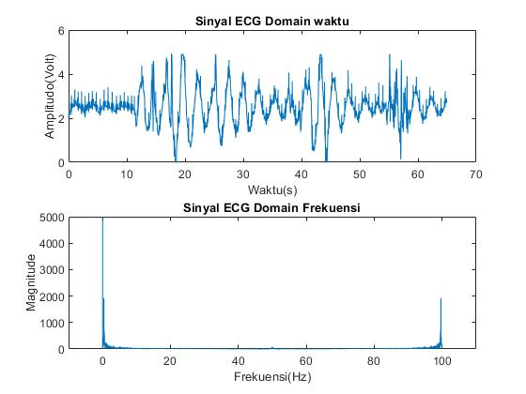

Ecg pli

RawECG =xlsread('RawECG.csv');

sinyal=RawECG(:,2)/1023.00*5.0;

fs=100; % frekuensi sampling 100

L=length(sinyal); %panjang data

time=L/fs;

waktu=linspace(0,time,L);

S = sin(2*pi*50*waktu); % noise pli

ss=transpose(S);%menyamakan matriks

noise=sinyal+ss;

%---------- SINYAL SETELAH NOISE --------------

hold on

figure(1)

subplot(2,1,1)

plot(waktu,noise);

title("Sinyal ECG dengan Noise PLI domain Waktu");

xlabel("Waktu(s)");

ylabel("Amplitudo(Volt)");

%------- SINYAL DOMAIN FREKUENSI-----

B=abs(fft(noise));

frek=(0:L-1)*fs/L;

subplot(2,1,2)

plot(frek,B)

title("Sinyal ECG dengan Noise PLI domain Frekuensi");

xlabel("Frekuensi(Hz)");

ylabel("Magnitude");

xlim([-10 110]);

ylim([0 5000]);

hold off

csvwrite("file_noise_pli.csv",noise);%save noise

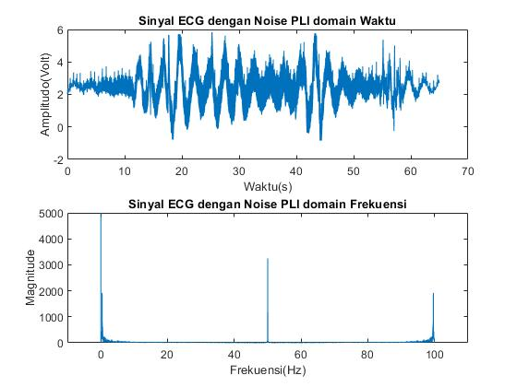

Ecg ma

RawECG =xlsread('RawECG.csv');

sinyal=RawECG(:,2)/1023.00*5.0;

fs=100; % frekuensi sampling 100

L=length(sinyal); %panjang data

time=L/fs;

waktu=linspace(0,time,L);

rdom=rand(1,1) %noise Motion Artifact

S = sin(2*pi*rdom*waktu); %noise Motion Artifac

ss=transpose(S);

noise=sinyal+ss;

%---------- SINYAL SETELAH NOISE --------------

hold on

figure(2)

subplot(2,1,1)

plot(waktu,noise);

title("Sinyal ECG dengan Motion Artifact Noise domain Waktu");

xlabel("Waktu(s)");

ylabel("Amplitudo(Volt)");

%------- SINYAL DOMAIN FREKUENSI-----

B=abs(fft(noise));

frek=(0:L-1)*fs/L;

subplot(2,1,2)

plot(frek,B)

title("Sinyal ECG dengan Motion Artifact Noise domain Frekuensi");

xlabel("Frekuensi(Hz)");

ylabel("Magnitude");

xlim([-10 110]);

ylim([0 5000]);

hold off

csvwrite("file_noise_MA.csv",noise);

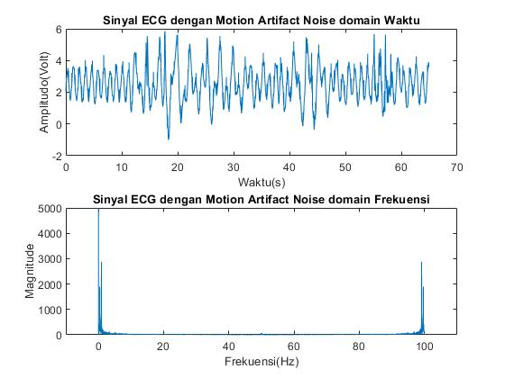

Ecg wb

RawECG =xlsread('RawECG.csv');

sinyal=RawECG(:,2)/1023.00*5.0;

fs=100; % frekuensi sampling 100

L=length(sinyal); %panjang data

time=L/fs;

waktu=linspace(0,time,L);

ss=1.5; %Noise Wandering Baseline

noise=sinyal+ss;

%---------- SINYAL SETELAH NOISE --------------

hold on

figure(2)

subplot(2,1,1)

plot(waktu,noise);

title("Sinyal ECG dengan Wandering Baseline Noise domain Waktu");

xlabel("Waktu(s)");

ylabel("Amplitudo(Volt)");

%------- SINYAL DOMAIN FREKUENSI----

B=abs(fft(noise));

frek=(0:L-1)*fs/L;

subplot(2,1,2)

plot(frek,B)

title("Sinyal ECG dengan Wandering Baseline Noise domain Frekuensi");

xlabel("Frekuensi(Hz)");

ylabel("Magnitude");

xlim([-10 110]);

ylim([0 5000]);

hold off

csvwrite("file_noise_MA.csv",noise);

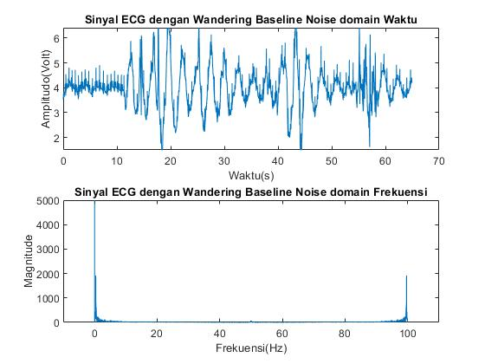

Fir high ma

sinyal =xlsread('file_noise_MA.csv');

fs=100; % frekuensi sampling 100

L=length(sinyal); %panjang data

time=L/fs;

waktu=linspace(0,time,L);

fc=3;

N=57; %keoefisien filter belum jadi

fcn=fc/fs; %normalisasi

for k=1:N

n=k-(N-1)/2;

if n==0

hd(k)=1-(2*fcn);

else

hd(k)=-sin(2*pi*fcn*n)/(pi*n);

end

end

nn=[1:N];

wn=0.42-0.5*cos(2*pi*nn/100)+0.08*cos(4*pi*nn/100);

h=hd.*wn;

hk=conv(sinyal,h,'same');

%-----sebelum----

hold on

figure(1)

subplot(2,1,1)

plot(waktu,sinyal);

title("Sinyal ECG noise Motion Artifact sebelum filter domain waktu");

xlabel("waktu(s)");

ylabel("amplitudo(v)");

%-----fft------

B=abs(fft(sinyal));

frek=(0:L-1)*fs/L;

subplot(2,1,2)

plot(frek,B)

title("Sinyal ECG noise Motion Artifact sebelum filter domain Frekuensi");

xlabel("Frekuensi(Hz)");

ylabel("Magnitude");

xlim([-10 110]);

ylim([0 5000]);

hold off

%-----------setelah-----

hold on

figure(2)

subplot(2,1,1)

plot(waktu,hk);

title("Sinyal ECG setelah filter FIR Highpass domain Waktu");

xlabel("waktu(s)");

ylabel("amplitudo(v)");

%------fft---------

C=abs(fft(hk));

frek=(0:L-1)*fs/L;

subplot(2,1,2)

plot(frek,C)

title("Sinyal ECG setelah filter FIR Highpass domain Frekuensi");

xlabel("Frekuensi(Hz)");

ylabel("Magnitude");

xlim([-10 110]);

ylim([0 5000]);

hold off

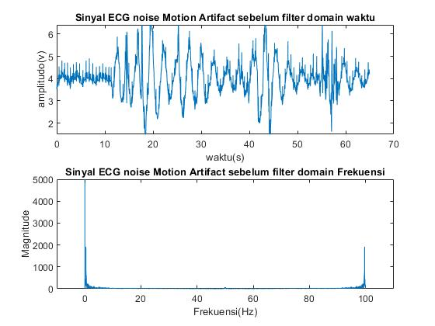

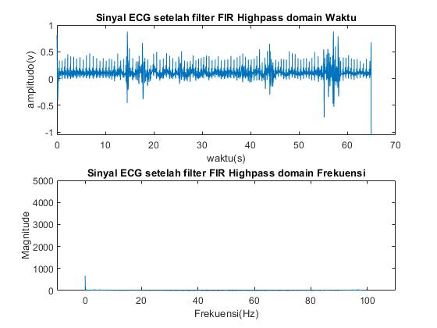

Fir bandstop pli

sinyal =xlsread('file_noise_pli.csv');

fs=100; % frekuensi sampling 100

L=length(sinyal); %panjang data

time=L/fs;

waktu=linspace(0,time,L);

fk=48/fs;

fl=50/fs;

N=77; %keoefisien filter belum jadi

for k=1:N

n=k-(N-1)/2;

if n==0

hd(k)=1-(2*fl-2*fk);

else

hd(k)=(sin(2*pi*fk*n)/(pi*n))-(sin(2*pi*fl*n)/(pi*n));

end

end

nn=[1:N];

wn=0.42-0.5*cos(2*pi*nn/100)+0.08*cos(4*pi*nn/100);

h=hd.*wn;

hk=conv(sinyal,h,'same');

%-----sebelum----

hold on

figure(1)

subplot(2,1,1)

plot(waktu,sinyal);

title("Sinyal ECG noise PLI sebelum filter domain waktu");

xlabel("waktu(s)");

ylabel("amplitudo(v)");

%-----fft------

B=abs(fft(sinyal));

frek=(0:L-1)*fs/L;

subplot(2,1,2)

plot(frek,B)

title("Sinyal ECG noise PLI sebelum filter domain Frekuensi");

xlabel("Frekuensi(Hz)");

ylabel("Magnitude");

xlim([-10 110]);

ylim([0 5000]);

hold off

%-----------setelah-----

hold on

figure(2)

subplot(2,1,1)

plot(waktu,hk);

title("Sinyal ECG setelah filter FIR Bandstop domain Waktu");

xlabel("waktu(s)");

ylabel("amplitudo(v)");

%------fft---------

C=abs(fft(hk));

frek=(0:L-1)*fs/L;

subplot(2,1,2)

plot(frek,C)

title("Sinyal ECG setelah filter FIR Bandstop domain Frekuensi");

xlabel("Frekuensi(Hz)");

ylabel("Magnitude");

xlim([-10 110]);

ylim([0 5000]);

hold off

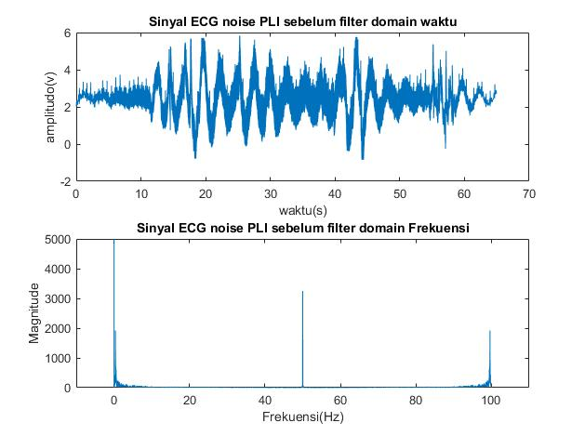

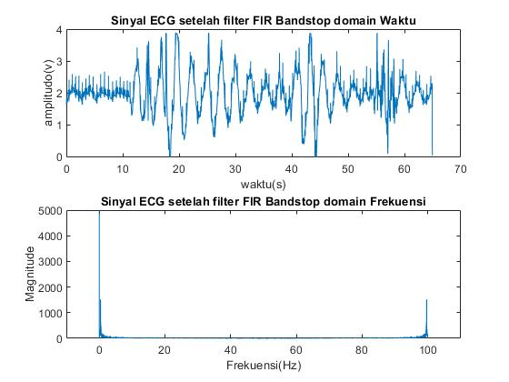

Iir high ma

clc

clear

sinyal =xlsread('file_noise_MA.csv');

fs=100; % frekuensi sampling 100

L=length(sinyal); %panjang data

time=L/fs;

waktu=linspace(0,time,L);

fc=3;

N=1;

%------ sebelum------

hold on

figure(1)

subplot(2,1,1)

plot(waktu,sinyal)

title("Sinyal ECG noise Motion Artifact sebelum filter domain waktu");

xlabel("waktu(s)");

ylabel("amplitudo(v)");

%-----fft------

B=abs(fft(sinyal));

frek=(0:L-1)*fs/L;

subplot(2,1,2)

plot(frek,B)

title("Sinyal ECG noise Motion Artifact sebelum filter domain Frekuensi");

xlabel("Frekuensi(Hz)");

ylabel("Magnitude");

xlim([-10 110]);

ylim([0 5000]);

hold off

%----------filter IIR Highpass

Highpass=designfilt('highpassiir','FilterOrder',N,'PassbandFrequency',fc,'PassbandRipple',0.5,'SampleRate',fs);

y=filter(Highpass,sinyal);

%-------setelah-----

hold on

figure(2)

subplot(2,1,1)

plot(waktu,y)

title("Sinyal ECG setelah filter IIR Highpass domain Waktu");

xlabel("waktu(s)");

ylabel("amplitudo(v)");

%------fft---------

C=abs(fft(y));

frek=(0:L-1)*fs/L;

subplot(2,1,2)

plot(frek,C)

title("Sinyal ECG setelah filter IIR Highpass domain Frekuensi");

xlabel("Frekuensi(Hz)");

ylabel("Magnitude");

xlim([-10 110]);

ylim([0 5000]);

hold off



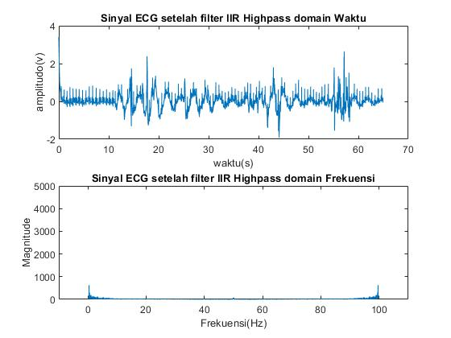

Iir banstop pli

sinyal =xlsread('file_noise_pli.csv');

fs=100; % frekuensi sampling 100

L=length(sinyal); %panjang data

time=L/fs;

waktu=linspace(0,time,L);

fk=48/fs;

fl=50/fs;

N=58;

%------ sebelum------

hold on

figure(1)

subplot(2,1,1)

plot(waktu,sinyal)

title("Sinyal ECG noise Motion Artifact sebelum filter domain waktu");

xlabel("waktu(s)");

ylabel("amplitudo(v)");

%-----fft------

B=abs(fft(sinyal));

frek=(0:L-1)*fs/L;

subplot(2,1,2)

plot(frek,B)

title("Sinyal ECG noise Motion Artifact sebelum filter domain Frekuensi");

xlabel("Frekuensi(Hz)");

ylabel("Magnitude");

xlim([-10 110]);

ylim([0 5000]);

hold off

%----------filter IIR Highpass

bandstop=designfilt('bandstopiir','FilterOrder',N,'HalfPowerFrequency1',fk,'HalfPowerFrequency2',fl,'SampleRate',fs);

y=filter(bandstop,sinyal);

%-------setelah-----

hold on

figure(2)

subplot(2,1,1)

plot(waktu,y)

title("Sinyal ECG setelah filter IIR Highpass domain Waktu");

xlabel("waktu(s)");

ylabel("amplitudo(v)");

%------fft---------

C=abs(fft(y));

frek=(0:L-1)*fs/L;

subplot(2,1,2)

plot(frek,C)

title("Sinyal ECG setelah filter IIR Highpass domain Frekuensi");

xlabel("Frekuensi(Hz)");

ylabel("Magnitude");

xlim([-10 110]);

ylim([0 5000]);

hold off

