**Energy Auditing & Management**

Unit-3(EECA)+Practice Q/A

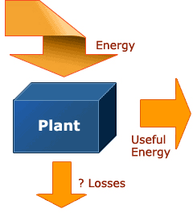

# What is an Energy Audit ?

**Energy audit is the first step toward systematic efforts for conservation of energy. It involves collection and analysis of energy related data on regular basis and in a methodological manner.**

Objectives of Energy Audit

The Energy Audit provides the vital information base for overall energy conservation program covering essentially energy utilization analysis and evaluation of energy conservation measures.

It aims at :-

* **Identifying the quality and cost of various energy inputs.**
* **Assessing present pattern of energy consumption in different cost centers of operations.**
* **Relating energy inputs and production output.**
* **Identifying potential areas of thermal and electrical energy economy.**
* **Highlighting wastage’s in major areas.**
* **Fixing of energy saving potential targets for individual cost**

centers.

* **Implementation of measures for energy conservation & realization of savings.**

#### The Role of an Energy Audit

An energy audit identifies which areas in your establishment unnecessarily consume too much energy, where energy is being consumed and assesses energy saving opportunities, which is the most cost-effective to improve, so you get to save money where it counts the most.

In the factory, doing an energy audit increases awareness of energy issues among plant personnel. An energy audit in effect gauges the energy efficiency of your plant against “best practices”. When used as a “baseline” for tracking yearly progress against targets, an energy audit becomes the best first step towards saving money in the production plant.

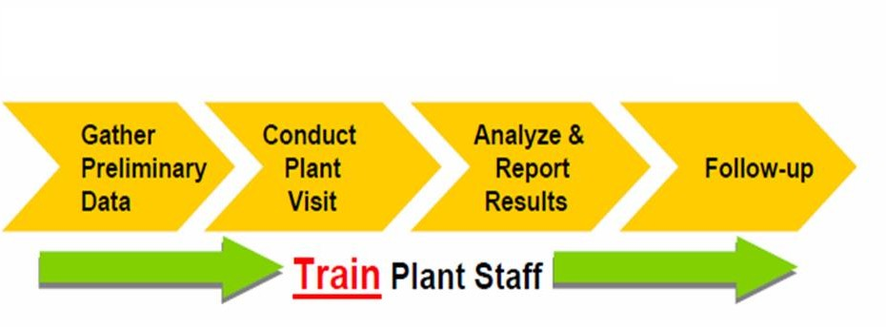

**Stages of Energy Audit**

**Energy audit stages**

Energy audit can be categorized into two types, namely walk- through or preliminary and detail audit.

***Walk-through or preliminary audit***

Walk-through or preliminary audit comprises one day or few days visit to a plant and the output is a simple report based on observation and historical data provided during the visit. The findings will be a general comment based on rule-of- thumbs, energy best practices or the manufacturer's data.

***Preliminary energy audit***

* + **Establish energy consumption in the organization**
* **Estimate the scope for saving**
* **Identify the most likely (and the easiest areas for attention**
* **Identify immediate (especially no-/low-cost) improvements/ savings**
* **Set a 'reference point‘**
* **Identify areas for more detailed study/measurement**
* **Preliminary energy audit uses existing, or easily obtained**

data.

**Detailed Energy Audit**

The detailed audit goes beyond quantitative estimates of costs and savings. It includes engineering recommendations and well-defined project, giving due priorities. Approximately 95% of all energy is accounted for during the detailed audit. The detailed energy audit is conducted after the preliminary energy audit. Sophisticated instrumentation including flow meter, flue gas analyzer, scanners and other advanced instruments are used to compute energy efficiency.

## Inputs and Outputs of Energy audit

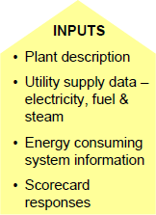

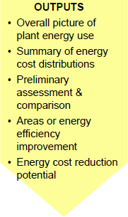

#### Contents of an Audit

An energy audit assesses the effectiveness of management structure for controlling energy use and implementing changes. The energy audit report establishes the needs for plant metering and monitoring, enabling the plant manager to institutionalize the practice and hence, save money for the years to come. The energy audit action plan lists the steps and sets the preliminary budget for the energy management program.

**Steps for Energy Management and Energy audit….**

* **Analysis of energy use**
* **Identification of energy projects**
* **Cost benefit analysis**
* **Action plan to set implementation priority**

#### Analysis of energy use

Identifying where energy is used is useful because it identifies which areas the audit should focus on and raises awareness of energy use and cost.

Analysis of energy use in the review of management structures and procedures for controlling energy use. This is a good source data for allocating energy use. The plant manager can also list all equipment used and the corresponding operating hours. With this information, one can create spreadsheet information and generate charts useful for analysis.

#### Analysis of energy use

**Important points to be considered when collecting Site Load Data:**

* **Operating hours - This can be gathered from plant personnel. It is important to ensure the accuracy of this data because much of the potential for energy savings lies on correct estimation of the equipment’s operating hours.**
* **Duty cycle - Machines such as large electric motors have varying loads and hence, different power requirements.**
* **Actual power consumed - For electric power users, this is based on either 3- phase current/voltage readings or power analyzer measurements (e.g., direct kW which incorporates power factor). For fuel users, tank readings of monthly consumption estimates and flow meters with totalization can be sources of measurement of air, water, steam, oil etc..**

# Identification of energy projects

* **Opportunities for energy savings can range from the simplest, such as lighting retrofits, to the most complex such as the installation of a cogeneration plant. The important thing to remember is to focus on major energy users and areas. Always apply the 80/20 rule, focus on opportunities that provide 80% of the saving but require 20% input. After the preliminary identification of opportunities, spend more time on those which have shorter payback periods.**

## Cost benefit analysis

* **The identified energy conservation opportunities should be analyzed in terms of the costs of implementing the project versus the benefits that can be gained. If you want to, say, install a heat plate exchanger to recover waste heat, you need to calculate the total cost of installation and compare that with the savings you will derive from recovering waste heat. It makes sense to go on with the project if there is a net positive benefit from the project.**

## Action plan to set implementation priority

* **After passing the cost benefit test, an action plan should be developed to ensure that the opportunities identified are implemented. The action plan should include all the major steps for implementing the opportunity as well as the people responsible.**

**And finally, …**

**This program will be successful when the top managements of the organization understand that energy audit produces the highest profits in the organization at a minimum cost.**

Practice Questions-UNIT-III(EECA)

**Define energy audit**

**Explain the Need for Energy Audit**

**Explain briefly the difference between preliminary and detailed energy audits?**

**Explain how matching energy usage to requirement can enhance energy efficiency**

**List any one energy audit instrument used for power measurement and one for flue gas**

**measurement along with parameters to be measured?**

**Define the energy audit as per the energy conservation Act 2001?**

**Discuss Simple Payback Period**

**Define ‘energy management**

**List steps involved in pre-audit phase**

**List the objective of Energy Management**

**List the Types of Energy Audit**

**List the objective of Preliminary Energy Audit Methodology**

**Sketch the principles of energy management**

**Sketch the base line data that an audit team should collect while conducting detailed**

**energy audit?**

**Sketch the steps involved in ‘detailed energy audit’**

**Sketch the steps involved in ‘Energy management Strategy’**

**Sketch a typical energy audit reporting format.**

**Demonstrate with examples on fuel and energy substitution**

**Sketch the process flow diagram and list process steps; identify waste streams and obvious**

**energy wastage**

**Distinguish between ‘preliminary energy audit’ and ‘detailed energy audit’?**

**Design Detailed Energy Audit Methodology with various phases**

**Design the Energy Conservation Opportunities**

**Demonstrate the power cost and fuel cost**

**Analyze Benchmarking and Energy Performance**

**Develop Sankey Diagram and its Use in material and Energy balance**

**Develop the Method for Preparing Process Flow Chart**