Manager Mindset 3

Intro 3

High-performing technology teams 4

3 Key Mindsets of Great Managers 5

The Servant Mindset 5

The Growth Mindset 5

The Multiplier Mindset 5

Influential IT leaders 5

Keep asking why 6

How to Present Your Ability to Be a Manager Without Previous Experience 7

PMP: People (Domain 1 – 42%) 8

Conflict Management 8

Lead a team 8

Principle 1: Build Vision 9

Principle 2: Nurture Collaboration 9

Principle 3: Promote Performance 9

Principle 4: Cultivate Learning 10

Principle 5: Ensure Results 10

Support team performance 11

Appraise team member performance against key performance indicators 11

Setting SMART KPIs 11

Ask yourself the following questions to help you to understand the context and define effective KPIs: 11

How to design KPI’s 11

How to Set Individual KPIs 12

Using KPIs: an Example 12

Empower team members and stakeholders 12

How to Empower Your Team 12

Shared Responsibility 12

What Can Managers Do to Help? 13

Self-Directed Teams 13

How to Lead 13

What to Watch Out For 13

5 Signs Your Team Is Out of Control 14

They Procrastinate 14

They Miss Objectives 14

They Upset Stakeholders 14

They Create Silos 14

There Is Too Much Conflict 15

Negotiate project agreements 15

Negotiation Strategies 15

The Negotiation Process 15

Ten Rules of Negotiating 18

Here are ten negotiating techniques: 19

Win-Win Negotiations 20

Final Words 20

PMP: Process (Domain II – 50%) 21

Execute project with the urgency required to deliver business value 21

Manage communications 21

There are three common types of communication that happen in the workplace. 22

10 Ways to Hone Your Communication Skills 22

Develop communications strategy 23

Develop communications plan 24

Assess and manage risks 24

Engage stakeholders / Stakeholder Management 25

Identify Project Stakeholders 25

Identify Stakeholders Interests, Impact Level, and Relative Priority 27

Assess Stakeholders for Importance and Influence 27

Outline Assumptions and Risks 29

Define Stakeholder Participation 29

Plan and manage scope 31

Scope Creep 31

Determine appropriate project methodology/methods and practices 32

Project Management Best Practices 32

Selecting the Right Project Management Method 33

Identify the best project management method to fit your project 33

Project Management Software 34

Project Management Methodologies 34

The Scaled Agile Framework (SAFe) 36

These five competencies are: 36

Establish project governance structure 37

Reason for project governance 37

Core project governance principles 37

Good project governance includes 38

Eight Governance Components 39

Project Governance Critical to the Success of a Project 40

Manager Mindset

# Intro

A manager needs to focus on becoming a successful teacher and mentor in order to help their people develop and grow, and to increase the overall capacity of the team. jumping into the weeds and trying to do everything, even if it works initially, is not a sustainable strategy.

Start by tracking the improvement of your direct reports from where they are rather than comparing their output and capabilities to your own. If you assess people individually, their talents will emerge—and their progress will become a measure of your own success.

* Take the Long View
  + managers needs to be looking further ahead.
  + Good managers spend much of their time anticipating challenges, negotiating political situations, and creating a road map that pulls together what each team member is working on independently.
  + Seeing the bigger picture
    - you should have a solid understanding of the needs and goals of your department, as well as the entire organization.
    - Recognizing your team’s capacity will give you the ability to *better forecast when your team will be stretched or when it will experience bottlenecks, and to set expectations accordingly.*
* Ask More Questions
  + Asking questions can be a great way to help a team member work through a problem.
  + helping your employee look at the obstacle in a new way or uncover alternative possibilities.
* Focus on What and When
  + It’s always best when setting goals with your team to focus on what the deliverables are, and when they need to be complete, but to leave the details of how that gets done up to each person.
* Trust Your Gut
  + Stepping into a new role can throw you off balance. You are working hard to learn new ways of thinking and behaving and it can make you feel like you’re wrong a lot of the time. But your instincts are still valuable. If you feel like a project is going off the rails, don’t wait until it’s too late to respond. You may be figuring out how to be a good leader, but your sense of whether the work is being done and done right is likely on target—especially if it’s work that you’ve done yourself in the past.
  + Many new managers delay confronting a team member who is missing deadlines or struggling in some way because they doubt their instincts or aren’t sure how to address the problem productively. But rather than waiting until the situation grows worse, sit down and have a conversation. Make sure you’re aware of how people are doing, and check in with them regularly. When you feel like something is off, it probably is.
* Be Patient
  + leader takes time. Don’t expect these skills to evolve overnight, and don’t be discouraged if you have some setbacks as you try to strike a balance between getting things done and coaching your team
  + Most of us aren’t natural-born managers. The mind-set of a manager can be learned and honed with practice.

## High-performing technology teams

A culture hack, is a small change that exploits a single area where your culture is vulnerable to change. Hacks are small, emotional, immediate changes that have big impacts.

* Create
  + substantial benefits to the business
  + including faster learning
  + shorter time-to-market
  + higher quality and productivity
* Value streams
  + Merchandising
  + Customer Acquisition & Retention
  + Content & Media
  + Customer Purchase & Service
  + Supply Chain
  + Corporate Services
* five talent differentiators to execute on that strategy
  + engineering excellence,
  + collectivism,
  + customer advocacy,
  + curiosity, and
  + courage
* Way to make high performance team
  + Let the team question everything
    - One of the things stifles innovation, and creativity is having the team follow orders.
    - we should encourage our team also think outside the box. And the first step in that direction is to let the team question the norm.
    - Don’t let the team be bogged down with status quo thinking.
    - question every step with “why?” and follow up with “how (to improve)?”
  + Forget bureaucracy – Encourage autonomy
    - encourage the team to come up with their goals, suggestions, deadlines and schedule. As long as they’re not too far from the corporate goals and deadlines,
  + Let the team (cross) learn new technology
    - In light of the limited budget for training, the best way is to let the team cross-train each other.
    - Encourage them to share their expertise and also allow learning from others within the organization.
    - join projects where they can share their respective knowledge and expertise.
    - Lunch and learn sessions
  + Forget Agile, encourage agility
    - fail fast and fail forward.
    - If the team is encouraged to test out some options, let the outcome be evaluated fast. Then either continue or find alternate ways.
  + Take the torch, be the entrepreneurial leader
    - To wish and encourage entrepreneurial thinking for the team, the leader needs to start and show the work. The team needs to have the trust in the leader as one who not only talks the talk but walks the walk.
    - A leader has to start questioning the norms. Discuss with the team, gather suggestions, ideas and get back to the senior management to make them implement those new ways.
    - Rewarding the team who come up with ideas that save the company in terms of time or money should be encouraged too.

# 3 Key Mindsets of Great Managers

## The Servant Mindset

1. As a leader, you serve your team. As a servant leader, you are focused on the needs of each member of your team and how your efforts can help them succeed and do their best work.
2. What makes them tick?
3. What are their strengths and weaknesses?
4. What do they need to do their best work?
5. What problems do you need to fix on the team to make it a well oiled machine?
6. As a manager, you are now judged on the results and success of your team.
7. ensure their people each get the credit they deserve

## The Growth Mindset

1. Developing talent from within your team is powerful and motivating; people, especially A players, enjoy learning new skills and growing in their careers.
2. As a Coach, You should be putting everyone in a position to succeed and grow.
3. Never accept statements like, “I could never do that” or “they’re a natural and I’m not.”

## The Multiplier Mindset

1. you are no longer an individual contributor, you need to think about what work you can do that has a multiplier effect for your team.
2. Realize that fixing problems on your team is a huge multiplier opportunity

# Influential IT leaders

* Position yourself for each unique audience
  + You have to understand the room, agenda and be clear about what you think your role in the meeting
* Demonstrate how your ideas have value to others
  + Understand ‘What’s in it for me?’
  + “If you’re trying to sell an idea, negotiate a good outcome, provide a moment of truth in the business, you need to understand the WIIFM,” Roberts says. “All that means is, go sit on the other side of the table and understand what it’s like there. Because if you get what’s important to your business partner, the world gets a lot clear and you’re now able to influence and be a leader.”
  + “You need to remind people every time a problem happens that, ‘This is how we can change it,’. You shop it around and make sure they understand the value proposition.”
* Tell stories to articulate their ideas
  + You must able to articulate a vision and explain how technology fits into the organizations tactical and strategic goals.
  + You got to influence people who do not typically know or care about technology.
  + A story that everyone can understand, draw a pic that will really land with your audience.
* Win over the toughest customers first
* Put the organization first
  + CIOs have been getting the message that they need business acumen to succeed today , and that they must know how to develop technology-enabled strategies that can help the business grow.
  + CIOs don’t just show that they understand the business; they demonstrate that they have organizational success as their very top priority.
  + That helped me build credibility because it showed I understood the priorities of the company,”
* Be open-minded and informatic
  + CIOs work on building consensus around ideas by leveraging the good rapport they’ve built with colleagues and their IT teams along with using strong communication and negotiation skills. They also keep an open mind, drawing on other perspectives to craft the right solution to whatever problem they’re trying to solve.
  + As an influential leader you have to know who knows their stuff, and then build a high-performing team and bring the right diversity together.

## Keep asking why

“The biggest issues I’ve seen arise is when business leaders don’t communicate what their goals and objectives are to the IT organization,” Parzych says. For example, a business leader might simply tell IT that user experience for external customers needs improvement. The reason might be that the company is trying to grow its customer base, and frustrated customers tend to leave, resulting in churn. That’s the reason behind the emphasis on customer experience, but that reason isn’t always shared with IT.

So you have to probe a little deeper. “Ask, ‘Why does this matter?’” Parzych advises. “You might have to ask multiple times because the first answer may not be the real business reason. ‘You care about availability — why?’

‘Because users are happier.’

‘What does that have to do with the company?’

‘When they’re happier, they spend more time on the site and make more purchases.’”

Digging down to an answer like that one can be really helpful, she explains, because there might be a better way to achieve that business goal. For example, rather than strive for five nines, you might be better off adding features to the site that engage customers’ attention. “If you’re focusing on availability and not on building features that customers like, you might be missing the mark,” she says.

# How to Present Your Ability to Be a Manager Without Previous Experience

* Leadership Qualities
  + Lead a Project
  + Patience
  + Excellent organizational skills.
  + The ability to inspire.
  + The ability to motivate.
  + Excellent time management.
  + Proven conflict resolution.
  + The ability to delegate.
  + Team-building spirit.
* Train, Teach, Coach, and Mentor
* Interviewing Skills
* Create and Manage a Budget
* Learn to Manage Conflict
* Projects and Initiatives
  + Did you spearhead a new program,
  + develop an innovative way to approach a task or manage a project team
  + Strong Example: As a sales associate, I spearheaded prospecting challenges, devised individual and group earning goals and helped develop best practices that increased close rates by 20 percent.
* Show Your Ambition
  + An effective way to qualify what you can do without having already done it is to describe hypothetical scenarios for potential employers, based on your present circumstances.

PMP: People (Domain 1 – 42%)

# Conflict Management

There are five conflict management techniques that you need to know for the PMP exam. **Collaborate/Problem Solve** is *always* the best one. If you can, collaborate and problem solve. (You don’t really need to memorize that one — it makes intuitive sense.)

Here are the conflict management techniques for the PMP exam:

* **Withdraw/Avoid** – This techniques involves ignoring the problem until someone else solves it.
* **Smooth/Accommodate** – This solution focuses on the area where folks agree and kind of just ignores the places they disagree, in the interest of positive relationships.
* **Compromise/Reconcile** – Get folks to agree on something so that the conflict is partially resolved.
* **Force/Direct** – Use your power as the PM to tell your project members what to today.
* **Collaborate/Problem Solve** – Work together to solve the problem and ensure that the entire team is on board with the solution.

Ex;

You are the PM, and two of your team members are always arguing. In order to resolve their latest conflict, you help them come to a conclusion that uses a little of both of their ideas. Which conflict management technique have you employed?

A. Withdraw/Avoid  
B. Smooth/Accommodate  
C. Compromise/Reconcile  
D. Collaborate/Problem Solve

Answer: **C. Compromise/Reconcile**. Since you went with a solution that used both of their ideas, it’s a compromise. Sometimes deciding between Smooth/Accommodate and Compromise/Reconcile can be tricky, so it’s important to do lots of practice questions on this topic.

# Lead a team

The five leadership principles for project success are:

1. Build vision
2. Nurture collaboration
3. Promote performance
4. Cultivate learning
5. Ensure results

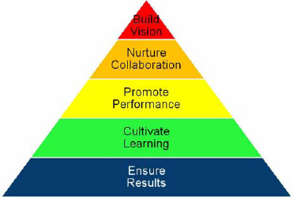

## Principle 1: Build Vision

*Build vision.* Sharing a common project vision and goals and having the same understanding about tracking the progress towards this vision is one of the key factors in the success of a project and team. One of the key characteristics of projects is that they are following SMART project objectives, when SMART stands for specific, measurable, achievable, relevant and time-boxed.

A project vision sets the overall picture of your project. Project objectives qualify this vision and make it specific.

Project leaders do not start a project without a project vision.

## Principle 2: Nurture Collaboration

Project success is not about individual accomplishments. The project team delivers the project. Collaboration is necessary for the team to achieve the vision and project objectives.

How to be a collaborator;

* Share information openly.
* Give and accept open and constructive feedback.
* Be a good team player and work with your team.

## Principle 3: Promote Performance

As a leader it is your responsibility to create an environment that promotes performance, on both the individual and team levels. Building vision and nurturing collaboration are prerequisites for project success. Alas, they are useless if you cannot move your team to the performance stage.

The following rules help achieve this:

**Rule 1: Be a role model:** Walk your own talk and be true to your own principles. Demonstrate authentic leadership.

**Rule 2: Create the right environment**: *If you want to promote performance in your team, take the time to find out what motivates each individual team member and the team as a whole.*

**Rule 3: Empower your team.** Give your team the power and all the information it needs to do its job and perform. Give your team the opportunity to excel and have an active hand in project success.

**Rule 4: Develop a solution-and-results orientation toward problems and risks**. A problem or risk is not seen as a potential show-stopper, but instead as a chance to learn and prove skills and competencies on the individual and group levels.

**Rule 5: Invite productive competition.** provided that the competitiveness aims at improving team performance and is linked with collaboration and social sharing.

**Rule 6: Let it happen. no need to micromanage team members**. Trust your team and let the team do its job

**Rule 7: Celebrate performance**. Look for behaviors that reflect the purpose and values, skill development, and team work, and reward, reward, reward those behaviors

## Principle 4: Cultivate Learning

Project Leadership Pyramid, learning is embedded between performance and results. As project leader, you serve as partner and coach for learning and information sharing. You facilitate learning. You are not the sole source of information. Instead, create a learning environment in your team. Set the expectation that you want everyone in your team to join and support you in cultivating learning for the purpose of the project.

* It is ongoing and should become a daily routine in your team.
* When you or someone on your team makes a mistake, learn from them. Correct your shortcomings, improve your performance, and continue to work toward accomplishing the project vision.
* Create room for your team members to be creative, to try something new, share their ideas, and learn from each other.
* Plan sufficient time for your team to think outside the box and beyond the known path traveled, and to find new avenues to reach the goals of the projects.

## Principle 5: Ensure Results

Ensure results. Delivering results is both a prerequisite and an outcome of effective project leadership. Project success is not defined by a single product or service delivered at the completion of a project. It is the accumulation of the many results yielded from each and every principle in the Project Leadership Pyramid. Vision, collaboration, performance, and learning are just as important. erequisite and an outcome of effective project leadership. An effective project leader always looks beyond the delivery of results. Ongoing project results serve as a reflection of project leadership and how well the five principles of the Project Leadership Pyramid are practiced.

# Support team performance

## Appraise team member performance against key performance indicators

A Key Performance Indicator (KPI) is a quantifiable metric that reflects how well an organization is achieving its stated goals and objectives.

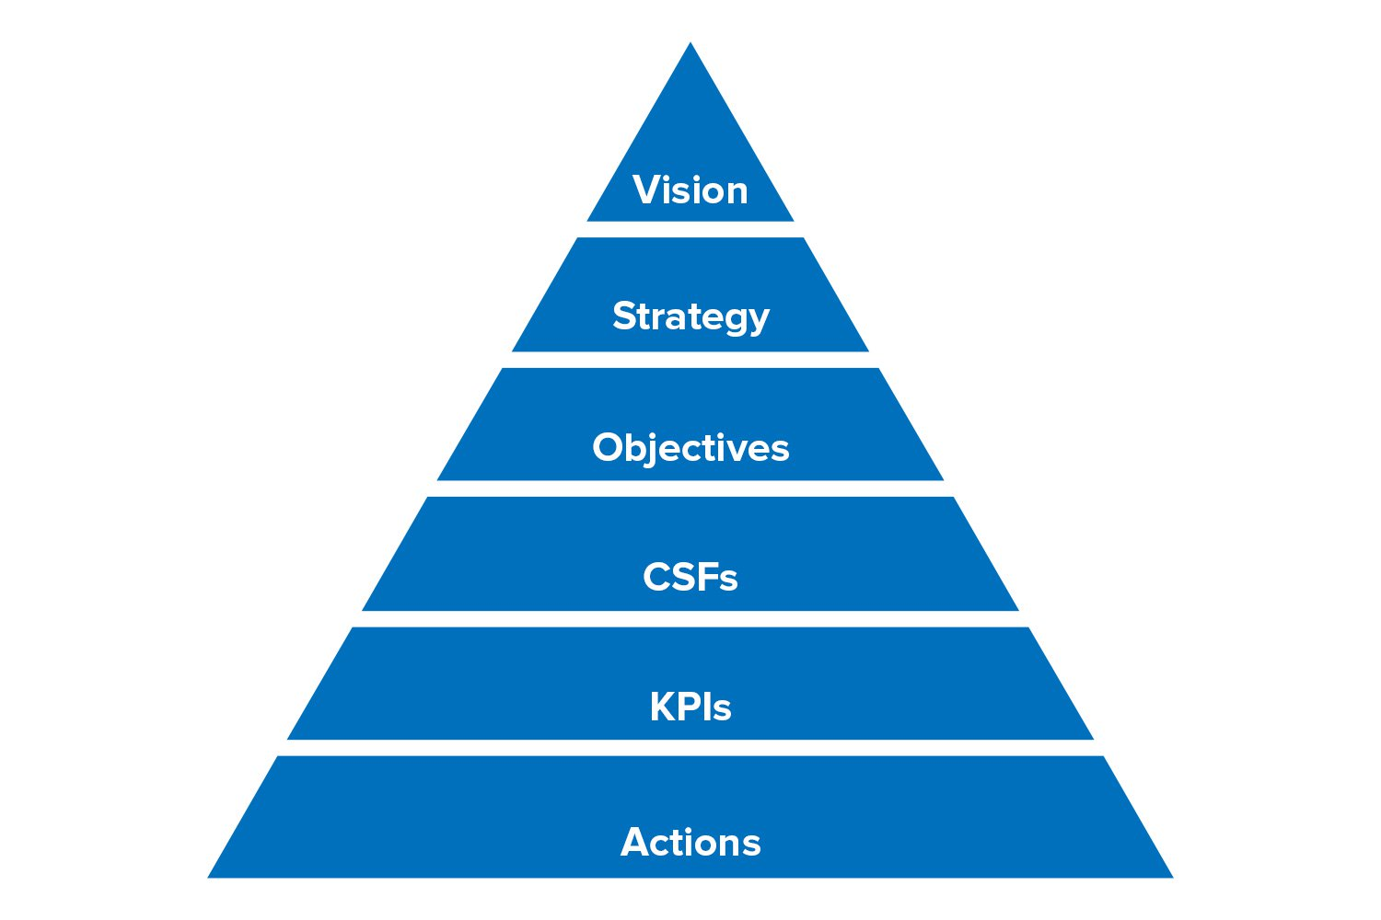

### Setting SMART KPIs

* Specific: be clear about what each KPI will measure, and why it's important.
* Measurable: the KPI must be measurable to a defined standard.
* Achievable: you must be able to deliver on the KPI.
* Relevant: your KPI must measure something that matters and improves performance.
* Time-Bound: it's achievable within an agreed time frame.

### Ask yourself the following questions to help you to understand the context and define effective KPIs:

* What is your organization's vision? What's the strategy for achieving that vision?
* Which metrics will indicate that you are successfully pursuing your vision and strategy?
* How many metrics should you have?
* What should you use as a benchmark?
* How could the metrics be cheated, and how will you guard against this?

### How to design KPI’s

* KPIs should be clearly linked to the strategy, i.e. the things that matter the most.
* KPIs have to provide the answers to our most important questions.
* KPIs should be primarily designed to empower employees and provide them with the relevant information to learn.

### How to Set Individual KPIs

"What gets measured gets done" is a common management saying. If you set a goal around a desired outcome, the chances of that outcome occurring are much higher, simply because you have committed to managing and measuring your progress toward it.

### Using KPIs: an Example

Here's an example of how organizational strategy cascades down to an individual team member's goals and KPIs:

* Organizational Vision: to be known for high customer satisfaction and superior service.
* Organizational Objective: to reduce the number of dissatisfied customers by 25 percent.
* Organizational KPI: the number of customer complaints that remain unresolved at the end of a week.
* Team Member's Goal: to increase the number of satisfactory complaint resolutions by 15 percent in this period.
* Team Member KPI: the weekly percentage difference in complaints handled that result in satisfied customers, as against unsatisfied customers.

# Empower team members and stakeholders

## How to Empower Your Team

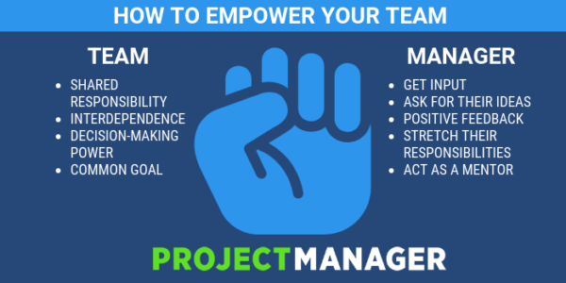

### Shared Responsibility

When each member takes responsibility for a specific aspect of the project, then they will feel ownership for that work, but also understand how they are connected to the overall project. Their work isn’t done in isolation but as an integral part of the whole.

This empowers everyone in the team and makes them do their best, for they’re not working for their own glory but are part of a larger, more important picture.

### What Can Managers Do to Help?

1. Include Them in Important Discussions
2. Provide Positive Feedback
3. Give Them Authority; give them more authority, stretch their capabilities and develop leaders.
4. Be a Mentor; lead them to act independently.

### Self-Directed Teams

These teams are mostly like any team that’s created to tackle a task or project. They are unique, though, in that they are not managed from the top down, like in a traditional managerial hierarchy.

Self-directed teams stress collaboration, and therefore those on the team are chosen because they complement one another and promote cross-function. These teams are assembled usually for a specific task or initiative, and they’re made up of individuals with different skills who are working together for a common goal.

### How to Lead

1. **Communicate**: By communicating clearly and seeking feedback, you get buy-in from the team. Use tools that foster collaboration and communication.
2. **Metrics**: Allow the team to define their metrics of success. If they do so, then they’re going to be more accountable for meeting their goals. Software with real-time dashboards can help track metrics.
3. **Present Outcomes**: By having the team present outcomes regularly, you promote feedback loops with other teams in the organization and enforce accountability.
4. **Leverage Success**: Leverage their success for the good of the business.

### What to Watch Out For

1. **Alignment**: Be careful to make sure that team initiatives align with corporate strategy.
2. **Accountability**: If anyone on the team is not taking accountability for their actions, that’s a red flag.
3. **Culture**: What sort of culture is developing in the team? If it’s one of “no results,” be careful.
4. **Immunity**: There cannot be immunity from the rest of the corporate structure or organization

## 5 Signs Your Team Is Out of Control

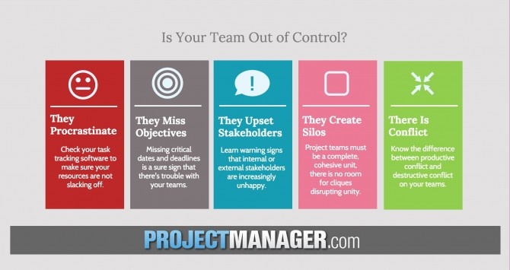

### They Procrastinate

Procrastination means that the project team are putting other work first, or simply not bothering to get your project tasks done.

* nothing is getting marked as complete
* The timesheets that your project team completes include the minimum amount of hours.
* the motivation to get things done has dropped off

### They Miss Objectives

If you start to miss critical dates and fail to complete project objectives along the way, then it’s a sure sign that you won’t be able to meet your final delivery date and achieve your overall goal.

### They Upset Stakeholders

* Are there higher-than-usual numbers of frustrated emails?
* Did a team member approach you about their concerns about a client meeting?
* Are people actively requesting to not attend client meetings with particular team members?

### They Create Silos

Your project team should be a complete, cohesive unit. You are all working towards the same common goals and you are all on the same team. So there shouldn’t be any need for silos or cliques or any other grouping that is detrimental to the project overall.

However, I have seen this in project teams, especially those that are just starting to become dysfunctional. Project team members create little groups of one ‘clique’ against another and they work for each other’s interest instead of the company or the project as a whole.

### There Is Too Much Conflict

* A poorly performing project team will blame each other for problems, and individuals will fail to take ownership for their own part in any issues.
* I’ve also seen people take credit for work that their colleague has done, and you can imagine the bad feeling that this created.

# Negotiate project agreements

Among the bountiful harvest of definitions for project success, meeting the triple constraints is just a starting point. Sometimes we can be right on scope, schedule, and resources, and still fail to be successful, perhaps because the market changed, or a competitor outdid us, or a client changed his or her mind.

The main items to address while negotiating a contract can be vastly different, depending on what is being purchased. To achieve a signed contract, the items usually negotiated are scope, schedule and price. Other things that can be negotiated include responsibilities, authority, applicable law, project management processes to be used, payment schedule etc. Many people do not realize that price may not be the primary section criteria or the major concern while negotiating. Often it is not a factor at all. Schedule may be more important and a buyer might sacrifice cost to gain speed.

## Negotiation Strategies

1. **Concession making** – Involves changing your proposal so that it provides less benefit to you and more benefit to the other side. You may agree to make the requested changes without any additional charges or extensions to the project completion date.
2. **Contending** – Involves trying to persuade the other side to make a proposal more favorable to you, but less favorable to them. Tactics include threats and arguments. You are unwilling to make any additional concessions.
3. **Compromising** – Intermediate between concession making and contending. A middle ground is sought that involves some degree of sacrifice for both sides. Two project managers may agree to share the costs of the changes or agree to an extension in the project completion date.
4. **Problem solving** – Efforts to find agreements that are highly beneficial to both parties. Project managers may honestly discuss their objectives and priorities. By exchanging information on budgets and deadlines, a solution may be found.
5. **Inaction or withdrawal** – Involves attempts to delay or avoid serious negotiations. The strategy of withdrawal involves terminating negotiations without an agreement.

## The Negotiation Process

Negotiation is:

* Communication back and forth for the purpose of making a joint decision.
* A way of finding a mutually acceptable solution to a shared problem.
* Achieving an ideal outcome: a wise decision, efficiently and amicably agreed upon.

Options for negotiation style are (Fisher & Ury, 1992):

* Hard (controlling)
  + Hard bargaining is adversarial—you assume that your opponent is your enemy and the only way you can win is if he or she loses. So you bargain in a very aggressive, competitive way.
* Soft (giving in)
  + Soft bargaining is just the opposite. Your relationship with your opponent is so important that you concede much more easily than you should. You get taken advantage of in your effort to please, and while agreement is reached easily, it is seldom a wise one.
* Principled (much more effective): P2O2
  + People: Separate the people from the problem
  + Positions: Focus on interests not positions
  + Options: Generate options for mutual gain before choosing
  + Objective Criteria: Decide based on objective criteria
  + + BATNA (Best Alternative to Negotiated Agreement): Know theirs. Know & improve yours.

Good negotiations consist of a relentless search for the **Third Alternative**:

* We humans are presently conditioned to expect our relationships to be win/lose.
  + View most situations from an “either/or” point of view: either I win or I lose
  + It has to be one or the other.
* There is a third alternative.
  + May be harder to find, but there almost always exists a third way of doing things where no one loses
  + Or at worst are assured that the loss has been minimized and fairly shared
* Minimizes and distributes the loss so it has the least negative effect
* This is the win-win way—this is synergy.

Sources of power in negotiation are:

* Developing good working relationships among people negotiating
* Understanding interests
* Inventing an elegant option
* Using external standards and benchmarks
* Developing a good BATNA
* Understanding their BATNA
* Making a carefully crafted commitment: an offer, something you will do, something you will not do.

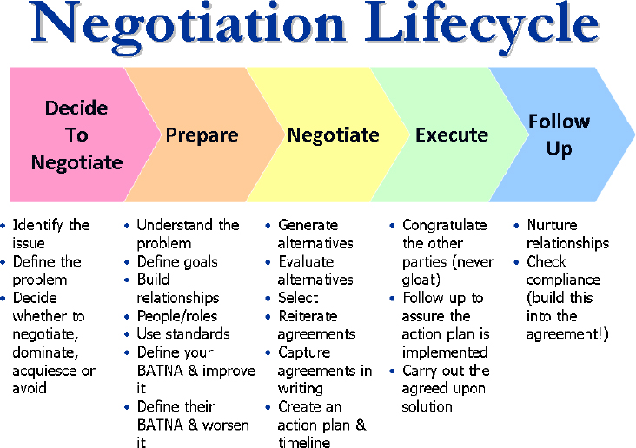

## Ten Rules of Negotiating

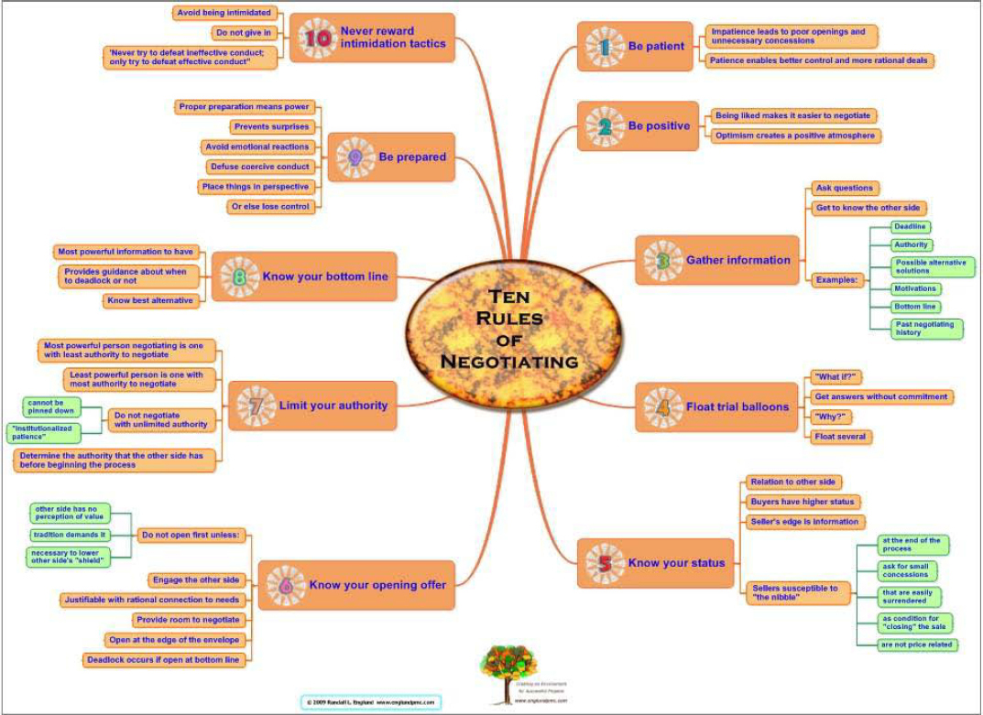

* Be Patient:
  + Dealing with a team member who is underperforming - develop rapport with the person, ask for permission to provide feedback or suggestions, carefully answer any questions that come up, and take the time to reach satisfactory agreement.
* Be Positive:
  + A positive attitude with project sponsors helps build confidence and credibility in their minds. This means they engage more willingly with the PM in supporting the project and maintaining that support throughout the project lifecycle.
* Gather information
  + Review the relationship history, especially if support issues have come up and whether or not they were adequately addressed. Find out their timetable or deadline, both to purchase and then to implement the solution.
* Float trial balloons
  + explore reactions from the other party about possible approaches they may be willing to consider.
* Know your status
  + Project managers are closest to the action on most projects and have significant status attributable to the information they possess. Other stakeholders have status via the authority they have to allocate resources or dispense funds. Project manager has access on such as extend a resource’s time on the project or reduce features in order to meet cost or time pressures.
* Know your opening offer
* Limit your authority
  + Try to negotiate with the decision-maker so you deal with them directly and get agreement quickly. When you are the decision-maker, have someone else negotiate on your behalf so you cannot be pinned down by hard core negotiating tactics. This provides opportunity to practice patience, review the proposal more thoroughly (instead of in an emotional moment), and to come back with counter proposals.
* Know your bottom line
  + Two vendors have similar products where one has a slight edge and costs more. The PM wants the better product but has a strict budget limit of $10K. Negotiations with the higher priced vendor proceed in order to get a lower price or arrange terms that fall within the budget limit. Use the limit to stand firm, negotiate with due diligence, and fall back on the other vendor if not successful. Knowing these limits determines whether to continue or walk away.
* Be prepared
  + Have a risk management plan that provides advance notice of technology that may not work or tasks that take longer than planned. Clear trigger points invoke contingency plans calling for negotiations on the pros and cons of various options, leading to quick resolution. Preparation avoids being caught by surprise and having to invent options where none previously existed.
* Never reward intimidation tactics
  + A PM whose does not push back against unreasonable scope, schedules, or resources is training sponsors to continue a demanding behavior. Instead, set expectations by negotiating the triple constraints at project start-up and when changes occur. Make concessions when the other side makes them as well. Do not give in to intimidation tactics or “the beatings will continue until morale improves.”

## Here are ten negotiating techniques:

1. Make the pie bigger
2. Use humor
3. Show your strength
4. Ask a question
5. Review your preparation (privately)
6. Breathe deeply
7. Name hard-line tactics
8. Take a break
9. Use silence (after your proposal)
10. Reframe an issue.

## Win-Win Negotiations

Successful negotiators view the opposing party as colleague rather then an opponent. The goal at the end of the day is for the parties to shake hands and say something like “That was fun and mutually benefiting! Hope we get to do this again sometime!”

Therefore, your goal and mindset in any negotiation should be to:

1. Use the process to meet needs (the other party’s needs)
2. Harmonize or reconcile needs (yours with the other party’s)
3. Watch for and avoid conflicts which stem from differences in experience, information, and role.

More tips to achieve win-win outcomes for the business analyst:

* Build Trust - Find out as much as you can about the other party needs and wants, show genuine concern for the other party’s welfare, and transform the relationship in to collaboration.
* Don’t make enemies – As a business analyst you interact with people possessing various levels of knowledge. If you know more or understand it better don’t forget the power of your attitude – check your own ego at the door.
* Communicate your needs – Many of us do not succeed at negotiations because we don’t make our needs known. The squeaky wheel really gets the grease, if it knows where, when and how to squeak.

Another way to put this is summarized by the golden rule: “treat others as you would like to be treated.”

## Final Words

Specific suggestions for negotiating in the project environment include:

* Assure the project is properly chartered and sponsored.
* Establish clear company priorities with buy-in and support from the sponsor and leadership team.
* Locate the project results within company priorities.
* Tie project goals and results to supporting business goals.
* Clearly define and vividly illustrate the tasks required to reach project goals.
* Clearly define and vividly illustrate project resource requirements.
* Build trust and credibility through accurate project planning, schedules, open and honest communications.
* Provide risk assessments for missing resources.
* Know the cost of delay.
* Quantify the cost of NOT having the resources required.

PMP: Process (Domain II – 50%)

# Execute project with the urgency required to deliver business value

# Manage communications

There are three type of communication in a project;

* Plan communications
  + Plan Communications Management is the process of developing an appropriate approach and plan for project communications based on stakeholder’s information needs and requirements, and available organizational assets.
  + The key benefit of this process is that it identifies and documents the approach to communicate most effectively and efficiently with stakeholders.
  + Communication inputs
    - Project management plane
    - Enterprise environmental factors
    - Stakeholders
    - Organizational process
  + Communication tools
    - Communication requirements analysis
    - Technology, models and methods
    - Meetings
  + Communication output
    - Communication management plan
    - Project doc update
* Manage communications
  + Manage Communications is the process of creating, collecting, distributing, storing, retrieving, and the ultimate disposition of project information in accordance to the communications management plan.
  + The key benefit of this process is that it enables an efficient and effective communications flow between project stakeholders.
  + Communication inputs
    - Communication management plane
    - Enterprise environmental factors
    - Work performed
    - Organizational process
  + Communication tools
    - Information management system (IT)
    - Performance reporting
    - Technology, models and methods
  + Communication output
    - Project communications
    - Project management plane update
    - Project doc update
    - Organizational process assets update
* Control communications
  + Control Communications is the process of monitoring and controlling communications throughout the entire project life cycle
  + The key benefit of this process is that it ensures an optimal information flow among all communication participants, at any moment in time.
  + Communication inputs
    - Project plane
    - Communications
    - Issue
    - Work performed
    - Organizational process
  + Communication tools
    - Information management system (IT)
    - Meetings
    - Expert judgment
  + Communication output
    - Work performance info
    - Change request
    - Project management plane update
    - Project doc update
    - Organizational process assets update

## There are three common types of communication that happen in the workplace.

* **Durable Communication**: Written or visual, like reports, email, or user stories, wireframes or mockups (not to be confused with production assets; they are not intended for communication with the team)
* **Explicit Communication** Events: Meetings
* **Organic Communication**: Communication that “just happens” as a result of collaboration. There’s a sub-set of organic communication that I like to call Spontaneous Ephemeral Communication (think water-cooler conversations). Decisions are often made here. Sometimes seemingly small decisions which can have lasting effects on a project.

## 10 Ways to Hone Your Communication Skills

1. **Communicate to people where they are**; Communicate the same clear message to everyone, everywhere, at once. Not everybody read there email and not everybody like to do communicate face to face.
2. **Make the message easy to comprehend;** Communicate what you need to say in as few words as possible. Think Twitter feed, not legalese or tax code.
3. **Set concrete objectives**, not just subjective visions, In a meeting, don’t say “This needs to happen as soon as possible,” but “The drop dead date for this enhancement to roll out is June 1.”
4. **Tailor the message to the audience**. Software developers may not need to be sold on the awesomeness of the new product, but a customer who’s providing early feedback or is part of a virtual focus group will.
5. **Be proactive.** Don’t let others interpret a project’s details or status for you. If it’s controversial or important, put it clearly in writing, and send it out in dated material. Don’t let colleagues, stakeholders, or developers hear it from someone else.
6. **Use the resources at your disposal**. If you’re stuck on how to communicate something clearly to the masses, call on your marketing department. Chances are they’ve called on you many times to help them understand a product. Technical writers can also help. One phone call to a communications expert can help you tailor your message and save dozens of times re-explaining things later.
7. **Do a read-through to eliminate run-on sentences and overly technical language.**
8. **If need be, brush up on your vocabulary and grammatical skills.** “Effective written communication requires that the business analyst have a broad vocabulary, strong grasp of grammar and style, and an understanding of which idioms and terms will be readily understood by the audience.”
9. **Always use spoken communications as a supplement to what’s already in writing.** Make sure what you want to communicate is written clearly, and published for your audience to access easily.
10. **Keep your tone positive and friendly.** Negativity often makes people defensive, and there’s no benefit in alienating your colleagues. For every audience, stay positive—whether presenting a problem or a solution.

## Develop communications strategy

A communication strategy guides an entire program or intervention. It sets the tone and direction so that all communication activities, products and materials work in harmony to achieve the desired change.

Most communication strategies include the following elements:

* Brief summary of the situation analysis
* Audience segmentation
* Program theory to inform strategy development
* Communication objectives
* Approaches for achieving objectives
* Positioning for the desired change
* Benefits and messages to encourage desired change
* Communication channels to disseminate messages
* Implementation plan
* Monitoring and evaluation plan
* Budgets

The steps are;

1. Determine Method for Engaging Stakeholders and Partners
2. Write a Brief Summary of Analyses
3. Select a Theory
4. Select Audiences
5. Develop Communication Objectives
6. Select Strategic Approaches
7. Decide on Positioning
8. Identify Key Benefits and Support Points
9. Draft Key Message Points
10. Select Channels
11. Outline Activities
12. Develop an Implementation Plan
13. Draft a Budget
14. Develop a Monitoring and Evaluation Plan

## Develop communications plan

Your simple communication plan should capture the following elements:

* With whom you will communicate (e.g., leadership team)
* What will be communicated (e.g., status report on project)
* When you will communicate (e.g., monthly)
* How you will communicate (e.g., at the leadership meeting)
* Format for your communications (e.g., presentation at the meeting)

Capture the following elements in more detailed communication plans:

* List of all stakeholders (individual names), including their responsibility on the project and contact information (along with time zone differences where they exist)
* Stakeholder information requirements by group and/or individual
* Requirements for how information will be distributed to stakeholders including:
  + What will be communicated (e.g., status report, project budget)
  + Due dates for communications
  + With whom you are communicating (e.g., stakeholder group and/or individual)
  + Person on the team responsible for the communication component
  + How you will distribute the information (e.g., email, presentation, via a portal)
* Requirements for how information will be gathered and reported on, including:
  + What information is needed from stakeholders (e.g., information on the budget, scope of project)
  + Team member responsible for collecting and reporting on the information
  + Stakeholder responsible for communicating/sharing the information
  + Due dates
* Guidelines for gathering and distributing information
  + How project information will be stored
  + Approved communications methods and technologies

# Assess and manage risks

# Engage stakeholders / Stakeholder Management

Stakeholders are individuals who either care about or have a vested interest in your project. They are the people who are actively involved with the work of the project or have something to either gain or lose as a result of the project.

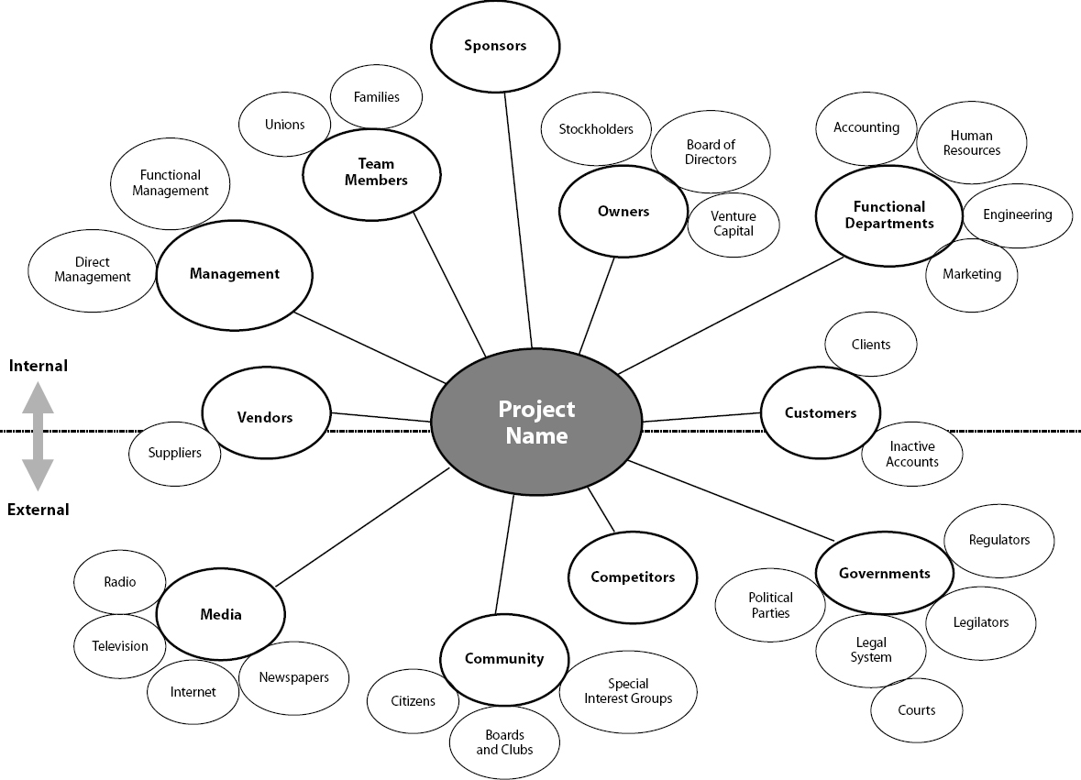

## Identify Project Stakeholders

To be classified as a stakeholder, the person or group must have some interest or level of influence that can impact the project. The first effort should be a brainstorming activity with appropriately selected members and an optional facilitator. All stakeholders should be initially considered and possibly dropped in later stages of the analysis. It is often difficult to force classifications into groups and determine who is considered truly inside and outside the project context. To gain a more powerful understanding of needs and expectations, it is usually helpful to identify these stakeholders by name rather than generic terms such as customer, owner, sponsor, etc.

Stakeholder Interest and Impact Table:

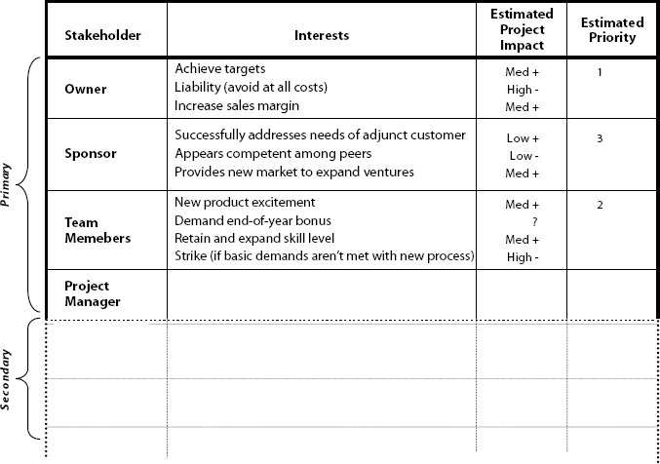

Interest-Influence Classification:

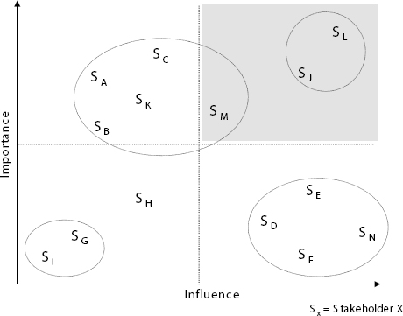

## Identify Stakeholders Interests, Impact Level, and Relative Priority

asking them questions such as:

* What are your expectations of this project?
* How does the successful completion of the project benefit you?
* Are there any stakeholders that may conflict with your interest?
* Which stakeholders do you believe are in conflict with your interests?

Once the major interests are identified, it is also useful to outline the how the project will be impacted if these are or are not met. In most cases, a simple annotation of positive (+), negative (–), or unknown (?) can be used as well as high (H), medium (M), low (L), or uncertain (?).

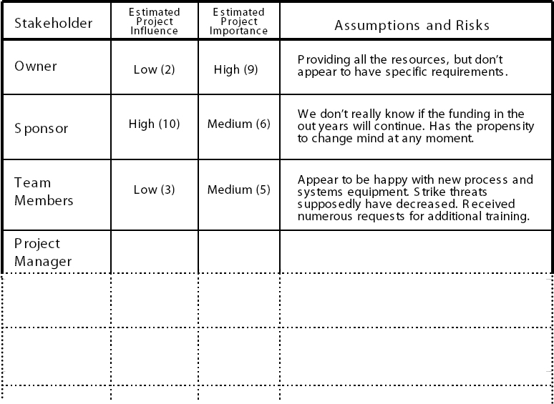

## Assess Stakeholders for Importance and Influence

**Influence** indicates a stakeholder’s relative power over and within a project. A stakeholder with high influence would control key decisions within the project and have strong ability to facilitate implementation of project tasks and cause others to take action.

**Importance** indicates the degree to which the project cannot be considered successful if needs, expectations, and issues are not addressed. This measure is often derived based on the relation of the stakeholder need to the project’s goals and purposes.

Note that stakeholders in the high influence—high importance quadrant would be considered key stakeholders. Although counter to typical approaches, this area is where we may need to focus our attention at times when the project is suffering rather that on “beating up” individuals in the opposite corner quadrant.

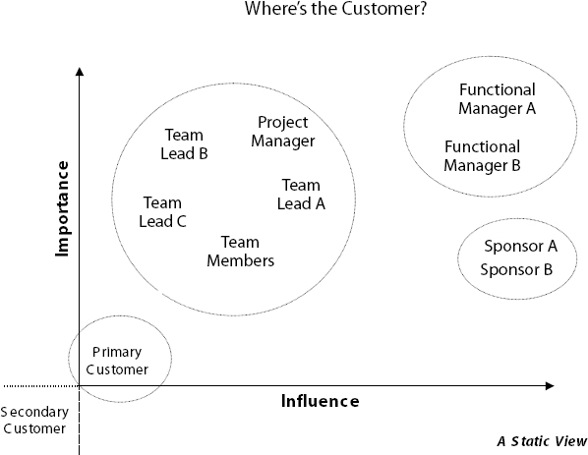

## Outline Assumptions and Risks

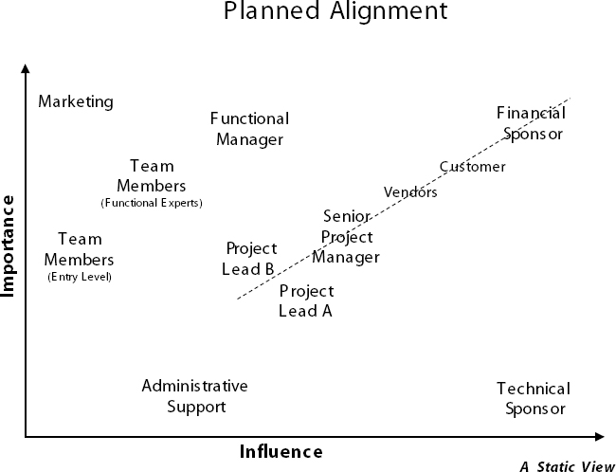

Project success also depends on the validity of key assumptions and risks. risks are manifest when there are conflicting needs and expectations. To bring to light key risks, the project manager needs to clarify unspecified stakeholder roles and responsibilities, play “what-if” scenarios using unfulfilled needs and expectations, and double check the plausibility of assumptions made.

## Define Stakeholder Participation

Now that we have made an effort to understand the stakeholders, we need to assess their level of participation and information needs. A well-designed project will not only clarify key stakeholder roles, but will define as much as possible who participates when.

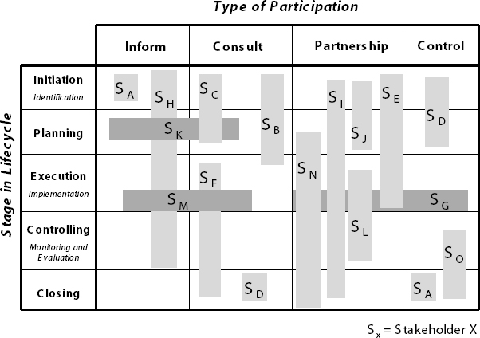

# Plan and manage scope

## Scope Creep

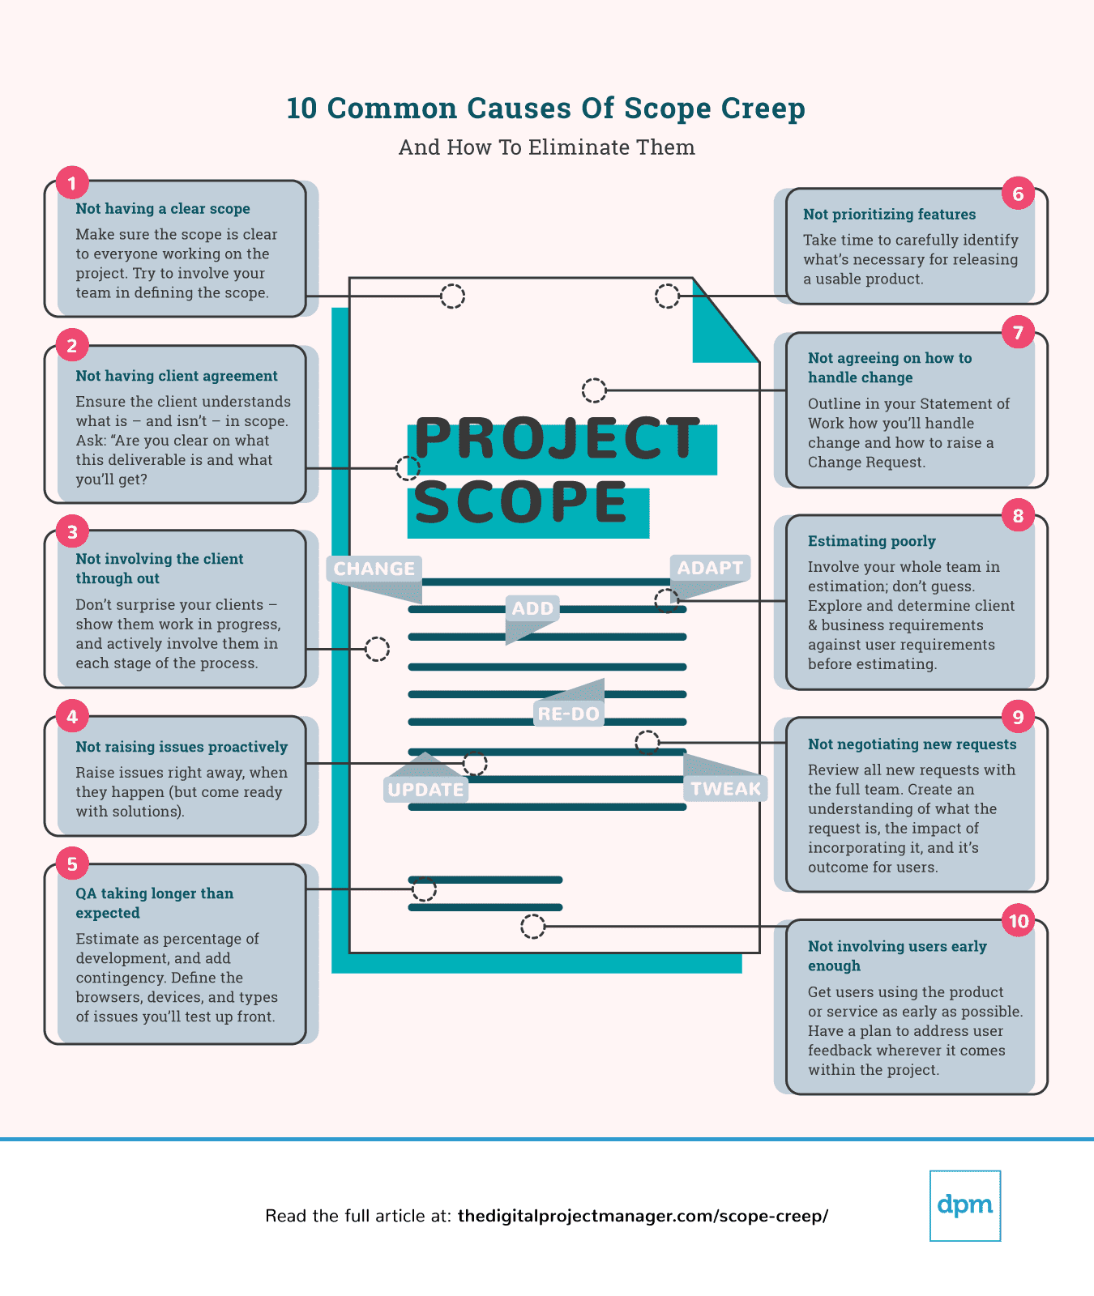

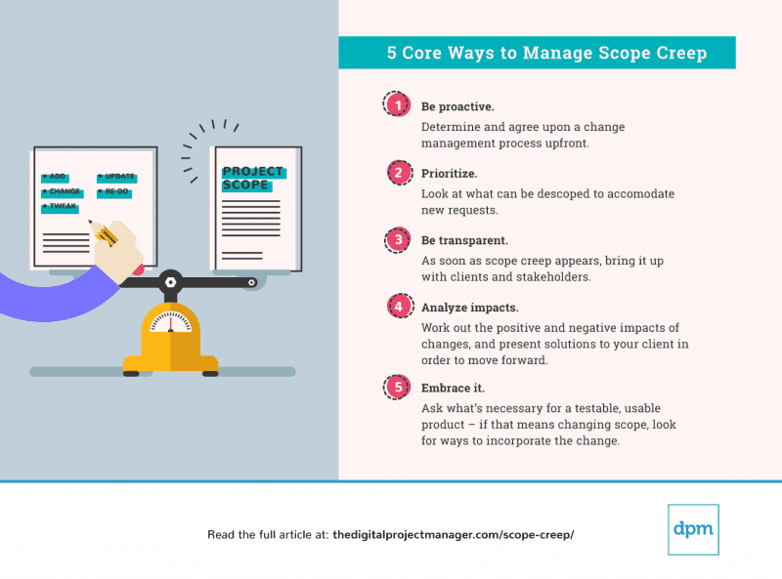

# Determine appropriate project methodology/methods and practices

## Project Management Best Practices

Managing a project is a large feat full of many moving parts. There are four major best practices that can help all PMs effectively tackle their next project. These best practices include:

1. **Expect delays**: Obstacles can pop up at any point during a project, and being prepared for these issues will prevent unnecessary stress and delays in the long run. Complete a risk analysis early on to ensure you have a plan in place should an issue arise, and add a cushion to timelines should delays occur.
2. **Estimate accurate durations**: As a PM, you are responsible in guiding team members towards an achievable timeline. Coaching employees to break down work into smaller, manageable chunks will lead to more accurate duration estimates and timelines.
3. **Consider everyone’s way of thinking**: Not all people work in the same way. Some people may be linear thinking, rooted in logic and numbers, while others prefer to break down objectives and detail each step of every plan before proceeding. Taking this into consideration and balancing all team members’ work styles will better prepare you for leading a project. Play to the strengths of each team member, and leverage those strengths wherever possible.
4. **Sometimes you need to take a break from the plan**: Project management is not a set-in-stone process, and you must remain flexible to adapt to changes that occur. That’s why, when issues arise, it may be helpful to step away from the project plan and bring your team together to brainstorm a solution. Having the right tools in place to facilitate collaboration and communication will expedite this process and the eventual resolution.

## Selecting the Right Project Management Method

The key factor to determine the right methodology is the type of project or process that you manage. With a vast array of frameworks and methodologies, narrowing down the approach based on specific criteria is critical. These factors include:

* Project focus (e.g. task activities versus final product)
* Customer and stakeholder involvement
* Industry
* Flexibility of timeline
* Allotted budget
* Number and type of teams working on the project
* Complexity of projects
* Resources needed versus resources available
* Scalability of project
* Resistance to change
* Rigidity of structure
* Specialization of roles
* Set start and end dates

## Identify the best project management method to fit your project

Some criteria to consider when evaluating project management methodologies include:

* What is the final goal of the project?
* How complex is the project?
* What are the required benefits of the final deliverable?
* What methodology is currently in use in the organization?
* Are there any learnings or outcomes from previous projects that should be considered?
* How involved does your customer want/need to be in the project?
* Do your stakeholders prefer a particular methodology?

Some approach you can take;

1. Establish the variables that will drive the project and weigh those against the overall goals of the project.
2. Determine the criteria that the methodology will impact.
3. Assess all possible methodologies and decide which methods are most relevant to your project.
4. Analyze each potential methodology by weighing the pros and cons of each against your project.
5. Examine which methodology will bring the most success and efficiency to your project, and conversely, which methodology will bring the most risk.
6. Collaborate with other team members to weigh the decision.
7. Document the chosen methodology to be implemented.
8. Apply the methodology to the project and monitor it for progress and success.

## Project Management Software

* **Gantt Charts**: This view shows the amount of time taken to complete a project in comparison to the amount of time that was originally planned.
* **Kanban Boards**: A Kanban board is a workflow visualization tool that helps teams optimize the flow of work and physically see the way work is progressing. They are also useful in Lean to allocate tasks and maintain resource management.
* **Calendars**: With calendars you can show a comprehensive view of the project timeline and all of its expected dates of completion, giving full visibility to customers, stakeholders, and team members.
* **Cross-Project Summary Views**: A cross-project view gives all teams and departments involved with production full insight into the continuous development process. This feature enables real-time status reports, checkpoint roll-up details, and dashboards that give teams and customer progress updates throughout the process.

## Project Management Methodologies

* Agile
  + Values
    - Individuals and interactions over processes and tools
    - Working software over comprehensive documentation
    - Customer collaboration over contract negotiation
    - Responding to change over following a plan
  + Principles
    - Customer satisfaction through early and continuous software delivery
    - Accommodate changing requirements throughout the development process
    - Frequent delivery of working software
    - Collaboration between the business stakeholders and developers throughout the project
    - Support, trust, and motivate the people involved
    - Enable face-to-face interactions
    - Working software is the primary measure of progress
    - Agile processes to support a consistent development pace
    - Attention to technical detail and design enhances agility
    - Simplicity
    - Self-organizing teams encourage great architectures, requirements, and designs
    - Regular reflections on how to become more effective
  + Best suited for: Projects that require flexibility and have a level of complexity or uncertainty. For instance, a product or service that hasn’t been built by the team.
* Scrum
  + Values:
    - commitment,
    - courage,
    - focus,
    - openness, and
    - respect.
  + It’s goal is to develop, deliver, and sustain complex products through collaboration, accountability, and iterative progress.
  + Best suited for: Projects that consists of teams of less than seven people who need a flexible approach to delivering a product or service.
* Kanban
  + it is very visual method that aims to deliver high quality results by painting a picture of the workflow process so that bottlenecks can be identified early on in the development process.
  + six general practices, which are:
    - Visualization
    - Limiting work in progress
    - Flow management
    - Making policies explicit
    - Using feedback loops
    - Collaborative or experimental evolution
    - Best suited for: Like Scrum, Kanban is fitting for projects with smaller teams, who need a flexible approach to delivering a product or service. Kanban is also great for personal productivity purposes.
* Lean
  + Lean methodology promotes maximizing customer value, while minimizing waste. It aims to create more value for the customer by using fewer resources.
  + Stemmed from the Japanese manufacturing industry, its values suppose that ‘as waste is eliminated, quality improves while the production time and cost are reduced.’
  + types of waste
    - **Muda**: activity or process that does not add value. Type of muda are; Transport, Inventory, Motion, Waiting, Overproduction, Over-processing and Defects.
    - **Mura**: Mura is about eliminating variances in the workflow process at a scheduling and operation level so that everything flows evenly.
    - **Muri**: Muri is about removing overload so that the nothing slows down. It refers to managers and business owners imposing unnecessary stress on their employees and processes due to things such as poor organization, unclear ways of working, and using incorrect tools.
* Waterfall
  + phases are
    - System and software requirements
    - Analysis
    - Design
    - Coding
    - Testing
    - Operations
  + Best suited for: Larger projects that require maintaining stringent stages and deadlines, or projects that have been done various times over where chances of surprises during the development process are relatively low.
* Six Sigma
  + It aims to improve quality by reducing the number of errors in a process by identifying what is not working and then removing it from the process.
  + They are DMAIC which is used for improving business processes,
    - ‘Define the problem and the project goals
    - Measure in detail the various aspects of the current process
    - Analyze data to, among other things, find the root defects in a process
    - Improve the process
    - Control how the process is done in the future’
  + DMADV which is more for creating new processes
    - ‘Define the project goals
    - Measure critical components of the process and the product capabilities
    - Analyze the data and develop various designs for the process, eventually picking the best one
    - Design and test details of the process
    - Verify the design by running simulations and a pilot program, and then handing over the process to the client’
  + Best suited for: Larger companies and organizations that want to improve quality and efficiency through a data-driven methodology.
* PMI/PMBOK
  + PMI stands for the Project Management Institute
  + PMBOK stands for the Project Management Body of Knowledge and is a set of standard terminology and guidelines for project management.
* Hybrid Methods
  + Hybrid models, often mixing Waterfall and Agile, are becoming increasingly popular. Combining the best elements of two methods, a hybrid model allows organizations to implement the right approach for the project.

# The Scaled Agile Framework (SAFe)

The Scaled Agile Framework encompasses a set of principles, processes and best practices that helps larger organizations adopt agile methodologies, such as Lean and Scrum, to develop and deliver high-quality products and services faster.

## These five competencies are:

1. Lean agile leadership:
   1. Leaders should drive and support organizational change and operational effectiveness.
2. Team and technical agility
   1. Teams must possess certain vital skills and adhere to Lean agile practices to create well-designed solutions quickly.
3. DevOps and release on demand
   1. The establishment of a continual, ongoing pipeline for deliverables is vital for creating value to meet your customers’ needs.
4. Business solutions and Lean systems engineering
   1. The more organizations facilitate Lean agile practices to drive blueprints, development and deployment, the more innovative they can be.
5. Lean portfolio management
   1. A sound organizational strategy that includes financial considerations, portfolio management and compliance-related aspects is essential to SAFe success.

# Establish project governance structure

The challenge that many project managers has struggled with is how to define, validate and quantify the return on investment in establishing project governance, as well as determining how to make the project governance framework repeatable but dynamic to the project specific requirements.

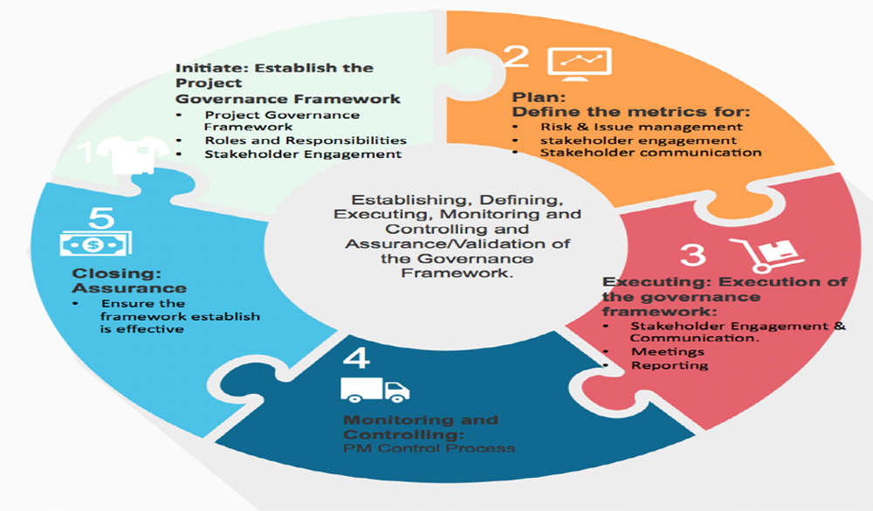

## Reason for project governance

* Outline the relationships between all internal and external groups involved in the project
* Describe the proper flow of information regarding the project to all stakeholders
* Ensure the appropriate review of issues encountered within each project
* Ensure that required approvals and direction for the project is obtained at each appropriate stage of the project.

## Core project governance principles

* Principle 1: Ensure a single point of accountability for the success of the project
  + The accountable person must hold sufficient authority within the organisation to ensure they are empowered to make the decisions necessary for the project’s success.
* Principle 2: Project ownership independent of Asset ownership, Service ownership or other stakeholder group
  + The Project Owner is engaged under clear terms which outline the organisations key result areas and the organisation's view of the key project stakeholders.
* Principle 3: Ensure separation of stakeholder management and project decision making activities
* Principle 4: Ensure separation of project governance and organisational governance structures

## Good project governance includes

* A compelling business case, stating the objects of the project and specifying the in-scope and out-of-scope aspects
* A mechanism to assess the compliance of the completed project to its original objectives
* Identifying all stakeholders with an interest in the project
* A defined method of communication to each stakeholder
* A set of business-level requirements as agreed by all stakeholders
* An agreed specification for the project deliverables
* The appointment of a project manager
* Clear assignment of project roles and responsibilities
* A current, published project plan that spans all project stages from project initiation through development to the transition to operations.
* A system of accurate upward status- and progress-reporting including time records.
* A central document repository for the project
* A centrally-held glossary of project terms
* A process for the management and resolution of issues that arise during the project
* A process for the recording and communication of risks identified during the project
* A standard for quality review of the key governance documents and of the project deliverables.

## Eight Governance Components

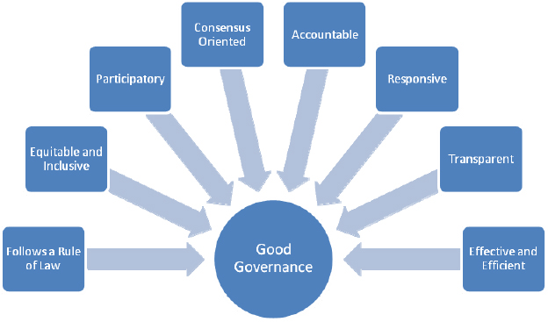

1. Governance Models
   1. the amount of rigor that you want to incorporate
2. Accountability and Responsibilities
   1. When defining accountability and responsibilities, the project manager needs to define not only who is accountable, but also who is responsible, consulted and informed for each of the project's deliverables.
3. Stakeholder Engagement
   1. When establishing the foundation for your governance plan, understanding the project ecosystem is mandatory. The first step is to identify all the stakeholders.
4. Stakeholder Communication
   1. The communication plan needs to be developed once all the stakeholders have been identified and their interests and expectations have been defined. A well-formulated communication plan delivers concise, efficient and timely information to all pertinent stakeholders.
5. Meeting and Reporting
   1. Once the communication plan is identified, the project manager needs to ensure that there is a right balance of meetings and reporting. This needs to be defined to ensure that each stakeholder understands the mode and content of communication, frequency, owner/receiver, communication milestones and decision gates. In addition, communication needs to be crisp, precise and to the point.
6. Risk and Issue Management
   1. At the beginning of any project or program, there needs to be a consensus on how to identify, classify and prioritize the risks and issues. Quite frankly, how you handle the risk or issue is more important than the issue/risk itself.
7. Assurance
   1. Project assurance ensures that risks and issues are managed effectively and defines the metrics that foster the delivery confidence of the project/program.
   2. Some of the metrics include but are not limited to adherence to the business case; effectiveness of the change control and risk analysis process; the ability to monitor deviations in project scope, time, cost and schedule; and quality assessment and tracking accuracy of the project plan.
8. Project Management Control Process
   1. The monitoring and controlling process has purview of all tasks and metrics associated with the project and programs and measures performance against the baseline scope, budget, time, and resources. This is not a one-time assessment; the project/program manager needs to be constantly measuring the performance and taking timely action on any deviations.

## Project Governance Critical to the Success of a Project

* Single point of accountability;
* Outlines roles, responsibility and relationships among project stakeholders;
* Issue management and resolution; and
* Information dissemination and transparent communication.