**Things used in this project**

**Hardware components**[**Adafruit itsy Bitsy M0 Express**](https://www.adafruit.com/product/3727)[**QTR-1A Reflectance Sensor**](https://www.pololu.com/product/2458)[**Adafruit DotStar Digital LED Strip**](https://www.adafruit.com/product/2241)[**DFRobot Wireless Charging Module 5V/1A**](https://www.dfrobot.com/product-1284.html) **Motor RS-540SH**

**Software apps and online services  
Arduino IDE**

**Story**

**I made a full color POV (persistence of vision) display using a wireless charging module and DotStar LED tape.  
Constitution  
LED tape, microcomputer and reflectance sensor are mounted on the rotating part, and LED tape uses DotStar. Using the wireless charging module, the power supply to the rotating part was carried out wirelessly.**

**One AA battery was used for the motor and three AA batteries for the wireless power supply to the rotating part.**

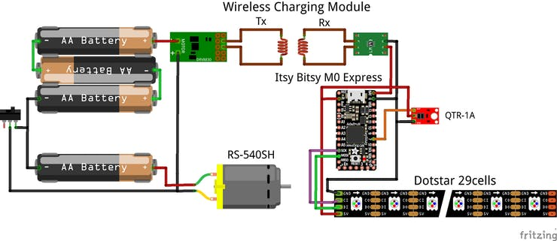

**DotStar  
This is an LED tape with the following characteristics:  
Fast write for SPI input [CLK, DATA]. It seems to correspond to the input frequency 30MHz  
Luminous refresh rate 19.2 kHz and high speed  
It can be said that the LED cell for POV. It is very easy to be able to turn on the LED tape with the signal input to the serial at high speed by the signal input in the parallel to the LED in the past and to achieve high-speed lighting.**

**It is easy to use the LED tape Neopixel which is very popular with one signal line, but the speed is severe because it becomes the original signal input of 800 kHz fixed.Because the refresh rate is 400 Hz, it is not suitable for the POV.**

**Wireless Charging Module  
The first wall of the POV production is the power supply to the LED rotating part. It is seen to make a rotatable contact and to be energized by making a good thing, but the processing seems to be very difficult to make me…**

**So, I used the wireless charge module here.It is only placed in the face-through the transmission coil to the rotation axis of the motor without almost processing. I thought it was a nice idea.**

**POV Display Device  
The motor was fixed with metal fittings and the handle was made with black wood, and the battery socket and power supply on/off slide switch were fixed.**

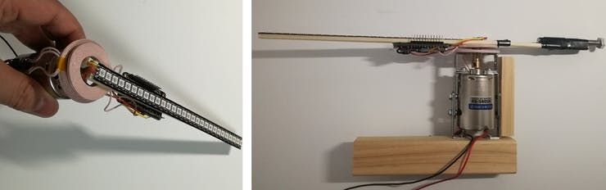

**The rotating part is completely independ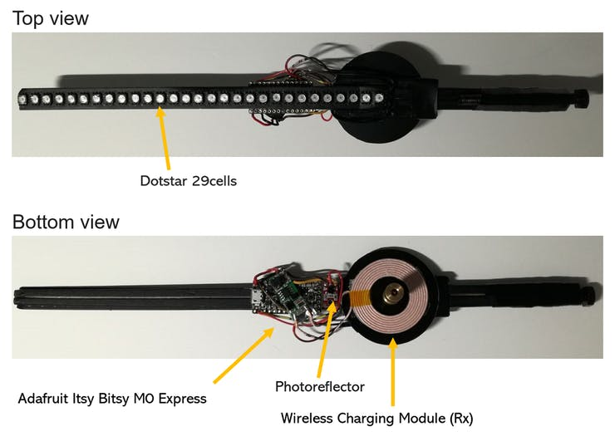ent by radio as follows.**

**The rotational speed is measured by detecting the white marker at the top of the motor side with reflectance sensor of the rotating part.**

**Arduino IDE Code  
The following libraries are used for Dotstar.https://github.com/adafruit/Adafruit_DotStar**

**When a reflectance sensor detects a marker, it decreases the output, so it detects it in the attachinterrupt and measures the time it takes to interrupt processing by one lap.**

**It switches the LED blink by dividing the time of one lap by 250. 250 LED display patterns are stored in flash memory as an array in graphics.h.  
I change the color every fixed time.**

**Display graphic data creation method**

**The array of images to be displayed written in graphics.h was created using Excel.**

**Writing a number in the circle makes the background color purple, so I divided it by 250, and expanded it.**

